 |  | 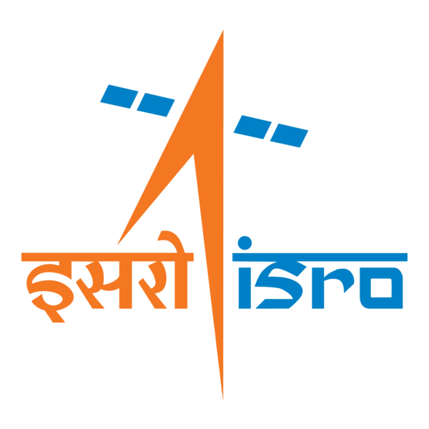

🌌 अंतरिक्ष समाचार | Space News
शुक्रवार, २३/१०/२०२६ | Friday, 23/10/2026

1. Goa unveils AI policy 2026, launches state-level hackathon
Read more
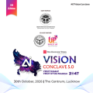
- Policy - 3 min Read The announcements were made at the inaugural session of the two-day Goa AI Tech Conclave 2026 organised by the Goa Department of Information Technology, Electronics and Communications at the INOX Courtyard. - PTI - Published On Oct 22, 2026 at 08:17 PM IST - Select ETGovernment as Preferred Choice on Google - Share Icon Copy Link Share on Whatsapp Share on Linkedin Share on X Share on Telegram Share on Facebook - Bookmark - Comment Chief Minister Pramod Sawant, IT Minister Rohan Khaunte and other senior officials and industry representatives attended the event, held under the theme 'AI for People, Planet and Progress'. The Goa government on Thursday unveiled its Artificial Intelligence (AI) Policy 2026 and launched a state-level hackathon to promote responsible adoption of the technology, strengthen governance and create new economic opportunities. The announcements were made at the inaugural session of the two-day Goa AI Tech Conclave 2026 organised by the Goa Department of Information Technology , Electronics and Communications at the INOX Courtyard. Chief Minister Pramod Sawant, IT Minister Rohan Khaunte and other senior officials and industry representatives attended the event, held under the theme 'AI for People, Planet and Progress'. The AI Policy 2026 lays out a three-year framework for 2026-29, with the government aiming to position Goa as a hub for responsible AI and applied innovation. It focuses on five pillars - skilling and capacity building; startups and industries; capital and investments; policy, governance and infrastructure; and responsible, safe and ethical AI, officials said. Addressing the gathering, Sawant emphasised the need to expand AI training opportunities for young people across the state. The AI training programme that began in Porvorim could be extended to other talukas, with the Department of Information Technology and the Education Department working together to establish AI laboratories in educational institutions, the CM said. Khaunte said the policy, along with the proposed Goa AI Mission 2027, aims to use artificial intelligence to promote inclusive growth, improve citizen-centric governance and generate new economic opportunities. He also announced plans for an IT Techno Centre in Porvorim, envisaged as a hub for the state's technology ecosystem, bringing together infrastructure, incubation facilities and collaborative workspaces. The Goa AI Hackathon was launched to encourage the development of technology-based solutions for governance and public service delivery through a phased implementation strategy, officials said. In another major initiative, the Department of Information Technology signed a memorandum of understanding with BITS Pilani Goa to establish an AI Centre of Excellence. The conclave also highlighted efforts to develop a Konkani Large Language Model (LLM) in collaboration with Digital India BHASHINI . The initiative, based on an agreement signed with the department six months ago, is being undertaken in coordination with the Higher Education Department and the Directorate of Official Languages. The proposed language model aims to develop localised AI applications for governance, with data collection supported by BhashaDaan, BHASHINI's crowdsourcing initiative that invites citizens, students and language experts to contribute linguistic data. Another initiative, Granthika, is designed to support the digitisation and preservation of historical, legal and manuscript records by engaging citizens, including elderly people, in safeguarding the material, officials said. The event also saw the launch of the 'Living Library of Goa Rural AI' report by Hyprlocl and the felicitation of 12 'Drone Didis' who completed foundational drone training and are progressing to advanced courses. The government also showcased the first batch of 10 AI trainees trained by TAWAI Studio. According to the organisers, some participants secured job opportunities after acquiring AI skills, including one Shradha Sawant, who was placed with McLaren Strategic Solutions. The conclave brought together industry leaders, startups, researchers, students and representatives from academia to discuss the application of AI in governance, tourism, climate resilience and industrial development. The programme included panel discussions, industry roundtables, skill development workshops, startup pitching sessions and an exhibition featuring 30 technology experience zones and institutional stalls. Among the industry participants were CoRover.ai, Adani Global Capability Centres and Quidich Innovation Labs. The second day of the conclave is scheduled to feature sessions on climate resilience and industrial transformation, according to the organisers. Comments What are your thoughts?

2. Amit Shah launches 43 Yamuna cleaning projects worth ₹8,941 crore in Delhi
Read more
- Smart Infra - 3 min Read Union Home Minister Amit Shah said the Delhi government has successfully reduced sewer discharge into the Yamuna, and he pledged that the BJP government would ensure the river is cleaned in Delhi by May 2029. - PTI - Published On Oct 22, 2026 at 09:07 PM IST - Select ETGovernment as Preferred Choice on Google - Share Icon Copy Link Share on Whatsapp Share on Linkedin Share on X Share on Telegram Share on Facebook - Bookmark - Comment The launched projects include a new sewage treatment plant (STP) at Okhla, 29 decentralised sewage treatment plants (DSTPs), and new sewer lines. Union Home Minister Amit Shah on Thursday laid the foundation for 43 projects worth ₹8,941 crore, including the city's biggest STP at Okhla aimed at cleaning the Yamuna river. Shah said the Delhi government has successfully reduced sewer discharge into the Yamuna, and he pledged that the BJP government would ensure the river is cleaned in Delhi by May 2029. The launched projects include a new sewage treatment plant (STP) at Okhla, 29 decentralised sewage treatment plants (DSTPs), and new sewer lines. The inauguration took place in Najafgarh. "These projects are like the backbone of cleaning the Yamuna river. The Centre, Delhi government, Uttar Pradesh and Haryana, these 'four engines' are working together to provide a clean Yamuna and drinking water to the public," Shah said while addressing the public. Touted to be the biggest STP in the country and Delhi, DJB officials said that the new 124 million gallons per day (MGD) plant has been constructed at an estimated cost of ₹1,161 crore. The plant is a joint venture between the National Mission for Clean Ganga and Delhi Jal Board, originally sanctioned in 2017. "Built under the Yamuna Action Plan-III, the plant will treat wastewater. Arrangements have also been made to ensure that the treated water meets prescribed standards and to generate energy. The project is expected to benefit around 70 lakh people in the Okhla area," a DJB official said. Previous governments only used to make excuses, but now the current BJP government will clean the Yamuna before May 2029. The plan is to provide sewer connection and clean drinking water to every household in three years, Shah added. Chief Minister Rekha Gupta and Water Minister Parvesh Verma were also present at the inauguration. "Under these projects, new sewage treatment plants will be built, the capacity of old plants will be increased, the sewer network will be expanded, and drainage arrangements will be improved. This will greatly help in preventing dirty water from entering the Yamuna," Gupta said. Twenty-nine new DSTPs and sewage pumping stations in outer Delhi will cover 358 unauthorised colonies and 113 villages, benefiting 36.29 lakh residents in Narela, Bawana, Kanjhawala, Bijwasan, Tikri Kalan and nearby areas. "The decentralised STPs and sewage pumping stations will be constructed at the cost of ₹3,113.67 crore," Gupta added. Another project involving the laying of 1,034 kilometre of new sewer network was launched, costing around ₹1,691 crore benefitting around 25.82 lakh people. The Delhi government is also replacing the old water treatment plant at Chandrawal with a new facility that will have a capacity of 477 million litres per day (MLD), for which a foundation-laying ceremony was held. The new plant, which will benefit around 22 lakh residents, will be constructed at the cost of ₹298.3 crore, replacing two old WTPs set up in 1935 and 1955. Water Minister Verma stated that these projects will bolster the Delhi government's efforts to clean the Yamuna. "Through these projects, key initiatives such as the development of water treatment plants , expansion of the sewer network, enhancement of wastewater treatment capacity, and improvement of the drainage system will gain momentum," Verma said. He said the aim behind these projects will be to intercept sewage that reaches the Yamuna, treat it and reuse it instead. Comments What are your thoughts?

3. Chairman ISRO/ Secretary DOS participated in the International Astronautical Congress (IAC) held at Antalya, Türkiye - ISRO
Read more
Chairman ISRO/ Secretary DOS participated in the International Astronautical Congress (IAC) held at Antalya, Türkiye ISRO

4. Isro to launch much-delayed indigenous navigation satellite NVS-03 on Oct 30 - The Indian Express
Read more
Isro to launch much-delayed indigenous navigation satellite NVS-03 on Oct 30 The Indian Express

5. ISRO to Launch NVS-03 Navigation Satellite on October 30 - GK Today
Read more
ISRO to Launch NVS-03 Navigation Satellite on October 30 GK Today

6. ISRO Recruitment 2026: Applications begin for technical, non-technical roles; Here's how to apply - Education Times
Read more
ISRO Recruitment 2026: Applications begin for technical, non-technical roles; Here's how to apply Education Times

7. NASA Invites Media to 2026 von Braun Space Exploration Symposium
Read more
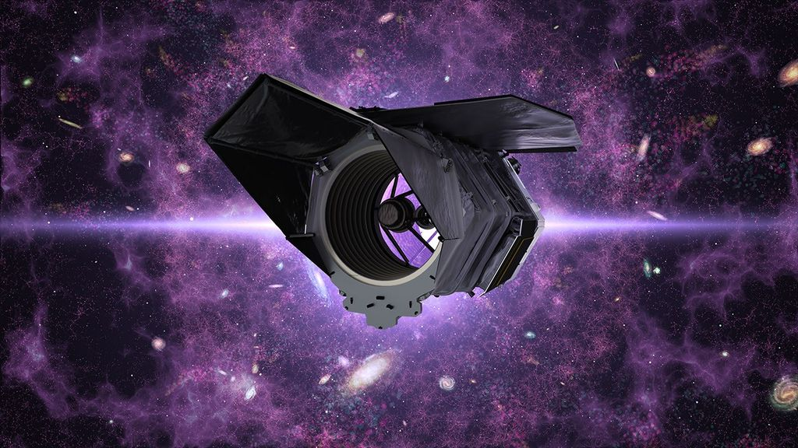
Members of the media are invited to join NASA at the 2026 von Braun Space Exploration Symposium from Monday, Oct. 26, to Wednesday, Oct. 28, at the University of Alabama in Huntsville. This year's symposium is focused on humanity's return to the Moon, sustainable lunar infrastructure, advanced space propulsion, and the evolving space workforce. Panels include discussions on Artemis II and III, space propulsion flash talks, building utilities and infrastructure for sustainable lunar operations, Moon base supply chain resilience, space nuclear technology, navigating the new NASA workforce, and engineering the future, featuring keynotes and awards presentations. NASA speakers include: Deputy Associate Administrator Casey Swails Stephen Cash, director, NASA Marshall Nicky Fox, associate administrator, Science Mission Directorate, NASA Headquarters Charlie Blackwell-Thompson, Artemis II launch director, NASA Kennedy Steve Creech, Human Landing System program manager, NASA Marshall Debbie Whitis Korth, acting program manager, Orion Program, NASA Johnson To request an interview with NASA speakers during the event, media must contact Lance D. Davis, lance.d.davis@nasa.gov, and Joel Wallace, joel.w.wallace@nasa.gov. Media interested in participating in-person or online must contact the American Astronomical Society to register. Organized by the American Astronautical Society in collaboration with NASA's Marshall Space Flight Center in Huntsville, Alabama, the annual event gathers leaders from government, industry, policy, and academia to discuss the current landscape of space exploration and help chart a path forward. For more information on NASA Marshall, visit: https://www.nasa.gov/marshall -end- Lance D. Davis Marshall Space Flight Center, Huntsville, Ala. 256-640-9065 lance.d.davis@nasa.gov

8. NASA's Hubble Charts Path for Roman with Gravitational Lenses
Read more
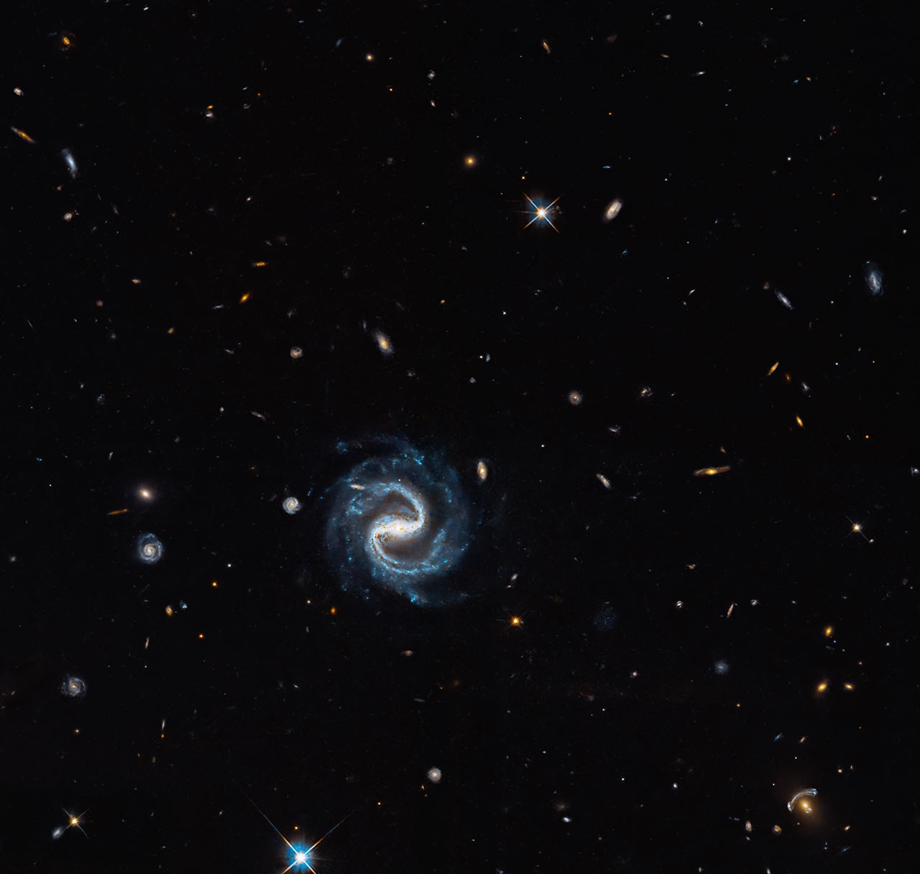
A sinuous spiral galaxy (center) appears in the same field of view as a vivid gravitational lens (right corner) in this Hubble image. The lens consists of a reddish elliptical foreground galaxy and the blue arcs of a magnified background galaxy. NASA, ESA, and X. Huang (University of San Francisco); Processing: Gladys Kober (NASA/Catholic University of America) A sweeping barred spiral galaxy marks the spot in this image, but the real treasure is the gravitational lens in the lower-right corner, where a distant background galaxy is being magnified and distorted by the gravity of a closer galaxy. This observation is one of many gravitational lensing images taken by NASA's Hubble Space Telescope in preparation for science with the new Nancy Grace Roman Space Telescope. Gravitational lensing occurs when the mass of a foreground object - such as a galaxy - warps spacetime, causing light to bend, distort, and magnify as it passes around the object, similar to a giant lens in space. Lenses like this occur when a precise chance alignment takes place between the foreground and background galaxies, causing light from the background galaxy to curve around the foreground galaxy. In this image, the gravitational lens features a foreground elliptical galaxy that is about 4.5 billion light-years away. That means the light we see from this galaxy now would have first started traveling toward us when our solar system was still forming. The background galaxy is about eight billion light-years away, almost twice as far. It appears as a pair of arcs, one large and very noticeable to the upper left of the foreground galaxy, the other a much smaller, flipped image of the same background galaxy to the lower right. This configuration is called an arc-counterarc pair. The background galaxy magnified and made visible by this gravitational lens appears twice in this image ― as a large arc and smaller, flipped arc ― on opposite sides of the elliptical foreground galaxy. NASA, ESA, and X. Huang (University of San Francisco); Processing: Gladys Kober (NASA/Catholic University of America) The more massive the foreground galaxy is, the stronger the gravitational lens and the more significantly it bends light. By studying the distortion of the background galaxy, researchers can determine how much mass the foreground galaxy contains. This plays a huge role in the study of dark matter, the mysterious, invisible substance that makes up the majority of mass in the universe. The visible matter is not enough to account for the level of distortion in the background galaxy, which allows researchers to calculate both the mass of the foreground galaxy and how much dark matter it contains. Almost all of the objects in this image are galaxies, except for a few scattered foreground stars. The barred spiral galaxy in this image - so called because its arms extend from a bar of stars in its center - is about the size of our own Milky Way galaxy, which astronomers think is a barred spiral as well. The tiny spiral to the left of the large spiral may be a satellite galaxy, similar to the Large and Small Magellanic Clouds that orbit the Milky Way. Hubble views the cosmos primarily in visible and ultraviolet light with some infrared coverage, and Roman sees mainly infrared wavelengths and some visible light. Hubble can provide high-resolution views of individual objects, while Roman has a much larger field of view conducive to panoramas. Images like this offer a glimpse of how Hubble and Roman will work together to build an even more comprehensive picture of the cosmos. This is just one of many gravitational lens images captured by Hubble. Astronomers will use them to analyze gravitational distortions to learn more about dark matter in the foreground galaxies and to lay the groundwork for future Roman observations. Hubble can only view these gravitational lenses one at a time, while Roman's wide view of the sky will provide a greater sample of these lenses. Astronomers are using Hubble's sharp images to build a computer model to better analyze dark matter-induced distortions. This tool will help astronomers analyze Roman's large images. Hubble will also follow up on interesting lenses Roman detects. Explore More Media Contact: Claire Andreoli NASA's Goddard Space Flight Center, Greenbelt, MD claire.andreoli@nasa.gov

9. On this day in space! Oct. 22, 1992: Ashes of 'Star Trek' creator Gene Roddenberry launch into space on NASA shuttle
Read more
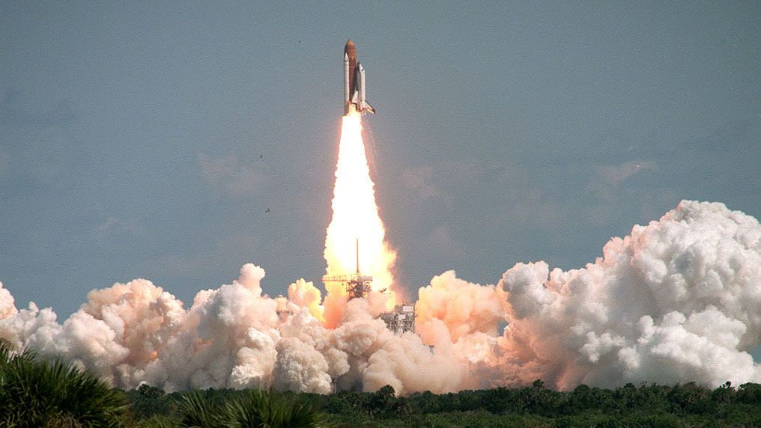
Click for next article On Oct. 22, 1992, the space shuttle Columbia launched into space with the ashes of Gene Roddenberry, the creator of " Star Trek ," aboard. During mission STS-52, NASA astronaut and shuttle commander James Wetherbee brought a small container with a portion of Roddenberry's ashes into space as part of his personal effects at the request of Roddenberry's widow, Majel Barrett . It was Roddenberry's lifelong dream to go to space, but he never got to go while he was alive. But thanks to his wife, a little bit of Roddenberry finally made it to space almost exactly one year after his death. NASA and his family didn't tell anyone about it until almost two years later in 1994. Wetherbee said he was "honored to be asked" by Barrett to carry Roddenberry's ashses on the spaceflight. "I'm just glad I was able to bring a little happiness to the family," he said, according to Newsweek . The Space Shuttle Columbia (STS-52) launches from NASA's Kennedy Space Center on Oct. 22, 1992. (Image credit: NASA) Here's why it mattered The launch of Roddenberry's ashes into space on NASA's STS-52 mission aboard the space shuttle Columbia marked the world's first " space burial ," but it wouldn't be the last. About five years after Roddenberry's memorial flight, in 1997, the space memorial company Celestis began launching a series of "burial" flights by flying capsules with human cremains on rockets . In fact, more of Roddenberry's ashes flew on Celestis' "founders flight" in April 1997 aboard an air-launched Pegasus rocket that took off from the Canary Islands in Spain. The ashes of Roddenberry's wife and of Star Trek actor James Dooha n have also flown in space, among others. Celestis has gone on to launch human cremains on many suborbital and orbital flights, including some on SpaceX Falcon 9 rockets. The company even launched the ashes of the late astronomer Eugene Shoemaker to the moon in 1999 on the Luna 1 flight, with another set of cremains launched into deep space on the Enterprise mission in 2023. Want more space history? Check out our full On This Day In Space Story archive and watch our On This Day In Space videos on YouTube .

10. After Starshield interruption, Ukraine wants to build its own satellite communication network with ICEYE and Nokia
Read more

Click for next article The Finnish companies ICEYE and Nokia recently announced a partnership with Ukraine to investigate developing a sovereign satellite-communications network for the nation. Ukraine wants its own satellite-communication system, which shouldn't be surprising given the events of the past week or so. The Ukrainian military just signed a letter of intent with two Finnish companies - the telecom giant Nokia and satellite maker ICEYE - to look into developing a sovereign satellite-communications network for Ukraine. "Ukraine needs secure, sovereign and high-performance satellite communications systems that it controls," ICEYE cofounder and CEO Rafal Modrzewski said in a statement today (Oct. 22). "We have a proven track record of delivering sovereign missions at speed to help build that capability. ICEYE has proudly supported Ukraine since 2022, and we remain committed to continuing that support today." Ukraine relies heavily on satellite-based communications and data to defend itself from Russia, which invaded the nation in February 2022 and continues to attack it with ground troops, missiles and drone strikes. But Ukraine does not own those satellites. It primarily uses the services provided by SpaceX's Starlink megaconstellation in low Earth orbit (LEO) and Starshield , a military-grade, jamming-resistant version of Starlink employed by the U.S. government and its allies. Starshield in particular is crucial to Ukraine, as it allows the nation to operate fast-moving drones over large distances in war zones. Ukraine has gotten very good at drone warfare, employing these little robots both in offensive and defensive capacities. On Oct. 14, however, Ukrainian soldiers and officials reported a severe throttling of their access to Starshield services - a speed limit on terminal-carrying drones, which caused many of them to fall out of the sky . It's not entirely clear who's behind the throttling. Some U.S. officials have apparently said the order came from Elon Musk , but the billionaire SpaceX founder and CEO put the ultimate responsibility on the Trump administration. "Starshield systems are owned and controlled by the US government. Any limits on speed or usage are decided by the US military and ultimately POTUS," Musk said on Oct. 14 via X, the social media platform he owns. Whoever made the call, it certainly wasn't Ukraine. And the Starshield throttling - which apparently is still in effect - has doubtless reinforced the nation's desire to control its own satellite-communications infrastructure. "Nations need communications they can rely on in every situation. Satellite networks extend and protect connectivity when networks on the ground are disrupted," Mikko Hautala, Nokia's chief geopolitical and government relations officer and chairman of Nokia Defense, said in the same statement. "This makes them a key part of any secure communications system," he added. "Through this Letter of Intent, together with Ukraine and ICEYE, we will explore how trusted, sovereign satellite communications can strengthen Ukraine's resilience and give it control over the connectivity it depends on." Nokia and ICEYE announced on Oct. 1 that they plan to work together to help nations develop such sovereign satcom systems. The partnership with Ukraine follows on from that earlier agreement. Russia's Luch-2 satellite approaches another geostationary satellite on April 12, 2024, as tracked by the French company Aldoria's observation stations. (Image credit: Aldoria) ICEYE has already been aiding the Ukrainian defense effort. The Finnish company and its U.S. subsidiary jointly operate a fleet of Earth-observing satellites in LEO, which study our planet using synthetic aperture radar. Ukraine uses data from the ICEYE constellation for intelligence and planning purposes. This relationship has put ICEYE - or one of its satellites, at least - in Russia's crosshairs. A Russian inspector satellite called Kosmos 2612 recently made an extremely close approach to ICEYE-X36 , which is operated by ICEYE US. The goal of the unsanctioned rendezvous is unclear. Russia may have wanted to assess the satellite's capabilities or interfere with it in some way. Or perhaps the nation simply wanted to send a message, letting ICEYE (and Ukraine) know that it could mess with satellites if it wanted to.

11. 'Cabin leak suspected': Artemis II astronaut reveals how a warning nearly derailed NASA's epic moon mission
Read more
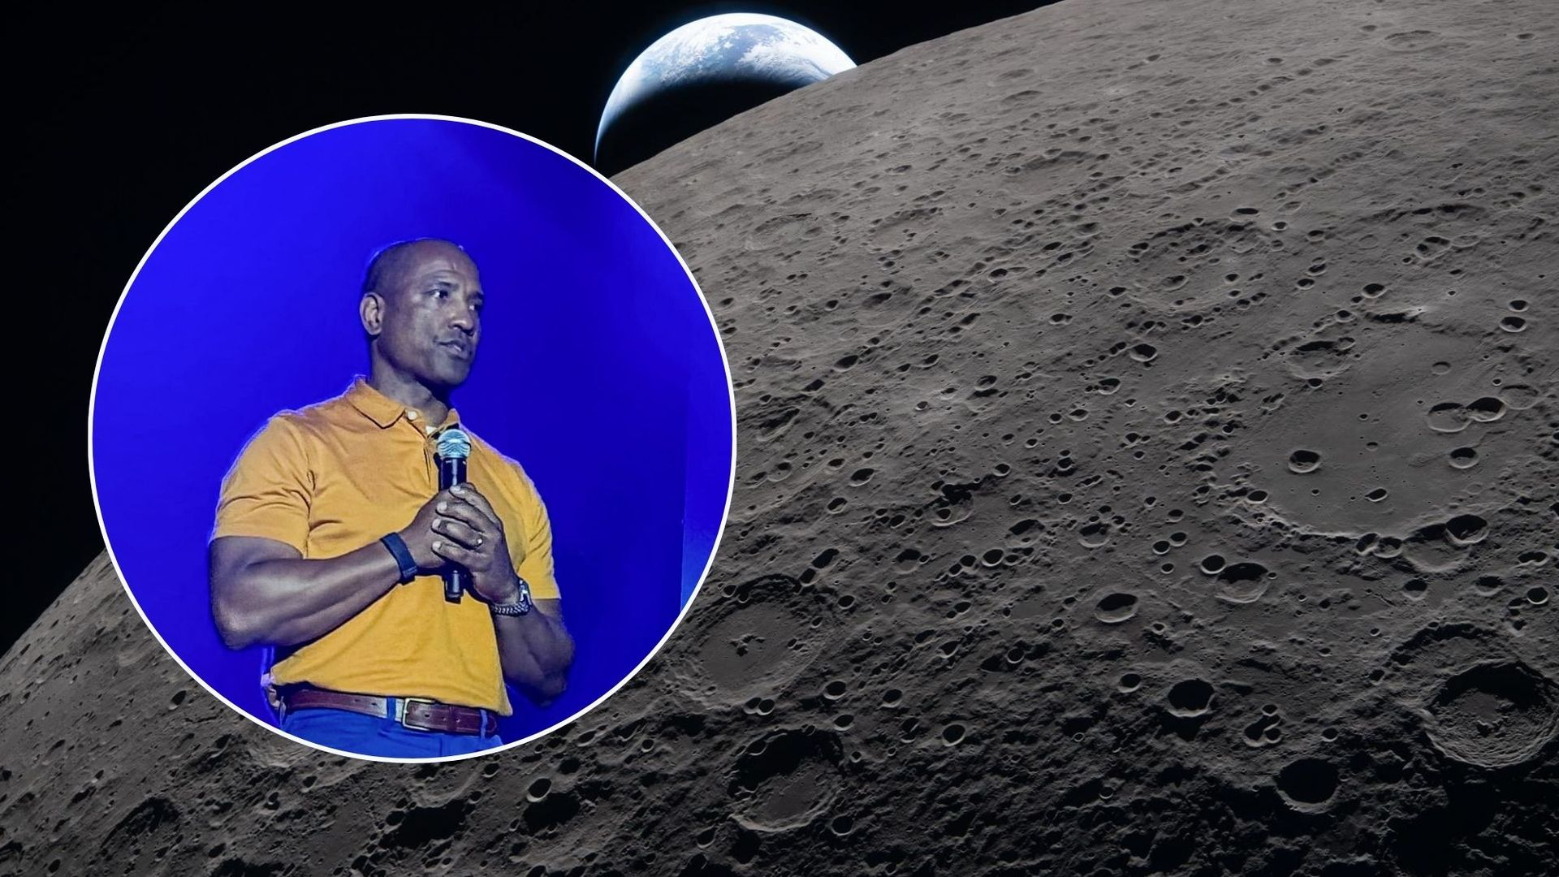
Click for next article Inset: Victor Glover recounting the Artemis II mission at the Starmus VIII festival in Tenerife. Background: Close up view of the moon with Earth in the background, captured during the Artemis II mission. TENERIFE, CANARY ISLANDS - NASA's Artemis II astronauts were just minutes away from a critical engine burn that would send them toward the moon when an unexpected cabin leak warning threatened to change the course of their historic mission. "If it had happened five minutes later, we may not have been able to have that burn," Artemis II pilot Victor Glover revealed during an Oct. 18 discussion with Canadian former astronaut Chris Hadfield at the Starmus VIII festival here in Tenerife. The incident unfolded on April 2, the second day of the Artemis II mission, as the astronauts' Orion spacecraft swooped back toward Earth after traveling some 38,000 miles (61,000 kilometers) away. Orion had been completing a highly elliptical orbit around Earth , giving the crew and mission control an opportunity to test the capsule's systems before committing to the journey to the moon . Orion was now approaching its closest point to our planet, roughly 100 miles (160 km) above the surface, ahead of the crucial translunar injection (TLI) burn that would send the astronauts moonward. "Jeremy looks out the window and says, 'I think we're going to run smack dab into the middle of Earth,'" Glover recalled, referring to Artemis II mission specialist Jeremy Hansen of the Canadian Space Agency . "Because we were getting so low." The close approach brought additional challenges, as Orion passed through a region populated by orbital debris and satellites. "The density of things is going up from where we are, and also an increase in radiation," Glover explained. It was at this particularly demanding point in the mission that Orion issued a warning that indicated a possible cabin leak, around 15 minutes before the critical TLI burn. "So, determining whether it was real or not was a big deal," Glover said. The crew and mission control faced a crucial question: Was it safe to continue heading to the moon , or would they have to abandon the planned maneuver and cut the mission very short? "Are we going to do a TLI and burn to go to the moon, or are we putting on our spacesuits to prepare to come back to Earth right now?" Glover recalled. The timing was particularly critical. The TLI burn was designed to propel Orion out of Earth orbit and onto its trajectory around the moon, marking the first time astronauts had headed toward Earth's nearest neighbor since the Apollo era. The moon, seen here backlit by the sun during a solar eclipse on April 6, 2026, captured by one of the cameras on the Orion spacecraft's solar array wings. (Image credit: NASA) Luckily, as NASA flight director Judd Frieling told us during an April 2 media briefing , the warning turned out to be a false alarm. So Artemis II received the go-ahead. Orion fired its main engine for approximately five minutes and 50 seconds, successfully setting the four astronauts on their journey around the moon. "We're watching the timer count down, velocities go up, and the magenta and green numbers coming together," Glover recalled. "Everything is tracking. It's looking good." Before long, the crew had broken free of Earth's gravitational hold and were hurtling toward the moon at around 24,500 mph (39,430 kph). Despite the tense moments before the burn, Artemis II went on to make history. NASA astronauts Reid Wiseman (the mission's commander), Glover (pilot) and Christina Koch (mission specialist), along with Hansen, traveled farther from Earth than any humans before them, reaching a maximum distance of 252,756 miles (406,771 km) during their journey around the moon.

12. NASA giving update about Artemis moon plans on Oct. 23: Watch it live
Read more
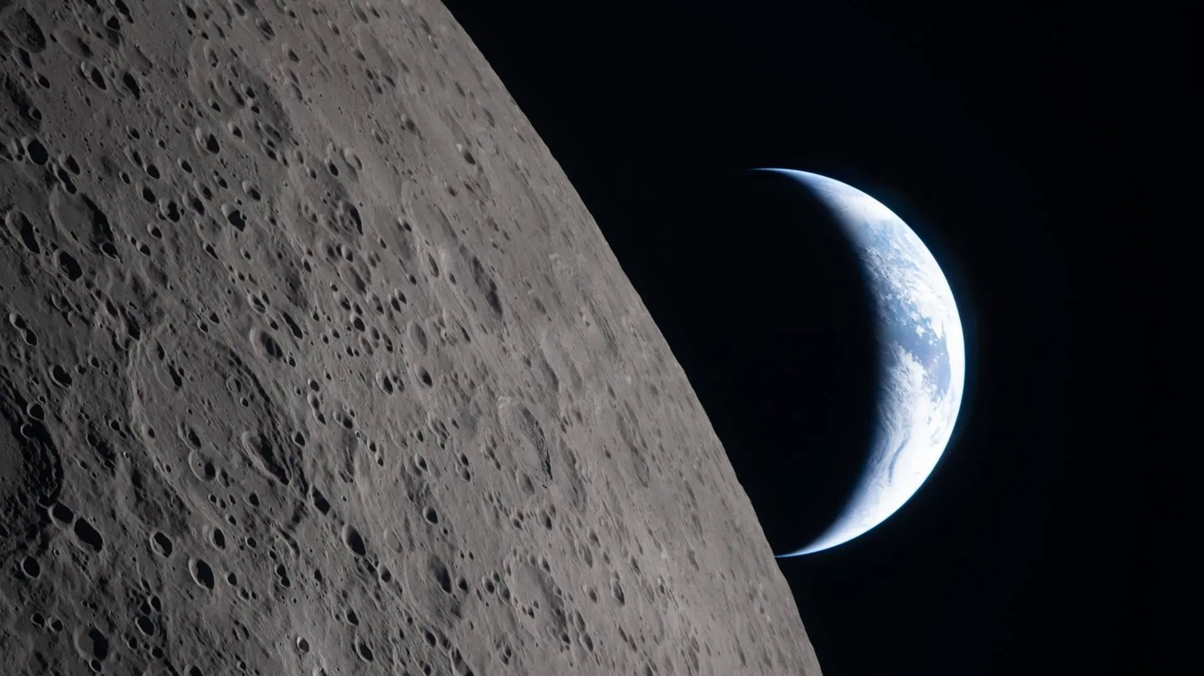
Click for next article Artemis Acceleration (Oct. 23, 2026) - YouTube Watch On NASA will provide an update about its Artemis moon plans on Friday (Oct. 23), and you can watch it live. The news will come during a press conference at the agency's Kennedy Space Center in Florida, which starts Friday at 2 p.m. EDT (1800 GMT). You can watch it live here at Space.com, courtesy of NASA. "The update will include details about NASA's Artemis III mission that will send four astronauts to low Earth orbit next year to test critical systems needed for future lunar landings, and how plans to return American astronauts to the moon by 2028 are progressing," NASA officials said in an Oct. 14 media advisory . The crew of NASA's Artemis II mission captured this photo of a crescent Earth on April 6, 2026, as they began passing behind the moon. (Image credit: NASA) Three agency officials will participate in Friday's "Artemis Acceleration" event. They are: NASA Administrator Jared Isaacman NASA Associate Administrator Amit Kshatriya Jeremy Parsons, NASA's Artemis program manager NASA is currently gearing up for Artemis III, which is targeted for mid-2027. The mission will test rendezvous and docking technologies between NASA's Orion capsule and one or both of the private spacecraft that NASA picked to be the Artemis program's crewed lunar landers: SpaceX's Starship and Blue Origin's Blue Moon . After that will come Artemis IV, which will land astronauts near the lunar south pole in early 2028, if all goes to plan. That will be the first crewed moon touchdown since Apollo 17 way back in 1972. It's unclear which lunar lander will fly on Artemis IV; that depends on how the development of each one progresses and what happens on Artemis III. And there will be other landings after Artemis IV. NASA plans to establish a moon base via Artemis, and doing so will require a variety of missions, both robotic and crewed.

