संकलन
SANKALAN
07th September 2026 to 13th September 2026
ई-न्यूज़लेटर | e-Newsletter

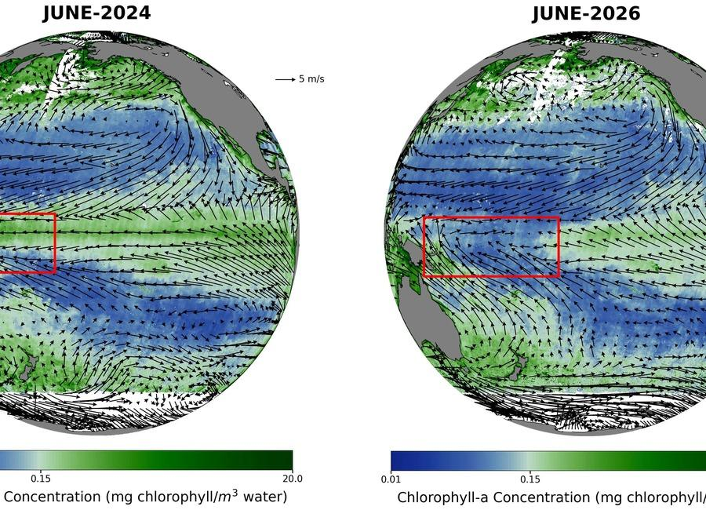 | 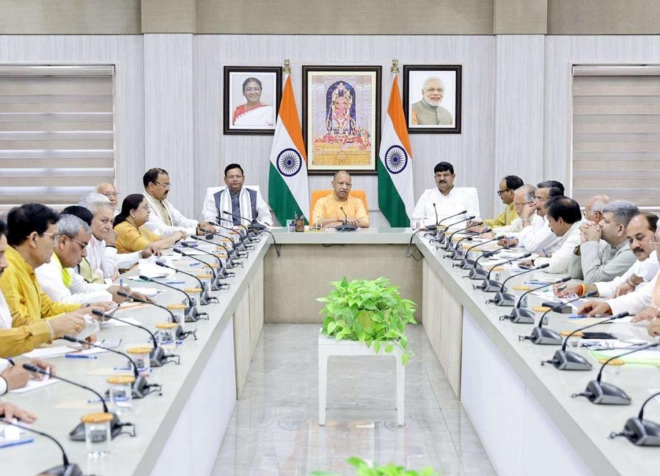 | 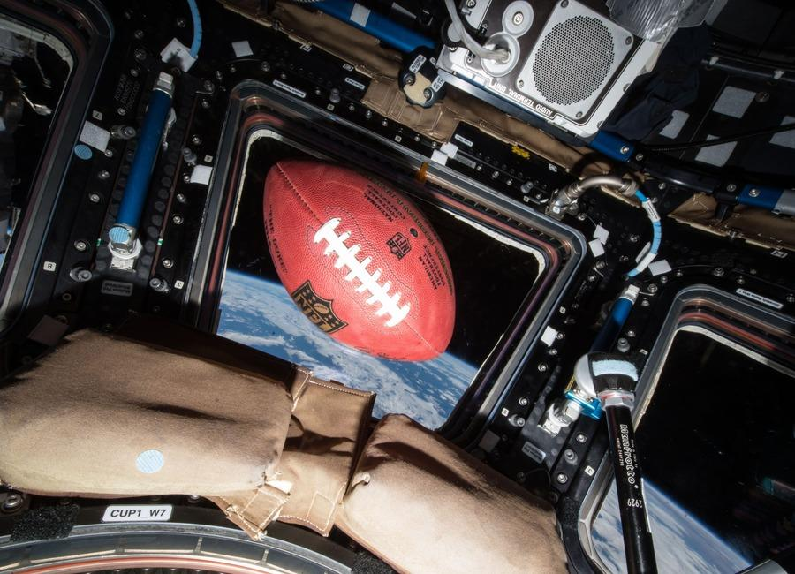
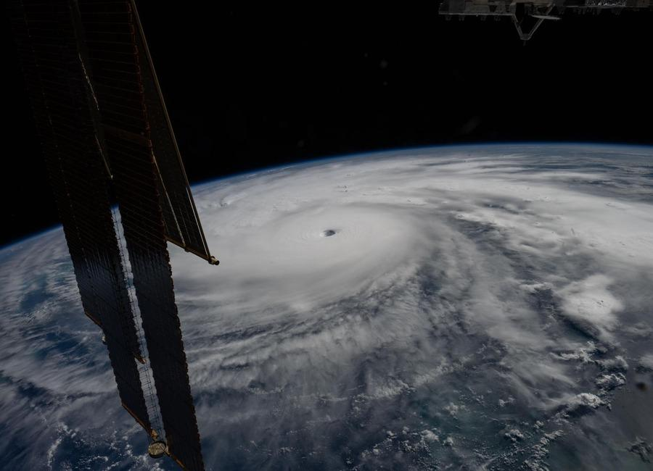 |  | 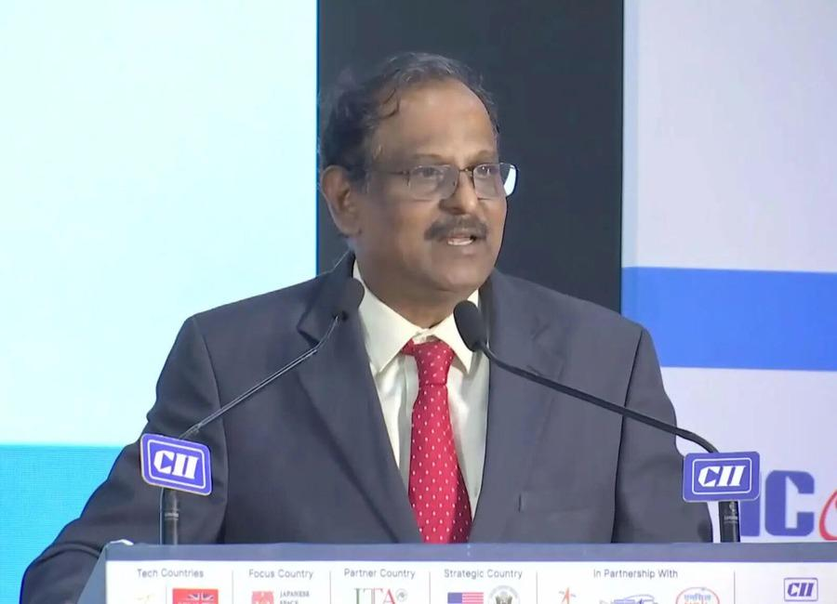
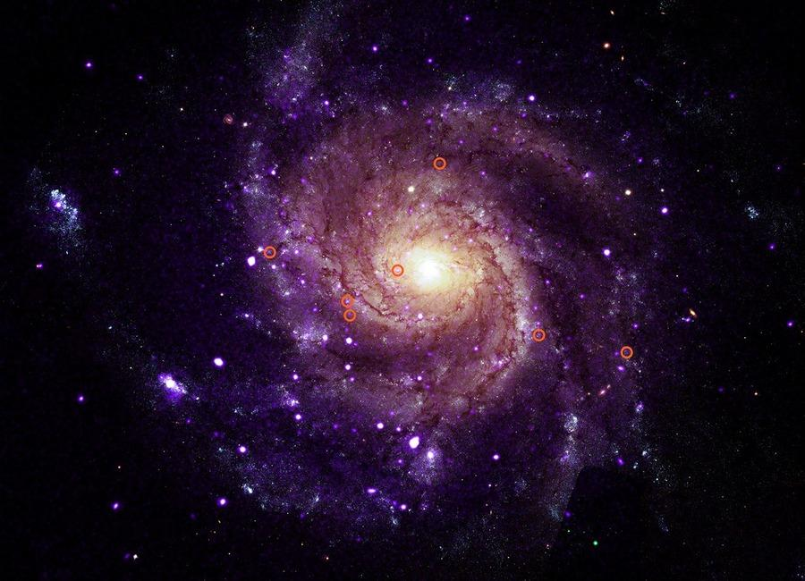 | 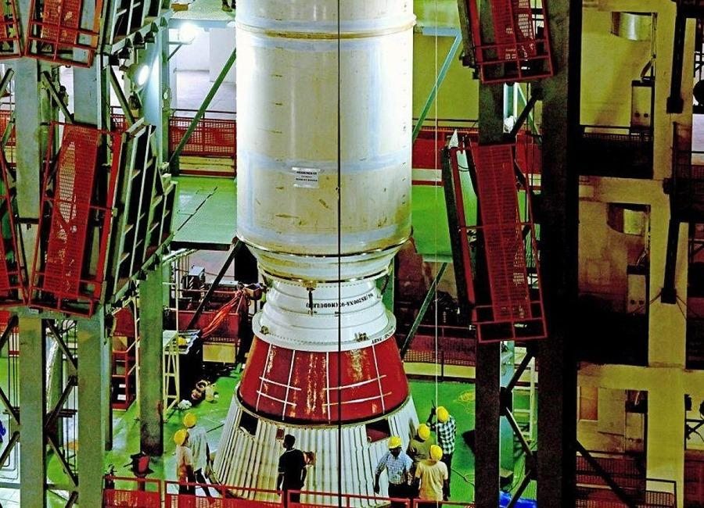 | 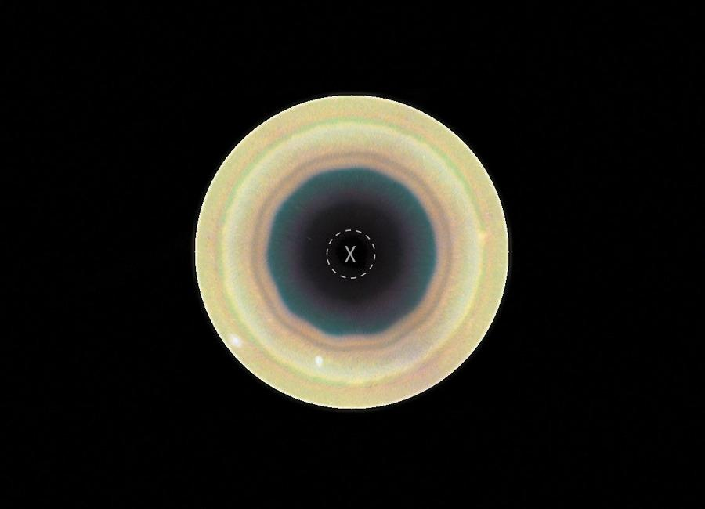

Indian Institute of Remote Sensing (ISRO), Dehradun
Collection of recent developments in the realms of Space Technology

Table of Contents
S. No. | Title
1 | ISRO says space sector reforms focus on ecosystem expansion, not privatisation - News On AIR
2 | ISRO rejects privatisation claims, says role in India's space programme won't diminish - thefederal.com
3 | 'Isro's role won't diminish': Agency allays concerns over privatisation | India News - Hindustan Times
4 | Why ISRO Staff Are Worried About ISRO's Future - Rediff
5 | Steady gaze: On the launch of the ISRO's EOS-05 satellite - The Hindu
6 | ISRO employees raise concerns over private-sector push - HR Katha
7 | SpaceX Falcon 9 rocket launches 27 Starlink satellites, lands on ship at sea (video)
8 | Feel the Force with these 10 out-of-this-world Lego Star Wars starships
9 | NASA expands Deep Space Network with giant new dish in California desert
10 | Germany's Isar Aerospace launches rocket into orbit from Norway
11 | China's chip giant AMEC launches 6 new machines to boost semiconductor production
12 | China puts missile-armed jets to operate over contested area, move could intimidate Philippines
13 | ISRO staff bodies seek clarification on trajectory of privatisation
14 | The logic behind ISRO and DRDO's tech transfers - LinkedIn
15 | ISRO won't be 'diminished', says IN-SPACe chairman - The Hindu
16 | ISRO not getting privatised, says Chairman Narayanan - The New Indian Express
17 | APOD: 2026 September 8 - Hubble: Decagon Around Saturn's South Pole
18 | 'The Last Starship' is 2026's most slept-on space game - you need to check out this 'FTL'-like shipbuilding strategy gem
19 | On this day in space! Sept. 7, 1995: NASA launches its 100th astronaut flight on space shuttle Endeavour's STS-69 mission
20 | The future of Earth observation: Private satellites and AI bring benefits but also pose risks
21 | Labor Day in space: NASA astronauts get the holiday off
22 | ISRO, IN-SPACe, NSIL and industry: Building India's new architecture for the space economy
23 | ESA to explore cooperation with ISRO in human space flight, lunar and Venus missions - The Hindu
24 | Karnataka, ISRO to explore deeper space collaboration - The New Indian Express
25 | For ISRO, expanding ecosystem is way forward - The Indian Express
26 | NASA Calls for Proposals to Accelerate Lunar Surface Technologies
27 | Stoke Space raises $1 billion for fully reusable rockets, targets 'early 2027' for 1st-ever launch
28 | On this day in space! Sept. 8, 2004: NASA's Genesis spacecraft crashed in the Utah desert, shattering its samples of solar wind particles from the sun
29 | 2 satellites just burned up in Earth's atmosphere - and scientists were watching from a private jet. Here's why
30 | SpaceX rocket taxi returns after Roman Telescope launch | Space photo of the day for Sept. 8, 2026
31 | The Vela Incident: Did an American satellite detect a secret nuclear test in 1979?
32 | How studying astronauts could help tackle aging on Earth
33 | ISRO says space sector reforms focus on ecosystem expansion, not privatisation - News On AIR
34 | Isro transparency on 'failures' comes under lens amid private sector expansion - Telegraph India
35 | National Anubhav Awards, 2026 - ISRO
36 | Karnataka seeks ISRO support to promote practical science education among students - Bangalore Mirror
37 | NASA Adds Relativity Space's Terran R to Launch Services Contract
38 | NASA's Chandra Unveils Mysterious X-Ray Objects
39 | How 2 US, European Satellites Are Studying Hurricanes During El Niño
40 | NASA Names Two Artemis II Astronauts to Emeritus Program
41 | Watch SpaceX launch classified mission for the US Space Force today
42 | International Space Station astronaut gives out of this world tribute to honor Star Trek's 60th anniversary
43 | NASA's newly launched Roman Space Telescope will 'directly' image exoplanets. But what does that mean?
44 | China on track to launch Mars sample-return mission in 2028: 'If accurate, this represents a Sputnik moment'
45 | EOS-06/Oceansat-3 detects impact of the developing El Niño on Marine Productivity in the Equatorial Pacific Ocean - isro.gov.in
46 | Is ISRO moving towards privatisation? Chief V. Narayanan responds - The Hindu
47 | ISRO Successfully Tests CE20 Engine At 220 KN For LVM3 Mission - Sarkaritel.com
48 | ISRO Admit Card 2026 For UDC, PA and Stenographer, Hall Ticket Link - Adda247
49 | ISRO Satellite Captures El Niño's Impact on Pacific Ocean - Deccan Chronicle
50 | ISRO successfully tests cryogenic engine for next LVM3-M7 mission - MillenniumPost
51 | NASA Invites Media to Djibouti Artemis Accords Signing Ceremony
52 | NASA's Life-Saving Technology Where Cell Signals Can't Go
53 | NASA, NFL Team Up to Showcase Space, Aeronautics Innovation
54 | On this day in space! Sept. 10, 2011: NASA launches GRAIL probes to the moon to map lumpy lunar gravity
55 | LINK spacecraft gets close to NASA's Swift Observatory, but not close enough to save it
56 | What comes after the moon? Artemis II commander and pilot shift to 'emeritus' status at NASA
57 | CM Adityanath orders immediate repair of rain and flood-damaged roads across UP
58 | One lakh fishing vessels to be fitted with transponders developed By ISRO soon - DD News
59 | ISRO's 'privatisation' move: What India's space policy says - indianexpress.com
60 | ISRO: Making space for industry? - Deccan Herald
61 | ISRO Satellite Detects Clearest Sign Yet Of "Mother Of All" El Nino Events - NDTV
62 | Rocket Lab protests NASA's decision to award Blue Origin $700 million Mars orbiter contract
63 | Rocket Lab launches mystery satellite to orbit for secret customer (photo)
64 | 2 private spacecraft zoom within 650 feet of each other to showcase 'advanced capabilities' in orbit (photos)
65 | 25 years ago, a NASA astronaut witnessed the tragic 9/11 attacks from space. Here's what he saw.
66 | New Houston stand puts Rotating Detonation Rocket Engine through mission-like tests
67 | BRICS New Delhi Summit: Consensus, not de-dollarisation, emerges as the real story
68 | French military jets launch 40-day global flight to project power, strengthen alliances
69 | ISRO Admit Card 2026 Out For UDC, PA and Stenographer, Hall Ticket Download Link - Adda247
70 | AI moves into India's tea gardens as Tea Board partners with ISRO and NIT Rourkela - AgroSpectrum India
71 | Amit Shah Pitches Zero Disaster Casualties. ISRO Sent Its Warnings Years Ago - NDTV
72 | Trump is proposing a US Space Academy - if created, it could blur the lines between NASA and the military (op-ed)
73 | NASA, IBM launch new AI model for studying the moon
74 | Why are the stars around our galaxy's black hole missing their companions?

 |  | 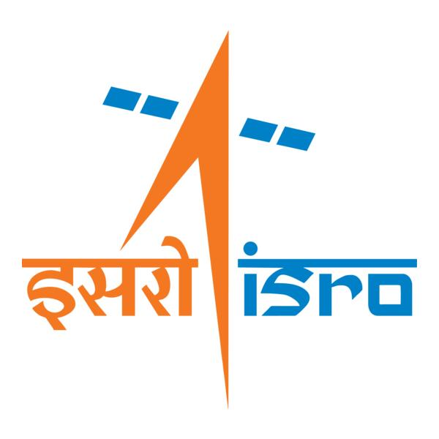

🌌 अंतरिक्ष समाचार | Space News
सोमवार, ०७/०९/२०२६ | Monday, 07/09/2026

1. ISRO says space sector reforms focus on ecosystem expansion, not privatisation - News On AIR
Read more
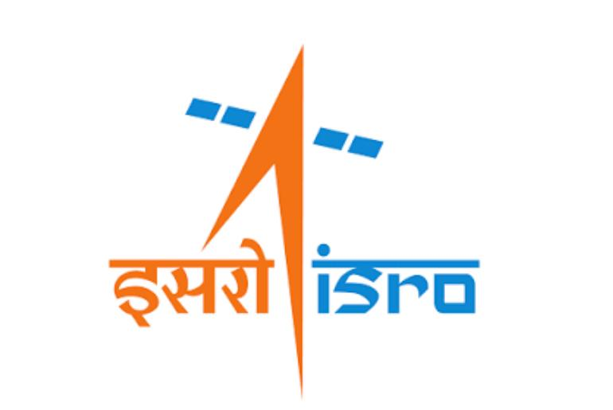
Indian Space Research Organisation (ISRO) has issued a clarification on reports circulating in the media regarding speculations and misinformation that there is an attempt to privatise ISRO or reduce its role. In a social media post, ISRO said that it will neither be privatised nor will its importance be diminished. It added that participation of the private sector in space is aimed at enabling ISRO to focus even more strongly on the next generation of India's space programme, while industry scales up mature technologies and capabilities. ISRO said the space-sector reforms aim to create a larger, stronger and globally competitive Indian space ecosystem. It said the reforms should therefore be seen as ecosystem expansion and capability multiplication, rather than privatisation. Noting the growth in India's industrial and technological capabilities, ISRO said that mature and scalable activities can increasingly be undertaken by Indian industry. This would enable large-scale production, commercialisation, innovation and access to global markets, while allowing ISRO's scientific and technical manpower to concentrate on advanced research, next-generation technologies and complex national missions. ISRO said this approach will allow it to devote more resources and scientific manpower to the next generation of technologies and missions, while the wider ecosystem provides the investment, manufacturing capacity and scale required by an expanding national space programme.

2. ISRO rejects privatisation claims, says role in India's space programme won't diminish - thefederal.com
Read more
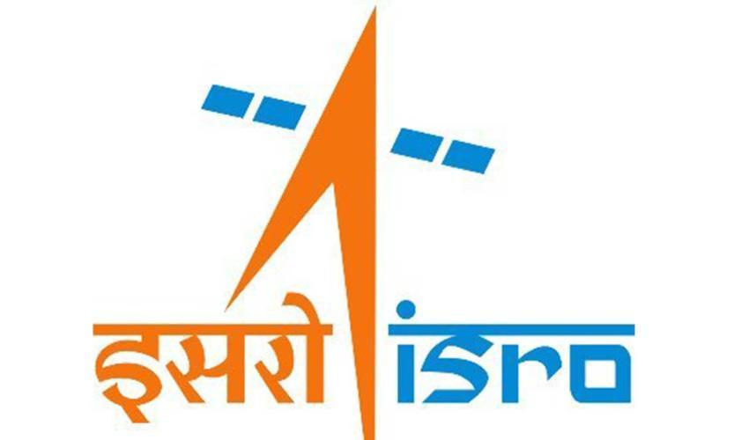
ISRO has dismissed claims of its potential privatisation, stating that there was neither any such possibility nor would its importance diminish. In a post on X on Sunday (September 6), the organisation said that with industry participation, it could focus on the next generation of India's space programme, as the industry would take on scaling mature technologies and capabilities. "We wish to categorically state that ISRO will neither be privatised nor will its importance be diminished. ISRO will continue to remain India's principal institution for advanced space research and technology development, national and strategic missions, space science and exploration, and critical and frontier space capabilities," stated ISRO. Clarification regarding media reports on concerns relating to Space Sector Reforms and the role of ISROISRO's Next Chapter: Leading India's National Space EcosystemThere has been considerable reporting in parts of the media around the future role of ISRO including speculations… - ISRO (@isro) September 6, 2026 The statement comes days after nine employee associations at ISRO wrote to the space agency's Chairperson V Narayanan on September 4, seeking official clarification on the proposed transfer of its manufacturing and operational functions to private entities. They were referring to the remarks made by Pawan Goenka, chairperson of the Indian National Space Promotion and Authorisation Centre (IN-SPACe), on August 21. Agency outlines future role ISRO made it clear that its "role will progressively strengthen in areas where its scientific expertise matters most: frontier R&D, advanced technologies, human spaceflight, next-generation launch systems, deep-space and planetary missions and strategic national capabilities." Also Read: IN-SPACe overreach threatens ISRO's strategic future: G Madhavan Nair The space agency further stated that it would continue developing cutting-edge technologies, including advanced payloads for communication, navigation and Earth observation, sensors, propulsion systems and other critical technologies. "Meanwhile, mature and routinely manufactured systems can increasingly be scaled through industry. Production of mature launch vehicles, routine satellites and other established systems can increasingly be undertaken by industry or PSUs through appropriate competitive processes," said ISRO. Industry to scale mature systems It highlighted that this would allow it to devote more resources and scientific manpower to the next generation of technologies and missions. These include: the Bharatiya Antariksh Station by 2035, undertaking an Indian crewed mission to the Moon by 2040, developing next-generation and reusable launch systems, pursuing sustained lunar and planetary exploration, and establishing India as a major global space power. Also Read: ISRO's strategic satellite delays expose cracks in India's space readiness IN-SPACe is an autonomous agency under the Department of Space that promotes, enables, authorises, and supervises various space activities of non-governmental entities. Employee groups seek clarity At a public event, Goenka had reportedly said that eventually, ISRO would not manufacture any launch vehicles, and the private sector or a PSU would do so. The employee associations claimed that these remarks had not been accompanied by any corresponding official communication from the Department of Space, explaining the approved policy, its legal and administrative basis, its phasing or its consequences for the existing workforce and future public recruitment. "Technology developed by ISRO is a national asset. Its transfer must be transparent, accountable and consistent with strategic, safety and employment considerations -- not presented to employees through newspaper reports," the letter said. Goenka defends space reforms Goenka, in a series of posts on X on Sunday, said that ISRO is by no means diminishing, and it will remain the bedrock of the Indian space sector. "The reforms since 2020 are about expanding India's overall space ecosystem. The idea is to let industry increasingly manufacture and scale mature launch vehicles, satellites and other systems," he added. Also Read: 9 ISRO employee bodies write to chairman, seek clarity on space privatisation plans ISRO will focus on advanced research and development, scientific missions, strategic missions, new technologies, and infrastructure that is too complex for the private sector to develop on its own, he said. India targets 50 launches a year The IN-SPACe chairperson also highlighted that ISRO and private companies would have to work together to ensure India reaches its target of 50 launches a year by 2030. "A goal of this scale cannot be achieved by one organisation alone," he said. (With agency inputs)

3. 'Isro's role won't diminish': Agency allays concerns over privatisation | India News - Hindustan Times
Read more
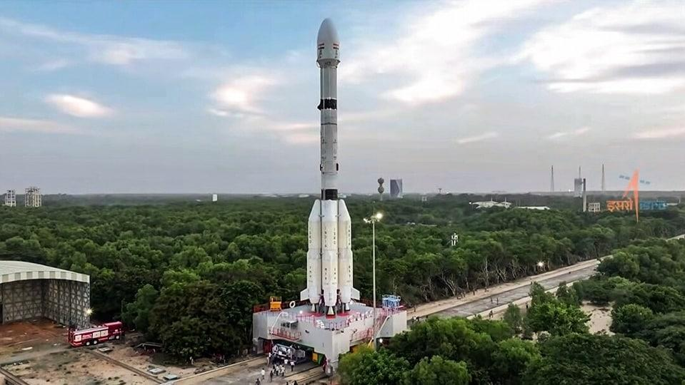
'Isro's role won't diminish': Agency allays concerns over privatisation ISRO said private-sector participation would enable the agency to focus on the next generation of India's space programme while industry matures technologies. Updated on: Sep 7, 2026, 08:57:01 IST By Snehal Fernandes Prefer HT on Google Share via - Copy link - Two days after nine associations representing thousands of Indian Space Research Organisation (Isro) employees sought clarity on the privatisation of the space sector, IN-SPACe chairman Pawan Goenka and Isro on Sunday said the space agency's role would not diminish. Isro said neither it would be privatised nor its importance diminished. (@ISRO/Representational) Goenka said there had been "some misleading narrative" in the media about Isro's future role. "Let me say it unequivocally: ISRO's role is by no means diminishing. It will remain the bedrock of Indian space sector. The reforms since 2020 are about expanding India's overall space ecosystem," he said in a post on X. The employees' associations had written to the Department of Space secretary and Isro chairman V Narayanan seeking clarity after Goenka said that "eventually, ISRO will not make any launch vehicles and will not manufacture any launch vehicles. That will all be done by the private sector or PSU." The associations sought clarity on whether Goenka's statement represented government policy, besides asking about the transfer of Isro's manufacturing and operational functions, the agency's future role and the impact on serving employees and future generations. Also Read I Thousands of ISRO employees question fate, write to chairman amid privatisation push ISRO clarifies on its privatisation stance Isro, in a separate post on X on Sunday, said neither it would be privatised nor its importance diminished. The agency said private-sector participation would enable the agency to focus on the next generation of India's space programme while industry scales mature technologies. Isro said its "role will progressively strengthen in areas where its scientific expertise matters most: frontier R&D, advanced technologies, human spaceflight, next-generation launch systems, deep-space and planetary missions and strategic national capabilities." "Meanwhile, mature and routinely manufactured systems can increasingly be scaled through industry. Production of mature launch vehicles, routine satellites and other established systems can increasingly be undertaken by industry or PSUs through appropriate competitive processes," said Isro. - ABOUT THE AUTHOR Snehal Fernandes Snehal Fernandes is senior associate editor, who joined HT in 2006. She heads the Mumbai edition's city reporting team that writes on civic and urban governance, transport and infrastructure, health, and education. She is also the National Science Editor. With a career spanning more than two decades, her expertise lies in writing on science and technology, space, environment, sustainable development, climate change, and nuclear energy. Her work consistently breaks down, and without oversimplyfying, science and research developments into an easy read for a broad audience. In 2009, she was among the very first journalist to report on the opposition to the Jaitapur nuclear power plant in Ratnagiri (Konkan) following the Indo- US civil nuclear agreement and consistently followed it with multiple stories from ground zero; wrote about the introduction and subsequent halt to the cultivation of genetically modified (BT) brinjal, and has interviewed Nobel laureates and award winning scientists. In 2012, she was awarded 'The Press Club Award for Excellence in Journalism' (Political category) for reports on the mining scam in Goa. Prior to HT, she wrote on education and transport at the Indian Express. She graduated in sociology from St Xavier's College, and firmly believes in the phrase by Karl Marx that 'Religion is the opium of the people'. - Isro - Space - Launch Vehicle Get the latest India News, breaking headlines and real-time updates from across the country. Stay informed about politics, government policies, crime, weather major national developments and Karnataka Bandh LIVE . Home / India News / 'Isro's Role Won't Diminish': Agency Allays Concerns Over Privatisation See Less

4. Why ISRO Staff Are Worried About ISRO's Future - Rediff
Read more
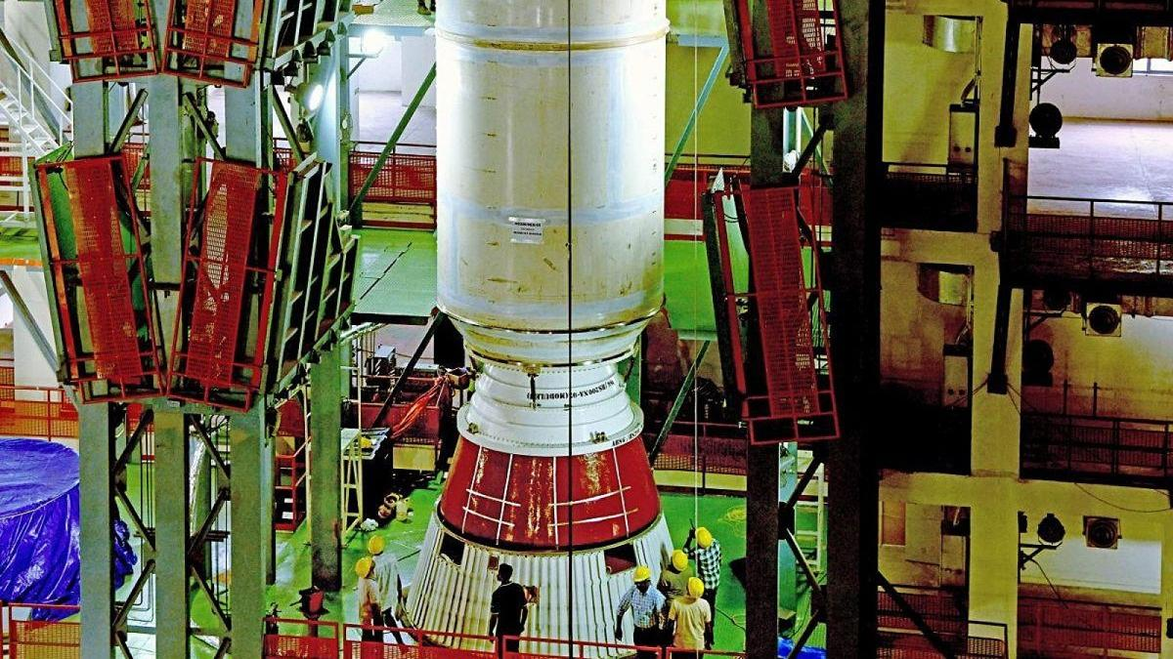
A rocket designed and developed by ISRO is being transferred to industry for production. Nine ISRO associations want to know whether this is simply an effort to expand India's industrial capacity or part of a larger policy under which ISRO itself will eventually withdraw from rocket manufacturing. Photograph: ANI Photo Nine employee associations representing the interests of thousands of employees of the Indian Space Research Organisation (ISRO) seem to have finally woken up from their slumber and questioned the role of the Indian National Space Promotion and Authorisation Centre (IN-SPACe) in transferring rocket-manufacturing technologies to the private sector, apparently to the exclusion of the public sector. They have a fundamental question for the Department of Space: Has the Government actually approved this policy? If so, the associations want to know when the decision was taken, by which authority and what the approved policy actually says. Key Points Nine ISRO employee associations have questioned IN-SPACe's role in transferring rocket-manufacturing technologies to the private sector, seeking clarity on government policy. Concerns arose after IN-SPACe Chairman Dr Pawan Kumar Goenka reportedly stated ISRO would eventually cease manufacturing launch vehicles, shifting this to the private sector or PSUs. The associations fear a gradual withdrawal of ISRO from core activities could reduce in-house work, affect manpower, and impact career progression and recruitment. They argue that ISRO-developed technology is a national asset, and its transfer must be transparent, accountable, and consider strategic capability, safety, quality, and employment. The associations demand official communication from the Department of Space explaining the policy, its legal basis, phasing, and consequences for the existing workforce. The nine associations have addressed a detailed representation to Dr V Narayanan, secretary, Department of Space, chairman of the Space Commission and chairman of ISRO, raising questions about the future role of ISRO, technology transfer, rocket manufacturing, launch infrastructure and the fate of its employees. The timing of the representation is significant. It comes several days after media reports and comments by retired ISRO chairman, including G Madhavan Nair, questioned aspects of IN-SPACe's expanding role in technology transfer and other matters. What appears to have finally shaken the nine associations is a reported statement by IN-SPACe Chairman Dr Pawan Kumar Goenka: 'Eventually, ISRO will not make any launch vehicles and will not manufacture any launch vehicles. That will all be done by the private sector or PSU.' That statement has raised a much larger question inside the organisation: If ISRO stops making rockets, what exactly will ISRO do? PSLV and LVM3 to move towards private industry IN-SPACe has invited bids from the Indian private sector to acquire the technology to manufacture two of ISRO's major rockets -- the Polar Satellite Launch Vehicle (PSLV) and LVM3, earlier called GSLV-Mk III. The move follows the technology-transfer process for ISRO's Small Satellite Launch Vehicle (SSLV), for which an agreement has already been signed with Hindustan Aeronautics Ltd, a PSU. The emerging pattern is therefore unmistakable. A rocket designed and developed by ISRO is being transferred to industry for production. But the nine associations want to know whether this is simply an effort to expand India's industrial capacity or part of a larger policy under which ISRO itself will eventually withdraw from rocket manufacturing. That distinction is crucial. GSLV-Mk II Exception There is an interesting twist. While SSLV has moved towards industry and PSLV and LVM3 are being offered for technology transfer, ISRO's GSLV-Mk II has been left out of the exercise. Instead, the rocket could be on its way to retirement. "As per plans, the GSLV-Mk II rocket will be retired after the approved launches are completed," a former top ISRO official told this correspondent, requesting anonymity. "It is not economical to operate GSLV-Mk II due to its cost and complexity. Future launches to be managed with LVM3," the retired official added. The number of approved GSLV-Mk II launches is understood to be about five at present. At the same time, ISRO is developing a new-generation heavy rocket, currently referred to as Soorya. SSLV is moving to industry. PSLV and LVM3 are being opened for technology transfer. GSLV-Mk II is likely to retire. Soorya is under development. What will ISRO continue to build itself? Is IN-SPACe stepping into NSIL's shoes? The debate is not confined to who manufactures the rockets. Retired ISRO officials are also questioning whether IN-SPACe is moving beyond its regulatory and promotional mandate and entering the commercialisation space traditionally assigned to NewSpace India Ltd (NSIL). Former ISRO chairman G Madhavan Nair has argued that NSIL was created specifically to commercialise ISRO's services, technologies and rockets, while IN-SPACe's role is essentially regulatory and facilitative, particularly for the private sector. 'While the sectoral regulator can be independent, ISRO, NSIL and industrialisation should be under one roof with the unity of direction and command being a must. NSIL can form a joint venture with the interested parties instead of transferring the technologies,' Nair said. A retired top ISRO official, who did not want to be named, put it more directly: "IN-SPACe is basically an authorisation agency as the name suggests. ISRO has the technology and NSIL is mandated to exploit it commercially." Another former ISRO official said: "IN-SPACe should focus on policies that would facilitate easy access to ISRO facilities for the private space sector players, faster frequency clearances and other aspects. Commercialisation of ISRO's assets should be done by NSIL." IN-SPACe sees its role differently IN-SPACe itself describes its mandate more broadly. According to the organisation, it is responsible to 'promote, enable authorize and supervise' various space activities of non-government enterprises, including building launch vehicles and satellites, providing space-based services, sharing space infrastructure and premises under the control of the Department of Space/ISRO, and establishing new space infrastructure and facilities. IN-SPACe is of the view that its actions are in line with the government's space sector reforms and the Indian Space Policy-2023, which opened space operations to private sector participation. IN-SPACe has been involved in the transfer of technology for ISRO's SSLV to HAL for ₹511 crore and is now inviting bids for the transfer of technologies for PSLV and LVM3. The question being raised by retired officials is therefore not whether IN-SPACe has a role in enabling private participation. It clearly does. The question is whether technology commercialisation itself should fall within that role -- or whether it should remain primarily with NSIL. More than a manufacturing exercise For the employee associations, however, the issue goes beyond the institutional turf battle between ISRO, NSIL and IN-SPACe. For them, launch vehicles are not merely products that can be manufactured under licence. The design, development, fabrication, integration, testing and launch of rockets represent decades of accumulated institutional knowledge and constitute the core competence of ISRO. A gradual withdrawal of ISRO from these activities, the associations fear, could reduce in-house work and affect manpower requirements across scientific, technical, administrative, stores, procurement, quality, safety and industrial cadres. The concern is therefore not simply about who owns a factory. It is about whether ISRO could eventually lose the capability to build and operate the very launch vehicles it has spent decades developing. And what happens to the employees? For the thousands of ISRO employees represented by the associations, the issue is also deeply personal. If activities currently performed within ISRO move outside, what happens to the people performing those activities? The associations fear that employees working in ISRO's development and production facilities could be rendered surplus, redeployed or left with reduced opportunities while private companies perform similar functions using technology developed by ISRO. Promotion and career progression could also suffer if the in-house workload shrinks. So could recruitment. If ISRO progressively withdraws from manufacturing and other operational activities, the associations fear that recruitment to Group A, B and C positions could decline further. For many young engineers, scientists and technicians, ISRO is not simply another employer. It is a public institution representing scientific excellence and national service. If the organisation stops building rockets, will it also stop hiring the people who would have built them? The bigger taxpayer question The debate goes beyond ISRO employees. India's launch vehicles were developed over decades using public money, public infrastructure and the collective effort of generations of ISRO scientists, engineers and other employees. The associations therefore argue that ISRO-developed technology is a national asset. Its transfer to private industry, they say, must be transparent and accountable and should take into consideration strategic capability, safety, quality and employment. The associations have also raised a fundamental question about what happens to the public infrastructure and knowledge accumulated over decades once private industry enters the picture. 'The institutional arrangement under which publicly created technology, test facilities, launch complexes and know-how -- built with taxpayer funds and the labour of generations of ISRO employees-are being transferred or opened to private operation, and the role of NSIL vis-a-vis IN-SPACe in such transfers,' the letter notes. That is perhaps one of the most consequential questions in the entire representation. The issue is not whether Indian industry should benefit from ISRO's technological capabilities. The issue is how much of that capability should remain within the public institution that created it -- and under whose authority public assets and know-how are being opened to private operators. Where is the government policy? This is perhaps the most pointed aspect of the representation. The associations say that statements regarding technology transfer, private manufacture, satellite production and private operation of launch infrastructure have received wide publicity. But there has been no corresponding official communication from the Department of Space to its employees explaining the policy, its legal and administrative basis, its phasing or its consequences for the existing workforce. The associations therefore want the Department of Space to spell out the policy. If the government has approved the eventual withdrawal of ISRO from rocket manufacturing, they want the date, authority and text of the decision. If it has not, they want to know whether the reported statements about ISRO's future role represent government policy or merely the vision of IN-SPACe. Don't let uncertainty become policy The nine associations have made their representation in what they describe as a 'constructive and democratic spirit'. They have also stressed that their loyalty to ISRO and India's space programme is unquestionable. Precisely because of that loyalty, they say, they consider it their duty to seek clarity before uncertainty becomes irreversible policy. India's space programme has already crossed the line from a predominantly government-driven model to one in which private industry has an increasingly important role. The question now is not whether the private sector should enter the space business. It already has. The question is whether ISRO can build a powerful private space industry without surrendering the institutional capabilities that made India a spacefaring nation in the first place. After years of relative silence, the nine associations have finally asked that question.

5. Steady gaze: On the launch of the ISRO's EOS-05 satellite - The Hindu
Read more

The successful launch of the Indian Space Research Organisation's (ISRO) EOS-05 satellite is India's first earth-imaging satellite bound for a geosynchronous orbit, meaning that it is locked-in to the earth's rotation and can be tuned to continuously observe the same location. The rocket placed it in a transfer orbit early on Friday; onboard thrusters are expected to raise it to its final perch at some 36,000 kilometres above the earth's surface over the coming weeks. From there it can track fast-changing events such as floods, cyclones and forest fires, and monitor crops, forests, water bodies and land use. Unlike a conventional camera, its sensors examine how the earth's surface reflects different wavelengths of light, helping distinguish vegetation, water and other land cover. Because it is perched farther away than conventional low-orbit imaging satellites, its strength is not ultra-fine detail but the ability to return to the same broad areas very frequently. India has long had eyes in geostationary orbit, but they have been weather satellites, namely the INSAT-3D series. Its dedicated earth-imaging satellites have operated in low, polar or sun-synchronous orbits. Flying a few hundred kilometres up, they capture much finer detail, but move constantly around the planet, imaging a different strip of territory on successive passes and taking days to return. EOS-05's timing could hardly be better. Given the devastation by the Bhote Koshi deluge in Nepal, which has claimed 1,344 lives, such satellites can play some role in understanding changes in landforms and how they may act as precursors to glacier-breaks and avalanches. Or, as winter approaches in north India, in establishing whether stubble fires over Punjab have genuinely declined or burning has simply shifted in time to slip past the polar satellites. ISRO has described the EOS-05 as a "strategic" satellite, a term that stretches from security to weather. All of this is premised on the data reaching a wide enough set of analysts who can turn the images into forecasts and actionable insight. There is cheer, too, that ISRO's first successful launch of 2026 - and another vote of confidence in the cryogenic stage that failed the agency in 2021 - comes after setbacks. But that does not soften the temperamental nature of launches. Two consecutive failures of the PSLV, the agency's workhorse since the 1990s, in May last year and again this January, both traced to the third stage, suggest that dependability is not infallibility. The usefulness of its payloads, and the cadence of its launches, should be ISRO's calling card, rather than any single launch as the hallmark of institutional credibility.

6. ISRO employees raise concerns over private-sector push - HR Katha
Read more
Nine employee associations at the Indian Space Research Organisation (ISRO) have written to Chairperson V Narayanan asking for official clarification on the government's plan to shift manufacturing and operational functions to private companies. The letter, dated 4 September, highlights worries about ISRO's future role, the impact on current staff, and implications for recruitment. The associations argue that while private participation in commercial activities can coexist with a strong public ISRO, reducing the agency to a limited research body while handing over launch vehicle production and infrastructure operations to private hands requires open debate. They point to comments made on 21 August by Pawan Goenka, chairperson of IN-SPACe, who said that eventually all launch vehicle manufacturing would be done by private firms or public-sector undertakings (PSUs). Employees note that no formal communication has followed to explain the approved policy, its legal basis, or its effect on workforce planning. The letter stresses that ISRO's technology is a national asset and its transfer must be transparent, accountable, and aligned with strategic, safety and employment considerations. Specific concerns include whether PSLV, LVM3, SSLV and future vehicles will remain ISRO functions, and how sanctioned strength, vacancies, recruitment calendars, and induction of scientific and technical staff will be affected. Meanwhile, Goenka has reportedly stated that ISRO and private industry must work together to achieve India's target of 50 launches annually by 2030. He emphasised that ISRO's research will continue to push boundaries, while private firms are expected to scale up manufacturing of rockets, satellites and new technologies.

7. SpaceX Falcon 9 rocket launches 27 Starlink satellites, lands on ship at sea (video)
Read more
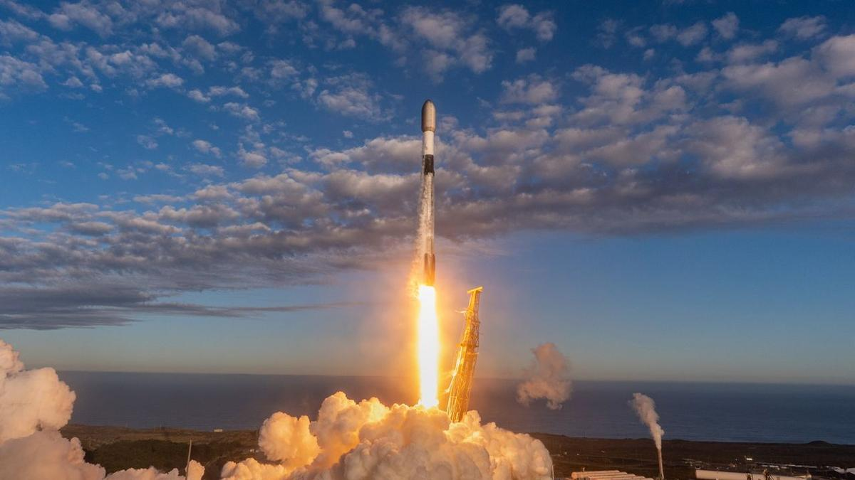
Click for next article SpaceX launched 27 more of its Starlink internet satellites to orbit today (Sept. 6). The spacecraft rode to low Earth orbit (LEO) atop a Falcon 9 rocket, which lifted off from California's Vandenberg Space Force Base at 10:26 a.m. EDT (1426 GMT; 7:26 a.m. local California time). The Falcon 9 rose into blue morning skies - something of a rarity for California's central coast, which is often cloaked in fog. The Falcon 9's first stage came back to Earth as planned 8.5 minutes later, landing in the Pacific Ocean on the SpaceX drone ship "Of Course I Still Love You." A SpaceX Falcon 9 rocket launches 27 Starlink satellites into orbit from Vandenberg Space Force Base in California on Sept. 6, 2026. (Image credit: SpaceX) It was the 19th flight for this particular booster, which is designated B1088. This marks about the halfway point to the SpaceX record of 37 flights, which was set by B1067 during a Starlink launch on Aug. 25. The Falcon 9's upper stage, meanwhile, carried the 27 Starlink satellites to LEO, deploying them on schedule 62 minutes after launch. SpaceX's sooty Falcon 9 rocket first stage on the drone ship Of Course I Still Love You in the Pacific Ocean after a successful launch and landing on Sept. 6, 2026. (Image credit: SpaceX) Previous Booster 1088 launches NROL-126 | Transporter-12 | SPHEREx | NROL-57 | 13 Starlink missions Today's launch was the 103rd Falcon 9 mission of 2026. Eighty of those flights have been dedicated to building out the Starlink megaconstellation, by far the largest satellite network ever assembled. It currently consists of more than 11,000 active spacecraft, according to astronomer and satellite tracker Jonathan McDowell. Starlink missions fly exclusively out of Vandenberg these days. SpaceX used to launch them from Florida as well, but the company recently put those missions on hold until it gets its Starship megarocket up and running on the Space Coast.

8. Feel the Force with these 10 out-of-this-world Lego Star Wars starships
Read more

Click for next article As impressive as this Lego Star Wars Venator set is, there are plenty of smaller sets worth owning. Star Wars' starships are almost as memorable the saga's character and thanks to Lego's Star Wars range, you can build your own replicas of these iconic craft. We've rounded up the very best, from a palm-sized version of Darth Vader's Tie Fighter to a massive, table-hogging Star Wars Clone Wars-era Venator Star Destroyer. While several of these sets are display pieces, we've included some play-friendly models, such as this mid-sized Lego Star Wars Millennium Falcon that can be swooshed around your living room and this Lego Star Wars Imperial Star Destroyer which, with seven mini-figures and removable roof, will delight younger Star Wars fans. Read on and build the largest fleet the galaxy has ever known.

9. NASA expands Deep Space Network with giant new dish in California desert
Read more
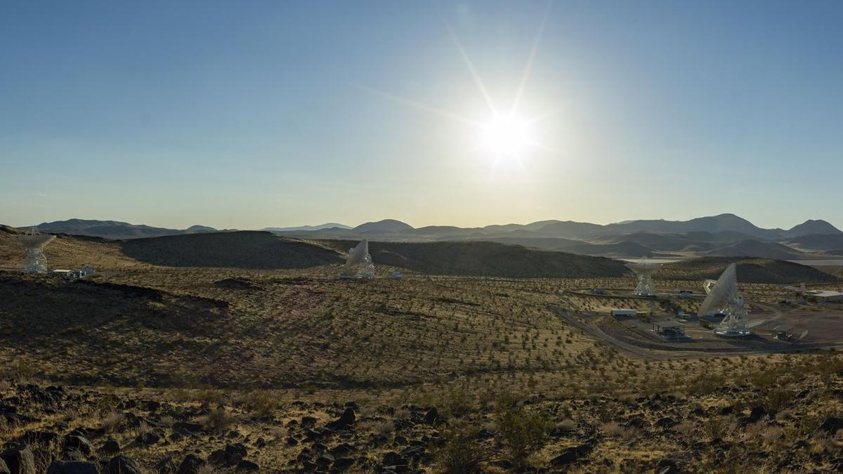
Click for next article Antennas at the Deep Space Network's Goldstone complex near Barstow, California. The recently completed Deep Space Station 23 is in the foreground to the right. NASA's long-distance spacecraft-calling network just got a boost. The Deep Space Network (DSN), best known for communicating with distant spacecraft such as Voyager 1, Voyager 2 and New Horizons , added a 114-foot (34-meter) radio-frequency antenna in California, boosting capacity on the increasingly crowded network. More than 40 spacecraft exploring the solar system and interstellar space use DSN, which has struggled to keep pace with growing demand. Communications with the uncrewed Artemis 1 mission in 2022 and the crewed Artemis 2 mission in 2026 took priority as they traveled around the moon , substantially reducing the network's capacity to support other missions. At least as early as 2021, managers were warning that despite ongoing efforts to add new antennas to DSN, the agency cannot reach all deep-space missions at once. "We're trying to add capacity and more antennas, but we can't keep up with the demand that's currently out there, so missions should expect to be getting less availability," Brad Arnold, DSN manager at NASA's Jet Propulsion Laboratory (JPL), said during a presentation attended by Space News . Arnold also warned that the Artemis moon program would be "the gorilla in the room," because the astronauts by default have to be prioritized over robotic spacecraft: "That ultimately will affect our ability to service the rest of the missions." That's because the DSN is designed to serve both human and robotic deep-space spacecraft. While JPL (then under contract to the U.S. Army) had three spacecraft radio-tracking stations in Nigeria, Singapore, and California ready for the early space program in 1958, the DSN with more powerful dishes was established in December 1963 as "the de facto network for missions into deep space," state JPL materials from the 50th anniversary celebration in 2013. The recently completed Deep Space Station 23 at the Deep Space Network's Goldstone complex near Barstow, California. (Image credit: NASA/JPL-Caltech) The DSN helped relay communications from Apollo 11's historic moonwalk by NASA astronaut Neil Armstrong's on July 20, 1969, and has since supported countless milestones. This includes images from Mars rovers starting in the 1990s and data showing that both Voyager 1 and Voyager 2 crossed into interstellar space in the 2010s. These days, Artemis isn't the only extra demand on DSN; other space agencies also use the network for their own spacecraft, to a much greater degree than 50 years ago as space exploration has matured. NASA is also planning a permanent Moon Base near the lunar south pole as soon as the 2030s, although the agency does promise the base will, in its third phase, include "a coordinated lunar network supporting communications across Moon Base assets." The DSN operates three complexes - at Goldstone in California, near Madrid in Spain and Canberra in Australia - each of which includes a large 230-ft (70m) antenna alongside several smaller dishes. The new antenna is about half that size and is co-located at Goldstone. It came online on Aug. 3, tracking NASA's Chandra X-ray Observatory. DSS-23 is the fifth of six new 34-meter antennas planned under the DSN's Aperture Enhancement Project, which began in 2009. The project is expected to be completed when the sixth antenna, DSS-33, comes online at the Canberra complex in 2029.

10. Germany's Isar Aerospace launches rocket into orbit from Norway
Read more

Germany's Isar Aerospace launched a rocket into orbit from Norway on Saturday as Europe races to boost its ability to economically send satellites into space independently of the United States.

11. China's chip giant AMEC launches 6 new machines to boost semiconductor production
Read more
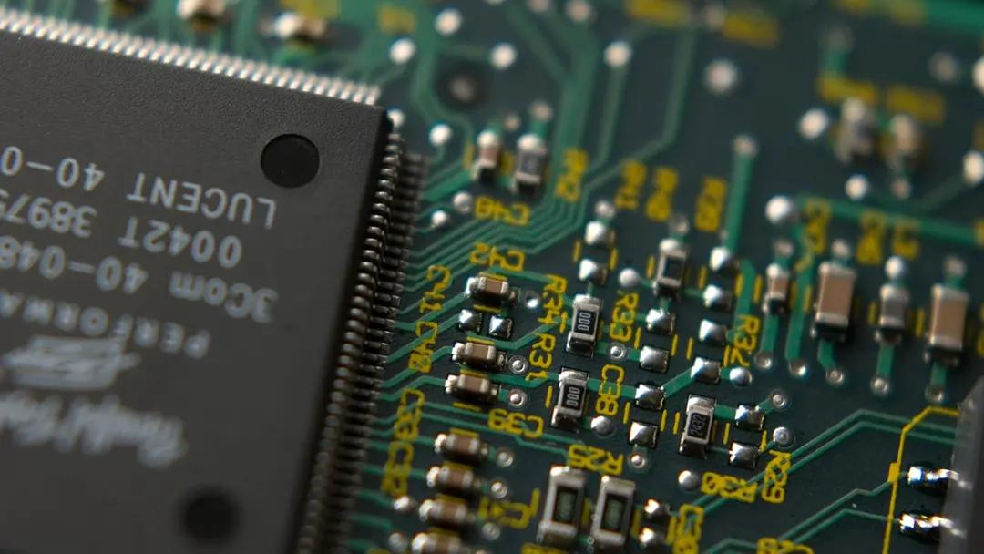
Chinese semiconductor equipment manufacturer Advanced Micro-Fabrication Equipment (AMEC) has unveiled six new chip-making machines as it expands beyond its traditional core in etching and pushes deeper into China's semiconductor manufacturing supply chain. The new equipment was announced at an industry conference in Wuxi, China, on September 2 and covers several key stages of semiconductor production. These include etching machines, deposition systems and equipment designed for the manufacture of silicon-carbide power chips. Four of the six newly announced products are deposition tools, highlighting AMEC's effort to broaden its portfolio beyond the etching equipment for which it is best known. In case you are unaware, etching and deposition are two fundamental processes used repeatedly during semiconductor manufacturing. Deposition systems add extremely thin layers of material onto a silicon wafer. These layers can be conductors, insulators, or semiconductor materials and may be only a few nanometers thick. Etching equipment essentially performs the reverse operation. AMEC unveils new toys It selectively removes material from the wafer, allowing microscopic patterns produced during earlier manufacturing stages to be transferred into the layers beneath. Modern chips can require hundreds of individual processing steps involving repeated cycles of deposition, patterning and etching before their transistors and electrical connections are complete. AMEC has built much of its semiconductor equipment business around etching, making its expansion into deposition particularly significant. The six-machine launch reflects the company's wider attempt to develop into a more comprehensive supplier of semiconductor manufacturing equipment rather than remaining focused on a single part of the fabrication process. The company also unveiled equipment associated with silicon-carbide semiconductor production. Silicon carbide (SiC for short) is a semiconductor material increasingly used in power electronics because it can operate at higher voltages and temperatures while suffering lower energy losses than conventional silicon devices in many applications. That makes SiC devices particularly attractive for electric vehicles, charging infrastructure, industrial power systems, and other applications where electrical efficiency and heat management are important. The six new machines are currently at different stages of commercialization, meaning not all of the equipment has necessarily entered large-scale use in semiconductor factories. Reducing dependence on imports Moving from the development of semiconductor equipment to widespread commercial deployment can require extensive testing and customer qualification. Chip manufacturers need equipment to deliver extremely high levels of precision, repeatability and reliability while operating continuously in production environments. AMEC's expansion comes as China continues efforts to increase the proportion of domestically produced equipment used by its semiconductor industry. Chinese chip manufacturers remain dependent on overseas suppliers for several important categories of fabrication equipment, while export restrictions imposed by the United States and its allies have limited Chinese access to some of the most advanced technologies.

12. China puts missile-armed jets to operate over contested area, move could intimidate Philippines
Read more

China has deployed armed JL-10 trainer jets to intercept and drive away Philippine aircraft over Scarborough Shoal, a coral atoll in the disputed South China Sea. The latest deployment of the jets highlights China's potentially cheaper approach to the increasingly frequent air confrontations in the contested region. According to footage released by the PLA's Southern Theatre Command, at least three Chinese JL-10s carrying PL-5 short-range air-to-air missiles were involved in the operation. The video showed the jets tracking three Philippine aircraft, including a BN-2A Islander, C-208, and PA-31T, while a Chinese pilot was heard warning the aircraft to leave the area or face unspecified action. The deployment is notable because Beijing has previously relied on more expensive combat aircraft for similar missions. JL-10 offers a cheaper option The JL-10, also known as the L-15 in its export configuration, is a twin-engine lead-in fighter trainer designed for advanced pilot training and light combat missions. Its relatively low minimum controllable speed makes it better suited than high-performance fighters to operating around slow-moving aircraft. The Philippine aircraft involved in the incident fly at substantially lower speeds than modern fighter jets. The slowest can reportedly operate at around 162 mph, creating a difficult interception problem for high-speed combat aircraft that must slow down considerably while maintaining control and situational awareness, the South China Morning Post reported. The JL-10 can reportedly operate at speeds as low as roughly 130 to 162 mph while retaining the ability to carry air-to-air missiles and guided weapons. That makes it a practical platform for missions that require persistent monitoring and interception rather than the full capabilities of a heavyweight fighter. Cost is another factor, as the JL-10 is estimated to cost roughly $10 million to $15 million on the international market, while a J-16 fighter can approach an estimated $100 million. Pairing the trainer with older but capable PL-5 infrared-guided missiles therefore gives China a considerably less expensive option for confronting relatively lightly equipped aircraft. Different approach to South China Sea patrols The operation marks the first time China has publicly shown armed JL-10s taking the lead in an encounter around Scarborough Shoal. The PLA has previously used more sophisticated platforms, including J-16 fighters, for similar missions.
13. ISRO staff bodies seek clarification on trajectory of privatisation
Read more
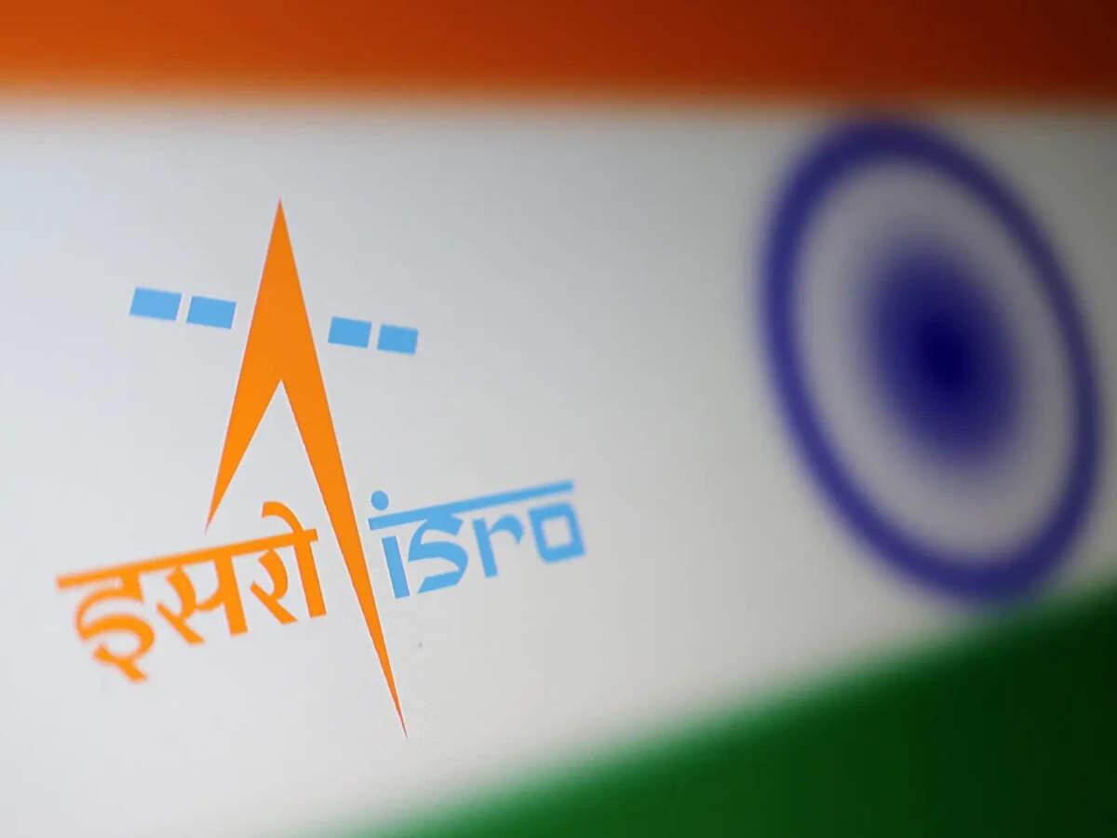
- Governance - 2 min read In a letter, dated September 4, the associations also raised questions about the agency's future role, and the consequences for serving employees and future recruitment. - PTI - Published On Sep 7, 2026 at 12:11 PM IST Select ETGovernment as Preferred Choice on Google Copy Link Share on WhatsApp Share on Linkedin Share on X Share on Telegram Share on Facebook ISRO will not be privatised, role to strengthen as India expands its space ecosystem New Delhi, Nine employee associations at the Indian Space Research Organisation (ISRO) have written to the space agency's Chairperson V Narayanan, seeking official clarification on the proposed transfer of its manufacturing and operational functions to private entities. "Private participation in defined commercial activities can coexist with a strong, publicly owned ISRO. What cannot be accepted without debate is a policy that reduces ISRO to a residual R&D (research and development) boutique while the realisation of the nation's launch vehicles and the operation of its launch infrastructure pass out of public hands," the letter said. Advt It pointed to the August 21 comments made by Pawan Goenka, chairperson of the Indian National Space Promotion and Authorisation Centre (IN-SPACe), which promotes, enables, authorises and supervises various space activities of non-governmental entities. Goenka, at a public event, reportedly said, "Eventually, ISRO will not make any launch vehicles and will not manufacture any launch vehicles. That will all be done by the private sector or PSU." The employee associations claimed that these remarks have not been accompanied by any corresponding official communication from the Department of Space, explaining the approved policy, its legal and administrative basis, its phasing or its consequences for the existing workforce and future public recruitment. "Technology developed by ISRO is a national asset. Its transfer must be transparent, accountable and consistent with strategic, safety and employment considerations -- not presented to employees through newspaper reports," the letter said. It raised several other concerns. These include whether the design, development, realisation, integration, testing and launch of PSLV, LVM3, SSLV and successor vehicles will continue as ISRO functions or will cease. Also, it asked about the implications of the proposed shift for sanctioned strength, existing vacancies, recruitment calendar and induction of scientific/technical/administrative/industrial manpower in all ISRO centres. In a post on X on Sunday, Goenka wrote that ISRO and private companies would have to work together to ensure India reaches its target of 50 launches a year by 2030. "A goal of this scale cannot be achieved by one organisation alone," he said. The IN-SPACe chairperson also highlighted that ISRO's research would continue to push the frontiers of what is possible. He added, "Private industry must translate that momentum into manufacturing at scale: more rockets, more satellites, more launch capacity and new technologies." - See more on: - Indian Space Research Organisation , - ISRO privatization , - launch vehicle manufacturing , - employee concerns ISRO , - employee associations ISRO Telegram Facebook Comments What are your thoughts? Comment Now --> Comment Now Read Comment (1) All Comments By commenting, you agree to the Prohibited Content Policy Post Find this Comment Offensive? Choose your reason below and click on the submit button. This will alert our moderators to take actions REASONS FOR REPORTING Foul Language Defamatory Inciting hatred against a certain community Out of Context / Spam Others Report Join the community of 2M+ industry professionals. Subscribe to Newsletter to get latest insights & analysis in your inbox. --> All about ETGovernment industry right on your smartphone! - Download the ETGovernment App and get the Realtime updates and Save your favourite articles. Scan to download App --> - Home - News - ISRO staff bodies seek clarification on trajectory of privatisation

14. The logic behind ISRO and DRDO's tech transfers - LinkedIn
Read more

Our goal with The Daily Brief is to simplify the biggest stories in the Indian markets and help you understand what they mean. We won't just tell you what happened; we'll tell you why and how too. We do this show in both formats: video and audio. This piece curates the stories that we talk about. You can listen to the podcast on Spotify, Apple Podcasts, or wherever you get your podcasts and watch the videos on YouTube. You can also watch The Daily Brief in Hindi. In today's edition of The Daily Brief: 1. The logic behind ISRO and DRDO's tech transfers Why are ISRO and DRDO handing perfected technologies to private firms? Public labs excel at R&D, not factory mass production. To scale up India's space and defense manufacturing, mature systems like rockets and missiles are being transferred to private partners. This frees scientists for next-gen breakthroughs while building a commercially viable domestic industry. 2. India's surveillance takes a turn Why have Chinese CCTV cameras vanished from India's market? Strict cybersecurity rules now ban camera brains (SoCs) and firmware sourced from land-bordering nations over national security and spying risks. The mandate has cleared out foreign supply chains, creating huge opportunities for domestic chip designers and camera makers. The logic behind ISRO and DRDO's tech transfers Imagine spending a decade solving a problem nobody else in the country has managed to solve, like a brand new missile or rocket. Once it's proven, the plan is to commercialise it, for which you might need to partner with the private sector. That is more or less what's happening inside DRDO right now. The defence ministry has cleared the transfer of technology for all conventional missile systems to Indian companies, so they can manufacture missiles at scale rather than DRDO doing it alone. ISRO has also been walking the same road for a while now. The Indian Space Policy 2023 explicitly tells ISRO to step back from manufacturing space systems it has already mastered and instead hand them over to industry to build and sell. Take, for example, the SSLV, ISRO's compact rocket for small satellites. ISRO designed it, tested it, and got it flying. Then it ran a competition, and Hindustan Aeronautics Limited won the rights to manufacture and sell it commercially. y is proven? Why would any organisation do that on purpose? The nature of public R&D There are multiple reasons, and they all stem from the nature of what a research organisation like DRDO or ISRO is meant to do. Every new technology starts as an idea. Scientists test individual parts, then prototypes, then full systems, and the conditions get closer to reality with every round. Things break, designs get tweaked, and the cycle repeats until the organisation is confident the technology works and reaches maturity. Early on, the question is simply "can we make this work at all". Once something reaches maturity, the question becomes "how do we make thousands of these reliably and cheaply?" India has a legal policy framework to assess this progress, collectively called Technology Readiness Levels (TRLs). A scientist's job is to discover the unknown. That means there are endless outcomes, each of which has an unknown probability of being achieved. That is a lot of uncertainty, and one way to reduce it is to use public money to fund R&D efforts that don't have immediate profit motives attached. But once that uncertainty disappears, the harder problems become sourcing components, maintaining quality across a production run, and reducing unit cost. That may or may not be within the job description of a pure scientist or research lab. And that is the primary reason behind ISRO's tech transfers. You see, to achieve scale and speed in mass-manufacturing together, you may have to partner with other actors, including in the private sector. The government's own ambition puts India's space economy at ~$8.4 billion today, on track for $40-45 billion by 2030. That's a scale ISRO alone was never going to build out on its own payroll. Similarly, a brilliant missile design means very little in an actual conflict if the country can't produce enough of them fast enough. But that's not the only reason for why ISRO or may be asked to transfer technology. Talent is another. Once ISRO knows how to build a working rocket, the country's best propulsion scientists may not want to spend their careers supervising a production line when they could be working on the next big breakthrough technology. A third reason is the need to build an industry that survives beyond government orders. The bigger bet is that Indian companies eventually sell rockets, satellites and imagery commercially, in India and abroad. Defence exports stay far more tightly controlled given the security stakes, but approved Indian systems can still reach foreign militaries under government clearance, and India's defence exports reached a record ₹38,424 crore in FY2025-26, up nearly 63% year-on-year. Anyway, inheriting a mature technology doesn't hand a company a business. It can walk away with world-class know-how and still fail if nobody's buying their product. Capital-heavy industries like space and defence need steady, predictable demand to justify investments in factories, machinery and a trained workforce. That demand isn't guaranteed just because the technology works. The real measure of this experiment, then, was never going to be how many technologies DRDO or ISRO manage to sign away. It's whether the companies receiving them actually manufacture at scale, win repeat orders, improve the product, and discover new customers. From 2D to 3D Now, what happens when DRDO or ISRO transfers a technology? Depending on the technology, a company can receive step-by-step production instructions, design specifications, material requirements, testing procedures and quality checklists. DRDO bundles all of this into what it calls a Transfer of Technology document. Crucially, its own scientists stay on to guide the manufacturer through the first production runs, rather than handing the file over and walking away. The space sector runs its own version of this process, split across three separate organisations. One, ISRO develops the technology. Two, IN-SPACe regulates and enables private companies to access it. Lastly, NSIL handles the commercial side, including signing the actual transfer agreements. A company applies through this chain, gets assessed, works out fees and terms, and then ISRO's own people support the transition of technical knowledge on the ground. Interestingly, in many of these deals, the company isn't buying the underlying intellectual property outright. The government typically keeps the underlying IP, retains rights over sensitive uses, and controls where the product can be exported. What a company actually receives is the know-how (and right) to manufacture and sell it, but on terms the government still writes. The prize That naturally leads to the next question. If not every company gets these rights, who does, and why? The answers differ slightly for space and defence. Space In space, the SSLV rocket is a good example of how the selection process works. You might think that HAL got the rights to build it simply because it is government-owned, but that wasn't actually the case. IN-SPACe actually held an open competition where bidders had to show they had the money and technical experience to build the rocket. HAL competed against two other groups and won. The other bids show how startups can still participate. Alpha Design, an established aerospace company, teamed up with Agnikul, while government-owned Bharat Dynamics partnered with Skyroot. In both cases, a larger company brought the money and manufacturing capacity, while the startup brought its specialised rocket expertise. A startup doesn't need to build an entire rocket to have a role here. Some make propulsion systems, some build satellites or sensors, while others use satellite images to help farmers or insurers. Many smaller companies simply specialise in one job. As we covered in two past stories, this large supplier ecosystem was only enabled with the government opening up space to the private sector. The creation of IN-SPACe and NSIL was specifically intended to govern private sector space activity. India had just one registered space startup in 2014. By August 2026, that number had grown to around 440. However, only a smaller number of them have IN-SPACe approval to build specific space systems. We recommend going through those stories for a brief history of the private sector's role in India's space age. Defence Defence is a little different. India already had companies that could make many of the mechanical and electronic parts used in defence systems, so they weren't always starting from scratch. The sector also had a decades-long head start, with government-owned defence companies and ordnance factories already working with large networks of suppliers. By December 2025, the government said around 2,000 companies were capable of manufacturing DRDO-developed systems. Some can even get involved before a technology is ready. Under DRDO's Development-cum-Production Partner programme, a company can help develop a technology and later become one of its manufacturers once it is ready. So this isn't really a story of startups competing with companies like Tata. The government is trying to bring both into the same supply chain. Large companies bring money, factories and experience, while smaller ones can focus on solving very specific problems. What could still derail this None of these tech transfers are a done deal, though. There are things that could still break agreements. Former ISRO chairman G. Madhavan Nair has questioned whether companies are ready to take over critical work such as the final assembly, testing and launch of rockets like the PSLV. His concern is that ISRO has spent decades building this expertise, and handing it over isn't as simple as transferring a design. There is another problem. The companies that can take on an entire rocket programme are already a small group. In the SSLV transfer, for instance, bidders needed at least seven years in business and annual turnover of ₹400 crore or more just to qualify. Those requirements make sense for something as complicated as a rocket, but they also risk concentrating production among a handful of large companies. When it comes to defence, a licence to manufacture a missile isn't the same as an order to build one. In fact, defence projects are very prone to delays. A 2022 CAG audit found that 119 of the 178 projects it reviewed missed their original deadlines, some by more than five times. The reasons included faults unearthed during manufacturing, poor monitoring, and slow approvals. Delays that long create another problem. A technology can become outdated by the time it finishes testing and reaches the forces. And handing manufacturing to private companies doesn't fix that on its own. A company could set up a production line for a DRDO missile, only to have it sit idle for years if the military's order gets delayed. What's more, a defence manufacturer can't easily use exports as a fallback. Exports need government clearance, and the Armed Forces are the only buyer within India. A licensed factory's fate depends almost entirely on New Delhi's own procurement calendar staying on schedule, and DRDO has little reason to assume that will be true. Conclusion None of this is about either organisation shrinking in their aims, either. ISRO, for instance, already has a long list of what it wants to work on next. That includes human spaceflight, a space station by 2035, a crewed Moon mission by 2040, reusable rockets and so on. Transferring an existing technology doesn't mean ISRO stops working on it. DRDO is trying to do something similar. Its scientists are increasingly focused on newer areas such as hypersonic weapons, directed-energy weapons, quantum technology and artificial intelligence. Even this new research is no longer happening entirely inside government labs. Startups, universities and established companies are being brought in much earlier, sometimes from the design stage itself, instead of waiting for DRDO or ISRO to finish a technology and hand it over later. India spent decades building institutions that could invent indigenous technologies. But as with any public research lab, the effectiveness of these institutions is decided by how quickly and efficiently they get monetised. Space and defence are among the most critical industries, and in no way is the job here going to be easy. But this is a start. India's surveillance takes a turn In 2024, the Indian government introduced new security requirements for the CCTV cameras it purchased. Cameras procured by central government departments and other entities covered by the public-procurement order had to meet a set of Essential Requirements for Security. The government later added these requirements to the certification regime covering all CCTV cameras. This extended the rules beyond government procurement to cameras sold across India. The wider requirement took effect in April 2025. Companies were given a temporary window to clear old inventory and get new CCTV models certified. That window closed on 1 April 2026. From then on, CCTV cameras that did not meet the security requirements could not be sold in India. The rule has reshaped India's ~$2 billion network-camera market. Chinese brands and components once made up a large part of India's CCTV supply chain. As the new rules took effect, many struggled to qualify, leaving Indian camera makers and chip designers to fill the gap. What exactly is the government testing? To understand what changed, we need to look at the government's Essential Requirements for Security. The basic idea is simple: CCTV cameras can no longer be treated like ordinary electronic goods. Their hardware, software and supply chains must be tested before they can be certified for sale. The Bureau of Indian Standards already administers the registration system for CCTV cameras. Under the new framework, the Standardisation Testing and Quality Certification Directorate, or STQC, is responsible for the security testing also now. Before these rules, CCTV cameras already needed BIS safety certification, but they did not have to undergo a mandatory cybersecurity assessment. Now, every model or eligible product series must clear a set of prescribed security checks. The STQC guidance focuses on a few critical parts of a CCTV camera. These include the system-on-chip, or SoC, firmware, circuit-board assembly, network card and physical ports such as USB. However, these components are not all tested in the same way. Labs check the origin of the SoC and firmware, inspect the circuit-board assembly, and test the network card and physical ports for security vulnerabilities. Most importantly, the SoC and firmware cannot be sourced from a country that shares a land border with India. This means the logo on the camera tells us little about whether it will qualify. A camera made in India can still fail if its technology or supply chain does not comply. The same applies to an American or European model. The published rule also does not automatically disqualify a model simply because its brand is Chinese. On paper, the restriction concerns the source of its SoC and firmware. But why focus on these two components? A modern CCTV camera is essentially a small computer. The lens captures light, the image sensor converts it into an electronic image, and the network connects the camera to other systems. At the centre of it all is the SoC-the camera's brain. The SoC processes and compresses footage, runs features such as motion or face detection, manages storage, and helps handle encryption and network communication. It accounts for roughly 25-35% of a camera's bill of materials. But its strategic importance is far greater than its share of the cost suggests. If the SoC or firmware is compromised, with or without malicious intent, the entire camera could behave differently from what its owner expects. That is why it matters where the SoC came from-and who designed, manufactured and supplied it. Under the new rules, manufacturers must provide invoices, technical documents and other records that allow the component to be traced through the supply chain. But establishing a chip's origin is not straightforward. A chip may be designed by a Chinese company, fabricated by TSMC in Taiwan, packaged in Malaysia and finally imported by an Indian camera maker. So what determines its origin: the designer, the foundry, the seller-or all three? The rules do not offer a neat answer for every mixed supply chain. Instead, they leave STQC to examine the evidence and determine whether a component complies with the requirements. That is probably why Chinese CCTV models have largely disappeared from the Indian market. STQC is interpreting the rules and checking whether a camera's SoC or firmware can be traced back to China. Which brings us to the larger question: why does the government care so much about who controls the chip and code inside a camera in the first place? Why does the government care so much? A network camera does more than record video. It can connect to the internet, receive software updates and communicate with other systems. If compromised, an attacker could access its footage, redirect data or use it as a way into a larger network. The stakes depend on where the camera is installed. Footage from a home is sensitive. Footage from a military base, RBI office or nuclear facility can become a national-security risk. In such places, the government cannot afford to be unsure about who controls the camera or where its data travels. But does this mean Chinese cameras are spying on India? There are two separate concerns. The first is product security. In 2021, the Australian Cyber Security Centre warned about a flaw in certain Hikvision cameras that could let an attacker take control of the device and target other systems on the same network. This proves that the cameras had a serious vulnerability. It does not prove that Beijing planted or exploited it. The second concern is strategic. China's National Intelligence Law requires organisations to support and cooperate with state intelligence work. A foreign-designed SoC raises questions about what is embedded in the device and how thoroughly it can be inspected. Control over the firmware, remote updates or cloud services creates a more direct concern because the supplier may retain an ongoing route into the system. The policy is therefore partly evidence-based and partly precautionary. Governments do not want to discover the risk only after sensitive systems have been compromised. For Indian camera makers, this creates an opportunity. Companies can replace Chinese components with compliant alternatives from elsewhere, while Indian chip designers such as Mindgrove, Netrasemi and IndieSemiC build their own SoCs. Cameras may become more expensive because Chinese suppliers were cheaper. And an approved camera will not necessarily be entirely Indian. It may still use a foreign lens, image sensor or foundry. The goal is not complete self-sufficiency. It is to reduce the riskiest dependencies. India is not alone. The US, UK and Australia have also restricted Chinese surveillance equipment in sensitive settings, each in its own way. And this concern extends beyond cameras. It applies to drones, routers, cloud infrastructure and chips too: what happens when a critical part of your technology is controlled by someone you cannot fully inspect or trust? That is the question behind India's new CCTV rules. - This edition of the newsletter was written by Vignesh & Kashish. Subtext by Zerodha We sat down with Mudit, co-founder of Voltseal, to talk about the duck curve, the many problems batteries can solve, and what happens when the grid finally gets intelligent. With over two decades in the industry, he helped us connect what we had learned through research with how the power system actually works. Watch the full episode on YouTube. Tidbits 1. Govt mandates manual verification of imported drugs and medical devices Customs officers must now manually verify licences, permissions and registrations before clearing imported drugs, medical devices, cosmetics and related inputs. The temporary step has been introduced because CDSCO documents are not yet fully integrated into the SWIFT 2.0 system. 2. Russia pushes back against pressure over oil sales to India Russia's ambassador to India has criticised Western pressure to curb purchases of Russian crude, saying Moscow is ready to supply as much oil as India needs. His comments come as a US sanctions bill proposes steep tariffs on major buyers of Russian energy, including India. 3. Govt considers allowing FDI in more plantation crops The government is considering expanding foreign direct investment rules to cover more commercial plantation crops. The move is part of a broader push to attract investment into agriculture as India targets $100 billion in agricultural exports by 2030, up from about $53 billion currently. Source: Financial Express 4. AIFs push to retain existing foreign-control rules India's alternative investment funds are urging the government and regulators to retain the current definition of "foreign control" as FEMA rules are reviewed. The industry argues that tighter rules could reduce foreign capital flows into funds that are managed domestically. Source: The Economic Times 5. India proposes mandatory battery storage for new government solar and wind projects India has proposed requiring new government solar and onshore wind projects commissioned from July 2027 to include battery storage equal to at least 10% of generation capacity. The draft is aimed at making renewable power more reliable and reducing the need to curtail excess generation. Source: Reuters Check out Weekly Tidbits: Beyond Today's Brief There's always more happening at Markets by Zerodha. The Chatter: How is SEBI targeting network-level market risks, and why is Maruti Suzuki betting on biogas alongside EVs? Plus, key updates from United Breweries, Indian Bank, Zen Technologies, and Lumino. Aftermarket Report: Why did rate hike fears and rising oil prices drag Nifty down to close below 23,800? How are SEBI's new FPI compliance relaxations and India's ₹1.1 lakh crore defence clearance shaping sentiment? Plus, key updates on Maruti's price hikes, JLR job cuts, and surging Brent crude. Points & Figures: How did India's mutual fund industry surge to ₹74 lakh crore as SIPs became a monthly habit for millions? What is driving the rise of passive investing, and how far has the boom spread beyond top cities? Join us on WhatsApp, where we share interesting soundbites from concalls, articles, and everything else we come across throughout the day. You'll also get notified the moment a new video or article drops so that you can read or watch it right away. This post was first published on Substack. Thank you for reading. Do share this with your friends and make them as smart as you are 😉

15. ISRO won't be 'diminished', says IN-SPACe chairman - The Hindu
Read more
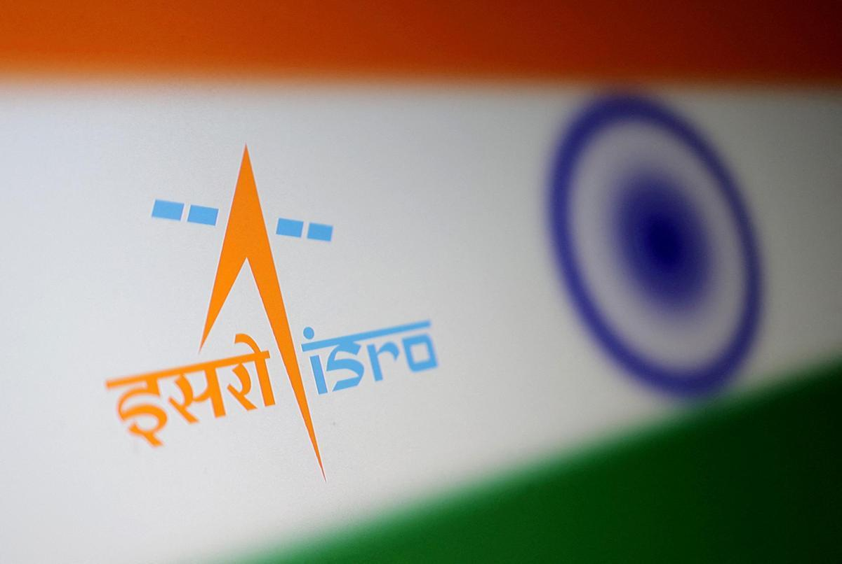
The role of the Indian Space Research Organisation (ISRO) was "by no means diminishing", said IN-SPACe chairman Pawan Kumar Goenka on Sunday (September 6, 2026), responding to a joint letter from nine ISRO employee associations seeking written clarification on whether the government intends to transfer the agency's launch-vehicle and satellite manufacturing to private firms. "ISRO will remain the bedrock of the Indian space sector," Dr. Goenka said in a post on X, describing recent reporting as a "misleading narrative." The reforms begun in 2020, he said, were aimed at expanding India's overall space ecosystem, with IN-SPACe authorising non-government participation and NewSpace India Limited (NSIL) commercialising mature capabilities. Industry would increasingly manufacture and scale mature launch vehicles and satellites, he added, while ISRO would concentrate on advanced R&D, scientific and strategic missions, and infrastructure too complex for private developers - including the Bharatiya Antariksh Station by 2035 and an Indian crewed lunar mission by 2040. "The direction is not a smaller ISRO," he wrote. His post was followed by a longer clarification from ISRO, calling suggestions of privatisation "completely baseless and incorrect" and stating that the agency would neither be privatised nor have its importance reduced. Transferring a mature technology, it said, did not amount to withdrawal from that domain; the shift was towards an "ISRO-led national space ecosystem", institutionalised through the Indian Space Policy 2023. The agency said India now has over 450 space startups against a handful in 2020, and aims to grow its roughly $8.4-billion space economy to $44 billion by 2033. Ownership of critical national space infrastructure, it said, would remain with the government. The letter that prompted the responses was dated September 4 and addressed to Dr. V. Narayanan, Secretary, Department of Space and Chairman, ISRO. Its signatories cited Dr. Goenka's public remarks on August 21 that ISRO would eventually not make or manufacture any launch vehicles. They asked whether that position represented an approved Space Commission decision, what would happen to sanctioned strength and recruitment over the next five to ten years, and whether the associations would be consulted before irreversible decisions. Employees of the Department of Space are exempted from the statutory definition of "industry" and cannot form trade unions. They instead organise as service associations recognised under the Central Civil Services (Recognition of Service Associations) Rules, 1993. The letter was copied to the Confederation of Central Government Employees and Workers. The letter was sent on the same day ISRO successfully launched its first Earth imaging satellite, the EOS-05, aboard the GSLV-F17 from Sriharikota. This was the first successful launch by ISRO this year after a series of setbacks.

16. ISRO not getting privatised, says Chairman Narayanan - The New Indian Express
Read more

BENGALURU: The US Ambassador to India, Sergio Gor, on Monday said India and the US were moving towards "co-creation" from "cooperation" and data-sharing. He stressed that NASA and ISRO will be working together on the Moon Base Programme, and said: "Make no mistake: we are going back to the Moon, and we want India by our side on the lunar surface." "When the United States and India work together, we do not just practice addition; we practice multiplication. Not even the sky is the limit. Let us work together to build a global space economy. Let us return to the Moon together. And let us prove to the world that when free nations lead in space, the entire world looks up with hope and further aspirations." He was speaking at the inauguration of the three day long, ninth edition, Bengaluru Space Expo- 2026, organised by Confederation of Indian Industry, in partnership with ISRO, IN-SPAe and New Space India Limited (NSIL), in Bengaluru. Gor said the Moon "may be our destination, but the engine of this journey is ground-level innovation, including the laboratories, startups and commercial markets." India's bold space sector reforms have ignited a commercial awakening. Innovators like Pixxel and GalaxEye are redefining Earth observation. Digantara is leading the way in space situational awareness. Bellatrix is propelling space forward. Pioneers like Skyroot and Agnikul are building next-generation launch capabilities, he said. "The American market is open to you. Our investors are watching you. Our ecosystems welcome you. We are here to help you make that leap," he asserted to the Indian space sector firms. Referring to the 9th edition of the US-India Civil Space Joint Working Group meeting that was recently held in Bengaluru, Gor said the discussions affirmed that the partnerships are no longer just about cooperation; it is about co-creation. "We are no longer just sharing data; we are co-designing instruments, co-funding startups, and co-authoring the future of human discovery."

17. APOD: 2026 September 8 - Hubble: Decagon Around Saturn's South Pole
Read more
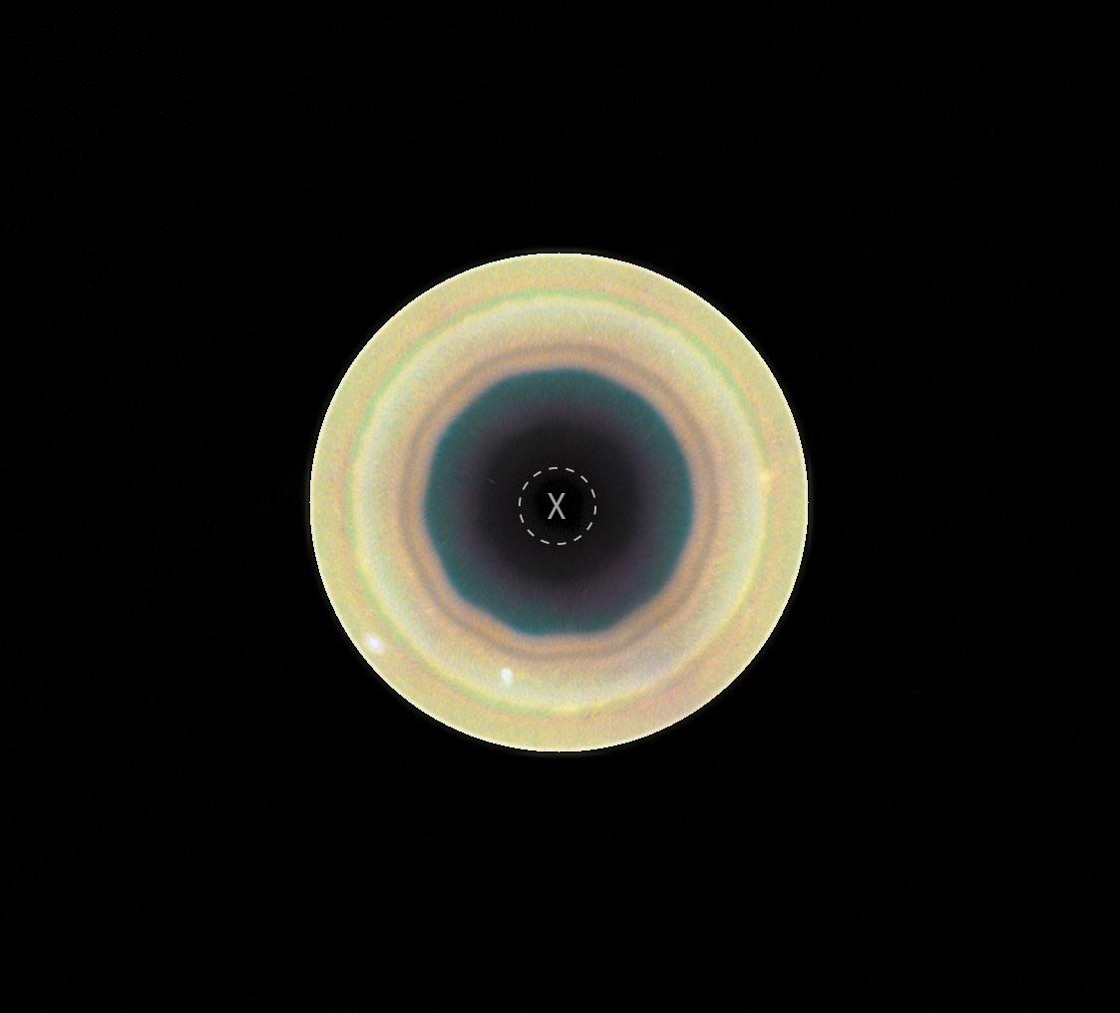
APOD - Science - APOD - APOD: 2026 September 8 -... - Today's APOD - Archive - Submissions - Index - Search - Calendar - RSS - Education - About - Discuss APOD Astronomy Picture of the Day Discover the cosmos! Each day a different image or photograph of our fascinating universe is featured, along with a brief explanation written by a professional astronomer. Hubble: Decagon Around Saturn's South Pole Explanation: Why are Saturn's poles geometric? Saturn 's North Pole has been known to be surrounded by a hexagonal (6 sides) cloud since discovery in 1987 in data taken by NASA's Voyager spacecrafts , which quickly flew past the ringed world in the early 1980s. Now, recent observations of Saturn by the Hubble Space Telescope reveal a slightly different geometric cloud pattern around the South Pole: a decagon (10 sides ). The geometric boundaries are possibly caused by waves when the fast-moving gas away from the poles interacts with slower-moving gas closer to the poles. In the featured image composite by the Hubble taken last year, the South Pole of Saturn is marked by an X and surrounded by bands of circulating clouds. The decagon appears most prominent in the dark inner regions. The northern hexagon has proven stable for over 40 years, while the stability of the southern decagon will surely remain a topic of research . APOD's main NASA site is moving : From apod.nasa.gov to science.nasa.gov/apod Tomorrow's picture: open space Date September 8, 2026 Credit NASA , ESA , STScI , HST ; A. Sánchez-Lavega ( UPV ), A. Simon (NASA-GSFC), M. Wong (UC Berkeley); Processing: A. Pagan ( STScI ) Authors & editors: Robert Nemiroff, Jerry Bonnell, Cecilia Chirenti, Keighley Rockcliffe A service of: ASD at NASA / GSFC , NASA Science Activation & Michigan Tech. U. Random APOD Generator Yesterday's Image APOD: 2026 September 7 - The Pelican Nebula in Gas, Dust, and Stars Tomorrow's Image

18. 'The Last Starship' is 2026's most slept-on space game - you need to check out this 'FTL'-like shipbuilding strategy gem
Read more

Click for next article I'm a pretty thrifty guy; no one will ever accuse me of being a hoarder or a bulk shopper. You won't ever see me at a Costco lugging around 48-count packs of toilet paper, hernia-inducing apple bags, or ginormous 5-pound boxes of Goldfish Crackers. But after tinkering around with "The Last Starship" for a while, I think I could be converted into a doomsday prepper; someone who loads up on necessary supplies and has a keen sense of the proper protocol for acquiring stockpiles of food, water, ammo, and -if I were stuck out in deep space - oxygen. After being available in early access for nearly three years, "The Last Starship" 1.0 was finally released on Feb. 6, 2026, for PC from Introversion Software, the same inventive creators of "Prison Architect". It's hardly a new release at this point, but I've been absorbed by it for the last few months, and it's definitely one that space game fans should check out. This engaging indie sci-fi video game teaches single-player gamers how to strategically operate an interstellar shipping and trading conglomerate. It does this by repeatedly driving home the importance of planning ahead while operating in the cold vacuum of outer space and fortifying your sturdy spaceship. Oh, and watch out for space pirates! The Last Starship - Official Launch Trailer - YouTube Watch On Introversion's "The Last Starship" is officially classified as a 2D space construction and simulation game , where you design, build, and upgrade your very own working starship. Once it's in operational order, you strike out into the starfields to investigate colorful solar systems, discover rare resources, and even stumble upon arcane secrets. There's a dreamy, meditative element to "The Last Starship" that can't be denied, even in this middle-aged gamer's attitude of flying by the seat of my pants and holding an advanced degree in procrastination from Cambridge University. You get a sense of genuine pride in accomplishing goals, fine-tuning your interstellar trading operations, and seeing them flourish before you. Just as in real life, your specific choices will dictate your personal odyssey, whether you're a brave soul itching to become a pirate hunter, a working joe looking to get into salvaging, mining, or transport delivery, or a visionary scientist like the Stargate engineer. First, choose an appropriate spaceship hull, then boost its propulsion system with engines, add critical life support systems, external sensors, thrusters. Then, supply your crew with tasty chow, and some bristling lasers and autocannons to test your might on the battlefield against space buccaneers. Rescue crews and civilians in peril, or go into business for yourself organizing an asteroid mining camp for profit. The choice is yours. It's all hands to battle stations in this scene from "The Last Starship" (Image credit: Introversion Software) And for my fellow right-brained individuals who can barely fathom how a basic kitchen toaster works, this indie gem is a real eye-opener to the planning and engineering know-how that goes into such fantastic machines. Once you're up and running and your dutiful crew is bustling about carrying out various operational tasks, you're free to explore the galaxy in your new cosmic ride as its proud captain, picking up missions. Gliding around the cosmos as the master of your own epic domain with your starship humming happily beneath you provides a supreme sense of satisfaction. Mostly you'll be hopping around the open-world environment, building and customizing your vessel, and grabbing contracts for a variety of legitimate and illegitimate enterprises to fatten your alien-skin wallet. (Image credit: Introversion Software) Feeling ambitious? Become a hustler as a commercial spacebus driver or strike out excavating and smelting minerals for profit to sell and bolster your bank account to purchase even larger starships or equipment upgrades. Feeling lazy? Just play around and create cool ships while traversing the universe! For intrepid commanders, the game's procedurally generated map delivers missions and meteor storms featuring a multitude of characters inhabiting their own storylines waiting to be uncovered. Managing your resources will be of the utmost importance, but organizational aptitude and drone deployment will exponentially increase your survivability in the final frontier. Intense space combat sessions do remind me of some of the cooler "close quarters battle" scenes in "The Expanse." Cruising a massive spaceship build from Introversion's "The Last Starship" (Image credit: Introversion Software) On the slight downside, "The Last Starship" might be a bit rudimentary for gamers seeking more challenging logistical endeavors, as I've found it's pretty easy to build up your spaceship. Obstacles are usually solved easily by slapping on another module or installing more reactors and managing your oxygen and CO2. Despite that, it's a thoroughly enjoyable initial iteration that's constantly receiving attentive updates and patches, so hang with it, ye gallant captains. "The Last Starship" is an excellent 2D open-world, spaceship-building game that offers tons of strategy fun in a nostalgic visual package. If you're an "F.T.L." fanatic, you'll absolutely dig it!

19. On this day in space! Sept. 7, 1995: NASA launches its 100th astronaut flight on space shuttle Endeavour's STS-69 mission
Read more
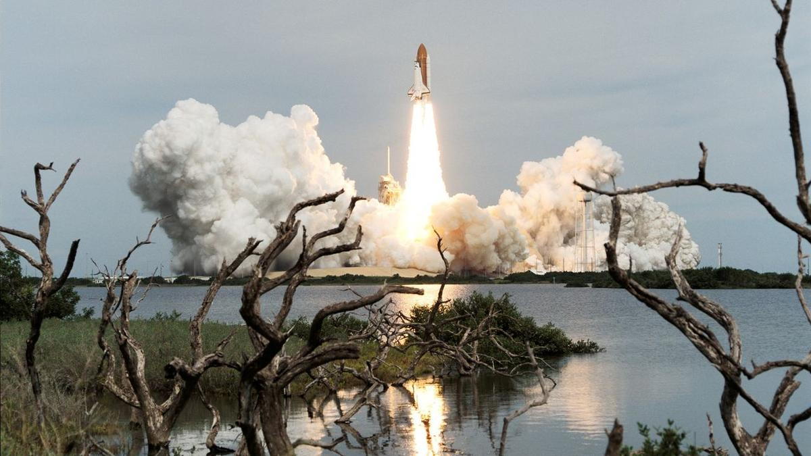
Click for next article On Sept. 7, 1995, the space shuttle Endeavour launched on mission STS-69. This was the 100th successful crew spaceflight mission for NASA. Endeavour lifted off from NASA's historic Pad 39A launch site at the Kennedy Space Center in Florida. During the 11-day mission, five crewmembers did science experiments, deployed and retrieved a satellite called Spartan 201, and conducted a nearly seven-hour-long spacewalk to practice methods future astronauts would use to build the International Space Station. The astronauts also deployed the Wake Shield Facility , a saucer-shaped satellite that flew free of the shuttle for several days. This was the first time two different payloads were retrieved and deployed during the same mission. NASA's space shuttle Endeavour lifts off on the space agency's 100th astronaut flight on Sept. 7, 1995. (Image credit: NASA) Why it mattered The launch of STS-69 on space shuttle Endeavour was a milestone of sorts for NASA and U.S. space exploration. As the 100th crewed flight by NASA astronauts, it showed that flying humans in space was not a one-off or occasional feat. The five-astronaut crew was commanded by David Walker, with Kenneth Cockrell as pilot. Astronaut Jim Voss served as payload commander (remember, this was the first time two different payloads would be deployed in space), with astronauts Jim Newman and Michael Gernhardt rounding out the team as mission specialists. Image 1 of 2 The saucer-shaped Wake Shield Facility moves away from space shuttle Endeavour after its initial deployment on STS-69. (Image credit: NASA) The five astronauts of NASA's 100th crewed mission, STS-69 on Endeavour: David M. Walker (right front) is mission commander; with Kenneth D. Cockrell (left front) scheduled to serve as pilot. On the back row are (left to right) Michael L. Gernhardt and James H. Newman, both mission specialists; and James S. Voss, payload commander. (Image credit: NASA) Image 1 of 2 View Original Image 2 of 2 View Original The Spartan 201-03 payload was an experiment designed to study the sun's outer atmosphere as it transitioned into solar wind . It was the third of four such Spartan 201 flights on a NASA space shuttle . The Wake Shield Facility-2, meanwhile, was a sort of in-space factory. The saucer-shaped platform was actually a stainless steel disk designed to create an "ultravacuum environment" in space in order to grow thin films that could be used for new advanced electronics. The disk was actually deployed twice during the 11-day mission and successfully grew four thin films of seven planned, while also performing an electrical field experiment for the U.S. Air Force on its second deployment. The one spacewalk of the mission was performed by astronauts Voss and Gernhardt, who spent 6 hours and 46 minutes working outside Endeavour to test new thermal upgrades to NASA's extravehicular activity (or EVA) suits, as well as new tools and techniques to build the then nascent International Space Station. There was one space oddity on this STS-69 mission, according to NASA. The crew was NASA's second "dog crew," or Dog Crew II, with each of the astronauts adopting a dog nickname. "Walker was Red Dog; Cockrell was Cujo; Voss, Dog Face; Newman, Pluto; and Gernhardt, Under Dog," NASA said in an overview . Want more space history? Check out our full On This Day In Space Story archive and watch our On This Day In Space videos on YouTube .

20. The future of Earth observation: Private satellites and AI bring benefits but also pose risks
Read more
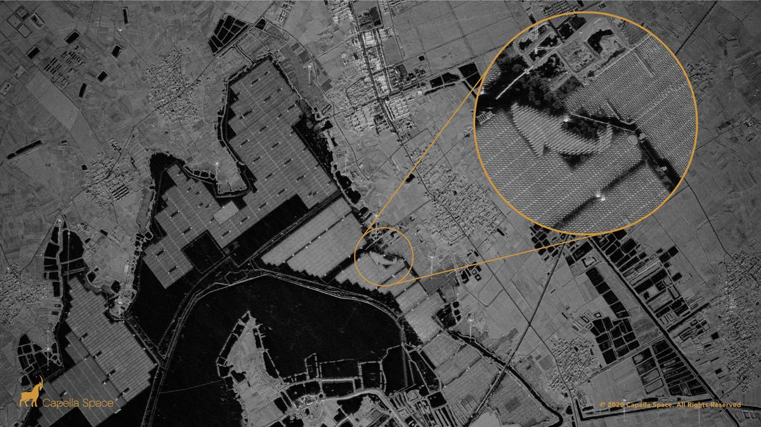
Click for next article This synthetic aperture radar image captured by a Capella Space satellite shows a solar farm floating on top of the human-made Lake Tiangang in China. We are a planet-based species: With a few notable (astronaut) exceptions, everyone who has ever lived remained glued to our spinning Earth, which now houses 8.3 billion people. That's the gravity of the situation. But we're also a world of floods, typhoons, earthquakes, heat and cold calamities, volcanic eruptions and even encounters with sun-caused auroras and bruises from incoming asteroids . It's quite a world worth watching - and for decades that's what spacecraft have been doing. But what do they view and who's on the other end of the space-based telescopes capturing our daily doings, faults and all, down here on terra firma? The U.S. government's Deep Space Climate Observatory (DSCOVR) satellite captured its first view of the entire sunlit side of Earth from one million miles away on July 6, 2015. (Image credit: NASA) Privacy, security and trust Recently, the Organization for Economic Co-operation and Development (OECD), a group based in Paris, published a report on the expanding access to satellite Earth-observation data, spotlighting what it means for privacy, security and trust. "Advances in optical systems, photonics, cloud computing and artificial intelligence [AI] have democratized both the quality and accessibility of satellite data. However, this convergence of technologies also carries risks, including for national security and privacy," states the report, which was authored by the OECD's Marit Undseth and Claire Jolly. Broadening access to advanced satellite data also creates new challenges, states the report, such as one of the key characteristics of Earth observation - its dual-use nature. "The same satellites used to track illegal fishing can often also detect military troop movements," the authors write. Illustration of a USGS-NASA Landsat remote-sensing satellite studying Earth. Government satellites the Landsat line were once the only craft doing such work. (Image credit: NASA) New concerns The OCED report notes that Earth-observation data and the technological convergence with artificial intelligence raise new concerns about national security, privacy and the ethical use of these data. In fact, the report points to the growing hazard of fake or incorrectly used satellite imagery. "As part of the growing trend of digital disinformation, the trust in satellite data can be eroded by fake, misinterpreted or intentionally misrepresented imagery," it states. Space.com asked leading remote-sensing specialists what's being done, what's being learned and what we should worry about. Sovereignty and cost efficiency Viktor Stoyanov is the chief operating officer of Smart Solutions at Space42, where he oversees the business unit's operational and financial performance. Space42 is a United Arab Emirates-based space technology company that integrates satellite communications, geospatial analytics and AI capabilities. The group runs the Foresight Earth Observation constellation of synthetic aperture radar (SAR) satellites. Space.com asked Stoyanov about the growing international use of remote-sensing data. "Governments increasingly expect Earth-observation systems to deliver both sovereignty and cost efficiency, two goals that were long seen as mutually exclusive, as sovereignty typically meant heavy in-country investment in duplicative research and development and capital infrastructure," he responded. Dual use Stoyanov said Space42's focus is to combine those two outcomes. "We believe that can only be achieved through international cooperation. Our Foresight constellation reflects this model, as the first sovereign dual-use synthetic aperture radar constellation in the region," Stoyanov said. The satellites were manufactured in partnership with ICEYE in Finland, with critical integration and testing completed in the organization's facility in Abu Dhabi. "The Abu Dhabi facility was built in cost-cautious and scalable manner, so that it can satisfy current sovereignty requirements commensurate with the constellation size, with the ability to expand the facility and meet demand of future programs," Stoyanov said. Through cloud, dust and darkness What new in-orbit technologies are being applied to Earth observation? "The biggest shift in recent years has been the move from few, large, general-purpose platforms to constellations of small, specialized satellites and synthetic aperture radar," said Stoyanov. "SAR satellites image through cloud, dust and darkness, which matters enormously for our region and for any customer who needs consistency regardless of timing and weather," he added. Looking ahead, Stoyanov said that the short lifespan of satellites in low Earth orbit is an opportunity to ensure that each replenishment cycle becomes an upgrade cycle. "As we plan to maintain and expand our fleet, we will continuously seek to deploy technical improvements across various performance metrics of the system - resolution, latency, satellite life, for example," said Stoyanov. Artificial intelligence A SAR constellation generates far more imagery than analysts can review manually within the allocated time, Stoyanov said. So the value lies in what can be extracted from it, not in the pixels themselves. AI is therefore becoming increasingly important as a sorting tool for remote-sensing data, Stoyanov said. It is now the only practical way to work, for three reasons: volume, speed and accuracy. Customers responding to a flood, a maritime incident or a supply-chain disruption need an answer in minutes, not a report next week - "decision-grade intelligence within minutes," explained Stoyanov. On the topic of accuracy, while trained analysts are excellent at interpretation and large-object classification - like buildings and sea vessels - there are changes that the eye can easily miss. "Algorithms comparing each new pass against the historical baseline - they catch those consistently, without fatigue," said Stoyanov. A SkySat Earth-observation satellite operated by the California company Planet spotted the wreckage of a failed launch out of Iran's Imam Khomeini Space Center on Aug. 29, 2019. (Image credit: Planet Labs, Inc.) Hybrid model Francis Doumet is the CEO and co-founder of Metaspectral, a company based in Vancouver, British Columbia, that builds AI technology to rapidly analyze hyperspectral imagery. Doumet views collaboration between different national space agencies as "extensive and, somewhat uniquely, very open." Missions are frequently carried out through "shared funding, instruments, expertise and ground infrastructure," he said, with the resulting scientific data made available internationally. Commercial imagery is less openly distributed because it is commercially licensed and may have security implications, Doumet said, but it is increasingly enabling international cooperation in the defense sector. For example, the U.S. Space Force 's Tactical Surveillance, Reconnaissance and Tracking (TacSRT) program combines commercial satellite imagery and analytics from American companies and allied nations to rapidly respond to operational requests, Doumet said. "This has shaped the Earth-observation sector into a hybrid model," said Doumet. Governments and allies share requirements and intelligence, he explained, while commercial operators supply imagery and analytics "at a speed and scale that would be difficult or impossible for a single nation to produce alone." Artist's illustration of Planet's Pelican-2 Earth-observing satellite in orbit. (Image credit: Planet Labs PBC) Hyperspectral sensors The improvement in the spatial resolution of hyperspectral sensors is an important advance in Earth observation, Doumet pointed out. Better sensors, high-speed compression and improved communications, such as optical links , are now narrowing a "resolution gap." Onboard AI is equally transformative, he added. "Satellites can analyze imagery in real time, identify relevant signatures and transmit alerts or compact intelligence products instead of waiting to download an entire hyperspectral data cube," Doumet explained. Spectral fingerprints Angie Crews is a principal research associate with the University of Colorado, Boulder's Center for National Security Initiatives. "There has been a tremendous growth in the commercial remote-sensing industry," Crews told Space.com, noting that this field had previously been government-based. "It's now possible for these commercial companies to deploy entire constellations of Earth-observing satellites , which fundamentally changes the architecture in place." Crews pointed to the hyperspectral nature of Earth remote sensing - taking the "spectral fingerprints" of what's occurring on Earth. "It's impressive how the industry is moving forward with some of these capabilities," she said. Balancing act "There are some tremendous benefits as well as some things that we need to think about" when it comes to the new direction that Earth observation is taking, Crews said. Remote-sensing data can be inherently dual use, she added. "Overall, I think we're seeing some enormous benefits from our increasingly capable commercial remote-sensing systems. But it does raise some security and governance questions," said Crews. It's a balancing act to manage, according to Crews. How best to secure the information for national security purposes versus not putting the squeeze on innovation exhibited by the private Earth-observation firms? Meaningful information Shifting to her teaching role at the University of Colorado, Boulder, Crews told Space.com that one of the things that's especially important is to train students in the remote-sensing field to think beyond any single sensor or dataset. "The next generation needs to understand how different sensing technologies work and also how to work with very large datasets and extract meaningful information using AI and machine learning," Crews said. "We also need to train the students on critical thinking and ensure they are aware of the limitations of AI. The underlying physics need to be understood and the results need to be validated so that the students use and interpret the results appropriately," she concluded.

21. Labor Day in space: NASA astronauts get the holiday off
Read more
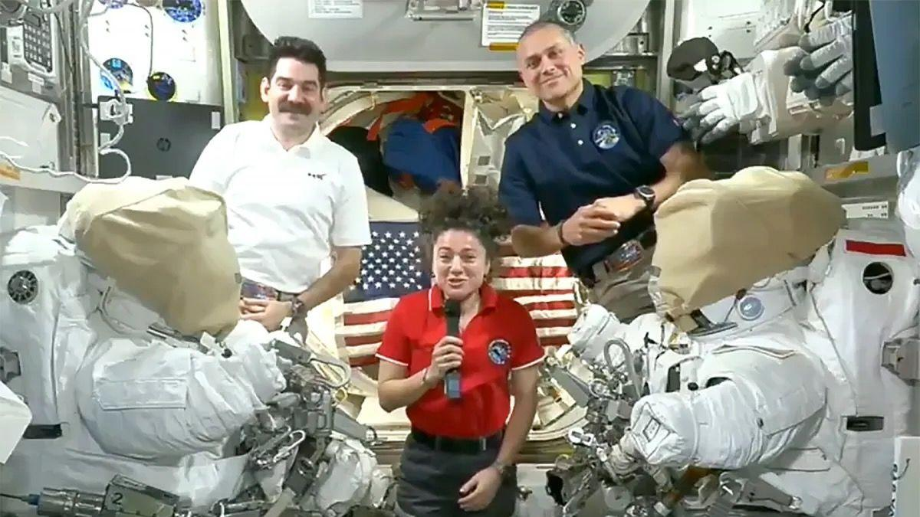
Click for next article two men and a woman speak from the international space station Like most of their compatriots here on terra firma, the three Americans living off Earth will get to put their feet up today (Sept. 7). NASA astronauts Jack Hathaway, Jessica Meir and Anil Menon will get Labor Day off aboard the International Space Station (ISS), the agency said on Friday (Sept. 4). European Space Agency astronaut Sophie Adenot, the first French woman ever to perform a spacewalk , will also be off duty. However, the three Russian cosmonauts living on the ISS will have to clock in as usual. NASA astronaut Jessica Meir (left) and the European Space Agency's Sophie Adenot work together inside the International Space Station's Quest airlock during spacesuit fit and leak checks. (Image credit: NASA) The trio - Pyotr Dubrov, Andrey Fedyaev and Anna Kikina - "will be busy monitoring the Progress 94 resupply spacecraft when it undocks on Monday, packed with trash and obsolete gear, from the Poisk module," NASA officials said in an update on Friday . "It will be replaced by the Progress 96 resupply spacecraft after it launches from Kazakhstan's Baikonur Cosmodrome on Sept. 9 for an automated docking two days later to Poisk's vacated port," they added. Adenot, Feyaev, Hathaway and Meir arrived at the ISS in mid-February on SpaceX's Crew-12 mission . Dubrov, Kikina and Menon are relative newcomers, reaching the station aboard a Russian Soyuz spacecraft on July 14 . NASA astronauts on long-duration missions to the ISS generally work a relatively normal schedule , getting weekends and major holidays off. Such downtime is crucial to mission success, as it helps the spaceflyers stay happy, healthy and productive. They may not be able to mark the holidays in exactly the same ways we do here on Earth, however. For example, the astronauts won't be grilling any hamburgers or hot dogs today, as open flames are verboten on the ISS.
22. ISRO, IN-SPACe, NSIL and industry: Building India's new architecture for the space economy
Read more
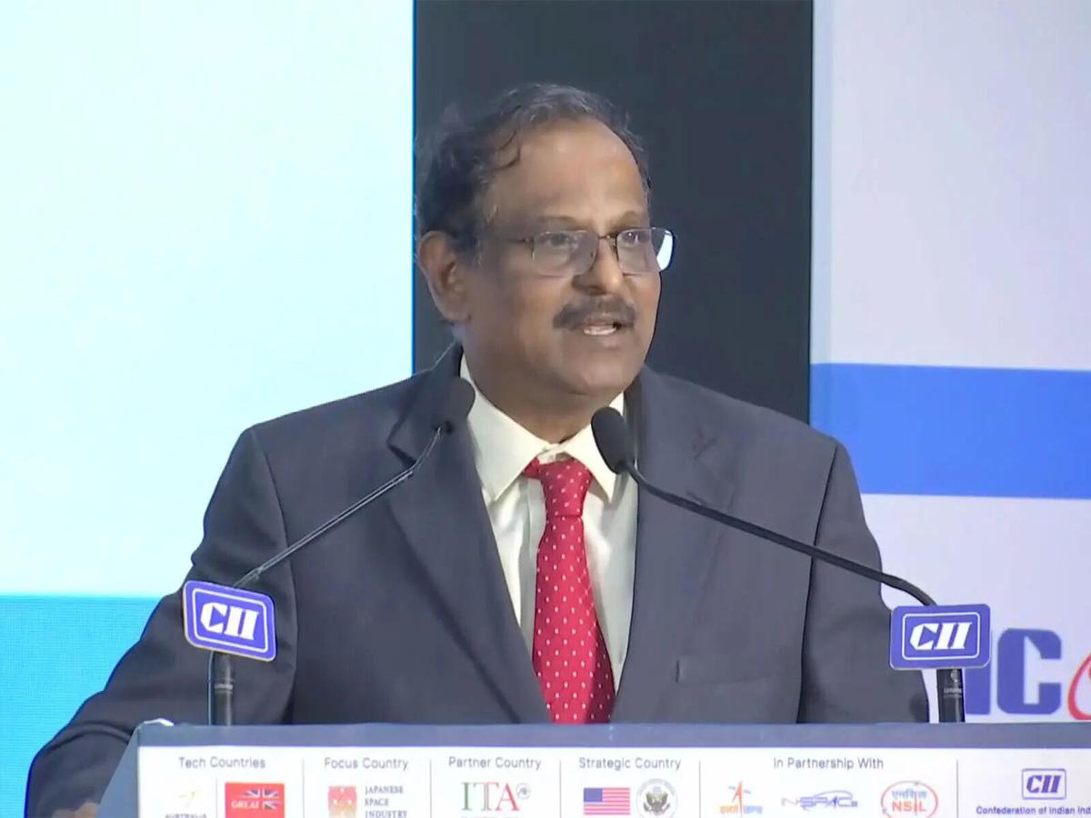
- Digital India - 6 min read India's space reforms must define clear roles for ISRO, IN-SPACe, NSIL and industry, drawing lessons from the NASA-SpaceX model to combine state capability with private innovation and scale. Anoop Verma - ETGovernment - Published On Sep 9, 2026 at 06:54 AM IST Select ETGovernment as Preferred Choice on Google Copy Link Share on WhatsApp Share on Linkedin Share on X Share on Telegram Share on Facebook "Cannot be done only by ISRO": ISRO Chairman Dr. V Narayanan calls for greater industry role to scale India's space sector The most important question confronting India's space programme is no longer whether the private sector should be allowed into space. That decision has already been made. The harder question is what the government should continue doing once private companies become capable of building rockets, satellites and space services themselves. The answer will determine whether India's current reforms produce merely a larger space industry-or a fundamentally more powerful national space ecosystem. Advt The immediate debate has been triggered by concerns within ISRO about the transfer of manufacturing and operational activities to industry. A consortium involving Hindustan Aeronautics Limited (HAL) and Larsen & Toubro is taking up production of the Polar Satellite Launch Vehicle, while Small Satellite Launch Vehicle technology has been transferred to HAL. ISRO employees have consequently sought clarity about where this transition ultimately leads. ISRO has responded categorically. "We wish to categorically state that ISRO will neither be privatised nor will its importance be diminished," the agency said on September 6. It described the emerging framework as an "ISRO-led national space ecosystem", arguing that industry should scale mature technologies while ISRO concentrates its scientific manpower on frontier research, advanced technologies and complex national missions. That formulation points towards the real issue: institutional boundaries. India now effectively has four pillars in its space architecture-the Department of Space, ISRO, IN-SPACe and NewSpace India Limited ( NSIL )-alongside an increasingly important fifth pillar: private industry. The success of the reforms will depend on whether their responsibilities remain sufficiently distinct. The Department of Space should provide overall policy direction and retain governmental control over strategically important capabilities. ISRO should increasingly become India's high-technology engine: undertaking frontier R&D, human spaceflight, advanced propulsion, next-generation launch systems, deep-space exploration, scientific missions and technologies whose risks or time horizons make them unsuitable for immediate commercial investment. IN-SPACe occupies a fundamentally different position. It is supposed to enable, facilitate and authorise non-government space activities. Its importance will grow as private companies begin operating launch vehicles, satellites, constellations and infrastructure of their own. It therefore needs to evolve into a technically sophisticated and institutionally credible authorisation and oversight mechanism-not merely a facilitator for private investment. NSIL has yet another function. Created in 2019 as a government-owned company, its mandate is commercial. It commercialises ISRO-developed capabilities, facilitates technology transfer, markets launch and satellite services and helps shift mature technologies towards industrial production. Its mandate has included PSLV productionisation, SSLV-related industrialisation and commercial exploitation of technologies developed within ISRO. Put simply, the emerging division should be: ISRO invents and pushes the technological frontier; IN-SPACe authorises and oversees the non-government ecosystem; NSIL commercialises mature public technologies and services; industry manufactures, innovates and competes; and the Department of Space sets national policy and protects strategic interests. But these lines cannot remain theoretical. As private participation deepens, difficult questions will emerge. Who certifies that an industry-produced rocket is safe to launch? Who carries responsibility when a launch fails? Who approves modifications to an ISRO-designed vehicle once manufacturing has been transferred? Can IN-SPACe simultaneously promote private space companies and independently scrutinise them? Where does NSIL's commercial role end and ISRO's technological responsibility begin? India will eventually need answers embedded in transparent rules, certification regimes and institutional accountability. There is a useful precedent-and warning-in the United States. America did not build its commercial space industry by dismantling NASA . It maintained a powerful government space agency while creating conditions in which companies could develop capabilities previously dominated by government programmes. The spectacular rise of Elon Musk's SpaceX demonstrates the possibilities. NASA's Commercial Orbital Transportation Services programme helped companies develop commercial cargo transportation systems. SpaceX began delivering cargo to the International Space Station in 2012. NASA subsequently awarded Boeing and SpaceX fixed-price Commercial Crew contracts in 2014. SpaceX's Crew Dragon was certified by NASA for human transportation in 2020 and has since become an operational means of carrying astronauts to and from the International Space Station. The institutional principle is more important than the individual contracts. NASA did not tell SpaceX simply to manufacture NASA rockets. It increasingly defined requirements, provided funding and technical expertise, established stringent safety standards, certified systems and then purchased transportation as a service. The private company had incentives to design, manufacture, iterate and operate its own system. NASA describes the objective explicitly: commercial companies can concentrate on transportation to low-Earth orbit while NASA focuses resources and expertise on deep-space missions. Under Commercial Crew, NASA purchases astronaut transportation from private providers through fixed-price arrangements while retaining certification and safety responsibilities. That distinction contains an important lesson for India. The ultimate ambition should not be to create private factories that manufacture ISRO-designed rockets indefinitely. That would expand industrial capacity, but it would not necessarily create Indian equivalents of SpaceX. A genuinely competitive space industry emerges when companies begin owning designs, taking technological risks, investing their own capital, competing for government contracts and selling the resulting services to customers beyond government. SpaceX succeeded partly because government demand gave the company an anchor customer while leaving substantial engineering responsibility with the company. Its Falcon 9 became the first orbital-class rocket capable of re-flight, while Dragon developed from cargo transportation into a human-rated spacecraft. NASA remained the customer, technical partner and safety authority without having to own SpaceX. The model has now extended much further. NASA is working with SpaceX and Blue Origin on lunar landing systems for Artemis. Even here, where human safety and national prestige are involved, NASA combines private development with governmental requirements, engineering collaboration and safety oversight. India should not mechanically copy this architecture. ISRO and NASA emerged from different histories, operate at vastly different budgetary scales and function within different industrial environments. India's strategic requirement for technological self-reliance is also particularly important. But the American experience establishes an important proposition: private-sector success does not require a weaker government space agency. In fact, a technologically formidable public agency can make private success more likely. NASA provides scientific programmes, difficult missions, infrastructure, technical knowledge, standards and enormous government demand. Companies such as SpaceX provide capital, entrepreneurial risk-taking, rapid engineering cycles, manufacturing scale and commercial discipline. India needs its own version of that equilibrium. ISRO should therefore become more ambitious, not smaller. If industry can eventually manufacture PSLVs and SSLVs, ISRO's engineers should be concentrating on reusable launch vehicles, advanced propulsion, human spaceflight, the Bharatiya Antariksh Station, next-generation satellites, lunar infrastructure and missions deeper into the solar system. At the same time, Indian companies must eventually progress beyond being suppliers to ISRO. They should design launch systems, build satellite constellations, operate commercial missions and compete internationally. The government's latest numbers suggest that this ecosystem is beginning to acquire scale. More than 400 space start-ups were registered by February 2026, while investment in Indian space start-ups had exceeded $500 million. The government wants India's roughly $8 billion space economy to grow to around $40-45 billion over the coming decade. Achieving that ambition requires more than transferring production lines. India must create an architecture in which ISRO undertakes what industry cannot yet do, industry does competitively what the government no longer needs to do exclusively, NSIL converts public technology into commercial opportunity, and IN-SPACe ensures that competition develops without compromising safety, security or national interest. The debate over whether ISRO is being "privatised" therefore risks missing the larger transformation. The United States did not have to choose between NASA and SpaceX. It eventually created an ecosystem capable of sustaining both. India should aspire to something similar-not an Indian SpaceX created by weakening ISRO, but several globally competitive Indian space companies growing around an ISRO that remains technologically indispensable. That would be the real measure of successful space reform: not how much activity ISRO gives up, but how much additional capability India gains. Anoop Verma , --> - By - See more on: - ISRO , - Indian Space Research Organisation , - IN-SPACe , - NewSpace India Limited (NSIL) , - private space companies , - space technology , - NASA , - NSIL , - ISRO IN-SPACe Private space companies , - Vikram-1 Skyroot Telegram Facebook Comments What are your thoughts? Comment Now --> Comment Now Read Comment (1) All Comments By commenting, you agree to the Prohibited Content Policy Post Find this Comment Offensive? Choose your reason below and click on the submit button. This will alert our moderators to take actions REASONS FOR REPORTING Foul Language Defamatory Inciting hatred against a certain community Out of Context / Spam Others Report Join the community of 2M+ industry professionals. Subscribe to Newsletter to get latest insights & analysis in your inbox. All about ETGovernment industry right on your smartphone! - Download the ETGovernment App and get the Realtime updates and Save your favourite articles. Scan to download App --> - Home - News - ISRO, IN-SPACe, NSIL and industry: Building India's new architecture for the space economy

23. ESA to explore cooperation with ISRO in human space flight, lunar and Venus missions - The Hindu
Read more

The European Space Agency (ESA) will be holding discussions with the Indian Space Research Organisation (ISRO) on co-operation in human space flight and lunar exploration, during the International Space Summit in Paris, which gets underway on September 9. A high-level delegation from India is in Paris to take part in the International Space Summit. Josef Aschbacher, ESA Director General, said that he would be holding discussions with ISRO Chairperson Dr. V. Narayanan. "I am meeting the Chairperson of ISRO. We will make good use of his visit to Paris. We have quite a number of co-operation points between the two agencies, and exploration is a topic of priority," Mr. Aschbacher told The Hindu. Elaborating on the potential areas of co-operation between the two space agencies, Daniel Neuenschwander, Director for Human and Robotic Exploration, ESA, said that that they would be exploring co-operations in the areas of human space flight and lunar exploration. "We have already signed an agreement with ISRO for cooperating on the human space flight (Gaganyaan). If you speak about human space flight you can talk about low Earth orbit. India will soon have its own capability to launch humans in space. India is also developing the Bharatiya Antariksh Station. We are developing certain capabilities and we are exploring how we can mutually benefit from these capabilities to strengthen the partnership. We can certainly start with low Earth orbit but we are also exploring potential cooperation on lunar exploration," said Mr. Neuenschwander. ISRO and ESA have already signed a Technical Implementing Plan (TIP) document for Ground Tracking Support for Gaganyaan missions. The TIP will enable the ESA to provide ground station support for Gaganyaan missions, which will ensure continuity in data flow and communication with the Orbital Module for monitoring and orbital operations. The Gaganyaan project envisages demonstration of human spaceflight capability by launching a crew of three members to an orbit of 400 km for a three-day mission, and bringing them back safely to Earth by landing in Indian sea waters. Venus mission The two space agencies have also been exploring potential cooperation in the Venus Orbiter Mission. "We have the Venus science coordination group that partners with those who have interest in missions to Venus. We are speaking to our ISRO colleagues to make sure that the missions complement each other," said Prof. Carole Mindel, Director of Space, ESA. India's maiden mission to Venus - ₹1,236-crore Venus Orbiter Mission (VOM) - has been approved by the Union Cabinet and the ISRO. A spacecraft, which is scheduled for launch in March 2028, will embark on a 112-day journey to Venue, which is the second planet from the Sun. According to the targeted launch window for VOM, the Earth departure date is scheduled for March 29, 2028, and the arrival date on Venus is July 19, 2028. VOM will be launched by Launch Vehicle Mark-3 (LVM-3). The Indian space agency had earlier said that 19 payloads will be onboard VOM, of which 16 are Indian payloads, two are Indian and international collaborative payloads, and there would be one international payload. (This reporter is in Paris at the invitation of France's Ministry for Europe and Foreign Affairs to cover the International Space Summit)

24. Karnataka, ISRO to explore deeper space collaboration - The New Indian Express
Read more
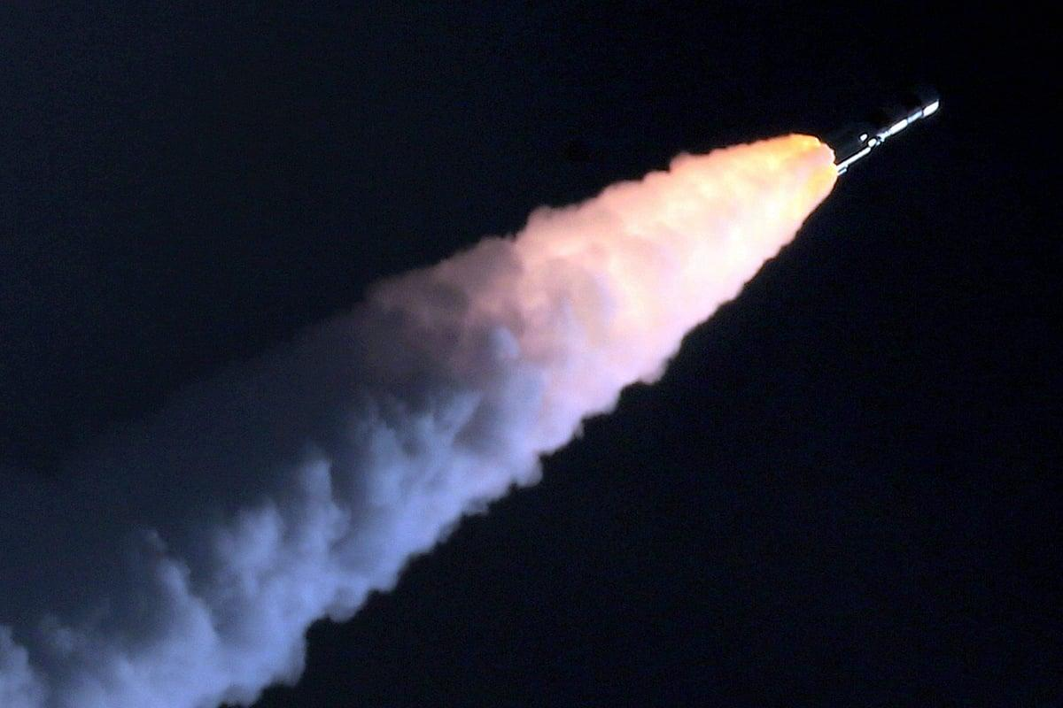
BENGALURU: Ajay Dharam Singh, Minister for Minor Irrigation, Science and Technology, on Tuesday said a meeting with Indian Space Research Organisation (ISRO) Chairman V Narayanan and Karnataka Chief Minister DK Shivakumar will take place this month to explore opportunities for deeper space collaborations. Singh said there was considerable scope to further strengthen cooperation between ISRO and the State government in science, technology and emerging innovation sectors. Singh had visited the ISRO head office to congratulate the team for the success of the GSLV-F17-EOS-05. He also facilitated a telephonic conversation between the CM and Narayanan. "ISRO's achievement is a matter of pride. The State Government is fully committed to supporting the growth of space science, research, SpaceTech, DeepTech, startups and emerging technologies in Karnataka," Singh said. Earlier in the day, speaking at the High-Level Roundtable on Space, Singh said the State wants industries and innovators to engage from the early stages and contribute ideas, technologies and partnerships to shape the State's deep-tech ecosystem. He used the platform to invite global technology companies, startups, investors and researchers to partner with the State government in building Karnataka's proposed Quantum City as a globally competitive hub for research, innovation and industry collaboration. Referring to the Karnataka Space Technology Policy 2025-30, he said the State aims to capture 50% of India's space market and 5% of the global market by 2033, attract USD 3 billion in investments and train 50,000 professionals. The Minister also advocated greater use of satellite imagery, drones, GIS, remote sensing and AI for groundwater management, mapping of tanks and lakes, irrigation asset management and project monitoring. Secretary, Department of Electronics, IT, Biotechnology and Science and Technology, N Manjula on Tuesday said, Karnataka's vision is not only to develop space technologies, but also to become a leading adopter of space-enabled solutions for societal impact. She said the State is holding brainstorming sessions on developing a constellation of satellites which will serve not just the needs of Karnataka but other states as well. She said the government was looking at various sorts of partnerships for this. The State is also looking at the sectors of geospatial intelligence, advanced manufacturing, Earth observation and digital infrastructure that will drive the next phase of growth. Speaking on the second day of the 9th edition of Bengaluru Space Expo 2026, she said the State launched the Karnataka Space Technology Policy 2025-30 as a strategic roadmap for building a globally competitive space economy. She added that Karnataka has also set a target of attracting USD 3 billion in investments by 2034 through policy interventions, infrastructure creation and ecosystem development. Karnataka is also advancing plans for a dedicated Space Park and Space Manufacturing Cluster near Bengaluru.

25. For ISRO, expanding ecosystem is way forward - The Indian Express
Read more
For ISRO, expanding ecosystem is way forward The Indian Express

26. NASA Calls for Proposals to Accelerate Lunar Surface Technologies
Read more
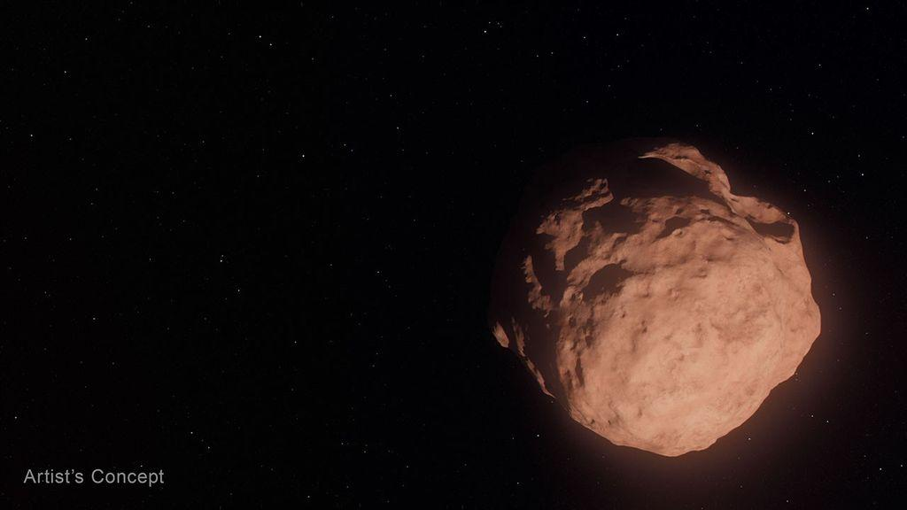
Artistic concept of lunar surface technologies and infrastructure capabilities, including in-situ resource utilization oxygen production systems, surface power systems, in-space manufacturing tools, and advanced nanomaterials production. Credit: NASA NASA is seeking proposals to advance the technology and infrastructure needed to explore the Moon and establish a Moon Base in the lunar South Pole region. Announced on Tuesday, Sept. 8, the solicitation targets capability gaps, including power generation, oxygen extraction, and producing materials on the Moon required for construction and operations. These technologies are essential to making humanity's next great leap in lunar exploration. "NASA is accelerating the development of key technologies and closing critical gaps needed for long-term human exploration at the Moon," said Greg Stover, director of NASA's Advanced Research and Technology Division. "Partnering with industry will strengthen the U.S. industrial base as we mature the capabilities and infrastructure needed for a sustainable lunar presence." The NextSTEP-3 Broad Agency Announcement Appendix A: Lunar Enabling Infrastructure Accelerator solicitation aims to mature and demonstrate capabilities in five areas: Vertical solar array technology that can provide consistent power generation, management, distribution, and energy storage. In-situ resource utilization oxygen from regolith production to extract usable oxygen molecularly bonded to rock and dust covering the Moon's surface. Radioisotope Stirling generator, a type of nuclear energy technology that uses heat from fissile materials to produce electric power for operating spacecraft systems in the darkest, dustiest, and most remote places. In-space advanced manufacturing to reduce reliance on resupply missions from Earth and to optimize mission flexibility and resilience on the Moon. Innovative nanomaterials production to advance the commercial availability and quality of nanomaterials that can be used in lunar exploration. The solicitation intends to cultivate U.S.-led capabilities while maintaining full and open competition among private industry, academic institutions, and not‑for‑profit entities, as well as international partners participating through U.S.-led teams. NASA may apply insights gained from the resulting contracts of this solicitation, such as technical data, and demonstration results, to shape future acquisition strategies. To learn more about NextSTEP-3, visit: https://go.nasa.gov/4x20o3t -end- Rob Margetta Headquarters, Washington 202-358-0918 robert.j.margetta@nasa.gov

27. Stoke Space raises $1 billion for fully reusable rockets, targets 'early 2027' for 1st-ever launch
Read more
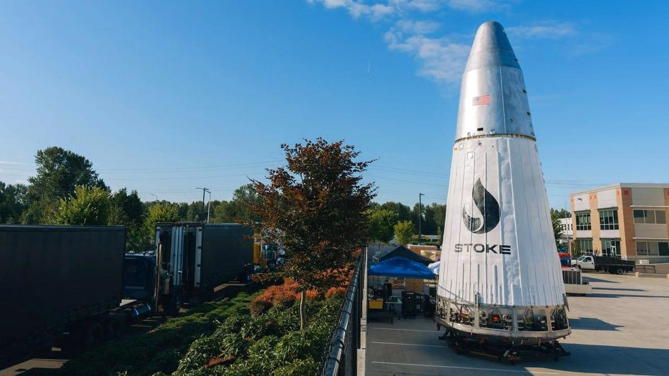
Click for next article Stoke Space has amassed a substantial sum during its latest round of financing and is revealing exactly where it plans to invest its new stack of cash. The Kent, Washington-based company just raised $1 billion via its"Series E" capital campaign, bringing Stoke's total investor haul to $2.3 billion. The Sept. 8 announcement provided a development update for Stoke's fully reusable Nova Pathfinder launch vehicle and included plans for its never-before-seen Nova Block 2 rocket, a more powerful system designed to be able to deliver up to 15 tons to low Earth orbit (LEO). "We are humbled by the trust our investors and customers have placed in us in pursuit of this critical generational challenge," said Andy Lapsa, Stoke CEO and co-founder. "This investment enables us to scale toward delivering the capability and cadence our customers require." Nova Pathfinder is Stoke's first orbital launch vehicle (the largest first rocket ever undertaken by a U.S. launch company, according to Stoke), and is based on the same technologies the company is building into its Block 2 design. Both two-stage vehicles are being manufactured with full and rapid reusability in mind, with Pathfinder serving as the proving ground for that architecture. Pathfinder's first stage is powered by seven Stoke-designed full-flow, staged-combustion (FFSC) Zenith rocket engines, fueled by liquid oxygen and liquefied natural gas (LNG). The first stage on Nova Block 2 will be equipped with 14 Zeniths. Stoke calls FFSC "perhaps the most difficult rocket engine cycle to develop," but highlights its advantages; the tech leaves fewer residuals like soot around the engines and reduces the amount of maintenance needed between flights, according to the company. The upper stage of both rockets is the more atypical approach to spacecraft design, compared to other vehicles of the same launch class. The aft end of Nova's second stage is designed with a heat shield to protect the vehicle during reentry through Earth's atmosphere. Instead of the ceramic tiles historically used on the heat shields of previous spacecraft, the dome-like structure at the base of Nova's upper stage is made of metal, which is actively cooled by the liquid hydrogen that fuels the stage's Andromeda propulsion system. Rather than a single large, vacuum-optimized engine bell at its center, Nova's upper stage features 12 small dual-thrust chambers integrated into a circle around the outer edges of the vehicle's heat shield. Stoke successfully completed a "hopper" test flight of Pathfinder's upper stage engine system in 2023, flying the vehicle about 30 feet (10 meters) into the air before it safely touched down. Andromeda upper stage engine and integral re-entry heat shield. (Image credit: Stoke Space) Scaling up to Block 2, Stoke plans to equip the upper-stage system with independent systems for each of the 12 engines, potentially increasing thrust by over a factor of five, according to the company. Block 2's upper stage also drops Pathfinder's tapered design in favor of cylindrical tanks, increasing propellant and payload volume to accommodate a 5-meter-wide (16.4 feet) fairing. Stoke says the larger Block 2 configuration has been in the works alongside Pathfinder for several years. The company is developing the more powerful rocket to support large commercial and national security satellite constellations, of which there soon may be a high demand. Nova Block 2's closest competitors are SpaceX's Falcon 9 rocket and Rocket Lab 's upcoming Neutron launch vehicle, which is still under development. And Falcon 9 is already being sundowned by SpaceX as the company gets closer to operational flights with its next-generation Starship rocket. While certain Falcon 9 flights for NASA , like crew launches to the International Space Station , are expected to continue until at least 2030, SpaceX CEO Elon Musk has said that Starship's ultimate success "means winding down Falcon." The timing should line up with when Stoke hopes to step in with Nova Block 2. Block 2's first launch is targeted for 2029, with production and flight cadence expected to increase from there. Nova Pathfinder next to Nova Block 2. (Image credit: Stoke Space) As Stoke ramps up development for its upgraded launch vehicle, the company's fresh round of funding will also go toward construction of the physical infrastructure Stoke needs to build, test and eventually operate both vehicles. The company is planning a 475-acre (192 hectares) expansion to its 75-acre (30 hectares) Moses Lake Test Site in Washington to support propulsion and vehicle testing as Pathfinder nears its first launch and Block 2 hardware begins coming online. Stoke is also expanding its operations at Cape Canaveral Space Force Station (CCSFS) in Florida. The company was selected by the U.S. Space Force in 2023 to manage CCSFS's Space Launch Complex-14 , where it's now building a new payload processing facility sized to accommodate both vehicles. And to complete its full reusability system, the company is also developing an offshore recovery platform. Pathfinder has a much shorter timeline to the launch pad. Stoke is targeting early 2027 for Pathfinder's debut launch, which the company plans to send to orbit with a customer payload. If that's successful, Stoke hopes to fly multiple Pathfinder missions throughout 2027 and 2028 while Block 2 development and testing continue in parallel. Once Block 2 does reach the launch pad, Stoke plans to keep Pathfinder in service. "We see value in having more than one way to serve the market, since some missions are particularly well suited to the Pathfinder configuration," the company said.

28. On this day in space! Sept. 8, 2004: NASA's Genesis spacecraft crashed in the Utah desert, shattering its samples of solar wind particles from the sun
Read more
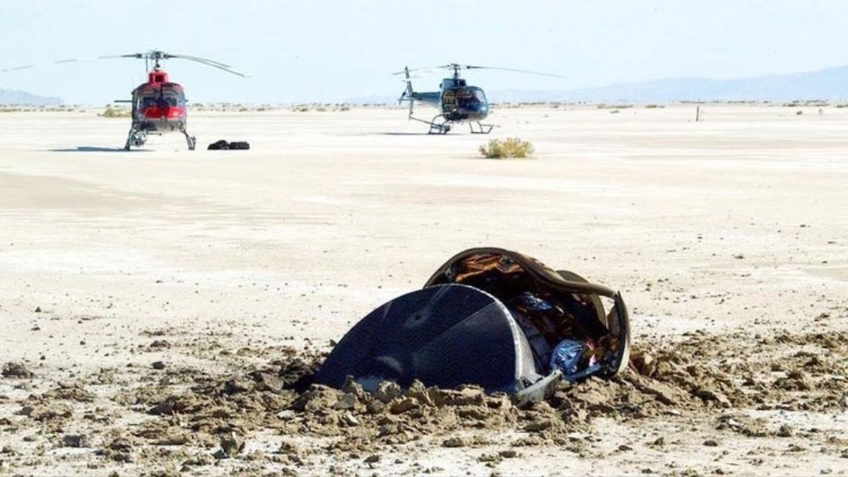
Click for next article On Sept. 8, 2004, NASA's Genesis spacecraft crash-landed in Utah after its parachutes failed to deploy. Genesis was NASA's first sample-return mission since the Apollo program , and the first attempt ever to bring back samples from someplace farther than the moon. The spacecraft picked up solar wind particles while orbiting the L1 Lagrange point , which is about 1 million miles from Earth. L1 is a "sweet spot" between the Earth and the sun, where the gravitational pull from both objects balances out. Genesis collected samples of the solar wind using arrays made of ultrathin semiconductors called "wafers." Atoms and ions floating around in space stuck to these wafers, and Genesis was supposed to bring them back safely. But that didn't happen, because its parachute didn't work . Instead, Genesis tumbled from the sky and slammed into the Utah desert . Scientists literally had to pick up the pieces after the wafers containing the solar wind samples shattered into thousands of tiny shards. Luckily, scientists were still able to salvage some of the samples. NASA's Genesis solar wind sample return capsule, seen here half-buried in the Utah desert floor, crashed due to a design flaw on Sept. 8, 2004. (Image credit: USAF 388th Range Squadron) Why it mattered NASA's Genesis probe launched in August 2001 on a $264 million mission to collect samples of the solar wind. It was the first time NASA tried a sample-return mission since Apollo 17 in 1972 (which was a crewed flight), and this trip would be fully robotic. In order to secure the Genesis solar wind samples safely, NASA opted for a tried and true approach for space retrieval: capturing a returning craft by the parachute using a helicopter. Similar techniques were used in the past to collect spy satellite film from military satellites . Image 1 of 3 A scientist in protective gear trying to secure solar wind samples from crashed Genesis spacecraft. (Image credit: NASA) Fragments of NASA's shattered Genesis sample cansiter with solar wind samples. (Image credit: NASA) This artist's concept shows what the Genesis spacecraft looked like in space with its fragile sample return wafers exposed to collect solar wind samples. (Image credit: NASA) Image 1 of 3 View Original Image 2 of 3 View Original Image 3 of 3 View Original But a design flaw in the parachute system , and a fairly basic one at that, doomed the Genesis spacecraft. Four gravity switches in the sample-return canister were installed backwards due to an error in the design schematics. It affected both the primary and backup parachute systems. The switches were supposed to detect when Genesis began braking in Earth's atmosphere and trigger parachute deployment. That never happened, so the probe crashed into Earth instead. NASA scientists were still able to glean some science from the shattered Genesis sample-return capsule , but the result was far from optimal, as you'd expect. The mishap also prompted reviews of NASA's Stardust comet sample return probe , which used the same type of gravity switches, but that spacecraft's switches were installed correctly and it made a successful landing in 2006 . Happy Birthday, Star Trek! (Image credit: Paramount) Speaking of things flying through space. There was another event that occurred on this day in 1966 that - while not actually being in space - has influenced our concept of spaceflight for a decade. On Sept. 8, 1966, the first episode of " Star Trek " debuted on television. The iconic science fiction series, which has spawned a myriad of spin-offs and feature films (not to mention all the merch), has inspired countless engineers, scientists and space fans over six decades. The Star Trek franchise celebrates its 60th anniversary in 2026, and you can find our Star Trek coverage here . Want more space history? Check out our full On This Day In Space Story archive and watch our On This Day In Space videos on YouTube .

29. 2 satellites just burned up in Earth's atmosphere - and scientists were watching from a private jet. Here's why
Read more

Click for next article The European Space Agency's Tango satellite disintegrated above the Pacific Ocean on Sept. 1, 2026. observed by a team of researchers from aboard a private jet. A team of researchers just chased a pair of reentering satellites in a private jet to learn about the pollution caused by space debris burning up in Earth's atmosphere. The satellites in question were the European Space Agency 's (ESA) Tango and Samba spacecraft , which once formed the Cluster constellation, together with the already de-orbited Rumba and Salsa. The quartet used to study the interaction of Earth's magnetic field with the solar wind . After 25 years of service, ESA took advantage of the Tango and Samba's controlled demise to help scientists learn what happens when satellites break apart and burn up during their spiral back to Earth. The international team of researchers chased the two reentries, which occurred one day apart - on Aug. 31 and Sept. 1 - above the southern Pacific Ocean a few hundred miles from the Polynesian archipelago of Tonga. Samba's reentry: Seen from the sky - YouTube Watch On Their goal was to understand what happens when satellites disintegrate and what chemical compounds arise in the process. Although companies such as SpaceX , Amazon and Blue Origin want to launch huge numbers of satellites to space in the next decade - SpaceX alone plans to loft 100,000 of its Starlink V3 spacecraft - very little is known about the effects of satellite reentries on Earth's atmosphere. Researchers are also still unsure which spacecraft burn up completely and how many fragments may reach the ground, putting lives and property at risk. "We want to understand what happens to these bodies as they fly through the atmosphere, which causes friction and very high temperatures," Jiří Šilha, CEO of the Slovak company Astros Solutions, and one of the researchers aboard the plane, told Space.com. "We know that those satellites break up into fragments, which subsequently melt in the atmosphere." The researchers chased the reentering spacecraft following exact calculations provided by ESA controllers , who were able to maintain connection with the spacecraft until the very last moment before they plunged into the atmosphere. Researchers inside a private jet during a campaign observing the reentry of ESA's Cluster Tango satellite on Sept. 1, 2026. (Image credit: Jiří Šilha) The satellite reentries, although they occurred during daylight, were visible from aboard the plane even to the naked eye, said Šilha, and created spectacular fireballs that lasted tens of seconds. "Bolides and meteors only last a few seconds or less," said Šilha. "But satellites are slower. They enter the atmosphere at a shallower angle, and the atmosphere slows them down further." But the researchers were there for science, not for a sky show. And it was a rare opportunity: The Cluster trajectories were so precisely known that the scientists could prepare for them and be at the exact spot at the exact time to witness those explosions from only a couple of hundred miles away. The aircraft, a small commercial business jet, was packed with 30 cameras and spectrometers fitted with special filters to capture not only how the satellites disintegrated but also detect the spectral signatures of the chemical elements released as their bodies burned up. Eight scientists were squashed on board the darkened jet operating the instruments through the aircraft's six windows as the pilots navigated to the vicinity of the spot where ESA analysts had predicted the breakup would occur. "We were flying toward the object, and first it looked like a compact source of light as the material ablated," said Šilha. "At some point, there was a sudden explosion as the satellite disintegrated." The plane allowed the researchers to overcome any clouds that could obscure the view from the ground, and also to bypass the thickest layer of the atmosphere, which would distort the measurements. As the satellites hurtled through the air, slowing down from the mind-boggling speed of 22,370 mph (36,000 kph) at which they hit the upper atmosphere, the jet approached them to within a distance of around 75 miles (120 kilometers). "We begin observing it when it's at about 90 kilometers [56 miles] and it stops being visible at about 65 to 70 kilometers [40 to 44 miles]," Šilha said. "For about thirty to forty seconds after the explosion, you can observe an interesting structure as all those various fragments ablate in the atmosphere. Then they all either burn up or slow down." Šilha said the cameras captured tens of fragments, in detail that had never been observed before. The researchers also attempted to trace seven chemical compounds, including titanium, sodium and potassium, which get released as satellites burn up. The team was especially interested in aluminum, which makes up the majority of a satellite body. Aluminum is not naturally present in Earth's atmosphere and most likely forms aluminum oxide during the incineration. The potential presence of aluminum oxide in the atmosphere in higher concentrations worries scientists, as it could potentially trigger ozone depletion in the stratosphere. "We tried to measure the aluminum at different altitudes, using specialized filters, which could tell us when this aluminum interacts with the atmosphere," said Šilha. "That's when the aluminum oxide likely forms, and that's something that has never been observed before. We don't know exactly how and in what quantities the aluminum oxide might be forming." The researchers will now analyze the data to learn exactly what chemical reactions may be occurring during every second of the breakup and burn-up process. The data will help atmospheric physics and chemistry researchers improve their models to further our understanding of the potential damage the growing satellite industry might do to the planet and its climate in the future. "The data will help us validate whether the models agree with reality," said Šilha.

30. SpaceX rocket taxi returns after Roman Telescope launch | Space photo of the day for Sept. 8, 2026
Read more
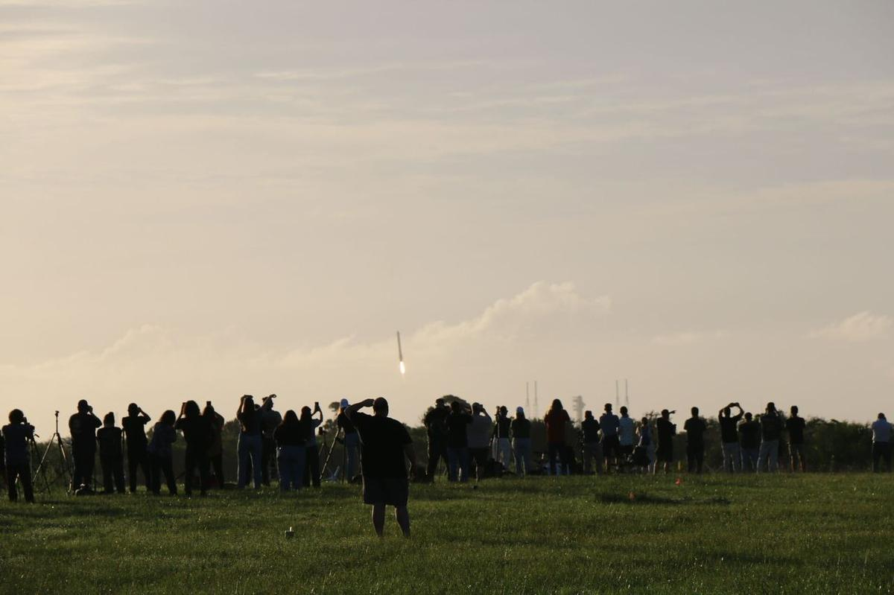
Click for next article This might look like a rocket launching off Earth, but it's actually a rocket booster perfectly landing on our planet after fulfilling its duty. (Image credit: Chelsea Gohd) On Aug. 30, the Nancy Grace Roman Space Telescope launched into space aboard a SpaceX Falcon Heavy rocket - then, after completing their job, the rocket's boosters safely landed back on Earth. Watching the events unfold, Space.com's Chelsea Gohd caught one of these beautiful landings on camera as onlookers at NASA's Kennedy Space Center watched in awe. What is it? The Roman Space Telescope is NASA's next great observatory, meant to revolutionize how we view the cosmos. Equipped with instruments like a coronagraph that can directly image exoplanets and a Wide-Field Instrument (WFI) that has a massively wide field of view, it's designed to work with big names like the Hubble Space Telescope and James Webb Space Telescope and reveal our universe's intricacies on a grand scale. But to get to space, like any other space telescope, it needed a rocket to ferry it there. In this case, that was SpaceX's Falcon Heavy rocket. Falcon Heavy is about 230 feet (70 meters) tall and can lift nearly 141,000 pounds (64 metric tons) of payload to low Earth orbit. And importantly, Falcon Heavy's two boosters are reusable. After launching a payload to space, the boosters split and each lands back on Earth in an upright position. In the image above, Gohd captured one of those boosters landing in the distance. Why is it incredible? Though we hear about it so often , there is something undeniably dreamlike about living in a time when a rocket can land its parts back on Earth so precisely. I was also there for the launch of the Roman Space Telescope in Florida, and it was breathtaking to watch such a huge piece of equipment navigate mid-air and straighten itself before landing. The crowd in the picture was equally astonished while the event unfolded. My mother texted me just after she watched the Roman Space Telescope launch live online, exclaiming that the booster's landing looked just like a taxi returning to its station, getting ready for the next task. I hadn't thought about it that way before, but she was correct. One of the boosters that participated in Roman's launch landed at Landing Zone 2 and the other hit the ground at Landing Zone 40. As NASA explained in a statement, one of these boosters carried out its very first mission while the other was on its third . Now, the next spectacle to take our breath away will be Roman's very first images of the universe. Those are expected to drop next year.

31. The Vela Incident: Did an American satellite detect a secret nuclear test in 1979?
Read more
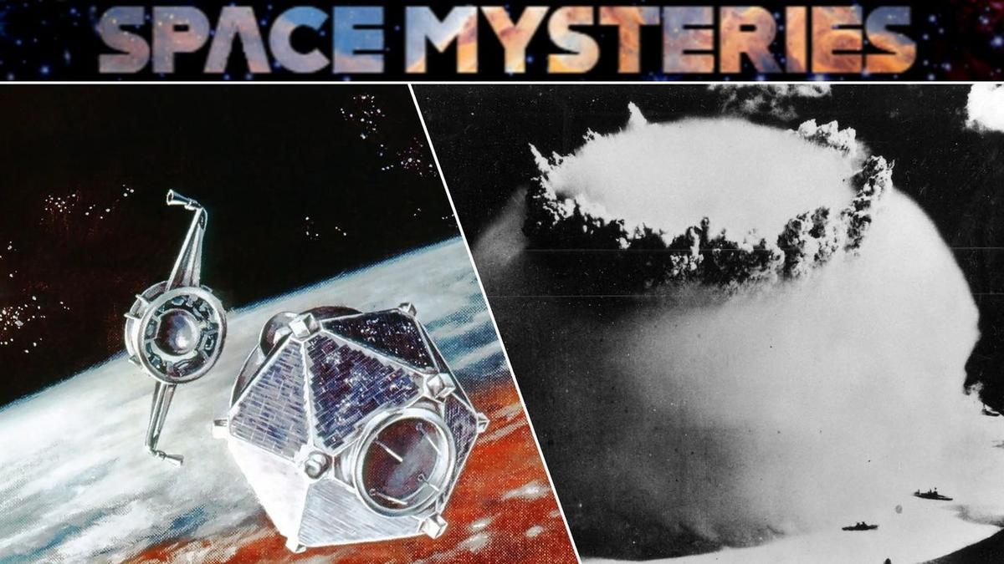
Click for next article It began with an unusual flash detected off the coast of South Africa by an aging American satellite - and to this day, debate continues over whether this odd Cold War event involved an illicit atmospheric nuclear test. The strange story of the "South Atlantic Flash," better known as the Vela Incident, began on Sept. 22, 1979. At that time, Vela 6911, a satellite in a constellation developed by the United States for the specific purpose of detecting nuclear detonations , observed something that immediately alarmed officials: a peculiar flash of light emanating from somewhere over the South Atlantic Ocean. A significant part of what concerned U.S. officials at the time had been the double flash of light detected during the event - a distinctive feature that strongly resembled the flashes produced by a nuclear explosion in Earth's atmosphere . The characteristic double flash results from the rapidly changing brightness of the fireball and shock wave produced by an atmospheric nuclear detonation, creating a distinctive optical signature that Vela's sensors were specifically designed to recognize. The South Atlantic event, therefore, seemed like a prime candidate for a secretive nuclear test being carried out by an unknown party - but if that were the case, who was responsible? Space Mysteries: Did an American satellite detect a secret nuclear test in 1979? - YouTube Watch On What do we know? U.S. officials responded to a possible nuclear test Then-President Jimmy Carter was promptly alerted to the situation, as evidenced in diaries the former U.S. leader would publish years later . "There was indication of a nuclear explosion in the region of South Africa," Carter wrote in an entry on the same date of the event. A later entry penned the following February would go on to add that "We have a growing belief among our scientists that the Israelis did indeed conduct a nuclear test explosion in the ocean near the southern end of Africa." President Jimmy Carter, seated at a desk in the Oval Office of the White House in 1980. (Image credit: Bettmann/Getty Images) Despite that belief regarding the possibility of a clandestine nuclear test, a scientific panel assembled in 1980 , chaired by MIT professor Jack Ruina, eventually put forward an alternative explanation: that the flash had more likely been an anomaly caused by a small meteoroid striking the satellite. Notably, the panel did not rule out the possibility of a nuclear explosion at the time, although the alternative they put forward remained controversial among scientists and intelligence officials. A memorandum to Director of Central Intelligence Stansfield Turner from Frank Press, White House science adviser, in which Press explains the reasoning behind the Ruina panel's conclusion that the Vela flash was "probably not from a nuclear explosion" and was therefore more likely "caused by a natural event." (Image credit: Public Domain/National Security Archive) Documents and government insiders surface By the turn of the 21st century, formerly classified documents began to surface that revealed the extent of the inner tensions between U.S. government agencies over what caused the Vela incident. Among the critics of the debris-induced "anomaly" hypothesis had been Defense Intelligence Agency Vice Director Jack Varona. According to documents released in 2006, Varona said the investigations by the 1980 scientific panel had been a politically motivated "whitewash," and that evidence collected by the U.S. intelligence community included detections "unique to nuclear shots in a maritime environment," based on an analysis by the Naval Research Laboratory. Varona wasn't alone. Other former intelligence officials who came forward over the years included Stansfield Turner, the former Director of Central Intelligence during the Carter administration, who in 2003 described the Vela detection as a "man-made phenomenon." Similar views were advanced by retired CIA officer Tyler Drumheller, who in 2006 wrote that he had sources at the time who "collectively provided incontrovertible evidence that the [South African] apartheid government had in fact tested a nuclear bomb in the South Atlantic in 1979, and that they had developed a delivery system with assistance from the Israelis." The Vela-5A & B satellites in a cleanroom at Los Alamos National Laboratory (left); and an illustration of one of the satellites in orbit above Earth (right). (Image credit: Los Alamos National Laboratory) What remains unknown? Scientists revisit the mystery While we still don't know if the South Atlantic Flash was a nuclear test, several scientists have reexamined the available evidence within the last decade, and what they found has lent further weight to the idea that the Vela incident had involved a detonation of some kind. Among the most significant assessments, a 2017 study by Christopher Wright and Lars-Erik De Geer combined modern research into interplanetary dust and hypervelocity impacts with revelations from recently declassified documents, as well as publicly available information that had been previously overlooked. Their conclusion: while no model was presented for the tenuous "meteoroid" theory advanced by the May 1980 scientific panel, the double flash observed by the Vela satellite in 1979 was indeed "consistent with a nuclear explosion, albeit detected by an aged satellite for which background modulation was abnormal and/or commenced earlier," adding that additional radionuclide and hydroacoustic evidence existed which supported the conclusion "that the Vela Incident was a nuclear weapon test explosion." Wright and De Geer weren't alone either. A 2022 study examined data collected by NASA's Nimbus-7 satellite just 16 minutes and 44 seconds after the double flash over the South Atlantic, which suggested a disturbance in the ozone layer that appeared to be consistent with a blast-generated shock wave. Artist's concept of a Nimbus spacecraft in orbit over Earth. (Image credit: NASA) Still, some of the original members of the 1980 scientific panel have defended its work amid the more recent scientific studies. Richard Mueller, who served as the panel's youngest member at the time, defended the group's conclusions in a November 2019 oral history conference , maintaining that the chances the Vela incident had involved a nuclear event were "as close to zero as it gets." This determination, Mueller argued, was made despite early interpretations by many panelists that a nuclear event had seemed most likely. Wright and De Geer, both of whom attended the 2019 oral history conference, were among the participants that pushed back on Mueller's views. Who was responsible? Amid the mounting evidence over the last several decades suggesting the Vela incident was indeed a nuclear test, debate continues over who was most likely to have been responsible. Although suspicions have long centered on a cooperative - and secret - strategic effort between apartheid-era South Africa and Israel, publicly available evidence remains lacking, and a fair amount of information in declassified documents that could point to this possibility remains redacted. An illustration of two Vela satellites separating in orbit. (Image credit: Los Alamos National Laboratory) The mystery remains Thus, after more than four decades, questions continue to linger over the famous Vela incident, including what nations might have been involved in such a test if it occurred. Despite that uncertainty, one thing does seem evident: information conveyed in unredacted portions of declassified records, combined with modern scientific analyses, increasingly point to the likelihood that the strange "South Atlantic Flash" in 1979 was anything but natural.

32. How studying astronauts could help tackle aging on Earth
Read more

Astronauts who undergo long-duration spaceflight aboard the International Space Station often return with health problems that resemble some age-related conditions in people on Earth.
33. ISRO says space sector reforms focus on ecosystem expansion, not privatisation - News On AIR
Read more
Indian Space Research Organisation (ISRO) has issued a clarification on reports circulating in the media regarding speculations and misinformation that there is an attempt to privatise ISRO or reduce its role. In a social media post, ISRO said that it will neither be privatised nor will its importance be diminished. It added that participation of the private sector in space is aimed at enabling ISRO to focus even more strongly on the next generation of India's space programme, while industry scales up mature technologies and capabilities. ISRO said the space-sector reforms aim to create a larger, stronger and globally competitive Indian space ecosystem. It said the reforms should therefore be seen as ecosystem expansion and capability multiplication, rather than privatisation. Noting the growth in India's industrial and technological capabilities, ISRO said that mature and scalable activities can increasingly be undertaken by Indian industry. This would enable large-scale production, commercialisation, innovation and access to global markets, while allowing ISRO's scientific and technical manpower to concentrate on advanced research, next-generation technologies and complex national missions. ISRO said this approach will allow it to devote more resources and scientific manpower to the next generation of technologies and missions, while the wider ecosystem provides the investment, manufacturing capacity and scale required by an expanding national space programme.

34. Isro transparency on 'failures' comes under lens amid private sector expansion - Telegraph India
Read more
Isro transparency on 'failures' comes under lens amid private sector expansion Telegraph India

35. National Anubhav Awards, 2026 - ISRO
Read more
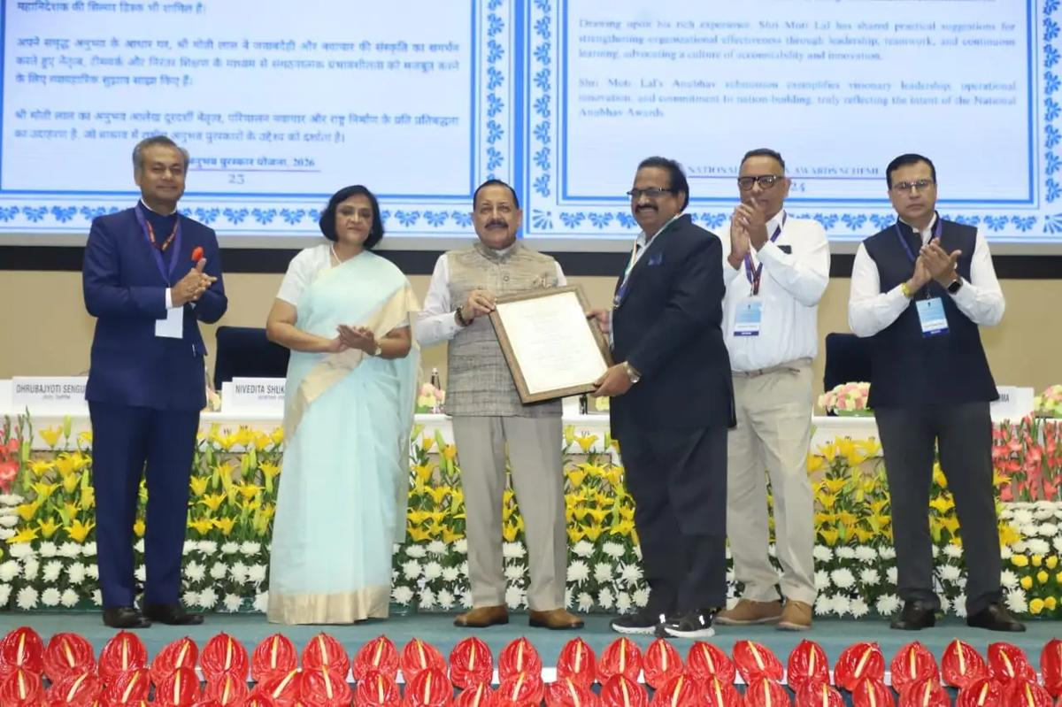
September 09, 2026 The National Anubhav Awards 2026 were conferred on the awardees on August 17, 2026 by Hon'ble MoS, Dr. Jitendra Singh. Dr. Ainapurapu R. Rao, retired Post Graduate Teacher, SDSC SHAR, ISRO, Department of Space, received the coveted Jury Certificate and a medal under the National Anubhav Awards Scheme, 2026. Award presentation during the National Anubhav Awards 2026 ceremony

36. Karnataka seeks ISRO support to promote practical science education among students - Bangalore Mirror
Read more
Karnataka Science and Technology Minister Ajay Dharam Singh has sought ISRO's support to organise direct interaction programmes between scientists and students at science centres across the state, a release said. The initiative aims to take science beyond textbooks and make learning more experiential and interactive, the minister said.During his meeting with ISRO Chairman V Narayanan, Singh formally proposed the initiative and sought support to enable students to interact directly with scientists and learn about space science, research, satellite technology and career opportunities in science and technology."When students get an opportunity to interact directly with scientists, science begins to appear not merely as a subject in a textbook, but as a future opportunity. The experiences and achievements of ISRO scientists can inspire curiosity, a research mindset and bigger aspirations among young students," Singh said.Singh said the state government is expanding science centres, mobile planetariums and telescope-based learning initiatives to promote practical and interactive science education among students.The Science and Technology Department's Mobile Digital Planetarium programme has already reached 3,282 schools and benefited more than 5.46 lakh students and teachers. Under the Providing Access to Telescopes (PAT) programme, telescopes have also been provided to KREIS schools and colleges, along with training for science teachers.The proposed ISRO Scientist-Student Interaction Programme at science centres would help bring space science and technology closer to students in a more engaging and meaningful way, the minister said."Science must be shown, experienced and questioned. Direct interaction with scientists can strengthen scientific temper among students and help nurture the next generation of scientists, researchers and technology professionals," he said.ANIThrough ISRO's partnership, the state government aims to extend the interaction programmes across science centres in the state and create opportunities for students not only in cities but also in districts and taluks to engage directly with scientists. (ANI)

37. NASA Adds Relativity Space's Terran R to Launch Services Contract
Read more
Credit: NASA A NASA Launch Services (NLS) II contract has been awarded by the agency to Relativity Space Inc., and its Terran R launch service in accordance with the contract's on-ramp provision. The Terran R launch service will be available to NASA's launch services to use for future missions. The NLS II contracts are multiple-award, indefinite-delivery/indefinite-quantity contracts with an ordering period through June 2030 and an overall period of performance through December 2032. The NLS II contracts include an on-ramp provision that provides an opportunity annually for new launch service providers to compete for future missions and allows existing contractors to introduce launch vehicles not currently on their NLS II contracts. The NLS II contracts support the goals and objectives of the agency's Human Spaceflight Mission Directorate, Science Mission Directorate, and the Research and Technology Mission Directorate. Under the contract, NASA also can provide launch services to other government agencies, such as the National Oceanic and Atmospheric Administration. NASA's Launch Services Program Office at the agency's Kennedy Space Center in Florida manages the NLS II contracts. For more information about NASA, visit: https://www.nasa.gov -end- Joshua Finch / Jimi Russell Headquarters, Washington 202-358-1100 joshua.a.finch@nasa.gov / james.j.russell@nasa.gov Amanda Griffin Kennedy Space Center, Fla. 321-593-6244 amanda.griffin@nasa.gov

38. NASA's Chandra Unveils Mysterious X-Ray Objects
Read more

X-ray: NASA/CXC/Univ. of Alabama/M. Muhibullah et al.; Optical: NASA/ESA/STScI; Image Processing: NASA/CXC/SAO/N. Wolk Using NASA's Chandra X-ray Observatory, scientists have discovered a new class of objects behaving unlike any they have seen before. Astronomers suggest these newly spotted objects in other galaxies may help solve not one, but two long-standing questions in astrophysics. These mysterious objects give off unusually low-energy X-rays but intense levels of ultraviolet radiation. This discovery is featured in a paper published Wednesday in Nature Astronomy. "We've never encountered a group of objects that act like this," said Mustafa Muhibullah of the University of Alabama who led the study. "Of course, the next step was to try to figure out what these things are." M101 with illustrated circles calling out seven of the newly-discovered objects. X-ray: NASA/CXC/Univ. of Alabama/M. Muhibullah et al.; Optical: NASA/ESA/STScI; Image Processing: NASA/CXC/SAO/N. Wolk The researchers found a total of 84 of these "hypersoft X-ray sources" - so named because they give such low-energy X-rays - in the six different galaxies they searched, using data openly available to the public in the Chandra archive. Two of the galaxies are spirals, M31 (the Andromeda galaxy) and M101 (the Pinwheel galaxy), while the other four are ellipticals. They found hypersoft X-ray sources both in regions of active star formation and areas where there are older stars. The team spotted the sources by finding objects that appeared in Chandra images taken at the lowest X-ray energies but vanished in higher-energy images. That means these objects give off far more low-energy X-rays than high-energy ones. Because low-energy X-rays border energetic ultraviolet radiation on the electromagnetic spectrum, the researchers determined that these sources are producing large amounts of energetic ultraviolet radiation as well. It is unclear what types of objects are responsible for these low-energy X-rays and intense ultraviolet radiation. The team thinks they most likely involve a black hole, neutron star, or white dwarf pulling material from a companion star. The material pulled from the companion star is heated up to produce X-rays before falling onto the white dwarf or neutron star, or into the black hole. Such binary systems have been seen before, but not with such bright ultraviolet radiation and low-energy X-rays. The discovery suggests that there may be large populations of binary systems with energetic ultraviolet radiation that have been undetected until now. "These clandestine X-ray sources are actually among the most energetic objects in galaxies, and they could be solving two cosmic mysteries at once," said Muhibullah. Scientists think that some white dwarf systems pulling material from companion stars may eventually explode as a supernova - known as a Type Ia - that is critical for measuring the expansion of the universe. These supernovae played a key role in discovering that this expansion is accelerating. Astronomers have been looking for the stars that turn into Type Ia supernovae for many years, so far without success. "If we could find a way to spot these Type Ia supernova explosions before they go off, that would be really important," said co-author Jimmy Irwin, also of the University of Alabama. "Right now, we study them after they've exploded, and astronomers have struggled to understand what is actually ignited." The other mystery these hypersoft X-ray sources might explain is what strips electrons from gas between the stars in some galaxies. This stripping of electrons is important to probe because it can affect how quickly stars form and influence the life cycles of galaxies. Hot, massive stars play a role, but they do not completely explain what is causing this stripping. The intense levels of ultraviolet radiation from the hypersoft X-ray sources may play a vital role. Why were these hypersoft X-ray sources not found until now? In addition to the low-energy X-ray output, which is very difficult for X-ray telescopes to detect, the high-energy ultraviolet radiation is readily absorbed by helium and hydrogen gas that fills the space between the stars, creating a nearly impenetrable barrier to look through. "By combing through the Chandra archive, we were able to eliminate what used to be a blind spot for telescopes," said co-author Rosanne Di Stefano of the Center for Astrophysics | Harvard & Smithsonian. "That's how we found what appears to be a new class of cosmic objects with remarkable qualities." NASA's Marshall Space Flight Center in Huntsville, Alabama, manages the Chandra program. The Smithsonian Astrophysical Observatory's Chandra X-ray Center controls science operations from Cambridge, Massachusetts, and flight operations from Burlington, Massachusetts. To learn more about NASA's Chandra mission, visit: https://www.nasa.gov/chandra Visual Description This release features a composite image of a spiral galaxy, M101; one of six identified galaxies housing a new class of mysterious objects that give off unusually low-energy X-rays. In this composite image, M101 faces us directly. It has multiple arms in shades of purple, spiraling clockwise around a golden yellow core. Scattered along and between the arms are scores of tiny specks in white and purple. Most of those specks are pairs of stars, but seven of them are a mystery. To casual observers, the unusual objects are visually indistinguishable from the other specks of light in the galaxy. An annotated version of the composite image is included in this release, with red circles around the mysterious specks for easy identification. These mystery specks behave like no other class of object discovered before. The curious objects give off X-rays of such low energy, they in fact produce large amounts of ultraviolet radiation, as UV radiation borders X-rays on the electromagnetic spectrum. Searching images of galaxies with low-energy X-rays in the Chandra Observatory archive, scientists have found a total of 84 such objects spread across M101 and five other galaxies. They have dubbed these mysterious objects "hypersoft X-ray sources."

39. How 2 US, European Satellites Are Studying Hurricanes During El Niño
Read more
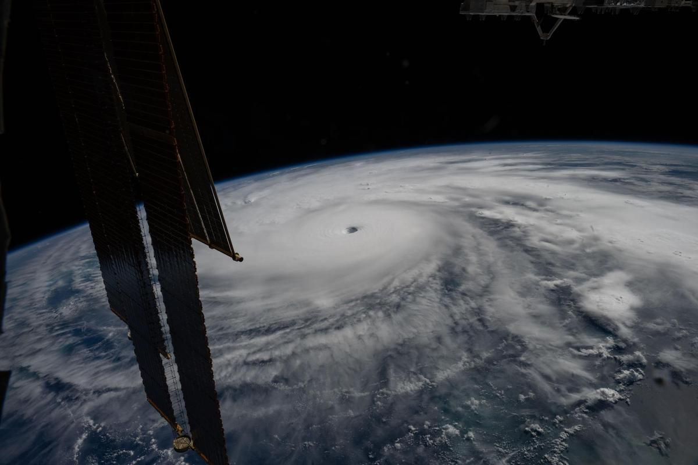
Hurricane Melissa is seen 50 miles south of Jamaica in this photograph taken from the International Space Station on Oct. 28, 2025. NASA Last November, NASA and its European partners launched the Sentinel-6B satellite to improve hurricane forecasts, help protect infrastructure, and benefit commercial industries, including shipping. The satellite now is flying 30 seconds behind its predecessor, Sentinel-6 Michael Freilich. Both satellites are providing precise sea level height measurements during what oceanographers expect to be a historic El Niño, a naturally occurring oceanic phenomenon in which warmer-than-usual Pacific waters shift global weather patterns. The two satellites make up the Copernicus Sentinel-6/Jason-CS (Continuity of Service) mission, the latest in a series of ocean-observing radar altimetry missions that have been monitoring Earth's changing seas continuously since the early 1990s. The data each satellite is collecting will not only allow scientists to better understand this year's El Niño but will also help them create more accurate hurricane predictions. "This El Niño was a late-bloomer," said Josh Willis, Sentinel-6B's project scientist at NASA's Jet Propulsion Laboratory in Southern California. "It didn't kick off until the middle of the year and is just now reaching a strength similar to what we've seen in the satellite record during significant El Niños in 1997 and 2015. We expect it to be big, and it's already having big impacts." El Niños generally scramble weather patterns tied to rainfall and storms, including hurricanes. They also redistribute heat in the ocean, which affects sea level. Normally, Earth's warmest ocean waters sit along the equator in the western Pacific. During El Niño, weakened winds, which usually blow westward along the equator, result in heat spreading east toward South America. The change in ocean heat shifts hurricane activity from the Atlantic to the Pacific Ocean. Predicting hurricane strength On July 15, Sentinel-6B began delivering low-latency data to scientists that could be used for weather predictions. That data will take some time to work its way into the research models on which meteorologists and climate scientists rely, but when it does, those improved models could save lives. Data from Sentinel-6 satellite missions feeds into hurricane tracking algorithms used by federal and state agencies. Those predictions can activate disaster response efforts, mobilizing resources ranging from sandbag placement to National Guard activation. They also can lead to evacuation orders that require quick but well-informed decisions about logistics at a local level. More severe events may require engaging larger organizations, such as the Federal Emergency Management Agency. A tropical storm can take a week or more to become a hurricane and make its way to a coastline, but a hurricane can rapidly intensify in the 48 hours prior to landfall, leaving planners little time to prepare. "Hurricanes have been known to speed up quickly at the last moment, so the window in which to decide what to do is short," said Deirdre Byrne, an oceanographer and altimetry expert with the National Oceanic and Atmospheric Administration (NOAA). "The goal is to forecast how much and how rapidly intensification will happen so that officials can make the right calls." Byrne oversees one of the country's most crucial hurricane forecasting algorithms, NOAA's Satellite Ocean Heat Content Suite, which has been operating since 2012. Each Sentinel-6 satellite measures ocean height, as well as the size of waves and marine wind speed, using a radar altimeter, which bounces thousands of radar pulses a second off the crests and troughs of waves. Ocean height varies from place to place and provides insight into the ocean's heat content, since warm water expands. That, in turn, helps forecast how fast hurricanes will grow. The satellites each carry a second instrument, called the Global Navigation Satellite System - Radio Occultation (GNSS-RO), which measures atmospheric properties, such as humidity, pressure, and temperature. Among the measurements Sentinel-6 is gathering, Byrne is most anticipating the ocean height data, which she plans to begin incorporating into the current Satellite Ocean Heat Content Suite algorithm by the end of the year. "In terms of data quality, the Sentinel-6 missions are unparalleled," Byrne said. Together, the missions are also extending a precise dataset deep into its fourth decade. This record of sea level observations traces back to the TOPEX/Poseidon mission, which launched in 1992, and continues through to the present day with Sentinel-6 Michael Freilich. Sentinel-6B will take over for its predecessor as the reference satellite for global sea level measurements later this year. "The key is consistency, measuring the same way, every time," said Severine Fournier, Sentinel-6B deputy project scientist, JPL. "That's what lets us predict hurricanes, and, in turn, protect coastal communities and infrastructure." More about Sentinel-6B Sentinel-6 Michael Freilich, named after a former director of NASA's Earth Science Division, is one of two satellites that compose the Copernicus Sentinel-6/Jason-CS mission. Sentinel-6/Jason-CS, a part of the European Union's Earth observation program called Copernicus, was jointly developed by ESA (European Space Agency), EUMETSAT (European Organisation for the Exploitation of Meteorological Satellites), NASA, and NOAA, with funding support from the European Commission and technical support on performance from the French space agency CNES (Centre National d'Études Spatiales). Spacecraft monitoring and control, as well as the processing of all the altimeter science data, is carried out by EUMETSAT on behalf of the European Union's Copernicus Programme, with the support of all partner agencies. NASA JPL, a division of Caltech in Pasadena, contributed three science instruments for each Sentinel-6 satellite: the Advanced Microwave Radiometer, the GNSS-RO, and the Laser Retroreflector Array. NASA also contributed launch services, ground systems supporting operation of the agency's science instruments, the science data processors for two of these instruments, and support for the United States members of the international Ocean Surface Topography Science Team. For more about Sentinel-6B, visit: https://science.nasa.gov/mission/sentinel-6B -end- Media Contacts Andrew Good / Andrew Wang Jet Propulsion Laboratory, Pasadena, Calif. 818-393-2433 / 626-379-6874 andrew.c.good@jpl.nasa.gov / andrew.wang@jpl.nasa.gov 2026-060

40. NASA Names Two Artemis II Astronauts to Emeritus Program
Read more
From left, NASA astronauts Victor Glover, Artemis II pilot, and Reid Wiseman, Artemis II commander, conduct leak checks on their spacesuits inside the crew suit-up room in the Neil A. Armstrong Operations and Checkout Building at the agency's Kennedy Space Center in Florida on Wednesday, April 1, 2026, ahead of the Artemis II test flight. Credit: NASA/Kim Shiflett Following their landmark Artemis II mission earlier this year, distinguished NASA astronauts Victor Glover and Reid Wiseman are transitioning in September to emeritus status at the agency's Johnson Space Center in Houston. In an emeritus role, individuals with a high degree of technical and professional knowledge can continue to support the agency by donating their time to train and mentor the current workforce. This allows the agency to maintain access to top talent in a specialized consultant role, while simultaneously providing the individual with the flexibility to pursue other opportunities. "I've had the privilege of knowing Reid and Victor for years, and both exemplify the leadership, character, and commitment that define NASA at its best." said NASA Administrator Jared Isaacman. "Reid commanded Artemis II after previously spending 165 days aboard the International Space Station, while Victor brought his experience as a naval aviator, test pilot, and Crew-1 astronaut to his role as pilot. Together, they took on one of the most challenging missions in human spaceflight and helped return America to the lunar environment. As Reid and Victor transition to emeritus status, I'm grateful they will continue sharing what they learned with our astronauts, flight controllers, and engineers as we prepare for Artemis III in 2027 and the missions that follow." Glover will support aerospace, leadership, and public service efforts as he transitions within and outside of NASA. He's committed to transferring his knowledge of Orion and its spacecraft systems, among other expertise, to future Artemis missions. "As I grow into this new role, NASA and spaceflight remain a meaningful part of my journey of service," said Glover. "I'm excited to keep uplifting my friends and cheering them on as they reach for the Moon. Together, we'll keep pushing boundaries and inspiring the next giant leap." Wiseman is set to share his spaceflight experience with colleagues ahead of the agency's Artemis III mission in low Earth orbit to test rendezvous and docking capabilities between Orion and commercial human landing systems. "There is no better place to work, and there are no better people to work with, than those in this agency," said Wiseman. "NASA gave me tremendous responsibility, supported me through two space missions, and my time as chief astronaut, and was always there for my family when we needed it most. I'm thrilled to continue serving future missions and programs through the emeritus program." "Reid and Victor's commitment to exploration, steady leadership, and service to our astronaut corps and our nation have made a lasting impact," said Vanessa Wyche, director of NASA's Johnson Space Center in Houston. "Throughout their careers, they have each brought excellence, humility, and purpose to every role they have held at NASA. Their contributions have helped advance our mission and inspire those around them, leaving a legacy that will continue to shape the future of human spaceflight. We are immeasurably grateful for all they have given to NASA and are glad that this is not the end of their journey with the agency." "Reid and Victor are trusted teammates whose professionalism, calm leadership, and unwavering commitment to NASA have strengthened our office and inspired everyone around them," said Scott Tingle, chief of the Astronaut Office at Johnson. "As they transition into their emeritus roles, they leave a legacy of operational excellence that will continue shaping the astronaut corps for years to come. We're grateful that they will still be part of our community, sharing their experience and insight as they begin this next chapter." Among their many accomplishments at NASA, as Artemis II crew members, Glover and Wiseman were two of the four astronauts to first launch on top NASA's SLS (Space Launch System) rocket aboard the Orion spacecraft for a mission around the Moon. Following a 10-day mission with crewmates NASA astronaut Christina Koch and CSA (Canadian Space Agency) astronaut Jeremy Hansen, they safely splashed down on April 10 as the first humans to travel to lunar orbit in more than 50 years, ultimately flying farther in space than anyone had before. Support and knowledge transfer from both Glover and Wiseman is critical for the upcoming Artemis III mission as NASA prepares to return American astronauts to the lunar surface on the Artemis IV mission in 2028. To learn more about NASA astronauts, visit: https://www.nasa.gov/astronauts -end- George Alderman / Cheryl Warner Headquarters, Washington 202-356-1600 george.a.alderman@nasa.gov / cheryl.m.warner@nasa.gov

41. Watch SpaceX launch classified mission for the US Space Force today
Read more
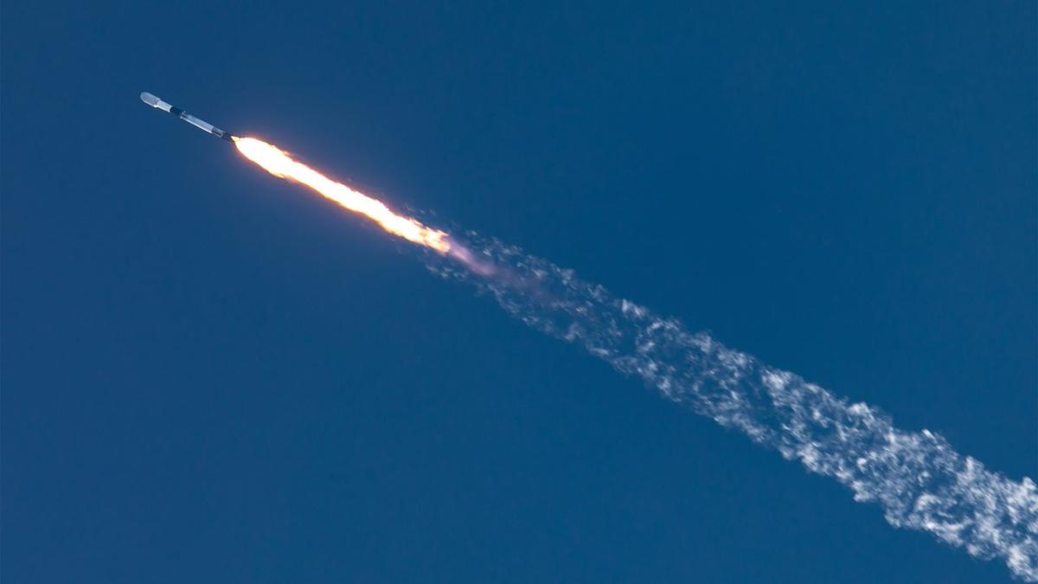
Click for next article A SpaceX Falcon 9 rocket launches the NROL-172 mission from California on May 11, 2026. SpaceX will launch a secret mission for the U.S. Space Force today (Sept. 10), and you can watch the action live. A Falcon 9 rocket is scheduled to lift off from California's Vandenberg Space Force Base today during a three-hour window that opens at 11:37 a.m. EDT (1537 GMT; 8:37 a.m. local time), kicking off a mission called USSF-153. You can watch live via SpaceX, starting about 10 minutes before launch. USSF-153 is a classified mission, so little is known about its payloads - what they are or where exactly they're headed. We likely won't get clarity from the webcast, which is expected to end shortly after the Falcon 9's first stage comes back to Earth. The booster will land in the Pacific Ocean atop a SpaceX drone ship about 8.5 minutes after liftoff. However, the location of that touchdown provides some potentially useful information about USSF-153, according to NextSpaceflight.com . The mission might be carrying "a batch of classified LEO [ low Earth orbit ] satellites for a U.S. government entity based on SpaceX's Starshield satellite bus, based on locations of rocket stage drop zones being exact fits with previous Starlink Group 15 launches," the outlet wrote. Starlink is SpaceX's constellation of LEO broadband satellites. "Starshield leverages SpaceX's Starlink technology and launch capability to support national security efforts," SpaceX wrote in a description of the Starshield program. Today's launch will be the 104th Falcon 9 mission of 2026. Eighty of the rocket's flights this year have been dedicated to building out the Starlink megaconstellation, which currently consists of more than 11,000 active spacecraft.

42. International Space Station astronaut gives out of this world tribute to honor Star Trek's 60th anniversary
Read more
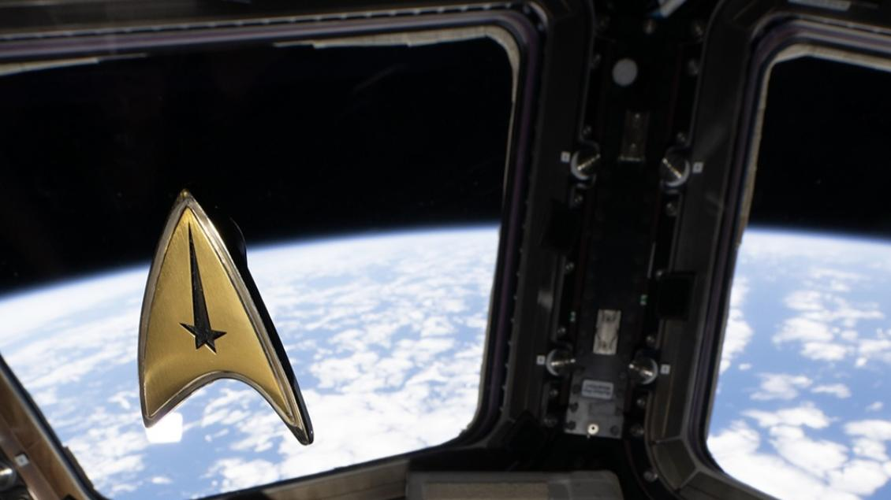
Click for next article Celebrations of Star Trek's 60th anniversary made it all the way to the final frontier. Among the science and supplies delivered to the International Space Station (ISS) for European Space Agency (ESA) astronaut Sophie Adenot's mission on orbit was a small piece of memorabilia to honor one of the most influential pop culture phenomena that has continually called for humanity to turn its gaze to the stars . Adenot carried a small Starfleet badge from one of Star Trek's newest series, Strange New Worlds, which she wore during a video posted by ESA and Star Trek . "It's a small object, but it carries something bigger: sixty years of a story that taught us to dream about exploring together," ESA said in a separate post picturing the golden badge floating in front of the station's large Cupola windows. "From the crew of the USS Enterprise to the crews on the International Space Station, the mission hasn't really changed. Explore. Discover. Do it together," the post says. Adenot launched to the ISS aboard a SpaceX Dragon capsule on NASA 's Crew-12 mission to the orbital lab on Feb. 13, and is serving as flight engineer for ISS Expedition 75. It's her first launch to space , and is set to wrap up soon, pending the launch and arrival of SpaceX's next Dragon spacecraft carrying the astronauts of NASA's Crew-13 mission, expected within just a few weeks. In Adenot's video, she is seen donning the Starfleet badge on her ESA-issue ISS shirt, floating in ESA's Columbus laboratory module. "For me, exploration and science are about curiosity and cooperation, daring to go a little farther together, learning from what we discover and build, and turning that knowledge into a better future for everyone," she said. Star Trek , too, has resonated with similar themes. Since its premiere on Sept. 8, 1966, the show has told stories that place social issues and cultural conflicts front and center in a way that 'demonstrates the best traits of humanity. It depicts, in its creator Gene Roddenberry's view, an idyllic version of humanity he believed was truly achievable through the act of simply accepting one another. A post shared by Star Trek (@startrek) A photo posted by on "The whole show was an attempt to say that humanity will reach maturity and wisdom on the day that it begins not just to tolerate, but to take a special delight in differences in ideas and differences in life forms," Roddenberry said in the 1976 album The Star Trek Philosophy. "If we cannot learn to actually enjoy those small differences - take a positive delight in those small differences between our own kind - here on this planet, then we do not deserve to go out into space and meet the diversity that is almost certainly out there." ESA celebrated that philosophy, and the potential it holds for humanity. "Science fiction imagines the future. We build it," ESA's post said. "From the crew of the USS Enterprise to the crews on the International Space Station, the mission hasn't really changed. Explore. Discover. Do it together."

43. NASA's newly launched Roman Space Telescope will 'directly' image exoplanets. But what does that mean?
Read more

Click for next article A brand new observatory began its tenure on Aug. 30 - it's called the Nancy Grace Roman Space Telescope, and it's equipped with a high-tech tool that can directly photograph planets beyond our solar system. The tool is called a coronagraph; in simple terms, a coronagraph is a device that can be affixed to a telescope and block out the light of a star the telescope is looking at to study features around that star. Without such a device, starlight can be so overpowering that it outshines details nearby. You can think of a coronagraph as a way to recreate a total solar eclipse, except instead of the moon blocking out the sun it's a humanmade mask of sorts that does that trick. But while coronagraphs have been used many times before, the one that just launched toward the stars is unprecedented. "The Roman Space Telescope is carrying the most advanced coronagraph that humanity has ever put into space," Dominic Benford, the telescope's program scientist, told Space.com. If you can remember the striking " Pale Blue Dot " image of Earth that NASA's Voyager 1 spacecraft captured while floating about 3.7 billion miles (6 billion kilometers) from the sun, this is the kind of thing scientists expect to see with Roman's coronagraph. A menagerie of Pale Brown Dots should soon make us feel the weight of our existence. "I love the feeling of smallness that comes from understanding you're not alone in the universe," Vanessa Bailey, Roman's coronagraph instrument scientist, told Space.com. Earth as a "pale blue dot" seen by Voyager 1 in 1990. (Image credit: NASA/JPL-Caltech) How does it work? Coronagraphs aren't really a new thing. Often, they're even used to study our own sun. For example, NASA's PUNCH mission - which stands for Polarimeter to Unify the Corona and Heliosphere - launched in 2025 and consists of four spacecraft, one of which holds a coronagraph. This coronagraph blocks out the light of our sun in order to reveal the wispy tendrils of the sun's outer atmosphere, or corona. "In fact, more than 100 years ago, astronomers used coronagraphs to create an artificial eclipse to study the sun's corona," Bailey said during a press briefing on Aug. 29, a day before Roman launched to space . "That's the reason for the name." But when it comes to other stars, coronagraphs hold another purpose. They can block out a star's light in such a way that planets actually orbiting that star come into view. "We can block that starlight until we have only a few parts per billion of the light of the star remaining," Benford said of Roman's coronagraph. As a result, he explained, "we can directly see the light bouncing off something like a Jupiter around another star, which we've never been able to do before." NASA's Solar and Heliospheric Observatory, or SOHO, constantly observes the outer regions of the sun's corona using a coronagraph, which blocks the bright solar disk. (Image credit: ESA/NASA/SOHO) This process will surely give us our Pale Brown Dots - but to take things a step further, scientists will also be able to dissect the light bouncing off the theoretical Jupiter to reveal what the atmosphere of the world is like, too. To be clear, Roman isn't the only astronomy tool we have that utilizes a coronagraph while looking beyond our solar system. Even the James Webb Space Telescope and Hubble Space Telescope have their own, for that matter. However, Roman's is far more complex . For one, the Roman's coronagraph doesn't exactly "block" out starlight like a standard coronagraph does. For the "moon" in its artificial eclipses, it uses a combination of patterned disks and special filters to create destructive interference with the light of a target star. Destructive interference means competing waves of light cancel one another out, leading to a zeroed amplitude. In effect, this blocks out the starlight as necessary and only allows light reflected off the planets of interest to pull through and reflect off the coronagraph's mirrors. A diagram showing what the disk's pattern might look like. (Image credit: NASA's Goddard Space Flight Center) The first active coronagraph Which brings us to the next special part about Roman's coronagraph: It's the first "active" coronagraph to fly in space. What this means is it can adjust those mirrors in real-time to make sure its exoplanet observations are as clear as possible. This is important because as light reflects off the coronagraph's mirrors, it can create small distortions that mess up the delicate destructive interference dance. You'd need to adjust to bring the balance back, and these adjustments are possible because Roman's coronagraph has hundreds of tiny pistons built into its mirrors. This makes them deformable so they can change shape to account for distortions. If it all works out, this coronagraph should be capable of detecting exoplanets that are about 100 million times fainter than their stars. "These deformable mirrors are a real engineering feat," Bailey said during the press briefing. "They can be commanded with the precision approaching the size of an atom, and this is what really allows us to make this transformative performance." The Roman Space Telescope's coronagraph as scientists were working on it. (Image credit: NASA/JPL-Caltech) As for what the specific hope is for Roman's coronagraph, Bailey explained there are a few nearby star systems the team is particularly interested in peering into because we have hints of Jupiter -like planets orbiting in those systems that still haven't been imaged. "Or," she said, "there may be really interesting remnants of dust and debris from the process of planet formation." Perhaps that dust could exist in the habitable zones of the stars Roman looks toward, and perhaps this could tell us more about the birth of planet Earth. "That is interesting in its own regard but also interesting as a precursor to the Habitable Worlds Observatory ," Bailey said, in reference to NASA's next great project that will be equipped with a more advanced version of Roman's coronagraph. "We can study how dusty these nearby systems are and understand whether any of them might have too much dust for us to be able to observe an Earth-like planet in the future." An animation shows what Roman looks like deploying in space. (Image credit: NASA's Goddard Space Flight Center Conceptual Image Lab) While Roman will pretty much be focusing on Jupiter-like worlds because they're big enough to be detected with its current capabilities, HWO could certainly find another Earth someday. From 6,000 exoplanets to 100,000 And before we wrap up, we must briefly mention this newly christened exoplanet hunter's partner tool, the majorly impressive Wide Field Instrument (WFI) that can survey huge swaths of sky in one go. It is because of the partnership between the WFI and its coronagraph that Roman will immensely expand our exoplanet gallery, says associate administrator for NASA's Science Mission Directorate Nicky Fox. The coronagraph won't be finding new exoplanets alone, but rather will be diving deeper into exoplanets the WFI finds first. The Roman Space Telescope's WFI. (Image credit: NASA/Chris Gunn) WFI will use two different techniques to contribute to our gallery. The first one is called the transit technique, and it's the same method big names like Kepler and TESS tapped into. It involves noticing dips in starlight that happen when a possible planet transits the face of a star from the telescope's vantage point. "If you see that happen multiple times," Fox said, "you can infer that it's a planet, and you can get the radius and the size of the planet from that observation." The second technique has to do with gravitational lensing, which refers to how objects with mass in space (and therefore gravitational influence) can warp the very fabric of spacetime and alter the path of light traveling through the affected region. What comes to mind might be a mighty galaxy cluster twisting spacetime like a sheet of satin, but little things like stars and planets can do it, too. The so-called "microlensing" effect of smaller objects warping spacetime leads to the brightening of background objects. Fox sums up WFI's two techniques in a nutshell: "If you see a little dip, that can suggest there's a transiting planet. You see a little brightening, that can suggest there's a microlensing planet." For WFI, the microlensing technique will be sensitive to Earth-size planets in the habitable zones of their stars, while the transiting technique will be more sensitive to planets closer to their stars. And as Bailey reminds us, there are absolute heaps of planets to test Roman out on: "When you look up at the night sky, most of those stars have planets."

44. China on track to launch Mars sample-return mission in 2028: 'If accurate, this represents a Sputnik moment'
Read more

Click for next article Both China and the United States aim to haul pristine samples of Mars to Earth in the coming years. China is making progress on its Tianwen 3 Mars sample return mission, which aims to bring back to Earth roughly 500 grams (17.6 ounces) of Red Planet collectibles in 2031. According to the China National Space Administration, the Tianwen 3 mission will have a lander, an ascender, a service capsule, an orbiter and an Earth reentry module. If all goes to plan, Tianwen 3 will launch in 2028 on two Long March 5 heavy-lift rockets from the Wenchang Space Launch Site on the island of Hainan, China's southernmost province. Sputnik moment "The Tianwen 3 mission is progressing smoothly, with intensified efforts being made to overcome technical challenges," Hou Zengqian, the mission's chief scientist, recently told CCTV, a state-run Chinese broadcaster. "The probe equipment has entered the prototype development phase, and scientifically, many scientist teams from across the country are working together to tackle the challenges in accordance with the mission's scientific objectives," Hou added. Meanwhile, NASA's plans for hauling Mars samples to Earth are murky at the moment . So China appears to be in the lead to notch a major space milestone. "If accurate, this represents a Sputnik moment ," said former NASA "Mars Czar" Scott Hubbard, referring to the reported Tianwen 3 progress. "China will not only grab the headlines but may be the first to find evidence of life on another planet ," Hubbard, who also previously directed NASA's Ames Research Center in Silicon Valley, told Space.com. Diagram of China's Tianwen 3 Mars sample return mission. (Image credit: The University of Hong Kong/Zengqian Hou, et al.) Top scientific priority "The Tianwen 3 mission will look for microbial traces potentially similar to early forms of life on Earth , while also taking into consideration the possibility of unknown forms of life that may have emerged through Mars' unique evolutionary history, providing crucial evidence to answer this major scientific question," Hou told the state-run Xinhua news agency in a recent interview . Searching for potential signs of life on Mars is the top scientific goal of the Tianwen 3 mission, Hou said on Sept. 3 during the 2026 International Deep Space Exploration Conference on, which was held in Hefei, the capital of eastern China's Anhui Province. Landing site China's Mars sample-return trek will be launched "around 2028" on two Long March 5 rockets departing from the Wenchang Space Launch Site in China's southernmost island province of Hainan. (Launch windows for Mars missions come around just once every 26 months. The next one opens in November-December of this year, and the one after that, which Tianwen 3 apparently is targeting, runs from December 2028 to January 2029.) Hou also said China expects to finalize the landing site for the mission by the end of 2026, with Chinese specialists advancing work on a next-generation geological map of Mars in its entirety. If everything goes according to plan, the mission will collect samples from the Martian surface and then send them back to Earth around 2031. "Regardless of whether signs of life are found, the returned Martian samples will have irreplaceable scientific value," Hou said. Tackle the challenges Hou added that analyses of the returned samples at microscopic, molecular and isotopic scales could deepen our understanding of Mars' geology and environment, as well as the evolution of habitability and the conditions under which life may originate. According to Hou, Mars sample return is an extremely complex project, with landing-site selection, planetary protection and contamination control, and the identification of potential signs of life among its key challenges. Chinese Mars researchers are selecting candidate landing sites for the mission based on factors that include geological age, history of water activity, habitability and the potential for preserving biosignatures . Planetary protection lab Xinhua reported last month that a " planetary protection laboratory" is to be built in the first phase of Hefei's Deep-Space Science City in east China's Anhui Province, citing the Deep Space Exploration Laboratory (DSEL). "The planetary protection laboratory will implement a two-way protection system that guards both the returning Martian samples and Earth's biosphere," Xinhua reports. The lab's tasks encompass sample sterilization, unsealing, processing and biological risk assessment. "The facility is designed to support the implementation of major deep-space missions and to enable scientific research on Martian samples," added Xinhua. China "will follow the planetary protection policies of the Committee on Space Research, to prevent biological contamination of Mars by terrestrial organisms and to protect Earth from any potential extraterrestrial life forms that may be carried back in the samples," said Li Hang, director of the development planning department at DSEL, according to Xinhua.
45. EOS-06/Oceansat-3 detects impact of the developing El Niño on Marine Productivity in the Equatorial Pacific Ocean - isro.gov.in
Read more
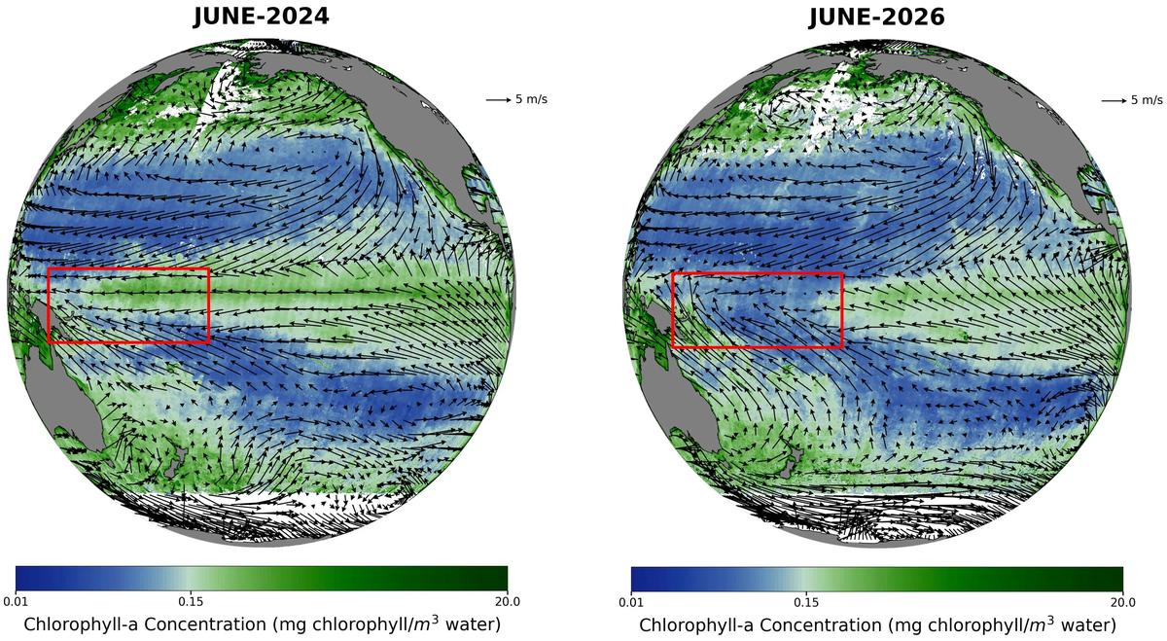
September 10, 2026 The El Niño-Southern Oscillation (ENSO) is a major global climate phenomenon occurs in the tropical Pacific Ocean, characterised by alternating phases of anomalous warming (El Niño) and cooling (La Niña). These large-scale changes in the tropical Pacific can influence weather and climate patterns across the globe. During El Niño, weakened equatorial trade winds and a deepening thermocline reduce the upward transport of cool, nutrient-rich waters from the subsurface. With fewer nutrients reaching the sunlit upper ocean, phytoplankton growth can be suppressed, resulting in lower concentrations of surface chlorophyll-a and, consequently, reduced marine productivity. To better understand the evolution of ENSO during 2026, ISRO's National Remote Sensing Centre (NRSC) analysed observations on Chlorophyll-a measurements from the Ocean Colour Monitor-3 (OCM-3) combined with ocean-surface wind vector observations from the EOS-06 Scatterometer across the tropical Pacific for April, May and June during 2023-2026. A comparison of the June 2024 and June 2025 composites, representing neutral ENSO conditions, with June 2026 observations during the developing El Niño reveals a notable reduction in surface chlorophyll-a. This decline coincides with a reversal of ocean-surface winds-from easterlies, which blow from east to west, to westerlies, which blow from west to east. This weakening and reversal of the prevailing winds suppresses the normal equatorial upwelling across parts of the western and central equatorial Pacific. The resulting reduction in the supply of nutrient-rich subsurface waters is reflected in the observed decline in surface chlorophyll-a. The apparent contraction of the westward extent of the elevated-chlorophyll region between April and June 2026 further supports the weakening of equatorial upwelling as the El Niño event developed. This synergistic application of multi-sensor data from both OCM-3 and Scatterometer sensors of EOS-06 conforms the strong biophysical coupling in the equatorial Pacific Ocean during the ongoing ElNino event. If this El Niño intensifies further as forecasted, the low-chlorophyll region may become more pronounced with time. This should be further inferred with concurrent estimates of anomalies in equatorial winds, sea-surface temperature, sea-level height, thermocline depth, and ocean circulation in the coming months. The observations from EOS-06/Oceansat-3 also complement the World Meteorological Organization (WMO) outlook. In its June 2026 El Niño/La Niña update, the WMO estimated an approximately 80% probability of El Niño conditions developing during June-August 2026, with several forecast models indicating the possibility of a strong event. By late July, the WMO reported that El Niño conditions were intensifying and were expected to strengthen during August-October 2026. Satellite observations from EOS-06/Oceansat-3 reveal a clear decline in marine productivity associated with the developing El Niño conditions across the equatorial Pacific Ocean.

46. Is ISRO moving towards privatisation? Chief V. Narayanan responds - The Hindu
Read more
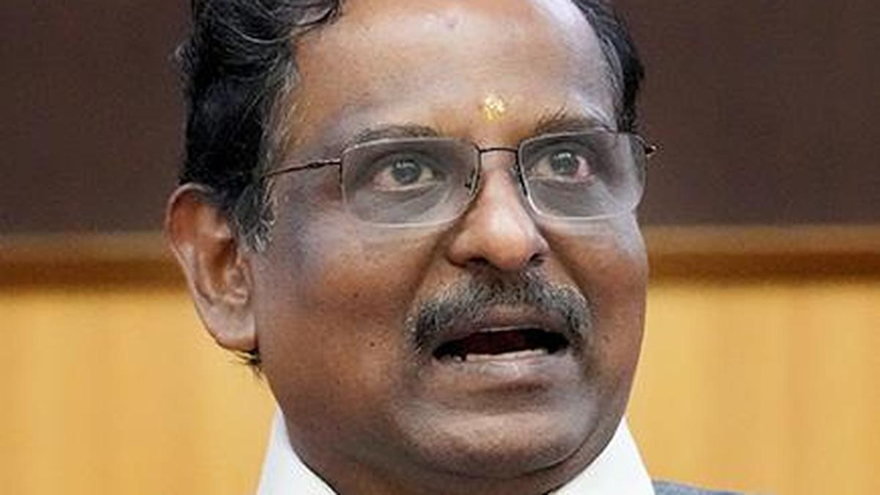
Is ISRO moving towards privatisation? Chief V. Narayanan responds The Hindu

47. ISRO Successfully Tests CE20 Engine At 220 KN For LVM3 Mission - Sarkaritel.com
Read more

ISRO has successfully conducted a 220 kN flight acceptance hot test of the CE20 cryogenic engine at its Mahendragiri facility in Tamil Nadu. The engine is earmarked for the C32 upper stage of an upcoming LVM3 mission. The test also successfully demonstrated the LOX Tank Pressurization Module for future Gaganyaan missions. Key Highlights ISRO successfully hot-tests CE20 cryogenic engine at 220 kN uprated thrust. uprated thrust. Engine is designated for the C32 upper stage of an upcoming LVM3 mission . . Test also demonstrated the LOX Tank Pressurization Module for Gaganyaan. The test strengthens India's capabilities in advanced launch and human-spaceflight systems. New Delhi, Sept 10: The Indian Space Research Organisation (ISRO) has successfully conducted a flight acceptance hot test of its CE20 cryogenic engine at an uprated thrust of 220 kN, marking another important milestone ahead of an upcoming LVM3 mission. The test was carried out on September 9, 2026, at the ISRO Propulsion Complex (IPRC), Mahendragiri, Tamil Nadu. The engine tested is earmarked for the C32 upper stage of the mission. The CE20 test at 220 kN thrust was conducted to validate the engine's performance under uprated operating conditions before its flight assignment. The successful demonstration adds to ISRO's efforts to qualify and operationalise advanced propulsion systems for heavier launch missions. The LVM3 remains one of India's key launch vehicles for carrying heavier payloads and plays an important role in the country's expanding space programme. During the same test, ISRO also successfully demonstrated the performance of the LOX Tank Pressurization Module (LTPM) intended for C32 stages associated with the Gaganyaan human spaceflight programme. The successful validation of the module represents an additional milestone for technologies supporting India's human spaceflight ambitions. Reliable cryogenic propulsion and associated systems are critical to the performance and safety requirements of complex launch missions. The latest hot test comes as ISRO continues to expand India's capabilities across next-generation launch systems, human spaceflight, lunar and planetary exploration and the planned Bharatiya Antariksh Station. India's space-sector reforms are also aimed at creating a broader national ecosystem in which private companies, startups and academic institutions contribute alongside ISRO. While industry participation is expanding, the space agency is increasingly focusing on advanced research, frontier technologies and complex national missions, making successful propulsion qualification an important part of India's long-term space ambitions. The successful 220 kN CE20 hot test strengthens ISRO's propulsion readiness for LVM3 missions while advancing technologies supporting Gaganyaan and India's future human-spaceflight programme.

48. ISRO Admit Card 2026 For UDC, PA and Stenographer, Hall Ticket Link - Adda247
Read more
ISRO Admit Card 2026 For UDC, PA and Stenographer, Hall Ticket Link Adda247

49. ISRO Satellite Captures El Niño's Impact on Pacific Ocean - Deccan Chronicle
Read more

Nellore:India's EOS-06/Oceansat-3 satellite has captured clear signs of the developing El Niño and its impact on marine productivity across the tropical Pacific Ocean, offering fresh insights into the complex relationship between ocean winds, upwelling, and climate. An analysis by the National Remote Sensing Centre (NRSC) of ISRO, using data from the satellite's Ocean Colour Monitor-3 (OCM-3) and Scatterometer sensors, has revealed a marked decline in surface chlorophyll-a concentration during June 2026, compared with observations from neutral ENSO (El Niño-Southern Oscillation) years. The decline in chlorophyll-a-a key indicator of phytoplankton abundance and marine productivity-has coincided with a dramatic shift in ocean-surface winds. The prevailing easterly winds have weakened and reversed to westerlies, disrupting the normal equatorial upwelling that brings nutrient-rich waters from the ocean depths to the surface. The satellite observations show that the region of elevated chlorophyll-a progressively contracted westward between April and June 2026, providing further evidence of weakening equatorial upwelling as El Niño developed. According to ISRO, the combined observations from OCM-3 and the EOS-06 Scatterometer demonstrate strong coupling between atmospheric winds and biological processes in the equatorial Pacific. If El Niño intensifies further, as forecast, the low-chlorophyll region could become increasingly pronounced. ISRO said on Thursday that the satellite observations complement the World Meteorological Organization's outlook, which had estimated an 80 per cent probability of El Niño conditions developing during June-August 2026. By late July, the WMO reported that the event is intensifying and is expected to strengthen further during August-October. The findings underline how India's space-based ocean-monitoring capabilities are helping scientists track not only atmospheric and oceanic changes, but also their consequences for marine ecosystems and global climate.

50. ISRO successfully tests cryogenic engine for next LVM3-M7 mission - MillenniumPost
Read more
Bengaluru: ISRO on Thursday said it had successfully conducted the flight acceptance hot testing of the cryogenic engine identified for the seventh operational mission of the LVM3 launch vehicle (LVM3-M7), scheduled for the fourth quarter of 2026. The same test demonstrated the performance of a LOX Tank Pressurisation Module (LTPM) designed for the C32 stage, an upgraded cryogenic upper stage planned for India's Gaganyaan missions, it said. The Gaganyaan project aims to demonstrate India's human spaceflight capability by carrying a 3-member crew to a 400-km orbit for a 3-day mission and safely returning them to Earth, with a landing in Indian sea waters. The test was conducted on Wednesday at the Main Engine and Stage Test Facility (MET) at the ISRO Propulsion Complex (IPRC), Mahendragiri. LVM3, formerly known as GSLV MkIII, is ISRO's heaviest rocket and uses the CE20 cryogenic engine to power its upper stage. "Cryogenic engines for every mission undergo hot testing as part of their acceptance for flight. To conduct hot testing of this upper-stage engine under sea-level conditions, despite its nozzle being designed for high-altitude operations, a Nozzle Protection System (NPS) was developed and previously validated through multiple qualification tests," ISRO said in a post on its website.

51. NASA Invites Media to Djibouti Artemis Accords Signing Ceremony
Read more
Credit: NASA The Republic of Djibouti will sign the Artemis Accords during a ceremony at 11 a.m. EDT, Monday, Sept. 14, at NASA Headquarters in Washington, becoming the 72nd country signatory. NASA Deputy Administrator Matt Anderson will host Ambassador of Djibouti to the United States Mohamed Siad Douale for the ceremony, together with U.S. State Department Assistant Secretary for African Affairs Frank Garcia. This event is in person only. Media interested in attending must RSVP no later than 8 a.m. on Sept. 14 to: hq-media@mail.nasa.gov. NASA's media accreditation policy is online. In 2020, during the first Trump Administration, the United States, led by NASA and the State Department, joined with seven other founding nations to establish the Artemis Accords, responding to the growing interest in lunar activities by both governments and private companies. The accords introduced the first set of practical principles aimed at enhancing the safety, transparency, and coordination of civil space exploration on the Moon, Mars, and beyond. Learn more about the Artemis Accords at: https://www.nasa.gov/artemis-accords -end- Camille Gallo / Elizabeth Shaw Headquarters, Washington 202-358-1600 camille.m.gallo@nasa.gov / elizabeth.a.shaw@nasa.gov

52. NASA's Life-Saving Technology Where Cell Signals Can't Go
Read more

Memorial Day weekend 2024 started with a blue sky and a mild three- to four-foot chop in the water off the Gulf Coast of Mississippi - a perfect day for a fishing competition. A team of five was about 40 miles offshore checking their sonar, and 30 seconds later the boat was gone. They were in the water struggling to pull on life jackets and grab the coolers as they bobbed up. When a boat sinks, survivors can be virtually invisible amid the vast expanse of water. When their fishing trip went wrong, Easton Barrett had the only mobile phone and no cell service. He recorded a brief farewell, planning to put his phone in a cooler in hopes someone would find it. Another team member activated a personal locator beacon (PLB) that had been stowed at the last minute, which sent a distress signal to the Search and Rescue Satellite-Aided Tracking (SARSAT) technology carried by multiple satellites in Earth orbit. In the SARSAT system, developed partly by NASA, an emergency signal containing the transmitter's location is directed to the nearest available ground station. 406 megahertz is the wavelength dedicated for PLB distress signals. On the annual 406 Day, Easton Barrett posts videos and messages on his social media accounts to help raise awareness about essential survival gear. Credit: ACR A mission control center then alerts rescue coordination centers to mobilize search and rescue crews. For Barrett and his crew, that was a Florida Coast Guard boat. "Ever since, I have tried to teach others about safety on the water and in the outdoors by using a PLB," said Barrett. "If that will save one life, it's worth the effort." A beacon like the one that saved his crew, a registered ResQLink PLB developed by ACR Electronics Inc. of Fort Lauderdale, Florida, also notifies the device owner's emergency contact, indicating a distress call was activated. All emergency beacons must meet the same requirements to ensure they work when needed. Every rugged, buoyant, handheld devices have a five- to 10-year battery life. SARSAT began operations in 1982, becoming an international collaboration in 1985. The flight and ground technologies used globally were originally developed at NASA's Goddard Space Flight Center in Greenbelt, Maryland. Now there are 62 satellites in the program and 45 nations contributing services, from operating ground stations to providing rescue crews. More than 63,000 lives have been saved. Turning on a ResQLink View PLB from ACR Electronics will automatically "ping" orbiting satellites that send location and GPS information to the nearest search and rescue station. Whether on land or water, the appropriate resources will be dispatched to help anyone in distress anywhere in the world. Credit: ACR SARSAT by the Numbers The Search and Rescue Satellite-Aided Tracking system developed over several decades by NASA and other government agencies saves lives on land or at sea. 1982 - the start of U.S. operations 1985 - the start of international operations 62 operational satellites 45 nations contributing services 63,000+ lives saved One rescue in 2024 demonstrates how it all comes together. 40 miles off the Mississippi Gulf Coast 5-person team participating in a fishing competition 30 seconds for a boat to sink 200 pounds of bait dumped to make a cooler buoyant 3 close encounters with wildlife, likely sharks and eels 4 hours in the water 1 personal locator beacon 1 Coast Guard rescue boat 5 lives saved

53. NASA, NFL Team Up to Showcase Space, Aeronautics Innovation
Read more
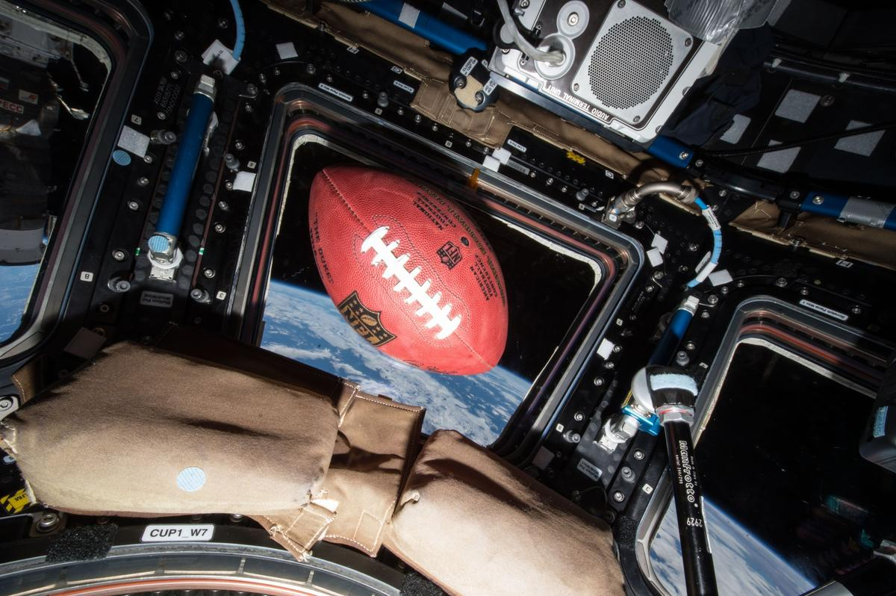
A football floats in microgravity aboard the International Space Station, high above the Earth. Credit: NASA Through a new collaboration between NASA and the National Football League (NFL), the agency will soon bring America's strengths in space exploration and aeronautics innovation to the football field. NASA will conduct flyovers, astronaut appearances, and fan engagement at NFL games across the United States as part of its new Inspiration Tour. "This is the first season NASA is taking part in flyovers at NFL games, bringing the excitement of America's space program directly to fans across the country," said NASA Administrator Jared Isaacman. "We're returning to the Moon, building a Moon Base, advancing fission-powered spacecraft, and pushing the boundaries in aeronautics, science, and discovery. Achieving those ambitions will take the very best of America, and partnering with the NFL gives us an incredible platform to inspire the next generation to look up and imagine the possibilities." NASA participation is targeted for the following games. Additional details will be released prior to each game, and more dates may be added: 1 p.m., Sunday, Sept. 13: Pittsburgh Steelers vs. Atlanta Falcons in Pittsburgh 1 p.m., Sunday, Sept. 20: Baltimore Ravens vs. New Orleans Saints in Baltimore 1 p.m., Sunday, Oct. 4: Philadelphia Eagles vs. Los Angeles Rams in Philadelphia 1 p.m., Sunday, Oct. 11: New York Jets vs. Cleveland Browns in East Rutherford, New Jersey Flyovers scheduled at some of the games will showcase NASA's fleet of aircraft, which are used for high-speed testing, high-altitude research, astronaut training, and more. Regularly flying the aircraft maintains the health of the fleet and publicly demonstrates new technologies that may be applied to future commercial air travel. With stops across the nation and led by Isaacman, NASA's Inspiration Tour convenes academic, industry, and public sector stakeholders to connect the agency with the people, technologies, and organizations that drive American leadership in space. The tour will culminate in MAX POWER, a public exposition of American air and space innovation, Nov. 7 and Nov. 8, on and near the agency's Kennedy Space Center in Florida. Held in honor of America's historic 250th anniversary, the multi-day, family-friendly event will showcase the next-generation aircraft, spacecraft, autonomous vehicles, and technologies that will help define the future of transportation in air and space. For more information about MAX POWER and the agency's missions, visit: https://www.nasa.gov/maxpower -end- Camille Gallo / Jessica Taveau Headquarters, Washington 202-358-1600 camille.m.gallo@nasa.gov / jessica.c.taveau@nasa.gov

54. On this day in space! Sept. 10, 2011: NASA launches GRAIL probes to the moon to map lumpy lunar gravity
Read more
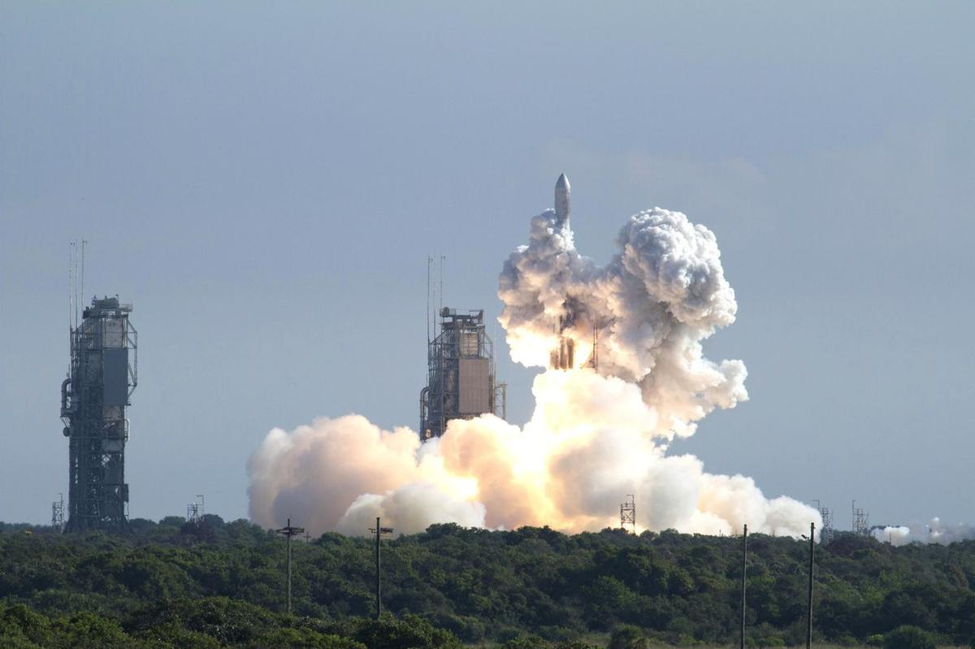
Click for next article On Sept. 10, 2011, NASA's GRAIL spacecraft launched on a mission to the moon! GRAIL, which stands for Gravity Recovery and Interior Laboratory, was sent to the moon to map its gravitational fields . Scientists could study the moon's interior structure by looking at maps of the moon's gravity. Asteroid impacts from billions of years ago left dense pockets of material under the lunar surface, which can exert extra gravitational pull on spacecraft orbiting the moon . So by measuring that gravitational pull, the GRAIL mission could reveal information about what lies beneath the surface. The mission actually consisted of two twin spacecraft named Ebb and Flow , which would fly in tandem around the moon to map variations in its gravitation field. Both lifted off on the same Delta II rocket from Cape Canaveral, Florida and arrived in lunar orbit almost four months later. They mapped the moon for about nine months before NASA decided it was finished with the mission, and the two orbiters crashed into the moon . A Delta II rocket launches NASA's twin Gravity Recovery and Interior Laboratory (GRAIL) mission to the moon from Cape Canaveral Air Force Station in Florida on Sept. 10, 2011. (Image credit: NASA/Kenny Allen) Why it mattered The moon is a weird place. It may look like a cold, gray ball of solid rock, but its density varies from location to location due to odd "mass concentrations" (or mascons for short) buried under the lunar surface. That leads to a strange, lumpy gravity that's not uniform across the lunar surface. That's where GRAIL's Ebb and Flow probes came in. Each of the twin spacecraft carried three instruments to map the interior of the moon . Those included a Lunar Gravity Ranging System, a Radio Science Beacon and a camera called MoonKam Lunar-Imaging system. Together, the instruments mapped the mascons on the moon in extreme detail to monitor where lunar gravity increased from the norm. Astronomers had long suspected that mascons on the moon and other planets formed during violent asteroid impacts. Image 1 of 2 Artist's concept of NASA's Grail mission. Grail's twin spacecraft are flying in tandem orbits around the moon to measure its gravity field in unprecedented detail. (Image credit: NASA/JPL) A visualization created using data from NASA's GRAIL spacecraft shows differences in the moon's gravity field. (Image credit: NASA/JPL-Caltech/MIT/GSFC) Image 1 of 2 View Original Image 2 of 2 View Original "GRAIL data confirm that lunar mascons were generated when large asteroids or comets impacted the ancient Moon when its interior was much hotter than it is now," Jay Melosh, a GRAIL co-investigator at Purdue University, said in a NASA overview . The MoonKam tool was actually a student experiment (MoonKam is short for Moon Knowledge Acquired by Middle School Students). It was built by undergradutate students at the University of California, San Diego in partnership with the Sally Ride Science foundation to encourage younger students to study science and space. (The names Ebb and Flow as GRAIL probe names were also suggested by 4th grade students at Emily Dickinson Elementary School in Bozeman, Montana, as part of a national competition.) The $496 million GRAIL probes orbited the moon in an extremely low orbit, coming within 30 miles (50 km) of the lunar surface at their closest approach. They were separated from each other at distances that ranged from 109 miles to 140 miles (175 km to 225 km). NASA crashed the GRAIL probes into the moon on Dec. 17, 2012 once its fuel reserves reached the point that it could not maintain its low lunar orbit. They crashed into a crater rim near the moon's north pole to prevent them from randomly crashing uncontrolled into someplace like an historic Apollo moon landing site . Want more space history? Check out our full On This Day In Space Story archive and watch our On This Day In Space videos on YouTube .

55. LINK spacecraft gets close to NASA's Swift Observatory, but not close enough to save it
Read more

Click for next article A solar panel on Katalyst Space's LINK robotic servicing spacecraft is seen in orbit, in this image captured by one of LINK's cameras on August 24, 2026. LINK, the satellite sent to boost the orbit of NASA's Swift Observatory, may have had to give up on its mission, but LINK's manufacturer and operator Katalyst Space hasn't completely abandoned the spacecraft to its cosmic demise. NASA called off LINK's mission to rendezvous with its Neil Gehrels Swift Observatory when the specialized probe encountered a thruster control issue. LINK was delivered to orbit on July 3, aboard an air-launched Northrop Grumman Pegasus XL rocket, but began to spin uncontrollably about three weeks after reaching space. Swift's orbit began decaying faster than expected last year, due to increased solar activity, and LINK was designed to rendezvous with Swift, grapple it, and then raise the observatory to a more stable altitude. LINK's Swift Boost mission was considered a "Hail Mary" attempt from its onset. NASA's discovery of Swift's swiftly decaying orbit meant the Arizona-based Katalyst had less than a year to design, manufacture and test LINK before needing to launch. Now, with both of their missions on the short-track for destruction, NASA and Katalyst are left both trying to get the most out of their spacecraft with the time each has left. LINK's failure means Swift is destined to burn up in Earth's atmosphere before the end of the year, and LINK itself is expected to fall to the same fate within just the next few weeks. But the probe's inability to save Swift hasn't stopped Katalyst from getting as much data from LINK as it can . Though a closer rendezvous is no longer in the cards, the spacecraft managed to successfully fire all three of its electric propulsion thrusters and adjust its orbit to fly within 7.5 to 9 miles (12 to 15 kilometers) of Swift. Katalyst was also able to deploy all three of LINK's robotic arms, which would have been used to grapple Swift for its orbital adjustment. Swift launched in November 2004, and has been studying high-energy phenomena like gamma-ray bursts , supernovas, black-hole ejections and fast radio bursts across the universe for more than 20 years. Despite its impending demise, two of Swift's three science instruments - its X-ray Telescope (XRT) and Ultraviolet/Optical Telescope (UVOT) - were turned back on in late August after being shut down in February to minimize atmospheric drag on the spacecraft in anticipation of LINK's now defunct orbital boost efforts. With the option for LINK to raise Swift's orbit now off the table, Katalyst and NASA are working to perform whatever technology demonstrations are possible aboard the spacecraft, in the hopes the technology can be used to service other satellites on missions in the future.

56. What comes after the moon? Artemis II commander and pilot shift to 'emeritus' status at NASA
Read more
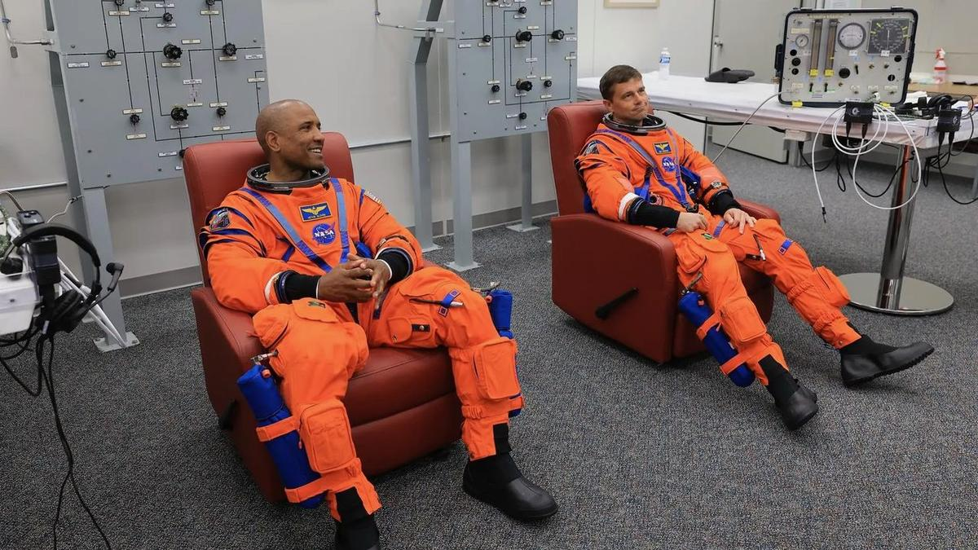
Click for next article From left: NASA astronauts Victor Glover, Artemis II pilot, and Reid Wiseman, Artemis II commander, conduct leak checks on their spacesuits at NASA's Kennedy Space Center in Florida on April 1, 2026, ahead of the Artemis II launch. Three of NASA's Artemis II astronauts are starting off the school year with new assignments. Artemis II commander Reid Wiseman and pilot Victor Glover , both NASA astronauts, will transition into "emeritus status" in September, the space agency announced on Wednesday (Sept. 9). Meanwhile, Canadian mission specialist Jeremy Hansen shared a video on X on Tuesday (Sept. 8) concerning his already-announced transfer from active duty to reserve status in the Canadian military. The fourth Artemis II astronaut, NASA mission specialist Christina Koch , appears to still be on active duty, as no announcements have been made saying otherwise. The Artemis II quartet flew around the moon in April, becoming the first people to go beyond low Earth orbit since 1972. The historic journey was widely expected to be the last step in active astronaut duty for at least some of the mission's four astronauts, especially Hansen, who had waited for a flight assignment for 17 years in part due to how Canadian Space Agency funding is allocated. (Robotics provided by the CSA form a minority share of international space partnerships with NASA, and astronaut flight rates are tied to funding.) The Artemis II astronauts made a series of public appearances together this summer, culminating on Aug. 28 when President Trump awarded them the Congressional Space Medal of Honor . Hansen was only the second non-American to receive the award, which had previously been given to just 30 astronauts total. While NASA's Wednesday announcement about Glover and Wiseman did not explicitly state that the duo are exiting active astronaut duty, their new role is described as allowing the astronauts to assist NASA as consultants and "individuals with a high degree of technical and professional knowledge," while allowing them to do other things. The two astronauts are expected to help NASA plan future Artemis program missions. "I'm grateful they will continue sharing what they learned with our astronauts, flight controllers and engineers as we prepare for Artemis III in 2027 and the missions that follow," NASA administrator Jared Isaacman said in the statement. From left: The Artemis II crew - NASA astronaut Christina Koch, Canadian Space Agency astronaut Jeremy Hansen, and NASA astronauts Reid Wiseman and Victor Glover - take time out for a group hug inside the Orion spacecraft on April 6, 2026. (Image credit: NASA) Glover, who also retired from the U.S. Navy recently, will now assume a full-time role at his alma mater, California Polytechnic State University in San Luis Obispo, which has aerospace and space programs. The news was announced by the university on Wednesday, but the position took effect on Sept. 1. Glover will be an administrative leader providing advice to senior leadership on education, research and workforce strategies, according to Cal Poly. "The most meaningful moments of my NASA career were supporting astronauts and their families through missions, and mentoring interns and new hires as they began their own journeys in technical and public service," Glover wrote Wednesday in a post on X about the career change. Wiseman did not share any specific updates about his career plans on social media. The astronaut also exited active astronaut duty temporarily between 2020 and 2022 when he was chief of the astronaut office for NASA, a role that precludes flying in space as the chief is involved in flight assignments. Wiseman left that role and resumed active astronaut duty before being assigned to Artemis 2, which occurred shortly before the public announcement of the mission's crew in April 2023 . "NASA gave me tremendous responsibility, supported me through two space missions - and my time as chief astronaut - and was always there for my family when we needed it most," Wiseman said in the NASA statement about his career change. "I'm thrilled to continue serving future missions and programs through the emeritus program." The mission continues! pic.twitter.com/2R6Dwb63bSSeptember 8, 2026 Hansen's Artemis 2 duties officially concluded on Sept. 2, according to his X account, and the astronaut - who has been based out of Houston since 2009 - posted a new video of himself Wednesday walking in the woods in Canada. Hansen said he has retired as a colonel with the Royal Canadian Air Force and is now a reservist working with 3 Canadian Space Division, which is essentially Canada's Space Force . "The intention of that is to continue to serve Canada and government - the Canadian Space Agency - when it makes sense, to help us take advantage of some of the extraordinary opportunities that are before us right now," Hansen said in the video, adding that he will divulge more details about that work shortly. Hansen also said he accepted a role as honorary national president with the Canadian military's Air Cadet League of Canada, which the astronaut has often said helped equip him with both flying and leadership skills when Hansen was growing up.
57. CM Adityanath orders immediate repair of rain and flood-damaged roads across UP
Read more

- Governance - 2 min read Chairing a review meeting of the Public Works Department on Friday, UP CM Adityanath said, "The rains are continuing. Therefore, the condition of roads should be continuously monitored and a survey should also be conducted of roads newly damaged due to rain. - PTI - Published On Sep 11, 2026 at 03:59 PM IST Select ETGovernment as Preferred Choice on Google Copy Link Share on WhatsApp Share on Linkedin Share on X Share on Telegram Share on Facebook "Roads are directly connected with the everyday life of common people. Roads near educational institutions, hospitals, main markets, government offices, and other places with heavy public movement should be taken up on priority," UP CM Adityanath said. Uttar Pradesh Chief Minister Yogi Adityanath on Friday directed officials to immediately repair roads damaged by rain and floods and make them motorable, while undertaking permanent renewal of roads wherever required after the monsoon. Chairing a review meeting of the Public Works Department on Friday, he said, "The rains are continuing. Therefore, the condition of roads should be continuously monitored and a survey should also be conducted of roads newly damaged due to rain. Advt "A large number of people will travel during the upcoming festivals. Therefore, there should be no difficulty whatsoever in movement on major roads." Adityanath directed that necessary repair and renewal works be completed before the festivals. The chief minister said the campaign to make roads pothole-free should not be limited to patchwork. "Wherever a road is currently in a poor condition, it should be made motorable now and, after the monsoon ends, permanent renewal should be undertaken as required," he said. It was informed in the meeting that besides excessive rainfall, several roads have also been damaged due to heavy vehicle movement linked to ongoing construction projects on expressways, national highways and railways, among others. The department is conducting surveys of such routes and will identify damaged roads based on the findings and set department-wise targets to make them pothole-free, the state government said in a statement. In view of the upcoming festivals, 681 important routes have been identified for priority attention. These include roads witnessing increased movement during Ganesh Chaturthi, Vishwakarma Puja, Navratri, Diwali, Chhath Puja and Kartik Purnima. Adityanath also sought information from officials of the Union Ministry of Road Transport and Highways on their action plan and reviewed plans of the Mandi Parishad, Panchayati Raj, Irrigation, Rural Development, Urban Development, Housing and Urban Planning, and Infrastructure and Industrial Development departments. He stressed the need for better coordination among all concerned departments. According to the department's presentation, roads under nine departments have been included in the pothole-free campaign . These departments have around 4.36 lakh kilometres of roads under their jurisdiction, of which around 50,000 kilometres have been targeted to be made pothole-free. Work on around 5,751 kilometres has been completed so far, while targets will be finalised after the survey of damaged routes. The department has also set a target of renewing around 30,000 kilometres of roads and carrying out special repairs on around 5,000 kilometres. So far, renewal work has been reported on around 14,000 kilometres and special repairs on around 700 kilometres, officials said. "Roads are directly connected with the everyday life of common people. Roads near educational institutions, hospitals, main markets, government offices, and other places with heavy public movement should be taken up on priority," Adityanath said. "Immediate work should be started on these routes and wherever repairs are required, the road should be made motorable without delay," he said, while stressing that along with expediting the work, full attention should also be paid to quality. - See more on: - Yogi Adityanath , - Uttar Pradesh , - rain damaged roads , - flood repair UP , - Pothole-free campaign , - Uttar Pradesh road repair , - CM Yogi Adityanath initiatives , - flood-damaged roads , - public works department UP Telegram Facebook Comments What are your thoughts? Comment Now --> Comment Now Read Comment (1) All Comments By commenting, you agree to the Prohibited Content Policy Post Find this Comment Offensive? Choose your reason below and click on the submit button. This will alert our moderators to take actions REASONS FOR REPORTING Foul Language Defamatory Inciting hatred against a certain community Out of Context / Spam Others Report Join the community of 2M+ industry professionals. Subscribe to Newsletter to get latest insights & analysis in your inbox. --> All about ETGovernment industry right on your smartphone! - Download the ETGovernment App and get the Realtime updates and Save your favourite articles. Scan to download App --> - Home - News - CM Adityanath orders immediate repair of rain and flood-damaged roads across UP

58. One lakh fishing vessels to be fitted with transponders developed By ISRO soon - DD News
Read more
Around one lakh marine fishing vessels across India will soon be equipped with indigenously developed transponders under the Vessel Communication and Support System (VCSS), following the Union government's approval of a nationwide rollout plan aimed at enhancing fishermen's safety, communication and navigation. The Union Department of Fisheries on Thursday approved the national rollout of the VCSS under the Pradhan Mantri Matsya Sampada Yojana (PMMSY) at an estimated cost of Rs 364 crore. The project includes the installation of transponders on marine fishing vessels, establishment of earth stations and associated communication infrastructure, and development of the 'Nabhmitra' mobile application in regional languages. Under the scheme, eligible fishermen will receive the transponders free of cost. The project will be implemented on a 60:40 cost-sharing basis between the Centre and the states, while Union Territories will receive 100 per cent central assistance. The VCSS has been developed by the Indian Space Research Organisation (ISRO) to strengthen the monitoring, control and surveillance of marine fishing vessels. ISRO has also developed the 'Nabhmitra' application to provide real-time communication and support services to the marine fishing community. The application offers a range of features, including periodic position reporting, two-way messaging, emergency and SOS alerts, automatic geo-fencing-based boundary crossing warnings, weather and cyclone advisories, emergency weather alerts, Potential Fishing Zone (PFZ) information, navigational assistance, and an e-Token/Trip Declaration system. According to officials, the system is expected to significantly improve the safety of fishermen by enabling faster search and rescue operations during emergencies and adverse weather conditions. It will also help prevent Indian fishing vessels from inadvertently crossing into the territorial waters of neighbouring countries by issuing timely boundary alerts. As part of the project, communication infrastructure will be developed at 423 Fish Landing Centres (FLCs) out of the 1,547 notified FLCs across the country. The centres have been selected by states and Union Territories based on factors such as the number of operational fishing vessels, dependence of local fishing communities, fish landing volumes, proximity to fish markets and processing facilities, techno-financial viability, availability of funds and compliance with statutory requirements. According to government data, Andhra Pradesh has the highest number of notified Fish Landing Centres at 350, followed by Tamil Nadu with 301 and Kerala with 204. (With inputs from IANS)

59. ISRO's 'privatisation' move: What India's space policy says - indianexpress.com
Read more
ISRO's 'privatisation' move: What India's space policy says indianexpress.com

60. ISRO: Making space for industry? - Deccan Herald
Read more
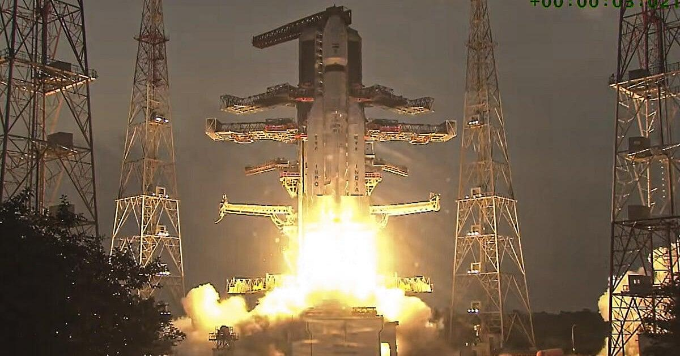
ISRO: Making space for industry? Deccan Herald

61. ISRO Satellite Detects Clearest Sign Yet Of "Mother Of All" El Nino Events - NDTV
Read more
ISRO Satellite Detects Clearest Sign Yet Of "Mother Of All" El Nino Events NDTV

62. Rocket Lab protests NASA's decision to award Blue Origin $700 million Mars orbiter contract
Read more
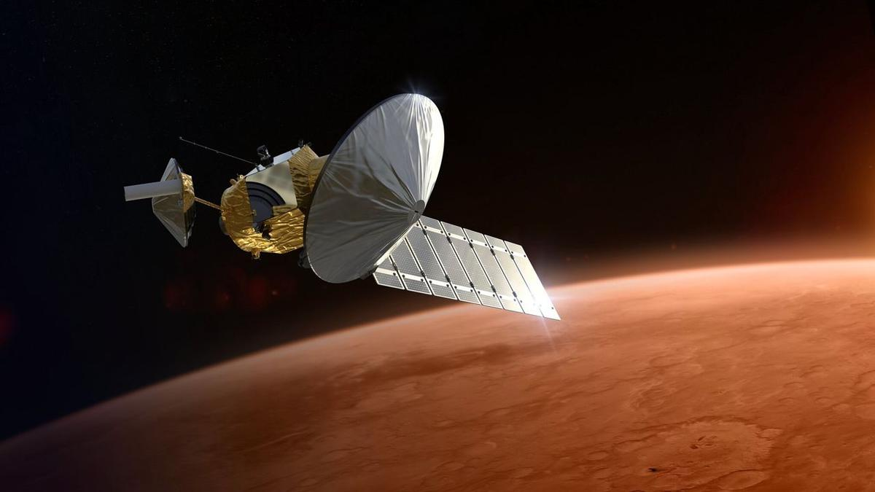
Click for next article Rocket Lab still holds out hope that it can build NASA's next Mars orbiter. The agency picked Blue Origin for that job earlier this month, awarding Jeff Bezos ' spaceflight company $700 million to develop, launch and operate the Mars Telecommunications Network (MTN). Today (Sept. 11), however, Rocket Lab announced that it has challenged that decision, filing a formal protest with the Government Accountability Office (GAO). Rocket Lab has filed a formal protest with the Government Accountability Office challenging NASA's award decision for the Mars Telecommunications Network.NASA's award decision appears to be inconsistent with the eligibility criteria mandated by Congress. In addition, the… pic.twitter.com/g48AWgiIoRSeptember 11, 2026 "NASA's award decision appears to be inconsistent with the eligibility criteria mandated by Congress. In addition, the agency's punitive review of Rocket Lab's technical volume was inconsistent, making incorrect assertions and conclusions," Rocket Lab said today in an X post that laid out its argument. "Procurement standards exist to ensure fair competition and protect public investment," the California-based company added. "We are pursuing this review to ensure those standards are upheld for critical infrastructure that will underpin American exploration at Mars for decades to come." As its name suggests, the MTN orbiter will serve as a communications link between mission controllers here on Earth and other NASA spacecraft studying the Red Planet. Just two agency orbiters fulfill that relay role these days, and both are quite old: Mars Odyssey launched in 2001, and the Mars Reconnaissance Orbiter lifted off in 2005. NASA had been eyeing a new Mars telecom orbiter for years and finally got Congressional funding for it in July 2025 - $700 million, to be precise. The agency issued a request for proposals this past May , drawing considerable interest from the private sector. Blue Origin and Rocket Lab were widely considered the front-runners, and NASA ended up going with Blue. The award calls for the company to deliver MTN (which, despite the "network" in its name, is a single spacecraft) to NASA no later than Dec. 31, 2028. It's expected to be up and running at the Red Planet by 2030. Blue Origin has been in Rocket Lab's shoes before, and has behaved similarly. Bezos' company filed a protest with the GAO in 2021 after NASA picked SpaceX to provide the first crewed moon lander for the agency's Artemis program .

63. Rocket Lab launches mystery satellite to orbit for secret customer (photo)
Read more
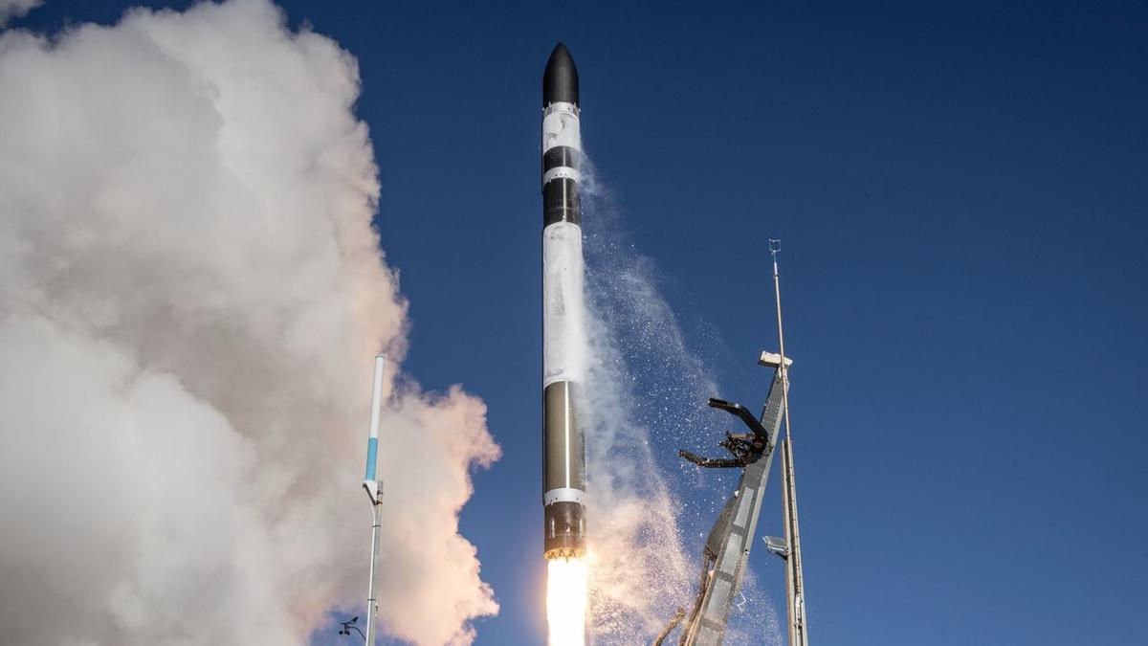
Click for next article A Rocket Lab Electron rocket launches on the "Happily Ever Faster" mission from New Zealand on Sept. 10, 2026. Rocket Lab just launched a mystery mission to orbit. An Electron rocket lifted off from Rocket Lab's New Zealand site on Thursday (Sept. 10) at 11:28 p.m. EDT (0328 GMT and 3:28 p.m. local New Zealand time on Sept. 11). The launched kicked off a mission the company called "Happily Ever Faster," which we know little about. 'Happily Ever Faster' to orbit 🌌✨ Today we launched our 95th Electron at 3:28 pm NZST and deployed a single Earth observation satellite to a 500km LEO for a confidential customer - our 16th mission of the year with 100% mission success. pic.twitter.com/xAsy30uyNPSeptember 11, 2026 Rocket Lab did not livestream the mission or reveal who booked it, saying only that it aimed to loft "a single commercial satellite to a 500 km low Earth orbit ." That did indeed happen successfully, the company announced via X about 80 minutes after launch. Speculation has worked to fill the information vacuum, as it generally does. For example, some outside observers think "Happily Ever Faster" carried up a "Gen-3" satellite for the geospatial intelligence company BlackSky. These spacecraft are powerful Earth observers, capable of resolving features as small as 14 inches (35 centimeters) on our planet's surface. Rocket Lab has launched BlackSky Gen-3 satellites before, so this is a pretty good bet - especially since, in that post-launch X post, the company revealed that the deployed payload was an Earth-observing craft. "Happily Ever Faster" was Rocket Lab's 16th launch of 2026, and the 13th involving the 59-foot-tall (18 meters) Electron, which gives small satellites dedicated rides to space.

64. 2 private spacecraft zoom within 650 feet of each other to showcase 'advanced capabilities' in orbit (photos)
Read more
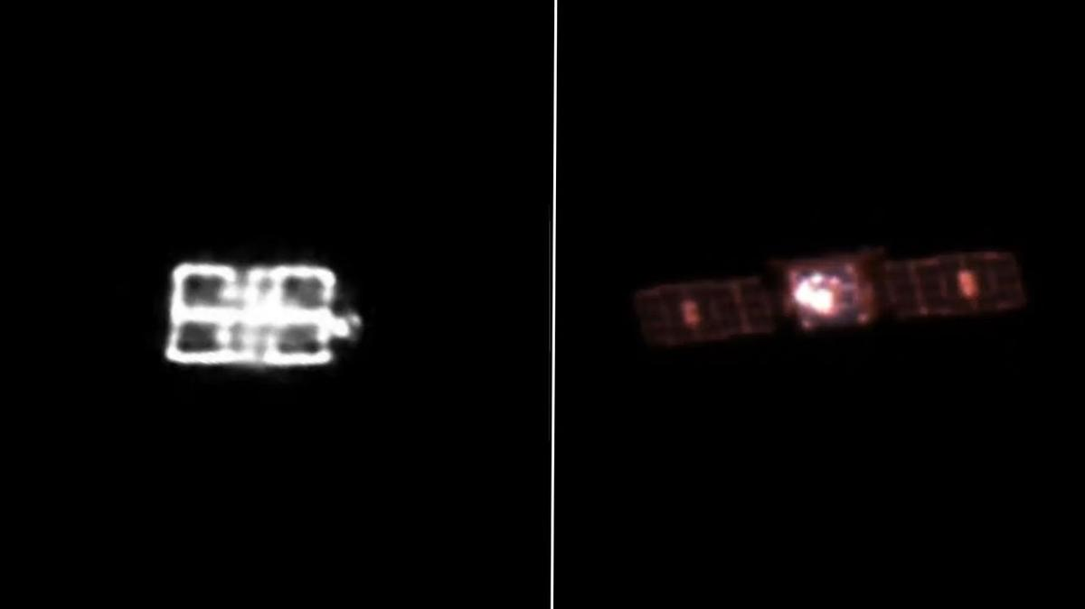
Click for next article Impulse Space's LEO-2 Mira vehicle, as seen from a telescope onboard LEO-3 from a distance of approximately 5,000 meters (16,400 feet). A pair of private spacecraft just showed off some impressive maneuverability high above Earth. The two probes - Mira satellites operated by the California startup Impulse Space - zoomed within 650 feet (200 meters) of each other in low Earth orbit (LEO) recently. The rendezvous demonstrated skills that could be useful to a variety of customers down the road, according to the company. "These types of dynamic, agile maneuvers are how we unlock full access to space after launch and create new mission possibilities," Tom Mueller, CEO and founder of Impulse Space (and, prior to that, the first person Elon Musk ever hired at SpaceX ), said in a statement on Tuesday (Sept. 8). "Our teams that design, build and operate Mira are leading the way toward a true space age, and customers across all sectors will be the beneficiaries." The LEO-3 Mira vehicle, taken from a distance of approximately 700 meters (2,300 feet) by a camera onboard LEO-2. (Image credit: Starfish Space/Impulse Space) Mira is an orbital transfer vehicle - a spacecraft designed to deliver customer payloads to precise locations in Earth orbit or beyond. The dishwasher-sized Mira can carry up to 660 pounds (300 kilograms) of gear and is highly maneuverable, as the recent rendezvous showed. The operation involved Mira satellites that launched in January 2025 and November 2025, on missions that Impulse calls LEO Express 2 (LEO-2) and LEO Express 3 (LEO-3), respectively. Impulse Space's LEO-2 Mira vehicle, as seen from a telescope onboard LEO-3 from a distance of approximately 5,000 meters (16,400 feet). (Image credit: HEO/Impulse Space) The action began this past February, when the LEO-2 Mira conducted a lengthy engine burn to close in on its counterpart. LEO-2 performed additional, smaller burns throughout the spring and summer, coming into orbital alignment with LEO-3. "Then in July, LEO-2 executed a series of close approaches to LEO-3, starting at about 820 meters [2,690 feet] apart and subsequently moving closer to LEO-3," Impulse Space wrote in the Tuesday update. "Ultimately, for the closest approach, LEO-2 maneuvered to within about 200 meters of LEO-3." Both Miras chronicled the rendezvous, snapping photos of each other with onboard camera gear. Two other companies, Starfish Space and HEO, worked with Impulse Space to pull off this orbital photo shoot. Two Miras - less than 200 meters apart! Our LEO Express 2 and LEO Express 3 spacecraft recently met for a family reunion in orbit, following a series of carefully coordinated maneuvers that brought the two vehicles within approximately two football fields of each other.The… pic.twitter.com/XoHgOzjuaLSeptember 8, 2026 Impulse has worked with Starfish before. The duo collaborated late last year on a rendezvous between LEO-2 and the first space-flown Mira, which launched on the Leo Express 1 mission in November 2023. On that operation, called Remora , LEO 2 used Starfish Space navigation software to get within 4,100 feet (1,250 m) of LEO 1. "We're showcasing some of the advanced capabilities that set Mira apart from other vehicles," Drew Damon, vice president of spacecraft programs at Impulse, said in Tuesday's statement. "Twice now, we've demonstrated that Mira has the agility and propulsion to support a new class of dynamic operations on orbit, and our team is excited to continue tackling the mission sets Mira is uniquely qualified to handle."

65. 25 years ago, a NASA astronaut witnessed the tragic 9/11 attacks from space. Here's what he saw.
Read more

Frank Culbertson had a birds-eye view of one of the most memorable and tragic events in American history. The NASA astronaut was the only American off of Earth on Sept. 11, 2001. He was circling the planet aboard the International Space Station (ISS) when terrorists flew commercial jets into the twin towers of the World Trade Center in New York City, killing more than 2,700 people. The ISS passed over New York shortly after the attacks took place, so Culbertson saw the devastation from an eerie remove. He shared his thoughts with Mission Control at NASA's Johnson Space Center in real time, chronicling the tragedy like no one else could. The aftermath of the 9/11 attacks on the World Trace Center in New York City, as seen by the astronauts onboard the International Space Station on Sept. 11, 2001. (Image credit: NASA) "We could see New York City and the smoke from the fires," Culbertson said. "Our prayers and thoughts go out to all the people there and everywhere else here - I'm looking up and down the East Coast to see if I can see anything else - and to the people in Washington." Terrorists hijacked four commercial planes on 9/11, flying two of them into the World Trade Center and one into the Pentagon in Washington, D.C. Passengers on the fourth plane overpowered the hijackers, forcing it to crash in a field in Pennsylvania rather than hit the terrorists' intended target, which was likely the U.S. Capitol building or the White House. "I hope that the people responsible are caught and brought to justice as soon as possible," Culbertson added. "But first, our prayers and condolences to all involved. And I just wanted the folks to know that their city still looks very beautiful from space. I know it's very difficult for everybody in America right now, and I know folks are struggling very hard to to deal with this and recover from it. But the country still looks good, and, for New Yorkers, your city still looks great from up here." Culbertson gave a more complete accounting of his thoughts in an open letter , which he published a day after the attacks. "The world changed today. What I say or do is very minor compared to the significance of what happened to our country today when it was attacked," he wrote. "It's horrible to see smoke pouring from wounds in your own country from such a fantastic vantage point," Culbertson added. "The dichotomy of being on a spacecraft dedicated to improving life on the Earth and watching life being destroyed by such willful, terrible acts is jolting to the psyche, no matter who you are." NASA astronaut and ISS commander Frank Culbertson on Sept. 17, 2001 aboard the International Space Station. (Image credit: NASA) Culbertson arrived at the ISS on Aug. 12, 2001 aboard the space shuttle Discovery along with cosmonauts Vladimir Dezhurov and Mikhail Tyurin. The trio comprised Expedition 3, the third-ever crewed mission to the orbiting lab, which ran through December of that year. We're now up to Expedition 75, and there have been no breaks: The ISS has been continuously staffed by rotating astronaut crews since November 2000. Expedition 3 was Culbertson's third and final spaceflight. He retired from NASA in August 2002 and went to work in the private sector. Among other roles, he led human spaceflight efforts at Orbital Sciences Corp., which built the Cygnus ISS resupply spacecraft. Cygnus still flies today, for the aerospace giant Northrop Grumman, which bought Orbital Sciences in 2018. Culbertson, 77, retired from Northrop Grumman in 2018. He currently serves on the board of directors of the nonprofit Space Foundation, among other roles. NASA astronauts Mark Kelly (left) and Dan Tani hold a bag of American flags on the flight deck of the space shuttle Endeavour. The flags carried on the shuttle included 6,000 small U.S. flags, one U.S. flag that was recovered from the debris of the World Trade Center, a Marine Corps flag that was retrieved from the Pentagon, and an American flag from the State of Pennsylvania. (Image credit: NASA) For example, NASA flew nearly 6,000 small American flags on the STS-108 mission of the space shuttle Endeavour , which launched on Dec. 5, 2001 and landed 12 days later.

66. New Houston stand puts Rotating Detonation Rocket Engine through mission-like tests
Read more
Venus Aerospace has opened a new propulsion test stand at Houston Spaceport as it pushes its rotating detonation rocket engine through increasingly demanding ground tests. The new facility gives engineers more room to run higher-thrust firings and extend test durations. That allows Venus to examine how the engine behaves under conditions that more closely resemble flight. The company demonstrated the capability on September 10 with a live hot-fire test at the newly opened stand. The event also brought together Texas aerospace officials, Houston leaders and representatives from the local space industry. Bigger test envelope Rotating detonation engines have attracted interest because they can produce combustion through rapidly moving detonation waves. That process differs from the combustion used in most conventional rocket engines. Getting the concept to work in a laboratory is only one part of the challenge. Engineers must also show that the hardware can withstand sustained operation at useful thrust levels. The new stand gives Venus additional capacity for that work. It can support longer tests and higher-thrust operations than some of the company's existing infrastructure. That extra testing time can reveal problems that short firings might miss. It also gives engineers more data as they refine the engine and its supporting systems. Venus CEO and co-founder Sassie Duggleby said propulsion programs need infrastructure that can keep pace with their technical development. "Building and testing propulsion systems at this pace requires the right infrastructure around the technology," Duggleby said. She also credited the Texas Space Commission and the State of Texas for helping fund the facility. The project received support through the commission's Space Exploration and Aeronautics Research Fund. Texas backs propulsion The funding forms part of a broader state effort to expand aerospace activity in Texas. Houston Spaceport has become one of the locations supporting that push. Venus said it completed the test stand on schedule and within its planned budget. The facility now gives the company another place to run propulsion tests as its program grows. That capacity could become increasingly important after several major developments for Venus. The company raised $91 million in a Series B round during 2026. It has also expanded its leadership team and announced new customer and strategic relationships. Those moves have accompanied continued work on its propulsion technology.
67. BRICS New Delhi Summit: Consensus, not de-dollarisation, emerges as the real story
Read more

- Governance - 5 min read BRICS stops short of challenging dollar dominance, but the New Delhi Declaration shows India's ability to bridge geopolitical divides and position the grouping as a platform for global reform. Anoop Verma - ETGovernment - Published On Sep 13, 2026 at 07:12 AM IST Select ETGovernment as Preferred Choice on Google Copy Link Share on WhatsApp Share on Linkedin Share on X Share on Telegram Share on Facebook Modi, Xi, Putin & other leaders planted saplings at Bharat Mandapam The most revealing outcome of the BRICS Summit in New Delhi may be what the grouping did not do. It did not announce a common currency. It did not declare war on the dollar. Nor did it transform itself into an explicitly anti-Western alliance. Instead, an enlarged grouping containing countries divided by wars, strategic rivalries and competing economic interests managed something less dramatic but arguably more useful: it negotiated a common position. The unanimous adoption of the New Delhi Declaration on Saturday is therefore significant. With Iran and the United Arab Emirates sitting within the same grouping amid escalating tensions in West Asia, agreement was far from automatic. Yet BRICS leaders expressed "deep concern" over the escalation and called for "maximum restraint", while urging countries to avoid actions that could aggravate the situation. The declaration reaffirmed dialogue, consultation and diplomacy as the preferred means of resolving international disputes. Advt That language is deliberately cautious. But diplomatic ambiguity was probably the price of unanimity. The declaration also condemned deliberate attacks on civilian infrastructure and safeguarded peaceful nuclear facilities, and criticised unilateral sanctions imposed without authorisation from the UN Security Council. Crucially, it did not identify the countries responsible for the actions it criticised. That weakens attribution, but it also explains how countries with markedly different relationships with the United States, Israel and Iran could endorse the same document. This is where India's presidency appears to have made its mark. New Delhi has consistently resisted attempts to define BRICS simply through opposition to the West. Prime Minister Narendra Modi's message at the summit was that "BRICS is not against anyone"; its purpose, in India's formulation, is to widen participation in global governance rather than construct another rigid geopolitical bloc. Modi's more consequential formulation concerned the Global South . He argued that developing countries must move from being rule-takers to becoming "rule-shapers", and called for the existing "pyramid of privilege" in global governance to be transformed into a "platform of partnership". His argument links BRICS expansion to India's longstanding demand for reform of institutions such as the UN Security Council and international financial institutions. That distinction matters. There is a fundamental difference between demanding greater representation within the international system and attempting to overturn that system. India's approach is closer to the former. Russia's rhetoric in New Delhi was, interestingly, also calibrated. President Vladimir Putin told the BRICS Business Forum: "We're not against anyone." He added that Russia was prepared to work with "all of our partners, old ones and new ones". China, meanwhile, used the summit to call for a larger diplomatic role for BRICS. President Xi Jinping urged the grouping to contribute to peacemaking in West Asia and confirmed that China will assume the BRICS chairmanship and host the next summit in 2027. The New Delhi consensus nevertheless should not be confused with strategic convergence. BRICS remains an extraordinarily heterogeneous grouping. India and China are strategic competitors despite their improving dialogue. Iran faces Western sanctions and is directly involved in the West Asian confrontation, while the UAE has very different security and commercial relationships. India maintains deep strategic partnerships with the United States and Europe even while sustaining its longstanding relationship with Russia. The same contradictions become even clearer when economics enters the picture. For years, speculation about BRICS has focused disproportionately on de-dollarisation . Yet New Delhi demonstrates why replacing the dollar is far easier to discuss than accomplish. BRICS countries can increase bilateral settlement in national currencies, develop interoperable payment mechanisms and reduce transaction costs without creating a common currency or abandoning the dollar. The structural problem is trade. India's merchandise trade deficit with the other BRICS economies reached $226.1 billion in FY2026, according to a Global Trade Research Initiative analysis based on trade data. India's exports to BRICS rose from $64.3 billion in FY2021 to $95.7 billion in FY2026, while imports surged from $138.8 billion to $321.8 billion. BRICS economies now account for 41.5 per cent of India's merchandise imports. These numbers expose the limits of monetary engineering. Local-currency settlement can alter the currency in which an invoice is denominated; it cannot eliminate the underlying imbalance between exports and imports. If one country persistently sells substantially more to another than it buys, somebody must ultimately hold the resulting currency, convert it into another asset or find additional goods and investments on which to spend it. That is why the dollar retains its centrality. Its strength does not arise merely from political pressure by Washington. It rests on deep and liquid American capital markets, widespread international acceptance, the scale of dollar-denominated trade and finance, and the ability of governments, companies and investors to deploy dollar surpluses across a vast range of financial assets. BRICS can gradually reduce dependence on the dollar at the margins. Replacing it at the centre of the global monetary system is another proposition altogether. New Delhi has therefore been more persuasive when BRICS concentrates on practical cooperation. Modi's proposal for a Seafarers' Emergency Support Network is a good example. With conflict disrupting major shipping routes, the initiative seeks greater coordination to assist maritime workers in emergencies. Modi had already framed the economic logic succinctly: "Global trade progress is possible only when sea lanes are secure, supply routes remain open, and seafarers are safe." Such initiatives may sound less revolutionary than a BRICS currency, but they are more likely to produce tangible results. That points to the larger lesson from New Delhi. BRICS does not need to become a military alliance, monetary union or anti-Western coalition to matter. Its potential lies precisely in its ability to bring together states that frequently disagree-and give them an institutional setting in which those disagreements do not automatically prevent cooperation. The New Delhi Declaration embodies that approach. Its language on West Asia is cautious, sometimes deliberately ambiguous and devoid of explicit attribution. Yet securing unanimous language from governments occupying very different sides of today's geopolitical divides is itself a diplomatic achievement. BRICS may therefore be evolving into something more complicated than either its champions or critics sometimes suggest: not an alternative world order, but another influential centre within an increasingly multipolar one. De-dollarisation remains largely an aspiration. The more immediate test of BRICS is whether it can turn political diversity into workable cooperation. In New Delhi, India has demonstrated that consensus itself can be a form of strategic power. Anoop Verma , --> - By - See more on: - BRICS New Delhi Summit , - de-dollarisation , - Global South , - New Delhi Declaration , - India BRICS presidency , - strategic cooperation , - national currency settlement , - global governance reform , - multilateral relations , - BRICS Telegram Facebook Comments What are your thoughts? Comment Now --> Comment Now Read Comment (1) All Comments By commenting, you agree to the Prohibited Content Policy Post Find this Comment Offensive? Choose your reason below and click on the submit button. This will alert our moderators to take actions REASONS FOR REPORTING Foul Language Defamatory Inciting hatred against a certain community Out of Context / Spam Others Report Join the community of 2M+ industry professionals. Subscribe to Newsletter to get latest insights & analysis in your inbox. All about ETGovernment industry right on your smartphone! - Download the ETGovernment App and get the Realtime updates and Save your favourite articles. Scan to download App --> - Home - News - BRICS New Delhi Summit: Consensus, not de-dollarisation, emerges as the real story

68. French military jets launch 40-day global flight to project power, strengthen alliances
Read more

- Defence - 4 min read Four French fighter jets are undertaking a significant global flight exercise. This extensive journey spans forty thousand kilometers across three continents. - AP - Published On Sep 12, 2026 at 04:00 PM IST Select ETGovernment as Preferred Choice on Google Copy Link Share on WhatsApp Share on Linkedin Share on X Share on Telegram Share on Facebook The Associated Press accompanied French planes this week over Greenland and Alaska and during exercises they conducted with US fighter jets. Eielson Air Force Base : Four fighter jets rose into the air over a French military base and settled into formation at the start of a 40-day flight taking them through the icy Arctic and steamy tropics before ending in a desert. The aircraft left Istres air base in southern France on Tuesday and will travel 40,000 kilometres, cross three continents and make nine stopovers, working with international partners along the route to demonstrate the value of alliances at a time when big powers such as China and the United States seem determined to go it alone. Advt The military exercise called Pegase 26 aims to project military might and prove the nuclear power can defend distant territories and allies by strengthening French cooperation in the air with strategic partners including Japan, South Korea, Indonesia and India. Almost a year in the planning, the aircraft will be supported by three refuelling planes, two transport aircraft and around 300 personnel overseen from a headquarters near Lyon in eastern France. The Associated Press accompanied French planes this week over Greenland and Alaska and during exercises they conducted with US fighter jets. Showing commitment to law and freedom of navigation "In practical terms, we fly together, we land together, we work together," Alice Rufo, a deputy defence minister, said before the two single-seater and two twin-seater Rafale aircraft departed France. "If we're called upon to act together in the face of a threat, we need to be immediately interoperable," Rufo said. "That doesn't just happen. It must be prepared, and these exercises and missions allow us to prepare for that." Flying halfway around the world also will demonstrate France's commitment to international law and the freedom of navigation in places where these principles face growing challenges such as the Middle East. The aircraft will fly in the Persian Gulf region via Qatar and end their journey in Egypt. But along with political and practical advantages of navigating through complex new airspace in a range of temperatures, Pegase 26 is highly symbolic. Aircraft experience new challenges over Greenland In the early stage of the trip, the twin-engined jets headed for Alaska and passed over Greenland, where an Airbus A400M support plane capable of landing on ice was stationed. The flight from Istres to Alaska took nearly 11 hours, with the jets refuelling midair five times to cover the vast distance without stopping. US President Donald Trump's repeated threats to take control of Greenland have destabilised NATO, damaging confidence between allies meant to defend rather than attack each other. Greenland is a self-governing part of NATO member Denmark. The flight exercise has been held annually since 2018, but the Pegase 26 commander, General Julien Sabene, told The Associated Press this is "the first time we are heading up north, over Greenland, toward Alaska." "It's important for us that we explore different routes," he said. "We never know in case we need to go in the Indo-Pacific region, and there are thermals and it's difficult to go the other way around. That gives us another option, going up north." Global warming also is making the Arctic more accessible to possible adversaries such as China and Russia. "Climate change is changing the stakes and maritime routes are evolving," Sabene said. "There is a need for us to be present in the High North alongside our allies, and naturally alongside the Danes, who are an integral part of Greenland." Making a symbolic show of strength through partnership The exercise also comes six months after President Emmanuel Macron offered to share France's nuclear umbrella with his European partners as concern mounted about Trump's reliability on security matters. Some Rafale jets can be fitted with nuclear-armed missiles. They would probably be paired with the same Airbus A330 MRTT refuelling planes to deliver those weapons over long distances, officials said. To be clear, Pegase 26 is not a nuclear exercise. The fighter jets carry no real weapons, only mock conventional armaments adding weight and shifting aerodynamics to bring a more realistic edge to the drills. But pilots from France's Strategic Air Force, which operates part of France's nuclear deterrent, are involved. The marathon flight also shows France can rapidly move combat aircraft between potential conflict zones in the Arctic, Pacific and Middle East, where many US refuelling planes are tied up with the Iran war, while sustaining operations from French bases. At a time when great powers are questioning the value of multinational organisations and sometimes seeking to undermine them, Rufo said Pegase 26 proves France can exercise freedom of navigation while respecting international rules with the help of its allies and friends. "Sovereignty can only be effectively exercised within a network of partnerships, and the exceptional number of partners involved in this mission demonstrates that," she said. - See more on: - French military jets , - Pegase 26 exercise , - international military alliances , - freedom of navigation , - military cooperation with allies , - Rafale aircraft , - French Air Force operations , - nuclear deterrent France , - Eielson Air Force Base , - climate change and military strategy Telegram Facebook Comments What are your thoughts? Comment Now --> Comment Now Read Comment (1) All Comments By commenting, you agree to the Prohibited Content Policy Post Find this Comment Offensive? Choose your reason below and click on the submit button. This will alert our moderators to take actions REASONS FOR REPORTING Foul Language Defamatory Inciting hatred against a certain community Out of Context / Spam Others Report Join the community of 2M+ industry professionals. Subscribe to Newsletter to get latest insights & analysis in your inbox. --> All about ETGovernment industry right on your smartphone! - Download the ETGovernment App and get the Realtime updates and Save your favourite articles. Scan to download App --> - Home - News - French military jets launch 40-day global flight to project power, strengthen alliances

69. ISRO Admit Card 2026 Out For UDC, PA and Stenographer, Hall Ticket Download Link - Adda247
Read more
ISRO Admit Card 2026 Out For UDC, PA and Stenographer, Hall Ticket Download Link Adda247

70. AI moves into India's tea gardens as Tea Board partners with ISRO and NIT Rourkela - AgroSpectrum India
Read more
The CHAAYANKAN project will use AI, machine learning and hyperspectral data to address some of tea growers' biggest challenges, from pest outbreaks to yield uncertainty India's tea industry is turning to artificial intelligence and satellite-based sensing to tackle one of agriculture's most persistent problems: knowing what is happening in the field before it shows up in production numbers. The Tea Board India has entered into a tripartite memorandum of understanding with the National Remote Sensing Centre (NRSC) of ISRO and NIT Rourkela to develop an AI-based system for monitoring tea plantations across the country's major tea-growing regions. The research and development initiative, titled "CHAAYANKAN-Comprehensive AI-based Geospatial Data Analytics for Tea Plantation Monitoring," is scheduled to run until March 2029. It will combine remote sensing with conventional field intelligence to create a more data-driven system for monitoring the health and productivity of India's tea gardens. The project reflects a broader shift in agricultural management: from relying primarily on periodic field inspections and historical production data toward using high-resolution, technology-enabled information to identify problems as they emerge. At the centre of the initiative will be hyperspectral and optical remote sensing data collected from satellites and unmanned aerial vehicles, or UAVs. That imagery will be combined with ground observations, weather information and entomological data to develop artificial intelligence and machine learning solutions for tea plantation monitoring. One of the project's priorities will be the automatic mapping of tea-growing areas. AI and machine learning algorithms will also be developed to identify biotic and abiotic stresses affecting plantations using hyperspectral data. That capability could have significant implications for tea growers. Crop stress caused by pests, diseases, weather conditions or other environmental factors can directly affect both productivity and quality, while identifying such stress early enough to respond remains a challenge across large plantation areas. The project will therefore go beyond simply mapping where tea is grown. It will seek to forecast major pests and diseases affecting tea gardens, potentially giving growers and industry stakeholders greater lead time to respond to biological threats. Yield estimation is another major component. The project will use hyperspectral indices derived from satellite and UAV data to estimate green leaf yield, creating the possibility of more frequent and geographically detailed production assessments than conventional field-based approaches can provide. The partnership brings together three distinct capabilities. The Tea Board will provide technical and ground-level support through its existing administrative framework, facilitating implementation and the integration of field data. NRSC, the remote-sensing arm of ISRO, brings expertise in satellite-based earth observation and geospatial analytics, while NIT Rourkela will contribute research capabilities in artificial intelligence, machine learning and data analysis. The ambition extends beyond the development of individual algorithms. The initiative is also expected to create a data repository that can support future policy decisions and strengthen technology-driven management of India's tea sector. That repository could become one of the project's most important long-term assets. Agricultural technology becomes significantly more useful when different streams of information can be brought together over time. Linking plantation maps, crop-health indicators, weather conditions, pest and disease observations and yield data could create a more comprehensive picture of how tea-growing regions respond to changing conditions. The project's significance also lies in its attempt to combine technologies that have often operated separately. Satellite imagery can provide scale, UAVs can offer more detailed observations, while ground data can help validate what remote sensing detects. Weather and entomological information add another layer, connecting what is visible in imagery with the environmental and biological factors driving plantation performance. The challenge now will be converting that data into tools that work reliably under real plantation conditions. Tea gardens vary significantly in terrain, crop age, management practices and environmental conditions, making field validation critical to the development of useful AI models. CHAAYANKAN is ultimately an attempt to build that bridge between India's growing geospatial and AI capabilities and the day-to-day challenges of one of its most important plantation crops. The bigger opportunity is not simply to put AI into tea cultivation. It is to create an information infrastructure that allows the industry to manage uncertainty more systematically-and potentially make Indian tea production more productive and sustainable in the process.

71. Amit Shah Pitches Zero Disaster Casualties. ISRO Sent Its Warnings Years Ago - NDTV
Read more
Amit Shah Pitches Zero Disaster Casualties. ISRO Sent Its Warnings Years Ago NDTV

72. Trump is proposing a US Space Academy - if created, it could blur the lines between NASA and the military (op-ed)
Read more

Click for next article This article was originally published at The Conversation . The publication contributed the article to Space.com's Expert Voices: Op-Ed & Insights . During a visit to NASA's Johnson Space Center in Houston on Aug. 28, 2026, President Donald Trump signed an executive order to create a United States Space Academy The proposal, which would establish a NASA-led institution set up along the lines of a military academy, is a new one. As a space policy expert , I see several open questions and potential problems related to the vision Trump's executive order described. The proposal During his first term in office, Trump undertook several actions supporting space exploration. He established the Artemis program, to return astronauts to the Moon , in 2017. A year later, he announced his support for a new branch of the military dedicated to space . In 2019, this became reality with the establishment of the Space Force . Given this record, it's not surprising that Trump has continued to show interest in space during his second term. During his remarks in Texas, Trump stated that the U.S. Space Academy will " serve both the United States Space Force as well as NASA and the civilian spaceflight industry." Further, he said the school would be comparable to the other service academies such as West Point, the U.S. Air Force Academy and the U.S. Naval Academy. The actual executive order doesn't create a space academy outright. It establishes a commission that must gather information and give a report within 120 days about the feasibility of a U.S. Space Academy. The commission will be led by Jared Isaacman, the NASA administrator , and will include, among others, the secretary of defense, the national security adviser and the director of the Office of Management and Budget. That order says the academy would "develop a professional corps of civically grounded leaders prepared to advance American interests within the space domain." As a NASA-led federal academy, it would be the first nonmilitary service academy that the government would run. The commission would then determine what exactly would be taught. Open questions Both Trump's speech and the executive order leave several open questions. First, former NASA leaders and members of Congress have expressed concerns about the relationship between a space academy and the military. The president's comparison of the space academy to the military academies and his use of the Space Force in justifying a space academy contradict the executive order's description of the effort as NASA-led, as NASA is not part of the military. This confusion even extends into reporting on Trump's order, with news outlets running headlines like " A West Point for Space ?" Since the 1950s, American space policy has separated civilian space efforts like NASA from military ones. While this division hasn't always been perfect, the U.S. Space Academy proposal reignites a debate over this civilian-military split. This leads to another question about what a space academy would teach. Military academies like West Point combine military training and education with typical college degree programs like engineering or the social sciences. It remains unclear what a space academy would teach and how much of its curriculum would be about military uses of space, versus exploration and science. The executive order opens up other questions about the academy's relationship to civilian and military space programs. These include whether there are any potential obligations to serve in the Space Force and the extent to which Space Academy students would receive military-specific training. A second problem involves Congress. Not only is Congress responsible for establishing new bureaucratic organizations, but it must also provide funding for them. So, congressional action will be required to actually create the U.S. Space Academy. While getting the exact funding numbers for the military service academies is difficult, one member of Congress estimated that each service academy costs roughly US$1 billion per year. Starting an entirely new academy would require significantly more than that. If, as the executive order suggests, NASA would lead the academy, funding may be even more difficult because funding NASA is not mandatory . In fact, it is often one of the first agencies to suffer budget cuts. My quick thoughts on the US Space Academy:The US Space Academy proposed today is an intriguing idea. Graduating classes of engineers and scientists dedicated to fulfilling public goals in space evokes the fictional Starfleet Academy. In a time when most policy decisions from…August 29, 2026 Other questions also remain: How will students be selected? Or will they apply? Where will the academy be located? And what degrees will it offer? Implications Establishing the U.S. Space Academy could be a wise decision, as space is becoming more important in everyday life . The pace of space activities - civilian, commercial and military - has increased significantly in the past decade and is poised to continue. For example, satellite constellations like SpaceX's Starlink provide internet access globally, and the Global Positioning System, GPS , is a vital part of the economy worldwide. A space academy could help educate the next generation of engineers, scientists and spacecraft operators . A space academy could help train future space-sector professionals, though many existing universities also offer programs for aerospace scientists and engineers. (Image credit: NASA.JPL-Caltech) But the biggest implication of this space academy proposal is that it would almost certainly lead to a reconsideration of the relationship between military and civilian space. The distinction between these two areas has been a cornerstone of U.S. space policy for over 65 years. While the lines have been blurred at times, a U.S. Space Academy that serves as both a military and civilian institution confuses them even further. As tensions in space between the United States and its potential adversaries continue to rise , balance will be necessary to avoid any potential escalation. Space activities that are civilian in nature, like scientific exploration, should not be confused with those that are distinctly military-related, such as missile warning or defense, that might be seen as more aggressive. Keeping this distinction clear will help to clear up any confusion about U.S. intentions in space. It will also be important to define the precise purpose of the space academy and who exactly it will serve. What advantage does a space academy offer over civilian schools and universities that offer similar programs? Will commercial space companies have an opportunity to be involved? And what would that look like?

73. NASA, IBM launch new AI model for studying the moon
Read more
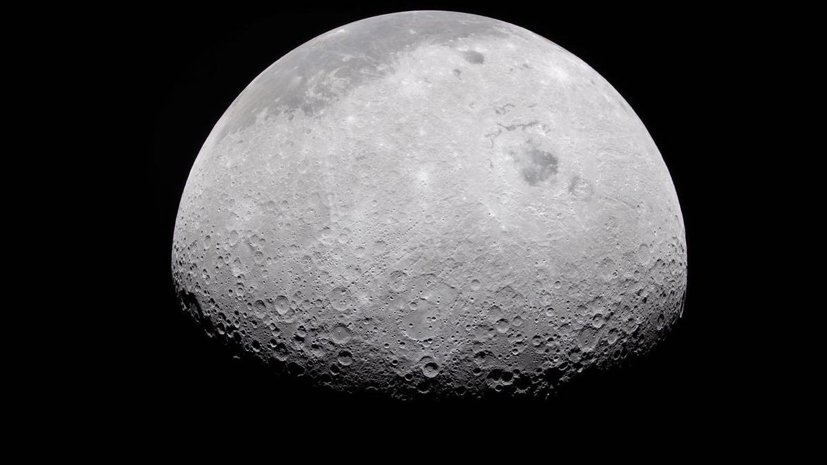
Click for next article NASA and IBM have developed a new AI model to help the agency analyze its mountains of moon data. We've been studying the moon for a long time. NASA has gathered mountains of data over decades of lunar missions and studies. The data collected by the Lunar Reconnaissance Orbiter (LRO) alone, for example, exceeds that of all NASA's other planetary missions combined. Analyzing all this information takes lots of time and effort from researchers. So, NASA and IBM have developed an AI model to help sift through the moon data - an advance the agency announced on Thursday (Sept. 10). The open-source model, called the NASA-IBM Lunar Foundation Model, is currently available for free at Hugging Face. "NASA has spent decades building an extraordinary scientific record of the moon , but collecting data is only part of the job," NASA's Kevin Murphy, chief science data officer and acting chief data and AI officer, said in the announcement. The new AI model can help researchers with tasks like mapping craters, finding young volcanic features, and modeling possible locations of water ice near the lunar poles, according to NASA. In the announcement, Murphy said that NASA needs to make scientific data easier to explore and use. To this end, NASA has been developing and releasing science-focused AI models with IBM. Previous models include one focused on Earth observation and another for heliophysics. This is part of a larger trend of AI use in planetary science . Space agencies and private space companies around the world have been looking into how AI models can help with analysis to increase scientific productivity, reduce costs and streamline workflows. "The NASA-IBM Lunar Foundation Model shows what's possible when we bring AI to NASA's petabytes of scientific data," Murphy said in the announcement. "That's a real opportunity we see with AI: turning large-scale data into new discoveries." The AI model was mostly trained on data from the LRO mission. Over 17 years, NASA's lunar orbiter has compiled a nearly complete mosaic of images that detail the moon's surface in high definition.

74. Why are the stars around our galaxy's black hole missing their companions?
Read more

A new study suggests that the young stars orbiting the Milky Way's central black hole may have a surprisingly ordinary origin. But the black hole's influence may be what makes their origin look more exotic than it really is. Along with shaping their orbits, it may also destroy their stellar companions. The paper outlining this work was published in Astronomy & Astrophysics on A...

द्वारा अभिकल्पित एवं संकलित
DESIGNED & COMPILED BY:
पुस्तकालय एवं सूचना संसाधन प्रभाग
Library & Information Resources Division, IIRS (ISRO), Dehradun
अस्वीकरण | Disclaimer:
सभी लेख / सूचनाएँ सार्वजनिक डोमेन में उपलब्ध हैं तथा केवल सूचना एवं सामान्य जागरूकता के उद्देश्य से
इंटरनेट से संकलित की गई हैं。
All the articles / information are available in public domain and are taken from
Internet for information & general awareness only.

