 |  | 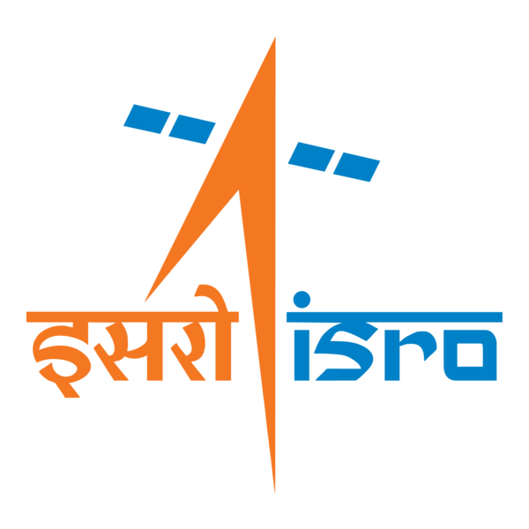

🌌 अंतरिक्ष समाचार | Space News
बुधवार, २८/१०/२०२६ | Wednesday, 28/10/2026

1. CM Adityanath launches 48 infrastructure projects worth ₹411 crore in Kanpur
Read more

- Smart Infra - 2 min Read Emphasising that the expansion of civic amenities and promotion of innovation form the core of the 'New Uttar Pradesh' vision, the CM noted that the state is balancing grassroots infrastructure with cutting-edge technology. - Faiz Rahman Siddiqui - TIMESOFINDIA.COM - Published On Oct 27, 2026 at 04:43 PM IST - Select ETGovernment as Preferred Choice on Google - Share Icon Copy Link Share on Whatsapp Share on Linkedin Share on X Share on Telegram Share on Facebook - Bookmark - Comment The CM also distributed certificates to the beneficiaries of various public welfare schemes. Chief minister Yogi Adityanath on Monday rolled out a major infrastructure boost for Kanpur Nagar by inaugurating and laying the foundation of 48 development projects worth over ₹411 crore in the Bilhaur and Bithoor assembly constituencies. The CM also distributed certificates to the beneficiaries of various public welfare schemes. Addressing the event, Yogi said eligible Ujjwala Yojana beneficiaries would receive one free cooking gas cylinder each on Deepawali. About 2 crore beneficiaries in the state have received cooking gas connections under the scheme. Yogi said Kanpur now has metro rail services, while its airport has been expanded following demands from residents and public representatives. A new expressway connects Kanpur and Lucknow, construction of Kanpur Bypass is under way, and approval has been granted for a new bridge over Ganga in the Trans Ganga area. Inaugurated projects included the four-laning of the Mandhana-Ganga Barrage-Shuklaganj-Mohanlalganj route at a cost of ₹159.35 crore and the widening of the Mandhana-Tikra-Hetpur-Dool-Bhool-Bhaupur route at ₹13.76 crore. Defence Corridor works inaugurated included a boundary wall costing ₹9.5 crore and, at Saadh village, a pond costing ₹1 crore, internal roads worth ₹8.7 crore, a main gate, guard room and lighting worth ₹4.9 crore, and sewerage, STP and water-supply works costing ₹1.6 crore. Other inaugurated works included the Satarkta Adhishthan office at ₹6.5 crore; the Kisan Nagar canal embankment road via Pakri Bhisar at ₹1.24 crore; the Patarsa-Gopalpur road at ₹1.4 crore; and link roads from the Mandhana-Tikra-Hetpur-Dool-Bhoolbhaupur route to Newadi at ₹1.53 crore, from Ikdariya to Barnao via the Rind river at ₹1.29 crore, and from Pipauri to Banpurwa at ₹1.15 crore. Foundation stones were laid for the development of a botanical garden at ₹31.5 crore; a 30-metre master-plan road in New Kanpur City Yojana at ₹19.54 crore; the beautification of the four-lane Ganga Barrage-Mandhana road at ₹10.14 crore; and Phase 1 of the Mukhyamantri Model Composite Vidyalaya at Khersa village in Bidhnu at ₹24 crore. Other projects included non-residential and residential buildings at Sachendi police station costing ₹8.22 crore and ₹1.39 crore, respectively; a fire station building costing ₹3.35 crore; and a 40-person barracks and investigation room at Bithoor police station costing ₹2.59 crore. Comments What are your thoughts?

2. Isro changes its playbook for NVS-03 mission: The crucial fix after NVS-02 failure - India Today
Read more
Isro changes its playbook for NVS-03 mission: The crucial fix after NVS-02 failure India Today

3. Sapphire International School students explore India's space missions at ISRO - Pioneer Edge
Read more
Sapphire International School students explore India's space missions at ISRO Pioneer Edge

4. India to Operate Four Launch Pads by 2029, Says ISRO Chief V Narayanan - Pragativadi
Read more
India to Operate Four Launch Pads by 2029, Says ISRO Chief V Narayanan Pragativadi

5. NVS-03 to fly with pyro valves open as ISRO seeks to avert repeat failure - The Federal
Read more
NVS-03 to fly with pyro valves open as ISRO seeks to avert repeat failure The Federal

6. ISRO Recruitment 2026: Applications open for 97 posts, salary up to Rs 1.42 lakh - Babushahi.com
Read more
ISRO Recruitment 2026: Applications open for 97 posts, salary up to Rs 1.42 lakh Babushahi.com

7. NASA Invites Media to Crew Completion of Yearlong Mars Simulation
Read more
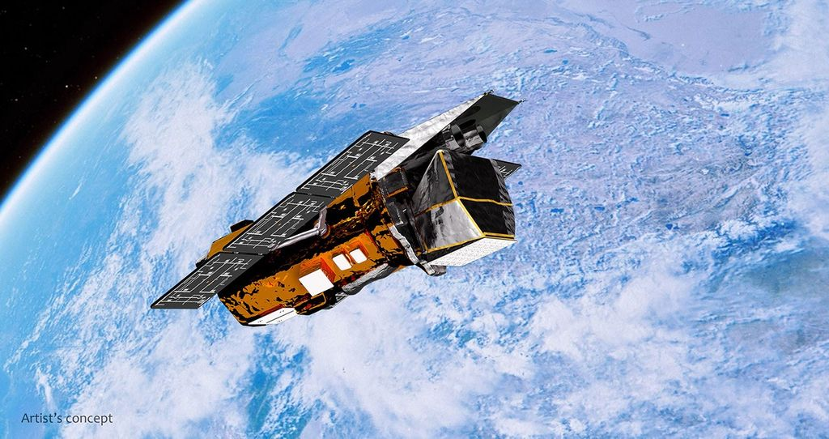
Crew Health and Performance Exploration Analog (CHAPEA) Mission 2 crew members (from left) Ross Elder, Matthew Montgomery, Ellen Ellis, and James Spicer, pose for a photo on Oct. 8, 2025. Credit: NASA The four volunteers who lived and worked in a simulated NASA Mars mission for more than a year will exit their habitat on Saturday, Oct. 31, after 378 days of isolation in a facility at the agency's Johnson Space Center in Houston. Health and performance data collected from the simulation can help NASA develop methods to counter human spaceflight risks for future Artemis and Moon Base missions. Beginning at 3 p.m. EDT, NASA will provide live coverage of the volunteers' departure from the Crew Health and Performance Exploration Analog (CHAPEA, pronounced cha-pea'-ah) mission habitat. The exit ceremony will be streamed on NASA Johnson's YouTube and social accounts. Johnson Center Director Vanessa Wyche and NASA astronaut Jack Hathaway will provide remarks. The CHAPEA crew members Ross Elder, Ellen Ellis, James Spicer, and Matthew Montgomery also will provide remarks. Media are invited to watch the CHAPEA Mission 2 ceremony live at NASA Johnson on a screen outside the hangar holding the CHAPEA facility, after which a subject matter expert will be available in person to answer questions. Media will have the opportunity to capture the moment the crew exits the building, stepping outside for the first time in more than a year. U.S. media interested in attending the activities in person, or media interested in speaking virtually with the CHAPEA Mission 2 crew members in the days following completion of their mission, must contact the NASA Johnson newsroom no later than 2 p.m., Friday, Oct. 30, at jsc-newsroom@mail.nasa.gov. The second CHAPEA mission began on Oct. 19, 2025. Four crew members have lived and worked inside a 3D-printed 1,700-square-foot facility, simulating Mars mission operations, conducting simulated spacewalks, exercising, performing habitat maintenance, growing plants, and more, while operating under stressors that future deep space crews will likely experience. These included communication delays, resource limitations, and isolation. Data from the mission can aid preparation for NASA's lunar missions by optimizing food system design, efficient use of crew time, bandwidth on NASA's Deep Space Network, and other aspects of living in deep space. In addition, data can help flight doctors and psychologists strengthen spaceflight medical care and behavioral support practices to ensure crew readiness and performance. To learn more about NASA's CHAPEA mission, visit: https://www.nasa.gov/humans-in-space/chapea -end- Rachel Kraft Headquarters, Washington 202-358-1600 rachel.h.kraft@nasa.gov Kelsey Spivey Johnson Space Center, Houston 281-483-5111 kelsey.m.spivey@nasa.gov

8. NASA's Neo Surveyor Sunshade
Read more
BAE Systems Space & Mission Systems A technician inspects the large sunshade of NASA's Near-Earth Object (NEO) Surveyor mission in this image released on Oct. 26, 2026. The sunshade structure, which stands 20 feet (6 meters) tall and measures 8 feet (2.4 meters) wide at its base, will keep the infrared space telescope cool as it searches for near-Earth asteroids and comets while also providing the spacecraft with power. When in space, NEO Surveyor will detect some of the hardest-to-find asteroids and comets, some of which may be located in the direction of the Sun - a region of sky where ground-based optical telescopes have a harder time searching. Image credit: BAE Systems Space & Mission Systems

9. How a Johnson Mentor Shapes the Next Generation of NASA Talent
Read more
When Rice University student Malvika Bhardwaj asked her mentor Daniel Cohen, a Guidance, Navigation & Control (GN&C) engineer at NASA's Johnson Space Center, whether he had time to keep teaching interns with his busy workload, he answered, "You decide what's important." In honor of National Mentoring Day on Oct. 27, Bhardwaj reflects on how Cohen's advice and support has shaped her internship experience at Johnson. Through NASA's Office of STEM Engagement, interns like Bhardwaj contribute to agency projects while learning from NASA mentors and gaining technical skills and hand-on experience to build a future career in space exploration. Bhardwaj studies computational and applied mathematics at Rice University and interns with the GN&C team, which focuses on how spacecraft determine their position and maneuver in orbit. She is developing tools to analyze thruster firings on the U.S. Deorbit Vehicle that will help NASA safely deorbit the International Space Station at the end of its operational life. Bhardwaj also uses computer simulations to test the vehicle's control system and identify conditions under which it could fail. "I've learned about the culture of community and support at Johnson and NASA as a whole. Daniel made an effort to introduce me to the team and include me in conversations and meetings. I saw how team members step up to help one another and keep the whole unit moving forward," Bhardwaj said. Cohen, a Rice University alumnus with a master's in mechanical engineering, began his NASA career as a flight operations intern in 2020. He later held internships in docking dynamics, propulsion systems, and GN&C analysis before joining Johnson as a full-time engineer in August 2024. His current work includes developing simulations and models for studies of the U.S. Deorbit Vehicle, analyzing its control algorithms and GN&C performance, and evaluating SpaceX's design at multiple life-cycle reviews. He also analyzes settings for the Orion spacecraft's docking camera, which provides positioning measurements that can help inform navigation during future Artemis rendezvous activities. Cohen supports Bhardwaj beyond her internship, giving her a closer look at how colleagues collaborate on projects and share ideas. He sets aside a couple of hours each week to teach interns topics such as orbital mechanics and control systems. Bhardwaj took Cohen's advice to heart: How she spends her time and energy reflects what she values. She believes that her internship has shown her that problem-solving is rarely an individual effort. Team members bring different perspectives and need to understand how their work connects to a larger project. Working alongside interns in outreach, social media, and digital design has also broadened Bhardwaj's view of STEM careers. "No matter what interests you, there's likely a role for you here," she said. She was proud to complete her first project, a set of analysis tools she built from scratch. Working through the debugging process and seeing a finished, functioning product was especially rewarding. Bhardwaj's advice to students interested in NASA internships is to apply even if they do not feel fully prepared. "You're probably never going to feel 100% ready, but so much of the learning happens on the job," she said. "Trust in your ability to navigate new environments."

10. How 'spacewalking' underwater made me feel like I was really in space
Read more
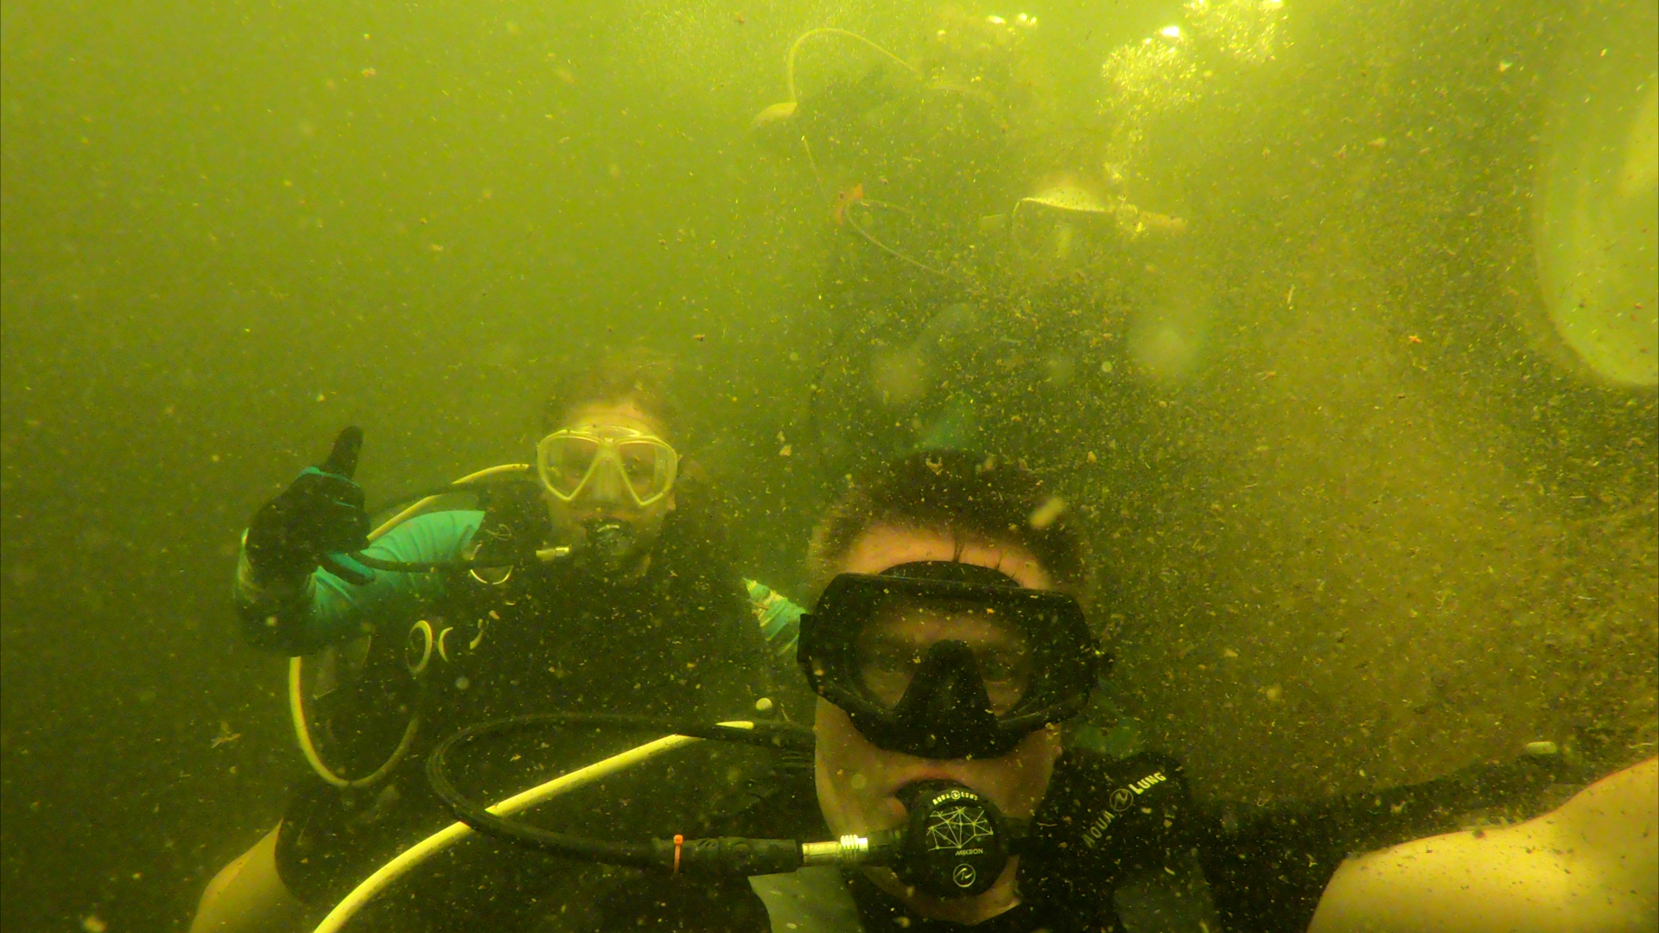
Click for next article I was breathing just fine through my life support systems, but I kept feeling an urge to double check that everything was ok with my "spacesuit" before heading out on this "spacewalk." I have worn many different types of spacesuits on Earth during my career, but for the first time in my life, I knew that I couldn't just stop to breathe the air outside if there were an emergency. That's because I was underwater. On this excursion, I was leading a simulated space mission underwater called SEA STAR. My " spacesuit " was actually scuba diving gear, and the simulated spacewalks , or EVAs (Extra-Vehicular Activities), included outings where we explored underwater environments. Being underwater, if we encountered a major problem with our gear, we would have had to treat it as seriously as if we were astronauts on the International Space Station . There was no immediate "out." This was serious. Before this underwater mission, I had worked as the commander of nearly 40 analog missions that simulated crewed missions to the moon and Mars . The goal of these types of missions is to test what living and working in lunar or Martian environments might be like. We study everything from the psychology of living in extreme conditions, or in isolation, to the technology that astronauts might use to complete those missions successfully. Testing spacesuit technology is also an important part of these analog space missions. These suits are usually a much simpler version of the ones astronauts use in space, which can weigh around 310 pounds (141 kilograms) when fully equipped with life support systems. Analog spacesuits usually weigh a maximum of 30 pounds (14 kg). While there are many differences between suits designed for use in space and these suits designed for testing on Earth , the biggest one is that, on an analog mission, crew members can open their helmets and breathe the outside air if necessary. Scuba "spacesuit" equipment for simulated "spacewalks" during the SEA STAR mission. (Image credit: Michaela Musilova) Astronauts in space don't have that advantage. But neither do aquanauts, those performing a simulated space mission underwater. Aquanauts spend at least 24 hours underwater in a so-called state of saturation. That's a physiological condition achieved by a person who breathes underwater long enough for the body's tissues to absorb the maximum possible amount of inert gas (like nitrogen), for a specific depth and pressure. Water leaking into our suits or into our underwater habitat can pose serious risks for the crew, as well as health problems related to the higher pressures underwater, amongst other challenges unique to this environment. This is what pushed me to be extra thorough, and perhaps even a bit paranoid, when preparing for my scuba diving "spacewalks." While scuba diving, the dangers of your equipment failing or decompression sickness can be as lethal as some of the difficulties astronauts face during their spacewalks. That's why we follow strict protocols when preparing to go on underwater EVAs and during the outings themselves. A SEA STAR crewmember performing a simulated "spacewalk" underwater. (Image credit: Michaela Musilova) As an experienced scuba diver, I wasn't concerned with the scuba diving aspect of the mission itself. In many ways, it was much easier than some dives in pitch black water I performed in the open ocean or cave dives. But for these EVAs, I was more on edge because I was the Commander of the SEA STAR crew living 22 feet (7 meters) underwater in the station, called the Jules' Undersea Lab, in Florida. Being responsible for other people's lives made me extra cautious and also more worried than usual when diving. Despite the many challenges of these underwater EVAs, these experiences and lessons learned can teach us a lot about what we still need to improve for future long-duration space missions. Our aquanaut "spacesuits" were essentially the same as scuba gear, with the exception of two important accessories that aren't always necessary for normal dives. Those were gloves and flashlights. We needed the gloves as protection from a number of factors in the environment around us, like barnacles and other sharp natural formations. They also made using cameras and vacuums for environmental cleaning underwater more challenging, which was a good approximation for how gloves limit astronauts' dexterity during spacewalks. The underwater environment around us had very low visibility, which is why the flashlights were a mandatory component of our EVAs. They helped us to navigate through the darkness and find each other. Even still, with just the small flash of light we could only see a couple of feet ahead of us. That is why it was also vital that we worked together and moved side-by-side. Good communication skills were another crucial component of our underwater simulated space mission. Before each EVA, we prepared a plan, talked about backup plans and went over emergency procedures. During the EVA, we used standard scuba diving sign language to communicate, and we created some new mission-specific signals as well. This visual communication is very useful during simulated space missions on land, too, especially in situations when our communications technologies have not worked properly. No matter how much we prepared, though, the fear of the unknown and of getting lost can still get to a crew. A common safety protocol when diving is to safely return to the surface if you get lost or separated from your team and cannot find them. However, during the SEA STAR mission, we planned on staying underwater for the full five-day duration of our mission. That meant that such an option was out of the question, except of course in emergency scenarios. Personally, I enjoyed the challenge of the low visibility in new terrain. It allowed me to hone my orientation and navigation skills, as well as my abilities as a leader in challenging environments. Though I was more vigilant than I perhaps needed to be, once I dove out of our submerged station, I went straight into my favorite mode: exploration. Despite not being able to see very much ahead of me, and all while keeping a watchful eye on my crewmembers, I finally truly felt like an astronaut on a spacewalk. Darkness was all around me, but my determination and curiosity propelled me toward exploring the unknown.

11. Mars rover tracks from a historic drive | Space photo of the day for Oct. 27, 2026
Read more
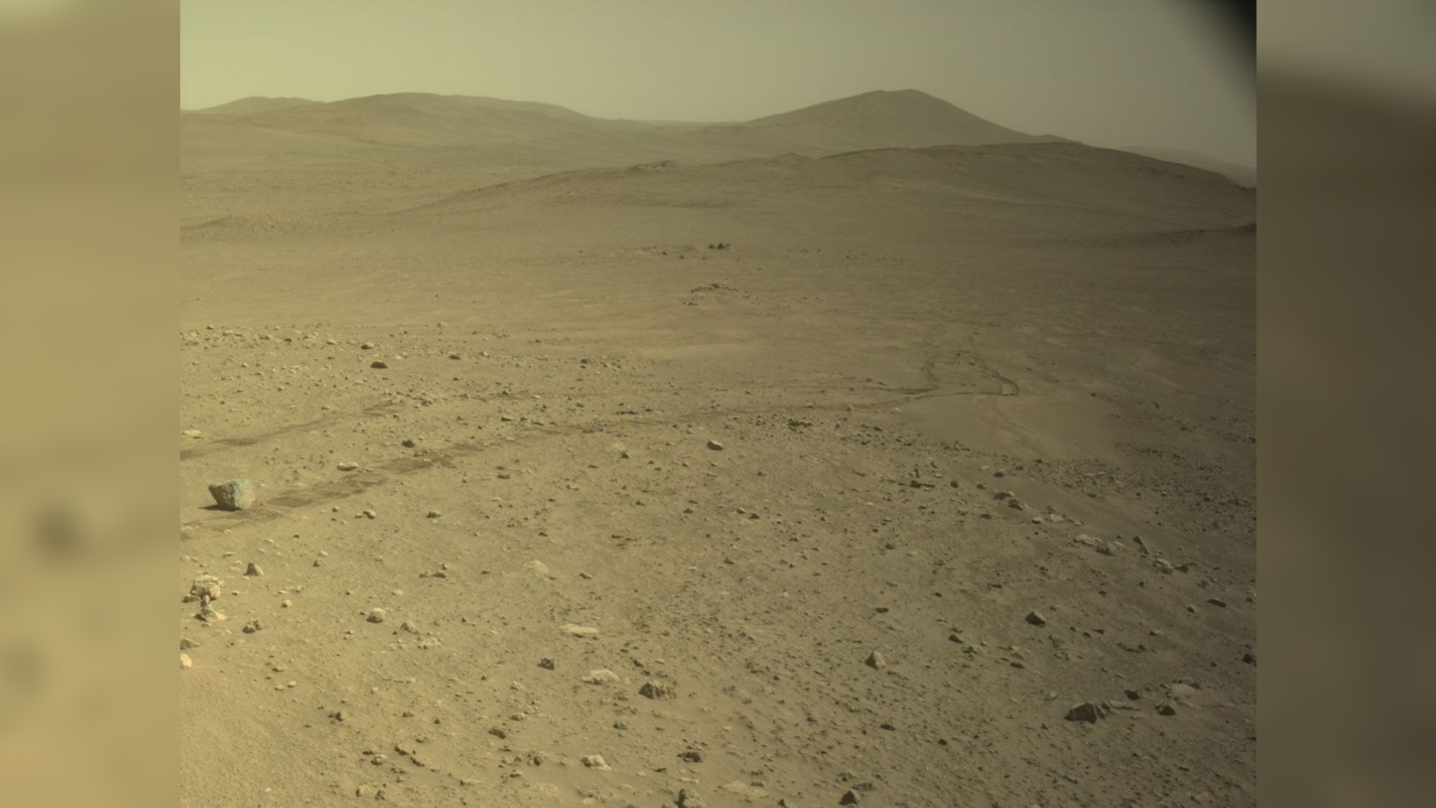
Click for next article Rover tracks can be seen on the Martian surface, left behind by NASA's Perseverance Mars rover. (Image credit: NASA/JPL-Caltech) NASA's Perseverance Mars rover left a mark on the Martian landscape when it passed a historic milestone driving across the Red Planet. What is it? On Oct. 11, Perseverance passed 28.10 miles (45.22 kilometers) driven on Mars. This is farther than anything has ever traveled on the surface of another world, earning the rover the interplanetary driving record . Previously, this record was set by NASA's Opportunity rover, and it took Opportunity roughly 14 years to drive this far. Perseverance traversed this distance in just over 5 years. In this snapshot captured by Perseverance, the rover looked back at its progress, capturing its own tracks pressed into the planet's dusty surface. This moment of reflection captures years of achievement on the Red Planet. Perseverance's driving record comes after many years of different rovers pushing autonomous driving on other worlds to new levels. As Vandi Verma, Chief Engineer for Robotic Operations at NASA's Jet Propulsion Laboratory, shared in a recent mission update , the rover team continues to push the envelope, exploring new and better ways to drive the rovers remotely from another planet. Why is it incredible? While Perseverance has traveled nearly 30 miles across the surface of another planet, the rover has accomplished so much more than just this distance record on its enduring mission. Since landing on Mars back in 2021, Perseverance has observed, sampled and studied a wide variety of rocks, boulder fields, Martian slopes and more. Recently, observations made using Perseverance provided the strongest evidence yet of possible biosignatures on the planet. While we have not yet found conclusive evidence that life once existed on Mars, as the rover has made its way across the planet's surface, it has gotten us closer to that answer than we have ever been before.

12. SpaceX Falcon 9 launches early morning Starlink mission from California (video)
Read more
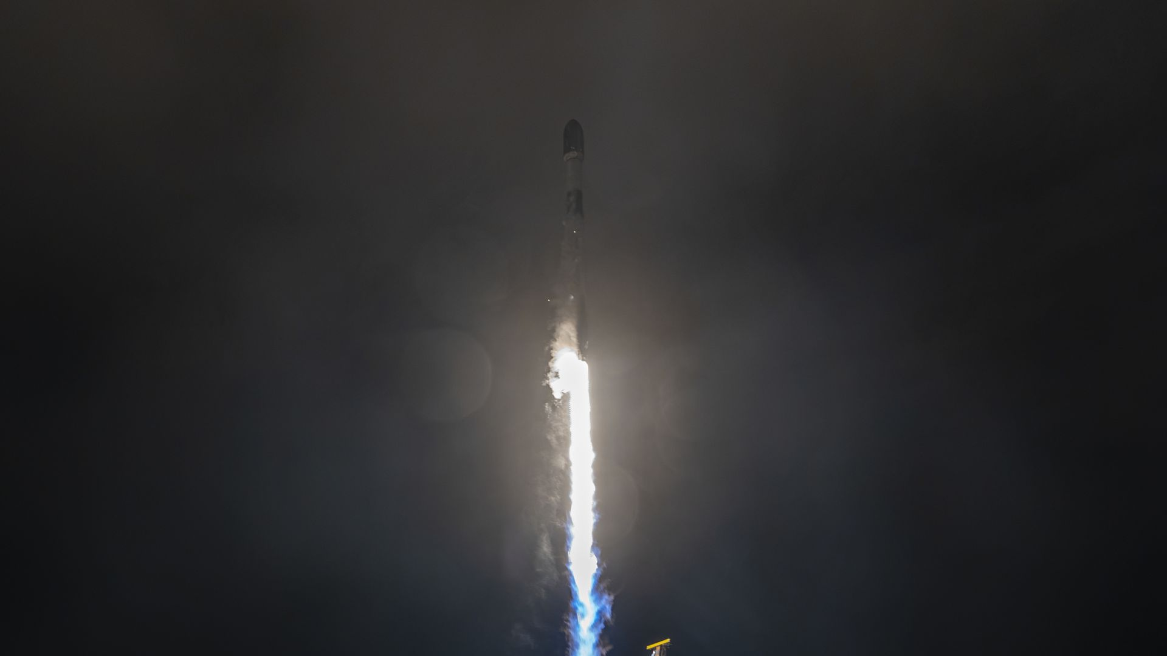
Click for next article A new stack of Starlink satellites is now in orbit following an early morning SpaceX launch from California. A Falcon 9 rocket lifted off at 3:25 a.m. EDT (0725 GMT) on Oct. 27, from from Pad 4E at Vandenberg Space Force Base. The rocket delivered the 27 satellites of Starlink Group 15-16 to low Earth orbit (LEO), and successfully executed its first stage booster landing. The mission's booster, B1082, cut its engines and disengaged from Falcon 9's upper stage approximately 2.5 minutes into flight, and adjusted its trajectory for a touchdown on SpaceX's Of Course I Still Love You (OCISLY) droneship in the Pacific Ocean. A SpaceX Falcon 9 rocket launches 27 Starlink satellites from California on Oct. 23, 2026. (Image credit: SpaceX) B1082 successfullly landed on OCISLY at T+8:23, seconds before Falcon 9's second stage completed its first engine burn. The return of B1082 marks the booster's 21st Starlink mission, and 26th overall flight, the others of which include USSF-62 , OneWeb Launch 20 , NROL-145 , Transporter-18 . Falcon 9's upper stage ignited its engine for a second time about 53 minutes after liftoff, circularizing its orbit with a burn that lasted a very short 3 seconds. That was followed several minutes later by the deployment of the rocket's Starlink payloads. The Falcon 9 launches on Oct. 27, 2026. (Image credit: SpaceX) SpaceX's Starlink network consists of more than 11,000 active spacecraft. The speed with which the company is delivering them to orbit in bulk, however, has slowed somewhat. As SpaceX shifts focus to its larger, more powerful Starship rocket under development, plans to retire Falcon 9 have already begun. Part of that process included ending Starlink launches from Florida earlier this year. Today's mission was the 117th Falcon 9 launch of 2026, so far. About three-quarters of those were dedicated to Starlink.

13. Astroscale proposes fleet of 'bodyguard' spacecraft to protect satellites from orbital attacks
Read more
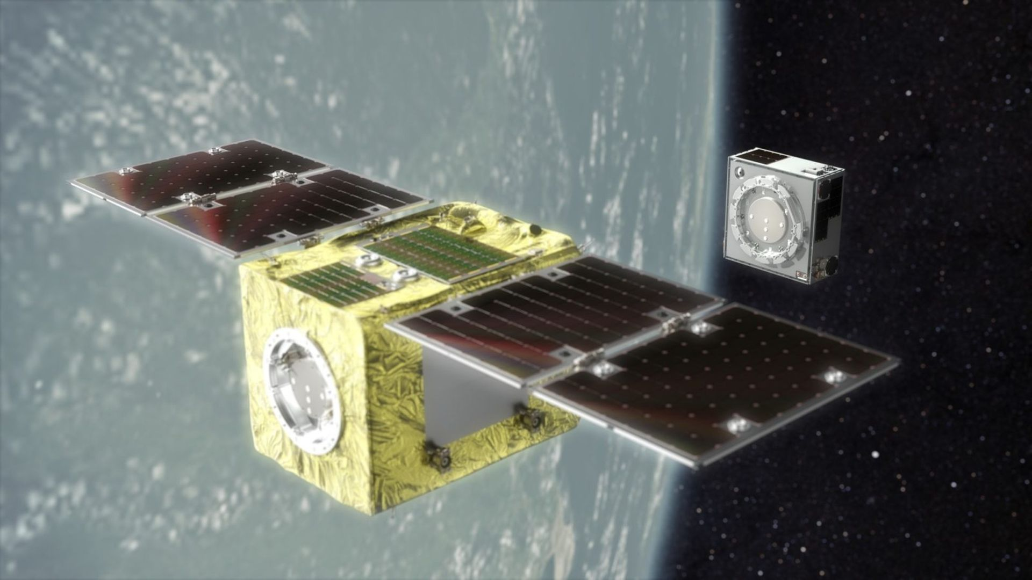
Click for next article Technologies developed and tested in orbit to remove space junk and fix broken satellites can be speedily repurposed to build fleets of bodyguard spacecraft to protect important satellites from adversary attacks, space clean-up company Astroscale thinks. Astroscale made history with its 2024 up-close in-orbit inspection of a discarded Japanese rocket stage during the pioneering ADRAS-J mission in low Earth orbit (LEO), the region of space below altitudes of 1,200 miles (2,000 kilometers). The firm's ELSA-D mission , which ran from 2021 to 2024, was the first commercial endeavor to demonstrate orbital capture technologies in LEO. Now, this technology can come in handy as Western space assets face increasing threats from Russia. Speaking on the sidelines of an event in London earlier this month, Alex Godfrey, Astroscale's head of defense, said the company could have a protector spacecraft ready for launch in under three years. "In in-orbit servicing, we have to achieve very high levels of agility to be able to dock and close to a distance of zero meters to refuel something or remove it from orbit," Godfrey told Space.com. "With space control, you're rarely getting quite as close, so in some ways it's simpler because you are further away." Space control - a military term for ensuring the space around Earth remains orderly and peaceful - is quickly becoming a hot talking point. Godfrey's remarks came just as the world witnessed in shock as Russia made close-up maneuvers around a radar satellite owned by Finland headquartered Earth-observation company ICEYE. The October incident, described by experts as the first rendezvous of two active satellites in low Earth orbit conducted without the consent of the target, raised concerns Russia may be preparing to damage the satellite, which is part of a fleet providing critical intelligence to Ukraine . U.S. Under Secretary of State Thomas G. DiNanno described Russia's actions on X as "threatening behavior" and "consistent with on-orbit weapons operations." The ICEYE incident is only the latest in a long string of activities conducted by Russia in space designed either to eavesdrop on or interfere with the activity of critical Western space assets. The Luch-1 and Luch-2 satellites have been stalking Europe's and America's communications satellites in geostationary orbit - the busy region 22,000 miles (36,000 km) above the planet where satellites have a fixed view of a portion of the globe-since 2014. Germany's military space command chief Major General Michael Traut admitted earlier this year that the Luch spacecraft have been spying on European strategic communications in space for years. Russia's Luch-2 satellite approaches another geostationary satellite on April 12, 2024 as tracked by ground-based observation stations. (Image credit: Aldoria) A bodyguard satellite would make sure no such intruder gets dangerously close. Godfrey said that the cost of a bodyguard mission would be on the order of a single percent of the value of a military-grade geostationary communications constellation such as the U.K.'s £8.4-billion Skynet fleet. "To build a bodyguard satellite is absolutely within the capability and the budget of a single country like the U.K.," said Godfrey. "It would be similar to a carrier strike group where you have a [naval aircraft] carrier, but that carrier never leaves the port on its own. It has an escort of much smaller, lower-cost systems that move around to protect it." Although Astroscale, headquartered in Japan but with significant presence in the U.K., is a leader in the commercial orbital rendezvous and proximity operations technology, no Western players currently match the deployed capabilities of Russia and China. Europe, in particular, is under-equipped for defense and military operations in space, according to the Secure World Foundation's Global Counterspace Capabilities Report. With Russia's accelerating orbital forays, the clock appears to be ticking. Godfrey proposes a pan-European fleet of orbital bodyguards patrolling clusters of European assets to ward off future Russian attempts to jam or damage the satellites. "The UK, for example, has multiple assets in different positions around the geostationary ring," Godfrey said. "That is difficult to protect with a single spacecraft. So what I encourage nations to think about is how to form a geo-patrol force through collaboration. If France has assets in a similar location to the UK and maybe Germany, then it makes sense for one spacecraft to protect two or three allied spacecraft, and then, in another region, another country takes responsibility for the protection." Nick Shave, the UK managing director at Astroscale, told Space.com that the company sees interest in its technologies and is "in discussions" with "companies and customers across Europe" although it has not signed any contracts to develop bodyguard satellites. "We have spent a good amount of time talking over the last few years, but now we have to go and really deliver," Shave said. "The UK government is promising funding for space control development from 2030 onwards. So what needs to happen now is really preparing the ground so that we've got the right capabilities, the right investment and the right demonstrator capability, by 2030."

14. Autonomous rendezvous system overcomes simulated spacecraft failures in lab tests
Read more
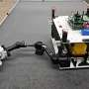
There is a problem in low Earth orbit, and it's growing. According to the European Space Agency, there are about 19,440 satellites on orbit, 3,540 of which are nonfunctioning and/or not emitting a signal to warn other spacecraft of their location. The need to service these sleepwalking satellites in space will only increase as more are launched.

