 |  | 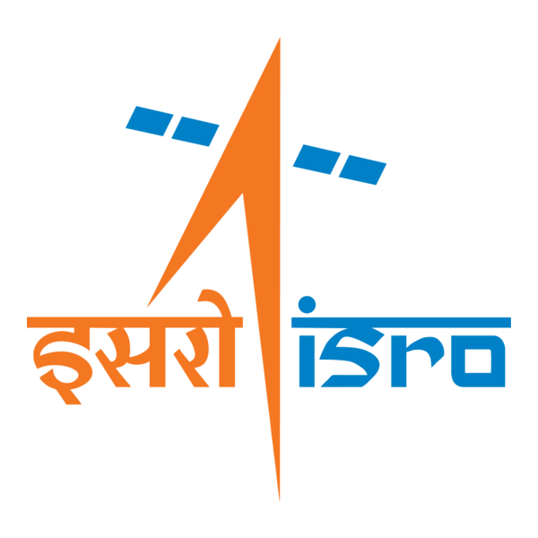

🌌 अंतरिक्ष समाचार | Space News
रविवार, २७/०९/२०२६ | Sunday, 27/09/2026

1. India launches maritime safety group to protect ships and seafarers at UNGA
Read more

Advt By , ET Bureau Join the community of 2M+ industry professionals. Subscribe to Newsletter to get latest insights & analysis in your inbox. All about ETGovernment industry right on your smartphone! Download the ETGovernment App and get the Realtime updates and Save your favourite articles. India and Liberia on Friday announced the establishment of a "Group of Friends" on the safety and security of shipping and seafarers, a key maritime initiative launched amid growing challenges to commercial shipping against the backdrop of the crisis in the Strait of Hormuz and Bab-el-Mandeb.The initiative was launched at the ministerial-level meeting of the "Friends on Safety and Security of Shipping and Seafarers" on the sidelines of the 81st UN General Assembly in New York."India, as a major source of seafarers, and Liberia, as the largest shipping registry, have come together to highlight the safety and security of shipping and seafarers," External affairs minister S Jaishankar said at the meeting. Jaishankar listed recent incidents of attacks on seafarers and ships, saying that, "regrettably", these are no longer exceptional occurrences.Addressing the inaugural meeting, Jaishankar said, "From the Black Sea to the Red Sea to the Gulf, attacks on civilian shipping have become a growing cause of concern. These actions that disrupt maritime commerce and cost innocent lives are simply indefensible. We are here to not just highlight this dangerous trend, but to urge the international community to close ranks and deter such attacks."He said the effort was aimed at bringing all relevant stakeholders together through an inclusive platform. The EAM said the group includes major ship-owning member states, countries with the largest number of ship registries and those that provide the maximum number of seafarers.Jaishankar said that two days ago, the Antigua and Barbuda-flagged bulk carrier MV Cape Dao was attacked in the Gulf of Oman and an Indian sailor was killed. Earlier, the Panama-flagged oil tanker El Gaia was struck while transiting Hormuz, after which an Indian crew member went missing."These, regrettably, are no longer exceptional occurrences. In the last few months, commercial shipping and mariners have been subjected to repeated attacks in the Gulf, the Red Sea and its vicinity. Such unacceptable actions are also occurring in the Black Sea," he said.

2. Assam CM Himanta Biswa Sarma Lays Foundation Stone for ISRO Advanced Radar Research Facility - News On AIR
Read more
Assam CM Himanta Biswa Sarma Lays Foundation Stone for ISRO Advanced Radar Research Facility News On AIR

3. ISRO scientist Dr Gupta assumes charge as Director in JNARDDC - thehitavada.com
Read more
ISRO scientist Dr Gupta assumes charge as Director in JNARDDC thehitavada.com

4. ISRO scientist Dr CS Madhusudhana Conferred with Prestigious IETE Award 2026 - Whispers in the Corridors
Read more
ISRO scientist Dr CS Madhusudhana Conferred with Prestigious IETE Award 2026 Whispers in the Corridors

5. Silver Touch Technologies Gets ISRO Order To Supply High-End Workstations By February 2, 2027 - Sahi
Read more
Silver Touch Technologies Gets ISRO Order To Supply High-End Workstations By February 2, 2027 Sahi

6. India's journey towards 'Viksit Bharat' being written in rockets built on Indian soil: ISRO chief - EdexLive
Read more
India's journey towards 'Viksit Bharat' being written in rockets built on Indian soil: ISRO chief EdexLive

7. Engineers teach spacecraft to 'dream' their way to the space station
Read more
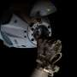
Docking with the ISS may seem simple. However, actually doing so shows how difficult orbital mechanics can be. It's like traveling down a highway at 28,000 km/hr (17,000 mph) and parallel parking in an open garage on a multibillion-dollar laboratory traveling at the same speed. If you try to accelerate forward, you actually drift up, and there's no air friction to naturally slo...

8. A real-time look inside spacecraft heat shields during extreme heat conditions
Read more
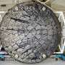
When a spacecraft reenters Earth's atmosphere at hypersonic velocities, its protective heat shield faces extreme conditions, including temperatures beyond 3,000 degrees Fahrenheit (1,650 degrees Celsius). To survive, the shield relies on specialized materials that absorb heat as they degrade in a controlled process called ablation, sacrificing the shield's outer layers to prote...

9. US Navy preparing sailors for robot warfare, launches autonomous systems warfighting center
Read more
To maintain decisive maritime advantage, the U.S. Navy has established a new warfighting center (RASWDC) to rapidly integrate robotic and autonomous systems into operations, training, and deployment. Launched on September 24, the new center is led by Rear Admiral Melvin Smith as its inaugural commander, according to a U.S. Navy news release. Headquartered at Joint Expeditionary Base Little Creek-Fort Story in Virginia, the RASWDC will serve as the Navy's dedicated operational integration point for robotic and autonomous systems across maritime operations. "To maintain our decisive maritime advantage, we must rapidly integrate robotic and autonomous systems into how we operate, train, and deploy," said Chief of Naval Operations Adm. Daryl Caudle. "The establishment of RASWDC will equip Sailors with the tactical edge, advanced training, and specialized doctrine required to win the high-end fight." Navy moves to integrate autonomous systems RASWDC is an Echelon 3 warfighting development center operating under U.S. Fleet Forces Command. It will equip sailors with "the tactical edge, advanced training, and specialized doctrine required to win the high-end fight," said Caudle. The Navy has spent years experimenting with these technologies across "multiple warfare communities, commands, laboratories, and acquisition organizations," Caudle wrote in an administrative note. "That work has produced important capability and invaluable experience. But much of it has advanced independently within individual domains," which the Navy now intends to integrate. The Navy has pursued a range of systems, including unmanned aerial systems, uncrewed surface vessels and unmanned underwater vehicles. RASWDC will have three core missions: developing warfighting concepts, training sailors, and fielding and testing new technologies. The center will test uncrewed platforms under realistic operational conditions and threats, including degraded or denied communication environments. "Systems that work will move forward," added Caudle in the administrative note. The Navy plans to improve, redirect, or stop systems that don't. Connecting development with the Fleet RASWDC will operate alongside the recently announced Direct Reporting Portfolio Manager for Robotic and Autonomous Systems (DRPM RAS). While DRPM RAS provides portfolio authority for RAS acquisition, requirements implementation, budgeting, technical standards, and fielding, RASWDC will focus on employment. The Navy said the two organizations will create a direct feedback loop between the acquisition enterprise and operational forces. Lessons and performance data gathered through testing, experimentation, and training can be returned to developers and program managers to improve future capabilities. "RASWDC is the critical bridge between capability development and operational employment," Caudle said in the press release. "By forging a direct feedback loop, we are accelerating the delivery of unmanned capabilities from the foundry directly to the Fleet, ensuring our forces are postured to meet any challenge." Preparing sailors for autonomous warfare "Ultimately," the news release said, "to prepare sailors for 'The Fight,' the center will develop specialized doctrine, tactics, techniques, and procedures, as well as an advanced tactical instruction framework for sailors operating and deploying autonomous platforms."

