 |  | 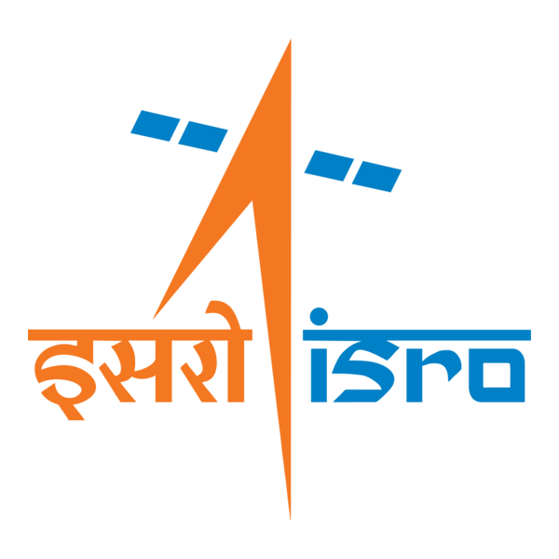

🌌 अंतरिक्ष समाचार | Space News
सोमवार, २८/०९/२०२६ | Monday, 28/09/2026

1. Silver Touch Technologies Receives ISRO Purchase Order For Workstations Delivery By February 2, 2027 - Sahi
Read more
Silver Touch Technologies Receives ISRO Purchase Order For Workstations Delivery By February 2, 2027 Sahi

2. 'Leave ISRO ALONE!' - Rediff
Read more
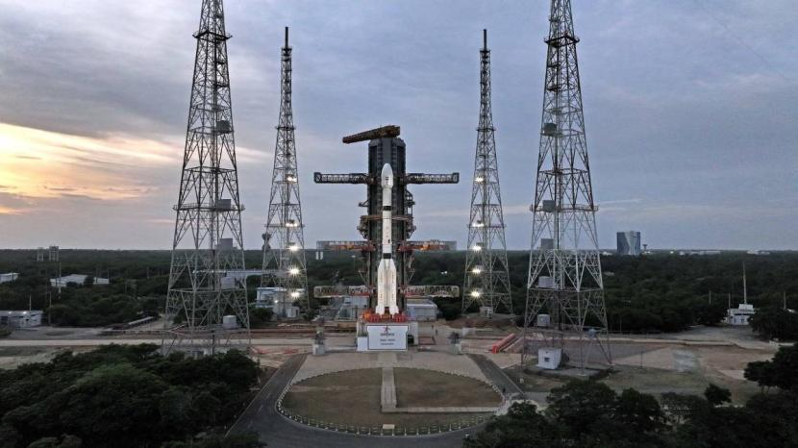
'Leave ISRO ALONE!' Rediff

3. Tamil Nadu readies workforce for ISRO facility, engineering grads to build satellite modules - The New Indian Express
Read more
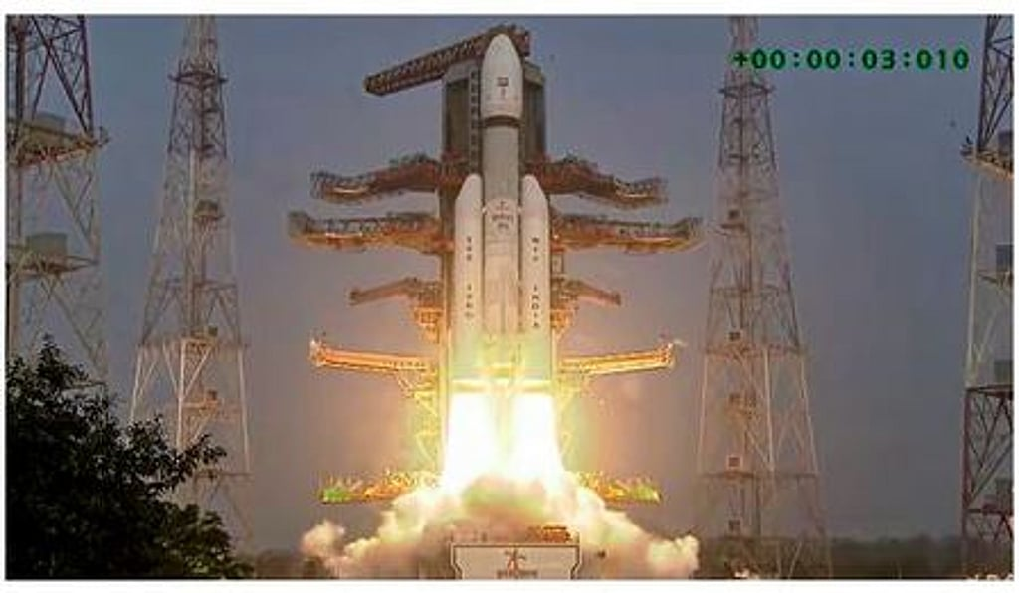
Tamil Nadu readies workforce for ISRO facility, engineering grads to build satellite modules The New Indian Express

4. Silver Touch Technologies receives order from Space Applications Centre, ISRO - Business Standard
Read more
Silver Touch Technologies receives order from Space Applications Centre, ISRO Business Standard

5. Isro's navigation satellite NVS-03 launch in Oct to reactivate NavIC, spell good news for security forces - The Times of India
Read more
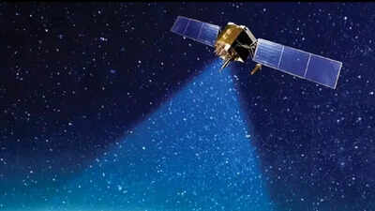
Isro's navigation satellite NVS-03 launch in Oct to reactivate NavIC, spell good news for security forces The Times of India

6. Silver Touch Technologies Secures High-Performance Computing Order from ISRO's Space Applications Centre - EquityBulls
Read more

Silver Touch Technologies Secures High-Performance Computing Order from ISRO's Space Applications Centre EquityBulls

7. 7 SpaceX rocket details that challenge what you know about launches
Read more
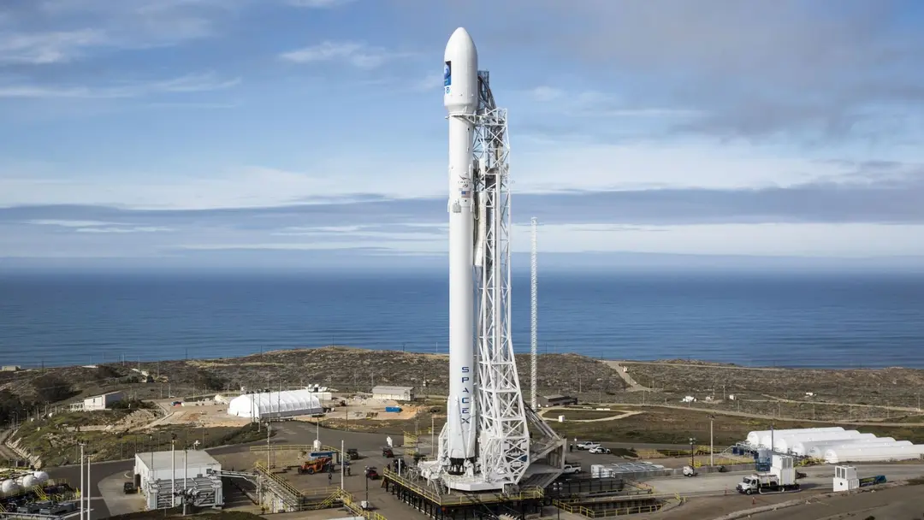
A SpaceX launch has a familiar outline. The rocket lifts off, its stages separate, and a payload continues toward space. The less familiar story is what happens to the hardware along the way, and how SpaceX has changed systems that rockets usually leave behind or use only once. Some differences are visible, such as a booster returning to its launch tower. Others are hidden inside the vehicle, where rocket fuel can help steer engines and compressed gas can push stages apart. Here are seven surprising facts we bet you did not know about SpaceX and its rocket launches. 1. A Falcon 9 booster can land while the upper stage is still climbing Wikimedia Commons Most rocket first stages are discarded after they finish their job. Falcon 9's first stage can instead turn around and land while its second stage continues carrying a payload toward orbit; NASA documented exactly that sequence during SpaceX's first successful orbital-class booster landing in 2015. This does not happen in the same order on every mission. On another NASA-documented flight, Dragon was already in orbit before the booster attempted to land. What is different is that SpaceX plans a controlled return for the first stage while the rest of the mission proceeds independently. 2. SpaceX flies used satellite covers The fairing is the protective shell around a satellite during ascent, and rockets release it once the thickest part of the atmosphere is behind them. SpaceX recovers and reuses fairing halves; its Falcon user guide says previously flown halves had been used on 307 missions as of February 2025. That makes the fairing more than packaging thrown away after launch. Booster landings receive the attention, but SpaceX also treats these large covers as hardware worth recovering, inspecting, and flying again. 3. A booster used for a crew launch can return for another mission In 2020, a Falcon 9 launched NASA astronauts Bob Behnken and Doug Hurley aboard Dragon on the Demo-2 mission. The same first-stage booster later launched an uncrewed cargo Dragon, and NASA identified that launch as the booster's fourth flight. It is easy to assume that a rocket assigned to astronauts would be used only once. The example shows how SpaceX can recover the booster from a crew launch and prepare it for a subsequent mission, while the spacecraft carrying the astronauts continues on its own. 4. Compressed gas pushes Falcon's stages apart Stage separation is a critical moment. The spent booster must move clear so the upper stage can continue its flight. SpaceX's Falcon user guide says pneumatic devices release and push apart Falcon's stages, as well as Falcon Heavy's side boosters. Unlike the traditional explosives-based separation system described in the guide, Falcon's pneumatic system allows SpaceX to functionally test the actual hardware that will fly. That gives engineers a way to check the separation mechanism before the rocket reaches the point where it must work. 5. Starship fires its upper-stage engines before separation is complete Wikimedia Commons The expected order is simple: disconnect one rocket stage, then start the next. Starship uses hot staging, igniting its upper-stage engines before the booster's engines have completely shut down. That puts engine exhaust close to the booster while the vehicles separate. In SpaceX's V3 design, the forward dome of a booster fuel tank is directly exposed during the maneuver, with internal tank pressure and a protective steel layer helping it withstand the event. 6. Super Heavy returns to a tower instead of landing on legs Falcon 9 carries legs to support itself when it touches down. SpaceX designed Starship's Super Heavy booster for a different recovery method: it returns to the launch site, where the tower catches it. The surprise is that the landing equipment is on the ground rather than carried through the flight. The company has also gone beyond a single catch demonstration - a Super Heavy booster caught after Starship's seventh flight test was flown again on its ninth. 7. Falcon 9 uses rocket fuel to help steer its engines Rocket engines must be directed during flight to keep the vehicle on course, and moving them requires power. SpaceX's Falcon user guide says the first-stage thrust-vector control system draws from its high-pressure kerosene system instead of carrying a separate supply of hydraulic fluid. In other words, the rocket's fuel does a second job before it is burned. SpaceX says this removes potential failure points associated with a separate hydraulic system and with running out of hydraulic fluid.

8. China conducts satellite-to-satellite refueling operation in high Earth orbit: Report
Read more
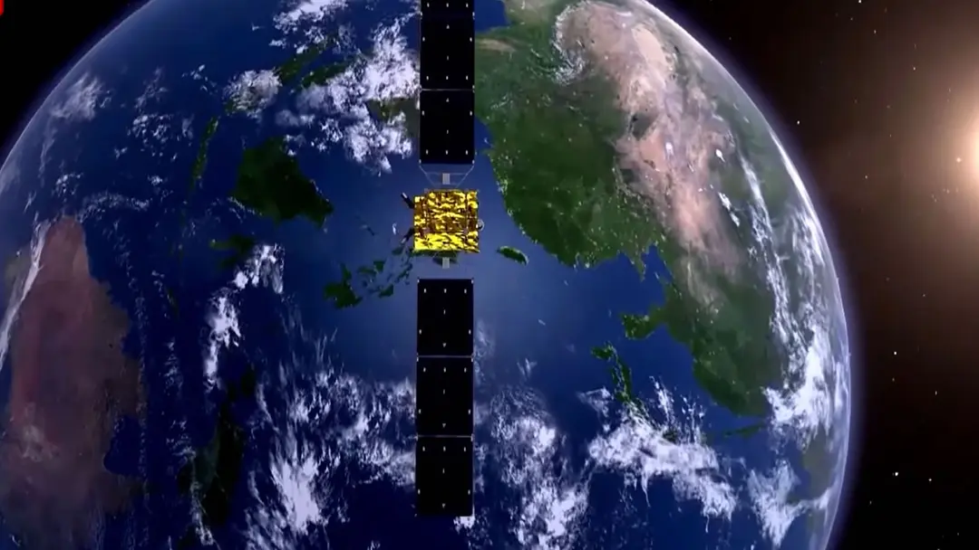
China has successfully refuelled one of its BeiDou satellites in high orbit, according to reports. The operation - occurred in February this year, but for whatever reason - has only just been submitted for peer review with the Chinese Journal of Deep Space Exploration. In case you are unaware, these satellites are China's answer to the US Global Positioning System (GPS). They are vital for positioning, navigation, and timing for things like smartphone maps, military drones, and missile guidance on Earth. The operation involved the transfer of room-temperature propellant from one "tanker satellite" to a BeiDou satellite. If true, this means the nation is now capable of continuing to extend the lifespan of valuable spacecraft in space. Satellites like the BeiDou are launched with a finite amount of propellant. This is needed for things like orbit corrections, station-keeping, attitude control, and collision avoidance. Eventually, the spacecraft can still have perfectly functional electronics, solar panels, and atomic clocks, but if it runs too low on propellant, it becomes increasingly difficult to operate. Under normal circumstances, you would need to replace it with another satellite once the propellant is exhausted. Mid-orbit refuelling is now a thing However, the ability to top up propellant in orbit could rewrite the rules. It is also an impressive feat. The servicing spacecraft has to find and approach a target travelling at kilometres per second, and match its orbit extremely precisely. Once there, it needs to get within centimetres or millimetres without smashing into it. It then needs to mechanically connect (or otherwise create a fluid connection) and transfer fuel in microgravity without leaks, bubbles, contamination or destabilising either spacecraft. All this with spacecraft operating in medium Earth orbit and geosynchronous-type orbits. So the servicing mission would have been operating thousands or tens of thousands of kilometres above Earth. That makes communications, navigation, orbital rendezvous, and mission logistics substantially harder. As for the propellant itself, this was likely some form of storable chemical rather than cryogenic fuel such as liquid hydrogen or liquid oxygen. Storable propellants can remain liquid for years without refrigeration. That's why they're common for satellite thrusters. From an engineering perspective, they are much easier to transfer than cryogenic propellants. Cryogenic fuel is a completely different beast. It boils away, has to be kept incredibly cold, creates complicated pressure and thermal-management problems, and behaves strangely in microgravity. Should other nations be worried? While spacecraft-to-spacecraft cryogenic refuelling is yet to be achieved, the ability to refuel storable chemical propellant is still a game-changer. It now means China can extend the usable life of satellites like BeiDou, with each refuelling satellite likely able to service multiple satellites in one trip. That translates to significant savings in satellite servicing, eliminating the need to develop and launch replacements. Other than the refuelling/servicing satellite(s), of course. Very interesting, but there is another interesting angle here too. The capability to safely approach, dock with, and interact with another satellite in orbit has other implications too.

