IIRS Daily Space Digest Tuesday, 12/05/2026

1. Kaushik directs immediate response & other measures for disaster scenarios
Pioneer Edge | Uttarakhand News in English | Dehradun News Today| News Uttarakhand | Uttarakhand latest news
Read more

PIONEER EDGE NEWS SERVICE/Dehradun Disaster Management minister Madan Kaushik directed officials to ensure immediate response in case of disaster scenarios. Chairing a meeting to review preparations for the monsoon on Monday, Kaushik said that the rainy season is a very sensitive and challenging period for Uttarakhand. He pointed out that the Char Dham Yatra is at its peak at a time when the monsoon is about to arrive in the State. No negligence or casual attitude can be tolerated in such a situation. He directed all linear departments, district administrations, police, State Disaster Response Force (SDRF), National Disaster Response Force (NDRF) and other agencies to remain in an alert mode 24×7. Stating that response time is vital in disaster management, Kaushik directed all departments to make their response mechanism more effective and swifter. Special focus should be laid on cleaning all nalas and drains in the State through a special campaign. All the nalas and drains in the State should be cleaned at least twice before the advent of monsoon to mitigate waterlogging and floods in urban areas, he said. The minister further said that the availability of all necessary equipment and machinery in working condition should be ensured for tackling situations in areas prone to waterlogging and in case of floods. He said that the police, SDRF and NDRF should especially remain alert and active. The minister further said considering the Char Dham Yatra and monsoon, medical posts should be established in sensitive and disaster prone locations. Adequate number of doctors, paramedical staff and essential medicines should be ensured in such posts. Laying special focus on the possibility of water borne and contagious diseases during monsoon, necessary medicines and adequate preparation by the Health department must also be ensured, he said. Kaushik directed the Animal Husbandry department to form a special quick response team for assisting cattle to ensure their rescue and treatment during disaster scenarios. Proper arrangements should be made for the safety and treatment of cattle since they are also an important part of the rural economy, he said. The minister also issued directions related to issuance of standard operating procedures for the safety of trekkers and channelisation of rivers before the advent of monsoon. The department's advisory committee vice chairman Vinay Rohila said that all district magistrates should ensure adequate quantity of foodgrains, ration and other essential commodities for the monsoon in their districts.

2. Bihar govt launches portal, helpline number to resolve people's grievances
Government News | Latest news on eGovernance, Digital India, Smart Cities | ET Government : ETGovernment.com
Read more


- Governance - 2 min read The CM made it clear that strict departmental action, including suspension, would be initiated against those who fail to act on applications listed on the portal and issue orders accordingly within 30 days. - PTI - Published On May 11, 2026 at 05:26 PM IST Copy Link Share on WhatsApp Share on Linkedin Share on X Share on Telegram Share on Facebook Bihar Chief Minister Samrat Choudhary on Monday launched an online portal and a helpline number for prompt resolution of people's grievances. Patna , Bihar Chief Minister Samrat Choudhary on Monday launched an online portal and a helpline number for prompt resolution of people's grievances concerning government departments in the state, officials said. The ' Sahyog Portal ' and toll-free helpline number '1100' was rolled out during the day for the purpose, they said. Advt "The issues will be resolved within 30 days by organising 'Sahyog' camps at the panchayat level. Concerned district magistrates (DMs) and superintendents of police (SPs) will monitor the process in real time. Work is underway to install CCTV cameras in all blocks, circle offices, and police stations for constant monitoring of activities of officials," Choudhary said here. "Resolving problems of the common people is the top priority of the Bihar government . Under the initiative, 'Sahyog' camps will be organised at the panchayat level on the first and third Tuesday of every month. Applications may be submitted both online and offline. Every application will be disposed of within 30 days, and compliance details will be uploaded on the Sahyog Portal ," he said. The objective of the 'Sahyog' camps is to resolve citizens' problems in an integrated and transparent manner, said the CM. "The Bihar government is continuously striving to resolve the problems of ordinary citizens effectively and within a fixed timeframe," he said. Choudhary said former chief minister Nitish Kumar had also undertaken several public outreach tours, and made every effort to ensure prompt resolution of people's grievances. "If the officer concerned fails to dispose of an application and issue an order within 30 days, or shows negligence, they will automatically be suspended on the 31st day. "An online mechanism is also being put in place whereby the suspension order format against negligent officials will automatically be generated on the portal," the CM said. - See more on: - patna , - bihar , - Sahyog Portal , - Bihar government , - governance , - e-Governance Telegram Facebook Comments What are your thoughts? Comment Now --> Comment Now Read Comment (1) All Comments By commenting, you agree to the Prohibited Content Policy Post Find this Comment Offensive? Choose your reason below and click on the submit button. This will alert our moderators to take actions REASONS FOR REPORTING Foul Language Defamatory Inciting hatred against a certain community Out of Context / Spam Others Report Join the community of 2M+ industry professionals. Subscribe to Newsletter to get latest insights & analysis in your inbox. --> All about ETGovernment industry right on your smartphone! - Download the ETGovernment App and get the Realtime updates and Save your favourite articles. Scan to download App -->

3. 'Rocket woman' in Washington: Why the Smithsonian Museum is displaying an Isro scientist's saree - The Indian Express
"ISRO OR NRSC OR IIRS after:2026-05-11" - Google News
Read more


The Smithsonian National Air and Space Museum in Washington, DC, has placed a saree worn by Isro scientist Nandini Harinath in one of its newest displays. Celebrated as "rocket woman", Harinath played a key role in India's historic Mars Orbiter Mission, popularly known as Mangalyaan. Over a career spanning more than two decades, Harinath contributed to over 14 missions at the Indian Space Research Organisation. Sharing the post on Instagram, the official handle of the Smithsonian wrote, "As a rocket scientist and the Mars Orbiter Mission's deputy operations director, Harinath was integral to mission planning and operations. Far exceeding its mission of six to 10 months, the spacecraft spent eight years in orbit, documenting Mars' surface and atmosphere."

4. National Jute Board expands tech-driven crop monitoring system with ISRO collaboration - DD News
"ISRO OR NRSC OR IIRS after:2026-05-11" - Google News
Read more

National Jute Board expands tech-driven crop monitoring system with ISRO collaboration DD News

5. Isro to help upgrade Hope habitat in Ladakh for training Gaganyaan astronauts - India Today
"ISRO OR NRSC OR IIRS after:2026-05-11" - Google News
Read more
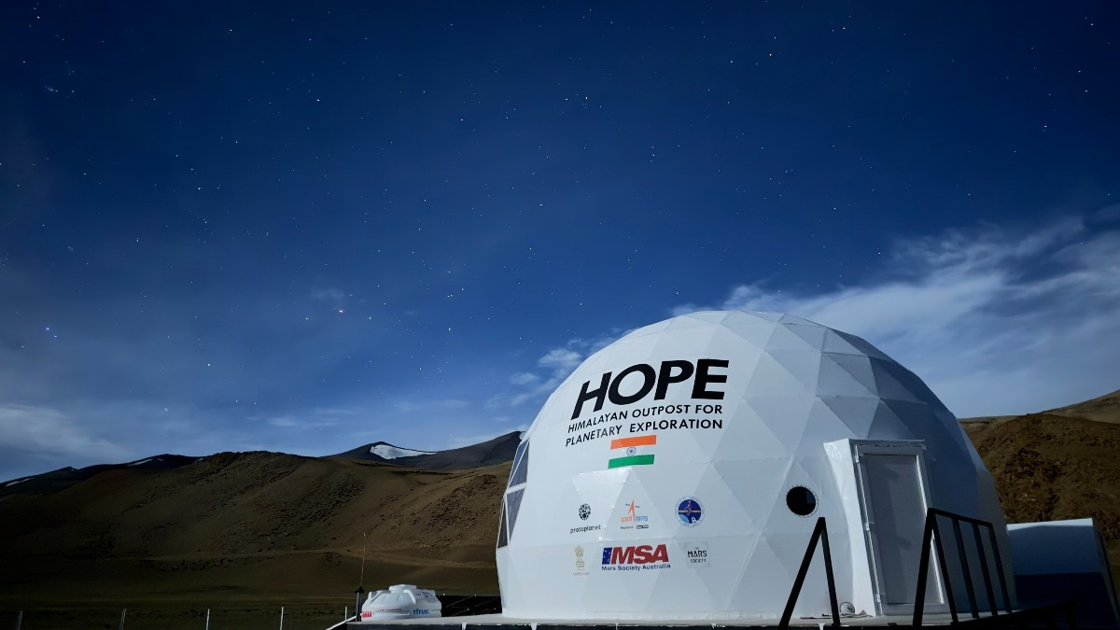

India's ambitions for human spaceflight are driving new upgrades deep in the high-altitude cold desert of Ladakh, where a remote analogue habitat designed to simulate the harsh conditions of space is being expanded to support future astronaut training missions linked to the Indian Space Research Organisation's (Isro) Gaganyaan programme. The Hope Habitat, set up in the Tso Kar valley of Ladakh and developed by space research company Protoplanet, is now being upgraded after completing an earlier analogue isolation mission with help from the Indian space agency. The Hope habitat in Ladakh's Tso Kar valley. (Photo: Sibu Tripathi) According to Dr. Siddharth Pandey, founder of Protoplanet, the initiative is being carried out in collaboration with Isro's Human Space Flight Centre to help astronauts prepare for the physical and psychological challenges of spaceflight. Pandey said the project gained momentum after the successful Hope analogue mission conducted in 2025. The programme later evolved into a specialised training exercise involving Isro engineers and astronauts, aimed at studying how teams function under stressful and isolated conditions similar to those encountered during long-duration space missions. WHY IS LADAKH IDEAL FOR SPACE TRAINING? The Ladakh environment was chosen because it replicates several spaceflight stressors. The region's extreme isolation, low atmospheric pressure, oxygen scarcity, freezing temperatures, and sharp thermal swings create conditions that affect both physical performance and group dynamics. Researchers are particularly interested in understanding how astronauts collaborate and make decisions in such environments. Protoplanet was recently involved in a simulation mission involving all four designated Gaganyaan astronauts, making it a rare opportunity for researchers to observe actual spaceflight crews instead of analogue participants alone. While earlier missions primarily tested the habitat and infrastructure, the recent programme focused heavily on behavioural studies and teamwork. The four astronauts part of Gaganyaan Mission. (Photo: India Today) HOPE HABITAT TO BE UPGRADED To support the future Hope mission, Protoplanet is working on upgrading the communications systems, power infrastructure, and data monitoring capabilities inside the habitat. The station will also be equipped with surveillance systems, cameras, and wearable biometric devices to study how astronauts respond physiologically and psychologically to prolonged isolation. Psychologists from the Institute of Aerospace Medicine in Bengaluru will also be stationed at the site during the future test mission. The company plans a major expansion of the Hope Habitat over the next two years. The upgrades will allow more personnel to stay at the station while centralising the collection of scientific and behavioural data. Some improvements are expected to be completed during the current summer season in Ladakh, with additional work continuing into next year. Discussions are underway with Isro to make such analogue missions a recurring component of astronaut training for future human spaceflight missions as part of Gaganyaan. - Ends

6. ISRO and Protoplanet upgrade Ladakh's Hope habitat for astronaut training - NewsBytes
"ISRO OR NRSC OR IIRS after:2026-05-11" - Google News
Read more


Hope Habitat gains wearables and psychologists The upgrades include better communication technology, stronger power systems, and smart wearables to track astronaut health. Psychologists from Bengaluru will also keep an eye on how crews handle stress and teamwork during long stays. Over the next two years, the expanded facility will fit bigger teams and collect more data, helping ISRO prepare its astronauts for future missions in space.

7. ISRO advances talks with Russia for semi-cryogenic engines for next-gen rockets - MSN
"ISRO OR NRSC OR IIRS after:2026-05-11" - Google News
Read more

ISRO advances talks with Russia for semi-cryogenic engines for next-gen rockets MSN

8. Curiosity Blog, Sols 4886-4892: Ingenuity and Perseverance, Curiosity Style
NASA
Read more
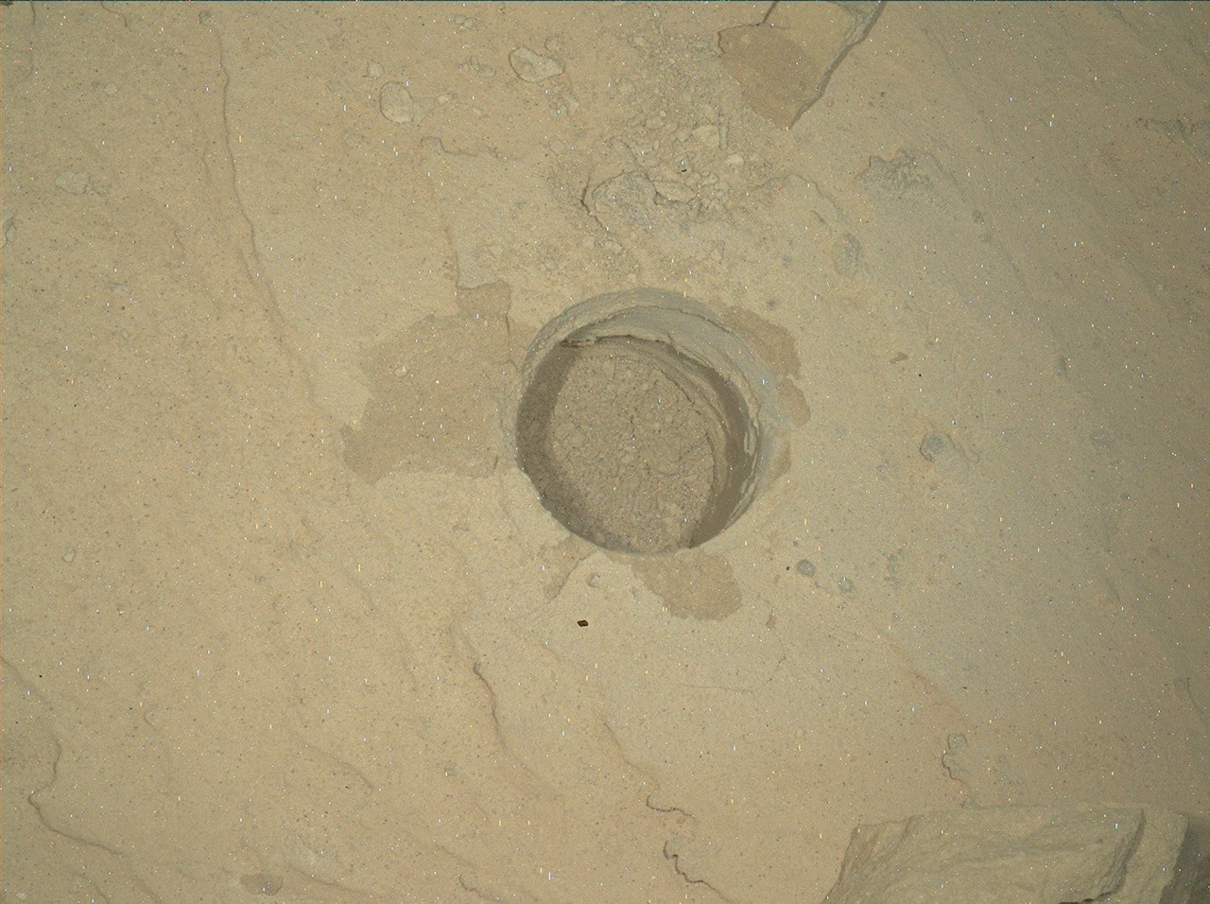

NASA's Mars rover Curiosity acquired this image showing an oblique view into the "Atacama" drill hole, where the rover's drill was briefly lodged. Curiosity created the image using its Mars Hand Lens Imager (MAHLI), a close-up camera located on the turret at the end of the rover's robotic arm, and an onboard focusing process that merges multiple images of the same target at different focus positions, creating a composite that brings as many features into focus as possible. Curiosity performed the focus merge on May 6, 2026 - Sol 4887, or Martian day 4,887 of the Mars Science Laboratory Mission - at 01:39:34 UTC. NASA/JPL-Caltech/MSSS Written by Michelle Minitti, MAHLI Deputy Principal Investigator Earth planning date: Friday, May 8, 2026 While we know the monikers Ingenuity and Perseverance are attached to our sister helicopter and rover on the Mars 2020 mission, those characteristics were in full force with Curiosity over the past week. The science we achieved this week was enabled by the ingenuity of the Curiosity engineers and scientists manifested in this extraordinary time lapse. It demonstrates the careful dance of arm motions employed - each one diligently planned by the team - to free Curiosity's drill from the "Atacama" target. Watch the arm twist, bend, and turn with a rock slab attached, and be amazed. The highest-priority activities after liberating the drill included imaging the drill with Mastcam and ChemCam RMI, and imaging into the now-empty drill hole with MAHLI (the image above). The science team made the most of the freshly-broken surfaces created when Atacama fell back to Mars, and the freshly-exposed sand once hidden underneath Atacama. ChemCam targeted one of the clean fracture faces with two LIBS rasters at "Tamarugal" and "Tamarugo," and followed with another raster on a light-toned patch of bedrock formerly under Atacama at "Colchane." MAHLI and APXS analyzed sand near Colchane at the target "Yerba Loca." Beyond Atacama, Mastcam and ChemCam imaged the large buttes towering above our current and future drive paths. Mastcam also imaged two exposures of the polygonal fractures present in this area (targets "Cerro Elefantes" and "Azul Pampa") and looked for wind-induced changes in the sand ("Playa los Metales"). ChemCam planned a passive spectroscopy observation of light-toned features on the "Paniri" butte and checked out a potential meteorite with a LIBS raster at "Isla Mocha." As engineering assessments continued, Curiosity drove uphill to study a contact between two different rock types, which can indicate a change in formation conditions, a break in time, or both. MAHLI, APXS, and ChemCam teamed up to study both rock types at the lighter-toned, layered "Toro" target and the darker, flaky "Inca de Oro" target. Mastcam planned multiple mosaics capturing different structures and transitions exposed along the contact. Across the plans during the week, REMS, RAD, and DAN regularly measured the environment above and below the rover, and Navcam and Mastcam teamed up to look for clouds, dust devils, and dust in the atmosphere. With the health of the drill and arm confirmed by the engineers, Curiosity exhibited perseverance by heading toward a new workspace with a promising (larger) block for a new drill attempt. Our Martian exploration continues undaunted.

9. NASA's Curiosity Takes Close Look at Rock That Got Stuck on Drill
NASA
Read more
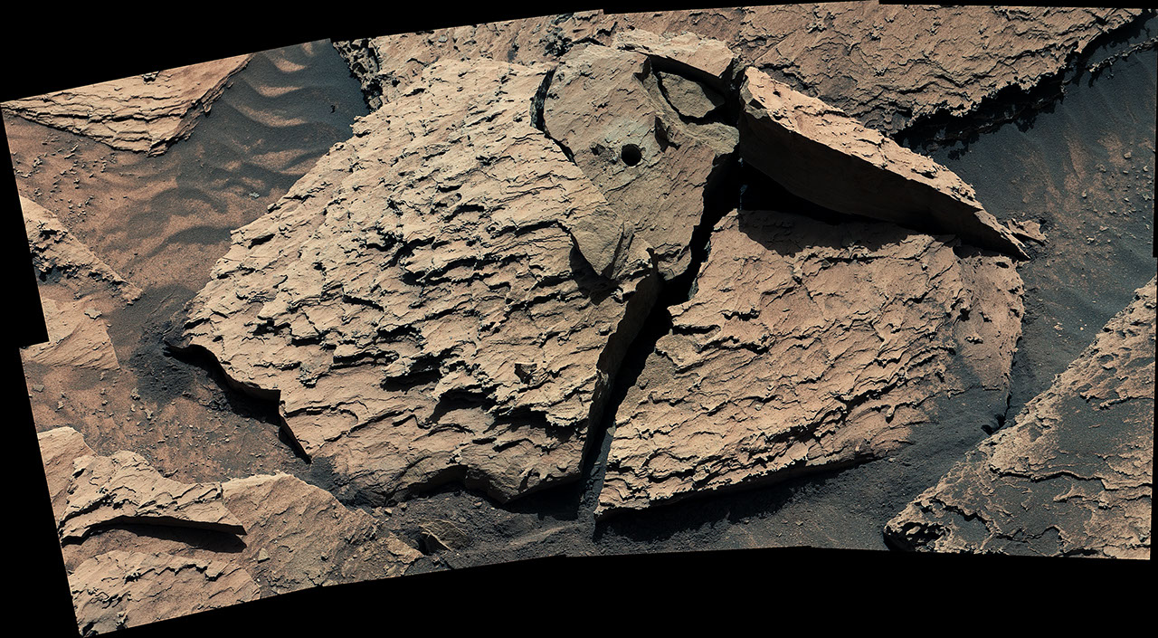

Description NASA's Curiosity Mars rover used its Mast Camera, or Mastcam, to capture this view of a rock nicknamed "Atacama" on May 6, 2026, the 4,877th Martian day, or sol, of the mission. The rock had gotten stuck to the drill on the end of Curiosity's robotic arm on April 25. Engineers spent several days repositioning the arm and vibrating the drill to try and get the rock loose, finally detaching the rock on May 1. Atacama is estimated to be 1.5 feet in diameter at its base and 6 inches thick. It would weigh roughly 28.6 pounds (13 kilograms) on Earth (and about a third of that on Mars). The circular hole produced by Curiosity's drill is visible in the rock. This mosaic is made up of eight images that were stitched together after being sent back to Earth. The color has been approximately white-balanced to resemble how the scene would appear under daytime lighting conditions on Earth. Curiosity was built by NASA's Jet Propulsion Laboratory, which is managed by Caltech in Pasadena, California. JPL leads the mission on behalf of NASA's Science Mission Directorate in Washington as part of NASA's Mars Exploration Program portfolio. Malin Space Science Systems in San Diego built and operates Mastcam. To learn more about Curiosity, visit: science.nasa.gov/mission/msl-curiosity

10. May 2026 Satellite Puzzler
NASA
Read more


Every month, NASA Earth Observatory features a puzzling satellite image. The May 2026 puzzler appears above. Your Challenge Identify the location shown in this satellite image. Share what clues you see, where you think it is, and what makes this place interesting or unique to you. How to Answer Submit your response using this form and select "Puzzler Answer" as the topic. Please include your preferred name or alias. You can keep it simple and just guess the location. Want to impress us? Tell us which satellite and instrument captured the image, which spectral bands were used, or point out a subtle detail about the geology or history of the area. If something catches your eye, or if this is your home or means something to you, we'd love to hear about it. The Prize We can't offer prize money or a trip to space to see Earth like satellites and astronauts do. But we can offer something almost as rewarding: puzzler bragging rights. About a week after the challenge, we'll post the answer at the top of this page, along with a link to an Earth Observatory Image of the Day story that explains the image in more detail. We'll recognize the first person who correctly guesses the location, and we may also highlight readers who share especially thoughtful or interesting answers. By submitting a response, you acknowledge that your comments may be edited, excerpted, and published on this page. Until then, zoom in, look closely, and enjoy the challenge. See you at the reveal!

11. Nicholas Houghton: Engineering Crew Safety for NASA's Artemis Missions
NASA
Read more
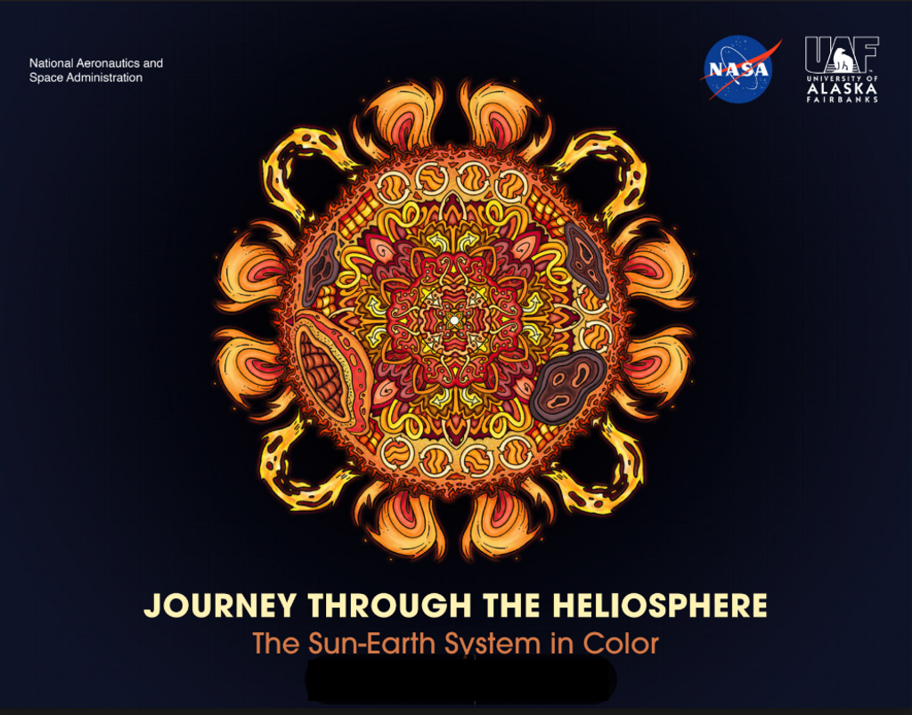

Nicholas Houghton always dreamed of working at NASA and one day becoming an astronaut. Today, he helps design systems that keep crews safe during missions aboard NASA's Orion spacecraft, including the successful Artemis II mission around the Moon. Nicholas Houghton in NASA's Orion Crew Survival System Spacesuit. I hope someday people look back at Artemis and marvel at the technological achievement and collective dedication that it took to carry out these missions, just like we do now for Apollo. Nicholas Houghton Orion Crew Survival Systems Engineer After joining NASA as a Pathways intern, Houghton later became a full-time engineer on the Orion Crew Survival Systems (OCSS) team at NASA's Johnson Space Center in Houston. The OCSS team designs and certifies the orange pressure suits that were worn by astronauts inside Orion during Artemis II, along with the survival hardware integrated into each suit system. Houghton manages key pieces of flight hardware that keep crew members safe during contingency scenarios before launch, in flight, and after landing, including the Orion Crew Survival Kits, Suit-Worn Survival Suite, and Life Preserver Units. He guides each system from design through testing and final certification to ensure it performs as required in flight. Nicholas Houghton, left, and two other suited subjects participate in Human Vacuum Chamber Testing at NASA's Johnson Space Center to help certify Orion's environmental control and life support system (ECLSS) for Artemis II. The test lasts about 12 hours while fully suited. Like many complex engineering efforts at NASA, the work relies on close collaboration across disciplines. Houghton works alongside experts in electromagnetic interference, radiation, stress and loads, and materials to evaluate and refine each system. He also helps lead development of water survival and post-landing hardware, writing manufacturing and assembly procedures and troubleshooting issues during integration and testing. Nicholas Houghton gives U.S. Navy medical personnel space suit training aboard amphibious transport dock USS Somerset (LPD 25) during NASA Underway Recovery Test 12 in the Pacific Ocean, March 26, 2025. Beyond hardware development, Houghton prepares astronauts and recovery teams for real-world operations. He supports suit-up activities, helps train Department of Defense recovery forces, and participates in Underway Recovery Training alongside the U.S. Navy to rehearse post-splashdown operations. Ground testing plays a critical role in that preparation. During these tests, systems are pushed to their limits to uncover potential issues before flight. I have had my hardware fail during ground testing. It takes teamwork, quick thinking, technical understanding, and a willingness to dig into every detail to solve these kinds of problems. Nicholas Houghton Orion Crew Survival Systems Engineer Nicholas Houghton, right, supports crew suit-up operations during Underway Recovery Training 12, an end-to-end practice recovery run conducted at sea to prepare for Artemis II. Outside of his NASA career, Houghton gives back by volunteering as a firefighter and emergency medical technician. "Serving my community is something that I have always been passionate about," he said. "I am thankful to have the opportunity to support those around me."

12. NASA Invites Media to Annual Lunabotics Robotics Competition
NASA
Read more
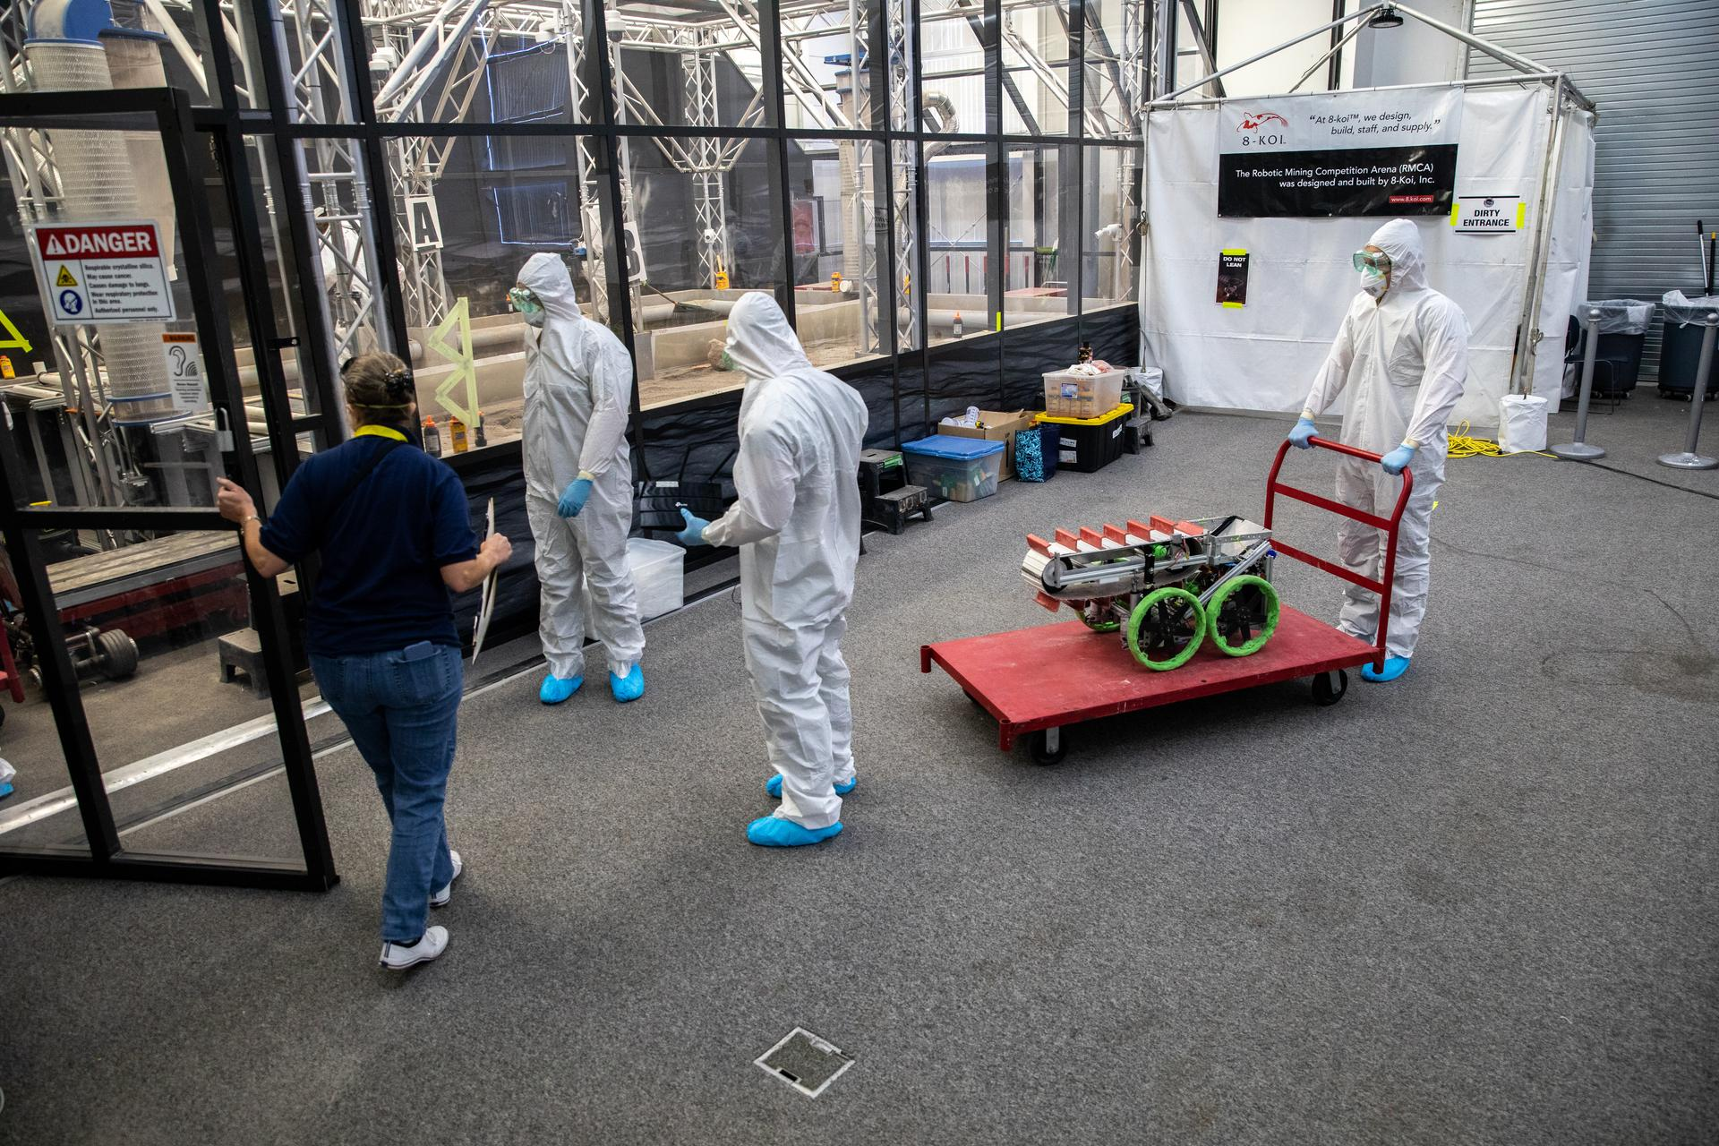

Students from the United States Military Academy (West Point), dressed in safety gear, prepare to enter the mining arena with their robotic miner during NASA's LUNABOTICS competition on May 24, 2022, at the Center for Space Education near the Kennedy Space Center Visitor Complex in Florida. More than 35 teams from around the U.S. have designed and built remote-controlled robots for the mining competition. NASA/Kim Shiflett NASA will hold its 2026 Lunabotics Challenge Tuesday, May 19, to Thursday, May 21, at the Astronauts Memorial Foundation's Center for Space Education at the Kennedy Space Center Visitor Complex in Florida. Links to view the Lunabotics competition live can be found on the agency's Lunabotics page. The competition is slated to run between 8 a.m. and 6 p.m. each day. Media are invited to attend the competition event on Wednesday, May 20, and should RSVP by 4 p.m. EDT on Monday, May 18, to the Kennedy newsroom at: ksc-newsroom@mail.nasa.gov. For this challenge, 50 college teams from across the country will convene to design, build, and operate their own lunar robot prototypes. The teams' self-driving rovers must be capable of building a berm, a protective barrier, from soil and other material simulating lunar regolith to safeguard Artemis infrastructure on the Moon. In space, such berms could protect equipment from debris during lunar landings and launches, shade cryogenic propellant tank farms, help shield a nuclear power plant from space radiation, and serve other purposes. "The task of robotically building berm structures will be important for preparation and support of crewed lunar missions," said Kurt Leucht, NASA software developer, In-Situ Resource Utilization researcher, and Lunabotics commentator located at Kennedy. "These competing teams are not only building critical engineering skills that will assist their future careers, but they are literally helping NASA prepare for our future Artemis missions to the Moon." NASA's Lunabotics Challenge was established in 2010. As one of the agency's Artemis Student Challenges, the competition is designed to engage and retain students in STEM fields by expanding opportunities for student research and design in science, technology, engineering, and mathematics. For more competition information, visit: https://www.nasa.gov/learning-resources/lunabotics-challenge -end- Amanda Griffin Kennedy Space Center, Fla. 321-867-2468 amanda.griffin@nasa.gov

13. Joint Earth Observation Mission Quality Assessment Framework - Optical Guidelines Documents Released
NASA
Read more


Released on April 26, 2026, the Optical Guidelines document provides specific guidelines for the mission quality assessment of optical sensors as part of the implementation of the generic Earth observation mission quality assessment for the optical domain. NASA's Commercial Satellite Data Acquisition (CSDA) program, in conjunction with the European Space Agency (ESA) and the U.S. Geological Survey (USGS), has released the Joint Earth Observation Mission Quality Assessment Framework - Optical Guidelines. Released on April 26, 2026, the Optical Guidelines document provides specific guidelines for the mission quality assessment of optical sensors as part of the implementation of the generic Earth Observation (EO) mission quality assessment for the optical domain. This document summarizes the goals of the Joint Earth Observation Mission Quality Assessment Framework, reviews how optical mission quality is demonstrated through documentation, outlines guidelines for verifying that a mission's data quality aligns with stated sensor performance, and provides appendices containing information on common radiometric and geometric calibration and validation practices. "The release of these joint guidelines for EO data from optical missions both documents the rigorous standards we have for commercial data and bolsters the confidence of the user community in the CSDA's commercial data acquisitions," said CSDA Project Manager Dana Ostrenga. "By releasing this document to the public, we're giving end-users the opportunity to review the approach for verifying whether the quality of commercial EO data is consistent with the stated performance of the mission." The Joint Earth Observation Mission Quality Assessment Framework was produced as part of an ESA and NASA partnership supporting Earthnet Data Assessment Project (EDAP) and CSDA activities, the document details the methodology used to assess the quality of data from commercial satellite data providers. This framework provides standardized, transparent, and repeatable data quality assessment processes and outputs to support mission selection, data integration, and the trusted use of commercial EO data for science and applications. Furthermore, the agencies intend to update the guidelines in step with the evolution of the market and the advancement of Earth sciences and applications of EO data products. About the Joint EO Mission Quality Assessment Framework The expanding range of applications for EO data products and the availability of low-cost launch services have resulted in a growing number of commercial EO satellite systems. This growth in the marketplace has prompted space agencies like NASA, ESA, and others to explore the acquisition of commercial EO data products and their potential to complement the capabilities and services currently available for scientific and operational purposes. To ensure that decisions regarding the acquisition of commercial data can be made with confidence, ESA, NASA, and other stakeholders agreed there was a need for an objective framework to assess the quality of data from commercial sources. To that end, ESA established the EDAP, which performs early assessments of EO mission data to evaluate their quality and the potential integration of these missions as third-party missions within ESA's Earthnet program. The development of EDAP led to the Joint Earth Observation Mission Quality Assessment Framework, which was later customized for the different types of sensors used in atmospheric, synthetic aperture radar, thermal infrared, and now, optical EO missions. This joint framework serves as the foundation for the CSDA program's comprehensive evaluation process to ensure the quality of commercial EO data. The process focuses on assessing geometric and radiometric quality, validating data against trusted reference datasets, ensuring completeness and traceability of dataset documentation, and evaluating data accessibility and utility. Together, these rigorous evaluation efforts help build trust in commercial partnerships, ensure scientific integrity and interoperability, and foster innovation within the EO community.

14. Hubble Survey Sets Up Roman's Future Look Near Milky Way's Center
NASA
Read more
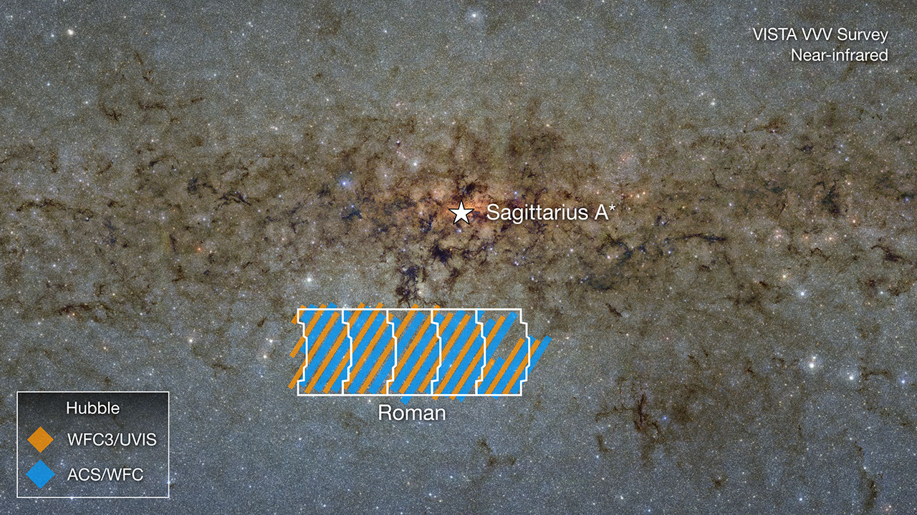

This VISTA VVV Survey image shows the galactic bulge near Sagittarius A*, the supermassive black hole at the Milky Way's center. A region planned for observation by NASA's Nancy Grace Roman Space Telescope is outlined. This area has been observed by NASA's Hubble Space Telescope. Image: NASA, Alyssa Pagan (STScI); Acknowledgment: VISTA, Dante Minniti (UNAB), Ignacio Toledo (ALMA), Martin Kornmesser (ESO) The Milky Way's galactic bulge, the bulbous region that surrounds the galactic center, contains a dense collection of stars, planets, and other free-floating objects. This region has been studied for decades with numerous ground-based and space-based telescopes, including NASA's Hubble and James Webb space telescopes. Soon, NASA's Nancy Grace Roman Space Telescope will be the first to make studying the galactic bulge a part of its core science objectives, building on the data collected from all observatories before it. Roman's field of view will cover more area at a far faster cadence than previous space telescopes, allowing it to survey millions of stars and find thousands of new exoplanets. To support Roman in characterizing numerous stars and planets, astronomers sought to use Hubble to observe many of the same areas of the galactic bulge that Roman will observe in its core Galactic Bulge Time-Domain Survey. By comparing Hubble data taken months or years earlier to new Roman data, astronomers will be better able to interpret Roman's forthcoming observations. The Roman telescope team is targeting as soon as early September 2026 for launch. "A top priority of our Hubble survey is to cover as much sky area as possible," said Sean Terry, project lead and assistant research scientist from the University of Maryland, College Park and NASA's Goddard Space Flight Center in Greenbelt. A paper about the team's work published May 11, 2026 in the Astrophysical Journal. 'Small' lenses, large discoveries Many planetary systems within the Milky Way evolve much like our solar system did, beginning with the collapse of a cosmic gas cloud, the growth of a star, and the formation of surrounding planets. However, in some systems, different events can result in a planet being ejected from the system where it formed. Hundreds of these "rogue planets" will be detected by Roman's Galactic Bulge Time-Domain Survey, in addition to previously unseen, isolated neutron stars, and even black holes with masses similar to our Sun. This survey consists of six 72-day observing seasons during which Roman will take a snapshot every 12 minutes of a large portion of the bulge (approximately 1.7 square degrees of the region, or the area of 8.5 full moons). While it will detect a variety of targets, the survey is optimized to look for a specific type of event known as microlensing. Microlensing events, a type of gravitational lensing event, occur when the light from a more distant object is warped by the mass of a closer object along the line of sight. These events occur on a much smaller scale than larger lensing events (on the order of individual stars instead of galaxies or galaxy clusters) and allow us to search for exoplanets between us and the densely packed stars within the galactic bulge. "The great thing about microlensing is that we'll be able to do a complete census of objects as small as Mars that are moving between us and these fields in the bulge, no matter what it is," said co-author Jay Anderson of the Space Telescope Science Institute in Baltimore. For Roman, from Hubble When a telescope observes a lensing object, such as a bright star, aligning with a star in the galactic bulge, it can be difficult for astronomers to decipher which of the two the starlight comes from. Therefore, timing is a key consideration. If astronomers can identify light sources separately before a microlensing event occurs, it becomes far easier to disentangle them. To collect this pre-Roman data, astronomers used the Hubble Space Telescope to conduct a large-scale survey, which began in the spring of 2025, covering much of the same area that Roman will observe in the Galactic Bulge Time-Domain Survey. The size of this program is even larger than two previous surveys (each around 0.5 square degrees) that led to Hubble's largest mosaic, that of our neighboring Andromeda galaxy, which took over 10 years to assemble. "The main goal of these observations is to be able to identify objects that participate in lensing events during the Roman survey, catching them before they undergo the lensing event," said Anderson. "When, in a couple of years, an event happens during Roman's long stare at the field, we can go back and say, 'This was a red star, this was a blue star, and the event happened when the red star went in front of the blue star.'" The data from Hubble also will help shape the analysis of the lensing objects themselves. The microlensing event itself measures only a ratio of the masses of a host star and its planet. With data from stars before or after their microlensing events, however, scientists would be able to measure the stars' individual masses, echoing the way Hubble previously determined the mass of a star and its planet in the Milky Way. This method turns a more opaque measurement of the relationship between a star and its planet into one far more certain. "Instead of estimating a mass ratio of a planet that's orbiting a star, we can say that we're confident it's a Saturn-mass planet orbiting a star that's 0.8 solar masses, for example," Terry said. "So with the help of precursor imaging from Hubble you can hope to get direct measurements of the masses as opposed to indirect mass ratios." Next leap in magnitude While exoplanet discovery is a large part of Roman's Galactic Bulge Time-Domain Survey, observing such a large area with Hubble also can help identify areas of extinction, dense pockets of dust and gas that absorb or scatter light, allowing us to create maps detailing where we can see stars and where we can't. Hubble's survey also has provided the crucial beginning of a brand-new catalog of stars, which will help astronomers characterize the host stars of exoplanets discovered by Roman. The research team predicts Roman will add to Hubble's star catalog by an order of magnitude. "This Hubble survey will build a catalog of 20 to 30 million point sources," said Terry. "But, by the end of the Galactic Bulge Time-Domain Survey, Roman may measure about 200 to 300 million, and it will produce, essentially, some of the deepest images ever taken of any part of the sky." The data from the most recent Hubble survey is available in the Mikulski Archive for Space Telescopes. The Hubble Space Telescope has been operating for over three decades and continues to make ground-breaking discoveries that shape our fundamental understanding of the universe. Hubble is a project of international cooperation between NASA and ESA (European Space Agency). NASA Goddard manages the telescope and mission operations. Lockheed Martin Space, based in Denver, also supports mission operations at Goddard. The Space Telescope Science Institute in Baltimore, which is operated by the Association of Universities for Research in Astronomy, conducts Hubble science operations for NASA. The Nancy Grace Roman Space Telescope is managed at NASA Goddard with participation by NASA's Jet Propulsion Laboratory in Southern California; Caltech/IPAC in Pasadena, California; the Space Telescope Science Institute; and a science team comprising scientists from various research institutions. The primary industrial partners are BAE Systems, Inc. in Boulder, Colorado; L3Harris Technologies in Melbourne, Florida; and Teledyne Scientific & Imaging in Thousand Oaks, California.

15. NASA Astronaut Jessica Meir
NASA
Read more


NASA/Josh Valcarcel NASA Astronaut Jessica Meir sits for a portrait at NASA's Johnson Space Center in Houston on Sept. 23, 2025. This photo was chosen as one of the 2025 NASA Photographer of the Year finalists. Meir launched on NASA's SpaceX Crew-12 mission to the International Space Station in February 2026 with fellow NASA astronaut Jack Hathaway, ESA (European Space Agency) astronaut Sophie Adenot, and Roscosmos cosmonaut Andrey Fedyaev. Meir was selected by NASA in 2013. Prior to becoming an astronaut, her career as a scientist focused on the physiology of animals in extreme environments. Meir served as flight engineer on the International Space Station for Expedition 61 and 62 and participated in the first all-female spacewalks. Image credit: NASA/Josh Valcarcel

