 |  | 

🌌 अंतरिक्ष समाचार | Space News
मंगलवार, २०/१०/२०२६ | Tuesday, 20/10/2026

1. PFRDA launches unified digital platform for NPS subscribers
Read more

- Digital India - 1 min Read The Pension Fund Regulatory and Development Authority (PFRDA) has launched NPS Central, a streamlined digital platform designed to enhance the management of pension accounts. - PTI - Published On Oct 19, 2026 at 03:54 PM IST - Select ETGovernment as Preferred Choice on Google - Share Icon Copy Link Share on Whatsapp Share on Linkedin Share on X Share on Telegram Share on Facebook - Bookmark - Comment PFRDA launches unified digital platform for NPS subscribers. Pension regulator PFRDA has launched a unified digital platform , NPS Central , to enable subscribers of the National Pension System (NPS) to enrol, invest and manage their pension accounts through a single interface. Launched on October 1 on the occasion of NPS Diwas, the platform has been jointly developed and is managed by the three Central Recordkeeping Agencies (CRAs) under NPS, the Pension Fund Regulatory and Development Authority (PFRDA) said in a statement on Monday. The platform brings all three CRAs to a common digital interface, simplifying access to pension-related services across the NPS ecosystem, which includes CRAs, Pension Funds and Points of Presence (PoPs), it said. The initiative marks a step towards creating a more integrated, accessible and subscriber-centric digital pension ecosystem. NPS Central also facilitates registration for NPS Swasthya, which combines a dedicated investment corpus with a super top-up health insurance arrangement, extending access to healthcare-related services within the broader digital pension ecosystem, it said. The platform will also facilitate integration with NPS ecosystem participants and existing NPS digital touchpoints, enabling them to offer unified NPS services through their respective channels, it added. Comments What are your thoughts?

2. Amit Shah to launch sewerage infrastructure projects in Delhi on Oct 22
Read more
- Governance - 1 min Read Union Home Minister Amit Shah is set to launch several sewerage infrastructure projects in Delhi on October 22. The projects include decentralised sewage treatment plants and new sewer lines aimed at preventing untreated wastewater discharge. - PTI - Published On Oct 19, 2026 at 02:44 PM IST - Select ETGovernment as Preferred Choice on Google - Share Icon Copy Link Share on Whatsapp Share on Linkedin Share on X Share on Telegram Share on Facebook - Bookmark - Comment Union Home Minister Amit Shah Union Home Minister Amit Shah will launch several sewerage infrastructure projects in Delhi on October 22, Delhi Water Minister Parvesh Verma said on Monday. The projects, including decentralised sewage treatment plants (DSTPs) and new sewer lines, will be launched from the Najafgarh area, Verma said at a press conference. "Once all these works are completed over the next two to two-and-a-half years, no untreated wastewater from Delhi will flow into the drains and, through them, into the Yamuna. We will then be able to see the impact of these efforts on our sacred river," he said. The Delhi government had earlier announced plans to set up around 30 decentralised sewage treatment plants through the Delhi Jal Board (DJB) to bridge existing gaps in sewage treatment. Where large sewage treatment plants (STPs) cannot be constructed due to space constraints, the DJB plans to install 40 DSTPs to ensure localised wastewater treatment, Verma said. He also said nearly 35,000 residents participated in a recent cleaning drive at Yamuna ghats. Comments What are your thoughts?

3. RSGSL launches PNG drive in Kota, targets more households under PNGRB campaign
Read more
- Smart Infra - 1 min Read RSGSL has also announced an incentive of 5,000 points, equivalent to ₹500 worth of PNG, for households in Kota that obtain new PNG connections by December 31, 2026. - ETGovernment Desk - ETGovernment - Published On Oct 19, 2026 at 01:27 PM IST - Select ETGovernment as Preferred Choice on Google - Share Icon Copy Link Share on Whatsapp Share on Linkedin Share on X Share on Telegram Share on Facebook - Bookmark - Comment The initiative will cover residential areas, high-rise buildings, guest houses, paying guest accommodations, hostels, hotels, restaurants and industrial areas. Rajasthan State Gas Limited (RSGSL) has launched a campaign in Kota to connect more households to piped natural gas (PNG) from October 17 to December 31, 2026, under the PNGRB Drive 3 special campaign. RSGSL Managing Director Vinay Patni said the Centre and state government are focusing on shifting liquefied petroleum gas (LPG) connections to domestic piped natural gas (DPNG) connections and developing LPG-free zones . As part of the campaign, RSGSL will organise camps in different areas of Kota to connect households to PNG. The initiative will cover residential areas, high-rise buildings, guest houses, paying guest accommodations, hostels, hotels, restaurants and industrial areas. Patni said PNG is supplied directly to households through pipelines and is available round the clock, eliminating the need to book and replace LPG cylinders. RSGSL Deputy General Managers C P Chaudhary and Vivek Srivastava said preparations for the campaign had been completed. Comments What are your thoughts?

4. Why does ISRO test methane rocket despite its dangerous nature?: Inspired by SpaceX's Starship technology, ... - Bhaskar English
Read more
Why does ISRO test methane rocket despite its dangerous nature?: Inspired by SpaceX's Starship technology, ... Bhaskar English

5. ISRO Tests Ignition of New Methane Rocket Engine - StratNews Global
Read more
ISRO Tests Ignition of New Methane Rocket Engine StratNews Global

6. ISRO ICRB admit card 2026 expected soon at isro.gov.in: Check steps to download hall tickets here - The Times of India
Read more
ISRO ICRB admit card 2026 expected soon at isro.gov.in: Check steps to download hall tickets here The Times of India

7. NASA Improves Shock, Vibration Analysis
Read more
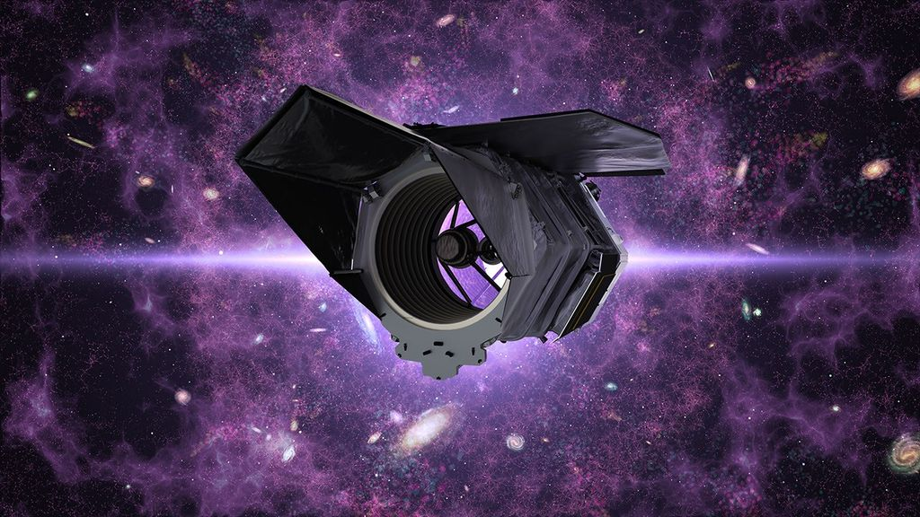
Stirling Allen, part of the Dynamic Environments Group with NASA's Launch Services Program Office, showcases a commercial digital software at NASA's Kennedy Space Center in Florida. The software performs finite element modeling to support shock and vibration analysis and ensure spacecraft and rockets can withstand harsh vibration, shock, stress, or other physical forces before launch, strengthening mission safety in the process. NASA/Clayton Rougelot Rockets vibrate, shake, and flex intensely as they climb into space, and spacecraft packed with delicate scientific instruments must survive those forces. Before any rocket leaves the ground, NASA engineers work to predict how those stresses will affect every part of a spacecraft. To do that, engineers in the Dynamic Environments Group with NASA's Launch Services Program Office at the agency's Kennedy Space Center in Florida have streamlined how they ensure spacecraft and rockets can withstand harsh vibration, shock, stress, or other physical forces, strengthening mission safety in the process. Using a commercial digital software tool in a new way, the engineers developed a standardized modeling workflow for finite element modeling to strengthen shock and vibration analysis and ensure hardware is prepared for the extreme environments of launch and ascent. "This computer-based method helps predict how rockets and spacecraft behave under extreme conditions before hardware is built and helps identify weak spots and potential failure risks early so the team can address the findings," said Brian Beaver, chief of the Flight Analysis Division with the Launch Services Program Office at NASA Kennedy. The team recently used the software for the first time while certifying a commercial launch provider's rocket selected for a NASA mission. The commercial partner provided vibration testing but not shock testing. The Dynamic Environments Group determined shock testing was needed and used a template the group created to run what-if comparisons, visualize structural behavior, and answer complex questions that would have required extensive manual modeling in the past. The team verified the company's testing results for flight environments, and the analysis provided new insights addressing shock during transport. "We are using a tool that's existed for decades, but it's not normally used by the dynamic environments disciplines," said Alex Hardt, aerospace engineer with the Launch Services Program Office at NASA Kennedy. "But we're changing that. We're using it in a relatively new area of dynamics." Although rockets and spacecraft are designed to absorb shocks and vibrations, those forces can cause wear and tear or potentially flight failures, especially during launch and ascent. "We define how severe the random vibration levels and shock levels are, and then we verify that all the parts going on future rockets have been tested to those levels, maximizing their longevity," Hardt said. Software time saver For decades, engineers have estimated shock and vibration environments using rules of thumb or by scaling previous data to estimate how each rocket component or spacecraft equipment would be impacted once assembled and flown. The approach worked, but relied heavily on engineering judgment and simple approximations drawn from past missions. Because most dynamic environments engineers use finite element modeling tools infrequently, they often need to re-learn complex workflows. The software replaces older tools and provides a standard template that guides engineers more quickly and thoroughly through vibration profiles and shock conditions. Finite element analysis is a powerful simulation technique that breaks a complex structure into smaller components so computers can accurately predict how a spacecraft or rocket could respond to specific forces or launch environments. This is important because issues can be addressed on the ground; once the rocket leaves the launch pad, most problems cannot be repaired or corrected, making early identification essential. "We've used it to get really valuable insight very quickly into verifying a provider's system," Hardt said. "It's already provided some really deep insight into something that normally takes a lot of effort." Hardt says having the ability to visualize non-intuitive dynamics problems using finite element models also highlights the software's valuable impact on learning, efficiency, and alignment with NASA's people focused culture. The workflow can help the engineers share knowledge, refine assessments with additional flight data, and increase proficiency with modeling tools. This capability already has saved months by allowing the team to run analysis independently without having to request and wait for analysis reports or data, and by helping them identify risks that weren't previously considered. NASA's Launch Services Program Office is responsible for launching rockets delivering spacecraft that observe the Earth, visit other planets and explore the universe, from weather satellites to space telescopes to Mars rovers. The team is constantly adopting new tools like this to give the agency the highest practical chance of success for each mission.

8. NASA's Simulated Mars Crew Marks One Year Inside Habitat
Read more
Members of NASA's CHAPEA (Crew Health and Performance Exploration Analog) Mission 2 crew stands in their workspace after spending a year in their isolated and confined habitat at NASA's Johnson Space Center in Houston. (from left: James Spicer, Matthew Montgomery, Ellen Ellis, and Ross Elder). NASA The four crew members in NASA's simulated Mars mission have spent the past year living and working in isolation in a confined habitat at NASA's Johnson Space Center in Houston. For the past 365 days, the Crew Health and Performance Exploration Analog (CHAPEA) Mission 2 crew members have operated as though they were on the Red Planet, growing crops, managing limited resources, navigating communication delays, and conducting suited extravehicular activities on a simulated Martian surface. Crew members include Ross Elder, mission commander; Ellen Ellis, medical officer; Matthew Montgomery, science officer; and James Spicer, flight engineer. They entered their 1,700 square foot 3D-printed habitat Oct. 19, 2025. Leading up to the one-year mark of their 378‑day mission, science teams at NASA prepared to process health and performance data collected on the crew. This critical data can help NASA balance priorities and develop methods that counter spaceflight risks during future long-duration missions on Mars. "We are extremely proud of the crew for their commitment and achievements over the last year on such a fast-paced, highly demanding mission," said Grace Douglas, CHAPEA principal investigator. "The entire CHAPEA team is excited to congratulate the crew in person." The crew will exit their habitat on Saturday, Oct. 31, to conclude their mission. They will have a chance to reconnect with their families, who they've only spoken with via email over the course of their mission with a Mars-like communication delay. The crew will then begin two weeks of post-mission evaluations and debriefs with NASA scientists. These debriefs and evaluations will help scientists learn what it takes for crews to adapt to the routines and demands of daily life on long-duration missions, giving NASA insight into what future explorers may need to stay healthy, productive, and connected during missions far from Earth. For example, data could shed light on how limited food and exercise systems will influence NASA's ability to achieve mission objectives, including spacewalks on the surface of Mars. Some data also could help NASA foster autonomy and build decision-making support systems that best aid crew with communication delays lasting up to 45 minutes each way. "This mission has been incredibly valuable in starting to teach us how to understand requirements for year-long missions, including medical and psychological care, via communication delays," said Michael Stenger, chief scientist for NASA's Human Research Program. "When combining this Mars-realistic mission analog with a suite of physiological, psychological, and performance measures in a rigorously controlled environment, we'll be able to translate the knowledge from these experiences to Moon Base and beyond." To watch the CHAPEA Mission 2 egress ceremony on Oct. 31, visit: https://www.youtube.com/live/2MONMgAmXNU James Spicer, Crew Health and Performance Exploration Analog (CHAPEA) Mission 2 flight engineer, participates in an extravehicular geological activity. NASA Ellen Ellis, CHAPEA Mission 2 medical officer, performs a medical task with Ross Elder, mission commander. NASA The CHAPEA crew showcases the instruments they brought on their mission. The crew elected to include instruments as part of their personal item allowance. From left: James Spicer, Ellen Ellis, Matthew Montgomery, and Ross Elder. NASA CHAPEA Mission 2 crew members Ellen Ellis (left) and Ross Elder (right) conduct a maintenance task during a simulated extravehicular activity, also known as a spacewalk. NASA Photos that the CHAPEA Mission 2 crew arranged around a boot print in the simulated Martian sand outside their habitat. NASA ____ NASA's Human Research Program NASA's Human Research Program pursues methods and technologies to support safe, productive human space travel. Through science conducted in laboratories, ground-based analogs, commercial missions, the International Space Station and Artemis missions, the program scrutinizes how spaceflight affects human bodies and behaviors. Such research drives the program's quest to innovate ways that keep astronauts healthy and mission ready as human space exploration expands to the Moon, Mars, and beyond.

9. New 'Blade Runner 2099' trailer is a space fan's dream with sinister starships and strange exoplanets (video)
Read more

Click for next article Cue the depressing rain, dark trench coats, and a dire dystopian dirge because the Blade Runner 2099 trailer is here! Cyberpunk is charging back in confident fashion with Prime Video's latest detour into the neon-drenched dystopia of humans and rogue replicants first introduced in director Sir Ridley Scott's "Blade Runner" from 1982, then revisited in Denis Villeneuve's "Blade Runner 2049." Arriving Nov. 25, 2026, " Blade Runner 2099" 's plot turns the tables as resentful artificial beings are now the ones running the show and hunting down Earth's humans after a successful uprising against their original makers. This newest atmospheric trailer was unveiled at last week's New York Comic-Con and has us totally jacked to re-immerse ourselves in that noirish futuristic realm. Check it out below: Blade Runner 2099 - NYCC Trailer | Prime Video - YouTube Watch On It's executive produced by showrunner Silka Louisa ("Shining Girls") and stars Oscar winner Michelle Yeoh ("Everything Everywhere All at Once") as Olwen, playing a fading replicant Blade Runner who joins forces with Hunter Schafer's ("Euphoria") Cora, a pure human on the run attempting to evade a squad of exterminating Blade Runners while examining their existential natures. But aside from the dazzling visuals of the City of Angels at the gates of the 22nd century, fans will also be strapping in for some cool outer space action, as evidenced by fresh footage delivering some arresting scenes of space travel, off-world planets, and Yeoh in a bizarre helmet. "Blade Runner 2099" hits Prime Video starting on Nov. 25, 2026 (Image credit: Prime Video) " Blade Runner 2099" 's cast includes Dimitri Abold ("The Hunger Games: The Ballad of Songbirds & Snakes") and Lewis Gribben ("Somewhere Boy") alongside Katelyn Rose Downey ("The Nun II"), Daniel Rigby ('Renegade Nell"), Johnny Harris ("A Gentleman in Moscow"), Amy Lennox ("Only Child"), Sheila Atim ("The Woman King") and Matthew Needham ("House of the Dragon"). Launching with an 8-episode debut season and executive produced by Scott Free Productions, "Blade Runner 2099" and its new world order lands on Prime Video on Nov. 25, 2026.

10. 'They're kind of goth': NASA spacecraft gives mysterious brown dwarfs a close-up
Read more

Click for next article Using NASA's SPHEREx spacecraft, astronomers have studied a host of "failed stars," also known as brown dwarfs. These strange cosmic bodies straddle the line between planets and stars, possessing a mass between 13 and 80 times that of Jupiter (0.013 to 0.08 times the mass of the sun ). They get the nickname failed stars because they form like stars from collapsing clouds of gas and dust but fail to gather enough mass to trigger the fusion of hydrogen to helium in their cores, the process that powers actual stars . This formation process also means that brown dwarfs are cosmic loners, wandering the darkness of space alone, bereft of the light of a parent star. That description might sound like lyrics from a Type O Negative song ("Black No. 1," anybody?). And that's apt, according to the leader of the new study, which reveals that, chemically speaking, the atmospheres of these dark and cloudy worlds are not unlike those of our solar system's gas giant planets. "They're kind of goth," Zafar Rustamkulov, of the California Institute of Technology (Caltech), said in a statement . "Unlike exoplanets , free-floating brown dwarfs are completely independent celestial objects that will fade into eternity alone. We're still learning how complex they are." Rustamkulov added that, from Earth orbit, SPHEREx - short for Spectro-Photometer for the History of the Universe, Epoch of Reionization, and Ices Explorer - sees wavelengths of light that are nigh-impossible to see with telescopes on the ground because water in Earth's atmosphere absorbs them. That is important for bringing brown dwarfs into the light. "We are picking up light from the deep, red clouds of brown dwarfs all over the sky," he said. A forest (of brown dwarfs) Brown dwarfs have been somewhat mysterious since their discovery in the 1990s, due to the fact that the small amount of nuclear fusion that occurs within them causes them to emit no more than a faint glow. That means that our understanding of their makeup, their storms, and their evolution really only comes from theory. To help lift this observational darkness, the team turned to data from SPHEREx. They studied 37 nearby brown dwarfs in a spectrum of light including 102 wavelengths, from the deepest red our eyes can see to the invisible infrared light. These local failed stars spanned the full temperature range for brown dwarfs - from 4,000 degrees Fahrenheit to minus 10 degrees Fahrenheit (2,200 to minus 20 degrees Celsius). Considering that the temperature of the sun is about 10,000 degrees Fahrenheit (5,500 degrees Celsius), you could definitely say brown dwarfs run cold. Brown dwarfs observed by SPHEREx. (Image credit: Zafar Rustamkulov/NASA/JPL-Caltech) The spectra of brown dwarfs seen by SPHEREx allowed the team to determine that their atmospheres are chemically rich in water, carbon dioxide, carbon monoxide and methane. "We're seeing the signatures of these molecules and how they change from object to object across the entire temperature regime," said team member J. Davy Kirkpatrick, also of Caltech. "Our paper concentrated on just three dozen, but we have thousands more that we are in the process of analyzing. "I really want to see what bounds the universe places on the variety of brown dwarfs." All my colors Brown dwarfs have been routinely observed by other telescopes, including NASA's James Webb Space Telescope and the agency's now-retired Spitzer Space Telescope , but the wide wavelength coverage of SPHEREx has made it particularly useful in observing these failed stars. That's good news for astronomers waiting for change in the atmospheres of brown dwarfs as they age and grow cold. The researchers found that some brown dwarfs observed by SPHEREx are at a stage of extreme change in which their clouds are clearing, creating atmospheres rich in methane. The team may have discovered significant new details about brown dwarfs, but they are still on the proverbial mystery street when it comes to these strange celestial objects, "The state-of-the-art models are capturing the general chemical trend, but when it comes to these cloudy transitions, the models are struggling to match the data," said Rustamkulov. "No two brown dwarfs are alike. Even at the same temperature, their spectra look quite distinct." NASA's SPHEREx reveals molecules like methane (CH4), carbon dioxide (CO2), and carbon monoxide (CO) in brown dwarf atmospheres. The telescope's view of three different brown dwarfs appears on the left. (Image credit: Zafar Rustamkulov/International Gemini Observatory/NOIRLab/NSF/AURA, M.H. Wong (UC Berkeley) et al. Acknowledgments: M. Zamani) "This journey has turned many of us into accidental meteorologists. We know how hard it is to predict weather on our own planet, and we realize it's going to be just as challenging to explain the phenomena we see in these bizarre, cold objects," Kirkpatrick said. "The findings are a call to action to explore even more of these dark worlds." As astronomers resond to that call to action, I will ponder how I could have worked Bauhaus' Goth classic "Bela Lugosi is Dead" into this article.

11. Watch Japan launch a bold sample-return mission to Mars moon Phobos today
Read more
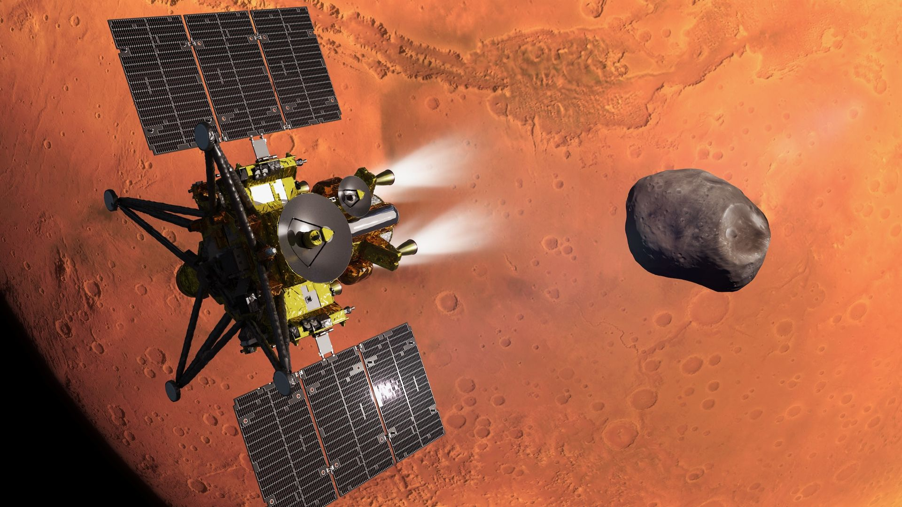
Click for next article Editor's note: Japan launched its bold MMX sample-return mission to the Mars moon Phobos on Oct. 19) at 3:41 p.m. EDT (1941 GMT). Watch a replay of the liftoff and read our launch story here. Launch live streaming of Martian Moons eXploration (MMX)/H3 Launch Vehicle flight No.10(English) - YouTube Watch On Japan will launch an epic mission to Mars today (Oct. 19), and you can watch the action live. The Martian Moons eXploration ( MMX ) mission is scheduled to lift off atop an H3 rocket from Japan's Tanegashima Space Center today at 3:41 p.m. EDT (1941 GMT; 4:41 a.m. on Oct. 20 local Japan time). You can watch it live via the Japan Aerospace Exploration Agency (JAXA). Coverage will begin at 2:45 p.m. EDT (1845 GMT). An artist's concept of JAXA's MMX spacecraft during its Mars orbit insertion. The Martian moon Phobos, which MMX will explore and sample, is in the background. (Image credit: JAXA) As its full name suggests, MMX will focus on Mars ' two moons, Phobos and Deimos . They're both tiny compared to Earth's own moon; Phobos is just 14 miles (22 kilometers) wide, and Deimos is even smaller, with a diameter of about 8 miles (13 km). They're also quite mysterious. While astronomers have a pretty clear understanding of our own moon's birth - it coalesced from material blasted into space when a Mars-sized planet slammed into Earth long ago - there's no consensus about Phobos and Deimos' origin story. The duo "may be the remains of a massive impact on Mars that sent material into orbit around the planet, or they could be ancient asteroids that were captured by Mars' gravity billions of years ago," Tom Statler, MMX program executive and program scientist at NASA Headquarters, said in an Oct. 15 statement . (NASA is a partner on the mission, providing a scientific instrument, a technology demonstration, communication support and funding for American scientists on the MMX team.) "Having the answer will help illuminate that early era when Earth and the other inner planets may have been acquiring much of their water and organic compounds," Statler added. MMX will help provide that answer, if all goes according to plan. The spacecraft will arrive in the Mars system in August 2027, then slip into orbit around Phobos a month later. It will study that moon and Deimos from a distance for about 18 months, then deploy the French-German Idefix rover onto Phobos' surface in early 2029. The 55-pound (25 kilograms) Idefix "has two main tasks: providing information to prepare for the landing of the main spacecraft to collect samples, and analyzing the composition and texture of Phobos' surface," European Space Agency officials wrote in an MMX mission description . "The gravity on Phobos is so low that Idefix will only weigh the equivalent of 15 grams [0.5 ounces] on its surface!" they added. The MMX mothership's Phobos landing will occur in 2030. The spacecraft will grab at least 10 grams (0.4 ounces) of samples from the moon, then head back toward Earth with this extraterrestrial bounty. MMX's return capsule will land here in 2031, after which scientists around the world will scrutinize the Phobos sample for clues about the history and evolution of Mars and our solar system more broadly. Engineers conduct a thermal vacuum test with JAXA's MMX Mars moon sample-return spacecraft. JAXA posted this image on X on May 15, 2025. (Image credit: JAXA) MMX was originally supposed to launch in 2024, but issues with the H3 rocket prevented it from doing so. Mars and Earth align properly for interplanetary launches just once every 26 months, so MMX had to wait a while for its next chance.

12. US aircraft carrier establishes 2,100-mile satellite control link with MQ-25A drone
Read more
The US Navy has remotely connected to and controlled an MQ-25A Stingray unmanned refueling aircraft from an aircraft carrier more than 2,100 miles away, marking a new milestone in its effort to integrate drones into carrier operations. The test took place aboard the USS Ronald Reagan, a Nimitz-class aircraft carrier operating in the Pacific Ocean. The MQ-25A test aircraft was at Boeing's facility in Mascoutah, Illinois. During preliminary sea trials, operators aboard the carrier used the ship's Unmanned Air Warfare Center (UAWC) to establish a beyond-line-of-sight connection with the aircraft through a satellite network. The Navy described the event as its first successful connection between an underway aircraft carrier's control station and an MQ-25A aircraft. The demonstration tested the communications and command systems needed for future carrier-based drone operations. Satellites bridge operational distance The connection used a proliferated low Earth orbit (pLEO) satellite network, which relies on satellites operating relatively close to Earth to support communications over long distances. The carrier's UAWC used an MD-5C Ground Control Station to establish the link. The system combines the Navy's command, control, communications, computers, and intelligence network with hardware and software developed by Lockheed Martin and other government-produced equipment. The MD-5C is designed to provide command and control for the MQ-25A and potentially other unmanned aircraft that could operate from US Navy carriers. The demonstration was part of a series of tests intended to validate the procedures, networks, and interfaces required to operate the Stingray from a carrier. Earlier testing included evaluations while ships were docked and at sea. The work involved the Navy's Unmanned Carrier Aviation Program Office and an integrated test team comprising personnel from the Navy, Boeing and Lockheed Martin. "This first-ever underway connection between a carrier-based UAWC and an MQ-25A aircraft proves that the Carrier Air Wing of tomorrow is a reality today," said Capt. Daniel Fucito, program manager for the Navy's Unmanned Carrier Aviation Program Office. Although the test demonstrated remote connectivity and control over a considerable distance, the Navy did not report an autonomous flight, aerial refueling operation, or carrier landing as part of this event. Extending carrier aircraft reach Boeing's MQ-25A Stingray is being developed to refuel US Navy aircraft in flight, reducing the need to assign crewed combat aircraft to tanker duties. The Navy expects the drone to support F/A-18E/F Super Hornets, allowing them to remain airborne longer and operate farther from their carrier. Using dedicated unmanned refueling aircraft could also free more Super Hornets for combat missions instead of requiring them to carry additional fuel for other aircraft. The MQ-25A is intended to become the Navy's first operational carrier-based unmanned aerial refueling aircraft and establish a foundation for integrating additional unmanned aircraft into future carrier air wings. The latest demonstration validates an important part of that plan: the ability to maintain a command connection between a moving aircraft carrier and a remotely located aircraft.

