 |  | 

🌌 अंतरिक्ष समाचार | Space News
गुरुवार, १२/११/२०२६ | Thursday, 12/11/2026

1. ISRO at a crossroads: The unease over India's space sector reforms - The News Minute
Read more
ISRO at a crossroads: The unease over India's space sector reforms The News Minute

2. Pralhad Joshi visits ISRO in Bengaluru, lauds its role in advancing 'One Nation, One Time' initiative - DD News
Read more
Pralhad Joshi visits ISRO in Bengaluru, lauds its role in advancing 'One Nation, One Time' initiative DD News

3. ISRO Scientist Engineer Answer Key 2026 Released: Download Response Sheet PDF at isro.gov.in - Jagran Josh
Read more
ISRO Scientist Engineer Answer Key 2026 Released: Download Response Sheet PDF at isro.gov.in Jagran Josh

4. ISRO's Shukrayaan Mission to Venus: March 2028 launch on track, what happens next? - Moneycontrol.com
Read more
ISRO's Shukrayaan Mission to Venus: March 2028 launch on track, what happens next? Moneycontrol.com

5. 'Space could become unusable in 5 years': Ex-ISRO engineer racing to clean Earth's orbit - The Federal
Read more
'Space could become unusable in 5 years': Ex-ISRO engineer racing to clean Earth's orbit The Federal

6. EDITORIAL: Sen. Bernie Moreno is the right man to lead the NRSC - Washington Reporter
Read more
EDITORIAL: Sen. Bernie Moreno is the right man to lead the NRSC Washington Reporter

7. SpaceX launches 2nd mystery mission for US Space Force in 6-day span (photos)
Read more
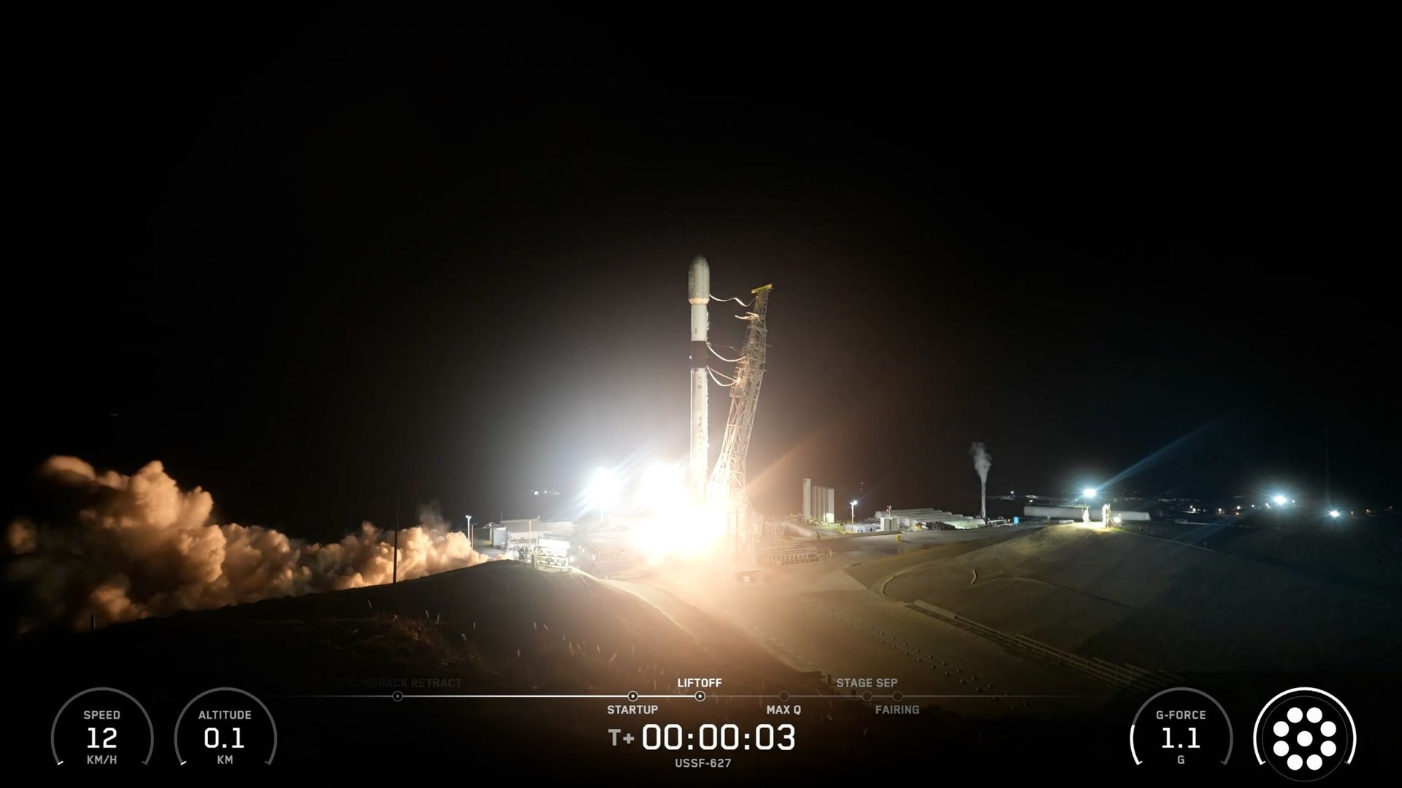
Click for next article A SpaceX Falcon 9 rocket launches the USSF-627 mission for the U.S. Space Force from California on Nov. 11, 2026. SpaceX launched a classified mission for the U.S. Space Force from California tonight (Nov. 11), the second such flight for the company in a six-day span. A Falcon 9 rocket lifted off from California's Vandenberg Space Force Base tonight at 11:36 p.m. EST (8:36 p.m. local California time; 0136 GMT on Nov. 12), kicking off a mission called USSF-627. Vandenberg hosted a similar liftoff less than a week ago: On Nov. 6, a Falcon 9 sent the USSF-432 mission skyward from the site, which lies on California's gorgeous but often foggy central coast. A Falcon 9 first stage rests on a SpaceX drone ship shortly after launching the USSF-627 mission on Nov. 11, 2026. (Image credit: SpaceX) We don't know much about USSF-627 or USSF-432; both are classified. Some experts have speculated , however, that each mission launched a batch of SpaceX's Starshield satellites for the Space Force's Space Based Sensing and Targeting portfolio, which helps the military branch track potential targets around the world. SpaceX didn't reveal details about either USSF-627 or USSF-432, and the company ended the webcast of both launches shortly after the first stages of their Falcon 9 rockets came back to Earth . In both cases, that touchdown occurred about 8.5 minutes after liftoff on the SpaceX droneship "Of Course I Still Love You," which was stationed downrange of Vandenberg in the Pacific Ocean. It was the seventh mission for USSF-627's Falcon 9 booster, which carries the designation 1103. Previous Booster 1103 missions NROL-179 | SDA-T1TL-E | SDA-T1TL-A | 3 Starlink missions USSF-627 was the 120th Falcon 9 launch of 2026 and the rocket's 15th national-security flight of the year to date. Eighty-five of the 120 flights have been devoted to building out SpaceX's Starlink broadband constellation in low Earth orbit , which currently consists of more than 11,000 satellites.

8. NASA kick-starts a fresh push to bring Mars samples home
Read more
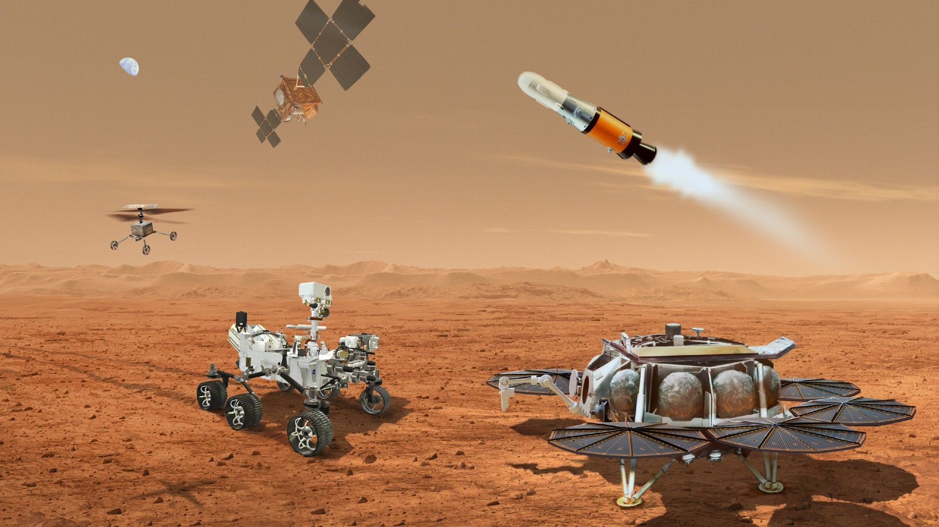
Click for next article A long-term goal at NASA has been the ability to robotically haul back to Earth specimens from the Red Planet. NASA is kickstarting a new initiative for its troubled Mars Sample Return (MSR) program, called the Perseverance Sample Retrieval Architecture, or PSRA in space shorthand. The plan is to establish a fresh NASA strategy for gathering Mars samples collected by the Perseverance rover and launching them back to Earth. The PSRA initiative was noted on Nov. 9 by Tiffany Morgan, director of the NASA Mars Exploration Program (MEP), during the virtual meeting of the Mars Exploration Program Analysis Group (MEPAG). Here's the PSRA strategy: Develop impartial recommendations for retrieving the Martian samples collected by NASA's Perseverance Mars rover and deliver them to Earth Assess proposed mission requirements Review prior lessons learned Evaluate current capabilities and acquisition options Morgan noted that there will be a PSRA strategy team kickoff in January 2027 with a final report due in winter 2027-2028. Pick-me-ups The backdrop to the PSRA activity is that there's one busy rover already on the Red Planet snagging and bagging samples. NASA's Perseverance Mars rover remains on the prowl within Jezero Crater following its touchdown in February 2021. That car-sized robot has been grabbing select specimens from across the area and gingerly dropping the sealed pick-me-ups on the surface of Mars , as well as stuffing them inside the rover itself. Those collectibles may well hold signs of past life on the enigmatic, dusty and foreboding Red Planet. NASA and the European Space Agency have for years been intently plotting out plans to send future spacecraft to Mars and haul those Perseverance-plucked bits, pieces, and sniffs of atmosphere to Earth for rigorous inspection here on Earth using state-of-the-art equipment. This photomontage shows each of the sample tubes deposited by NASA's Perseverance Mars rover at the Three Forks sample depot, as viewed by the WATSON camera on the end of the rover's robotic arm. (Image credit: NASA/JPL-Caltech/MSSS) Sticker shock However, over the years, multiple reviews of a NASA Mars Sample Return (MSR) project by independent groups have reported sticker shock findings. Indeed, one last price tag came in at about $11 billion, with samples being returned to Earth in 2040. That finding was deemed by NASA itself as too costly and not doable within an acceptable time frame. Yet another appraisal group ended up finding it feasible to return Mars samples as early as 2035 for a less costly ship and shoot cost of some $8 billion. How the PSRA review deals with MSR cost and a multitude of other concerns is in the to-be-determined column. Why samples now? In the first place, why are samples from Mars delivered by robotic means? Why not let a human expedition bring back the goods? Also speaking at MEPAG was Bruce Jakosky of the Laboratory for Atmospheric and Space Physics at the University of Colorado Boulder and Department of Earth and Space Sciences at the University of Washington. Jakosky called for an integrated approach to planning human missions to Mars. He highlighted recommendations stemming from a workshop in which he participated, held last May and organized by Explore Mars, Inc. That report focused on the impact of MSR on reducing risk for human missions, rather than focusing on the science, Jakosky told Space.com. "The purpose is to understand the risk to astronauts and to hardware. The risk includes that from compounds that are present in the soil that are hazardous to astronauts if breathed in," said Jakosky. "This includes perchlorates and chloromethanes that have been identified already, and detection of other species that might be present. It also includes dust that can be breathed in by astronauts and that can affect hardware wear and tear," he said. During the MEPAG gathering, Jakosky flagged the importance of returning samples prior to human missions to Mars, such as: Identify and characterize known hazardous chemicals to ensure astronaut safety (e.g., perchlorates and chloromethanes), and look for possible additional hazardous chemicals Characterize very fine dust particles that could cause respiratory issues in astronauts Characterize dust and regolith properties for spacesuit design and wear patterns Search in advance of the arrival of humans for evidence of extant life that could interact with terrestrial life Enhance astronaut effectiveness on the surface and science return from human missions by providing initial context and analysis Demonstrate successful round-trip to Mars Demonstrate successful round-trip travel, including entry, descent, landing and ascent from the surface of Mars. Demonstrate implementation of planetary protection protocols. While human missions would not use the same approaches, what we learn from doing these would make the approach for humans much easier to plan and implement. China's program Diagram of China's proposed Tianwen 3 Mars sample return mission. (Image credit: The University of Hong Kong/Zengqian Hou, et al.) Yet one more forcing factor for NASA in yet another relook at MSR is that China is making progress on its Tianwen-3 Mars Sample Return mission. According to the China National Space Administration, the country's Tianwen-3 probe will have a lander, an ascender, a service capsule, an orbiter, and an Earth reentry module. Tianwen-3 appears on track getting the trek underway around 2028 on two Long March-5 heavy-lift carrier rockets from the Wenchang Space Launch Site in China's southernmost island province of Hainan. China's Tianwen-3 mission is dedicated to bring back to Earth roughly 500 grams of Red Planet collectibles in 2031.

9. On this day in space! Nov. 11, 1966: NASA launches Gemini 12 mission with astronaut icons Buzz Aldrin and Jim Lovell aboard
Read more
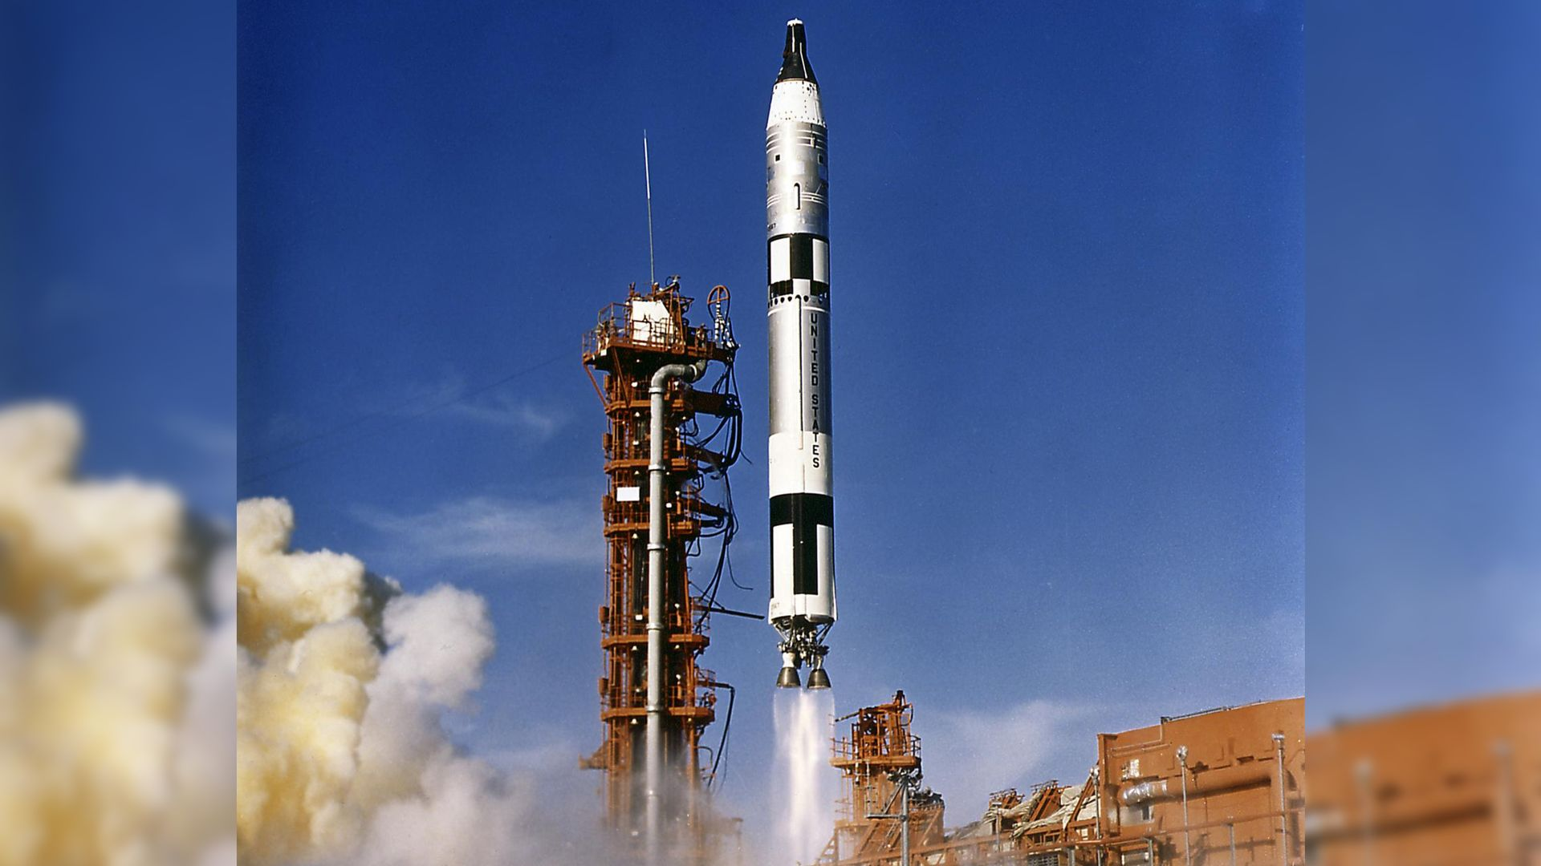
Click for next article On Nov. 11, 1966, the Gemini 12 mission launched an astronaut crew into orbit and set the stage for NASA's Apollo program to land humans on the moon. Gemini 12 was the last mission of the Gemini program. It had two astronauts on board: Jim Lovell and Buzz Aldrin . NASA wanted to send humans to the moon. But first, it needed to make sure crews had the right skills, like docking vehicles in space and taking spacewalks. Before Gemini 12, astronauts struggled with spacewalks because there weren't enough handholds on their spacecraft. NASA made some spacewalk changes for Gemini 12. Aldrin performed three spacewalks and spent more than five hours working in space with no major problems. Gemini 12 also successfully docked to an unpiloted Agena booster that launched the same day. The astronauts returned to Earth after four days in space. Both Aldrin and Lovell went on to join the Apollo program . Aldrin became the second person to walk on the moon during Apollo 11 , and Lovell became the commander of Apollo 13 . The Gemini 12 astronauts James Lovell and Edwin Aldrin lifted off aboard a Titan launch vehicle from the Kennedy Space Center on November 11, 1966, an hour and a half after their Agena target vehicle was orbited by an Atlas rocket. (Image credit: NASA/MSFC) Why it mattered Gemini 12 may have closed out NASA's Gemini program of two-person space missions, but it established the mission also established the fundamentals of spacewalking that Apollo astronauts would use when they walked on the moon. It's fitting that Aldrin was the primary spacewalker of the mission. A rookie astronaut (and the first to earn a Ph.D.), Aldrin set a precedent by training for his spacewalk in a neutral buoyancy pool in Maryland to better simulate working in weightlessness. Then he did it again as the second person to walk on the moon on Apollo 11. "This approach became so successful, underwater training has become the primary spacewalk training method used by the United State, Russia and China," NASA officials said in a mission overview . "Today, NASA's Neutral Buoyancy Laboratory in Houston is large enough to include mockups of major sections of the International Space Station . As such, it is the largest indoor body of water in the world, with 6.2 million gallons of water." Image 1 of 3 Astronaut Buzz Aldrin practices spacewalking tasks for Gemini 12 in an underwater mockup of his spacecraft in 1966. (Image credit: NASA) The Gemini 12 astronauts walk out to their launch pad with signs on their back denoting "THE END" of the Gemini program. (Image credit: NASA/MSFC) (Image credit: NASA) Image 1 of 3 View Original Image 2 of 3 View Original Image 3 of 3 View Original The Agena docking target for Gemini 12 launched into orbit just over 90 minutes ahead of Lovell (the mission commander) and Aldrin. Aldrin ended up using a sextant to help Lovell rendevous with the agena after they lost radar lock within 74 miles of the vehicle. During his spacewalks, Aldrin installed handrails, used foot restraints and other tools that have since become routine on spacewalks in orbit. They also tested tools and techniques that Aldrin and other moonwalks would use on the moon . Gemini 12 also tested a computer-controlled reentry technique when it returned to Earth on Nov. 15, landing Lovell and Aldrin just 3 miles from their target near their recovery ship the USS Wasp in the Atlantic Ocean, about 600 miles east of Cape Canaveral. Want more space history? Check out our full On This Day In Space Story archive and watch our On This Day In Space videos on YouTube .

10. 'There's tremendous demand': Rocket Lab raises price of Neutron launch from $55 million to $70 million
Read more
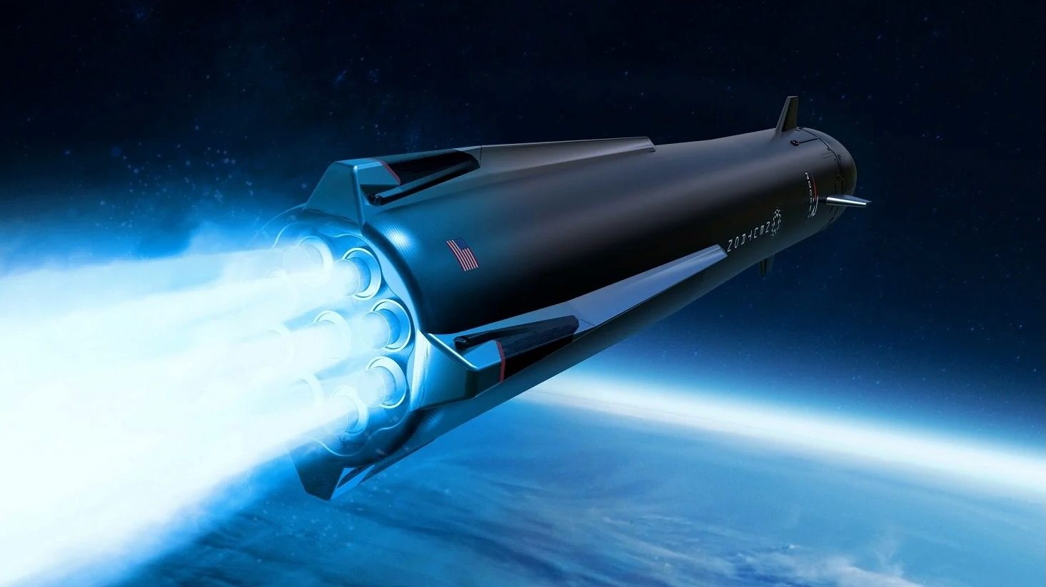
Click for next article The coming launch bottleneck has ramped up demand for a rocket that has yet to leave the ground. Rocket Lab announced on Monday (Nov. 9) that it recently raised the price of a Neutron launch from $55 million to $70 million - an increase of more than 25%, for a ride on a rocket that's set to debut in 2027. "Launch is extremely constrained, and that is exactly the situation we predicted," Rocket Lab founder and CEO Peter Beck said on Monday during the company's third-quarter earnings call. "We saw a pent-up launch market on the horizon, and rather than provide early discounted launches, we set out to deliver a rocket into an environment with extreme demand at full price or higher." Rocket Lab is best known for Electron , a workhorse small-satellite launcher that debuted in 2017 and now has 90 orbital missions under its belt. The 59-foot-tall (18 meters) expendable rocket and can haul 660 pounds (300 kilograms) to low Earth orbit (LEO). Neutron is the company's entry into the medium-lift market. It features a reusable first stage, stands 141 feet (43 m) tall and can carry 14.3 tons (13 metric tons) of payload to LEO. Rocket Lab announced Neutron back in 2021 and first targeted a 2024 debut for the vehicle. But various problems have cropped up over the years, pushing things back. Last month, for example, Rocket Lab announced that it was delaying the first Neutron flight from late 2026 into 2027 due to a manufacturing issue (which it says is now under control). Such setbacks have not dampened demand for Neutron's services, however. During Monday's call, Beck revealed that Rocket Lab booked eight Neutron launches during the third quarter of 2026, which ran from July 1 through Sept. 30. The contracts for those eight flights are worth "a total of roughly 515 million, including multiple missions on a new escalated base price of $70 million," Beck said. Neutron's first 16 launches are now sold out, he added, and bookings from here on will be for flights in the 2030s. "The demand is a function of both a tightening global launch supply and our customers' confidence that Rocket Lab is the right partner to break the world's launch bottleneck," Beck said. Artist's illustration of Neutron's first stage coming down for a landing on a ship at sea. (Image credit: Rocket Lab) That bottleneck is coming in 2028 or so, when SpaceX plans to retire its Falcon 9 rocket . For some perspective, and comparison with Neutron: SpaceX currently charges $74 million for each Falcon 9 launch. The rocket has a reusable first stage and can carry about 25 tons (22.7 metric tons) to LEO. The medium lifter has been the world's most prolific rocket for the past few years. In 2025, for example, it flew 165 times - roughly the same number of orbital missions as all other launchers in the world combined. And all 165 of those flights were successful. But SpaceX is phasing out the Falcon 9 - and its heavy-lift cousin, the Falcon Heavy - nonetheless, shifting all launch work over to its fully reusable Starship megarocket, which can haul more than 100 tons to LEO. There's a real worry among folks in the space community that this massive payload capacity won't be available to them for a while. SpaceX has made it pretty clear that early Starship operations will be geared toward internal priorities - specifically, the buildout of SpaceX's Starlink V3 broadband network and its Starmind AI data-center constellation. These will be very big jobs, even for the most powerful rocket ever built. For example, the Starlink V3 megaconstellation will consist of about 100,000 satellites , according to SpaceX founder and CEO Elon Musk . Starship can carry about 60 of these spacecraft to LEO per launch, so just building out the constellation will require about 1,700 liftoffs. The numbers for Starmind will be even more mind-boggling, for SpaceX wants that constellation to eventually harbor a million satellites . The coming launch bottleneck should increase demand for Electron as well as Neutron, Beck said during Monday's call. After all, many small-satellite operators have launched with SpaceX over the years, booking spots on Falcon 9 "rideshare" flights . And those opportunities are now drying up. "The next logical alternative is of course an Electron, so we see tremendous traction there," Beck said.

11. Hubble Space Telescope reveals glittering stars with mysterious origins | Space photo of the day for Nov. 11, 2026
Read more
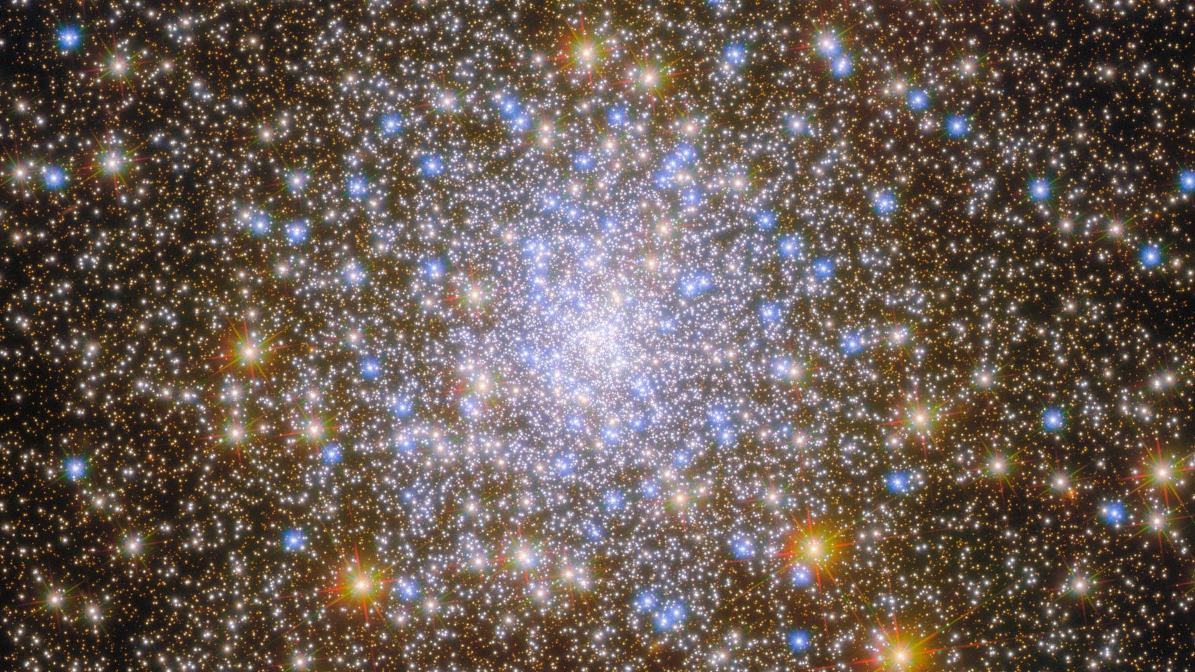
Click for next article The Hubble Space Telescope has captured a breathtaking view of thousands of stars glittering like cosmic jewels in a dazzling display of blue, gold and orange. But this spectacular scene is far more than just a pretty picture. Some of these stars are almost as old as the universe itself and could hold clues to how our Milky Way formed. M30 is a globular star cluster located approximately 27,500 light-years from Earth. (Image credit: ESA/Hubble & NASA, M. Libralato, G. Piotto, A. Sarajedini) What is it? The exquisite image released by ESA on Nov. 5 shows Messier 30 (M30), a densely packed collection of stars located approximately 27,500 light-years from Earth in the constellation Capricornus. M30 is a globular cluster, a roughly spherical collection of tens of thousands to millions of stars held together by gravity . Our Milky Way is home to at least 150 of these ancient stellar gatherings, some of which are estimated to be between 11.5 billion and 13.5 billion years old. For comparison, the universe itself is approximately 13.8 billion years old! Why is it amazing Besides looking like a vast cosmic treasure trove glittering across the universe, M30 also has a fascinating story to tell. Globular clusters are essentially cosmic time capsules. Their ancient stars preserve chemical clues about the conditions that existed when they formed, helping astronomers piece together the Milky Way's early history. Astronomers have also discovered that M30, along with several other globular clusters, traverses the Milky Way in the opposite direction to the galaxy's rotation. This unusual motion raises the intriguing possibility that M30 may not have formed in our galaxy at all. It could have simply been captured by the Milky Way billions of years ago.

12. NASA's new UVEX space telescope will peer deep into the universe's most violent events
Read more
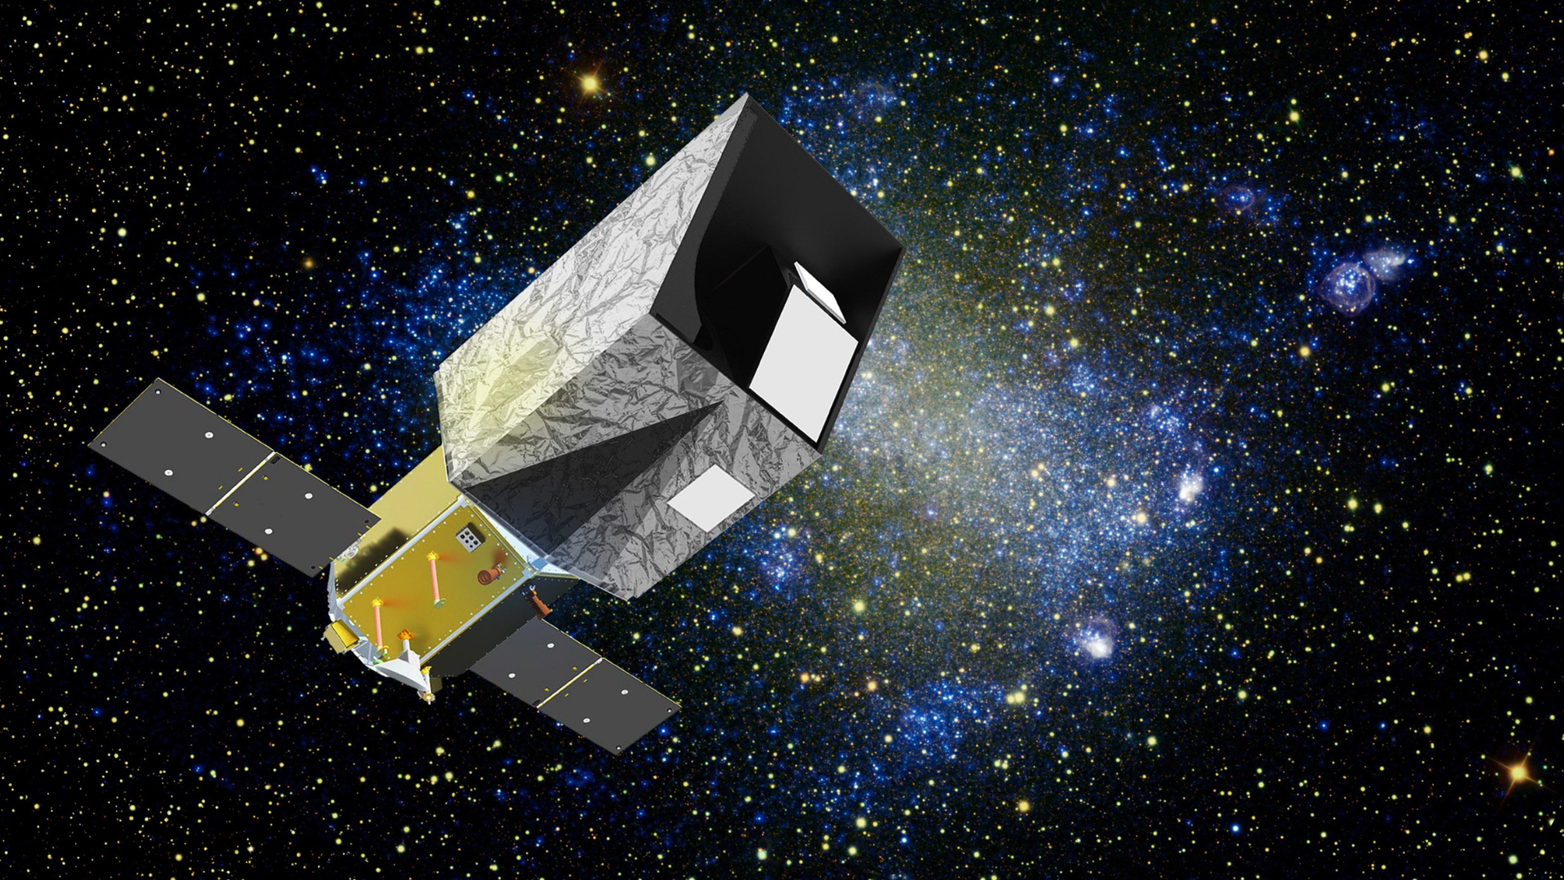
Click for next article A new NASA space telescope will study the universe in ultraviolet light to reveal the violent and turbulent events that bubble under what appears to be a cosmic sea of tranquility. The Ultraviolet Explorer (UVEX) mission, developed by NASA in conjunction with the California Institute of Technology (Caltech), will be the first mission to create deep all-sky maps in ultraviolet light. Thus, when it launches in 2031, UVEX will join new sky-mapping surveys like NASA's SPHEREx (Spectro-Photometer for the History of the Universe, Epoch of Reionization and Ices Explorer), which scans the cosmos in infrared, and the Vera C. Rubin Observatory, which does the same over the southern hemisphere in visible light, in creating deep-sky maps across a broad swathe of the electromagnetic spectrum. UVEX's ultraviolet views will reveal explosive events such as the collisions between ultra-dense stellar corpses called neutron stars and the supernova explosions that mark the deaths of massive stars and the births of neutron stars and black holes. Additionally, the NASA ultraviolet telescope should be able to detect a multitude of low-mass galaxies much closer to the Milky Way than similar galaxies that are currently being observed millions and even billions of light-years away by NASA's James Webb Space Telescope (JWST) . The $590 million UVEX mission will "advance fundamental frontiers in astrophysics, from understanding the smallest galaxies to diagnosing the aftermath of neutron-star mergers and other cosmic explosions," the mission's principal investigator, Caltech physics professor Fiona Harrison, said in an Oct. 27 statement . "The first major ultraviolet space mission in two decades, UVEX is a bold leap forward in our exploration of the ultraviolet universe," Caltech President Ray Jayawardhana said in the same statement. UVEX will paint a picture of cosmic life, death and afterlife UVEX will benefit from a major leap forward in UV sensitivity thanks to its Caltech-built sensors, which are based on complementary metal-oxide-semiconductor (CMOS) imaging technology. This will help the spacecraft tap into what Harrison described as "the untapped opportunity in the UV." UVEX will be uniquely poised to spot millions of nearby, small, and faint galaxies that are teeming with infant stars that emit bright UV light. "In optical light, it's very hard to distinguish these nearby galaxies from faraway ones that look similar," Harrison said. "UV light will make them easier to find." UVEX won't just be investigating the infancy of stars , however. It will also examine the deaths of ancient stars in the form of supernovas. The supernova relic Pa 30, as seen by the Gemini north telescope. (Image credit: International Gemini Observatory/NOIRLab/NSF/AURA) Supernovas occur when a massive star runs out of fuel for nuclear fusion and can no longer support itself against the inward push of its own gravity. As the core of the star collapses, its outer layers are blasted outward in cosmic explosions we call supernovas. This is a process that scientists are keen to understand, as these explosions fling the heavy elements forged during the stars' lifetimes into surrounding galaxies. This material becomes the building blocks of the next generation of stars, planets, and possibly even life. UVEX will also investigate what happens to the end products of some supernovas, neutron stars, when they meet and merge. An illustration shows two neutron stars colliding and merging. (Image credit: Robert Lea (created with Canva)) Neutron stars contain between one and two times the mass of the sun crammed into a width of around 12 miles (20 kilometers). That means they are composed of matter so dense that, if a teaspoon of it were brought to Earth, it would weigh over 1 billion tons. That's equivalent to stacking around 9 million adult blue whales on a spoon. So, when neutron stars in binary systems spiral together and merge, they create an environment so violent that it's the only place in the universe where scientists are sure that elements heavier than lead, like gold, silver, and platinum, are able to be forged. Currently, neutron star mergers are detected via ripples in spacetime called gravitational waves . Scientists can then follow up on the aftermath of the mergers by observing them in electromagnetic light, from high-energy gamma rays to low-energy radio waves. Thus, UVEX will add another aspect to the investigation of neutron star collisions and our understanding of where heavy elements originate. The new space telescope's maneuverability will allow it to observe these explosive events very shortly after they happen, giving it an advantage over other instruments, including NASA's long-serving Hubble Space Telescope. "With UVEX, we will now be able to follow up on gravitational-wave events in ultraviolet light," UVEX team member and Caltech scientist Mansi Kasliwal said in the same statement. "I can count on two hands how many spectra we have of transient events in their infancy phase with the Hubble Space Telescope. Hubble is, of course, amazing and does have some ultraviolet capabilities, but it cannot rapidly pivot to observe real-time events." An illustration of a stripped blue star (Image credit: Robert Lea) UVEX will also be revolutionary in the study of blue stars that have had their outer layers of hydrogen stripped away by companion stars. These stars offer researchers a unique opportunity to study the interior of stars, which is usually obscured by their outer layers. "We will be able to see what's inside the stars," Kareem El-Badry, an associate professor of astronomy at Caltech and a member of the UVEX team, said in the same statement. "We only know of a small number of stripped stars of this type now. UVEX will find hundreds." All of the above elements discussed are the expected discoveries and investigations that UVEX will be involved with. Perhaps even more exciting, however, are the unexpected elements of the universe it will uncover. "Every time you look at the skies in a new wavelength, you learn something new and unexpected," El-Badry said.

