 |  | 

🌌 अंतरिक्ष समाचार | Space News
बुधवार, ०९/०९/२०२६ | Wednesday, 09/09/2026

1. MDDA tightens checks on Dehradun PGs after Delhi disaster
Read more
PIONEER EDGE NEWS SERVICE / Dehradun The Mussoorie Dehradun Development Authority (MDDA) claimed that it has intensified its checking drive at paying guest accommodations in Dehradun after a PG building collapsed in South Delhi's Satya Niketan, officials said on Tuesday. The move has raised fresh concerns over the safety of students living in PGs, especially in university areas. Most PGs in the city are located around Premnagar, Karanpur, Clement Town and Sahastradhara. MDDA secretary Mohan Singh Barnia said the authority had already started checking PGs on the outskirts of the city. However, the drive has now been intensified following the Delhi incident. "MDDA has directed engineers and assistant engineers to conduct regular checks and ensure compliance with the rules at PGs," he said. A social media search by this reporter found more than 1,000 PGs operating across Dehradun. A visit to Karanpur found several PGs operating in narrow lanes, raising concerns about emergency access and student safety. A student living in Karanpur said he shares a room with a roommate on the third floor because the accommodation is close to his college. He said the building has narrow stairs and small rooms. The investigation also found that some PGs lack security guards, lifts and proper drinking water facilities. Dampness and poor ventilation were also reported at several accommodations. The intensified checks are important as authorities need to ensure that PG buildings meet basic fire and safety standards before housing large numbers of students.

2. ISRO, IN-SPACe, NSIL and industry: Building India's new architecture for the space economy
Read more
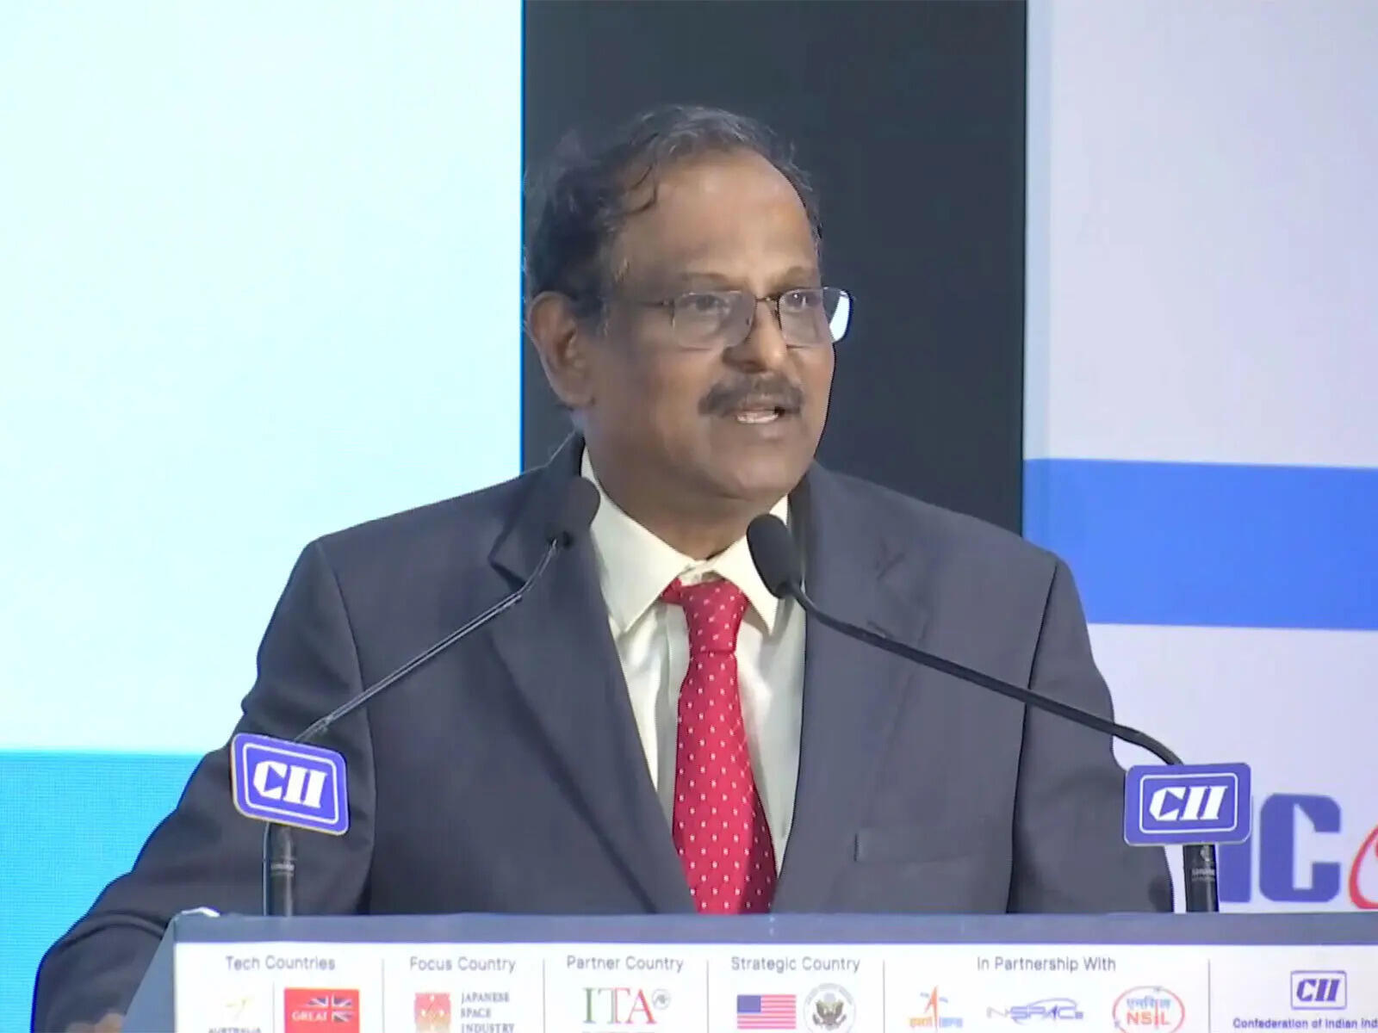
- Digital India - 6 min read India's space reforms must define clear roles for ISRO, IN-SPACe, NSIL and industry, drawing lessons from the NASA-SpaceX model to combine state capability with private innovation and scale. Anoop Verma - ETGovernment - Published On Sep 9, 2026 at 06:54 AM IST Select ETGovernment as Preferred Choice on Google Copy Link Share on WhatsApp Share on Linkedin Share on X Share on Telegram Share on Facebook "Cannot be done only by ISRO": ISRO Chairman Dr. V Narayanan calls for greater industry role to scale India's space sector The most important question confronting India's space programme is no longer whether the private sector should be allowed into space. That decision has already been made. The harder question is what the government should continue doing once private companies become capable of building rockets, satellites and space services themselves. The answer will determine whether India's current reforms produce merely a larger space industry-or a fundamentally more powerful national space ecosystem. Advt The immediate debate has been triggered by concerns within ISRO about the transfer of manufacturing and operational activities to industry. A consortium involving Hindustan Aeronautics Limited (HAL) and Larsen & Toubro is taking up production of the Polar Satellite Launch Vehicle, while Small Satellite Launch Vehicle technology has been transferred to HAL. ISRO employees have consequently sought clarity about where this transition ultimately leads. ISRO has responded categorically. "We wish to categorically state that ISRO will neither be privatised nor will its importance be diminished," the agency said on September 6. It described the emerging framework as an "ISRO-led national space ecosystem", arguing that industry should scale mature technologies while ISRO concentrates its scientific manpower on frontier research, advanced technologies and complex national missions. That formulation points towards the real issue: institutional boundaries. India now effectively has four pillars in its space architecture-the Department of Space, ISRO, IN-SPACe and NewSpace India Limited ( NSIL )-alongside an increasingly important fifth pillar: private industry. The success of the reforms will depend on whether their responsibilities remain sufficiently distinct. The Department of Space should provide overall policy direction and retain governmental control over strategically important capabilities. ISRO should increasingly become India's high-technology engine: undertaking frontier R&D, human spaceflight, advanced propulsion, next-generation launch systems, deep-space exploration, scientific missions and technologies whose risks or time horizons make them unsuitable for immediate commercial investment. IN-SPACe occupies a fundamentally different position. It is supposed to enable, facilitate and authorise non-government space activities. Its importance will grow as private companies begin operating launch vehicles, satellites, constellations and infrastructure of their own. It therefore needs to evolve into a technically sophisticated and institutionally credible authorisation and oversight mechanism-not merely a facilitator for private investment. NSIL has yet another function. Created in 2019 as a government-owned company, its mandate is commercial. It commercialises ISRO-developed capabilities, facilitates technology transfer, markets launch and satellite services and helps shift mature technologies towards industrial production. Its mandate has included PSLV productionisation, SSLV-related industrialisation and commercial exploitation of technologies developed within ISRO. Put simply, the emerging division should be: ISRO invents and pushes the technological frontier; IN-SPACe authorises and oversees the non-government ecosystem; NSIL commercialises mature public technologies and services; industry manufactures, innovates and competes; and the Department of Space sets national policy and protects strategic interests. But these lines cannot remain theoretical. As private participation deepens, difficult questions will emerge. Who certifies that an industry-produced rocket is safe to launch? Who carries responsibility when a launch fails? Who approves modifications to an ISRO-designed vehicle once manufacturing has been transferred? Can IN-SPACe simultaneously promote private space companies and independently scrutinise them? Where does NSIL's commercial role end and ISRO's technological responsibility begin? India will eventually need answers embedded in transparent rules, certification regimes and institutional accountability. There is a useful precedent-and warning-in the United States. America did not build its commercial space industry by dismantling NASA . It maintained a powerful government space agency while creating conditions in which companies could develop capabilities previously dominated by government programmes. The spectacular rise of Elon Musk's SpaceX demonstrates the possibilities. NASA's Commercial Orbital Transportation Services programme helped companies develop commercial cargo transportation systems. SpaceX began delivering cargo to the International Space Station in 2012. NASA subsequently awarded Boeing and SpaceX fixed-price Commercial Crew contracts in 2014. SpaceX's Crew Dragon was certified by NASA for human transportation in 2020 and has since become an operational means of carrying astronauts to and from the International Space Station. The institutional principle is more important than the individual contracts. NASA did not tell SpaceX simply to manufacture NASA rockets. It increasingly defined requirements, provided funding and technical expertise, established stringent safety standards, certified systems and then purchased transportation as a service. The private company had incentives to design, manufacture, iterate and operate its own system. NASA describes the objective explicitly: commercial companies can concentrate on transportation to low-Earth orbit while NASA focuses resources and expertise on deep-space missions. Under Commercial Crew, NASA purchases astronaut transportation from private providers through fixed-price arrangements while retaining certification and safety responsibilities. That distinction contains an important lesson for India. The ultimate ambition should not be to create private factories that manufacture ISRO-designed rockets indefinitely. That would expand industrial capacity, but it would not necessarily create Indian equivalents of SpaceX. A genuinely competitive space industry emerges when companies begin owning designs, taking technological risks, investing their own capital, competing for government contracts and selling the resulting services to customers beyond government. SpaceX succeeded partly because government demand gave the company an anchor customer while leaving substantial engineering responsibility with the company. Its Falcon 9 became the first orbital-class rocket capable of re-flight, while Dragon developed from cargo transportation into a human-rated spacecraft. NASA remained the customer, technical partner and safety authority without having to own SpaceX. The model has now extended much further. NASA is working with SpaceX and Blue Origin on lunar landing systems for Artemis. Even here, where human safety and national prestige are involved, NASA combines private development with governmental requirements, engineering collaboration and safety oversight. India should not mechanically copy this architecture. ISRO and NASA emerged from different histories, operate at vastly different budgetary scales and function within different industrial environments. India's strategic requirement for technological self-reliance is also particularly important. But the American experience establishes an important proposition: private-sector success does not require a weaker government space agency. In fact, a technologically formidable public agency can make private success more likely. NASA provides scientific programmes, difficult missions, infrastructure, technical knowledge, standards and enormous government demand. Companies such as SpaceX provide capital, entrepreneurial risk-taking, rapid engineering cycles, manufacturing scale and commercial discipline. India needs its own version of that equilibrium. ISRO should therefore become more ambitious, not smaller. If industry can eventually manufacture PSLVs and SSLVs, ISRO's engineers should be concentrating on reusable launch vehicles, advanced propulsion, human spaceflight, the Bharatiya Antariksh Station, next-generation satellites, lunar infrastructure and missions deeper into the solar system. At the same time, Indian companies must eventually progress beyond being suppliers to ISRO. They should design launch systems, build satellite constellations, operate commercial missions and compete internationally. The government's latest numbers suggest that this ecosystem is beginning to acquire scale. More than 400 space start-ups were registered by February 2026, while investment in Indian space start-ups had exceeded $500 million. The government wants India's roughly $8 billion space economy to grow to around $40-45 billion over the coming decade. Achieving that ambition requires more than transferring production lines. India must create an architecture in which ISRO undertakes what industry cannot yet do, industry does competitively what the government no longer needs to do exclusively, NSIL converts public technology into commercial opportunity, and IN-SPACe ensures that competition develops without compromising safety, security or national interest. The debate over whether ISRO is being "privatised" therefore risks missing the larger transformation. The United States did not have to choose between NASA and SpaceX. It eventually created an ecosystem capable of sustaining both. India should aspire to something similar-not an Indian SpaceX created by weakening ISRO, but several globally competitive Indian space companies growing around an ISRO that remains technologically indispensable. That would be the real measure of successful space reform: not how much activity ISRO gives up, but how much additional capability India gains. Anoop Verma , --> - By - See more on: - ISRO , - Indian Space Research Organisation , - IN-SPACe , - NewSpace India Limited (NSIL) , - private space companies , - space technology , - NASA , - NSIL , - ISRO IN-SPACe Private space companies , - Vikram-1 Skyroot Telegram Facebook Comments What are your thoughts? Comment Now --> Comment Now Read Comment (1) All Comments By commenting, you agree to the Prohibited Content Policy Post Find this Comment Offensive? Choose your reason below and click on the submit button. This will alert our moderators to take actions REASONS FOR REPORTING Foul Language Defamatory Inciting hatred against a certain community Out of Context / Spam Others Report Join the community of 2M+ industry professionals. Subscribe to Newsletter to get latest insights & analysis in your inbox. All about ETGovernment industry right on your smartphone! - Download the ETGovernment App and get the Realtime updates and Save your favourite articles. Scan to download App --> - Home - News - ISRO, IN-SPACe, NSIL and industry: Building India's new architecture for the space economy

3. PM Modi inaugurates final WDFC sections, launches ₹35,000 crore projects in Vadodara
Read more

- Smart Infra - 3 min read The three sections cover 326 route km and complete India's 2,843-km Dedicated Freight Corridor network, which now carries more than 443 freight trains a day on average. ET Infra Desk - ETInfra - Published On Sep 8, 2026 at 04:08 PM IST Select ETGovernment as Preferred Choice on Google Copy Link Share on WhatsApp Share on Linkedin Share on X Share on Telegram Share on Facebook Addressing the gathering at the 'NaMo for Viksit Bharat' programme, Modi described the completion of the freight corridor as a major milestone for India's infrastructure. Prime Minister (PM) Narendra Modi on Tuesday inaugurated the final three sections of the Western Dedicated Freight Corridor (WDFC), completing India's 2,843-km dedicated freight corridor network. The three sections - New Sanand (North)-New Makarpura, New Umbergaon-New Saphale and New Saphale-New JNPT - cover 326 route km and were developed at a cost of more than ₹20,700 crore. The inauguration was part of a package of development projects worth more than ₹35 ,000 crore launched in Vadodara. Advt With the three sections becoming operational, the Eastern and Western Dedicated Freight Corridors now form a fully commissioned dedicated freight network. The corridors together currently handle an average of more than 443 freight trains a day, according to the Railways. The WDFC provides direct rail connectivity to the Jawaharlal Nehru Port Authority (JNPA), facilitating the movement of export and import cargo between ports and industrial centres. The corridor is also expected to help reduce logistics costs and ease pressure on Mumbai's conventional rail network. Freight services flagged off PM Modi also flagged off freight train services from New Sanand (North), New Makarpura, New Umbergaon and New JNPT in Mumbai. A passenger train service between Tanda Road and Vadodara (Pratapnagar) was also inaugurated. The service is expected to benefit passengers in Vadodara, Chhota Udepur and Alirajpur. PM Modi dedicated the Jobat-Tanda Road new rail line to the nation. Built as part of the Chhota Udepur-Dhar project, the line will connect remote and tribal areas of Alirajpur with the national rail network. ₹9,700 crore railway projects The Prime Minister also laid the foundation stones for three railway projects spanning 329 km at a cost of more than ₹9,700 crore. These include the Vadodara-Ratlam third and fourth railway lines, Miyagam Karjan-Choranda-Malsar gauge conversion and Vishwamitri-Dabhoi doubling. The projects are aimed at increasing passenger and freight capacity, easing congestion and strengthening rail connectivity between Gujarat and Madhya Pradesh. ₹1,780 crore highway projects Three National Highway projects worth around ₹1,780 crore were also launched. These include six-laning of the Kamrej-Chalthan section of NH-48; additional structures, including major bridges over the Tapi and Narmada, on the Vadodara-Surat section of NH-48; and grade-separated structures at Abhava, Mindhola and Khajod junctions on NH-53. Floating solar, urban infrastructure The package also includes Gujarat government projects worth around ₹2,600 crore. These include Phase-II of the Vadodara Urban Development Authority Ring Road, a 110 MW floating solar project at Kadana Dam and a new office building for the Vadodara Municipal Corporation. PM Modi also inaugurated housing projects under the Pradhan Mantri Awas Yojana (PMAY) and a water-supply project covering 11 villages in eastern Vadodara. 'Historic achievement' for infrastructure Addressing the gathering at the 'NaMo for Viksit Bharat' programme, Modi described the completion of the freight corridor as a major milestone for India's infrastructure. "For a Viksit Bharat, we need connectivity that is not only seamless but also faster and in tune with the times. Vadodara is the city of Gati Shakti University. Today, the final links of the Dedicated Freight Corridor have also been connected from here," he said. "We are strengthening India's infrastructure to move people and goods faster, create new opportunities and power economic growth," Modi added. PM Modi is scheduled to travel to Mumbai later on Tuesday to inaugurate the Global Fintech Fest 2026, whose theme this year focuses on agentic AI, tokenisation and quantum technologies in finance. ET Infra Desk , --> - By - See more on: - PM Modi inaugurates WDFC , - Western Dedicated Freight Corridor , - ₹35 , - Vadodara infrastructure development , - freight train services India Telegram Facebook Comments What are your thoughts? Comment Now --> Comment Now Read Comment (1) All Comments By commenting, you agree to the Prohibited Content Policy Post Find this Comment Offensive? Choose your reason below and click on the submit button. This will alert our moderators to take actions REASONS FOR REPORTING Foul Language Defamatory Inciting hatred against a certain community Out of Context / Spam Others Report Join the community of 2M+ industry professionals. Subscribe to Newsletter to get latest insights & analysis in your inbox. All about ETGovernment industry right on your smartphone! - Download the ETGovernment App and get the Realtime updates and Save your favourite articles. Scan to download App --> - Home - News - PM Modi inaugurates final WDFC sections, launches ₹35,000 crore projects in Vadodara

4. ESA to explore cooperation with ISRO in human space flight, lunar and Venus missions - The Hindu
Read more

The European Space Agency (ESA) will be holding discussions with the Indian Space Research Organisation (ISRO) on co-operation in human space flight and lunar exploration, during the International Space Summit in Paris, which gets underway on September 9. A high-level delegation from India is in Paris to take part in the International Space Summit. Josef Aschbacher, ESA Director General, said that he would be holding discussions with ISRO Chairperson Dr. V. Narayanan. "I am meeting the Chairperson of ISRO. We will make good use of his visit to Paris. We have quite a number of co-operation points between the two agencies, and exploration is a topic of priority," Mr. Aschbacher told The Hindu. Elaborating on the potential areas of co-operation between the two space agencies, Daniel Neuenschwander, Director for Human and Robotic Exploration, ESA, said that that they would be exploring co-operations in the areas of human space flight and lunar exploration. "We have already signed an agreement with ISRO for cooperating on the human space flight (Gaganyaan). If you speak about human space flight you can talk about low Earth orbit. India will soon have its own capability to launch humans in space. India is also developing the Bharatiya Antariksh Station. We are developing certain capabilities and we are exploring how we can mutually benefit from these capabilities to strengthen the partnership. We can certainly start with low Earth orbit but we are also exploring potential cooperation on lunar exploration," said Mr. Neuenschwander. ISRO and ESA have already signed a Technical Implementing Plan (TIP) document for Ground Tracking Support for Gaganyaan missions. The TIP will enable the ESA to provide ground station support for Gaganyaan missions, which will ensure continuity in data flow and communication with the Orbital Module for monitoring and orbital operations. The Gaganyaan project envisages demonstration of human spaceflight capability by launching a crew of three members to an orbit of 400 km for a three-day mission, and bringing them back safely to Earth by landing in Indian sea waters. Venus mission The two space agencies have also been exploring potential cooperation in the Venus Orbiter Mission. "We have the Venus science coordination group that partners with those who have interest in missions to Venus. We are speaking to our ISRO colleagues to make sure that the missions complement each other," said Prof. Carole Mindel, Director of Space, ESA. India's maiden mission to Venus - ₹1,236-crore Venus Orbiter Mission (VOM) - has been approved by the Union Cabinet and the ISRO. A spacecraft, which is scheduled for launch in March 2028, will embark on a 112-day journey to Venue, which is the second planet from the Sun. According to the targeted launch window for VOM, the Earth departure date is scheduled for March 29, 2028, and the arrival date on Venus is July 19, 2028. VOM will be launched by Launch Vehicle Mark-3 (LVM-3). The Indian space agency had earlier said that 19 payloads will be onboard VOM, of which 16 are Indian payloads, two are Indian and international collaborative payloads, and there would be one international payload. (This reporter is in Paris at the invitation of France's Ministry for Europe and Foreign Affairs to cover the International Space Summit)

5. Karnataka, ISRO to explore deeper space collaboration - The New Indian Express
Read more
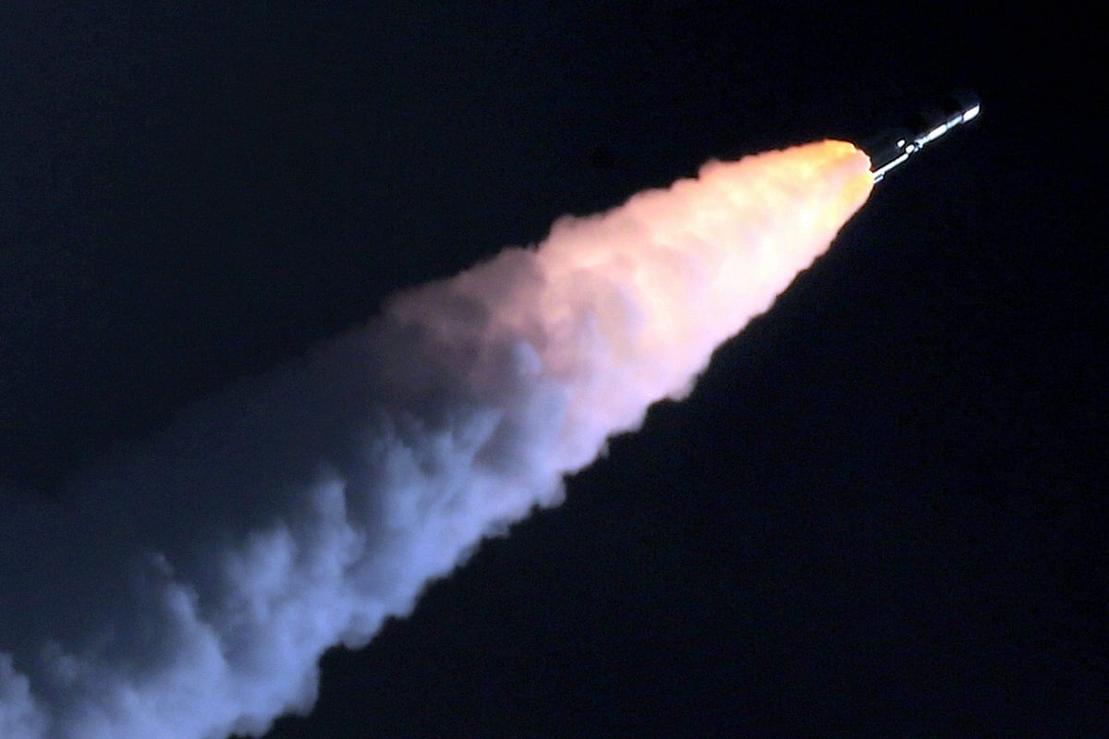
BENGALURU: Ajay Dharam Singh, Minister for Minor Irrigation, Science and Technology, on Tuesday said a meeting with Indian Space Research Organisation (ISRO) Chairman V Narayanan and Karnataka Chief Minister DK Shivakumar will take place this month to explore opportunities for deeper space collaborations. Singh said there was considerable scope to further strengthen cooperation between ISRO and the State government in science, technology and emerging innovation sectors. Singh had visited the ISRO head office to congratulate the team for the success of the GSLV-F17-EOS-05. He also facilitated a telephonic conversation between the CM and Narayanan. "ISRO's achievement is a matter of pride. The State Government is fully committed to supporting the growth of space science, research, SpaceTech, DeepTech, startups and emerging technologies in Karnataka," Singh said. Earlier in the day, speaking at the High-Level Roundtable on Space, Singh said the State wants industries and innovators to engage from the early stages and contribute ideas, technologies and partnerships to shape the State's deep-tech ecosystem. He used the platform to invite global technology companies, startups, investors and researchers to partner with the State government in building Karnataka's proposed Quantum City as a globally competitive hub for research, innovation and industry collaboration. Referring to the Karnataka Space Technology Policy 2025-30, he said the State aims to capture 50% of India's space market and 5% of the global market by 2033, attract USD 3 billion in investments and train 50,000 professionals. The Minister also advocated greater use of satellite imagery, drones, GIS, remote sensing and AI for groundwater management, mapping of tanks and lakes, irrigation asset management and project monitoring. Secretary, Department of Electronics, IT, Biotechnology and Science and Technology, N Manjula on Tuesday said, Karnataka's vision is not only to develop space technologies, but also to become a leading adopter of space-enabled solutions for societal impact. She said the State is holding brainstorming sessions on developing a constellation of satellites which will serve not just the needs of Karnataka but other states as well. She said the government was looking at various sorts of partnerships for this. The State is also looking at the sectors of geospatial intelligence, advanced manufacturing, Earth observation and digital infrastructure that will drive the next phase of growth. Speaking on the second day of the 9th edition of Bengaluru Space Expo 2026, she said the State launched the Karnataka Space Technology Policy 2025-30 as a strategic roadmap for building a globally competitive space economy. She added that Karnataka has also set a target of attracting USD 3 billion in investments by 2034 through policy interventions, infrastructure creation and ecosystem development. Karnataka is also advancing plans for a dedicated Space Park and Space Manufacturing Cluster near Bengaluru.

6. For ISRO, expanding ecosystem is way forward - The Indian Express
Read more
For ISRO, expanding ecosystem is way forward The Indian Express

7. NASA Calls for Proposals to Accelerate Lunar Surface Technologies
Read more
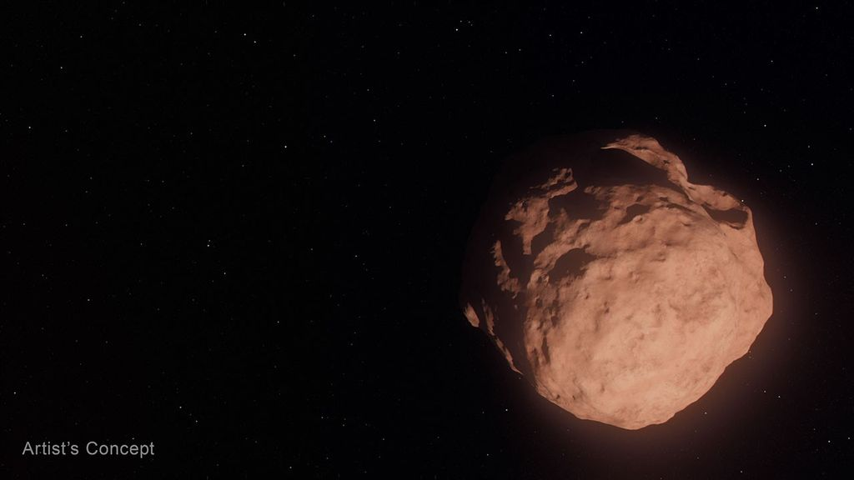
Artistic concept of lunar surface technologies and infrastructure capabilities, including in-situ resource utilization oxygen production systems, surface power systems, in-space manufacturing tools, and advanced nanomaterials production. Credit: NASA NASA is seeking proposals to advance the technology and infrastructure needed to explore the Moon and establish a Moon Base in the lunar South Pole region. Announced on Tuesday, Sept. 8, the solicitation targets capability gaps, including power generation, oxygen extraction, and producing materials on the Moon required for construction and operations. These technologies are essential to making humanity's next great leap in lunar exploration. "NASA is accelerating the development of key technologies and closing critical gaps needed for long-term human exploration at the Moon," said Greg Stover, director of NASA's Advanced Research and Technology Division. "Partnering with industry will strengthen the U.S. industrial base as we mature the capabilities and infrastructure needed for a sustainable lunar presence." The NextSTEP-3 Broad Agency Announcement Appendix A: Lunar Enabling Infrastructure Accelerator solicitation aims to mature and demonstrate capabilities in five areas: Vertical solar array technology that can provide consistent power generation, management, distribution, and energy storage. In-situ resource utilization oxygen from regolith production to extract usable oxygen molecularly bonded to rock and dust covering the Moon's surface. Radioisotope Stirling generator, a type of nuclear energy technology that uses heat from fissile materials to produce electric power for operating spacecraft systems in the darkest, dustiest, and most remote places. In-space advanced manufacturing to reduce reliance on resupply missions from Earth and to optimize mission flexibility and resilience on the Moon. Innovative nanomaterials production to advance the commercial availability and quality of nanomaterials that can be used in lunar exploration. The solicitation intends to cultivate U.S.-led capabilities while maintaining full and open competition among private industry, academic institutions, and not‑for‑profit entities, as well as international partners participating through U.S.-led teams. NASA may apply insights gained from the resulting contracts of this solicitation, such as technical data, and demonstration results, to shape future acquisition strategies. To learn more about NextSTEP-3, visit: https://go.nasa.gov/4x20o3t -end- Rob Margetta Headquarters, Washington 202-358-0918 robert.j.margetta@nasa.gov

8. Stoke Space raises $1 billion for fully reusable rockets, targets 'early 2027' for 1st-ever launch
Read more
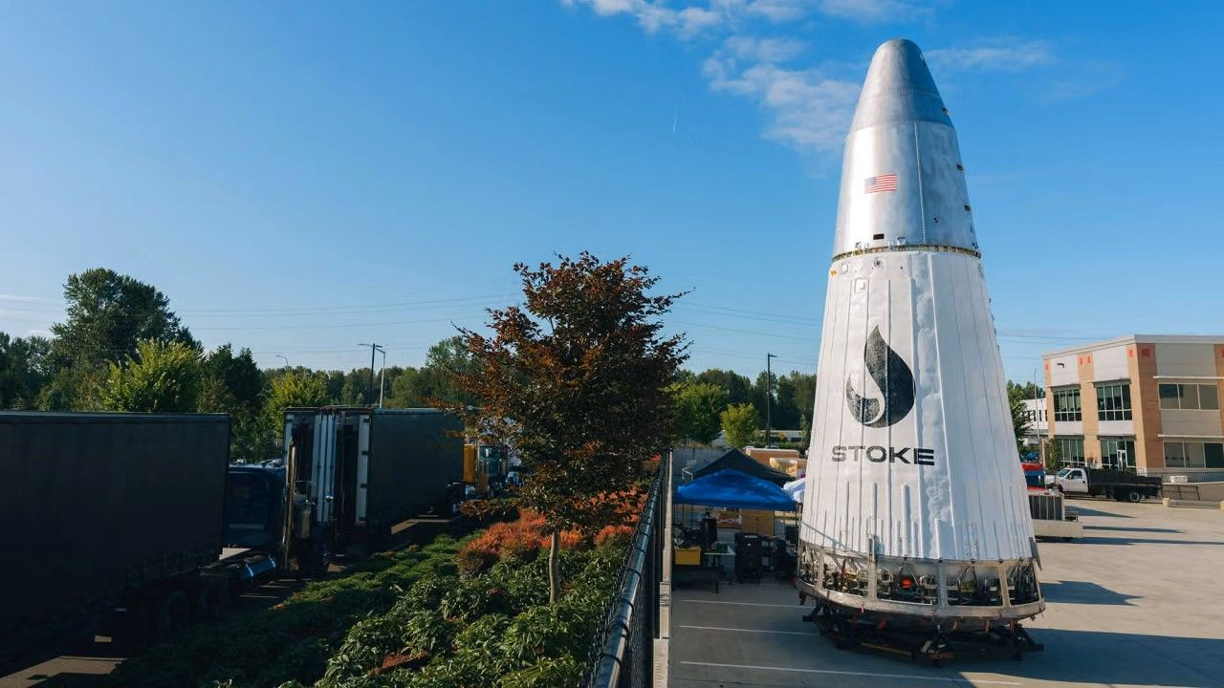
Click for next article Stoke Space has amassed a substantial sum during its latest round of financing and is revealing exactly where it plans to invest its new stack of cash. The Kent, Washington-based company just raised $1 billion via its"Series E" capital campaign, bringing Stoke's total investor haul to $2.3 billion. The Sept. 8 announcement provided a development update for Stoke's fully reusable Nova Pathfinder launch vehicle and included plans for its never-before-seen Nova Block 2 rocket, a more powerful system designed to be able to deliver up to 15 tons to low Earth orbit (LEO). "We are humbled by the trust our investors and customers have placed in us in pursuit of this critical generational challenge," said Andy Lapsa, Stoke CEO and co-founder. "This investment enables us to scale toward delivering the capability and cadence our customers require." Nova Pathfinder is Stoke's first orbital launch vehicle (the largest first rocket ever undertaken by a U.S. launch company, according to Stoke), and is based on the same technologies the company is building into its Block 2 design. Both two-stage vehicles are being manufactured with full and rapid reusability in mind, with Pathfinder serving as the proving ground for that architecture. Pathfinder's first stage is powered by seven Stoke-designed full-flow, staged-combustion (FFSC) Zenith rocket engines, fueled by liquid oxygen and liquefied natural gas (LNG). The first stage on Nova Block 2 will be equipped with 14 Zeniths. Stoke calls FFSC "perhaps the most difficult rocket engine cycle to develop," but highlights its advantages; the tech leaves fewer residuals like soot around the engines and reduces the amount of maintenance needed between flights, according to the company. The upper stage of both rockets is the more atypical approach to spacecraft design, compared to other vehicles of the same launch class. The aft end of Nova's second stage is designed with a heat shield to protect the vehicle during reentry through Earth's atmosphere. Instead of the ceramic tiles historically used on the heat shields of previous spacecraft, the dome-like structure at the base of Nova's upper stage is made of metal, which is actively cooled by the liquid hydrogen that fuels the stage's Andromeda propulsion system. Rather than a single large, vacuum-optimized engine bell at its center, Nova's upper stage features 12 small dual-thrust chambers integrated into a circle around the outer edges of the vehicle's heat shield. Stoke successfully completed a "hopper" test flight of Pathfinder's upper stage engine system in 2023, flying the vehicle about 30 feet (10 meters) into the air before it safely touched down. Andromeda upper stage engine and integral re-entry heat shield. (Image credit: Stoke Space) Scaling up to Block 2, Stoke plans to equip the upper-stage system with independent systems for each of the 12 engines, potentially increasing thrust by over a factor of five, according to the company. Block 2's upper stage also drops Pathfinder's tapered design in favor of cylindrical tanks, increasing propellant and payload volume to accommodate a 5-meter-wide (16.4 feet) fairing. Stoke says the larger Block 2 configuration has been in the works alongside Pathfinder for several years. The company is developing the more powerful rocket to support large commercial and national security satellite constellations, of which there soon may be a high demand. Nova Block 2's closest competitors are SpaceX's Falcon 9 rocket and Rocket Lab 's upcoming Neutron launch vehicle, which is still under development. And Falcon 9 is already being sundowned by SpaceX as the company gets closer to operational flights with its next-generation Starship rocket. While certain Falcon 9 flights for NASA , like crew launches to the International Space Station , are expected to continue until at least 2030, SpaceX CEO Elon Musk has said that Starship's ultimate success "means winding down Falcon." The timing should line up with when Stoke hopes to step in with Nova Block 2. Block 2's first launch is targeted for 2029, with production and flight cadence expected to increase from there. Nova Pathfinder next to Nova Block 2. (Image credit: Stoke Space) As Stoke ramps up development for its upgraded launch vehicle, the company's fresh round of funding will also go toward construction of the physical infrastructure Stoke needs to build, test and eventually operate both vehicles. The company is planning a 475-acre (192 hectares) expansion to its 75-acre (30 hectares) Moses Lake Test Site in Washington to support propulsion and vehicle testing as Pathfinder nears its first launch and Block 2 hardware begins coming online. Stoke is also expanding its operations at Cape Canaveral Space Force Station (CCSFS) in Florida. The company was selected by the U.S. Space Force in 2023 to manage CCSFS's Space Launch Complex-14 , where it's now building a new payload processing facility sized to accommodate both vehicles. And to complete its full reusability system, the company is also developing an offshore recovery platform. Pathfinder has a much shorter timeline to the launch pad. Stoke is targeting early 2027 for Pathfinder's debut launch, which the company plans to send to orbit with a customer payload. If that's successful, Stoke hopes to fly multiple Pathfinder missions throughout 2027 and 2028 while Block 2 development and testing continue in parallel. Once Block 2 does reach the launch pad, Stoke plans to keep Pathfinder in service. "We see value in having more than one way to serve the market, since some missions are particularly well suited to the Pathfinder configuration," the company said.

9. On this day in space! Sept. 8, 2004: NASA's Genesis spacecraft crashed in the Utah desert, shattering its samples of solar wind particles from the sun
Read more
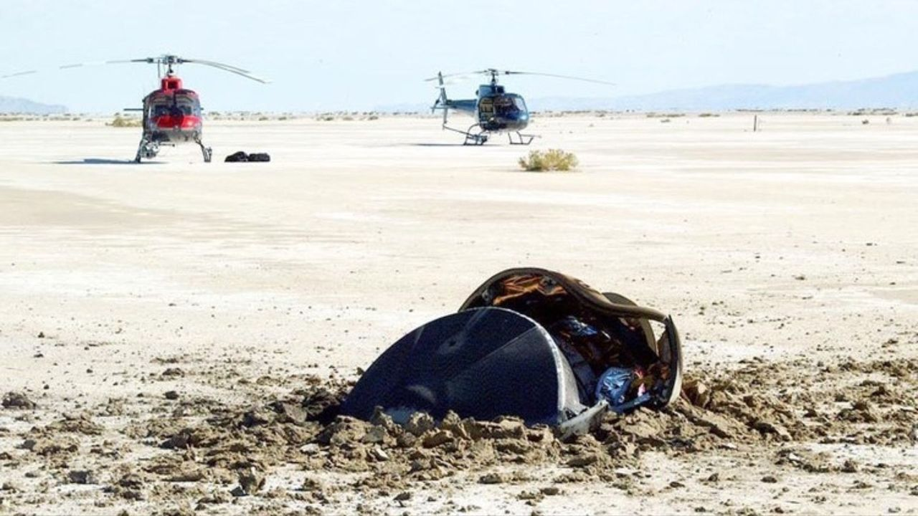
Click for next article On Sept. 8, 2004, NASA's Genesis spacecraft crash-landed in Utah after its parachutes failed to deploy. Genesis was NASA's first sample-return mission since the Apollo program , and the first attempt ever to bring back samples from someplace farther than the moon. The spacecraft picked up solar wind particles while orbiting the L1 Lagrange point , which is about 1 million miles from Earth. L1 is a "sweet spot" between the Earth and the sun, where the gravitational pull from both objects balances out. Genesis collected samples of the solar wind using arrays made of ultrathin semiconductors called "wafers." Atoms and ions floating around in space stuck to these wafers, and Genesis was supposed to bring them back safely. But that didn't happen, because its parachute didn't work . Instead, Genesis tumbled from the sky and slammed into the Utah desert . Scientists literally had to pick up the pieces after the wafers containing the solar wind samples shattered into thousands of tiny shards. Luckily, scientists were still able to salvage some of the samples. NASA's Genesis solar wind sample return capsule, seen here half-buried in the Utah desert floor, crashed due to a design flaw on Sept. 8, 2004. (Image credit: USAF 388th Range Squadron) Why it mattered NASA's Genesis probe launched in August 2001 on a $264 million mission to collect samples of the solar wind. It was the first time NASA tried a sample-return mission since Apollo 17 in 1972 (which was a crewed flight), and this trip would be fully robotic. In order to secure the Genesis solar wind samples safely, NASA opted for a tried and true approach for space retrieval: capturing a returning craft by the parachute using a helicopter. Similar techniques were used in the past to collect spy satellite film from military satellites . Image 1 of 3 A scientist in protective gear trying to secure solar wind samples from crashed Genesis spacecraft. (Image credit: NASA) Fragments of NASA's shattered Genesis sample cansiter with solar wind samples. (Image credit: NASA) This artist's concept shows what the Genesis spacecraft looked like in space with its fragile sample return wafers exposed to collect solar wind samples. (Image credit: NASA) Image 1 of 3 View Original Image 2 of 3 View Original Image 3 of 3 View Original But a design flaw in the parachute system , and a fairly basic one at that, doomed the Genesis spacecraft. Four gravity switches in the sample-return canister were installed backwards due to an error in the design schematics. It affected both the primary and backup parachute systems. The switches were supposed to detect when Genesis began braking in Earth's atmosphere and trigger parachute deployment. That never happened, so the probe crashed into Earth instead. NASA scientists were still able to glean some science from the shattered Genesis sample-return capsule , but the result was far from optimal, as you'd expect. The mishap also prompted reviews of NASA's Stardust comet sample return probe , which used the same type of gravity switches, but that spacecraft's switches were installed correctly and it made a successful landing in 2006 . Happy Birthday, Star Trek! (Image credit: Paramount) Speaking of things flying through space. There was another event that occurred on this day in 1966 that - while not actually being in space - has influenced our concept of spaceflight for a decade. On Sept. 8, 1966, the first episode of " Star Trek " debuted on television. The iconic science fiction series, which has spawned a myriad of spin-offs and feature films (not to mention all the merch), has inspired countless engineers, scientists and space fans over six decades. The Star Trek franchise celebrates its 60th anniversary in 2026, and you can find our Star Trek coverage here . Want more space history? Check out our full On This Day In Space Story archive and watch our On This Day In Space videos on YouTube .

10. An unmissable $450 off, we rank this vintage-style Nikon as the best camera under $2000, but it is going fast
Read more

Click for next article This Nikon Zf is an excellent astrophotography camera, and this is the cheapest it's been since last Black Friday. Looking for a quality camera that marries style and performance? Look no further than the Nikon Zf. Despite its vintage looks, it's one of the best Nikon cameras you can buy and with its excellent low-light performance, we also rank it as one of the best astrophotography cameras . Now, thanks to this deal, it's the cheapest it's been since last year's Black Friday. Save $453 and get the Nikon Zf camera, on sale for $1,747 at Amazon. In our Nikon Zf review , our expert called it "A great buy that offers excellent value for money when compared with some of the much more expensive Nikon models." Now less than $1,800, this is a steal for astrophotographers and photographers in general. Best classic style Nikon Save $453 Nikon Zf: was $2,200 now $1,747 at Amazon Save $453 on this impressively capable Nikon Zf camera. It isn't just a great low-light performer, it's an excellent all-rounder. Its retro-aesthetic is a bonus for those who miss the look and feel of film cameras. What's not to love about this Nikon Zf camera? We ranked it as the best camera under $2,000 , before inflation pushed it past that price point, and this deal makes it the cheapest it's been since last Black Friday. Not only does this full-frame mirrorless camera offer excellent low-light performance, so much so that we think it's one of the best cameras for astrophotography , it's a brilliant all-rounder too. In their Nikon Zf review , expert Jase Parnell-Brookes awarded it four-and-a-half stars, discovering that its strengths go far beyond its vintage stylings, remarking that "It delivered an impressive dynamic range and performed well in various lighting scenarios." And, while you can point and shoot, the Nikon Zf is packed with controls designed to enhance your experience. From changing the ISO and ISO sensitivity, through to switch to black-and-white mode, you have complete control over your images. That much choice may seem daunting but the buttons and dials are intuitive enough that using them becomes second nature. There are Nikon cameras out there that can beat its 24.5 MP images, but you'd have to spend significantly more. The Nikon Z8 , for example, is over half as much again. If you want to make your money count, the Nikon Zf is the camera to buy. However, you'll have to hurry if you want to make the most of this deal. As we write this, there are just a handful of units left in stock. Key features: 24.5 MP FX CMOS Sensor, Z mount, 100-64000 (expandable to 204,800) ISO, 4K UHD 30p video, 1 lb 9.1 oz / 710 g weight, 1SD UHS-II + MicroSD UHS-I card slots. Product launched: September 2023 Price history: This is the cheapest this camera has been all year. It last dropped to around this price last Black Friday. Price comparison: Amazon: $1747 | Adorama: $2197 | B&H Photo: $2047 Reviews consensus: Reviewing the Nikon Zf , we awarded it four-and-a-half stars praising, in particular, its low light performance and how it stacks up to Nikon's more expensive cameras. We were also impressed by its vintage appearance, replicating the look of a film camera. Its Amazon reviews are just as positive, with just a few purchaser complaining about its weight. Space: ★★★★½ | TechRadar: ★★★★½ | Digital Camera World: ★★★★½ Featured in guides: Best astrophotography cameras, best Nikon cameras, best cameras under $2000 ✅ Buy it if: You want a vintage-styled but powerful camera that will let you take stunning shots of whatever you point it at, the night sky included. ❌ Don't buy it if: You want maximum image detail. You can get better than the Zf's 24.5MP sensor; consider the Nikon Z8 instead. Chris McMullen Contributing writer Chris is a freelance journalist who, when not writing, skywatching, gaming or building Lego, indulges his taste for horror, sci-fi and the post-apocalyptic. As well as Space.com, you can find his work at GameSpew (where he's the weekend editor). Check out our other guides to the best telescopes, binoculars, cameras, star projectors, drones, Lego and much more.

11. 2 satellites just burned up in Earth's atmosphere - and scientists were watching from a private jet. Here's why
Read more
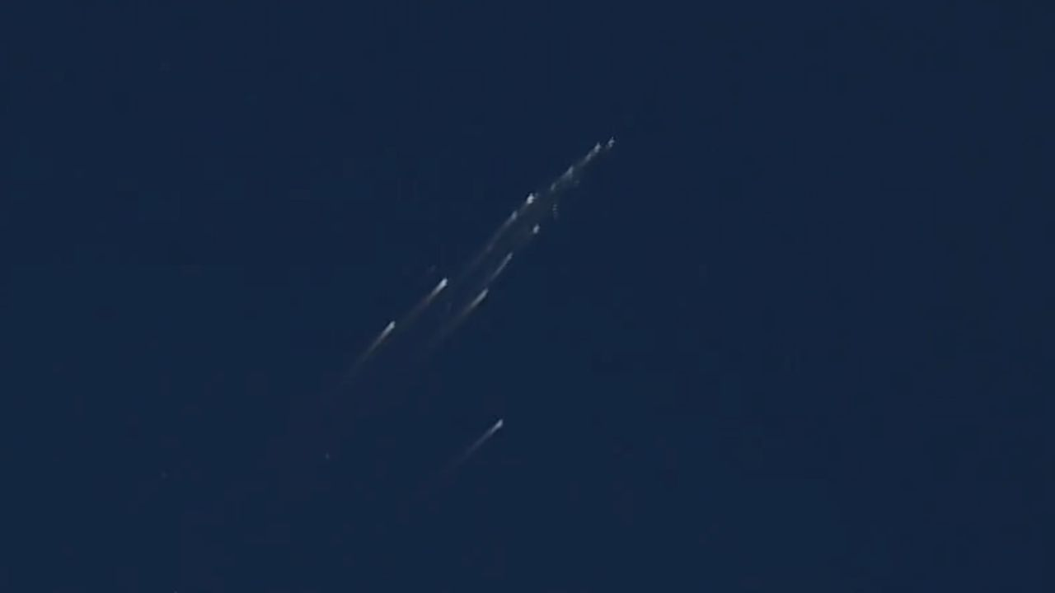
Click for next article The European Space Agency's Tango satellite disintegrated above the Pacific Ocean on Sept. 1, 2026. observed by a team of researchers from aboard a private jet. A team of researchers just chased a pair of reentering satellites in a private jet to learn about the pollution caused by space debris burning up in Earth's atmosphere. The satellites in question were the European Space Agency 's (ESA) Tango and Samba spacecraft , which once formed the Cluster constellation, together with the already de-orbited Rumba and Salsa. The quartet used to study the interaction of Earth's magnetic field with the solar wind . After 25 years of service, ESA took advantage of the Tango and Samba's controlled demise to help scientists learn what happens when satellites break apart and burn up during their spiral back to Earth. The international team of researchers chased the two reentries, which occurred one day apart - on Aug. 31 and Sept. 1 - above the southern Pacific Ocean a few hundred miles from the Polynesian archipelago of Tonga. Samba's reentry: Seen from the sky - YouTube Watch On Their goal was to understand what happens when satellites disintegrate and what chemical compounds arise in the process. Although companies such as SpaceX , Amazon and Blue Origin want to launch huge numbers of satellites to space in the next decade - SpaceX alone plans to loft 100,000 of its Starlink V3 spacecraft - very little is known about the effects of satellite reentries on Earth's atmosphere. Researchers are also still unsure which spacecraft burn up completely and how many fragments may reach the ground, putting lives and property at risk. "We want to understand what happens to these bodies as they fly through the atmosphere, which causes friction and very high temperatures," Jiří Šilha, CEO of the Slovak company Astros Solutions, and one of the researchers aboard the plane, told Space.com. "We know that those satellites break up into fragments, which subsequently melt in the atmosphere." The researchers chased the reentering spacecraft following exact calculations provided by ESA controllers , who were able to maintain connection with the spacecraft until the very last moment before they plunged into the atmosphere. Researchers inside a private jet during a campaign observing the reentry of ESA's Cluster Tango satellite on Sept. 1, 2026. (Image credit: Jiří Šilha) The satellite reentries, although they occurred during daylight, were visible from aboard the plane even to the naked eye, said Šilha, and created spectacular fireballs that lasted tens of seconds. "Bolides and meteors only last a few seconds or less," said Šilha. "But satellites are slower. They enter the atmosphere at a shallower angle, and the atmosphere slows them down further." But the researchers were there for science, not for a sky show. And it was a rare opportunity: The Cluster trajectories were so precisely known that the scientists could prepare for them and be at the exact spot at the exact time to witness those explosions from only a couple of hundred miles away. The aircraft, a small commercial business jet, was packed with 30 cameras and spectrometers fitted with special filters to capture not only how the satellites disintegrated but also detect the spectral signatures of the chemical elements released as their bodies burned up. Eight scientists were squashed on board the darkened jet operating the instruments through the aircraft's six windows as the pilots navigated to the vicinity of the spot where ESA analysts had predicted the breakup would occur. "We were flying toward the object, and first it looked like a compact source of light as the material ablated," said Šilha. "At some point, there was a sudden explosion as the satellite disintegrated." The plane allowed the researchers to overcome any clouds that could obscure the view from the ground, and also to bypass the thickest layer of the atmosphere, which would distort the measurements. As the satellites hurtled through the air, slowing down from the mind-boggling speed of 22,370 mph (36,000 kph) at which they hit the upper atmosphere, the jet approached them to within a distance of around 75 miles (120 kilometers). "We begin observing it when it's at about 90 kilometers [56 miles] and it stops being visible at about 65 to 70 kilometers [40 to 44 miles]," Šilha said. "For about thirty to forty seconds after the explosion, you can observe an interesting structure as all those various fragments ablate in the atmosphere. Then they all either burn up or slow down." Šilha said the cameras captured tens of fragments, in detail that had never been observed before. The researchers also attempted to trace seven chemical compounds, including titanium, sodium and potassium, which get released as satellites burn up. The team was especially interested in aluminum, which makes up the majority of a satellite body. Aluminum is not naturally present in Earth's atmosphere and most likely forms aluminum oxide during the incineration. The potential presence of aluminum oxide in the atmosphere in higher concentrations worries scientists, as it could potentially trigger ozone depletion in the stratosphere. "We tried to measure the aluminum at different altitudes, using specialized filters, which could tell us when this aluminum interacts with the atmosphere," said Šilha. "That's when the aluminum oxide likely forms, and that's something that has never been observed before. We don't know exactly how and in what quantities the aluminum oxide might be forming." The researchers will now analyze the data to learn exactly what chemical reactions may be occurring during every second of the breakup and burn-up process. The data will help atmospheric physics and chemistry researchers improve their models to further our understanding of the potential damage the growing satellite industry might do to the planet and its climate in the future. "The data will help us validate whether the models agree with reality," said Šilha.

12. SpaceX rocket taxi returns after Roman Telescope launch | Space photo of the day for Sept. 8, 2026
Read more
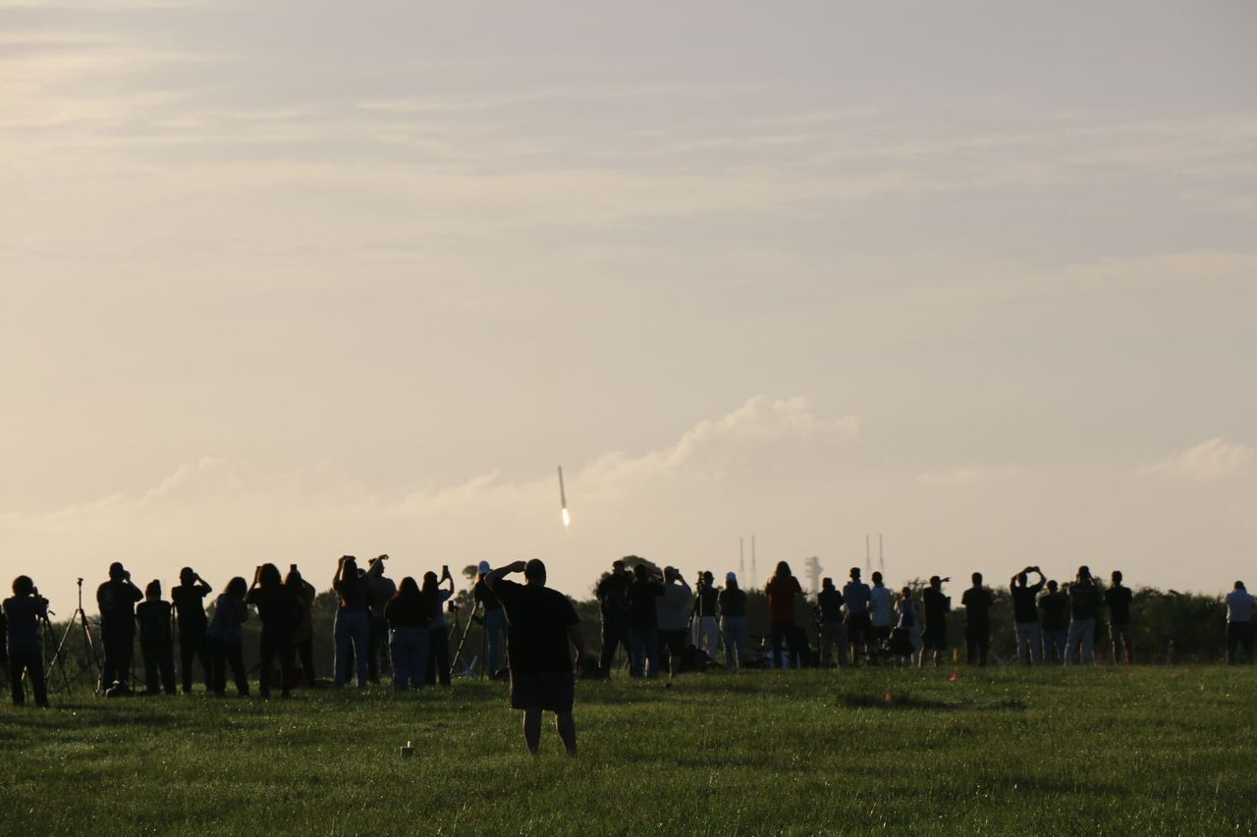
Click for next article This might look like a rocket launching off Earth, but it's actually a rocket booster perfectly landing on our planet after fulfilling its duty. (Image credit: Chelsea Gohd) On Aug. 30, the Nancy Grace Roman Space Telescope launched into space aboard a SpaceX Falcon Heavy rocket - then, after completing their job, the rocket's boosters safely landed back on Earth. Watching the events unfold, Space.com's Chelsea Gohd caught one of these beautiful landings on camera as onlookers at NASA's Kennedy Space Center watched in awe. What is it? The Roman Space Telescope is NASA's next great observatory, meant to revolutionize how we view the cosmos. Equipped with instruments like a coronagraph that can directly image exoplanets and a Wide-Field Instrument (WFI) that has a massively wide field of view, it's designed to work with big names like the Hubble Space Telescope and James Webb Space Telescope and reveal our universe's intricacies on a grand scale. But to get to space, like any other space telescope, it needed a rocket to ferry it there. In this case, that was SpaceX's Falcon Heavy rocket. Falcon Heavy is about 230 feet (70 meters) tall and can lift nearly 141,000 pounds (64 metric tons) of payload to low Earth orbit. And importantly, Falcon Heavy's two boosters are reusable. After launching a payload to space, the boosters split and each lands back on Earth in an upright position. In the image above, Gohd captured one of those boosters landing in the distance. Why is it incredible? Though we hear about it so often , there is something undeniably dreamlike about living in a time when a rocket can land its parts back on Earth so precisely. I was also there for the launch of the Roman Space Telescope in Florida, and it was breathtaking to watch such a huge piece of equipment navigate mid-air and straighten itself before landing. The crowd in the picture was equally astonished while the event unfolded. My mother texted me just after she watched the Roman Space Telescope launch live online, exclaiming that the booster's landing looked just like a taxi returning to its station, getting ready for the next task. I hadn't thought about it that way before, but she was correct. One of the boosters that participated in Roman's launch landed at Landing Zone 2 and the other hit the ground at Landing Zone 40. As NASA explained in a statement, one of these boosters carried out its very first mission while the other was on its third . Now, the next spectacle to take our breath away will be Roman's very first images of the universe. Those are expected to drop next year.

13. The Vela Incident: Did an American satellite detect a secret nuclear test in 1979?
Read more
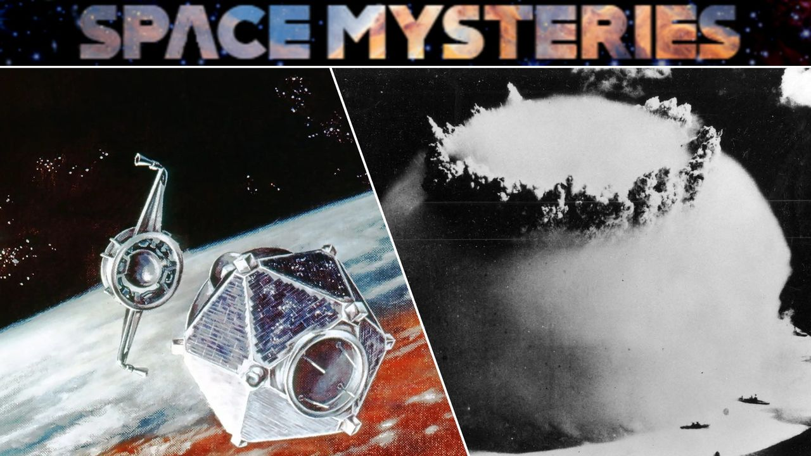
Click for next article It began with an unusual flash detected off the coast of South Africa by an aging American satellite - and to this day, debate continues over whether this odd Cold War event involved an illicit atmospheric nuclear test. The strange story of the "South Atlantic Flash," better known as the Vela Incident, began on Sept. 22, 1979. At that time, Vela 6911, a satellite in a constellation developed by the United States for the specific purpose of detecting nuclear detonations , observed something that immediately alarmed officials: a peculiar flash of light emanating from somewhere over the South Atlantic Ocean. A significant part of what concerned U.S. officials at the time had been the double flash of light detected during the event - a distinctive feature that strongly resembled the flashes produced by a nuclear explosion in Earth's atmosphere . The characteristic double flash results from the rapidly changing brightness of the fireball and shock wave produced by an atmospheric nuclear detonation, creating a distinctive optical signature that Vela's sensors were specifically designed to recognize. The South Atlantic event, therefore, seemed like a prime candidate for a secretive nuclear test being carried out by an unknown party - but if that were the case, who was responsible? Space Mysteries: Did an American satellite detect a secret nuclear test in 1979? - YouTube Watch On What do we know? U.S. officials responded to a possible nuclear test Then-President Jimmy Carter was promptly alerted to the situation, as evidenced in diaries the former U.S. leader would publish years later . "There was indication of a nuclear explosion in the region of South Africa," Carter wrote in an entry on the same date of the event. A later entry penned the following February would go on to add that "We have a growing belief among our scientists that the Israelis did indeed conduct a nuclear test explosion in the ocean near the southern end of Africa." President Jimmy Carter, seated at a desk in the Oval Office of the White House in 1980. (Image credit: Bettmann/Getty Images) Despite that belief regarding the possibility of a clandestine nuclear test, a scientific panel assembled in 1980 , chaired by MIT professor Jack Ruina, eventually put forward an alternative explanation: that the flash had more likely been an anomaly caused by a small meteoroid striking the satellite. Notably, the panel did not rule out the possibility of a nuclear explosion at the time, although the alternative they put forward remained controversial among scientists and intelligence officials. A memorandum to Director of Central Intelligence Stansfield Turner from Frank Press, White House science adviser, in which Press explains the reasoning behind the Ruina panel's conclusion that the Vela flash was "probably not from a nuclear explosion" and was therefore more likely "caused by a natural event." (Image credit: Public Domain/National Security Archive) Documents and government insiders surface By the turn of the 21st century, formerly classified documents began to surface that revealed the extent of the inner tensions between U.S. government agencies over what caused the Vela incident. Among the critics of the debris-induced "anomaly" hypothesis had been Defense Intelligence Agency Vice Director Jack Varona. According to documents released in 2006, Varona said the investigations by the 1980 scientific panel had been a politically motivated "whitewash," and that evidence collected by the U.S. intelligence community included detections "unique to nuclear shots in a maritime environment," based on an analysis by the Naval Research Laboratory. Varona wasn't alone. Other former intelligence officials who came forward over the years included Stansfield Turner, the former Director of Central Intelligence during the Carter administration, who in 2003 described the Vela detection as a "man-made phenomenon." Similar views were advanced by retired CIA officer Tyler Drumheller, who in 2006 wrote that he had sources at the time who "collectively provided incontrovertible evidence that the [South African] apartheid government had in fact tested a nuclear bomb in the South Atlantic in 1979, and that they had developed a delivery system with assistance from the Israelis." The Vela-5A & B satellites in a cleanroom at Los Alamos National Laboratory (left); and an illustration of one of the satellites in orbit above Earth (right). (Image credit: Los Alamos National Laboratory) What remains unknown? Scientists revisit the mystery While we still don't know if the South Atlantic Flash was a nuclear test, several scientists have reexamined the available evidence within the last decade, and what they found has lent further weight to the idea that the Vela incident had involved a detonation of some kind. Among the most significant assessments, a 2017 study by Christopher Wright and Lars-Erik De Geer combined modern research into interplanetary dust and hypervelocity impacts with revelations from recently declassified documents, as well as publicly available information that had been previously overlooked. Their conclusion: while no model was presented for the tenuous "meteoroid" theory advanced by the May 1980 scientific panel, the double flash observed by the Vela satellite in 1979 was indeed "consistent with a nuclear explosion, albeit detected by an aged satellite for which background modulation was abnormal and/or commenced earlier," adding that additional radionuclide and hydroacoustic evidence existed which supported the conclusion "that the Vela Incident was a nuclear weapon test explosion." Wright and De Geer weren't alone either. A 2022 study examined data collected by NASA's Nimbus-7 satellite just 16 minutes and 44 seconds after the double flash over the South Atlantic, which suggested a disturbance in the ozone layer that appeared to be consistent with a blast-generated shock wave. Artist's concept of a Nimbus spacecraft in orbit over Earth. (Image credit: NASA) Still, some of the original members of the 1980 scientific panel have defended its work amid the more recent scientific studies. Richard Mueller, who served as the panel's youngest member at the time, defended the group's conclusions in a November 2019 oral history conference , maintaining that the chances the Vela incident had involved a nuclear event were "as close to zero as it gets." This determination, Mueller argued, was made despite early interpretations by many panelists that a nuclear event had seemed most likely. Wright and De Geer, both of whom attended the 2019 oral history conference, were among the participants that pushed back on Mueller's views. Who was responsible? Amid the mounting evidence over the last several decades suggesting the Vela incident was indeed a nuclear test, debate continues over who was most likely to have been responsible. Although suspicions have long centered on a cooperative - and secret - strategic effort between apartheid-era South Africa and Israel, publicly available evidence remains lacking, and a fair amount of information in declassified documents that could point to this possibility remains redacted. An illustration of two Vela satellites separating in orbit. (Image credit: Los Alamos National Laboratory) The mystery remains Thus, after more than four decades, questions continue to linger over the famous Vela incident, including what nations might have been involved in such a test if it occurred. Despite that uncertainty, one thing does seem evident: information conveyed in unredacted portions of declassified records, combined with modern scientific analyses, increasingly point to the likelihood that the strange "South Atlantic Flash" in 1979 was anything but natural.

14. How studying astronauts could help tackle aging on Earth
Read more

Astronauts who undergo long-duration spaceflight aboard the International Space Station often return with health problems that resemble some age-related conditions in people on Earth.

