IIRS Daily Space Digest Wednesday, 03/06/2026

1. Govt says ISRO has developed & operationalised wide range of space-based applications to benefit society - News On AIR
"ISRO OR NRSC OR IIRS after:2026-06-02" - Google News
Read more

The Government has said that the Indian Space Research Organisation (ISRO) has developed and operationalised a wide range of space-based applications to benefit all sections of society, including the welfare of the Scheduled Caste community. Science and Technology Minister Dr. Jitendra Singh informed this in a written reply in the Lok Sabha today. The Minister said that key space application areas include satellite-based Potential Fishing Zone (PFZ) advisories, crop acreage and production forecasting, agrometeorological advisories for farmers, crop insurance support, geospatial support for flagship government programmes, tele-education, telemedicine, the Vessel Communication and Support System, and disaster management support. Mr. Singh noted that ISRO has established robust awareness and capacity-building programmes to promote the use of space technology for societal, governance, and disaster management purposes, enabling decision-makers to operate effectively at the grassroots level. He added that these initiatives are designed to be inclusive and accessible to targeted beneficiaries across the country. The Minister further said that the benefits of Earth observation, satellite communication, and navigation applications, particularly in terms of improved connectivity and navigation services, are reaching SC farmers, students, and disaster-prone regions within satellite coverage areas. He also highlighted that the Department has undertaken several measures to ensure the inclusive use of space technology, including the implementation of flagship initiatives such as Digital India, the BharatNet Programme, the Vessel Communication and Support System (VCSS) under the Pradhan Mantri Matsya Sampada Yojana (PMMSY), and the PM e-VIDYA scheme for tele-education.

2. Union Minister Jitendra Singh congratulates ISRO on successful testing of CE20 cryo engine at 22-tonne thrust - News On AIR
"ISRO OR NRSC OR IIRS after:2026-06-02" - Google News
Read more

Science and Technology Minister Dr Jitendra Singh today congratulated the Indian Space Research Organisation, ISRO, for a successful sea-level hot test of the CE20 Cryogenic Engine at 22-tonne thrust at the ISRO Propulsion Complex in Mahendragiri, Tamil Nadu. In a social media post, the Minister said that the successful test featuring the nozzle protection system and multi-element igniter marks another important step in strengthening the country's advanced cryogenic propulsion capabilities and further enhancing the reliability of the LVM3 programme.

3. ISRO expanding student participation in space missions, 11 student satellites already launched: Jitendra Singh - DD News
"ISRO OR NRSC OR IIRS after:2026-06-02" - Google News
Read more

Union Minister of State for Science and Technology Dr. Jitendra Singh on Thursday said the Indian Space Research Organisation (ISRO) is expanding student participation in space missions through structured programmes that allow young researchers to design satellites, develop payloads and participate in real mission experiments. Replying to an unstarred question by Sumitra Balmik in the Rajya Sabha, Singh said the government is committed to widening access to space technology so that students from institutions across the country, including those in tier-2 and tier-3 cities, can contribute to India's growing space ecosystem. The minister said ISRO has launched several initiatives aimed at providing hands-on exposure to space technology for students and researchers. Student satellite programme gaining momentum Singh said that ISRO's Student Satellite Programme, led by the U R Rao Satellite Centre, encourages academic institutions to design and develop satellites with technical mentorship from ISRO scientists. The organisation also supports integration and launch opportunities for these satellites through its missions. So far, the Indian National Space Promotion and Authorisation Centre (IN-SPACe) has authorised 17 student satellites and payloads, of which 11 have already been successfully launched, the minister informed. These projects have involved several academic institutions including the Indian Institute of Astrophysics, Indian Institute of Space Science and Technology, RV College of Engineering, Amity University Maharashtra, MIT World Peace University, Assam Don Bosco University and CV Raman Global University, reflecting growing national participation in student-led space missions. Competitions and innovation initiatives Singh said student engagement is also being promoted through national competitions organised by IN-SPACe. These include satellite and model rocketry competitions in which 97 student teams comprising nearly 850 students have participated. One such event - the Model Rocketry and CanSat India Student Competition - was organised jointly by IN-SPACe, ISRO and the Astronautical Society of India in October 2025 at Kushinagar in Uttar Pradesh. The event saw 67 teams with nearly 500 students design, fabricate and launch model rockets carrying CanSat payloads to an altitude of about one kilometre. Internship and research support The minister said students are also benefiting from internship and project trainee programmes that provide research exposure at ISRO centres for undergraduate, postgraduate and doctoral students. To strengthen collaboration between universities and ISRO scientists, the government has established Space Technology Incubation Centres (STICs) across various regions. These centres support students in developing indigenous space technologies under expert mentorship. In addition, Regional Academic Centres for Space (RAC-S) have been created to help students from smaller towns and institutions access ISRO programmes and research opportunities. Strengthening space education ecosystem Singh also highlighted the role of ISRO's RESPOND Programme, which provides financial and technical support to universities undertaking research in space science, technology and applications. He said the All India Council for Technical Education has approved a Space Technology Minor Course, while a national committee has been formed to promote adoption of space technology education in line with the Indian Space Policy 2023. The government has also earmarked around ₹10 crore annually for educational outreach activities in space science and technology. Singh said IN-SPACe is further supporting the next generation of space entrepreneurs through mentorship from domain experts, pre-incubation programmes and co-working facilities at its technical centres. "These initiatives are part of the government's broader vision to build a vibrant and inclusive space ecosystem in India, where students, startups, academic institutions and industry all contribute to the country's expanding role in the global space sector," the minister said.

4. Iranian Oil Reserve (ISOR) Price, ISRO Price, Live Charts, and Marketcap: isro coin, iosr coin, isor coin - Coinbase Canada - Coinbase
"ISRO OR NRSC OR IIRS after:2026-06-02" - Google News
Read more

Iranian Oil Reserve (ISOR) Price, ISRO Price, Live Charts, and Marketcap: isro coin, iosr coin, isor coin - Coinbase Canada Coinbase

5. ISRO Gaganyatris outline India's New Space Vision - MSN
"ISRO OR NRSC OR IIRS after:2026-06-02" - Google News
Read more

ISRO Gaganyatris outline India's New Space Vision MSN

6. Another great victory for ISRO - Kerala Kaumudi
"ISRO OR NRSC OR IIRS after:2026-06-02" - Google News
Read more

ISRO has created history by successfully putting the heaviest communication satellite ever launched by India into orbit. The satellite, named CMS-03, which has a crucial objective of strengthening the Navy, was launched. The satellite, which was launched from the Satish Dhawan Space Center in Sriharikota on ISRO's largest launch vehicle, Launch Vehicle Mark-3, safely reached orbit in 16 minutes. The 4410-kg multi-brand communication satellite, CMS-03 or GSAT-7R, will operate mainly for India's defense needs for about fifteen years. This satellite will capture clear images and signals from any bay for the Navy. It will also be useful in closely monitoring and warning the movements of enemy countries in the sea. Since it is a matter related to national security, ISRO has not released the images and more information of the satellite. This launch was also the fifth successful mission of the LVM3 rocket. ISRO Chairman Dr. V. Narayanan said that with the successful launch of GSAT-7R, the historic achievement of re-ignition of the Indian-made C-25 cryogenic system has been made possible. This will allow multiple satellites to be launched into different orbits together. Costs can be reduced and new business opportunities can be opened up by launching satellites of foreign countries and private companies together. The chairman announced that seven more major missions will be carried out this financial year. Every achievement of ISRO has a reason for Malayalis to be proud. That has not changed this time as well. Thrissur native T. Victor Joseph was the mission director. GSAT-7R was injected into a sub-Geosynchronous Transfer Orbit with an apogee of approximately 29,970 km due to a technical adjustment to accommodate the satellite's heavy mass. The control center has started the process of raising it by another 6000 km and placing it in a permanent orbit at an altitude of 36,000 km. This is the first time that India has launched a satellite weighing more than four tons to an altitude of 30,000 km. With the successful launch of GSAT-7R, hopes have been raised that heavy satellite launches, including Gaganyaan, will be possible in India. ISRO has achieved another prestigious success after the most prestigious Chandrayaan-3. This satellite launch, which took place at a time when India has significantly increased its defence security after Operation Sindoor, is of special importance. Being a subcontinent surrounded by sea on three sides, the Navy has a strategic role as important as the Army in guarding India's borders. The giant satellite launched on ISRO's LVM 3M-5 rocket, nicknamed "Baahubali", can be considered capable of doing so. We can wish ISRO new heroic stories with launch successes after this.

7. SpaceX wins $4 billion Space Force contract for satellites that target 'airborne threats' anywhere on Earth
Latest from Space.com
Read more
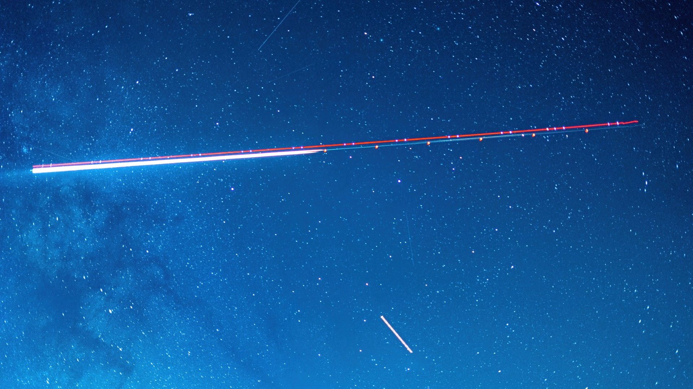

Click for next article The U.S Space Force has awarded SpaceX $4.16 billion to help the military track airborne targets using satellites. The massive contract is under the Space-Based Airborne Moving Target Indicator (SB-AMTI) program, which will add space systems to the U.S. military's tracking capabilities. SpaceX is the first of nine companies that Space Force has disclosed for the SB-AMTI vendor pool. The other eight companies have yet to be publicly announced. Space Force announced the SpaceX contract on May 29, stating that the award is for a satellite constellation that can "track and target airborne threats globally." The idea is that satellites can help with tracking in places where it could be dangerous for aircraft, which the military has long used for airborne tracking capabilities. The service aims to get an SB-AMTI satellite constellation up and running by 2028. "By focusing these capabilities to the space domain, we are providing the Joint Force with sustained battlespace awareness of contested airspace," USSF Col. Ryan Frazier, acting Space Force portfolio acquisition executive for SBST, said in a statement . "We are beginning development and integration efforts immediately to meet the program's rapid deployment milestones and address emerging national security requirements." Space Force described the SB-AMTI architecture as a "complex system-of-systems," which will integrate space-based sensors with fast, secure communication, as well as data processing technologies on the ground. It says that this program reflects "a rapid and strategic shift" toward a deeper collaboration between the contractors, research labs, and agencies that are collectively known as the government space industrial base. "Our mission is to deliver a resilient sensing layer that ensures our joint warfighters maintain a decisive information advantage in the air domain - especially in a denied or contested environment," USSF Col. Frazier said in a separate statement on April 27 . Denied or contested environments refer to airspace in which the U.S. military might face anti-aircraft attacks or other forces' aircraft. Future sensors SpaceX's satellites won't replace the current airplanes that the military uses to track moving targets. Right now, the two methods are meant to compliment each other. In the announcement, the Space Force highlighted the need to track airborne targets from space due to "continued challenges as adversaries develop increasingly sophisticated anti-access/area-denial (A2/AD) systems." A2/AD systems are used to prevent adversaries from entering a specific airspace. If the military moves some airborne target sensing to orbit, then it could reduce the risk to military aircraft that traditionally serve this function in contested regions. "We are providing continuous oversight where traditional sensors cannot reach to protect their freedom of maneuver," USSF Col. Frazier said in the April 27 statement. The Golden Dome missile defense system is one of the Trump Administration's keystone military initiatives, and these satellites would be expected to help track missiles for the Golden Dome, Reuters reports . Space Force anticipates that it will issue more awards in the coming year, which will help to expand its diversity of vendors.

8. Will SpaceX still be a launch company after its historic IPO?
Latest from Space.com
Read more
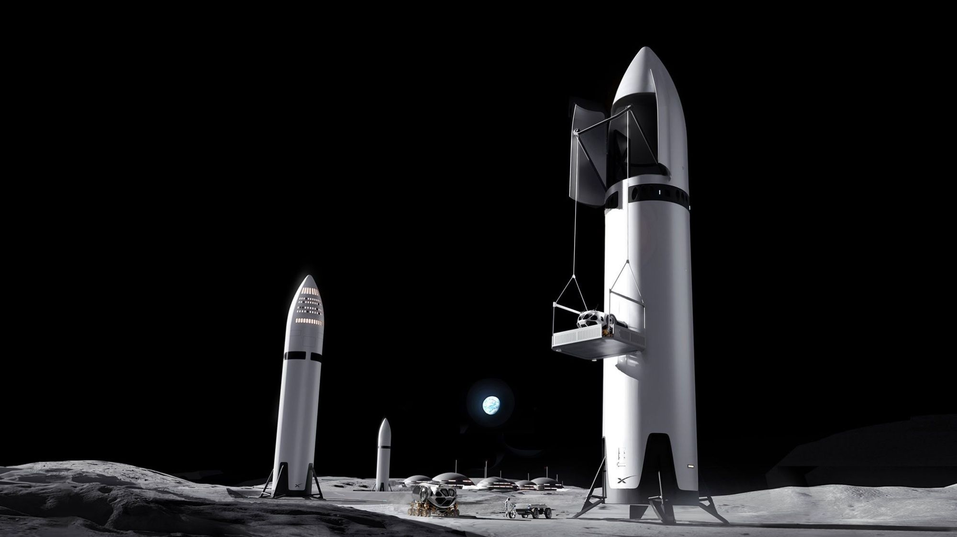

Click for next article On May 20, SpaceX filed with the U.S. Securities and Exchange Commission (SEC) key documentation for an initial public offering (IPO) of stock. An IPO signals that a private company is now selling shares to the public on a stock exchange. SpaceX's long-anticipated move could become the largest IPO in history , perhaps giving a $2 trillion dollar valuation to the company, which will soon be listed on the ticker as SPCX. SpaceX 's SEC Form S-1 is a vital registration step for U.S.-based companies planning an IPO, detailing significant corporate information to assist investors. "This prospectus contains forward-looking statements that are subject to a number of risks and uncertainties, many of which are beyond our control," SpaceX wrote in the S-1 . "You should read this entire prospectus carefully before making an investment decision." The prospectus adds: "We face a number of challenges relating to our business and growth strategy and, ultimately, the achievement of our mission to make life multiplanetary, understand the true nature of the universe , and extend the light of consciousness to the stars ." Space.com reached out to a number of experts about what the SpaceX IPO means for markets and individual investors - and the implications for a new wave of high-tech listings seeking fame and fortune. The Elon factor Shaun Davies is an associate professor of finance at the Leeds School of Business at the University of Colorado Boulder. He told Space.com that people should view this as much bigger than just "another IPO." "This could be one of the largest IPOs in history, both from a valuation perspective and from the sheer amount of attention it will attract," Davies said. "Everyone will be watching because of the Elon factor … Love him or hate him, you know who he is." What makes it unique is that SpaceX is no longer just a rocket company, Davies said. "When people hear 'SpaceX,' they think rockets , NASA partnerships, and commercial space travel. That is certainly part of the story," he said. But this is also tied to the company's Starlink internet megaconstellation and increasingly to xAI, a division of SpaceX, and the broader artificial intelligence (AI) arms race that is playing out right now, said Davies. Similar in view is Ann Lipton, a professor and the Laurence W. DeMuth Chair at the University of Colorado Boulder's School of Law. Lipton said the hype surrounding the IPO "does seem to have piqued investor interest in space stocks more generally. But it's true that the financials being disclosed suggest that SpaceX's profitability is being used to finance artificial intelligence development ." "We believe we have identified the largest actionable total addressable market (TAM) in human history." Chart shows SpaceX's estimated TAM by segment. (Image credit: SEC filing/SpaceX) New opportunities First of all, congratulations should go to Elon Musk and the team at SpaceX that made the IPO possible, said Scott Pace, director of the Space Policy Institute and a professor of the practice of international affairs at George Washington University's Elliott School of International Affairs. "Secondly, I believe fundamental drivers of growth will be information technologies that integrate communications, data and artificial intelligence using space in new ways," said Pace. "The iconic rocket launches and landings that the public sees have just opened the door to new opportunities," he added. Almost irrational exuberance "No commercial space firm has had a greater impact on private investor interest than SpaceX," said Scott Sacknoff, manager of the SPADE Defense Index, which develops and manages sector, thematic and regional equity indexes that can be used to benchmark markets. "Its forthcoming IPO has seen mainstream investor enthusiasm ramp up to a level of almost irrational exuberance," said Sacknoff. "Investment capital is flowing into the sector at unprecedented levels, and publicly traded space companies have seen stock prices rise 60-100% this year." What will happen following the IPO is unclear, Sacknoff said, as capital is likely to shift from other firms as investors buy shares in SpaceX. "At a $1.75 trillion valuation, investors that make money will likely be traders, not buy-and-hold investors," he said. SpaceX is now not a launch company, Sacknoff added: "It is a conglomerate with exposure to AI, advertising, communications and space manufacturing and operations." A rumored merger with Tesla, he said, will only diversify the firm further into automobiles, power storage and more. Not just a rockets story "There are a lot of moving pieces here," Davies emphasized. "It is aerospace, communications infrastructure, defense technology and AI all wrapped into one company. That is part of why investors are so fascinated by it." "This is not just a rockets story anymore," he continued. A successful SpaceX IPO would return a tremendous amount of capital back to investors and could help open more opportunities for the broader IPO market for other companies that have been waiting on the sidelines, Davies said. On the other hand, he added, if a deal this large struggles, "it could effectively shut down the IPO market for a while, particularly for speculative growth companies that have been waiting on the sidelines." That is why so many people will be watching this closely. "In many ways, SpaceX could become the bellwether for the next phase of the IPO market," Davies concluded.

9. Live coverage: SpaceX to launch 24 Starlink satellites on Falcon 9 rocket from Vandenberg
Spaceflight Now
Read more

SpaceX is set to launch a batch of its Starlink V2 Mini Optimized satellites on a Falcon 9 rocket from Vandenberg Space Force Base Wednesday morning. The Starlink 17-47 mission will add another 24 broadband internet to its low Earth orbit constellation. There are currently more than 10,000 satellites in orbit. Liftoff from Space Launch Complex 4 East is scheduled for 7:36 a.m. PDT (10:36 a.m. EDT / 1436 UTC). The Falcon 9 rocket will fly on a south-southwesterly trajectory upon leaving the pad. Spaceflight Now will have live coverage beginning about 30 minutes prior to liftoff. <span data-mce-type="bookmark" style="display: inline-block; width: 0px; overflow: hidden; line-height: 0;" class="mce_SELRES_start"></span> SpaceX will launch the mission with the Falcon 9 first stage booster with the tail number B1088. This will be its 16th flight after launching missions, like NASA's SPHEREx, Transporter-12 and NROl-126. More than eight minutes after liftoff, B1088 will target a landing on the drone ship, 'Of Course I Still Love You,' positioned in the Pacific Ocean. If successful, this will be the 200th landing on this vessel and the 619th booster landing to date.

10. Blue Origin vows to resume New Glenn flights by year's end
Spaceflight Now
Read more

Despite a spectacular launch pad explosion last week, Jeff Bezos's rocket company Blue Origin said Tuesday the damage was not as severe as initially feared and that the company plans to resume New Glenn rocket launches by the end of the year. Blue Origin CEO Dave Limp, in an overnight post on the social media platform X, said propellant tanks at launch pad 36 at the Cape Canaveral Space Force Station made it through the blast in good shape, as did a nearby processing hangar. The main support gantry, while damaged, can be repaired in place. "Now that we've had access to the pad and integration facility we can share a bit of good news," Limp said. "The propellant farm, oxygen, liquid hydrogen and LNG [cryogenic methane] tanks are all in good shape. This is good luck because these are very long lead items. "The water tower is also good. The big support tower is damaged, but it can be repaired in place rather than torn down and replaced." The New Glenn rocket that blew up on pad 36 last Thursday was destroyed along with its transporter-erector, used to move the rocket to the pad surface and then rotate it to vertical. But Limp said another New Glen first stage booster and three upper stages housed in a large hangar-like "integration facility" at the base of the pad "look good." 'We had already been working for some time on eliminating our transporter-erector in favor of an alternative vertical (rocket assembly capability), and we'll now go directly to that; so we don't need a new transporter-erector." No word yet on what might have caused the explosion, but Limp closed his post by declaring: "We will fly again before the end of this year. Gradatim Ferociter." The Latin expression, Blue Origin's motto, means "step by step, ferociously." Blue Origin was preparing to launch it's third New Glenn later this month to put a batch of Amazon Leo internet satellites into orbit. Last Thursday, engineers loaded both stages with supercold liquid methane and oxygen for a first stage engine test firing to verify its readiness for flight. The Leo satellites were not aboard. Such "hot-fire" tests are fairly routine in the rocket industry, giving engineers a chance to test launch-day fueling procedures, a booster's propulsion system and critical ground and flight software while the rocket remains securely bolted to its launch pad. <span data-mce-type="bookmark" style="display: inline-block; width: 0px; overflow: hidden; line-height: 0;" class="mce_SELRES_start"></span> But it was far from routine last Thursday. As the New Glenn's seven BE-4 engines began igniting and throttling up, a fire broke out at the base of the booster and moments later, now engulfed in flames, the rocket exploded in a tremendous fireball, shaking the ground for miles around in a conflagration visible all the way across the Florida peninsula. Footage captured by photo journalists from a helicopter the next day showed the rocket and its transporter-erector had been destroyed, at least some support beams at the base of the main gantry were either bent or blown away and a separate lightning tower had collapsed in a tangle of debris. Unlike rival SpaceX, which has two operation pads in Florida and one in California, Blue Origin only has pad 36. The company already had plans to build a second pad at the Cape and another at Vandenberg Space Force Base in California. But in the near term, New Glenns cannot fly until pad 36 is repaired. That's a problem for NASA's Artemis moon program and the agency's drive to beat the Chinese to the lunar surface. Chinese officials have said they plan to land their own "taikonauts" on the moon by the end of the decade. To win this self-declared "space race," NASA is relying on both SpaceX and Blue Origin to launch new moon landers into Earth orbit next yet for rendezvous and docking tests with Artemis astronauts in an Orion capsule. If those tests go well, NASA hopes to launch one, and possibly two, astronaut moon landing missions in 2028, soon followed by two flights per year thereafter before beginning assembly of a moon base near the lunar south pole where astronauts can live and work for months at a time. Blue Origin's lander would give NASA an alternative to SpaceX's, a variant of the company's Starship rocket. SpaceX has had its own problems perfecting the Super Heavy-Starship rocket needed to launch its lander, and it's not yet clear if they will be ready for the Artemis III Earth-orbit test flight next year as currently planned. Blue Origin's New Glenn also is needed to launch prototype rovers and other science experiments to the moon aboard an unpiloted cargo lander under contracts announced two days before last week's explosion. NASA Administrator Jared Isaacman remains optimistic about landing Artemis astronauts on the moon in 2028 using whatever landing craft is available. "Blue Origin leadership has responded incredibly quickly, and NASA will do all we can to help with root cause analysis and accelerate pad recovery timeframes while staying extremely focused on progressing the lander," he said on X. Kennedy Space Center Director Brian Hughes, appointed to the post just last month, told the Space Florida board of directors Tuesday that NASA is "doubling down on the lunar lander." "We'll be working with Blue and X lunar lander technology, and all of that is designed to keep us on path, meet the President's goal, which is to have American boots back on the moon before the end of 2028," he said. "Again, that's not just something to tout, it's an important demonstration of our nation's abilities." Limp's vow to resume flights by the end of the year might imply the "root cause" of the explosion might not have been an engine problem that would take months to correct and then test. Or at least, not a major design flaw. That would be good news for United Launch Alliance, a partnership between Boeing and Lockheed Martin. ULA uses Blue Origin's BE-4 engines in the first stage of its new Vulcan rocket. A drawn-out engine failure investigation would be a setback for ULA, but the BE-4s have not yet been blamed for the New Glenn mishap.

11. Live coverage: SpaceX to launch 29 Starlink satellites on Falcon 9 rocket from Cape Canaveral
Spaceflight Now
Read more

SpaceX hopes to launch its Falcon 9 rocket from Cape Canaveral Space Force Station on Wednesday morning, but poor weather may prove insurmountable. The Starlink 10-43 mission will add 29 broadband internet satellites to the company's low Earth orbit constellation. It consists of more than 10,000 spacecraft. Liftoff from Space Launch Complex 40 is scheduled for 6:11 a.m. EDT (1011 UTC). The Falcon 9 rocket will fly on a north-easterly trajectory upon leaving the pad. Spaceflight Now will have live coverage beginning about an hour prior to liftoff. <span data-mce-type="bookmark" style="display: inline-block; width: 0px; overflow: hidden; line-height: 0;" class="mce_SELRES_start"></span> The 45th Weather Squadron forecast a 30 percent chance for favorable weather during the launch window. Meteorologists describe a south-moving "cool" front that is like to make "weather conditions tricky for launch." "Scattered marine showers will likely scrape the East-Central Florida coastline during the launch window, and plentiful mid-level cloud decks will create concerns for both the Cumulus Cloud and Thick Cloud Layers Rules, with Surface Electric Fields Rule being a distant third should any of the showers move ashore," launch weather officers wrote. "Latest hi-resolution guidance has provided a more pessimistic view of the shower and mid-level cloud coverage during the launch window; thus we have increased POV. Recovery weather will also be a watch item with elevated wave heights and fresh breezes along the eastern Atlantic." SpaceX will launch the mission using the Falcon 9 first stage booster with the tail number B1090. This will be its 12th flight after launching missions, like NASA's Crew-10, CRS-33 and Bandwagon-3. Nearly 8.5 minutes after liftoff, B1090 will target a landing on the drone ship, 'A Shortfall of Gravitas,' positioned in the Atlantic Ocean off the coast of South Carolina. If successful, this will be the 153rd landing on this vessel and the 618th booster landing to date.

12. Before SpaceX goes public, a scramble to get on bandwagon
Space News - Space, Astronomy, Space Exploration
Read more
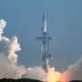

As SpaceX prepares its long-awaited stock market debut, investors everywhere are scrambling to get a piece of the action-through investment funds, related company stocks, and even online prediction markets.

13. Blue Origin says rocket explosion spared fuel tanks and key launch pad parts
Space News - Space, Astronomy, Space Exploration
Read more


Jeff Bezos' Blue Origin said Tuesday that last week's rocket explosion spared fuel tanks and some other critical parts of the launch pad.

14. For satellites as small as a briefcase, getting around in space just got a whole lot easier
Space News - Space, Astronomy, Space Exploration
Read more
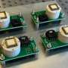

MIT engineers are testing a new propulsion system that combines the power and speed of conventional chemical thrusters with the precision and fuel-efficiency of electrical thrusters. The system could enable the design of nimbler, more flexible small satellites, which could perform both fast, powerful maneuvers and slower, precise adjustments, depending on the mission and moment...

