IIRS Daily Space Digest Sunday, 24/05/2026

1. PM Modi hails ISRO for successful SSLV-D3 launch - Newsonair
"ISRO OR NRSC OR IIRS after:2026-05-23" - Google News
Read more

Prime Minister Narendra Modi today congratulated the scientists of the Indian Space Research Organisation (ISRO) for the successful launch of the new Satellite Launch Vehicle (SSLV)-D3. In a social media post, Mr. Modi said it is a matter of immense joy that India now has a new launch vehicle. He said the cost-effective SSLV will play an important role in space missions and will also encourage private industry.

2. KV Umroi student bags top prize at ISRO space prog - The Shillong Times
"ISRO OR NRSC OR IIRS after:2026-05-23" - Google News
Read more

By Our Reporter SHILLONG, May 23: Adarsh Singh, a Class X student of PM SHRI Kendriya Vidyalaya Umroi Cantt, has bagged the first prize at the prestigious YUva VIgyani KAryakram (YUVIKA-2026), organised by the Indian Space Research Organisation (ISRO). The programme, held at the North Eastern Space Applications Centre (NESAC) from May 11 to 22, was designed to introduce students to space science, satellite technology and scientific research. Singh was part of the project team that won the top spot for their presentation titled 'Detection and Analysis of Earth's Dynamic Movements Through the Eyes of Satellites'. The project highlighted the application of satellite technology in monitoring and analysing terrestrial changes. The school fraternity has, meanwhile, expressed pride in the achievement and noted that such platforms provide invaluable learning opportunities and encourage students in the region to pursue careers in science and space research.

3. KV Umroi student shines at ISRO's YUVIKA - Highland Post
"ISRO OR NRSC OR IIRS after:2026-05-23" - Google News
Read more

KV Umroi student shines at ISRO's YUVIKA Highland Post

4. Gaganyaan's G-1 mission set for launch in three to four months - The New Indian Express
"ISRO OR NRSC OR IIRS after:2026-05-23" - Google News
Read more
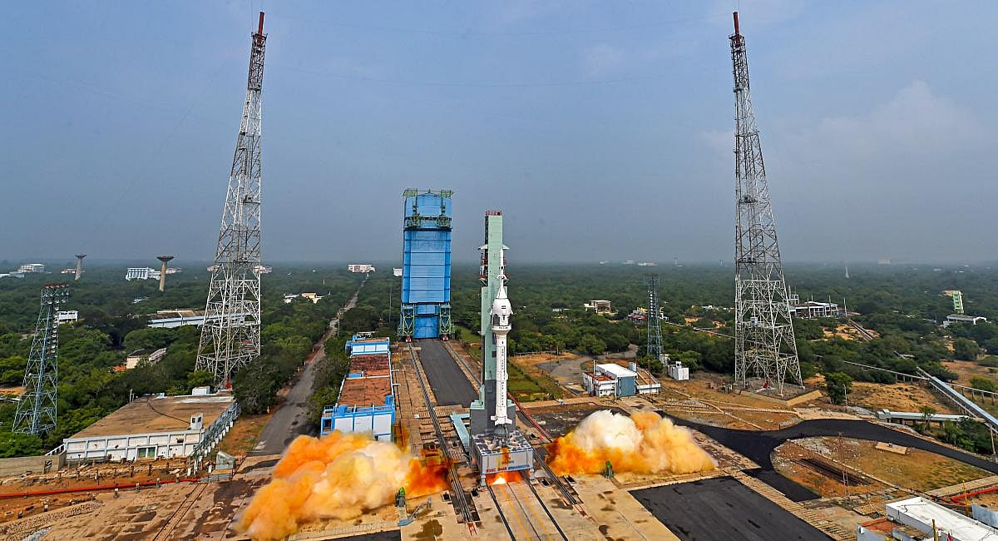

BENGALURU: The first satellite launch for the Gaganyaan mission, the G-1 (half-humanoid) mission is all ready to take off in the next 3-4 months."The Indian Space Research Organisation (ISRO) got clearances for G-1 from the National Review Committee in early May, 2026. The half-huanoid- G-1- mission is expected to launch in the coming 3-4 months, against the previous claims made," sources in ISRO told TNIE. Ideally campaign activities for any mission start 60 days before the launch date of the satellite. In case of the Gaganyaan, the campaign will start 90 days ahead of the scheduled mission. This is because Gaganyaan is a complex human-rated mission and everything is being built with latest state of the act technology indigenously. Three unmanned missions (G-1, G-2 and G-3) are slated before the first humanoid mission. "However, in case of the G-1 mission the launch activities were announced in December 2024, targeting a launch in March 2025. But then none of the systems were ready. This hasty announcement misguided the Ministry of Space, the country and the international space fraternity. It also put the entire operation at risk," an official said. Sources explained, when the internal independent committee reviewed the works in January-February 2025, they found that no systems were ready and they decided that the launch activities cannot take place. The developmental activities were accelerated only from March 2025. In January 2025, no national or expert committee review and certification was obtained for the G-1 mission.

5. ISRO completes preliminary design review of Venus Orbiter Mission - MSN
"ISRO OR NRSC OR IIRS after:2026-05-23" - Google News
Read more

ISRO completes preliminary design review of Venus Orbiter Mission MSN

6. India's IIT Madras startup Agnikul Cosmos launches world's 1st rocket with fully 3D-printed engine - Newsonair
"ISRO OR NRSC OR IIRS after:2026-05-23" - Google News
Read more

In a remarkable achievement, IIT Madras' startup, Agnikul Cosmos, has launched the world's first rocket with a single-piece three-dimensional (3D) printed engine. The rocket Agnibaan SOrTeD (SubOrbital Technological Demonstrator) is also India's first semi-cryogenic engine-powered rocket launch that was completely designed and manufactured indigenously. It was also launched from India's first privately developed launchpad called 'Dhanush' established by Agnikul at Sriharikota in Andhra Pradesh at 7.15 a.m. today. The test flight aims to demonstrate in-house and homegrown technologies, gather crucial flight data, and ensure the optimal functioning of systems for Agnikul's orbital launch vehicle, the 'Agnibaan'. While congratulating Agnikul Cosmos on the successful launch of Agnibaan-SOrTeD, ISRO Chairman S. Somanath said that the achievement motivates ISRO to support space startups and non-governmental entities for innovation and Atmanirbharata to create a vibrant space ecosystem in the country. Agnibaan is a two-stage rocket with a capacity to carry up to 300 kg to a height of 700 km. The rocket engines are powered by liquid oxygen or kerosene. It can access both low- and high-inclination orbits and is completely mobile, designed for accessing more than 10 launch ports, as per the company.

7. SpaceX Starship Flight 12: Don't miss these stunning photos from the launch of the most powerful Starship yet
Latest from Space.com
Read more
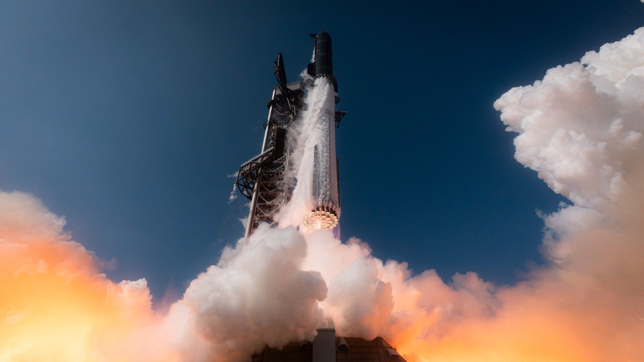

Click for next article SpaceX's Starship V3 rocket launches on a test flight from Starbase, Texas on May 22, 2026. SpaceX Starship's massive V3 launch looked incredible. Starship launch blasted off on Friday (May 22) from SpaceX's Starbase test site in South Texas, at 6:30 p.m. EDT (5:30 p.m. local time or 2230 GMT). The massive ship made a sojourn in suborbital space before both the Starship Super Heavy booster and its Ship upper stage made fiery splashdowns to conclude the mission. But while the trip itself was a repeat of previous flights, and the 12th overall for the Starship program, the ship was new. SpaceX 's newest version of Starship, standing at 408 feet or 124 meters tall, is larger and more powerful than any iteration before it. Some of the key upgrades include a new fuel transfer tube; a faster PEZ deployment system for future satellites; a more powerful Raptor Engine (39 of these across the two stages); three grid fins for reentry-directing instead of four; and a reusable "hot stage ring" lying at the intersection of Super Heavy and Ship. The 33 Raptor engines of SpaceX's Starship V3 rocket during its test flight from Starbase, Texas on May 22, 2026. (Image credit: SpaceX) SpaceX is hoping yesterday's test passes muster with NASA, because the company is competing with Blue Origin for future (and recently accelerated) Artemis program opportunities. SpaceX's Starship V3 rocket launches on a test flight from Starbase, Texas on May 22, 2026. (Image credit: Brandon Bell/Getty Images) So far, SpaceX is manifested to land astronauts on the moon for the Artemis 4 mission launching as soon as late 2028. SpaceX's Starship V3 rocket launches on a test flight from Starbase, Texas on May 22, 2026. (Image credit: SpaceX) But before that, Starship needs to show it can fly in Earth orbit, transfer fuel, and safely house an astronaut life-support system, among other milestones. SpaceX's Starship V3 rocket launches on a test flight from Starbase, Texas on May 22, 2026. (Image credit: RONALDO SCHEMIDT / AFP via Getty Images) NASA recently recast its moon-focused Artemis 3 mission into an Earth-orbiting test in which the Orion spacecraft will meet up with a Human Landing System from Blue Origin's Blue Moon or SpaceX's Starship. It could be that NASA redraws the first lunar landing effort to include Blue Origin, if that company is more ready on the mark than SpaceX for Artemis 3. SpaceX's Starship upper stage seen by a Starlink 'Dodger Dog' satellite designed to capture video and imagery of Starship after being deployed. (Image credit: SpaceX) On the other hand, however, Blue Origin hasn't even sent Blue Moon into space yet, although it is planning to do so later this year with the prototype Blue Moon Mark 1 .

8. SpaceX launches its biggest, most beefed-up Starship yet on a test flight
Space News - Space, Astronomy, Space Exploration
Read more


SpaceX launched its biggest, most powerful Starship yet on a test flight Friday, an upgraded version that NASA is counting on to land astronauts on the moon.

9. China could launch world's largest naval support ship with over 45,000-ton of displacement: Report
Interesting Engineering
Read more

A newly shared image from a major Chinese state-owned shipyard has fueled speculation that China may be developing an enormous new naval support vessel. The photo, published by the China State Shipbuilding Corporation during a social media post marking a traditional Chinese solar term, showed a giant hull sitting inside a dry dock in the background. Military analysts and online observers quickly began debating whether the vessel could be a next-generation auxiliary ship designed to expand the logistical reach of the People's Liberation Army Navy. Visible sections of the ship, including what appeared to be largely completed upper deck and island superstructures, suggested that construction is already at an advanced stage and that the vessel could soon move on to final outfitting and sea preparations. Limited overseas bases increase need for support ships China's growing focus on long-range naval operations has fueled theories that the newly spotted vessel could be a massive replenishment ship designed to support extended deployments far from home waters. As the People's Liberation Army Navy expands its presence across the Indo-Pacific and beyond, analysts say Beijing increasingly depends on large auxiliary vessels to sustain fleets at sea. Unlike the US, China operates only a limited number of overseas military bases, making logistical support ships essential for transporting fuel, ammunition, food, water and other supplies needed for prolonged blue-water missions, the South China Morning Post writes. China's carrier strike groups currently rely on a small fleet of fast combat support vessels to sustain operations at sea, including two 45,000-tonne Type 901 Fuyu-class ships alongside the smaller and slower Type 903 Fuchi-class replenishment vessels. However, growing expectations that Beijing is developing a new "super carrier" have intensified speculation that the People's Liberation Army Navy will require a larger generation of supply ships capable of supporting more demanding long-range deployments. Analysts believe such vessels would form a critical logistical backbone for future Chinese naval operations across distant waters. China's next-generation supply ship Fresh details about the mysterious vessel emerged last month after defense intelligence firm Janes analyzed commercial satellite imagery captured in March. According to the report, the ship is under construction at the Longxue shipyard in the southern Chinese city of Guangzhou. Analysts estimated the vessel measures roughly 890 feet in length and about 121 feet in width, making it significantly larger than most existing naval replenishment ships. Janes said the design appears intended to support carrier strike groups by transporting fuel, ammunition and other critical supplies during long-range operations. Based on the ship's reported size, defense analysts believe the vessel could displace between 60,000 and 65,000 tons, potentially making it larger than the retired US Navy Sacramento-class fast combat support ships, which displaced about 53,000 tons. Satellite images captured in March showed the vessel without its superstructure, indicating that major sections were installed within just the past two months. Observers added the rapid pace of construction highlights the speed of China's naval shipbuilding program.

10. US' nuclear project clears key NRC environmental milestone, to cut emissions by 440,000 tons
Interesting Engineering
Read more

The U.S. Nuclear Regulatory Commission (NRC) has completed the environmental assessment for the proposed Long Mott Generating Station in Texas, which is a major step forward in licensing what could become North America's first grid-scale advanced nuclear reactor deployed at an industrial site. The project, planned at Dow's Seadrift manufacturing complex in Texas, would use four X-energy Xe-100 high-temperature gas reactors. The plant is designed to provide both electricity and industrial steam to support operations at the site, which manufactures billions of pounds of materials annually for sectors including food packaging, pharmaceuticals, solar technology, and electrical applications. The NRC concluded that the project's environmental impacts would not be significant and issued a Finding of No Significant Impact (FONSI), eliminating the need for a broader Environmental Impact Statement (EIS). Faster review path for an industrial nuclear project According to the U.S. NRC and X-energy, the regulator opted for an environmental assessment rather than a full EIS because the proposed facility is located within an existing industrial site and was determined to have a relatively limited environmental footprint. Long Mott Energy, a wholly owned Dow subsidiary, submitted its construction permit application in March 2025. The NRC began environmental review activities in June and completed the assessment in less than a year, ahead of schedule. NRC Executive Director for Operations Mike King said the milestone demonstrates that reviews can be completed efficiently while maintaining environmental protections. The agency added that its analysis covered potential effects on air quality, water resources, and local habitats. X-energy stated that the review benefited from earlier pre-licensing work on the Xe-100 reactor platform and a construction permit package supported by year-long field surveys, groundwater monitoring, and consultations with Texas agencies, including the Texas Parks and Wildlife Department and Texas Historical Commission. The NRC expects to complete the project's safety review later this year under the 18-month timeline established through Executive Order 14300. A final agency decision on the construction permit would follow, although Dow would still need to obtain separate operating licenses before the plant could begin operation. Four-reactor plant aimed at industrial decarbonization The Long Mott project is centered around X-energy's Xe-100 advanced reactor design. Each unit is designed to produce approximately 80 MW of electricity and 200 MW of thermal energy in the form of high-temperature steam. Together, the four reactors would deliver up to 320 MWe and 800 MW thermal output, enabling the system to provide both baseload electricity and industrial process heat. The project is expected to reduce emissions from Dow's Seadrift site by roughly 440,000 ton s of carbon dioxide annually. If built, Long Mott would serve as an important demonstration project for deploying advanced nuclear technology in industrial settings. The facility has been described by Dow and X-energy as the first grid-scale advanced nuclear installation in North America specifically intended to serve an industrial operation. The project is also supported by the U.S. Department of Energy's Advanced Reactor Demonstration Program, which backs commercialization efforts for next-generation nuclear technologies.

11. NASA undergoes restructuring to align with the US National Space Policy
Interesting Engineering
Read more

NASA has announced a formal realignment of its internal organizational structure, a move that is intended to adopt a lean organizational model and to fast pace mission delivery. The announcement also comes against a backdrop of refocusing of priories under President Trump's Executive Order Ensuring American Space Superiority, also known as the National Space Policy. As per this policy NASA is directed to focus talent and resources on accelerating the Artemis program, establishing a Lunar Base, developing a nuclear space reactor, simulating the orbital economy, and expanding discovery and science missions. NASA Administrator Jared Isaacman said "This initiative reflects NASA's extreme focus on executing the mission in direct support of the National Space Policy. We are focusing resources on the most pressing objectives only NASA is capable of undertaking and liberating the workforce from unnecessary bureaucracy and obstacles that impede progress. We aim to rebuild competencies and instill a culture that attracts the best and brightest capable of pursuing the most demanding engineering challenges and moving safely and urgently". "There will be no reduction in force, no program cancellations, no closures, but we will achieve cost savings through more efficient execution and taking an active role in delivering the outcomes the world has been waiting for from NASA. This is how we deliver on the mission, meet the moment, and continue to make history on behalf of the American people." What the restructuring involves At present NASA is organized under Administrators, Administrator Staff Offices, 6 Mission Directorates, Mission Support Directorates, and 18 Centers and Facilities. The reorganization consolidates several existing directorates and reporting lines, reducing the number of organizational layers between mission teams and senior leadership. In practical terms, this is intended to shorten decision cycles and give program managers clearer authority over resources and schedules. Some of the reporting line changes include mission directorates directly reporting to the administrator and the associate administrator also serving as NASA chief engineer. Mission directorate integration includes the formation of Human Spaceflight Mission Directorate (HSMD) and Research and Technology Mission Directorate (RTMD). HSMD will focus on human spaceflight operations to both low Earth orbit and the Moon. The Exploration Systems Development Mission Directorate and Space Operations Mission Directorate will unify as HSMD. RTMD will be a combined research, space technology, and aeronautics organization charged with nuclear power and propulsion development. NASA will integrate the Aeronautics Research Mission Directorate and Space Technology Mission Directorate into the new RTMD. Budgetary context Fiscal year 2027 budget request for NASA is $18.8 billion which is $5.6 billion decrease (accounting to negative 23 percent) from the 2026 enacted level. With this proposed budget, NASA intends to primarily direct the funds towards Artemis and Martian missions ($8.5 billion), space exploration missions ($3.9 billion), commercial orbital economy ($3 billion), aeronautical research ($610 million), and upgrading NASA infrastructure ($101 million). Artemis architecture updates, these include standardizing the Space Launch System (SLS) rocket configuration, 2027 Artemis III demo mission, and 2028 Artemis IV and V landing missions on the Moon. NASA also intends to pause Gateway lunar orbital space station (in its current form) and shift focus to lunar surface infrastructure that enables sustained operations. Lunar base construction, to be carried out in threes phases. Phase I will be a building, testing and learning phase. Phase II will be focusing on establishing early lunar infrastructure and Phase III will be focusing on enabling continuous human presence on the Moon. LEO orbital infrastructure, the major focus area is to transition from the International Space Station (ISS) to commercial space stations. These will carry forward the ISS mission of serving as an orbital innovation laboratory. Nuclear space propulsion, NASA will launch Space Reactor 1 (SR-1) Freedom to Mars before the end of 2028, demonstrating deep space nuclear electric propulsion. Near term space exploration missions, these include Nancy Grace Space Telescope, and Dragonfly (a nuclear-powered octocopter launching in 2028 to arrive at Saturn's moon Titan in 2034). Lunar science missions include up to 30 robotic landings starting in 2027.

12. SpaceX's most powerful rocket ever launched in test, but booster fails and crashes
Interesting Engineering
Read more

SpaceX's giant Starship V3 rocket test saw its booster crash into the Indian Ocean during a failed splashdown attempt following the rocket's first full test flight. The Flight 12 mission was the first Starship launch since October, introducing the V3 design with upgraded Raptor engines for easier maintenance and faster reuse. The 407-foot megarocket lifted off from Texas, using 33 Super Heavy booster engines and six engines on the upper stage, making it the most powerful rocket ever launched. Despite one engine failing to ignite at liftoff, the rocket climbed successfully and completed stage separation high above the Gulf. Earlier, the Starship V3 launch was scrubbed at T-40 seconds due to a hydraulic pin failure and ground system issues, delaying its first test flight. Booster splasdown failure SpaceX launched the latest version of its giant Starship rocket on May 22 from a newly completed second launch pad at its Starbase facility in South Texas. Liftoff took place at 6:30 p.m. EDT (2230 GMT), sending the 408-foot-tall vehicle into the sky on its 12th suborbital test flight. The rocket lifted off using 33 Super Heavy booster engines and six upper-stage Raptor engines. One booster engine failed to ignite at launch, but the vehicle continued its ascent and completed stage separation above the Gulf. Watch Starship's twelfth flight test https://t.co/caRB1thMlg - SpaceX (@SpaceX) May 22, 2026 After separation, the Super Heavy booster attempted to return for a controlled splashdown in the Gulf. However, the engines needed for the landing burn failed to relight properly, causing the booster to tumble and break apart after hitting the sea. "Following stage separation, the Super Heavy booster performed a directional flip maneuver and attempted its boostback burn. It was unable to light all planned engines and performed a partial boostback burn that ended early. Super Heavy attempted to reignite its engines for the landing burn before experiencing a hard splashdown in the Gulf of America," said a statement from SpaceX. The upper-stage Starship continued its mission and carried out several test objectives, including deploying 20 dummy Starlink satellites and two operational satellites equipped with cameras to record heat shield footage during re-entry. One of the ship's six Raptor engines shut down during ascent, but the remaining five engines carried the vehicle to an altitude of nearly 121 miles (195 kilometers). The spacecraft later re-entered Earth's atmosphere over the Indian Ocean and completed a controlled descent. It landed in the targeted splashdown zone before exploding on contact with the water, as planned for the test mission. Hot staging test SpaceX engineers tested a new launch pad configuration at Starbase during the Starship Flight 12 mission. The pad remained stable during liftoff, marking a successful validation for future operations. The mission lasted about one hour from launch to splashdown. A minor hydraulic fault on the tower arm had delayed the attempt the previous day. Starship consists of the Super Heavy first-stage booster and the upper-stage Starship, also called Ship. About 2 minutes and 20 seconds into flight, hot staging occurred, with Ship igniting its engines before separation from Super Heavy. Unlike the V2 design, Starship V3 does not use a jettisoned interstage ring. Instead, it features a fixed structure around the booster's top to support engine ignition and separation dynamics, reports Space.com. After separation, Super Heavy attempted a boostback burn toward Starbase but did not complete the maneuver. SpaceX had planned a Gulf of Mexico splashdown instead of tower recovery to avoid pad risk on the first flight of new hardware. The booster ultimately fell into the Gulf. The upper stage continued its flight after separation. Earlier V3 testing in November resulted in the loss of a Super Heavy booster intended for this mission, contributing to a more than six-month gap since the previous Starship launch. NASA is banking on Starship as a crewed lunar lander for its Artemis program. The agency is also working with Blue Origin, which is developing the Blue Origin lunar lander. Artemis 2 has already completed a crewed lunar flyby mission. NASA is targeting Artemis 3 for mid to late 2027 and Artemis 4 for a lunar landing in 2028.

