 |  | 

🌌 अंतरिक्ष समाचार | Space News
गुरुवार, २५/०६/२०२६ | Thursday, 25/06/2026

1. Ecological concerns emerge as Delhi runs out of space to dispose drain silt
Read more
As Delhi has intensified desilting operations to improve drainage and prevent flooding ahead of the monsoon, authorities are grappling with a new concern: the heaps of silt being extracted from the city's drains. Officials say the material, often mixed with municipal waste, poses serious environmental risks and can no longer be disposed of through conventional means. Disposing large quantities of silt has emerged as a major challenge for the Irrigation and Flood Control (I&FC) Department, which oversees flood-control drains across the Capital. Officials said conventional disposal mechanisms - such as strengthening embankments, filling low-lying areas, depositing the material at landfill sites and allowing contractors to lift it for reuse - have reached a saturation point.

2. India launches anti-dumping probe into electrical steel imports from China, 3 other nations
Read more

India launches anti-dumping probe into electrical steel imports from China, 3 other nations This move, prompted by a complaint from JSW JFE Electrical Steel Nashik, aims to protect domestic manufacturers from alleged cheap imports that are reportedly causing significant harm. The probe will determine if dumping has occurred and if duties are necessary to ensure fair trade.

3. BRICS Heads of Space Agencies 2026 Conclude Meeting in Bengaluru, Advancing Discussions on Remote Sensing Satellite Constellation and Space Sustainability - isro.gov.in
Read more
June 24, 2026 The BRICS Heads of Space Agencies (HOSA) 2026 meeting in Bengaluru concluded successfully on June 24, 2026, bringing together the heads and senior representatives of the space agencies of the BRICS member countries - Brazil, China, Egypt, Ethiopia, India, Indonesia, Iran, Russia, South Africa and the United Arab Emirates. The two-day meeting, held during June 23-24, 2026, was hosted by the Indian Space Research Organisation (ISRO)/Department of Space (DoS) with the support of Ministry of External Affairs (MEA). The meeting was attended by the Hon'ble Union Minister of State for Space, Dr Jitendra Singh; Dr V. Narayanan, Chairman, ISRO and Secretary, Department of Space; and Dr Pawan Goenka, Chairman, IN-SPACe. The meeting emphasized international cooperation in the peaceful exploration and use of outer space, highlighting the critical importance of ensuring the long-term sustainability of space activities. During the sessions, the delegations discussed the potential of BRICS cooperation in leveraging space technology to address pressing global challenges, specifically in remote sensing, disaster management and climate change. BRICS Heads of Space Agencies meeting resulted significant progress on structural and operational frameworks of Space cooperation, including amendment to the BRICS Remote Sensing Satellite Constellation Agreement to include new BRICS members. In addition, Terms of Reference for the proposed BRICS Space Council were discussed in detail, marking a continued commitment to strengthening institutional collaboration among the member nations. Complementing the BRICS Space cooperation, IN-SPACe released an Indian Space Industry Brochure and showcased India's expanding private space ecosystem by facilitating presentations from space start-ups and industries. The event also included delegation visits to the facilities of private industries, providing first-hand experience to India's advanced space capabilities. For more information on BRICS and BRICS India 2026, visit https://www.brics2026.gov.in/

4. ISRO successfully conducts 2nd integrated air drop test for Gaganyaan mission - News On AIR
Read more
The Indian Space Research Organisation (ISRO) has successfully conducted the second integrated air drop test (IADT-02) for the upcoming Gaganyaan mission at Sriharikota in Andhra Pradesh. The system is essential to ensure safe recovery of the crew module - the capsule in which astronauts sit during a human flight. After the module's release, a parachute system, comprising 10 parachutes, was deployed, helping the capsule decelerate to a safe splashdown speed. The IADT-02 follows the successful completion of the first IADT, which took place on August 24, 2025, at the Satish Dhawan Space Centre in Sriharikota. In the first IADT, a 4.8-tonne dummy crew module was dropped from a height of three km by a Chinook helicopter. Air drop tests recreate the last leg of a spacecraft's return to the Earth. An aircraft or helicopter drops the spacecraft from a height to test various systems under different scenarios. These are the deployment of the parachute system in case the mission is aborted mid-flight, system performance when one parachute fails to open, and the spacecraft's orientation and safety during splashdown. Union Minister Jitendra Singh congratulated the ISRO for successfully conducting the test. India's first human spaceflight will be launched from Sriharikota in 2027.

5. ISRO to launch PSLV-C62 mission on January 12 from Sriharikota - The News Mill
Read more

The Indian Space Research Organisation (ISRO) will launch its PSLV-C62 mission on January 12 (Monday) at 10:17 AM IST from the First Launch Pad at Satish Dhawan Space Centre (SDSC), Sriharikota. In a post on X on Tuesday, ISRO shared, "The Launch of PSLV-C62 Mission is scheduled on 12 January 2026 at 10:17 hrs IST from First Launch Pad (FLP), SDSC SHAR, Sriharikota." The Launch of PSLV-C62 Mission is scheduled on 12 January 2026 at 10:17 hrs IST from First Launch Pad (FLP), SDSC SHAR, Sriharikota. Public can witness the launch from Launch View Gallery at SDSC SHAR, Sriharikota by registering through online from the following link… - ISRO (@isro) January 6, 2026 On December 24, ISRO successfully launched the BlueBird Block-2 communication satellite for the United States' AST SpaceMobile. The satellite was successfully placed in orbit, and the mission was declared a success. The launch took place from the Satish Dhawan Space Station in Sriharikota, Andhra Pradesh, at 8:55 AM IST. The mission deployed the next-generation communication satellite designed to provide high-speed cellular broadband directly to smartphones worldwide. The BlueBird Block-2 spacecraft would be the heaviest payload to be launched into Low Earth Orbit in the history of the LVM3 rocket. ISRO stated that the LVM3-M6/BlueBird Block-2 Mission is a dedicated commercial mission onboard the LVM3 launch vehicle, which will launch the BlueBird Block-2 communication satellite of AST SpaceMobile, USA. This mission marks the sixth operational flight of LVM3. In this mission, LVM3-M6 will place the BlueBird Block-2 satellite into Low Earth Orbit, which is the largest commercial communications satellite to be deployed in Low Earth Orbit. It will also be the heaviest payload to be launched by LVM3 from Indian soil. LVM3, developed by ISRO, is a three-stage launch vehicle comprising two solid strap-on motors (S200), a liquid core stage (L110), and a cryogenic upper stage (C25). It has a lift-off mass of 640 tonnes, a height of 43.5 meters, and a payload capability of 4,200 kg to Geosynchronous Transfer Orbit (GTO)

6. "India's growing space ecosystem to drive global collaboration", says ISRO Chairman V Narayanan after BRICS Space Agencies Meeting - ANI News
Read more
"India's growing space ecosystem to drive global collaboration", says ISRO Chairman V Narayanan after BRICS Space Agencies Meeting ANI News

7. ESA's Euclid captures the Milky Way's crowded heart
Read more
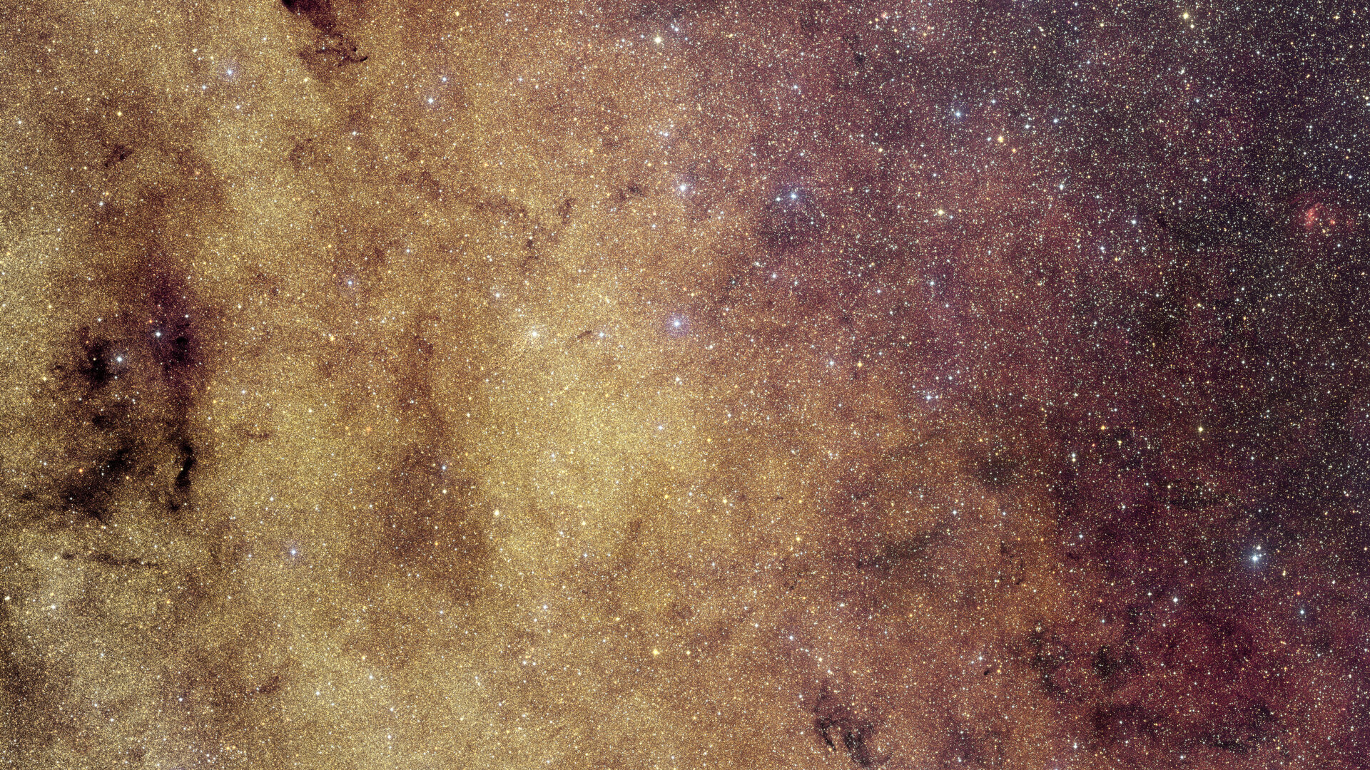
Science & Exploration ESA's Euclid captures the Milky Way's crowded heart 24/06/2026 28045 views 76 likes In brief The largest and most detailed photo ever made of our Milky Way galaxy's centre in visible light is revealed today by the European Space Agency's Euclid mission. Packed with more than 60 million stars, this image opens the door for scientists to confirm the existence of any exoplanet found in this region and measure its mass using tiny changes in starlight over time. In-depth For just one day, our dark Universe detective, Euclid, turned its gaze towards the light: the extremely bright inner region of our Milky Way galaxy, known as the galactic bulge. This special request came from astronomers who were after what Euclid does best: capturing huge areas of the sky in crisp detail. Designed to observe billions of faraway galaxies, the space telescope's visible light camera is sensitive enough to tell apart individual stars in our super-crowded galactic bulge, without being blinded. This rare ability is crucial for what scientists want to use this image for: studying planets around other stars using a special technique called microlensing. But before diving into that, let's first take a closer look at this awe-inspiring image itself. Location of Euclid's galactic bulge survey For comparison, Euclid's sharpness and sensitivity in visible light is similar to the NASA/ESA Hubble Space Telescope's wide field camera. But each pointing that Euclid captures in a few hours spans an area 270 times larger than Hubble's field of view. To observe the same Euclid mosaic, the Keck Observatory would need around 2000 hours. Euclid is faster, and able to capture details from fainter stars that would be otherwise missed when observing from the ground. This single mosaic also encompasses the entire region that the upcoming Roman space telescope will monitor for planet hunting. Infographic explaining Euclid's galactic bulge survey Euclid captured more than 60 million stars in this photo, along with nebulas and star clusters. This crowded region of our galaxy is the perfect place for astronomers to search for exoplanets with microlensing. Text continues after image slider. Finding exoplanets with gravitational microlensing Detecting exoplanets with microlensing Microlensing is a form of gravitational lensing. While Euclid mostly uses lensing to explore massive faraway objects, such as clusters of galaxies, this new image of the galactic centre helps scientists to study lenses on the smallest scales - caused by stars and exoplanets in our own galaxy. Microlensing relies on the chance alignment of two stars with an observer. As one star crosses in front of another, the nearer star acts like a cosmic magnifying glass, bending and brightening the background star's light. If a planet orbits the nearer star, its gravity also bends this light, in a slightly uneven way. This tiny additional change in brightness is how the presence of a planet is revealed. "To catch microlensing, you need to observe parts of the sky that are crowded with stars, such as close to the centre of our galaxy," explains Jean-Philippe Beaulieu of the Institut d'Astrophysique de Paris in France, and the University of Tasmania in Australia. Jean-Philippe was the original instigator of Euclid's galactic bulge survey, and he co-led the exoplanet working group of the Euclid Consortium. "During the last twenty years, almost 300 exoplanets have been discovered using this technique, all with ground-based telescopes and all towards the centre of our galaxy. This image from Euclid includes 51 known planetary systems - and it will assist in studying many more that will be found," he adds. Measuring planet masses with Euclid To catch a microlensing event, a telescope would need to study a star for over twenty days. This is needed to see the unevenness of the light being bent, as the planet orbits around its host star. So, in Euclid's one day of observation, no new events can be found. But what makes this image so special is that it allows scientists to measure the mass of planets that are already known, as well as planets that are yet to be discovered. "In 24 hours, Euclid has already captured the stars involved in all the future microlensing events that the Roman space telescope will detect, but before the stars and planets involved have aligned," says Natalia Rektsini of the Institut d'Astrophysique de Paris in France, who led the release of Euclid's galactic bulge survey data for the scientific community. "This means that anyone who detects a microlensing event in the same region, for example with Roman, will be able from now on to use Euclid data as a time reference in the past and see how the stars looked before they overlapped," Natalia explains. "Since Euclid can clearly separate individual stars, one can then measure how fast they move over time and use that information to confirm the existence of a planet and determine its mass. This would not be possible with data from one point in time." Icy planets and more With most planet-hunting techniques, it's easier to find large, hot planets orbiting massive stars. For microlensing that is not the case. "This technique is unbiased, we discover whatever is out there," says Natalia. "It is uniquely suited to discover cold exoplanets. And we expect every star in the Milky Way to host at least one such planet." The host stars of two known cold exoplanets appear in Euclid's data, and both are special to the team. "I led the team that discovered OGLE-2005-BLG-390Lb 20 years ago," says Jean-Philippe. "It's an icy planet, a bit like Hoth from Star Wars. After all this time, I'm excited that Euclid might finally allow us to measure its precise mass." "OGLE-2013-BLG-341Lb is a rare and fascinating system," says Natalia. "It consists of two stars and one planet. By combining earlier observations from Keck and Hubble with new Euclid data, we can finally separate the stars and confirm the planet's mass." "This result shows what a relatively small, dedicated team, can achieve within a large international mission," says Valeria Pettorino, Euclid Project Scientist at ESA. "The exoplanet team included strong contributions from early-career researchers and was supported by the Science Ground Segment unit working on the visible instrument." "In just 24 hours, Euclid has delivered unique data on the Milky Way's centre, with a large and sharp view of this region. With time, the separation between sources and lenses increases. That's why this Euclid data will be a time reference for past and future missions and enable studies of exoplanets and their masses. This data can also be used for other scientific applications, from brown dwarfs and binary stars to stellar motions and dust across our galaxy."

8. NASA's aging infrastructure can't handle Artemis launches without $1 billion in upgrades, watchdog warns
Read more
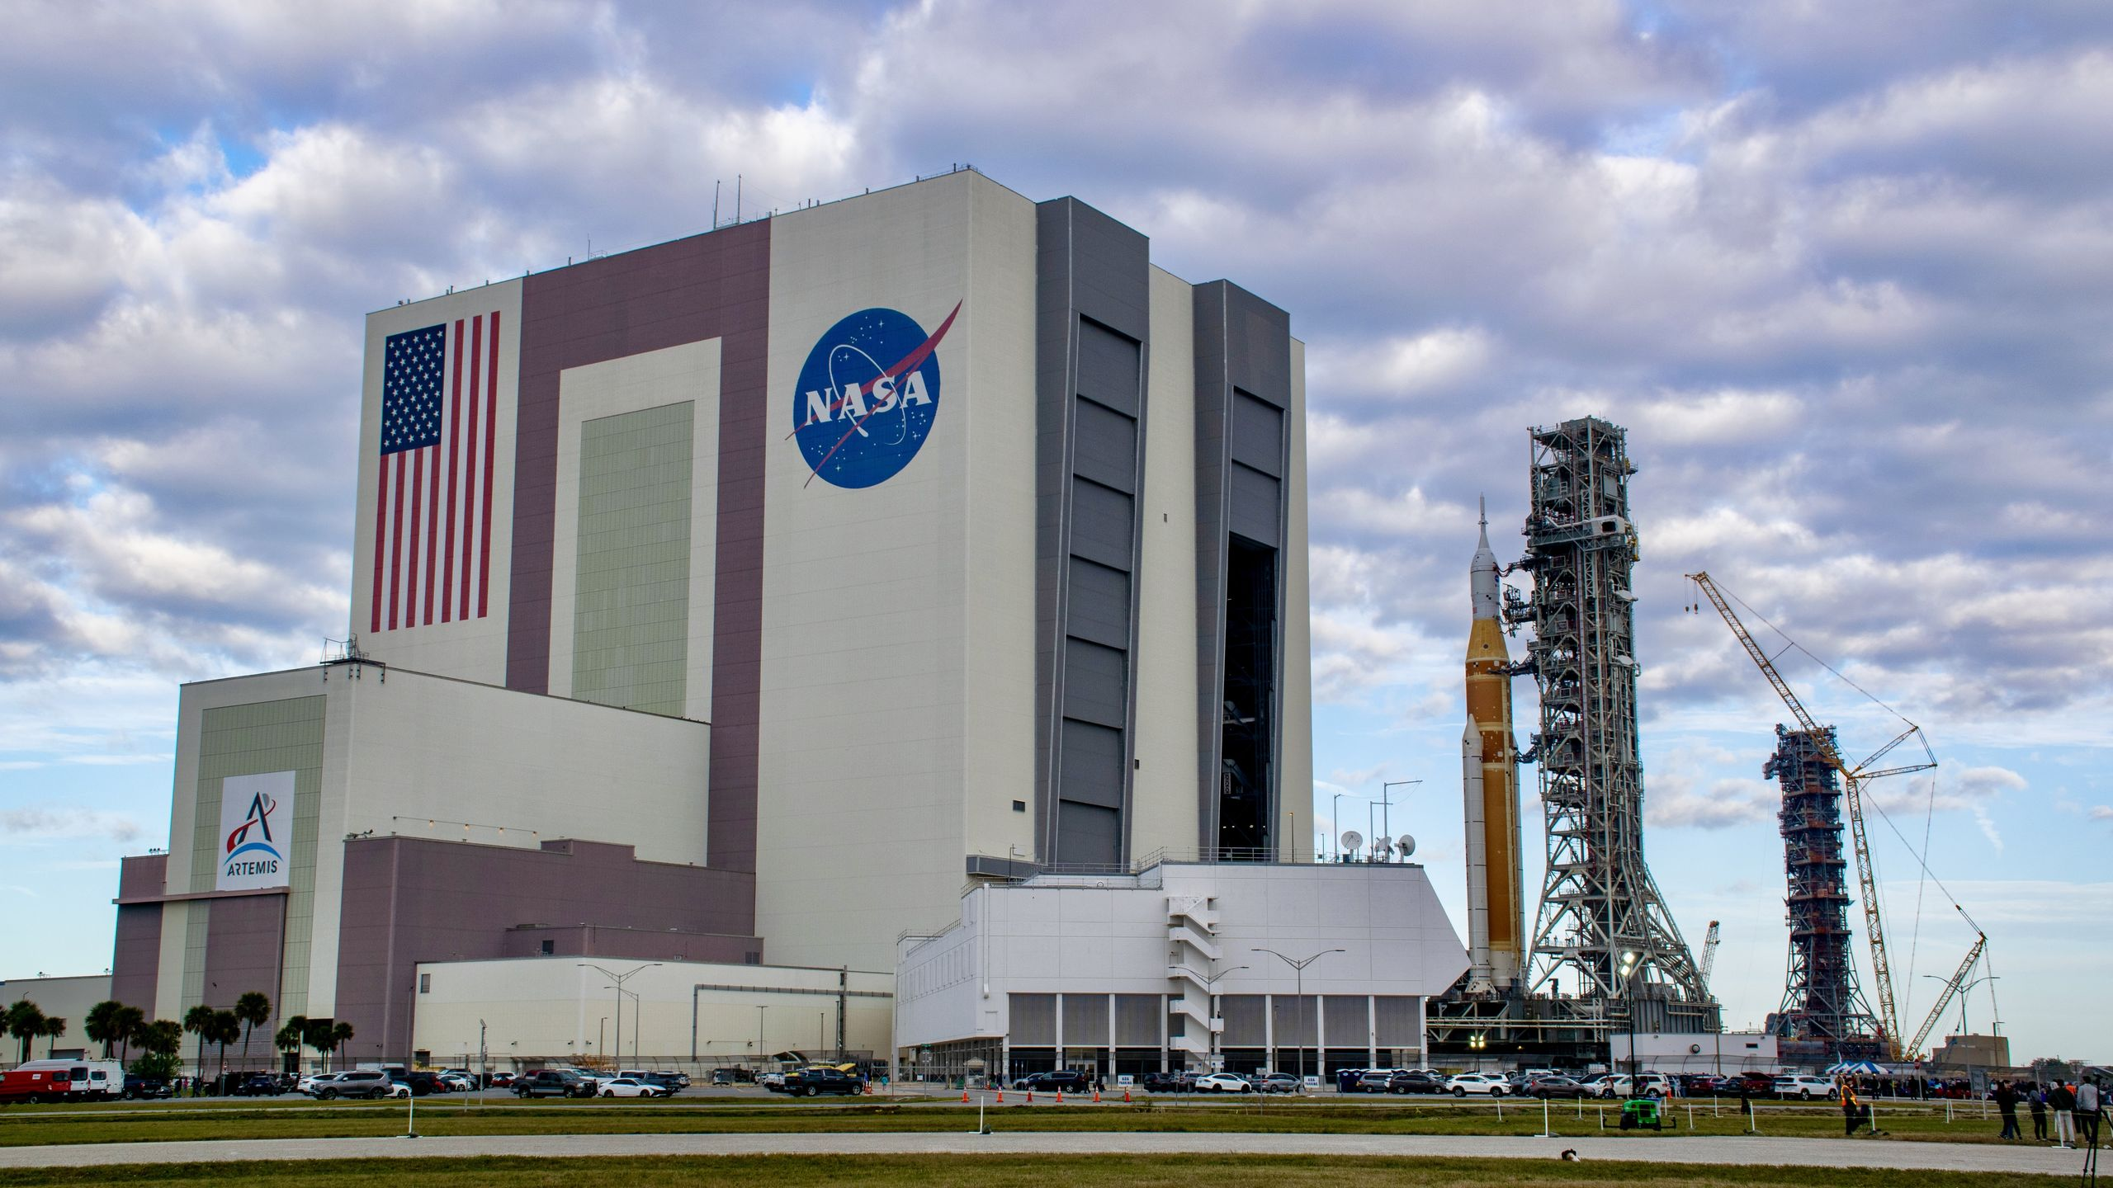
Click for next article NASA's Artemis 2 Space Launch System rocket rolls out of the Vehicle Assembly Building at the Kennedy Space Center, in Florida, Jan. 17, 2026. NASA's plan to return astronauts to the moon and bolster a rapidly growing commercial space industry is facing an infrastructure obstacle. A new report from NASA's Office of Inspector General (OIG) warns that launch facilities at the Kennedy Space Center (KSC) in Florida and Wallops Flight Facility in Virginia are approaching capacity as demand accelerates across the agency and the private sector. Support infrastructure - such as roads, electricity, and gas and fuel pipelines that laid the foundation for KSC's network of launch pads built to support the Apollo program in the 1960s - are being increasingly stretched by the demands of NASA's Artemis missions , SpaceX, Blue Origin, United Launch Alliance (ULA) and other users. "Based on current launch projections, Kennedy and Wallops are expected to operate near capacity in the 2028 to 2029 time frame," states the report , which was released on Monday (June 22). Though it credits NASA for already taking steps to address these issues, agency officials estimate it will take at least $1 billion to complete all the necessary upgrades, of which only $250 million was provided as part of NASA's funds allocated in last year's 2025 H.R.1 reconciliation bill. On Florida's Space Coast, the assessment encompasses launch facilities at KSC as well as Cape Canaveral Space Force Station (CCSFS), which saw an increase of NASA-supported launches from 31 in 2020 to 109 in 2025, according to the report. Wallops, where there are fewer and smaller launch pads, doesn't traditionally see as many missions compared to KSC. But the Virginia site has experienced an even sharper jump, percentage-wise, over the same timeframe - from three launches in 2020 to 17 in 2025 (a 467% rise). By 2030, NASA expects traffic at both sites to increase by another 150% or so. And NASA officials told auditors that raw launch counts don't fully capture the strain on infrastructure, because launch campaigns require days or weeks of support activity before liftoff. The report outlines launch infrastructure shortcomings at both facilities, but notes that Wallops' challenges have been partially mitigated by recent upgrades across its seven active launch sites. Wallops generally hosts small and medium-lift launch vehicles, like Northrop Grumman's Antares rocket and Rocket Lab's Electron , but has taken steps to support Rocket Lab's upcoming Neutron , as well as Firefly Aerospace's Alpha rocket , which is expected to launch from the site sometime this year. The major launch pads in question at KSC and CCSFS include Launch Complex-39A (LC-39A) and LC-39B, used by SpaceX and NASA, respectively; Space Launch Complex-40 (SLC-40), also used by SpaceX; SLC-41, used by ULA's Atlas and Vulcan rockets ; and SLC-36, used by Blue Origin's New Glenn rocket . SpaceX has transitioned to launching its Falcon 9 rocket primarily from SLC-40 and has reserved LC-39A for Falcon Heavy launches while construction of the first Florida launch tower for its Starship rocket is underway at the same pad. SpaceX hopes to start launching Starship from this pad before the end of 2026. The company also has plans for a second Space Coast pad for Starship, at SLC-37. Once Starship, which is still under development at SpaceX's Starbase, Texas, facility, becomes fully operational, the company expects up to 44 launches a year from KSC, with an additional 76 launches per year projected from SLC-37 at CCSFS. That equals about one Starship launch every eight days for LC-39A, but a higher cadence will be needed to successfully support NASA's Artemis program . Major launch pads on Florida's Space Coast. (Image credit: NASA OIG) Artemis missions utilize NASA's Orion spacecraft to transport astronauts from the Earth to the moon , and the agency has contracted Starship, as well as Blue Origin's Blue Moon lander , to be the program's crewed lunar landers. All of these vehicles require heavy-lift rockets. Orion launches on NASA's Space Launch System (SLS) rocket from LC-39B. For Artemis 4 , currently scheduled for 2028, NASA plans to dock Orion with Starship in Earth orbit, and use Starship to propel the two spacecraft to orbit around the moon. Starship will then undock from Orion, carry a set of astronauts down to the lunar surface , and then launch them back to orbit around the moon to rendezvous and dock again with Orion. To accomplish this, Starship will require at least 15 refueling flights to top off its tanks before its initial burn for the moon, which would fly in addition to the company's projected eight-day launch cadence, according to the report. Render of SpaceX's Starship docked with the Orion spacecraft. (Image credit: SpaceX) Growing demand for heavy-lift rockets is also increasing pressure to find additional launch sites. Blue Moon is designed to launch on New Glenn, and will also require refueling launches to reach the moon. Setting aside the fact that New Glenn recently exploded during a fueling test that severely damaged SLC-36, the report indicates that Blue Origin officials have told NASA that the pad alone may not provide sufficient long-term capacity and resiliency for the company's future plans, and noted that the constraints have already forced the company to delay launches. Much of the infrastructure between KSC and CCSFS facilities is considered "common-use," the report says, which puts added stress on available resources shared across different launch providers. That includes a massive electrical grid; 231 miles (372 kilometers) of roadway, much of which was paved in the 1960s without consideration for the weight and frequency of super heavy rocket stages being transported to and from launch pads; and more than 40 miles (64 km) of gaseous pipeline supporting nitrogen (GN2) and helium distribution, which is unable to supply high-flow operations from multiple users in its current state. "This issue created a major scheduling challenge during preparation for the New Glenn-1 mission that launched in January 2025 ," the report says. It also anticipates further Artemis mission launch constraints if the issue is not addressed. Renders of SpaceX's Starship (left) and Blue Origin's Blue Moon (right). (Image credit: SpaceX/Blue Origin) Artemis 3 , targeted for 2027, will require launches of SLS, New Glenn and multiple Starships all within a small handful of days. The mission will see both private landers - if they're both ready - rendezvous with Orion to practice docking maneuvers in low Earth orbit over the course of about two weeks, but the OIG report calls the feasibility of those back-to-back launches into question. "Kennedy will be unable to provide GN2 for future Space Launch System launches for Artemis from LC 39B while simultaneously supporting Blue Origin's New Glenn launch vehicle launching from Space Launch Complex 36 at CCSFS," the report says. It projects a possible one- to two-month blackout period of GN2 availability as a result of future SLS launches. The report further found that NASA has struggled to maintain and modernize its launch infrastructure, partially due to declining maintenance budgets and poor funding structures that prevent an equitable recoupment of costs from commercial providers leasing the launch facilities. "Significant statutory funding barriers prevent the Agency from receiving money directly from commercial partners for use of the Agency's launch infrastructure," the report says. And, as it currently stands, any commercial investment in NASA's infrastructure is deducted from the agency's budget appropriation, in addition to being a violation of the Antideficiency Act, which prohibits the agency from spending federal funds without Congressional approval. Ultimately, the report recommends prioritizing improvements to NASA's transportation networks, utility systems and resource distribution infrastructure while exploring additional funding mechanisms to support future upgrades. It also suggests three key action items for the space agency: Perform an assessment and create a mitigation strategy to address roadway degradation caused by the increased traffic from heavy-lift launch vehicle transportation and commercial providers. Prioritize the allocation of available funds for the maintenance of common-use launch infrastructure, including roads, electricity distribution, and gaseous pipelines and resource reserves. Explore alternative funding mechanisms and evaluate commercial partnership policies to charge an "Other Approved Indirect Rate" to contribute to upgrades necessary to maintain the aforementioned infrastructure. "While NASA's goal is to renew - replace, repair, or upgrade - its infrastructure every 66 years, the current renewal rate, based on the available budget, is over 260 years," the report says.

9. Did NASA just find evidence of ancient life on Mars? Perseverance rover spots complex carbon in Red Planet rocks
Read more
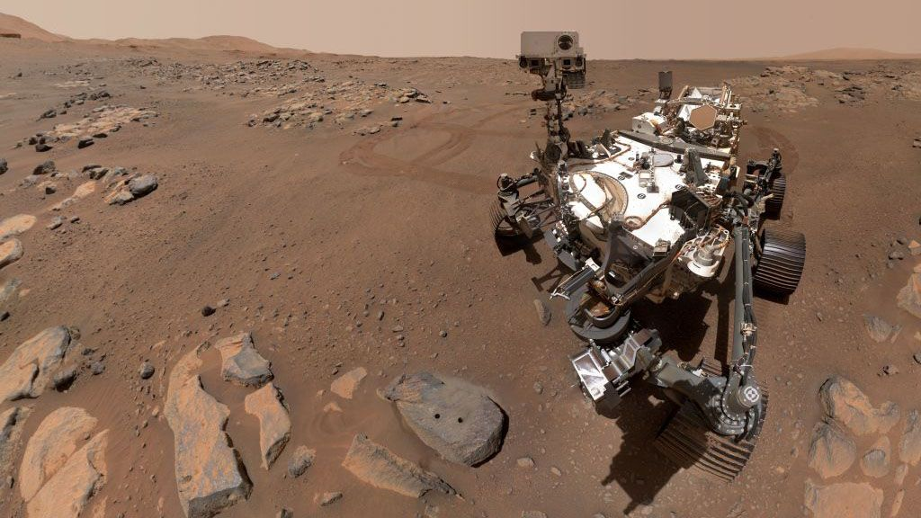
Click for next article Could Martian mudstones be holding evidence of ancient microbes? New findings strengthen the case that the Red Planet once held life. New data from NASA's Perseverance rover has revealed complex carbon in two Martian mudstones found in Mars' Jezero crater , the same location where previous evidence of possible ancient life has been found. Scientists think this macromolecular (meaning large) complex carbon, could hold evidence that ancient microbial life once existed in the same sedimentary material, according to one new paper describing these observations. "Measurements of two mudstones show hundreds of organic detections, making this the most robust organic detection in Jezero crater," the paper reads. This comes soon after the news last year that Perseverance found what has been dubbed the strongest evidence of potential biosignatures, or hints of life, on Mars . "Carbon is the primary building block for life on Earth, and all living things are made up of complex organic macromolecules," co-lead author Ashley Murphy, a researcher at the Planetary Science Institute, told Space.com. "On Earth, [macromolecular carbon] is often found in extremely old rocks and in some cases it is the only organic evidence of past microbial life. "Since early Mars may have been more similar to Earth," Murphy added, "we may anticipate finding [macromolecular carbon] in old Martian rocks too, so we are searching for these organic macromolecules on Mars and other planetary bodies to determine whether the necessary chemical ingredients and environmental conditions to support life have ever existed there." Perseverance landed on Mars in 2021 in Jezero Crater, an expansive crater thought to once be a lake that could have possibly harbored life. This landing site was in fact chosen because scientists thought it could have some of the best evidence for possible ancient life on the planet. And so far, in Perseverance's extensive explorations - which have now officially taken the rover the distance of a marathon on Mars - that prediction seems like it's turning out to be true. In this new research, a team of scientists co-led by Murphy used Perseverance's spectrometer SHERLOC (the Scanning Habitable Environments with Raman and Luminescence for Organics and Chemicals), which uses lasers to identify an area or object's chemical and mineral makeup, to map the distribution of organic matter in the individual mudstones. The crew found organic carbon inside two mudstones. Furthermore, these carbon-filled mudstones were found in the same location as the last year's discovery of a potential biosignature found in a sedimentary rock on the Red Planet, which scientists say is still the strongest evidence that life could have once existed on early Mars. In this discovery, Perseverance found a rock now-named "Cheyava Falls" with distinctive "leopard spots." These types of rock marking can be created in high heat or extremely acidic temperatures, but neither of these conditions are thought to have existed in the area. However, the markings can also be formed by the presence of life. So, while this rock wasn't conclusive evidence of past life on Mars, it certainly provided significant evidence that is now supported by this new data. With these observations, the rover has made two main findings. First, Perseverance has found organic, large, complex carbon in mudstones in Bright Angel , a rocky area on the northern and southern edges of Neretva Vallis, which is an ancient river valley in the Jezero area. And not only did Perseverance make hundreds of detections of organic carbon in these rocks, but the researchers also state that this is "the only detection of macromolecular carbon on a natural rock surface on Mars." "This is also the first detection of MMC in a mudstone on Mars outside of Gale Crater, suggesting that the availability of organics may have been widespread across the planet billions of years ago," co-lead author Kyle Uckert, the SHERLOC deputy principal investigator at NASA's Jet Propulsion Laboratory, told Space.com. A closeup of "leopard spots" on Mars seen by the Perseverance rover on the rock Cheyava Falls, which may show signs of a biosignature, but could also be from geologic processes. (Image credit: NASA/JPL-Caltech/MSSS) While both studied mudstones have organic carbon in their interiors, according to these observations from Perseverance, there were some differences between the two rocks. The carbon in one mudstone was found mixed with primarily silicate minerals, while the other was filled with carbon mixed with secondary carbonate and sulfate minerals. The team also found that the carbon in both rocks was relatively intact, meaning the specimens might be resistant to radiation and oxidation or that it may have been recently exposed to the Martian surface. Secondly, the team found that, in this identified carbon, Perseverance has detected evidence of potential biochemical interactions. These interactions left behind features in the two mudstones that look just like features created by microscopic life in sediments on Earth. This begs the question: Did ancient microbes on Mars really live in the sediments in this once-flowing river? Maybe, maybe not. While that would certainly be one explanation, it's also possible that the carbon could have been created without life. "There are multiple potential pathways to form abiotic organics on Mars," the authors state in this paper, clarifying that this, even compounded with other existing data, cannot conclusively say whether or not life created what Perseverance has observed. "The science payload of the Perseverance rover was not designed to distinguish between abiotic and biotic processes, but was instead selected to identify compelling rocks to be collected for possible return to Earth for more rigorous testing," Uckert told Space.com. Uckert added that there could be many non-life reasons behind the presence of this complex carbon, "for example, it may have been delivered to the surface via meteoritic infall, or formed through hydrothermal geologic processes," he said. For now, we can only wait until the next juicy bit of evidence about ancient life on Mars reveals itself.

10. SpaceX launches 24 Starlink satellites to orbit from California (video)
Read more
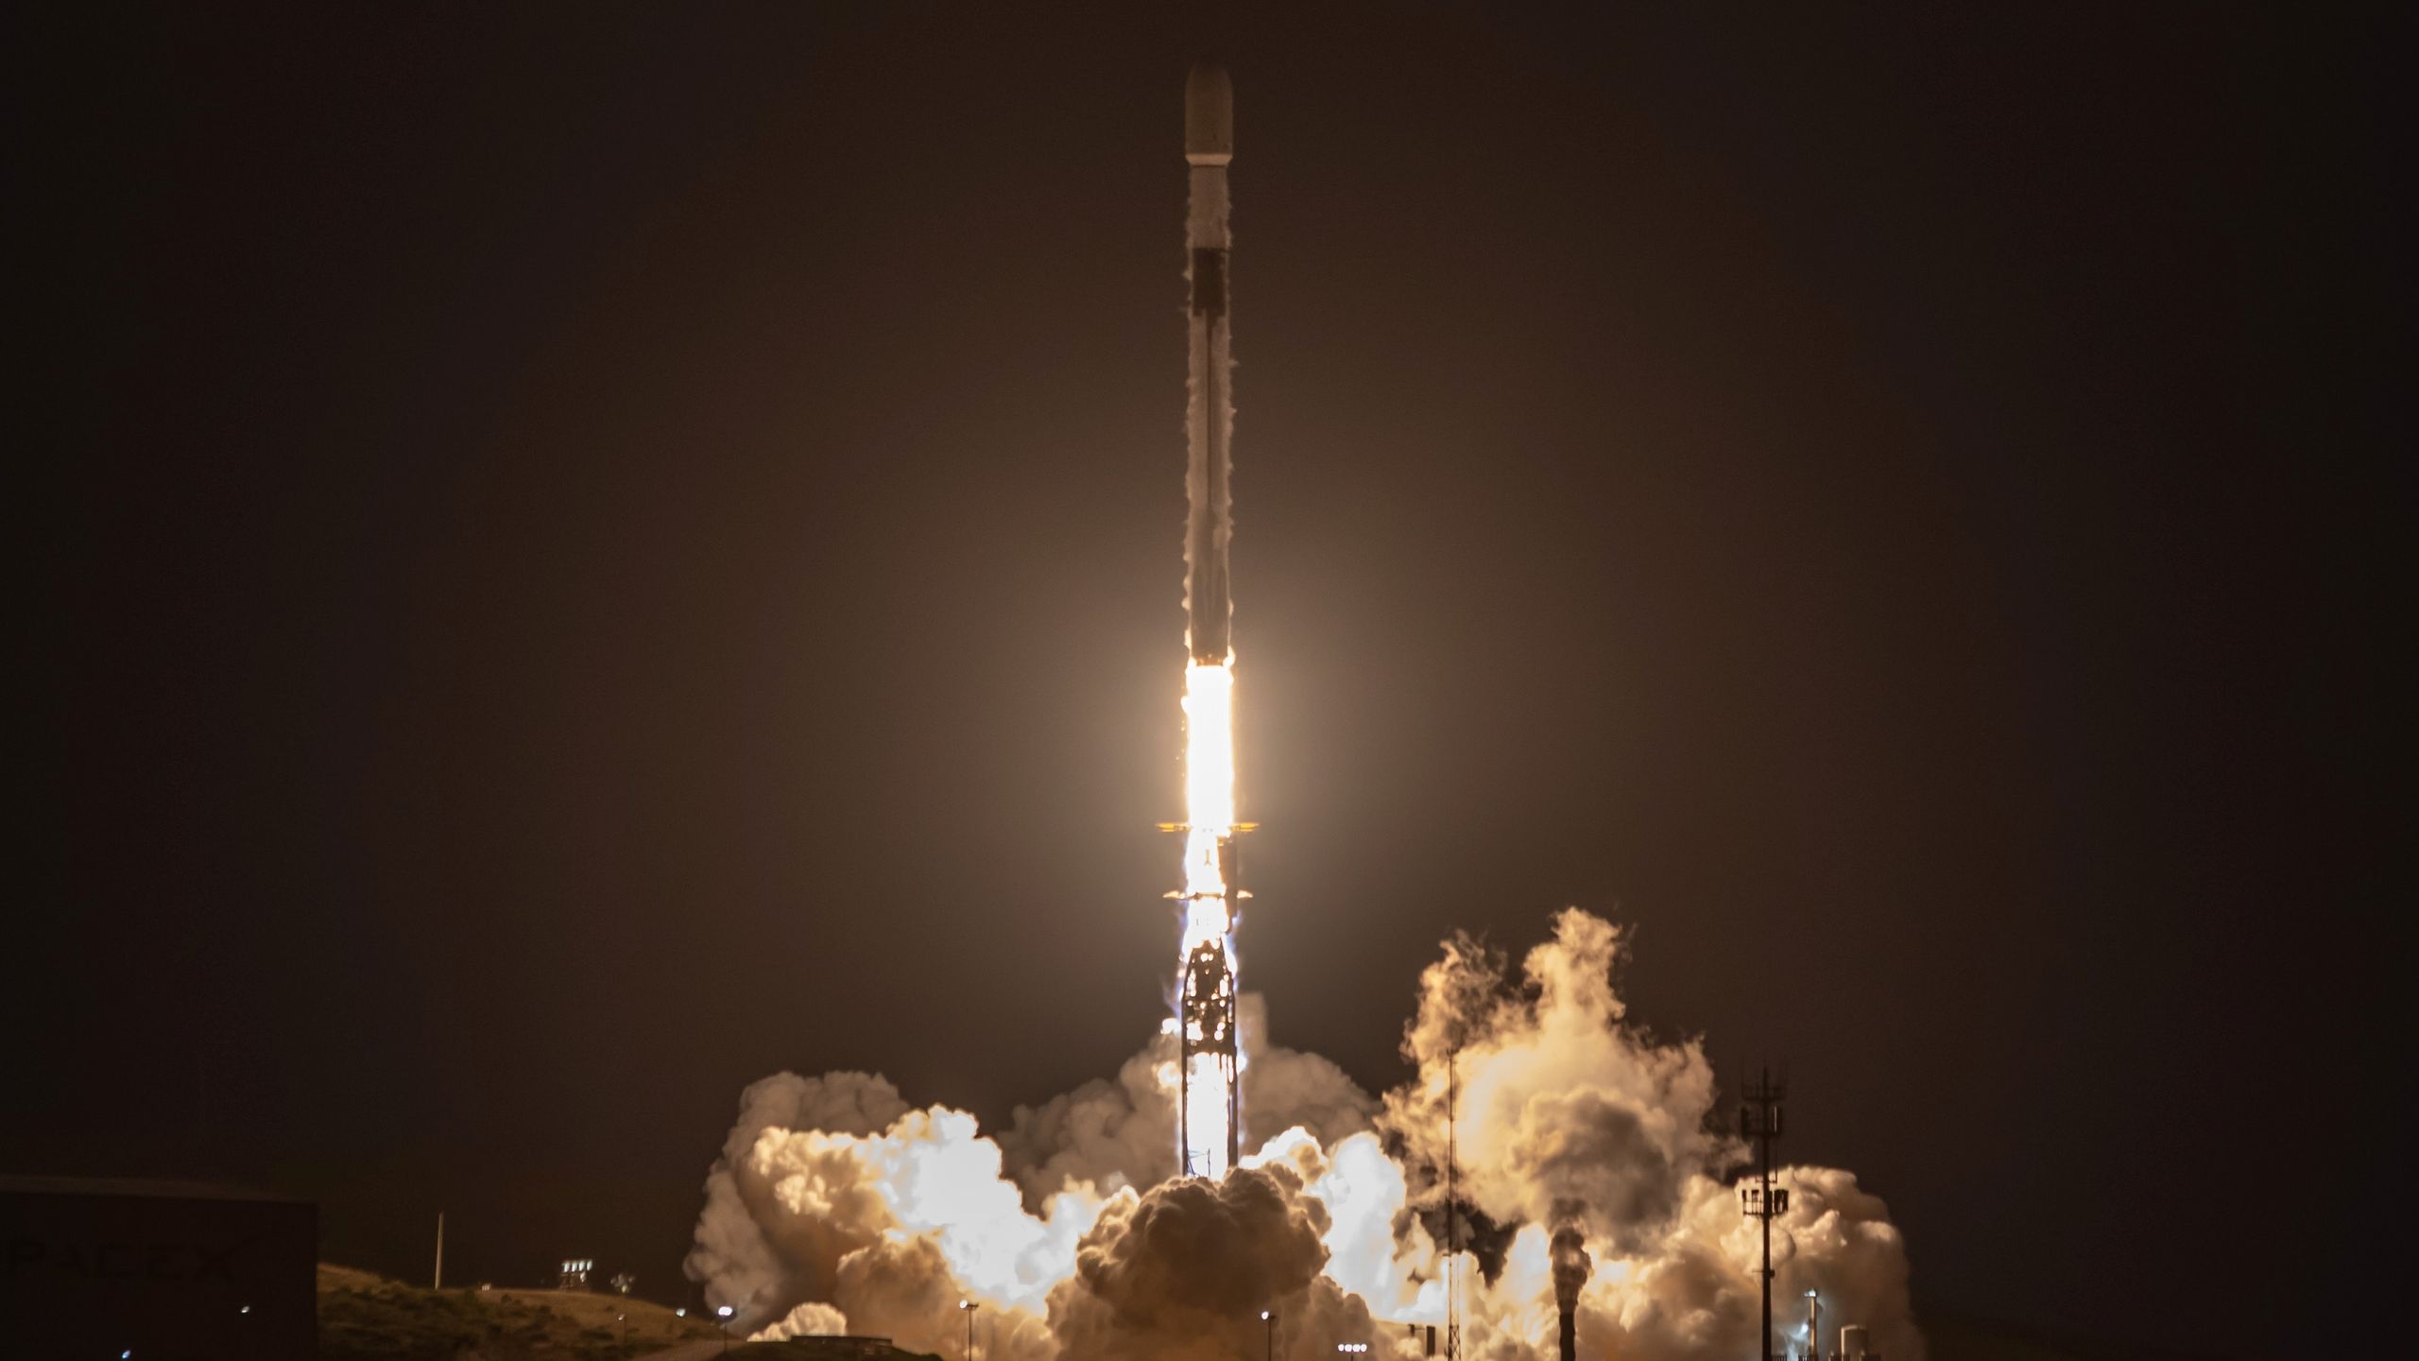
Click for next article SpaceX launched another batch of its Starlink satellites from California's central coast on Wednesday night (June 24). A Falcon 9 rocket lifted off from Vandenberg Space Force Base on Wednesday at 11:30 p.m. EDT (8:30 p.m. local time; 0330 GMT on June 25), carrying 24 of the broadband spacecraft to low Earth orbit (LEO). The Falcon 9's first stage came back to Earth about 8.5 minutes after launch as planned, touching down in the Pacific Ocean on the SpaceX drone ship " Of Course I Still Love You ." A SpaceX Falcon 9 rocket launches 24 Starlink satellites to orbit from California's Vandenberg Space Force Base on June 24, 2026. (Image credit: SpaceX) According to a company mission description , it was the 25th flight for this particular booster, which is known as B1081. The rocket's upper stage, meanwhile, continued hauling the 24 satellites to LEO. The spacecraft were deployed there on schedule, just under 62 minutes into flight, according to SpaceX . Wednesday's launch was the 74th Falcon 9 liftoff of the year, and the 59th of 2026 devoted to building out the Starlink megaconstellation. Starlink is by far the biggest satellite network ever assembled; it currently consists of nearly 10,700 active units, and the number goes up all the time. SpaceX has launched two non-Falcon 9 missions this year as well. On April 29, a Falcon Heavy lofted the Viasat-3 F3 telecom satellite. And the company's Starship megarocket launched on its 12th-ever test flight on May 22. Editor's note: This story was updated at 2:40 a.m. ET on June 25 with news of successful launch, rocket landing and satellite deployment.

11. Launch your sci-fi binge with these top streaming deals I found during Prime Day
Read more

Click for next article Not found what you want this Prime Day? That's where our round-up of the best summer streaming deals comes in, from HBO Max to Paramount Plus and beyond. Admittedly, a couple of these deals may put a few pennies in Jeff's pocket, but take advantage of these deals and you can shut out Prime Day and lose yourself in a world of sci-fi and superheroes.

12. NASA sent a FIFA World Cup 2026 ball to the ISS so astronauts can test their footwork in zero gravity (video)
Read more

Click for next article Astronauts on the ISS had an epic microgravity kickoff with a FIFA soccer ball, as the agency highlighted how soccer balls are influenced by space research. NASA and European Space Agency (ESA) astronauts got the official FIFA World Cup ball rolling, zero-G style, in the Kibo module of the International Space Station . The impromptu match, published on X June 20, formed part of NASA's push to explain how space relates to soccer. As NASA explains, soccer has been studied scientifically on the ISS. The orbital laboratory has hosted "studies that improve understanding of the aerodynamics and physics involved in soccer ball flight," the agency stated in a June 8 release about soccer tech. An example study in 2019 examined how the mass of a soccer ball influences the rotation, stability and motion of the sphere. NASA did not name the study, but the date lines up with the Adidas OS SPIN experiment that ran between 2019 and 2021, as described in an agency database of ISS experiments. A 2026 FIFA World Cup ball on the International Space Station. (Image credit: NASA) Adidas has put electronics in official match balls since 2022, NASA noted, which allows broadcasters and officiators to monitor speed, position and contactor. "But those sensors also add mass in specific locations inside the ball, and uneven mass distribution can affect how a ball moves through the air," the agency pointed out. Watching soccer ball movements in microgravity can therefore lead to better design to account for the sensors, the agency noted. "The findings have improved understanding of how embedded technologies, including match-ball sensors, can influence performance during play," NASA stated. "The research contributed to studies used in the development and evaluation of soccer balls for major international tournaments, including FIFA World Cup competition." More recently, ISS astronaut Jessica Meir showed students how soccer ball mass and spin works in microgravity. "What you see here is a soccer ball that passes one of the most important tests in sports engineering: balanced mass distribution," the Expedition 74 NASA astronaut said, floating alongside a spinning ball, in a YouTube video posted last month. NASA astronaut Jessica Meir spins a soccer ball in microgravity aboard the ISS. (Image credit: NASA) The agency has also studied soccer balls on the ground. At NASA's Ames Research Center in California, researchers examined Adidas' Brazuca ball in a wind tunnel. They particularly examined a phenomenon known as "knuckling", which happens when the airflow on the seams makes the ball move unexpectedly in mid-air. "NASA engineers measured the speeds and flow conditions where this effect was most pronounced," the agency stated of the Brazuca ball, which was used in the 2014 world cup. "Adjustments in panel shape, seam depth, and surface texture can influence flight consistency, helping determine whether a ball curves, dips, or holds its line during play." Artemis 2 crew members Reid Wiseman and Victor Glover places the match ball on the plinth before the FIFA World Cup 2026 Group F match between Netherlands and Sweden at Houston Stadium on June 20, 2026 in Houston, Texas. (Image credit: Michael Regan - FIFA/FIFA via Getty Images) NASA has showed up a lot at the celebrations already. On June 20, Artemis 2 moon astronauts Reid Wiseman and Victor Glover delivered the ball for a Netherlands-Sweden match in Houston (nearby NASA's Johnson Space Center for astronaut training). This year's world cup is jointly hosted by the U.S., Mexico and Canada and will wrap up on July 19. On June 11, NASA held an exhibit at Fan Festival Houston about FIFA, pledging to open the event during every tournament match held in Houston's east downtown.

13. NASA looks for the origins of interstellar comet 3I/ATLAS | Space photo of the day for June 24, 2026
Read more

Click for next article Researchers using JWST are finding clues about comet 3I/ATLAS' origins. (Image credit: NASA, ESA, CSA, STScI, Martin Cordiner (CUA, NASA-GSFC); Image Processing: Alyssa Pagan (STScI)) NASA's James Webb Space Telescope is finding clues that are leading scientists closer to understanding the origins of the interstellar comet 3I/ATLAS. What is it? Comet 3I/ATLAS captured the world's attention when it was discovered nearly a year ago on July 1, 2025. The comet was first spotted by the Asteroid Terrestrial-impact Last Alert System (ATLAS), and is only the third interstellar object every discovered. The comet swooped through our solar system, passing by Earth at a far (and safe) distance on its tour of our cosmic neighborhood. It is on a long trajectory that will take it out of our solar system, never to return . In observations from the James Webb Space Telescope, scientists were able to look in the direction the comet as it began moving away from the sun in December of last year. While in close proximity to our star, the sun's heat warmed the comet, making it extra bright and easy to observe. With this view, astronomers were able to calculate some of the ratios of the chemicals present in the comet. This further highlighted that the object is from out of our solar system, as they found ratios of carbon and heavy hydrogen not found in comets in our solar system. Researchers described their results in a new paper published June 22 in the journal Nature. This graph shows some of the differences between 3I/ATLAS and comets found in our own solar system. (Image credit: NASA, ESA, CSA, Martin Cordiner (CUA, NASA-GSFC), Leah Hustak (STScI)) Why is it incredible? Being only the third interstellar object ever found, people were excited about 3I/ATLAS. They were so excited, in fact, that conspiracies about the object sprouted up quickly . Due to it being from outside of our solar system, some claimed that the comet could be some sort of alien spaceship, similar to the initial suspicions about the interstellar object ' Oumuamua found years earlier. But with new information coming in from space telescopes, and astronomers eager to understand this object better, these clues are leading us closer and closer to the true origins of this strange comet.

14. ESA chief calls for greater European space autonomy as trust in US partnership erodes
Read more
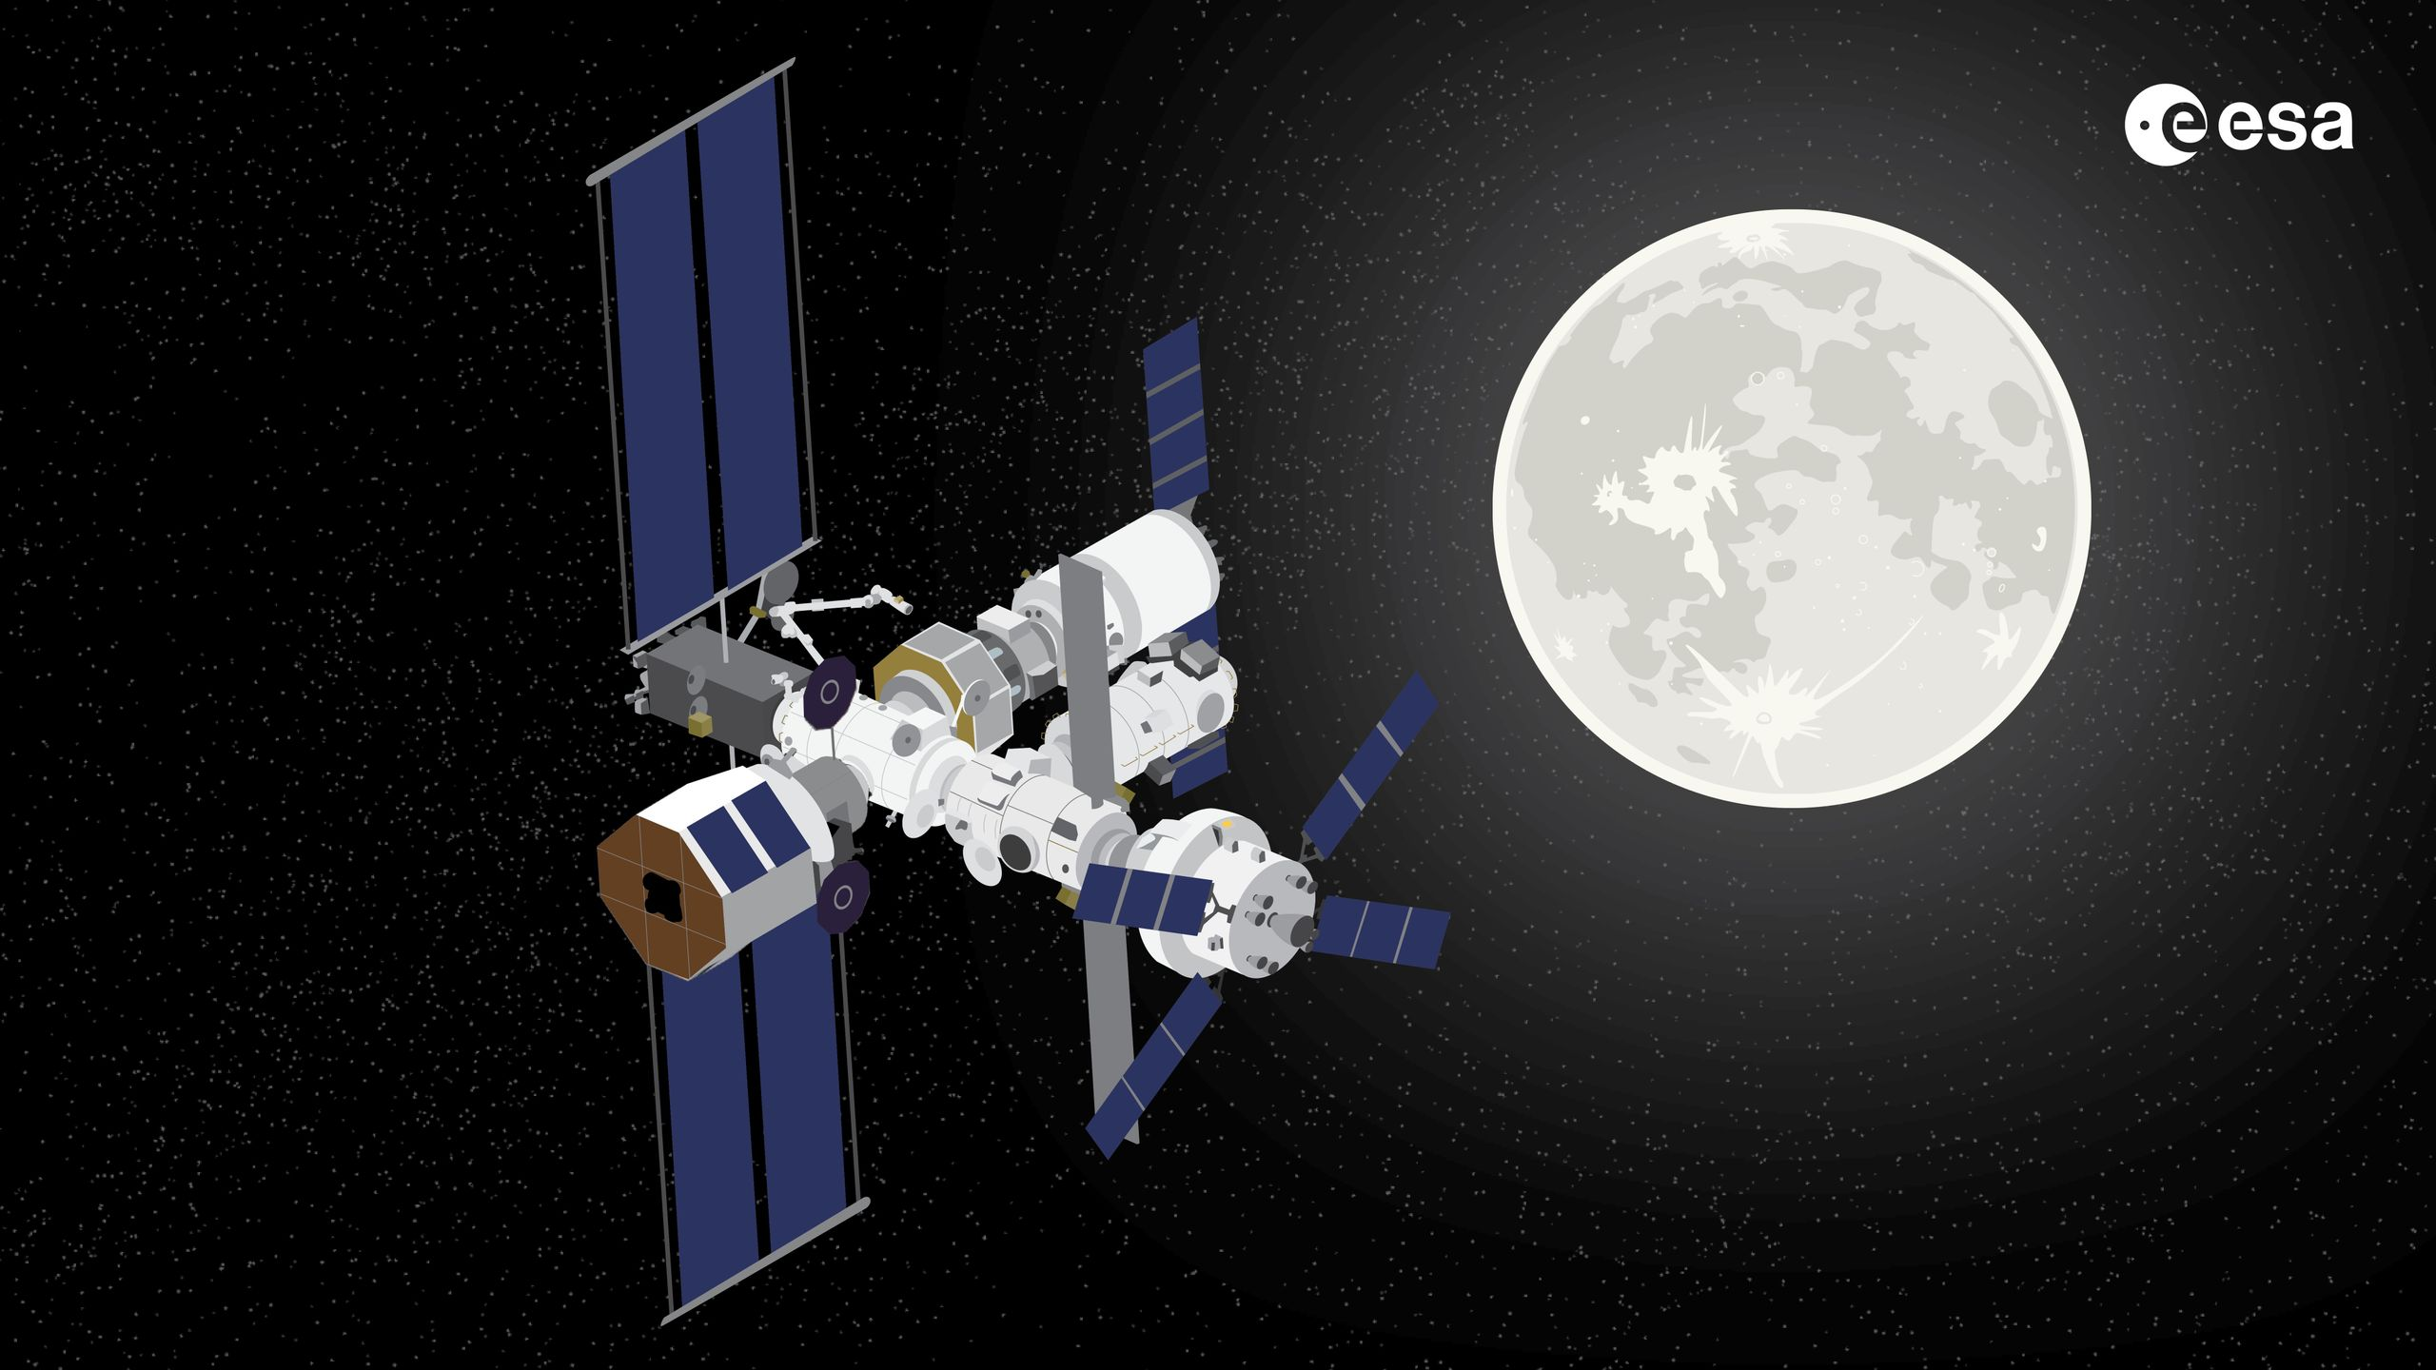
Click for next article Artist's illustration of NASA's Gateway moon-orbiting space station, development of which the agency has paused indefinitely. The head of the European Space Agency has issued a wakeup call to decision makers amid partners cancelling missions and geopolitical changes affecting the space sector, calling for Europeans to be pilots rather than passengers. In a LinkedIn post published last month, European Space Agency (ESA) Director General Josef Aschbacher stated that recent decisions taken by the United States to pause the lunar Gateway station and cancel the Mars Sample Return mission campaign - both major projects with deep ESA commitments - have revealed how dependent the agency is on outside actions. "Europe has become too exposed to decisions beyond its control," Aschbacher wrote, before laying out the challenge the continent faces. "The choice before Europe is clear: Do we pilot, or are we merely passengers?" The situation for ESA and its 23 member states is complex, requiring Europe to both develop agency and autonomy while balancing this with fruitful collaboration, Aschbacher noted. "The current environment demands both diversified international partnerships and strengthened autonomous capabilities," he wrote. "Only under these conditions can Europe decide when to act independently and when to cooperate globally, protecting our investments and our industrial base amid geopolitical uncertainty." With trust in the U.S. as a reliable partner taking a hit, collaboration with other space actors such as Japan, South Korea and Australia could grow, while Europe also pursues its own capabilities. Human spaceflight is one area Aschbacher is keen to push Europe forward, describing it as a necessity rather than a luxury, and one needed to secure ESA's freedom to unlock the "scientific, economic, strategic and geopolitical benefits of space and to inspire a new generation to shape Europe's future." The question is not new - it has long been debated by European policy makers and the space sector - but recent events and Aschbacher's comments have brought the issue to the fore. And there is clear support and grounds for greater European autonomy in space. "The disruption brought by the Trump administration has made this question more pressing," said Marco Aliberti, associate manager and lead on international engagement at the European Space Policy Institute (ESPI) in Vienna, an independent think tank that advises European space policymakers. "There is a realization in Europe that so far we have not been pursuing autonomy." Europe, Aliberti argued, has built genuine technical capacity, including the ability to build and operate world-class space systems, but, at the same time, has consistently failed to secure the political autonomy to decide how and with whom those capabilities are deployed. "Participation without agency is yet another form of dependency dressed up as ambition," he said. In other words, Europe has built the capacity to execute in space, but not the autonomy to decide its own agenda. Aliberti pointed out that this is not the first time Europe has needed to move to acquire greater autonomy. The birth of Europe's Ariane rocket in the 1970s was a response to an asymmetric relationship. The United States refused to launch the Franco-German Symphonie communications satellite unless Europe agreed to forgo commercial use, with the aim of protecting American dominance in commercial communications. European governments concluded they had no choice but to build their own launch capability. Aliberti went on to point out that history could, potentially, repeat itself, this time in the lunar realm, as a European partner dependent on U.S. transportation could face unacceptable conditions. "The U.S. may tell us: I will continue bringing you to the lunar surface, provided that you do not engage in commercial activity," he said. "We do not see the risks that being a passenger entails." And investment in space can bring huge payoffs. For example, NASA's Commercial Orbital Transportation Services contracts in the 2000s gave early funding to SpaceX , enabling the development of the company's workhorse Falcon 9 rocket, and ultimately, the rise of its Starlink broadband megaconstellation. "It was the billions that NASA gave to SpaceX that enabled the birth and growth of SpaceX," Aliberti stated. "Let's not neglect the impact that space exploration investment has across other parts of the ecosystem." Eartly artist's illustration of the major parts of a planned NASA-ESA Mars sample return campaign. NASA has canceled that version of the project and is looking for other ways to get samples collected by its Perseverance rover back to Earth. (Image credit: NASA/JPL-Caltech) (Image credit: NASA/JPL-Caltech) ESA's DG has signaled the need for action and its urgency, although he admitted it will take years to build autonomous capability. "If not now, then when? If not ESA, then who?" Aschbacher asked. What comes next is unclear. Institutionally, Aschbacher sees opportunities in a convergence of key meetings and milestones, including an ESA Council in mid-June, a ministerial focused specifically on exploration scheduled for December, and the crucial once-every-three-years ESA Ministerial Council in 2028. At the same time, the European Union, with a growing interest in space separate to ESA, is drafting its Multiannual Financial Framework for 2028-2034. Aliberti warned that, if ESA cannot act promptly, its member states could move to act alone to address shorter-term needs. He cited the recent development of the French government reaching an agreement to send a pair of its astronauts on missions with U.S. space station firm Vast . As confidence in the partnership with the U.S. government erodes, individual European nations may look to explore bilateral arrangements with commercial American providers, meaning less interest in investing into joint European efforts. The window for collective European action is open, but perhaps not for long. "If we take decisions by the Ministerial Council in 2028, we will be able to play a role and be pilots in 10 years," Aliberti says. "If not, it may become too late."

