IIRS Daily Space Digest Thursday, 14/05/2026

1. ISRO at National Technology Day 2026 - isro.gov.in
"ISRO OR NRSC OR IIRS after:2026-05-13" - Google News
Read more

May 13, 2026 National Technology Day, a proud commemoration of India's second Nuclear test at Pokhran was celebrated on 11th May, 2026 at National Institute of Immunology, New Delhi. ISRO took part in the event with 35 delegates from its various Centres, showcasing indigenously developed critical technologies along with other S&T Departments. Hon'ble Union Minister of State (Independent charge) for S&T and Earth Sciences; MoS for PMO, PP/DoPT, Atomic Energy and Space, Dr. Jitendra Singh inaugurated the event. During his visit to exhibition, he has appreciated ISRO's efforts in achieving Atmanirbharata in varied domains. Principal Scientific Advisor to Government of India, Prof. Ajay Kumar Sood and Secretaries of various Science and Technology departments were also present.

2. S&T minister visits ISRO facilities in Bengaluru, holds talks on space-tech collab - The New Indian Express
"ISRO OR NRSC OR IIRS after:2026-05-13" - Google News
Read more
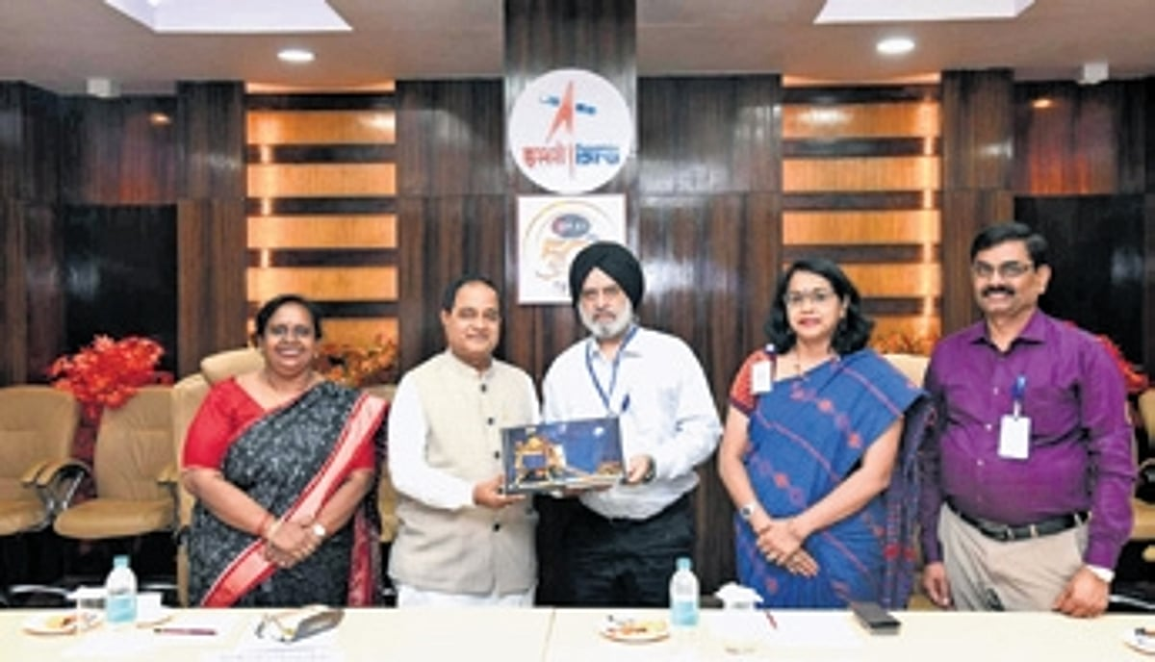

BHUBANESWAR: Science and Technology minister Krushna Chandra Patra on Wednesday visited the Indian Space Research Organisation's (ISRO) premier satellite facilities in Bengaluru, and held discussions on expanding the use of space technology in governance, disaster management and scientific education. During the visit, the minister toured the U R Rao Satellite Centre and the ISRO Satellite Integration and Test Establishment (ISITE). The visit was aimed at strengthening coordination between the Odisha government and ISRO for application of advanced space technologies in public administration and research. Patra held detailed discussions with senior ISRO scientists and officials on the use of satellite data for disaster management, food security monitoring and mapping of natural resources in Odisha. The deliberations also focused on enhancing technological collaboration in areas critical to the state's development planning. At the ISITE, Patra visited the satellite integration facilities and inspected the state-of-the-art clean room infrastructure. He was briefed on the complex processes involved in the integration and testing of India's future communication and navigation satellites. The minister also visited the space museum at the U R Rao Satellite Centre, where he experienced India's achievements in space exploration, beginning from the historic Aryabhata mission to the country's space programmes. He expressed the state government's desire to establish world-class science exhibitions at the proposed Science City in Bhubaneswar to motivate students towards science and innovation. Senior officials of S&T department accompanied the minister. Project director of U R Rao Satellite Centre, Jasvinder Singh Khorala appreciated Odisha's proactive initiatives in the fields of science and innovation.

3. SAMEER and ISTRAC/ISRO sign MoU for technological advancement in Deep Space missions - PIB
"ISRO OR NRSC OR IIRS after:2026-05-13" - Google News
Read more

Ministry of Electronics & IT SAMEER and ISTRAC/ISRO sign MoU for technological advancement in Deep Space missions Collaboration aims to develop indigenous high power systems and GaN-based technologies : Mumbai, 13th May, 2026 In a landmark event today, ISRO Telemetry, Tracking and Command Network (ISTRAC), a centre under Indian Space Research Organization (ISRO), Department of Space (DoS) and Society for Applied Microwave Electronics Engineering & Research (SAMEER), an autonomous R&D laboratory under the Ministry of Electronics & Information Technology (MeitY) signed a Memorandum of Understanding (MoU) to design and develop state-of-the-art high power Systems, employing homegrown semiconductor technologies, for Deep space exploratory observations. In each ground station, high power systems are required to amplify the tele-command signal before transmitting to the satellite. The MoU was signed by Dr. A.K. Anil Kumar, Director, ISTRAC/ISRO and Dr P. Hanumantha Rao, Director General SAMEER. The MoU signing ceremony took place at SAMEER HQ, IIT Bombay, Mumbai. Dr. A. K. Anil Kumar, Director ISTRAC, ISRO applauded this initiative reflecting the importance of this collaboration for the nation's self-reliance and technological landscape. He further added, the proposed developments in High-power amplifier (HPA) solutions for telecommand operations at Indian Deep Space Network (IDSN) station, will support ISRO's missions operating in X-Band frequency band. Dr.P. Hanumantha Rao, Director General, SAMEER, MeitY, said, that this initiative marks a significant milestone in strengthening the SAMEER and ISRO's technological capabilities which are aligned towards declared vision for Atmanirbhar Bharat. The proposed SAMEER-ISTRAC, collaboration in high power systems with indigenously built multiple high power Gallium Nitride (GaN) semiconductor modules, may place India on par with global space organisation. This development will reduce the dependency on foreign OEMs by utilising indigenously built GaN power modules from GATEC/DRDO. Dr Rao mentioned that, the idea to build indigenous highpower systems for deep space mission stared with initial discussions with Dr. V.K. Lakshmeesha (Rtd. Scientist ISRO) in the last quarter of 2025. ISTRAC is responsible for telemetry reception, tracking and commanding for all ISRO's low earth orbit Satellites, launch vehicle missions and Deep Space missions operating in S/X Band. SAMEER is specialised in building end to end solutions in Radio Frequency (RF), Microwaves and millimetre technologies for both strategic and civilian applications. SAMEER's technologies are built on in-house designs and developments. SAMEER has successfully deployed both on-board and ground based solutions for multiple missions. The partnership between SAMEER and ISTRAC is beyond an agreement and represents a shared commitment in exploring new technological frontiers. This collaboration is expected to reinvigorate with plans to establish a continued research and development activities in the next generation technologies towards ISRO's futuristic Deep space programs. The key objectives of this partnership include joint Research and Development through collaborative projects targeting deployable solutions by leveraging combined expertise in building high power amplifier technologies for Deep Space Communications. The partnership also focuses on indigenous semiconductor technologies by utilising homegrown highly integrated compact Gallium Nitride (GaN) chip technologies from GAETEC, Defence Research and Development Organisation, India. In addition, the proposed collaboration will strengthen the industry ecosystem by supporting the development of innovative solutions from conceptualization to large-scale production, involving MSMEs and Indian industries. The event was witnessed by Mr. M.R. Raghavendra, Associate Director ISTRAC, Ms. Ceena Sunil, Deputy Director, ISTRAC and Dr.Sandeep Kakatkar, Mr. Raymond Pinto, Dr. Arijit Majumder and Mr. Arun Kumar, Program Directors, SAMEER and other senior officials from ISTRAC, SAMEER and MeitY. The collaboration between SAMEER and ISTRAC aims to enhance technological infrastructure, with potential benefits that will not only be limited to space research but will go much beyond. Both organisations expressed confidence that this partnership will pave the way for ground breaking achievements and set a new standard for collaboration between government R&D institutions and play an instrumental role in the national initiative of 'Atmanirbhar Bharat'. *** Edgar Coelho/Parshuram Kor सोशल मिडियावर आम्हाला फॉलो करा: @PIBMumbai /PIBMumbai /pibmumbai pibmumbai[at]gmail[dot]com /PIBMumbai /pibmumbai (Release ID: 2260773) Visitor Counter : 194

4. SAMEER, ISRO's ISTRAC join hands for indigenous deep space technology - Deccan Herald
"ISRO OR NRSC OR IIRS after:2026-05-13" - Google News
Read more


SAMEER, ISRO's ISTRAC join hands for indigenous deep space technology Deccan Herald

5. ISRO Scientist Nandini Harinath's saree from Mangalyaan Mission showcased at Smithsonian Museum - India TV News
"ISRO OR NRSC OR IIRS after:2026-05-13" - Google News
Read more

ISRO Scientist Nandini Harinath's saree from Mangalyaan Mission showcased at Smithsonian Museum India TV News

6. Smithsonian displays saree worn by ISRO Mars mission scientist - MSN
"ISRO OR NRSC OR IIRS after:2026-05-13" - Google News
Read more

Smithsonian displays saree worn by ISRO Mars mission scientist MSN

7. NASA-Supported Space Tech Advances Earthly Construction
NASA
Read more

Branch's work outfitting a prototype of a lunar surface habitat they developed, pictured here, under a cooperative agreement with Marshall Space Flight Center, helped the company evolve its printing processes. Credit: Branch Technology Inc. An innovative 3D printing process that advanced NASA's approach to outfitting a lunar habitat is making buildings on Earth beautiful, efficient, and strong. Instead of building structures layer by layer, Branch Technology Inc. of Chattanooga, Tennessee, has developed a process the company calls Freeform 3D Printing, which creates shapes with lightweight lattice structures that can be filled or covered. The company uses the technique to manufacture visually interesting, modular building elements, such as wall panels and cladding. "Our process eliminates a ton of material from something that otherwise might be printed solid all the way through," said David Goodloe, who leads Branch Technology's Advanced Concepts team, which manages the company's NASA collaborations. In 2017, the company won Phase II of NASA's 3D-Printed Habitat Challenge, a public competition to build a habitat for deep space exploration. Tracie Prater, a technical manager in the Habitat Systems Development Branch at NASA's Marshall Spaceflight Center in Huntsville, Alabama, served as a subject matter expert for the challenge and worked with Branch Technology on a cooperative agreement. "With the 3D-Printed Habitat Challenge, teams were focused on how to build a large habitat structure on a planetary surface," said Prater. "But once that structure is pressurized and ready for crew occupancy, how do you populate it with systems and supplies? That's what Branch was looking at through the cooperative agreement - what their on-demand fabrication process enables in terms of novel designs for interior items." NASA's parameters for the habitat challenge led Branch to develop its nozzles to extrude unique lattice structures as well as more traditional layers. The company uses this dual capability frequently in its wall panels where traditionally printed sections offer solid substrates for attaching fasteners. The polymers Branch extrudes were informed by its materials science research for the 3D-Printed Habitat Challenge, which asked that print material be made of something like the dust and rocks found on the Martian surface and mission recyclables. Branch came up with a basalt fiber-reinforced plastic and from that work went on to develop an optimal loading recipe for its terrestrial "inks." These innovations exemplify the purpose of NASA's Technology Transfer program within the Space Technology Mission Directorate, which uses space-based solutions to improve life on Earth. For 50 years, NASA has documented the everyday benefits of space technology through the agency's Spinoff publication.

8. NASA Outlines Preliminary Artemis III Mission Plans
NASA
Read more

The Sun rises behind NASA's Artemis II SLS (Space Launch System) rocket and Orion spacecraft on top of a mobile launcher at Launch Complex 39B at NASA's Kennedy Space Center in Florida on March 30, 2026. Credit: NASA/Jim Ross NASA is moving quickly to define next year's Artemis III mission in Earth orbit, a crewed flight that will test rendezvous and docking capabilities between the agency's Orion spacecraft and commercial landers from Blue Origin and SpaceX. Since a February announcement adding an Artemis mission ahead of crewed landing missions to the Moon's South Pole region, engineers have been evaluating mission profile options and operational considerations for Artemis III to ensure the test flight helps the agency and its partners reduce risk ahead of the next Americans landing on the Moon during Artemis IV. "While this is a mission to Earth orbit, it is an important stepping stone to successfully landing on the Moon with Artemis IV. Artemis III is one of the most highly complex missions NASA has undertaken," said Jeremy Parsons, Moon to Mars acting assistant deputy administrator, NASA's Exploration Systems Development Mission Directorate in Washington. "For the first time, NASA will coordinate a launch campaign involving multiple spacecraft integrating new capabilities into Artemis operations. We're integrating more partners and interrelated operations into this mission by design, which will help us learn how Orion, the crew, and ground teams all interact together with hardware and teams from both lander providers before we send astronauts to the Moon's surface and build a Moon Base there." The mission is planned to carry out a series of objectives designed to demonstrate critical systems needed for a future lunar landing. During the Artemis III mission, the SLS (Space Launch System) rocket will launch the Orion spacecraft from NASA's Kennedy Space Center in Florida with four crew members. Instead of using the interim cryogenic propulsion stage as the upper stage of the rocket, NASA will use a "spacer," a representation of the mass and overall dimensions of an upper stage but without propulsive capabilities. The spacer will maintain the same overall dimensions and interface connection points as the upper stage between the Orion stage adapter and launch vehicle stage adapter. Design and fabrication activities for the spacer are progressing rapidly at NASA's Marshall Space Flight Center in Huntsville, Alabama. Material for the barrel section and the upper and lower rings is currently being machined at Marshall in preparation for upcoming welding operations. The Artemis III core stage sits in High Bay 2 in the Vehicle Assembly Building at NASA Kennedy with the core stage tank attached to its engine section on May 12, 2026. Credit: NASA/Kim Shiflett After the rocket delivers Orion to orbit, the spacecraft's European-built service module will provide propulsion to circularize Orion's orbit around the planet in low Earth orbit. This orbit increases overall mission success by allowing more launch opportunities for each element as compared to a lunar mission - SLS carrying Orion and its crew, SpaceX's Starship human landing system pathfinder, and Blue Origin's Blue Moon Mark 2 human landing system pathfinder. Informed by Blue Origin and SpaceX capabilities, NASA also is defining the concept of operations for the mission. While some decisions are yet to be determined, astronauts could potentially enter at least one lander test article. The crew will spend more time aboard Orion than during Artemis II, further advancing the evaluation of life support systems, and for the first time will demonstrate the docking system performance. The mission will inform lander rendezvous and habitation concepts and mission operations in preparation for future surface missions. The agency also plans to test an upgraded heat shield during Orion's return to Earth to enable more flexible and robust reentry profiles for future missions. The Artemis III Orion service module is pictured ahead of acoustic testing in NASA's Kennedy Space Center Operations and Checkout Facility on May 7, 2026. NASA/Jess Ruffa Over the coming weeks, NASA will continue to refine specific plans for the flight, including a timeline for identifying astronauts to train for mission operations, options to evaluate Axiom's AxEMU spacesuit lander interfaces ahead of lunar surface missions, mission duration, and potential science operations for the flight. NASA has asked for industry input on potential solutions to improve the communications with the ground during the mission since the Deep Space Network will not be used. The agency also is seeking both international and domestic interest in potentially flying CubeSats to deploy in Earth orbit, and may share other opportunities as the concept of operations for the mission is further defined. As part of the Golden Age of innovation and exploration, NASA will send Artemis astronauts on increasingly difficult missions to explore more of the Moon for scientific discovery, economic benefits, establish an enduring human presence on the lunar surface, and to build on our foundation for the first crewed missions to Mars. Learn more about NASA's Artemis program: https://www.nasa.gov/artemis

9. NASA's Planet-Hunting TESS Reveals Dazzling Night Sky
NASA
Read more
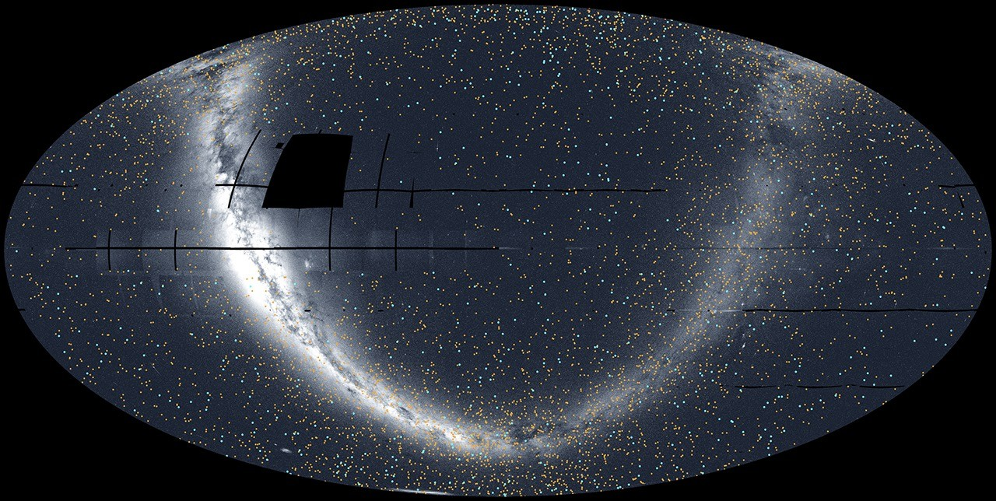

NASA's TESS (Transiting Exoplanet Survey Satellite) has released its most complete view of the starry sky to date, filling in gaps from previous observations. Nearly 6,000 colored dots scattered across the image show the locations of either confirmed or candidate exoplanets - worlds beyond our solar system - identified by the mission as of September 2025 at the end of TESS's second extended mission. "Over the last eight years, TESS has become a fire hose of exoplanet science," said Rebekah Hounsell, a TESS associate project scientist at the University of Maryland Baltimore County and NASA's Goddard Space Flight Center in Greenbelt, Maryland. "It's helped us find planets of all different sizes, from tiny Mercury-like ones to those larger than Jupiter. Some of them are even in the habitable zone, where liquid water might be possible on the surface, an important factor in our search for life beyond Earth." The TESS mission scans a wide swath of the sky, called a sector, for about a month at a time using its four cameras. These long stares allow the spacecraft to track the brightness changes of tens of thousands of stars, looking for variations in their light that might come from orbiting planets. Researchers assembled an all-sky mosaic made of 96 sectors observed between April 2018, when TESS began its work, and September 2025.

10. Will Starship launch from foreign shores? SpaceX 'constantly exploring' options for megarocket liftoff sites
Latest from Space.com
Read more
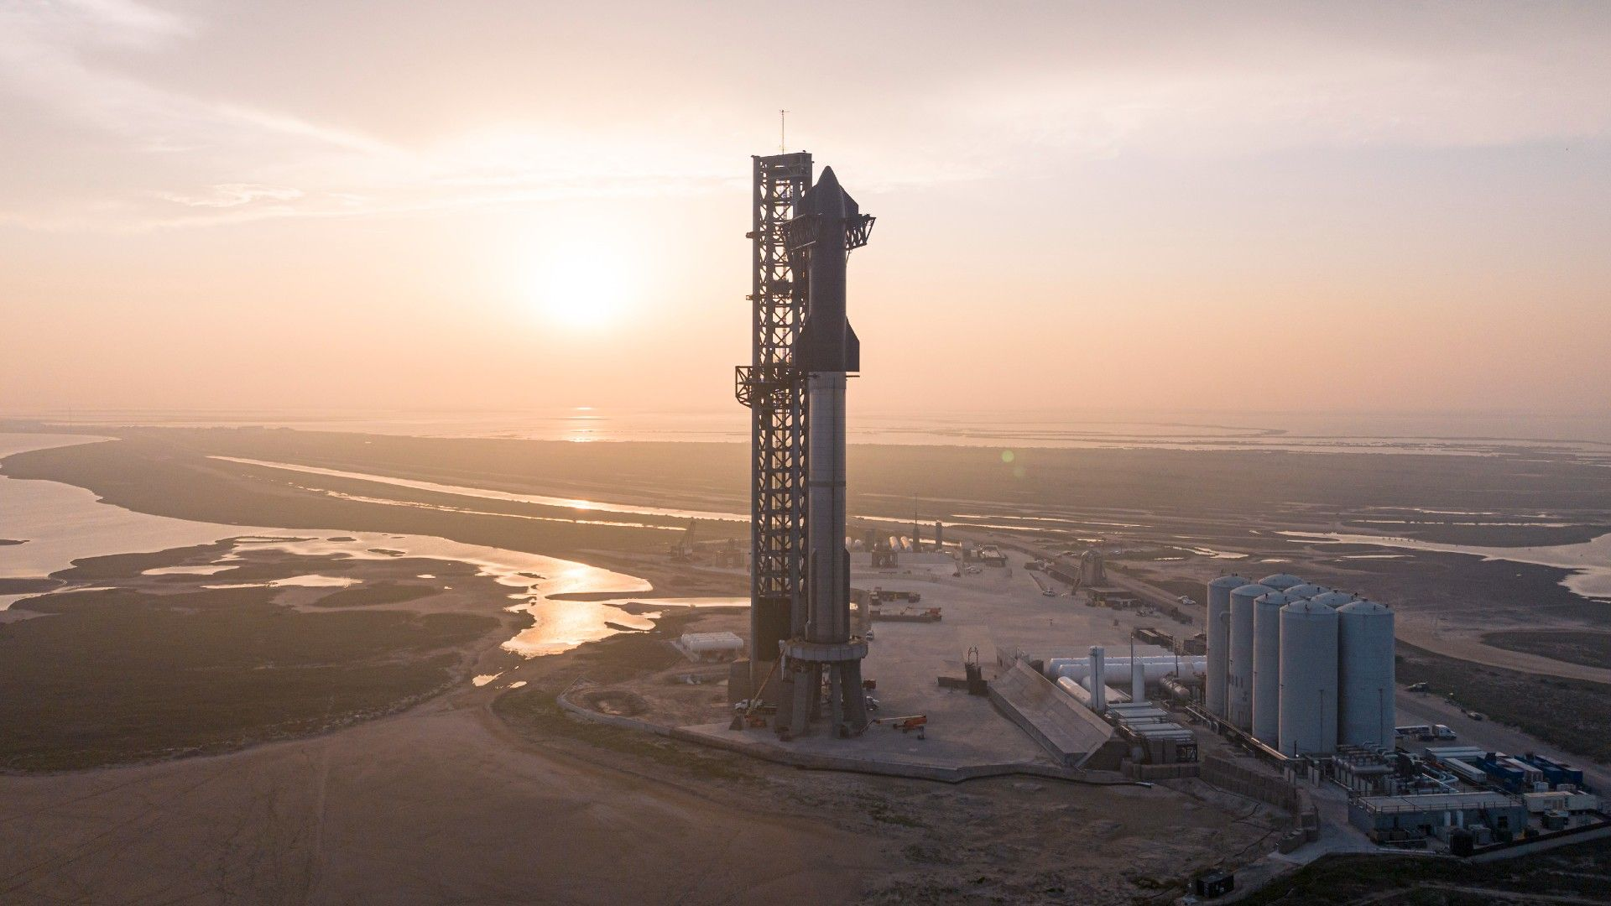

Click for next article Starship launches could soon be an international affair. SpaceX revealed on Tuesday (May 12) that it's hunting for additional launch sites for Starship , the giant rocket it's developing to help humanity settle the moon and Mars , among other tasks. And some of those sites may be on foreign shores. "It's no secret that we intend to launch Starship a lot, targeting thousands of flights per year. That cadence will require the ability to launch from many different locations, so we are constantly exploring to find viable sites to expand Starship operations in the future, both domestically and internationally," the company wrote via X on Tuesday . Those words addressed a May 4 post by X user S.E. Robinson, Jr., which discussed a rumor that SpaceX plans to acquire 212 square miles (550 square kilometers) of land in coastal Louisiana. "At the southeast corner of the land near the Freshwater City boat launch is a plot ready to be converted for port operations and direct access to the Intercoastal Canal and the Gulf of America," Robinson wrote. He also noted that the plot is about halfway between Boca Chica, Texas and Cape Canaveral, Florida. Boca Chica is home to Starbase, SpaceX's Starship manufacturing hub and the sole current launch site for the megarocket. (All 11 Starship test flights to date have lifted off from Starbase.) And SpaceX is modifying three pads in the Cape Canaveral area - Pad 39A at NASA's Kennedy Space Center and Launch Complex 37-A and 37-B at Cape Canaveral Space Force Station - to accommodate Starship launches. The huge vehicle could lift off from the Sunshine State for the first time later this year, if all goes to plan. Illustration showing two SpaceX Starship rockets at Cape Canaveral Space Force Station's Space Launch Complex-37. (Image credit: SpaceX) Starbase sports two launch mounts, the second of which will see its first action as soon as next Tuesday (May 19), when Starship Flight 12 is scheduled to lift off . That suborbital test flight will also mark the debut of Starship Version 3, a bigger and more advanced iteration of the megarocket. Starship V3 is the first variant capable of flying to the moon and other deep-space destinations, SpaceX founder and CEO Elon Musk has said. That makes five Starship launch pads that are officially in the works at the moment. But if the company is serious about launching thousands of Starship missions per year - and Musk has said that type of cadence will be necessary to build settlements on Mars - then more jumping-off points will be needed, as SpaceX's May 12 tweet makes clear. And it's important to note: It would be much easier, from a logistical and legal standpoint, to develop additional launch sites domestically than overseas. The U.S. government regards rockets as sensitive national-security technology and therefore subjects launches to the International Traffic in Arms Regulations framework, known as ITAR. American companies wishing to fly from foreign soil therefore have to jump through a number of bureaucratic hoops. The process is streamlined via the signing of a Technology Safeguards Agreement (TSA) at the nation-to-nation level. So maybe we should be on the lookout for SpaceX purchases in countries like Norway, New Zealand, Australia, the U.K. and Brazil, all of whom have inked TSAs with the U.S.

11. Blue Origin's lunar lander mockup is ready for NASA Artemis astronaut training
Latest from Space.com
Read more
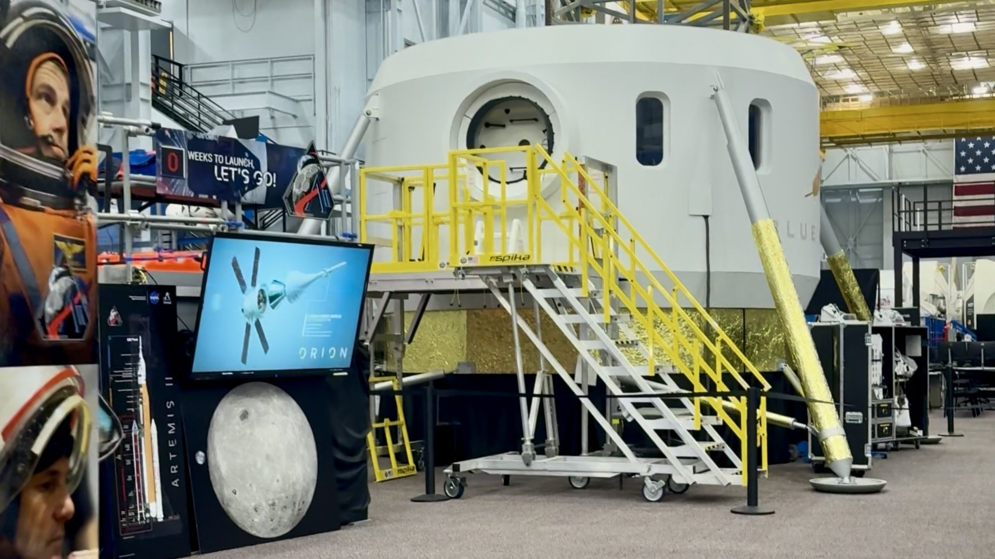

Click for next article NASA's Orion space capsule training simulator is located inside Building 9 at the Johnson Space Center in Houston. It's a full-scale, high-fidelity model of the real thing, and where the Artemis 2 astronauts spent more than a year preparing for their recent mission around the moon. For a long time, the Orion simulator sat alone in its own corner, away from the group of International Space Station training modules lined up inside the Space Vehicle Mockup Facility (SVMF). But now, Orion has a neighbor. A mockup of Blue Origin's Blue Moon Mark 2 (MK2) lunar lander has been assembled at the SVMF, and is ready for astronauts to come aboard to begin training, according to a NASA release . Standing adjacent to the Orion capsule, the Blue Moon crew cabin and exterior resemble the design of the lander's Mark 2 variant, which will eventually land Artemis astronauts on the moon , if all goes according to plan. With Blue Origin's mockup now assembled at JSC, astronauts can now seamlessly transition from training inside Orion to training in Blue Moon as they prepare for the Artemis missions ahead. The next mission, Artemis 3 , is dependent on at least one lunar lander being ready to fly before the mission can launch. Blue Moon is one of two lunar landers NASA has chosen through the agency's Human Landing System (HLS) contracts, the other being SpaceX's Starship , and is a critical component of NASA's Artemis program that aims to establish a permanent presence on the moon's surface. Comparison of the Apollo Lunar Module, Blue Origin's Blue Moon, and SpaceX's Starship. (Image credit: NASA OIG) Both landers have faced delays in development, but Blue Moon is the first of the pair to integrate a cabin model for training at a NASA facility. Astronauts wearing Artemis spacesuit prototypes from Axiom Space have had the opportunity to test some of Starship's early cabin designs , as well as the spacecraft's elevator that will be used to lower crews down the roughly 170 feet (52 meters) from Starship's cabin section to its base, but those tests have so far been limited to SpaceX 's own facilities. For comparison, the Blue Moon MK 2 will be about 52 feet (16 meters) tall, with the crew cabin located near the base. The full-scale prototype of the crew cabin of Blue Origin's Blue Moon Mark 2 crew lander is over 15 feet (5 meters) tall. Image credit: NASA Blue Moon lander training mockup Interior view of Blue Origin's Blue Moon lander mockup inside the Space Vehicle Mockup Facility in Building 9 at NASA's Johnson Space Center. Image credit: Blue Origin Blue Moon lander training mockup interior A full-scale prototype of the crew cabin of Blue Origin's Blue Moon Mark 2 crew lander is now operational for training and testing at @nasa_johnson!Read how we will be using this crew cabin for simulations to prepare for future Artemis missions >> https://t.co/Lo5tcckxUT pic.twitter.com/2OvYoXqyRZMay 8, 2026 Artemis 3 is scheduled for late 2027 , according to NASA Administrator Jared Isaacman, who based the timetable on Blue Origin 's and SpaceX's estimations of the earliest completion for their respective landers. NASA has indicated a willingness to fly with either or both vehicles, depending on their readiness. The mission will fly four astronauts aboard Orion into low Earth orbit , where the spacecraft will rendezvous with the lunar lander vehicles to practice docking procedures and verify their life support and communications systems. Artemis 3 astronauts may also have the chance to don Axiom's new spacesuits, but those have also faced significant delays . If Artemis 3 goes according to plan, and the landers and spacesuits are ready in time, NASA is targeting 2028 for a moon landing on Artemis 4, and possibly again on Artemis 5 that same year. But the landers have a long way to go before NASA will qualify either to deliver astronauts to the lunar surface. The Artemis moon landers will need to touch down safely on the moon, as well as deliver crews back to lunar orbit for transfer back aboard Orion. That's different from how Apollo astronauts performed lunar landings, flying aboard a two-stage vehicle that left half a spacecraft behind on the surface in order to shed the necessary weight to make it back to orbit. NASA's long-term, sustainable habitation approach for the Artemis program makes abandoning half a lunar lander on the surface for every mission untenable. Lift-off of Apollo 17 Lunar Module ascent stage, Dec. 14, 1972. (Image credit: NASA) To pull off the single-stage landing and launch back to orbit, both Starship and Blue Moon will need several on-orbit refueling flights, requiring transfer and long-term storage of cryogenic propellants - neither of which capabilities have ever been demonstrated in space . Once those milestones have been accomplished, NASA is also requiring successful uncrewed missions to the lunar surface for each lander, before they can qualify to carry astronauts. The Blue Moon lander mockup now operational in the SVMF is not the final design of the vehicle, inside or out, but NASA plans to use the test article to provide feedback on its design as Blue Origin continues the real MK2's development, according to a NASA release .

12. Cost estimate for 'Golden Dome' missile defense system balloons to $1.2 trillion
Latest from Space.com
Read more


Click for next article President Trump's Golden Dome may end up being quite a bit more expensive than originally thought. A new report by the nonpartisan Congressional Budget Office (CBO) estimates it will cost about $1.2 trillion to deploy the Golden Dome missile defense system and operate it for 20 years. That's more than double the CBO estimate from last year, which was $542 billion, and about seven times higher than the number cited by the White House when it announced the project in May 2025 ($175 billion). The Golden Dome for America (GDA) is an envisioned shield that will protect the United States against ballistic and hypersonic missiles and other aerial threats. It will feature advanced missile-tracking satellites as well as space-based interceptors - satellites capable of shooting down missiles headed toward the U.S., which the Space Force wants to be ready by 2028 . Those broad strokes are basically all we know, however; details of the architecture have not been released. So, the CBO had to get creative in its newly announced cost estimate, filling in gaps in the 2025 executive order that called for Golden Dome's creation. The agency did that, then crunched the numbers. "A national missile defense system possessing capabilities broadly consistent with those outlined in the executive order would cost about $1.2 trillion to develop, deploy, and operate for 20 years, CBO estimates," the 12-page report reads. That notional system features four interceptor layers, one of which is space-based. "The NMD system also includes additional sensors, communication systems and battle management systems to coordinate collective action among the layers," the report reads. "The layered structure of the overall system would provide the capacity to simultaneously engage multiple missiles launched by an adversary. Each layer would be able to operate independently if interaction with national command and control was disrupted." The vast majority of the $1.2 trillion price tag (about $1 trillion) would go toward acquisition costs - the money needed to develop, build and deploy the components of the interceptor and tracking layers, as well as conduct research into the system's performance and how to improve it. "The most expensive component is the space-based interceptor layer, which accounts for about 70 percent of acquisition costs and 60 percent of total costs," the CBO report states. That layer, in the CBO's notional Golden Dome, consists of 7,800 satellites in a near-polar low Earth orbit - enough spacecraft "to engage a raid of 10 nearly simultaneously launched ICBMs [intercontinental ballistic missiles] during their boost phase. The ability to launch up to 10 ICBMs in rapid succession is considered representative of the capabilities of a regional adversary," the report reads. A "regional adversary" is one with limited capabilities - North Korea, for example. The report also discusses "peer or near-peer adversaries" - nations close to the United States militarily, such as China and Russia. The report notes that its overall cost estimate of $1.2 trillion is significantly higher than one given recently by Department of Defense (DoD) officials - $185 billion over the next 10 years. "That difference suggests either that GDA's objective architecture is more limited than CBO's notional NMD system or that DoD expects significant funding from other accounts to contribute to GDA (or both)," the report states. "For example, procurement of interceptors might be funded directly through the services' missile procurement accounts instead of the GDA fund." The pricey notional system that CBO came up with would be able to "fully engage" an attack from a regional adversary, according to the report. "However, the system could be overwhelmed by a full-scale attack mounted by a peer or near-peer adversary," it states. "Furthermore, 'fully engage' is not the same as 'fully defeat' because no defense works perfectly every time." Complete protection would therefore be incredibly expensive - probably priceless, in both senses of the word.

13. Dual spacecraft capture both hemispheres of interstellar comet 3I/ATLAS at once
Space News - Space, Astronomy, Space Exploration
Read more
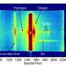

The Southwest Research Institute-led Ultraviolet Spectrograph (UVS) instruments aboard ESA's Jupiter Icy Moons Explorer (Juice) spacecraft and NASA's Europa Clipper made unique observations of interstellar comet 3I/ATLAS in late 2025. SwRI leads the UVS instruments on both spacecraft, simultaneously imaging both hemispheres of the comet and detecting the comet's ultraviolet emi...

14. NASA bets big on nuclear engines to cut journey times to Mars
Space News - Space, Astronomy, Space Exploration
Read more


Nasa is developing ways to use nuclear power to send spacecraft to their destinations. Nuclear propulsion could greatly reduce the journey time to Mars, perhaps cutting a voyage of more than six months to three or four months.

