 |  | 

🌌 अंतरिक्ष समाचार | Space News
शुक्रवार, १२/०६/२०२६ | Friday, 12/06/2026

1. Mix of science & traditional knowledge vital for disaster management
Read more
PIONEER EDGE NEWS SERVICE/Dehradun The use of traditional knowledge is also important along with modern science to enhance disaster management. Experts said this at the start of a two-day national training programme on monsoon preparations organised jointly by the Uttarakhand State Disaster Management Authority (USDMA) and National Institute of Disaster Management (NIDM) here on Thursday. The State Disaster Management Advisory Committee vice chairman lieutenant colonel (retd) Raghuveer Singh Bhandari said that along with the government machinery, it is important for every citizen to be capable of facing disasters. He stressed on the need for training and making the citizens capable of acting as first responders in disaster scenarios. Along with the latest technologies and scientific systems, it is also important to conserve and utilise the traditional knowledge of the local communities. Based on their experience, the residents of mountainous regions have developed a special skill to understand the weather, geology, water sources and signals from nature. Such traditional knowledge often helps in evaluating potential disaster threats, he said. Bhandari further stressed on the need for making disaster risk mitigation activities stronger at the village level. Stating that there is a considerable number of ex-servicemen in the State, he said that their experience, discipline, leadership skill and capability to make better use of resources can prove to be very useful in disaster management. Disaster Management and Rehabilitation secretary Vinod Kumar Suman said that this training programme is aimed at further strengthening coordination among various departments and informing officials about latest developments, innovations and best practices in the sphere of disaster management. Since disaster management involves multiple departments, clear communication, coordinated working style and clear understanding of the responsibilities is essential, he said. Pointing at the proclivity for making reels in rivers, waterfalls, deep ravines and other risky spots, he said that all such sites should be identified and declared no-selfie zones.

2. New tourism registration rules in force, homestays under one framework
Read more
PIONEER EDGE NEWS SERVICE / Dehradun The Uttarakhand Government recently notified the Uttarakhand Tourism and Travel Business Registration Rules 2026 replacing the Tourism and Travel Business Registration Rules 2014 and the Homestay Rules 2015. Uttarakhand Tourism Development Board (UTDB) additional director Poonam Chand stated that the new regulations create a single framework for registration, renewal and regulation of tourism-related establishments, including hotels, resorts, homestays, bed and breakfast units, travel agencies, tour operators and adventure tourism operators. Under the rules, all tourism units will be required to register with the UTDB. Registrations will remain valid for five years, after which renewal will be mandatory. The rules comprise a classification system for homestays and bed and breakfast establishments, categorising them into gold, silver and bronze grades based on infrastructure, amenities and service standards, Chand said. Homestays will be permitted a maximum of eight rooms and 24 beds. Owners must be permanent residents of Uttarakhand and reside on the premises. The registration fee has been fixed at Rs 1,000 for homestays and Rs 5,000 for bed and breakfast units. She said that the rules also require operators to maintain visitor records and display registration certificates carrying QR codes. Provisions relating to fire safety, parking arrangements and police verification in specified cases have also been included. Tourism businesses operating without registration or found violating the rules may face penalties starting from Rs 10,000. Chand added that Uttarakhand has around 6,000 registered homestays. The State government will continue implementing the Deen Dayal Upadhyay Homestay Development Scheme, which provides financial assistance for construction, renovation and expansion of homestays in rural areas outside municipal limits. Under the scheme, beneficiaries in mountain districts are eligible for subsidies of up to 50 per cent of bank loans, subject to a ceiling of Rs 15 lakh, while applicants in plain areas can avail subsidies of up to 25 per cent, capped at Rs 7.5 lakh.

3. ISRO successfully conducts 2nd integrated air drop test for Gaganyaan mission | Akashvani News - News On AIR
Read more
The Indian Space Research Organisation (ISRO) has successfully conducted the second integrated air drop test (IADT-02) for the upcoming Gaganyaan mission at Sriharikota in Andhra Pradesh. The system is essential to ensure safe recovery of the crew module - the capsule in which astronauts sit during a human flight. After the module's release, a parachute system, comprising 10 parachutes, was deployed, helping the capsule decelerate to a safe splashdown speed. The IADT-02 follows the successful completion of the first IADT, which took place on August 24, 2025, at the Satish Dhawan Space Centre in Sriharikota. In the first IADT, a 4.8-tonne dummy crew module was dropped from a height of three km by a Chinook helicopter. Air drop tests recreate the last leg of a spacecraft's return to the Earth. An aircraft or helicopter drops the spacecraft from a height to test various systems under different scenarios. These are the deployment of the parachute system in case the mission is aborted mid-flight, system performance when one parachute fails to open, and the spacecraft's orientation and safety during splashdown. Union Minister Jitendra Singh congratulated the ISRO for successfully conducting the test. India's first human spaceflight will be launched from Sriharikota in 2027.

4. Pakistan launches 6 satellites to watch India as Isro's NavIC struggles with failures - India Today
Read more
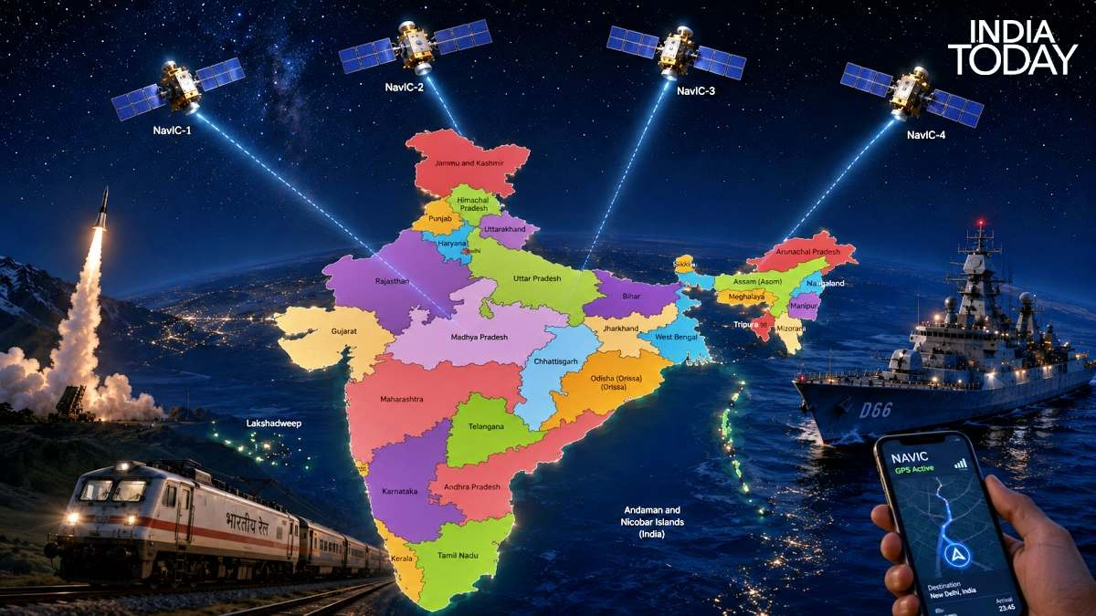
While Pakistan has rapidly expanded its space-based surveillance capabilities with a series of Chinese-backed satellite launches, India's indigenous navigation system NavIC is facing its most serious challenge since its inception, highlighting a widening contrast in the space capabilities of the two nuclear-armed neighbours. While India remains superior in other space-based domains compared to Islamabad, the new satellite blitz from the neighbourhood has raised concerns across Indian power corridors. Read Full Story Over the past 16 months, Pakistan has launched six Earth-observation satellites, creating what experts describe as an increasingly capable surveillance constellation that can monitor developments across Indian territory with greater frequency and precision. The launches, many undertaken with extensive Chinese support, represent a dramatic acceleration for Pakistan's traditionally modest space programme. The satellite buildup began even before the Pahalgam terror attack and India's subsequent Operation Sindoor, suggesting a longer-term strategic effort to strengthen Pakistan's space-based intelligence gathering capabilities. China has been regularly launching Pakistani satellites. (Photo: CMSA) According to analysts, the significance of the new constellation lies not merely in the number of satellites but in their combined capability. Together, the satellites can capture high-resolution imagery, track changes on the ground, detect concealed or camouflaged objects and maintain persistent surveillance over areas of military and strategic interest. "The constellation that has emerged from this sixteen-month burst is not a civilian earth observation system that happens to have military applications on the side," Rear Admiral Sudhir Pillai, former Flag Officer of the Indian Navy, wrote in an analysis of Pakistan's recent launches. He argued that the satellites' orbital architecture, sensor payloads and institutional backing indicate a system with clear strategic and security applications. WHERE IS ISRO'S NAVIC? The rapid expansion comes at a time when India is grappling with difficulties in one of its most important space infrastructure projects, the Navigation with Indian Constellation (NavIC). Developed by the Indian Space Research Organisation (Isro), NavIC was designed as India's independent answer to the American GPS system. The programme was born out of lessons learned during the Kargil War, when India recognised the strategic risks associated with depending on foreign navigation services during military crises. NavIC provides Positioning, Navigation and Timing (PNT) services across India and extends coverage roughly 1,500 kilometres beyond its borders, including much of the Indian Ocean Region. NavIC, India's own GPS, has fallen to just three active satellites. (Photo: Isro) The system supports both civilian users and encrypted military services used for strategic operations. However, by 2026 the constellation has entered a critical phase. WHAT'S WRONG WITH INDIA'S NAVIC? Several of the first-generation satellites launched between 2013 and 2016 have exceeded or are nearing the end of their design lives. A number of them have suffered failures of their rubidium atomic clocks - the ultra-precise timing devices that form the backbone of any satellite navigation network. Once these clocks fail, a navigation satellite can no longer provide accurate positioning information. The situation worsened earlier when NVS-02, a second-generation replacement satellite intended to strengthen the network, suffered propulsion-related problems and failed to reach its intended operational orbit. The setback disrupted Isro's plans to replenish the ageing constellation. Several of the first-generation NavIC satellites are nearing the end of their design lives. (Photo: Isro) As a result, the number of fully operational navigation satellites has fallen sharply. Industry assessments suggest that only a handful of spacecraft, including IRNSS-1B, IRNSS-1I and NVS-01, currently remain capable of delivering full navigation services. Some analysts count an additional partially functional satellite, but the constellation remains significantly below its originally planned strength of seven satellites. The decline is particularly concerning because a robust regional navigation system ideally requires at least seven operational satellites, while a minimum of four is generally needed for reliable three-dimensional positioning coverage. WHAT IS ISRO DOING? Despite the challenges, Isro has not abandoned the programme. Additional replacement satellites are being prepared as part of the second-generation NavIC constellation, which introduces L1-band signals alongside the existing L5 and S-band frequencies. The upgrade is expected to improve compatibility with smartphones and accelerate wider civilian adoption. For India, restoring NavIC is about far more than navigation. The system plays a critical role in missile guidance, naval operations, secure military communications, disaster management, fleet tracking and strategic infrastructure synchronisation. As Pakistan rapidly strengthens its eyes in the sky, India now faces the urgent task of ensuring that its own sovereign navigation backbone remains operational. The race for space-based strategic advantage in South Asia is increasingly being fought not only on the ground, but also hundreds of kilometres above it. - Ends Published By: Sibu Kumar Tripathi Published On: Jun 11, 2026 16:02 IST

5. ISRO partners with Andhra University for AI system to detect deadly rip currents - The New Indian Express
Read more
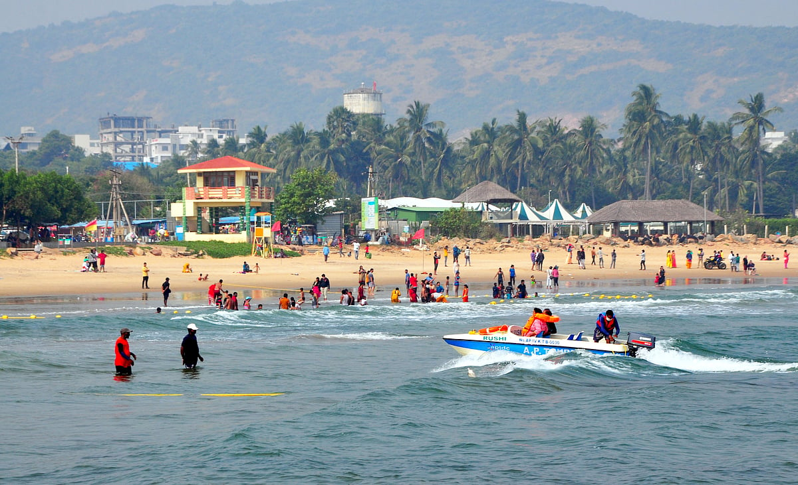
VISAKHAPTNAM: Aiming to strengthen beach safety through technology, the Space Applications Centre (SAC) of ISRO has partnered with Andhra University to develop an AI-enabled rip current detection and warning system under Project Bharati. The project seeks to provide real-time alerts to lifeguards, police and beach visitors, helping authorities respond more effectively to one of the leading causes of drowning incidents along the coast. The two-year research project has been sanctioned by the Space Applications Centre (SAC), ISRO, Ahmedabad, at an estimated cost of Rs22 lakh. The study is being led by scientist Dr SVV Arun Kumar of SAC-ISRO and Prof CV Naidu, Head of the Department of Meteorology and Oceanography at Andhra University. Rip currents are strong channels of water that flow away from the shore and can pull swimmers into deeper waters within seconds. They are considered one of the leading causes of drowning incidents at beaches across the world. Scientists say such currents are frequently observed along the Visakhapatnam coastline, particularly in areas where drainage channels and streams enter the sea. As part of Project Bharati, researchers are developing specialised AI software capable of identifying where and when rip currents are likely to form. The system will analyse satellite data, weather conditions, oceanographic information and live video feeds to detect dangerous conditions before an accident occurs. Scientists involved in the project said nearly 60 per cent of the software development work has already been completed. A key component of the initiative is the Next-Gen AI Lifeguard Alert System, a mobile beach safety unit designed to monitor coastal conditions around the clock. The unit will be equipped with AI-enabled 360-degree cameras capable of tracking beach activity and analysing wave patterns. Thermal cameras will allow monitoring during night-time and poor visibility conditions.

6. Require 200-plus satellites in 3 years for India: ISRO chairman V Narayanan - BusinessLine
Read more

India will need to launch over 200 satellites in the next three years to meet growing national and commercial requirements, Indian Space Research Organisation (ISRO) Chairman V Narayanan said on Thursday, calling for deeper participation from private industry, start-ups and academia in the space sector. "Currently, we have 56 satellites in orbit. But we require 200-plus satellites in another three years for the country. ISRO alone cannot do this. The entire space ecosystem has to work towards that. Lot of opportunities are there," Narayanan said at the 10th Industry Connect event organised by IN-SPACe in Ahmedabad. He said ISRO is increasingly positioning itself as an enabler for the broader ecosystem rather than working in isolation. "We are here to handhold and support the entire start-up ecosystem to contribute to the space sector of our country," he said. Sectoral reforms Narayanan noted that India's space start-up ecosystem has expanded significantly following sectoral reforms, with more than 400 start-ups now operating in the domain. He stressed that future growth will depend on coordinated efforts across ISRO, industry and research institutions. Highlighting long-term ambitions, the ISRO chief said India is also moving ahead with plans for an indigenous space station. "We are also building our own space station. You can see the model. It is a 52-tonne space station. India will have its own space station by 2035," he said. Narayanan also outlined the evolution of India's space programme - from early sounding rocket experiments to complex deep-space and commercial missions. He said satellites have become critical to communication, navigation, disaster management and strategic applications. Major milestones He highlighted major milestones including the Mars Orbiter Mission, Chandrayaan-1, Chandrayaan-2 and Chandrayaan-3, noting that India became the first country to successfully land near the lunar south pole with Chandrayaan-3. He also referred to the Aditya-L1 solar mission, which placed India among a select group of nations with dedicated solar observation capability. On commercial capabilities, he said India has transitioned into a global launch hub, including missions carrying large foreign payloads. "From that humble beginning, India progressed to a purely commercial launch of a 6,000 kg satellite for an American company using an Indian rocket," he said. He added that India has conducted over 4,000 sounding rocket launches, while its satellite fleet has expanded from early experimental systems to advanced platforms used across communication, Earth observation and navigation. Narayanan said satellites now form the backbone of modern infrastructure, supporting services such as banking, telecom, disaster warning, education and healthcare delivery. On Thursday, IN-SPACe signed an agreement with the Government of Tamil Nadu for the development of a Common Technical Facility at the upcoming Space Vehicles Cluster at SIPCOT Allikulam, which is being set up with a focus on 'manufacturing, testing and integration of launch vehicle systems'. The facility is intended for shared use by industries operating within the cluster, reinforcing a centre-state partnership model aimed at scaling India's space manufacturing capabilities. The Ahmedabad event, held under the IN-SPACe framework, brought together industry leaders, policymakers and start-ups as India looks to significantly scale up its presence in the global space economy. Published on June 11, 2026

7. G20 satellite is expected to be launched in 2027: ISRO Chairman - News On AIR
Read more
ISRO Chairman V. Narayanan has said that the G20 satellite, designed to study climate and air pollution and monitor weather, is expected to be launched in 2027. He said India is the first country to succeed in placing more than 100 satellites using a single rocket without any collision. Dr Narayanan was addressing scientists from DRDO, ISRO, and the Aeronautical Society of India at the Engineering Staff College of India in Hyderabad yesterday. He said India is taking the lead role in the launch of the G20 satellite for the G-20 countries. Dr Narayanan said ISRO is working towards sending a human to the moon by 2040. He said if ISRO makes it happen by 2040, India will be on par with any other space-faring nation in terms of launcher technology, satellite technology, application area, and human space flight program. According to Dr Narayanan, ISRO is in the process of making a 2.2 metre diameter, 100 mm thick titanium vessel for Samudrayaan, a project for the Deep Ocean Mission.

8. Isro, Andhra University To Develop AI-Based Beach Safety System - Deccan Chronicle
Read more

VISAKHAPATNAM: India's coastal safety framework is set for a technological upgrade through Project Bharati, a joint initiative of the Space Applications Centre (SAC) of Isro (Indian Space Research Organisation) and Andhra University, to develop an AI-enabled rip current detection and warning system aimed at reducing drowning incidents along the country's beaches. Dr S.V.V. Arun Kumar of SAC-Isro and Prof. C.V. Naidu of Andhra University's Department of Meteorology and Oceanography are leading the two-year ₹22 lakh project. Their initiative builds on years of research into rip currents along the Visakhapatnam coast, where such currents are frequently observed near drainage outlets and stream mouths. Rip currents are powerful channels of water flowing away from the shore that can rapidly pull swimmers into deeper waters. Researchers are developing software that combines satellite imagery, weather data, oceanographic information, and live video feeds to predict and detect rip currents in real time. Officials said nearly 60 per cent of the software development work has been completed. A key component of the project is the proposed Next-Generation AI Lifeguard Alert System, a mobile safety unit equipped with 360-degree AI-enabled cameras, thermal imaging for night-time monitoring, and weather stations that record wind speed, temperature, humidity, and atmospheric pressure. The system will continuously analyse these inputs and classify beach zones as safe, caution, or danger areas. Officials point out that rip currents can move at speeds of up to five metres per second and extend between 50 and 150 metres into the sea. As these currents are often difficult for beachgoers to identify, an early warning mechanism could significantly improve public safety. Under the proposed system, detection of a rip current will trigger sirens, flashing lights and public announcements. Simultaneously, alerts will be sent through 4G and 5G networks to lifeguards, coastal security police personnel and control rooms. Real-time safety information will be displayed on electronic boards for visitors. Each solar-powered beach safety mobile unit, mounted on a movable platform, is estimated to cost ₹2 lakh, enabling deployment at different beaches depending on seasonal conditions and risk levels. Officials said the pilot project is expected to benefit agencies including the coastal security police, GVMC, tourism department and the beach management authorities. If successful, the Isro-AU system would be expanded to beaches across the country.

9. ESA science missions get green light for new discoveries
Read more
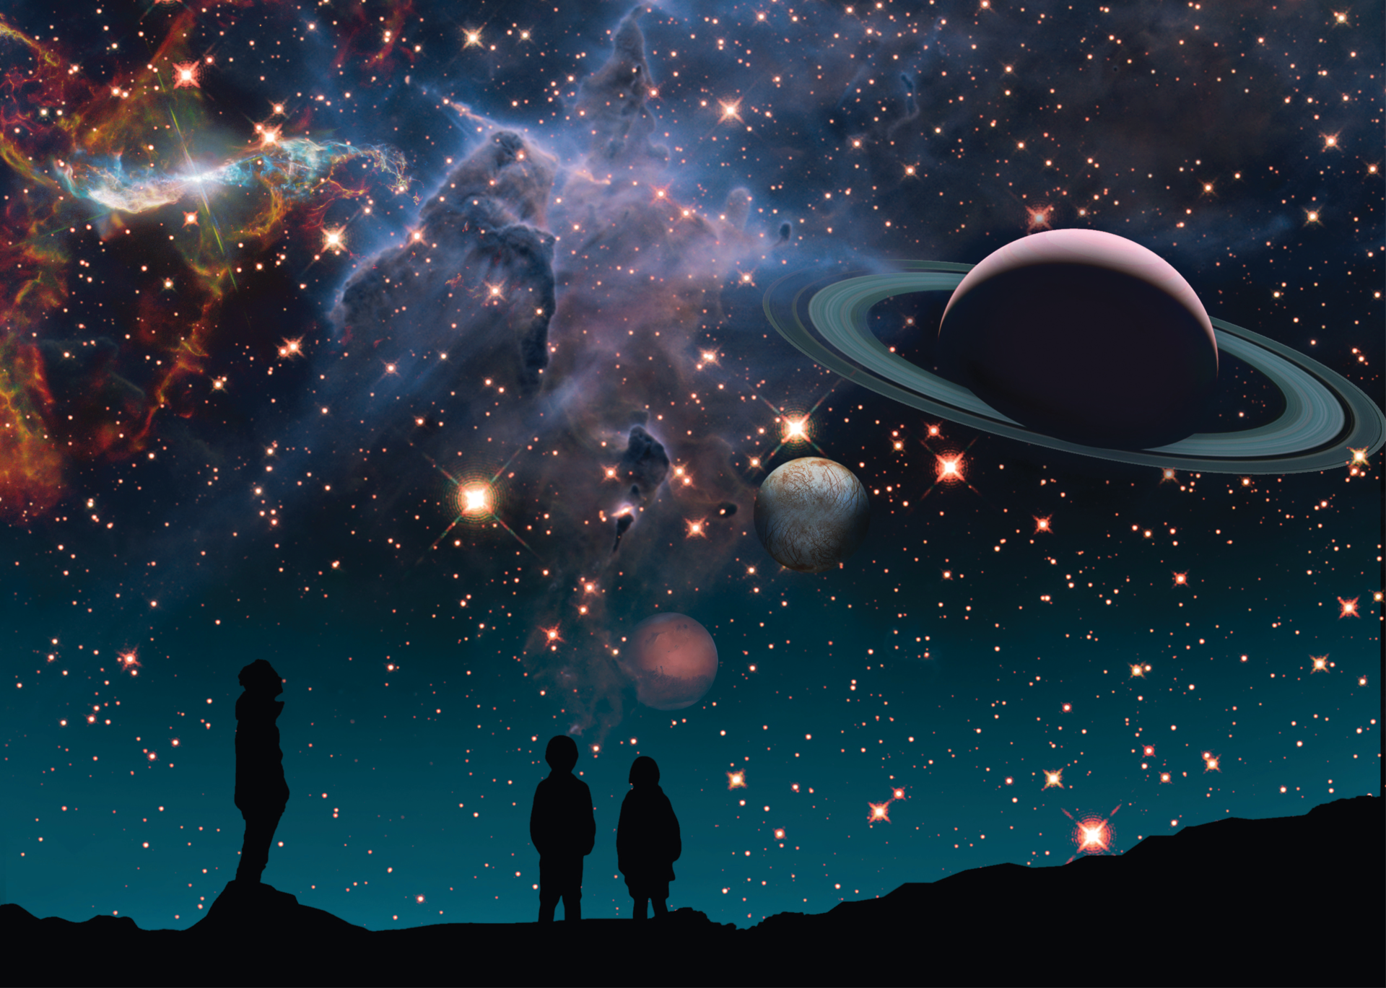
Science & Exploration ESA science missions get green light for new discoveries 11/06/2026 1934 views 4 likes On 10-11 June, representatives from European Space Agency (ESA) Member States met in Tenerife to make far-reaching decisions about the future of ESA's Science Programme. Their decisions to extend current missions and adopt the next 'fast-class' mission, Arrakihs, underscores European leadership in, and long-term commitment to, space science. ESA's world-leading Science Programme transforms bold ideas from European scientists into ambitious space science missions. It is community-driven, overseen by a Science Programme Committee that meets around three times per year. The Committee includes representatives from each of ESA's 23 Member States, ensuring that all countries have an equal say in major decisions that decide the future of European space science. ESA's Director of Science, Professor Carole Mundell says: "Being motivated by the scientific community means that we can build world-leading space missions that really meet the needs of European scientists. Our aim is to provide the best missions possible to encourage technological innovation and scientific discoveries across our Member States." The decisions taken and discussions held by the Science Programme Committee this week will guide the Programme throughout the 2030s and beyond. 13 missions extended ESA leads or co-leads ten active space science missions, and is involved in six more led by international partners. An initial mission operations phase typically lasts up to five years, depending on the mission's scientific goals. Extensions beyond this period depend on the ability of the mission to continue delivering novel science. The Science Programme Committee discussed the extension of the 13 missions that are due to end their current science phase before the end of 2026. It endorsed extensions for all 13, underlining the potential of these missions to support a wide range of scientific communities across Europe and beyond. In alphabetical order, these missions are: BepiColombo, Cheops, Einstein Probe, Hinode, Hubble, IRIS, Mars Express, Proba-3, SOHO, Solar Orbiter, Webb, XMM-Newton and XRISM. The extension is particularly important for Solar Orbiter, an ESA-led mission to study the Sun up close. Launched in 2020, Solar Orbiter is currently giving humankind its first views of the Sun's poles. The extension will allow the mission to continue going to higher latitudes, revealing the Sun from new angles, and enabling completely new discoveries. Missions that will still be operating in, or are yet to begin, their initial science phase at the end of 2029, including Euclid, Juice and Smile, were not considered for extension during this week's meeting. Arrakihs - ESA's next galactic archaeologist On 10 June, the Science Programme Committee approved the adoption of ESA's second 'fast-class' mission, Arrakihs. This means that ESA and its Member States commit to building and launching the mission. Arrakihs will capture the faint light from the haloes of stars and gas that surround galaxies to answer questions about cosmic history. Like other fast-class missions, it is based on adapting existing technology for novel science, and Member States - particularly Spain, in the case of Arrakihs - play a leading role in developing the mission. Arrakihs is expected to launch by the end of 2030. Find out more about the adoption of Arrakihs in our dedicated article. Plasma Observatory - sailing the shores of the cosmic ocean Medium-class missions form the backbone of ESA's Science Programme. Those currently flying include Solar Orbiter and Euclid, ESA's dark Universe detective. Back in 2023, the space science community narrowed down the shortlist for the next medium-class mission to three finalists. Since then, scientists and engineers have been carefully considering all three in terms of science, technical feasibility and how well they complement other missions. Medium science mission selection process Based on this assessment, ESA has proposed to the Science Programme Committee that Plasma Observatory be selected. The Committee has taken note of this recommendation and will make the formal decision at the next meeting in November 2026. Plasma Observatory would study how electrically charged particles (plasma) from the Sun interact with the protective magnetic bubble (the magnetosphere) that surrounds Earth. In particular, it would look at how the plasma gains energy through its interaction with Earth's magnetic field, how this energy enters and moves around the magnetosphere, and how it spreads to other particles around Earth. Previous missions, including ESA's Cluster, found that these interactions happen on different scales in space and time - from a few kilometres up to tens of thousands, and from milliseconds to minutes. But Cluster - made up of four spacecraft - could only study one scale at a time. Plasma Observatory would be a constellation of seven spacecraft, making it the first mission capable of studying the interactions on different scales of space and time simultaneously, to give us a detailed understanding of what exactly is happening and how the scales are connected. Plasma makes up 99% of the visible Universe, and the transfer of energy within it governs how pretty much everything in the Universe works. Plasma Observatory is using the magnetosphere as a laboratory for understanding the wider Universe, including the Sun, exploding stars and distant galaxies. Find out more about Plasma Observatory here. Notes for editors The Science Programme Committee convened at the Instituto Astrofísico de Canarias, Tenerife, on 10-11 June 2026. The Science Programme is part of ESA's mandatory activities, which means that all Member States contribute and participate. This provides budget stability and allows long-term planning of the cadence and types of missions to enable European leadership in frontier science and technology. The Programme has a long and successful history, with missions developed through planning cycles that last 10-20 years. The first cycle was Horizon 2000 (1985-2005). This was followed by Horizon 2000+ (2005-2015), leading to the current cycle, Cosmic Vision. The future is defined by Voyage 2050. Plasma Observatory would be the first medium-class mission in Voyage 2050. ESA's Science Programme is overseen and guided by the Science Programme Committee, established by the ESA Council and representing all Member States equally. For the selection of new missions, scientific advice and recommendations are provided to ESA by the Space Science Advisory Committee, which is guided by working groups made up of external scientists specialised in different topics. ESA then coordinates with the Science Programme Committee for approval on the content of the Programme. For more information, please contact ESA Media Relations media@esa.int

10. SpaceX sends 24 Starlink satellites into orbit as market awaits IPO launch (video)
Read more
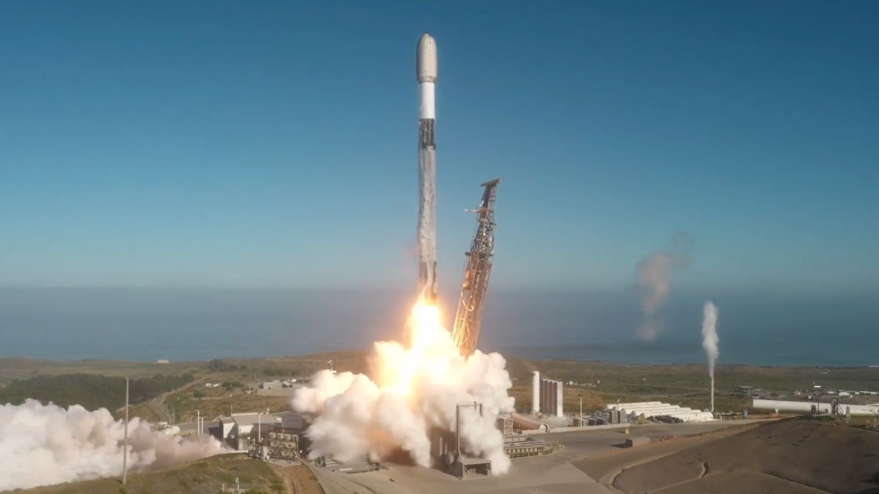
Click for next article SpaceX continued its almost continuous delivery of Starlink satellites into low Earth orbit on Thursday (June 11), with its latest launch from California. A Falcon 9 rocket carrying 24 of the internet broadband relays ( Group 17-44 ) launched at 11:05 a.m. EDT (1505 GMT or 8:05 a.m. PDT local time) from Space Launch Complex 4 East at Vandenberg Space Force Base in California. About an hour later, SpaceX confirmed the satellites were successfully deployed. A SpaceX Falcon 9 carrying 24 Starlink satellites launches from Vandenberg Space Force Base in California on Thursday, June 11, 2026. (Image credit: SpaceX) The flight's first stage booster (B1071) completed its 34th mission, touching down on its four landing legs atop the autonomous droneship " Of Course I Still Love You ," which was prestaged in the Pacific Ocean. The booster is one flight shy of tying the reuse record set by Booster 1067 on June 8. The launch came the same week as SpaceX's highly anticipated IPO (Initial Public Offering) on the NASDAQ stock market. This could have been the last SpaceX launch before it goes public, but another Starlink launch is currently targeted for Friday morning in Florida, before the market opens. IPO aside, the launch did increase the population of the Starlink megaconstellation to more than 10,600 satellites, according to tracker Jonathan McDowell . Thursday's launch was SpaceX's 67th Falcon 9 launch of the year and 660th completed mission since 2008.

11. James Webb Space Telescope discovers 'galaxy-killing' wind that may explain why some early galaxies lived fast and died young
Read more
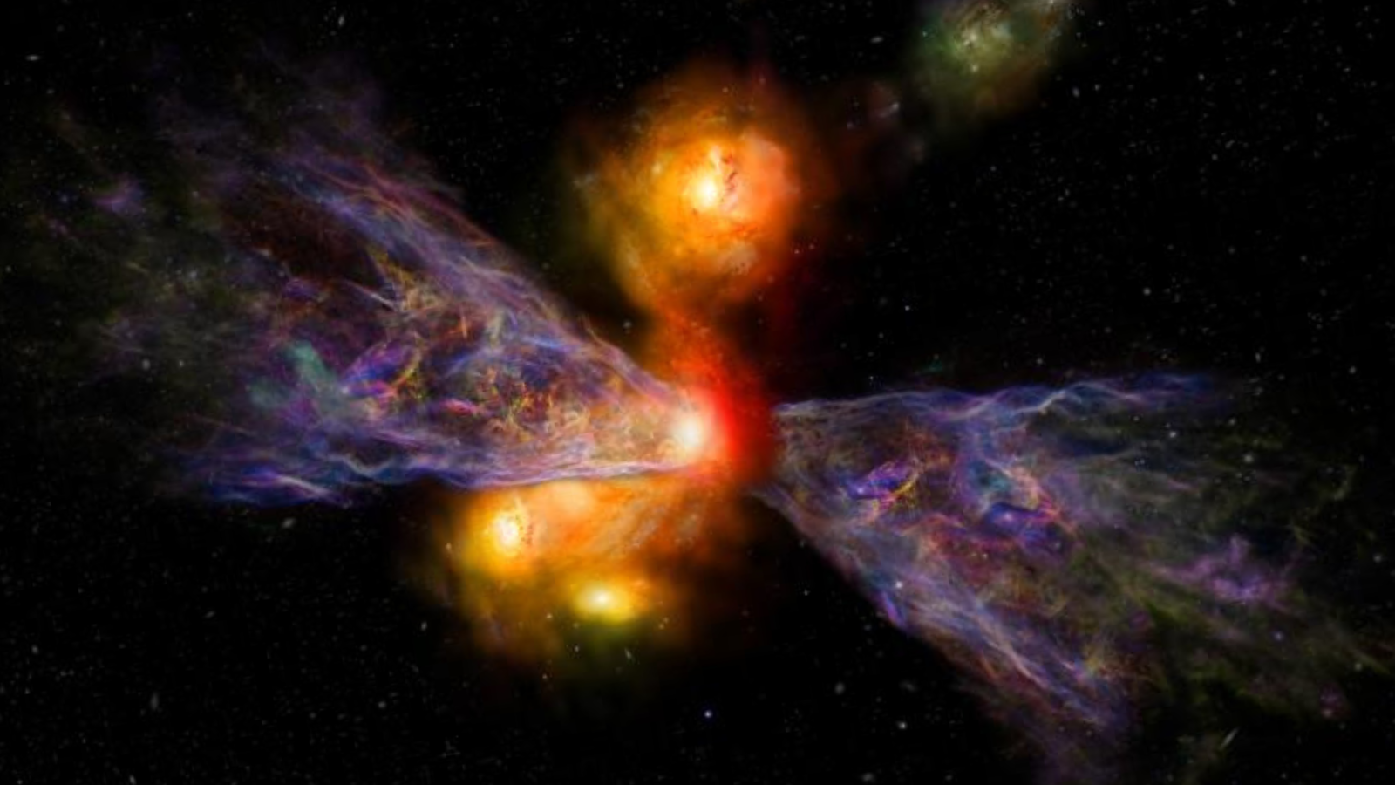
Click for next article Using the James Webb Space Telescope (JWST) and the Atacama Large Millimeter/submillimeter Array (ALMA), astronomers may have uncovered new clues about a longstanding mystery in galaxy evolution: why so many massive galaxies in the early universe appear to have died far sooner than expected. Galaxies are often considered "alive" when they are actively forming stars and "dead" when star formation has largely ceased. In today's universe, dead galaxies are common. But astronomers have been surprised to find large numbers of them in the early universe, when galaxies were expected to be rapidly growing and churning out stars. Using ALMA and JWST observations of a distant galaxy , researchers have detected a "galaxy-killing" wind - an enormous, high-speed outflow of gas - that is powerful enough to strip a galaxy of the raw material needed to make new stars. The discovery could help explain the puzzling population of massive "dead" galaxies found throughout the young cosmos, according to a statement from the Royal Astronomical Society. "Dense regions of the universe are like very active cities," Rebecca Davies, lead author of the study from Swinburne University of Technology in Melbourne, said in the statement . "Galaxies collide and undergo frenzied bursts of star formation. But when the biggest stars burn out, they explode as supernovas, launching powerful winds that blast away the very gas galaxies need to keep forming stars." Davies and colleagues observed a galaxy called CRISTAL-02 as it appeared just one billion years after the Big Bang, catching it in the midst of a rapid growth spurt. The observations revealed that CRISTAL-02 is forming stars at roughly twice the rate of similar galaxies from the same era. At the same time, JWST and ALMA detected a vast plume of cold gas extending far from the galaxy - a telltale sign that material is being blown out into intergalactic space, according to the statement. "The galaxy has a powerful wind that is ejecting material twice as fast as the galaxy forms stars," Davies added. "If this rapid blowout continues, the galaxy could be dead in less than 50 million years, explaining the origin of the mysterious massive dead galaxies in the early universe." The 18 galaxies from the ALPINE-CRISTAL-JWST survey including CRISTAL-02 (Image credit: Andreas Faisst (Caltech) and the ALPINE-CRISTAL-JWST Survey team) The discovery is particularly intriguing because CRISTAL-02 is not a single galaxy. Instead, it consists of multiple galaxies in the final stages of a merger . During these cosmic collisions, gas is funneled toward galactic centers, triggering intense bursts of star formation, later followed by supernova explosions that drive powerful winds that prevent any new stars from being born. What's more, observations suggest that nearly half of massive galaxies in the early universe were interacting with nearby companions, indicating that mergers and their galaxy-killing winds may have been widespread. In turn, many of the universe's earliest giant galaxies may have effectively destroyed their own ability to form stars - helping explain why so many of these galaxies seem to have lived fast and died young. "If many early galaxies collide and experience rapid growth , then it may not be surprising that we see so many dead galaxies in the early universe," Davies said in the statement. "CRISTAL-02 offers a natural solution to the mystery of why these massive galaxies live fast and die young."

12. Don't miss this beautiful 3-planet parade after sunset on June 12 - it won't last long
Read more
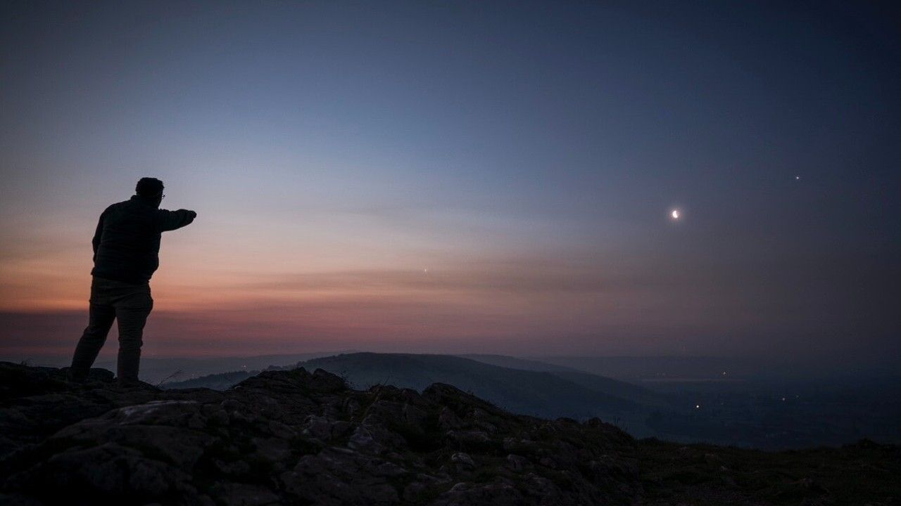
Click for next article A photograph of a planetary alignment on June 1, 2024 taken by Josh Dury near Somerset, England. Mercury, Venus, and Jupiter align low over the western horizon after sunset, creating a satisfying mini planetary parade and a perfect astrophoto opportunity using a wide-angle lens or even just a smartphone. Even though Venus and Jupiter have drifted apart slightly since their tight embrace on June 9, Mercury has climbed up beautifully from the sun's glare to join the party. Together, they form a striking slanted line along the ecliptic in the west-northwestern sky right after sunset. This is a high-speed game. The optimal viewing window starts exactly 30 minutes after your local sunset and lasts for only about 30 to 45 minutes before Jupiter and Mercury follow the sun below the horizon. Look for blazing Venus first - it will pop out while the sky is still bright. Drop your eyes down and slightly to the right to easily spot Mercury and Jupiter. For observers using telescopes or imaging equipment, June 12 also offers an interesting opportunity to compare the appearance of the three worlds. Venus will show a small, intensely bright, 80%-illuminated gibbous disk, while Mercury will present a stark contrast with its 50%-illuminated "half-moon" phase. Resolving a clean, tiny half-Mercury in twilight is an elite visual feather in any amateur's cap. Jupiter will appear as a much larger disk, although its low position above the horizon means atmospheric turbulence may blur some detail. Under steady conditions, advanced imagers may be able to capture hints of the planet's famous equatorial cloud belts alongside Mercury's sharply defined silhouette. Approximate positions of the three planets on June 12 at 9 p.m. local time. (Image credit: Starry Night) For photographers, however, June 12 is all about landscape composition. Put away the prime-focus telescope adaptors and grab a 50 mm to 85 mm prime lens on a DSLR/mirrorless camera. Expose for the deep twilight sky colors and frame the three planets as a slanted cosmic ladder ascending over a crisp local silhouette - like a mountain ridge, a distant city skyline, or a line of pine trees. If you're looking for a telescope or binoculars to observe the night sky in more detail, our guides for the best binocular deals and the best telescope deals can help. Our best cameras for astrophotography and best lenses for astrophotography can help you get ready to capture the next stunning skywatching event.

13. Astronauts watch from space as ice splinters from a glacier | Space photo of the day for June 11, 2026
Read more
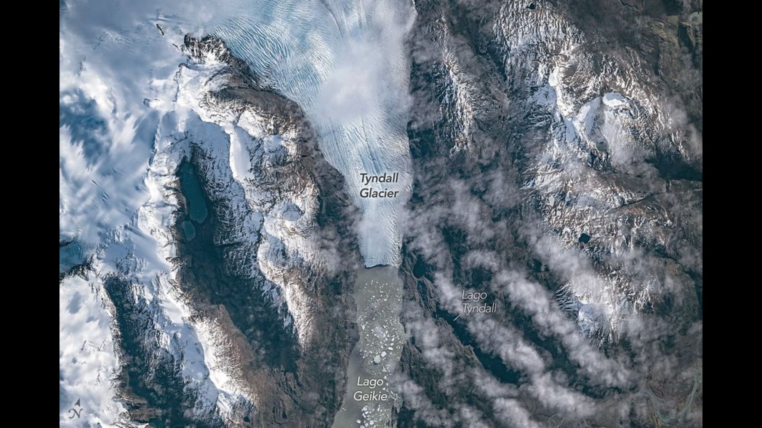
Click for next article The Southern Patagonian Icefield as seen from the International Space Station. (Image credit: NASA) Fragments of ice splintered from a glacier float down an Antarctic lake in a photo captured from aboard the International Space Station. What is it? In a new photograph snapped by astronauts on the International Space Station, you can see pieces of the Tyndall Glacier splintering off and floating out into the lake Lago Geikie. Even from space, the chunks of ice falling from the glacier can be seen floating away. The Tyndall Glacier in southern Chile is part of the Southern Patagonian Icefield. Located between Chile and Argentina, this is the second-largest continuous ice field like it in the world. It measures at over 5,000 square miles of ice (13,000 square kilometers). It is the larger half of two remaining pieces of the Patagonian Ice Sheet, an almost unbelievably massive sheet of ice that covered southern Chile during the last glacial period over 20,000 years ago. Why is it incredible? As of 2025, the worlds glaciers have lost over 300 tons (273 tonnes) of ice in just the last 20 years alone. With the progression of climate change, this ice continues to melt, fragment and contribute to rising sea levels around the globe. And in this image, we can see the process with our own eyes. The Tyndall Glacier has been shrinking for about 150 years; as more and more pieces of this glacier break off or melt, Lago Geikie continues to grow and expand. In the past four years alone, Tyndall has lost 1.4 miles (2.2 kilometers) in length, according to glaciologist Mauri Pelto of Nicholas College. Interestingly, while glacier shrinking is concerning as it contributes to sea level rise which puts coastal communities in serious danger, this glacial retreat revealed some unexpected findings beyond that. As this glacier has fallen away, it has exposed bedrock where scientists have found ichthyosaur fossils.

14. Elon Musk wants to put 1 million AI satellites in space. Here's how SpaceX could do it
Read more
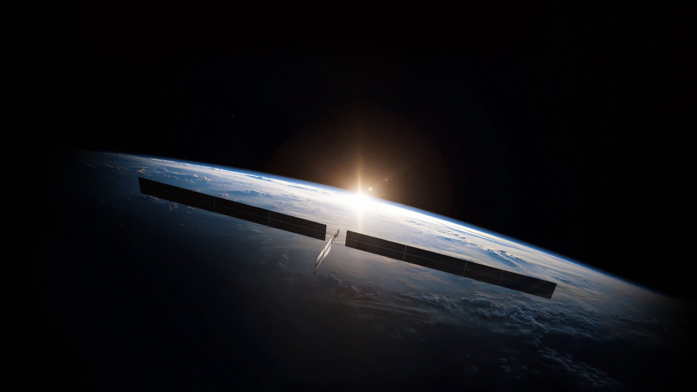
Click for next article SpaceX CEO Elon Musk outlined more details for his company's planned data centers in space ahead of a widely anticipated IPO on Thursday (June 11) expected to make him a trillionaire. A new half-hour video offers a typical Elon Musk fireside chat about where the billionaire founder of SpaceX wants to be taking his technology next. In the video posted on X on Monday (June 8), Musk described launching AI satellites, with "a lot of solar cells", as well as radiators and high-speed optical (laser) links for communication. SpaceX also expects to launch an AI-satellite-focused production facility by the end of next year, to be "operating at some reasonable volume," Musk said. "So, if anybody wants to work on AI satellites, this is kind of going to become the hub of that." The common pitch among these companies is that space is necessary to generate AI capabilities because data centers on Earth are running out of physical space to host them, as well as lacking community support out of concerns about significant power and water usage by these big computing hubs. The challenge is that orbital data centers are mostly notional, and not actually demonstrated by operating tech - at least yet. But SpaceX is confident it can develop the necessary technologies to make an AI data center constellation a reality. A rendering of one of SpaceX's planned AI1 satellites in orbit. (Image credit: SpaceX) The next generation of Starlink satellites SpaceX is developing already possess a lot of the tech needed to advance to AI centers, according to Musk. "A lot of this technology, we've already made for the Starlink V3 satellites," he said. "Basically, we don't think this is a super-hard problem, compared to things we already do." Musk described "racks of compute" (referring to the banks of computer chips on each satellite) that would connect with each other through laser links between the AI satellites, as well as with Starlinks. The data could be sent to the ground using antennas, or laser links at "not a particularly high latency" (meaning, high speed). Each AI satellite, Musk said, would generate 150 kW of power at peak, and 120 kW consistently, and would launch aboard SpaceX's heavy-lift Super Heavy and Starship vehicles the company is still testing out every few months for eventual mission operations. A rendering of one of SpaceX's planned AI1 satellites. (Image credit: SpaceX) The SpaceX CEO also appeared to wave off concerns about overcrowding low Earth orbit , even after numerous reports have emerged about Starlink satellites having to maneuver away from each other or from other spacecraft. (SpaceX's Starlink constellation is currently at 10,000-plus operational members , according to analyst Jonathan McDowell.) "There's a lot of space up there, and so even when you're talking thousands, or even - you know - up to a million satellites , yeah, you got plenty of room to move around up there. Space is really big, so it's not like space is going to get crowded," Musk said in the video. Pointing to the growth of Starlink, Musk said SpaceX is uniquely positioned to be the company delivering on orbital data centers. "We've got a pretty good idea of how to operate, just really large constellations, and do it safely now, right? We are the only operator that has any experience of that scale." A rendering of SpaceX's planned Gigasat factory where the company plans to build large numbers of AI data center satellites. (Image credit: SpaceX) Musk periodically offers these sorts of chats for Starship and the company's Mars plans, often (as with this video) mixing in musings about where he sees "civilization" and "humanity" going next . But lately, there's been financial incentive to add AI into the planning for SpaceX. When the IPO drops, SpaceX plans to list its shares at $135 apiece for a value of more than $1.75 trillion - and it is heavily betting on its company xAI , and orbital data centers in space to generate AI capabilities, in its pitch to investors.

15. Don't miss out on Star Trek: Strange New Worlds season 4 - stream it from anywhere at warp speed using this Norton VPN deal, now up to 70% off
Read more

Click for next article Norton is renowned for providing industry-leading antivirus and security software. The US brand's VPN service is recommended as one of the best VPN services and also one of the most improved VPN providers of 2026 by our tech expert colleagues at TechRadar. Norton VPN scored an impressive 4 out of 5-star rating, with its speeds, ease of use, and straightforward app being some of its review features. Norton has just dropped discounts across its three VPN plans, and you can save up to 70% or $192 when you sign up for a two-year plan. Get up to 70% off when you sign up for a Norton VPN two-year plan at Norton. As well as providing a host of online security features, a VPN allows you to view all your space and sci-fi streaming shows and movies from anywhere in the world. There is a load of exciting sci-fi series coming in the next few months, including Star Trek: Strange New Worlds season 4, which is scheduled to premiere globally on Paramount+ on Thursday, July 23, 2026. The crew of the U.S.S. Enterprise - led by Captain Christopher Pike (Anson Mount) - is set to embark on another season of thrilling and emotional adventures across the stars. Rebecca Romijn, who plays Commander Una Chin-Riley in the acclaimed sci-fi series, recently told fans, "We're so proud of this Strange New Worlds, and we're really proud of season 4; we think it's our best season yet." Save 70% ($140.22) Norton VPN Standard Plan: was $199.98 now $59.76 at Norton Norton has three VPN plans - Standard, Plus, and Ultimate, which have various levels of security features and protection. Norton has a handy comparison table to allow you to select the package that suits you best. It shows the number of devices you can include in the plan (very handy if travelling with family). The Ultimate package offers the biggest savings with $192 off, and just $4.49 per month over a two-year subscription. Check out the best VPN packages for you at Norton. Paul Brett Deal writer Paul Brett is a deals writer at Space, Live Science, and across the Sports and Knowledge titles at Future. Paul is a huge sci-fi fan, hooked on Star Wars from the moment he saw A New Hope in the cinema, and as part of his deals hunting role at Space, has started an unplanned (and expensive) Lego Star Wars collection. Star Trek: Strange New Worlds | Season 4 Official Teaser | Paramount+ (CCXP Mexico 2026) - YouTube Watch On A VPN is a solution to geo-blocking when it comes to viewing your streaming services. Assuming it complies with your broadcaster's T&Cs, you can use a VPN to unblock the streaming services you're subscribed to and allow for uninterrupted viewing from any location. Norton not only unlocks streaming geo-restrictions but also comes with added security benefits, which are particularly useful when overseas and connecting to unknown Wi-Fi connections. It offers ad blockers, anti-malware protection, a password manager and breach scanner, fast connections, and identity theft insurance. It means you can view and download content, work, and generally be online anywhere in the world with confidence. These Norton deals are live now, running from June 11-24 inclusive, with prices and offers varying depending on the plan chosen and your location. Key features: Up to 70% discount, high-speed VPN, ad and tracker blocker, anti-malware protection, password manager, data-breach scanner and cloud backup. Price history: Before today's deal, the price of the popular "Plus" plan was $199.98. It's now 70% off and takes it down to just $59.76, or $2.49 for a two-year plan. ✅ Buy it if: You're looking for maximum online security, and you want to stream all your favorite shows anywhere in the world. ❌ Don't buy it if: Either you already have a VPN, or you're not in the market for one. Those are the only reasons you wouldn't make the most of this excellent value offer. Check out our other guides to the best telescopes, binoculars, cameras, star projectors, drones, lego and much more.

16. SpaceX launches 24 Starlink satellites on Falcon 9 rocket from Vandenberg
Read more
SpaceX launched its next Falcon 9 rocket from Vandenberg Space Force Base on Thursday morning, a day before the company's stock becomes publicly available on the Nasdaq. The Starlink 17-44 mission added another 24 broadband internet satellites to the company's low Earth orbit constellation. There are more than 10,500 Starlink satellites currently in orbit. Liftoff from Space Launch Complex 4 East happened at 8:05:59 a.m. PDT (11:05:59 a.m. EDT / 1505:59 UTC). The rocket flew on a south-southwesterly trajectory upon leaving the pad. SpaceX launched the mission using the Falcon 9 first stage booster with the tail number B1071. This was its 34th flight after launching five times for the National Reconnaissance Office, five SpaceX rideshare missions, Germany's SARah-1, NASA's SWOT, CAS500-2 for South Korea and 20 previous Starlink delivery flights. The first stage booster launched on the SpaceX drone ship, 'Of Course I Still Love You,' positioned in the Pacific Ocean about eight and half minutes after launch. This was the 202nd landing on this vessel and the 622nd booster landing for SpaceX.

