 |  | 

🌌 अंतरिक्ष समाचार | Space News
मंगलवार, ३०/०६/२०२६ | Tuesday, 30/06/2026

1. ISRO successfully conducts 2nd integrated air drop test for Gaganyaan mission - News On AIR
Read more
The Indian Space Research Organisation (ISRO) has successfully conducted the second integrated air drop test (IADT-02) for the upcoming Gaganyaan mission at Sriharikota in Andhra Pradesh. The system is essential to ensure safe recovery of the crew module - the capsule in which astronauts sit during a human flight. After the module's release, a parachute system, comprising 10 parachutes, was deployed, helping the capsule decelerate to a safe splashdown speed. The IADT-02 follows the successful completion of the first IADT, which took place on August 24, 2025, at the Satish Dhawan Space Centre in Sriharikota. In the first IADT, a 4.8-tonne dummy crew module was dropped from a height of three km by a Chinook helicopter. Air drop tests recreate the last leg of a spacecraft's return to the Earth. An aircraft or helicopter drops the spacecraft from a height to test various systems under different scenarios. These are the deployment of the parachute system in case the mission is aborted mid-flight, system performance when one parachute fails to open, and the spacecraft's orientation and safety during splashdown. Union Minister Jitendra Singh congratulated the ISRO for successfully conducting the test. India's first human spaceflight will be launched from Sriharikota in 2027.

2. Former ISRO scientist Mayilsamy Annadurai to lead panel to overhaul TN school curriculum - ThePrint
Read more
Accordingly, the committee has been tasked with redesigning the existing curriculum to ensure students are well-equipped to meet evolving modern challenges and technological changes. The initiative aims to improve the quality of education for school students in the state to international standards and modernise the syllabus to align with contemporary global advancements, a recent government order said. Chennai, Jun 30 (PTI) The Tamil Nadu government has formed a new expert panel led by former ISRO scientist Mayilsamy Annadurai to overhaul the state board school education syllabus. The tenure of the 17-member committee headed by Annadurai, comprising educationists and academicians, will be three years from the date of issue of the government order. The government has also given permission to the State Council of Education Research and Training (SCERT) to constitute such other sub-committees for syllabus development, textbook enhancement and other academic activities necessary for the purpose. PTI SNR SNR ADB This report is auto-generated from PTI news service. ThePrint holds no responsibility for its content.

3. ISRO scientist Mayilsamy Annadurai named chairman of Tamil Nadu curriculum panel - The New Indian Express
Read more

CHENNAI: The School Education Department has appointed noted ISRO scientist Dr Mayilsamy Annadurai as the new chairman of the Curriculum Design Committee. A government order for the appointment was issued following the resignation of Sultan Ahmed Ismail (Retd), former head of the Department of Zoology at The New College and a member of the State Planning Commission, from the post. Annadurai, who served as project director of Chandrayaan-1 and later held key leadership roles in the Chandrayaan-2 and Mangalyaan mission, studied in government schools before pursuing engineering at the Government College of Technology, Coimbatore. Two committees were consituted in November 2025 to revamp the school curriculum and syllabus - the Curriculum Design Committee and the High-Level Expert Committee. While the High-Level Expert Committee is headed by the School Education Minister, the Curriculum Design Committee was initially chaired by Sultan Ahmed Ismail. Officials said Ismail chose to step down following the change in government. Annadurai has now been appointed to head the committee, while the remaining members of the 16-member panel have been retained.

4. Skyroot closer to Vikram-I launch: Private rocket getting stacked at Isro launch pad - India Today
Read more
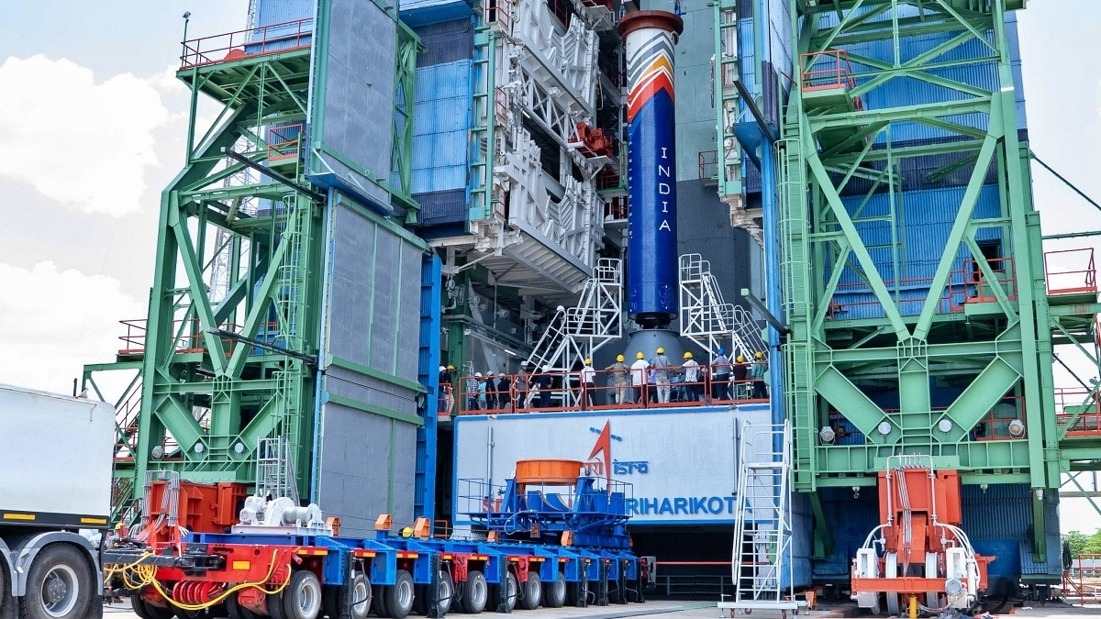
Indian space startup Skyroot Aerospace has crossed another major milestone in its journey to orbit, announcing that the first stage of its Vikram-I rocket has been successfully stacked at the First Launch Pad at the Satish Dhawan Space Centre in Sriharikota. The development marks a historic first for India's private space sector. According to Skyroot, it is the first time a privately designed, developed and manufactured orbital launch vehicle has been stacked on ISRO's First Launch Pad, a facility that has hosted some of the country's most iconic missions, including Chandrayaan and Mars Orbiter launches. Read Full Story The company shared images of the towering rocket stage being lifted into position, calling it a significant step towards the maiden launch of Vikram-I. Skyroot Vikram 1 is a multi-stage, small-lift orbital launch vehicle. (Photo: Skyroot) "Piece by piece, Vikram-I is coming alive - each stage carefully lifted, aligned and integrated into a single flight-ready rocket," Skyroot said in an X post. Rocket stacking is one of the final and most critical phases before launch. During the process, individual stages, payload structures and other components are assembled vertically on the launch pad with millimetre-level precision. Once fully integrated, the vehicle undergoes a series of electrical, mechanical and fueling readiness checks before the launch countdown can begin. Vikram-I is Skyroot's first orbital launch vehicle and has been designed to carry small satellites into low-Earth orbit. Vikram-I is built to carry communication, Earth observation, and university research payloads. (Photo: Skyroot) Named after Indian space pioneer Dr. Vikram Sarabhai, the rocket represents one of the country's most ambitious privately built launch systems since the Indian space sector was opened to private participation. The stacking milestone comes nearly three years after Skyroot made history with Vikram-S, India's first privately developed rocket to fly to space, in November 2022. Since then, the Hyderabad-based company has carried out a series of successful engine tests, stage qualification trials and launch vehicle integration activities in preparation for its first orbital mission. The upcoming launch of Vikram-I is expected to be a defining moment for India's growing commercial space industry. A successful mission would demonstrate that private Indian companies are capable of building and launching orbital-class rockets, opening new opportunities in the rapidly expanding global small satellite launch market. By providing access to launch infrastructure at Sriharikota, ISRO is enabling Indian startups to accelerate the development of indigenous launch vehicles while expanding the country's commercial space capabilities. - Ends

5. Former ISRO scientist Mylswamy Annadurai to head TN curriculum panel - The News Minute
Read more
Follow TNM's WhatsApp channel for news updates and story links. The Tamil Nadu School Education Department on Monday, June 29, appointed former Indian Space Research Organisation (ISRO) scientist Mylswamy Annadurai as the chairperson of the Curriculum Design Committee, replacing biologist Sultan Ahmed Ismail. A Government Order (GO) issued by the department reconstituted the committee, appointing Annadurai as its chairperson while retaining the other members of the 16-member panel. Annadurai is best known for serving as the project director of Chandrayaan-1 and for holding key leadership roles in the Chandrayaan-2 and Mangalyaan missions. He completed his schooling in government schools before pursuing engineering at the Government College of Technology, Coimbatore. The Curriculum Design Committee was constituted in November 2025 as part of the state government's initiative to revise the school curriculum and syllabus. A High-Level Expert Committee, headed by the School Education Minister, was also constituted to oversee the curriculum revision. Sultan Ahmed Ismail, former Head of the Department of Zoology at The New College and a member of the State Planning Commission, was appointed as the first chairperson of the Curriculum Design Committee. In June, Sultan Ahmed Ismail said in a social media post that the Tamil Nadu government had asked him to resign from the post as it planned to reconstitute the committee. Thanking former Chief Minister MK Stalin, he wished the incoming team well and expressed hope that it would continue the work undertaken by the previous committee. According to the GO, the reconstituted committee will have a tenure of three years. Its members will receive an honorarium, travel allowance, and accommodation in accordance with government norms. The department has so far introduced textbooks based on the revised curriculum for Classes 1 to 3.

6. TN govt reconstitutes Curriculum Design Committee, ISRO ex-chief Mayilsamy Annadurai to head - DT Next
Read more
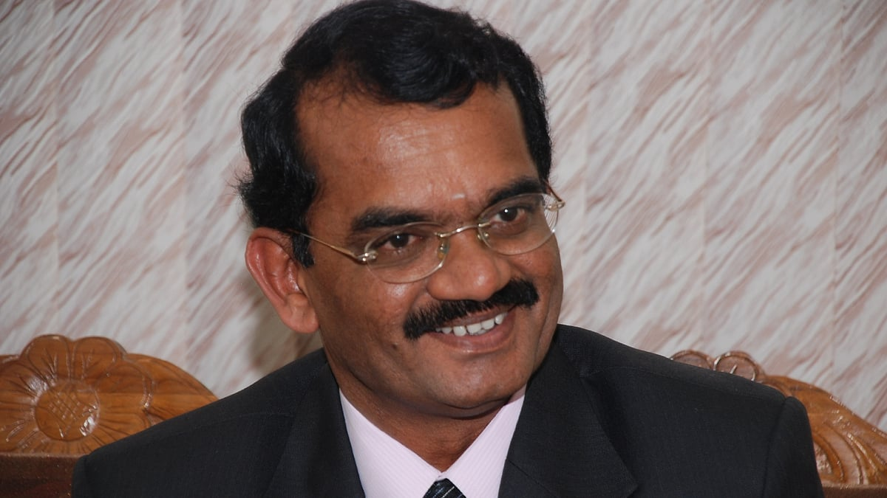
The committee has been mandated to develop the State curriculum and syllabus. The government has also authorised the Director of the State Council of Educational Research and Training (SCERT) to constitute sub-committees for syllabus development, textbook preparation and other academic activities. In November 2025, the then DMK government had constituted a High-Level Curriculum Expert Committee, headed by then School Education Minister Anbil Mahesh Poyyamozhi, and a Curriculum Design Committee chaired by Sultan Ahmed Ismail. Before its reconstitution, the curriculum committee had completed and released the Term I textbooks for Classes 1, 2 and 3, which are being used in schools during the current academic year.

7. NASA, SBA Announce New Initiative to Scale American Space Economy
Read more

NASA Administrator Jared Isaacman, right, and Administrator of the Small Business Administration Kelly Loeffler, left, pose for a photo after signing a Memorandum of Agreement Monday, June 29, 2026, at the Mary W. Jackson NASA Headquarters building in Washington. This Memorandum of Agreement will provide the framework for NASA and the Small Business Administration Office of Investment and Innovation to support the growth of the Small Business Investment Company-NASA Initiative. Credit: NASA/Keegan Barber NASA and the U.S. Small Business Administration (SBA) launched the SBIC-NASA Initiative on Monday to increase investment in American manufacturers of industrial components and providers of technologies critical to space exploration to support a sustained presence on the Moon and Mars. Under the Memorandum of Agreement, NASA will identify technology priorities and connect businesses to funding opportunities through the agency's new NASA Office of Strategic Capital. The initiative also will be a part of SBA's Small Business Investment Company (SBIC) Program, which provides leverage that matches private capital raised by investment funds and is designed to enhance fund-level investment returns. "To achieve President Trump's National Space Policy, NASA needs a stronger industrial base capable of moving at the speed this new space race demands," said NASA Administrator Jared Isaacman. "Through the NASA Office of Strategic Capital, this partnership with the SBA will help small businesses access the capital they need to scale, strengthen critical supply chains, rebuild America's industrial might, and deliver the outcomes necessary to ensure the United States leads the next era of space exploration." By augmenting the investable capital for investment funds licensed by the SBA under this SBIC-NASA Initiative, the new initiative expands access to capital for small businesses within the space industry. "To meet President Trump's objective of securing American leadership on every frontier, the SBA and NASA are partnering to supercharge the industrial base behind our space program and connect the innovators building critical technologies with needed capital," said SBA Administrator Kelly Loeffler. "Through this partnership with NASA, the SBA is mobilizing private sector investment to fuel the small businesses, manufacturers, and innovators that are driving American space dominance. By aligning capital with strategic national priorities, this exciting effort will help launch the next great era of space exploration." Under the agreement, NASA will define strategic aerospace technology focus areas and identify supply chain needs. The SBA will use those priorities to attract and license qualified private investment funds that commit to invest at least 60% of their capital into NASA-identified focus areas, including: Energy production, infrastructure, and storage Nuclear power and propulsion Advanced software, avionics, and communications systems Specialized materials and components Inhospitable environment infrastructure Scaled launch infrastructure Biomedical and life support technology Through this partnership between NASA and SBA, capital will flow into space industry sectors and upstream supply chain components vital to the National Space Policy and critical to national and economic security. For details about the new initiative and NASA's Office of Strategic Capital, visit: https://www.nasa.gov/strategiccapital -end- Camille Gallo / Cheryl Warner Headquarters, Washington 202-358-1600 camille.m.gallo@nasa.gov / cheryl.m.warner@nasa.gov

8. NASA Astronaut Chris Williams Preps for Spacewalk
Read more

X-ray: NASA/CXC/SAO; Optical: NASA/ESA/STScI/AURA; IR:NASA/JPL/Caltech; Image Processing: NASA/CXC/SAO/N. Wolk Flight engineer Sophie Adenot of ESA (European Space Agency) helps flight engineer Chris Williams of NASA as he tries on his spacesuit on June 23, 2026, testing its comfort and mobility as well as its communications and life support systems inside the International Space Station's Quest airlock. Williams will go on a spacewalk on June 30 with fellow NASA astronaut Jessica Meir. They will replace a malfunctioning wrist joint on the Canadarm2 robotic arm. Image credit: NASA/Jessica Meir

9. NASA Seeks Industry Input to Accelerate Lunar Surface Technologies
Read more

Artistic concept of lunar surface technologies and infrastructure capabilities, including in-situ resource utilization oxygen production systems, surface power systems, in‑space manufacturing tools, and advanced nanomaterials production. NASA Long-term lunar exploration requires technology, infrastructure, and operations that function together cohesively on the surface of the Moon. To accelerate the development of key lunar surface systems and reduce risk, NASA and industry must work together in the design, development, testing, and evaluation of innovative solutions that support U.S. space priorities. NASA is seeking feedback on a draft solicitation for the Lunar Enabling Infrastructure Accelerator, an effort to help develop emerging capabilities in surface power, in-situ resource utilization, advanced manufacturing, and innovative nanomaterials. The draft is available for review by U.S. organizations, including industry, educational institutions, and non-profits. Investments in space technology development unlock the near-impossible for NASA and the nation. A sustained human presence at the Moon requires breakthrough ideas from a competitive U.S industrial base, and we are proud to work toward that vision with our commercial partners. Greg Stover Director of the Advanced Research and Technology Division, Research and Technology Mission Directorate at NASA Headquarters in Washington This review period allows NASA an opportunity to gather feedback on the draft solicitation, including the requirements, schedules, proposal instructions, and evaluation approaches. NASA strongly encourages industry to carefully review the draft and identify any areas of ambiguity, or concerns. Industry input will help inform the solicitation's final requirements, acquisition planning, and solicitation parameters. The Lunar Enabling Infrastructure Accelerator includes five topics that address gaps in technology needed for exploring the Moon and the cislunar region between Earth and the Moon as identified in NASA's Civil Space Shortfalls. The topics focus on near-term mission priorities: Surface power: Access to continuous, localized, and scalable power generation throughout the lunar day and night is essential for initial phases of the Moon Base plan. NASA's needs include power generation, power management and distribution, and energy storage. Radioisotope power: A type of nuclear energy technology that uses heat to produce electric power for operating spacecraft systems in the darkest, dustiest, and most remote places in our solar system. In-situ resource utilization: As a sustained presence grows at the Moon, opportunities to harvest lunar resources could lead to safer, more efficient operations with less dependence on Earth. Advancing in-situ resource utilization technologies could support production of fuel, water, and oxygen from local materials, expanding exploration capabilities. In-space advanced manufacturing: Long-term human presence beyond Earth orbit requires autonomous in-space production of essential tools and materials. Advancing in-space manufacturing will be critical to reducing reliance on Earth resupply, as well as optimizing mission flexibility and resilience at the Moon, Mars, and elsewhere in deep space. Innovative nanomaterials: U.S. objectives related to the commercialization of low Earth orbit, building a sustained presence on the lunar surface, and pursuing deeper space exploration will involve work in demanding operational environments and under stringent mission constraints. To meet the agency's most ambitious space exploration goals, this topic seeks to advance the commercial availability, performance, quality, and uniformity of nanomaterials to address environmental, mass, and performance challenges. Lunar Enabling Infrastructure Accelerator awardees will be expected to design, develop, and demonstrate prototype systems and generate validated performance data, analytical models, and operational insights through testing and demonstration activities to mature technology and manufacturing applications. The solicitation, Next Space Technologies for Exploration Partnerships-3 (NextSTEP-3) Appendix A Lunar Enabling Infrastructure Accelerator (Solicitation No: 80GRC026R0008), is available on SAM.gov and is open for comment through July 17, 2026. For more information about NASA's space technology website as a reference for current technology strategy and priorities, visit: https://www.nasa.gov/resources/

10. 'The start of a new era': Rocket Lab buying satellite-communications company Iridium for $8 billion
Read more
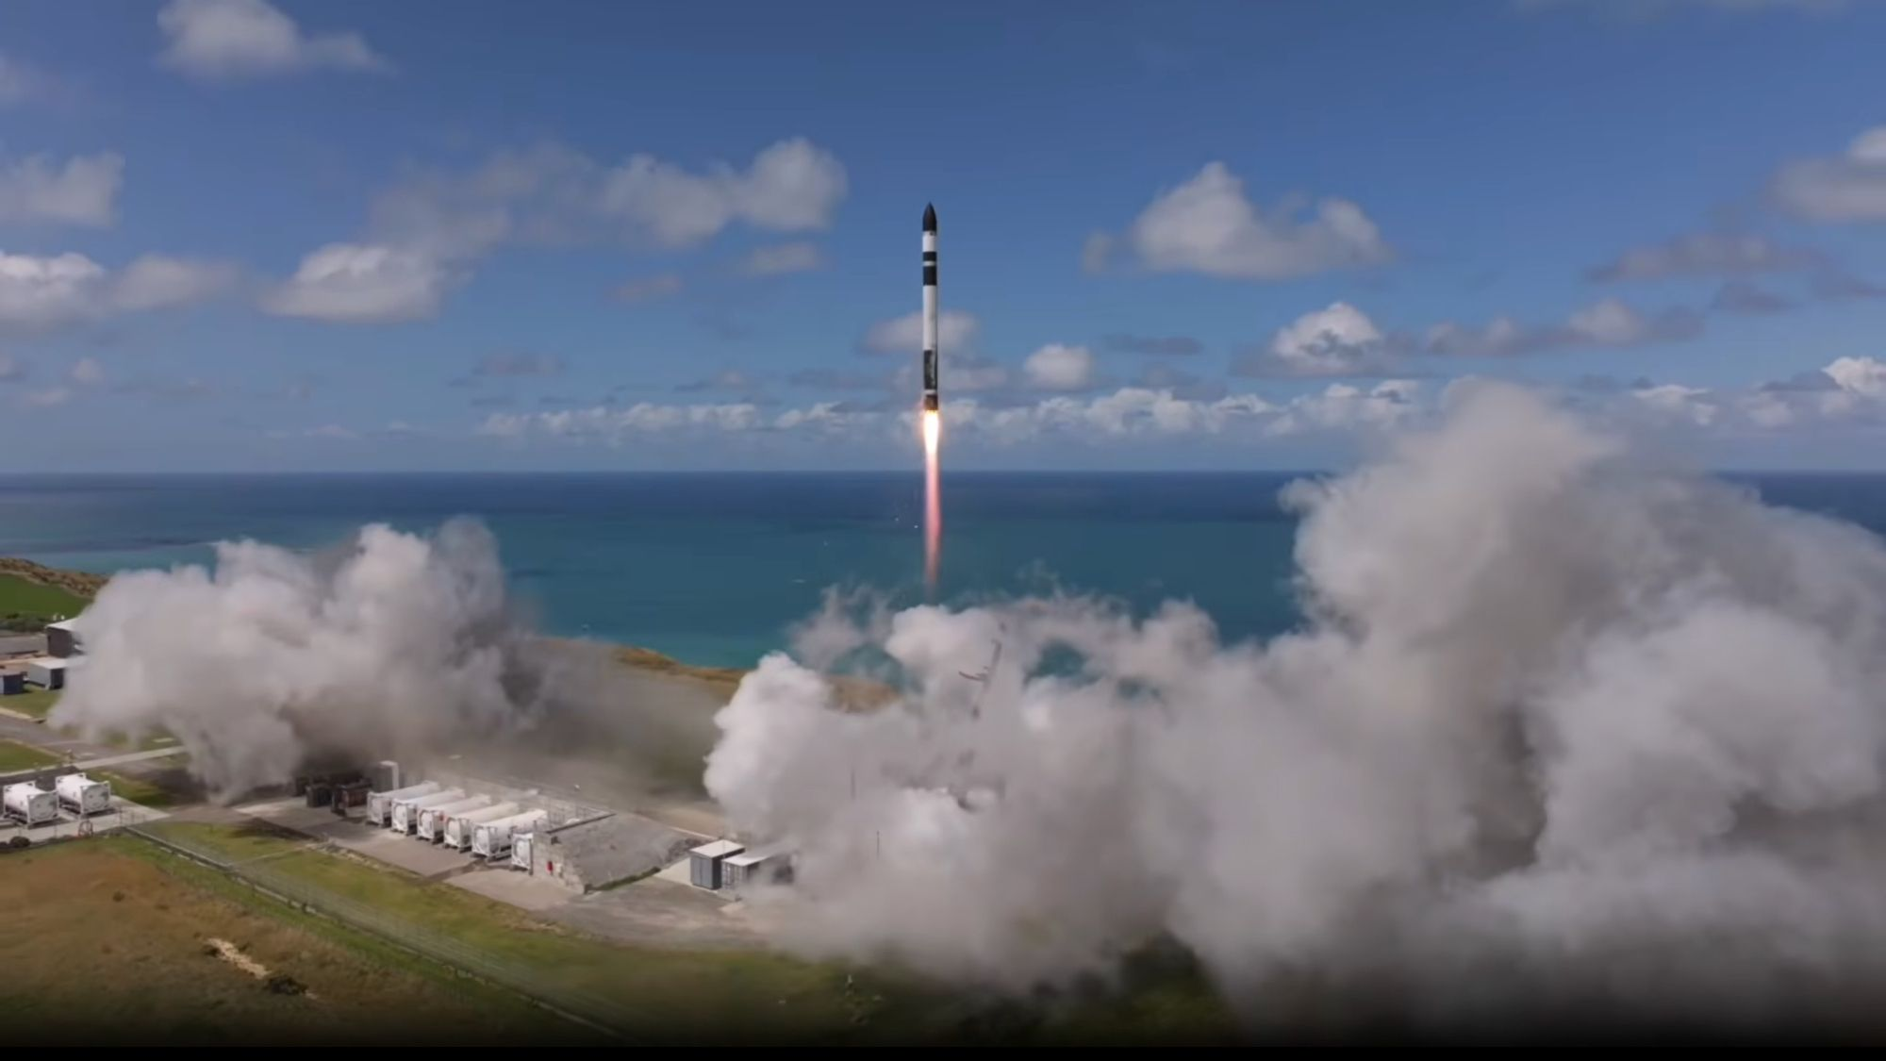
Click for next article California-based launch company Rocket Lab has inked a landmark $8 billion deal to acquire long-time satellite communications giant Iridium. Rocket Lab has brought a variety of companies into its space systems architecture in recent years, but none of those previous purchases were as notable as the acquisition announced today (June 29). Rocket Lab and Iridium settled on the purchase at $54 per share, equating to an $8 billion deal for the legacy satellite operator. "This is a defining moment for the space industry and the start of a new era of strategic, accelerated growth for Rocket Lab and Iridium," Rocket Lab CEO Peter Beck said in a statement . The merger folds another area of expertise into Rocket Lab's growing, vertically integrated operations and creates a stream of continued revenue from Iridium's existing subscribers. Iridium is a Virginia-based communications company that operates a constellation of L-band satellites in low Earth orbit (LEO) that provide a global network of voice, Internet of Things, aviation, maritime, defense and emergency communications services to more than 2.5 million customers. It was founded by Motorola, via the company's efforts in the 1980s to establish a handheld global satellite phone network. Iridium operated one of the first large commercial LEO constellations, but the success didn't last; the company went bankrupt in 1999. Iridium later rebuilt its constellation through the $3 billion Iridium NEXT campaign, launching 75 replacement satellites aboard SpaceX rockets between 2017 and 2019. Soon, that network will be operating under Rocket Lab's supervision. The newly announced agreement comes as Rocket Lab ramps up its business ventures, as well as its dealings with the U.S. government as a national defense contractor. Within just the last month, Rocket Lab passed a major test in its program to deliver a constellation of advanced missile warning and tracking satellites for the U.S. Space Force (USSF), broke a responsive readiness record by executing a Tactically Responsive Space launch within 16 hours and 42 minutes of receiving notice from USSF's Space Systems Command, and announced its selection by NASA for three different science missions to launch in 2027. Now that it's bringing Iridium under its umbrella, Rocket Lab is making even bigger plans. Instead of just supporting Iridium's existing network, Rocket Lab is planning its expansion. "We will go far beyond maintaining a legacy; we are going to build upon it to pioneer next-generation space applications and deliver sought-after capabilities to existing and new customers," Beck said. That includes Iridium's next-generation direct-to-device satellite network and the capabilities it will add to Rocket Lab's potential national security contributions. "By marrying Iridium's deep heritage, trusted infrastructure, and highly-sought-after spectrum with Rocket Lab's extensive and proven launch and manufacturing capabilities, we have the capability to unlock entirely new markets," Beck said.

11. Watch 2 NASA astronauts fix ISS' huge robotic arm during spacewalk today
Read more
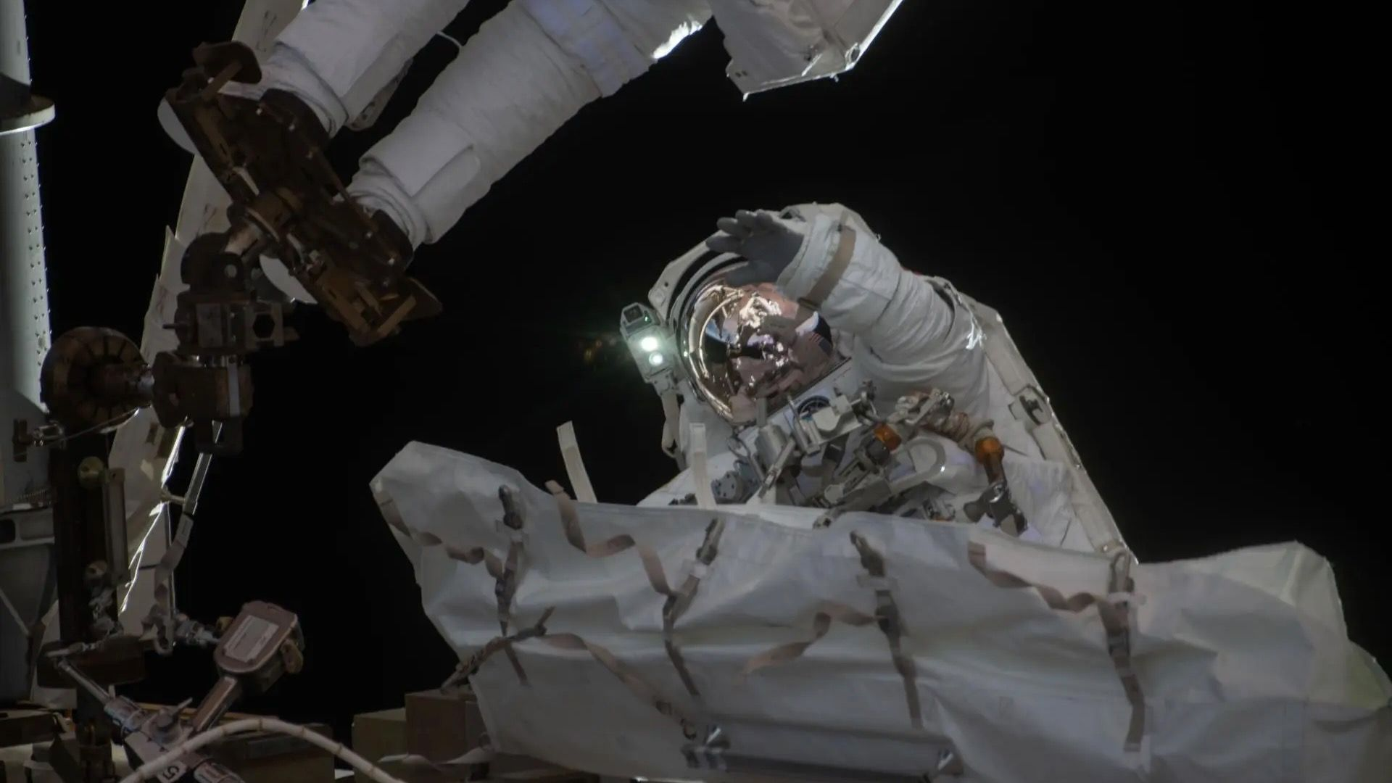
Click for next article U.S. Spacewalk 95 - YouTube Watch On NASA astronauts Chris Williams and Jessica Meir will fix the International Space Station's Canadarm2 during a spacewalk today (June 30), and you can watch the action live. Chris Williams and Jessica Meir will perform a roughly 6.5-hour spacewalk outside the International Space Station (ISS) today, starting at about 8:35 a.m. EDT (1235 GMT). You can watch here at Space.com courtesy of NASA, or directly via the agency . Coverage will begin at 7:00 a.m. EDT (1100 GMT). NASA astronaut Jessica Meir waves at the camera during a seven-hour, two-minute spacewalk outside the International Space Station on March 18, 2026. (Image credit: NASA) Williams and Meir will replace a 200-pound (90-kilogram) wrist joint, which malfunctioned "during normal Canadarm2 operations on May 27 after the arm drew elevated motor current and did not move as expected," NASA officials wrote in a June 22 spacewalk preview . The spare joint was already on board the ISS, which has been continuously occupied by rotating astronaut crews since November 2000. "Repairs to robotics, like Canadarm2, are normal and expected after more than 25 years of continuous operations, as the system was designed with replaceable components and planned maintenance in mind," NASA officials added in the preview. Canadarm2 is nearly as old as the ISS. The 56-foot-long (17-meter-long), 3,300-pound (1,500-kg) robot arrived at the orbiting lab aboard the space shuttle Endeavour in April 2001. Today's extravehicular activity (EVA) will be the second for Williams, who will be "spacewalk crewmember 1" and will wear a spacesuit with red stripes. It will be the fifth for Meir, who will be "spacewalk crewmember 2" and will wear a suit with no stripes. The duo performed an EVA together this past March , spending seven hours prepping the orbiting lab for a new solar array. Astronauts have performed a total of 279 spacewalks outside the ISS to date.

12. NASA to launch rescue mission June 30 to save Swift space telescope from burning up in Earth's atmosphere
Read more
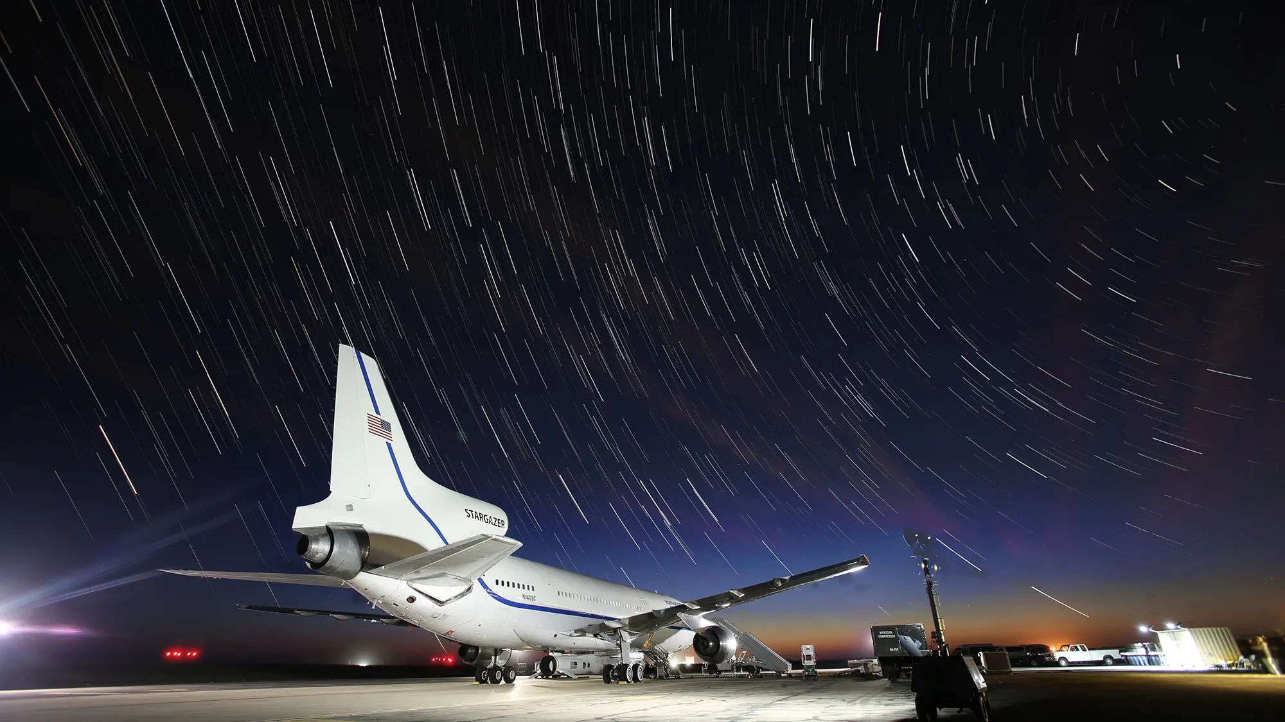
Click for next article An air-launched Northrop Grumman Pegasus XL rocket is scheduled to fly for the very last time early Tuesday morning (June 30), sending a private spacecraft on a rescue mission to save one of NASA's most iconic space telescopes from falling back to Earth. The Swift Boost mission will send the LINK satellite, built by Arizona-based Katalyst Space Technologies, to grapple NASA's Neil Gehrels Swift Observatory and tow it to a stable orbit, saving it from impending destruction as its trajectory dips farther into the atmosphere . LINK, aboard Pegasus, will take off from Bucholz Army Airfield at Kwajalein Atoll in the Marshall Islands, secured to Northrop Grumman's L-1011 Stargazer jet. Liftoff is scheduled for 6:23 a.m. EDT (1023 GMT), Tuesday. Pegasus will be released by Stargazer once the aircraft reaches about 39,000 feet (12,000 meters), traveling at Mach 0.82. Five seconds later, the rocket will ignite its engine and ascend to orbit. Pegasus is a three-stage, solid rocket-propelled launch vehicle that measures 55 feet in length (16.9 meters), capable of delivering up to 1,000 pounds (454 kg) into low-earth orbit (LEO). Following its separation from the Stargazer, the rocket's stages are ignited in sequence to reach its intended altitude in about 10 minutes. Pegasus debuted in 1990, and has since flown 45 missions. Its aerial deployment and flexibility to take off from different airfields allows the rocket to enter hard-to-reach orbital inclinations that are inaccessible from many major spaceports. That's one of the reasons Pegasus is launching LINK, a robotic servicing satellite that can reach Swift's low 20.6-degree inclination relative to Earth's equator. Another reason NASA chose the Pegasus rocket for this mission was time, which is running out for Swift. The $500 million Swift Observatory was launched in November 2004 to study gamma-ray bursts and other high-energy events across the universe. And, despite its more than 20 years of operation, Swift is still providing scientific value. Its orbit, though, has begun to dip dangerously low, where recent solar activity has increased atmospheric drag at higher LEO altitudes and will soon overcome the spacecraft, dragging it to its ultimate demise. Swift, unfortunately, was not designed to be serviced, and wasn't built with the thrusters it needs to raise its own orbit. Enter LINK. After its release from Pegasus' payload bay and initial systems checkouts, the Katalyst spacecraft will begin its long course to rendezvous with Swift. Before beginning its final approach, LINK will spend two to three weeks performing observations of Swift to assess optimal grapple points on the observatory. Stargazer flight path prior to Pegasus XL deployment. (Image credit: Northrop Grumman) LINK measures about 4.9 feet (1.5 m) tall, and is equipped with three robotic arms that will be used to capture Swift, which stretches about 12.7 feet (3.9 m). Once a grab-point is chosen and Swift secured, LINK will fire a set of gentle ion thrusters that will slowly raise the pair's orbit over the next several months. LINK is poised to be the first private spacecraft to attempt to capture an uncrewed U.S. government satellite. NASA selected Katalyst for the task in September 2025, with less than a year to carry out LINK's design, manufacture and testing. Despite its urgency and the relative short notice to get LINK in orbit, the entire Swift rescue mission and launch only cost NASA $30 million. "While NASA could have allowed Swift to re-enter the atmosphere, the situation presented an opportunity to demonstrate a key capability for the future of space exploration. This daring approach also extends Swift's scientific lifetime and is more affordable than replacing the observatory's unique capabilities," NASA states on the Swift Boost mission page . The goal is to return Swift to its original altitude of about 373 miles (600 km), which will extend the observatory's life expectancy by a number of years, provided its systems continue to operate as designed.

13. How NASA's 'America 250' celebrations are reaching from the sky to the moon
Read more
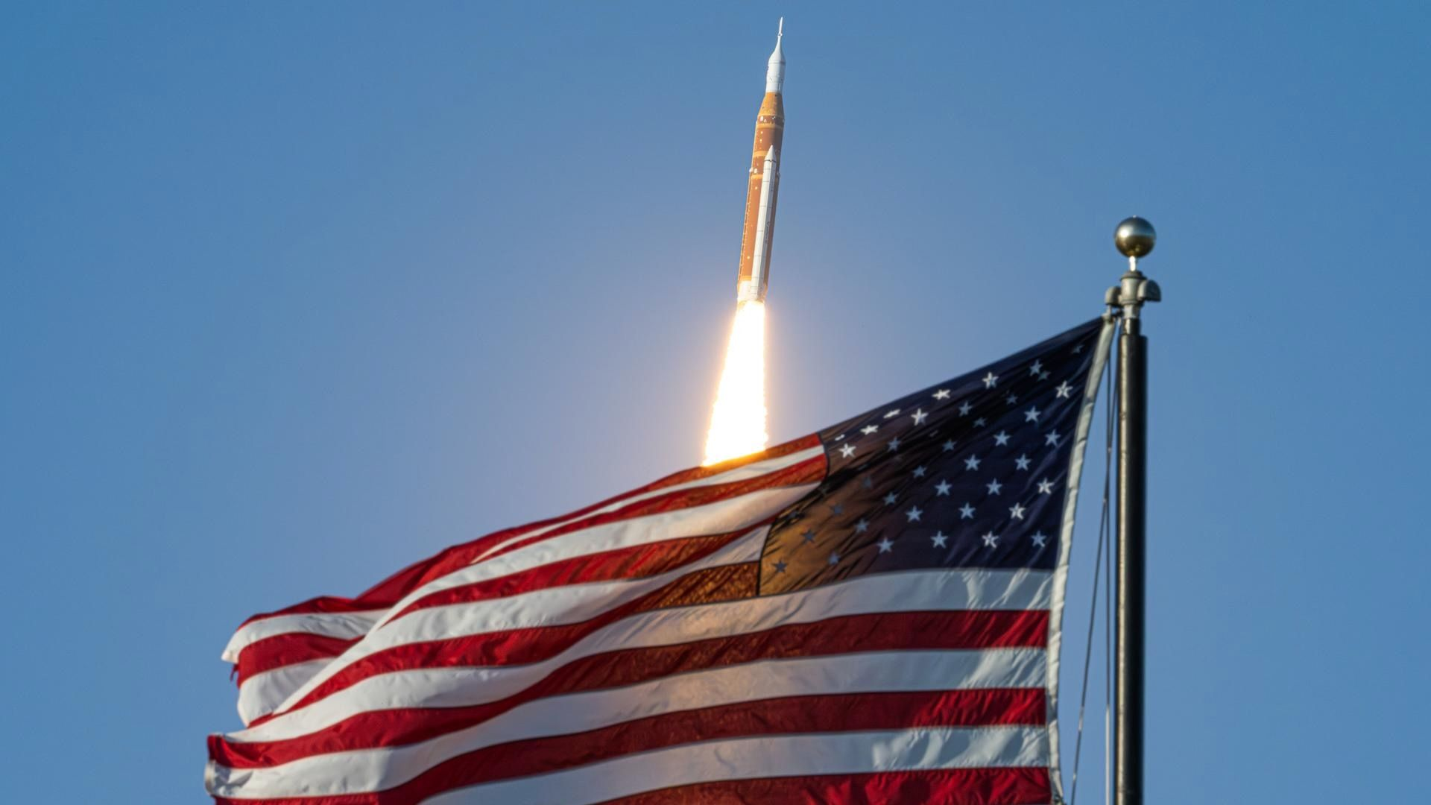
Click for next article NASA's Space Launch System rocket and Orion spacecraft launch on the Artemis 2 test flight on April 1, 2026, from Kennedy Space Center in Florida. NASA is taking the "America 250" birthday celebration to new heights. The agency has big plans for July 4 - the 250th anniversary of the ratification of the Declaration of Independence - which involves both aircraft and spacecraft. "From the earliest days of exploration, to the first steps on the moon and the missions shaping our future, NASA represents the spirit of discovery that defines our nation," the agency wrote on a webpage marking the milestone anniversary. A special patch worn by the Artemis 2 astronauts honors America's 250th anniversary. The theme of NASA's celebration is "Rocket's Red Glare," a famous lyric in "The Star-Spangled Banner." (Image credit: NASA/Joel Kowsky) The party was already underway in April, when the Artemis 2 mission circled the moon. The four Artemis 2 astronauts - three from NASA and one from the Canadian Space Agency - sported "America 250" patches among their gear. The patch shows NASA's Space Launch System (SLS) rocket launching into the black, near a "250" surrounded by stars. Around the edges of the patch are the words "NASA: The rocket's red glare," alluding to the U.S. national anthem. Another version of the America 250 emblem, prominently featuring the numbers in red and blue, also was mounted on each of the solid rocket boosters of Artemis 2's SLS. There's a lot more planned in the coming weeks to ramp up to Independence Day and beyond. NASA said it will have a "series of special aircraft flyovers" at the following locations and times: July 3-5: The Great American State Fair, Washington, D.C. July 4: Salute to America: The Nation's 250th Birthday Fireworks Celebration, Washington, D.C. July 23-24: EAA AirVenture, Oshkosh, Wisconsin Aug. 23: Freedom 250 Grand Prix of Washington, D.C. Oct. 3-4: Pacific Air Show, Huntington Beach, California Oct. 31-Nov. 1: Commemorative Air Force Wings Over Houston Air Show The agency also plans to make a special appearance at the Great American State Fair on the National Mall in Washington, D.C., between June 25 and July 10. NASA will host a pavilion featuring Artemis , a model of its planned Moon Base and a crew survival suit for the Orion spacecraft . Other pavilion exhibits include "authentic spacesuit tools, immersive pop-up visuals, the X-59 experimental aircraft model, interactive tabletop demonstrations, astronaut food, and life-size astronaut cutouts for photos," NASA officials stated. NASA has also celebrated America 250 by displaying the event logo on the countdown clock at NASA's Kennedy Space Center in Florida, the Artemis 2 launch site, and lighting up the Washington Monument with an SLS rocket projection around New Year's Eve. Meanwhile, NASA's Kennedy Space Center Visitor Complex is offering a " 250 Space Dreams " contest between July 1 and Aug. 2. The Space Coast facility will randomly select visitors to receive an envelope with a certificate and QR code inside. Prizes will vary, but winners could receive NASA merch, spots on a bus tour, a free ticket to an astronaut chat, or grand prizes for things such as signed astronaut gear or $250 for on-site souvenirs.

14. The James Webb Space Telescope peered into one of the universe's oldest galaxy clusters, and scientists can't explain what they saw
Read more

Click for next article Using the James Webb Space Telescope, astronomers have spotted a massive and densely packed galaxy cluster at "cosmic noon." The fact that this cluster is so highly evolved could change theories of cosmic evolution, as it seems to exist before such structures were thought to be possible. Designated XLSSC 122 and first seen in 2014, the cluster immediately stood out to the team in James Webb Space Telescope (JWST) data because, being so large and concentrated, it resembled the galactic clusters found much closer to our own galaxy. However, this cluster is seen as it was around 10.4 billion years, just around 3.4 billion years after the Big Bang , a time when such structures were theorized to have only just begun to assemble. Even more excitingly, XLSSC 122 is acting as a gravitational lens and is aligned with even more distant galaxies, amplifying their light and making them easier to study. "When we got those first images back from JWST, we said, 'wow, look at this, there's strong lensing coming from this cluster!' XLSSC 122 has now set the record for the most distant galaxy cluster displaying strong lensing, which is a valuable tool for astronomers," team leader Kyle Finner of the California Institute of Technology said in a statement . What is gravitational lensing and why is it so useful? Gravitational lensing was first predicted by Albert Einstein in his 1915 theory of gravity, known as general relativity . General relativity says that objects with mass cause the fabric of space and time to warp. Think of this as being akin to placing a bowling ball on a stretched rubber sheet. Gravity arises from this curvature. The greater the mass of the object, the more extreme the curvature and thus the greater the gravitational influence of that object. But there is another consequence. Light normally travels in a straight line, but spacetime is the track that it follows. If spacetime is curved, then the path of light is also curved. The closer that light travels to an object of great mass, the more its path swerves. That means when an object of great mass, in this case XLSSC 122, comes between Earth and a more distant light source, light from that background source arrives at our telescopes at different times based on the path it took around the intermediate object. This amplifies light from the background source and has been used by the JWST team to great effect in the study of ancient galaxies . When the Hubble Space Telescope previously studied XLSSC 122, it wasn't able to capture images that showed it was a strong gravitational lens; it took the tremendous observing power of the JWST to determine this. Two-panel image shows a distant galaxy cluster as it has been observed by NASA's Hubble Space Telescope and JWST. (Image credit: NASA, ESA, CSA; Kyle Finner (Caltech/IPAC) Image processing: Robert Hurt (Caltech/IPAC-SELab))

