 |  | 

🌌 अंतरिक्ष समाचार | Space News
गुरुवार, २२/१०/२०२६ | Thursday, 22/10/2026

1. ISRO recruitment 2026: Applications open for 97 posts; check eligibility and steps to apply - The Times of India
Read more
ISRO recruitment 2026: Applications open for 97 posts; check eligibility and steps to apply The Times of India

2. ISRO Admit Card 2026, Download Scientist Engineer Hall Ticket Here - Adda247
Read more
ISRO Admit Card 2026, Download Scientist Engineer Hall Ticket Here Adda247

3. ESTIC 2026 to Focus on Scientific Advancement Towards Viksit Bharat 2047, Says ISRO Chairman V Narayanan - News On AIR
Read more
ESTIC 2026 to Focus on Scientific Advancement Towards Viksit Bharat 2047, Says ISRO Chairman V Narayanan News On AIR

4. ISRO Validates Gaganyaan Module Separation Systems - https://www.usthadian.com/
Read more
ISRO Validates Gaganyaan Module Separation Systems https://www.usthadian.com/

5. Ex-ISRO chairman on privatisation and what left the space community 'alarmed' - Newslaundry
Read more
Ex-ISRO chairman on privatisation and what left the space community 'alarmed' Newslaundry

6. ISRO Recruitment 2026: Applications Open For 97 Posts, Check Last Date And How To Apply - NDTV Profit
Read more
ISRO Recruitment 2026: Applications Open For 97 Posts, Check Last Date And How To Apply NDTV Profit

7. NASA JPL Looks to Next 90 Years of Innovation, Exploration
Read more
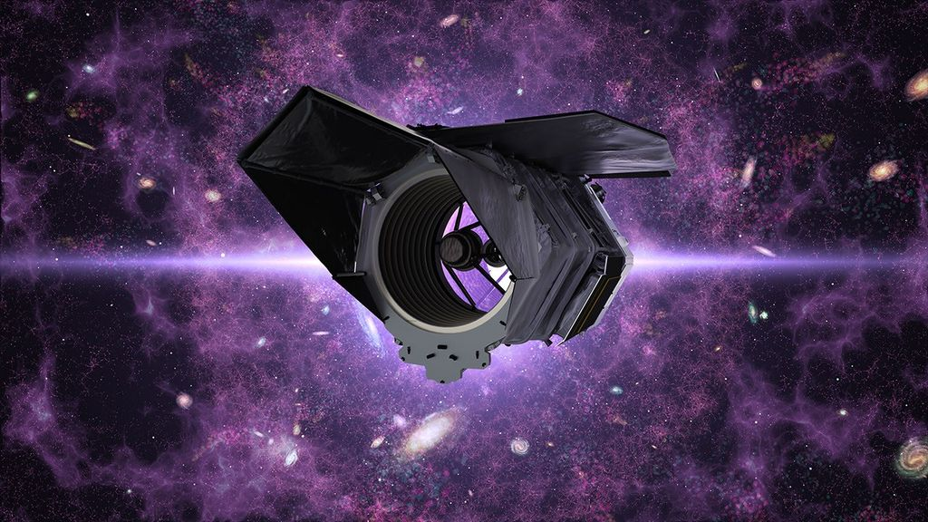
Clockwise from top: Caltech graduate students and friends carry out their first rocket firing on Halloween, 1936, in a dry riverbed along which JPL would rise. Their work helped make possible missions such as Perseverance and Europa Clipper as well as the future SkyFall and MoonFall missions. NASA/JPL-Caltech Interstellar probes. Lunar drones. Helicopters on Mars. When a group of Caltech graduate students and enthusiasts began conducting rocket-propulsion tests in Pasadena's Arroyo Seco on Oct. 31, 1936, they had no idea that their work marked the inception of the Jet Propulsion Laboratory. Ninety years later, the lab, now managed by Caltech for NASA, isn't only celebrating the long line of historic firsts accomplished here; it's paving the way for many to come. Initially a contractor for the U.S. Army, JPL launched America's first satellite, Explorer 1 in 1958. But rather than just orbiting Earth like the Soviet Union's Sputnik, Explorer 1 became the first spacecraft to conduct science, thanks to an onboard Geiger counter that discovered the protective radiation belts encircling Earth. The lab joined part of the newly formed NASA that same year. Within six years, in 1964, JPL sent the first U.S. mission to the Moon, Ranger 7. It also went on to lead the first planetary flyby, the first probe to visit all four gas giants, the first infrared telescope, the first rovers to roll on Mars, and the first rotorcraft to fly there, among many other historic milestones. More firsts are on the way. "Over the course of 90 years, JPL's first-of-a-kind missions have transformed our understanding of the universe and our place in it," said Dave Gallagher, JPL's director since 2025. In 1992, only a couple years after he started as an engineer at the lab, Gallagher led the JPL team that built and tested the Wide-Field and Planetary 2 Camera for NASA's Hubble Space Telescope, which delivered many of the mission's most iconic images. "We stand on an extraordinary foundation, and we're ready to push the boundaries with exciting new missions so that future generations can go even further." Aiming for a 2028 launch, the JPL-managed SkyFall mission will deploy three helicopters mid-descent over Mars to search to map hidden ice deposits and analyze weather patterns. Helping advance NASA's Moon Base, JPL is developing MoonFall, a mission that will land a group of large propulsive drones at the lunar South Pole that same year. Set for a 2027 launch, SunRISE (Sun Radio Interferometer Space Experiment) features six toaster-oven-size satellites that will fly in formation to create a miles-wide radio antenna dish in order to study the Sun's activity. What it reveals could help make space exploration safer for humans. Protecting humanity is also the goal of the asteroid-hunting NEO Surveyor (Near-Earth Object Surveyor) mission, which, managed by JPL, will hunt for potentially hazardous space rocks that other telescopes can't find. Once an object is spotted, NASA can offer a threat assessment and plan accordingly. Closer to home, the same lab that launched the first oceanographic satellite in 1978 is at work on several missions that will offer a deeper reading of Earth's vital signs. Where one mission will monitor the movement of water by measuring slight changes in gravity, another will study how powerful tropical convective storms form. A third will detail how different types of air pollution affect human health. They add to a fleet of other Earth missions and projects JPL helps lead, including NISAR (NASA-ISRO Synthetic Aperture Radar) a joint mission with the Indian Space Research Organisation that can pinpoint how Earth's surface changes in relation to natural disasters. Another, one of a series of instruments called AVIRIS (Airborne Visible Infrared Imaging Spectrometer), can even detect rare Earth elements critical to modern technology. Flown on airplanes, the AVIRIS sensors were developed at JPL's Microdevices Laboratory, which invented the "camera on a chip" technology that enables cellphones to take pictures. It's also where the detectors are being developed for PRIMA (PRobe far-Infrared Mission for Astrophysics), a newly announced NASA mission that will strengthen humanity's understanding of the universe by studying radiant energy visible only in the far-infrared. "Bringing together the very best of scientific brilliance and engineering ingenuity from across Caltech and JPL continues to advance NASA's priorities and empower America's space leadership," said Caltech's president Ray Jayawardhana, who is also a professor of astronomy. "I can only imagine what those Caltech students experimenting with rockets in a little patch of dry riverbed would think if they could to see what Caltech and JPL have accomplished since, and where we're headed next. Ninety years later, the same spirit of daring is still opening new frontiers and inspiring humanity." The 90th anniversary comes just a few weeks before another milestone, when on Nov. 18 Voyager 1 reaches a full light-day - the distance light will travel in 24 hours, which is some 16 billion miles, or 26 billion kilometers - from Earth. Ed Stone led the mission for 50 years, serving as JPL's director for 10 of them. Stone died in 2024, but the Voyagers are continuing on their journey deeper into interstellar space, a place no other spacecraft have ventured. Turning 50 next year, they rely on NASA's Deep Space Network (developed by JPL in the Apollo era) to receive commands and send back science data. Stone said that with both Voyagers exploring regions never before visited, "every day is a day of discovery." The same could be said for JPL. -end- Media contact Matthew Segal Jet Propulsion Laboratory, Pasadena, Calif. 818-354-8307 matthew.j.segal@jpl.nasa.gov 2026-073

8. NASA to Conduct NCAA Flyover, Engage Fans at University of Alabama
Read more
NASA's Freedom 250 F-5 team, including NASA Administrator Jared Isaacman, performs a flyover during the national anthem at an NFL game between the Cleveland Browns and the Carolina Panthers at Huntington Bank Field, Sept. 27, 2026, in Cleveland. NASA/Jordan Cochran As part of the agency's Inspiration Tour, NASA will conduct a flyover at the University of Alabama vs. Texas A&M football game in Tuscaloosa, Alabama, on Saturday, Oct. 24. NASA Administrator Jared Isaacman will pilot one of three F-5 fighter jets during the flyover, highlighting NASA's contributions to aeronautics and the agency's continued commitment to advancing aviation technologies. Ahead of the game, members of the news media are invited to visit the NASA Experience Zone on Champions Lane, where Isaacman will participate in a media opportunity at 11 a.m. CDT. Media interested in attending should confirm their attendance by 12 p.m. Friday, Oct. 23, with Lance D. Davis at lance.d.davis@nasa.gov to receive additional details and instructions. Supported by NASA's Marshall Space Flight Center in Huntsville, Alabama, the NASA Experience Zone will be open to the public from 10:30 a.m. to 2:30 p.m. CDT, with no game ticket required. The experience will give visitors an opportunity to meet NASA team members and learn more about the people and technologies advancing the agency's missions in aeronautics and space exploration. Attendees can engage with NASA team members and explore exhibits highlighting the agency's Artemis campaign and efforts to return astronauts to the Moon, including: An inflatable SLS (Space Launch System) rocket. Displays featuring the Starship and Blue Moon human landing systems. Information about NASA internship opportunities. Photo opportunities featuring NASA exhibits and displays. With stops across the nation, NASA's Inspiration Tour convenes academic, industry, and public sector stakeholders to connect the agency with the people, technologies, and organizations that drive American leadership in space. The tour will culminate in MAX POWER, a public exposition of American air and space innovation, Saturday, Nov. 7, and Sunday, Nov. 8, on and near the agency's Kennedy Space Center in Florida. Held in honor of America's historic 250th anniversary, the multi-day, family-friendly event will showcase the next-generation aircraft, spacecraft, autonomous vehicles, and technologies that will help define the future of transportation in air and space. For more information about MAX POWER and the agency's missions, visit: https://www.nasa.gov/maxpower -end- Lance D. Davis Marshall Space Flight Center, Huntsville, Ala. 256-640-9065 lance.d.davis@nasa.gov

9. Science on the Space Station with NASA Astronaut Jessica Watkins
Read more
NASA/Anil Menon NASA astronaut and Expedition 75 flight engineer Jessica Watkins works inside the Kibo laboratory module's Life Science Glovebox on Oct. 9, 2026, safely mixing living cell samples with a bioink and then filling a special cartridge with the cell‑ink mixture. The advanced research operations were part of the InSPA‑Auxilium Bioprinter‑Cell Printing investigation, which explores 3D bioprinting cartilage tissue in microgravity of higher quality than that produced on Earth. Results may advance the ability to biomanufacture cartilage, benefiting patients on Earth and crew members on long‑duration space missions. Image credit: NASA/Anil Menon

10. NASA's CASALS Instrument Bridges Gaps in 3D Maps of Earth's Surface
Read more
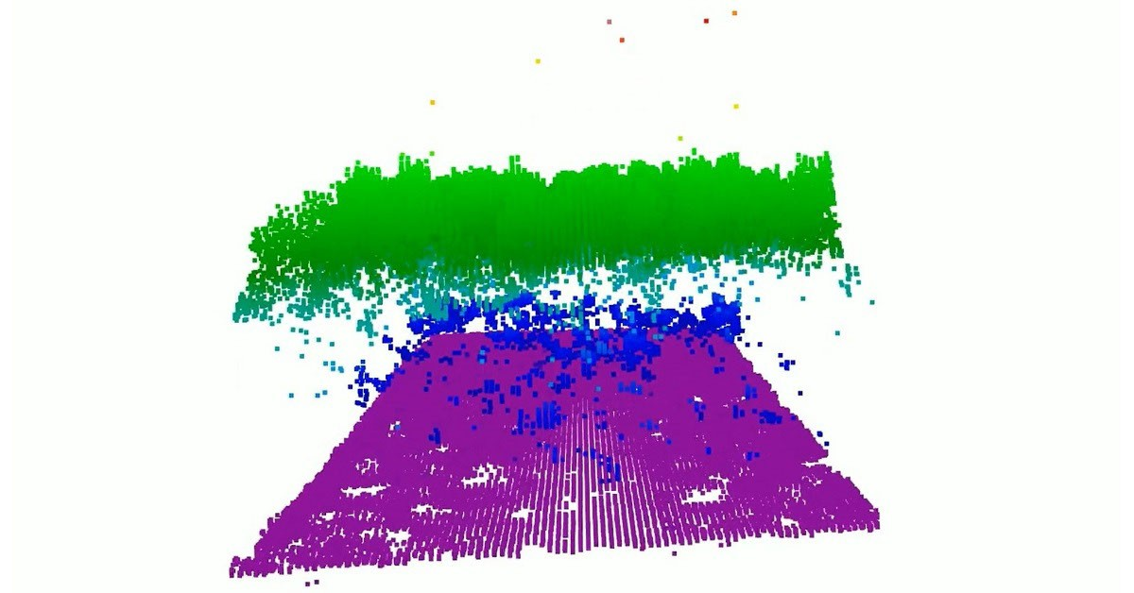
From orbit, today's space-based laser instruments measure Earth's forests and terrain one narrow line at a time. Between those lines are enormous gaps that include millions of acres of land scientists never directly measure. NASA's CASALS instrument will blend machine learning with an ultra-compact lidar instrument to adaptively 'sweep' large swaths of Earth's surface. This new capability for space-based remote sensors allows CASALS to create truly three-dimensional (3D) topographical renderings. To view this video please enable JavaScript, and consider upgrading to a web browser that supports HTML5 video Video from a CASALS flight over the Great Cypress Swamp in Delaware on Nov. 12, 2024, showing tree canopy tops in green, the ground in purple, and near-ground vegetation in blue. Credit: NASA A team of researchers at NASA's Goddard Space Flight Center (GSFC) has developed a new instrument designed to eliminate blind spots between lines of lidar data on the Earth's surface. Built with support from NASA's Earth Science Technology Office (ESTO), the Concurrent Artificially-intelligent Spectrometry Lidar System (CASALS) could help researchers map the features of Earth's surface with unprecedented detail. Rather than mechanically steering a laser with moving mirrors, CASALS steers light using wavelength itself, generating a continuous, 3D swath of the ground below. John Yorks, a physical research scientist at GSFC and Principal Investigator for CASALS, explained that the instrument features a novel transmitter and optical grating system that manipulates laser pulses without heavy, failure-prone motorized mirrors. Instead, CASALS uses a fast-pulsing, tunable "seed" laser centered at 1040 nanometers, rapidly cycling through 256 unique wavelengths as it pulses through an optical component with a microscopic pattern of ridges called a transmission grating. At this point, the physics of diffraction takes over. Because light bends at slightly different angles depending on its exact wavelength, the grating naturally "steers" each of the 256 pulses into a distinct position across the flight path. This non-mechanical approach paints a continuous 3D swath of the ground. Not only does this eliminate the large unmapped gaps left between the isolated tracks of legacy spaceborne lidars, but stripping away moving parts drastically reduces the instrument's size, weight, and power (SWaP) requirements. This makes it more reliable for the harsh environment of space. Another key innovation within CASALS is its detector array. This component features a uniquely high Quantum Efficiency (QE), a variable that describes how effectively a detector converts incoming light (photons) into an electrical signal. CASALS operates at 80% QE. This means CASALS wastes almost none of the light that makes it back to the sensor. With QE that high, CASALS can detect much weaker return signals, allowing it to collect useful measurements from darker surfaces or through denser vegetation. This technology isn't limited to a laboratory environment. In November 2024, an airborne CASALS prototype flew aboard NASA's B200 King Air aircraft. The instrument produced science-quality datasets on its first campaign, exceeding the team's expectations. "I'm very impressed with Guang Yang, Jeffrey Chen, and all our engineers, and how well CASALS performed. This worked really well from the first time we flew it, which is pretty impressive," said Yorks. Flying at an altitude of roughly five kilometers, CASALS can distinguish individual tree branches and subtle changes in ground elevation, thanks to its 22-centimeter horizontal resolution. "We're able to see really fine details of vegetation structure and changes in the topography of the surface," Yorks said. The team aims to fly CASALS again as part of the Airborne Surface, Cryosphere, Ecosystem, and Nearshore Topography (ASCENT) campaign, scheduled for summer 2027. But there's more work to do to prepare the technology for space. The team plans to make several improvements to CASALS before creating a space-ready prototype. Specifically, they're widening the instrument's swath and adding onboard data processing software. Transitioning from a successful airborne prototype to a fully realized space mission is a challenge, but the CASALS team is up to the task. "The team's really done a great job of sticking together and keeping on task and on schedule. We are being funded to optimize and improve the performance, and we're also then looking at ways to take the technologies used in the airborne instrument and mature them and prepare them for a spaceborne version in the future," said Yorks. If successful, CASALS could become the first spaceborne lidar capable of mapping Earth's forests and terrain as continuous three-dimensional swaths rather than isolated profiles, giving scientists a dramatically more complete picture of our changing planet. For additional details, see the entry for this project on NASA TechPort. Project Lead(s): John Yorks, NASA's Goddard Space Flight Center Sponsoring Organization(s): NASA's Decadal Survey Incubation (DSI) program; NASA's Instrument Incubation Program (IIP); NASA's Goddard Space Flight Center; University of California, Santa Barbara; Virginia Polytechnic Institute and State University

11. When will SpaceX and Blue Origin fly to the moon? NASA reveals lunar lander timelines (and an Artemis III update)
Read more
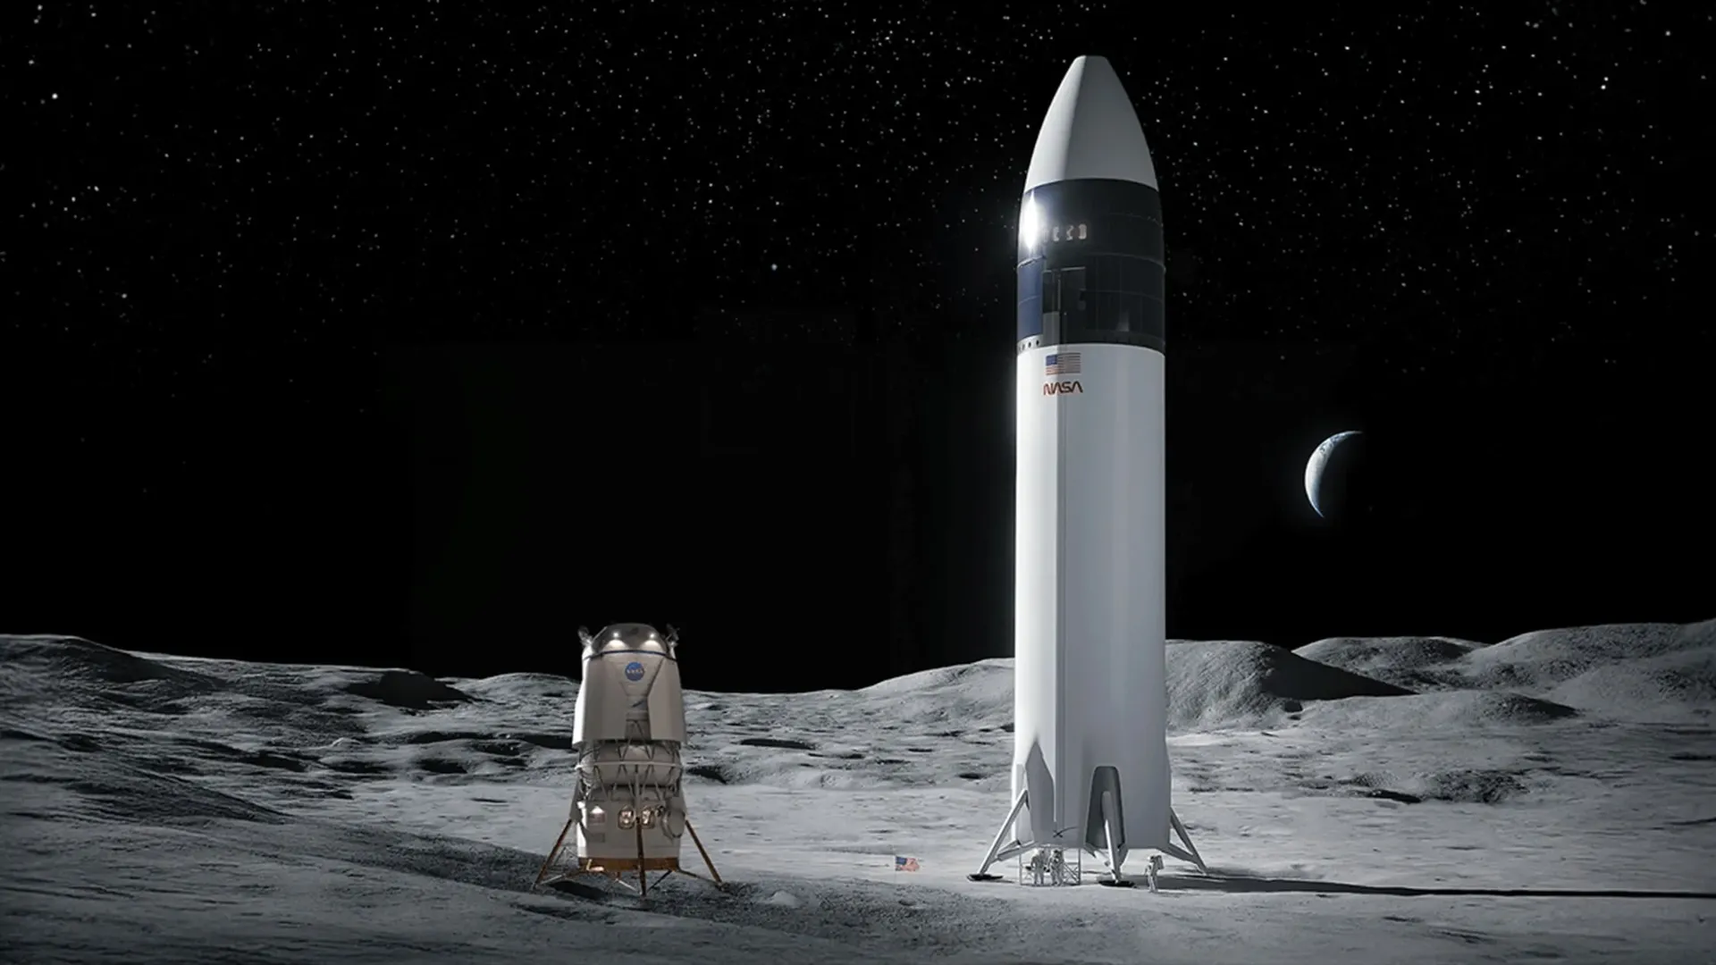
Click for next article NASA has revealed new details about its plans to return astronauts to the surface of the moon, outlining a series of upcoming milestones for SpaceX and Blue Origin as both companies race to ready their lunar landers for the agency's Artemis program . During an Oct. 5 presentation at the Astronautical Congress (IAC) in Antalya, Türkiye, Steve Creech, acting manager of NASA's Human Landing System (HLS) Program, laid out development timelines for both spacecraft, with key demonstrations planned through early 2028 that include orbital refueling and uncrewed lunar landing tests to qualify the vehicles to fly astronauts to the surface of the moon . A more pressing deadline, however, is NASA's Artemis III mission, which is targeted for the third quarter (Q3) of 2027. Artemis III will launch four astronauts aboard NASA's Orion spacecraft to low Earth orbit (LEO), where they will rendezvous and dock with test versions of both companies' landers for interoperability checkouts. Those demonstrations will help inform NASA's determination about which lander the agency will choose to carry astronauts to the moon's surface on Artemis IV, targeted for early 2028. SpaceX and Blue Origin were both awarded NASA contracts to develop HLS vehicles - Starship and Blue Moon , respectively - and have spent the past several years refining their respective lunar lander designs and dealing with various delays along the way. In the face of those delays, and in an effort to better structure its mission progression for success, NASA overhauled its Artemis program architecture in February to maintain its goal of landing astronauts on the moon by the end of 2028 and establish a more regular cadence of uncrewed landings in the meantime. As part of that shakeup, Artemis III, previously the program's first crewed lunar landing mission, was moved up a year and repurposed for the lunar lander vehicle tests the agency is preparing to fly to LEO next year. The program's first moon landing remains scheduled for 2028, but was shifted to the manifest for Artemis IV. Between now and then, both SpaceX and Blue Origin have more than a dozen test demonstrations and vehicle milestones to achieve, including success during Artemis III and flights afterward. This will all lead up to a key decision NASA must make: Which vehicle will carry out the first crewed landing on the surface of the moon since the Apollo program ended in 1972? Starship reached for the first time on its most recent test flight, which occurred on Sept. 28 from SpaceX's Starbase site in South Texas. NASA lists several other important goals for the vehicle to achieve in 2026, including (in the order listed during the IAC presentation) the first return and catch of the rocket's upgraded Version 3 (V3) booster at its launch pad; the first-ever return and catch of a Ship upper stage; the first Starship launch from one of SpaceX's launch pads still under construction on Florida's Space Coast; and, possibly, the first V3 booster reflight. NASA also expects SpaceX to complete the initial build of the crew cabin for its lunar lander Starship variant. SpaceX released renders of Starship's interior last year , as well as images of the test elevator astronauts are using to train for Starship egress on the lunar surface, but little else has been made public about the progress the company has made on the cabin's design. Artist's rendering of the cabin of SpaceX's Starship vehicle during an Artemis moon mission for NASA. (Image credit: SpaceX) Should the cabin's initial build wrap up by the end of the year, as NASA's presentation suggested, SpaceX will use Q1 2027 to complete integration of the systems that Starship will need to communicate with Orion during Artemis III, and deliver a cabin simulator for astronauts to train on leading up to the mission. SpaceX plans to continue Starship test flights through Q2 of next year, complete a landing leg demonstration and begin crew cabin airlock tests. Blue Origin's lunar lander mockup is ready for NASA Artemis astronaut training For Artemis III, SpaceX plans to fly one of its existing V3 Starship upper stages, with some slight modifications. Starship and Orion will dock as part of Artemis III but the SpaceX vehicle won't be equipped with a crew cabin for the mission's astronauts to enter. Between the end of this year and the beginning of the next, SpaceX is expected to complete the addition of a docking system and nosecone cover to the Artemis III Starship vehicle, which, NASA documents suggest, has already completed its mechanical fit checks. Render of SpaceX Starship and Orion docked in low Earth orbit. (Image credit: SpaceX) Other notches on SpaceX's checklist leading up to Artemis III include the first propellant transfer demonstration with Starship in orbit. As the first-ever launch vehicle and spacecraft designed for full reusability, Starship's fuel constraints require that its tanks be topped off in order to fly beyond LEO. For a moon landing mission, this could mean up to a dozen launches of SpaceX's Starship "tanker" spacecraft to an orbiting fuel depot, which the moon-bound Starship will visit. To pull that off, though, SpaceX has to show it can successfully transfer those cryogenic fuels on orbit, and also store them effectively enough to prevent too much boil-off. Starship won't require any refueling flights to complete its objectives for Artemis III, but SpaceX is expected to launch its first Starship tanker vehicle within a few months of that mission as it gears up for the Artemis IV moon landing mission. To that end, a launch of an uncrewed Starship lunar lander variant is targeted sometime toward the end of Q3/beginning of Q4, with an uncrewed lunar landing mission carried out before the end of 2027. Blue Origin, meanwhile, has its own set of milestones to meet as it develops its Blue Moon Mark 2 (MK2) lander - a 52-foot-tall (16 meters) spacecraft powered by three BE-7 engines. Unlike the bare-bones V3 Starship that SpaceX will launch on Artemis III, Blue Origin plans to fly a completed test vehicle, incorporating the crew cabin, partial life-support, flight software and other systems needed to allow astronauts to enter the lander from Orion during their time docked in LEO. Astronauts will be able to enter Blue Moon from Orion to get a feel for the lander in zero-g and test some of its systems. Render of Blue Origin's Blue Moon lander and Orion prior to docking in low Earth orbit. (Image credit: Blue Moon) NASA's timeline shows the company working to complete a series of manufacturing and testing milestones in the last few months of 2026, including continued BE-7 testing and qualification of Blue Moon's BT-7 maneuvering thrusters. The company also faces its Artemis III interim design review and a critical design review for an upcoming landing demonstration mission in 2028. Blue Origin is also working to restore its pad at Cape Canaveral Space Force Station's Launch Complex-36 (LC-36) to operation and return its New Glenn rocket to flight, following an explosion of the rocket in May that caused extensive damage to the facility. NASA's presentation places that milestone in Q4 2026, a timeline the company has also been very vocal about maintaining. A recent Reuters report , however, suggests that may not happen until early 2027. By early 2027, the company expects to complete the spacecraft's communications systems and finalize its flight software, with assembly, integration and testing continuing into Q2. Q1 2027 is also when Blue Origin's Blue Moon MK1 lander (a smaller, uncrewed version of its MK2 successor) will launch to the lunar surface as a part of NASA's Commercial Lunar Payload Services (CLPS) program of robotic moon missions. During Q2 2027, as the Artemis III mission approaches, Blue Origin is expected to complete integration of its test lander with New Glenn and conclude qualification of its BE-7 engine. Throughout next year, the company plans to continue construction and refurbishments at its launch facilities and hopes to have a new launch pad ready to support the upgraded, more powerful New Glenn 9x4 rocket l by the end of Q3. The first flight of that rocket variant is scheduled for Q4 2027, alongside a second MK1 lunar mission and the launch of an uncrewed MK2 demonstration lander. That spacecraft is expected to attempt its own uncrewed lunar landing in Q1 2028, around the same time Blue Origin has scheduled a third MK1 flight. Like SpaceX, Blue Origin will need to demonstrate that its lander can safely reach the moon's surface,operate there and return to lunar orbit before NASA clears it to carry astronauts on a future Artemis mission. NASA's overall timeline remains the same as it has been since the February revamp, with Artemis III expected to launch in mid-2027, followed by a crewed lunar landing on Artemis IV in 2028, and possibly another on Artemis V that same year. There may be changes on the horizon, though. NASA will host a press conference on Friday (Oct. 23) with Administrator Jared Isaacman and Associate Administrator Amit Kshatriya, as well as Artemis program director Jeremy Parsons. During the event, which you'll be able to watch here at Space.com , they will discuss the status of the upcoming moon missions and an "Artemis acceleration." SpaceX and Blue Origin still face tight schedules to complete their respective uncrewed landing demonstrations before Artemis IV. With SpaceX targeting Q4 2027 and Blue Origin Q1 2028, both are pushing the margins against NASA's hopes to return astronauts to the lunar surface that same year. Which company ultimately gets the green light for that first landing mission will depend on the progress each makes between now and then, and whether their landers can demonstrate the readiness that NASA requires to safely carry astronauts to the surface of the moon and back again.

12. Russian satellite plays 'cat-and-mouse' with a commercial US spacecraft likely used by Ukraine. But why the risky close encounter?
Read more

Click for next article An ICEYE synthetic aperture radar satellite image of the Kerch Strait Bridge, or Kerch Bridge, which connects mainland Russia with Crimea. A Russian satellite just took a very close look at an American spacecraft in low Earth orbit. A few days ago, the snooping satellite Kosmos 2612 rendezvoused with ICEYE-X36, a commercial craft that observes our planet using synthetic aperture radar (SAR). The close encounter, which occurred between Oct. 15 and Oct. 19, was reported by Marco Langbroek and other satellite trackers, with Langbroek calling it "a worrisome cat-and-mouse game" in orbit. The rendezvous has garnered a lot of attention in space circles, because it was non-consensual and startlingly close; at one point, the two spacecraft may have been separated by just a few meters. What did Russia hope to gain from it? 1/2 New blogpost: "KOSMOS 2612 and ICEYE-X36: a worrisome cat-and-mouse-game in Space" (link to blogpost in next tweet) https://t.co/bzNtADpIrAOctober 17, 2026 Not an isolated incident A worrisome cat-and-mouse-game in Space Dr, Marco Langbroek, satellite tracker Before tackling that question, we need to set the stage a bit. For example, it's important to note that inspections aren't unheard of in the final frontier. Russia , the United States and China have all maneuvered satellites into close proximity of other nations' hardware in recent years. Most of this activity has taken place in geostationary orbit , which lies 22,236 miles (35,786 kilometers) above Earth. At this altitude, orbital velocity matches our planet's rotational speed, allowing spacecraft to "hover" over one patch of Earth continuously. GEO is therefore a popular destination for spy, communications and weather satellites - and for spacecraft designed to shadow and assess them. Kosmos 2612 is operating in low Earth orbit (LEO), which is part of the reason its activities have created such a stir. Neither China nor the U.S. has conducted an uncooperative rendezvous in LEO, as far as we know. But Russia has, according to Victoria Samson, chief director of space security and stability for the nonprofit Secure World Foundation. "They've done a few," she told Space.com. "Kosmos 2543 got within about 30 kilometers [19 miles] of USA 245 in January 2020, and then Kosmos 2558 got within about 70 kilometers [43 miles] of USA 326 in August 2022. And they've done repeated approaches to 326." Kosmos 2612 got much closer to its target than those other inspectors did, of course. And there's another big difference: USA 245 and USA 326 are classified spy satellites managed by the U.S. National Reconnaissance Office, while ICEYE-X36 is a private Earth-observing craft . Russia's Luch-2 satellite approaches another geostationary satellite on April 12, 2024, as tracked by the French company Aldoria's observation stations. (Image credit: Aldoria) Eyes in the sky There are about 80 ICEYE spacecraft in LEO at the moment. They image our planet using SAR, which can peer through clouds and gather data both day and night. Some of these satellites are operated by ICEYE, a company based in Finland, while others are managed by its American subsidiary, ICEYE US. ICEYE-X36 is one of the latter. At least some ICEYE satellites provide imagery to Ukraine , which Russia invaded in February 2022 and continues to assault with ground troops and missile and drone attacks. Indeed, ICEYE signed a contract this past January firming up this data-sharing relationship with Ukraine. "The agreement ensures that the Ministry of Defence continues to receive a high volume of high-resolution satellite imagery through ICEYE's world-leading SAR constellation, supporting the Ukrainian Armed Forces with persistent situational awareness on tactical timelines," ICEYE representatives said in a January statement . That likely explains Russia's interest in ICEYE satellites, which is extensive and longstanding. For example, Kosmos 2612 launched in April of this year with five other spacecraft. In May, four members of this fleet, including Kosmos 2612, conducted maneuvers to get into a co-planar orbit with ICEYE-X36 . Such maneuvers use a lot of fuel and are therefore not performed lightly. (It's unclear if ICEYE-X36 is dedicated to capturing imagery of Ukraine or Russia, but Russia certainly seems to think it is.) However, we still don't know the purpose of Kosmos 2612's close approach ( which is apparently over , at least for now), Samson stressed. There are a few possibilities. For example, Russia may want to get a better idea of ICEYE satellites' capabilities, and/or figure out what exactly they're studying on Earth below. Or maybe Kosmos 2612 was actively interfering with ICEYE-X36 in some way - messing with its sensors, perhaps, or blocking or intercepting its communications with the ground. However, Samson leans toward another explanation. "I think they're getting frustrated," she said of the Russians. "They've been kind of in a stalemate, particularly for the past six months or so. And so I think it's just more a matter of demonstrating military prowess in a manner that the Ukrainians cannot respond to," she added. "The Ukrainians are just as good, perhaps even better than, the Russians on drones. But when it comes to space stuff, they're not peers, and this is just a way to remind everyone that that's the case." As Kosmos 2612's activities show, space is becoming an increasingly competitive and contested domain. The U.S. has long held the advantage above Earth, fielding the most capable reconnaissance and communications craft, but Russia and China are challenging that dominance . This drama is unfolding above our heads now, and it affects everyone on the planet. Samson therefore wishes that governments around the world were more forthcoming about their space activities - for example, that we learned about Kosmos 2612's shenanigans from the U.S .Space Force rather than from private companies and civilians who pore over government tracking data. "I think it just speaks to the importance of transparency, and sharing information about these sort of things," she said. "As much as you may want to, you cannot keep the existence of satellites classified, because people can see them."

13. NASA's CASALS instrument bridges gaps in 3D maps of Earth's surface
Read more

A team of researchers at NASA's Goddard Space Flight Center (GSFC) has developed a new instrument designed to eliminate blind spots between lines of lidar data on Earth's surface. Built with support from NASA's Earth Science Technology Office (ESTO), the Concurrent Artificially-intelligent Spectrometry Lidar System (CASALS) could help researchers map the features of Earth's sur...

14. Hubble observations challenge supernova winds' role in cosmic reionization
Read more

An international team of researchers, including members from the University of Michigan, has revealed surprising results that could rewrite our understanding of a key transition in the early universe.

