 |  | 

🌌 अंतरिक्ष समाचार | Space News
शुक्रवार, १७/०७/२०२६ | Friday, 17/07/2026

1. Over 100 scientists quit Isro, govt steps in to tighten exit norms amid mass resignations: Reports | India News - Hindustan Times
Read more
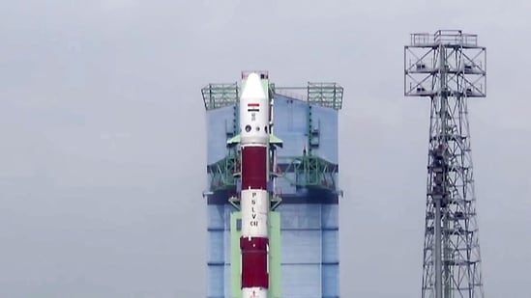
As per media reports, this move from the Centre comes after around 100 scientists submitted their resignations. The memorandum further adds that all requests for resignation and retirement will now be referred to the Department of Space. Centre has directed Isro centres not to accept resignation or voluntary retirement requests from Group 'A' scientific and technical personnel associated with Gaganyaan and other key missions, according to an internal document issued on July 14, accessed by India Today. The Indian Space Research Organisation (ISRO) has reportedly been hit by mass resignations with with at least 100 scientists putting in their papers in recent months, prompting Centre to step in to tighten rules on voluntary exits and retirement, especially for those working on critical missions such as Gaganyaan. While the Department of Space has not officially disclosed the number of departures, the Times of India reported multiple Isro sources have stated that between 100 and 120 scientists may have resigned in recent months. Nearly 80 scientists have left the UR Rao Satellite Centre (URSC) in Karnataka's Bengaluru, while around 20 departures have been reported from the Vikram Sarabhai Space Centre (VSSC) in Kerala's Thiruvananthapuram, per the report. While sources confirmed 100 resignations, they added that the number could be around 120, TOI reported. Also Read | Road to Bharatiya Antariksh Station, Moon and beyond: ISRO shows how tech maturity accumulates Acknowledging the mass resignations, ISRO chairman V Narayana told the publication that the space organisation was prepared to deal with the departures. "Yes, a lot of people go, but that's part of every organisation. The move [memorandum] isn't only to retain, but also to ensure that important projects don't suffer all of a sudden. But if someone is still going, someone else will take responsibility. We're taking care of it," he was quoted as saying.

2. Higher pay, better opportunities, more recognition: Why scientists are leaving Isro - India Today
Read more

India's space programme is facing an unexpected challenge, not from failed launches or technical setbacks, but from a growing exodus of experienced scientists from the Indian Space Research Organisation (Isro). Over 100 scientists have either resigned or taken voluntary retirement from the space agency within the last few months. The Department of Space (DoS) has now stepped in to stem the departures, issuing a fresh directive that restricts resignations and voluntary retirement of scientists working on flagship missions such as Gaganyaan. Read Full Story While the move points to the strategic importance of retaining talent, it also raises a larger question: Why are scientists choosing to leave Isro at a time when India's space ambitions have never been bigger? Isro is facing a major brain drain as the agency is hit by a wave of resignations. (Photo: PTI) WHY ARE SCIENTISTS LEAVING ISRO? Industry experts and senior officials within Isro point to a combination of factors ranging from the explosive growth of India's private space sector to organisational bottlenecks and uncertainty surrounding major national missions. One of the biggest drivers is the emergence of a vibrant private space ecosystem. Since the space sector was opened to private participation in 2020, startups such as Skyroot Aerospace, Agnikul Cosmos, Pixxel, Bellatrix Aerospace, Dhruva Space, Digantara and several others have transformed India's aerospace landscape. These companies are developing rockets, satellites, propulsion systems and space-based services at a pace that was unimaginable just a few years ago. For Isro scientists, the appeal is obvious. Private companies often offer significantly better salaries, stock options, greater flexibility and the opportunity to work in fast-moving environments where ideas move quickly from the drawing board to hardware. Unlike traditional government organisations, startups also provide leadership roles at an earlier stage of a scientist's career, along with the opportunity to build entirely new technologies. The trend is being reinforced by former Isro veterans themselves. Over the past few years, several retired and former senior Isro officials have gone on to establish or mentor aerospace startups, helping create an ecosystem that is increasingly attracting talent away from the national space agency. Their experience, combined with growing private investment, has opened career paths that previously did not exist for India's aerospace engineers. However, the attraction of private industry tells only part of the story. India's first private rocket, Vikram-1, on the launch pad. (Photo: Skyroot) DELAYS, EXTENDED TIMELINE, LOW ACCOUNTABILITY The departures also come at a time when Isro is grappling with an unusual slowdown in mission execution. Several high-profile missions, including the Gaganyaan G1 test flight, SSLV-L1, GSLV-F17 and the industry-built PSLV-N1, have slipped beyond their announced timelines. The twin PSLV setbacks earlier this year have further delayed launch activities, with the agency yet to publicly release a detailed failure assessment. Within sections of the organisation, there is also growing discussion about decision-making becoming increasingly centralised. Multiple current and former officials, speaking privately, have suggested that major technical and administrative decisions are now concentrated within the Chairman's Office, slowing approvals and limiting operational flexibility. EMPLOYMENT MODEL NEEDS TO CHANGE Senior officials, on condition of anonymity, also said that the space agency needs to look at western space agencies like Nasa and the European Space Agency for their employment models, which are mostly project-based. Nasa's workforce structure combines permanent civil servants, contractors, and project-specific hires. This gives the agency flexibility while retaining critical institutional expertise. Many space policy experts believe Isro could benefit from expanding this hybrid model. As India's private space ecosystem grows, Isro can increasingly focus on: Mission design and systems engineering. Human spaceflight and deep-space exploration. Advanced R&D such as reusable rockets and nuclear propulsion. ISRO RUSHING TO PLUG THE ISSUE The Department of Space's July 14 memorandum reflects concerns that the departures are affecting nationally important programmes. Scientists associated with Gaganyaan and other flagship missions will no longer be allowed to leave through routine approvals; instead, every resignation must now be cleared by the Department of Space. Although the number of departures represents only a small fraction of Isro's workforce of over 14,600 employees, the impact is disproportionately large because many of those leaving possess years of specialised expertise gained through missions such as Chandrayaan-3, SpaDeX and Gaganyaan. Such knowledge cannot be replaced simply by recruiting new graduates. Scientists associated with Gaganyaan and other flagship missions will no longer be allowed to leave through routine approvals. (Photo: Generative AI by India Today) The talent shift also reflects a broader transition in India's space sector. For decades, Isro was virtually the only destination for ambitious aerospace engineers. Today, it has become the anchor of a much larger ecosystem where private companies offer alternative career paths with competitive compensation, faster growth and the opportunity to shape the next generation of space technology. For Isro, the challenge is no longer just attracting the country's brightest minds, it is also retaining them. - Ends

3. India opened space to private players. ISRO brain drain is one result - ThePrint
Read more
Taking note of a spate of resignations in ISRO over the last year, the Department of Space (DoS) on July 14 issued an office memorandum, directing centres including the Vikram Sarabhai Space Centre (VSSC) and the UR Rao Satellite Centre (URSC) to not accept routine resignations from Group-A scientists. It is the Centre's policy of opening India's space sector to private players that is now haunting ISRO. Space scientists are now turning to the roughly 400 new space startups, which promise better opportunities and pay. New Delhi: The Indian Space Research Organisation is witnessing a surge in resignations due to low pay, and the private sector offering better opportunities to scientists. This has prompted the Centre to tighten rules around exits and voluntary retirements, said scientists who quit the government space agency in recent months. This category of scientists and technical personnel includes senior professionals, who are an integral part of important missions like the upcoming human spaceflight Gaganyaan, the setting up of the Bharatiya Antariksh Station and the Chandrayaan-4 lunar return mission. "Of late, it is noticed that there has been a spate of requests for voluntary retirement and resignation from Group 'A' Scientific/Technical personnel of ISRO including those associated with the prestigious Gaganyaan and other important missions/projects, severely impacting the implementation of projects of national importance," read ISRO's memorandum, seen by ThePrint. The order added, "In view of this, it has been decided that voluntary retirement and resignation requests from Scientific and Technical personnel associated with the Gaganyaan and other important Mission/ Projects may not be accepted as a matter of routine." DoS officials that ThePrint spoke to said that the order essentially means that every request for an early retirement and resignation by a senior scientist or a core member of "critical future missions" will first have to be cleared by the corresponding centre's directors and then passed on to the ministry for a final decision. Officials said, however, that the directive does not mean a blanket ban on resignations across the space agency. It is applicable to certain significant centres, including the Satish Dhawan Space Centre, VSSC, URSC, ISRO Telemetry and the National Remote Sensing Centre (NRSC). "We, of course, cannot stop people from leaving. But the ministry will review resignation requests of core scientists, who are leading important missions," an ISRO official told ThePrint. The official said that while an exact number is not known, around 120 personnel, including senior scientists, have left ISRO in the last 12 months. The most significant among the recent resignations was senior scientist Victor Joseph earlier this year. He was the project director of Launch Vehicle Mk-3, which is slated to carry the Gaganyaan Mission to space in February this year. Since then, at least two senior scientists associated to the Gaganyaan Mission have quit, according to ministry sources. Low pay better private opportunities Scientists who have recently quit ISRO said that the recent opening up of the space sector for private players has come as an opportunity for many, particularly young scientists. "Since the Indian Space Policy 2023, many space startups have started coming up and these provide better creative opportunities and pay packages. This is an incentive, especially for the younger lot," said a scientist, who left ISRO in 2024 to join a private company. ISRO data shows that attrition numbers started increasing with more private players entering the sector in the lead up to the space policy. Between 2018 and 2022, 381 scientists resigned from across ISRO centres. Similarly, 38 scientists quit the space agency for better opportunities from 2023 to mid-2024. Among all the ISRO centres, the Vikram Sarabhai Space Centre in Thiruvananthapuram and the Space Applications Centre in Ahmedabad-both among the most coveted centres of ISRO-have recorded the highest attrition. Meanwhile, the UR Rao Space Centre in Bengaluru has the lowest resignations. Between 2012 and 2017, 289 scientists quit ISRO from 25 of its centres. The situation remained the same ever since 2017, with only a minor improvement in 2023 and 2024 after missions like Chandrayaan-3 and Aditya-L1-India's first mission to study the sun-were launched. Data show that in 2023, ISRO had a staff strength of 9,337 group A or tier-1 scientists, 2,303 group B scientists, and 1,141 group C scientists, apart from its administrative staff. (Edited by Aakriti Handa)

4. 'Many Come And Go': Science Minister Downplays ISRO Resignations - NDTV
Read more
'Many Come And Go': Science Minister Downplays ISRO Resignations NDTV

5. ISRO's scientist exit wave: What is the reason behind mass exodus? - Moneycontrol.com
Read more
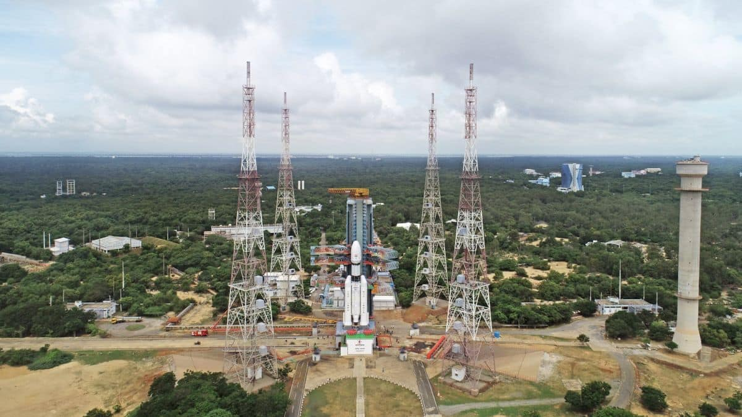
ISRO's scientist exit wave: What is the reason behind mass exodus? Moneycontrol.com

6. A Tide-Fueled Trove of Biodiversity in Guinea-Bissau
Read more

Relatively low tidal waters expose sandflats and mudflats in the Bijagós Archipelago of Guinea-Bissau in this image acquired on November 28, 2025, with the OLI (Operational Land Imager) on Landsat 8 . These coastal landforms support an array of invertebrates, making the archipelago a popular stopover for migratory shorebirds. NASA Earth Observatory/Lauren Dauphin Twice each day, tides ebb and flow through a maze of sandy channels, mudflats, and mangrove forests that flank the 88 islands and islets of Guinea-Bissau's Bijagós Archipelago (Arquipélago dos Bijagós in Portuguese). Seen from above, the process leads to stark changes to the landscape: around low tide, intertidal mudflats and sandflats emerge from the sea, causing islands to grow significantly before shrinking again hours later. The perpetual rhythm of the tides sustains outpourings of marine life in an archipelago that, as of 2025, was inscribed as a UNESCO World Heritage site. The site protects the only active deltaic archipelago on Africa's Atlantic coast, a place where tides, river sediments, coastal upwelling, and coastal currents come together to shape unusually productive and biodiverse island ecosystems. UNESCO estimates that the islands support some 870,000 migratory shorebirds, making this one of the most important feeding areas for birds in West Africa along the East Atlantic Flyway. Hundreds of species of birds dine on a potpourri of marine worms, crustaceans, mollusks, and small fish found on mudflats exposed by low tides. During high tides, manatees, dolphins, and schools of fish move closer to the islands, pushing deeper into the mangrove forests that ring them, and tens of thousands of sea turtles swim inland to sandy beaches as they hunt for nesting sites. A huge population of green sea turtles nests on the tiny island of Poilão, part of the João Vieira and Poilão Marine National Park. After hatching, young turtles make perilous nighttime dashes to the water, often pursued by crabs, lizards, and birds. Once they reach the water, baby sea turtles face an array of predators, including jacks, barracudas, groupers, and snappers that patrol shallow waters as well as tuna, mackerel, sharks, and rays in deeper waters. According to some estimates, less than 1 percent of green sea turtle hatchlings survive to adulthood. A 2025 analysis of the region's tides explored why the archipelago has some of the largest tidal ranges in West Africa. The researchers concluded that the region's wide, shallow shelf and the estuary's geometry combine to create a tidal range of up to 7 meters (23 feet), compared to about 1 meter (3 feet) in many other parts of the West African coast. The scientists used altimetry data from the NASA/CNES TOPEX/Poseidon, Jason-1, and Jason-2 satellites to help validate their findings. NASA Earth Observatory images by Lauren Dauphin, using Landsat data from the U.S. Geological Survey. Story by Adam Voiland. Downloads November 28, 2025 References & Resources

7. NASA Welcomes Serbia as Newest Artemis Accords Signatory
Read more

Serbia's Minister of Foreign Affairs Marko Đurić, right, shakes hands with NASA Deputy Administrator Matt Anderson, left, after signing the Artemis Accords Thursday, July 16, at NASA Headquarters in Washington. NASA/Keegan Barber The Republic of Serbia signed the Artemis Accords Thursday during a ceremony hosted by NASA at the agency's Headquarters in Washington, becoming the 69th nation to join a large community of like-minded nations committed to the peaceful, transparent, and responsible exploration of space. "Serbia's connection to NASA reaches back to the Apollo program, when the work of Serbian engineers helped make some of humanity's greatest achievements in space possible," said NASA Deputy Administrator Matt Anderson. "Among them was Milojko 'Mike' Vučelić, who was awarded the Presidential Medal of Freedom for the critical role he played in bringing the Apollo 13 crew safely home. Their story stands as a reminder that the greatest achievements in space are made possible by talented people working together." The broader team of Serbian American engineers played key roles during the Apollo era across systems engineering, propulsion, power systems, spacecraft docking, electronics reliability, and mission coordination. Their expertise supported critical functions ranging from lunar landing analysis to safe spacecraft docking. Serbia's Minister of Foreign Affairs Marko Đurić signed the Artemis Accords on behalf of the country. "The great beyond has always inspired humanity to achieve its greatest feats - from the Roman 'per aspera ad astra' to Norman Vincent Peale's belief that if we aim for the Moon, we will at least land among the stars," said Đurić. "Those words feel especially fitting today. We come from a nation of great minds like Nikola Tesla and Milutin Milanković, but also from the legacy of David Vujic, one of the pioneers of the Apollo missions and a member of the 'Serbian Seven,' a group of engineers and technicians whose contributions to NASA helped make the Moon landing possible. In that spirit, we owe it to both our brave ancestors and our children to keep pushing toward new frontiers - to explore, to inspire one another, and to dare even greater things." By signing the Artemis Accords, nations open the door to opportunities for future lunar exploration with NASA, such as providing science and technology payloads for the U.S.-led Moon Base and CubeSats for upcoming Artemis missions, advancing humanity's return to the Moon, and shaping the Golden Age of space exploration and innovation. Ambassador of the Republic of Serbia to the United States Dragan Šutanovac; State Secretary for Serbia's Ministry of Science, Technological Development and Innovation Marija Gnjatović; and U.S. Department of State Assistant Secretary for Oceans and International Environmental and Scientific Affairs Wesley Brooks all participated in Serbia's signing ceremony. In 2020, NASA and the Department of State joined with seven other founding nations to establish the Artemis Accords, responding to the growing interest in lunar activities by both governments and private companies. They introduced the first set of practical principles aimed at enhancing the safety and coordination between nations as they explore the Moon, Mars, and beyond, committing nations to: explore peaceably and transparently render aid to those in need enable access to scientific data ensure activities do not interfere with those of others preserve historically significant sites and artifacts by developing best practices Five years later, President Donald J. Trump's National Space Policy directed NASA to establish a sustained lunar outpost. With this Moon Base, NASA is putting the principles of the Artemis Accords into practice, inviting every signatory to take part in the endeavor. More countries are expected to sign the Artemis Accords in the months and years ahead, as NASA continues its work to establish a safe, peaceful, and prosperous future in space. Learn more about the Artemis Accords at: https://www.nasa.gov/artemis-accords

8. NASA Study Finds Near-Earth Asteroid Is Actually Comet
Read more

This artist's concept depicts a near-Earth asteroid with an elongated orbit. A few objects such as these can exhibit significant perturbations in their motion around the Sun and, like the asteroid 1998 SH2, could turn out to be regular comets with a weak tail and coma (the gas and dust around a comet's nucleus). NASA/JPL-Caltech New research led by scientists at NASA's Jet Propulsion Laboratory in Southern California has revealed the identity of a puzzling near-Earth object by precisely tracking its motion through space and using powerful observatories that image faint celestial objects. This object has a dual personality: Past images hadn't revealed obvious cometlike activity, suggesting it might be an asteroid, but its motion recently proved to be irregular like that of a comet. The scientists detailed their findings in a study published in the journal Nature Astronomy. The puzzle began on Aug. 28, 2025, when the object, provisionally known as the asteroid 1998 SH2, passed safely within 2 million miles (3 million kilometers) of our planet during its 4½-year orbit around the Sun. Researchers looking to observe 1998 SH2 with NASA's Deep Space Network (DSN) planetary radar system had calculated its position using data from previous orbits and factored in the effects that the gravity of the Sun and planets would have on its path. But when 1998 SH2 didn't show up where they expected, they realized that something unanticipated had been influencing the object's motion. Object tracking By using optical astrometry to precisely measure the object's position in the sky, the researchers were able to identify the cause. "After we measured the nongravitational perturbations affecting the motion of 1998 SH2 and recognized they weren't compatible with the object being an asteroid, we suspected the object could be an active comet," said Davide Farnocchia, a navigation engineer with NASA's Center for Near-Earth Object Studies at JPL and study lead. Although 1998 SH2's orbit around the Sun had been well-tracked from 1998 to 2016, the object had completed two solar orbits without additional observations by telescopes until the 2025 DSN attempts. Analyzing all observations collected since the object's discovery in 1998, researchers determined the perturbations to 1998 SH2's motion and hypothesized that the object may be generating a small thrust by venting gas into space, causing it to deviate from its predicted path. This venting results from the Sun heating ice mixed with rocky material, turning the ice into a gas. With regular comets, this activity forms a trademark bright tail and coma - the gas and dust surrounding a comet's nucleus. But when an object produces gas and dust in much smaller quantities, its tail and coma may not be detectable to most observatories. Tail, coma emerge The August 2025 close approach to Earth of 1998 SH2 provided the perfect opportunity for the paper's authors to gather observational evidence of visible cometary activity. They reached out to astronomers at the Canada-France-Hawaii Telescope, a 3.6-meter (12-foot) optical/infrared telescope near the summit of Mauna Kea, Hawaii, and the 1.5-meter (5-foot) European Southern Observatory's Danish Telescope in La Silla, Chile, to observe. Astronomers at the powerful European Southern Observatory's 8.2-meter (27-foot) Very Large Telescope on the Chilean mountain Cerro Paranal also tracked the object. "The images we collected from these observatories showed a weak but clear tail, thus confirming that 1998 SH2 is, in fact, a comet," said Olivier Hainaut, an astronomer with the European Southern Observatory and coauthor of the study. "That's how science works - you form a hypothesis, and you set out to test it. This data is exactly what was needed to confirm our hypothesis that 1998 SH2 was a comet." As an outcome of the investigation, 1998 SH2 will receive an additional comet provisional designation, P/1998 SH2. Planetary defense implications The research also sheds light on another, even more unusual, class of objects called dark comets. Like 1998 SH2, dark comets exhibit significant irregularities, or perturbations, in their trajectory but lack other visible evidence of comet activity - there's no coma, tail, or visible outgassing. These enigmatic objects fall into two distinct populations: larger ones with orbits similar to those of Jupiter-family comets (short period comets with highly elliptical, or eccentric, orbits), and smaller ones that orbit closer to the Sun. Since the 2016 discovery of the first dark comet, about a dozen more have been identified. The paper's authors suggest that many of the larger dark comets, which have orbits like 1998 SH2's, could turn out to be regular comets if astronomers get the right opportunity to observe them with powerful telescopes capable of imaging incredibly faint objects. And by analyzing the motion of all near-Earth objects using precision astrometry data, researchers may reveal more comets that were previously designated as asteroids if they exhibit cometlike nongravitational perturbations. "This work shows the importance of continuously tracking near-Earth objects," said Farnocchia. "Because of outgassing, the motion of comets is more significantly perturbed than that of asteroids. Detecting these perturbations can be an important diagnostic tool for planetary defense that will help understand which objects may be comets rather than asteroids, how their orbits evolve, and how that influences their Earth impact risks." Hunting for near-Earth objects NASA's upcoming Near-Earth Object (NEO) Surveyor will collect data that can be used to support this effort. The first space survey telescope to be built for planetary defense, this next-generation mission will seek out some of the hardest-to-find near-Earth objects, such as dark asteroids and comets that don't reflect much visible light. NASA's Center for Near Earth Object Studies, the Goldstone Solar System Radar Group, and NEO Surveyor all are managed by JPL and supported by the agency's Planetary Defense Coordination Office in Washington. Caltech in Pasadena manages JPL for NASA. The DSN receives programmatic oversight from the SCaN (Space Communications and Navigation) program office, also at NASA headquarters. More information about planetary radar, NASA's Center for Near Earth Object Studies, and near-Earth objects can be found at: https://www.jpl.nasa.gov/asteroid-watch News Media Contacts Ian J. O'Neill Jet Propulsion Laboratory, Pasadena, Calif. 818-354-2649 ian.j.oneill@jpl.nasa.gov Karen Fox / Molly Wasser NASA Headquarters, Washington 202-358-1600 karen.c.fox@nasa.gov / molly.l.wasser@nasa.gov 2026-046

9. SpaceX's Starship Flight 13 test launch aborts at last second (video)
Read more

Click for next article Starship wasn't quite ready to fly today (July 16). SpaceX tried to launch the Starship megarocket on its 13th test flight today but couldn't quite pull it off. Something went wrong just as the giant vehicle's 33 first-stage Raptor engines started to fire up, and an abort was triggered. "We'll take some time, dig into what triggered that abort once the booster was igniting to launch, and then we'll figure out what our path forward is going to be," SpaceX's Dan Huot said during the company's launch webcast today. SpaceX's second V3 Starship vehicle tries to launch on July 16, 2026. The attempt was aborted at the last second. (Image credit: SpaceX) It didn't take long for SpaceX to narrow in on the root cause and address it. "To be confident of a good flight, 2 Raptors will be removed & replaced. Most probable launch timing is early next week," company founder and CEO Elon Musk said this evening via X , the social media platform he owns. Starship Flight 13 will fly from SpaceX's Starbase site in South Texas. Today's attempt occurred at 6:45 p.m. EDT (2245 GMT; 5:45 p.m. local time), right at the beginning of a 90-minute launch window. $39.99 at Amazon Starship Die Cast Rocket Model Was $47.99 Now $39.99 on Amazon. Even if you can't see SpaceX's Starship in person, you can score a model of your own. Standing at 13.77 inches (35 cm), this is a 1:375 ratio of SpaceX's Starship as a desktop model. The materials here are alloy steel and it weighs just 225g. Flight 13 will be the second test launch of Starship Version 3 (V3), an upgraded variant of the megarocket designed to get it up to operational status. V3's first jaunt, Flight 12 on May 22 , was mostly successful, but there were a few issues. For example, Starship's Super Heavy first stage didn't steer itself back for a controlled splashdown in the Gulf of Mexico as planned, and the Ship upper stage wasn't able to relight one of its Raptor engines in space. Starship V3 will get a second chance on Flight 13, whose goals are similar to those of Flight 12: Get Super Heavy down on target in the Gulf and send Ship most of the way around the world, for a controlled splashdown of its own off the coast of Western Australia. (Ship pulled that off on Flight 12.) There are a few new objectives, however. The most notable is the payload suite flying on Flight 13 - 20 of SpaceX's next-gen Starlink V3 internet satellites. The company wants to build a constellation of 100,000 Starlink V3 spacecraft in low Earth orbit using Starship, and Flight 13 will mark the satellites' first-ever trip to space. They won't stay up there, however; the spacecraft will be deployed on Ship's suborbital trajectory and will crash back to Earth after about 20 minutes, according to SpaceX. Six of the 20 Starlinks going up on Flight 13 will be equipped with cameras, to image Ship's heat shield. SpaceX did this with a couple of V2 Starlinks on Flight 12 as well. Editor's note: This story was updated at 9:38 p.m. ET on July 16 with information from an Elon Musk X post.

10. SpaceX stacks massive Starship rocket ahead of today's Flight 13 test launch (video)
Read more
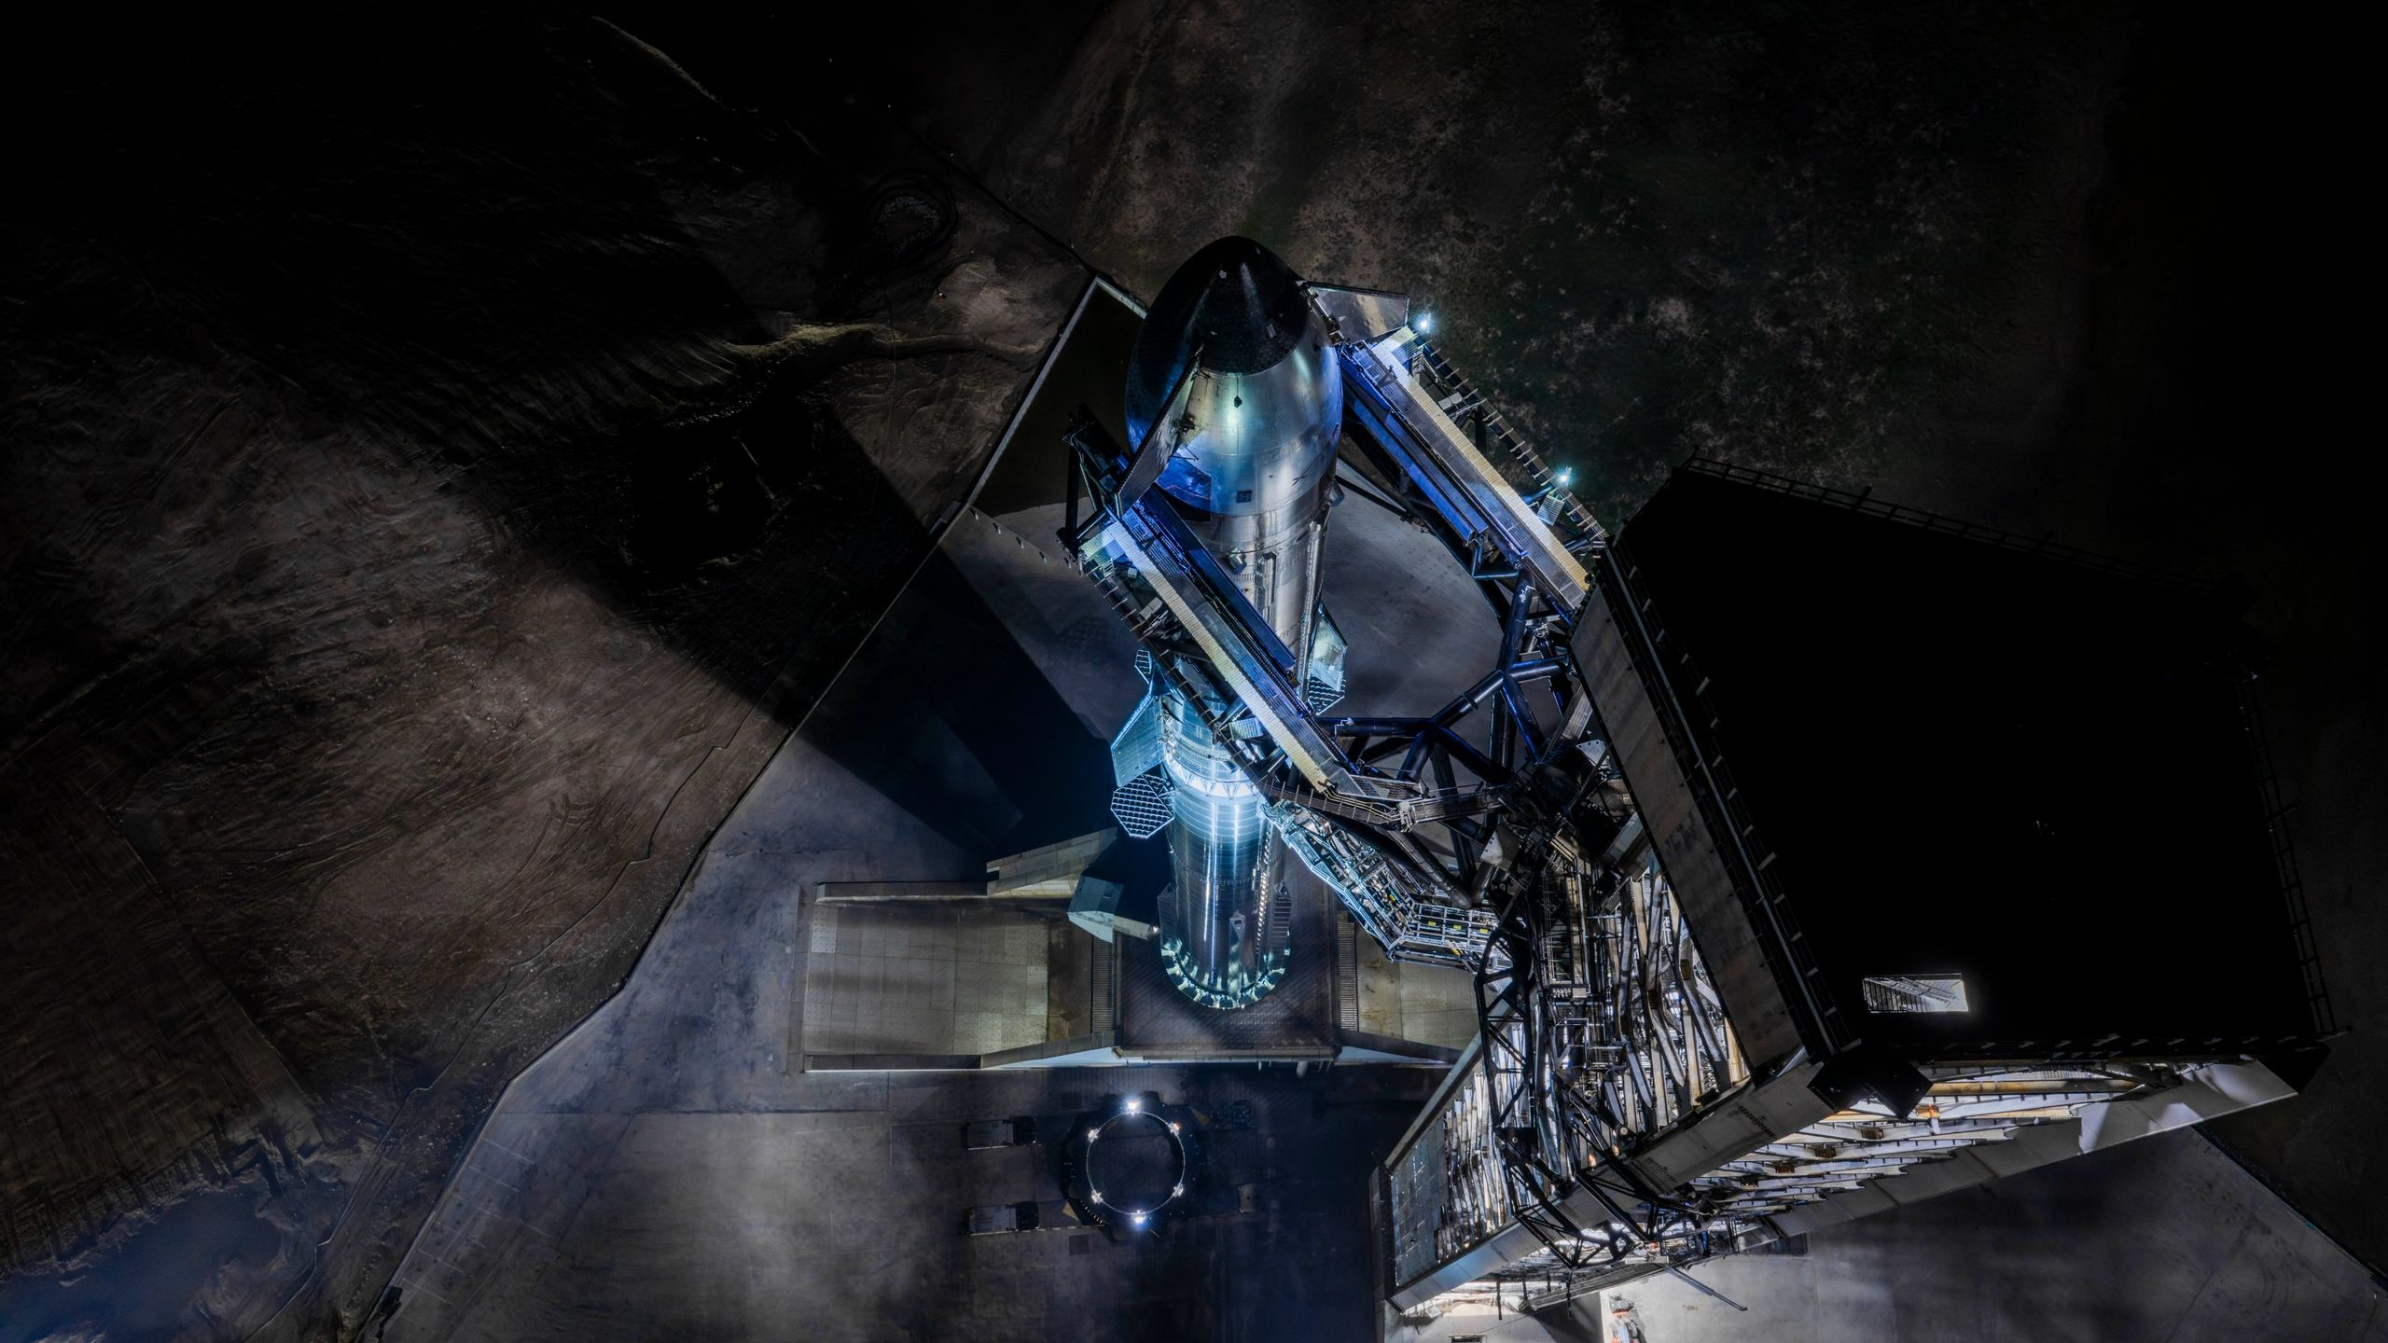
Click for next article Update for 7:10 p.m. ET on July 16: SpaceX's Starship Flight 13 test launch aborted at the last second on July 16: Read our abort story . Starship is about to take to the skies on a bold new test flight of the world's most powerful rocket. After several days of testing, SpaceX has stacked and readied its massive Starship rocket for its 13th test flight . Liftoff is scheduled to occur today (July 16) during a 90-minute launch window that opens at 6:45 p.m. EDT (2245 GMT), from pad 2 at SpaceX's facility in Starbase, Texas. Both stages had been in their respective Starbase hangars for final checkouts following successful engine tests. Booster 40, the Super Heavy first stage launching on Starship Flight 13 , was returned to the pad yesterday (July 15). Ship 40, the mission's upper-stage spacecraft, was rolled from the hangar beginning yesterday evening. The rocket was stacked overnight, according to a SpaceX post on X , and now awaits prelaunch procedures ahead of the beginning of Flight 13's launch countdown. Starship is stacked at Starbase, Texas, ahead of its planned 13th test launch on July 16, 2026. (Image credit: SpaceX) Flight 13 will launch the second "Version 3" (V3) Starship, a new iteration featuring extensive design upgrades to help mature the rocket toward clearing the vehicle for official operation. Compared to its Version 2 predecessor, V3 is taller, carries more propellant, and has lost significant mass around its engine section due to upgraded avionics systems. V3 is also equipped with 33 of SpaceX's upgraded Raptor 3 engines on Super Heavy, and another six (three sea-level, three vacuum-optimized) Raptor 3s on Ship. Starship is designed for full reusability, with both Super Heavy and Ship capable of returning to their launch site for landing and refurbishment, which means making sure there's enough fuel in the tank to make the journey back. One critical upgrade for Starship V3 involves the propellant transfer docking ports that have been added to Ship's dorsal side (opposite the heat-shield tiles on its belly, or ventral side). Ship uses the majority of its fuel getting to space and will therefore require propellant transfers from various refueling flights in order to fly beyond low Earth orbit . NASA is eyeing the development progress of Starship very closely, with a vested interest in the spacecraft's yet-unproven ability to transfer and maintain the types of cryogenic fuels that power its Raptor 3s. NASA has contracted SpaceX to design a lunar lander version of Starship to return astronauts to the moon as a part of the agency's Artemis program , and effectively managing its onboard propellants is one of the requirements on NASA's checklist to certify the vehicle to fly with crews. $39.99 at Amazon Starship Die Cast Rocket Model Was $47.99 Now $39.99 on Amazon. Even if you can't see SpaceX's Starship in person, you can score a model of your own. Standing at 13.77 inches (35 cm), this is a 1:375 ratio of SpaceX's Starship as a desktop model. The materials here are alloy steel and it weighs just 225g. SpaceX plans to complete such a demonstration later this year in preparation for Artemis III , targeted for mid-to-late 2027, which will fly a crew of four aboard NASA's Orion spacecraft to dock with Ship in Earth orbit ahead of the program's first moon landing mission on Artemis IV in 2028. NASA contracted Blue Origin 's Blue Moon spacecraft as an additional Artemis lander, which will also launch to Earth orbit for docking operations with Orion during Artemis III. Starship's readiness to fly those future missions will largely be determined by the rocket's performance on Flight 13, and its subsequent test launches in the coming months. Today's launch aims to smooth over a few rough patches that the vehicle ran into during V3's debut on the mostly successful Flight 12 , which occurred on May 22. Those hiccups included Super Heavy failing to steer itself back to Earth for a controlled splashdown and Ship not relighting one of its Raptor engines in space as planned. Stacking Starship for Flight 13 pic.twitter.com/L4XN6gqgRtJuly 16, 2026 If all goes according to plan on today's launch, Super Heavy will perform a boostback burn and soft splashdown in the Gulf of Mexico. Ship will carry on with a suborbital trajectory, and is expected to release 20 Starlink V3 satellites - the first of the upgraded Starlinks to fly to space. Six of those spacecraft are equipped with cameras to inspect Ship's heat-shield tiles during flight. The satellites , though, will be on the same suborbital trajectory as Ship, and are expected to burn up during reentry through Earth's atmosphere . Ship is scheduled to perform a landing burn and soft splashdown of its own a little more than an hour after liftoff, and will meet a watery demise in the Indian Ocean.

11. SpaceX launches 21 'data transport' satellites for US military (video, photos)
Read more
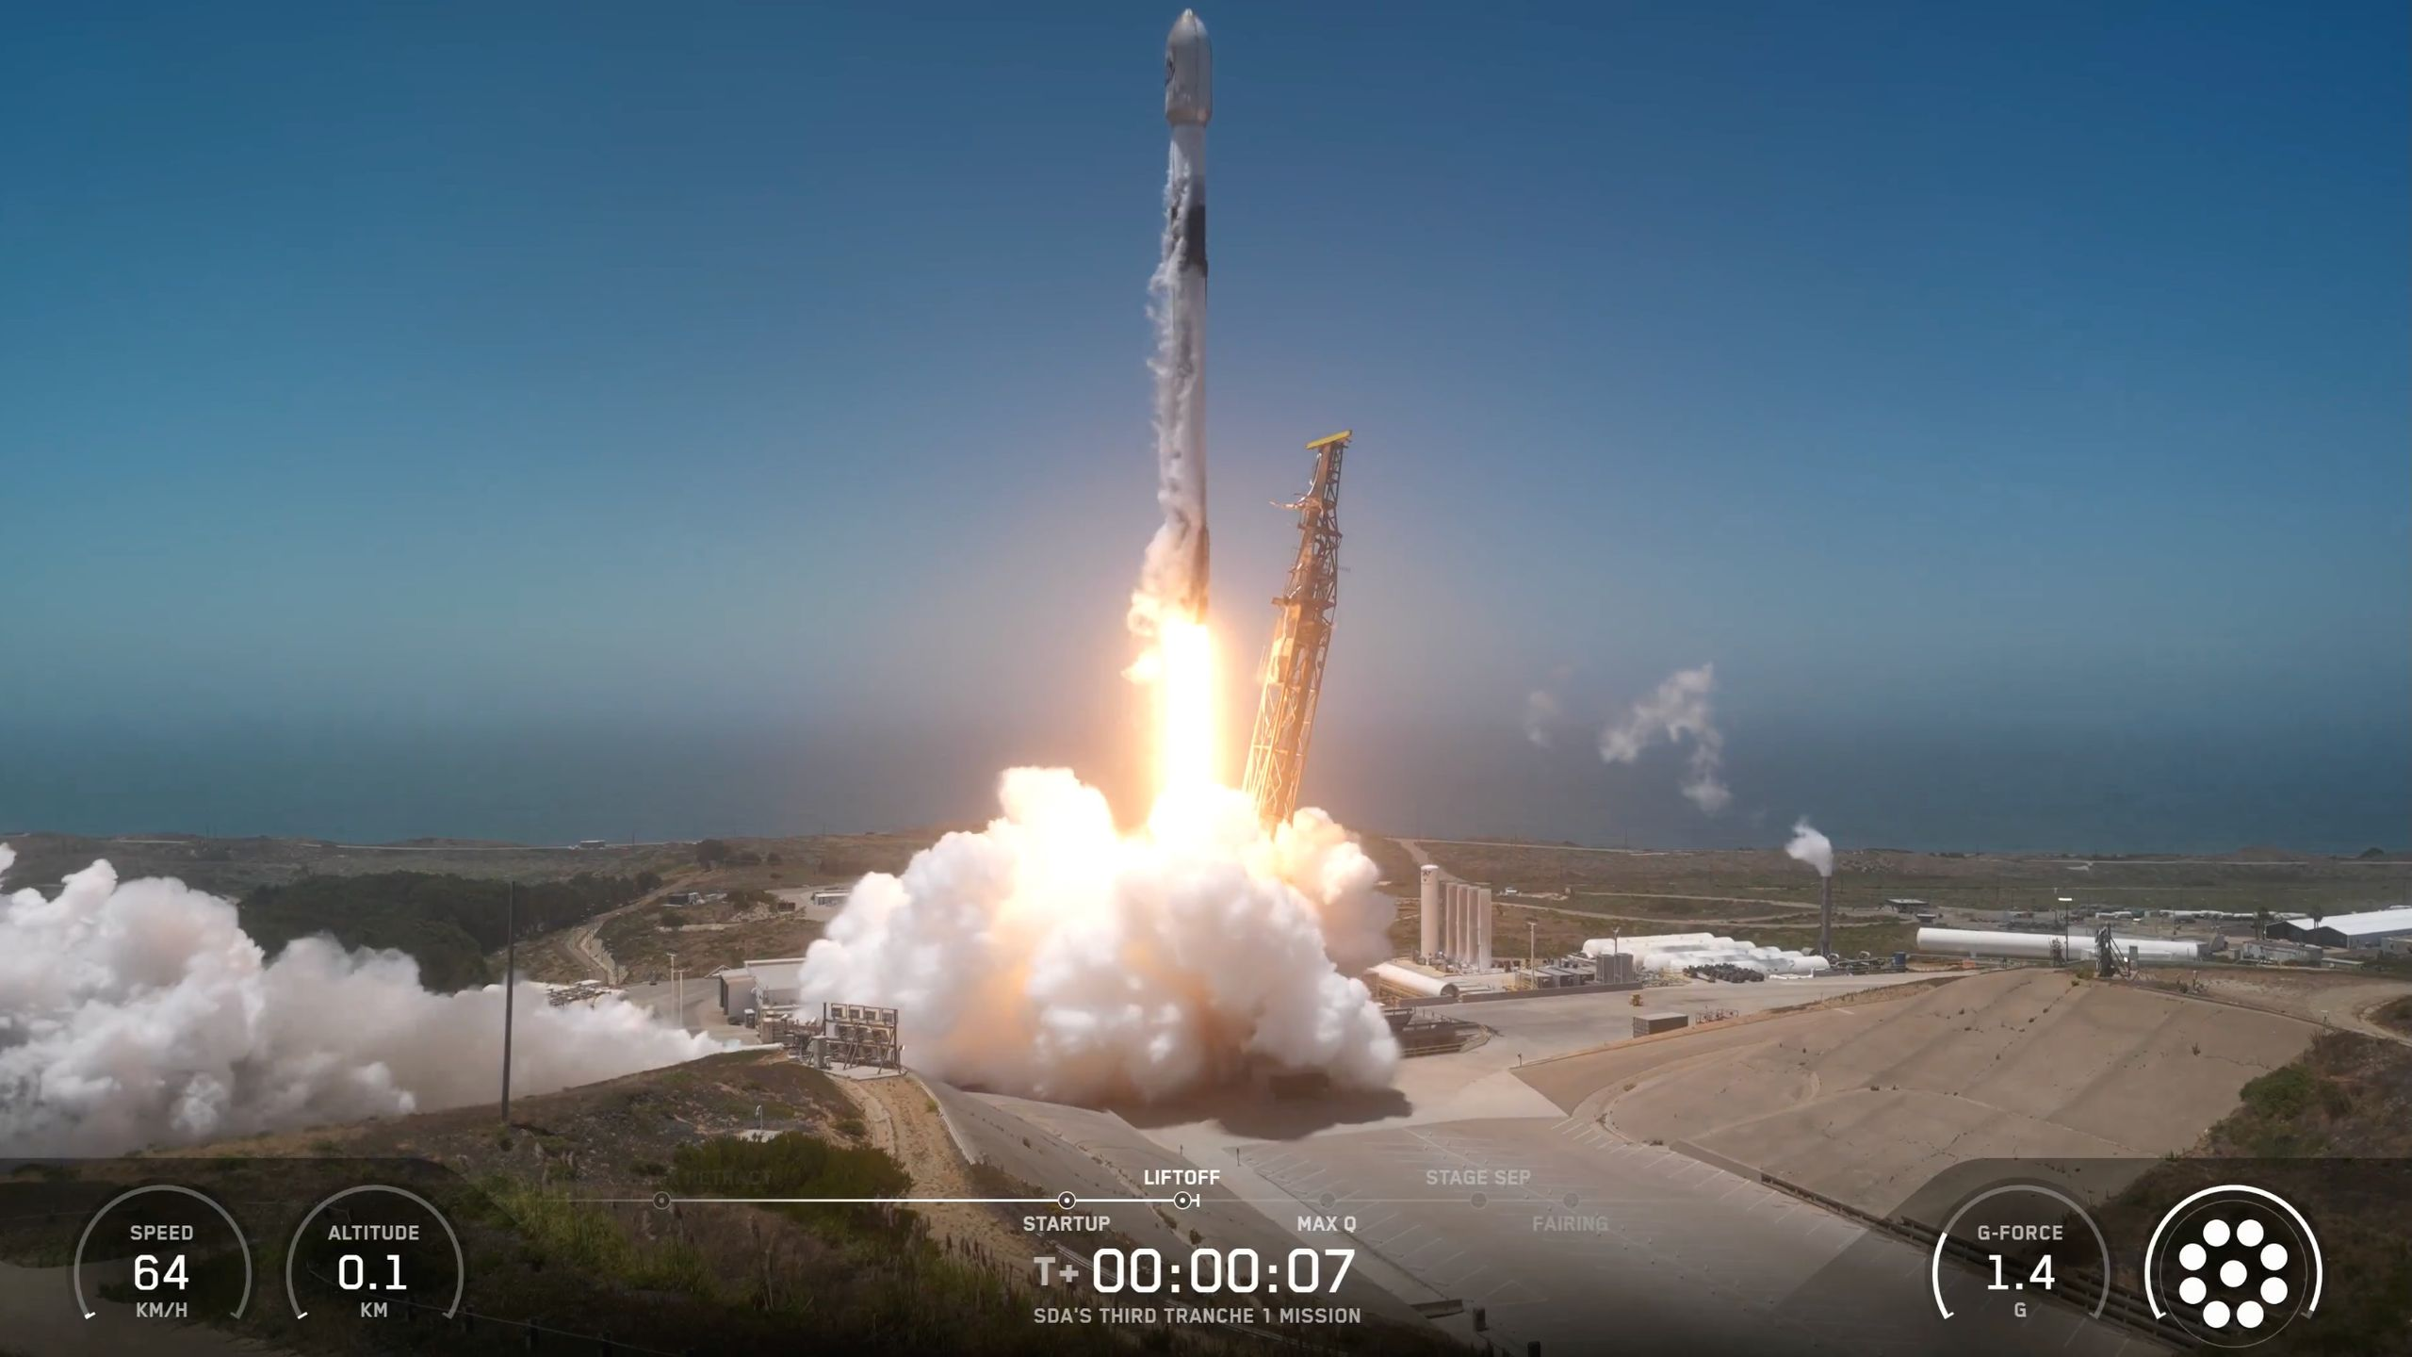
Click for next article Starship isn't the only SpaceX rocket flying today. A Falcon 9 rocket launched from California's Vandenberg Space Force Base today (July 16), carrying 21 satellites for the U.S. military's advanced new "Tranche 1 Transport Layer" (T1TL) constellation to orbit. Liftoff took place at 4:32 p.m. EDT (2032 GMT; 1:32 p.m. local California time). A SpaceX Falcon 9 rocket launches the Third Tranche 1 Mission for the U.S. Space Development Agency from Vandenberg Space Force Base in California on July 16, 2026. (Image credit: SpaceX) SpaceX's Starship megarocket - the biggest and most powerful launch vehicle ever built - is slated to make its 13th test flight a few hours later. It will lift off from the company's Starbase site in South Texas during a 90-minute window that opens at 6:45 p.m. EDT (2245 GMT; 5:45 p.m. local Texas time). SpaceX will stream that mission live, and Space.com will carry the feed . Coverage will begin about half an hour before launch. Today's Falcon 9 flight helps assemble the T1TL, a network in low Earth orbit (LEO) that will be operated by the U.S. Space Force 's Space Development Agency (SDA). The T1TL "will provide global communications access and deliver persistent regional encrypted connectivity in support of warfighter missions around the globe," SDA officials wrote in a explainer . The T1TL will eventually consist of 126 satellites, which will be built by York Space Systems, Lockheed Martin and Northrop Grumman. Sixty-three of the spacecraft have now launched to date, on three Falcon 9 launches from Vandenberg - one last September , another last October and today. These 126 spacecraft will be part of a larger LEO network that the SDA calls the Proliferated Warfighter Space Architecture. The PWSA is "a proliferated constellation of hundreds of optically linked small satellites, in low-Earth orbit (LEO), delivering capability at speed to the warfighter," SDA officials wrote in a Tranche 1 fact sheet . "SDA leverages spiral development to deploy and proliferate new capability into a new generation of the PWSA every two years, called a 'tranche,' to continually increase capability used by the warfighter," they added. The first stage of a SpaceX Falcon 9 rocket rests on a drone ship after launching the Third Tranche 1 Mission for the U.S. Space Development Agency on July 16, 2026. (Image credit: SpaceX) Previous Booster 1103 launches NROL-179 | 2 Starlink missions Everything went according to plan today, at least during the mission's early stages. The Falcon 9's first stage came back to Earth about 8.5 minutes after liftoff for a landing in the Pacific Ocean, on the drone ship "Of Course I Still Love You." According to a SpaceX mission description , it was the fourth flight for this particular booster, which is designated 1103. The Falcon 9's upper stage continued hauling the 21 satellites to LEO. We don't know when or exactly where they'll be deployed; the SpaceX mission description doesn't provide that information, and the company cut off its launch webcast shortly after booster landing at the request of the SDA. Editor's note: This story was updated at 4:44 p.m. ET on July 16 with news of successful launch and booster landing.

12. How NASA's Artemis III lander test will pave way for moon landings
Read more

Before Artemis astronauts land on the moon's surface in 2028, NASA will conduct the Artemis III demonstration mission in 2027, allowing teams on Earth and in orbit to practice rendezvous and docking operations between commercial human landing systems and the Orion spacecraft. Data from that mission, along with future uncrewed demonstration missions at the moon, will support ast...

