 |  | 

🌌 अंतरिक्ष समाचार | Space News
बुधवार, १५/०७/२०२६ | Wednesday, 15/07/2026

1. Nasa's Anil Menon, 2 Russian cosmonauts head to ISS: How to watch launch live
Read more
Nasa astronaut Anil Menon and Russian cosmonauts Pyotr Dubrov and Anna Kikina are set to launch to the International Space Station (ISS) today aboard Russia's Soyuz MS-29 spacecraft. The mission will lift off from the Baikonur Cosmodrome in Kazakhstan at 10:47 am EDT (8:17 pm IST). Nasa will begin live coverage of the launch at 9:45 am EDT (7:15 pm IST) through its official website and YouTube channel. The Soyuz spacecraft is expected to reach the ISS after a fast-track journey lasting just two orbits around Earth. Docking is scheduled for 1:56 pm EDT (11:26 pm IST), with live coverage resuming before the spacecraft arrives at the orbital laboratory. Hatch opening is expected later in the day, after standard safety checks.

2. BioTecNika Times-14-07-2026: Exclusive ISRO & ICMR Life Science Internships, ACTREC Govt Jobs, Roche Freshers Hiring, Master AI for Vaccine & More - BioTecNika
Read more
Special Highlight for the day Story 1 | 14 Jul 2026 | Biotech Internships & Projects Life Sciences External Student Internship at ISRO-IIRS | Apply Now Student Internship at ISRO-IIRS | Careers in Life Sciences Dreaming of working with ISRO and exploring cutting-edge research? The IIRS External Student Internship program offers a unique chance for students to gain practical exposure in advanced scientific fields. Through this. Open the special highlight Story 2 | 14 Jul 2026 | Biotech Internships & Projects Life Science Research Internship at ICMR-NIRT | TB Research & Dissertation Programme - Apply Now Life Science Research Internship at ICMR-NIRT Looking to gain hands-on research experience at one of India's premier biomedical research institutes? The Life Science Research Internship at ICMR-NIRT offers an exceptional opportunity for students to work on cutting-edge projects. Read the full post Featured update Don't Get Left Behind: Build AI Agents for Drug Discovery Before the Industry Moves Ahead | FREE LIVE Webinar - REGISTER NOW Discover how Agentic AI is transforming drug discovery and biotech careers. Join this FREE LIVE webinar to explore future-ready AI skills and emerging opportunities in life sciences. Open link Story 3 | 14 Jul 2026 | Biochemistry Jobs Govt Life Sciences Jobs at ACTREC | Walk-In for Entry-Level Roles Govt Life Sciences Jobs | ACTREC Recruitment | Entry-Level Roles ACTREC Recruitment brings an excellent opportunity under Govt Life Sciences Jobs for the position of Scientific Officer (Transplant Immunology & Immunogenetics Lab). If you are looking to build a strong Career in. Read the full post Story 4 | 14 Jul 2026 | B.E. Roche Careers - Freshers Biotech Jobs | Apply Now Freshers Biotech Jobs at Roche Careers | Associate Jobs Are you looking for Freshers Biotech Jobs at a leading global healthcare company? Roche Careers is inviting applications for the Associate Jobs role in Chennai. This is an excellent opportunity for fresh graduates and. Read the full post Featured update Master AI for Vaccine Design in Just 1 Day | Early Bird Ends Soon - Register Now Discover how AI is transforming modern vaccine development from immunology fundamentals to hands-on AI tools. Join this LIVE national workshop, secure the early bird price before it ends, and earn your participation certificate. Open link Story 5 | 14 Jul 2026 | Featured Life Science Remote Jobs at Parexel | Careers in Biotech Life Science Remote Jobs at Parexel Careers - Health Economics Associate Looking for Life Science Remote Jobs? Parexel Careers is hiring for the position of Health Economics Associate in India (Remote). This opportunity is ideal for candidates with a Master's degree or. Read the full post Story 6 | 14 Jul 2026 | B.Tech Freshers Recruitment at Sids Farm | Apply Now for Food Tech Jobs Food Tech Jobs for Freshers | Sids Farm Hiring | Apply Now Searching for exciting Food Tech Jobs in the dairy and food manufacturing industry? Sids Farm Recruitment has opened applications for the position of Production Executive at its Tumkur facility. As one of India's. Read the full post Story 7 | 14 Jul 2026 | Jobs Pharmacovigilance Jobs at TCS | Life Sciences Candidates Attend the Walk-In Pharmacovigilance Jobs at TCS | Life Sciences | Walk-In Looking for exciting Pharmacovigilance Jobs with one of India's leading multinational companies? TCS Career opportunities are now open for experienced professionals through a walk-in drive for Pharmacovigilance roles in. Read the full post Featured update Get Biotech Jobs First - Join BioTecNika's FREE WhatsApp Group BioTecNika provides updates on a daily, hourly, and minute-by-minute basis. Some jobs and opportunities expire within days. We don't want you to miss out waiting for the next newsletter, so subscribe to BioTecNika's free WhatsApp group to get jobs and updates faster than ever, and that too for free. Open link Story 8 | 14 Jul 2026 | B.Sc Upto ₹67,200/month IIT Biotechnology Jobs 2026 - Scientist Vacancies | Walk-In Interview Biotechnology Jobs at IIT | Candidates Apply Now Are you looking for Biotechnology Jobs at a prestigious IIT? IIT Guwahati has announced IIT Careers for Project Technician and Project Scientist Jobs under a cutting-edge research project focused on developing a potential. Read the full post Featured update Chanakya School of Biosciences Admissions Open For B.Tech Biotechnology & Bioengineering | Apply Now Build your Future with Chanakya University - B.Tech Biotechnology & Bioengineering Admissions Open. Open link Story 9 | 14 Jul 2026 | Jobs Junior Research Fellow Recruitment at National Institute of Immunology (NII) | Apply Now Junior Research Fellow at NII The National Institute of Immunology (NII) invites applications for the position of Junior Research Fellow (Project) under a DBT-funded research project. This Junior Research Fellow opportunity is ideal for candidates with an M.Sc in Life Sciences. Read the full post Story 10 | 14 Jul 2026 | Agriculture Jobs Rs. 70,000/- Per Month Govt Research Jobs at AIIMS | Online Applications Govt Research Jobs at AIIMS | Earn Rs. 70,000/- Per Month Looking for high-paying Govt Research Jobs at one of India's premier medical institutions? AIIMS Recruitment 2026 has announced an excellent opportunity for the position of Senior Project Associate under an ANRF-funded. Read the full post Story 11 | 14 Jul 2026 | Biochemistry Jobs ICAR-IARI Young Professional Job | Earn Upto ₹42,000 Salary | Apply Now Young Professional Jobs at ICAR-Indian Agricultural Research Institute Looking for a government-funded research opportunity in plant biotechnology? The Young Professional Job under the ICAR-Indian Agricultural Research Institute Recruitment offers an excellent opportunity for. Read the full post Story 12 | 14 Jul 2026 | B.Sc Lonza Careers 2026: Life Sciences & QA Jobs Life Sciences Jobs at Lonza | Candidates Apply Now Are you looking for Life Sciences Jobs or QA Jobs with a leading global pharmaceutical company? Lonza Careers has announced an excellent opportunity for the position of Quality Associate - GMP & DI Compliance in Rewari,. Read the full post Story 13 | 14 Jul 2026 | B.Sc Life Sciences Jobs at Fortrea | Apply Online for Roles in Bengaluru Life Sciences Jobs at Fortrea in Bengaluru | Apply Online Looking for exciting Life Sciences Jobs with a leading global CRO? Fortrea is hiring a Central Monitor Assistant in Bangalore, offering an excellent opportunity for professionals seeking growth in Clinical Research Jobs. Read the full post Story 14 | 14 Jul 2026 | B.Sc IQVIA Hiring in Bengaluru | Apply For Life Sciences Jobs Life Sciences Jobs | IQVIA Hiring in Bengaluru | Apply Now Looking for Life Sciences Jobs with a global leader in healthcare intelligence? IQVIA Careers is hiring for the position of Clin Process Coord in Bengaluru, India. This hybrid, full-time opportunity is ideal for life. Read the full post Story 15 | 14 Jul 2026 | B.Sc Clinical Research Job At ICON plc | Openings at Multiple Locations Clinical Research Job at ICON Are you searching for a Clinical Research Job in Clinical Data Management? ICON Strategic Solutions (FSP) is hiring for the position of CDC II in Bangalore, Chennai, Trivandrum, and Bengaluru. This hybrid opportunity is ideal for candidates with a. Read the full post Story 16 | 14 Jul 2026 | B.Sc Hybrid Clinical Research Job at IQVIA | Apply Online Here Hybrid Clinical Research Job at IQVIA If you are searching for a Hybrid Clinical Research Job with a globally recognised organisation, this IQVIA career opportunity could be the right fit. IQVIA is hiring for the position of Clin Process Assoc/ Sr Clin Process Assoc in Kolkata,. Read the full post Story 17 | 14 Jul 2026 | Jobs Cipla Hiring Microbiology Professionals! Apply Online Now Microbiology Job at Cipla Looking for an exciting Microbiology Job in the pharmaceutical industry? Cipla is hiring a Team Member - Microbiology at its Baddi manufacturing facility in Himachal Pradesh. This opportunity is ideal for M.Sc. Microbiology graduates with laboratory. Read the full post Story 18 | 14 Jul 2026 | B.Sc ICON Careers 2026: Clinical Data Science Associate | Apply Now Life Sciences Jobs at ICON Careers | Clinical Research Jobs - Clinical Data Science Associate Are you searching for Life Sciences Jobs, exploring ICON Careers, or aiming to grow in Clinical Research Jobs in India? ICON plc is hiring a Clinical Data Science Associate for its. Read the full post Story 19 | 14 Jul 2026 | Career Advice QA/QC Jobs for Biotechnology Freshers: Salary, Skills & Interview QA/QC Jobs for Biotechnology Freshers: Salary, Skills & Interview In the world of science, there are a few hidden and unsung superheroes. One of them is the Quality Control (QC) & Quality Assurance (QA) professionals who work to ensure that every drug that reaches us is safe.. Read the full post

3. ISRO successfully carries out tests of Gaganyaan crew module systems - Manorama Yearbook
Read more
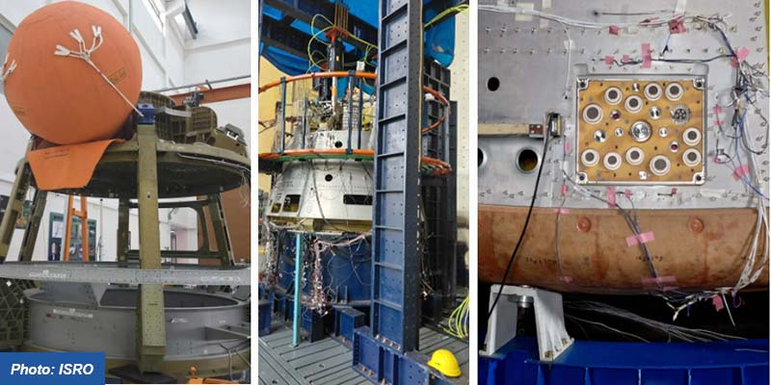
• The Indian Space Research Organisation (ISRO) successfully carried out three major tests of the Gaganyaan crew module systems on July 12. • The first test pertained to ensuring an upright position for the crew module after splashdown in the sea, considered one of the most important crew safety requirements. • To do this, a stored cold-gas-based uprighting system was developed and tested. • The second test involved examining the separation of the umbilical mechanism that serves as a link between the crew module, where astronauts live, and the service module, which provides power and propulsion. • The third test validated the structural integrity of the crew module during the apex cover separation event. • The apex cover protects the parachutes and associated subsystems during the mission. It is separated before parachutes are deployed to decelerate the crew module. Gaganyaan Mission • Prime Minister Narendra Modi announced the Gaganyaan mission in his Independence Day address in 2018. • Gaganyaan project envisages demonstration of human spaceflight capability by launching a crew of three members to an orbit of 400 km for a three days mission and bring them back safely to Earth, by landing in Indian sea waters. • For the first human spaceflight, four Indian Air Force pilots have been selected and are undergoing extensive training for the mission. • A budget of Rs 9,023 crore is allocated towards achieving the objectives of the mission. • ISRO developed indigenous technologies for the launch vehicle, habitable Crew Module, life support system, Crew Escape System, ground station network, crew training and recovery. • These technologies are crucial to meet the objectives of Gaganyaan mission and to take up any further interplanetary missions. • Gaganyaan will not be a one-off mission as the government has given approval for a sustained human spaceflight programme. • The programme comprises three uncrewed missions and one crewed mission. • The maiden Gaganyaan uncrewed mission is expected to be launched with a humanoid robot, Vyommitra. • The first crewed mission is targeted in 2027-28.

4. Is Gaganyaan mission getting closer to launch? ISRO says 3 crucial tests completed - theweek.in
Read more
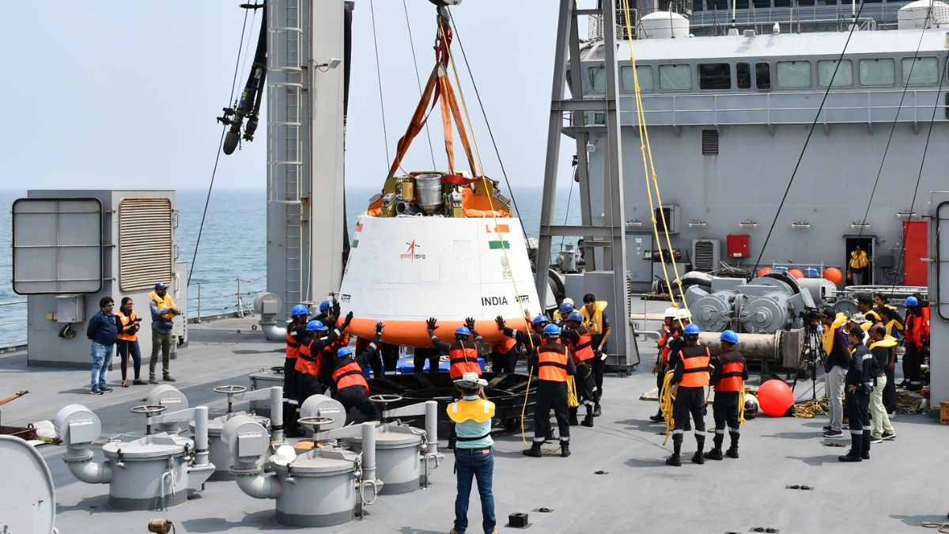
India's first human space journey has come one big step closer. The Indian Space Research Organisation (ISRO) has announced that it had successfully completed three important qualification tests for the Gaganyaan crew module. Gaganyaan is India's first mission to send astronauts into space and bring them back safely. If it succeeds, India will become only the fourth country in the world after the United States, Russia, and China to send humans into space using its own rocket and spacecraft. The astronauts, called Gaganyatris, will travel to Low-Earth Orbit, about 400 kilometres above the Earth, and stay there for up to a week. Why the three tests are crucial for the mission? The three tests are crucial as each one protects the astronauts at a different risky moment. The first test was for the Crew Module Uprighting System (CMUS). When the crew module finally returns from space, it lands in the sea with a big splash. Sometimes, a capsule can turn upside down in the water, which is dangerous for the people inside. To stop this, ISRO built a special system that uses stored cold gas. High-pressure gas is released through control valves, which inflates floating bags around the capsule. These bags turn the module back into the correct upright position, so the astronauts stay safe until rescue teams reach them. In the test, ISRO checked that the bags inflate properly and in the right time, across different gas pressures. It worked perfectly. The second test was for the Crew Module-Service Module Connect and Disconnect System (CS-CDS). "The crew module is where the astronauts sit. The service module supplies power, propulsion, and life support. These two parts are joined by connectors called umbilicals, think of them like cables and pipes carrying electricity and fluids. There are two such connectors, named CSU-1 and CSU-2. When the spacecraft comes back to Earth, these two parts must separate cleanly at the right moment. CSU-1 detaches when the service module leaves, and CSU-2 disconnects just before the crew module enters the atmosphere. ISRO tested the separation of CSU-2 using a model crew module and confirmed it separated cleanly, with the structure staying strong and stable," explained space analyst Girish Linganna. The third test was the Apex Cover structural qualification. "The apex cover is a protective cap that shields the parachutes during launch and the fiery return through the atmosphere. Without parachutes, the capsule cannot slow down for a soft landing. So the apex cover must stay firmly in place, and then jettison at exactly the right time to let the parachutes open. In this test, ISRO pushed the crew module with loads nearly 1.75 times stronger than what it will actually face during flight. Even under this extra pressure, the module stayed strong. The bending and stress remained well within safe limits," added Linganna. The success proves the reliability of the systems that will protect Indian astronauts during the most dangerous stages separation, re-entry, and splashdown. Is the launch happening soon? May not be as these tests are a big milestone, but they are only part of a long, careful process. In a human space mission, there is no room for even a small mistake. So every part is tested again and again until engineers are fully confident. Alongside these tests, ISRO's parachute qualification campaign (IMAT series) continues in phases, with a major air-drop test done earlier in 2026 to check parachutes for safe landing. Here is what still lies ahead. Before any human flies, ISRO will send uncrewed test missions. The first, called G1, is expected around late 2026. It will carry Vyommitra, a half-humanoid robot that will sit in the astronaut's seat and check the life-support and safety systems. Two more uncrewed flights, G2 and G3, will follow. Only after these successful trials will the first crewed mission, called H1, take flight currently planned for 2027. Four astronauts have already been selected and are training hard. Why is ISRO going so slowly and carefully? Human lives are at stake. Testing step by step allows engineers to find and fix problems on the ground, long before anyone climbs aboard. Over 8,000 ground tests have already been done for the Gaganyaan mission.

5. ISRO के बाद अब Indian Space Startups की बड़ी उड़ान, Bengaluru से बन रहे Smart Satellites - Prabhat Khabar
Read more
ISRO के बाद अब Indian Space Startups की बड़ी उड़ान, Bengaluru से बन रहे Smart Satellites Prabhat Khabar

6. NASA Invites Media to Serbia Artemis Accords Signing Ceremony
Read more
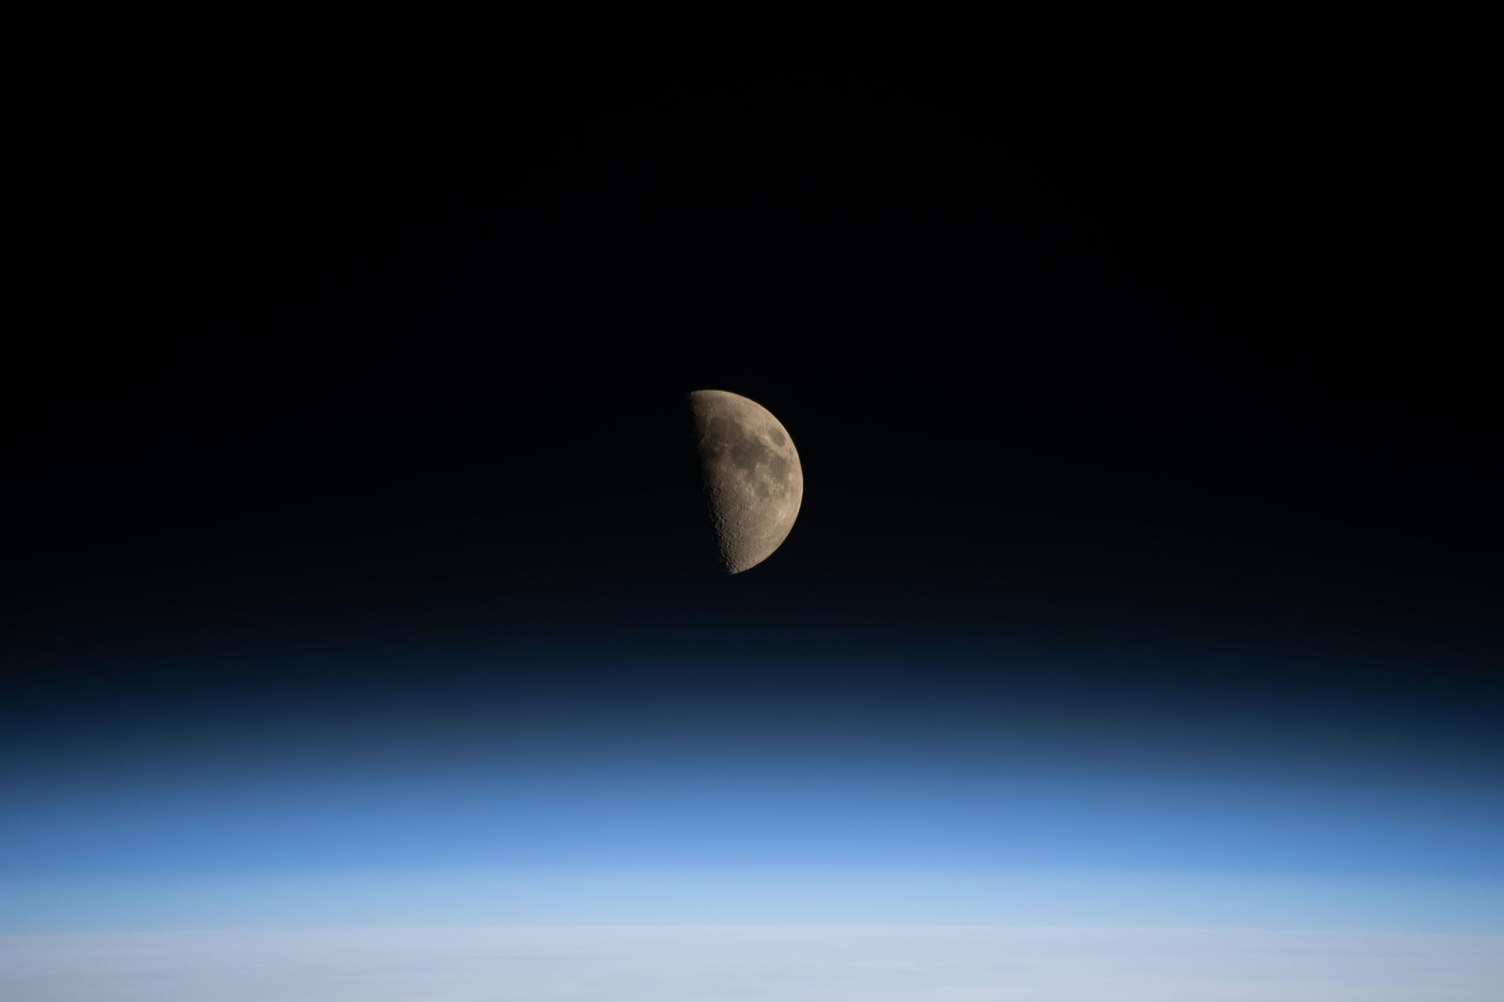
Credit: NASA The Republic of Serbia will sign the Artemis Accords at 5 p.m. EDT Thursday, July 16, during a ceremony at NASA Headquarters in Washington. NASA Deputy Administrator Matt Anderson will host Serbia's Minister of Foreign Affairs Marko Đurić and U.S. State Department Assistant Secretary for Oceans and International Environmental and Scientific Affairs Wesley Brooks for the ceremony. This event is in person only. Media interested in attending must RSVP no later than 3 p.m. on July 16, to: hq-media@mail.nasa.gov. NASA's media accreditation policy is online. In 2020, during the first Trump Administration, the United States, led by NASA and the State Department, joined with seven other founding nations to establish the Artemis Accords, responding to the growing interest in lunar activities by both governments and private companies. The accords introduced the first set of practical principles aimed at enhancing the safety, transparency, and coordination of civil space exploration on the Moon, Mars, and beyond. Serbia will be the 69th country to sign the Artemis Accords. https://www.nasa.gov/artemis-accords -end- Camille Gallo / Elizabeth Shaw Headquarters, Washington 202-358-1600 camille.m.gallo@nasa.gov / elizabeth.a.shaw@nasa.gov

7. NASA Astronaut Anil Menon, Crewmates Arrive at Space Station
Read more

The Soyuz rocket launches to the International Space Station with NASA astronaut Anil Menon and Roscosmos cosmonauts Pyotr Dubrov and Anna Kikina onboard, Tuesday, July 14, 2026, at the Baikonur Cosmodrome in Kazakhstan. Credit: NASA/Bill Ingalls NASA astronaut Anil Menon, along with Roscosmos cosmonauts Pyotr Dubrov and Anna Kikina, arrived safely at the International Space Station Tuesday, bringing the orbiting laboratory's crew to 10 for about the next two weeks. The trio launched aboard the Soyuz MS-29 spacecraft at 10:47 a.m. EDT (7:47 p.m. local time) from the Baikonur Cosmodrome in Kazakhstan. After a three-hour, two-orbit journey, the spacecraft docked at 1:52 p.m. with the station's Prichal module. Following hatch opening, expected about 4 p.m., the new arrivals will be welcomed by the space station Expedition 74 crew: NASA astronauts Jessica Meir, Jack Hathaway, and Chris Williams; ESA (European Space Agency) astronaut Sophie Adenot; and Roscosmos cosmonauts Sergey Kud-Sverchkov, Sergei Mikaev, and Andrey Fedyaev. NASA's live coverage of hatch opening begins at 3:30 p.m. on NASA+, Amazon Prime, and YouTube. Learn how to watch NASA content through a variety of online platforms, including social media. During his stay aboard the station, Menon will conduct scientific research and technology demonstrations aimed at advancing human space exploration and benefiting life on Earth. He will continue research to refine in-space production of semiconductor crystals to enable the large-scale manufacturing of components needed for high-performance computers, artificial intelligence, and improved medical devices. Menon also will perform ultrasound using augmented reality and artificial intelligence methods that could eliminate the need for medical support from Earth on future space missions. He will be a test subject helping researchers understand how blood flow is affected in space to protect future astronauts. He also will test bioprinting vascular constructs in microgravity to improve understanding of the aging process to advance therapeutic developments. Expedition 75 is scheduled to begin on Sunday, July 26, following the departure of Williams, Kud-Sverchkov, and Mikaev, as they conclude an eight-month science mission aboard the orbital outpost. Watch the change of command ceremony at 9:40 a.m. on Saturday, July 25, as station command transfers from Kud-Sverchkov to Meir, live on NASA+. Learn more about International Space Station, crews, research, and operations at: https://www.nasa.gov/station -end- Joshua Finch / Jimi Russell Headquarters, Washington 202-358-1100 joshua.a.finch@nasa.gov / james.j.russell@nasa.gov Sandra Jones Johnson Space Center, Houston 281-483-5111 sandra.p.jones@nasa.gov

8. Hubble Sees Crimson Cloud and Stars
Read more

A glowing landscape of gas and dust is heated and illuminated by a thriving population of young stars in the LH 95 region of the Large Magellanic Cloud. NASA, ESA, and N. Da Rio (The University of Virginia), G. De Marchi (European Space Agency - ESTEC), and D. Gouliermis (Universitat Heidelberg); Processing: Gladys Kober (NASA/Catholic University of America)

9. NASA Jets Turn Red, White, and Blue
Read more

A NASA F-15 aircraft flies above Washington on Saturday, July 4, 2026, as part of a flyover to celebrate America's 250th birthday. This aircraft is from NASA's Armstrong Flight Research Center in Edwards, California, and it joined other NASA aircraft for the flyover. NASA/Jim Ross In honor of America's 250th birthday, two of NASA's most iconic aircraft got a fresh coat of red, white, and blue paint ahead of a flyover in Washington on July 4, 2026, with other NASA aircraft. An F-15 and an F/A-18 from NASA's Armstrong Flight Research Center in Edwards, California, recently were repainted in patriotic colors as a tribute to the past and a salute to the future. The red, white, and blue commemorative paint and Freedom 250 logo will remain on these aircraft for at least the next year, so be sure to catch these at local air shows and events. Follow along on social media and at https://www.nasa.gov/freedom250/ to learn more about where to spot the aircraft (dependent upon availability and flying schedules): July 23-24: EAA AirVenture, Oshkosh, Wisconsin Oct. 3-4: Pacific Airshow, Huntington Beach, California And more… Check out more images here: https://www.nasa.gov/gallery/freedom-250/ NASA's F-15, right, and F/A-18 aircraft are shown at International Aerospace Coatings Inc.'s facility in Spokane, Washington, on Thursday, July 2, 2026, with new red, white, and blue paint to celebrate America's 250th birthday. The aircraft, from NASA's Armstrong Flight Research Center in Edwards, California, participated in the Freedom 250 flyover in Washington on Saturday, July 4, 2026, with other NASA and military aircraft. NASA/Jim Ross NASA/Jim Ross NASA's F-15 aircraft is shown at International Aerospace Coatings Inc.'s facility in Spokane, Washington, on Thursday, July 2, 2026, with new red, white, and blue paint to celebrate America's 250th birthday. The aircraft, from NASA's Armstrong Flight Research Center in Edwards, California, participated in the Freedom 250 flyover in Washington on Saturday, July 4, 2026, with other NASA and military aircraft. NASA/Jim Ross NASA/Jim Ross

10. NASA's Roman Telescope Will Spot Distant Black Holes That Shred Stars
Read more

Lee esta nota de prensa en español aquí. How do black holes at the center of galaxies form and grow over time? To answer this question, scientists need to detect and study supermassive black holes at great distances, which existed much earlier in the universe's history. New research suggests NASA's Nancy Grace Roman Space Telescope, which is on track to launch Aug. 30, 2026, will be able to detect these distant, ancient black holes that existed up to 11 billion years ago. This artist's concept portrays a Sun-like star being shredded by a supermassive black hole - a phenomenon known as a tidal disruption event. During these events, the region around a black hole can brighten and become visible across great distances. NASA's Nancy Grace Roman Space Telescope will be able to spot and study tidal disruption events that occurred early in the universe's history. By characterizing an earlier population of supermassive black holes, astronomers can learn about their origins. NASA, Ralf Crawford (STScI) Black holes are best studied by looking for the light emitted from their accretion disk - the matter that swirls around them before being consumed. Lighter supermassive black holes are challenging to observe because they tend to be less luminous due to less accretion. But occasionally, they shred and consume an entire star, brightening to outshine their entire host galaxy - known as a tidal disruption event (TDE). By characterizing that population of early supermassive black holes and how they evolve and grow for billions of years, Roman will provide clues to the ultimate origin of these behemoths. "The Roman Space Telescope is going to be transformative for transient science," said lead author Mitchell Karmen of the Johns Hopkins University, a graduate student and National Science Foundation Graduate Research Fellow. "Thanks to Roman's high sensitivity, we can find multiple tidal disruption events out to greater distances and earlier cosmic times than ever before." A paper about this research published Tuesday in The Astrophysical Journal. Shredding Stars Roman's High-Latitude Time-Doman Survey, one of three core community surveys, is particularly well suited to find and study TDEs in the early universe. This survey will cover about 18 square degrees on the sky, an area equivalent to 90 full moons, at a regular cadence. By revisiting the same regions repeatedly, astronomers can find large numbers of transient events like TDEs. Tidal disruption events are phenomena unique to lighter supermassive black holes. Heftier black holes weighing more than 1 billion Suns will swallow incoming stars whole. But lighter black holes of about 100,000 to 100 million Suns can shred a star before consuming it, creating a beacon that brightens over a couple of weeks before gradually fading away. The rate of TDEs fluctuates over cosmic time. Previous work predicted that the rate of TDEs would decrease with increasing distance because most young black holes were too light to generate a TDE. However, this new research takes into account numerous factors that evolve over time, like the frequency of galaxy (and hence black hole) mergers as well as the number of stars within the core of each galaxy and how closely packed they are. Karmen and his colleagues modeled these and other effects to predict how many tidal disruption events Roman could observe, as well as other observatories like the ground-based National Science Foundation-Department of Energy Vera C. Rubin Observatory and NASA's James Webb Space Telescope. The team forecasts that astronomers will see the rate of TDEs increase as Roman probes greater distances and earlier times until "cosmic noon," about 11 to 12 billion years ago when star formation peaked throughout the universe, before decreasing again. To view this video please enable JavaScript, and consider upgrading to a web browser that supports HTML5 video This visualization shows the average number of tidal disruption events NASA's Nancy Grace Roman Space Telescope is predicted to detect in a year, based on simulations. Roman is expected to record about 100 such events in a year. Video: NASA, STScI. Visualization: Christian Nieves (STScI). Sound: Christian Nieves (STScI). Designer: Dani Player (STScI). Animation: Greg Bacon (STScI) Complementary Observations Roman will observe near-infrared wavelengths of light. Light from distant TDEs becomes stretched to longer wavelengths by the expansion of the universe, a phenomenon known as cosmological redshift. As a result, Roman is inherently optimized to detect TDEs whose light traveled anywhere from 8 billion to 11 billion years to reach us. The Rubin Observatory also will scan large swaths of the sky and pick up many new TDEs. However, it will observe visible light, which limits it to closer TDEs than Roman. The research by Karmen's team finds that Rubin will detect thousands to tens of thousands of TDEs per year. While Roman is expected to find up to 100 TDEs per year, those black holes will be much more distant, within the realm of cosmic history that is most important for distinguishing among black hole origin scenarios. "Just by counting the number of TDEs as a function of redshift, you can put meaningful constraints on the population of million-solar-mass black holes," said co-author Suvi Gezari, an associate professor of astronomy at the University of Maryland. "Roman will be transformative in that it can probe tidal disruption events out to greater distances, so you can look at how the rate of TDEs evolves over time." Origins of supermassive black holes Astronomers have observed truly gargantuan black holes very early in the history of the universe - so early that theories struggle to explain how they could have become so large, so quickly. They must have started smaller and grown over time, but how much smaller? One theory, known as "light seeds," begins with black holes that are created from the deaths of massive stars. Such black holes might weigh up to a few hundred times our Sun. These black holes then would merge over time, as well as consume surrounding gas at an astonishing rate. In this scenario, every young galaxy would be expected to have a massive black hole at its center. A second theory, known as "heavy seeds," suggests that a black hole could be born with a much higher mass, up to a million times our Sun, through a process such as the direct collapse of a gas cloud. This process should be less common, though, which would result in supermassive black holes being much rarer in early galaxies. "Tidal disruption events help us probe the population of light supermassive black holes, which can help us discriminate between these models," Karmen said. Ultimately, Roman's tally of tidal disruption events will help researchers trace global effects that impact the black hole population over time. Once Roman and Rubin begin regular science operations, the team looks forward to comparing their forecasts to the actual detections those observatories make. "Just like Webb has transformed our understanding of distant, high-redshift galaxies, Roman is poised to transform our understanding of high-redshift transients," Gezari said. The Nancy Grace Roman Space Telescope is managed at NASA's Goddard Space Flight Center in Greenbelt, Maryland, with participation by NASA's Jet Propulsion Laboratory in Southern California; Caltech/IPAC in Pasadena, California; the Space Telescope Science Institute in Baltimore; and a science team comprising scientists from various research institutions. The primary industrial partners are BAE Systems, Inc. in Boulder, Colorado; L3Harris Technologies in Melbourne, Florida; and Teledyne Scientific & Imaging in Thousand Oaks, California. By Christine Pulliam Space Telescope Science Institute, Baltimore, Md. Media Contact: Claire Andreoli NASA's Goddard Space Flight Center, Greenbelt, Md. 301-286-1940

11. SpaceX launches flight-proven rocket for 600th time, sending Starlink satellites to orbit
Read more
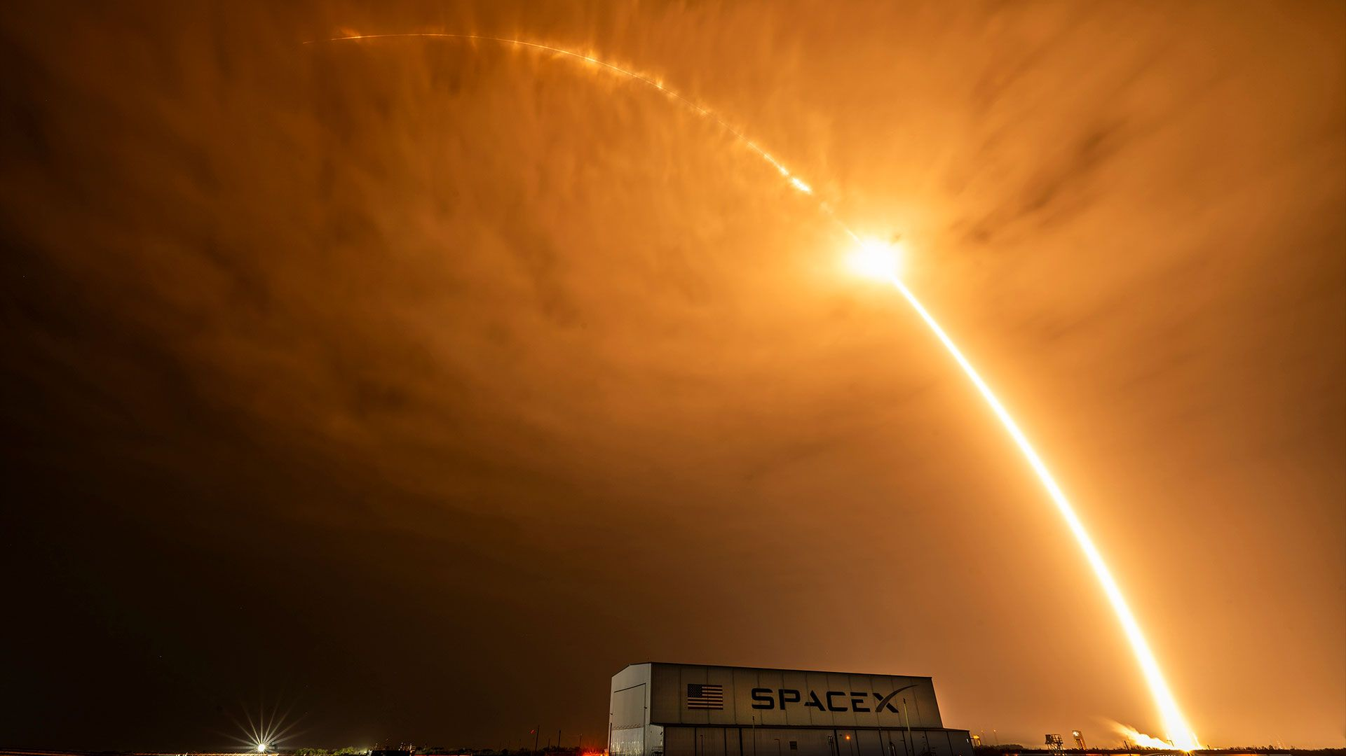
Click for next article A time-lapse photo of SpaceX Falcon 9 rocket lifting off from Cape Canaveral Space Force Station in Florida on July 14, 2026. It was the 600th reuse of a flight-proven Falcon 9 rocket stage. SpaceX reached a milestone with its latest Starlink launch, sending the satellites into orbit on its 600th flight of a flight-proven booster. The sexacentennial launch came on the second of two Falcon 9 missions that lifted off less than eight hours apart overnight from Monday to Tuesday (July 13 to July 14). The first flight, with Starlink batch 15-14 , launched at 9:28 p.m. EDT (0128 GMT or 6:28 p.m. PDT local time) from Space Launch Complex 4 East at Vandenberg Space Force Base in California. The second flight, with Starlink group 10-45 , followed at 5:10 a.m. EDT (0910 GMT) from Space Launch Complex 40 at Cape Canaveral Space Force Station in Florida. A SpaceX Falcon 9 rocket carrying Starlink satellites launches from Vandenberg Space Force Base in California on July 13, 2026. (Image credit: SpaceX) Both launches successfully deployed their payloads - 27 and 29 Starlink satellites, respectively - into their intended orbits, as confirmed by SpaceX . Previous Booster B0193 missions SDA-T1TL-B | SDA-T1TL-C | Transporter-16 | 11 Starlink missions Both flights also successfully recovered their Falcon 9 first stage boosters. B1093, launched from Florida, completed its 15th flight. B1080, launched from California, achieved its 28th mission. The record for a single Falcon 9 first stage's re-flight stands at 36 launches . The addition of 56 more Starlink satellites to SpaceX's megaconstellation brought the total active number of broadband internet relay units to 10,839, according to tracker Jonathan McDowell . In addition to Tuesday's launch being the 600th launch of a flight-proven Falcon 9 stage, SpaceX now stands at 83 Falcon 9 missions this year to date.

12. 'Once Upon a Time in Space': How to watch PBS's out-of-this-world astronaut documentary
Read more

Click for next article Preview - Once Upon a Time in Space - YouTube Watch On As our planet revels in the recent achievements of this spring's Artemis 2 mission and its four astronaut crew members, a new four-part PBS documentary series takes a scrutinizing look at space exploration and its inherent perils and promises. " Once Upon a Time in Space " will be available to watch on PBS (and the PBS app) starting on July 14, 2026 (9pm ET). Directed by James Bluemel and his filmmaking team - the crew behind the award-winning "Once Upon a Time in Northern Ireland" and "Once Upon a Time in Iraq" - "Once Upon a Time in Space" explores the connections between those venturing beyond Earth's gravity and the support staff remaining behind while pioneering souls venture into hostile outer space territory. "'Once Upon a Time in Space' tells the human stories behind one of our most extraordinary endeavors: the exploration of space," states the official synopsis. "Moving beyond scientific achievement, the series examines the personal experiences of astronauts, cosmonauts, ground-based participants, and the loved ones left on Earth. Across four episodes, it traces significant landmarks in spacefaring history, from the birth of the Shuttle and the pioneering Space Station Mir to the rise of commercial spaceflight." "Once Upon a Time in Space" launches on PBS on July 14 (Image credit: PBS/BBC) "Through powerful firsthand testimony and intimate, unseen archival footage, a complex portrait of humanity emerges: one that lays bare both our fragility and boundless curiosity. Accounts of bravery, friendship, and tragedy are told against the backdrop of a rapidly changing world, connecting technical and geopolitical developments to those who experienced them." Here's a schedule of the docuseries' chapters and their slated air dates: Episode 1 "America First" - Tuesday, July 14 - 9:00 p.m. ET Episode 2 "The Russian Thing" - Tuesday, July 21 Episode 3 "Politics Always Wins" - Tuesday, July 28 Episode 4 "Friends Forever" - Tuesday, August 4 This remarkable show features NASA astronauts Charlie Bolden, Anna Lee Fisher, Bill Fisher, Michael Foale, Jerry Linenger, Mike Mullane, Dan Tani, and Terry Virts. They're joined by cosmonauts Sergei Zalyotin and Alexander 'Sasha' Lazutkin, NASA officials, aerospace engineers, and numerous family members. Produced in collaboration with the BBC, "Once Upon a Time in Space" was first broadcast last fall in the UK, but now makes its U.S. premiere at 9:00 p.m. ET on PBS, PBS.org and the PBS app.

13. Photo: Hubble sees crimson cloud and stars
Read more
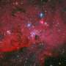
Blue and white stars shine brilliantly against a crimson background of glowing gas in this July 3, 2026, image of stellar nursery LH 95 from NASA's Hubble Space Telescope.

