 |  | 

🌌 अंतरिक्ष समाचार | Space News
रविवार, ०८/११/२०२६ | Sunday, 08/11/2026

1. GSLV-F18/NVS-03 Mission - pib.gov.in
Read more
GSLV-F18/NVS-03 Mission pib.gov.in

2. NRSC demands preservation of affidavit ballots in Mississippi - WJTV
Read more
NRSC demands preservation of affidavit ballots in Mississippi WJTV

3. Tamluk: ISRO Themed Kali Puja Pandal #Gallery - Social News XYZ
Read more
Tamluk: ISRO Themed Kali Puja Pandal #Gallery Social News XYZ

4. ISRO-Themed Kali Puja Pandal - Prokerala
Read more
ISRO-Themed Kali Puja Pandal Prokerala

5. Aditya completes one year of solar observations in space - INDIA - GENERAL - Kerala Kaumudi
Read more
Aditya completes one year of solar observations in space - INDIA - GENERAL Kerala Kaumudi

6. NASA Awards Moon Base Transportation, Technology, Science Projects
Read more
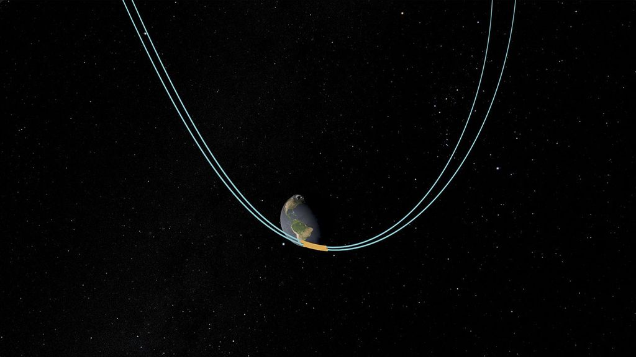
Artist's concept of living and working at Moon Base. Credit: NASA NASA announced a suite of awards and mission updates on Saturday to expand the agency's Moon Base exploration, science, and infrastructure capabilities. The investments will advance commercial robotic deliveries, a nuclear-powered rover named PROMISE, launch and orbital transfer services, and surface infrastructure as the agency works with American industry to establish a sustained presence on the Moon's South Pole. The agency shared the news at the MAX POWER aerospace expo and air show at NASA's Kennedy Space Center in Florida. "We are building the Moon Base mission by mission," said NASA Administrator Jared Isaacman. "Today's announcements expand nearly every part of that campaign, using the playbook that carried NASA through its greatest eras: fly often, learn, apply those lessons, and get more better and more capable with every mission. When our astronauts return to the Moon, they will arrive with the first elements of the Moon Base already waiting for them on the surface." "In the eight months since Ignition, we've made incredible strides in accomplishing the near impossible: establishing a permanent outpost on the lunar surface," said Carlos García-Galán, manager, Moon Base Program. "We've consolidated numerous efforts into a streamlined program, evolving our human exploration architecture into an iterative and sustained campaign for Moon Base technology development and implementation. Most importantly, we've taken action, awarding new contracts and forging new partnerships to accelerate development." Moon Base cargo landers To strengthen the cargo lander network needed to support the Moon Base, NASA selected eight companies for the next phase of its CLPS (Commercial Lunar Payload Services) initiative. The companies are eligible to compete for future lunar surface delivery missions under the new CLPS 2 contract: Blue Origin Firefly Aerospace Intuitive Machines ispace-U.S. Lockheed Martin Space Northrop Grumman Space Systems SpaceX Voyager Technologies Under the CLPS 2 framework, the companies will provide lunar delivery services, including managing, building, and operating landers that transport NASA science, technology, and infrastructure payloads to the Moon. The CLPS 2 framework is a 10-year, multiple-award, indefinite-delivery/indefinite-quantity master contract with a combined maximum value of $10 billion. NASA increased the value of the current CLPS 1.0 contract from $2.6 billion to $4.2 billion to support initial Phase One Moon Base objectives. The original CLPS contract will remain in place through November 2028, with an additional five-year period to complete awarded lunar deliveries through November 2033. Nuclear-powered Moon rover NASA also announced it is moving forward with development of PROMISE (Polar Rover for Observation, Mapping, and In-Situ Exploration). Carrying science instruments and technology demonstrations, the six-wheeled rover will land at the Moon's South Pole to characterize the surface and subsurface, assess resource potential, and provide data to enable landing site selection, as well as future infrastructure and exploration activities. The nuclear-powered rover can operate during long lunar nights and within permanently shadowed regions thought to harbor ice, which is crucial for a sustained human presence on the Moon. The agency's Jet Propulsion Laboratory in Southern California, a division of Caltech, will manage the mission and build the rover from a combination of spare flight components and engineering test models for NASA's Curiosity and Perseverance Mars rovers. Using proven hardware, software, and Mars rover operation approaches significantly reduces cost and enables integration and testing of the complex PROMISE rover on a shorter timeline. NASA has assessed the compatibility of the hardware with the lunar environment and determined it can tolerate the harsh conditions found near the Moon's South Pole. The PROMISE rover will carry a drill to extract regolith, or lunar dust, to characterize ice and other resources from approximately 3 feet (1 meter) below the surface, spectrometers for analyzing the chemical composition of surface material, temperature and radiation sensors, and visible-light cameras. It will demonstrate a next-generation, radiation-tolerant computing system, NASA's High Performance Spaceflight Computing, and advanced autonomy sensors and algorithms. NASA is targeting late 2028 to launch PROMISE and planning an 18-month mission for the rover. NASA awarded Blue Origin a $94 million base contract, with an option period worth an additional $140 million based on performance to deliver PROMISE to the lunar South Pole. The award expands the task order awarded in May 2026 to deliver two lunar terrain vehicles to the Moon. Blue Origin will use its Mark 1 lander to deliver and deploy the rover as part of the Moon Base's first phase. Launch, transportation awards Delivering Moon Base infrastructure will require a robust transportation network between Earth and the Moon. Orbital Transfer Vehicles (OTVs) act like long-distance freight trucks, carrying large loads across space. Lunar landers handle the final delivery, bringing supplies, equipment, and infrastructure safely down to the Moon's surface. To demonstrate those capabilities, NASA awarded six task orders as part of the agency's Venture-Class Acquisition of Dedicated and Rideshare (VADR) launch services contract. The awards were given to Arrow Science and Technology, Blue Origin, and Impulse Space to integrate and transport Moon Base cargo. Three mission types will allow NASA flexibility to fly science and technology demonstrations when they are ready. The first will include missions to reduce risks of future long-term human spaceflight for lunar exploration. The missions will verify that communication and navigation methods work properly during the journey from Earth orbit to the Moon, and OTV capability to support delivery of a CLPS lunar lander to a desired orbit. This mission type will deliver the CAPSTONE 02 spacecraft to deep space to test proximity maneuvers, navigation, and communications around the Moon. The second category of missions will prepare the lunar South Pole for human exploration by sending a group of highly mobile drones to survey the surface before astronauts arrive, enabling safer, more informed human missions while demonstrating advanced robotic capabilities. Such missions will include the agency's MoonFall drones, designed to scout areas beyond the reach of traditional rovers, as well as delivery of additional Moon Base assets necessary to support Phase One objectives. To reduce risk for future missions, the third mission type will test navigation technologies and demonstrate operations in multiple cislunar orbits, between Earth and the Moon. This mission type will demonstrate commercial orbital transfer capabilities intended to increase the amount of cargo that future landers can deliver to the lunar surface. The task orders have a value of approximately $1.3 billion combined and fall under the 10-year VADR indefinite-delivery/indefinite-quantity contract, which has a maximum total value of $5 billion across all contracts. The VADR contracts are managed by NASA's Launch Services Program Office at the agency's Kennedy Space Center as part of the agency's Commercial Access to Space Program. By procuring multiple launch and in-space transportation services together, NASA provides industry with a more predictable set of mission opportunities while gaining access to a broader range of commercial capabilities for future lunar exploration. Some missions will launch aboard Blue Origin's New Glenn, Relativity Space's Terran R, and SpaceX's Falcon 9 rockets. In-space transportation spacecraft for these missions will be provided by Blue Origin, Firefly Aerospace, Impulse Space, and Quantum Space. Complementing those in-space transportation demonstrations, NASA selected SpaceX for the Cislunar Communications Deployment Demonstration under an existing lunar logistics contract. Through a Specialized Delivery Mission task order, SpaceX will launch communications satellites aboard a Starship to cislunar space in 2028. The demonstration will help inform the development of future lunar communications networks that keep astronauts, mission controllers, and the Moon Base connected. Lunar architecture, infrastructure To extend infrastructure capabilities on the lunar surface, NASA plans to purchase commercial components for a Mini-Communications and Solar Tower (miniCAST), including solar arrays, batteries, and wireless power-transfer hardware. The agency awarded Honeybee Robotics, a Blue Origin company, for energy storage capability, Redwire for power generation, and Yank Technologies, Inc., for wireless power transfer in support of miniCAST. The miniCAST will combine power and communications capabilities to support future Moon Base activities. Engineers at NASA's Marshall Space Flight Center in Huntsville, Alabama, will assemble and test the systems before they are delivered to the lunar surface. NASA expects work to begin within months, and the initial effort will involve components rather than a major integrated system. The agency also plans a separate solicitation for fully integrated power systems, which is anticipated in early 2027. NASA intends to release a directed call under its Next Space Technologies for Exploration Partnerships, or NextSTEP-3 B, solicitation to help close architecture-driven, high-priority data gaps for Moon Base development. The effort will help NASA gather information it needs to plan future missions, reduce risk, and support technologies and infrastructure for sustained operations on the Moon's South Pole. The work could include small spacecraft missions, payloads on future Moon Base flights, or the purchase of data collected by commercial partners. As part of a Golden Age of innovation and exploration, NASA will send Artemis astronauts on increasingly difficult missions to the lunar South Pole to explore more of the Moon than ever before. In addition to providing economic benefits and advancing scientific discovery through its Moon missions, NASA will establish an enduring human presence on the lunar surface and build on this foundation for the first crewed mission to Mars. To learn more about the Moon Base, visit: https://www.nasa.gov/moonbase -end- George Alderman / James Gannon Headquarters, Washington 202-358-1600 george.a.alderman@nasa.gov / james.h.gannon@nasa.gov

7. Send your name to Saturn's moon Titan with NASA's upcoming Dragonfly mission
Read more
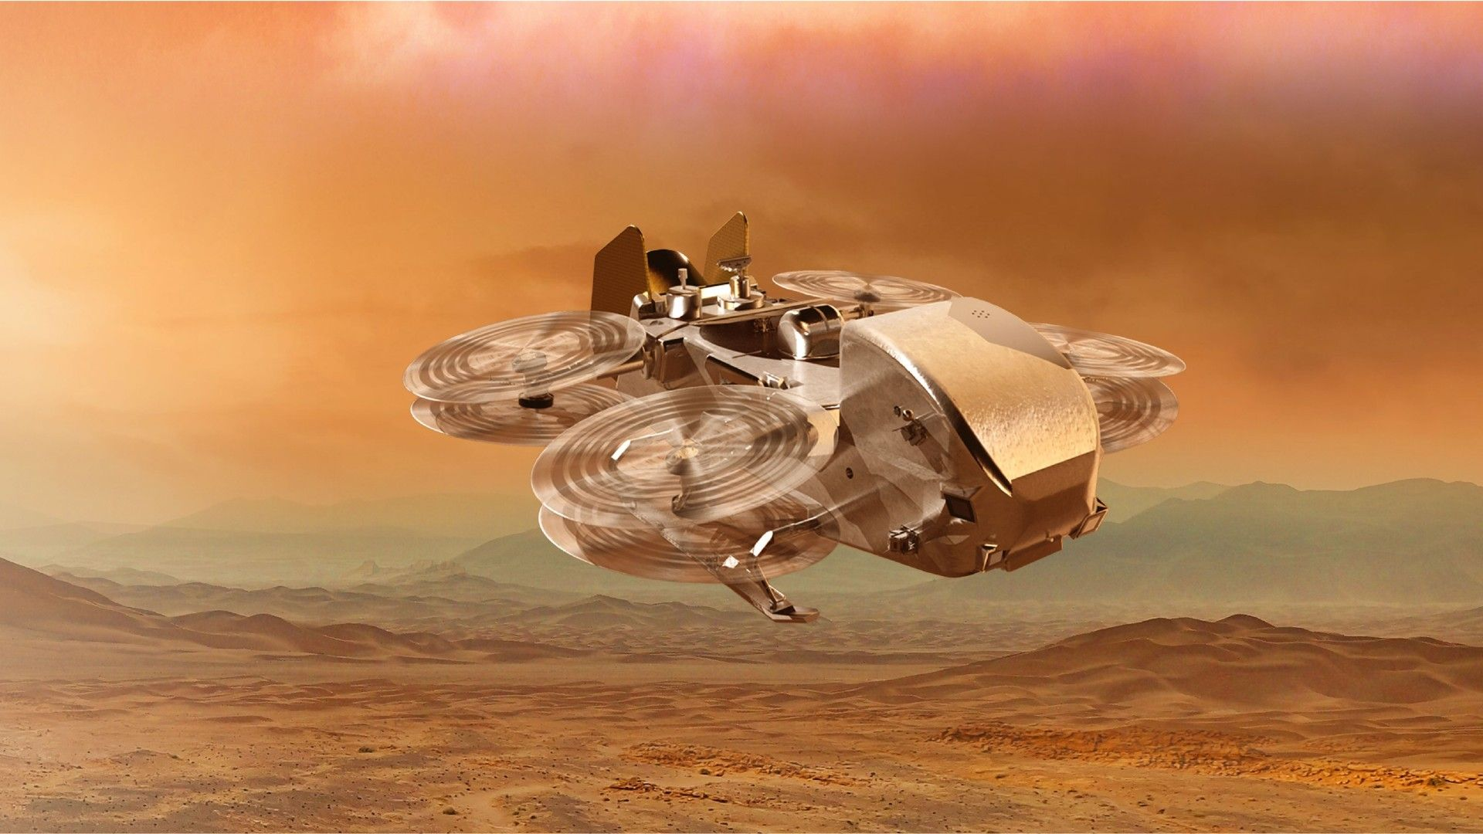
Click for next article We still may be some time away from sending humans to distant reaches of the solar system, but you can send your name to Saturn's moon Titan, which has the ingredients of life on its surface thanks to NASA's Dragonfly mission. Dragonfly is an SUV-sized nuclear-powered rotorcraft that NASA aims to launch towards Titan in 2028. The agency opened a special events page in late October to allow members of the public to put their name on the spacecraft. The names will be put upon a chip on Dragonfly during the spacecraft's assembly, and all names must be submitted before Jan. 15, 2027. The agency says that the mission has no "ordinary itinerary," as Dragonfly aims to between areas miles (or kilometers) apart after arriving on the surface in 2034. "Nearly a billion miles away, an extraordinary destination awaits. Titan has an atmosphere, rivers and lakes, seasons, sweeping dunes and a landscape rich in organic material," NASA officials wrote in the event page. "Upon arrival in 2034, Dragonfly will fly from place to place on this intriguing world to uncover clues about this remarkable moon, and the chemistry that could help us understand the ingredients for life." Dragonfly will be one of just a few flying crafts on another world, with the first being NASA's plucky Ingenuity mini-helicopter that arrived on Mars along with the still-running Perseverance rover in 2021. Ingenuity was only designed to make five flights, but made it to 72 until its blades were damaged during a landing on Jan. 18, 2024. NASA is now planning a SkyFall mission on Mars that would use three helicopters, and which may launch as soon as late 2028 for the Red Planet. Dragonfly, however, is not the first mission to Titan: that would be Huygens , which operated for just a few hours on Jan. 14, 2005 after deploying from the Cassini spacecraft. Huygens was the first lander on an outer solar system world, and measured Titan's atmosphere and took data from the surface. A mosaic image of Saturn's moon Titan composed of images produced by the Cassini spacecraft. (Image credit: NASA/JPL/University of Arizona/University of Idaho) For its part, Cassini flew by Titan more than 100 times before the mission concluded in September 2017 , providing valuable long-term data about the moon from above. Dragonfly aims to show the moon from up close for about 3.3 Earth years. Its destinations will include dunes and a young impact crater called Selk, according to NASA. "Dragonfly is expected to make one flight every one to two Titan days, which is called a Tsol and lasts about 16 Earth days," NASA officials added of the mission . Dragonfly will stop at a variety of geologic sites, where it will collect samples of surface material for analysis inside the rotorcraft by a suite of scientific instruments." Dragonfly's goals include learning more about prebiotic chemistry, or the conditions prior to life arising in a location; figuring out if Titan had habitable conditions in the past; and looking for "chemical indicators" of life based on water or hydrocarbons.

