 |  | 

🌌 अंतरिक्ष समाचार | Space News
शुक्रवार, १०/०७/२०२६ | Friday, 10/07/2026

1. Buying property through a power of attorney? Delhi brings in stricter registration rules
Read more

In a bid to plug stamp duty evasion and curb fraudulent property transactions, the Delhi government has tightened norms for the registration process through General Power of Attorney (GPA) documents - mandating closer scrutiny by sub-registrars. This would lead to adjudication before registration in several cases. Under fresh directions issued by the Revenue Department, every GPA presented for registration will now be examined to determine if it is, in effect, a disguised sale of property. Officials have been asked to check whether the document mentions monetary consideration, transfers possession of the property, is irrevocable in nature, or grants permanent authority to sell, gift, transfer or mortgage the property. It has been observed that in several cases, documents are registered merely as a 'GPA' by paying only a nominal stamp duty, even though they contain provisions relating to the sale of property, handing over possession and transfer of ownership rights, the government said. The government has now directed that GPAs executed in favour of persons other than close blood relatives - parents, spouse, children, siblings - will no longer be registered directly by sub-registrars. Instead, these documents will have to be referred to the Collector of Stamps, who will determine whether they are genuine powers of attorney or should be treated as conveyance deeds attracting full stamp duty. According to the directions, the Collector of Stamps will ordinarily be required to pass a reasoned order within 30 days, although the period may be extended to a maximum of three months in exceptional cases. Registration will not proceed until the adjudication is completed and the applicable stamp duty has been paid. Chief Minister Rekha Gupta said the measures were aimed at preventing revenue loss, tackling fraudulent property transactions and protecting buyers from defective documentation. She said the government would not allow misuse of GPA registrations to evade stamp duty and that greater transparency and accountability in property registration remained a priority. The government has also warned of disciplinary action against sub-registrars who register such GPAs without referring them for adjudication, where required. Story continues below this ad To improve oversight, every sub-registrar's office has been directed to maintain a separate register of such cases and submit monthly reports. The government has also asked officials to develop an online tracking system within a month to monitor referrals and their disposal.

2. Traffic crawls as incessant rain floods key roads in Delhi; IMD sounds 'red' alert
Read more
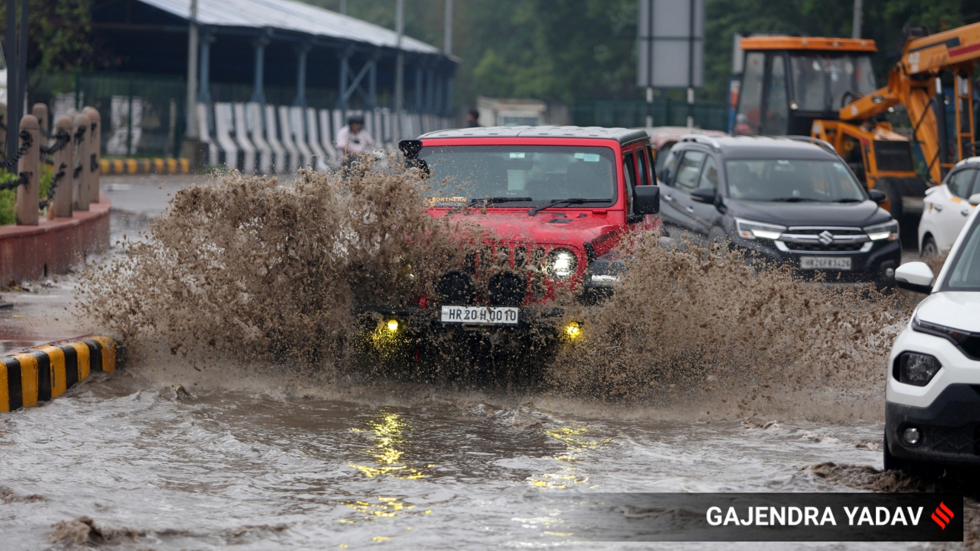
Delhi woke up to relentless rain, flooded streets, and traffic disruptions on Thursday after overnight showers drenched the capital. With heavy rainfall expected to continue, the India Meteorological Department (IMD) issued a red alert, warning of moderate to heavy rain accompanied by thunderstorms and lightning across the city through the day. The Safdarjung weather station, Delhi's base observatory, recorded 72.6 mm of rainfall in the 24 hours. Other stations also reported showers, with Lodhi Road receiving 80.2 mm, followed by Ridge (77.8 mm), Palam (63 mm), and Ayanagar (57.4 mm). The downpour brought a dip in temperatures, with the minimum settling at 24.3 degrees Celsius, 3.6 degrees below normal. The IMD said there has been no major change in minimum temperatures, while maximum temperatures have fallen by 6-8 degrees Celsius over the past 24 hours.

3. E20 fuel debate is 'manufactured', says Hardeep Singh Puri, links row to E85 launch
Read more

- Governance - 2 min read Puri said that E20 has been available for nearly two years and claimed that the controversy gained traction only after E85 flex-fuel vehicles entered the market. ETEnergyWorld Desk - ETEnergyWorld - Published On Jul 9, 2026 at 03:26 PM IST Select ETGovernment as Preferred Choice on Google Copy Link Share on WhatsApp Share on Linkedin Share on X Share on Telegram Share on Facebook Hardeep Singh Puri Union Petroleum and Natural Gas Minister Hardeep Singh Puri has dismissed the controversy surrounding E20 ethanol-blended petrol as "manufactured", saying the debate gained traction only after the launch of E85 flex-fuel vehicles and not because of any fresh consumer complaints. In an interview with NDTV, Puri said E20 petrol has been available in the market for nearly two years, while E15 fuel had been in use for around three-and-a-half years before that. "Why does a controversy take place now?" Puri asked, linking the timing of the debate to the recent launch of E85-compatible vehicles by Hero, Suzuki and Toyota. Advt "Someone must have thought that if E85 takes off in India… let's cast a doubt," he said, comparing the criticism to earlier concerns over LPG availability, which he said the government had successfully addressed. Responding to Karnataka minister Priyank Kharge 's allegation that the ethanol rollout amounted to "an experiment on 3.6 crore Indians", Puri said the Attorney General's submission before the Supreme Court had been misinterpreted. The minister said the statement related to ethanol procurement volumes under a best-effort clause rather than the percentage of ethanol blending. "He has misinterpreted that to talk about the percentage of blending," Puri said, referring to Kharge's remarks. Regarding concerns about fuel economy, Puri acknowledged that higher ethanol blends can reduce mileage but said the impact varies depending on driving habits, vehicle type, and operating conditions. "Ethanol does result in some percentage of less mileage," Puri said. Addressing concerns that older vehicles may require replacement of certain components, Puri said some parts, such as gaskets, could require servicing earlier than usual. He noted that while a gasket typically needs to be replaced after 50,000 km, it did not indicate a widespread defect. Puri cited Hero Motors as having serviced 1.5 crore vehicles running on E20 fuel without receiving a single complaint. The minister also rejected suggestions that consumers be offered a choice of ethanol blends at fuel stations, saying such an arrangement would not be practical due to infrastructure constraints. "You can't mix E20 and E15… so why do you want a choice?" Puri told NDTV. He added that consumers already have multiple fuel options available, including petrol, diesel, CNG and, increasingly, green hydrogen. ETEnergyWorld Desk , --> - By - See more on: - E20 fuel controversy , - E85 flex-fuel vehicles , - Hardeep Singh Puri interview , - high ethanol blend mileage impact , - ethanol blending percentage , - ethanol fuel options in India , - alternative fuels in India , - Karnataka minister Priyank Kharge , - Supreme Court ethanol procurement , - Hero Motors E20 vehicles Telegram Facebook Comments What are your thoughts? Comment Now --> Comment Now Read Comment (1) All Comments By commenting, you agree to the Prohibited Content Policy Post Find this Comment Offensive? Choose your reason below and click on the submit button. This will alert our moderators to take actions REASONS FOR REPORTING Foul Language Defamatory Inciting hatred against a certain community Out of Context / Spam Others Report Join the community of 2M+ industry professionals. Subscribe to Newsletter to get latest insights & analysis in your inbox. All about ETGovernment industry right on your smartphone! - Download the ETGovernment App and get the Realtime updates and Save your favourite articles. Scan to download App -->

4. EU launches energy connectivity project to expand coss-border power trade in South Asia
Read more

- Smart Infra - 9 min read The EU has launched a €5 million project to expand cross-border electricity trade, integrate renewable energy and strengthen energy security across five South Asian countries. Anoop Verma - ETGovernment - Published On Jul 9, 2026 at 10:12 PM IST Select ETGovernment as Preferred Choice on Google Copy Link Share on WhatsApp Share on Linkedin Share on X Share on Telegram Share on Facebook Hervé Delphin, European Union Ambassador to India and Bhutan, says interconnected power grids can improve access to cheaper and greener energy across South Asia. The European Union has launched a €5 million regional energy connectivity initiative aimed at accelerating cross-border electricity trade, integrating renewable energy resources and supporting the development of a more interconnected power market across South Asia. The four-year Energy Connectivity in South Asia ( ECSA ) project will work with Bangladesh, Bhutan, India, Nepal and Sri Lanka to strengthen energy security and improve access to affordable, reliable and cleaner electricity. The initiative will also seek to catalyse investment in renewable energy generation, cross-border transmission infrastructure and modern power systems, including through greater participation by European investors and institutions. Advt Launched in Kathmandu on July 9 under the EU's Global Gateway investment strategy, the project reflects growing international interest in harnessing South Asia's complementary energy resources. While the Himalayan countries possess substantial hydropower potential, India and other countries in the region are rapidly expanding solar and other renewable energy capacities. Greater interconnection could enable countries to exchange electricity across seasons and periods of peak demand, potentially reducing costs and improving the resilience of national power grids. The ECSA project is funded by the European Union and will be implemented by Expertise France . It seeks to address not only infrastructure requirements but also some of the regulatory, institutional and investment barriers that have constrained the emergence of a fully integrated regional electricity market. "Energy connectivity powers our economies and daily lives," said Jozef Síkela, European Commissioner for International Partnerships. "With the launch of this Global Gateway flagship, the European Union is investing in cheaper, cleaner and more reliable electricity that will strengthen resilience and unlock many opportunities for communities and businesses in South Asia." Síkela said the initiative demonstrated the growing strength of the partnership between the European Union and South Asian countries. The project was formally launched at a regional event titled "Powering South Asia's Energy Future: Advancing Cross-Border Electricity Trade, Investments and Energy Security." The programme brought together senior government representatives, regulators, development partners, investors, energy-sector leaders and technical experts from the five participating countries. The launch comes at a time when energy demand is expanding rapidly across South Asia, increasing the need for new generation capacity, stronger transmission networks and greater flexibility in power systems. Regional electricity trade could enable countries to use complementary generation patterns more efficiently, particularly by combining seasonal hydropower from the Himalayan region with rapidly growing solar capacity in the plains. Hervé Delphin, Ambassador of the European Union to India and Bhutan, said stronger regional grid interconnections could generate economic as well as energy-security benefits. "Such an initiative will help accelerate the regional interconnection of power grids, which will unleash multiple benefits: access to cheaper and greener energy, notably by integrating more easily the cheap seasonal hydropower from the Himalayan regions with renewable energies such as solar produced in the plains," Delphin said. He added that greater interconnectivity and the eventual development of a regional energy market could provide national grids with access to more abundant and affordable electricity. "This will be good for business and for people," Delphin said. The economic rationale for regional power connectivity rests on the diversity of South Asia's energy systems. Nepal and Bhutan possess considerable hydropower resources, while India has emerged as one of the world's largest renewable-energy markets. Bangladesh has rapidly growing electricity requirements, while Sri Lanka is seeking to increase the contribution of renewable energy to its power system. A more integrated electricity market could allow surplus generation in one country to address shortages or peak demand in another. It could also improve the commercial viability of large renewable-energy projects by expanding the market available to electricity producers beyond national borders. However, the development of such a market will require more than physical transmission infrastructure. Differences in national regulations, electricity-market structures, grid codes, pricing mechanisms and institutional capacities continue to pose challenges to deeper regional integration. The ECSA initiative will seek to address these issues through policy and regulatory support, technical studies, capacity-building programmes, modelling tools, investment roadmaps, workshops and knowledge exchanges. Depending on the requirements of participating countries, it may also support the identification and promotion of joint renewable-energy projects and cross-border interconnection infrastructure. Véronique Lorenzo, Ambassador of the European Union to Nepal, said Europe's experience demonstrated how interconnected electricity markets could contribute to more resilient and sustainable energy systems. "Europe's experience in building an integrated electricity market has demonstrated that stronger energy connectivity creates more resilient, affordable and sustainable energy systems," Lorenzo said. "Through the energy connectivity project, the European Union is proud to work in partnership with South Asian countries to help unlock the tremendous benefits of regional energy cooperation and clean-energy integration." Europe's integrated electricity system has evolved through decades of coordinated transmission planning, common market rules, regulatory cooperation and investments in cross-border infrastructure. Although South Asia has distinct political, economic and institutional conditions, several elements of the European experience could offer useful lessons for the region. A keynote presentation during the launch examined the governance structures and institutional mechanisms that supported energy integration in Europe. It highlighted the role of coordinated transmission planning, transparent market rules, independent regulation, market-coupling mechanisms and sustained cooperation among governments, regulators and power-system operators. Participants discussed how these principles could be adapted to South Asia rather than replicated without accounting for regional conditions. The discussions emphasised that effective cross-border electricity trade would require predictable regulations, harmonised technical standards and stronger coordination among national institutions. Biraj Bhakta Shrestha , Nepal's Minister of Energy, Water Resources and Irrigation and Chief Guest at the launch, said South Asia possessed substantial renewable-energy resources alongside rapidly growing electricity demand. "Enhanced cross-border electricity trade can help countries meet their development goals while improving energy reliability, affordability and sustainability," Shrestha said. "Nepal looks forward to strengthening regional partnerships through initiatives such as ECSA." For Nepal, stronger regional electricity connectivity could support the development of its hydropower sector by expanding access to neighbouring markets. Greater cross-border trade could also improve the utilisation of surplus electricity during periods of high hydropower generation while strengthening energy availability during seasonal fluctuations. India is expected to play a central role in the development of a more interconnected regional electricity architecture because of the scale of its power market, its geographical position and its existing electricity links with neighbouring countries. India already participates in bilateral and cross-border electricity trade with Nepal, Bhutan and Bangladesh, providing an institutional and infrastructure base for broader regional integration. The ECSA project could complement existing bilateral and regional initiatives by supporting regulatory dialogue, technical cooperation and investment planning. Its focus on renewable-energy integration is also aligned with the region's efforts to expand clean-energy capacity while maintaining grid reliability. Nicolas Chenet , Director of the Sustainable Development Department at Expertise France, said the initiative would provide a platform for technical cooperation and engagement among stakeholders from Europe and South Asia. "ECSA will serve as a platform for knowledge exchange, capacity building and collaborative problem-solving," Chenet said. "By combining European and South Asian experience, expertise and priorities, the project seeks to support practical pathways towards a more integrated regional electricity market." Discussions at the launch examined how policy and regulatory frameworks could be strengthened to support greater electricity trade. Participants identified opportunities to deepen cooperation among regulators, improve the alignment of technical and market frameworks, build institutional capacity and enhance coordination among governments, development partners and national energy-sector stakeholders. A separate discussion focused on the relationship between cross-border electricity trade, investment and energy security. Participants noted that a larger regional market could stimulate investment in renewable-energy generation, transmission networks, energy storage and modern grid technologies. However, attracting long-term public and private investment would require predictable regulatory environments and commercially viable project pipelines. Investors would also require greater clarity regarding electricity pricing, transmission access, market rules and mechanisms for managing cross-border risks. The initiative is expected to support evidence-based planning through technical studies and modelling tools. Such analysis could help countries assess future electricity demand, renewable-energy potential, transmission requirements and opportunities for regional power exchange. The project will also seek to facilitate discussions on investment roadmaps and potential joint renewable-energy initiatives. By improving coordination between policymakers, regulators, utilities, investors and development institutions, ECSA aims to help translate regional energy potential into implementable projects. The focus on cross-border electricity trade also has implications for climate objectives. Greater regional integration could enable power systems to accommodate higher levels of variable renewable energy by expanding the geographical area across which electricity supply and demand can be balanced. Hydropower resources in the Himalayan region could provide flexibility to complement solar generation, while interconnected grids could reduce the need for countries to maintain expensive surplus capacity independently. More efficient utilisation of renewable-energy resources could contribute to lower greenhouse-gas emissions while improving energy reliability. Participants identified several priority areas for the four-year programme, including strengthening regional policy dialogue, supporting technical studies and evidence-based planning, enhancing regulatory and institutional capacity, facilitating investment discussions and expanding knowledge exchange on renewable-energy integration and cross-border electricity trade. The ECSA project forms part of the EU's Global Gateway strategy, which seeks to mobilise public and private investment in sustainable infrastructure across the digital, energy and transport sectors, while also strengthening health, education and research systems. Under the Team Europe approach, the European Union, its member states and European development-finance institutions aim to mobilise up to €400 billion in investments between 2021 and 2027. For South Asia, the effectiveness of the ECSA initiative will ultimately depend on its ability to complement existing national and regional mechanisms and translate technical cooperation into measurable progress in electricity trade, grid connectivity and renewable-energy investment. The €5 million programme is relatively modest when compared with the scale of infrastructure investment required to build an integrated regional power market. Its potential significance, however, lies in addressing the institutional, regulatory and technical foundations needed to support larger investments. If participating countries are able to strengthen regulatory coordination, develop predictable market frameworks and expand cross-border transmission capacity, regional electricity trade could become an important instrument for improving energy security and supporting economic growth. By bringing Bangladesh, Bhutan, India, Nepal and Sri Lanka into a common platform for policy dialogue, technical cooperation and investment planning, the ECSA initiative seeks to advance a long-term vision in which electricity can move more efficiently across national borders-linking the hydropower resources of the Himalayas with expanding renewable-energy capacity and growing demand across South Asia. Anoop Verma , --> - By - See more on: - Energy Connectivity in South Asia (ECSA) project , - european union , - ecsa , - vronique lorenzo , - skela , - shrestha , - nicolas chenet , - herv delphin , - expertise france , - biraj bhakta shrestha Telegram Facebook Comments What are your thoughts? Comment Now --> Comment Now Read Comment (1) All Comments By commenting, you agree to the Prohibited Content Policy Post Find this Comment Offensive? Choose your reason below and click on the submit button. This will alert our moderators to take actions REASONS FOR REPORTING Foul Language Defamatory Inciting hatred against a certain community Out of Context / Spam Others Report Join the community of 2M+ industry professionals. Subscribe to Newsletter to get latest insights & analysis in your inbox. All about ETGovernment industry right on your smartphone! - Download the ETGovernment App and get the Realtime updates and Save your favourite articles. Scan to download App -->

5. Heavy rain alert: Isro satellite spots massive cloud build-up over Uttarakhand - India Today
Read more
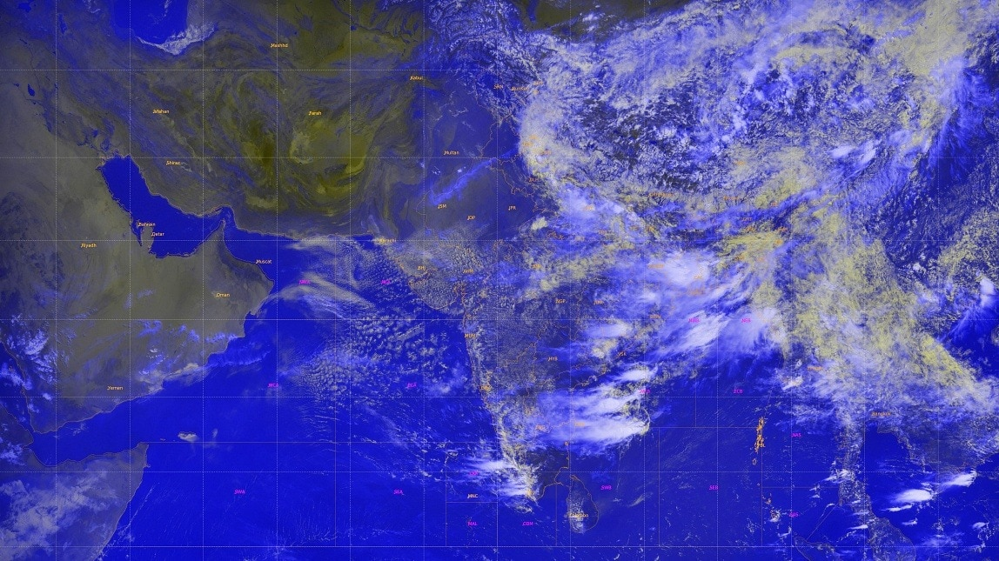
A massive blanket of rain-bearing clouds has gathered over Uttarakhand, with fresh satellite imagery showing dense convective cloud bands covering much of the Himalayan state as the India Meteorological Department (IMD) warned of heavy to very heavy rainfall on Friday, July 10. The latest satellite images reveal thick cloud masses stretching across northern India and the western Himalayas, indicating an active monsoon system capable of producing intense spells of rain, thunderstorms and lightning over the state. Read Full Story According to the IMD, light to moderate rainfall accompanied by thunderstorms is very likely at most places across Uttarakhand on July 10, with several districts expected to receive significantly heavier showers. An orange alert has been issued for Pauri Garhwal, Nainital, Udham Singh Nagar, Champawat and Bageshwar, where heavy to very heavy rainfall is likely. The weather office has also warned of very intense to extremely intense spells of rain, accompanied by thunderstorms and lightning, in these districts. Meanwhile, a Watch has been issued for Dehradun, Tehri Garhwal, Haridwar, Uttarkashi, Rudraprayag, Chamoli, Almora and Pithoragarh, where isolated locations are expected to witness heavy rainfall along with thunderstorms, lightning and intense rain spells. The IMD has advised residents in vulnerable areas, particularly those living near rivers, streams and landslide-prone slopes, to remain alert as heavy rainfall could trigger flash floods, waterlogging and slope failures in the mountainous terrain. The wet spell is expected to continue into Saturday, July 11. The weather department forecasts light to moderate rainfall with thunderstorms at many places in the Garhwal region and at most places in the Kumaon region. In addition, isolated heavy rainfall is likely across Uttarkashi, Rudraprayag, Chamoli, Almora, Bageshwar and Pithoragarh, where thunderstorms, lightning and intense to very intense rain spells are also expected. The renewed burst of monsoon activity comes after moisture-laden winds strengthened over northern India, allowing deep clouds to develop rapidly over the Himalayan foothills. Such weather systems often produce prolonged rainfall over Uttarakhand's steep terrain, increasing the risk of landslides, road blockages and swollen rivers. Authorities have urged tourists, pilgrims undertaking the Char Dham Yatra and local residents to closely monitor official weather advisories and avoid unnecessary travel through vulnerable mountain routes during periods of heavy rainfall. - Ends

6. ISRO conducts main parachute air drop test for Gaganyaan's crew module - Manorama Yearbook
Read more
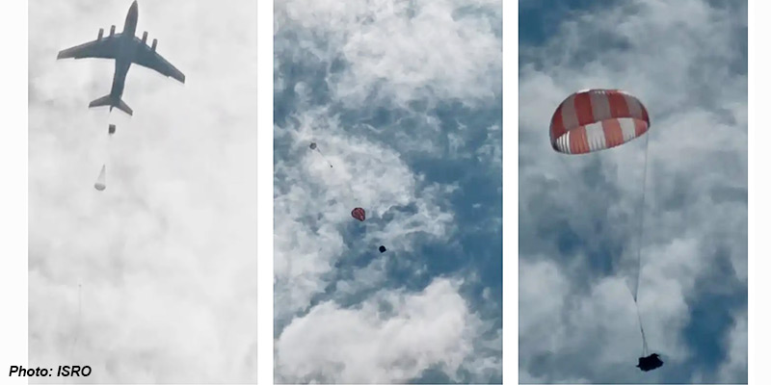
• The Indian Space Research Organisation (ISRO) successfully conducted a critical test on the main parachutes for the Gaganyaan's crew module. • The test was carried out at the Aerial Delivery Research and Development Establishment (ADRDE) drop zone in Sheopur, Madhya Pradesh on July 7. • The objective of this test was to qualify the main parachute for its structural integrity and design margins under the maximum expected load conditions in the first uncrewed Gaganyaan mission. • During the test, a simulated assembly of a single main parachute and a dummy mass was dropped from an altitude of 2.5 km using an Indian Air Force IL-76 aircraft. • Upon release, a drogue parachute was deployed. These types of parachutes are known to stabilise the crew module and reduce its velocity significantly. • Subsequently, the main parachute was deployed, slowing the payload to a safe terminal speed. • This successful test was a joint effort of ISRO, Defence Research and Development Organisation (DRDO), Indian Air Force and Indian Army. • This is the fifth test in a series of integrated main parachute airdrop tests (IMAT) to qualify the critical main parachute for the Gaganyaan Mission. • The successful completion of IMAT-05 provides necessary confidence in the performance and reliability of the Main Parachute System for the first uncrewed Gaganyaan Mission. • The Gaganyaan's crew module is equipped with 10 parachutes of four different types. • There are two apex cover separation parachutes, which remove the apex cover from the descending vehicle. The apex cover protects the parachute compartment from re-entry heat. • Then, there are two drogue parachutes and three pilot parachutes, which independently extract and deploy three main parachutes. Gaganyaan Mission • Prime Minister Narendra Modi announced the Gaganyaan mission in his Independence Day address in 2018. • Gaganyaan project envisages demonstration of human spaceflight capability by launching a crew of three members to an orbit of 400 km for a three days mission and bring them back safely to Earth, by landing in Indian sea waters. • For the first human spaceflight, four Indian Air Force pilots have been selected and are undergoing extensive training for the mission. • A budget of Rs 9,023 crore is allocated towards achieving the objectives of the mission. • ISRO developed indigenous technologies for the launch vehicle, habitable Crew Module, life support system, Crew Escape System, ground station network, crew training and recovery. • These technologies are crucial to meet the objectives of Gaganyaan mission and to take up any further interplanetary missions. • Gaganyaan will not be a one-off mission as the government has given approval for a sustained human spaceflight programme. • The programme comprises three uncrewed missions and one crewed mission. • The maiden Gaganyaan uncrewed mission is expected to be launched with a humanoid robot, Vyommitra. • The first crewed mission is targeted in 2027-28. (The author is a trainer for Civil Services aspirants.)

7. ISRO tests CE20 cryogenic engine with new nozzle system for LVM3-M7 - MSN
Read more
ISRO tests CE20 cryogenic engine with new nozzle system for LVM3-M7 MSN

8. NASA Sets Coverage for Astronaut Anil Menon Launch to Space Station
Read more

NASA astronaut Anil Menon and Roscosmos cosmonauts Pyotr Dubrov and Anna Kikina, Soyuz MS-29 prime crew members, pose for a portrait at the Gagarin Cosmonaut Training Center in Russia. Credit: GCTC NASA astronaut Anil Menon will launch aboard the Roscosmos Soyuz MS-29 spacecraft to the International Space Station on Tuesday, July 14, accompanied by cosmonauts Pyotr Dubrov and Anna Kikina, where they will join the Expedition 74 crew advancing scientific research. Menon, Dubrov, and Kikina will lift off at 10:47 a.m. EDT (7:47 p.m. Baikonur time) from the Baikonur Cosmodrome in Kazakhstan. Live launch and docking coverage is available on NASA+, Amazon Prime, and the agency's YouTube channel. Learn how to watch NASA content through a variety of online platforms, including social media. After a two-orbit, three-hour trip to the station, the spacecraft will automatically dock at 1:56 p.m. to the Prichal module. Shortly afterward, hatches will open between the Soyuz and the orbiting laboratory. Once aboard, the trio will join NASA astronauts Jessica Meir, Jack Hathaway, and Chris Williams, ESA (European Space Agency) astronaut Sophie Adenot, and Roscosmos cosmonauts Sergey Kud-Sverchkov, Sergei Mikaev, and Andrey Fedyaev. NASA's coverage schedule is as follows (all times Eastern and subject to change based on real-time operations): Tuesday, July 14 9:45 a.m. - Launch coverage begins on NASA+, Amazon Prime, and YouTube. 10:47 a.m. - Launch 1:10 p.m. - Rendezvous and docking coverage begins on NASA+, Amazon Prime, and YouTube. 1:56 p.m. - Docking 3:30 p.m. - Hatch opening and welcome coverage begins on NASA+, Amazon Prime, and YouTube. 3:55 p.m. - Hatch opening Menon, Dubrov, and Kikina will spend about eight months aboard the orbital complex as International Space Station Expedition 74/75 crew members before returning to Earth in April 2027. This will be Menon's first spaceflight and the second for both Dubrov and Kikina. During his stay on the station, Menon will conduct scientific research and technology demonstrations aimed at advancing human space exploration and benefiting life on Earth. He will continue research to refine in-space production of semiconductor crystals to enable the large-scale manufacturing of components needed for high-performance computers, artificial intelligence, and improved medical devices. Menon also will perform ultrasound using augmented reality and artificial intelligence methods that could eliminate the need for medical support from Earth on future space missions. He will be a test subject helping researchers understand how blood flow is affected in space to protect future astronauts. He also will test bioprinting vascular constructs in microgravity to improve understanding of the aging process to advance therapeutic developments. For more than 25 years, people have lived and worked continuously aboard the International Space Station, advancing scientific knowledge and making research breakthroughs not possible on Earth. The space station helps NASA understand and overcome the challenges of human spaceflight, expand commercial opportunities in low Earth orbit, and build on the foundation for long-duration missions to the Moon, as part of the Artemis program, and to Mars. To learn more about International Space Station research, operations, and its crews, visit: www.nasa.gov/station -end- Joshua Finch / Jimi Russell Headquarters, Washington 202-358-1100 joshua.a.finch@nasa.gov / james.j.russell@nasa.gov Sandra Jones Johnson Space Center, Houston 281-483-5111 sandra.p.jones@nasa.gov

9. NASA Scientists Take to Air and Space to Study Arctic Sea Ice
Read more
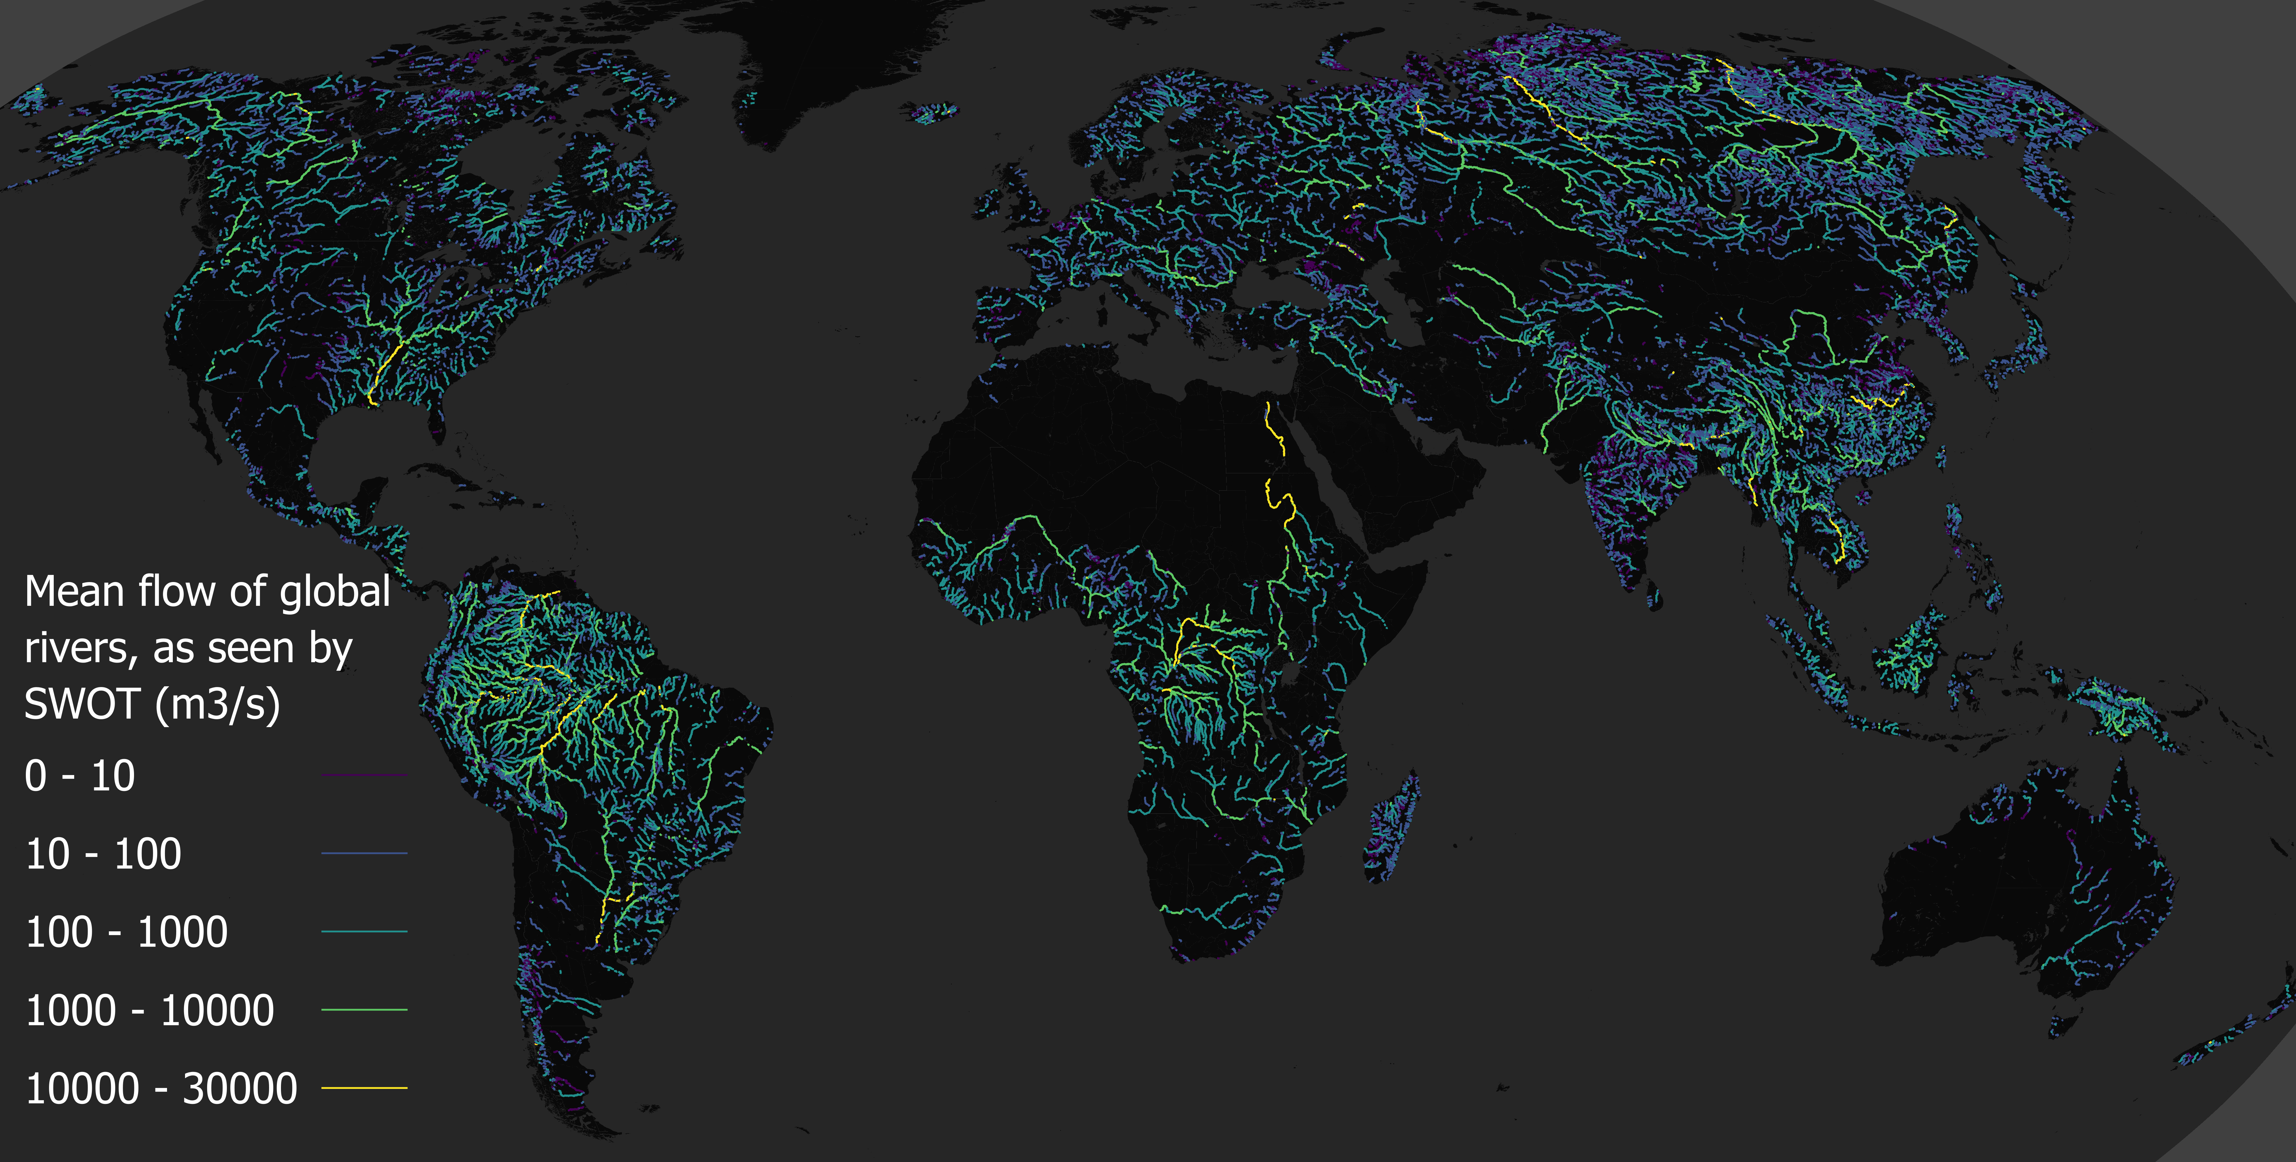
These four views were captured from a World War II-era aircraft in April 2026, when scientists used instruments aboard the plane to study Arctic sea ice. Their flights were timed to coincide with satellites passing overhead so the airborne and orbital data could be combined. NASA/JPL-Caltech This month, engineers at NASA's Jet Propulsion Laboratory in Southern California are testing a spacecraft sensor that will help measure how quickly Arctic sea ice is disappearing. And while that instrument won't launch for another year, scientists started preparing for its use during a recent field campaign in the Canadian wilderness. Researchers spent two weeks in April flying above the Arctic Ocean, often watching sunrise from an altitude of 1,500 feet (457 meters) in a World War II-era plane. A variety of cutting-edge sensors used to measure the thickness of sea ice and snow were aboard the plane, including a stand-in for the microwave radiometer now undergoing testing at JPL. Measuring sea ice thickness is tricky, requiring a number of precise figures, including how high the sea ice rises above water, the depth of snow on top of that ice, and microwave emissions from the surface. Flights were timed to the passage of satellites overhead so coordinated observations could be taken of the same features. Combining the airborne and satellite data will improve scientists' ability to measure sea ice and understand how climate conditions are evolving across the Arctic. In recent decades, the extent and thickness of Arctic sea ice have changed. Improving measurements of those changes helps scientists better understand the Arctic system while supporting navigation, weather and ocean research, and future satellite observations. As Arctic shipping activity increases, the region is also becoming strategically and economically more significant. According to Sahra Kacimi of JPL, who served as the field campaign's science lead, ongoing warming in the Arctic could potentially impact public safety and economic interests. Find out what Arctic sea ice looked like as scientists studied it from the air - and using space-based instruments - during a field campaign this past April. Credit: NASA/JPL-Caltech Frequent flyers Kacimi has spent years studying sea ice using satellite data, but the top-down view she gets from space is different than peering out a plane's window. The bewildering diversity of sea ice creates otherworldly landscapes. The ice can be attached to land or adrift in the ocean; it can be rough or smooth. Driven by winds and ocean currents, the ice is constantly shifting, breaking apart, and deforming. Cracks can open into long stretches of exposed ocean, and collisions between floes can push ice rubble into massive ridges that extend for miles. Some sea ice lasts only one season, while thicker ice can survive for several years (though multiyear sea ice is becoming less common in many parts of the Arctic). Entire ecosystems are affected by these changes, down to the arctic foxes and hares the scientists spotted throughout the trip. Improving estimates of sea ice thickness helps scientists better understand how the region is changing and supports long-term observations of the Arctic environment. The NASA team logged about 50 hours in the air over the two-week campaign, conducting flights over drifting ice near the town of Inuvik before studying ice fixed to the shore of another location, a hamlet called Cambridge Bay. For the Inuvik portion of the campaign, the team coordinated with the Surface Water and Ocean Topography (SWOT) mission, a satellite jointly developed by NASA and the French space agency, CNES (Centre National d'Études Spatiales), with JPL leading the United States component of the mission. Though it was designed to map the height of the globe's sea and fresh water, SWOT can also measure the amount of sea ice above the waterline. In Cambridge Bay, the NASA team joined researchers from ESA (European Space Agency), Germany's Alfred Wegener Institute, and Canada's University of Calgary. During this part of the campaign, coordinated flights soared over a field camp and under the tracks of satellite missions such as NASA's Ice, Cloud, and Land Elevation Satellite-2 (ICESat-2) and ESA's CryoSat-2. To improve sea ice thickness estimates, ESA is developing, with cooperation from NASA, a new polar mission called Copernicus Polar Ice and Snow Topography Altimeter (CRISTAL). During the April airborne campaign, scientists flew instruments similar to what CRISTAL will carry, including the microwave radiometer now being tested at JPL. "Combining observations from space, air, and ground surface instruments is essential for developing and validating algorithms for current and future missions," Kacimi said. For the scientists, it was also a chance to meet locals who see the Arctic's changes up close. Kacimi spoke to community leaders and students at a STEM camp about how disappearing ice is affecting their communities. "I'm used to looking at sea ice from space and thinking about its role in the global climate, but for people living in the Arctic, it carries a much deeper meaning," Kacimi said. Media Contacts Andrew Good Jet Propulsion Laboratory, Pasadena, Calif. 818-393-2433 andrew.c.good@jpl.nasa.gov Liz Vlock NASA Headquarters, Washington 202-358-1600 elizabeth.a.vlock@nasa.gov 2026-043

10. Making history! China lands rocket during an orbital launch for 1st time ever
Read more
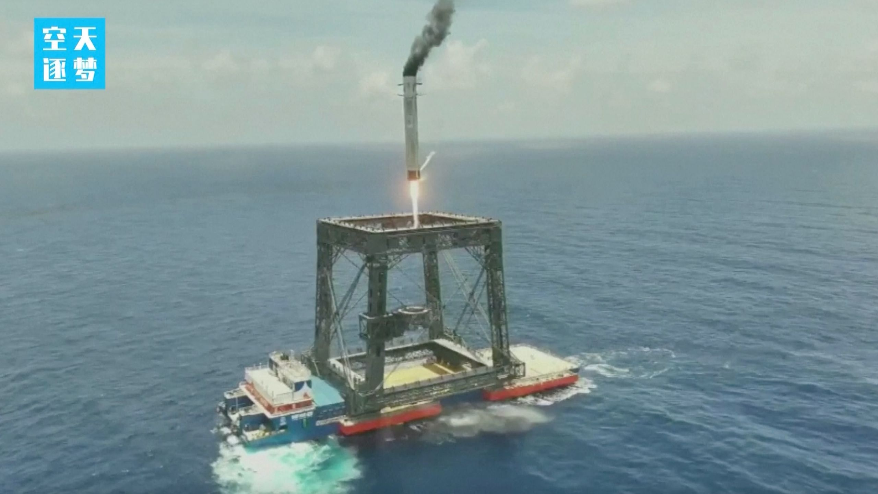
Click for next article The first stage of a Chinese Long March 10B rocket comes down for a landing at sea after successfully sending a satellite to orbit on July 10, 2026. China just notched a huge spaceflight milestone. The nation has recovered a rocket during an orbital launch for the first time ever, pulling off the feat during the Long March 10B's maiden liftoff on Friday (July 10). And that recovery was unique: The rocket's first stage nestled softly into a net-like structure carried by a ship at sea. "This mission marks my country's first successful controlled recovery of a launch vehicle and the world's first network-based recovery of a launch vehicle," the China Aerospace Science and Technology Corporation (CASC) announced via social media shortly after the launch. (Translation by Google.) "It signifies a historic breakthrough for my country in the field of reusable rocket technology and will lay a solid foundation for accelerating the improvement of my country's space access capabilities." The Long March 10B is a two-stage rocket that stands about 207 feet (63 meters) tall, according to the state-owned CASC, the main contractor for China's space program. The vehicle's first stage burns kerosene and liquid oxygen (LOX) propellants, whereas the second stage uses LOX and liquid methane. In reusable mode, the Long March 10B can loft about 16 tons of payload to low Earth orbit . And the rocket flew with a payload on its debut liftoff - a satellite that successfully reached "its predetermined orbit," according to the CASC update. That post did not provide any details about the spacecraft or its orbit. It did give a brief rundown of the first-stage recovery, however. "Approximately 6 minutes after the first and second stages separated, the first stage returned vertically and was successfully recovered at a sea-based recovery platform using a net system," CASC officials wrote, noting that launch occurred from the Hainan Commercial Space Launch Site on Friday at 12:15 a.m. EDT (0415 GMT; 12:15 p.m. Beijing time.) "The launch and first-stage recovery missions were a complete success." China plans to refly the first stage by the end of the year, they added. Until now, vertical landings of orbital-class rockets had been performed only by SpaceX, which does them on a regular basis. Indeed, Elon Musk 's company has landed orbital rockets more than 600 times to date. Such extensive reuse has allowed SpaceX to fly more cheaply and efficiently than its competitors and dominate the launch market - something that China is working hard to emulate. The Long March 10B's "reusable configuration significantly reduces launch costs, offering advantages of large payload capacity and high cost-effectiveness," CASC officials wrote in the post-launch update. Other partially reusable Chinese rockets are in the works as well, including CASC's Long March 12A and the Zhuque-3, a vehicle built and operated by the Beijing-based company Landspace. Both of those rockets debuted this past December, with similar results: They reached orbit as planned, but their first stages didn't stick the landing.

11. Wally Funk, trailblazing pilot and astronaut, passes away at 87
Read more

Click for next article Wally Funk, who flew to space at 82 after a lifetime of flying and fighting for women in aviation and aerospace, has passed away at age 87. Born in Texas in 1939, Funk was determined to take to the skies, flying as a teenager and becoming a professional aviator at the tender age of 20. Her dreams extended even beyond Earth , and in 1961 she joined the " Mercury 13 " group of women who completed the testing given to NASA's male Apollo astronauts. But Funk was the only Mercury 13 alum to ever reach space. After a lifetime of flying, in July 2021, the then 82-year-old Funk launched to suborbital space aboard a Blue Origin New Shepard vehicle, a trip that she described as "incredible." "We are deeply saddened by the passing of Wally Funk ," Blue Origin shared in a statement on X on Thursday (July 9). "Wally was a pioneer in every sense of the word … On NS-16, sixty years later, Wally made history as the oldest astronaut at the time and remains the oldest woman to ever fly to space. It was a moment six decades in the making. We were humbled to be part of her journey. Her story will continue to inspire generations of future explorers. Fly Wally, Fly." Making space history Funk's spaceflight was historic in every sense of the word. "I've been waiting a long time to finally get up there," she said during a livestreamed postflight briefing at the time. "I've done a lot of astronaut training through the world - Russia, America … I could always beat the guys on what they were doing, because I was always stronger. I've always done everything on my own." Wally Funk early in her aviation career. (Image credit: Blue Origin) At the time of her spaceflight, Funk was the oldest person to ever go to space. But she was also the only member of the Mercury 13 to ever make it there. Funk joined the group, officially called the "Women in Space" program, as its youngest member at only 21 years old. Led by physician William Lovelace, the program put a group of young women through the same rigorous physical and mental testing as NASA's male astronauts to see how they would fare. And, across the board, the group either kept pace with or even excelled by comparison. While the program didn't have official government sponsorship, there was hope that success could pave the way for women to be allowed into the human spaceflight program. (NASA astronauts were all male at the time; the agency didn't select a female astronaut candidate until 1978.) And in a way, it did, though it took far longer than the group likely expected. Despite the group not leading to spaceflight access for women at the time, the participants proved their capability beyond doubt. In one particular test, participants were submerged in a sensory deprivation tank, a test meant to measure a participant's mental fortitude. While famed NASA astronaut John Glenn - who became the first American to orbit Earth - lasted three hours in the tank, Funk stayed in for a whopping 10 hours and 35 minutes. 'Married to airplanes' Though Funk was quite young when she joined the Mercury 13, she'd already racked up years of aviation experience and an impressive array of accomplishments. In fact, Funk, who never married, famously said that she was "married to airplanes." From her teenage experience with the "Flying Susies," Funk found her way to the skies as early as possible. And following her participation in the Mercury 13 program, Funk became the first female civilian flight instructor at a U.S. military base. Her aviation career was storied; she served as the National Transportation Safety Board's first female Air Safety Investigator, competed in air races and was even chief pilot for multiple aviation schools across the country, sharing her knowledge and expertise with countless aviation hopefuls. But while she continued to make history and pursue her passions in aviation, her love for space never dwindled. When NASA finally began accepting women into the astronaut corps in the late 1970s, Funk was quick to apply. She applied three separate times but was denied on each occasion. Despite these setbacks, she remained close to the space world, even attending a launch with fellow former Mercury 13 members in 1995 to see NASA astronaut Eileen Collins lift off as the first woman to pilot a space shuttle . A dream, realized Wally Funk celebrates her spaceflight. (Image credit: Blue Origin) With her spaceflight dream still aflame, Funk was once again quick to act when Blue Origin got New Shepard fully up on running. And on July 20, 2021, Funk finally realized this lifelong goal, on the first-ever crewed flight of the suborbital spacecraft. (Blue Origin founder Jeff Bezos was on that flight as well, along with his brother Mark, Funk and Dutch student Oliver Daemen.) In thinking of her many aviation students, she said at the time, "I don't know if they're going to get to see this or not … but I felt so charged. I was just a normal person going up into space." Funk will be remembered for her passion, her dedication and her many accomplishments across aviation and aerospace, which will continue to inspire aviators for generations to come.

12. SpaceX wants to launch 100,000 Starlink satellites to orbit
Read more

Click for next article SpaceX's Group 17-54 Starlink satellites are seen in orbit on June 15, 2026, before deploying from the upper stage of their Falcon 9 rocket. SpaceX is nothing if not ambitious. Elon Musk 's company just filed an application with the U.S. Federal Communications Commission (FCC) to operate a 100,000-member constellation of "Gen3" satellites in low Earth orbit (LEO). This will presumably be an updated version of SpaceX's Starlink broadband network, according to astronomer and satellite tracker Jonathan McDowell, who reported the news via X today (July 9). SpaceX have filed for a 100,00 satellite "Gen3 NGSO" system. Presumably Starlink Gen3, but they don't call it that. The sats are 2000-2500 kg, area 300 to 400 sq m. Orbits 320-480 km at various inclinations. Have added to my page at https://t.co/uFI9aoSNnMJuly 9, 2026 The new plan would dramatically expand Starlink's already extensive orbital footprint. SpaceX currently operates nearly 10,800 of the internet spacecraft in LEO and has FCC approval for about 4,000 more. And each individual Gen3 satellite will be considerably larger than its predecessors. According to McDowell, SpaceX's FCC application states that each one will weigh 4,400 to 5,500 pounds (2,000 to 2,500 kilograms) and cover an area of 3,230 to 4,300 square feet (300 to 400 square meters) with its solar arrays extended. For perspective: The Starlink satellite version that SpaceX is launching these days, known as the V2 Mini, weighs about 1,760 pounds (800 kg) and covers about 1,250 square feet (116 square meters), according to SpaceflightNow . SpaceX launches V2 Minis aboard its workhorse Falcon 9 rocket, generally in fleets of 29 satellites apiece. The Gen3 is so big, however, that it will probably need to fly on Starship , the giant, super-heavy-lift rocket that SpaceX is developing to help get people to the moon and Mars , among other tasks. Starlink Gen3 isn't even the biggest satellite assemblage that SpaceX is cooking up: The company also aims to build a million-strong AI megaconstellation called Starmind. "Launching a constellation of a million satellites that operate as orbital data centers is a first step towards becoming a Kardashev II-level civilization , one that can harness the sun's full power, while supporting AI-driven applications for billions of people today and ensuring humanity's multi-planetary future," Musk wrote in a February 2026 update about the planned AI constellation. A number of other companies, including Amazon and Blue Origin , are also building out large constellations in LEO, or plan to do so in the near future.

13. The US wants to build offshore rocket launch sites. Critics say 'our coasts deserve better'
Read more

Click for next article A new request for information from the U.S. Bureau of Ocean Energy Management seeks information on how to turn infrastructure such as offshore oil rigs (like the one pictured here) into launch sites or for spacecraft recovery support. The United States government is looking into launching commercial rockets from sea-based launch sites, but some ocean advocacy experts say the move is part of a larger trend of allowing the spaceflight industry to use the ocean as a dumping ground. The U.S. Bureau of Ocean Energy Management (BOEM) on Tuesday (July 7) announced a Request for Information (RFI) to look into launching rockets and recovering spacecraft from the Outer Continental Shelf (OCS), a region of the United States that extends 200 nautical miles (370 kilometers) out from America's coastlines. "Offshore launch, reentry, and recovery infrastructure could expand operational flexibility, increase capacity, reduce constraints on growing launch demand, and strengthen the nation's commercial and national security space capabilities," acting BOEM Director Matt Giacona said in a bureau statement announcing the RFI. But while BOEM lauds the development of facilities on the continental shelf as a way to bolster America's space economy and support its ambitious space exploration goals , at least one ocean conservancy group says the plan could have disastrous effects on the ocean. According to the RFI , BOEM is looking for ideas from private industry on how to use existing offshore infrastructure such as oil and gas drilling platforms, as well as how to establish "new, purpose-built offshore facilities dedicated to commercial space launches, space re-entry, and related activities" on the Outer Continental Shelf. BOEM has jurisdiction over some 3.2 billion acres (1.3 billion hectares) of the shelf. The announcement builds on a White House Executive Order signed in December 2025 titled "Ensuring American Space Superiority" that aims to boost investment in the American space industry and "unleash commercial development and lay the foundation for a new space age." The order does not list offshore launches specifically, but it does aim to increase the frequency of launches and reentries through "new and upgraded facilities" and policy reforms. A map of the Outer Continental Shelf extending from the U.S. coastline. (Image credit: Minerals Management Service) But some critics are already speaking out against the idea. " Space junk and rocket explosions have already been trashing our coastal wildlife refuges, and now Trump wants to expand that destruction farther into our oceans," said Miyoko Sakashita, oceans program director at the Center for Biological Diversity, a nonprofit based in Tucson, Arizona. Sakashita added that the initiative is "likely another Trump excuse for allowing the oil industry to leave its rusty old junk in the ocean" and avoid imposing regulations on the energy sector. "The whales, sea turtles and other marine wildlife off our coasts deserve better than to suffer for Big Oil and the pet projects of trillionaires and billionaires," she said. "It's the administration's job to protect our public waters, not turn them into playgrounds for pipe dreams and profit." BOEM's RFI will be open for 30 days, closing on Aug. 7, 2026.

14. Staffing the moon base: How many astronauts should live in NASA's lunar outpost?
Read more
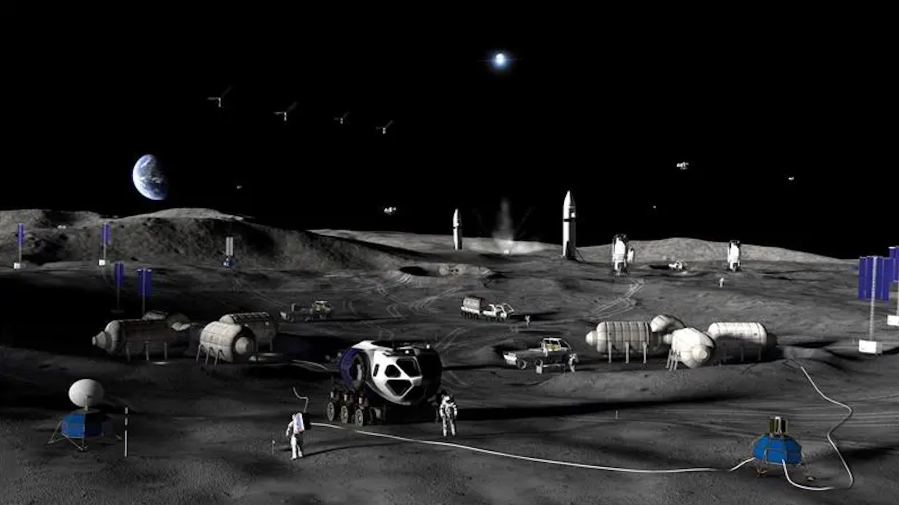
Click for next article The success of NASA's future moon base depends in large part on mission design, which should allow astronauts to work together well in a way independent from psychological training, a new study asserts. The goal of the study was to identify "specific conditions" for mission success and to look for any "red flags" that may stand in the way, lead investigator Anamaria Berea, a computational social scientist at George Mason University (GMU), told Space.com via email. (The first author of the PLOS ONE study , which was published in May, was GMU's Raymond Vera.) The team conducted the research using agent-based models, which are tools for computational simulations in fields ranging from the study of bird flocks to the spread of disease, Berea said. While a lot of modern-day AI "trains" or "learns" to extrapolate from information provided in a data set, agent-based modeling instead uses a data set to "understand emergent phenomena that don't have one single cause or direct cause," she said. The study team considered scenarios for how many astronauts would be on the moon base and how often resupply missions would occur. In an "initial case," for example, the assumed mission duration was three months, with a single resupply run at Month 2 with food, water, air and a fresh group of astronauts. Using a complex probability analysis known as a Monte Carlo simulation, the model astronauts in this scenario showed a productivity rate of about 20% against their expected tasks, "which is acceptable for a typical manufacturing process," the authors noted. This productivity rate doesn't take into account anything unexpected that may crop up during the mission, the authors added. "The low task completion rate suggests that, on average, teams are having challenges to overcoming psychological stressors and environmental disruptions," they wrote. Lessons from the International Space Station NASA tracks productivity a little differently on the International Space Station (ISS). The agency uses a metric called "utilization," which largely refers to the amount of crew time and number of scientific investigations that are performed on the space station during an increment or expedition. As of 2014, the ISS program suggested that ideal utilization should be 35 hours per crew per week when there are three people working on the U.S. part of the space station, and 68.5 hours if there are four or more. (The Russian side of the ISS works largely independently in this respect.) "NASA has generally met or exceeded this goal and set a high of 120 average hours per week devoted to research from October 2019 to April 2020," NASA's Office of the Inspector General (OIG), which has been tracking all of these productivity figures, stated in a report published in September 2024. "Starting March 2022 through March 2023, the latest published data, we have seen utilization near 90 hours per week," the OIG noted. "In addition to the hours spent per week on research, the number of scientific investigations performed on-orbit has increased." Figure 1 of the OIG report also shows both crew time and scientific investigations increasing, as a trend, between 2000 and 2023, suggesting that utilization of the space station is continuing to grow. And this is despite periodic and documented disruptions that required astronauts to take a step back from being productive, such as emergency ammonia leaks requiring spacewalks, the 9/11 disaster , or sheltering in place during brief contingencies such as space debris passing within a few miles of the station. Not all crew time can be used for utilization even if all goes well, however, as the station requires normal maintenance like cleaning, and astronauts also need daily time for sleep, meals and a little relaxation. Additionally, utilization tends to increase with larger crews on the space station compared with smaller ones, as maintenance becomes less of a burden with more hands to take on these tasks. But "lack of redundancy" in key supply items to the space station does pose a risk to utilization, the OIG has noted. As just one example, SpaceX Crew Dragon capsules and Roscosmos Soyuz spacecraft are the only two vehicles that bring astronauts to the station right now. "The lack of redundancy and limited capabilities of both cargo and crew transportation increase the risk to NASA's current and future ability to bring critical supplies, science, and crew to and from the station to maintain safe operations and full utilization of the ISS," the OIG wrote in the report. An artist's concept of astronauts working on the lunar surface. (Image credit: NASA) Isolated environments Those of us who have been on long car rides in a group, or who remember being in tight quarters with roommates or family during the pandemic, have some idea of what an isolated, confined environment (ICE) feels like: crowded, with limited resources, and possessing few connections with the outside world. Space serves as just one example of a true ICE; isolated research bases (like in Antarctica) or submarines have also been studied in the literature, according to a separate 2021 study in the journal Neuroscience & Biobehavioral Reviews. Put simply, ICE refers to a location where humans must work to a high standard in isolated and often dangerous circumstances, with only long-distance support (if possible) from a mission control or its equivalent. And, as the new study points out, a moon base would be a complex example of an isolated environment - one featuring not only resident astronauts but also rovers, other robots and occasional visiting crews. "The premise for our modeling approach came from trying to understand better the human factors involved in crewed space missions, particularly the deep-space ones, for which we don't have a lot of historical data," Berea said. That's because only a handful of people have traveled beyond low Earth orbit - the two dozen who flew to lunar realms on Apollo missions in the late 1960s and early 1970s, and the four astronauts of NASA's Artemis 2 flight around the moon this past April. "We ran various scenarios of space mission durations, number of astronauts, potentially unforeseen circumstances that can happen on the lunar surface or the habitat," she said. The model suggested the missions with the highest probability of success would include six astronauts working on the moon at a time, with fresh supplies coming from Earth every two weeks, and no extreme fluctuations in the environment from things like radiation or a micrometeorite impact . "In contrast, the worst-case scenario consists of four astronauts on the moon at one time, only one month resupply window between Earth and moon, and moderate to high adverse environmental probabilities," Berea said. And, when asked if training is a factor in mitigating adverse effects, she did not necessarily agree that the years of work NASA and other agency astronauts put in would be more effective than shorter-duration training used for moon base analogs . "People can be very, very well trained, but for long-duration or deep-space missions, there will always be a human factor involved," she said. "We looked at combinations of skills and personalities in a team of astronauts, and there is a fine line between having a team that is too small and a team that is too large, and there are synergies and emergent behaviors that come from people interacting with each other and with their environment. "The team is more than the sum of its people," she continued. "The best ways to overcome these is not by more training, but by fine-tuning other aspects of the missions: the duration of the mission, the frequency of resupply missions, and the contingency plans for accidents and unforeseen conditions in extreme environments." NASA, however, puts its ISS crews through many years of remote environment training long before they float through the space station hatch - and Artemis 2 commander Reid Wiseman told The New Yorker that extensive psychosocial training led to the obvious closeness seen live among his own four lunar crewmates despite tight quarters (and vent line issues that led to occasional toilet trouble). That psychological intervention during training was by design. "Preparation starts by recruiting mentally healthy people and then providing training to help them deal with potential situations and issues," wrote the Canadian Space Agency of this training, citing NASA protocols. "Astronauts repeat this training often enough that they can anticipate their own reactions and those of their teammates. They also receive constant support from teams on the ground and have access to a variety of tools to help them deal with potentially difficult situations." Berea noted, however, that psychology forms a part (but is not the focus) of her teams' simulation, including considering NASA TLX (task load index) scores and data, which measures coping and stress for astronauts. The researchers also considered case studies from analogs including Antarctic research missions and time aboard submarines or oil rigs, as some examples. "We need to pay attention not only to the astronauts, but the team as a whole, and each team and space mission are unique. We will not be able to model these with statistics or AI," she said. "But what we can do is to make sure that before we send any human to live and work on the moon, that we understand well the complexity of interactions and scenarios they will face during the mission, and we can help with that."

15. Artemis II astronauts reunite with their moonship 3 months after record-breaking flight
Read more

The Artemis II astronauts reunited with their capsule Wednesday three months after flying around the moon and traveling deeper into space than anyone in history.

