 |  | 

🌌 अंतरिक्ष समाचार | Space News
बुधवार, २३/०९/२०२६ | Wednesday, 23/09/2026

1. Delhi govt launches PM Surya Ghar portal; NDMC clears EVs, Ayush hospital, civic projects
Read more
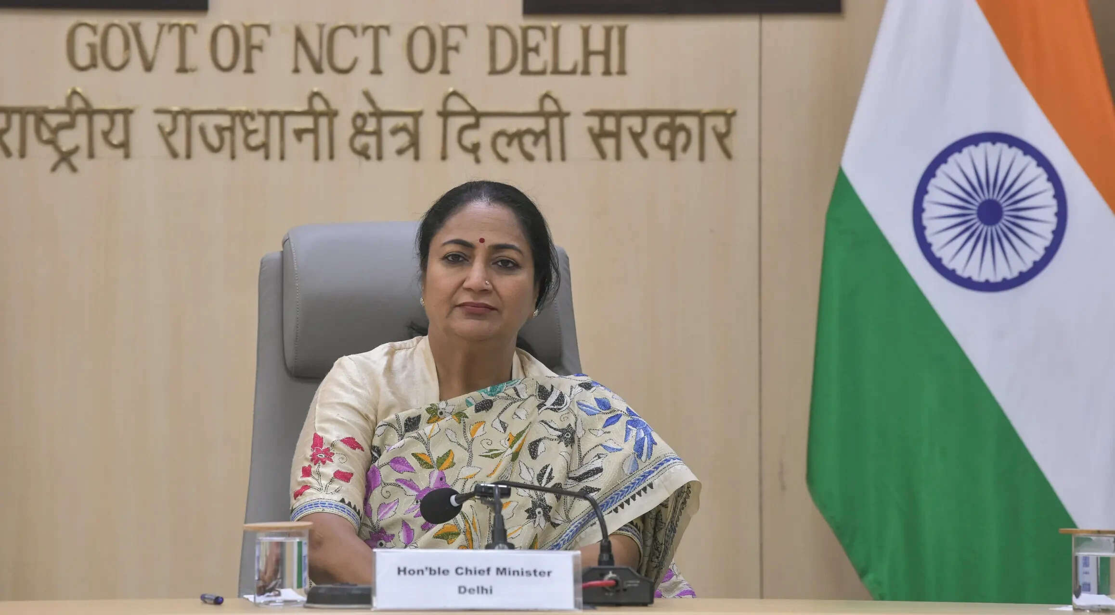
- Governance - 5 min read The key decisions include a one-time amnesty scheme on late payment surcharges for pending water bills, mandatory electric vehicle (EV) procurement for all new council vehicles, and in-principle approval for a 50-bedded Ayush hospital in Sarojini Nagar, according to NDMC Vice-Chairman Kuljeet Chahal. - ET Online - Published On Sep 22, 2026 at 12:04 PM IST Select ETGovernment as Preferred Choice on Google Copy Link Share on WhatsApp Share on Linkedin Share on X Share on Telegram Share on Facebook Delhi Chief Minister Rekha Gupta Delhi Chief Minister Rekha Gupta on Monday launched the 'Delhi PM Surya Ghar' registration portal under the PM Surya Ghar: Muft Bijli Yojana, an initiative designed to streamline rooftop solar installations for city residents, according to an official release. The newly launched portal, solar.delhi.gov.in, serves as a single window for consumers to register for rooftop solar power systems, check available subsidies, view lists of authorised vendors, and lodge grievances. Applications will be processed on a first-come, first-served basis. Under the scheme, the Union Government offers a financial subsidy of up to ₹78,000 for rooftop solar setups up to 3 kW capacity. The Delhi Government will match this amount with an additional subsidy of ₹78,000, raising the total assistance to ₹1.56 lakh per eligible installation. Advt Key benefits and coverage details include: - Domestic consumers using up to 400 units of electricity per month can get rooftop solar systems of up to 3 kW installed with zero upfront payment. - To accommodate homes with smaller roof areas, the government is encouraging compact installations of up to 2 kW. - Coverage extends to Group Housing Societies, where the common-area solar subsidy has been raised from ₹2,000 per kW to ₹11,000 per kW. - Low-use consumers in the 0-200 unit bracket will receive an additional financial incentive linked to lowering their grid power consumption post-installation. - Authorised vendors will handle full operation and maintenance of the installed systems for the first five years. - The Delhi Government targets equipping approximately 2.30 lakh families with rooftop solar capabilities to accelerate clean energy adoption across the capital. Power Minister Ashish Sood noted that the initiative would help transition Delhi toward becoming a "Solar Capital," enabling households to lower their monthly power bills and potentially generate additional income by supplying solar power back to the grid. NDMC approves electric vehicles, Ayush hospital and civic infrastructure measures Separately,The New Delhi Municipal Council (NDMC) on Monday passed 28 key agendas focused on infrastructure, green mobility, healthcare, and administrative reforms. The key decisions include a one-time amnesty scheme on late payment surcharges for pending water bills, mandatory electric vehicle (EV) procurement for all new council vehicles, and in-principle approval for a 50-bedded Ayush hospital in Sarojini Nagar, according to NDMC Vice-Chairman Kuljeet Chahal. Speaking to ANI after the council meeting, Chahal emphasized that the measures align with Prime Minister Narendra Modi's vision of a 'Viksit Bharat' by upgrading civic facilities across Delhi and New Delhi. "A meeting of the NDMC Council was held, and we passed a total of 28 agendas. Fulfilling the Honorable Prime Minister's vision for a 'Viksit Bharat' (specifically a developed Delhi and New Delhi), we passed 28 agendas today," Chahal said. Key decisions & civic relief measures The council approved a one-time amnesty scheme targeting pending water bills, waiving the Late Payment Surcharge (LPSC) to ease financial burdens on residents. Power billing for Dhobi Ghats will shift from commercial to residential meter rates. "In the social welfare department, for the Dhobi Ghats where our colleagues had been incurring high charges due to commercial electricity meters, we have approved charging them at residential meter rates," Chahal noted. To address newly identified unlit zones caused by tree growth and modern developments, the council approved a budget of ₹18.5 to ₹19 crore. "Following observations around the time of the BRICS summit, it was noted that new areas have been developed in NDMC (also through NBCC) and trees have grown, resulting in new dark spots at various locations. To ensure that no dark spots remain, a budget of approximately ₹18.5 to ₹19 crore has been approved. New poles with heights ranging between 6 metres and 11 metres will be installed, including foundation work, laying of cables, earthing, and other necessary electrical infrastructure," Chahal said. The council resolved to restrict all future vehicle acquisitions to electric models while offering a 50per cent discount on parking fees for EVs across NDMC-managed lots. "In line with the Prime Minister's vision to curb pollution, all new vehicles being procured by the NDMC will be electric vehicles. Additionally, we confirmed the decision to provide a 50 per cent discount on parking charges for electric vehicles at our parking lots to encourage green transport and a pollution-free environment," Chahal explained. Healthcare, education, and commercial upgrades - ₹55-Crore Ayush Hospital: The council granted in-principle approval for a 50-bedded Ayush Hospital in Sarojini Nagar, to be jointly funded on a 50:50 basis by the NDMC and the Ministry of Housing and Urban Affairs (MoHUA). "In the health sector, discussions regarding an Ayush Hospital," Chahal said, adding that detailed plans will be presented shortly. - Model Examination Centre: Plans were greenlit for a tech-enabled 'Palika Adarsh Pariksha Kendra' in Moti Bagh, following recommendations by a high-level task force led by Nandan Nilekani. "To ensure transparency, reliability, and tech-driven efficiency with zero scope for malpractice, it will be executed through an open tender/RFP," Chahal added. - Intelligent Parking Tenders: Request for Proposals (RFPs) were cleared for three parking clusters expected to bring in over ₹7 crore in monthly revenue through an Intelligent Integrated Parking System. "Parking is a major issue in the NDMC area. The RFP for parking tenders across three clusters (Cluster 1, Cluster 2, and Cluster 3) has been approved. This will generate a minimum monthly revenue of over Rs 7 crore," he said. - Connaught Place Escalators: The council gave in-principle approval to replace aging and faulty escalators throughout Connaught Place with modern units. The meeting was chaired by Delhi Public Works Department (PWD) Minister Parvesh Sahib Singh. Key attendees included Member of Parliament Bansuri Swaraj, NDMC Chairman Manoj Dwivedi, Vice-Chairperson Kuljeet Chahal, MLA and NDMC member Virender Singh Kadian, council members Dinesh Pratap Singh, Anil Valmiki, and Sarita Tomar, alongside NDMC Secretary Rahul Singh. - See more on: - PM Surya Ghar portal , - rooftop solar installations , - solar energy adoption in Delhi , - Delhi government initiatives , - financial subsidy for solar power , - electric vehicles procurement , - NDMC infrastructure projects , - Ayush hospital Sarojini Nagar , - green mobility initiatives , - electric vehicle parking discounts Telegram Facebook Comments What are your thoughts? Comment Now --> Comment Now Read Comment (1) All Comments By commenting, you agree to the Prohibited Content Policy Post Find this Comment Offensive? Choose your reason below and click on the submit button. This will alert our moderators to take actions REASONS FOR REPORTING Foul Language Defamatory Inciting hatred against a certain community Out of Context / Spam Others Report Join the community of 2M+ industry professionals. Subscribe to Newsletter to get latest insights & analysis in your inbox. --> All about ETGovernment industry right on your smartphone! - Download the ETGovernment App and get the Realtime updates and Save your favourite articles. Scan to download App --> - Home - News - Delhi govt launches PM Surya Ghar portal; NDMC clears EVs, Ayush hospital, civic projects

2. Delhi to launch 150 electric buses next month, seeks land for five depots
Read more
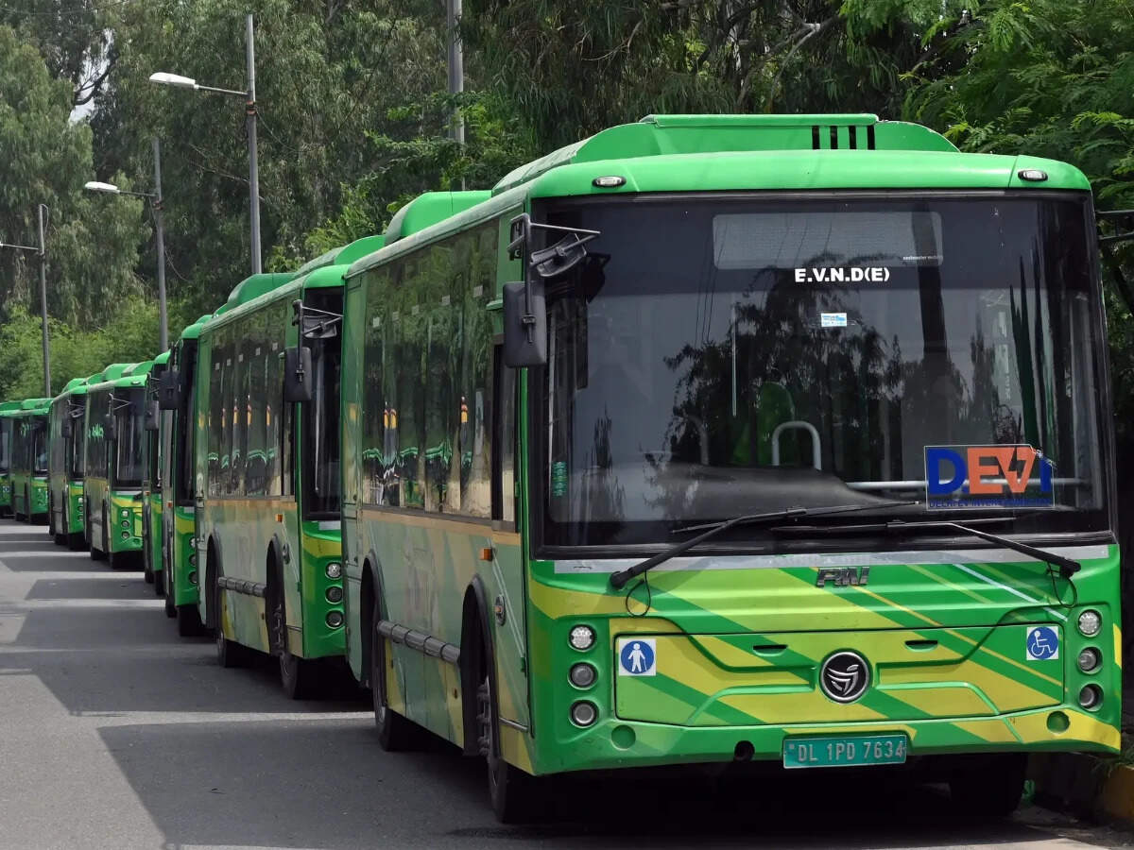
Advt Join the community of 2M+ industry professionals. Subscribe to Newsletter to get latest insights & analysis in your inbox. All about ETGovernment industry right on your smartphone! Download the ETGovernment App and get the Realtime updates and Save your favourite articles. The Delhi government will launch 150 electric buses next month and has also sought land for depots and charging infrastructure at five locations, Transport Minister Pankaj Singh said on Monday.He said the government has requested the Delhi Development Authority (DDA) and the Municipal Corporation of Delhi (MCD) for land at certain locations to bolster the required infrastructure."The Delhi government is developing bus depots and charging infrastructure in a coordinated manner, with every site closely monitored, so that new electric buses can be deployed without delay. Our aim is a clean and green Delhi, and the infrastructure will be built as per requirement and in harmony with the environment," Singh said in a statement.The government is also developing two new depots at Daurala and Jhuljhuli, with the capacity of 250 and 500 buses, respectively. It will cater to a large number of passengers from rural areas, the minister added."The date is yet to be finalised, but the buses are ready and will be launched anytime next month," a government official said.To find more space for depots and charging infrastructure, the government has requested land at Tikri Kalan village (PVC market), Jaunti village, Mungeshpur village, Bakkarwala and Gazipur Mandi.In addition, the Directorate of Panchayat has allocated land to Delhi Transport Corporation (DTC) and the transport department for developing bus depots and charging infrastructure, the minister added.

3. ISRO successfully conducts 2nd integrated air drop test for Gaganyaan mission - News On AIR
Read more
ISRO successfully conducts 2nd integrated air drop test for Gaganyaan mission News On AIR

4. Why ISRO is handing its commercial empire to private industry - Finshots
Read more
Why ISRO is handing its commercial empire to private industry Finshots

5. ISRO, ESA broaden cooperation agreement - Manorama Yearbook
Read more
ISRO, ESA broaden cooperation agreement Manorama Yearbook

6. A Different Mission This! Durga Puja Takes A Flight Into Space With ISRO Exhibition In Kolkata's New Town - ETV Bharat
Read more
A Different Mission This! Durga Puja Takes A Flight Into Space With ISRO Exhibition In Kolkata's New Town ETV Bharat

7. NASA-Funded Research Finds Complex Life Defying Record Heat
Read more
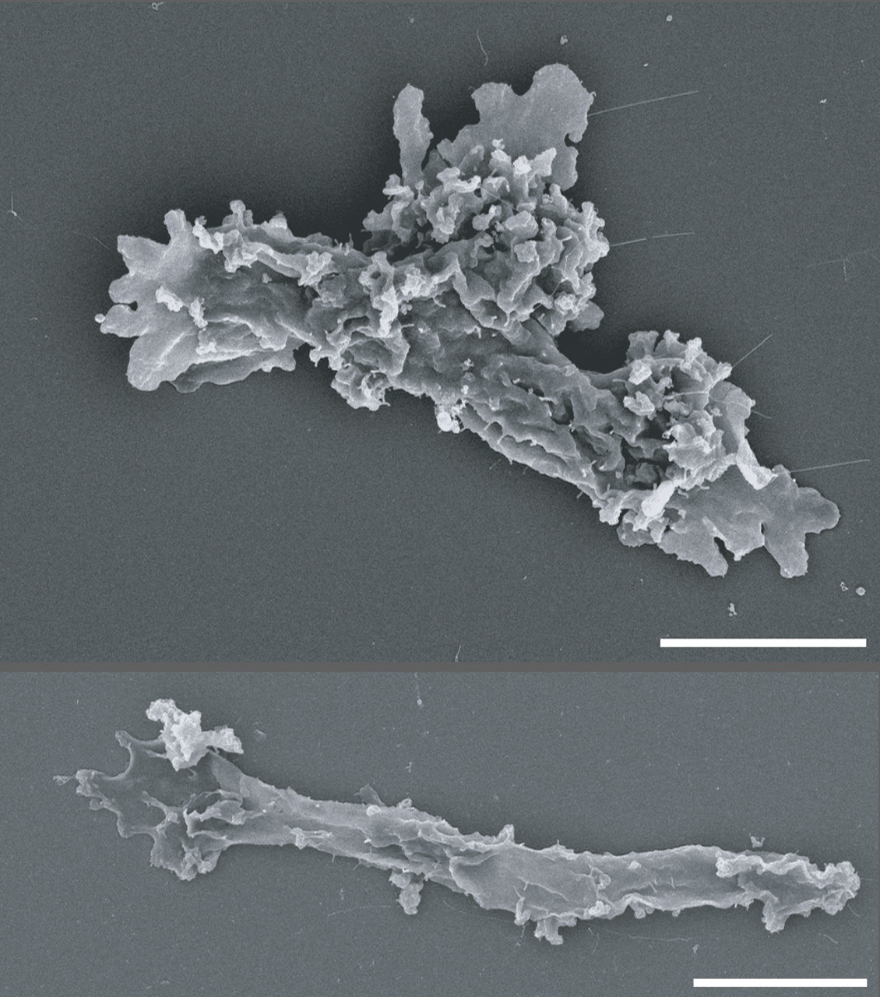
This video shows Incendiamoeba cascadensis motility at 60ºC. When pushed to its limits in the lab, I. cascadensis can remain partially active at 150.8 degrees Fahrenheit (66 degrees Celsius) and can recover from exposure to a staggering 158 degrees Fahrenheit (70 degrees Celsius) for five minutes. However, 176 degrees Fahrenheit (80 degrees Celsius) proved to be too much for the amoeba to come back from. Beryl Rappaport Lee esta historia en español aquí. NASA-supported scientists have discovered an organism that lives at extreme temperatures previously thought impossible for complex life. High temperatures can cause the destruction of necessary cell components, which is a big problem for cells with complex parts like a nucleus encasing delicate genetic information. In the heated waters of California's Lassen Volcanic National Park, a team of scientists observed an amoeba that can reproduce by division at an astonishing 145 degrees Fahrenheit (63 degree Celsius), setting a record for the upper temperature limit for all known eukaryotes. Incendiamoeba cascadensis, also dubbed the fire amoeba, stops reproducing above 145 degrees Fahrenheit but is still active, moving around to search for food at up to 147 degrees Fahrenheit (64 Celsius). The previous limit of 140 degrees Fahrenheit (60 Celsius) for eukaryotes was set by a few species of fungi and red algae. The results were published on Tuesday in the journal Cell. Astrobiologists have long studied the boundaries of life's survival on Earth to determine how organisms might live on other worlds like Mars where conditions are less hospitable than our home planet. Organisms that endure at the edges of habitability under extreme temperature, pH levels, radiation, and other environmental conditions are known as extremophiles. Studying them helps scientists understand what life as we know it is capable of. Extremophiles also produce unique proteins that can have promising uses in biotechnology, from industrial applications to medicine. Previous extremophile research has mostly focused on single-celled bacteria and archaea. The new study shows that the more complex cells of eukaryotes might be more durable than previously thought and could even help scientists understand locations in the universe where complex life could survive. Complex life on Earth Life on Earth is broadly divided into two categories, prokaryotes and eukaryotes. Prokaryotes are single-cell organisms that do not have a nucleus or membrane-bound organelles inside their single cell. This means that they have less cellular 'machinery' that can be damaged by extremes, such as blistering heat, bitter cold, caustic acidity, or damaging radiation. Organisms that live in extreme heat are known as thermophiles. To be a true 'heat-loving' thermophile, the organism must be able to replicate, move, eat, and survive above 113 degrees Fahrenheit (45 degrees Celsius). Prokaryotes include bacteria and archaea, with archaea being particularly adept at surviving extremes. Because of their relative simplicity, scientists also believe that prokaryotes were the first forms of life to appear on Earth, billions of years ago when the environment of our planet was much more inhospitable than it is today. Eukaryotes are more complicated organisms that are thought to have evolved later in the history of life on Earth. These organisms have a separate cell nucleus inside their cells that contains fragile genetic information. Eukaryotes also contain membrane-bound organelles, such as mitochondria and endoplasmic reticulum. These organelles are like mini cellular machines that perform specific functions. Eukaryotes include a wide span of life, from single-celled algae to multicellular organisms like plants and human beings. Complexity in Extreme Heat High temperatures lead to the breakdown of proteins and other biomolecules that living cells need to function. Heat also can cause membranes to break apart, thereby destroying cells. It has been suggested that organelle membranes in eukaryotes could not remain stable above 144 degrees Fahrenheit (62 degrees Celsius). The discovery of I. cascadensis proves that assumption wrong. "In part, studies on eukaryotes may have been limited because of assumptions about membrane stability," says Beryl Rappaport, graduate student at Syracuse University and lead author of the study. "We are hoping that the discovery of I. cascadensis encourages others to keep searching for high temperature eukaryotes." The team sequenced the I. cascadensis genome, studying the expression of genes at multiple temperatures. They found many genes that help the amoeba stabilize DNA and protect it from breaking down. Other genes allow the organisms to sense the external environment. At high temperatures, the expression of certain genes also increased, including those involved in maintaining protein folding. "We were able to uncover many strategies that could help I. cascadensis survive at high temperatures, and some of these strategies could be used by thermophiles across all life," says Rappaport. "For instance, some proteins in I. cascadensis have a high positive surface charge that could help them remain stable. These protein charges are similar to those found in thermophilic bacteria and archaea." The team also compared genetic information from other studies world-wide. In this trove of data, they found similar pieces of DNA from geothermal samples in places like New Zealand and Yellowstone National Park. This means that additional thermophilic amoebas related to I. cascadensis might be living all around the globe just waiting to be discovered. Lead author Beryl Rappaport collecting samples of Incendiamoeba cascadensis in California's Lassen Volcanic National Park. The organism's name means "Fire amoeba coming from the cascades." California's Lassen Volcanic National Park is the southernmost active volcanic region in the Cascade Range and includes Lassen Peak, the world's largest plug dome volcano. Kristen Skruber Search for life beyond Earth Earth is the only planet we know of that is inhabited with life. For life as we know it to survive on other planets in the solar system or beyond, organisms might have to cope with environmental conditions that are very different from those found here at home. "Studying extremophiles helps us better understand the biochemical and physiological limitations of life as we know it on Earth," says Alison Olcott, program scientist for Exobiology at NASA Headquarters in Washington. "This information, in turn, helps guide NASA's search for life as it expands the range of conditions we think life could potentially be inhabiting elsewhere." In particular, the study increases our understanding of where and how life with complex cells might persist on Earth and beyond. "Finding eukaryotes surviving in high temperature environments not only expands our understanding of where life could be found, but also of how complex that life could be," says Olcott. However, the researchers do point out that survival depends on many factors that are part of a larger ecosystem. "It could certainly be possible for complex life like I. cascadensis to survive on another planet, but Earth is the only planet we currently know of to have all the requirements for I. cascadensis to be happy," says Rappaport. "It's not just about temperature. An environment also needs the right acidity, oxygen levels, pressure, water, and food. I. cascadensis could not survive on its own. It needs other life to be supported as well." For more information on astrobiology at NASA, visit: https://science.nasa.gov/astrobiology

8. NASA's Chandra Finds Unusual Objects in Pinwheel Galaxy
Read more
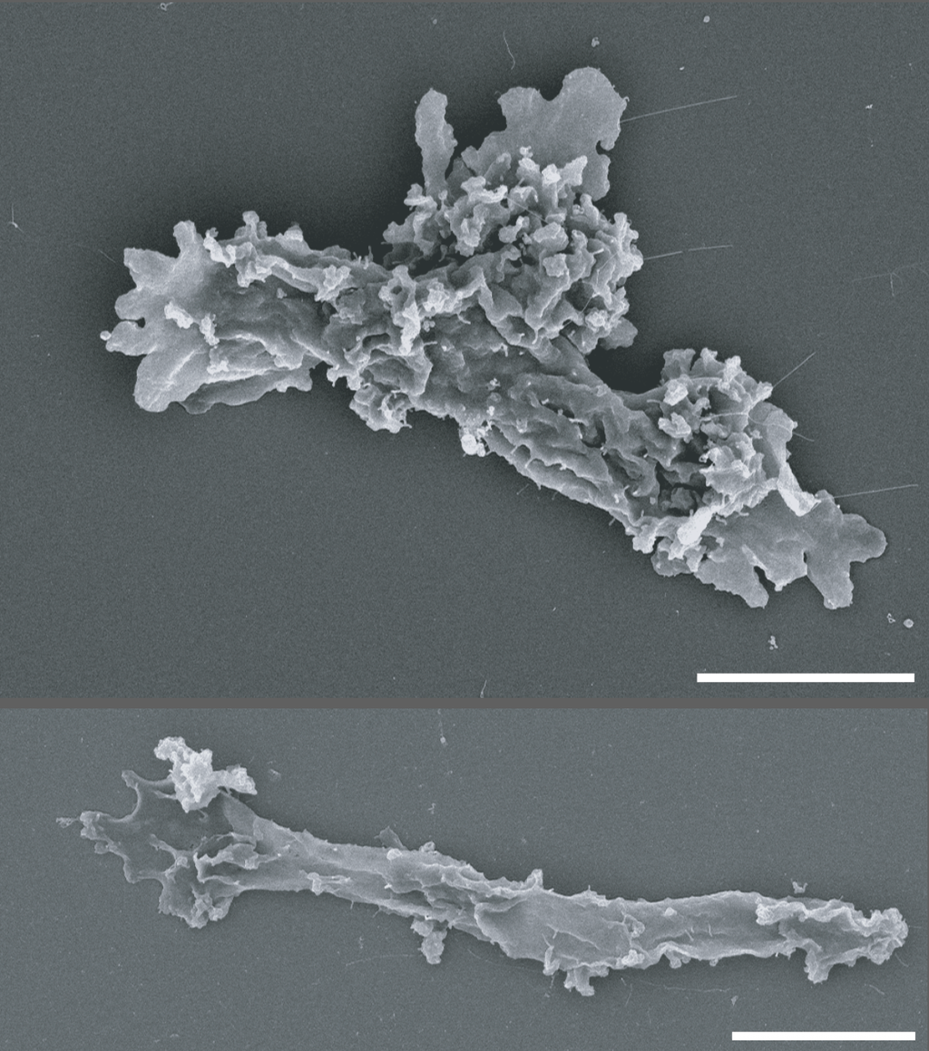
X-ray: NASA/CXC/Univ. of Alabama/M. Muhibullah et al.; Optical: NASA/ESA/STScI; Image Processing: NASA/CXC/SAO/N. Wolk Using NASA's Chandra X-ray Observatory, researchers found mysterious objects that give off unusually low-energy X-rays but intense levels of ultraviolet radiation. One of the galaxies they studied, M101, is pictured here in this image released on Sept. 9, 2026. Astronomers suggest these newly spotted objects in other galaxies may help solve not one, but two long-standing questions in astrophysics. Image description: X-ray: NASA/CXC/Univ. of Alabama/M. Muhibullah et al.; Optical: NASA/ESA/STScI; Image Processing: NASA/CXC/SAO/N. Wolk

9. NASA Astronaut to Answer Questions from New Hampshire Students
Read more
NASA astronaut Anil Menon reviews procedures for emergency scenarios while aboard the International Space Station as part of his long-duration science and research mission. Credit: NASA Editor's Note: This feature was updated Sept. 22, 2026, to note the time change for the in-flight call with students. Students in New Hampshire will hear from NASA astronaut Anil Menon as he answers prerecorded STEM questions while aboard the International Space Station. The Earth-to-space call will begin at 11:40 a.m. EDT Thursday, Sept. 24, and will stream live on the agency's Learn With NASA YouTube channel. This event is hosted by the McAuliffe-Shepard Discovery Center in Concord, New Hampshire, for students in grades K-12, and members of the community. This unique opportunity aims to deepen understanding of space exploration and enhance awareness of STEM careers. Media interested in covering the event must RSVP no later than 5 p.m. EDT, Wednesday, Sept. 23, to Kelly Thompson at kthompson@starhop.com. For more than 25 years, people have lived and worked continuously aboard the International Space Station, advancing scientific knowledge and making research breakthroughs not possible on Earth. The space station helps NASA understand and overcome the challenges of human spaceflight, expand commercial opportunities in low Earth orbit, and build on the foundation for long-duration missions to the Moon, as part of the Artemis program, and to Mars. For more information on NASA in-flight calls, visit: https://www.nasa.gov/stemonstation

