 |  | 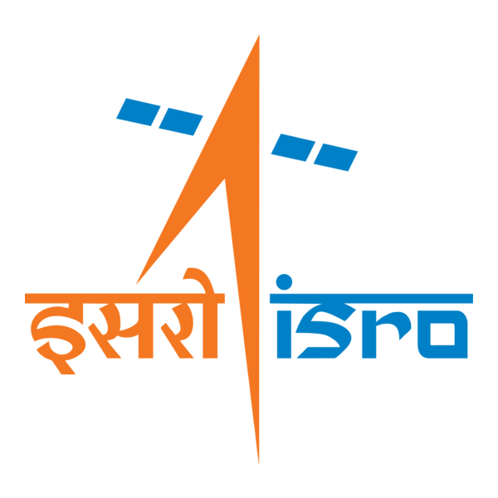

🌌 अंतरिक्ष समाचार | Space News
शनिवार, ३१/१०/२०२६ | Saturday, 31/10/2026

1. Noida police launches 'Operation FAST' to ensure faster ambulance movement
Read more

- Governance - 2 min Read An Ambulance Traffic Facilitation Cell is also being established in the Traffic Police Control Room to coordinate the movement of emergency vehicles, police said in a statement. - PTI - Published On Oct 31, 2026 at 12:30 AM IST - Select ETGovernment as Preferred Choice on Google - Share Icon Copy Link Share on Whatsapp Share on Linkedin Share on X Share on Telegram Share on Facebook - Bookmark - Comment As part of a trial conducted on Friday, an empty ambulance covered around 12 km from Chilla Border to Max Hospital and Fortis Hospital in approximately 10 minutes on each route during peak traffic hours, the statement said. The Gautam Buddh Nagar Police on Friday launched ' Operation FAST ' (Fast Ambulance Seamless Transition), a round-the-clock traffic coordination system to ensure quicker movement of ambulances carrying critically ill patients and road accident victims to hospitals, it said. A dedicated helpline -- 9218981716 -- has been set up for ambulance operators, hospital control rooms and ambulance staff to seek traffic assistance. An Ambulance Traffic Facilitation Cell is also being established in the Traffic Police Control Room to coordinate the movement of emergency vehicles, police said in a statement. The initiative has been developed under the guidance of Gautam Buddh Nagar Police Commissioner Lakshmi Singh, following research by DCP (Headquarters) Shavya Goyal, it said. As part of a trial conducted on Friday, an empty ambulance covered around 12 km from Chilla Border to Max Hospital and Fortis Hospital in approximately 10 minutes on each route during peak traffic hours, the statement said. "The trial demonstrated that effective and proactive traffic coordination can significantly reduce ambulance travel time, even during periods of heavy congestion," police said. Under the proposed system, ambulance dispatchers, hospital control rooms or ambulance staff will share the vehicle's location, destination and intended route with the dedicated control room. Traffic personnel stationed along the route will then coordinate to clear intersections in advance, regulate traffic from the opposite direction and manage signals temporarily wherever required. The system will follow a "rolling traffic clearance mechanism", under which traffic at successive intersections will be managed as the ambulance moves forward. Public address systems may also be used to alert motorists about an approaching ambulance. Major government and private hospitals, ambulance service providers and emergency dispatch centres have been brought into the coordinated network. Primary routes connecting major hospitals in the district have also been identified, the statement said. The initiative aims to minimise delays in transporting patients with severe injuries, head trauma, heavy bleeding and other life-threatening conditions to hospitals and trauma centres. It is also aligned with the broader 'Zero Fatality District' initiative aimed at reducing preventable deaths, police said. Citizens have been urged to give way to ambulances, avoid blocking intersections and cooperate with traffic personnel during emergencies. "The core objective is to ensure that no critically ill patient or road accident victim is deprived of life-saving treatment due to traffic congestion," the statement said. Comments What are your thoughts?

2. GSLV-F18/NVS-03 MISSION - ISRO
Read more
GSLV-F18/NVS-03 MISSION ISRO

3. ISRO launches NVS | Akashvani News - News On AIR
Read more
ISRO launches NVS | Akashvani News News On AIR

4. ISRO NVS-03 Mission 2026, Features, Applications, Significance - Vajiram & Ravi
Read more
ISRO NVS-03 Mission 2026, Features, Applications, Significance Vajiram & Ravi

5. PM congratulates ISRO scientists and engineers on successful launch of GSLV-F18 carrying NVS-03 - PM India
Read more
PM congratulates ISRO scientists and engineers on successful launch of GSLV-F18 carrying NVS-03 PM India

6. Isro NVS-03 satellite launch: The science and setbacks behind NavIC, India's version of GPS | HT Explainers - Hindustan Times
Read more
Isro NVS-03 satellite launch: The science and setbacks behind NavIC, India's version of GPS | HT Explainers Hindustan Times

7. Happy Halloween! SpaceX launches 27 Starlink satellites to orbit from California
Read more
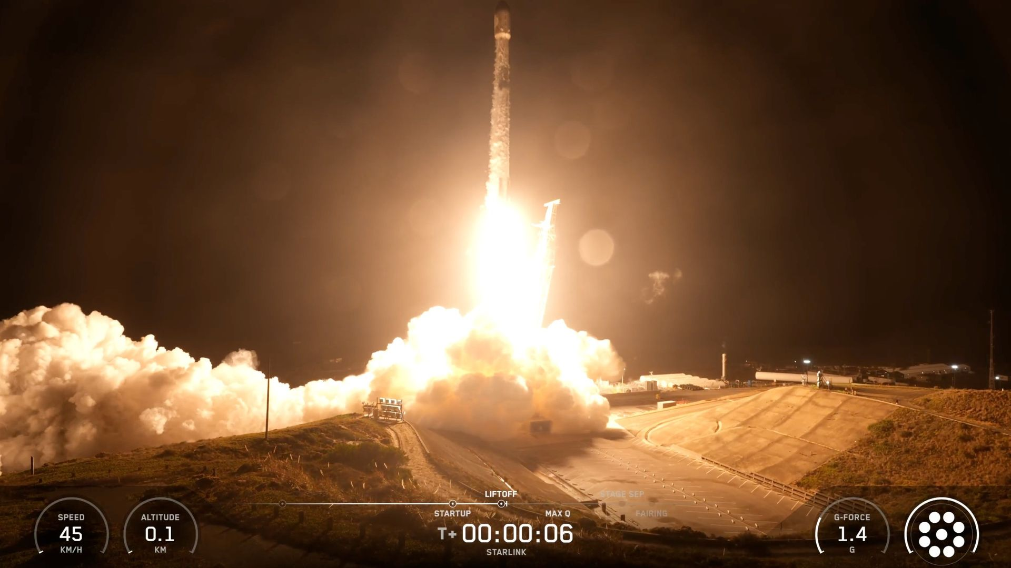
Click for next article A SpaceX Falcon 9 rocket launches 27 Starlink satellites from California's Vandenberg Space Force Base just after midnight ET on Oct. 31, 2026. SpaceX celebrated Halloween with an early-morning launch from California. A Falcon 9 rocket lifted off from Vandenberg Space Force Base today (Oct. 31) at 12:04 a.m. EDT (0404 GMT; 9:04 p.m. on Oct. 30 local time), sending 27 of the company's Starlink internet satellites to low Earth orbit (LEO). The Falcon 9's first stage came back to Earth as planned, touching down about 8.5 minutes after launch on the SpaceX drone ship "Of Course I Still Love You," which was stationed in the Pacific Ocean. The Falcon 9's first stage rests on the deck of a drone ship shortly after launch on Oct. 31, 2026. (Image credit: SpaceX) It was the 18th flight for this particular booster, which is designated B1093. The record for a SpaceX first stage is 37 , set this past August by the booster B1067. The Falcon 9's upper stage did its job as well today, deploying the 27 Starlink satellites into LEO about 62 minutes after launch. They're joining more than 11,000 spacecraft in the Starlink megaconstellation, which is by far the largest satellite network ever assembled. Previous Booster 1093 launches SDA-T1TL-B | SDA-T1TL-C | Transporter-16 | 14 Starlink missions Today's launch was the 118th Falcon 9 flight of 2026 so far. More than 70% of these missions have been devoted to building out the Starlink network. SpaceX has also launched its Falcon Heavy and Starship rockets three times apiece this year. Falcon Heavy is an operational vehicle, but Starship remains in the test-flight phase. The company is currently gearing up for another Starship launch , which is expected to take place sometime in November.

8. India launches next-gen navigation satellite to orbit (video)
Read more
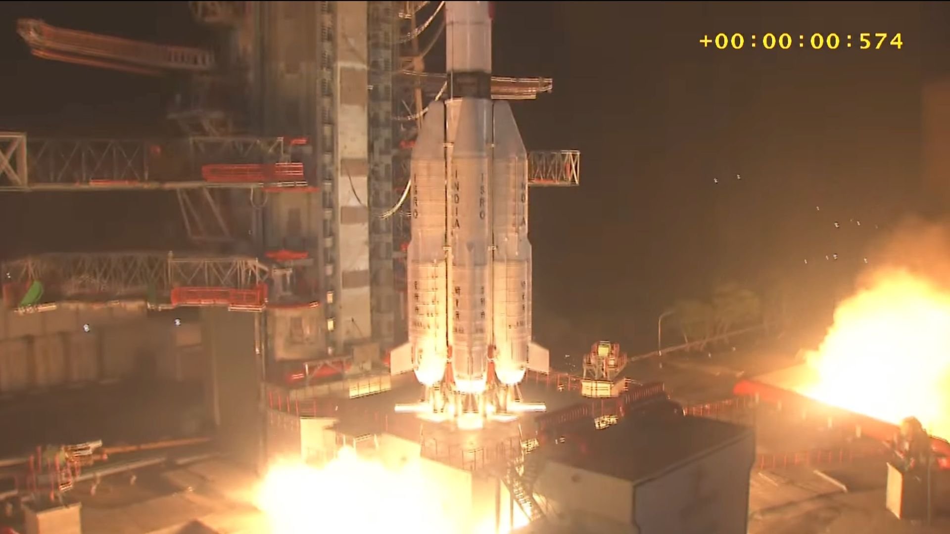
Click for next article India bolstered its homegrown satellite-navigation system today (Oct. 30). A GSLV Mark II rocket launched the nation's NVS-03 satellite from Satish Dhawan Space Centre today at 2:21 p.m. EDT (1821 GMT and 11:51 p.m. India Standard Time). Everything went well: The rocket deployed NVS-03 into geostationary transfer orbit as planned, officials with the Indian Space Research Organisation (ISRO) announced on X about 30 minutes after liftoff. An Indian GSLV Mark II rocket launches the NVS-03 navigation satellite on Oct. 30, 2026. (Image credit: ISRO) NVS-03 is the third next-gen satellite that India has launched for the Navigation with Indian Constellation (NavIC), its version of the United States' Global Positioning System ( GPS ). NavIC operates on a smaller scale than its American counterpart, however. It's "a regional navigation satellite system designed to provide accurate Position, Navigation and Timing (PNT) service to users in India as well as the region extending about 1,500 km [930 miles] beyond the Indian landmass, which is its primary service area," ISRO officials wrote in the NVS-03 launch brochure . The Indian constellation currently consists of three fully functioning satellites, and it requires four to provide PNT services. So today's launch was a big deal - and a lot of eyes will be watching NVS-03's commissioning and checkout phase. Today's launch was the 14th to date for the GSLV (Geosynchronous Satellite Launch Vehicle) Mark II, a three-stage rocket that stands 170 feet (52 meters) tall. Twelve of those 14 liftoffs have been successful. The GSLV Mark II debuted in 2010, the same year its predecessor retired. That previous launchers, the Mark I, flew a total of six times, with two failures.

9. SpaceX closes out October with Halloween eve Falcon 9 launch, 700th Falcon 9 launch to date
Read more
The Starlink 15-18 mission will add another 27 Starlink V2 Mini Optimized satellites to SpaceX's megaconstellation. Liftoff from pad 4E at Vandenberg Space Force Base is scheduled for 9:04 p.m. PDT (12:04 a.m. EDT / 0404 UTC).

10. NASA's Voyager 1 conserves power, resolves brief communications pause
Read more
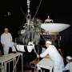
NASA's Voyager team is celebrating two recent developments with the Voyager 1 spacecraft: In September, they successfully completed a months-long effort to stretch the spacecraft's diminishing power supply. Then, on Oct. 20, an unexpected loss of communication with the spacecraft resolved itself after 48 hours, before the team sent commands to the spacecraft to troubleshoot the...

