 |  | 

🌌 अंतरिक्ष समाचार | Space News
सोमवार, ०६/०७/२०२६ | Monday, 06/07/2026

1. 'Inspiring learning spaces': Project to upgrade Delhi government school infra nears completion
Read more

The government said renovation work has been taken up in schools across North, South, West, North-East and Outer North districts. The Delhi government's initiative to upgrade infrastructure in government schools - Mission Kayakalp - is on the anvil of completion, according to officials. Chief Minister Rekha Gupta earlier said the objective of the project was to transform government schools into "safe, clean, modern and inspiring learning spaces" rather than "limiting them to centres of education". The programme focuses on addressing infrastructure gaps such as leaking roofs, damaged toilets, outdated science laboratories, inadequate drinking water facilities and poor campus maintenance, according to a statement from the Chief Minister's Office. While summer vacations were on, the Chief Minister had instructed officers concerned to undertake renovation work to improve basic facilities, and upgrade classrooms and campus conditions, sources said.

2. Isro tests new motor for rocket being built for Gaganyaan parachute trials - The Times of India
Read more

Photo credit: ANI BENGALURU: The Indian Space Research Organisation (Isro) has successfully completed the first ground test of the solid motor that will power a new sub-orbital test vehicle designed to support the Gaganyaan human spaceflight programme.The test, conducted on July 3 at the Static Test Facility at the Satish Dhawan Space Centre (SDSC) in Sriharikota, validated the performance of the solid motor for the proposed Sub-Orbital Launch Vehicle for Experiments (SOLVE). According to Isro, the motor performed as expected during the trial.As per Isro, SOLVE is being developed as a dedicated platform to carry out integrated parachute tests for the Gaganyaan crew module. The vehicle will loft the crew module to an altitude of between 10km and 17km before separating it in flight. A sequence of 10 parachutes will then deploy to slow the module's descent before it splashes down in the sea.The tests are aimed at validating the crew module's deceleration system under different flight conditions before India's first crewed space mission.The solid stage of the SOLVE vehicle is based on the strap-on motor used in the Polar Satellite Launch Vehicle (PSLV), but has been modified to meet Gaganyaan's requirements.The changes include a slow burn-rate propellant, a straight nozzle and a secondary injection thrust vector control system to steer the vehicle during flight.Isro said the development of the SOLVE vehicle would provide greater flexibility in conducting Gaganyaan test missions by allowing engineers to simulate a range of conditions expected during an actual crewed mission.The successful ground firing marks another step in preparations for Gaganyaan, under which Isro plans to send Indian astronauts into low-Earth orbit aboard an indigenous spacecraft before safely returning them to Earth. The parachute system is one of the mission's critical safety elements, ensuring the crew module can make a controlled splashdown after re-entering the atmosphere.

3. ISRO satellite images show monsoon in full force; Maharashtra and West Bengal brace for heavy rain - CNBC TV18
Read more

ISRO satellite images show monsoon in full force; Maharashtra and West Bengal brace for heavy rain CNBC TV18

4. ISRO clears key Gaganyaan parachute test - DT Next
Read more
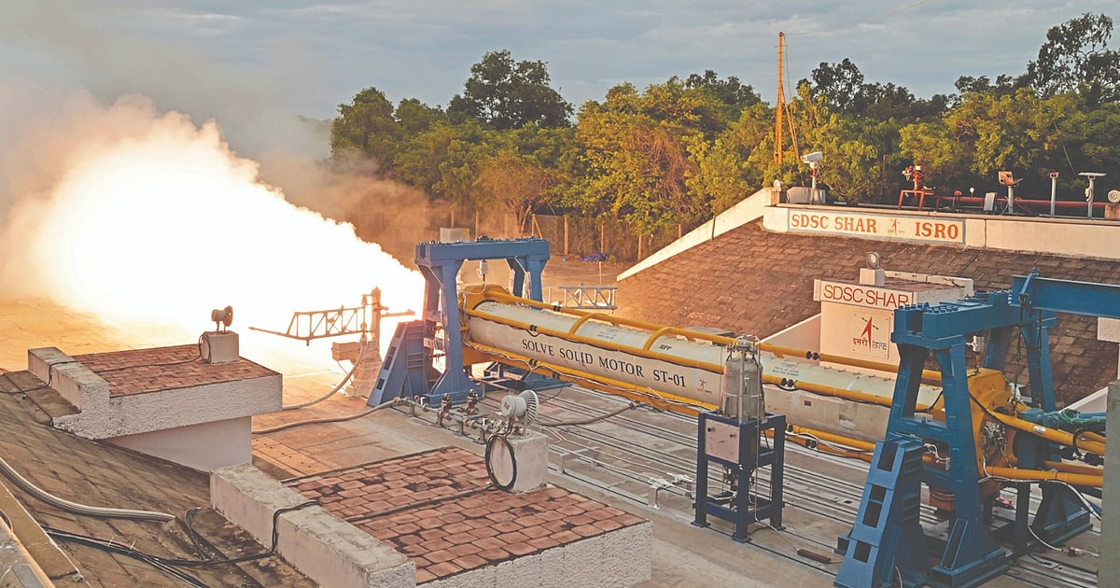
The test was conducted at the Satish Dhawan Space Centre, Sriharikota, to validate critical systems of the Gaganyaan crew module during sub-orbital test missions. According to ISRO scientists, the specially designed solid motor will carry the crew module to an altitude of 10 km to 17 km, after which the module will separate and descend safely using a sequence of 10 parachutes before splashdown in the sea. Scientists said all performance parameters of the motor were as expected, confirming the success of the test. The Gaganyaan mission aims to demonstrate India's capability to send a three-member crew into a 400-km low-Earth orbit for a three-day mission before safely recovering them in Indian waters.

5. Why countdown to Gaganyaan launch, India's 1st crewed space mission, is still likely to take a while - The Federal
Read more
On July 3, the India Space Research Organisation (ISRO) successfully conducted the first ground test for the solid motor of its Sub-Orbital Launch Vehicle for Experiments (SOLVE). According to ISRO, the development of the SOLVE vehicle provides flexibility in conducting tests for the Gaganyaan mission - India's first crewed space mission - simulating various conditions of the actual mission. It has been developed as a "test platform" to help with the Gaganyaan crew module's parachute-based deceleration system. However, days earlier, at an event in Bengaluru last month, ISRO chairman V Narayanan had announced a delay of the first uncrewed Gaganyaan mission, which, he hinted, may now slip to the third quarter of 2027. The delay could potentially push the Gaganyaan crewed flight to 2028 or beyond. Ongoing preparation for the Gaganyaan mission. Photo: ISRO Just months before, in November 2025, on the sidelines of the Emerging Science, Technology and Innovation Conclave (ESTIC-2025) in Delhi, Narayanan had declared that "nearly ninety per cent of the progress at the subsystem level has been achieved". The next phase, he had then said, would involve comprehensive integrated testing and verification. Every component, he emphasised, has to withstand the thunderous roar of launch, the vacuum of space, and the searing heat of re-entry. He had also informed that the first fully uncrewed orbital flight, designated Gaganyaan-1 (G1), was scheduled for December 2025. That was then. Now, once again, the launch of G1 has been delayed. Also read: How the Chandrayaan-3's little 'hop' changed our insight into building lunar habitats ISRO hopes to conduct at least three uncrewed test launches, G1, G2, and G3, before the human mission, or H1, is launched. Each uncrewed mission will carry Vyommitra, a robotic humanoid designed to monitor the environment the crew will eventually experience. The logic is to ensure the launch vehicle and spacecraft are safe and trustworthy before placing astronauts aboard. The ambitious project was initiated in 2018. According to the original plan, the crewed mission was scheduled for August 2022, a date chosen to coincide with the 75th anniversary of India's independence. Initially, the global Covid-19 pandemic (of 2021-22) caused delays. Then, inexplicably, the project has faced further delays. Technical preparations, the rigorous process of human-rating systems, "erratic fund flows" from the Union government, and, as some insiders say, inadequate recruitment of scientists and engineers have each taken their toll. And it is not just the timeline that is shifting. The mission goals are also evolving. Initially, the proposal was to send a three-member Indian crew into space, conduct experiments for about a week, and return them safely aboard an entirely indigenous spacecraft launched by an Indian rocket. A grand vision. Now, the mission will be more modest: a single crew member, perhaps just a few orbits around the Earth. Human spaceflight is difficult. Delays in space missions are common. They happen to every spacefaring nation. Just look at how much the Artemis project (NASA's moon exploration mission) or SpaceX's Starship were delayed. Delays in rocket science are inevitable. And that is precisely the point. Delays are better than loss of mission. Better to see it launch later than to rush it and have a tragedy on our hands. Space does not forgive haste or cutting corners. Until now, ISRO has been a reliable transporter, moving cargo to space. Gaganyaan changes that. It is a trucking firm becoming a passenger airline. The payload is no longer a machine; it is a human being. ISRO takes care even with satellites. But with humans, we need much better safety standards. A single failure means a life lost. In rocket science, this transformation has a name: human rating. It is the process of ensuring every component, launch vehicle, escape system, life support, even a single nut and bolt, is safe enough for human travel. It is the difference between a goods lorry and a passenger bus. Both can be reliable, but only one is expected to bring its cargo home alive. First crew module for Gaganyaan test flight. Photo: ISRO So let us begin with the launch pad, where the journey starts. A launch pad built for humans is a different beast from one built for satellites. It must be equipped with emergency escape systems, ready for trouble before liftoff. For Gaganyaan, ISRO has upgraded the Second Launch Pad at the Satish Dhawan Space Centre (SDSC-SHAR) in Sriharikota, Andhra Pradesh to host the Human Rated LVM3, or HLVM3. Among the new safety features is a NASA-style slide-wire, a zipline that can whisk astronauts from the tower to safety within seconds. The high-speed baskets will carry them to an underground blast-protected bunker in the blink of an eye. The ziplines are installed. The bunker is nearing completion. The tests, however, are yet to be done. There is another addition in the launch pad. A "white room". It sounds clinical, but it is where the final act of preparation unfolds. On launch day, the astronauts step out of a special van, take a lift up the tower, and walk across the Crew Access Arm. They step into the white room, put on their final gear, check their suits and climb through the hatch. Then they sit. Strapped in. Ready for take-off. If there is a delay in launch and the countdown is halted, it is in this sterile antechamber that they will rest before again entering the craft. Construction is ongoing. Only after several quality tests will it be used in the Gaganyaan mission. ISRO has built an 'Astronaut Facility' at the Sriharikota space centre for the Gaganyaan mission. It is the last stop before space. Many days before launch, the crew and their backups will be housed here, isolated from the outside world. No visitors. No infections. No risks to their safety. The logic is clear: a cold or a fever could derail a mission that has cost thousands of crores and years of effort. Inside, the facility has medical rooms for final health checks, preparation spaces where astronauts don their pressure suits, briefing rooms and secure transport to the launch pad. Alongside, ISRO has established the Orbital Module Preparation Facility, the Gaganyaan Control Centre, and the Gaganyaan Control Facility. In short, the buildings are up. The systems are in place. All that remains is for Indian astronauts to walk through them. Also read: Why the familiar-sounding warning of a potential super El Niño sounds shriller this time Now comes the launch vehicle. One misconception about Gaganyaan is that ISRO has built an entirely new rocket. It has not. Instead, it has taken its proven heavy-lift workhorse, the LVM3, popularly known as 'Bahubali', and transformed it into a Human Rated Launch Vehicle, or HLVM3. The LVM3 has already flown successfully seven times. The HLVM3 will retain the core architecture but with critical upgrades: human-rated HS200 boosters, an upgraded L110 core stage, and a new C32 cryogenic upper stage. The C32 is a significant leap; it carries about 32 tonnes of cryogenic propellant, up from the earlier version's 25 tonnes. Even the major propulsion systems - the High-Thrust Vikas liquid engines, the large S200 solid boosters, and the CE20 cryogenic engine - are based on hardware with years of flight heritage. What is new is not their basic design, but the way they have been redesigned, qualified, and certified for human spaceflight. Human-rating is rigorous quality control and redundancy to minimise the chance of failure. It is the process of ensuring a rocket is safe enough to carry people. A standard version might be built to handle 100 units of force. For the human-rated version, engineers build in extra margins so it can handle 150 units. The testing is rigorous. For certification, the CE20 cryogenic engine was needed to burn for 6,350 seconds. But ISRO engineers tested it for 8,810 seconds, an extra margin that acts as a vital safety net. The testing goes beyond ground. These human-rated systems are also validated during actual satellite launches. The HS200 boosters, for example, underwent thorough ground tests and were then used on the LVM3-M3/OneWeb India-2 mission in March 2023. One of the most crucial modifications is the addition of a Crew Escape System, or CES. Think of it as an ejection seat for the entire crew capsule. It is a special tower fitted with powerful quick-acting engines at the very top of the rocket. If something goes wrong during liftoff or ascent, the CES fires instantly, pulling the crew module away from the failing rocket and carrying the astronauts to safety. ISRO planned four Test Vehicle Abort Missions, designated TV-D1 through TV-D4. The first of these, TV-D1, was successfully conducted in October 2023. The Crew Module separated from the test vehicle and was swiftly carried away as planned. Parachutes deployed, slowing its descent. It splashed down safely in the Bay of Bengal. The test was a success. Integrated air drop test for Gaganyaan mission. Photo: ISRO But the work is far from over. Several critical tests remain, including the subsequent abort missions TV-D2 through TV-D4. ISRO must also demonstrate crew module recovery in challenging sea conditions, rough weather, high waves, and the unpredictable realities of the ocean.

6. ISRO conducts test of key component for Gaganyaan mission - PressReader
Read more
ISRO conducts test of key component for Gaganyaan mission PressReader

7. NASA tests advanced new Mars rover prototype in the California desert (video)
Read more
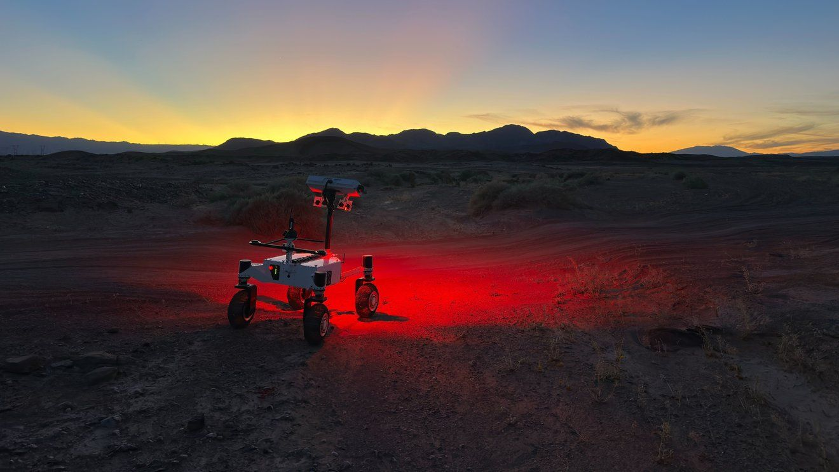
Click for next article A new rover prototype is teaching NASA scientists how to design robots that can think for themselves and navigate terrain that would leave old rovers stuck in the lunar or Martian dust. The Exploration Rover for Navigating Extreme Sloped Terrain (ERNEST), developed at NASA's Jet Propulsion Laboratory , recently completed a 16-mile (26 kilometers) trek through the desert in Southern California. The journey took more than 37 hours of driving time over the course of seven days, and ERNEST completed it almost entirely autonomously, "with minimal intervention" from engineers monitoring the test, according to a JPL statement . NASA hopes the technology can be incorporated into future rovers to the moon and Mars , which could one day travel farther and faster than their predecessors, relying on onboard programing to assess and navigate treacherous landscapes previously unreachable by robotic explorers. "This testing is helping us refine the mobility hardware and autonomy software to navigate extreme distances across a wide range of terrain and lighting conditions anticipated on the moon," Issa Nesnas, a JPL principal technologist, said in the June 18 statement. The ERNEST team tested the rover in low-lighting and night time conditions. (Image credit: NASA/JPL-Caltech) Development of ERNEST started in 2022 using JPL internal research and development funding and has since been brought under the umbrella of the NASA Science Mission Directorate's Exploration Science Strategy and Integration Office, as well the agency's Mars Exploration Program. Part of what sets ERNEST apart from its predecessors are its novel wheels and active suspension system . Paired with adaptive artificial intelligence, the rover is able to identify obstacles in its path to either avoid or overcome as it travels toward its next destination. ERNEST's intelligence is the result of months of reinforcement learning conducted in a virtual environment, where the rover accumulated thousands of hours of experiential data within the span of just a few days by running multiple simulations simultaneously. Then, to test out its learned knowledge after virtual testing, the team put the test rover through an obstacle course at JPL's Mars Yard before graduating it to the California desert sands. Past rovers, like Perseverance and Opportunity on Mars, have been designed with a "rocker-bogie" system, which uses open pivot points to passively distribute weight evenly across their six wheels. The four-wheeled ERNEST prototype uses two joints on its front chassis that gimbal to alter the rover's gait, creating motions that mimic "squirming, wheel-walking, and obstacle-climbing," according to the same statement. ERNEST is also able to steer each of its wheels, allowing the rover to maneuver from side to side, in addition to forward and backward. "While the rocker-bogie system has been very successful over the past 30 years, there's been a lot of research in that time on mobility and understanding terrain interaction," said Hari Nayar, lead principal technologist for the ERNEST team. During its week-long test this past March, engineering teams monitored ERNEST across several navigational scenarios, including traveling at night and other poor lighting conditions to simulate certain lunar environments. The rover measures 4 feet (1.2 meters) long and drove at speeds up to 0.6 mph (1 kph) - much faster than rovers currently operating on the moon and Mars, like Perseverance, which, after five years on the Red Planet, has only recently crossed the distance it takes to run a marathon on Earth (26.2 miles, or 42.2 km). Engineers hope ERNEST will be used as a model for even larger, more capable rovers designed to go much farther, and at higher speeds.

8. Next-gen ramjet fuel propulsion system for future offensive, defensive missions tested
Read more
L3Harris has taken a significant step toward advancing next-generation propulsion technology for future offensive and defensive missions. The company revealed that a recent test demonstrated progress toward a high-performance, lower-cost propulsion option. The test also met the Department of War's goal to provide superior advanced weapon systems, at affordable mass, that will outpace adversaries and expand the range of solutions available to the warfighter. "This test is an important step in proving solid fuel ramjet propulsion can deliver the speed, range and affordability our customers need," said Scott Alexander, President, Missile Propulsion, L3Harris. "We are reducing risk now so we can move faster toward a scalable capability for the warfighter." Full-scale test of new solid fuel ramjet fuel grain L3Harris highlighted that the event marked the company's first full-scale test of a new solid fuel ramjet fuel grain specially formulated to significantly reduce the cost of fuel when compared to historical industry standards. During the ground test, the team ignited and operated the system in a direct connect flight-representative environment, allowing engineers to evaluate performance across a large portion of the simulated flight envelope. Initial results showed propulsion levels were consistent with expectations for flight operation, giving the team valuable data as it continues to refine the design towards tactical missile system demonstration, according to a press release. Disciplined approach marks an essential risk reduction This test event helps validate key performance characteristics as L3Harris accelerates towards flight testing, and this disciplined approach marks an essential risk reduction step in enabling solid fuel ramjet propulsion to help close a critical performance and cost gap for the U.S. military and allies. "We are answering the Department of War's call for longer-reach, more capable, lower-cost propulsion that is producible at the scale needed," said Joel Warhurst, Director, Business Development, L3Harris.

9. Germany bolsters ballistic missile defense with expanded Arrow-3 coverage
Read more
Germany is expanding its emerging territorial missile defense system, with the the country's armed forces (Bundeswehr) moving forward with plans for a second Arrow air defense installation in Bavaria to complement the first operational battery near Berlin. The country's defense ministry said that a new "southern operational position" will be established in the greater Kaufbeuren area to host elements of the Arrow Weapon System for Germany. The facility is intended to extend coverage of the high-altitude interception network further into southern Germany. The development builds on the initial deployment completed last December, when Germany activated its first Arrow 3 battery at the Holzdorf/Schönewalde air base, located on the border of Brandenburg and Saxony-Anhalt. That installation marked the first operational use of the system outside Israel and represents the foundation of Germany's planned multi-layer missile defense architecture. Groundwork for nationwide Arrow-3 deployment structure The initial deployment, carried out under an accelerated schedule negotiated with manufacturer Israel Aerospace Industries, gave the German armed forces their first operational capability to detect and intercept ballistic missiles beyond the atmosphere, Defense News reported. At the time of the rollout, defense officials indicated that the system was not intended to remain a single-site capability. Instead, they outlined a longer-term structure that would include additional Arrow batteries positioned across Germany, including planned locations in Schleswig-Holstein in the north and Bavaria in the south, creating a more distributed and layered national defense network. German media reports say Kaufbeuren will host the system's radar installation, while the interceptor launchers for the battery are expected to be stationed at the nearby Lechfeld air base. The arrangement splits core components of the Arrow system between the two sites, with sensors and tracking capabilities concentrated in Kaufbeuren and launch infrastructure positioned at Lechfeld. Officials also underscore its broader strategic role within NATO, particularly Germany's function as a central logistics hub for allied reinforcement forces that could move eastward toward the alliance's eastern flank in the event of a high-end conflict scenario. Bavarian site to extend Germany's Arrow-3 interception coverage The new site near Kaufbeuren is designed to strengthen Germany's ability to detect and intercept ballistic missiles outside the Earth's atmosphere, using hit-to-kill technology at altitudes above 62 miles. Rather than relying on an explosive warhead, the Arrow 3 interceptor destroys incoming targets through the force of a direct collision, allowing threats to be engaged before they reenter the atmosphere and reducing the risk posed by debris over populated areas. The decision also carries significant economic implications for the Kaufbeuren region. The air base was originally slated for closure in 2011 as part of a broader restructuring of Germany's armed forces, but that plan was reversed in 2021 after years of uncertainty over the site's future. The planned Arrow deployment is expected to further elevate its strategic importance, an according to Bavarian officials, the radar installation will create about 40 new jobs in Kaufbeuren, while investment in the site is projected to exceed $94 million. According to Kaufbeuren Mayor Stefan Bosse, the decision to station elements of the Arrow missile defense system in the area provides long-term certainty for the local military installation. Bosse said the deployment brings stability to the site and reaffirmed the city's support for the German armed forces. Furthermore, Bavarian state lawmaker Bernhard Pohl also welcomed the move, describing it as a long-term guarantee for the future of the Kaufbeuren location and its role within Germany's expanding missile defense network.

