IIRS Daily Space Digest Wednesday, 27/05/2026

1. ISRO conducts Second Integrated Air Drop Test (IADT-02) for Gaganyaan - isro.gov.in
"ISRO OR NRSC OR IIRS after:2026-05-26" - Google News
Read more

April 10, 2026 The second Integrated Air Drop Test (IADT-02) for Gaganyaan mission was successfully conducted at Satish Dhawan Space Centre, Sriharikota on April 10, 2026. In this test, a simulated Crew Module, weighing about 5.7 tonnes, that is equivalent to the mass of the Crew Module in the first uncrewed Gaganyaan mission (G1), was lifted by an Indian Air Force Chinook helicopter to an altitude of about 3km and released over a designated drop zone in sea, near to Sriharikota coast. Ten parachutes of four types were deployed in a precise sequence during the descent of the Crew Module, gradually reducing the velocity for safe touchdown. Subsequently, the simulated Crew Module was successfully recovered in coordination with Indian Navy. The IADT-02 test validated the parachute-based deceleration systems in the Crew Module. This test marks another significant step towards the readiness for the Gaganyaan G1 Mission, with active support and participation from the Indian Air Force, Indian Navy, and Defence Research & Development Organisation (DRDO).

2. 3k Haryana students to take ISRO tour for space science sessions - The Times of India
"ISRO OR NRSC OR IIRS after:2026-05-26" - Google News
Read more


3k Haryana students to take ISRO tour for space science sessions The Times of India

3. ISRO, Axiom Space coordinate ahead of June 19 launch of Ax-4 mission - DD News
"ISRO OR NRSC OR IIRS after:2026-05-26" - Google News
Read more

The Indian Space Research Organisation (ISRO) on Monday said it is working closely with Axiom Space to refresh time-sensitive experimental specimens, following the rescheduling of the Axiom-4 mission to the International Space Station (ISS) for June 19. In a post on X, ISRO said: "@NASA, @Axiom_Space & @SpaceX are targeting no earlier than June 19 for the #Ax4 mission to the @Space_Station. Indian Principal Investigators & @isro are coordinating with @Axiom_Space to refresh time-sensitive experimental specimens. #Space #AxMission4 #ISRO #ISS." The Axiom-4 mission includes Indian Air Force Group Captain Shubhanshu Shukla, who will become the second Indian to travel to space after Rakesh Sharma's 1984 mission. Union Minister of State for Science and Technology Jitendra Singh confirmed the new launch date in a June 14 post on X, saying: "Launch date of the Axiom-4 mission carrying Indian astronaut Shubhanshu Shukla to the International Space Station is, as of now, rescheduled for June 19, 2025." He added that the technical issues which caused the initial delay had been resolved: "The SpaceX team has confirmed that all the issues that led to the earlier postponement of the launch have been duly addressed." The delay was first announced by SpaceX on June 11, when the company cited a need for additional time to repair a liquid oxygen (LOx) leak identified during post-static fire booster inspections. "Standing down from tomorrow's Falcon 9 launch of Ax-4 to the @Space_Station to allow additional time for SpaceX teams to repair the LOx leak identified during post-static fire booster inspections. Once complete - and pending Range availability - we will share a new launch date" SpaceX said on X. The Ax-4 mission is Axiom Space's fourth private astronaut flight to the ISS. The Ax-4 crew includes astronauts from India, Poland, and Hungary. According to Axiom, this will be the first government-sponsored human spaceflight for the three nations since the 1980s.

4. Odisha minister flags off educational tour of students to ISRO's Sriharikota Space Centre - EdexLive
"ISRO OR NRSC OR IIRS after:2026-05-26" - Google News
Read more
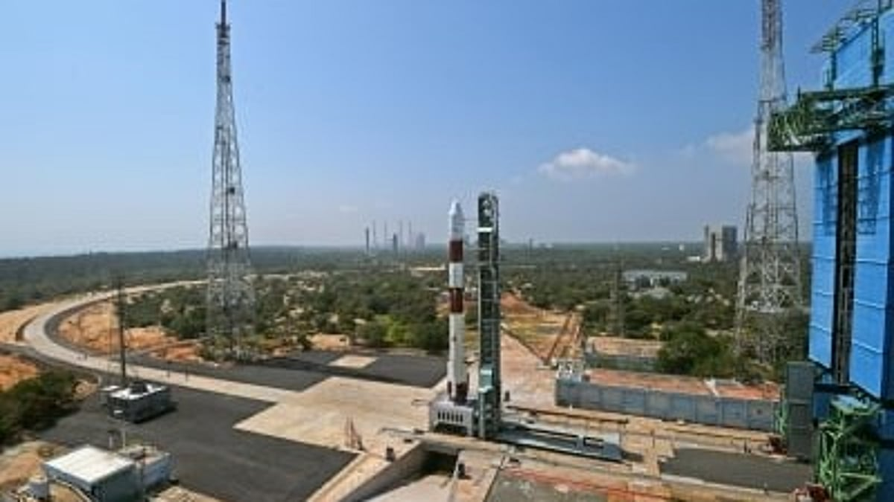

ISRO (representative image) News Odisha minister flags off educational tour of students to ISRO's Sriharikota Space Centre The educational exposure visit to ISRO's Satish Dhawan Space Centre (SDSC), Sriharikota Range (SHAR), in Andhra Pradesh will conclude on May 29, officials said. PTI Bhubaneswar: Odisha minister Krushna Chandra Patra on Tuesday flagged off an educational tour of 30 students to ISRO's Sriharikota space centre to encourage them in space science, astronomy and astrophysics, officials said. The students were selected through Tata Steel's Young Astronomer Talent Search (YATS), a flagship initiative aimed at encouraging school students across the state to pursue their interest and aptitude in space science, astrophysics and astronomy. Organised by Tata Steel in collaboration with the Pathani Samanta Planetarium, the programme offers students an opportunity to explore astronomy, astrophysics and space science while celebrating the legacy of legendary Odia astronomer Pathani Samanta. The educational exposure visit to ISRO's Satish Dhawan Space Centre (SDSC), Sriharikota Range (SHAR), in Andhra Pradesh will conclude on May 29, officials said. "For the first time, YATS winners are getting an opportunity to visit ISRO's facility at Sriharikota in Andhra Pradesh. I am sure the exposure visit will enlighten the YATS winners on space science, astronomy and astrophysics," the science and technology minister said. Addressing students, additional chief secretary (science and technology department) Chithra Arumugam said, "There is a huge opportunity in the space sector today, be it private or government. So, I urge you all to work hard and smart to be among the space explorers. I am happy that all of you will get the opportunity to witness the telemetry and see how the rockets are launched. It will surely inspire you all." Themed 'Stargazer Today, Gagannaut Tomorrow,' the 2025-26 edition of YATS aims to ignite imagination and strengthen scientific temperament among students. Since its inception in 2007, the initiative has engaged over 5.4 lakh students, with more than 260 winners having visited various ISRO facilities across the country. This report was published from a syndicated wire feed. Apart from the headline, the EdexLive Desk has not edited the copy. Also Read

5. YATS winners begin educational visit to ISRO's Sriharikota Space Centre - prameyanews.com
"ISRO OR NRSC OR IIRS after:2026-05-26" - Google News
Read more

Bhubaneswar, May 26: The top 30 winners of the 19th edition of the Young Astronomer Talent Search (YATS), a flagship initiative of Tata Steel in collaboration with Pathani Samanta Planetarium (PSP) under the Science and Technology Department, have embarked on an educational exposure visit to the Indian Space Research Organisation's (ISRO) Satish Dhawan Space Centre (SDSC), Sriharikota Range (SHAR), Sriharikota, Andhra Pradesh. The visit is scheduled from May 26 to May 29, 2026. The educational tour was flagged off by Krushna Chandra Patra, Science and Technology Minister during a ceremony held at the Pathani Samanta Planetarium in Bhubaneswar. This year's YATS witnessed overwhelming participation, with more than 76,700 students from across Odisha taking part in the competition through both offline and online modes. The top 30 students were selected through a rigorous multi-stage evaluation process designed to test scientific aptitude, curiosity and understanding of astronomy and space science. The flag-off ceremony was attended by Chithra Arumugam, Additional Chief Secretary, Science and Technology Department, and Chairperson, Pathani Samanta Planetarium; Urmiprava Maharana, Deputy Secretary, Science and Technology Department, and Director In-charge, Pathani Samanta Planetarium, Subhranshu Panda, Chief, Corporate Services, Tata Steel Meramandali (TSM) along with senior officials from the Government of Odisha, Tata Steel and Pathani Samanta Planetarium. Flagging off the exposure visit, Krushna Chandra Patra, Science and Technology Minister said, "For the first time YATS winners are getting a chance to visit ISRO's facility at Sriharikota in Andhra Pradesh. I am sure the exposure visit will enlighten the YATS winners on space science, astronomy and astrophysics. Wish all the best to the young astronomers to become renowned scientists and bring glory for the state and the nation." Wishing the YATS winners for a wonderful journey and experience at the Satish Dhawan Space Centre (SDSC) SHAR, Sriharikota, Chithra Arumugam said, "There is a huge opportunity in the space sector today. Be it private or government. So, I urge you all to work hard and smart to be among the space explorers. I am happy that all of you will get the opportunity to witness the telemetry and see how the rockets are launched. It will surely inspire you all." During the visit, the students, accompanied by teachers and officials from Tata Steel and Pathani Samanta Planetarium, will explore various facilities at SDSC-SHAR and gain insights into India's space missions, launch vehicle systems, satellite technologies and tracking operations. Themed "Stargazer Today, Gagannaut Tomorrow", the 2025-26 edition of YATS aims to ignite imagination and strengthen scientific temperament among students. Since its inception in 2007, the initiative has engaged over 5.4 lakh students, with more than 260 winners having visited various ISRO facilities across the country.

6. Odisha Students Embark on ISRO Space Tour - Devdiscourse
"ISRO OR NRSC OR IIRS after:2026-05-26" - Google News
Read more


Odisha minister Krushna Chandra Patra on Tuesday flagged off an educational tour of 30 students to ISRO's Sriharikota space centre to encourage them in space science, astronomy and astrophysics, officials said. The students were selected through Tata Steel's Young Astronomer Talent Search (YATS), a flagship initiative aimed at encouraging school students across the state to pursue their interest and aptitude in space science, astrophysics and astronomy. Organised by Tata Steel in collaboration with the Pathani Samanta Planetarium, the programme offers students an opportunity to explore astronomy, astrophysics and space science while celebrating the legacy of legendary Odia astronomer Pathani Samanta. The educational exposure visit to ISRO's Satish Dhawan Space Centre (SDSC), Sriharikota Range (SHAR), in Andhra Pradesh will conclude on May 29, officials said. For the first time, YATS winners are getting an opportunity to visit ISRO's facility at Sriharikota in Andhra Pradesh. I am sure the exposure visit will enlighten the YATS winners on space science, astronomy and astrophysics, the science and technology minister said. Addressing students, additional chief secretary (science and technology department) Chithra Arumugam said, There is a huge opportunity in the space sector today, be it private or government. So, I urge you all to work hard and smart to be among the space explorers. I am happy that all of you will get the opportunity to witness the telemetry and see how the rockets are launched. It will surely inspire you all. Themed 'Stargazer Today, Gagannaut Tomorrow,' the 2025-26 edition of YATS aims to ignite imagination and strengthen scientific temperament among students. Since its inception in 2007, the initiative has engaged over 5.4 lakh students, with more than 260 winners having visited various ISRO facilities across the country. (With inputs from agencies.)

7. NASA to Announce Artemis III Crew, Provide Mission Progress Update
NASA
Read more

NASA meatball NASA will provide an update on the agency's Artemis III mission and announce the astronauts assigned to the test flight during a live event at 11 a.m. EDT on Tuesday, June 9, at the agency's Johnson Space Center in Houston. The event will stream on NASA+ and on the agency's YouTube channel. Learn how to watch NASA content through a variety of online platforms, including social media. Following the event, the Artemis III crew will be available for limited in-person and virtual interviews. Interview requests must be submitted to the NASA Johnson newsroom by 5 p.m. on Thursday, June 4. International media interested in attending must contact the NASA Johnson newsroom at jsccommu@mail.nasa.gov by 5 p.m., Thursday, May 28. U.S. media must contact the newsroom by 5 p.m., June 4. Registered media will receive confirmation and additional event details by email. NASA's media accreditation policy is available online. Artemis III will launch four astronauts from NASA's Kennedy Space Center in Florida aboard the Orion spacecraft on the SLS (Space Launch System) rocket. The mission will test critical rendezvous and docking capabilities between Orion and commercial human landing systems needed to deliver astronauts to the lunar surface. Building on the successful Artemis II crewed test flight in April, Artemis III will pave the way for future surface missions. As part of the Golden Age of innovation and exploration, NASA will send Artemis astronauts on increasingly complex missions to explore more of the Moon for scientific discovery, economic benefits, establish an enduring human presence on the lunar surface, and to build on our foundation for the first crewed missions to Mars. Learn more about NASA's Artemis program: https://www.nasa.gov/artemis -end- Rachel Kraft Headquarters, Washington 202-358-1600 rachel.h.kraft@nasa.gov Anna Schneider Johnson Space Center, Houston 281-483-5111 anna.c.schneider@nasa.gov

8. NASA Astronauts to Answer Questions from Students in New York
NASA
Read more
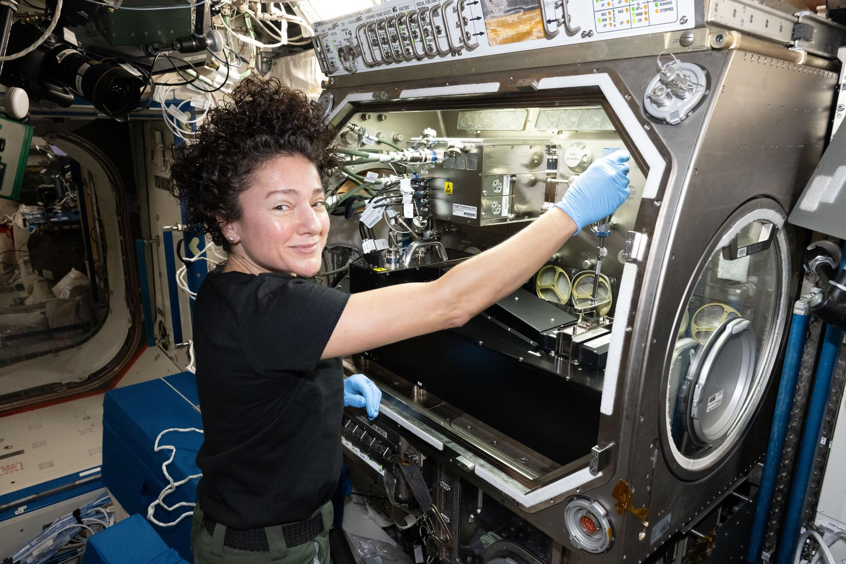

NASA astronaut and Expedition 74 flight engineer Jessica Meir configures research gear inside the Destiny laboratory module's Microgravity Science Glovebox aboard the International Space Station. Credit: NASA/Jessica Meir Students in New York will hear from NASA astronaut Jessica Meir as she answers their prerecorded science, technology, engineering, and mathematics (STEM) questions while aboard the International Space Station. The Earth-to-space call will begin at 11:05 p.m. EDT Thursday, May 28, and will stream live on the agency's Learn With NASA YouTube channel. This event is hosted by the Cradle of Aviation Museum in Garden City, New York, for students in grades K-12 and members of the community. This unique opportunity aims to deepen understanding of space exploration and enhance awareness of STEM careers. Media interested in covering the event must RSVP no later than 5 p.m. EDT, Wednesday, May 27, to Jerelyn Zontini at: 516-567-0537 or jzontini@cradleofaviation.org. For more than 25 years, astronauts have continuously lived and worked aboard the space station, testing technologies, performing science, and developing skills needed to explore farther from Earth. Astronauts communicate with NASA's Mission Control Center in Houston 24 hours a day through SCaN's (Space Communications and Navigation) Near Space Network. Research and technology investigations taking place aboard the space station benefit people on Earth and lay the groundwork for other agency deep space missions. As part of NASA's Artemis program, the agency will send astronauts to the Moon to prepare for future human exploration of Mars, inspiring the world through discovery in a new Golden Age of innovation and exploration. For more information on NASA in-flight calls, visit: https://www.nasa.gov/stemonstation

9. Watch 2 Russian cosmonauts take 5-hour spacewalk outside the ISS today
Latest from Space.com
Read more


Click for next article Roscosmos Spacewalk 66 - YouTube Watch On Two cosmonauts will venture into the void today (May 27), and you can watch the action live. Sergey Kud-Sverchkov and Sergei Mikaev, of the Russian space agency Roscosmos , will perform a five-hour spacewalk outside the International Space Station (ISS) today, starting at about 10:15 a.m. EDT (1415 GMT). You can watch it live here at Space.com, courtesy of NASA, or directly via the agency . Coverage will begin at 9:45 a.m. EDT (1345 GMT). Cosmonaut Sergey Ryzhikov is seen at the end of the European robotic arm as he works on a high‑resolution camera during a 6-hour spacewalk outside the International Space Station on Oct. 16, 2025. (Image credit: NASA) Kud-Sverchkov and Mikaev "will install a solar radiation experiment on the Zvezda service module and remove other science hardware from the Poisk and Nauka modules of the orbiting complex's Roscosmos segment," NASA officials wrote in a May 22 description of the spacewalk . "If time allows, the duo also will photograph one of the Progress 94 cargo spacecraft's Kurs rendezvous antennas, which failed to deploy in March following its launch to the space station," they added. It will be the second extravehicular activity (EVA) for Kud-Sverchkov, who commands the ISS' current Expedition 74 mission, and the first for Mikaev, a flight engineer. You'll be able to tell them apart: Kud-Sverchkov's spacesuit will have red stripes, and Mikaev's will have blue stripes. Today's EVA will be the second of 2026; NASA astronauts Jessica Meir and Chris Williams conducted a seven-hour spacewalk on March 18 to help prepare the ISS for a new solar array. To date, astronauts have performed 278 spacewalks outside the ISS, which has hosted rotating crews continuously since Nov. 2, 2000.

10. Artemis moon base will cover 'hundreds of square miles' with hopping drones and new lunar rovers, NASA says
Latest from Space.com
Read more
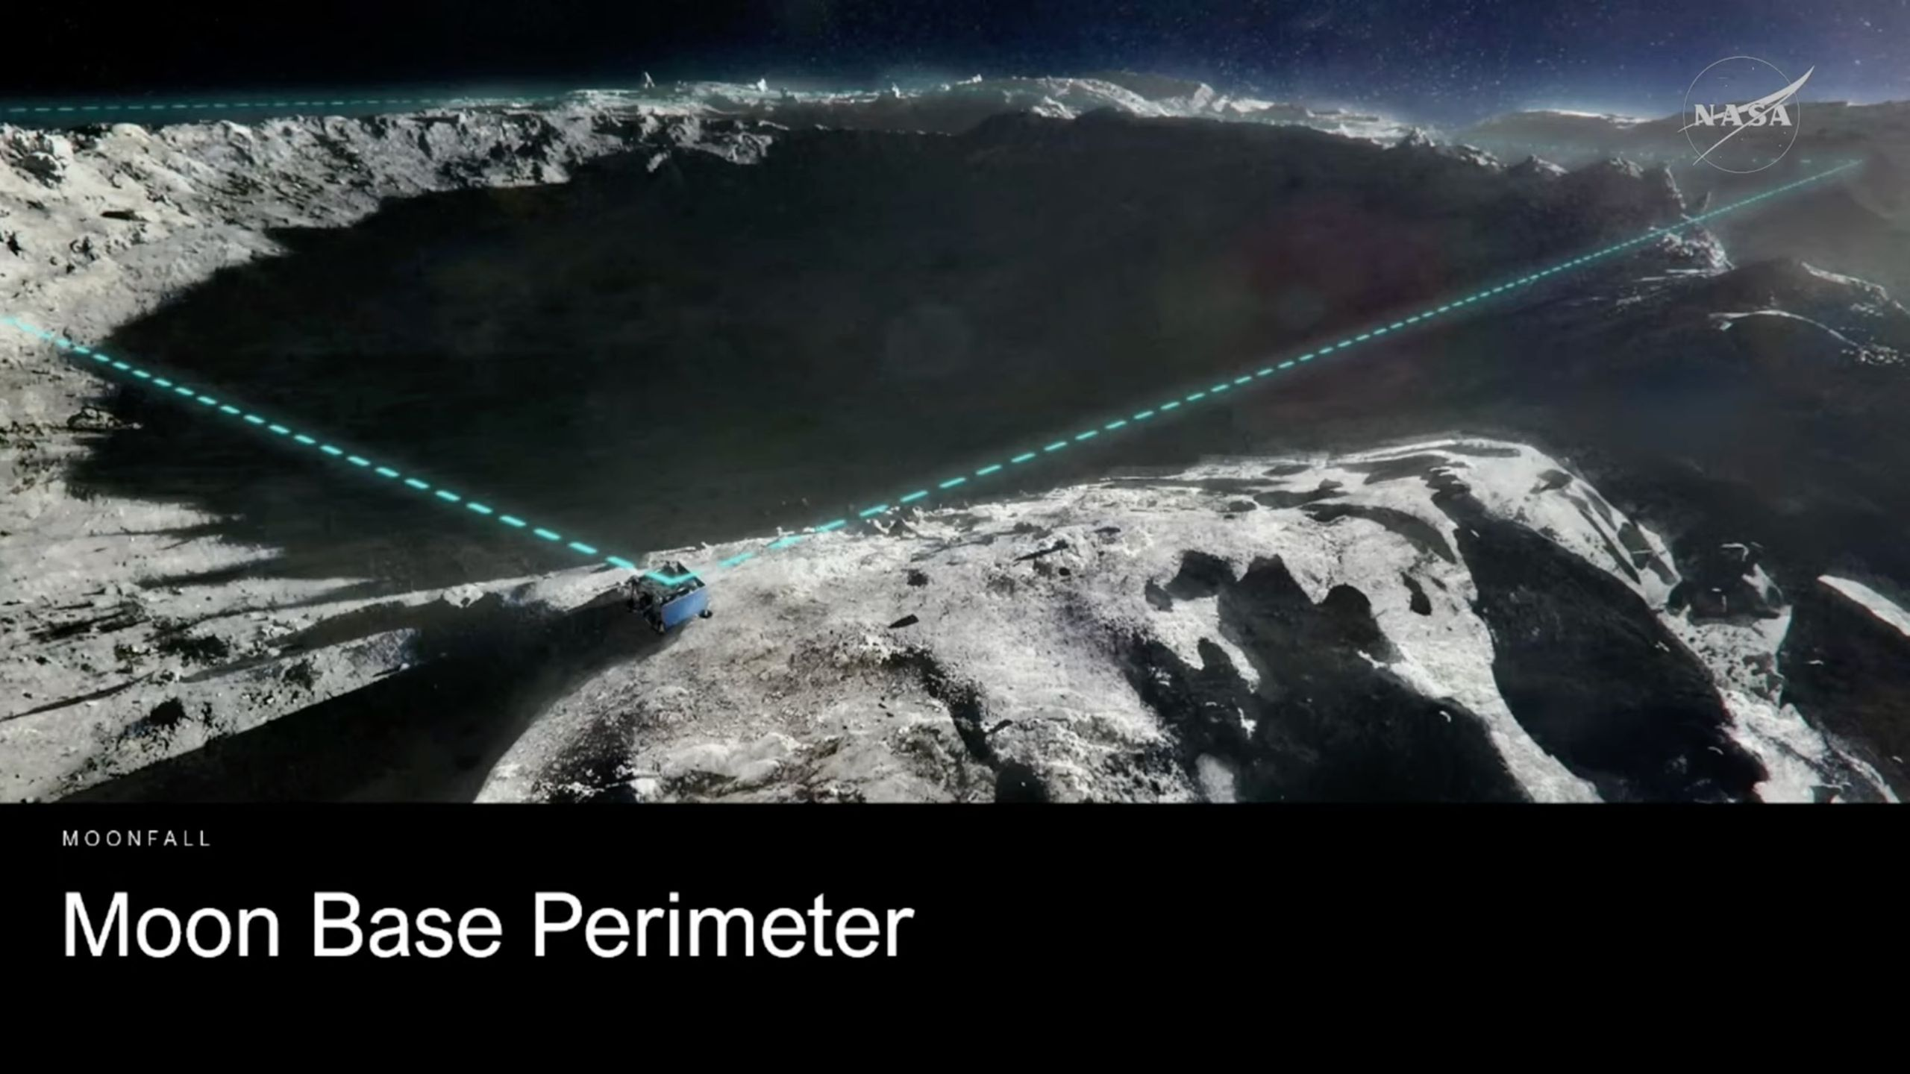

Click for next article NASA is definitely thinking big on the moon. The U.S. space agency plans to build a crewed lunar base over the next decade or so via its Artemis program - and we just got a sense of that project's impressive scope. "We envision the moon base to be hundreds of square miles, with different assets all building up to the objective of permanent lunar presence on the moon ," Carlos García-Galán, the manager of NASA's Moon Base program at the agency's headquarters in Washington, D.C., said during a press conference Tuesday (May 26). This NASA chart outlines the three major steps of NASA's Moon Base program from 2026 through 2032, starting with unpressurized rovers and sorties, and ending with a permanent lunar base. (Image credit: NASA) The base will be constructed over the next decade or so near the lunar south pole, which is thought to harbor large amounts of water ice . This precious resource has been accumulating for billions of years on the permanently shadowed floors of craters in the region, scientists say. NASA didn't go into the moon base-planning process with a big footprint as a priority. Rather, it emerged naturally, as all of the envisioned elements started coming together in planners' heads. "There's no one spot that covers all the science, all the technology, all the habitation needs of the surface, and even within the local area, you have to consider the terrain," NASA's Nujoud Merancy, chief architect of the Moon Base program, said during today's briefing. Artist's impression of a NASA MoonFall drone helping to mark the perimeter of the agency's planned lunar base. (Image credit: NASA) "So, you'll have the habitats on the tops of the hills where they get sunlight," she added. "Power systems - nuclear systems - need to be a kilometer or more away for the radiation protection, so all of these things, when you start putting them together, end up sprawling a little bit more like a city as you start building it out." And scientists and mission planners still don't know a lot about the lunar south pole, which is another reason for a settlement there to cover a lot of ground, according to García-Galán. "We're going to want to explore different sites to really maximize the mix of scientific objectives and viability of a permanent presence," he said. NASA plans to reduce the uncertainty via the use of MoonFall drones - small, hopping robots that will scout out the south polar region ahead of moon base construction. The first MoonFall batch, a set of three or four spacecraft, will launch to the moon in 2028 aboard a lander built by Firefly Aerospace, NASA announced today. (Firefly nabbed a $75 million contract for the mission, the company said .) Those drones, or others like it, could also help mark the moon base's borders, said García-Galán. "We're going to be able to basically put them at the corners of the areas where we think we have either key scientific objectives or we want to build up the moon base," he said. China plans to build a base on the moon in the coming years as well (its first astronaut landing is aimed for 2030 ), and U.S. officials have repeatedly stressed the importance of getting the American one up and running first. The U.S. wants to be the one establishing norms of responsible behavior on Earth's nearest neighbor, the argument goes. So, during today's press conference, Ars Technica's Eric Berger asked García-Galán and NASA Administrator Jared Isaacman , who also participated in the event, if the MoonFall drones could help delineate a keep-out zone of sorts. "I think it's important for us to get there first," Isaacman said. "I think the idea that there are areas of great interest on the lunar surface - we do want to get there and explore them, and we also obviously want to be very mindful of the Outer Space Treaty , so that we are respectful of other nations that are putting assets on the on the lunar surface. We would expect that to be reciprocal." From left to right: Models of the Blue Origin Blue Moon Mark 1 lander, Astrolab Crewed Lunar Rover, Lunar Outpost Pegasus rover and Firely's Elytra Dark orbiter are unveiled at NASA headquarters in Washington, D.C. on May 26, 2026. (Image credit: NASA/Aubrey Gemignani) The moon base's envisioned size was just a sidelight of today's event. The main purpose was to announce contracts that the agency just awarded to get the ball rolling on the outpost's construction. Firefly wasn't the only compay to win a NASA Moon Base program contract. NASA is giving California-based Astrolab $219 million and Colorado's Lunar Outpost $220 million for production of their lunar terrain vehicles (LTVs). LTVs are large rovers that Artemis astronauts will use to explore the lunar surface. These vehicles will also be capable of autonomous operation, meaning they can land before crewed missions, be remotely controlled from Earth, and meet up with astronauts at their touchdown sites. And that is indeed the goal: NASA wants to have at least one LTV on the lunar surface before Artemis 4 touches down near the lunar south pole in late 2028. Both LTVs will be delivered to the lunar surface by Blue Origin's Blue Moon lander, NASA announced today. Those two contracts are worth $234 million apiece, agency officials said during the briefing. Blue Origin is also building a crewed variant of Blue Moon, which is in the running to fly the Artemis 3 and Artemis 4 astronaut missions, as well as future flights. Artemis 3 is a docking test in Earth orbit between NASA's Orion capsule and one or both of the program's privately developed crewed lunar landers - Blue Moon and SpaceX's Starship . NASA aims to launch Artemis 3 in mid-2027, Isaacman said today. NASA plans to build the moon base in three phases. Phase One, which runs from now through 2029, will gather detailed information and "secure reliable access" to the lunar surface, according to the agency . Phase Two runs from 2029 to 2032 and will set up the base's "initial operating capability." Phase Three, which runs from 2032 far into the future, will "achieve semi-permanent crew presence" on the moon. "The Moon Base will be America's and humanity's first outpost on another celestial world," Isaacman said in a NASA statement today . "Every mission, crewed and uncrewed, will be a learning opportunity as we return to the lunar surface, build the infrastructure to stay, and master the skills required to live and operate in one of the most demanding and dangerous environments imaginable."

11. Satellites imaged an underwater volcano erupting - but scientists have no idea what's actually happening on the seafloor
Latest from Space.com
Read more


Click for next article Closely spaced volcanic plumes, surrounded by clouds, stream from a growing underwater volcanic platform in this natural-color image captured by the OLI (Operational Land Imager) on Landsat 9 on May 11, 2026, three days after the eruption began. In early May, NASA satellites imaged an underwater volcanic eruption in the Bismarck Sea off the coast of Papua New Guinea. But when volcanologists looked to study the event, they reached a frustrating wall. There are no high-resolution maps of the seafloor here. That lack of baseline data made it more difficult for scientists to determine exactly how the eruption reshaped the seafloor or how large the volcanic structure may be. In fact, they aren't even sure which geological feature even erupted. Current theories suggest the eruption likely occurred along the Titan Ridge, about 10 miles (16 kilometers) southeast of a 1972 submarine eruption site. "The good news is that there are huge opportunities to explore and learn using both government and commercial satellite platforms already in orbit," Jim Garvin, the chief scientist at NASA's Goddard Space Flight Center, said in a statement . Existing satellite imagery allows scientists to analyze the miles-high ash plume, discoloration in the ocean water, rafts of the volcanic rock pumice emanating from the event, and even thermal events captured by the Visible Infrared Imaging Radiometer Suite (VIIRS) on NASA's Suomi NPP satellite. "There must be a lot of hot material near the surface to generate so many thermal anomalies," Simon Carn, a volcanologist at Michigan Tech, said in the statement. "This suggests a fairly shallow eruption vent - much shallower than what's implied by the existing bathymetry, which shows water depths of several hundred meters or more." Now, researchers are waiting to see if a new island will be born out of the eruption, which Garvin points out is something we've rarely observed via satellite in real-time. It would likely take some time for one to form, and it's unclear how long this eruption might last. The nearby 1972 eruption, for instance, lasted four days, whereas another nearby eruption in 1957 lasted just short of four years. Floating pumice and green, discolored water extend southwest from the eruption site as a white volcanic plume drifts west overhead in this image acquired by the MODIS (Moderate Resolution Imaging Spectroradiometer) on NASA's Terra satellite on May 15, 2026. (Image credit: NASA Earth Observatory/Michala Garrison) If one does form, it might provide a chance for boots-on-the-ground research. "This new eruption could present an even better opportunity for 'island-naut' exploration as we prepare to return to the moon with women and men via Artemis IV, " said Garvin. With this, Garvin is referring to how researchers could study the budding island and test out how it responds to different weather events and introduction of some animal species - and even the humans themselves. Could the results from such studies inform how future astronauts attempt to create settlements on the moon and Mars someday? Maybe so. But either way, we can be certain the discussion prompted by this satellite footage proves one common truism in oceanography: We know far more about the surface of the moon than the deep-ocean floor.

12. 'Redshift' blends James Webb Space Telescope, Artemis 2 and Pink Floyd into a cosmic journey through light and sound (video, photos)
Latest from Space.com
Read more
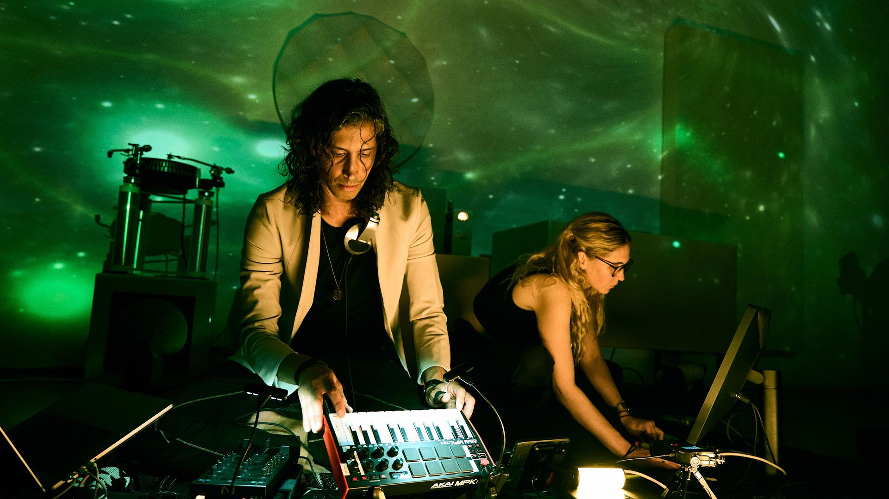

Click for next article On May 22 at Heft Gallery in New York City, "Redshift" transformed a gallery space into an existential experience for an intimate audience. The immersive audiovisual performance, created by artist Ashley Zelinskie and DJ/Producer illich Mujica, blended live electronic music, custom-coded visuals, NASA-inspired imagery and spoken-word narration into a cosmic ride through light and sound themselves. The sold-out event opened with a listening session of NASA's Golden Record - the message launched aboard the interstellar Voyager probe in 1977 to offer a slice of Earth to any intelligent life that might encounter it. Played through the "Volumes" listening system designed by Joe Doucet, the opening moments set the tone for a performance rooted in science, art and wonder. "Redshift" performance at Heft Gallery in New York City on May 22, 2026. (Image credit: Artem Belov (@art.photo.usa)) Drawing heavily from imagery captured by the James Webb Space Telescope , Zelinskie's visuals, projected on a wall of the gallery, shifted through wavelengths of light to simulate the astronomical phenomenon of redshift - the stretching of light across space and time. Mujica's live audio performance moved alongside the stunning visualizations, weaving together ambient electronica, psychedelic rock, and NASA-inspired spoken word samples to deliver a psychedelic event that was meditative and hypnotic at times. In the conversation below, Zelinskie, Mujica and gallery owner Adam Berninger talk about how "Redshift" came to life, the Webb imagery behind the visuals, the inclusion of Pink Floyd's "Is There Anybody Out There?," and more. Space.com: How did you decide which part of NASA's historic Golden Record would open the experience? Adam Berninger: The evening began with a listening session from NASA's Golden Record, the sounds of Earth encoded on a disc and launched into deep space in 1977 aboard Voyager. A message from us to whatever might be out there. We listened to the opening greeting from the United Nations followed by a selection of music. The record was played on the Volumes listening system designed by Joe Docet, conceived as spatial listening instruments rather than conventional audio speakers. They're installed as the centerpiece of our "Transmissions" initiative , created to bring together important musical experiences with a range of systems-based fine artworks at our LES gallery, Heft. These events run from May 15 - June 12th. "Redshift" performance at Heft Gallery in New York City on May 22, 2026 featuring James Webb Space Telescope imagery of galaxy M77. (Image credit: Future/Steven Spaleta) Space.com: "Redshift" was shaped by both astronomy and sound design. How did the concept evolve between the two of you? Ashley Zelinskie: Once Illich and I decided we wanted to collaborate on a Transmission, we met in my studio to come up with our concept. We liked the way sound and light are both waves (sometimes). Redshift occurs when light gets older, the waves stretch out and become longer or more red. This is similar to the Doppler effect with sound. During my time working alongside the Webb Telescope team, which is an infrared telescope for this very reason, I became familiar with this phenomenon. Our concept for "Redshift" ended up being "light in service of sound and sound in service of light." We started our performance in the ultraviolet light spectrum and slowly shifted toward red. The music also shifted from long-wave, experimental sounds to higher BPM (Beats Per Minute) and more complete scores of music - short light waves, long sound waves / long light waves, short sound waves. The cross back and forth was important to us. "Redshift" performance at Heft Gallery in New York City on May 22, 2026 featuring a blend of James Webb Space Telescope imagery. (Image credit: Future/Steven Spaleta) Space.com: The James Webb Space Telescope (JWST) imagery throughout the performance was stunning. Which observations resonated most with you artistically, and why were they chosen? Ashley Zelinskie: I am always drawn back to the first images. They will forever be my favorite. They made such a huge impact on my artistic practice because I watched the telescope be built and launched, and then had the honor of being at Goddard when the first images were released. They were the core inspiration for my exhibition Unfolding the Universe: First Light in 2021 at Onassis ONX Studio. I made several visuals based on the cosmic cliffs of the Carina Nebula . One of my calmer visuals was the slow orbit and collision of Stephan's Quintet and for the end of the performance I had the pulsing beat of rings of stardust exploding from the Southern Ring Nebula. I used a few new JWST images as well, including the MIRI (Mid-Infrared Instrument) image of galaxy M77 . Every visual had a background of stars trained off a LoRA of Webb deep fields. I used a few AI tools to create the visuals as well as wrote the VJ software used in the performance. illich Mujica: I DJ'ed and mixed the audio spontaneously during performance time using curated playlists of my 25 year catalogue of DJ'ing. I was chopping, looping, time-stretching, adding FX and blending 4 channels of audio via Traktor Pro 4; choosing from my library of ambient and electronica (old and contemporary), Psychedelic & Indie Rock and samples from space-related podcasts and films. On the hardware side of things I used a portable Traktor Z1 DJ mixer and sound card + an AKAI Pro MIDI keyboard to MIDI control and navigate my whole laptop DJ rig. While I use the mini MIDI keyboard to produce music while I travel, this time it functioned fully as a DJ controller. Both of our machines were MIDI-linked via Ethernet cable connection. Space.com: A memorable moment of the night was the inclusion of Pink Floyd's "Is There Anybody Out There?" What drew you to that particular piece? illich Mujica: That was my choice, and it was an in-the performance moment. I was frantically browsing through my psychedelic rock playlist before the music went to silence, hoping to find spacey/space-related songs. I was actually looking for David Bowie's "Space Oddity" at first and then I remembered about Pink Floyd's "Is there Anybody Out There?". This isn't one of their most famous songs, it actually works as a bridge song in the album "The Wall" between "Hey You" (a well-known song of theirs), and "Nobody Home" on Volume 2 of that album. The themes of Pink Floyd's concept album "The Wall" revolve around aspects of alienation, trauma and self-isolation. When I first heard "Is there anybody out there?" in my teenage years, I understood it as an inner monologue of the mind; that monologue of detachment someone could have when grappling with issues of mental health; but over time, after many years, for me, the theme of this song as I hear it, morphed into the age-old question of "is there life in other planets?". I love playing this on listening sessions and felt the sonic ethereal and more-abstract qualities of it was a better fit than Bowie's song for the nature of our Redshift performance; specially as I knew I was about to mix in a sample from a podcast interview with the crew of the Artemis II expedition where one of the astronauts talks about whether or not there is life (or someone) out there. Space.com: The spoken-word samples and narration added a cinematic layer to the performance. Can you talk about the voices and stories woven into the show? illich Mujica: As I mentioned, it was a selection of samples I dug exclusively for the performance. On one hand I sampled a question a kid asked the crew of the Artemis II in the NY Times' podcast The Daily . The question was "is there life out there?" and one of the answers one of the crew members shared just blew my mind: "If you look at the closest neighboring galaxy which is Andromeda - let's say there's another amazing civilization there with the most amazing telescope, looking at Earth right now while we are chatting - what do they see? - They see us a couple of thousand years ago, so … we are not here. That's our closest neighboring galaxy so it gives you an idea of how hard it is to look for life in the universe..." This concept also tied in with the spirit of Redshift and light as a measurement of time. The opening sample is also from "The Daily," in the same interview they used the kid singing about going to the moon as their intro. For "The Daily," the sample was about space travel - for me it was about that, but most importantly, we were about to travel into a sonic journey with Joe Doucet's "Volumes" sound art/sound system! The other sample used is my friend Tory Stolper, whose spoken word poem is part of our song "Surya Rising." I was able to not only play my original song on this amazing sound system but also feature a never-before-played sample from her voice note messages, where she was unsure about the creative process of the song from her perspective, as a prelude to our song about to be mixed in. It's one of my most famous songs (with her), and I knew my crowd and fans were waiting for this one to drop on the amazing sound system. It was a treat for them, but it also fit the cosmic nature of the performance. "Surya Rising" (Surya = sun in San script) was a song I wrote about sunrises at Burning Man. It speaks to the feelings this cinematic sunrise evokes in the desert as we find ourselves on this amazing planet.

13. Seeing double with the Artemis 2 rocket boosters | Space photo of the day for May 26, 2026
Latest from Space.com
Read more
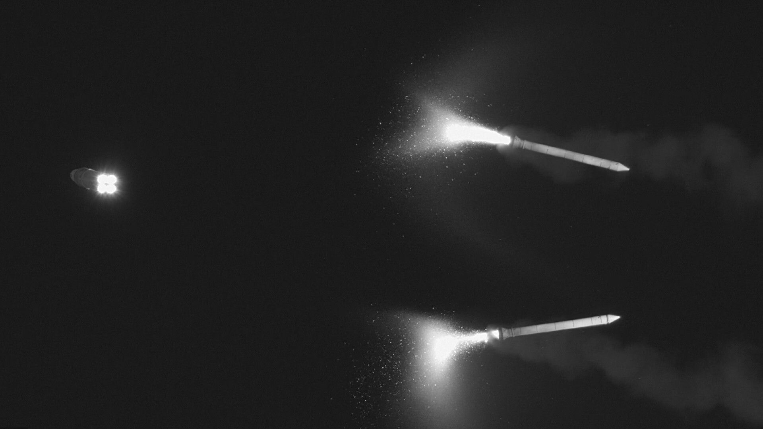

Click for next article The rocket boosters for NASA's Artemis 2 mission following separation. (Image credit: NASA) The rocket boosters from NASA's Artemis 2 mission appear in striking unison in this photograph. This dual-booster moment was captured following the boosters' separation from the rocket's core stage, which you can see on the left, heading off to set the Orion spacecraft on its way around the moon . What is it? On April 1, 2026, NASA's Artemis 2 mission blasted off carrying four astronauts on a journey around the moon and back. The mission sent the crew - commander Reid Wiseman, pilot Victor Glover and mission specialist Christina Koch of NASA and Canadian Space Agency mission specialist Jeremy Hansen - to space aboard the Orion spacecraft (named Integrity). Latest Videos From View more The capsule launched atop NASA's SLS (Space Launch System) rocket, a heavy-duty launch vehicle designed for missions just like this that propel humans to the moon. SLS features two solid rocket boosters that add power behind this massive rocket. In fact, these two boosters provide 75% of the initial thrust that the mission needs to escape Earth's gravity. But once their fuel is used up, which happened just two minutes and 8 seconds after liftoff on this flight, the boosters' 16 different separation motors ignite to push the boosters away from the rocket and one another. Ultimately, the boosters fall into the Atlantic Ocean and are discarded. Why is it incredible? It is amazing to see these boosters separating so perfectly and elegantly in Earth's upper atmosphere as the mission travels into space. The SLS rocket has been a massive undertaking for NASA. But despite all of the time and budget concerns that have plagued the rocket's reputation over the years, this photograph shows a brilliant execution of separation. Between the Orion spacecraft seamlessly motoring onward on the left of this image and two boosters mirroring one another on the right, this booster separation is picture perfect.

14. 'Very interesting wiggles' in data from silent NASA Mars spacecraft lead to unexpected solar wind discovery
Latest from Space.com
Read more
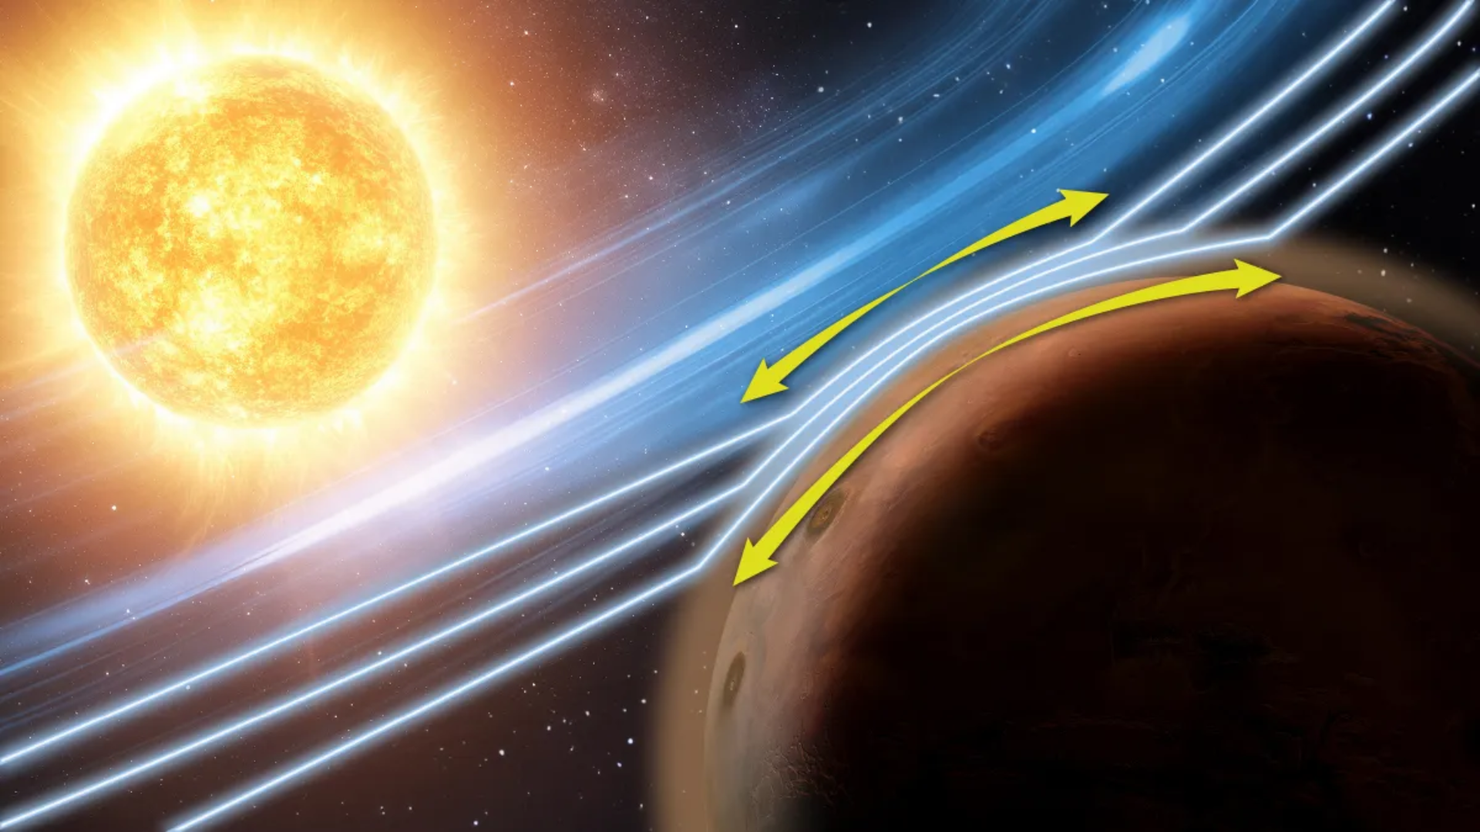

Click for next article An artistic representation of the Zwan-Wolf effect at Mars, as observed by NASA's MAVEN (Mars Atmosphere and Volatile Evolution) mission. Even as NASA continues to try to restore contact with the MAVEN spacecraft after it fell silent in late 2025, scientists analyzing its data have spotted a phenomenon in Mars' atmosphere that, until now, had only been observed around strongly magnetized planets like Earth. The finding could help scientists better understand how space weather shapes worlds without protective magnetic shields, including planets such as Venus and Saturn's largest moon Titan , the researchers say. The phenomenon, known as the Zwan-Wolf effect, helps deflect the solar wind - the constant stream of charged particles flowing from the sun - as it encounters a planet's magnetic environment. On Earth, a powerful magnetic field generated deep within the planet's core creates a vast protective bubble, or magnetosphere, that continuously redirects those particles around the planet. Mars, however, lost most of its global magnetic field billions of years ago and today possesses only a much weaker, patchier magnetic environment formed when the solar wind interacts directly with the planet's thin upper atmosphere. This makes the new finding especially surprising, researchers say. Until now, the Zwan-Wolf effect had only been observed in the large magnetospheres surrounding strongly magnetized planets, not deep within a planetary atmosphere. "No one expected that this effect could even occur in the atmosphere," Christopher Fowler, a professor at West Virginia University who led the study, said in a statement . "That's what makes this even more exciting." The discovery, he added, "introduces interesting physics that we haven't yet explored and a new way the sun and space weather can change the dynamics in the Martian atmosphere." Fowler and his team identified the phenomenon while examining data collected by the now-silent MAVEN , short for Mars Atmosphere and Volatile Evolution, during the aftermath of a powerful solar storm that struck Mars in December 2023. Roughly 12 hours after the storm slammed into the planet, MAVEN recorded unusual fluctuations in Mars' upper atmosphere, according to the study. The team's analysis showed charged particles were being funneled and squeezed along temporary magnetic structures created during the solar storm - behaving "like toothpaste coming out of a tube" - in a way that closely matched the Zwan-Wolf effect seen around Earth. "When investigating the data, I all of a sudden noticed some very interesting wiggles," Fowler said in the statement. "I would never have guessed it would be this effect, since it's never been seen in a planetary atmosphere before." An illustration of the MAVEN spacecraft. (Image credit: NASA/GSFC) The findings also suggest the phenomenon may actually occur continuously on Mars, but under normal conditions it is likely too weak for MAVEN's instruments to detect. Researchers say the intense solar storm temporarily amplified the effect enough for it to stand out clearly in the spacecraft's observations. "The effect likely operates continuously at Mars, but below instrumentation detection thresholds most of the time," the study notes. The discovery also arrives during an uncertain period for the MAVEN mission itself. The spacecraft, which has been studying Mars since 2014, lost contact with Earth in December 2025 after it was expected to emerge from behind Mars following a planned communications pause during a solar conjunction. NASA's attempts to reestablish contact have so far been unsuccessful , and the agency has launched an anomaly review board to assess the spacecraft's condition and chances of recovery. "We haven't officially said MAVEN is lost yet," Louise Prockter, director of NASA's planetary science division, said during a town hall at this year's Lunar and Planetary Science Conference in Texas. "We're still looking for it."

