IIRS Daily Space Digest Thursday, 07/05/2026

1. ISRO expanding student participation in space missions, 11 student satellites already launched: Jitendra Singh - DD News
"ISRO OR NRSC OR IIRS after:2026-05-06" - Google News
Read more

Union Minister of State for Science and Technology Dr. Jitendra Singh on Thursday said the Indian Space Research Organisation (ISRO) is expanding student participation in space missions through structured programmes that allow young researchers to design satellites, develop payloads and participate in real mission experiments. Replying to an unstarred question by Sumitra Balmik in the Rajya Sabha, Singh said the government is committed to widening access to space technology so that students from institutions across the country, including those in tier-2 and tier-3 cities, can contribute to India's growing space ecosystem. The minister said ISRO has launched several initiatives aimed at providing hands-on exposure to space technology for students and researchers. Student satellite programme gaining momentum Singh said that ISRO's Student Satellite Programme, led by the U R Rao Satellite Centre, encourages academic institutions to design and develop satellites with technical mentorship from ISRO scientists. The organisation also supports integration and launch opportunities for these satellites through its missions. So far, the Indian National Space Promotion and Authorisation Centre (IN-SPACe) has authorised 17 student satellites and payloads, of which 11 have already been successfully launched, the minister informed. These projects have involved several academic institutions including the Indian Institute of Astrophysics, Indian Institute of Space Science and Technology, RV College of Engineering, Amity University Maharashtra, MIT World Peace University, Assam Don Bosco University and CV Raman Global University, reflecting growing national participation in student-led space missions. Competitions and innovation initiatives Singh said student engagement is also being promoted through national competitions organised by IN-SPACe. These include satellite and model rocketry competitions in which 97 student teams comprising nearly 850 students have participated. One such event - the Model Rocketry and CanSat India Student Competition - was organised jointly by IN-SPACe, ISRO and the Astronautical Society of India in October 2025 at Kushinagar in Uttar Pradesh. The event saw 67 teams with nearly 500 students design, fabricate and launch model rockets carrying CanSat payloads to an altitude of about one kilometre. Internship and research support The minister said students are also benefiting from internship and project trainee programmes that provide research exposure at ISRO centres for undergraduate, postgraduate and doctoral students. To strengthen collaboration between universities and ISRO scientists, the government has established Space Technology Incubation Centres (STICs) across various regions. These centres support students in developing indigenous space technologies under expert mentorship. In addition, Regional Academic Centres for Space (RAC-S) have been created to help students from smaller towns and institutions access ISRO programmes and research opportunities. Strengthening space education ecosystem Singh also highlighted the role of ISRO's RESPOND Programme, which provides financial and technical support to universities undertaking research in space science, technology and applications. He said the All India Council for Technical Education has approved a Space Technology Minor Course, while a national committee has been formed to promote adoption of space technology education in line with the Indian Space Policy 2023. The government has also earmarked around ₹10 crore annually for educational outreach activities in space science and technology. Singh said IN-SPACe is further supporting the next generation of space entrepreneurs through mentorship from domain experts, pre-incubation programmes and co-working facilities at its technical centres. "These initiatives are part of the government's broader vision to build a vibrant and inclusive space ecosystem in India, where students, startups, academic institutions and industry all contribute to the country's expanding role in the global space sector," the minister said.

2. India aims to land astronauts on the Moon by 2040: Former ISRO chief - MSN
"ISRO OR NRSC OR IIRS after:2026-05-06" - Google News
Read more

India aims to land astronauts on the Moon by 2040: Former ISRO chief MSN

3. NASA-ISRO satellite maps Mexico City's rapid sinking as water crisis deepens - Smart Water Magazine
"ISRO OR NRSC OR IIRS after:2026-05-06" - Google News
Read more

New satellite data from NASA and the Indian Space Research Organisation (ISRO) has revealed that parts of Mexico City are sinking by several centimetres a month, highlighting the strain on the capital's water infrastructure and built environment. The findings come from the NISAR mission, a joint Earth observation project that uses synthetic aperture radar (SAR) to detect very small changes in surface elevation. Images captured between 25 October 2025 and 17 January 2026, during Mexico City's dry season, showed parts of the metropolitan area subsiding by more than 2 cm per month. Scientists say the sinking, known as land subsidence, is largely caused by more than a century of groundwater extraction from the aquifer beneath the city, combined with the weight of urban development. Mexico City was built on the bed of an ancient lake, and as water is drawn from the underlying soils, the soft clay sediments compress and the surface drops. The problem was first documented by an engineer in 1925, and during the 1990s and 2000s, some areas were sinking at around 35 centimetres per year - enough to crack pipes, distort roads and damage buildings, including parts of the Metro. NASA said the gradual but uneven ground movement has contributed to "fracturing roads, buildings, and water lines" across the metropolitan area. New data from NISAR show areas of Mexico City and its surroundings where subsidence of up to several centimetres per month (shown in blue) occurred between 25 October 2025 and 17 January 2026. These irregular and seemingly minor changes in elevation have accumulated over the decades, causing cracks in roads, buildings and water pipes. NASA/JPL-Caltech/David Bekaert NISAR, launched in July 2025, carries an L-band synthetic aperture radar - a long-wavelength sensor that can see through clouds and vegetation, and can monitor ground movement day or night. By comparing repeated radar passes over the same area, the mission can track subtle motion linked to subsidence, uplift, glacier flow and crop growth as it revisits each region several times a month. The map released by NASA shows the Benito Juárez International Airport near the centre of the imaged area. The Angel of Independence - the 36-metre monument on Paseo de la Reforma, built in 1910 to mark the centenary of Mexican independence - is highlighted as a visible indicator of long-term subsidence: 14 steps have been added to its base over the decades as the surrounding ground has sunk. "Mexico City is a well-known hot spot when it comes to subsidence, and images like this are just the beginning for NISAR," said David Bekaert, a project manager at the Flemish Institute for Technological Research (VITO) and a member of the NISAR science team. "We are going to witness a wave of new discoveries from around the world, given NISAR's unique sensing capabilities and constant global coverage." The metropolitan region, home to around 20 million people, has long struggled with water shortages, ageing infrastructure and flooding. Subsidence compounds those pressures by straining water pipes, drainage systems and transport networks, and pushing up the cost of maintaining buildings and roads. NISAR is the first satellite to carry two SAR instruments at different wavelengths. NASA's Jet Propulsion Laboratory, managed by Caltech, leads the US component of the mission and supplied the L-band radar and antenna reflector, while ISRO provided the spacecraft and the second, S-band radar.

4. Vidyarthi Vigyan Vari scheme: Maharashtra launches new programme for schools; top students to visit NASA and ISRO - Mid-day
"ISRO OR NRSC OR IIRS after:2026-05-06" - Google News
Read more

The state government has approved an expenditure of Rs 3.30 crore for the initiative. Separate committees will be set up at the taluka, district and state levels to ensure effective planning and execution The Maharashtra government on Wednesday approved the 'Vidyarthi Vigyan Vari scheme' initiative, under which meritorious students will get an opportunity to visit leading space and research centres such as Indian Space Research Organisation (ISRO) and National Aeronautics and Space Administration (NASA) in the United States, officials said.

5. ISRO to open Gaganyaan astronaut selection to civilians as India expands space plans - MSN
"ISRO OR NRSC OR IIRS after:2026-05-06" - Google News
Read more

ISRO to open Gaganyaan astronaut selection to civilians as India expands space plans MSN

6. ISRO completes preliminary design review of Venus Orbiter Mission - MSN
"ISRO OR NRSC OR IIRS after:2026-05-06" - Google News
Read more

ISRO completes preliminary design review of Venus Orbiter Mission MSN

7. Webb & Hubble find massive star clusters emerge faster
ESA Space Science
Read more
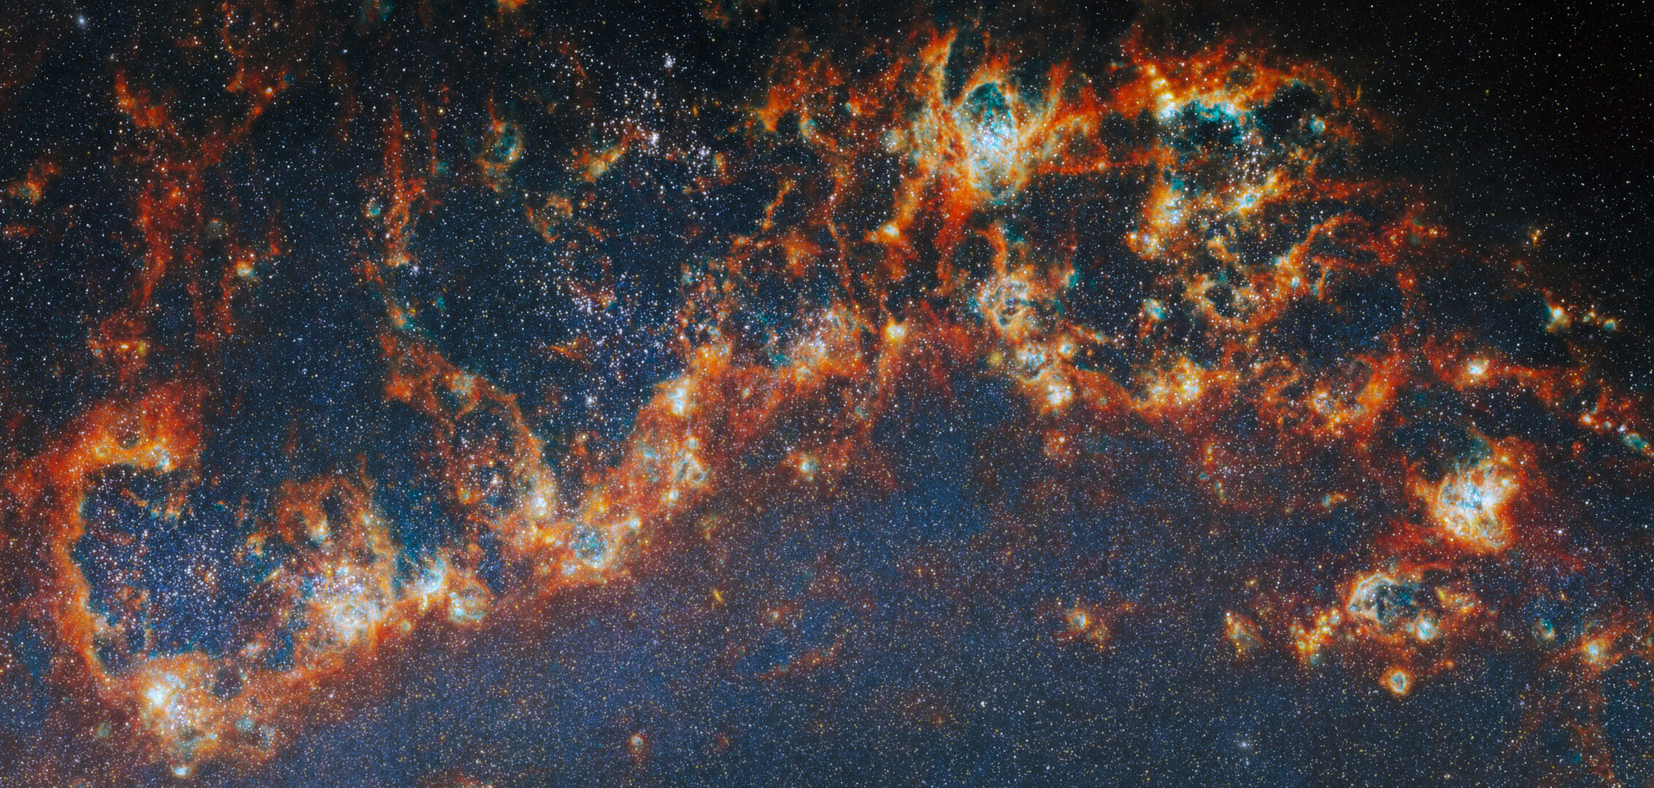

Science & Exploration Webb & Hubble find massive star clusters emerge faster 06/05/2026 1380 views 27 likes Astronomers using the NASA/ESA/CSA James Webb Space Telescope together with the NASA/ESA Hubble Space Telescope have looked deeply at thousands of young star clusters in four nearby galaxies, studying clusters at different stages of evolution. Their findings show that more massive star clusters emerge more quickly from the clouds they are born in, clearing away gas and filling the galaxy with ultraviolet light. The result gives us a better understanding of star formation in galaxies, as well as how and where planets can form. Star-forming regions in M51 Astronomers have long known that understanding how star clusters come to be is key to unlocking other secrets of galactic evolution. Stars form in clusters, created when clouds of gas collapse under gravity. As more and more stars are born in a collapsing cloud, strong stellar winds, harsh ultraviolet radiation and the supernova explosions of massive stars eventually disperse the cloud, ending star formation before all the gas is used up. Once the cloud of gas a star cluster was born in is gone, its light can bear down on other star-forming regions in the galaxy, too. This process is called stellar feedback, and it means that most of the gas in a galaxy never gets used for star formation. Researching how star clusters develop, then, can answer questions about star formation at a galactic scale. Studies of the closest star-forming regions, in the Milky Way galaxy and the dwarf galaxies that orbit it, allow us to dissect star clusters in the smallest details, but our position in the disc of our galaxy means only a few such regions are visible to us. By observing nearby galaxies, astronomers can survey thousands of star-forming regions and characterise entire populations of star clusters at many stages of evolution - a feat made possible with the launch of space telescopes, most prominently the NASA/ESA Hubble Space Telescope. Both kinds of investigation are necessary to truly understand how star formation takes place in galaxies. Star-forming region in M51 (close-up) The continuous development of infrared astronomy has allowed us to pull back the gaseous curtains that still hide the youngest star clusters and learn about the earliest stages of their development, but some subjects still puzzle researchers. For instance: when a star cluster forms, what determines how long it takes to disperse its natal cloud and begin radiating ultraviolet light out into the galaxy? Now, the state of the art has been further developed with both Hubble and Webb working together to provide a broad-spectrum view of thousands of young star clusters. An international team of astronomers has pored over images of four nearby galaxies - Messier 51, Messier 83, NGC 4449, and NGC 628 - from the FEAST observing programme (#1783), trying to solve this mystery. Their results, published today in Nature Astronomy, show that it is the most massive star clusters that clear away their gaseous shroud the fastest, and begin lighting their galaxy the earliest. The team identified nearly 9000 star clusters in the four galaxies in different evolutionary stages: young clusters just starting to emerge from their natal clouds of gas, clusters that had partially dispersed the gas (both from Webb images), and fully unobstructed clusters visible in optical light (found in Hubble images). With Webb's ability to peer inside the gas clouds, they were able to then estimate the mass and age of each cluster from its light spectrum. The most massive clusters had fully emerged and dispersed the clouds of gas after around five million years, while less massive clusters were between seven and eight million years old when they emerged from their nurseries. Answering this open question of which star clusters clear away their birth clouds the fastest advances our understanding of galaxy formation. "Simulations of star formation and stellar feedback have struggled to reproduce how star clusters form and emerge from their natal clouds. These results give us important new constraints on that process," explained Angela Adamo of Stockholm University and the Oskar Klein Centre in Sweden, a lead author on the study and PI of the FEAST programme. Nearby star-forming FEAST galaxies Massive star clusters with their abundances of hot stars naturally emit most of the ultraviolet light in galaxies, but this work confirms that they also get a head start on producing stellar feedback over lighter clusters. Knowing where and when this stellar feedback is strongest throughout the lifetime of a galaxy allows astronomers to better predict how star-forming fuel is pushed around the galaxy and therefore how stars, and star clusters, are likely to form. Our theories of how planets form are also impacted by this research. The faster gas is cleared away within a star cluster, the earlier protoplanetary discs around stars are exposed to harsh ultraviolet radiation from other stars, and the less opportunity they have to attract further gas from the nebula. This reduces the opportunities they have to grow dust and create planets. "This work brings together researchers simulating star formation and those working with observations, as well as groups researching planet formation," said Alex Pedrini, lead author, also of Stockholm University and the Oskar Klein Centre in Sweden. "Using Webb, we can look into the cradles of star clusters and connect planet formation to the cycle of star formation and stellar feedback." Location of star-forming region in M51 More information Webb is the largest, most powerful telescope ever launched into space. Under an international collaboration agreement, ESA provided the telescope's launch service, using the Ariane 5 launch vehicle. Working with partners, ESA was responsible for the development and qualification of Ariane 5 adaptations for the Webb mission and for the procurement of the launch service by Arianespace. ESA also provided the workhorse spectrograph NIRSpec and 50% of the mid-infrared instrument MIRI, which was designed and built by a consortium of nationally funded European Institutes (The MIRI European Consortium) in partnership with JPL and the University of Arizona. Webb is an international partnership between NASA, ESA and the Canadian Space Agency (CSA). Science paper Release on esawebb.org Contact: ESA Media relations media@esa.int

8. Europe's 1st reusable spacecraft 'Space Rider' clears key hurdles on the road to launch
Latest from Space.com
Read more

Click for next article Before Europe's new spacecraft design can lift off on its first mission, the European Space Agency must first test the hardest parts of bringing it home. Space Rider, a novel spacecraft concept from the European Space Agency (ESA), is advancing toward its first flight, with new milestones tackling two of the vehicle's biggest challenges: surviving the heat of reentry and executing a precise landing back on Earth. Engineers recently pushed the spacecraft's thermal protection system to extreme conditions while also completing assembly of a full-size drop-test model that will soon undergo a guided landing attempt. Together, the progress marks a shift from component-level validation toward mission simulation, as Europe moves closer to flying its first reusable orbital vehicle later this decade. Render of ESA's Space Rider orbiter. (Image credit: European Space Agency) Space Rider is designed as an uncrewed laboratory that can stay in low Earth orbit for about two months before returning experiments and cargo to Earth . It can support microgravity research, technology demonstrations and on-orbit validation work, with the ability to return its contents for analysis back on the ground. Instead of splashing down or drifting under parachutes, the vehicle uses a lifting-body design (without wings) and will land under a steerable parafoil for a runway-style touchdown - a flight system unlike any that has matured to operability on a spacecraft to date. It's a design meant to allow for more precise landing predictions and faster recovery. The minivan-sized drop model includes the spacecraft's avionics system, which can autonomously control the parafoil once deployed. It carries onboard guidance, navigation and control software that will actively steer the descent during each drop, reacting to wind and changing conditions in real time. ESA plans to conduct multiple helicopter drop tests over theSalto di Quirra range, on the Italian island of Sardinia, later this year, releasing the model from altitude and tracking its full descent profile. The campaign will not replicate orbital reentry, but it will target the final phase of flight - the portion most directly tied to recovery and reuse. To reach that point on an actual mission, though, Space Rider must also survive atmospheric reentry, which is why ESA also recently completed plasma wind tunnel testing of the vehicle's thermal protection system, exposing materials to temperatures around 2,900 degrees Fahrenheit (1,600 degrees Celsius). The spacecraft's unique lifting-body shape features 21 tiles on its underside and control flaps that are made of "ISiComp," a ceramic material developed by the Italian Aerospace Research Centre (CIRA) and Petroceramics. To test the thermal system under flight conditions, CIRA used its own in-house plasma wind tunnel - the largest in the world - to bombard the components with a jet of gas blasted at 10 times the speed of sound. Separate tests examined how the thermal protection system performs when its surface is damaged, simulating impacts from debris or micrometeoroids. To do this, engineers introduced defects into the material and then exposed it to reentry-like conditions inside the plasma tunnel to better understand how the system functions under off-nominal conditions. The prototype "has been acing its tests so far," according to an ESA statement on April 29. "It is wonderful to see Space Rider reentry module taking shape like this; the teams have been working years on this project," said Aldo Scaccia, ESA's Space Rider Space Segment manager, in the statement.

9. 'Whatever Russia is testing, it's sophisticated': 2 Russian satellites get within 10 feet of each other in orbit
Latest from Space.com
Read more
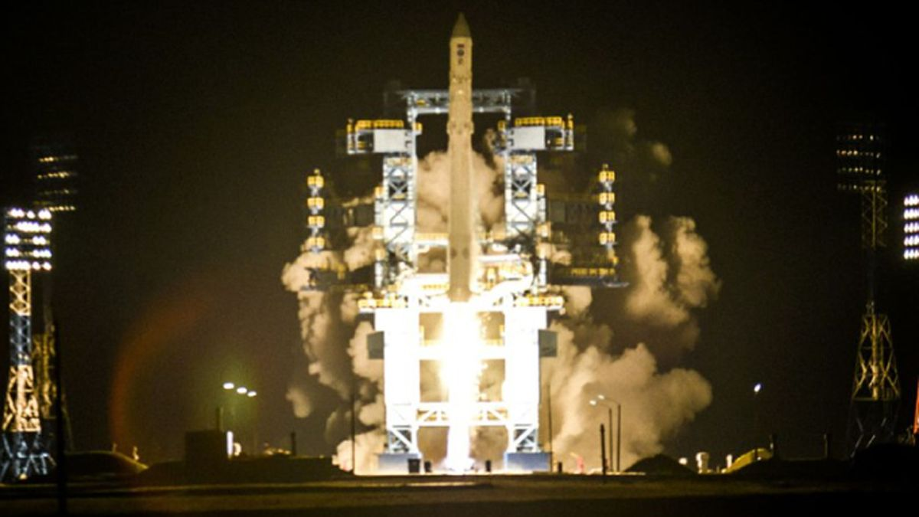

Click for next article An Angara rocket launches the COSMOS 2560 satellite from Plesetsk Cosmodrome on Oct. 15, 2022. Another trio in the COSMOS series - COSMOS 2581, 2582 and 2583 - launched in February 2025 and has performed sophisticated rendevzous operations in orbit. Two Russian spacecraft just demonstrated a very particular set of orbital skills. The satellites , known as COSMOS 2581 and COSMOS 2583, got within just 10 feet (3 meters) or so of each other on April 28, according to COMSPOC, a Pennsylvania-based space situational awareness company. "This wasn't a coincidental pass - COSMOS 2583 performed several fine maneuvers to maintain this tight configuration," COMSPOC wrote in a May 1 post on X , which featured an animation of the rendezvous. 🛰️Russian satellites multi-object proximity event in LEORadar tracking data via @LeoLabs_Space, processed through COMSPOC SSA Suite.This week we observed a complex proximity event involving Russian satellites: COSMOS 2581, 2582, 2583, and Object F (a subsatellite released by… pic.twitter.com/3nDkcOmTuDMay 1, 2026 The two satellites and a third one, COSMOS 2582, launched to low Earth orbit in February 2025 atop a Soyuz rocket. According to COMSPOC, all three of them were involved in the recent rendezvous and proximity operations (RPO), as was "Object F," a subsatellite previously deployed by COSMOS 2583 . During the 10-foot close approach, "COSMOS 2582 trailed the formation at sub-100 km range, while Object F passed within 15 km of 2582 and within 10 km of 2581 - neither maneuvered," wrote COMPSOC, which analyzed radar tracking data gathered by the California company LeoLabs . "For context: in late 2025 to now, we tracked these same COSMOS satellites performing 3-object RPO," COMSPOC added in the May 1 post. "Whatever Russia is testing, it's sophisticated." Such sophisticated orbital maneuvering is not exactly surprising; we've seen similar things from Russia before. For example, according to outside observers, the nation has operated multiple " inspector satellites ," including COSMOS 2542, which made a close approach to a U.S. spy satellite in 2020 .

10. Webb and Hubble find massive star clusters emerge faster
Space News - Space, Astronomy, Space Exploration
Read more
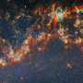

Astronomers using the NASA/ESA/CSA James Webb Space Telescope together with the NASA/ESA Hubble Space Telescope have looked deeply at thousands of young star clusters in four nearby galaxies, studying clusters at different stages of evolution. Their findings show that more massive star clusters emerge more quickly from the clouds they are born in, clearing away gas and filling ...

11. On the ground or in the atmosphere? Swarm satellites help characterize and pinpoint destructive events
Space News - Space, Astronomy, Space Exploration
Read more


When solar storms strike Earth, they can disrupt power grids, rail systems, satellites, and even marine life. These effects arise because solar wind and geomagnetic activity disturb the magnetosphere-ionosphere system, generating electric and magnetic field variations that can resemble fainter signals from natural hazards. This risk is not theoretical.

12. Space junk falls to Earth faster when sunspots peak, reshaping satellite collision forecasts
Space News - Space, Astronomy, Space Exploration
Read more
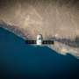

Solar emissions exert 'drag' on space junk orbiting Earth. From historical measurements across a period of 36 years, researchers have now shown that space junk begins to fall down much faster once the sun's activity across the solar cycle reaches approximately 67% of its peak. This result, which is expected to hold for station-keeping satellites too, is important for better pla...

13. Drone killer launches thin metal chains to take down enemy UAVs in seconds
Interesting Engineering
Read more

Researchers in Germany have developed a new drone interceptor that uses thin metal chains to disable unmanned aerial vehicles (UAVs) midair by tangling their spinning rotors. The concept was made by scientists at the Karlsruhe Institute of Technology (KIT). It adapts the physics behind the traditional South American bola weapon into a modern drone defense technology designed for short-range interception. The system works by firing lightweight, thin metal chains towards incoming UAVs. Once the chains make contact, they reportedly wrap around the drone body and rotors. This way, they prevent the propellers from spinning and force the aircraft into a controlled crash. "We use a well-known physical principle similar to the bola used by shepherds in South America and adapt it specifically for drone defense," Claus Mattheck, PhD, a distinguished senior fellow at KIT's Institute for Applied Materials, who created the method together with external partners, pointed out. An anti-drone chain system Drones have recently become an increasing concern in both military and civilian environments. They pose a particular threat to airports, industrial facilities, and critical infrastructure. Meanwhile, Germany has recorded repeated sightings of drones near sensitive locations in recent years. In 2025 alone, the country reported more than 1,000 suspicious drone incidents, according to the Federal Criminal Police Office (BKA). To address the issue, the KIT researchers built a low-cost interception system that could be deployed without sophisticated electronics or even explosive projectiles. "Instead of balls attached to ropes, we use thin chains, which proved superior in simulation calculations," Mattheck explained. As the chains strike the drone, they rapidly coil around the aircraft structure and spinning rotor blades. Once entangled, the propellers lose mobility, causing the UAV to fall from the sky. "Upon contact, the chains wrap around the drone's body and rotors," Mattheck continued. "As a result, the rotors lose mobility and the drone crashes." The team believes that the approach could offer a simpler and potentially safer alternative to conventional anti-drone systems. They said that existing counter-drone technologies often cost too much, rely on complex systems, and even face deployment limitations. Simulations and live tests To evaluate the drone interceptor, the engineers carried out computer simulations and analyzed how metal chains between three and four millimeters thick behaved when colliding with model drones. Their calculations analyzed factors including geometry, friction, as well as motion dynamics to find out how effectively the chains could wrap around drone rotors during flight. "We verified the fundamental suitability of the method through these computer simulations," Mattheck said. "One particular advantage of chains as projectiles is that, when falling, they pose less risk of collateral damage than a compact projectile of the same mass," he concluded in a press release. "Further verification was carried out experimentally through firing tests at the Ballistics Center in Sternenfels." The researchers now aim to expand field testing to evaluate the interceptor under a wider range of operational conditions. If future trials prove successful, the team believes industry partners could move the concept toward practical deployment. The results of the simulations and initial tests have been published in Aerospace & Defence and Konstruktionspraxis.

