 |  | 

🌌 अंतरिक्ष समाचार | Space News
शुक्रवार, २६/०६/२०२६ | Friday, 26/06/2026

1. How AI-based system is expected to make AQI forecast sharper in Delhi
Read more
Every year, as the Capital battles severe air pollution during winters, emergency measures are introduced based on forecasts of how foul the air is likely to get. With an aim to make those forecasts sharper, IIT-Kanpur's Airawat Research Foundation (ARF) has been building a system under a pilot initiative, The Indian Express has learnt. The Indian Express had reported last November that the Decision Support System (DSS) - the current model used for identifying sources and air quality forecasts - suffers from several issues, including an ageing emissions database and accuracy that tails off outside the peak winter months. To resolve these issues and modernise the system, IIT-K signed a memorandum of understanding (MoU) with the Delhi Environment department last month. Improved prediction Drawing on a constant stream of live pollution data, the new AI-based DSS will use artificial intelligence (AI) to spot the first signs of a worsening episode early, so that action can be taken before conditions worsen, sources said. This marks a shift from the system that the Capital currently relies on, which produces a single forecast each day from a fixed scientific model. The new system, by contrast, continuously learns from patterns - studying the city's AQI data from the past to anticipate how it will behave next, and improving its predictions in the long run, sources added. A report by the Council on Energy, Environment and Water (CEEW) released last October underlined that even as Delhi's existing forecasting and decision-support setup meets most of the requirements of an ideal system, "Delhi's Air Quality Early Warning System (AQEWS) and DSS satisfy most of the requirements for an ideal Air Quality Decision Support System (AQDSS)" yet its accuracy is uneven. The forecasts are strongest at the dangerous end of the scale, predicting "'very poor and above' (AQI > 300) pollution episodes more than ~80% of the time" in recent winters, but the system has been formally evaluated only for the post-monsoon and winter months, leaving much of the year less rigorously tested. The DSS has also historically been run mainly during the winter season rather than throughout the year. A central weakness flagged by the report is the data underpinning the model. CEEW recommends that the emission inventory (EI) - the database of which sources emit how much, on which the forecasts rest - be refreshed on a regular cycle, suggesting "a framework in place to update the EI every two to three years" and noting that "the immediate focus should be on upgrading the EI for the Delhi NCR region to improve Delhi's forecasts." Even with better data, the report cautions that "even after revamping the EI, the model output may still have errors. It specifically urged the use of artificial intelligence to close that gap, recommending that the agencies "use machine learning (ML) models to correct errors in the forecasts." Focus of new system Story continues below this ad The AI-driven approach now being piloted by IIT-Kanpur's Airawat Research Foundation maps closely onto these prescriptions - modernising the underlying data, adding machine-learning-based correction, and moving towards a year-round, more granular system. The predictive analytics dashboards, hotspot detection systems, hyperlocal source apportionment and forecasting models that form the core of the new platform are designed to give a far more granular picture of the city's air than they have had before. According to the agreement, the system is being built to generate pollution forecasts and advisories 48 to 72 hours in advance - a window intended to give authorities time to act before an episode peaks. Rather than a single city-wide snapshot, the tools aim to pinpoint where pollution is building up, identify the airsheds and regional movement feeding it, and trace the contribution of individual sources. Airawat Research Foundation (ARF) is a non-profit set up under Section 8 at IIT-Kanpur as part of the Centre's initiative for an AI Centre of Excellence for Sustainable Cities. Beyond forecasting, the MoU envisages expanding Delhi's monitoring network through low-cost sensors, mobile laboratories and the integration of satellite data. The improved forecasts are meant to affect directly the staged curbs Delhi imposes as air quality deteriorates. Under the plan, the partnership will help formulate Standard Operating Procedures, coordination mechanisms and graded response protocols aligned with the Graded Response Action Plan (GRAP) and the National Clean Air Programme (NCAP). Because these measures are triggered by forecasts, the accuracy and timing of predictions directly shape how effective - and how disruptive - the response is. As per the arrangement the Department of Environment will coordinate with other departments and stakeholders, provide access to operational and technical data subject to applicable laws, nominate a nodal officer, and validate the analytical models before they are deployed. ARF, for its part, will develop the AI-driven tools, deploy technical experts and researchers, ensure compliance with data protection and IT laws, and submit periodic progress reports and policy recommendations. A component of the project is devoted to capacity building for training officials to interpret the analytical systems and plan interventions. The Secretary, Department of Environment, will act as the supervising authority on behalf of the GNCTD, while the CEO or Project Director of airawat will coordinate implementation from the foundation's side, with regular review meetings to track progress. The agreement is valid for five years and can be extended by mutual consent, the MOU has stated.

2. Nasa's spacecraft finds a peanut-shaped asteroid that wobbles
Read more
Scientists also got their first clear look at the asteroid's distinctive peanut shape, along with the craters and ridges covering its surface. (Screenshot/NASA official website) Nasa's Lucy spacecraft has spotted an asteroid shaped, oddly, like a peanut which wobbles in space instead of smoothly spinning on a single axis. The asteroid, named Donaldjohanson, also carries possible evidence of ancient water, making it important for understanding the mysterious early history of our solar system, according to Nasa's website. Lucy collected its first close-up images and data on Donaldjohanson on April 20, 2025, passing just 960 km from the asteroid, and a look at the data revealed that this asteroid has a two-axis rotation, unlike most asteroids and planets, which usually spin simply around a single axis. Scientists also got their first clear look at the asteroid's distinctive peanut shape, along with the craters and ridges covering its surface.

3. Fadnavis launches indigenous 'Maha AI' model, rolls out digital governance reforms
Read more

- Governance - 2 min read The CM inaugurated the Maha AI platform, MahaDBT 2.0, digital life certificate system and standardisation of 'Aaple Sarkar' service centres at the Vidhan Bhavan here. - PTI - Published On Jun 25, 2026 at 04:41 PM IST Select ETGovernment as Preferred Choice on Google Copy Link Share on WhatsApp Share on Linkedin Share on X Share on Telegram Share on Facebook Fadnavis said citizens applying for various schemes would now have to provide less information as data available with the government would be automatically populated in applications. The Maharashtra government on Wednesday launched its indigenous " Maha AI " model and a slew of digital governance initiatives, with Chief Minister Devendra Fadnavis saying the state has taken a significant step towards building a knowledge-driven and data-based administration. The move is aimed at delivering faster and more transparent services to citizens, he said. The CM inaugurated the Maha AI platform, MahaDBT 2.0 , digital life certificate system and standardisation of ' Aaple Sarkar ' service centres at the Vidhan Bhavan here. Advt "The state has taken an important step towards building knowledge-based and data-driven governance through its own AI model. These initiatives will ensure that government services become faster, simpler and more transparent for citizens," Fadnavis said. The integrated data pool created under the 'MahaSarathi' initiative would help not only in delivering welfare schemes efficiently but also in designing, planning and implementing future programmes in a targeted manner. The system would help eliminate duplication of beneficiaries, identify misuse and ensure that eligible citizens receive benefits without hurdles, he added. Fadnavis said citizens applying for various schemes would now have to provide less information as data available with the government would be automatically populated in applications. With the increasing use of agentic AI in future, the process would become even more seamless and quicker, he said. Calling MahaDBT 2.0 a major reform, the chief minister said all departments have been directed to migrate their schemes to the unified platform within a stipulated period, failing which schemes on older systems would be discontinued. He said the Direct Benefit Transfer (DBT) mechanism had already brought transparency in scholarship disbursal and curbed irregularities, and a wider rollout across schemes would ensure benefits reach intended beneficiaries directly. Fadnavis described the state's network of over 31,000 Aaple Sarkar service centres as the face of governance for citizens and said their standardisation and a new incentive-based ranking system would improve service quality. He said the digital life certificate facility would provide relief to pensioners and beneficiaries by enabling them to submit proof of life from home, reducing the need for repeated visits to government offices. Highlighting the significance of the Maha AI platform developed jointly by the state government and the National Informatics Centre (NIC), Fadnavis said data had become the "new gold and new oil" and it was essential for the government to utilise its own data through an indigenous AI model. "The AI system trained on the government's own data will help protect against future cyber and information-related threats, improve administrative efficiency, accelerate decision-making and enable faster delivery of services," he said. According to the government statement, MahaDBT 2.0 has reduced the number of data fields in applications to 66 from 138 and offers Aadhaar-based verification and faster benefit disbursal. The official release said Maharashtra's "Maha AI" is the country's first state-level initiative aimed at creating an AI-enabled hub for improving governance and citizen-centric services. - See more on: - Maha AI , - Maharashtra government , - digital governance , - AI model for governance , - Devendra Fadnavis , - MahaDBT 2.0 , - Direct Benefit Transfer , - digital life certificate , - Aaple Sarkar , - Making AI Work Telegram Facebook Comments What are your thoughts? Comment Now --> Comment Now Read Comment (1) All Comments By commenting, you agree to the Prohibited Content Policy Post Find this Comment Offensive? Choose your reason below and click on the submit button. This will alert our moderators to take actions REASONS FOR REPORTING Foul Language Defamatory Inciting hatred against a certain community Out of Context / Spam Others Report Join the community of 2M+ industry professionals. Subscribe to Newsletter to get latest insights & analysis in your inbox. --> All about ETGovernment industry right on your smartphone! - Download the ETGovernment App and get the Realtime updates and Save your favourite articles. Scan to download App -->

4. India launches anti-dumping probe into electrical steel imports from China, 3 other nations
Read more

- Economy - 2 min read This move, prompted by a complaint from JSW JFE Electrical Steel Nashik, aims to protect domestic manufacturers from alleged cheap imports that are reportedly causing significant harm. The probe will determine if dumping has occurred and if duties are necessary to ensure fair trade. - PTI - Published On Jun 26, 2026 at 10:42 AM IST Select ETGovernment as Preferred Choice on Google Copy Link Share on WhatsApp Share on Linkedin Share on X Share on Telegram Share on Facebook India has launched an anti-dumping investigation into electrical steel imports from China, Japan, Korea, and Russia. New Delhi: India has initiated an anti-dumping probe against imports of electrical steel, used in transformers, from China, Japan, Korea and Russia, a commerce ministry notification said. The investigation followed a complaint in this regard by JSW JFE Electrical steel Nashik Pvt Ltd to the Directorate General of Trade Remedies (DGTR). The applicant has alleged that the cheap imports of 'Cold Rolled Grain Oriented Electrical Steel and Amorphous Metal' is significantly harming the domestic industry. Advt "On the basis of the duly substantiated written application submitted by the applicant and having reached satisfaction based on the prima facie evidence submitted by the applicant concerning dumping of the product...the authority hereby initiates an anti-dumping investigation," the DGTR's notification said. In the probe, the directorate would determine the existence, degree and effect of the alleged dumping of the chemical exported from China and Japan. If it is established that the dumping has caused material injury to domestic players, the DGTR would recommend the imposition of the levy on imports. The finance ministry takes the final decision to impose these duties. The principal end-use of the product is for manufacture of power/distribution transformer cores. Both materials are used by the same consumer industries - transformer manufacturers supplying to utilities, industrial users, and renewable power projects. The product is primarily used as an intermediate in the manufacture of tyre and rubber products and in resin bonding applications. It is also used in the manufacture of specialised wood adhesive resins, dyes, pharmaceuticals, and cosmetic preparations. India has also initiated similar probe against imports of sodium nitrite from China; and 'Para Nonylphenol' from Russia and Taiwan. Anti-dumping probes are conducted by countries to determine whether domestic industries have been hurt because of a surge in cheap imports. As a countermeasure, they impose these duties under the multilateral regime of the Geneva-based World Trade Organisation (WTO). The duty is aimed at ensuring fair trading practices and creating a level playing field for domestic producers vis-a-vis foreign producers and exporters. India and these countries are members of the WTO. India has already imposed anti-dumping duties on several products to tackle cheap imports from various countries, including China. - See more on: - India anti-dumping probe , - electrical steel imports , - China Japan Korea Russia , - JSW JFE Electrical steel , - Directorate General of Trade Remedies Telegram Facebook Comments What are your thoughts? Comment Now --> Comment Now Read Comment (1) All Comments By commenting, you agree to the Prohibited Content Policy Post Find this Comment Offensive? Choose your reason below and click on the submit button. This will alert our moderators to take actions REASONS FOR REPORTING Foul Language Defamatory Inciting hatred against a certain community Out of Context / Spam Others Report Join the community of 2M+ industry professionals. Subscribe to Newsletter to get latest insights & analysis in your inbox. --> All about ETGovernment industry right on your smartphone! - Download the ETGovernment App and get the Realtime updates and Save your favourite articles. Scan to download App -->

5. ISRO successfully conducts 2nd integrated air drop test for Gaganyaan mission - News On AIR
Read more
The Indian Space Research Organisation (ISRO) has successfully conducted the second integrated air drop test (IADT-02) for the upcoming Gaganyaan mission at Sriharikota in Andhra Pradesh. The system is essential to ensure safe recovery of the crew module - the capsule in which astronauts sit during a human flight. After the module's release, a parachute system, comprising 10 parachutes, was deployed, helping the capsule decelerate to a safe splashdown speed. The IADT-02 follows the successful completion of the first IADT, which took place on August 24, 2025, at the Satish Dhawan Space Centre in Sriharikota. In the first IADT, a 4.8-tonne dummy crew module was dropped from a height of three km by a Chinook helicopter. Air drop tests recreate the last leg of a spacecraft's return to the Earth. An aircraft or helicopter drops the spacecraft from a height to test various systems under different scenarios. These are the deployment of the parachute system in case the mission is aborted mid-flight, system performance when one parachute fails to open, and the spacecraft's orientation and safety during splashdown. Union Minister Jitendra Singh congratulated the ISRO for successfully conducting the test. India's first human spaceflight will be launched from Sriharikota in 2027.

6. ISRO successfully conducts CE20 cryogenic engine ground test - News On AIR
Read more
The Indian Space Research Organisation (ISRO) has successfully conducted a key ground test of its CE20 cryogenic engine, demonstrating higher thrust capability that could improve the performance of India's heavy-lift rocket, the LVM3 launch vehicle. The sea-level hot test was carried out on March 10 at the ISRO Propulsion Complex, Mahendragiri in Tamil Nadu, where the engine operated for 165 seconds and generated about 22 tonnes of thrust. The CE20 engine powers the upper stage of LVM3 and is critical for missions requiring heavy payloads. It has also been human-rated for India's upcoming Gaganyaan mission. ISRO said the higher-thrust testing is aimed at enhancing the rocket's payload capacity for future satellite and space exploration missions.

7. NASA, US Small Business Administration to Announce Partnership
Read more

Credit: NASA NASA and the U.S. Small Business Administration will sign a memorandum of agreement during a ceremony at 1 p.m. EDT, Monday, June 29, at NASA Headquarters in Washington. The agreement will create a new interagency initiative that directly responds to President Donald J. Trump's National Space Policy and supports the growth of the American space economy. Participants include: NASA Administrator Jared Isaacman SBA Administrator Kelly Loeffler This event is in person only. Media interested in attending must RSVP no later than 10 a.m. on June 29 to: hq-media@mail.nasa.gov. NASA's media accreditation policy is available online. For more information about NASA's missions, visit: https://www.nasa.gov -end- Camille Gallo / Cheryl Warner Headquarters, Washington 202-358-1600 camille.m.gallo@nasa.gov / cheryl.m.warner@nasa.gov

8. NASA Welcomes Botswana as 68th Artemis Accords Signatory
Read more

From left to right, Senior Advisor on Space for the Bureau of Oceans and International Environmental and Scientific Affairs Greg Autry, NASA Deputy Administrator Matt Anderson, Minister of Communications and Innovation David Tshere, and Acting Ambassador of the Republic of Botswana to the United States Mabedi Ngwenya pose for a photo following an Artemis Accords signing ceremony with the Republic of Botswana Thursday, June 25, 2026, at the Mary W. Jackson NASA Headquarters building in Washington. NASA/Keegan Barber The Republic of Botswana signed the Artemis Accords Thursday during a ceremony hosted by NASA at the agency's headquarters in Washington, becoming the sixth African nation to join a growing community of nations committed to the peaceful, transparent, and responsible exploration of space. "It is my privilege to welcome Botswana as the newest signatory of the Artemis Accords," said NASA Deputy Administrator Matt Anderson. "Today marks an important milestone in our international partnership and in the continued growth of the Artemis community. Botswana joins at an important moment. Earlier this month, we announced the crew of Artemis III and, as we speak, their spacecraft is being assembled as they prepare to play their part in mankind's greatest adventure." Botswana's Minister of Communications and Innovation David Tshere signed on behalf of the country. U.S. Department of State Senior Advisor for Space Gregory Autry, and Mabedi Ngwenya, acting ambassador of the Republic of Botswana to the United States, also participated in the ceremony. "Botswana like many countries, we have interest in space exploration, found it important to become a signatory to the Artemis Accords to promote the safe, transparent, and sustainable civil space exploration, and to advance international cooperation, and a shared framework for responsible activities in the space," said Tshere. This new chapter builds on Botswana's long history of collaboration with the United States in space-based Earth observation. In the early 1970s, Botswana participated in the satellite program later known as Landsat, joining dozens of other nations in pioneering satellite-based environmental observation. Botswana marked another milestone with the launch of its first Earth observation satellite, Botswana Satellite 1, in March 2025, aboard a SpaceX Falcon 9. In 2020, during the first Trump Administration, the United States, led by NASA and the State Department, joined with seven other founding nations to establish the Artemis Accords, responding to the growing interest in lunar activities by both governments and private companies. The Artemis Accords introduced the first set of practical principles aimed at enhancing the safety and coordination between like-minded nations as they explore the Moon, Mars, and beyond. Signing the Artemis Accords means committing to explore peaceably and transparently, to render aid to those in need, to enable access to scientific data that all of humanity can learn from, to ensure activities do not interfere with those of others, and to preserve historically significant sites and artifacts by developing best practices for space exploration for the benefit of all. More countries are expected to sign the Artemis Accords in the months and years ahead, as NASA continues its work to establish a safe, peaceful, and prosperous future in space. Learn more about the Artemis Accords at: https://www.nasa.gov/artemis-accords

9. NASA Selects Rocket Lab to Launch Sun, Earth Science Missions
Read more

NASA has selected Rocket Lab to provide the launch service for both the agency's PolSIR (Polarized Submillimeter Ice-cloud Radiometer) and Total and Spectral Solar Irradiance Sensor-2 (TSIS-2) missions. The two selections are part of NASA's Venture-Class Acquisition of Dedicated and Rideshare (VADR) launch services contract. This contract allows the agency to award fixed-price indefinite-delivery/indefinite-quantity launch service task orders during VADR's 10-year ordering period, with a maximum total contract value of $300 million. The PoISIR mission will help provide a better understanding of ice clouds that form at high altitudes throughout tropical and subtropical regions. Rocket Lab will launch PolSIR aboard two of its dedicated Electron rockets no earlier than June 2027 from Launch Complex 1 in Mahia, New Zealand. Consisting of two small satellites, both of PoISIR's 16U CubeSats have a scientific instrument designed to measure a specific spectrum of electromagnetic radiation, which will determine how the amount of ice in tropical clouds rises and falls during the day, as well as how the ice changes connect to larger storms. The instruments also will help determine how ice clouds affect sunlight and heat radiation throughout the day. The pair of CubeSats will fly in orbits separated by several hours to observe the pattern of cloud ice content changes over a day. This information will help researchers make more accurate weather predictions. The PolSIR mission's principal investigator is Vanderbilt University in Nashville. Science operations will be conducted by the Space Science and Engineering Center at the University of Wisconsin in Madison. The two spacecraft are being built by Blue Canyon Technologies. The TSIS-2 mission will measure the Sun's energy input to Earth. The spacecraft will provide critical data for understanding our planet's ocean currents, seasons, and weather. The mission will continue NASA's work to study and protect our home planet by providing insights that can only be gathered from space. Rocket Lab will launch TSIS-2 aboard an Electron rocket in early 2027 from Launch Complex 1 in Mahia. The satellite measures Earth's solar energy input, both the total irradiance, which is the Sun's overall brightness at the top of Earth's atmosphere, and the spectral irradiance, or how that energy is distributed across ultraviolet, visible, and infrared wavelengths. The satellite's two instruments, the Total Irradiance Monitor and the Spectral Irradiance Monitor, are similar to those used for TSIS-1. Together, they cover a wavelength range that includes 96% of the energy in the solar spectrum. While TSIS‑1 works from the International Space Station, TSIS‑2 will operate from a free‑flying spacecraft. Managed by NASA's Goddard Space Flight Center in Greenbelt, Maryland, TSIS-2 includes instruments provided by the Laboratory for Atmospheric and Space Physics at the University of Colorado, Boulder, and the spacecraft is provided by General Atomics - Electromagnetic Systems. NASA's Launch Services Program, based at the agency's Kennedy Space Center in Florida, manages the VADR contract. Learn more about VADR online: https://www.nasa.gov/vadr-venture-class-acquisition-of-dedicated-and-rideshare-launch-services

10. Watch live: Rocket Lab launching 'Ten Owl of Ten' mission for Synspective today
Read more
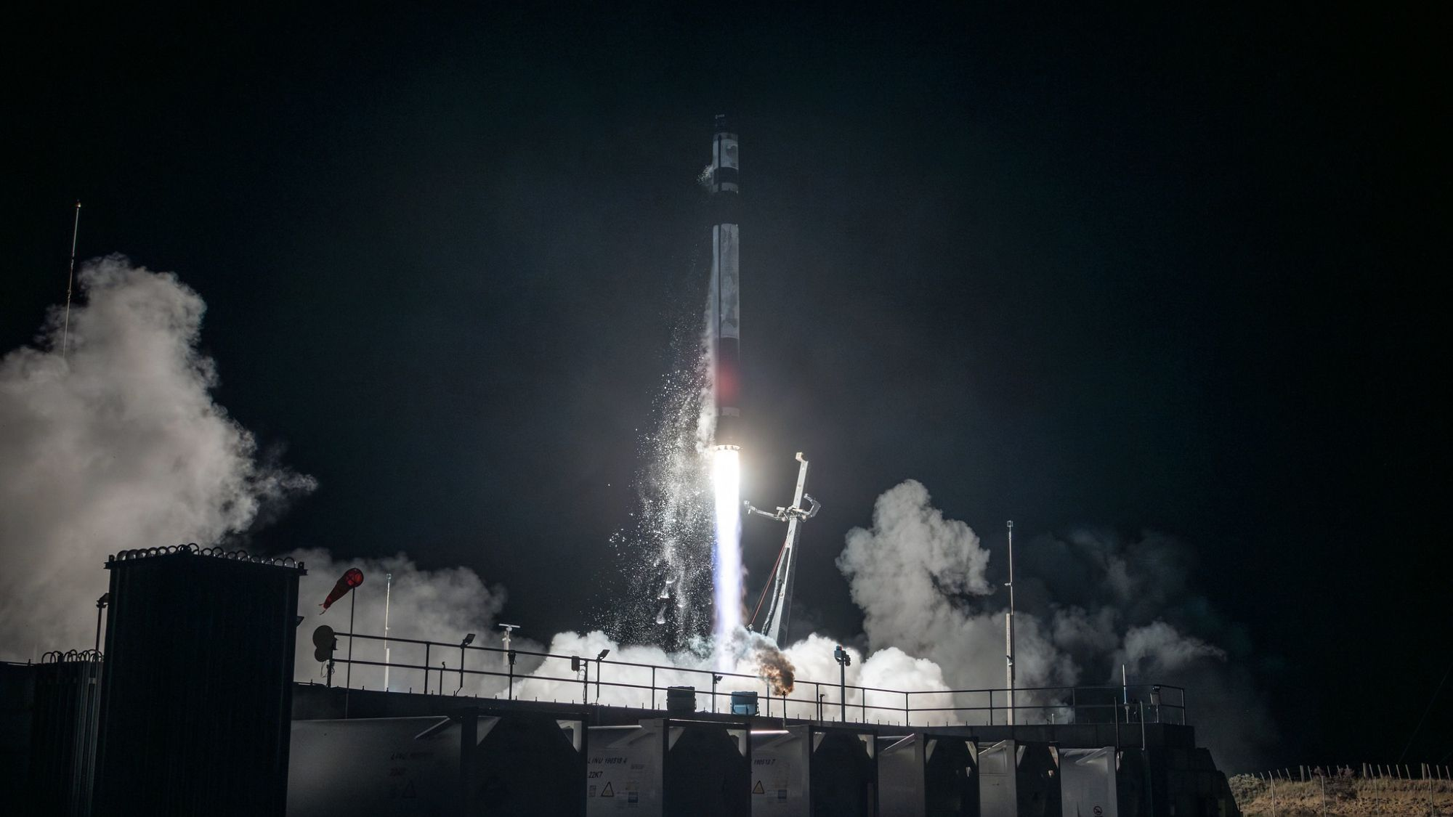
Click for next article Rocket Lab - '10 Owl Of 10' Launch - YouTube Watch On Rocket Lab is scheduled to launch another Strix satellite for Japanese company Synspective's imaging constellation, in orbit above the island nation. An Electron rocket will lift off from Rocket Lab's Launch Complex-1 (LC-1) in New Zealand today (June 26), during a window that opens at 12:45 p.m. EDT (1645 GMT; 4:45 a.m. on June 27 local New Zealand time). As its name suggests, the "Ten Owl of Ten" mission will launch Synspective's 10th synthetic aperture radar (SAR) satellite, which will expand the company's network above Japan to provide imaging data for use in city planning, monitoring infrastructure and responding to natural disasters. You can watch it here at Space.com, courtesy of Rocket Lab, as well as on the company's website . Coverage is expected to begin about 30 minutes before the opening of the launch window. A Rocket Lab Electron rocket launches the "Daughter of the Stars" mission for the European Space Agency on March 28, 2026. (Image credit: Rocket Lab) The launch will be Rocket Lab's 12th so far in 2026, and the ninth for Electron this year (the other flights were performed by the HASTE rocket , a suborbital variant of Electron). Electron, Rocket Lab's workhorse small-lift launch vehicle, stands 59 feet (18 meters) tall and can launch payloads weighing up to 661 pounds (300 kilograms) to low Earth orbit (LEO). Synspective has booked Electron to launch the entirety of its Strix constellation, with 17 more on the rocket's manifest expected to launch before 2030. The satellites are named after a genus of owls, drawing inspiration from the birds' visual acuity. Like their namesake, the Strix satellites' SAR antennas allow the spacecraft to collect Earth -observation data in every lighting condition (and also through cloud cover, which the birds can't quite match). The patch for Rocket Lab's "Ten Owl of Ten" mission. (Image credit: Rocket Lab) Each Strix satellite weighs about 220 pounds (100 kg), and stretches to 16.4 feet (5 meters) wide with its SAR antenna fully deployed. Each satellite has an on-orbit lifespan of about five years, according to Synspective's website . The spacecraft cruise in LEO between 15 and45 degrees of inclination. Electron will deliver the "Ten Owls of Ten" Strix to an inclination of 42 degrees, at a LEO altitude of 343 miles (552 kilometers). Electron's second stage will separate about 2 minutes, 40 seconds after liftoff today, with the third or "kick" stage taking over about nine minutes into flight. Payload separation is expected about 45 minutes later, around T+1 hour after liftoff.

11. James Webb Space Telescope catches 6 galaxies merging into one of the largest galaxies in the universe
Read more
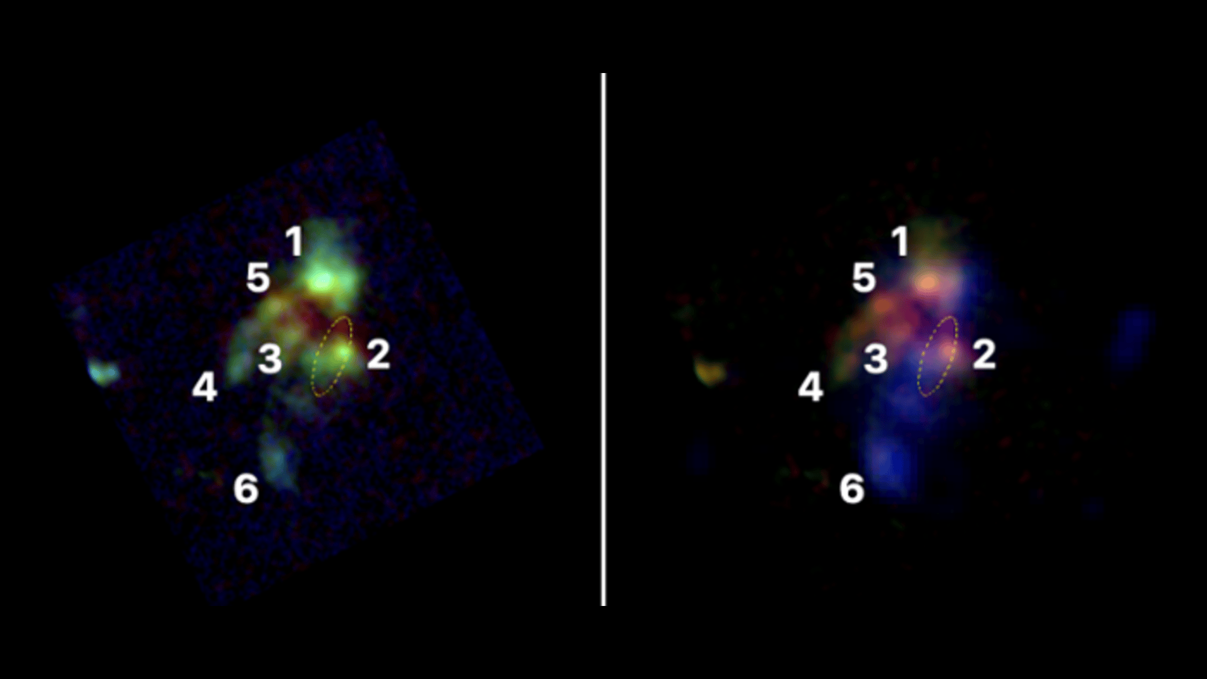
Click for next article The JWST image of six galaxies in the process of merging in the early universe. An intense demolition derby of at least six galaxies smashing into one another has been found lurking in the early universe by the James Webb Space Telescope. This merger is also expected to fuel the growth of a supermassive black hole and trigger the formation of what will eventually become one of the most massive galaxies in the cosmos. "What makes this special is that we can follow both the build-up of a giant galaxy and the growth of the black hole at its center," Huub Röttgering, an astronomer at the Netherlands' Leiden Observatory, said in a statement . The discovery came after a tip-off from radio astronomers who had noticed emissions that seemed to be coming from an undiscovered active black hole. When the James Webb Space Telescope (JWST) looked closer, it found a surprise. "We didn't find a single galaxy, but an entire complex of at least six galaxies," said Aayush Saxena of the University of Oxford. These six galaxies sit at a redshift of 4.0, which equates to a time about 12 billion years ago, just 1.8 billion years after the Big Bang . Through the vision of the JWST 's Near-Infrared Camera the six galaxies appear fuzzy, reminiscent of a faraway version of Stephan's Quintet , which is a collection of five galaxies, four of which form a compact group that are on course to merge to become a giant elliptical galaxy. Similarly, the six galaxies spotted by the JWST, and collectively termed TGSSJ1530+1049, will undergo a series of rapid mergers to become what is known as a 'brightest cluster galaxy,' which is an enormous elliptical galaxy of the kind found at the center of galaxy clusters. "We call structures like this protoclusters: the precursors of the vast collections of galaxies we see today," said Leiden's Roderik Overzier. "These are places where matter came together very early on. We think we are seeing a rare moment when several massive galaxies still exist separately, but are already in the process of forming one much larger galaxy." Already a supermassive black hole has formed at the heart of this galactic maelstrom, and radio observations with the European VLBI (very long Baseline Interferometer) Network and the U.K.'s e-MERLIN (enhanced Multi-Element Remotely Linked Interferometer Network) at a resolution on the scale of a 100 milliarcseconds have identified radio lobes and hotspots typical of an active black hole's jet interacting with the gas surrounding it. "Using a network of connected radio telescopes, we were able to produce a very sharp image of TGSSJ1530+1049," said Krisztina Gabányi of Eötvös Loránd University in Budapest, Hungary. "The radio emission is produced as material falls into the black hole, while some of it is expelled again at high speed." The jet doesn't seem to extend as far as all the galaxies in TGSSJ1530+1049 yet, implying that the black hole is still fairly young. The six galaxies of TGSSJ1530+1049 span a volume only a few tens of thousands of light-years across, which is smaller than our Milky Way galaxy - and yet, they pack in a humungous amount of stars, equivalent to hundreds of billions of solar masses and a star-formation rate somewhere between 70-163 solar masses per year. That's a frenetic pace compared to the Milky Way, which produces much less than ten solar masses per year. TGSSJ1530+1049 is one of the densest collections of heavyweight galaxies found in the early universe so far, and is giving exciting clues as to how the most massive galaxies, clusters and black holes in the universe formed.

12. A SpaceX rocket will slam into the moon this August. Will we be able to see it?
Read more
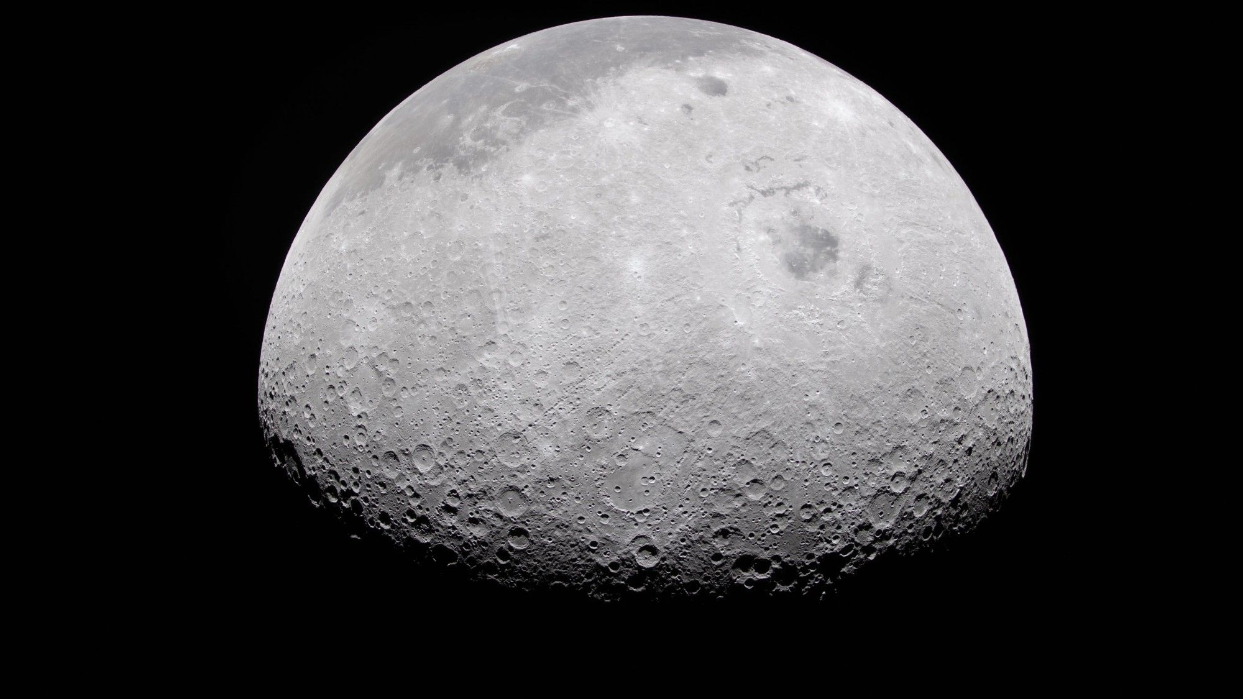
Click for next article The moon appears half-illuminated in this photo captured by the Artemis 2 crew on day six of their mission in April 2026. Earth's moon is due for a human-made impact this August courtesy of a spent SpaceX Falcon 9 upper stage. The Falcon 9 upper stage is left over from the launch that sent Firefly's Blue Ghost-1 lander to the moon on Jan. 15, 2025 by way of NASA's Commercial Lunar Payload Services (CLPS) initiative. Also sent moonward on that flight was the Hakuto-R Mission 2 , called Resilience, a robotic lunar lander developed by the Japanese company ispace. This striking event is expected to occur close to Einstein Crater near the moon's western limb and could be visible by ground and space-based telescopes. Varying forecasts have sparked debate on whether or not we'll be able to see the rocket body slam into the moon on Aug. 5, and, if so, how both citizen scientists and astronomers can best observe it it. 'This wonderful environment of the moon' The consequences of this rocket mission's leftover hardware is on target for a "limb shot," meaning it could strike the far western edge of the moon. Another possible impact site is Bell Crater, just out of sight on the moon's far side . Earlier this month, NASA's Solar System Exploration Research Virtual Institute (SSERVI) hosted a discussion with experts regarding the approaching impact. Taking part in the meeting of moon-watching specialists was Brian Day, SSERVI's lead for citizen science and community development. "One of the things that is really important here with this impact that is coming up is it serves as a reminder to us that the moon is a dynamic environment. We think of it as being static. It is not. It is being whacked. It is changing," Day said. Citizen scientists can actually get involved to help understand the dynamic environment of the moon thanks to the Impact Flash! program , said Day. "And that can be done either with instrumentation you have in your own backyard or you can use ours in orbit around the moon," Day added. "This impact is a great reminder of this wonderful environment of the moon." Information Session: Observing the Falcon 9 impact into the Moon - YouTube Watch On Moon viewing maybe But will the impact be visible from Earth? Any assured answer is in a hedge-your-bet, yes/no mind bender. "I've gone from 'probably' to 'probably not,' and more recently, to 'maybe,'" said Bill Gray of Project Pluto, creator of a telescope-tracking application used worldwide by professional and amateur astronomers alike to keep tabs on asteroids, comets, and other near-Earth objects. It was Gray's work with Project Pluto that got the word out about the roughly four metric ton Falcon 9 upper stage intersection with the moon at over two kilometers a second. In September 2025, his software for computing orbits analyzed the observations and projected an impact with the moon on Aug. 5, 2026. "Even though we have tracked it since launch, our idea of when and where it's going to hit are currently fuzzy by minutes and dozens of kilometers," Gray said. "But we will refine that and get an idea of where it's going to hit." An illustration of the moon with an arrow pointing to a predicted impact site for the Falcon 9 upper stage 2025-010D in August 2026, courtesy of Project Pluto. (Image credit: Project Pluto) Out on a limb "I think it's going to be very subtle. I think it's going to be very, very hard to see, if not impossible. But there's always a chance," said William Cooke, program manager of NASA's Meteoroid Environment Office at Marshall Space Flight Center in Huntsville, Alabama. Cooke quickly added that, along with a rapid-fire impact flash, the upper stage impact will kick up huge amounts of lunar regolith, the dust that coats the surface of the moon. "It will excavate that out of the crater and this may create a plume that will be illuminated by the sun," Cooke said. "So, it's not only important to look for the impact flash, but if this occurs close enough to the limb, you may be able to see that plume of material rising, and that would be significant as well." Time and inclination Still, concerning the spotting of that over-the-limb plume, it remains a guessing game. How much material might be lofted, and how high will it go? Given the moon's one-sixth gravity, how long will it take for that material to fall back onto the lunar surface? "So, no good feeling for how long the plume will be up there," Cooke said. Putting aside all the unknowns, it is Cooke's view that "if you've got the time and the inclination, it might be worth a look." Regarding the possibility of seeing the ejecta plume, Gray of Project Pluto, later told Space.com he agreed. "We pretty much shrugged about this and said "we dunno' and we should look and see if we can observe it." A SpaceX photo of one of the company's Falcon 9 second stages, taken in 2022. A similar second stage is expected to impact the moon in August 2026. (Image credit: SpaceX) On-location orbiters Speaking of time and inclination, there is an on-location witness to the before and after results from the rocket stage plummeting into the moon. Brent Garry is the project scientist for NASA's Lunar Reconnaissance Orbiter (LRO) at Goddard Space Flight Center in Greenbelt, Maryland. LRO will be passing over the projected crash site about seven days prior to the impact and about seven days after the impact, Garry said. "After the impact we might have a little bit more knowledge of where it is. We can do some additional targeting about a week after the impact and get some targeting over where the site is," said Garry. Different observers This event emphasizes that when you're looking for impact flashes on the moon , either anthropogenic or natural, there's a need for as many observers as possible, said SSERVO's Day. "Because these flashes are so short, they can very much mimic a cosmic ray impact on your detector and just be a sudden blip," said Day. What really helps researcher's distinguish between cosmic ray impacts and actual flashes on the moon is to have different observers in different locations observing that flash at the same time, Day said. "And if you see that, if you have that coincidence of events," Day said, "that's one of the reasons why we like to have as many people looking as possible."

13. Another 'Star' is born: SpaceX names AI megaconstellation 'Starmind'
Read more
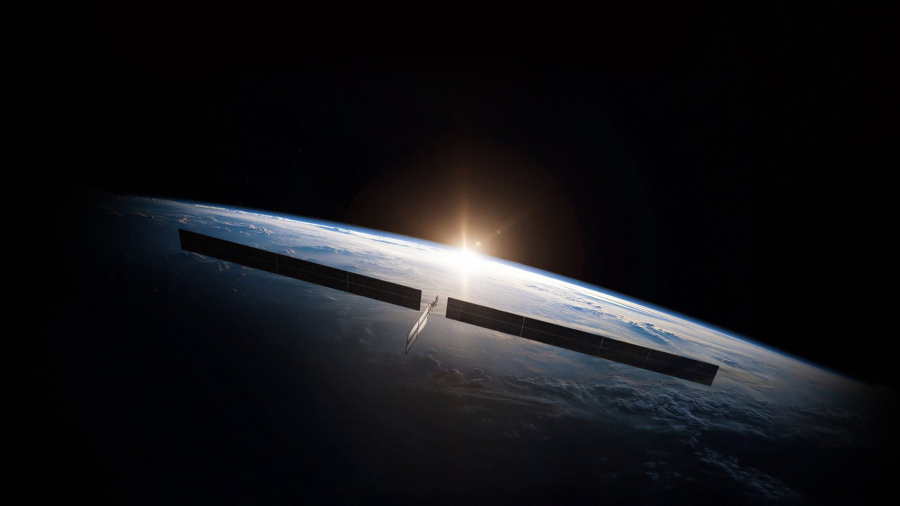
Click for next article A rendering of one of SpaceX's planned "Starmind" AI satellites in orbit. Once again, SpaceX has looked to the stars for naming inspiration. Elon Musk confirmed on Tuesday (June 23) that SpaceX will call its planned AI satellite megaconstellation " Starmind ". The choice should come as no surprise, as it continues the company's long-running stellar naming theme. Here's a rundown: Starship : SpaceX's next-generation launch vehicle, the biggest and most powerful rocket ever built. Starship is designed to be fully and rapidly reusable, a breakthrough that Musk thinks will make Mars settlement economically feasible SpaceX's next-generation launch vehicle, the biggest and most powerful rocket ever built. Starship is designed to be fully and rapidly reusable, a breakthrough that Musk thinks will make settlement economically feasible Starbase : The company's facility in South Texas, which serves as Starship's manufacturing and launch hub. In May 2025, Starbase became an incorporated city . The company's facility in South Texas, which serves as Starship's manufacturing and launch hub. In May 2025, Starbase became . Starlink : SpaceX's broadband network in low Earth orbit . Starlink is by far the biggest satellite constellation ever assembled; it currently consists of nearly 10,700 active units, and the number is growing all the time. SpaceX's broadband network in . Starlink is by far the biggest satellite constellation ever assembled; it currently consists of nearly 10,700 active units, and the number is growing all the time. Starshield : A modified version of the Starlink satellite that flies national security missions for the U.S. government, focusing on Earth observation, communications and payload-hosting tasks. A modified version of the Starlink satellite that flies national security missions for the U.S. government, focusing on Earth observation, communications and payload-hosting tasks. Starfall : SpaceX's newly unveiled uncrewed return capsule, which is designed to carry materials from orbit safely down to Earth. SpaceX's newly unveiled uncrewed return capsule, which is designed to carry materials from orbit safely down to Earth. Starfactory : The huge Starship production facility at Starbase, which covers about 1 million square feet (93,000 square meters). Starmind is perhaps the most ambitious of all of these stellar projects. If everything goes according to plan, the megaconstellation will be about 100 times bigger than the current version of Starlink. "By directly harnessing near-constant solar power with little operating or maintenance costs, these satellites will transform our ability to scale compute," Musk wrote in a February 2026 update about the company's planned AI network. "It's always sunny in space!" he added. "Launching a constellation of a million satellites that operate as orbital data centers is a first step towards becoming a Kardashev II-level civilization , one that can harness the sun's full power, while supporting AI-driven applications for billions of people today and ensuring humanity's multi-planetary future." The "star" theme has apparently supplanted a previous SpaceX nomenclature convention. The company named its original rocket line "Falcon" after the Millennium Falcon , Han Solo's ship in the " Star Wars " universe, then followed this same birds-of-prey theme for the vehicles' engines ("Merlin" and "Kestrel"). The company's next-gen engine, the one that gets Starship off the ground, still follows this older custom: it's called "Raptor."

14. Smile spacecraft reaches science orbit
Read more
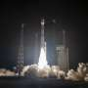
The European-Chinese Smile mission reached its designated science orbit on June 20, 2026. The team is now embarking on a two-month campaign to commission the spacecraft, which involves switching on and testing its toolbox of science instruments.

