संकलन
SANKALAN
27th July 2026 to 02nd August 2026
ई-न्यूज़लेटर | e-Newsletter

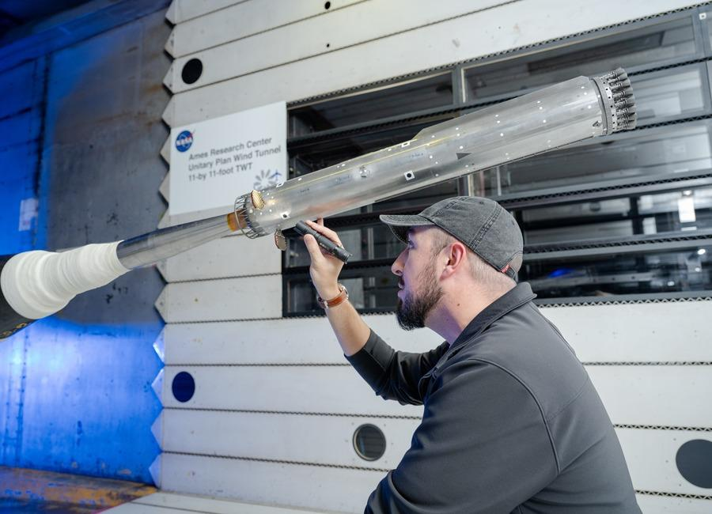 |  | 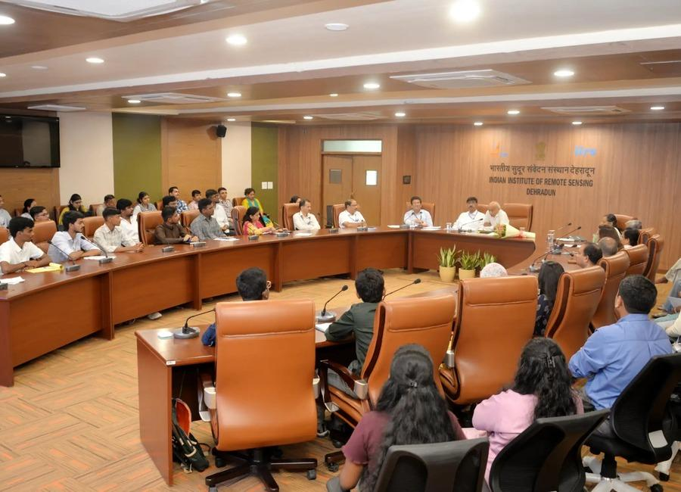
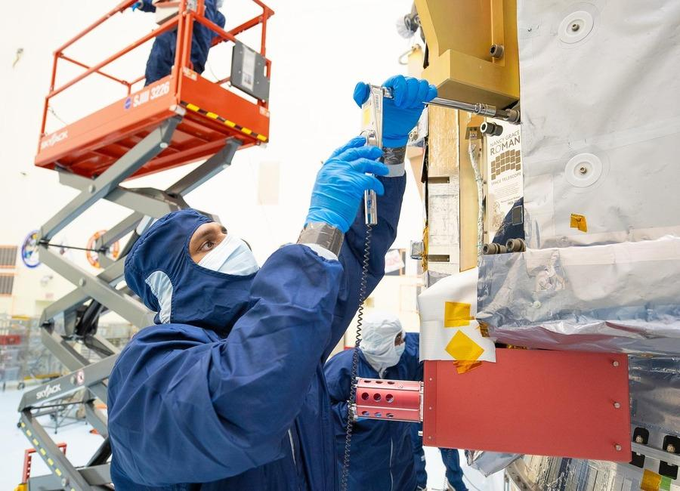 | 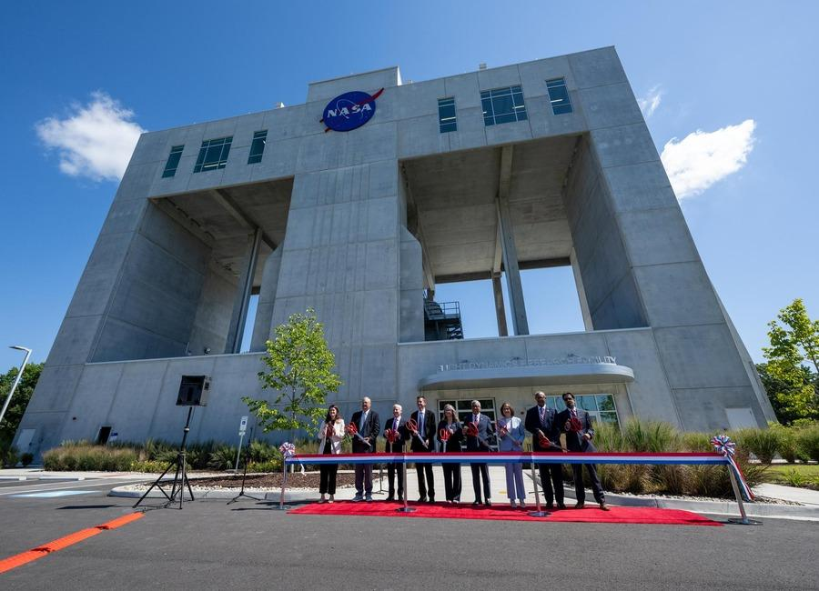 | 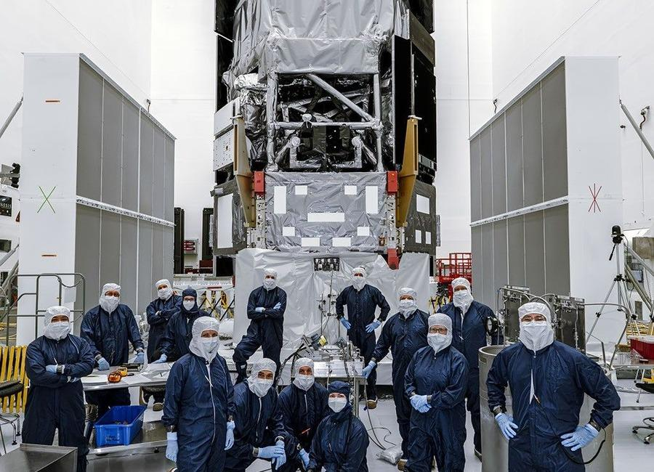
 |  | 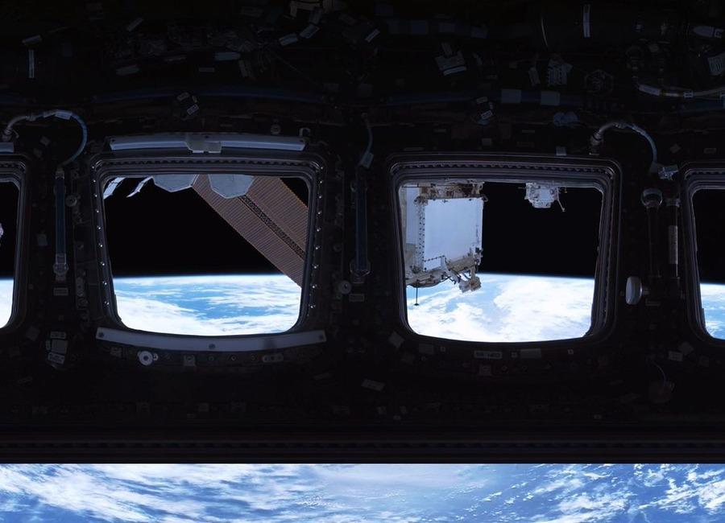

Indian Institute of Remote Sensing (ISRO), Dehradun
Collection of recent developments in the realms of Space Technology

Table of Contents
S. No. | Title
1 | Isro begins public release of Nisar data through Bhoonidhi - The Times of India
2 | ISRO-NASA Satellite Data Reveal 60 CM Ground Shift In Venezuela Earthquake - ETV Bharat
3 | Isro satellite images show 90% of India is under cloud cover. How much rain is likely? - India Today
4 | From Aadhaar to ISRO: What the six-member NTA reform panel brings to the table - Moneycontrol.com
5 | ISRO Bengaluru receives hoax bomb threat, investigation underway - The News Mill
6 | NASA Astronaut Chris Williams, Crewmates Return from Space Station
7 | I'm not an astronaut, but I went to the International Space Station (sort of)
8 | China's new alloy can withstand extreme heat; could be used in reactors, hypersonic missiles
9 | ISRO Recruitment 2026 Notification PDF Out for 244 Assistant, UDC, JPA, and Steno Posts, Application Dates, Eligibility - Adda247
10 | Assam floods: Isro's Nisar satellite captures Brahmaputra's might from space - India Today
11 | Before Team Nilekani, ex-ISRO chief-led panel tried to fix exams - The Indian Express
12 | Venezuela earthquakes shifted ground by nearly 2 feet, NASA-ISRO satellite finds | To read what more the satellite found | Inshorts - Inshorts
13 | Starship in space! See highlights of SpaceX megarocket's epic Flight 13 test launch (video)
14 | Rocket Lab to start launching missile-defense missions from Alaska under $266 million Space Force deal
15 | Curiosity Mars rover inspects cracked wheel | Space photo of the day for July 27, 2026
16 | How NASA plans to build the Habitable Worlds Observatory
17 | Could we send a spacecraft to a black hole?
18 | Are we missing alien lighthouses?
19 | ISRO Recruitment 2026 Notification Out For 244 Posts; Apply Here - NDTV
20 | Deep Depression weakens, no new vortex over Bay of Bengal, Arabian Sea: Isro images - India Today
21 | ISRO Scientist & Engineer Recruitment 2026 Through GATE: Notification Out for 92 Vacancies, Eligibility & Apply Online - PW
22 | NASA fuels its next-gen Roman Space Telescope for August launch
23 | SpaceX launches 24 Starlink satellites to orbit in wake of Starship test flight (video)
24 | ISS meets Venus in incredible daylight photo | Space photo of the day for July 28, 2026
25 | NASA science soars during August total solar eclipse
26 | NASA's Swift rescue spacecraft spins out of control after losing two reaction wheels
27 | ISRO Conducts START Capacity Building Workshop-2026 at IIRS, Dehradun - ISRO
28 | ISRO Recruitment 2026: 244 Posts, Apply Online by August 16 - PW
29 | ISRO maps over 2,000 glaciers, 3,219 glacial lakes in Ladakh: Centre - Greater Kashmir
30 | ISRO Recruitment 2026: 244 Administrative Posts Announced - Education Today
31 | NASA Awards 2026 Innovative Technology Concepts
32 | NASA Sets Coverage for August Northern Hemisphere Total Solar Eclipse
33 | NASA's Curiosity Views a Sand-Capped Butte
34 | NASA's Curiosity Discovers a Field of Martian Polygons
35 | NASA's Curiosity Mars Rover Discovers Field of Honeycomb Textures
36 | NASA Webb Explores Family Tree of Newly Discovered Distant Objects
37 | 'It's going to do things that currently are impossible': The Roman Space Telescope, NASA's next great observatory, is ready to launch Aug. 30
38 | ISRO Apprentice Recruitment 2026 Notification Out: Apply Online Till August 29 - NDTV
39 | ISRO Apprentice recruitment 2026 opens for over 400 posts at URSC; apply by August 28 - The Times of India
40 | ISRO's NavIC system can no longer provide navigation data independently: Government - The Indian Express
41 | From ISRO to Inspiring a Greener India | Pankti Pandey's Story - adityabirla.com
42 | Satellites spy penguin poop on Danger Islands | Space photo of the day for July 30, 2026
43 | A SpaceX rocket will crash into the moon next week, and scientists aren't sure what to expect
44 | Scientists advance space agriculture for future moon and Mars missions
45 | Tracking satellites and space debris using radio antennae
46 | Mission-ready Moon excavation system targets 2028 for NASA's lunar base construction
47 | Youth can take India to zenith of space research: Group captain Shukla
48 | ISRO successfully conducts Integrated Main Parachute Air Drop Test (IMAT) for Gaganyaan Programme - ISRO
49 | ISRO aims for space station by 2035, Moon Mission by 2040 - The New Indian Express
50 | ISRO calls for stronger academia-industry partnership to power future space missions - The Hindu
51 | What's Up: August 2026 Skywatching Tips from NASA
52 | NASA to Host Florida Event Celebrating American Air, Space Leadership
53 | NASA, SpaceX Advance Wind Tunnel Tests for Starship Rocket
54 | NASA Opens New Flight Dynamics Research Facility in Virginia
55 | NASA's Roman Telescope to Carry 1.35 Million Names to Deep Space
56 | SpaceX's Starship seen in space by next-gen Starlink satellite (video)
57 | NASA is sending 2 probes to the moon to test complex 'three-body orbits'
58 | Watch SpaceX's Starship land at sea in these stunning new videos
59 | Rajneesh Pandey appointed KU's interim registrar
60 | The many challenges for ISRO: Rise of startups, launch setbacks, attrition - The Indian Express
61 | ISRO Recruitment 2026: Check Eligibility, Stipend, Last Date - education.sakshi.com
62 | Govt says ISRO has developed & operationalised wide range of space-based applications to benefit society - News On AIR
63 | Chandrayaan-5 Mission Update: ISRO, JAXA Move Closer to Exploring the Moon's South Pole - Indianmasterminds
64 | This Week In Space podcast: Episode 221 - Starship Can Float?
65 | On this day in space! Aug. 1, 1968: NASA ends production of Saturn V moon rocket
66 | SpaceX launches 24 Starlink satellites to orbit from California (photos)
67 | US launches 1 ton per day antimony pilot processing plant to aid weapons production

 |  | 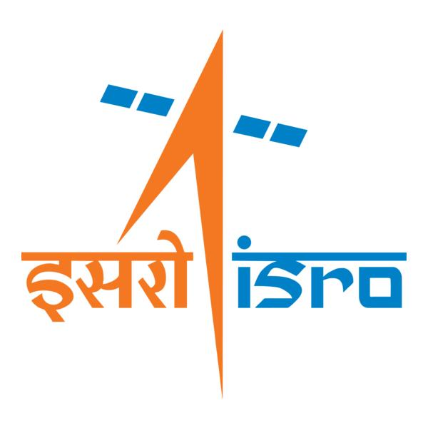

🌌 अंतरिक्ष समाचार | Space News
सोमवार, २७/०७/२०२६ | Monday, 27/07/2026

1. Isro begins public release of Nisar data through Bhoonidhi - The Times of India
Read more
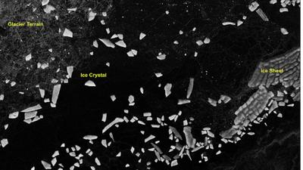
Antractica_dop_10Jul2026_HH_polarization BENGALURU: Isro has made public the first batch of S-Band radar data from the Nasa-Isro Synthetic Aperture Radar (SAR) or Nisar mission, releasing it through Bhoonidhi, the agency's earth observation data portal.The agency also shared sample images from Tamil Nadu (Nagapattinam), Antarctica, Assam (Brahmaputra basin), Idaho, Greenland and Indonesia showing the radar's range of applications, from tracking coastal wetlands to mapping irrigation patterns and ice movement, underlining the mission's relevance to both scientific research and everyday resource management, from coastal planning to precision farming and disaster monitoring.Nisar is a joint mission between Nasa and Isro, and is the first spaceborne radar to carry two frequency bands, L-band and S-band, on a single satellite. It uses a 12-metre reflector antenna and a scanning technique called SweepSAR, which lets it capture a wide strip of the Earth's surface, about 240 km across, in high resolution without sacrificing coverage.Orbiting the Earth at 747km, the satellite revisits the same spot every 12 days, building up a steady stream of images useful for tracking floods, glaciers, farmland and other fast-changing features, regardless of weather or daylight.Isro said the mission is now in its science phase, gathering data from locations around the world as per its observation plan. The S-band data is received at Isro's ground stations and processed at the Integrated Multi-Mission Ground Segment for Earth Observation Satellites in Shadnagar, run by the National Remote Sensing Centre.A nationwide network of ground-based reflectors is being used to check the accuracy of the data, alongside other reference targets chosen for specific scientific purposes."...All data gathered from Cycle 25 onwards, which began on July 8, 2026, is now available for download as soon as it is processed. Older data, collected before Cycle 25, will be reprocessed in stages and added to the archive over time," Isro said.The release includes several categories of processed imagery, ranging from raw radar scans to geocoded and interferometric products that can detect subtle shifts in the Earth's surface, useful for monitoring subsidence, landslides and glacier movement.Users can search, view and download the data on Bhoonidhi after registering, using filters such as location, date and product type. Isro has also added two tools on the portal: one that converts the radar files into more widely used formats such as GeoTIFF, and another, built for QGIS software, that helps researchers analyse the data further.Isro noted that some scenes may show faint striping over featureless areas such as deserts and oceans, and occasional interference from radio signals, adding that both issues would be addressed in future updates as calibration improves.Launched on July 30, 2025, Nisar, had beamed back its first images of Earth in Sept last year, Nasa had announced, adding that the spacecraft was to begin its full operations later that year.

2. ISRO-NASA Satellite Data Reveal 60 CM Ground Shift In Venezuela Earthquake - ETV Bharat
Read more

ETV Bharat / international ISRO-NASA Satellite Data Reveal 60 CM Ground Shift In Venezuela Earthquake A rescue dog from the Argentine search and rescue team searches for bodies in the rubble of a collapsed building in Caraballeda, La Guaira state, Venezuela, on June 28, 2026, following twin earthquakes. ( AFP ) Washington: The twin earthquakes that struck north Venezuela last month shifted the earth almost two feet at some places, leading to massive devastation in Caracas and La Guaira, an analysis of data from the NISAR satellite has revealed. Researchers studied the images of the Earth taken by the NASA-ISRO Synthetic Aperture Radar (NISAR) satellite on June 13 and 18 (before the quake) and on June 25 and 30 to detect the changes in the terrain after the June 24 earthquake. On June 24, a magnitude 7.2 earthquake struck northern Venezuela, followed by a magnitude 7.5 mainshock 39 seconds later. It killed more than 5000 and injured 16,700 while causing large-scale damage in Caracas and La Guaira. The states of Trujillo, Yaracuy, Carabobo, Aragua and Miranda had also been affected. Scientists used a technique called InSAR, which compares data from repeat passes to detect subtle changes in the distance between the satellite and the ground, NASA said in a statement earlier this month. This was the first time the NISAR urgent response system was used to map surface displacement from a large earthquake. The fault is part of a network of fractures that lies along the boundary between the Caribbean plate to the north and the South American plate to the south. Scientists say faults along this plate boundary, including the San Sebastian fault system, where these quakes likely occurred, and possibly part of the Bocono system, have long been accumulating strain. The fault rupture propagated offshore, toward the east, and then back onshore near the international airport north of Caracas. Just south of this fault section, along this part of the fault, the displacement was far greater than elsewhere, reaching as much as 60 centimetres (24 inches).

3. Isro satellite images show 90% of India is under cloud cover. How much rain is likely? - India Today
Read more
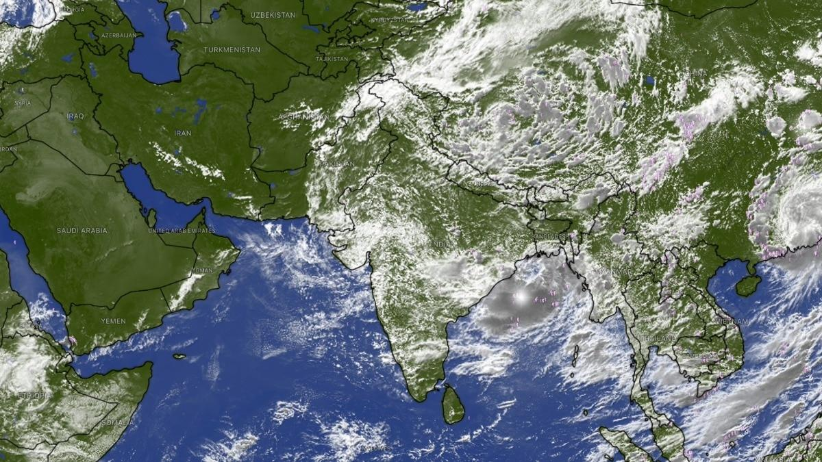
Four days ago, India's landmass nearly vanished from view from the skies. The Indian Space Research Organisation (Isro)'s weather satellites, parked far above the equator, found almost nowhere left to look through, as a cloud sheet stretched from the Arabian Sea to the Bay of Bengal and covered close to 95 per cent of the country. That peak has passed, but the sheet has not broken up. Based on the latest thermal infrared, cloud top brightness temperature and water vapour imagery captured by Isro's Insat 3DR and Insat 3DS satellites, and released through the India Meteorological Department (IMD), somewhere between 88 and 92 per cent of India's landmass, call it roughly 90 per cent, is under cloud cover at this moment. Read Full Story Both figures come from reading separate satellite channels closely against IMD's own written bulletins, rather than a single official pixel-count released for public use, so they are close, defensible estimates rather than laboratory-grade readings. So to be clear: 95 per cent was the peak, recorded around 21 to 22 July. Roughly 90 per cent is where things stand today, a slight easing, not a clearing. And a cloud sheet still this large is never just scenery. It is fuel, hanging over the country right now, waiting to fall. IMD's latest bulletin spells out exactly where that fall is headed over the coming week. WHAT DOES TODAY'S CLOUD COVER LOOK LIKE FROM SPACE? The latest thermal infrared images show clouds still dominating central and eastern India, Bay of Bengal and the northeast, with a dense, cold cluster visible over the Odisha-Andhra coast. Western Rajasthan and parts of the desert belt remain the clearest patches on the map, much as they were during the earlier peak. That pattern traces the monsoon trough, a belt of low pressure across northern India that governs where rain falls in the days ahead, not just where cloud sits today. Cloud top brightness temperature imagery showing the coldest cloud tops sitting directly over the Odisha-Andhra coast. (Photo: IMD) The IMD's latest bulletin places the trough south of its normal position, with a low-pressure area that formed over the northwest Bay of Bengal and adjoining West Bengal coast now lying over that same stretch of coast. This system, the IMD says, is likely to meander over the same region and become more marked over the next two to three days, which means the cloud sitting over eastern India right now is set to intensify rather than clear. HOW MUCH RAIN WILL THIS LEVEL OF CLOUD COVER BRING OVER THE COMING WEEK? The IMD's seven-day rainfall forecast, issued alongside this imagery, gives a direct, region-by-region answer for what happens next. Himachal Pradesh, Jammu and Kashmir, and Uttarakhand are forecast to get fairly widespread to widespread rain through the end of the month, with isolated heavy rainfall continuing for most of that period. Water vapour imagery showing dry air still sitting over Pakistan and western Rajasthan while the rest of India stays moist. (Photo: IMD) Chhattisgarh and East Madhya Pradesh face a similar run of widespread rain across nearly the entire seven-day outlook, while Odisha, sitting directly beneath the strengthening low-pressure system, is forecast to get very heavy rainfall. By contrast, the IMD's forecast keeps south peninsular India, including Tamil Nadu, Rayalaseema and interior Karnataka, largely in the "isolated to scattered" category through the coming week, the driest classification on its scale, confirming the coming rain will follow the same uneven pattern the satellite images already show. WHERE WILL THE HEAVIEST RAIN LAND OVER THE NEXT FEW DAYS? The clue sits in cloud top brightness temperature, or CTBT, which tells forecasters how tall a cloud has grown, using a simple rule of physics: air cools as it rises, right up to a layer called the tropopause, roughly the ceiling of the atmosphere that makes our weather. The colder a cloud's top reads from space, the taller and more capable of heavy rain it is. The latest CTBT imagery shows the coldest, tallest cloud tops sitting over the Odisha-Andhra coast and the Bay of Bengal, exactly where the IMD's low-pressure system now sits. With that system expected to become more marked over the next two to three days rather than weaken, Odisha and the surrounding coast should expect the current spell of extremely heavy rainfall to continue before any easing. WILL THE WESTERN DRY POCKET STAY DRY OVER THE COMING WEEK? Largely, yes, though not entirely. The latest water vapour imagery still shows a long, dark band of dry air sitting over Pakistan, Afghanistan and India's own north-western desert. The IMD's forecast reflects this, keeping West Rajasthan mostly in the "isolated to scattered" rainfall category through much of the coming week. There is one live exception. A low-pressure system over southwest Rajasthan is driving fresh extremely heavy rainfall. (Photo: PTI) The IMD's latest bulletin confirms a separate low-pressure area, which had earlier lain over southeast Rajasthan, has moved westward and now sits over southwest Rajasthan and neighbourhood. This system is what drove the exceptionally heavy rainfall recorded over Gujarat in the recent 24-hour period, with isolated extremely heavy rainfall likely to continue over Gujarat, even as the desert belt further west and north stays largely untouched. SO HOW LONG WILL THIS LEVEL OF CLOUD COVER AND RAIN LAST? The IMD's latest outlook does not describe conditions easing back to normal any time soon. Both the Bay of Bengal low and the Rajasthan low are forecast to remain active and intensify over the next two to three days, keeping central, eastern and northwestern India under significant cloud and rain through the end of the month. South peninsular India is expected to remain comparatively drier over the same period. Expect the next satellite pass to show cloud cover still sitting somewhere in the high 80s to low 90s, well below the peak of 95 per cent but far from clearing, with the heaviest rain continuing to track wherever these two low-pressure systems happen to sit. - Ends Published By: Radifah Kabir Published On: Jul 26, 2026 13:29 IST

4. From Aadhaar to ISRO: What the six-member NTA reform panel brings to the table - Moneycontrol.com
Read more

From Aadhaar to ISRO: What the six-member NTA reform panel brings to the table The six-member panel brings together experts from technology, space research, intelligence, cybersecurity, education administration and logistics to recommend structural and technological reforms for a more secure, transparent and accountable NTA. Moneycontrol News

5. ISRO Bengaluru receives hoax bomb threat, investigation underway - The News Mill
Read more

ISRO Bengaluru receives hoax bomb threat, investigation underway The News Mill

6. NASA Astronaut Chris Williams, Crewmates Return from Space Station
Read more
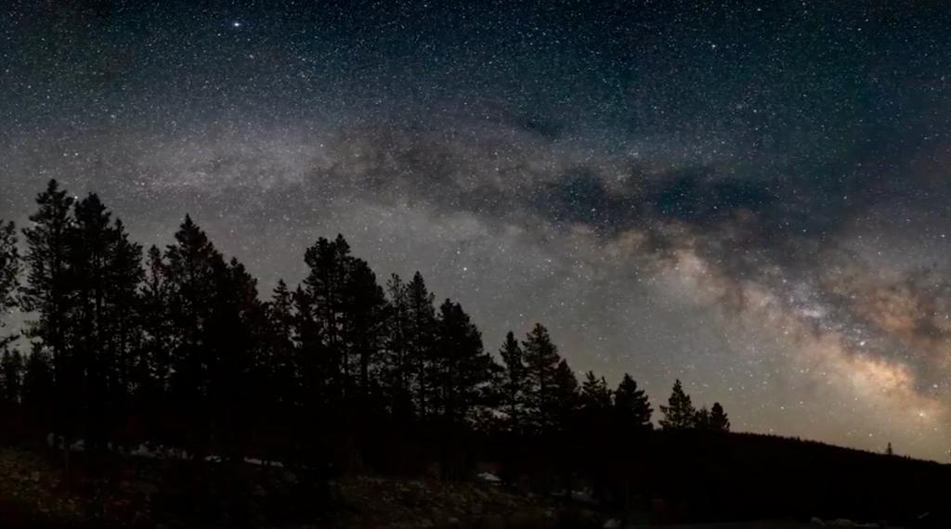
The Soyuz MS-28 spacecraft is seen as it lands in a remote area near the town of Zhezkazgan, Kazakhstan with Expedition 74 NASA astronaut Chris Williams, and Roscosmos cosmonauts Sergey Kud-Sverchkov, and Sergei Mikaev aboard, Sunday, July 26, 2026. NASA/Bill Ingalls Concluding an eight-month science mission aboard the International Space Station, NASA astronaut Chris Williams returned to Earth on Sunday alongside Roscosmos cosmonauts Sergey Kud-Sverchkov and Sergei Mikaev. The crew made its safe, parachute-assisted landing at 5:27 a.m. CDT (3:27 p.m., Kazakhstan time), southeast of Dzhezkazgan, after departing the space station at 2:03 a.m., aboard the Soyuz MS-28 spacecraft. The crew was in space for 241 days, orbiting the Earth 3,856 times and traveling more than 102 million miles. They launched to the International Space Station on Nov. 27, 2025. The mission was the first for Williams and Mikaev and the second for Kud-Sverchkov. While aboard the orbiting laboratory, Williams supported a wide range of scientific investigations and technology demonstrations. He helped advance research for new cancer treatments and improved in-space manufacturing of materials used in high-performance computers and electronics. Williams also completed two spacewalks to prep for space station power system upgrades and to replace a faulty joint on the Canadarm2 robotic arm. The crew's work aboard the space station helps improve life on Earth and prepare for future human missions to the Moon and Mars. Following post-landing medical checks, the crew members will fly by helicopter to Karaganda, Kazakhstan, where recovery teams are based. Williams then will board a NASA aircraft bound for the agency's Johnson Space Center in Houston. For more than 25 years, people have lived and worked continuously aboard the International Space Station, advancing scientific knowledge and making research breakthroughs not possible on Earth. The space station helps NASA understand and overcome the challenges of human spaceflight, expand commercial opportunities in low Earth orbit, and build on the foundation for long-duration missions to the Moon, as part of the Artemis program, and to Mars. To learn more about International Space Station research, operations, and its crews, visit: www.nasa.gov/station -end- Joshua Finch / Jimi Russell Headquarters, Washington 202-358-1100 joshua.a.finch@nasa.gov / james.j.russell@nasa.gov Leah Cheshier / Anna Schneider Johnson Space Center, Houston 281-483-5111 leah.d.cheshier@nasa.gov / anna.c.schneider@nasa.gov

7. I'm not an astronaut, but I went to the International Space Station (sort of)
Read more
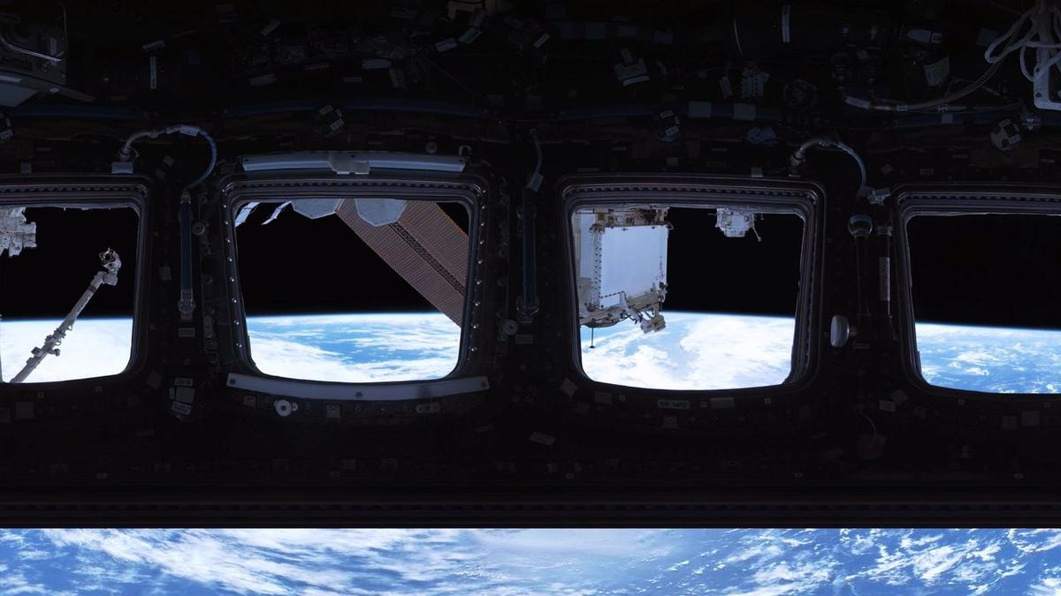
Click for next article NEW YORK - I'm the kind of person who, every so often, falls into accidental daydreams about the concept of space. Usually because I'm listening to some sort of sad girl Spotify playlist, I start feeling infuriated that we may never learn the true meaning of the cosmos and become embarrassingly poetic about our isolation on Earth. I tend to ponder how strange microgravity is and begin Googling things like "what lies beyond the edge of the universe best evidence we have" and "when commercial rocket launch become same price JetBlue flight." I'm pretty sure I've lived in these clouds ever since I got past the Freddi Fish and Microsoft Paint phase of my internet literacy - but then, a month before my 30th birthday, something huge happened. On a random Tuesday, I woke up, brushed my teeth, made myself an espresso, sauntered over to the Franklin Avenue C, and went to the International Space Station . Once I got there, it was bizarre to float through the corridors and living quarters I've written about for so long as a science journalist and thought about for even longer. The walls felt lived in. The station's speed in orbit seemed a little too fast for comfort. The highly esteemed cupola - a protruding corner of the station with seven windows arranged in the shape of a daisy - was far larger than I imagined. In fact, the entire ISS was way more enormous than I can explain. Solar panels tower over you like rust-colored billboards and the station's floors threaten to collapse any second, fooling you as you gaze down at Earth . It's a little scary to be so exposed to the void of space, and that's true even when you're there in virtual reality. Yes, unfortunately (or fortunately, depending on your caution levels) I launched to the ISS through a virtual reality experience called " Space Explorers: The ISS Experience " shown at Eclipsio in Manhattan. It's probably the closest I'll ever get to the real thing, until of course my dream of a cheap RocketBlue economy seat becomes possible. And most importantly, I'm here to tell you that if you're ever able to do the same, you should do it, too. Here's what you'd see The way it works is you put on some VR glasses and follow instructions in your headset to walk a certain direction or move your hands a certain way - your "hands" in the digital world look like floating yellow outlines of hands that correspond to the movements of your actual hands. To be transparent, my glasses were a bit glitchy. My digital hands were quite a bit unstable, for example, which did distract me a little bit but it was easy to get over. Okay, once you're in the world of space, which is simply darkness, a few things happen (which I won't spoil). Eventually, a life-size structure of the International Space Station (ISS) appears. Suddenly, you're within the station. The interior of this structure isn't totally accurate to reality, to be clear. It's a gray, translucent rendering of the ISS's insides that you can explore. Still, the size is meant to be true to life. People walking around the Eclipsio space during the show. (Image credit: Space Explorers: The ISS Experience) Along the way, you can touch giant floating orbs that bring you a short snippet of video to watch. It is because of these snippets that I think this show is 100% worth it. Each one corresponds to the location in which the orb sits - a cupola orb might show you a couple of astronauts floating around and looking out the window, while one near the gym equipment might bring you straight into a training session with Artemis II mission specialist Christina Koch. Perhaps you'd like to venture "outside" and float eye-level with the station's robotic arm. In your periphery to the left, a spacewalker traverses the exterior of the station. To the right, the Earth is majestic. In front of you, sunlight hitting the laboratory's worn white walls causes a realistic glare. You can't help but squint. And the reason these snippets are outstanding is that they are made with real footage from the ISS. A still from Space Explorers: The ISS Experience. (Image credit: Space Explorers: The ISS Experience) A show made by astronauts I sat down with Félix Lajeunesse, co-founder of Felix & Paul studios - the organization behind the exhibit - to learn how this was possible. What does it take to recreate the ISS with this level of detail, and this level of soul? "It took about a year and a half to two years to just prepare for this project, and eventually cameras were sent up there in space," he said. "That was the beginning of a three year production." More specifically, the footage you see in this VR show was filmed across six NASA expeditions and involved shipping three cameras to space - two cameras operating inside the ISS and one camera designed to function in the vacuum of space. That latter camera was attached to the Canadian robotic arm on the exterior of the station and operators on the ground could remotely control it to achieve the cinematic quality they wished. The astronauts first put it on the sliding table of the ISS's Japanese module. Then, the camera was egressed from the station and the robotic arm could pick it up. When it came to the interior cameras, however, that's where the astronauts themselves stepped in. "It's not a traditional camera - it's a virtual reality camera," Lajeunesse said. "So, if you're going to be around a table, for example, having coffee together in the morning, well, this camera is not going to be in the middle of the table because no one would ever be there. It will be at the same height as the rest of you around the table because in the end it's going to be replaced by a person being there with you." "This kind of anthropomorphic idea that the camera is a person really resonated with them," he added. In order to ensure the camera didn't interfere with the many experiments and procedures on the station Lajeunesse and his team made sure to send the astronauts what he calls a "shooting script" for each day of work. This script explained which different camera positions were desired; if anything wasn't possible, the astronauts would offer suggestions of better locations. "We had this ongoing conversation with them during the production, as if it was on a real set, essentially," Lajeunesse said. And speaking with Lajeunesse, it became remarkably clear that this show wouldn't have been as heartfelt as it is without the astronauts' own desire to create it. It seems like the astronauts wanted to be able to share their indescribable experience of living beyond our planet with those stuck on it. This is a way for them to show their families the place they used to call home. The team even made sure to premiere the U.S. version of the show at Houston, Texas, often called "Space City" because that's where NASA astronaut training happens at the agency's Johnson Space Center . "Our first audience in the United States were the astronauts," Lajeunesse said. "It was quite an extraordinary and emotional turnout - almost all of them referred to experiencing this as going back home." A time capsule for future generations As upsetting as it is, the International Space Station isn't forever. Unless a potential boosting mission reaches fruition, it'll be de-orbited and mostly lost in the flames of reentry in the year 2030. Its charred remnants will probably be placed in museums. One day, those museums will be visited by people who never lived during a time when you just knew the iconic lab was up there somewhere in the sky. When that day comes, this ISS show will grow in sentimental value. It may end up offering the only way for ISS astronauts to go "home." "VR points to the capacity to create simulations that are just as rich and vibrant and open and possibilities than reality itself." Lejeuneusse said, comparing it to console video games or movies. "I think it's probably the most human medium there's ever been." He hopes that, someday, VR will improve to the point where it becomes possible to generate open worlds that we can all be a part of together. Perhaps, he says, artificial intelligence will be a big part of that. "This feeling of witnessing the Earth, this sense of the overview experience is something pretty special, pretty emotional for people, and something that could not be communicated through any other media," he said. As for what's next? The team is working on a show in Las Vegas called Interstellar Arc , a science fiction futuristic VR experience that Lajeuneusse says is even more interactive than this International Space Station one. But still, he emphasizes that while future VR shows may continue to increase in capabilities, there will always be something profound about the ISS project. "You know, the International Space Station is one of the most extraordinary examples of human collaboration; human cooperation. It's many different countries, some of them which are opponents at the political stage, that kind of all came together to build this enormous structure in space habitat where humans can go and live," he said. "It was all built through cooperation, and it's all maintained through cooperation." "When they're up there, they're kind of like a microcosm of humanity," he added. "Just the fact that it exists, just the fact that it continues to exist. We should marvel at that."

8. China's new alloy can withstand extreme heat; could be used in reactors, hypersonic missiles
Read more

In a breakthrough that could reshape the future of aerospace and advanced engineering, researchers in China have developed a new metal alloy capable of maintaining its strength at temperatures as high as 2,400 degrees Celsius. The innovation addresses one of the biggest challenges in materials science-creating metals that remain structurally stable under extreme heat while continuing to bear heavy mechanical loads. Already known for its exceptionally high melting point The research, led by a team from Xi'an Jiaotong University, centres on a specially engineered tantalum-based alloy. Tantalum is already known for its exceptionally high melting point of nearly 3,000°C, making it one of the most heat-resistant metals available. However, even tantalum alloys have traditionally suffered from a loss of strength at very high temperatures. The Chinese researchers claim to have overcome this limitation by designing an alloy with an optimized internal microstructure that resists deformation even in extreme thermal environments. Modern technologies such as hypersonic aircraft, reusable spacecraft, advanced rocket engines and next-generation nuclear reactors require materials that can survive enormous temperatures without weakening. Conventional high-performance alloys, including nickel-based superalloys widely used in jet engines, begin to lose their mechanical strength as temperatures approach 2,000°C. Newly developed alloy remains capable of supporting heavy loads The newly developed alloy reportedly remains capable of supporting heavy loads at temperatures up to 2,400°C, representing a significant improvement over existing high-temperature structural materials. Metals generally become softer as temperatures rise because their internal crystal structures become more mobile. Once temperatures exceed roughly 60% of a metal's melting point, atoms can move more freely, causing the material to deform under stress. According to the researchers, the new tantalum alloy has been engineered with a carefully controlled microscopic structure that slows this process. By stabilising the material's internal arrangement, the alloy retains its strength even under conditions that would normally weaken conventional metals. The findings were published in the peer-reviewed journal Nature, highlighting the scientific significance of the work. If the material performs similarly outside laboratory conditions, it could have wide-ranging industrial applications, including hypersonic missile and aircraft components, rocket nozzles and combustion chambers, spacecraft thermal protection systems, advanced gas turbines, and nuclear reactor components. The ability to operate safely at such extreme temperatures could improve engine efficiency, extend component lifespan and reduce cooling requirements in demanding engineering environments. While the laboratory results are promising, commercial adoption will require further testing. Scientists must demonstrate that the alloy can be manufactured economically, withstand repeated heating and cooling cycles, resist oxidation and corrosion, and perform reliably over long service periods. Tantalum is also an expensive metal, meaning large-scale industrial use will depend on whether production costs can be reduced without compromising performance. The development reflects the growing pace of innovation in advanced materials research. As countries compete to build faster aircraft, more efficient space vehicles and safer nuclear technologies, breakthroughs in high-temperature alloys are becoming increasingly important. If successfully commercialized, the new tantalum-based alloy could expand the limits of engineering design, enabling machines and vehicles to operate in environments previously considered too extreme for conventional metals.
9. ISRO Recruitment 2026 Notification PDF Out for 244 Assistant, UDC, JPA, and Steno Posts, Application Dates, Eligibility - Adda247
Read more
ISRO Recruitment 2026 Notification PDF Out for 244 Assistant, UDC, JPA, and Steno Posts, Application Dates, Eligibility Adda247

10. Assam floods: Isro's Nisar satellite captures Brahmaputra's might from space - India Today
Read more

As Assam grapples with another devastating flood season, India's latest Earth observation satellite, Nisar, has captured a stunning close-up view of the mighty Brahmaputra River, revealing its vast network of braided channels, islands and floodplains from space. The image, acquired on July 9, 2026, covers a section of the Brahmaputra near Debitala in Assam, extending towards the West Garo Hills of Meghalaya. It showcases the river's enormous width and constantly shifting network of channels that make the Brahmaputra one of the most dynamic rivers in the world. The dark ribbons cutting across the image represent the river's multiple water channels, while the lighter surrounding areas show floodplains, vegetation and inhabited landscapes. The river collects water from glaciers, snowmelt and intense rainfall. (Photo: Isro) The image highlights how the Brahmaputra does not flow through a single channel but spreads across a wide valley, splitting and rejoining around dozens of sandbars and river islands known as chars. The satellite observations come as Assam continues to battle severe flooding. This year's floods have claimed 68 lives and affected more than 5.24 lakh people, with several districts remaining inundated. Developed jointly by the Indian Space Research Organisation (Isro) and NASA, Nisar is designed to monitor changes on Earth's surface with unprecedented precision. Unlike conventional optical satellites, its radar can image the ground through clouds and during both day and night, making it especially valuable during the monsoon when thick cloud cover limits traditional satellite observations. The detailed imagery helps scientists map river channels, monitor erosion, identify flooded regions and track how the Brahmaputra changes course over time. These observations are crucial because the river is constantly reshaping its banks, eroding land in one place while depositing sediment in another, making Assam one of India's most flood-prone states. Currently in its science operations phase, Nisar is collecting observations across the globe while its data is processed by Isro's ground stations and the National Remote Sensing Centre. For a river as powerful and unpredictable as the Brahmaputra, the satellite's regular observations offer an unprecedented view of its changing landscape, helping scientists and disaster managers better understand floods and improve future preparedness. - Ends

11. Before Team Nilekani, ex-ISRO chief-led panel tried to fix exams - The Indian Express
Read more
As the Supreme Court on Monday (July 27) heard petitions seeking changes to the conduct of the NEET examination after the 2026 paper leak controversy, the Centre informed the court that it has constituted a high-powered committee under entrepreneur and Infosys cofounder Nandan Nilekani to recommend the next phase of examination reforms. This came on the same day the Central government introduced the Public Examinations (Prevention of Unfair Means) Amendment Bill in Lok Sabha to strengthen the anti-paper leak law and increase the punishment for those involved in paper leaks. The Centre's decision regarding the Nilekani-led committee has brought attention to an earlier reform blueprint: the K Radhakrishnan Committee report. The Committee, which was constituted in 2024 after the NEET-UG 2024 paper leak controversy, submitted a report containing 101 recommendations "with short term, medium term and long-term perspective". The report was prepared under former ISRO Chairman Dr K Radhakrishnan and submitted to the Ministry of Education in October 2024. The panel said that the report was developed after "twenty-three formal full-day physical sittings" and more than 37,000 responses received from students and parents through the MyGov portal. Its stated vision was to transform the National Testing Agency (NTA) into "a nimble, zero-error, adaptive and integrative process". Why was it constituted? Constituted amidst "the rousing public concern on the integrity of entrance tests after reports of breaches and leakage of question paper", initially, the Ministry of Education asked the panel to recommend reforms in three areas: improving examination processes, strengthening data security, and reviewing the NTA's structure and functioning. Its mandate later expanded after directions from the Supreme Court in Vanshika Yadav v. Union of India. The additional terms of reference included examination security and administration, technological safeguards, policy and stakeholder engagement, international collaboration, staff training, and mental-health support for students. What did it find? Instead of treating paper leaks as isolated incidents, the report argued that vulnerabilities existed across the entire examination ecosystem. It mapped weaknesses throughout what it called the "Testing Life Cycle" - from printing and transporting question papers to candidate verification, examination centre management, and grievance redressal. The report found that the NTA had been "operating as a single window agency" despite having "conducted more than 240 examinations since its inception involving over 5.4 crore candidates". It concluded that the agency's "present capacity and internal domain expertise need to be augmented". Replacing physical transport with digital delivery The report's central technological recommendation was Computer-assisted Secure Pen-and-Paper Testing (CPPT), designed "to eliminate potential breaches during the printing, storage and transportation chains" of question papers. Instead of printing papers at central presses and transporting them across the country, encrypted question papers would be transmitted electronically to secure servers at examination centres and printed there shortly before the examination. At the same time, candidates would continue writing conventional pen-and-paper tests. Also read | NEET and beyond, a systematic assault on education By eliminating the need to transport printed question papers over long distances, the committee believed the model would significantly reduce opportunities for leaks during transit. DIGI-EXAM The committee also proposed a digital authentication framework called DIGI-EXAM, modelled "on the lines of 'Digi Yatra'", to ensure "that ONLY the candidate writing the exam joins the intended programme". Instead of verifying candidates only on examination day, the system envisaged a continuous "multi-stage authentication of candidate's" across application, examination, and admission stages using Aadhar, biometrics, and AI-based analytics. A complete overhaul of the NTA The report argued that technology alone would not solve the NTA's problems. It said the agency needed stronger institutional capacity and should reduce dependence on outsourced agencies for critical examination functions. Former ISRO Chairman Dr K Radhakrishnan. The report was submitted to the Ministry of Education in October 2024. Photo: Wikimedia Commons Former ISRO Chairman Dr K Radhakrishnan. The report was submitted to the Ministry of Education in October 2024. Photo: Wikimedia Commons It recommended that the NTA's Governing Body "be recast as an empowered and accountable Apex Body" headed by a Director General "not below the rank of Additional Secretary to GoI". It also proposed creating 10 dedicated verticals within the agency, including Nation-wide Testing Centre Infrastructure, Information Security, Vigilance and Forensics, and Research and Development. Testing centres To reduce dependence on private vendors, the committee recommended developing "at least 1,000 SecureTesting Centres… in a phased manner, in reputed Government institutions," in accessible locations requiring power supply, seating requirements, technical support and candidate support facilities such as lockers for phones, ventilation in exam halls, help desks, and waiting areas for families of the candidates. For remote and underserved regions, it proposed mobile testing centre buses equipped with laptops and servers that would function as fully operational examination centres for around 150 candidates. For examinations involving very large numbers of candidates, the report recommended moving towards Multi-Session Testing spread over several days or weeks. It also described Multi-Stage Testing for NEET-UG as "a viable possibility". Where multiple sessions are held, it stressed that score normalisation should be transparent and properly established and documented. Over the longer term, it also recommended gradually shifting towards Computer Adaptive Testing, in which question difficulty adjusts according to a candidate's performance. Mental health The report also placed considerable focus on student welfare to make their approach "holistic". Its recommendations included creating a dedicated mental-health cell within the NTA, tele-helplines, counselling services, and teacher sensitisation programmes. It also suggested that "a suitable oversight mechanism may be considered for Coaching Institutes", citing concerns over student stress and the financial burden placed on families. Newsletter Follow our daily newsletter so you never miss anything important. On Wednesday, we answer readers' questions. Subscribe The committee recommended equipping the NTA's Grievance Reporting and Redressal Cell with AI and machine learning-based interactive chatbots so that candidates could "receive clarifications in the language of their choice" for queries that arise during the examination process. On implementation Recognising that expert reports often remain on paper, the committee proposed establishing "a high-powered steering committee" under the Ministry of Education to oversee implementation of its recommendations "in mission mode and within a time frame". The proposed body, it said, would mentor the NTA, help overcome implementation bottlenecks and submit regular progress reports to the ministry.

12. Venezuela earthquakes shifted ground by nearly 2 feet, NASA-ISRO satellite finds | To read what more the satellite found | Inshorts - Inshorts
Read more

- - - Venezuela earthquakes shifted ground by nearly 2 feet, NASA-ISRO satellite finds - - - - - - - - inshorts Venezuela earthquakes shifted ground by nearly 2 feet, NASA-ISRO satellite finds Data from the NASA-ISRO NISAR satellite revealed that twin earthquakes in northern Venezuela on June 24 shifted parts of the ground by nearly two feet. The magnitude 7.2 and 7.5 tremors struck 39 seconds apart, killing more than 5,000 people. The analysis marked the first use of NISAR's Urgent Response system for a natural disaster. tap for more at Firstpost / yesterday To read what more the satellite found Tap here Share Load More

13. Starship in space! See highlights of SpaceX megarocket's epic Flight 13 test launch (video)
Read more
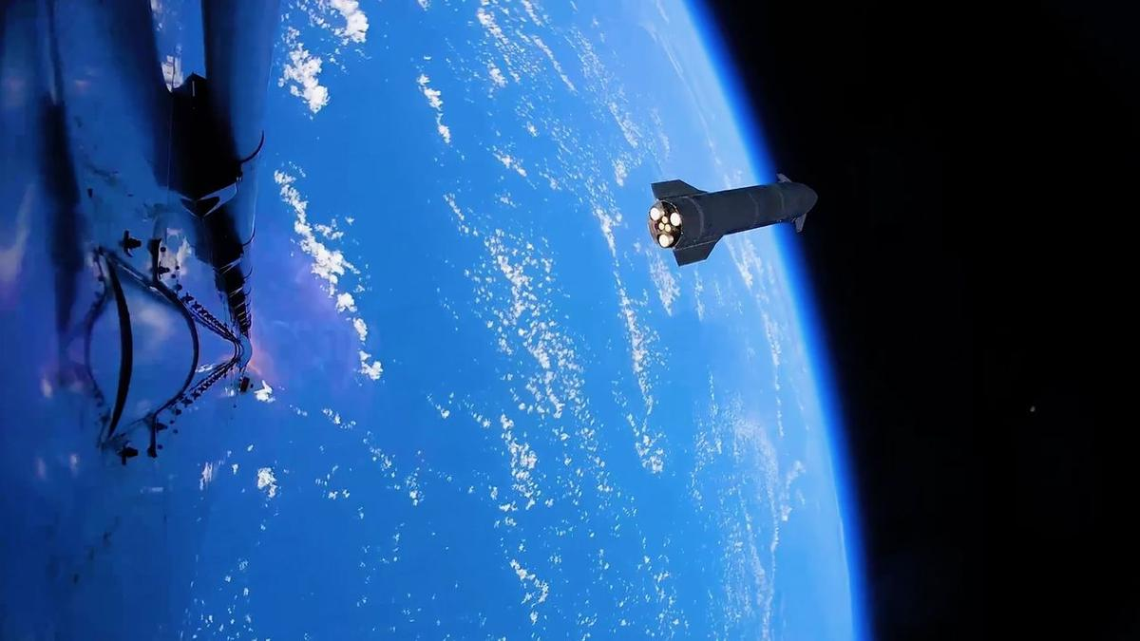
Click for next article The 13th test flight of SpaceX's Starship megarocket went pretty well - and provided some amazing visuals, too. Flight 13 launched on Friday (July 24), sending the 408-foot-tall (124 meters) Starship Version 3 (V3) vehicle aloft from SpaceX's Starbase site in South Texas. Starship's Super Heavy booster had some engine issues on its way back to Earth. But the Ship upper stage hit all of its marks, successfully deploying 20 next-gen Starlink satellites, re-igniting one of its Raptor engines in space as planned and splashing down softly off the coast of Western Australia. So softly, in fact, that Ship didn't explode after hitting the water - a first for a Starship flight. The two stages of SpaceX's Starship megarocket separate during the vehicle's 13th test flight, on July 24, 2026. (Image credit: SpaceX) SpaceX shared these milestones with us in real time, via the company's Flight 13 launch webcast. And the company highlighted a few of them after the fact as well, with some stunning imagery published on its X account. One Friday post , for example, shows footage from Super Heavy of Ship cruising away shortly after stage separation, its six Raptors glowing with exertion against the backdrop of a gorgeously blue Earth . Another Friday X post provides a Ship's-eye view of the vehicle's descent toward the Indian Ocean, steering its way from sky to sea. The video switches over to drone footage just before Ship hits the water, capturing from above the dramatic splashdown - and Ship's survival, despite the outbreak of a sizeable fire around its nose. $39.99 at Amazon Starship Die Cast Rocket Model Was $47.99 Now $39.99 on Amazon. Even if you can't see SpaceX's Starship in person, you can score a model of your own. Standing at 13.77 inches (35 cm), this is a 1:375 ratio of SpaceX's Starship as a desktop model. The materials here are alloy steel and it weighs just 225g. Both Ship and Super Heavy are designed to be fully and rapidly reusable. Eventually, both vehicles will return to the launch site shortly after liftoff, for capture with their launch tower's "chopstick" arms, refurbishment and reflight. SpaceX has already caught Super Heavy on three Starship test flights and will try to do the same with Ship for the first time on Flight 14, provided no red flags emerge during Flight 13 data review, according to SpaceX founder and CEO Elon Musk . Starship conducted its first test flight in April 2023. Flight 13 was the second launch Version 3 of the vehicle, the first iteration of the vehicle that's designed to be operational.

14. Rocket Lab to start launching missile-defense missions from Alaska under $266 million Space Force deal
Read more
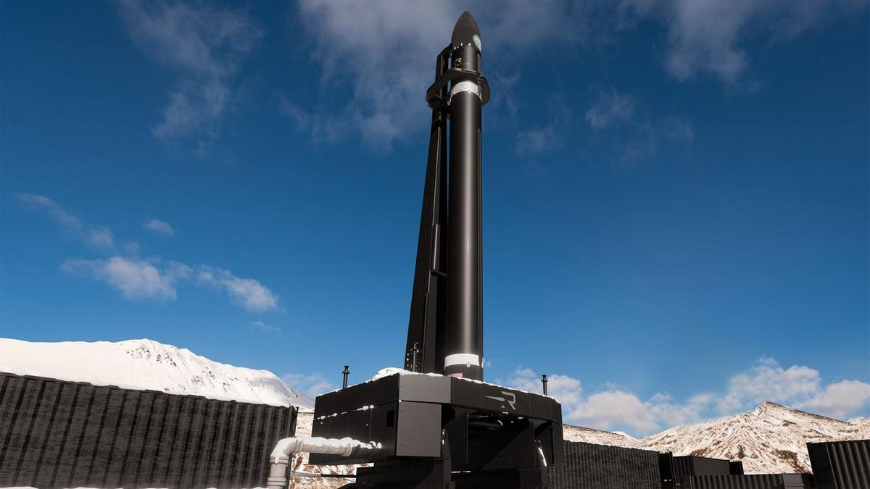
Click for next article Rocket Lab has signed a contract with the U.S. Space Force to launch up to 18 missile-defense missions, most of them from the Pacific Spaceport Complex in Alaska. Rocket Lab is expanding its launch operations to the snowy north. The California-based company, which already flies from New Zealand and Virginia, just inked a $266 million deal with the U.S. Space Force to fly up to 18 missile-defense missions , most of them from Alaska. "The size and scale of this contract reflects the Space Force's confidence in our ability to meet their urgent national security demands with speed, responsiveness and scale, and we're proud to provide the high-frequency launch capacity required to keep the U.S. ahead of global threats," Rocket Lab founder and CEO Peter Beck said in a statement today (July 27). The contract covers 12 suborbital launches, with the possibility of up to six more. These missions "will primarily take place" from the Pacific Spaceport Complex , a picturesque site on Alaska's Kodiak Island, which is most famous for its thriving population of brown bears. The spaceport has hosted nearly three dozen missions since opening in 1998, most of them suborbital flights for the U.S. military. Recently, however, it has supported launches of private orbital rockets - specifically, those built by Astra and ABL Space Systems (now known as Long Wall). The newly announced Rocket Lab missions will almost certainly be performed by HASTE , a suborbital variant of the company's workhorse Electron small-satellite launcher that customers use to test hypersonic technologies in the flight environment. They may also be part of the United States' sprawling Golden Dome missile-defense initiative, though we don't know that for sure; today's release provides few details about the launches. A Rocket Lab HASTE suborbital rocket launches on the "Prometheus Run" mission for the U.S. military on Nov. 18, 2025. (Image credit: Rocket Lab) Rocket Lab's primary launch site is on Māhia Peninsula, on the North Island of Peter Beck's native New Zealand. The company also flies from two pads on Wallops Island, Virginia, one of which has been the jumping-off point for all HASTE suborbital launches to date. HASTE debuted in June 2023 and now has nine missions under its belt. Electron lifted off for the first time in May 2017 and has flown 82 times to date.

15. Curiosity Mars rover inspects cracked wheel | Space photo of the day for July 27, 2026
Read more
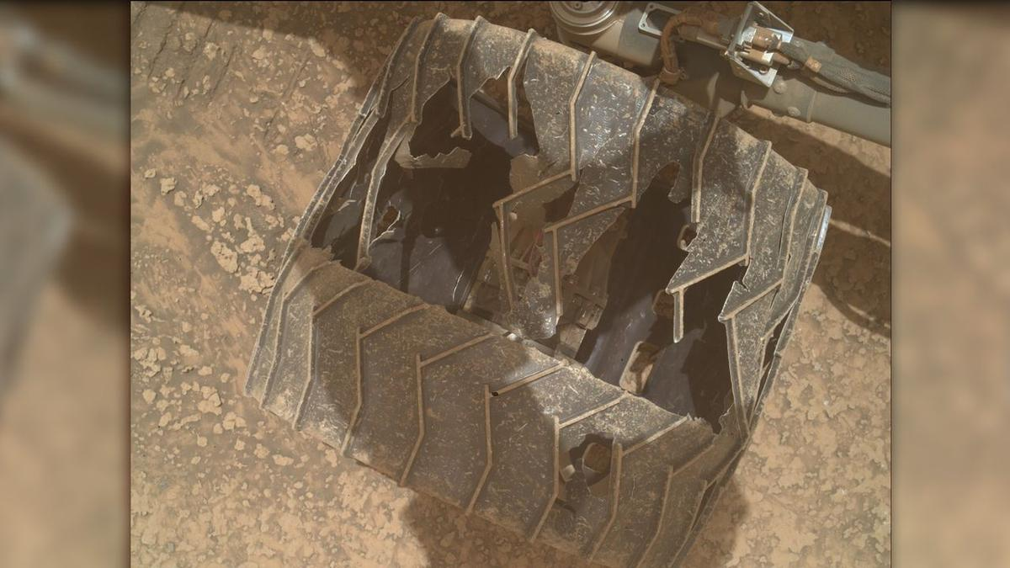
Click for next article A photo of one of NASA's Curiosity Mars rover's wheels, taken by the rover using its Mars Hand Lens Imager (MAHLI) on July 23, 2026, or Sol 4963 of its mission. (Image credit: NASA/JPL-Caltech/MSSS) NASA's Curiosity Mars rover has experienced some serious wear and tear during its nearly 14 years on the Red Planet. A new photo posted to Curiosity's raw image server offers a close-up of the damage one of the rover's wheels has experienced as it explores the Martian surface . What is it? Curiosity landed in Mars' Gale Crater on Aug. 5, 2012, touching down while hanging under a 'sky crane' that lowered it to the planet's surface. Since then, the rover has traveled over 20 miles (32 kilometers) across the rocky Martian soil, searching for potential signs of ancient life on the Red Planet. All of that mileage has taken a toll on the rover, as these new images show. Curiosity weighs over one ton, and the terrain on Mars can be quite rocky and rugged. NASA and the Jet Propulsion Laboratory (JPL) periodically use the rover's cameras to check on the wheels, and despite the holes and cracks, the agency said in a 2024 statement that they're "holding up well despite taking some of the worst abuse from Mars." Images of NASA's Curiosity Mars rover's wheels, taken by the rover on July 23, 2026, or Sol 4963 of its mission. (Image credit: NASA/JPL-Caltech/MSSS) Why is it amazing? We've been exploring Mars for decades now, so it can be easy to take for granted how incredible it is that we get new images beamed from the surface of another planet to Earth daily from NASA's two robotic explorers. These images of Curiosity's wheels help illustrate the incredible feats of engineering and science it took to place wheeled robots safely on the surface of another planet where they spend years and travel dozens of miles to bring us answers about what other worlds are like. While they might not be human, Curiosity and Perseverance nonetheless represent humanity's first foray into becoming an interplanetary species. The groundwork laid by the rovers and other Mars orbiters, landers and probes could someday help humanity take its first steps on another planet.

16. How NASA plans to build the Habitable Worlds Observatory
Read more

We've been covering the journey of the Habitable Worlds Observatory for some time now. Over the past few years, it's gone from a proposal to a relatively fleshed-out plan for how and what the next Great Observatory should do-in this case, look at and characterize potentially habitable exoplanets.

17. Could we send a spacecraft to a black hole?
Read more

Black holes represent some of the most extreme environments in the universe. They are the sources of the strongest gravitational fields, allowing us to test Einstein's theory of general relativity to an extent impossible with small objects. But we are also reaching the limit of what we can learn about one remotely. So, various authors have put forward ideas for how we might eve...

18. Are we missing alien lighthouses?
Read more

Searching for extraterrestrial intelligence has so far primarily meant focusing on one particular type of signal-and that signal has normally been based on our own current cutting-edge technology. But what if that's the wrong way to look for signs of alien intelligence? What if a resource-conscious civilization decided it was too complicated to send femtosecond lasers in high-e...
19. ISRO Recruitment 2026 Notification Out For 244 Posts; Apply Here - NDTV
Read more
ISRO Recruitment 2026 Notification Out For 244 Posts; Apply Here NDTV

20. Deep Depression weakens, no new vortex over Bay of Bengal, Arabian Sea: Isro images - India Today
Read more
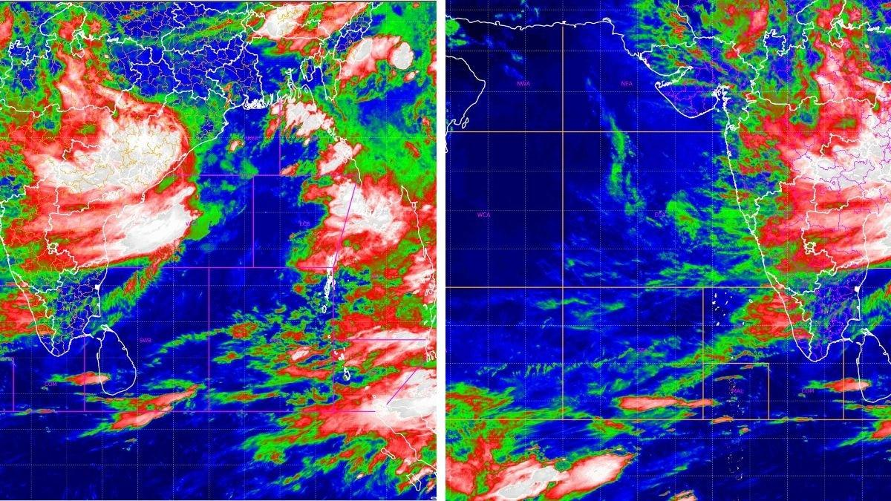
The monsoon has kept large parts of India under rain today. It might sound like several storms are converging at once, but the satellite picture and the India Meteorological Department (IMD)'s own tracking say otherwise. It is still one system, moving at a steady, unspectacular 12 kilometres an hour, and it is now deep enough inland that neither the Bay of Bengal nor the Arabian Sea is currently host to anything resembling a storm. WHAT DOES THIS MORNING'S ISRO SATELLITE IMAGE SHOW? The infrared picture, captured by INSAT-3DR, a weather satellite built by the Indian Space Research Organisation (Isro) and operated by the IMD, was taken between 4:45 am and 5:12 am IST today. It reads temperature rather than light. White and pale pink mark cloud tops colder than minus 70 degrees Celsius, the sign of the tallest, most intense thunderstorms; green and red mark milder clouds below that. Today's frame shows two features. A broad white and pink mass sits inland over the Chhattisgarh, Odisha and Madhya Pradesh belt, well away from the Bay of Bengal, where the system originally formed at sea, and that is the Deep Depression's rain engine. A second, separate bright patch has built up further west over Maharashtra, close to the Arabian Sea coast, produced by the same system pulling in moisture from the Arabian Sea and forcing it up against the Western Ghats, a process called orographic lift, rather than by any new storm forming at sea. WHERE EXACTLY IS THE DEPRESSION NOW, AND HOW FAST IS IT MOVING? According to the IMD, the Deep Depression that began over the northwest Bay of Bengal is moving west-northwest at 12 kilometres an hour, weakening gradually as it goes. ' That slow, grinding pace is normal. Monsoon depressions rarely race across the map. They crawl, and it is that crawl which lets them dump so much rain over any one place. IS A NEW VORTEX FORMING OVER THE BAY OF BENGAL? No. The northern Bay, where this depression was born four days ago, has gone quiet in today's image, showing only broken, scattered cloud rather than the tight, spinning mass that marks an organised low. A vortex, meaning a mass of air rotating around a low-pressure centre, needs a closed circulation to count as a genuine system, and there isn't one out there this morning. It helps here to keep the terms apart, because they get used loosely. A cyclonic circulation is simply air turning anticlockwise around low pressure, the loosest and weakest stage, often not even visible at the surface. If that circulation tightens and organises itself with a defined centre, it becomes a depression, then a Deep Depression as its winds cross 51 kilometres an hour, and eventually a cyclone if it strengthens further still out at sea. A vortex is the broader, more general term for any of these rotating air masses, whichever stage they happen to be at. So every depression is a vortex, but not every vortex is a depression, and what the Bay shows this morning is neither. There isn't a closed circulation there at all. WHAT IS HAPPENING OVER THE ARABIAN SEA TODAY? The central and northern Arabian Sea remain mostly clear in today's image, shown in dark blue, meaning warm sea and little cloud above it. There is cloud along India's west coast, feeding monsoon rain there, and a band of storms near the equator that belongs to the Intertropical Convergence Zone, or ITCZ, the permanent belt of showers that circles the globe where winds from the northern and southern hemispheres meet. A second cloud mass further west reflects the depression's moisture meeting a mountain range, feeding today's monsoon rain across the region. (Photo: IMD/ISRO) There is one small addendum worth mentioning. Earlier this week, forecasters had flagged a weak upper-air cyclonic circulation over the east-central Arabian Sea, sitting a few kilometres above the surface rather than at ground level. The IMD's own bulletin today describes that feature as having become less marked, in other words, weaker than before, not stronger. It was never a depression or a storm, only a subtle circulation aloft, and it is fading rather than building. WHAT DOES THIS MEAN FOR MONSOON RAIN GOING FORWARD? It means the current spell of rain has an identifiable end point, even if it is not immediate. As the depression weakens further over the next few days, the intensity of rain will ease from its current peak, though the moisture it has already pulled inland will keep skies cloudy and showers frequent across large parts of the country a while longer. With no new vortex building over either sea, there is nothing at present to hand the baton to once this system fades. WHAT SHOULD PEOPLE IN THE RAIN'S PATH DO? The advice remains unchanged from earlier this week. Stay off the water in the northwest Bay of Bengal. Avoid sheltering under trees during lightning. Keep an eye on local flood warnings in areas where soils are already saturated after days of rain. The story today is not a new storm. It is the same one, older, slower and further inland, still carrying enough moisture to keep large parts of the country under watch, while the seas it came from settle back into an ordinary monsoon calm. - Ends

21. ISRO Scientist & Engineer Recruitment 2026 Through GATE: Notification Out for 92 Vacancies, Eligibility & Apply Online - PW
Read more
ISRO Scientist & Engineer Recruitment 2026 Through GATE: The Indian Space Research Organisation (ISRO) has officially released the Scientist/Engineer 'SC' Recruitment 2026 Notification through the ISRO Centralised Recruitment Board (ICRB). The recruitment is being conducted for 92 Scientist/Engineer 'SC' vacancies across multiple engineering disciplines including Electronics, Mechanical, Computer Science, Civil, Electrical, Refrigeration & Air Conditioning, and Architecture. Selection will be based on valid GATE 2025 or GATE 2026 scores, followed by an interview. Interested candidates can submit their online applications from 28 July 2026 to 17 August 2026 through the ISRO recruitment portal. ISRO Scientist & Engineer Recruitment 2026 Highlights The ISRO Scientist & Engineer Recruitment 2026 offers an excellent opportunity for engineering graduates to join India's premier space agency through valid GATE 2025/2026 scores. Check the important details, including vacancies, eligibility, selection process, salary, application dates, and other key information, in the table below. The table below highlights all the important dates for the ISRO Scientist & Engineer Recruitment 2026 process, including the application start date, last date to apply, and fee payment deadline. Candidates should complete each step within the prescribed schedule to avoid missing the recruitment process. Event Date Notification Release 28 July 2026 Online Application Starts 28 July 2026 Last Date to Apply 17 August 2026 Last Date for Fee Payment 19 August 2026 ISRO Scientist & Engineer Vacancy 2026 ISRO has announced a total of 92 vacancies across various engineering disciplines. Discipline Vacancies Electronics 34 Mechanical 26 Computer Science 13 Civil 10 Electrical 4 Refrigeration & Air Conditioning 2 Architecture 2 Civil (PRL - Autonomous Body) 1 Total 92 ISRO Scientist Engineer Recruitment 2026 Notification PDF ISRO Scientist/Engineer Recruitment 2026 Notification PDF ISRO Scientist Engineer Eligibility 2026 Candidates must possess: BE/B.Tech or equivalent degree in the relevant discipline. Minimum 65% aggregate marks (average of all semesters) or CGPA of 6.84/10. A valid GATE 2025 or GATE 2026 Score in the corresponding paper. Graduation should have been completed within the prescribed duration of the course. Discipline-wise GATE Paper Required Engineering Discipline GATE Paper Code Electronics & Communication EC Mechanical ME Computer Science CS Civil CE Electrical EE Refrigeration & Air Conditioning ME Architecture AR ISRO Scientist Engineer Age Limit 2026 The upper age limit is: 28 years as on 17 August 2026 Age relaxation is applicable for SC, ST, OBC, PwBD candidates and Government employees as per Government of India rules. SRO Scientist Engineer Recruitment 2026 Apply Online Candidates can submit their online application for the ISRO Scientist/Engineer 'SC' Recruitment 2026 through the official ISRO recruitment portal. The online registration window is open from 28 July 2026 to 17 August 2026, while the last date to pay the application fee is 19 August 2026. Applicants should complete the registration, upload the required documents, and verify all details before final submission. ISRO Scientist/Engineer Recruitment 2026 Apply Online How to Apply for ISRO Scientist Engineer Recruitment 2026? Candidates can apply online by following these steps: Visit the ISRO recruitment portal. Complete the online registration. Fill in the application form carefully. Enter the valid GATE 2025/2026 score. Upload the required photograph, signature, and GATE score card. Pay the application fee, if applicable. Submit the application and save the registration number for future reference. ISRO Scientist Engineer Application Fee 2026 Category Fee General/OBC/EWS ₹250 Women Exempted SC Exempted ST Exempted PwBD Exempted Ex-Servicemen Exempted Documents Required Candidates need to upload: Recent passport-size photograph (JPG) Signature (JPG) GATE Score Card (PDF) Original documents related to educational qualification, age, category, and NOC (if applicable) must be produced during the interview. ISRO Scientist Engineer Selection Process 2026 The recruitment process consists of the following stages: Screening based on valid GATE 2025/2026 Score. Candidates shortlisted in a 1:7 ratio will be called for the interview. Final merit list will be prepared by giving: 50% weightage to GATE Score 50% weightage to Interview Marks Interview Assessment Criteria Parameter Marks Technical Knowledge 40 Technical General Awareness 20 Presentation & Communication Skills 20 Comprehension 10 Academic Achievements 10 Total 100 Qualifying Criteria Category GATE Interview Overall UR/EWS 50% 50% 60% SC/ST/OBC/PwBD (Reserved Posts) 40% 40% 50% ISRO Scientist Engineer Salary 2026 Selected candidates will be appointed as Scientist/Engineer 'SC' in Level-10 of the Pay Matrix. They will receive: Basic Pay: ₹56,100 per month Dearness Allowance (DA) House Rent Allowance (HRA) Transport Allowance Medical facilities Leave Travel Concession (LTC) Group Insurance House Building Advance Pension benefits as per applicable Government rules. ISRO Scientist Engineer Recruitment 2026: Key Points

22. NASA fuels its next-gen Roman Space Telescope for August launch
Read more
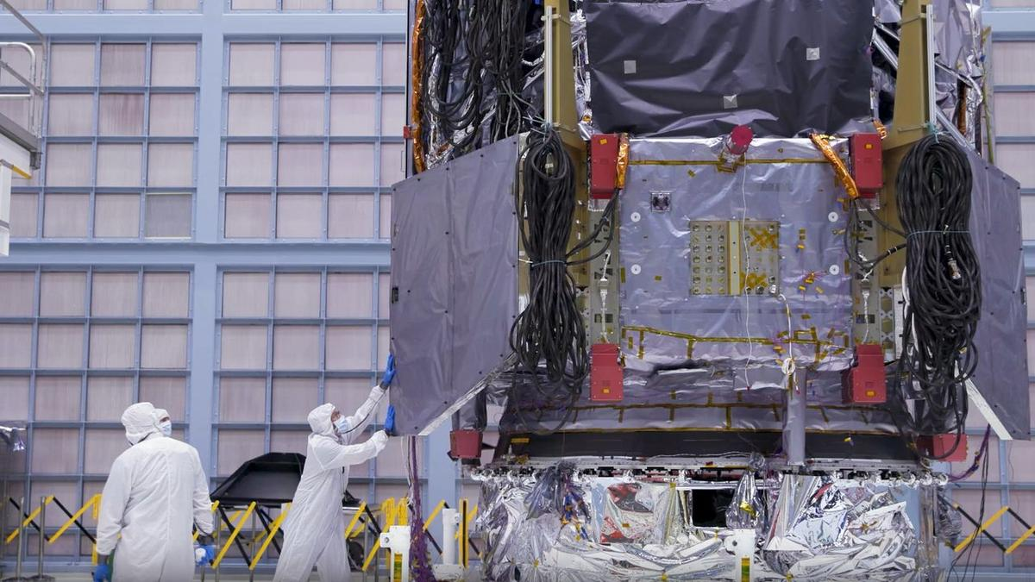
Click for next article NASA announced on Tuesday (July 28) that it has officially fueled-up the Roman Space Telescope - a magnificent new observatory expected to generate over 500 terabytes of cosmic data per year. By comparison, the Hubble Space Telescope, in its 35 years of service, has created over 400 terabytes in total. At present, the Roman Space Telescope 's launch aboard a SpaceX Falcon Heavy rocket is scheduled to occur on Aug. 30 at 7:26 a.m. EDT (1126 GMT). And considering the project is sort of the gold-standard for telescope-building, as the team says it's nine months ahead of schedule and under budget, hopes are high that this launch date will stick. Fueling of the observatory took place on Saturday (July 25) and involved pumping it up with what's known as hydrazine fuel. Hydrazine fuel is a classic sort of fuel used in NASA spacecraft as it's highly efficient; however, because its extremely toxic and unstable, there have been attempts to move away from this sort of fuel and replace it with something less hazardous. The Roman Space Telescope's inauguration into NASA's fleet of observatories will mark a pretty big moment for the advancement of astronomy. Roman's specs are quite impressive; thanks to that showy data-generation figure discussed above, the telescope is expected to further our knowledge of intriguing phenomena like dark matter , dark energy, supernova explosions and even the hunt for habitable exoplanets . It will work as a complement to other major telescopes, including the James Webb Space Telescope (JWST). For example, while Roman can't see as far as the JWST, it does have the same sort of infrared vision that enables such deep space probing. What it can do that the JWST cannot, though, is see a much wider swath of space at once. Members of NASA's Nancy Grace Roman Space Telescope propellant, safety, and quality assurance team pose for a photo on July 20 prior to technicians loading propellant into the observatory. (Image credit: NASA/Sydney Rohde (Rocz)) One of Roman's instruments, named Wide Field Instrument (WFI), will be able to create images of the infrared universe 50 times wider than the JWST's images. This means that while the JWST is zooming in on a particular object of interest, Roman could meanwhile be compiling future targets for the JWST or catching anything fleeting that the JWST would've missed due to its highly narrow view. As another example, to help with dark universe studies, this ultra-wide view should allow Roman to study lots of galaxy movements at once. That's great because the only way we even know dark matter and dark energy exist (aka one of the best ways we have of studying the two) is by the way they affect galaxy movements. "So we're going to see thousands of supernovae, and some of these are going to be further away than any supernovae we've ever seen before," Dominic Benford, program scientist for the Nancy Grace Roman Telescope previously told Space.com. To accomplish all of these goals though, Roman will have to use its new fuel supply to get to its designated station in space: Lagrange point 2. This is a sought-after spot for spacecraft as it's a gravitationally stable point about a million miles from Earth. That stability means spacecraft have to use less fuel to stay put. "Roman will use its propellant to power two types of thrusters that help it stay in its planned orbit around L2 and ensure the solar array panels face the sun, which is the observatory's main source of power throughout the mission," NASA explained in a statement . It's where the JWST is right now - if all goes to plan, we'll really have a nice tag-team operation happening over there.

23. SpaceX launches 24 Starlink satellites to orbit in wake of Starship test flight (video)
Read more
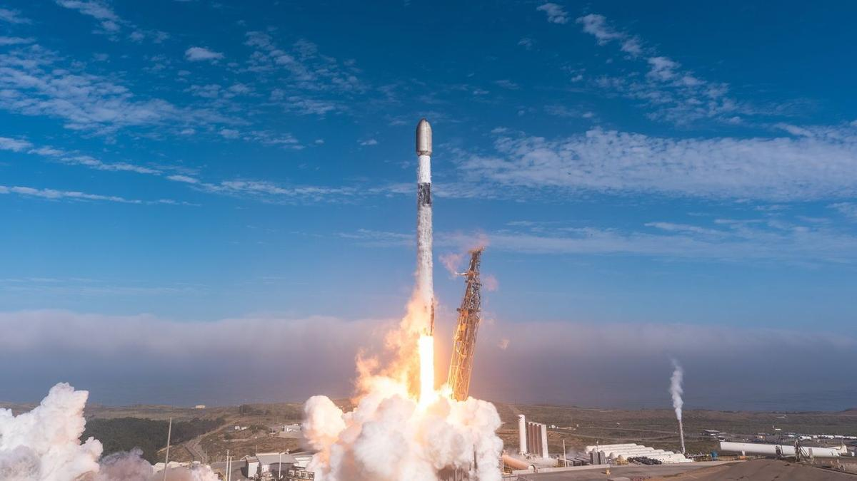
Click for next article SpaceX launched 24 more satellites for its Starlink network on Saturday (July 25), a day after demonstrating it could do the same on its next-gen rocket. A Falcon 9 rocket carrying Starlink group 17-51 lifted off at 11:51 a.m. EDT (1521 GMT or 8:51 a.m. PDT local time) on Saturday from Space Launch Complex 4 East at Vandenberg Space Force Base in California. About an hour later, the 24 broadband internet satellites were deployed into low Earth orbit (LEO), as planned. Previous Booster B1100 launches NROL-105 | 6 Starlink missions The launch marked the eighth flight of the Falcon's 9 first stage (Booster 1100), which touched down on the "Of Course I Still Love You" droneship, stationed in the Pacific Ocean. The successful launch raised the total number of active Starlink satellites to 10,865, according to satellite tracker Jonathan McDowell . That number had been 20 units higher for about 20 minutes on Friday, when SpaceX conducted a deployment and operations trial during the 13th test flight of its Starship launch vehicle. The Starship test was planned to be short-lived but was successful in providing data to support NASA's decision to fly Starlink systems on its Artemis III crewed mission to LEO, which is scheduled to fly next year. Saturday's launch was SpaceX's 87th Falcon 9 mission of the year.

24. ISS meets Venus in incredible daylight photo | Space photo of the day for July 28, 2026
Read more
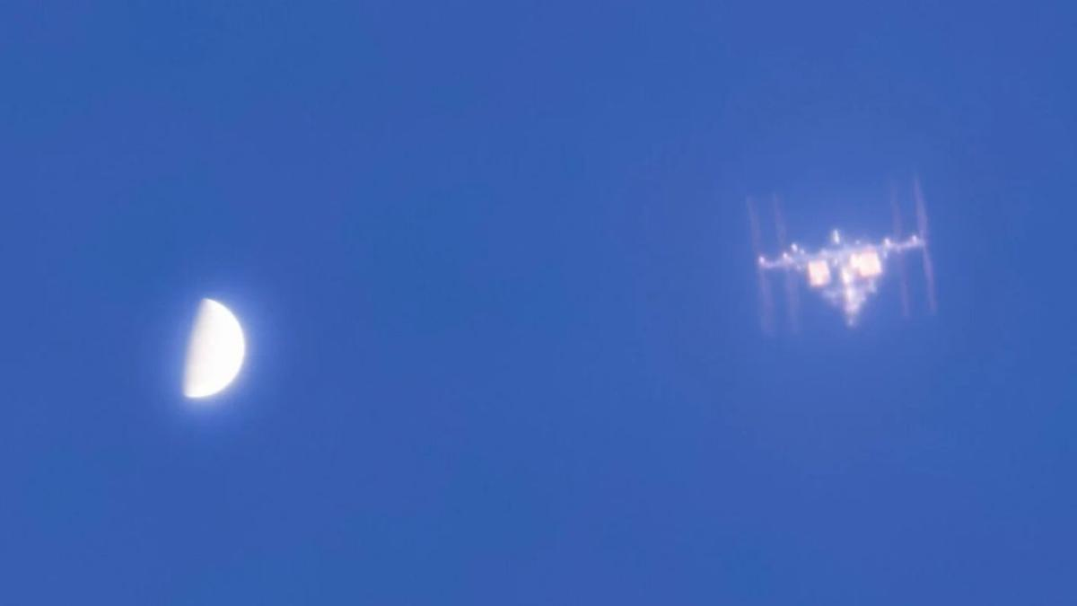
Click for next article Venus beside the International Space Station as captured by photographer A.J. Smadi from Edmonds, Washington on July 18, 2026. (Image credit: AJ Smadi) An astrophotographer captured a breathtaking scene as the International Space Station zoomed by Venus in the daytime sky. A post shared by AJ Smadi (@aj.smadi) A photo posted by on What is it? Photographer AJ Smadi set up the scene on July 18 in a park near Seattle, Washington. Smadi used a 9.25" (23.5 cm) Celestron Schmidt-Cassegrain Telescope and a ZWO ASI662MC camera equipped with an ultraviolet and infrared filter to capture the incredible image. But this isn't the first time Smadi has pulled off such a feat. Just over a year ago, the photographer captured the ISS beside Venus in a photo that was selected by NASA as one of its Astronomy Photos of the Day. "The thing that inspired me to capture Venus with the ISS is the fact that nobody has done it before," Smadi told Space.com by email. "After having realized this in April 2025 following my first time capturing the pair together, I was determined to best my own achievement," Smadi said. Smadi regularly photographs the ISS but says the clarity differs greatly depending on the stability of the air and its distance. A timelapse photo of Venus passing beside the International Space Station as captured by photographer A.J. Smadi from Edmonds, Washington on July 25, 2026. (Image credit: AJ Smadi) Why is it incredible? Capturing Venus, the ISS, or any other object in space (other than the moon) during the daylight hours takes careful planning and a deep understanding of astrophotography techniques and filters. The ISS travels at a mind-boggling 4.6 miles per second (7.5 km per second) and is 84 million miles (135 million kilometers) away from Venus, so lining up a photograph of the two seemingly side-by-side is no easy feat and takes painstaking planning. For more of AJ Smadi's work, including photos of the ISS transiting the sun, the moon, and passing by Saturn, visit his Instagram .

25. NASA science soars during August total solar eclipse
Read more

Each time the moon covers the sun during a total solar eclipse-darkening daytime skies and briefly revealing the sun's ethereal outer atmosphere, the corona-it presents new opportunities to better understand our star and its influence on Earth.

26. NASA's Swift rescue spacecraft spins out of control after losing two reaction wheels
Read more
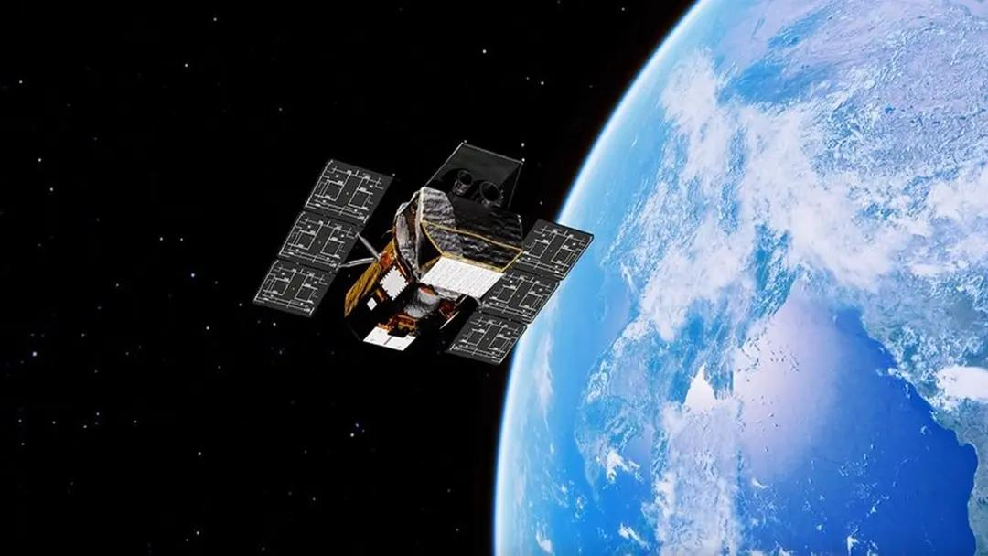
Katalyst Space's LINK spacecraft has suffered a new attitude-control failure that could complicate its mission to capture and raise NASA's Neil Gehrels Swift Observatory into a higher orbit. The robotic servicing spacecraft began spinning over the weekend after losing control of its orientation. A preliminary investigation found that two of LINK's three reaction wheels are no longer operational, while the spacecraft has also experienced some loss of functionality in its cold gas thruster system. LINK remains power positive and in communication with the Katalyst team, with its other major subsystems functioning as expected. The team is now working to halt the spacecraft's spin using its electric propulsion thrusters over the next few days. Spacecraft faces fresh setback Once LINK is stabilized, Katalyst plans to reassess the spacecraft and update its guidance, navigation, and control systems to work with its new configuration. The company will then work with NASA to determine whether it is safe to proceed with the planned approach and capture of Swift. The development comes after an earlier attitude-control problem during LINK's initial commissioning phase. At that time, Katalyst had reported an issue with one of the spacecraft's three reaction wheels, but said it had restored stable attitude control and reliable communications through flight software patches and operational updates. LINK launched July 3 aboard a Northrop Grumman Pegasus XL rocket, which was deployed from the company's Stargazer aircraft over the South Pacific. The spacecraft established communications after launch and began commissioning, including checks of its power, avionics, propulsion, sensors and navigation systems. The spacecraft is designed to travel to Swift, survey the 21-year-old observatory and capture it before gradually raising its orbital altitude over several months. The mission is intended to address the observatory's rapidly declining orbit, which has been worsened by atmospheric drag and increased solar activity. Swift mission now under review NASA contracted Katalyst in September to design, build, test, and launch LINK and complete the rendezvous, capture, and orbit-raising mission in less than a year. The mission is challenging because Swift does not have a propulsion system capable of maintaining its orbit indefinitely. As a spacecraft moves through low Earth orbit, even the thin upper atmosphere creates drag that gradually lowers its altitude. Recent solar activity increased atmospheric drag around Earth, accelerating Swift's orbital decay faster than anticipated. LINK's propulsion architecture includes three xenon-fueled electric thrusters, which were previously fired during commissioning. These thrusters are intended to propel LINK toward Swift and later help raise the observatory's orbit. Before the latest setback, Katalyst had said LINK was about halfway through commissioning and preparing to enter its transit phase toward Swift. The team had also built flexibility into the commissioning schedule to allow it to pause operations, assess spacecraft data and make adjustments as needed. The immediate priority is now to stop LINK's spin and establish stable attitude control. Katalyst and NASA will then have to determine whether the spacecraft remains capable of safely approaching and capturing Swift, or whether the mission plan needs to be revised further.
27. ISRO Conducts START Capacity Building Workshop-2026 at IIRS, Dehradun - ISRO
Read more
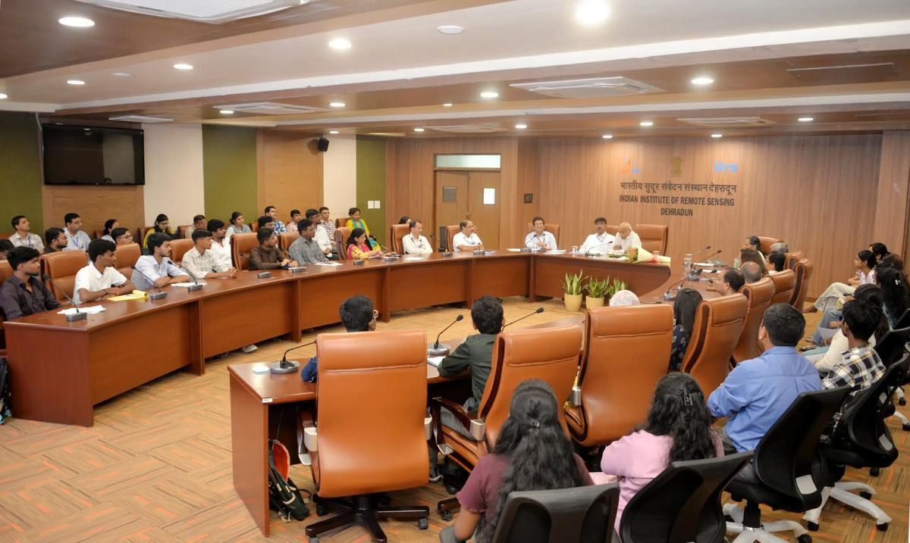
July 29, 2026 Inaugural session of the ISRO-START Capacity Building Workshop - 2026 on July 27, 2026 During July 27 to July 31, 2026, ISRO is conducting the concluding session of the ISRO-START-2026 programme, through the newly conceived ISRO-START Capacity Building Workshop at IIRS, Dehradun, benefiting 50 students, which include 12 research fellows from IIRS, Dehradun. Among them, 38 students, from the undergraduate and post-graduate levels, have been selected from the toppers of the ISRO-START-2026 online examination, through a stringent set of criteria, representing multiple states of India. The event was inaugurated by Shri. A S Kiran Kumar, Member, Space Commission and former Secretary, DOS / Chairman, ISRO, in the presence of Dr. R.P. Singh, Director of IIRS, Dehradun, Dr. Tirtha Pratim Das, Director, Science Programme Office, ISRO Headquarters, Dr. Harish Karnatak, Head, GIT-DL, IIRS, and the senior faculty members of IIRS. Left: Experiments on Infra-Red Remote Sensing; Right: Hands-on session on Land Surface Temperature analysis using satellite data The ISRO-START Capacity Building Workshop-2026 comprises several components like advanced lectures on space science & applications, interactions with senior scientists of ISRO / Department of Space, physical demonstration of scientific concepts (IR remote sensing, Raman Spectroscopy, etc.), hands-on exercise on satellite data analysis, as well as project work. The students, hailing from different states of the country, are made to team up, and deliver the project-deliverable. This rigorous engagement enhanced the awareness of the students about the space-based techniques, and may initiate some of them to pursue their career in the domains of space science and technology. ISRO has been conducting the START programme since year 2023, each year presenting a unique theme in the realm of space science and technology, with around 20 to 25 specially curated lectures delivered by the pan-India experts, targeting the undergraduate and post-graduate students in science, technology and engineering. A programmatic connection has also been established between ISRO-START and ISRO's biennial scientific meet 'National Space Science Symposium', where selected students among the toppers of the START examination attend a specially curated students' session for closer mentoring and idea exchange. The START-2023 lectures, on the theme of 'Overview of Space Science and Technology', have been included as a credit course by the AICTE. The theme of START-2026, conducted during March 11 to April 2, 2026, has been 'Scientific Observations from Space' which was inaugurated by Secretary, DOS / Chairman, ISRO on March 11, 2026. The START programme, so far, has cumulatively benefited about 1.6 lacs of students, faculty members, as well as space enthusiasts.

28. ISRO Recruitment 2026: 244 Posts, Apply Online by August 16 - PW
Read more
The Indian Space Research Organisation has opened the online application window for 244 vacancies across administrative and support cadres, and the clock is already running. The ISRO Recruitment 2026 notification, issued through the ISRO Centralised Recruitment Board (ICRB), covers the posts of Assistant, Junior Personal Assistant (JPA), Upper Division Clerk (UDC) and Stenographer. Candidates who meet the eligibility criteria can submit the ISRO online application 2026 through the official website, isro.gov.in, until August 16, 2026. This is one of the larger non-technical hiring drives announced by the space agency this year, and it is aimed squarely at graduates rather than engineers - which is precisely why it is expected to draw a very heavy volume of applications from across the country. ISRO Vacancy 2026: Post-Wise Breakdown According to the ISRO Recruitment 2026 notification PDF, the vacancy distribution is as follows: Assistant - 113 posts Junior Personal Assistant (JPA) - 81 posts Upper Division Clerk (UDC) - 22 posts Stenographer - 10 posts In addition to the above, other ISRO units have notified 17 Assistant posts and one Junior Personal Assistant post, taking the total ISRO 244 posts recruitment count to 244 vacancies. ISRO Eligibility Criteria 2026: Qualification and Age Limit Applicants must hold a bachelor's degree from a recognised university with a minimum of 60 per cent marks, or a CGPA of 6.32 on a 10-point scale. Importantly, the degree must have been completed within the duration prescribed by the university - a condition that candidates with extended or backlog-delayed courses should read carefully before applying. The maximum age limit is 28 years as on August 16, 2026. Age relaxation will be granted as per Government of India norms: OBC candidates may apply up to 31 years SC and ST candidates applying against reserved vacancies are eligible up to 33 years Relaxation is also available to eligible government employees, ex-servicemen, persons with disabilities, meritorious sportspersons, widows, divorced women and women legally separated from their husbands who have not remarried ISRO Recruitment 2026 Application Fee The prescribed application fee is Rs 100. However, every candidate must additionally pay a processing fee of Rs 500 at the time of submitting the online application. Payment can be made only through the Bharatkosh e-Payment gateway, and the payment link becomes active only after the application form has been filled in. Candidates are advised not to close the browser window mid-transaction, as the fee step is sequential and linked to the completed form. ISRO Selection Process 2026: Written Exam and Skill Test The selection process begins with a written examination to be conducted at 38 centres across India. It will comprise a single objective-type paper of 150 minutes' duration. Candidates who clear the written examination will be shortlisted for a skill test. ISRO will shortlist candidates in a maximum ratio of 1:5 against the notified vacancies in each category, and wherever applicable, a minimum of 10 candidates will be called for the skill test. The skill test is the decisive stage for JPA and Stenographer aspirants in particular, since shorthand and typing speed carry direct weight in those cadres. How to Apply for ISRO Jobs 2026 Key Dates at a Glance Application start: Online window currently open Last date to apply online: August 16, 2026 Age reckoning date: August 16, 2026 Written examination centres: 38 across India Official website: isro.gov.in Why This ISRO Recruitment Matters For lakhs of general-degree graduates preparing for SSC, banking and state-level examinations, ISRO Jobs 2026 in the Assistant and UDC cadres represent a rare central-government opening with a space agency, without an engineering prerequisite. With only 244 seats against an applicant pool that historically runs into several lakhs for ICRB administrative posts, the written examination is expected to be sharply competitive. Aspirants should treat the 150-minute objective paper as a speed-and-accuracy contest rather than a knowledge-depth test, and JPA and Stenographer candidates should begin shorthand and typing practice immediately rather than waiting for written-exam results. Candidates are advised to apply well before the closing date, as heavy last-day traffic on the portal and the Bharatkosh gateway is common during ISRO recruitment cycles.

29. ISRO maps over 2,000 glaciers, 3,219 glacial lakes in Ladakh: Centre - Greater Kashmir
Read more

Advertisment Replying to an unstarred question in the Lok Sabha, Union Minister of State in the Prime Minister's Office, Personnel, Public Grievances and Pensions, Atomic Energy and Space, Dr Jitendra Singh, said the Indian Space Research Organisation (ISRO) and other government agencies are using advanced satellite-based technologies to monitor glaciers, glacial lakes, snowfall, water resources and landslide-prone areas across Ladakh. According to the minister, a database of more than 2,000 glaciers in Ladakh has been generated using satellite data collected between 2020 and 2023. In addition, changes in the extent of more than 1,000 glaciers over the past two decades have been mapped to assess long-term climatic and environmental changes. The minister said an inventory of 3,219 glacial lakes, each measuring more than 0.25 hectares, has been prepared under the National Hydrology Project of the Ministry of Jal Shakti. He informed the House that satellite-based Glacial Lake Outburst Flood (GLOF) risk modelling has also been carried out for high-risk glacial lakes, including Katkar and Suru, to strengthen disaster preparedness and early risk assessment. The government has also undertaken daily satellite-derived snow cover mapping across the Indian Himalayan region, including Ladakh, from 2019 until September 2025 to monitor seasonal snow conditions and water availability. As part of broader environmental mapping, 4,912 wetlands in Ladakh have been identified and mapped in collaboration with the University of Jammu, Dr Singh said. He further informed Parliament that satellite imagery is being used to monitor around 41 waterbodies larger than five hectares. The information is made available through the Bhuvan Waterbody Information System, under which periodic monitoring has been carried out since 2012. The minister also said ISRO is regularly updating Ladakh's landslide inventory using satellite imagery to support hazard assessment and disaster mitigation efforts. The information was provided in response to Lok Sabha Unstarred Question No. 1808, highlighting the Centre's increasing reliance on space-based technologies for environmental monitoring, climate resilience and disaster risk management in the ecologically fragile Himalayan region.

30. ISRO Recruitment 2026: 244 Administrative Posts Announced - Education Today
Read more
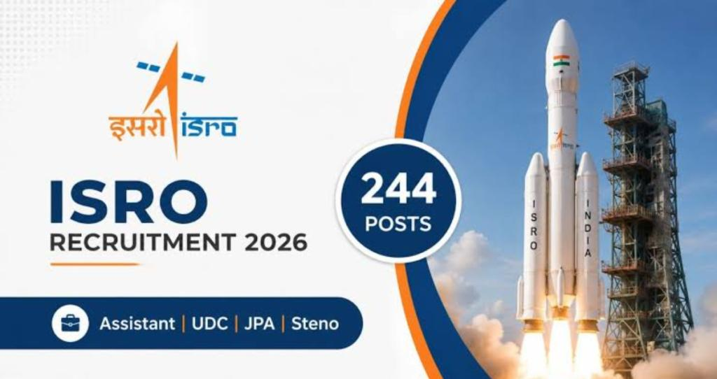
ISRO Recruitment 2026 Notification Released for 244 Administrative Posts; Applications Open for Assistant, JPA, UDC and Stenographer Roles Leave a Comment / Daily News The Indian Space Research Organisation (ISRO) has announced its recruitment drive for 2026, inviting applications for 244 administrative positions across various centres. The recruitment notification has been released under the Centralised Recruitment Board (ICRB), offering opportunities for eligible candidates to apply for posts including Assistant, Junior Personal Assistant (JPA), Upper Division Clerk (UDC) and Stenographer. The online application process has commenced, and interested candidates can submit their applications through the official ISRO recruitment portal within the specified deadline. The recruitment drive provides an opportunity for graduates and eligible candidates seeking government employment in one of India's leading space research organisations. EducationToday and TopEducationNews continue to highlight major career opportunities, recruitment announcements and academic developments that help students and job aspirants stay informed about important opportunities across India. ISRO Recruitment 2026: Vacancy Details Through the latest notification, ISRO has announced a total of 244 vacancies for administrative and support roles. These positions are available across different ISRO centres and units, depending on organisational requirements. The available posts include: - Assistant - Junior Personal Assistant (JPA) - Upper Division Clerk (UDC) - Stenographer Candidates interested in these positions must carefully review the eligibility requirements, selection process and application guidelines before submitting their forms. The recruitment notification outlines the number of vacancies, post-wise requirements and other important details related to the selection procedure. Applicants are advised to check the official notification thoroughly to understand the criteria before applying. Important Dates for ISRO Recruitment 2026 The recruitment process has started with the opening of the online application window. Candidates must complete registration and submit their forms before the deadline mentioned by ISRO. Key dates include: - Notification release date: July 2026 - Online application commencement: July 27th, 2026 - Last date to submit applications: August 16th, 2026 Candidates should avoid waiting until the final date to complete their applications, as technical issues or incomplete submissions may create difficulties during the registration process. Eligibility Criteria for ISRO Administrative Posts Candidates applying for ISRO administrative positions must fulfil the required educational qualifications and age criteria specified in the recruitment notification. For posts such as Assistant and Upper Division Clerk, applicants generally require a bachelor's degree from a recognised university along with relevant computer knowledge. Candidates applying for Junior Personal Assistant and Stenographer roles must meet the required qualifications related to typing speed and shorthand skills. The age limit and relaxation criteria may vary depending on the post and category of the applicant. Eligible candidates belonging to reserved categories will receive age relaxation as per government regulations. Applicants should verify all eligibility requirements before applying to ensure that they meet the conditions prescribed for their preferred position. ISRO Recruitment 2026 Application Process Eligible candidates can complete the application process through the official ISRO recruitment website. The online application system has been introduced to make the recruitment procedure more accessible and streamlined. Candidates can follow these steps to apply: - Visit the official ISRO recruitment portal - Select the recruitment notification for administrative posts - Register using the required personal and contact details - Fill in the application form with accurate information - Upload the necessary documents and certificates - Pay the application fee, if applicable - Submit the form and download a copy for future reference Candidates should ensure that all details entered in the application form are correct, as incorrect information may lead to disqualification during later stages of the recruitment process. Selection Process for ISRO Recruitment 2026 The selection process for the announced posts will be conducted according to ISRO's recruitment guidelines. Candidates may have to appear for written examinations and skill-based tests depending on the position applied for. The recruitment process is expected to assess candidates on various aspects, including general awareness, reasoning ability, quantitative aptitude, language skills and post-specific requirements. For positions such as Junior Personal Assistant and Stenographer, candidates may also need to demonstrate typing and shorthand abilities as part of the selection procedure. Applicants who qualify through all stages will be considered for appointment based on merit and organisational requirements. Click below to watch the video. Documents Required During Application Candidates should keep the following documents ready while completing the online application process: - Educational qualification certificates and mark sheets - Valid identity proof - Recent passport-sized photograph - Signature image - Category certificate, if applicable - Other relevant documents mentioned in the notification Uploading clear and valid documents is essential to ensure successful submission of the application form. Career Opportunity with ISRO ISRO is recognised as one of India's premier space research organisations, contributing significantly to the country's space exploration and technological advancements. Apart from scientific and technical roles, the organisation regularly offers opportunities in administrative and support areas. The latest recruitment drive allows candidates from diverse educational backgrounds to become part of India's space ecosystem. Successful candidates will contribute to the smooth functioning of ISRO centres by supporting various administrative operations. Government recruitment opportunities such as these attract thousands of applicants due to job stability, professional growth prospects and the opportunity to work with prestigious institutions. What Applicants Should Keep in Mind Candidates preparing for the ISRO Recruitment 2026 process should focus on understanding the exam pattern, revising relevant subjects and keeping track of official updates. Important points to remember: - Read the official notification carefully before applying - Complete the registration process before the deadline - Keep application details safely for future communication - Prepare according to the prescribed selection pattern - Regularly check official updates regarding examination dates and further instructions The ISRO Recruitment 2026 notification has created a valuable opportunity for candidates looking to build a career in the government sector. With 244 vacancies across multiple administrative roles, eligible applicants should make use of this opportunity and complete the application process within the given timeline. Post Views: 337 UP Board's Derecognition of 465 Non-Functional Schools Signals a Strong Push for Educational Accountability Daily News

31. NASA Awards 2026 Innovative Technology Concepts
Read more
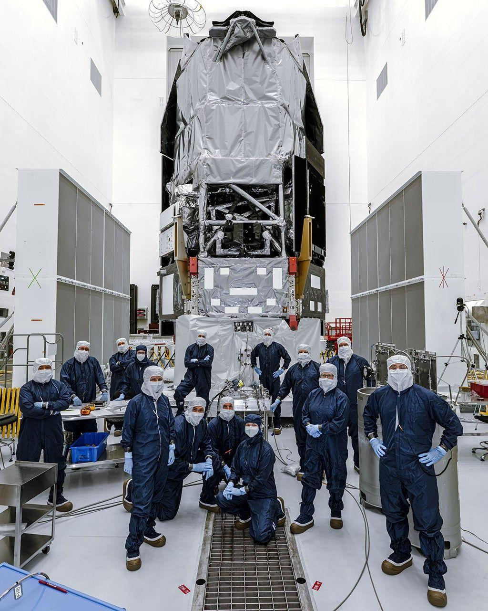
A collage of artist concepts highlighting the novel approaches proposed by the 2026 NIAC awardees. Credit: NASA The NASA Innovative Advanced Concepts (NIAC) program has created 18 new awards to support visionary ideas to improve aerospace technologies in areas ranging from the exploration of the solar system to understanding the universe. The 18 NIAC Phase I awards total $3.2 million. Each award provides up to $175,000 for a nine-month initial investigation. The NIAC projects are about early-stage concept development and are not considered official NASA missions. "NASA has outlined an ambitious vision for the future of space exploration, we're returning the Moon to stay, advancing to Mars, and pushing to deepen our understanding of space," said Greg Stover, director of the Advanced Research and Technology division within the Research and Technology Mission Directorate at NASA Headquarters in Washington. "Achieving that will require more than incremental technological advancement. It means we need great leaps. These awards are the kinds of innovation the world needs NASA to help foster." As an innovation incubator, NIAC funds early development of potential breakthrough technologies. Concepts for award consideration must have both transformative potential and possible feasibility for eventual implementation. "Every innovation, every leap in technology, starts with a seed of an idea," said Phillip Williams, NIAC's acting program executive. "The NIAC program allows NASA to germinate those seeds and determine if there's something that could be grown to benefit future space missions and our nation's aerospace economy." As NASA and its partners push for sustained lunar presence, some of the 2026 awardees focused on ways to help explore the Moon and build infrastructure there. These include a system to support hovering robots to explore lava tubes under the Moon's surface, a method to manage temperatures for small mobile exploration robots, and a way to incorporate radioisotopic heat sources into suits to help keep astronauts warm when operating in the Moon's nearly two-week-long lunar nights. Other concepts focus on exploring some of the solar system's most remarkable features. Venus, with its hot atmosphere, presents an imposing challenge for research vehicles, so one NIAC awardee explores methods for hardening instruments for longer missions. Two other concepts could help study planetary rings. One would use a swarm of 10,000 tiny satellites to map and analyze the rings of Saturn, while another would create a system for collecting samples from rings such as those circling Saturn, Uranus, and Neptune. Some NIAC awardees will look far beyond the solar system, exploring ways to power interstellar spacecraft, map out continents on exoplanets, observe the photon rings around black holes, and detect subtle gravitational waves to explain how galaxies formed. Others will work to answer questions directly related to life on Earth, like the potential use of spaceborne dust to reduce solar radiation, and awareness about the debris orbiting Earth. Researchers, known as NIAC Fellows, will investigate their concepts and identify potential challenges and opportunities for further development. The 18 selections for 2026 NIAC Phase 1 grants are: Saptarshi Bandyopadhyay, NASA Jet Propulsion Laboratory, Pasadena, California: Dimming the Sun Using Controllable Dust Cloud to Reduce Solar Insolation (DimSun) David Bugby, NASA Jet Propulsion Laboratory: Combinatory Architecture offering Neomobility, on-Venus Adaptability, and Survivability (CANVAS) A.C. Charania, Zeno Power Systems, Inc., Washington: Extended Astronaut Radioisotope-EVA in Nighttime and Deep-space Icy Landscapes (EARENDIL) Anish Damodaran, University of Central Florida, Orlando: PS21: Transforming Submillimeter Space Interferometry with Photonic Technologies Artur Davoyan, University of California, Los Angeles: Coilable Stacked Solar Sails for Very High delta-V Missions Daniel Drew, University of Hawaii, Honolulu: Solid-state Propulsion for Autonomous Reconnaissance of Karst (SPARK) Gilly Elor, Stone Aerospace, Inc., Del Valle, Texas: Power-over-Fiber to Enable a Lunar Underground eXplorer (LUX) Zhaoyan Liu, NASA Ames Research Center, California's Silicon Valley: Quantum Wind Lidar Applications for Planetary and Earth Science Missions Jeff Nosanov, Orbital Velocity, LLC, Decatur, Georgia: OBLIVIAN: Observing Black hole LIght Via Intensity cOrrelatioN (OBLIVIAN) Keunhan Park, University of Utah, Salt Lake City: Plasmon-Enhanced Radioisotope Thermophotovoltaic (PRTPV) Power Generation for Interstellar Missions Austin Phoenix, Virginia Polytechnic Institute and State University, Blacksburg, Virginia: Efficient variable Conductivity Lunar Insulator for Passive Surveyor Environmental Control (ECLIPSE) Marco Quadrelli, NASA Jet Propulsion Laboratory: PRAXIS: Planetary Rings Autonomous EXploration with In-situ Sampling (PRAXIS) Michael Rubenstein, Northwestern University, Chicago: Actively Steerable Femtosat Constellations for In-situ Exploration of Saturn's Rings, Atmosphere, and Magnetosphere Benjamin Schafer, Rarefied Technologies Inc., Albuquerque, New Mexico: : Photophoretic Tracers for Near-Space Remote Sensing at 30-100 km Altitudes David Smith, Duke University, Durham, North Carolina: Robotically Assembled Electromagnetic Metamaterials for Long-Range Space Situational Awareness Pablo Sobron, Search for Extraterrestrial Intelligence Institute, Mountain View, California: Interworld Slingshot Resource Surveys Paul Stankus, Brookhaven Science Associates, Upton, New York: Mapping Alien Continents: Achieving Optical VLBI for Exoplanet Imaging Paul Stankus, Brookhaven Science Associates, Upton, New York: Precision Astrometry Using Optically Independent Spacecraft for Gravitational Wave Detection To learn more about NASA's NIAC program, visit: https://www.nasa.gov/about-niac -end- Rob Margetta Headquarters, Washington 202-358-0918 robert.j.margetta@nasa.gov

32. NASA Sets Coverage for August Northern Hemisphere Total Solar Eclipse
Read more

A total solar eclipse is seen in Dallas, Texas on Monday, April 8, 2024. A total solar eclipse swept across a narrow portion of the North American continent from Mexico's Pacific coast to the Atlantic coast of Newfoundland, Canada. A partial solar eclipse was visible across the entire North American continent along with parts of Central America and Europe. Credit: NASA/Keegan Barber On Wednesday, Aug. 12, a total solar eclipse will be visible in parts of Greenland, Iceland, northern Russia, the Atlantic Ocean, Spain, and a small corner of Portugal. NASA will stream the eclipse live with views across the path and interviews with subject matter experts through a variety of platforms. Learn where to watch online: https://www.nasa.gov/live Viewers in other places in the Northern Hemisphere also will have the chance to experience a partial solar eclipse, including parts of the U.S. (from Alaska to North Carolina), most of Canada, much of Europe, and northwestern Africa. During the eclipse, NASA will conduct experiments in the path of totality. To investigate the dynamics of the Sun's corona, a NASA-funded science team will chase the Moon's shadow with a WB-57 high-altitude research aircraft. The NASA-supported Nationwide Eclipse Ballooning Project is sending students from several U.S. universities to Iceland and Spain to launch scientific balloons before, during, and after the eclipse to research how the temporary darkening of our skies during the eclipse affects Earth's atmosphere. NASA's eclipse coverage is as follows (all times Eastern): Wednesday, Aug. 12 1:15 p.m.: Eclipse broadcast begins 1:45 p.m.: Totality begins in Iceland 2:28 p.m.: Totality begins in Spain NASA photography coverage Photos of the eclipse, dependent on visibility, will be available shortly after the eclipse. View images on the agency's Flickr account. Watch, engage on social media During the broadcast, NASA experts will answer questions submitted on social media. Send in your questions and let people know you're watching the eclipse on X, Facebook, and Instagram by following and tagging these accounts: X: @NASA, @NASASolarSystem, @NASAScience_ Facebook: NASA, NASASolarSystem, @NASAScience Instagram: @NASA, @NASASolarSystem, @NASAScience_ Learn more about the eclipse at: https://science.nasa.gov/eclipses -end- Abbey Interrante / Karen Fox Headquarters, Washington 301-201-0124 / 202-358-1600 abbey.a.interrante@nasa.gov / karen.c.fox@nasa.gov

33. NASA's Curiosity Views a Sand-Capped Butte
Read more
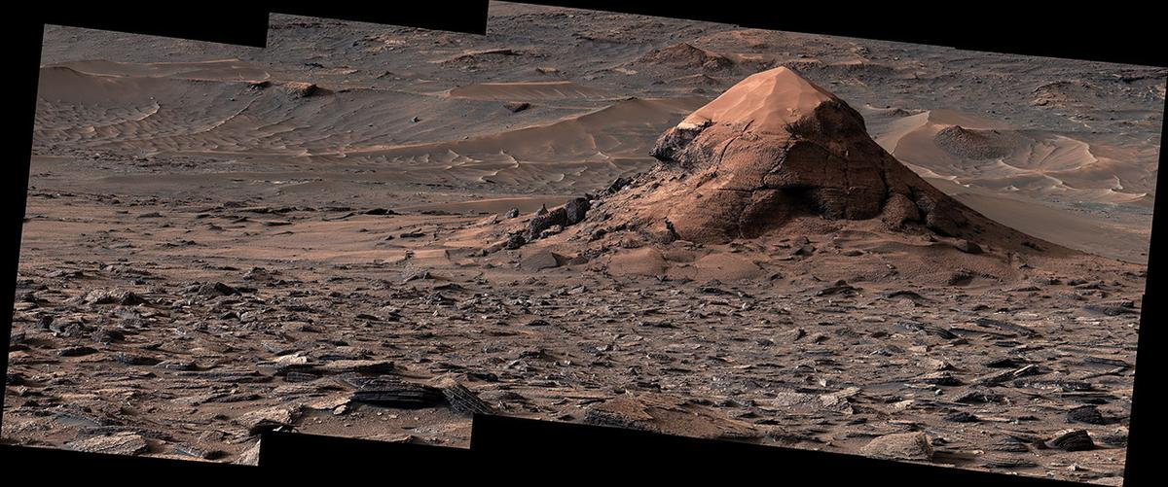
Description NASA's Curiosity Mars rover captured this sand-capped butte, nicknamed "Miraflores," estimated to be about 20 feet (6 meters) tall, with its Mast Camera, or Mastcam, on June 11, 2026, the 4,923rd Martian day, or sol, of the mission. The butte was left behind as surrounding rock eroded away over time, deepening the broad valley Curiosity is climbing through. The surrounding area includes an expanse of terrain covered in surface features called polygons. The panorama is made up of 11 individual images that were sent to Earth and stitched together. The color has been adjusted to match lighting conditions as the human eye would see them on Earth. Curiosity was built by NASA's Jet Propulsion Laboratory, which is managed by Caltech in Pasadena, California. JPL leads the mission on behalf of NASA's Science Mission Directorate in Washington as part of NASA's Mars Exploration Program portfolio. Malin Space Science Systems in San Diego built and operates Mastcam. To learn more about Curiosity, visit: science.nasa.gov/mission/msl-curiosity

34. NASA's Curiosity Discovers a Field of Martian Polygons
Read more
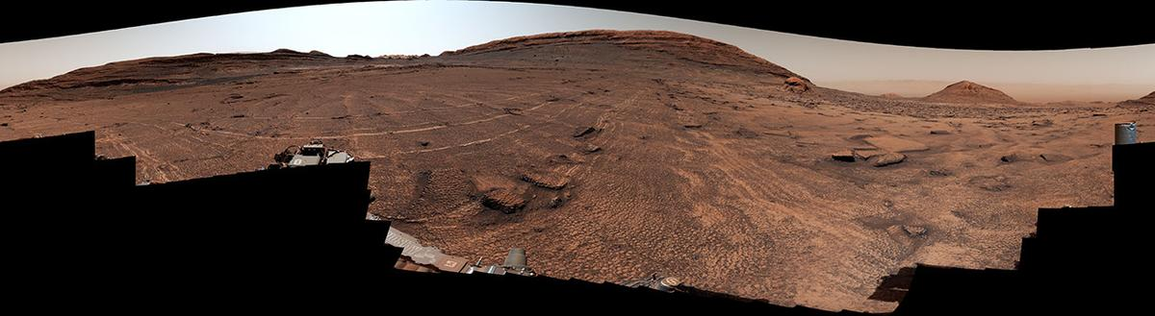
Description NASA's Curiosity Mars rover captured this 360-degree view of an expanse of terrain covered in surface features called polygons on June 19 and 20, 2026, the 4,930th and 4,931st Martian days, or sols, of the mission. The rover has found polygons several times in the past, but never so many in one place. Across the center of this image, the surface is covered by shapes ranging in size from roughly 2 to 4 inches (5 to 10 centimeters) in diameter. The features also surround and wrap around a sand-capped butte nicknamed "Miraflores," seen at far right in the image. Figure A Figure A is a crop from the bottom-center of the panorama highlighting the polygons and their honeycomb-like textures. Polygonal textures can form from a variety of conditions, including drying out of the surface (like in mud cracks), temperature cycles, compaction after being buried, or shrinkage of the sediment from loss of water or mineral changes. Scientists are measuring characteristics of these polygons to home in on which process formed them. This panorama was captured by Curiosity's Mast Camera, or Mastcam, as the rover continued its ascent of the foothills of Mount Sharp, a 3-mile-tall (5-kilometer-tall) mountain that it's been climbing since 2014. The panorama is made up of 340 individual images that were sent to Earth and stitched together. The color has been adjusted to match lighting conditions as the human eye would see them on Earth. Curiosity was built by NASA's Jet Propulsion Laboratory, which is managed by Caltech in Pasadena, California. JPL leads the mission on behalf of NASA's Science Mission Directorate in Washington as part of NASA's Mars Exploration Program portfolio. Malin Space Science Systems in San Diego built and operates Mastcam. To learn more about Curiosity, visit: science.nasa.gov/mission/msl-curiosity

35. NASA's Curiosity Mars Rover Discovers Field of Honeycomb Textures
Read more
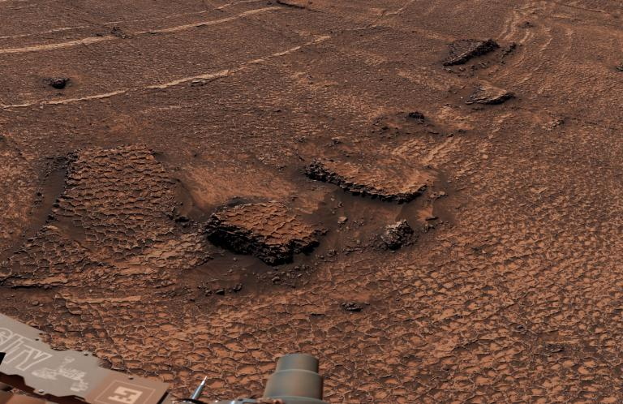
NASA's Curiosity Discovers a Field of Martian Polygons NASA/JPL-Caltech/MSSS As NASA's Curiosity rover recently began climbing up a Martian valley nicknamed "Valle Grande," it sent back images that were a familiar sight to mission scientists: honeycomb-like textures called polygonal fractures, each one about 1.5 to 3 inches (4 to 8 centimeters) across. The mission has spotted small patches of these geometric shapes several times before, but nothing at the scale discovered in Valle Grande. In a 360-degree panorama that the rover captured on June 19 and 20, the 4,930th and 4,931st Martian days, or sols, of the mission, the polygonal shapes spread in all directions for as far as the rover can see. They even wrap around the sides of a nearby butte nicknamed "Miraflores," which stands 20 feet (6 meters) tall and is topped with a thick cap of sand. "We've seen a lot of fascinating landscapes through Curiosity's eyes, but this sea of polygons took our breath away," said the mission's project scientist, Ashwin Vasavada of NASA's Jet Propulsion Laboratory in Southern California. "We measured their shapes and chemistry carefully and are hopeful there are clues in the data as to how these features formed." A close-up of the polygon fractures discovered by NASA's Curiosity Mars rover highlights their honeycomb-like textures NASA/JPL-Caltech/MSSS Some of the polygons that the mission has spotted in the past clearly formed as mud cracks, though a variety of processes can contribute to their honeycomb textures, including cycles of warm and cold temperatures or compression that squeezed water out of the sediment when the surface was buried. These newly discovered polygons are among the many surprises Curiosity has trundled across since landing on Mars 14 years ago, on Aug. 5, 2012. Besides sulfur crystals, shiny meteorites, and other interesting geologic features, the rover has made major discoveries about the ancient Martian environment - most importantly, that it had the water, chemistry, and nutrients to support microbial life. Billions of years ago, lakes and streams dappled the lower foothills of Mount Sharp, a 3-mile-tall (5-kilometer-tall) mountain that Curiosity has been ascending since 2014. The rover has previously uncovered chemistry left over from Mars' watery history, including carbon-based molecules believed to be precursors to RNA and DNA, two nucleic acids that carry genetic information. Scientists have no way of knowing whether these organic molecules were created by biologic or geologic processes - either path is possible - but their discovery reconfirmed that ancient Mars had the right chemistry to support life. NASA's Curiosity Mars rover captured this sand-capped butte, nicknamed "Miraflores," estimated to be about 20 feet (6 meters) tall, on June 11, 2026. The surrounding area includes an expanse of terrain covered in surface features called polygons. NASA/JPL-Caltech/MSSS Managed by Caltech in Pasadena, JPL built Curiosity and leads the mission on behalf of NASA's Science Mission Directorate in Washington as part of the agency's Mars Exploration Program portfolio. To learn more about Curiosity, visit: https://science.nasa.gov/mission/msl-curiosity News Media Contacts Andrew Good Jet Propulsion Laboratory, Pasadena, Calif. 818-393-2433 andrew.c.good@jpl.nasa.gov Karen Fox / Alana Johnson NASA Headquarters, Washington 240-285-5155 / 202-672-4780 karen.c.fox@nasa.gov / alana.r.johnson@nasa.gov 2026-051

36. NASA Webb Explores Family Tree of Newly Discovered Distant Objects
Read more

Since their discovery by NASA's James Webb Space Telescope in 2022, little red dots (LRDs) have been the subject of great interest to astronomers. Understanding the nature of these extremely distant, compact red sources has been a puzzling scientific endeavor. One popular theory is that little red dots are supermassive black holes known as active galactic nuclei, although they display characteristics unlike nearby active galactic nuclei. While they appear abundant at high redshift early in the universe, they rapidly decrease in number at lower redshifts. (The higher the redshift, the greater the distance the light has traveled across the universe.) This perplexing shift in number raises the question: What happens to little red dots as the universe matures? A team of researchers led by Pierluigi Rinaldi of the University of Arizona's Steward Observatory, now at the Space Telescope Science Institute (STScI) in Baltimore, has built upon their previous research in a new study published on July 29 in The Astrophysical Journal and proposed one pathway LRDs can follow as the universe ages: Though they may look like a unique galaxy population, these dots are affected by observational bias - some features just don't appear at higher redshifts with current technology. Image: Saguaro in GOODS-North Field (NIRCam) Scientists have proposed one pathway little red dots can follow as the universe matures based on their analysis of spiral galaxy WISEA J123635.56+621424.2, nicknamed the "Saguaro." They suggest little red dots may be a temporary phase of highly active supermassive black holes. Image: NASA, ESA, CSA, STScI, Pierluigi Rinaldi (Steward Observatory); Image Processing: Alyssa Pagan (STScI) Their conclusions are based on their analysis of lower-redshift spiral galaxy WISEA J123635.56+621424.2, nicknamed the "Saguaro" for its prominent arms, like the cactus native to the Sonoran Desert in the Southwestern United States. A particularly intriguing feature of this redshift 2 galaxy, which corresponds to approximately 3.3 billion years after the big bang, is its little red dot-like center that is reminiscent of the ruby red fruit produced by the desert plant. "Everything created in the early universe must evolve into something around us. We have had little idea of what LRDs become, but these results finally show us how to find their progeny," said co-author George Rieke of the University of Arizona. Previous studies by NASA's retired Spitzer Space Telescope provided the first hint of the dust-obscured, compact galaxy population in the lower-redshift universe that the Saguaro belongs to, paving the way for NASA's Hubble and James Webb space telescopes' high-resolution analyses. "The Saguaro is important because it's a prototypical little red dot and is one of the few we have found at lower redshift. It can be used to study the pathway of these dots throughout cosmic time," said Fabio Pacucci of the Harvard-Smithsonian Center for Astrophysics in Cambridge, Massachusetts, and a co-author of the study. Among the thousands of sources Rinaldi looked at across several surveys, the Saguaro was an example of the right place - with one of Webb's microshutter arrays perfectly framed over the galaxy's core to take spectroscopic data - and right time - being at lower redshift. To get as broad a view of the spiral galaxy as possible across the electromagnetic spectrum, the team used Hubble's ultraviolet- and Webb's infrared-imaging and spectroscopic archival data, respectively. "Because the Saguaro is at lower redshift, we can see the very beautiful and bright host galaxy in high resolution and detail with Webb and Hubble," said Zihao Wu of the Harvard-Smithsonian Center for Astrophysics, and a co-author of the study. "Webb's observations can help us understand how the galaxy and its little red dot-like nucleus are connected." The team took multiple approaches to verify that the Saguaro's compact red nucleus matched the characteristics of a prototypical LRD. In particular, the Hubble and Webb data showed that the nucleus is brighter in both ultraviolet and infrared light than in visible light, just like distant LRDs. The team also carefully disentangled the light emitted from the host and nucleus, and considered the presence of X-ray emission from the source. Although the majority of little red dots at high redshift are not detectable in X-ray light, NASA's Chandra X-ray Observatory detected weak X-ray emission from the Saguaro. "What the X-ray light observations show is that this galaxy has an active galactic nucleus, and a very obscured one at that," said Carys Gilbert, a Master's student at the University of Cape Town in South Africa and a co-author of the paper. "It's not only obscured but also X-ray weak. That kind of combination could explain the lack of X-ray emission that we see from all other little red dots. It fits the puzzle of little red dots nicely." In addition to demonstrating how the Saguaro's central compact red source fits the little red dot criteria, the team synthetically shifted the galaxy to a higher redshift to explore how this galactic environment would appear to observers if located in the early universe. As expected, the Saguaro's surrounding galactic structure fades so that only the bright, LRD-like source at its center is visible. "Our theory is that most of these distant sources are affected by this cosmological effect, creating an observational bias," said Rinaldi. "We simply are not able to sample the immediate environment of high-redshift little red dots because their surroundings are just too faint to be observed even with Webb. Little red dots are far more complex than just being a dot. They're just the tip of the iceberg - of a supermassive black hole interacting with its nearby surroundings." Image: Little Red Dot at Redshift 2: Real and Simulated Graphic Scientists synthetically shifted the Saguaro, a lower-redshift spiral galaxy, to a higher redshift to find out how it would appear if it was in the early universe. Its compact red appearance suggests that little red dots are a phase of highly active supermassive black holes. Image: NASA, ESA, CSA, Pierluigi Rinaldi (Steward Observatory); Image Processing: Alyssa Pagan (STScI); Illustration: Leah Hustak (STScI) Considering the Saguaro case study, the team believes that LRDs may not be a unique galaxy population, but instead a temporary phase of highly active supermassive black holes. Could this theory be the link between the populous high-redshift little red dots seen by Webb and the local universe? While the Saguaro is not representative of all LRDs, the team proposes that this is one phase of these compact red sources. To build more confidence, further study of the Saguaro is necessary, as well as seeking other Saguaro-like galaxies at lower redshift. The team also intends to comb through Webb's bountiful archival data to build a census of little red dots to study how their environments may impact how they mature. These different approaches are all geared to helping uncover the family tree of little red dots. The James Webb Space Telescope is the world's premier space science observatory. Webb is solving mysteries in our solar system, looking beyond to distant worlds around other stars, and probing the mysterious structures and origins of our universe and our place in it. Webb is an international program led by NASA with its partners, ESA (European Space Agency) and CSA (Canadian Space Agency). The Hubble Space Telescope has been operating for over three decades and continues to make ground-breaking discoveries that shape our fundamental understanding of the universe. Hubble is a project of international cooperation between NASA and ESA (European Space Agency). NASA's Goddard Space Flight Center in Greenbelt, Maryland, manages the telescope and mission operations. Lockheed Martin Space, based in Denver, also supports mission operations at Goddard. The Space Telescope Science Institute in Baltimore, which is operated by the Association of Universities for Research in Astronomy, conducts Hubble science operations for NASA. To learn more about Webb, visit: https://science.nasa.gov/webb To learn more about Hubble, visit: https://science.nasa.gov/hubble Downloads & Related Information The following sections contain links to download this article's images and videos in all available resolutions followed by related information links, media contacts, and if available, research paper and Spanish translation links.

37. 'It's going to do things that currently are impossible': The Roman Space Telescope, NASA's next great observatory, is ready to launch Aug. 30
Read more
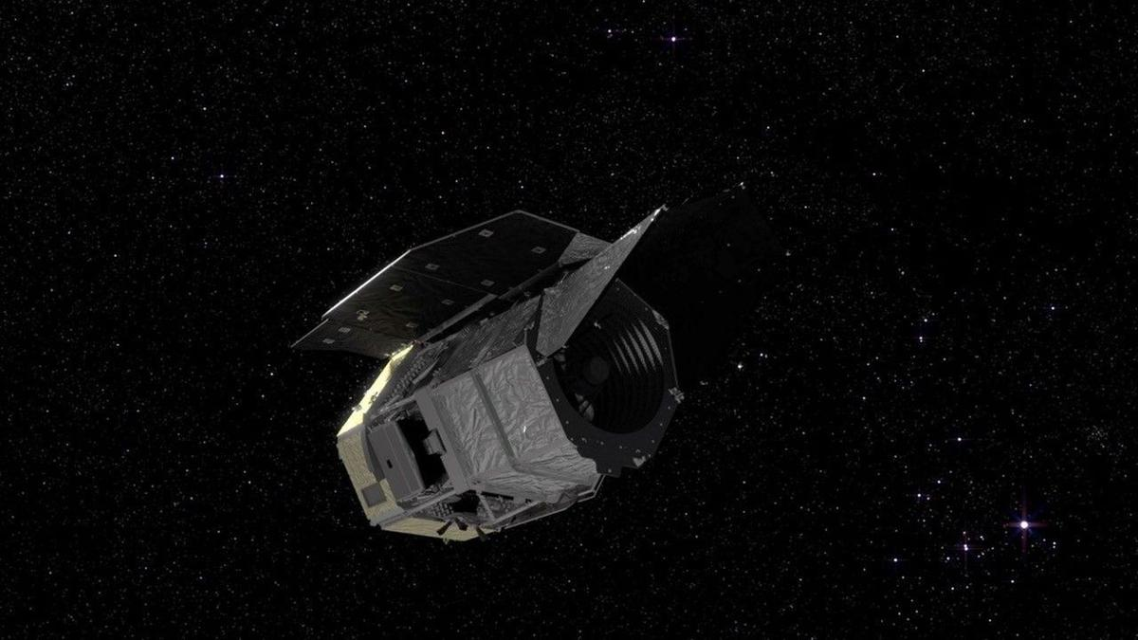
Click for next article The next great American observatory in space is just one month away from leaving this planet. NASA scientists got together Wednesday (July 29) to share a status update on the Nancy Grace Roman Space Telescope - the agency's next great observatory that will soon join the ranks of absolute legends like the Hubble Space Telescope and the James Webb Space Telescope . And that press conference was overflowing with good news. The $4 billion Roman Space Telescope is scheduled to launch on a SpaceX rocket on Aug. 30 at 7:26 a.m. EDT (1126 GMT). That's nine months ahead of schedule according to the team. I think of this as doing magic with physics." Julie McEnery, Roman senior project scientist "In 30 days, we're going to be launching Roman, testing it out, opening the deployable aperture cover, looking at the sky, and sending data down to the ground for the first time," Jeremy Perkins, Roman's telescope integration and test scientist, said during the press conference at NASA's Goddard Space Flight Center in Greenbelt, Maryland. Wednesday's update comes just days after NASA announced Roman is loaded up with hydrazine fuel , a kind of fuel that's known to be very efficient - though at the cost of being toxic and unstable. For that reason, the agency is looking for ways to move away from this kind of fuel, but it's still used often until a suitable replacement becomes available. And with Roman, a lot of hydrazine is necessary. This is for a few reasons, as Perkins explained. First, it's important to know that Roman's headed to what's known as Lagrange Point 2 , a gravitationally stable point a million miles away, between Earth and the sun . This is a popular location for observatories because it allows spacecraft to be oriented in such a way that their instruments remain safe from heat while their solar panels can still receive sunlight for power. The James Webb Space Telescope (JWST), for instance, is at L2 as well. On the way to L2, Roman needs to use some its fuel to course correct and make sure it's headed to the correct destination. "We do a final orbit insertion around day 100 to get into our final orbit around L2," Perkins said. "After that, we have enough fuel to do all of the momentum dumps and the station keeping maneuvers that we need to do for five years and more." The Roman Space Telescope hangs in the clean room. (Image credit: NASA/Sydney Rohde (Rocz)) Now that Roman's fueled up, the next step will be to get it attached to the SpaceX Falcon Heavy rocket that'll carry it beyond our planet. "Encapsulation, which is when the observatory is installed into the fairing that will carry us to orbit, that happens in three short weeks," Jackie Townsend, Roman's project manager, said during the conference. Townsend also added that, all in all, the whole Roman team is ready to go: "The Roman dream team continues to do mighty things, and I am delighted to say yet again, Roman is ready for launch." A diagram of the Lagrange points. (Image credit: NASA / WMAP Science Team) As for what comes after launch, well, there's one way to put things into perspective. To compare Roman to the Hubble Space Telescope , consider that scientists expect Roman to produce over 500 terabytes of data per year. In its approximately 35 years of service, Hubble has produced 400 terabytes of data in total. "Roman has broadly the same sensitivity and sharpness of vision as Hubble, but we survey the sky much faster, so that one month of observations to survey our Milky Way galaxy would take about a century with with Hubble," Julie McEnery, Roman's senior project scientist said during the conference. "We would need over half a million 4K TVs to fully display the single Roman image from our largest survey," McEnery said. "To understand the scale, these TVs would cover 45 Manhattan city blocks." What about comparing Roman to the JWST? While the Roman Space Telescope does have some near-infrared capabilities, thanks to its impressive Wide-Field Instrument (WFI). However, it doesn't quite stack up to the JWST's ultrasensitive infrared sensors . Where it does have an advantage, though, is when it comes to its panoramic view. A Roman image would be about 50 times wider. "Webb is designed to be able to probe very deeply and with exquisite sensitivity into the universe so we can find rare things in the early universe," McEnery said of the JWST. "But you need Roman to find rare things in the more nearby universe." As an example, McEnery pointed out the " little red dots, " elusive objects that seem to repeatedly appear in JWST images of the ancient universe. The key to understanding what these objects are is to find as many as possible. However, with the JWST's extremely zoomed in images focused on the deep, deep universe, it can't exactly map that many at once. But Roman is built to do just that. Once all this data is in hand, the possibilities for what we may find are endless. One of Roman's instruments called a coronagraph is expected to revolutionize exoplanet research while WFI scans the cosmos to image around 2 billion galaxies during the telescope's main survey. "I think of this as doing magic with physics. We're taking advantage of the wave properties of light to cancel out the light from a star, so that we can image planets next to it," McEnery said. The Roman Space Telescope undergoing acoustic testing. (Image credit: NASA/Jolearra Tshiteya) Understanding the dynamics of as many galaxies as possible will help scientists decode the intricacies of dark matter and dark energy. We can't see the dark universe , but we can see how it affects its observable counterpart. And these are just a few of the expected outcomes of Roman's survey. As the team has continuously suggested - in fact, as most observatory teams tend to suggest - the best discoveries will be the surprises. Even when you think about other technological advances, the principle holds true. When the internet was first invented , its inventors probably didn't expect it to lead to innovations like Facebook or Spotify and when the first video game was invented, the concept of an open world RPG maybe seemed beyond our means. "When we built Hubble and Webb, we were chasing far off galaxies in the farthest corners of the universe. But because we have a Hubble and Webb, we're able to track asteroids that would pose a threat to Earth or to future lunar outposts on on the lunar surface," Shawn Domagal-Goldman, director of the astrophysics division at NASA Headquarters said during the conference. "Those were impossibilities that are now just possible and sometimes routine." Perhaps whatever Roman has in store for us will lead to the next generation of its namesake, Townsend pondered. Roman is named after Nancy Grace Roman, a pioneer in her field who was the first female executive at NASA as well as the agency's first chief of astronomy. She's sometimes called the "mother of Hubble" because of her major contributions to the telescope and is famous for breaking ground in research about satellites. She also helped form the foundation for exoplanet science decades before the first exoplanet discovery. "The next Dr. Nancy Grace Roman, sitting in a classroom somewhere next year, will be studying our data and hopefully catch the science bug and go on to transform the world in the same way that Dr. Nancy Grace Roman did," Townsend said. "I could not be prouder to be part of this project."
38. ISRO Apprentice Recruitment 2026 Notification Out: Apply Online Till August 29 - NDTV
Read more
ISRO Apprentice Recruitment 2026 Notification Out: Apply Online Till August 29 NDTV

39. ISRO Apprentice recruitment 2026 opens for over 400 posts at URSC; apply by August 28 - The Times of India
Read more

The Indian Space Research Organisation (ISRO) has launched its Apprentice Recruitment 2026 drive for 410 positions at the U.R. Rao Satellite Centre in Bengaluru. Aspirants can apply through the NATS portal until August 28, 2026. The recruitment covers graduate, technician and commercial apprentice roles, with candidates to be shortlisted on the basis of their academic performance.

40. ISRO's NavIC system can no longer provide navigation data independently: Government - The Indian Express
Read more
The reply also stated: "Next NavIC satellite NVS-03 is ready for launch and two more satellites NVS-04 and NVS-05 are in advanced stage of realisation." For the first time since positioning data from one of its satellites was lost in March, the government has accepted in the parliament that the seven-satellite navigation constellation (NavIC) can no longer independently aid people in navigation. The Indian Space Research Organisation (ISRO) earlier this year informed that IRNSS-1F satellite, which was launched in March 2016, completed its designed mission life of 10 years and the on-board atomic clock stopped functioning. "…presently the NavIC constellation has three satellites for providing PNT (Positioning, Navigation, Timing) services - IRNSS-1B, IRNSS-1I and NVS-01. To provide basic positioning service, minimum four operational satellites are required in orbit. Hence, the NavIC constellation cannot provide standalone positioning service, however timing service is functional," union minister of state for space Dr Jitendra Singh replied in a written answer in Parliament.

41. From ISRO to Inspiring a Greener India | Pankti Pandey's Story - adityabirla.com
Read more
Pankti Pandey spent the early years of her career at ISRO, building the future through science. But some of the values that shaped her life came much earlier, from her grandmother, who taught her that every resource has value. Years later, as she prepared to become a mother, those lessons returned with a new purpose. Wondering what kind of world she would leave behind for her daughter, Pankti began making small changes at home. She started composting kitchen waste, carrying cloth bags to the market, recycling whatever she could, and reducing plastic in her daily life. While many questioned these choices, Pankti believed that lasting change begins with everyday habits. As she puts it, "People often choose convenience because that's what the world encourages... But change doesn't come overnight. It starts with one small habit." Those small habits soon inspired others. Neighbours began adopting similar practices, and what started in one home gradually grew into a community movement. In 2021, Pankti founded Zero Waste Adda, a platform that makes sustainable living simple and practical. Today, it has reached over 4.5 lakh Indians. In her own community, 100 families compost every day, over 80% of homes generate their own solar electricity, and more than 16,000 kg of plastic has been diverted from landfills over the last four years. For Pankti, the journey has always been about starting where you are. "I strongly believe that change always begins at home. So if we want to change the world, we have to change ourselves first. And if we want a better future for our kids, we have to change our habits today." Aditya Birla Group is proud to partner with The Better India to amplify stories of individuals who are changing lives by choosing to be #AForceForGood.

42. Satellites spy penguin poop on Danger Islands | Space photo of the day for July 30, 2026
Read more

Click for next article Pieces of sea ice drift near Antarctica's Danger Islands in this image, acquired on Jan. 22, 2023, by the Landsat 8 satellite. Several of the islands are stained pink by guano from Adélie penguins with a krill-rich diet. (Image credit: NASA Earth Observatory/Michala Garrison) The diets of penguins on Antarctica's Danger Islands can be seen from space. At least indirectly. Using satellite images captured by the Landsat 8 spacecraft operated by NASA and the United States Geological Survey, scientists can track changes in Adélie penguins' diets based on the color of their guano, or droppings. What is it? The image above shows pinkish-orange guano staining large sections of some of the Danger Islands, Heroína Island and Beagle Island. The penguins that live there eat a diet rich in krill, small marine crustaceans that are bright pink in color due to a specific type of algae upon which they feed. A group of Adelie penguins jumping from ice pebble to ice pebble on a beach of Paulet Island on the tip of the Antarctic Peninsula. (Image credit: Wolfgang Kaehler/LightRocket via Getty Images) The bright pink color of the penguins' droppings stands out in satellite imagery, allowing researchers to monitor the birds' populations from space. But scientists wanted a closer look, and collected drone imagery as well, as seen in the image below. A colony of Adélie penguins is visible in this image captured by a drone during a research expedition to the Danger Islands. (Image credit: Thomas Sayre-McCord/WHOI/MIT) Why is it incredible? It's pretty amazing that the diet of a specific population of birds can be monitored from 438 miles (705 kilometers) above Earth's surface. The imagery collected by Landsat-8 helped scientists locate where the penguin colonies might be, allowing them to find them in-person and collect guano samples. Those samples contained evidence of what the penguins were eating over time. Researchers are using those satellite images and samples to track how the penguins' diet might be affected by changes in sea ice conditions, according to a NASA statement . "Sea ice is such a hugely important factor in the Antarctic marine environment," said Clemson University biologist Casey Youngflesh who led a study comparing the penguins' diet and sea ice conditions. "The structure of the region's food web is changing in response."

43. A SpaceX rocket will crash into the moon next week, and scientists aren't sure what to expect
Read more
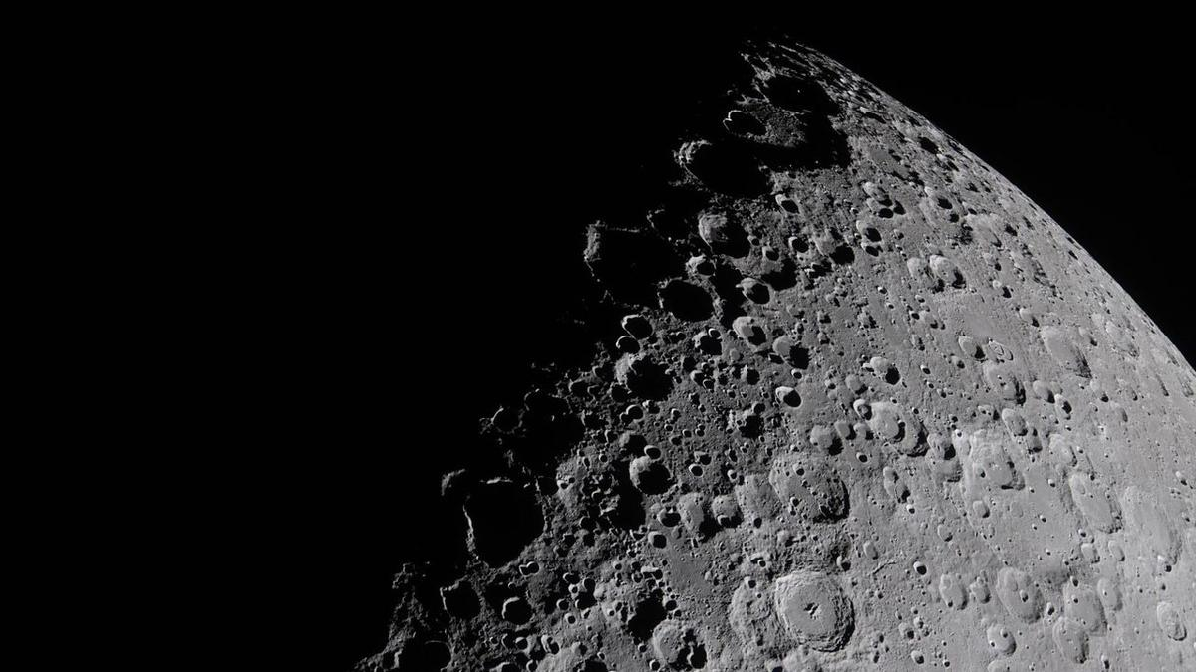
Click for next article A portion of the moon captured by the Artemis II crew during their ten-day mission in April 2026. On Aug. 5, Earth's moon is due for a human-made, high-speed impact from an identified flying object: a spent SpaceX Falcon 9 upper stage. The event will lead to a literal "dust up" on the lunar landscape. That Falcon 9 upper stage is a leftover from the launch that sent Firefly's Blue Ghost-1 lander to the moon on Jan. 15, 2025. Onboard the same flight was the Hakuto-R Mission 2 , called Resilience, a robotic lunar lander developed by the Japanese company ispace. And according to a new study by an international team published on the open-source arXiv server, the resulting impact plume may briefly be bright enough to see against the dark sky near the moon's edge. That means it might be visible to moongazers with sufficiently sensitive telescopes. This head-on collision of the errant stage is expected to occur near the Einstein and Bell craters near the western lunar limb. It may well be visible to ground and space-based assets. Indeed, putting aside all the unknowns and modeling uncertainties, some specialists suggest if you've got the time and observational prowess, it might be worth a look. Visible ejecta spike Using special physics simulations to model the impact, William Jo, a graduate research assistant at the University of Texas, Austin and colleagues predict the debris plume from the impact will have the central ejecta spike reaching roughly 47 miles to over 60 miles (75 kilometers to 100 kilometers) altitude. "Our calculations suggest the plume should be several orders of magnitude brighter than the dark-sky background for the first few minutes after impact," Jo told Space.com. "So the plume should be visible, though I'd stress this is a single nominal case. The real one will look different, and the numbers are on the optimistic side. But the point worth making is that the flash isn't really the story here." Jo emphasized that there's great slam-dunk science to be had. "Watching this one gives us a rare chance to open up ejecta-plume science and calibrate those models against a real event, which matters for every future thing we deliver to the moon," Jo said. An animation predicting the evolution of the target ejecta column density, rendered on the lunar surface at the predicted impact site near Einstein crater by William Jo et al. (Image credit: William Jo/UT Austin) Implications for future moon missions According to new research led by Benjamin Fernando of the Los Alamos National Laboratory in New Mexico, the impact flash and resultant ejecta plume are "potentially observable" from ground- and space-based observational facilities. "This event provides an opportunity to attempt the recording of an artificial impact in real-time; although many of the properties of the event (such as visual magnitude) are imprecisely predicted at present," Fernando and colleagues report. Moreover, this rocket stage meets moon occasion yields an opportunity to test a pipeline for localizing impacts on the lunar surface for future seismic experiments, investigating the dust and plume dynamics from impact events on the moon, and considering hazards from artificial space debris impacts that future astronauts on the lunar surface might have to avoid, Fernando and team members point out. "The maximum ballistic range of resolved particles is found to be slightly under 1,000 km, which is far enough to be significant from the perspective of presenting a hazard to future astronauts or infrastructure across much of the lunar surface," Fernando et al wrote in the study. A SpaceX photo of one of the company's Falcon 9 second stages, taken in 2022. A similar second stage is expected to impact the moon in August 2026. (Image credit: SpaceX) Before and after Brent Garry is a project scientist for NASA's Lunar Reconnaissance Orbiter (LRO) at Goddard Space Flight Center in Greenbelt, Maryland. LRO will be passing over the projected rocket stage crash site about seven days prior to the impact and about seven days after the impact, Garry explains. "After the impact we might have a little bit more knowledge of where it is. We can do some additional targeting about a week after the impact and get some targeting over where the site is," said Garry, as noted in earlier Space.com reporting . Meanwhile, Jo at the University of Texas, Austin underscores the fact that a spent rocket stage is a hollow, spacecraft-like body, and there are very few impact models for human-made objects like it. They seem to produce very different plumes than natural impactors, like asteroids or comets do. But Jo stresses that the real scientific contributions will come by studying the moments after the impact. "My concern is that most observers will stop at the sub-second flash and never track down the ejecta, which is the part that should actually be visible, and where the science is."

44. Scientists advance space agriculture for future moon and Mars missions
Read more
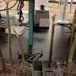
Space isn't known for rich soil or ideal agricultural conditions anywhere in the solar system. Yet amid extreme temperatures and vast distances, multidisciplinary teams at USF's Aerospace: Science, Technology, Research and Applications Center (ASTRA) are collaborating on sustainable space agriculture projects with potential applications back on Earth.

45. Tracking satellites and space debris using radio antennae
Read more

Every year, thousands of satellites are launched into orbit around our planet. The result is an increasingly congested "space" above Earth populated by equipment that provides services to the surface. At the same time, these satellites affect ground-based astronomy and create the potential for damage when they eventually fall through Earth's atmosphere to the surface. In additi...

46. Mission-ready Moon excavation system targets 2028 for NASA's lunar base construction
Read more
Before permanent lunar bases become possible, someone has to level the ground. Preparing the Moon for a sustained human presence will require far more than rockets and habitats. Future missions will also depend on heavy machinery capable of clearing terrain, stabilizing landing areas, and performing construction work without constant human control. That challenge is driving a deeper partnership between lunar resources company Interlune and industrial equipment manufacturer Vermeer Corporation. The companies have expanded their collaboration to develop construction systems for future Moon Base missions, with a mission-ready lunar site-preparation tool now targeted for 2028. The effort aligns with NASA's long-term plans to establish permanent infrastructure on the Moon. It also reflects growing commercial interest in building the equipment needed before large-scale exploration and resource extraction can begin. Heavy equipment heads Moonward Interlune and Vermeer will develop an autonomous tool designed to prepare the lunar surface for construction activities. Engineers plan to integrate the system with a lunar rover before testing it on Earth and later demonstrating it on the Moon. The Interlune-Vermeer excavator prototype unveiled in 2025. Credit - Interlune Unlike traditional construction equipment, the machine must operate in an environment covered with abrasive dust, exposed to extreme temperature swings, and separated from Earth by communication delays. Those conditions demand highly autonomous systems that can perform excavation and site preparation with limited human input. The companies first worked together on a full-scale prototype lunar excavator unveiled in May 2025. That project served as an engineering proof of concept. Their expanded partnership now shifts attention toward hardware intended for operational missions. Interlune co-founder and CEO Rob Meyerson said dependable excavation and autonomous mobility will form the backbone of permanent lunar infrastructure. He added that the companies are now focused on scalable systems capable of supporting future Moon Base construction and harvesting lunar resources. Engineering beyond Earth Vermeer has spent nearly eight decades developing industrial equipment for demanding construction sites. Interlune specializes in robotic systems, space infrastructure and operations in the lunar environment, giving the partnership expertise across both terrestrial engineering and space technology. Engineers expect the equipment to perform some of the earliest construction work on the Moon. Preparing stable surfaces for landing pads, transport routes and future facilities will become increasingly important as mission activity grows. Vermeer President and CEO Jason Andringa said the company views the Moon as its most demanding job site yet. He said Vermeer plans to work with Interlune, NASA and other partners to help supply the infrastructure required for future lunar settlements. Foundation for future missions The partners expect to deliver a mission-ready site-preparation system by 2028, matching NASA's broader Moon Base timeline. Success could influence how future missions approach extraterrestrial construction. Equipment developed for the Moon may eventually support resource extraction, infrastructure projects, and exploration efforts on Mars and other destinations. As governments and private companies increase their lunar ambitions, autonomous construction equipment is emerging as a critical piece of the broader space economy. The ability to reshape the lunar surface before astronauts arrive could determine how quickly permanent outposts become reality.
47. Youth can take India to zenith of space research: Group captain Shukla
Read more
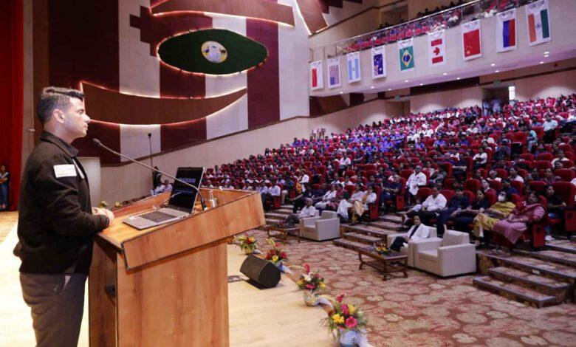
PIONEER EDGE NEWS SERVICE/ Dehradun Group captain Shubhanshu Shukla known for the 'Gaganyan mission' has said that India's youth have the potential to take the country to new heights in global space research. He was interacting with the students at the All India Institute of Medical Sciences (AIIMS) Rishikesh on Friday. Shukla motivated the students to pursue careers in space science, innovation and other challenging fields, he emphasised that even the most difficult goals can be achieved through determination, a positive mind-set and persistent effort. Shukla narrated his journey from his school days to becoming an Indian Air Force officer and eventually an astronaut. Through a video presentation, he explained the astronaut selection process, training for gravity and microgravity, physical and mental preparation, medical emergency training, mission launch procedures, medical care in space and the safe return to Earth. He explained that prolonged stays in space affect muscles, bones and the body's balance system. Therefore, after returning to Earth, astronauts undergo rehabilitation to retrain their muscles and restore balance and coordination. Sharing his experience of travelling hundreds of kilometres above Earth to the International Space Station (ISS), he said that science is a field driven by curiosity, discipline and dedication. During the interactive session, he also answered questions from students representing different schools and colleges. Welcoming Group Captain Shukla, executive director of AIIMS Rishikesh Meenu Singh described him as a true national hero. She said that by representing India in space, he has made the entire nation proud.

48. ISRO successfully conducts Integrated Main Parachute Air Drop Test (IMAT) for Gaganyaan Programme - ISRO
Read more

July 08, 2026 Indian Space Research Organisation (ISRO) has successfully conducted a critical Integrated Main parachute Airdrop Test (IMAT) for the Gaganyaan Missions on July 07, 2026 at the Aerial Delivery Research and Development Establishment (ADRDE) drop zone in Sheopur, Madhya Pradesh. The deceleration system of Gaganyaan Crew Module comprises of a total of 10 parachutes of 4 types. The descent sequence begins with two Apex Cover Separation parachutes that remove the protective cover of the parachute compartment, followed by two Drogue Parachutes that stabilize and decelerate the module. Upon release of the drogues, three Pilot Parachutes are deployed to extract three Main Parachutes, which further slows down the Crew Module to ensure a safe splashdown in the sea. The objective of this test was to qualify the Main Parachute for its structural integrity & design margins under the maximum expected load conditions in the first uncrewed Gaganyaan G1 mission. A simulated assembly of single main parachute and a dummy mass was dropped from an altitude of 2.5 km using an Indian Air Force IL-76 aircraft. The complex descent sequence began with an extractor parachute that deployed a Drogue parachute to stabilize oscillations. Upon achieving the requisite conditions, the main parachute was deployed which slowed the payload to a safe terminal speed. This is the 5th test in a series of Integrated Main parachute Airdrop Tests (IMAT) to qualify the critical Main Parachute for the Gaganyaan Mission. The successful completion of IMAT-05 provides necessary confidence in the performance and reliability of the Main Parachute System for the first Uncrewed Gaganyaan Mission (G1). This successful test is a joint effort of ISRO, DRDO, Indian Air Force and Indian Army.

49. ISRO aims for space station by 2035, Moon Mission by 2040 - The New Indian Express
Read more

He opined research should move beyond publications and result in technologies, patents and products that benefit society. He opined research should move beyond publications and result in technologies, patents and products that benefit society. Photo | Express VISAKHAPATNAM: "ISRO is working towards establishing India's own space station by 2035 and sending an Indian to the Moon aboard an Indian rocket by 2040," ISRO Chairman V Narayanan said on Friday. He was addressing the inaugural session of the 'ISRO Academia Connect @ AU' programme, organised by Andhra University, through virtual mode. Narayanan said India's progress towards becoming a developed nation by 2047 would require stronger collaboration among educational institutions, firms and research organisations. He opined research should move beyond publications and result in technologies, patents and products that benefit society. Highlighting ISRO's contributions, he stated that the organisation's satellites support more than 50 sectors, including telecommunications, weather forecasting, disaster management, agriculture, fisheries, water resources and border security. He added that satellite-based advisories to fishermen have helped improve their incomes.

50. ISRO calls for stronger academia-industry partnership to power future space missions - The Hindu
Read more
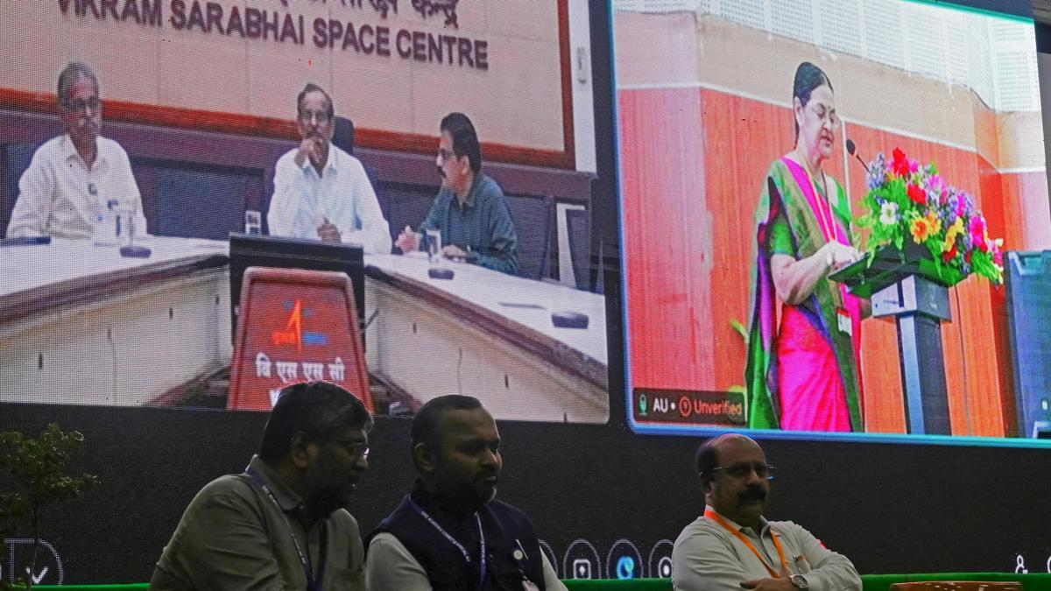
ISRO Chairman and Secretary, Department of Space, V. Narayanan, on Friday called for closer collaboration between academia, industry and research institutions to help realise India's ambitious space programme, including plans to establish an indigenous space station by 2035 and land Indians on the Moon by 2040. Delivering the keynote address virtually at ISRO Academia Connect @ AU, organised by the Capacity Building Programme Office (CBPO), ISRO, in association with Andhra University College of Engineering (A), Mr. Narayanan said the century-old Andhra University had made significant contributions to the nation by producing scientists, academicians and administrators, making it an ideal partner for advancing research and innovation. Highlighting India's achievements in space, he said the country had become the first to achieve a successful soft landing near the Moon's south pole through Chandrayaan-3 and added that work was under way on Chandrayaan-4 and Chandrayaan-5. "There should not be any gap between space and the common man of this country," he said, noting that ISRO's satellites were supporting more than 50 sectors, including telecommunications, weather forecasting, disaster management, agriculture, fisheries, water resources and border security. He said India had also developed indigenous cryogenic technology after being denied access to it by other countries. Calling for application-oriented research, Mr. Narayanan urged universities to move beyond academic publications and develop patents, technologies and products that benefit society. He expressed confidence that the collaboration between ISRO and Andhra University would create greater opportunities for research and internships while contributing to the country's space programme. ISRO Scientific Secretary M. Ganesh Pillai said the event at Andhra University was the fifth edition of ISRO's nationwide Academic Connect initiative. "Every successful space mission is built upon decades of research, innovation and academic excellence," he said, urging universities to undertake mission-oriented research leading to technologies, prototypes and products for future space missions.

51. What's Up: August 2026 Skywatching Tips from NASA
Read more

A solar eclipse, the Perseids, bright Venus after sunset, and a deep partial lunar eclipse highlight August's skywatching. Skywatching Highlights Aug. 5: Last Quarter Moon Last Quarter Moon Aug. 12: Total solar eclipse across northern Russia, Greenland, Iceland, northern Spain, and part of Portugal; partial eclipse in parts of the U.S.; New Moon Total solar eclipse across northern Russia, Greenland, Iceland, northern Spain, and part of Portugal; partial eclipse in parts of the U.S.; New Moon Aug. 12-13: Perseid meteor shower peak under dark skies Perseid meteor shower peak under dark skies Aug. 14-16: Venus reaches greatest eastern elongation and shines low in the west after sunset Venus reaches greatest eastern elongation and shines low in the west after sunset Aug. 27-28: Partial lunar eclipse visible from much of North and South America and parts of Europe and Africa Transcript A solar eclipse, one of the year's best meteor showers, Venus at its brightest in the evening sky, and a lunar eclipse to close out the month. That's "What's Up" for August. On Aug. 12, a total solar eclipse crosses northern Russia, Greenland, Iceland, and northern Spain, with a small corner of Portugal inside the path of totality. In parts of the United States, from Alaska to North Carolina, the eclipse is partial. The Moon will take only a small bite out of the Sun, and the amount of coverage will vary with location. A map showing viewing areas of the August 2026 total solar eclipse. NASA/JPL-Caltech Remember to watch safely. Use certified eclipse glasses or a safe solar viewer any time any part of the Sun is visible. Regular sunglasses are not safe. And never use binoculars, a telescope, or a camera without a solar filter made for the front of the optics. Later that same night, the Perseid meteor shower will light up the sky, peaking the evening of Aug. 12 into the early morning hours of the 13th. And with a New Moon arriving on the 12th, the skies will be ideally dark. The Perseids happen every year when Earth passes through a debris stream left behind by Comet Swift-Tuttle. As those tiny bits of comet dust hit our atmosphere at high speed, they burn up as bright streaks of light. To view this meteor shower, look toward the northeast once it's fully dark and watch for the constellation Perseus to clear the horizon. This is where the meteors originate, but let your eyes wander, because they can flash across any part of the sky. For the best view, stay out late as the stars climb higher, find a dark open spot, and give your eyes 30 minutes to adjust. This illustration shows where in the night sky to look for the Perseid meteor shower. NASA/JPL-Caltech Aug. 14-16, Venus reaches its greatest eastern elongation, which is its widest apparent separation from the Sun during this evening appearance. Look low in the western sky shortly after sunset for the bright object that will outshine every star around it. Through a telescope after sunset, Venus will look close to half lit, like a tiny lunar phase. This illustration shows where to observe Venus after sunset in August. NASA/JPL-Caltech On the night of Aug. 27, continuing into Aug. 28 for some time zones, the Full Moon slips through Earth's shadow, resulting in a partial lunar eclipse. It will be visible from much of North and South America and parts of Europe and Africa. Viewing areas for the August 2026 lunar eclipse. NASA/JPL-Caltech At maximum eclipse, about 93% of the Moon's diameter will be inside Earth's dark central shadow, called the umbra. The Moon will not be completely covered, but it can look dramatically darkened, with a rusty, coppery tint along the covered edge. Unlike a solar eclipse, a lunar eclipse is safe to watch with just your eyes. Binoculars or a small telescope can give you a closer view of Earth's curved shadow moving across the Moon. Here are the phases of the Moon for August. You can stay up to date on all of NASA's missions exploring the solar system and beyond at science.nasa.gov. I'm Raquel Villanueva from NASA's Jet Propulsion Laboratory, and that's What's Up for this month.

52. NASA to Host Florida Event Celebrating American Air, Space Leadership
Read more
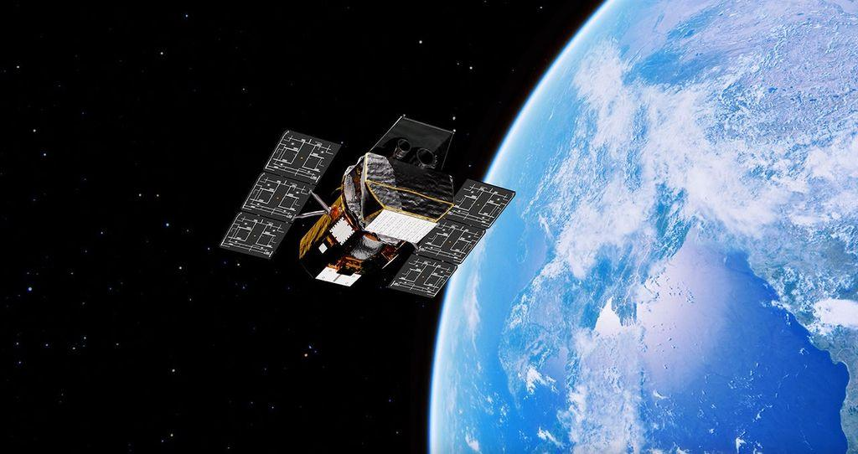
An American flag is seen in front of NASA's SLS (Space Launch System) rocket and Orion spacecraft at NASA's Kennedy Space Center in Florida on Jan. 17, 2026, ahead of the historic Artemis II test flight. NASA will host a news conference at NASA Kennedy on Friday, Aug. 14, to highlight American leadership in space and aviation. Credit: NASA/Joel Kowsky NASA will hold a news conference at 2:30 p.m. EDT, Friday, Aug. 14, live from the agency's Kennedy Space Center in Florida, and media and digital creators are invited to attend in person. The announcement, held in the XLV Hangar at the Shuttle Landing Facility, will preview a new event at NASA Kennedy later this year tied to America's 250th anniversary, showcasing American leadership in aviation, space exploration, and emerging technologies while bringing together the public, industry leaders, innovators, and the next generation of explorers. Participants include: NASA Administrator Jared Isaacman NASA leadership Members of Congress The agency will stream this news conference live through a variety of platforms: https://www.nasa.gov/live This event is open to U.S. media and digital creators. The request to attend must be received no later than 12 p.m. on Thursday, Aug. 6, to the Kennedy newsroom at: https://media.ksc.nasa.gov. NASA's media accreditation policy is available online. For more information about NASA's missions, visit: https://www.nasa.gov -end- George Alderman / Cheryl Warner Headquarters, Washington 202-358-1600 george.a.alderman@nasa.gov / cheryl.m.warner@nasa.gov Danielle Sempsrott Kennedy Space Center, Fla. 321-298-8990 danielle.c.sempsrott@nasa.gov

53. NASA, SpaceX Advance Wind Tunnel Tests for Starship Rocket
Read more
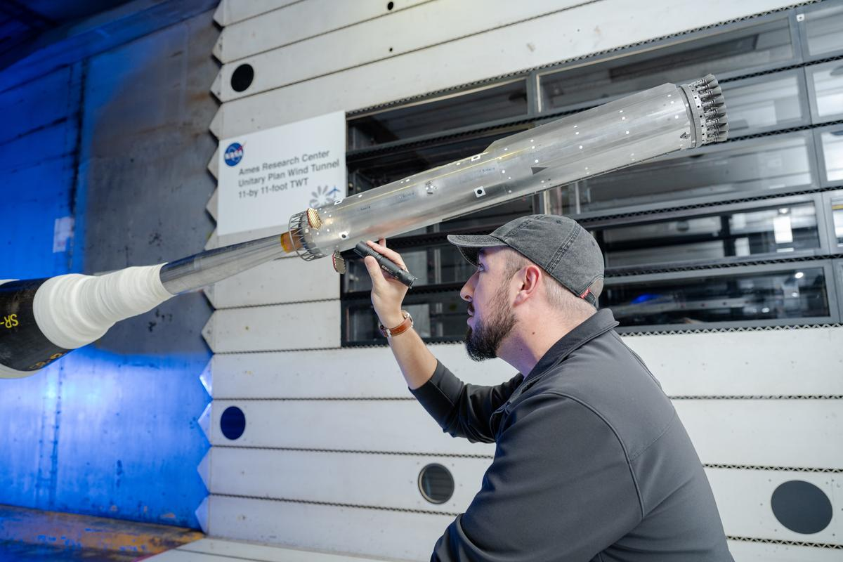
NASA and its industry partners are preparing for next year's Artemis III demonstration mission by completing new wind tunnel tests on SpaceX's Super Heavy Version 3 rocket booster. The tests, conducted at NASA's Ames Research Center in California's Silicon Valley, focused on better understanding the extreme aerodynamic forces the rocket can experience during re-entry. The recent test series builds on previous testing completed at NASA Ames in 2024. NASA is working with SpaceX to develop the company's Starship Human Landing System (HLS) to safely carry astronauts from lunar orbit to the Moon's surface and back. The upgraded Super Heavy rocket booster is part of SpaceX's Starship launch system. Version 3 of Starship and Super Heavy is expected to be the basis for the Starship HLS for Artemis III in 2027 and a later crewed lunar landing in 2028. Engineers at NASA Ames conduct transonic and supersonic wind testing on a 1.2% scale model of the Super Heavy Version 3 rocket that will launch the Starship human landing system. NASA Engineers at NASA Ames conduct transonic and supersonic wind testing on a 1.2% scale model of the Super Heavy Version 3 rocket that will launch the Starship human landing system. NASA Engineers at NASA Ames conduct transonic and supersonic wind testing on a 1.2% scale model of the Super Heavy Version 3 rocket that will launch the Starship human landing system. NASA Engineers at NASA Ames conduct transonic and supersonic wind testing on a 1.2% scale model of the Super Heavy Version 3 rocket that will launch the Starship human landing system. NASA Although Starship HLS is a lunar lander designed and built by SpaceX, NASA collaborates with commercial companies to provide access to specialized testing facilities, like the wind tunnels at NASA Ames, and technical expertise, such as the team that set up the wind tunnel testing and helped analyze the results. "NASA has a lot of experience with unsteady aerodynamics," said Manish Mehta, discipline lead engineer for the HLS Plume and Aero Environments team, NASA's Marshall Space Flight Center in Huntsville, Alabama. "We used the agency's broad experience base of conducting wind tunnel tests for the space shuttle, the SLS (Space Launch System) rocket, and Orion spacecraft to efficiently set up and analyze the wind tunnel testing for the Super Heavy Version 3. In fact, similar testing at the Ames Unitary Plan Wind Tunnel resulted in adding strakes to SLS for Artemis II, so what we learned for Artemis II is helping us get to Artemis III and beyond." Testing SpaceX's Starship consists of a 33-engine first-stage Super Heavy rocket, or booster, and the second-stage Starship. Version 3 of Super Heavy incorporates many new and upgraded systems, including: New propulsion systems and new Raptor 3 rocket engines No engine section skirt, individual engine shrouds, or integrated large-scale base heat shield Three gridfins on the Super Heavy booster instead of four, with each fin now 50% larger An integrated hot stage replacing the previous single-use protective interstage With significant changes to Super Heavy, NASA and SpaceX engineers wanted more information about the steady and unsteady aerodynamic forces the rocket will experience during atmospheric re-entry as it returns to the launch site for refurbishment and re-use. "When a rocket, or an airplane, flies through air at high speed, it's subjected to steady aerodynamic forces and moments, and unsteady aerodynamic forces and moments," explained Jayanta Panda, unsteady aerodynamics subject matter expert at NASA Ames and part of the Human Landing System Plume and Aero Environments team. "An example of a steady aerodynamic force would be when air smoothly flows over the surface of the rocket as it ascends. An unsteady aerodynamic force would be air 'buffeting,' or hitting, certain areas the rocket at less predictable times and potentially causing vibrations." Wind tunnels NASA and SpaceX used a 1.2% scale model of the Super Heavy Version 3 in the transonic wind tunnel and the supersonic wind tunnel at NASA Ames for testing. The transonic tunnel blasts scale models of rockets or aircraft with air at speeds ranging from Mach 0.2 to Mach 1.4 (Mach 1 is the speed of sound, or about 761 miles per hour). The smaller supersonic tunnel fires winds at higher speeds, from Mach 1.55 to Mach 2.5. The wind tunnel tests on Super Heavy Version 3, conducted in late 2025, used both tunnels to measure steady and unsteady air flows on the surfaces of Super Heavy. "Resulting wind tunnel data on steady forces and moments helps predict how the rocket will react to forces in the atmosphere during re-entry so the flight software can effectively guide the rocket during flight," Mehta said. "The unsteady pressure data helps engineers understand the environment around the rocket as it re-enters Earth's atmosphere. Engineers use that information as one input into software that analyzes loads on the rocket." Through the Artemis program, NASA is returning humans to the Moon for scientific discovery, economic opportunity, to establish an enduring human presence on the lunar surface, and build the foundation for the first crewed missions to Mars - for the benefit of all. To learn more about Artemis, visit: https://www.nasa.gov/artemis

54. NASA Opens New Flight Dynamics Research Facility in Virginia
Read more
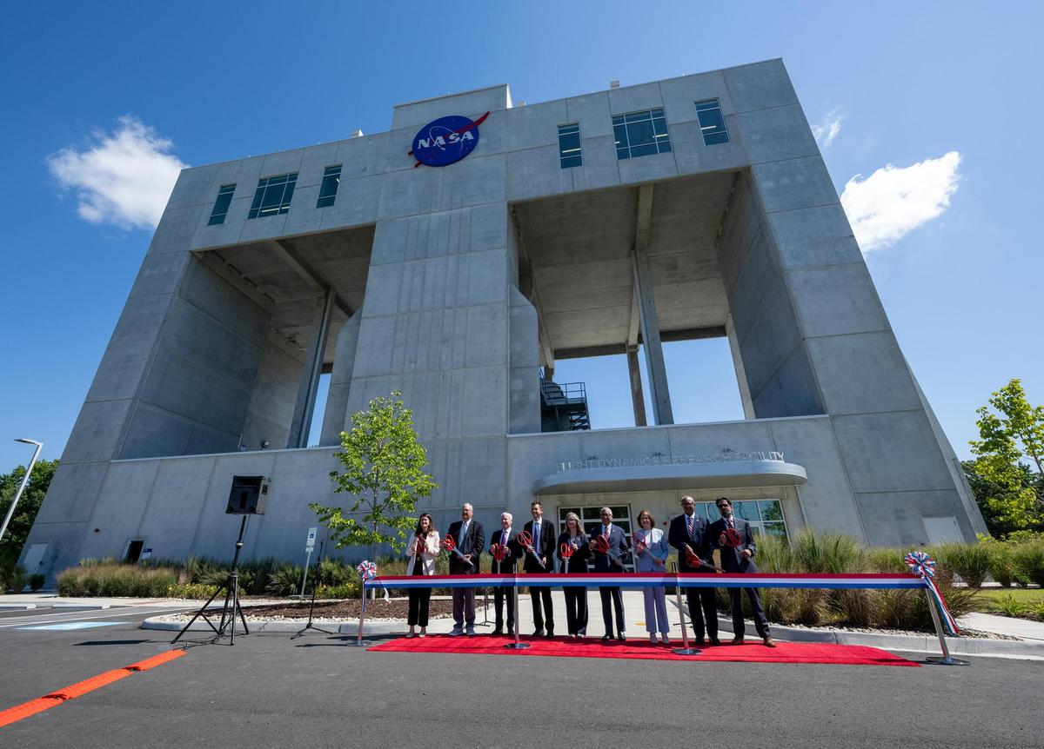
From left to right: Casey Swails, NASA deputy associate administrator; Mike Waller, vice president of BL Harbert International Federal Division; Edward C. Forst, administrator of the U.S. General Services Administration; NASA Administrator Jared Isaacman; Dr. Trina Dyal, director of NASA's Langley Research Center; Rep. Robert "Bobby" Scott (D-Va.); Virginia Lt. Gov. Ghazala F. Hashmi; Jimmy Gray, mayor, City of Hampton; and Amit Kshatriya, NASA associate administrator, pose for a photo before cutting the ribbon to open the Flight Dynamics Research Facility, NASA's newest wind tunnel, Friday, July 31, 2026, at NASA's Langley Research Center in Hampton, Virginia. Credit: NASA/Keegan Barber NASA opened its newest wind tunnel, the Flight Dynamics Research Facility, Friday, providing a critical resource for the agency and its partners to test the safety and performance of future generations of aircraft, rockets, and space exploration vehicles. Located at NASA's Langley Research Center in Hampton, Virginia, the Flight Dynamics Research Facility will support advances in aircraft safety, X‑plane development, drone research, and spacecraft technology. The facility will enable both free‑flight and mounted testing of a wide range of scale-model vehicles designed to travel through an atmosphere, from airplanes to space capsules returning to Earth. "The Flight Dynamics Research Facility is NASA's first major new wind tunnel in more than 40 years and gives us a powerful new platform to test the ideas and technologies that will shape the future of aviation and exploration," said NASA Administrator Jared Isaacman. "America has led in air and space because we were willing to take on hard problems, challenge assumptions, and build what didn't exist before. This facility gives the talented team at Langley, and our partners across government, industry, and universities, the tools to keep pushing the boundaries of what's possible and ensure America remains the world leader in air and space." A ribbon-cutting ceremony at NASA Langley marked the start of a new chapter in flight research. Agency leaders, partners, and Virginia officials emphasized how the Flight Dynamics Research Facility's state-of-the-art capabilities will shape the future of flight and exploration. "The opening of the Flight Dynamics Research Facility represents a significant advancement for NASA and for the nation," said Dr. Trina Dyal, NASA Langley center director. "By bringing modernized testing capabilities under one roof, we are enabling transformative research that will ensure the United States remains at the forefront of aeronautics and exploration." Built through a partnership with the U.S. General Services Administration (GSA), the facility replaces aging infrastructure with an energy-efficient facility that reduces maintenance costs and provides the flexibility needed for future research. The Flight Dynamics Research Facility is part of a broader, long-term collaboration between the agencies, representing the fourth new building GSA has delivered to NASA under Langley's 20-year campus revitalization plan. "GSA is proud to partner with NASA in delivering the Flight Dynamics Research Facility, a state-of-the-art asset that will power the next generation of American dominance in aeronautics and space exploration," said Edward C. Forst, GSA administrator. "This facility reflects what we do best: provide the advanced, expertly designed installations that federal agencies need to carry out their missions. With these new capabilities, NASA will be better equipped to test bold ideas, validate new designs, and advance technologies that will serve the nation for decades to come." The Flight Dynamics Research Facility combines and improves upon the capabilities of two historic NASA Langley wind tunnels - the 20-Foot Vertical Spin Tunnel and the 12-Foot Low-Speed Tunnel. The 25,000-square-foot building features a vertical wind tunnel with improved airflow, modern digital systems, and flexible testing capabilities that will allow researchers to study how aircraft, spacecraft, parachutes, and other vehicles behave during flight. The facility's 20-foot diameter test chamber is much larger than those of its NASA Langley predecessors, allowing for more air to pass around test models and improving data accuracy. Its increased size also allows for the use of larger, more detailed models during testing. The Flight Dynamics Research Facility's top airspeed of 117 miles per hour is twice as fast as the old facilities, enabling free-flight tests of heavier scale models. This will allow simulations of full-scale vehicles flying at higher altitudes - a critical capability for operations such as studying the stability of aircraft or reentry capsules coming back from space. The facility's wind power comes from four 750-horsepower motors, each with an integrated, 14-foot diameter, eight-bladed fan. The fan blades are made of lightweight carbon fiber, enabling rapid, precise airspeed adjustments during free‑flight tests. The Flight Dynamics Research Facility illustrates the powerful synergy between NASA's aeronautics and space exploration efforts, with each driving innovation in the other. The facility will drive experimental research across a wide range of flight systems, advancing the development of autonomous flight vehicles, drones, commercial and military aircraft, and X‑planes. As NASA prepares for a sustained human presence on the lunar surface through the Artemis program and the development of a Moon Base, the facility will play a key role in testing vehicle designs for entry, descent, and landing that will help reduce mission risk and support the safe return of crews to Earth. NASA also will be able to use the wind tunnel to help design aircraft for Mars and other destinations in our solar system where atmospheric flight is possible. With the Flight Dynamics Research Facility now open, NASA is entering a new era in flight research - one that will shape the aircraft and spacecraft of tomorrow, strengthen industry partnerships, and extend the agency's legacy of pioneering aerospace leadership. The facility is managed under the Aerosciences Evaluation and Test Capabilities portfolio in the Aeronautics Division of NASA's Research and Technology Mission Directorate. Learn more about the Flight Dynamics Research Facility at: https://go.nasa.gov/4yzKEGQ -end- Camille Gallo / Rob Margetta Headquarters, Washington 202-358-1600 camille.m.gallo@nasa.gov / robert.j.margetta@nasa.gov Kimiko Booker / Brittny McGraw NASA Langley, Hampton, Virginia 757-506-5939 / 757-769-3763 kimiko.s.booker@nasa.gov / brittny.v.mcgraw@nasa.gov

55. NASA's Roman Telescope to Carry 1.35 Million Names to Deep Space
Read more
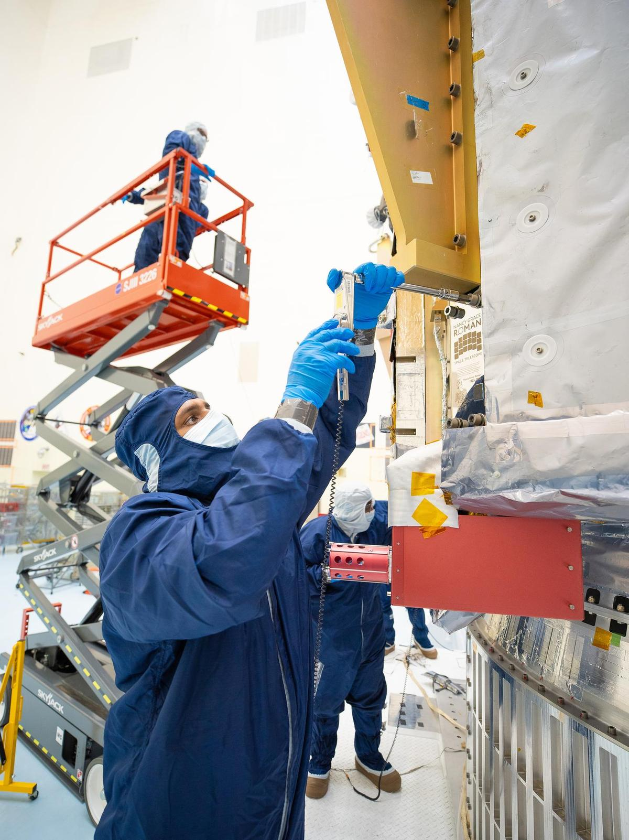
On July 27, technicians at NASA's Kennedy Space Center in Florida installed a memory card containing 1,350,144 names as part of a commemorative plaque on the Nancy Grace Roman Space Telescope. The names were submitted by people globally, including astronauts from Artemis II and Artemis III. The memory card will travel with the Roman observatory to the Sun-Earth Lagrange point 2, or L2, about one million miles from Earth, where the Sun's and Earth's gravity balance out. Roman is named after Dr. Nancy Grace Roman, NASA's first chief astronomer and one of the architects of the agency's modern science program. Roman championed space-based observatories that could study the universe from above Earth's hazy atmosphere while making their data broadly available to the scientific community. NASA and SpaceX are targeting launch for no earlier than 7:26 a.m. EDT Sunday, Aug. 30 aboard a SpaceX Falcon Heavy from Launch Complex 39A at Kennedy. To learn more about the Roman mission, visit: https://www.nasa.gov/roman Image credit: NASA/Jolearra Tshiteya

56. SpaceX's Starship seen in space by next-gen Starlink satellite (video)
Read more
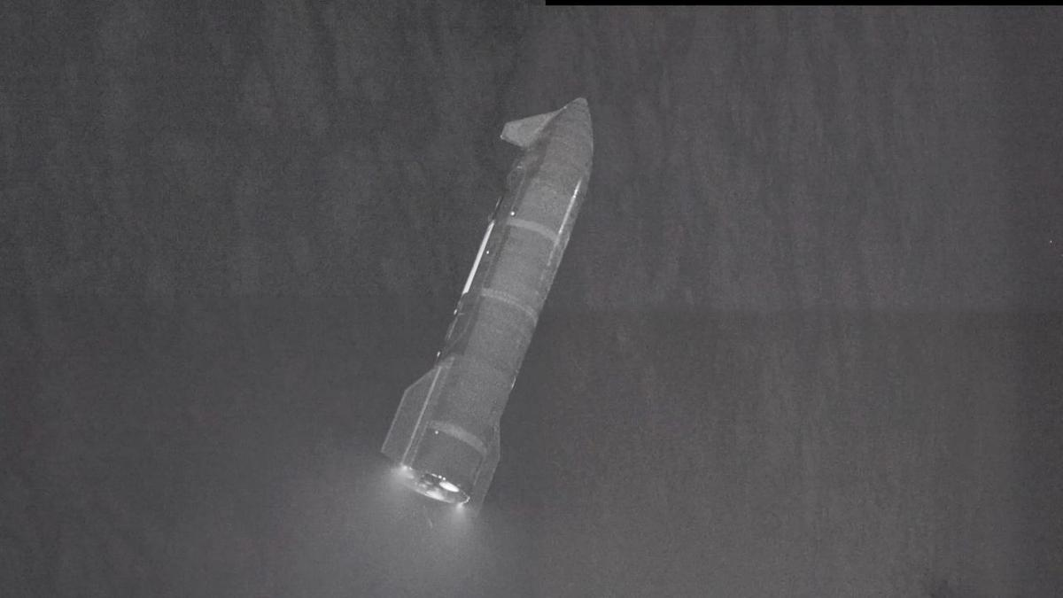
Click for next article The upper stage of SpaceX's Starship megarocket, seen on July 24 during the vehicle's 13th test flight by one of the company's Starlink V3 satellites. We just got an amazing new view of SpaceX's Starship vehicle, thanks to one of the company's next-gen Starlink satellites. Starship , the biggest and most powerful rocket ever built, launched on its 13th test flight from South Texas last Friday (July 24). The suborbital jaunt was similar in many respects to past Starship test missions, with one big exception: This time, the vehicle deployed a batch of functional, next-gen Starlink internet satellites into space. Six of those "Starlink V3" spacecraft carried cameras, so that SpaceX could get good views of the heat shield on Starship's upper stage, which is known as Starship, or simply Ship. The satellites did that job and more, capturing amazing views of Ship as it cruised away from them high above Earth . View of Starship in space from a Starlink V3 satellite on Flight 13.This composite is made of imagery from four separate cameras on a single satellite. Six of the satellites were equipped with cameras to scan Starship's heat shield and transmit imagery down to operators to… pic.twitter.com/sNTHHz5vLrJuly 31, 2026 SpaceX shared one such view on X Friday evening (July 31) - a 65-second video that stitches together imagery taken by four different cameras on a single Starlink V3 satellite. The video starts with an up-close view of the shiny, 171-foot-tall (52 meters) Ship. We see more of the vehicle as the footage rolls and the two spacecraft get farther and farther apart. Toward the end, we see Ship in its entirety, and we get a sense of its activity; three of its six Raptor engines are firing, and small puffs of white vapor indicate that the vehicle is engaging its fine-tuning reaction control thrusters. Like all Starship test missions to date, Flight 13 targeted a suborbital trajectory. So the 20 Starlink V3 satellites, the first ever to reach space, did not stay up for long; they came back down to Earth about 20 minutes after deploying into the final frontier. Their successors will get higher - and there will be many of them. According to a filing with the U.S. Federal Communications Commission, SpaceX wants to operate a megaconstellation of 100,000 Starlink V3 satellites . Starship will be key to building and maintaining this constellation, which will require many launches of the brawny, fully reusable rocket. (SpaceX currently operates a constellation of nearly 11,000 Starlink satellites, but those V2 craft are considerably smaller than the 4,400-pound V3 iteration.) SpaceX's Starship upper stage splashes down in the Indian Ocean to wrap up its 13th test flight on July 24, 2026. (Image credit: SpaceX) Ship seems to have checked all of its boxes on Flight 13. After deploying the satellites and successfully reigniting one of its Raptors in space, it splashed down on target in the Indian Ocean off the coast of Western Australia about 65 minutes after liftoff. The vehicle survived its harrowing return trip through Earth's atmosphere in one piece and remains intact today, as far as we know; SpaceX recently shared a photo of the vehicle bobbing in the Indian Ocean five days after splashdown. But Starship's giant first-stage booster, known as Super Heavy, had a few issues on Flight 13. Its landing burn employed only five of a planned 13 Raptor engines, for example, and the booster hit the waters of the Gulf of Mexico at a higher velocity than intended. (Super Heavy has a total of 33 Raptors, all of which fire at liftoff.)

57. NASA is sending 2 probes to the moon to test complex 'three-body orbits'
Read more
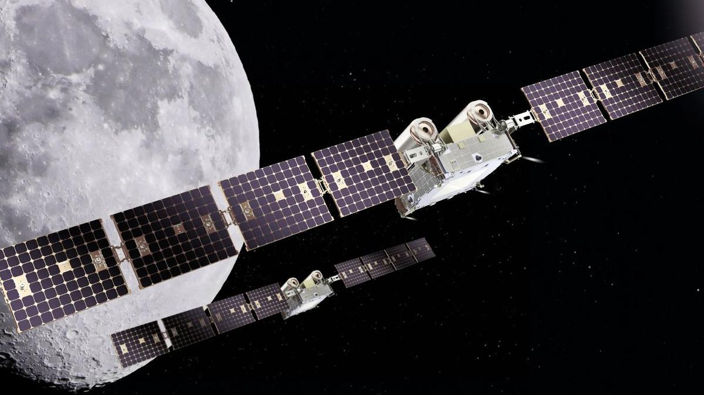
Click for next article NASA is planning to send two maneuverable probes to lunar orbit in order to learn how spacecraft are affected by the complex gravitational environment near the moon. The mission, known as CAPSTONE 02, is currently aiming to launch in 2027. It will see the two probes maneuver in close proximity to one another and fly in "formation" so mission operators can better understand the gravitational effects spacecraft experience in cislunar space . This area of space is under the influence of both Earth's gravity and the moon's, meaning spacecraft operating there will have to navigate what are known as "three-body orbits." While testing spacecraft maneuverability in these complex orbits, CAPSTONE 02 will also study communication and navigation systems that will be used in NASA's planned Artemis missions of lunar exploration and moon base construction . "This mission represents an important step in the maturation of cislunar capabilities," said NASA's Sean Fuller, Moon Base CAPSTONE manager, in an agency statement . "CAPSTONE 02 lays the foundation for lunar infrastructure and commercial services that support Artemis, Moon Base, and future missions to deep space." The two CAPSTONE 02 probes are being built by Terran Orbital Systems, Inc. Once in space, they will alternate jobs while flying in formation, switching between what NASA calls "chaser" and "target" roles. The spacecraft pair will use celestial navigation, optical sensors and data collected by telescopes on the ground during these maneuvers. This is similar to how NASA will use a variety of data to help its Orion spacecraft meet up with a lunar lander en route to the moon. On the upcoming Artemis III mission, currently scheduled for 2027, NASA will test some of these techniques as Orion will rendezvous with both Blue Origin's Blue Moon lander and SpaceX's Starship, if all goes according to plan. "Transporting crew to the lunar surface from cislunar orbit depends on knowing how well navigation systems will perform during these operations. Since these conditions can't be fully recreated on Earth, they must be tested in space," NASA wrote in its statement outlining the CAPSTONE 02 mission. An artist's rendering of NASA's Orion spacecraft meeting up with SpaceX's Starship on the planned Artemis III mission. (Image credit: SpaceX) As its name implies, this will be the second mission under NASA's CAPSTONE program, or Cislunar Autonomous Positioning System Technology Operations and Navigation Experiment. The first CAPSTONE probe launched in 2022 and operated for four years before NASA officially concluded its mission in June 2026. That microwave-oven-sized CAPSTONE spacecraft tested communications tech and became the first spacecraft to test three-body orbits around the moon, according to a NASA statement .

58. Watch SpaceX's Starship land at sea in these stunning new videos
Read more
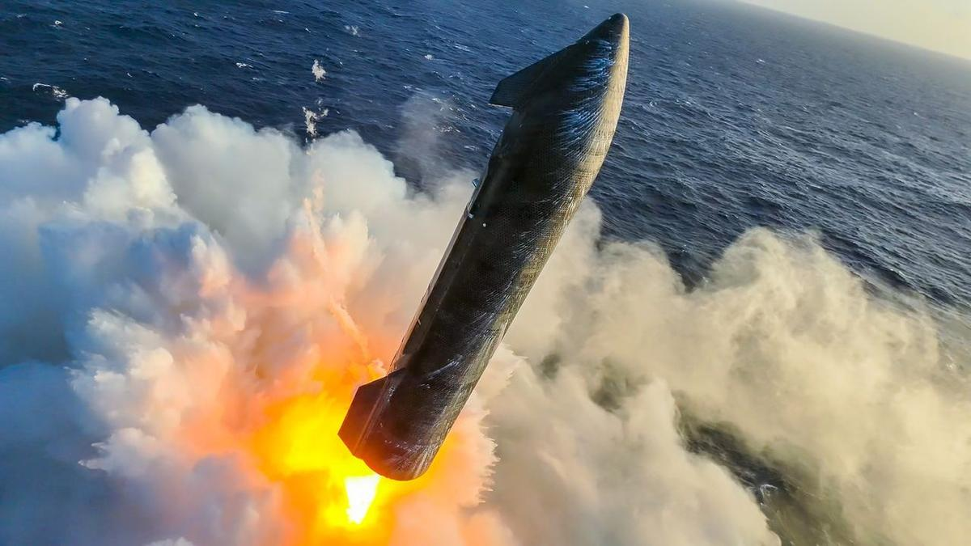
Click for next article It was Lucky 13 for SpaceX, as new videos show just how much work came into getting the latest flight of Starship's upper stage softly down into the ocean. After Starship made its 13th launch on Friday (July 24) from SpaceX's Starbase site in South Texas, the upper stage achieved all major milestones: putting 20 next-gen Starlink satellites aloft to watch it go, reigniting a Raptor engine in space, and then the soft splashdown off the coast of Western Australia. While the lower stage of Starship faced engine issues, fresh video shows some incredible views of the successful upper stage. Starlink satellites, ferrying signal from a buoy in the Indian Ocean, helped create a video on X showing the 171-foot (52-meter) upper stage roaring above the water, then generating steam as the engines swiveled to make a gentle splashdown. SpaceX's Starship upper stage fires its engines to slow down before splashing down on the Indian Ocean after its 13th test flight on July 24, 2026. (Image credit: SpaceX) Getting down that way was no easy feat, as SpaceX posted another video on Tuesday (July 28) showing Starship swaying dramatically in midair to achieve a near-vertical orientation above the water. If you don't mind a bit of vertigo, SpaceX also provided an on-ship view of the splashdown, complete with dramatic swings and ocean steam. The upper stage's ocean arrival was so soft, in fact, that days after launch on July 28 the 171-foot (52-meter) stage was reported as still afloat in the Indian Ocean, SpaceX said on X , adding that its Starship recovery team is continuing to gather imagery of the vehicle at sea. SpaceX's Starship Recovery Team poses for a portrait in front of the company's Starship V3 rocket afloat in the Indian Ocean on July 28, 2026. (Image credit: SpaceX) Starship's Version 3 (which flew on Friday) is a 408-foot-tall stacked system including the Super Heavy booster and the upper stage, also known as Starship (or Ship). SpaceX aims to make this system rapidly reusable for applications ranging from astronaut moon missions to launching even more powerful and larger Starlinks. That said, SpaceX still needs to notch some goals ahead of its expected participation for docking during the Artemis III astronaut mission scheduled for next year, and to possibly bring astronauts to the moon's surface during Artemis IV.
59. Rajneesh Pandey appointed KU's interim registrar
Read more
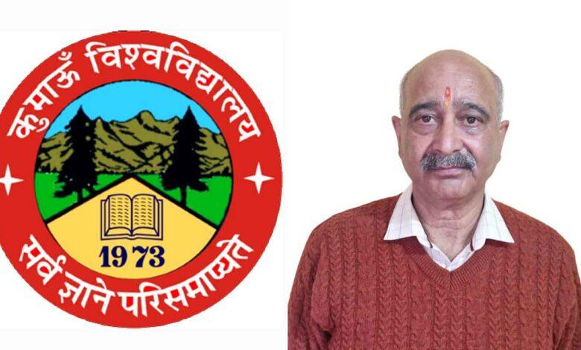
PIONEER EDGE NEWS SERVICE/NAINITAL With the post of the registrar of Kumaon University remaining vacant following the voluntary retirement of the former registrar, Mangal Singh Manral, the university administration has handed over the charge to Rajneesh Pandey as an interim arrangement. Manral had availed voluntary retirement from May 12 in compliance with the Uttarakhand High Court order. Upon assuming office, he reviewed various administrative and academic departments of the university while expressing his commitment to further enhance the university's academic quality, administrative efficiency, and developmental activities. He currently serves as the dean of the Faculty of Arts and head of the department of Economics.

60. The many challenges for ISRO: Rise of startups, launch setbacks, attrition - The Indian Express
Read more
The many challenges for ISRO: Rise of startups, launch setbacks, attrition The Indian Express

61. ISRO Recruitment 2026: Check Eligibility, Stipend, Last Date - education.sakshi.com
Read more
ISRO Recruitment 2026: Check Eligibility, Stipend, Last Date education.sakshi.com

62. Govt says ISRO has developed & operationalised wide range of space-based applications to benefit society - News On AIR
Read more

The Government has said that the Indian Space Research Organisation (ISRO) has developed and operationalised a wide range of space-based applications to benefit all sections of society, including the welfare of the Scheduled Caste community. Science and Technology Minister Dr. Jitendra Singh informed this in a written reply in the Lok Sabha today. The Minister said that key space application areas include satellite-based Potential Fishing Zone (PFZ) advisories, crop acreage and production forecasting, agrometeorological advisories for farmers, crop insurance support, geospatial support for flagship government programmes, tele-education, telemedicine, the Vessel Communication and Support System, and disaster management support. Mr. Singh noted that ISRO has established robust awareness and capacity-building programmes to promote the use of space technology for societal, governance, and disaster management purposes, enabling decision-makers to operate effectively at the grassroots level. He added that these initiatives are designed to be inclusive and accessible to targeted beneficiaries across the country. The Minister further said that the benefits of Earth observation, satellite communication, and navigation applications, particularly in terms of improved connectivity and navigation services, are reaching SC farmers, students, and disaster-prone regions within satellite coverage areas. He also highlighted that the Department has undertaken several measures to ensure the inclusive use of space technology, including the implementation of flagship initiatives such as Digital India, the BharatNet Programme, the Vessel Communication and Support System (VCSS) under the Pradhan Mantri Matsya Sampada Yojana (PMMSY), and the PM e-VIDYA scheme for tele-education.

63. Chandrayaan-5 Mission Update: ISRO, JAXA Move Closer to Exploring the Moon's South Pole - Indianmasterminds
Read more
Indian Masterminds Stories New Delhi: India and Japan have taken another major step toward the Chandrayaan-5 mission, a joint Moon exploration project that will study the Moon's south pole. The mission brings together the Indian Space Research Organisation (ISRO) and the Japan Aerospace Exploration Agency (JAXA) to search for water ice and learn more about the Moon's surface using advanced technology. Chandrayaan-5 Mission: ISRO And JAXA Hold Key Technical Meeting ISRO and JAXA recently held a high-level Technical Interface Meeting (TIM) in Bengaluru to review the progress of Chandrayaan-5, also known as the Lunar Polar Exploration (LUPEX) mission. The meeting included senior scientists and engineers from both space agencies. They discussed important technical systems needed to ensure the mission works smoothly from launch to landing. Read also: How Close Is India to Sending Astronauts to Space? ISRO Shares Big Gaganyaan Mission Update Chandrayaan-5 Mission: India Will Build The Lander, Japan Will Build The Rover Under the mission plan: ISRO will design and build the lunar lander. JAXA will provide the advanced lunar rover. The rover will travel across the Moon's surface after landing. Scientific instruments from ISRO, JAXA, ESA, and NASA will study lunar soil and water ice. Chandrayaan-5 Mission: Main Focus Is The Moon's South Pole The Chandrayaan-5 mission will explore the Moon's south polar region, especially Permanently Shadowed Regions (PSRs). Scientists believe these dark areas may contain frozen water ice that has remained untouched for billions of years. Finding and studying this water is important because it could support future human missions by providing drinking water, oxygen, and even rocket fuel. Teams Finalise Critical Mission Systems During the technical meeting, experts reviewed several important mission systems. These included communication between the lander and rover, power transfer, interface compatibility, mission timelines, landing site planning, and overall mission coordination. The goal is to ensure every system works perfectly once the spacecraft reaches the Moon. Launch Planned On Japan's H3-24L Rocket According to ISRO, the mission will be launched aboard JAXA's H3-24L launch vehicle. The Government of India approved the Chandrayaan-5/LUPEX mission on 10 March 2025, allowing the project to move into full-scale development. The launch is currently expected around 2027-2028, although the exact date will depend on mission readiness. Why Chandrayaan-5 Mission Is Important Chandrayaan-5 is much more than another Moon mission. It strengthens India-Japan space cooperation, advances lunar science, and supports long-term plans for human exploration of the Moon. The mission also builds on the success of Chandrayaan-3 and supports India's broader roadmap for future lunar exploration, including Chandrayaan-4 and eventually human Moon missions. Read also: ISRO Successfully Completes Three Critical Gaganyaan Crew Module Tests Ahead of India's First Human Spaceflight

64. This Week In Space podcast: Episode 221 - Starship Can Float?
Read more

Click for next article Starship Can Float? - Roman Space Telescope Ready to Launch! - YouTube Watch On On Episode 221 of This Week In Space, Tariq Malik and guest host Rick Jenet of the National Space Society talk about SpaceX's Starship Flight 13, which deployed new Starlink V3 satellites and stunned viewers when the ship survived reentry intact enough to float in the ocean for days afterward. They also discuss NASA's Roman Space Telescope, now just a month from launch, and an in-progress emergency effort to save the ailing Swift Space Observatory using a servicing spacecraft that is itself now experiencing technical trouble. Finally, they look into Boeing's continued Starliner delays and India's first successful private orbital launch via Skyroot Aerospace's Vikram-1 rocket. Tune in! Download or subscribe to this show at: https://twit.tv/shows/this-week-in-space. Get episodes ad-free with Club TWiT at https://twit.tv/clubtwit Space news of the week Model Falcon 9! TOP TELESCOPE PICK: (Image credit: Celestron) Looking for a telescope to see planets and comets? We recommend the Celestron Astro Fi 102 as the top pick in our best beginner's telescope guide. Finally, did you know you can launch your own SpaceX rocket? Model rocket maker Estes' stunning scale model of a Falcon 9 rocket that you can pick up now. The launchable model is a detailed recreation of the Falcon 9 and retails for $149.99. You can save 10% by using the code IN-COLLECTSPACE at checkout, courtesy of our partners collectSPACE.com. About This Week In Space This Week in Space covers the new space age. Every Friday we take a deep dive into a fascinating topic. What's happening with the new race to the moon and other planets? When will SpaceX really send people to Mars? Join Rod Pyle and Tariq Malik from Space.com as they tackle those questions and more each week on Friday afternoons. You can subscribe today on your favorite podcatcher. Host of This Week In Space on TWiT Host of This Week In Space on TWiT Rod Pyle Social Links Navigation Space author and historian Rod Pyle is an author, journalist, television producer and Editor-in-Chief of Ad Astra magazine. He has written 18 books on space history, exploration, and development, including Space 2.0, Innovation the NASA Way, Interplanetary Robots, Blueprint for a Battlestar, Amazing Stories of the Space Age, First On the Moon, and Destination Mars In a previous life, Rod produced numerous documentaries and short films for The History Channel, Discovery Communications, and Disney. He also worked in visual effects on Star Trek: Deep Space Nine and the Battlestar Galactica reboot, as well as various sci-fi TV pilots. His most recent TV credit was with the NatGeo documentary on Tom Wolfe's iconic book The Right Stuff. This Week In Space co-host This Week In Space co-host Tariq Malik Social Links Navigation Space.com Editor-in-Chief Responsible for Space.com's editorial vision, Tariq Malik has been the Editor-in-Chief of Space.com since 2019 and has covered space news and science for 18 years. He joined the Space.com team in 2001, first as an intern and soon after as a full-time spaceflight reporter covering human spaceflight, exploration, astronomy and the night sky. He became Space.com's managing editor in 2009. As on-air talent has presented space stories on CNN, Fox News, NPR and others. Tariq is an Eagle Scout (yes, he earned the Space Exploration merit badge), a Space Camp veteran (4 times as a kid, once as an adult), and has taken the ultimate "vomit comet" ride while reporting on zero-gravity fires. Before joining Space.com, he served as a staff reporter for The Los Angeles Times covering city and education beats. He has journalism degrees from the University of Southern California and New York University.

65. On this day in space! Aug. 1, 1968: NASA ends production of Saturn V moon rocket
Read more
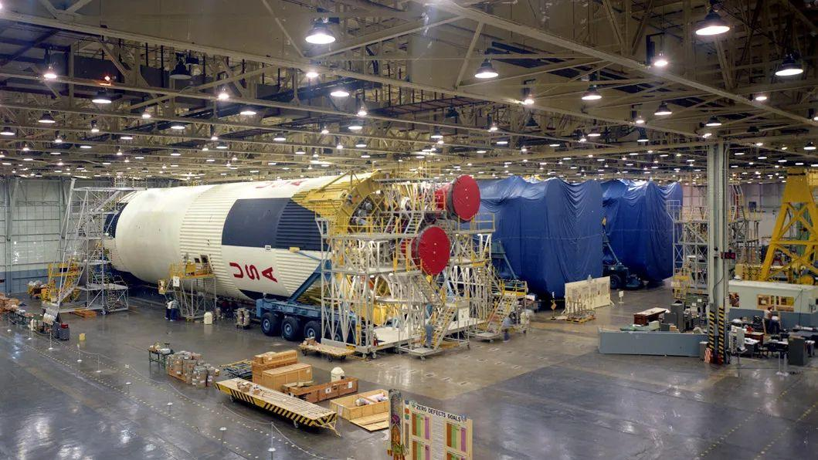
Click for next article On Aug. 1, 1968, NASA canceled the production of its Saturn V moon rocket . At the time, the giant rocket was the only launch vehicle to have ever carried astronauts beyond low-Earth orbit, and it was then the largest, most powerful rocket ever. NASA built 15 of these rockets but only flew 13 of them. When NASA made the decision to stop building the Saturn V, it was almost a year before Apollo 11 astronauts would walk on the moon for the first time. Giant rocket stages for NASA's Saturn V moon rocket are assembled at the Michoud Assembly Facility in this undated NASA photo. (Image credit: NASA) A federal budget deficit and the rising costs of the Vietnam War led Congress to slash nearly three-quarters of the funding that President Lyndon Johnson had allotted for the Apollo program . The last Saturn V launched in 1973, and it was originally supposed to send Apollo 18 to the moon. However, that mission was canceled, and that Saturn V launched the Skylab space station instead. Why it mattered From start to finish, NASA spent a reported $9.4 billion on the Saturn family of rockets (which would be an estimated $118 billion in today's dollars) to develop the Saturn V. That includes the Saturn I and Saturn IB blocks. But the decision to shut production down in 1968 over those costs spelled the end of NASA's Apollo program to send astronauts to the moon a year before the Apollo 11 astronauts even walked on the moon in 1969. Without a steady supply of heavy-lift rockets (the Saturn V was the most powerful of its day), NASA only had a limited number of moonshots left. The final Saturn V rocket to carry astronauts sent the Apollo 17 astronauts to the moon in 1972. The Skylab mission flew a year later, with the final Saturn IB rocket launching an Apollo command module on the Apollo-Soyuz flight in 1975. It would not be until 2022, when NASA launched the first Space Launch System on the Artemis I mission , that the space agency had another megarocket to rival the Saturn V. In April 2026, that new rocket launched NASA's Artemis II astronauts around the moon. SpaceX has developed a new megarocket that is even more powerful than the Saturn V, with its Starship and Super Heavy booster .

66. SpaceX launches 24 Starlink satellites to orbit from California (photos)
Read more
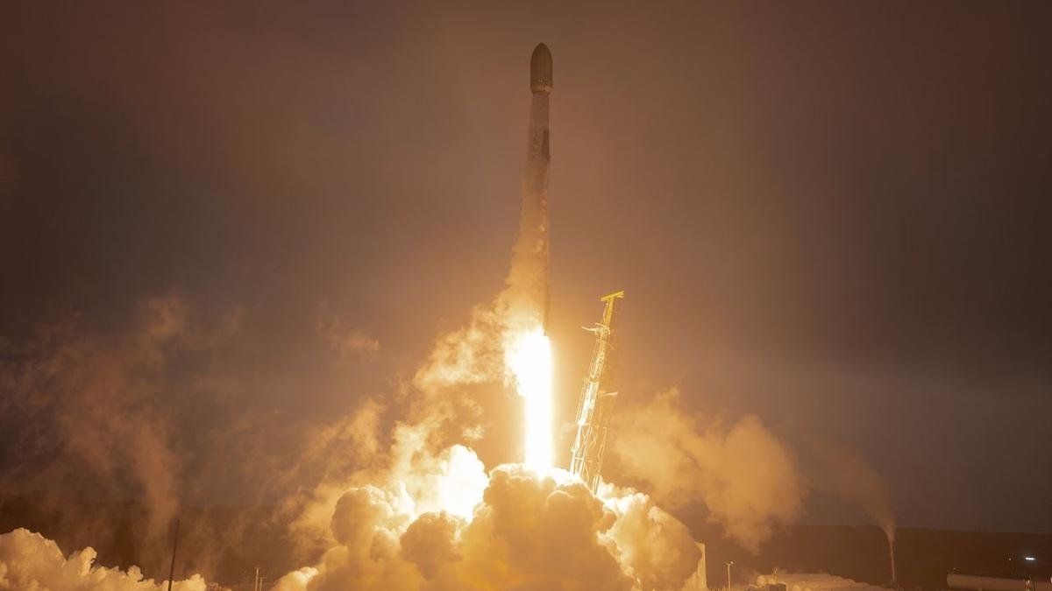
Click for next article A SpaceX Falcon 9 rocket launches 24 of the company's Starlink internet satellites from Vandenberg Space Force Base in California on July 31, 2026. SpaceX has sent yet another batch of its Starlink internet satellites into orbit. A Falcon 9 rocket carrying 24 of the broadband spacecraft lifted off from California's Vandenberg Space Force Base on Friday (July 31) at 11:08 p.m. EDT (8:08 p.m. local time; 0308 GMT on Aug. 1). The rocket's first stage came back to Earth as planned 8.5 minutes later, touching down in the Pacific Ocean atop the SpaceX droneship "Of Course I Still Love You." It was the 26th mission for this particular booster, which is designated B1081. The 24 Starlink satellites were deployed into low Earth orbit (LEO) 61.5 minutes after liftoff as planned, SpaceX confirmed via X . They're joining more than 10,800 other spacecraft in the Starlink megaconstellation, by far the largest satellite network ever assembled. A batch of SpaceX's Starlink satellites is seen high above Earth before deployment from their Falcon 9 rocket on July 31, 2026. (Image credit: SpaceX) SpaceX has now launched 89 Falcon 9 missions in 2026, 69 of which have been dedicated Starlink flights. The company also has three other liftoffs under its belt this year - one launch of its powerful Falcon Heavy vehicle and two test flights of Starship , the fully reusable megarocket SpaceX is developing to help humanity settle the moon and Mars, among other tasks.

67. US launches 1 ton per day antimony pilot processing plant to aid weapons production
Read more
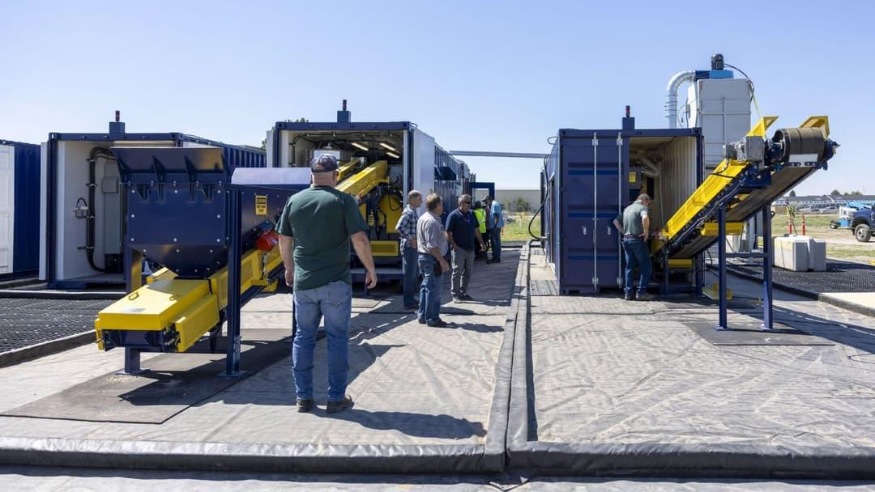
A modular mineral processing plant has officially opened at Idaho National Laboratory to test how the United States can produce military-grade antimony from domestic ore. Developed by Perpetua Resources, the U.S. Army and INL, the facility will process samples from Perpetua's Stibnite Gold Project in central Idaho. Its main technical goal is to demonstrate a domestic method for producing high-quality antimony trisulfide, a specialized material used in ammunition, batteries, solar glass and flame-retardant products. The plant opened on July 29 following a ribbon-cutting attended by state and federal officials. Modular system tests domestic processing Unlike a commercial refinery, the facility is designed as a modular pilot system. This allows engineers to test processing stages, collect operating data and refine methods before production is expanded. The system links material from the country's only identified domestic antimony reserve with INL's expertise in advanced materials and process development. Engineers will study how ore samples behave through the plant and whether it can consistently produce antimony trisulfide that meets military specifications. "This pilot plant is more than a demonstration facility; it's an investment in the nation's critical mineral future," INL Laboratory Director John Wagner said. "The data and operational experience generated here will help advance domestic antimony production while demonstrating how national laboratories, industry and government can work together to strengthen America's supply chains and national security," he continued. Technology supports a ground-to-round chain The project forms part of a "ground-to-round" strategy, covering the chain from mined material to finished ammunition components. China and Russia have dominated global antimony production, while China stopped supplying the United States with the specialized trisulfide used in more than 300 ammunition types in 2021. The pilot plant is intended to close the technical gap between mining antimony-bearing ore and producing material suitable for defense applications. "Establishing resilient domestic supply chains for critical minerals is vital to our national defense," said Col. Steve Adcock, Portfolio Management Executive Ammunition & Energetics at Picatinny Arsenal. "This pilot plant represents an important step toward reducing America's dependence on foreign sources of antimony while strengthening the industrial capabilities needed to support our warfighters. Partnerships like this help ensure the United States can reliably access the materials essential to military readiness." Platform could process other minerals Beyond antimony, the modular plant could provide a flexible platform for testing methods for other critical minerals. Its design may allow equipment, workflows and control systems to be adapted for different feed materials. The project will also support workforce training and develop the technical knowledge needed to rebuild commercial-scale mineral processing capacity. "From the mountains of central Idaho to the national laboratories advancing America's defense and energy capabilities, today's milestone shows what's possible when industry, government, and scientific innovation work together on practical domestic solutions," said Jon Cherry, President & CEO of Perpetua Resources. "As construction advances at the Stibnite Gold Project, this pilot plant extends that momentum downstream by helping establish the capabilities needed to produce military-grade antimony materials here in America," he continued. "Together, these investments are laying the foundation for a secure, end-to-end domestic supply chain that strengthens national security while creating long-term economic opportunity," Cherry said.

द्वारा अभिकल्पित एवं संकलित
DESIGNED & COMPILED BY:
पुस्तकालय एवं सूचना संसाधन प्रभाग
Library & Information Resources Division, IIRS (ISRO), Dehradun
अस्वीकरण | Disclaimer:
सभी लेख / सूचनाएँ सार्वजनिक डोमेन में उपलब्ध हैं तथा केवल सूचना एवं सामान्य जागरूकता के उद्देश्य से
इंटरनेट से संकलित की गई हैं。
All the articles / information are available in public domain and are taken from
Internet for information & general awareness only.

