 |  | 

🌌 अंतरिक्ष समाचार | Space News
बुधवार, ०४/११/२०२६ | Wednesday, 04/11/2026

1. EAM Jaishankar Congratulates ISRO on Successful Launch of NVS-03 - News On AIR
Read more
EAM Jaishankar Congratulates ISRO on Successful Launch of NVS-03 News On AIR

2. Success Of NVS-03: Why India Needs To Rethink Its Satellite Navigation Strategy - Analysis - Eurasia Review
Read more
Success Of NVS-03: Why India Needs To Rethink Its Satellite Navigation Strategy - Analysis Eurasia Review

3. Vikram-1 Ends the ISRO Monopoly on Indian Orbital Launch - KeepTrack
Read more
Vikram-1 Ends the ISRO Monopoly on Indian Orbital Launch KeepTrack

4. Sullivan campaign, NRSC form 'recount fund' for Alaska Senate race - The Hill
Read more
Sullivan campaign, NRSC form 'recount fund' for Alaska Senate race The Hill

5. NRSC Sends Cease and Desists to County Clerks Misinforming Michigan Voters - NRSC.org
Read more
NRSC Sends Cease and Desists to County Clerks Misinforming Michigan Voters NRSC.org

6. ISRO Launches NVS-03: What This Means for India's NavIC System - Infomance
Read more
ISRO Launches NVS-03: What This Means for India's NavIC System Infomance

7. Astronaut and Earth
Read more
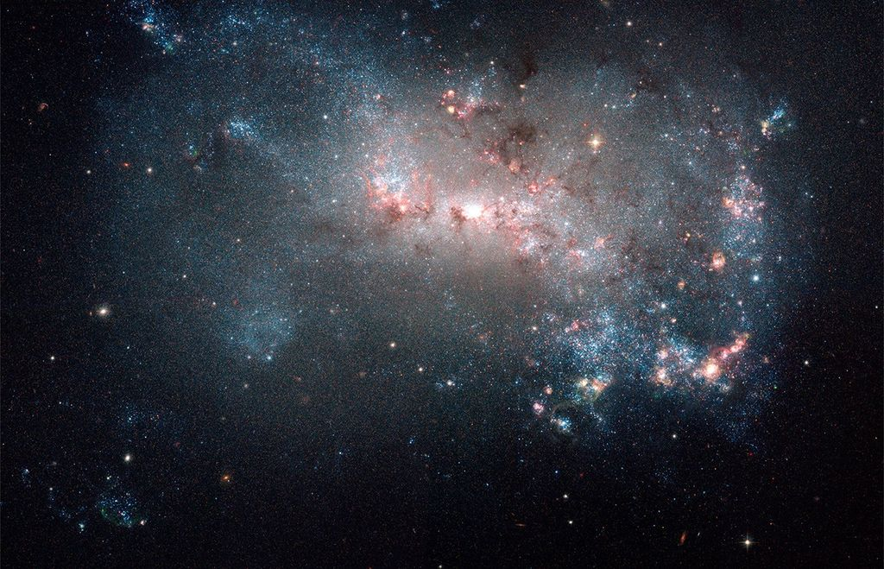
CSA CSA (Canadian Space Agency) astronaut Joshua Kutryk is pictured during the Oct. 29, 2026, spacewalk. The International Space Station was soaring 267 miles above the South Atlantic Ocean at the time of this photograph. Kutryk and NASA astronaut Anil Menon installed a new roll-out solar array on the space station and performed some get-ahead work for their next spacewalk, which will take place on Nov. 5, 2026. The pair will install the eighth and final roll-out solar array; together, the eight arrays will increase the station's available power by up to 30%. Image credit: CSA

8. NASA Astronaut, STEM Creator Connect with Students for STEM Day
Read more
NASA astronaut and Expedition 74 flight engineer Anil Menon is photographed on July 17, 2026, servicing a spacesuit and its components inside the International Space Station's Quest airlock. Credit: NASA/Jessica Meir Students across the country will have the opportunity to connect directly with the International Space Station during a live, interactive in-flight call with NASA astronaut Anil Menon and Mark Rober STEM content creator and founder of ClassCrunchLabs Foundation. The event, hosted by NASA's Office of STEM Engagement, celebrates National STEM Day by bringing real‑world science, engineering, and exploration into classrooms nationwide. The Earth-to-space call will begin at 11 a.m. EST on Wednesday, Nov. 4, and will be available to watch on the agency's flagship YouTube with additional engagement across Learn With NASA channels. From aboard the space station, Menon will answer questions from students about living and working in microgravity, the path to becoming an astronaut, and the technologies that make human spaceflight possible. Rober, joining from California, will share how curiosity, creativity, and hands‑on problem‑solving shaped his career from NASA engineer to STEM creator. A look at STEM in action During the downlink, students will see the space station in real time as Menon demonstrates how everyday activities, from eating to experimenting, change in microgravity. The downlink supports NASA's broader effort to connect students with authentic STEM experiences to help build technical skills and introduce aerospace careers to students. National STEM Day is an opportunity to recognize the power of hands‑on learning and to inspire the next generation of scientists, technicians, engineers, and innovators who will carry NASA's exploration goals forward. A new collaboration to expand STEM access This downlink also marks the launch of a new collaboration between NASA and the ClassCrunchLabs Foundation. Together, the organizations will work to broaden access to STEM learning experiences for students across the country by aligning NASA's mission‑driven educational resources with CrunchLabs' hands‑on engineering content. Through shared programming and outreach, the partnership aims to inspire more learners to engage with science, engineering, and problem‑solving skills that prepare them for future opportunities in the aerospace sector and beyond. Educators and families are encouraged to tune in and celebrate National STEM Day with an inspiring conversation between a NASA astronaut in orbit and a STEM educator on Earth. For more information on NASA in-flight calls, visit: https://www.nasa.gov/stemonstation

9. NASA asks industry for ideas about saving Hubble Space Telescope
Read more
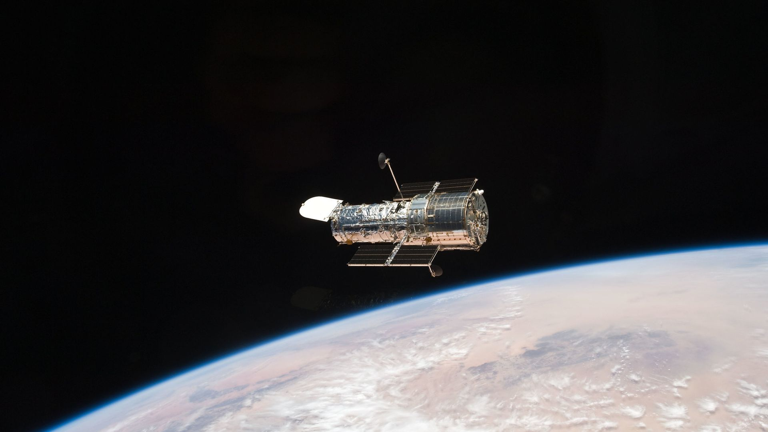
Click for next article NASA is reviving discussions to rescue the Hubble Space Telescope, which is operating well but is on track to reenter Earth's atmosphere about six years from now. The agency issued a request for information (RFI) on Oct. 29 for "in-space servicing" capabilities, which could include boosting Hubble's orbit (which is naturally degrading due to atmospheric drag), or even a mission to "enhance its capabilities" in some way. Hubble, which launched in April 1990 in partnership with the European Space Agency , was serviced five times by astronauts on space shuttle missions, the most recent being in 2009. The observatory's groundbreaking achievements include helping to show that the expansion of the universe is accelerating - a discovery that won the Nobel Prize - as well as a swath of finds about planets, galaxies, stars and other parts of the universe . Hubble also regularly teams up with other telescopes for science work, and its observations have led to the publication of at least 23,000 scientific papers , NASA figures suggest. And, despite its age, Hubble remains in high demand. "Astronomers request about seven times as much observing time as is available each year," the agency stated in September. Hubble is also widely appreciated by the public. People have long enjoyed and celebrated its iconic images , such as the Eagle Nebula's "Pillars of Creation," a gorgeous shot that has been revisited several times over the decades. As such, this is not the first time in recent years that discussions have opened about keeping the famed observatory running for a while longer. In 2022, for example, billionaire tech entrepreneur Jared Isaacman proposed using SpaceX hardware to mount a Hubble-servicing mission. (Isaacman also purchased and commanded two crewed SpaceX missions to Earth orbit, which flew in September 2021 and September 2024 .) NASA declined , however, citing possible risks to the healthy observatory. But things have changed, apparently. Isaacman, who in December 2025 became NASA administrator, said in an Oct. 30 agency statement that Hubble's science return means the agency should "be looking at every reasonable opportunity to keep it delivering for as long as possible" - especially if doing so would be a cost savings compared with launching another mission. In an Oct. 30 post on X , Isaacman added that it's "still worth exploring the options" and noted that NASA had previously considered "a far lower-cost solution" to keep the observatory flying. "That was then. Still worth the effort - Hubble deserves it," he added. The new RFI also allows for alternative scenarios, however, which could include a "safe, controlled reentry into Earth's atmosphere or orbital disposal at the end of Hubble's mission." Hubble will naturally enter the atmosphere in 2033 or 2034 due to orbital drag, so any attempt to service it would have to be in 2032, the agency stated. Earlier this year, NASA worked with Katalyst Space Technologies on a $30 million mission that aimed to boost the orbit of the Neil Gehrels Swift Observatory, which is also falling back to Earth due to orbital drag.

10. Voting in space: NASA astronauts cast ballots from International Space Station
Read more
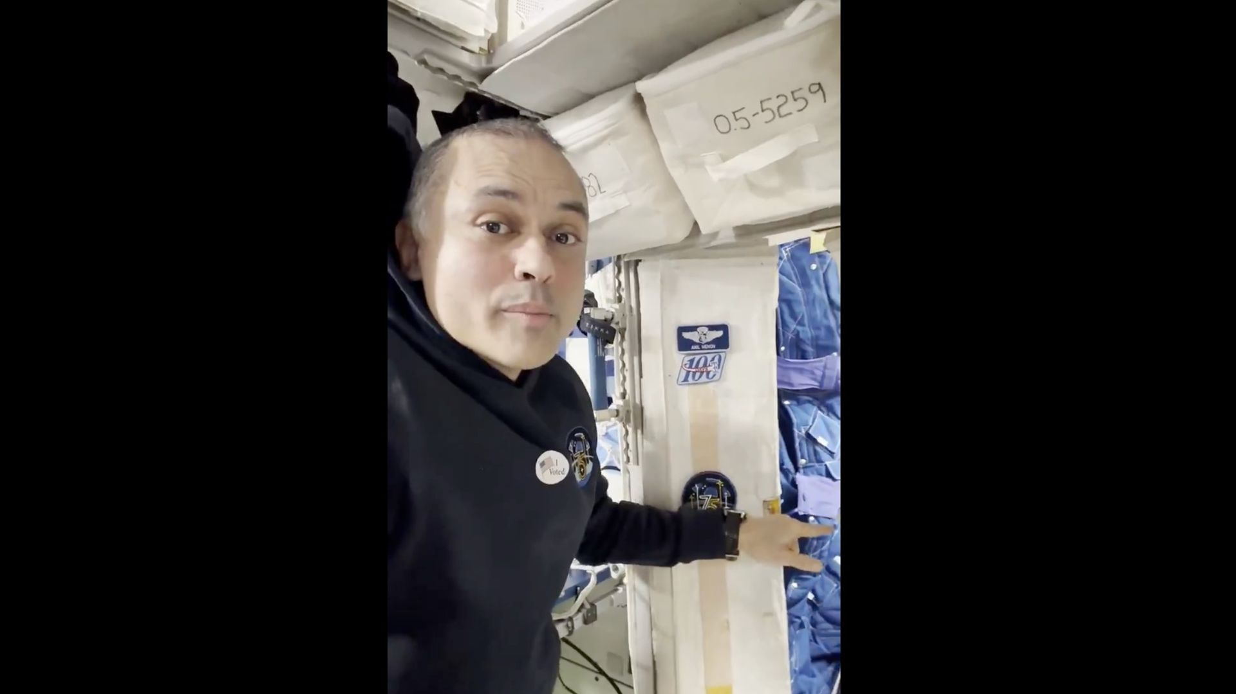
Click for next article NASA astronaut Anil Menon shows off his "voting booth" aboard the International Space Station on Nov. 3, 2026. The three Americans currently living off Earth just made sure their electoral voices were heard. Anil Menon told us today (Nov. 3) that he and fellow NASA astronauts Luke Delaney and Jessica Watkins voted in the U.S. midterm elections from the International Space Station (ISS). "Yes, you can even vote from space! All three U.S. crew members had the privilege of voting from space station. We filled out an electronic ballot and sent it securely to the election officials," Menon wrote in an X post this morning . Yes, you can even vote from space! All three US crew members had the privilege of voting from space station. We filled out an electronic ballot and sent it securely to the election officials. https://t.co/hJCExQ2nKrNovember 3, 2026 That post included a 29-second video, in which Menon - wearing, like many of us today, an "I voted" sticker - shows us his "voting booth." It's actually his room on the ISS, Menon explained. "Inside of it is my computer, where I was able to fill out an electronic form and send it to Harris County so I could vote today," he said. Most NASA astronauts register to vote in Texas' Harris County; it's home to Johnson Space Center in Houston, the agency's human spaceflight hub. Americans have been able to vote from space since 1997, when Texas passed a law allowing this to happen. The first person to take advantage of the legislation was NASA astronaut David Wolf, who cast his ballot from Russia's Mir space station that same year. (The ISS didn't welcome its first crew until November 2000.) "Just like any other American away from home, astronauts may fill out a Federal Post Card Application to request an absentee ballot," NASA officials wrote in an astronaut-voting explainer . The process is somewhat involved, however. "After an astronaut fills out an electronic ballot aboard the orbiting laboratory, the document flows through NASA's Tracking and Data Relay Satellite System to a ground antenna at the agency's White Sands Test Facility in Las Cruces, New Mexico," they added. "From New Mexico, NASA transfers the ballot to the Mission Control Center at NASA Johnson and then on to the county clerk responsible for casting the ballot. To preserve the vote's integrity, the ballot is encrypted and accessible only by the astronaut and the clerk." NASA's Near Space Network enables astronauts on the International Space Station to communicate with Earth and electronically deliver ballots from space. (Image credit: NASA) Delaney and Watkins launched to the ISS on Oct. 1 on SpaceX's Crew-13 mission . Menon has been there since mid-July, arriving aboard a Russian Soyuz spacecraft .

11. Hubble Telescope sees cosmic 'cat's tail' that could wrap around Earth and the sun 500 times
Read more
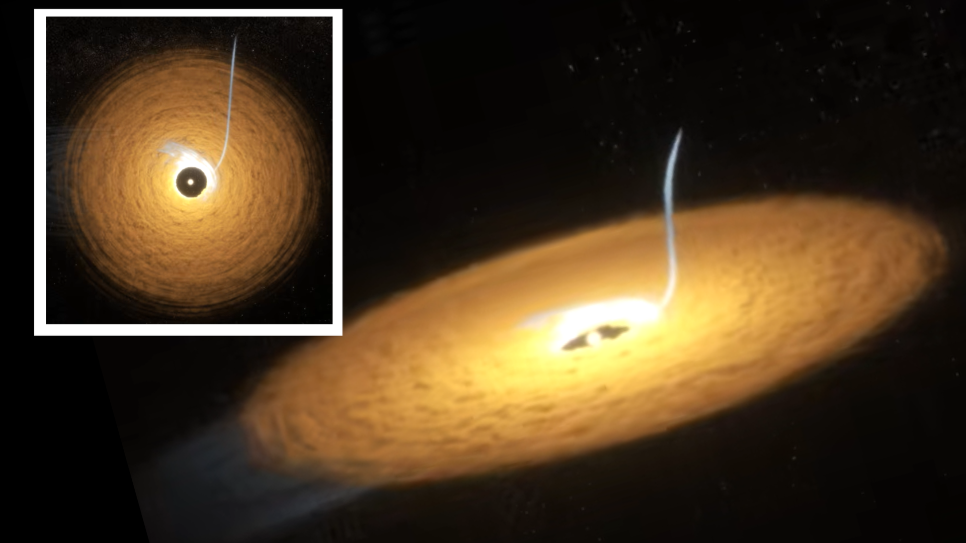
Click for next article Using the Hubble Space Telescope, astronomers have investigated a cosmic cat's tail, finding it likely formed after two Pluto-sized bodies smashed together. The feature, nicknamed the Cat's Tail, extends out from the debris disk known as Beta Pictoris which is located in a planetary system located 63 light-years away. This tail would put that of the average tabby to shame: It's so long that it could curl around the sun-Earth system about 500 times. That's about as long as 200 trillion house cats. The major difference between our solar system and the planetary system that hosts the Cat's Tail is the latter's relative youth. While our solar system is around 4.6 billion years old , Beta Pictoris is a cosmic kitten no more than a few million years old. That means it is still host to collisions between planetary bodies similar to the ones that rocked the solar system during its infancy. The team behind this research gained new insights into the Cat's Tail using 14 years of observations. This allowed them to solve the long-standing mystery of the violent conditions under which it formed. "The Cat's Tail is thought to be the aftermath of a collision between large bodies - think something like Pluto ," team leader Arin Avsar of the University of Arizona said in a statement. "Oddly, this feature had previously only been seen with the James Webb Space Telescope (JWST), which detects infrared light, but remained invisible at shorter wavelengths, which has puzzled the community for a while." Cosmic cat tail is also pleasingly fluffy Comparing Beta Pictoris and our solar system, one thing rapidly becomes apparent: our cosmic neighborhood is relatively well-ordered. The planets orbit the sun with most space rocks neatly delegated into bands: the main asteroid belt between Mars and Jupiter , and the Kuiper belt out beyond the orbit of Neptune. However, this is a stark contrast to the solar system's violent and chaotic youth. Back then, the solar system was host to an infant star surrounded by a swirling disk of gas and dust in which collisions between bodies called planetesimals - the building blocks of planets - were commonplace. Astronomers can't look back to the solar system's infancy, so to learn more about how our cosmic backyard took shape, they study nearby young planetary systems. Systems like Beta Pictoris. That doesn't mean it has been quick to divulge its secrets, though. "We think the Cat's Tail has eluded our observations in visible light until now because of what it's made of," Avsar explained. "It consists almost entirely of what we call organic refractory material, which is heavily carbon-based. These long chains of carbon atoms absorb visible light, so they're quite black." Beta Pictoris Cat's Tail - YouTube Watch On This new study revealed that the feline feature is cat-like in more ways than just its shape. It's also pleasingly fluffy, Hubble observations suggest. That's because the grains that compose it are extremely porous. "How you can get dust grains that small that are as porous as we see here no one really understands, and that's part of why we study this feature," Avsar said. "It's possible that the velocities involved in the collisions were so high that the carbon grains vaporized, turned into gas, and then recondensed as they cooled, and that's how they became so porous," team member Kevin Wagner of the U of A said. An illustration of the exoplanet Beta Pictoris b. (Image credit: NASA) The scientists also discovered a hitherto undiscovered feature in the Cat's Tail - a warp that seems to be the result of an interaction between the trail of material and one of the planets in the system, Beta Pictoris b, a gas giant planet 10 times more massive than Jupiter. "This gives us another line of evidence into how giant planets influence comets through their immense gravitational force," Avsar said. "It's a testament to how much these massive planets really influence their surrounding dust and icy bodies out to hundreds of astronomical units [one astronomical unit being the distance between Earth and the sun]."

12. Robot cube explores the International Space Station | Space photo of the day for Nov. 3, 2026
Read more
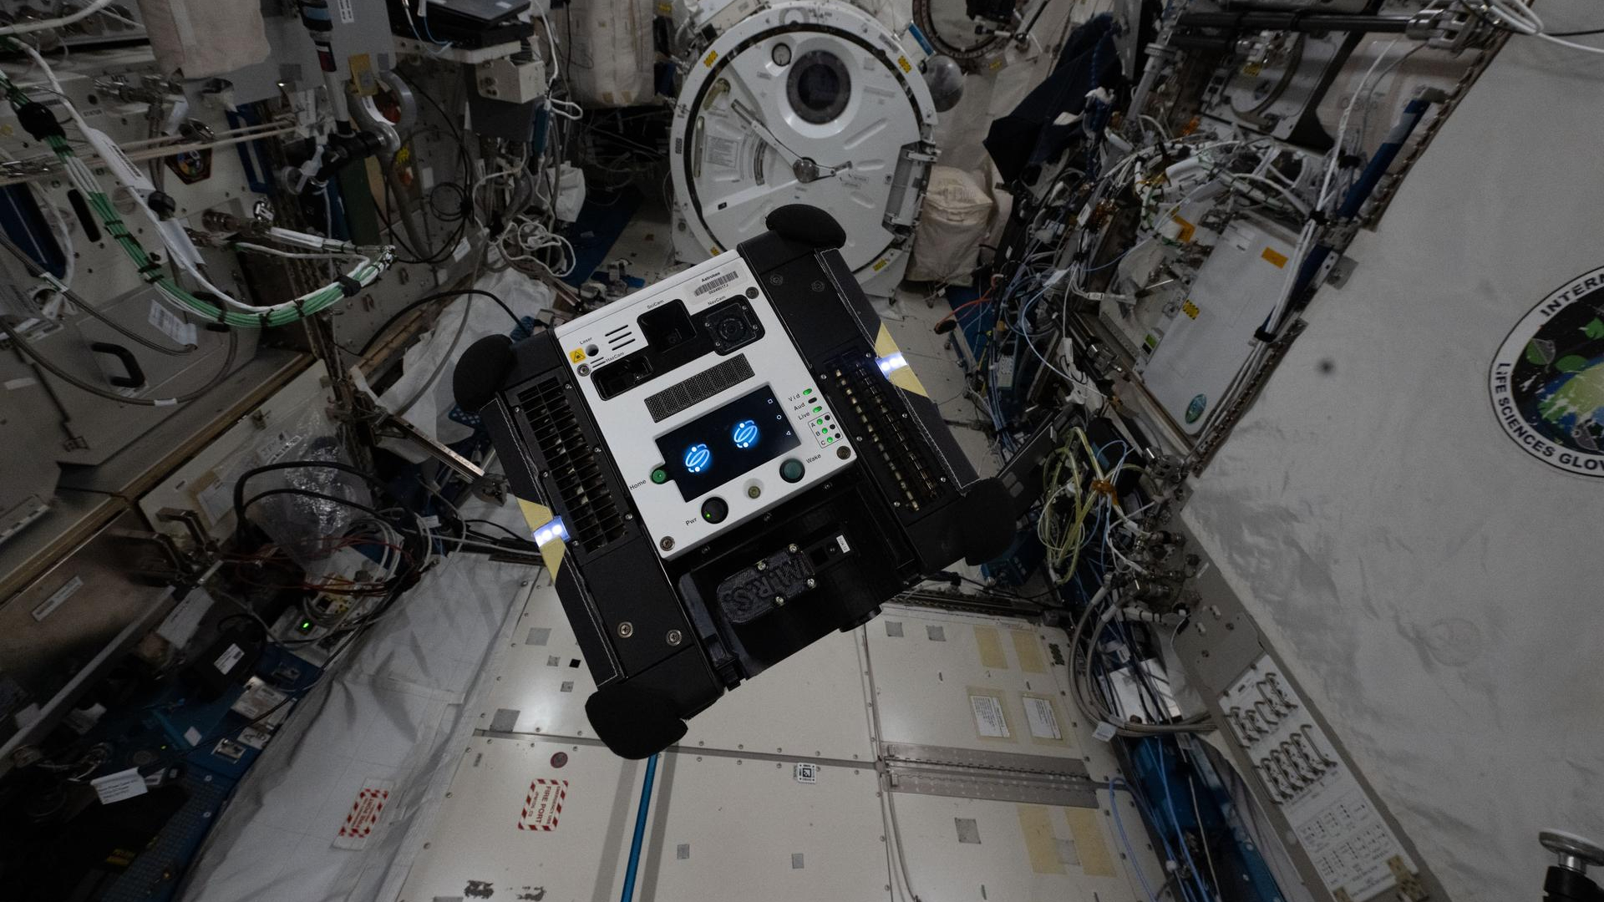
Click for next article An Astrobee, a tiny robot cube, is zipping around the International Space Station helping out the astronauts on board. (Image credit: NASA/Jessica Watkins) A tiny robot cube is zipping around the International Space Station, trying to help astronauts with the endless challenging tasks onboard. What is it? Reminiscent of Rocky rolling around the lab helping out Dr. Ryland Grace in Project Hail Mary, the Astrobee robot is a helpful assistant for astronauts aboard the space station . A metal cube about the size of a toaster, the Astrobees are free-flying robotic assistants that NASA developed to help out astronauts. The first two Astrobee robots (named Bumble and Honey) were sent to the station in 2019. The third Astrobee robot, named Queen, joined later that year, and 7 years later, the program is still going strong. So what can a free-floating cube help with? The robots are designed to assist the astronauts onboard with testing new technologies in microgravity and helping mission team members back on Earth to better observe inside the station. The little robot cubes can even help astronauts with everyday chores in space. In this image , snapped by NASA astronaut and Crew-13 commander Jessica Watkins, we can see one of the Astrobee robots helping out in the station's Kibo laboratory. Why is it incredible? The idea of a robot assistant helping out with chores and technology development aboard an orbiting space laboratory sounds positively science fiction. While Astrobee is certainly not the first robot in space or aboard the space station, its compact shape and ability to fly autonomously gives it a unique quality. It really looks like a companion aboard the space station. While the robotic space helpers of today might be cute little cubes, the success of the Astrobee program begs the question of how robots in space might continue to evolve. Will astronauts on the moon have robotic companions autonomously exploring and helping out? What will they look like?

13. Do we know how many Starship launches SpaceX will need to get NASA astronauts to the moon? No. Will its refuelling plan be simple? Also no.
Read more
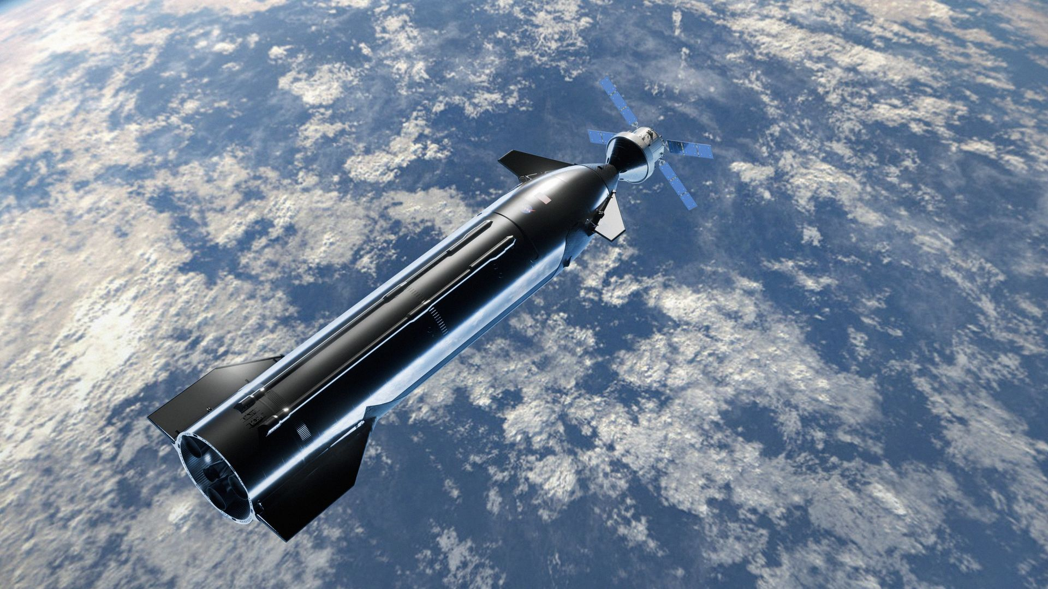
Click for next article NASA's Artemis IV moon mission will be a complicated affair - especially if SpaceX's Starship ends up being the lunar lander. For all of the changing components of the Artemis program over the past several years, one of its most persistent may be the question of how many refueling flights Starship will need to land astronauts on the moon . By summer 2021, it was common knowledge that Starship would require multiple launches to pull off an Artemis moon landing. A Government Accountability Office audit at the time, for example, estimated that it could take up to 16. Earlier this month, a member of the Aerospace Safety Advisory Panel said the refueling number could be as high as 22. But that estimate was quickly refuted by SpaceX founder and CEO Elon Musk , who posted on his social media platform, X, that it would actually be closer to six or eight. Perhaps an even bigger head scratcher, though, is how the refueling process will be carried out. Where (and when) will Starship's upper stage gas up when it's off planet? NASA released a graphic during a recent Artemis update that outlined an order of operations for the spacecraft on Artemis IV , which will be the program's first crewed lunar landing. The mission will launch a Space Launch System (SLS) rocket with the four Artemis IV astronauts aboard NASA's Orion capsule to high Earth orbit, where they will rendezvous and dock with the Starship lunar lander. NASA's Artemis IV mission outline featuring Starship as the lunar lander. (Image credit: NASA) Using Starship's engines, the two spacecraft will burn for the moon, and separate upon their arrival in low lunar orbit. Two astronauts will remain aboard Orion, while the other two will head down to the lunar surface in Starship. After a little run through the regolith and a celebration of America's triumphant return to the moon, the duo will board Starship again to launch back to lunar orbit and dock with Orion before beginning the trip back to Earth . All that seems well and good for a mission to the moon, and even has some resemblances with missions from NASA's Apollo days . What doesn't seem as immediately obvious when mapping out the Artemis IV mission outline, though, are the steps that Starship will be taking during its refueling process before the astronauts ever make it to space . Orion will rendezvous with Starship in high Earth orbit - but that's not where the lander will launch initially. According to NASA's Artemis IV outline, SpaceX will first launch a depot ship to low Earth orbit (LEO), which will serve as the repository for all the fuel the Starship lander will eventually need. The graphic shows a tanker Starship docked with the depot with "(multiple)" written next to it, so we don't know how many refueling flights will be needed for this initial depot fill. Once that's done, SpaceX will launch the Starship lunar lander to join the depot in LEO for its first pit stop. Then, and this is where some of the head scratching begins, Starship will undock from the depot and raise its altitude to what NASA has labeled the "final tanking orbit," or FTO. The baseline concept for NASA's Artemis IV Starship refueling operations. (Image credit: NASA) At some point after the Starship lander departs LEO, SpaceX will launch another round of "(multiple)" tanker ships to fill the depot with even more propellant. It will apparently then send the depot to meet the lander for another refill in FTO, where, as the name suggests, the two will dock for the pair's final fuel transfer. After bidding the depot a second farewell, Starship will ascend to high Earth orbit to meet Orion. NASA's graphic shows SLS launching Orion before Starship gets the last of its fuel, and the agency's website explainer for Artemis IV says the unusually choreographed order of operations for the mission does serve a purpose. However many fuel boosts Starship ends up needing to get from LEO to the surface of the moon, its staggered orbital staging will apparently create some flexibility around when SLS can launch the Artemis IV astronauts to begin their mission. And while Starship's orbital dance seems unnecessarily complicated, NASA says the new approach will actually reduce the amount of fuel SpaceX needs for the mission. That's partly because Starship will take Orion directly to low lunar orbit, instead of the much higher orbit envisioned in previous mission plans.

14. NASA's Neil Gehrels Swift Observatory to burn up this week after more than two decades in space
Read more
As of Monday, the U.S. Space Force predicted Swift would re-enter Earth's atmosphere at approximately 3:30 a.m. EST Wednesday, Nov. 4, somewhere within about 21 degrees north or south of the equator - a band that is mostly ocean.

