 |  | 

🌌 अंतरिक्ष समाचार | Space News
मंगलवार, ११/०८/२०२६ | Tuesday, 11/08/2026

1. Cloudburst in Chamoli: Bridge swept away, border villages cut off
Read more
PIONEER EDGE NEWS SERVICE / Jyotirmath A bridge over the Tamak Nala, connecting the Malari National Highway and located about 37 km from Jyotirmath, was washed away after the stream swelled following heavy rainfall on Monday afternoon, disrupting connectivity to more than a dozen villages in the border region. The bridge, which was constructed only a month ago, was swept away by the surging water and strong currents. With the bridge gone, movement to several border villages has come to a complete standstill. The incident has once again highlighted the vulnerability of the route during the monsoon. A permanent bridge at the same location was also washed away last year after the Tamak Nala swelled. Locals said the bridge is repeatedly damaged or destroyed during the rainy season whenever the stream overflows. Local resident Prem Singh Butola said the bridge was washed away after the water level in the stream suddenly rose in the afternoon. Jyotirmath Sub-Divisional Magistrate Chandrashekhar Vashishth said the extent of damage was being assessed. A BRO employee was reportedly missing following the incident, while teams of the SDRF, NDRF and district administration had proceeded to the site, SDM added.

2. Bharatiya Antariksh Hackathon 2026 - Grand Finale Concludes Successfully - ISRO
Read more
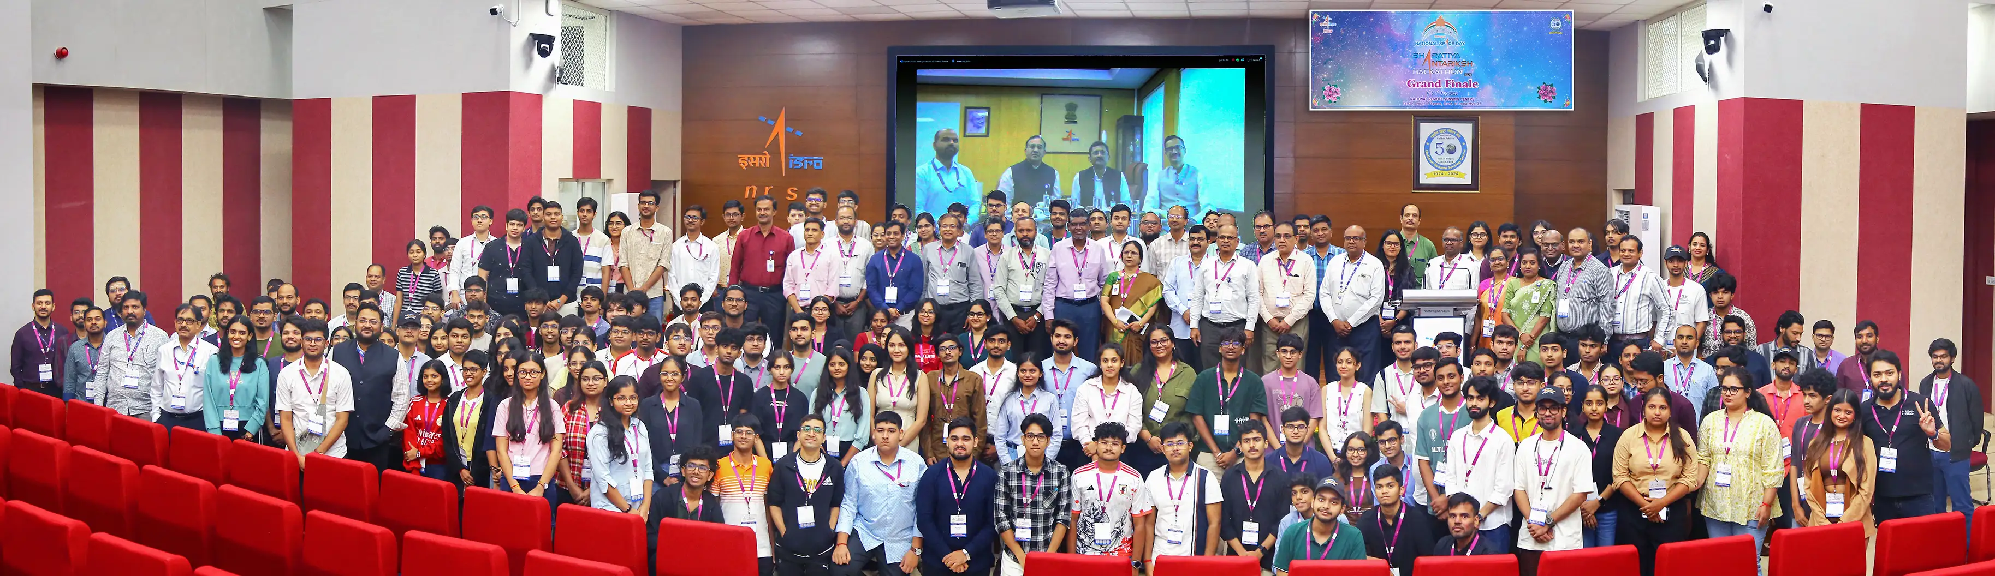
August 10, 2026 The third edition of Bharatiya Antariksh Hackathon (BAH), a national level hackathon, was launched on 10 June 2026, and the Grand Finale was held from 6th - 7th August 2026. This programme is a flagship initiative of ISRO, which aims to inspire and engage young minds across the country and foster creativity, innovation, and problem-solving in the field of space technology. BAH 2026 featured 15 carefully curated problem statements covering critical domains such as Geospatial Technology, Space Science, Image Processing, and Artificial Intelligence/Machine Learning (AI/ML). More than 1,00,000 students pursuing undergraduate, postgraduate, and Ph.D. programmes registered for the hackathon. A total of 15,104 teams, each comprising 3-4 members, submitted innovative solutions to the given problem statements. After evaluation of the ideas submitted, the top 34 teams were selected to compete in the Grand Finale, representing some of the brightest young talent from across the country. The Grand Finale was held at the National Remote Sensing Centre (NRSC), Hyderabad, and comprised an intensive 30-hour event. During the finale, the participating teams developed their solutions and presented to a Jury Panel chaired by Dr. Prakash Chouhan, Director, NRSC. The top three teams were selected based on the creativity, technical excellence, and feasibility of their solutions.

3. ISRO Scientist Recruitment 2026: Apply for 92 Posts - educationtoday.co
Read more
ISRO Scientist Recruitment 2026: Applications Open for 92 Posts, Check Eligibility and Selection Process Leave a Comment / Daily News Table of Contents - 92 Scientist and Engineer Vacancies Announced - Academic Eligibility for Applicants - Age Limit and Application Fee - Selection Based on GATE Score and Interview - How Candidates Can Apply - Why the Recruitment Matters for Engineering Graduates - Engineering Skills Meet Space Technology - A Career Opportunity Within India's Space Programme The Indian Space Research Organisation (ISRO) has opened applications for 92 Scientist/Engineer 'SC' positions across multiple engineering disciplines, offering qualified candidates an opportunity to build a career with India's premier space research organisation. The recruitment is being conducted through the ISRO Centralised Recruitment Board (ICRB), with candidates required to hold a valid GATE score in the relevant discipline. The recruitment comes at a time when opportunities in space science, engineering and advanced technology are expanding alongside India's growing space programme. For engineering graduates with the required academic qualifications and GATE scores, the vacancies provide an opportunity to enter a highly specialised technical environment. Candidates interested in the posts must complete the online application process by 17th August 2026. Applicants are advised to verify their eligibility and submit their forms well before the deadline rather than waiting until the final day. 92 Scientist and Engineer Vacancies Announced The vacancies have been distributed across several engineering disciplines. Electronics has the highest number of positions, followed by Mechanical and Computer Science. The discipline-wise distribution is: - Electronics: 34 vacancies - Mechanical: 26 vacancies - Computer Science: 13 vacancies - Civil: 10 vacancies - Electrical: 4 vacancies - Refrigeration and Air Conditioning: 2 vacancies - Architecture: 2 vacancies - Civil at PRL: 1 vacancy - Total: 92 vacancies The distribution highlights the range of technical expertise required across ISRO's operations. Engineers from conventional disciplines as well as specialised areas can therefore find opportunities within the recruitment process. Academic Eligibility for Applicants Candidates applying for the Scientist/Engineer 'SC' positions must possess a BE, BTech or equivalent degree in the relevant engineering discipline. Applicants are required to have secured at least 65% aggregate marks or a CGPA of 6.84 on a 10-point scale. Another important requirement is the GATE score. Candidates must have a valid score from either GATE 2025 or GATE 2026 in the corresponding paper. This requirement makes the recruitment particularly relevant for engineering graduates who have recently appeared for the national-level examination. The eligibility criteria are designed to ensure that applicants possess both the required academic foundation and a recognised national-level assessment score before moving to the next stage of recruitment. Age Limit and Application Fee Age is another important criterion that applicants must consider before submitting their forms. Candidates must be 28 years of age or below as on 17th August 2026, subject to the applicable provisions and relaxations specified by ISRO. Candidates belonging to the unreserved category are required to pay an application fee of ₹250. Applicants should carefully review the official notification for applicable provisions before completing the payment and final submission. Since recruitment applications involve document verification at later stages, candidates should ensure that the information entered in the application form matches their educational records and other supporting documents. Selection Based on GATE Score and Interview The selection process combines the candidate's performance in GATE with an interview. According to the recruitment notification, the final merit list will be based on the interview and GATE score. This makes the recruitment particularly important for candidates who have already invested significant preparation in the GATE examination. A strong GATE performance can provide the academic foundation for progressing through the recruitment process, while the interview offers ISRO an opportunity to assess candidates beyond their examination performance. The combination of a national-level examination score and a specialised interview also reflects the technical nature of the positions. Successful candidates are expected to contribute to highly specialised engineering and scientific work within the organisation. How Candidates Can Apply Eligible candidates can complete their applications through the official ISRO recruitment portal. The application process involves several stages, and applicants should carefully follow the instructions provided in the notification. The broad application process includes: - Visiting the official ISRO website and accessing the Careers section - Opening the relevant Scientist/Engineer recruitment notification - Registering with an email ID and mobile number - Entering personal and educational details - Uploading the required documents - Paying the applicable application fee - Submitting the completed application form - Downloading and retaining a copy of the submitted form for future reference Candidates should check every detail before final submission, particularly their educational qualifications, GATE information and personal particulars. Why the Recruitment Matters for Engineering Graduates A Scientist/Engineer position at ISRO represents more than a conventional engineering career. The organisation works across areas involving spacecraft, launch vehicles, satellite systems, electronics, communication, propulsion, remote sensing and other advanced technologies. The recruitment therefore provides qualified engineers with an opportunity to work in an environment where engineering knowledge is applied to complex national space missions. The diversity of disciplines in the latest vacancies also demonstrates that India's space programme requires expertise extending well beyond aerospace engineering alone. For engineering students and recent graduates, the recruitment can also underline the importance of building strong fundamentals alongside preparation for examinations such as GATE. Click below to watch the video. Engineering Skills Meet Space Technology Engineering careers are increasingly extending into specialised sectors such as space technology, satellite systems and advanced research. EducationToday views the ISRO recruitment drive as a notable example of how strong engineering fundamentals, combined with national-level examinations such as GATE, can open pathways into highly specialised careers. The opportunity is particularly relevant for graduates who want to apply their technical knowledge to projects with national significance. It also highlights the growing importance of interdisciplinary engineering capabilities as India's space programme expands into increasingly sophisticated areas of research and technology. For aspiring engineers, such recruitment drives can serve as a reminder that career opportunities are not limited to conventional corporate roles. Public-sector research and technology institutions can also offer pathways into specialised technical work. A Career Opportunity Within India's Space Programme The 92 vacancies offer engineering graduates an opportunity to enter a demanding technical environment and contribute to India's space programme. With recruitment spanning Electronics, Mechanical, Computer Science, Civil, Electrical and other disciplines, the drive reflects the broad engineering expertise required to support complex space missions. For eligible candidates, the immediate priority is to focus on the application deadline. With 17th August 2026 approaching, applicants should verify the eligibility requirements, keep the necessary documents ready, and complete the online registration carefully. The selection process also requires candidates to prepare beyond the application stage. Since the final merit list takes into account both GATE performance and the interview, applicants should be prepared to demonstrate not only academic knowledge but also their understanding of engineering concepts and their suitability for specialised work. The latest recruitment drive provides a significant opportunity for qualified engineering graduates seeking a technically challenging career within India's space sector. Candidates who meet the prescribed requirements should make use of the application window and approach the selection process with careful preparation. 1. How many vacancies are available in ISRO Scientist Recruitment 2026? ISRO has announced 92 vacancies for Scientist/Engineer posts under the 2026 recruitment drive. 2. Who is eligible for ISRO Scientist Recruitment 2026? Eligibility depends on the post and discipline. Candidates generally need the prescribed engineering or relevant technical qualification with the required academic performance specified in the official recruitment notification. 3. What is the age limit for ISRO Scientist/Engineer Recruitment 2026? The age limit varies according to the recruitment notification and applicable category-based relaxations. Candidates should check the official notification before applying. 4. How can candidates apply for ISRO Scientist Recruitment 2026? Eligible candidates can submit their applications online through the official ISRO recruitment portal by completing the form, uploading required documents, and paying the applicable fee, if required. 5. What is the selection process for ISRO Scientist Recruitment 2026? The selection process generally involves shortlisting based on the prescribed criteria, followed by the relevant written test and/or interview, depending on the post and recruitment notification. Post Views: 195 UP Board's Derecognition of 465 Non-Functional Schools Signals a Strong Push for Educational Accountability Daily News

4. Never-before-seen ozone layer detected over Bay of Bengal. Isro tracking it - India Today
Read more

Scientists have detected an unusually thick layer of ozone high above the North Bay of Bengal, offering new clues about how ozone-rich air is transported and redistributed through Earth's upper atmosphere. The unusual ozone enhancement was found at an altitude of around 21-23 kilometres, in the lower stratosphere, during a nationwide atmospheric observation campaign. Researchers found that the concentration was significantly higher than normally observed over eastern India, with the unusual layer persisting for more than a day. Read Full Story The ozone layer is a region of Earth's stratosphere, roughly 15-35 km above the surface, containing relatively high concentrations of ozone (O). It acts as Earth's natural shield, absorbing most of the Sun's harmful ultraviolet (UV) radiation, protecting humans, animals, plants and marine ecosystems from radiation damage. The discovery was made as part of the Phase-I NetRAD-ASMA campaign, a coordinated effort involving atmospheric research institutions across India. Scientists used an extensive network of instruments, including atmospheric radars, weather balloons, satellites and advanced atmospheric models, to track the movement of ozone and air masses across the country. A key role was played by the Aryabhatta Research Institute of Observational Sciences (ARIES). The enhanced ozone layer was detected during both day and night. (Photo: Reuters) During the campaign, ARIES' indigenously developed 206.5 MHz Stratosphere-Troposphere (ST) Radar at Nainital collected observations alongside similar radars at Haringhata, Gadanki and Kochi. Weather balloons equipped with instruments were also launched to measure atmospheric conditions and ozone concentrations. Scientists further used observations from the Aura MLS and INSAT-3DR satellites, allowing them to track the unusual ozone structure from space and compare it with ground-based measurements. The observations revealed something particularly intriguing. The enhanced ozone layer was detected during both day and night, suggesting that sunlight-driven chemical reactions were unlikely to be the main reason for its formation. Researchers instead examined atmospheric convection, wind shear, horizontal transport and vertical air movements. Their analysis showed persistent downward air motion in the lower stratosphere above the region. By combining observations from the radars, balloons, satellites and atmospheric models, scientists concluded that the unusual ozone enhancement was primarily caused by the transport of ozone-rich air, followed by downward movement and compression of the air mass. The ozone layer normally reaches its highest concentration around 25-30 kilometres above Earth and plays a crucial role in shielding life from harmful ultraviolet radiation. The findings, published in Earth and Space Science by the American Geophysical Union, provide new quantitative evidence of how atmospheric circulation can redistribute stratospheric ozone over the Indian subtropical region. - Ends

5. Up to ₹2.08 Lakh/Month Salary! Multiple Life Sciences Jobs at ISRO - BioTecNika
Read more
Multiple Vacancies at ISRO-HSFC | Life Sciences Role Are you looking for high-paying Life Sciences Jobs in India's space research sector? The Human Space Flight Centre has announced Multiple Vacancies under ISRO Careers 2026 for Scientist/Engineer-SD positions. Candidates with a PhD in Biotechnology, Molecular Biology, Bioinformatics, Biomedical Sciences and related disciplines can apply online by 30 August 2026. About the Institute The Human Space Flight Centre (HSFC), Bengaluru, was formed as a new centre in ISRO to realise the vision of the Human Space Flight Programme. As the lead centre for human space activities, HSFC undertakes multidisciplinary research and development in human science and technology while maintaining high standards of reliability and human safety. - Get Jobs Faster - Job Overview Multiple Vacancies Post Code Discipline Vacancies 01 Bioinstrumentation OR Biophysics OR Medical Physics 01 UR 02 Developmental Biology OR Biotechnology 01 UR 03 Cellular & Molecular Biology OR Cell Biology 01 UR 04 Computational Biology OR Systems Biology OR Bioinformatics 01 UR 05 Biomedical Engineering OR Biomedical Sciences 01 UR 06 Biomedical Engineering OR Biomedical Sciences 01 UR Key Responsibilities Post Code 01 Design and validate wearable health monitoring sensors and systems and instrumentation of biomedical sensors. Bio-signal data acquisition and processing. Medical Imaging and informatics. Development of portable diagnostic devices and wearable sensors. Post Code 02 Radiation biology and exposure models. Develop regenerative approaches to preserve musculoskeletal integrity during training and in space. Mammalian and stem cell culture; primary cell lines; 3D/organoid culture systems. In vivo and ex vivo animal physiological studies. Working on disease biology models relevant to astronaut health. Host-pathogen interaction studies under stress/microgravity. Post Code 03 Study immune and cellular adaptation across the astronaut health cycle. Bioinformatics analysis of proteomic data for biomarker identification for spaceflight application. Molecular cloning, confocal microscopy, live-cell imaging and gene editing for spaceflight application. Large-scale proteomic dataset analysis, gene expression and statistical workflows. Post Code 04 In silico models to anticipate astronaut adaptation, assess countermeasures and guide rehabilitation. Development of therapeutics and space-grade diagnostics. Multi-omics integration for spaceflight stressors studies. Modelling cellular pathways, host-microbe interactions and metabolic networks under spaceflight conditions. Computational simulation of closed-loop life support systems. Generative models for predictive simulation of astronaut physiology and disease states through Digital Twin Biology, including neural networks and deep learning. Post Code 05 Gait analysis, exercise countermeasures, motion capture and force-plate studies and rehabilitation programme development. Biomechanical analysis of the musculoskeletal system. Analyse human performance data from wearables. Collaborate on rodent/human analogue design for spaceflight experiments. Post Code 06 Develop and validate bio-imaging systems for microgravity tissue changes. Implement DSP algorithms for ECG/EEG/EMG from wearables, noise reduction and feature extraction. Analyse bioinformatics datasets for space radiation effects on cells and tissues. Development of portable diagnostic devices, biosensors, point-of-care testing and real-time astronaut health monitoring tools. Integration of biomedical devices, wearable sensors and lab-on-chip technologies. Integrate AI/ML for real-time signal and imaging analysis in human/rodent spaceflight experiments. Qualifications Post Discipline Qualification 01 Bioinstrumentation/Biophysics/Medical Physics Relevant PhD + relevant ME/MTech/MS (60%/6.5 CGPA) + BE/BTech (65%/6.84 CGPA). 02 Developmental Biology/Biotechnology Relevant PhD + relevant ME/MTech/MS and BE/BTech, or BS-MS in Biological Sciences/Biology. 03 Cellular & Molecular Biology/Cell Biology Relevant PhD + relevant MSc and BSc, or BS-MS in Biological Sciences/Biology. 04 Computational Biology/Systems Biology/Bioinformatics Relevant PhD + relevant ME/MTech/MS and BE/BTech, or BS-MS in Biological Sciences/Biology. 05 Biomedical Engineering/Sciences Relevant PhD with thesis in biomechanics/human movement/musculoskeletal modelling + relevant ME/MTech/MS and BE/BTech. 06 Biomedical Engineering/Sciences Relevant PhD with thesis in bio-imaging/signal processing/bioinformatics + relevant ME/MTech/MS and BE/BTech. Selection Process Initial screening will be conducted based on applications submitted through the ISRO Live Register portal. The prescribed qualifications are minimum requirements and do not automatically make candidates eligible for an interview. Final selection will be based only on performance in the Personal Interview. How to Apply Applications will be accepted only through the ISRO Live Register portal. These Multiple Vacancies under ISRO Careers 2026 offer an exceptional opportunity for PhD candidates seeking high-paying Life Sciences Jobs in bioastronautics, biomedical research and human spaceflight science. Eligible candidates should complete their online application before 30 August 2026.

6. How ESA mimics and models the 2026 total solar eclipse
Read more
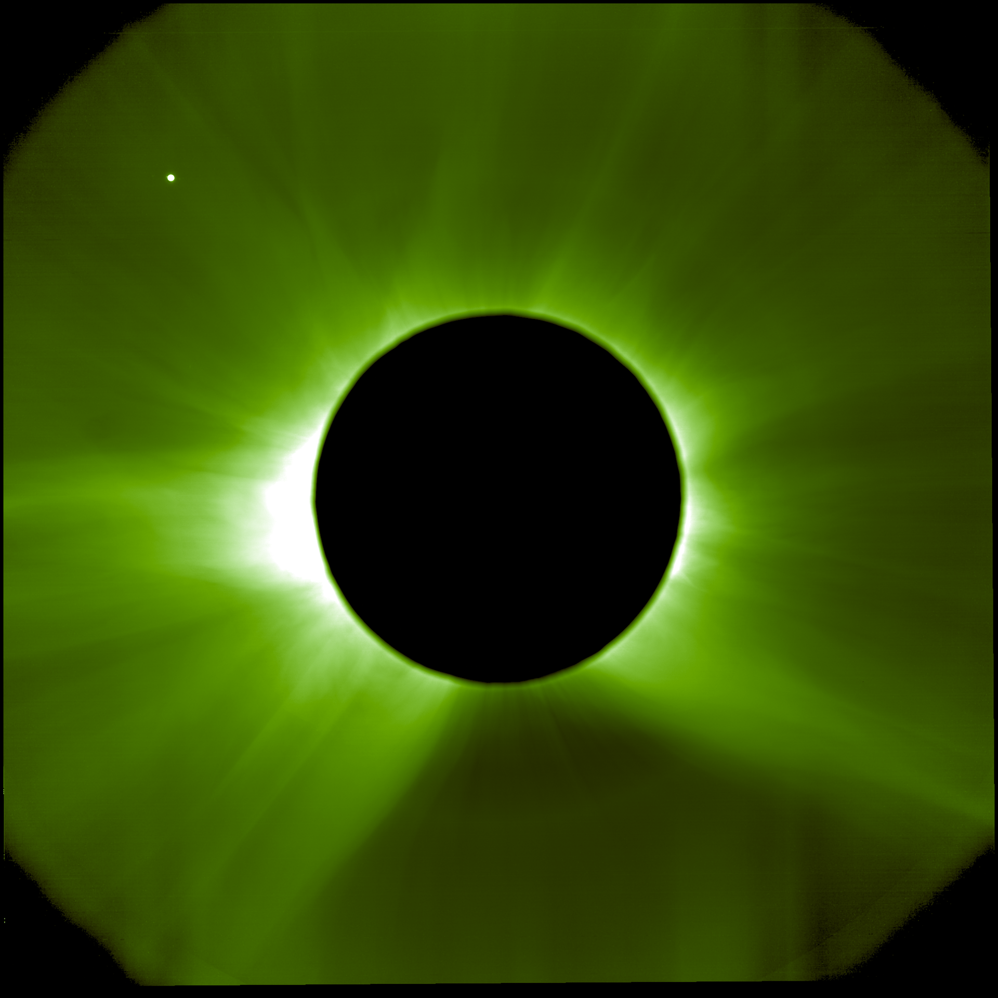
Enabling & Support How ESA mimics and models the 2026 total solar eclipse 10/08/2026 2880 views 17 likes On 12 August 2026, parts of Europe will experience a total solar eclipse. With the Sun's bright disc covered, its surrounding atmosphere - the solar corona - will become visible to the naked eye. Unfortunately, total solar eclipses are rare and last at most a few minutes, giving scientists little time to study the Sun's enigmatic halo. This is why ESA developed missions that create eclipses artificially, and why experts use computer models to create digital simulations. So how do we do it, and why is it important? In two days, the Moon will completely shield the Sun for parts of Greenland, Iceland, Spain and Portugal, creating a total solar eclipse. For up to just over two minutes, the brightness of day will turn into twilight and reveal the solar corona, normally kept invisible by the Sun's glare. The corona is where space weather originates: where the solar wind gains speed before streaming out into the Solar System, and where coronal mass ejections arise. Space weather can disrupt our satellite networks, communication infrastructure, power grids and other technologies that modern society relies on. Until recently, the full corona could only be observed from Earth during the short periods of total eclipses. These occur around once, very rarely twice a year, in different places across the globe, and last at most a few minutes. A solar eclipse is an example of a natural 'solar occultation' - when an object (in this case the Moon) blocks the Sun's disc from an observer's perspective. To stretch the short observation window that natural eclipses offer, scientists invented ways to create occultations artificially, using an instrument called a 'coronagraph': a telescope incorporating a disc to occult the Sun. Seeing another side of the Sun While Proba-3's mimicry of solar eclipses is unique, other solar missions are taking this eclipse just as seriously. In the days leading up to 12 August, the ESA-led Solar Orbiter mission is running a special observation campaign with its various remote-sensing instruments. Totality reveals structures in the corona that are shaped by the Sun's magnetic field. This means that eclipses provide a rare opportunity to test whether computer simulations accurately capture the Sun's magnetic environment. "A total solar eclipse lets us verify that our models are correct by comparing forecasts with actual observations," says Jorge Amaya, ESA Space Weather Modelling Coordinator. Most solar observations are made from near Earth, providing only a limited view of a vast three-dimensional system. Luckily, Solar Orbiter follows a different path around the Sun than other solar observatories. Today, the spacecraft is facing the side of the Sun that will soon roll into Earth's view, giving observers on the ground the opportunity to decide which targets to focus on during the eclipse. Magnetogram using data from Solar Orbiter's PHI instrument Particularly useful are the magnetic maps (magnetograms) of the Sun's visible surface, recorded by Solar Orbiter's Polarimetric and Helioseismic Imager (PHI). With the spacecraft's unique vantage point, these data provide modellers with a much more complete picture of the Sun's magnetic field today. For example, PHI is seeing a newly emerging active region on the Sun, which is likely to affect what the corona will look like during the 12 August eclipse. Spotting this active region would not have been possible without Solar Orbiter. "The magnetic field lines that we see in simulations are like hairs in a fuzz ball," adds Jorge. "Observing the Sun from multiple viewpoints allows us to determine their orientation in three dimensions. That is the key to dramatically improving forecasts of how solar activity will affect our technology." Solar Orbiter's location today gives us a sneak preview of what ESA's space weather forecasting mission Vigil will see. Planned for launch in 2031, Vigil will tail Earth to provide continuous, near real-time observations of the Sun's side. "With Proba-3 and Solar Orbiter, we have an unprecedented view of our star," comments Miho Janvier, ESA project scientist for the two missions. "Both missions are contributing to our understanding of the Sun, from its surface to its extended atmosphere. The upcoming total solar eclipse offers a chance to see how this knowledge comes together, comparing observations with modelling."

7. NASA+ Debuts on discovery+, Coming Soon to HBO Max
Read more
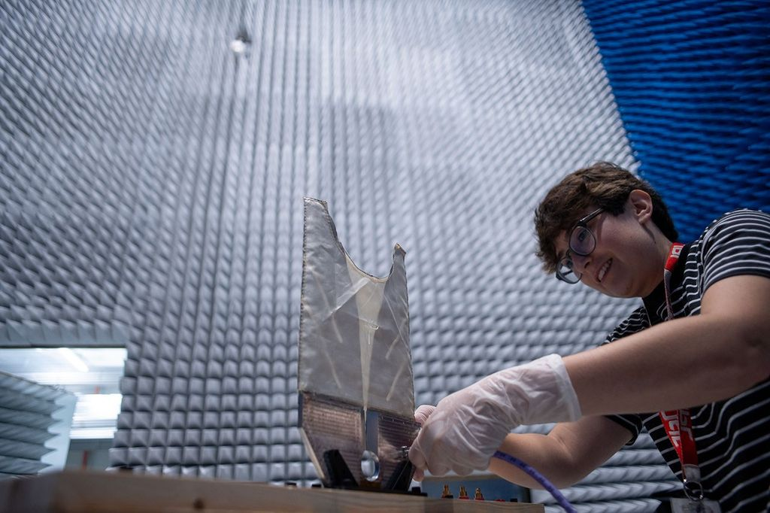
Credit: NASA As NASA+ continues its expansion across multiple streaming platforms to bring space closer to home, NASA announced Monday programming is next heading to discovery+ and HBO Max. A continuous live feed of NASA+ programming is streaming on discovery+ live channels, while HBO Max will stream NASA's special events, including the Artemis III mission in 2027. Viewers on those platforms can stream NASA+ content in Dolby Vision on supported devices, which will bring space exploration to life with vivid colors, sharper contrast, brighter imagery, and richer detail. This enhanced streaming experience will help viewers experience space coverage in a uniquely immersive way. Future programming may include science mission launches, a test flight for rendezvous and docking with human landing systems, robotic lunar deliveries, the first crewed mission to the Moon under Artemis, and more. As always, NASA+ also remains available for free, with no ads, through the NASA app and on the agency's website. "The National Aeronautics and Space Act of 1958 calls on us to share our story of space exploration with the broadest possible audience and we continue to honor that commitment," said Rebecca Sirmons, general manager of NASA+ at the agency's Headquarters in Washington. "Artemis II captured the hearts and minds of viewers globally, inspiring the Artemis generation. As we return to the Moon to stay, our goal is to provide transparent, engaging content coverage every step of the way." Earlier this year during its Ignition event, NASA shared plans for a bold path forward for the agency, including increasing its cadence of Artemis missions to the lunar surface, and building the first Moon Base, among other agency priorities. These continuous streaming agreements strengthen NASA's promise to public engagement, making the agency's mission and educational content available on multiple devices for viewers on their preferred channels For more about NASA's missions, visit: https://www.nasa.gov -end- Jennifer Dooren / Lauren Low Headquarters, Washington 202-358-1600 jennifer.m.dooren@nasa.gov / lauren.e.low@nasa.gov

8. Lion Nebula Roars to Life With NASA's Webb
Read more
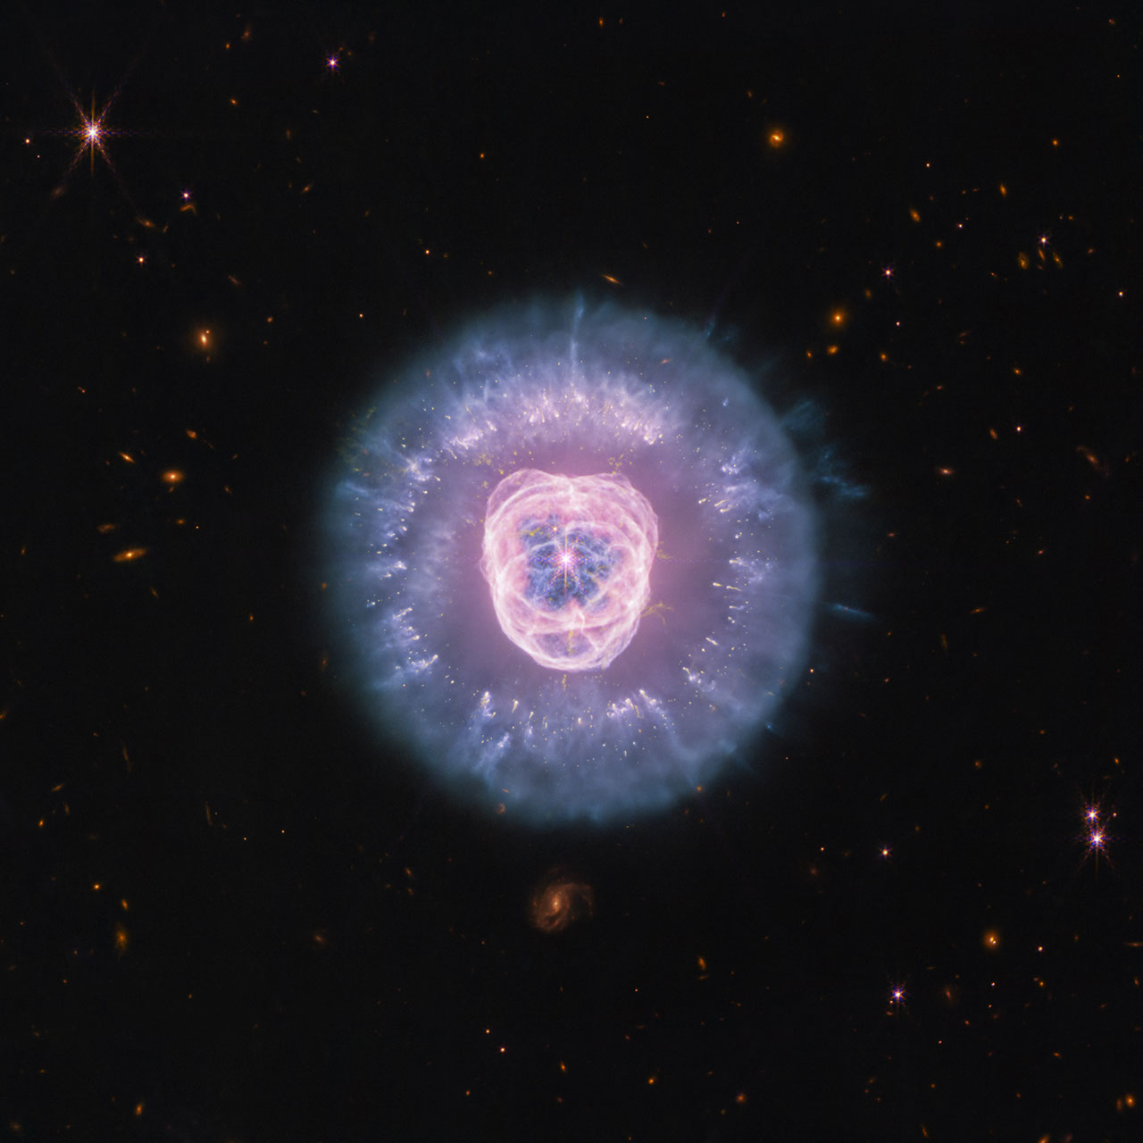
Observing across the starry "plains" of space, NASA's James Webb Space Telescope has taken new images of NGC 2392, nicknamed the Lion Nebula. NASA's Hubble Space Telescope previously viewed this planetary nebula in 2000, imaging the lion face-shaped target in visible light and revealing features such as the "mane" of hazy, comet-shaped objects. Now Webb has captured a clearer, more detailed view of the Lion Nebula due to its high-resolution imaging. Lion Nebula (NIRCam and MIRI Image) NASA's James Webb Space Telescope imaged the planetary nebula NGC 2392, the Lion Nebula, using the observatory's NIRCam and MIRI instruments. The central star's remains are responsible for the nebula's structure, including a lion face-shaped bubble of ionized gas and dust "mane." Image: NASA, ESA, CSA, STScI; Image Processing: Alyssa Pagan (STScI) At first glance the nebula's overall structure in Webb's infrared images, with both the NIRCam (Near Infrared Camera) and MIRI (Mid Infrared Instrument) instruments, may look quite similar to Hubble's earlier visible-light view. However, Webb's infrared vision highlights features like compact clumps of dust and a haze of ionized gas. It's taken several thousand years for this collection of gas and dust to reach its current shape, and the nebula's components continue to be altered. The source of these constant changes and the reason for the Lion Nebula's distinct appearance is located at the center: the remains of a dying star. Though it looks like the button nose of the lion, its energy and radiation are powering the intricate structures seen here. Lion Nebula (MIRI Image) NASA's James Webb Space Telescope's mid-infrared image of planetary nebula NGC 2392, nicknamed the Lion Nebula, highlights the varying dust structures. Some dust is being destroyed by the dying central star's radiation, while some dust filaments manage to survive. Image: NASA, ESA, CSA, STScI; Image Processing: Alyssa Pagan (STScI) Massive stars undergo supernova explosions at the end of their lives, but these kinds of events are few and far in between. Most of the universe's stars have lower masses, like the one belonging to NGC 2392. When a lower-mass star can no longer sustain itself with nuclear reactions in its core, the star becomes unstable and pulsates, losing its mass by shedding its outer layers, which then turn into shells of gas and dust called a planetary nebula. (Stars at this life stage are responsible for producing much of the universe's observable dust.) The star's radiation drives the ejected material away, leaving behind the very hot stellar core, also known as a white dwarf. In the Lion Nebula's case, the death of the oxygen-rich central star has left behind a white dwarf that is "cooking" everything from the inside and producing a bubble of ionized gas as it does. The gas bubble, which forms the lion's face, is expanding over time and destroying dust that is in its path. Understanding why the swept-up gas has a complex structure of rings and shells, a common feature in planetary nebulae, is an ongoing endeavor. The mane of the lion is the interior of a dust shell that is being illuminated by the white dwarf at the center. The tufts of hair, which look like cometary tails of material, are compact clumps of dust that have survived the stellar core's radiation and protect the material that lies behind them. Webb's imagery "freezes" this planetary nebula in time, though the star's death, and its tumultuous effects, go on. NGC 2392 will continue to undergo changes as its gas and dust migrate away from the stellar core. Astronomers estimate the lion will eventually disperse in approximately 10,000 years - a relatively short period in astronomical terms. The James Webb Space Telescope is the world's premier space science observatory. Webb is solving mysteries in our solar system, looking beyond to distant worlds around other stars, and probing the mysterious structures and origins of our universe and our place in it. Webb is an international program led by NASA with its partners, ESA (European Space Agency) and CSA (Canadian Space Agency). To learn more about Webb, visit: https://science.nasa.gov/webb Downloads & Related Information The following sections contain links to download this article's images and videos in all available resolutions followed by related information links, media contacts, and if available, research paper and Spanish translation links.

9. Launch Into a New School Year With NASA
Read more
4 Min Read NASA STEM Team Aug 10, 2026 Article A new school year brings fresh opportunities to get involved with NASA. Whether you're curious about space or eager to build real STEM skills, NASA offers a world of experiences putting you close to the action. As we enter a new golden age of exploration, there's no better time to jump in, try something bold, and see where your curiosity takes you. Gain Hands-On NASA Experience NASA opens the door to authentic mission experiences through internships and student challenges. As members of the NASA team, interns work on genuine agency projects and gain industry-ready skills, all with the guidance of NASA mentors. Visit NASA's internships website to learn more about current vacancies, deadlines, eligibility requirements, and more. Through NASA's student challenges and competitions, student teams tackle some of the critical technical hurdles facing mission planners. Flex your innovative muscles and sharpen your collaborative and problem-solving skills while developing, prototyping, and testing your team's designs. Check out the full list of NASA STEM challenges and opportunities , choose one that fits your interests, and assemble your team. Students cross the finish line in their human-powered rover during the 2025 Human Exploration Rover Challenge at NASA's Marshall Space Flight Center in Huntsville, Alabama USSRC/Emily Riddle Discover Technical Careers at NASA The future of aerospace depends on a steady pipeline of skilled technical experts ready to make missions and ideas a reality. NASA invites students in high school, community college, and career technical education programs to join in-person and virtual events to explore these important career paths. NASA Career Technical Education Days bring students on-site to meet NASA skilled technical workers who share what their jobs are like, how they built their careers, and the skills, training, and certifications that have helped them succeed. During NASA's Next Gen STEM Virtual Career Connections , students interact live with technical experts supporting the agency's missions. Students and teachers can learn more on the Next Gen STEM for Careers website. A technician performs welding on a spacecraft transporter at NASA's Kennedy Space Center in Florida. NASA/Ben Smegelsky Contribute to NASA Science as a Citizen Scientist NASA's Science Mission Directorate invites you to help make real discoveries through science projects powered by volunteers. Join from anywhere, whenever it fits your schedule, and start working with authentic mission data. Help identify comets and asteroids, hunt for binary star systems, and more. Find the project that's right for you on the list of current citizen science projects . Keep Up With NASA Missions and Discoveries Don't miss out on NASA's biggest mission milestones this school year! Up first is the Nancy Grace Roman Space Telescope , scheduled to launch no earlier than 7:20 a.m. EDT on Sunday, Aug. 30. This powerful new observatory has a field of view at least 100 times larger than the Hubble Space Telescope. Be a virtual guest for launch and learn more about the telescope with fun activities provided by NASA's Science Mission Directorate. You can also sign up to be a virtual guest for NASA's next crewed launch to the International Space Station, SpaceX Crew-13 , set to launch in September. And be sure to follow NASA's continuing crew training and hardware preparations for Artemis III . Set to launch into Earth orbit in 2027, the flight will test rendezvous and docking capabilities with commercial human landing systems - landers that will carry astronauts to the lunar surface on Artemis IV and future missions to the Moon. NASA astronauts Jack Hathaway and Jessica Meir answer questions inside the International Space Station's Kibo laboratory module during a live downlink event in May 2026 . NASA Stay Engaged With NASA Schools, classrooms, and community-based student groups have further options to engage with NASA and its people. Through In-Flight STEM Downlinks , students have their pre-recorded questions answered live by astronauts aboard the International Space Station, demonstrating how STEM careers reach far beyond Earth. Additionally, the NASA Engages public outreach program connects agency experts with student audiences to share mission and science updates, helping people discover how NASA's work unfolds and how they can be part of the journey. This school year, whether you're interested in aerospace jobs or eager to dive into authentic STEM challenges, you'll find an array of activities and career exploration tools on NASA's Learning Resources website. Explore exciting NASA student opportunities and subscribe to the weekly NASA EXPRESS email newsletter for the latest NASA STEM opportunities and updates! Keep Exploring Discover More Topics From NASA For Students Grades 9-12 Mobile and Desktop Apps Games and Interactives NASA STEM Opportunities and Activities For Students

10. 'Launching anywhere, anytime and without compromise': Rocket Lab unveils new 'GHOST' portable spaceport system
Read more
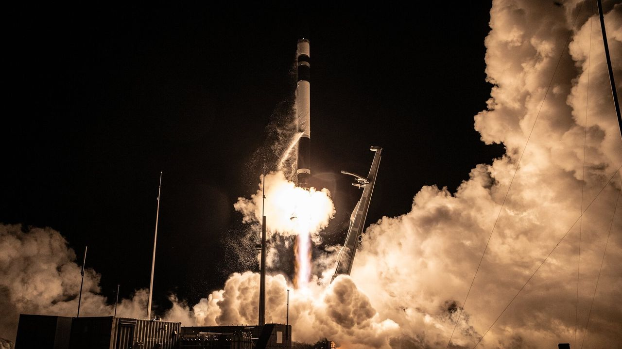
Click for next article A Rocket Lab Electron rocket launches "The Grain Goddess Provides" mission for the Japanese company iqps from New Zealand on Aug. 6, 2026. Rocket Lab plans to start launching even more frequently and flexibly, thanks to a new portable spaceport system called "GHOST." GHOST - short for "Global Hypersonic & Orbital Spaceport Technology" - turns the company's " Electron and HASTE rockets into a launch-anywhere, launch-anytime capability for multi-launch flight campaigns and critical national security missions," Rocket Lab representatives said in a statement today (Aug. 10). "Packaged entirely within standard shipping containers, GHOST deploys complete rockets, launch infrastructure, ground support and range control systems anywhere in the world," they added. Electron is Rocket Lab's workhorse orbital rocket, giving small satellites dedicated rides to the final frontier. The expendable 59-foot-tall (18-meter-tall) launcher debuted with a test flight in 2017 and has 83 missions under its belt to date. As its full name suggests, HASTE ("Hypersonic Accelerator Suborbital Test Electron") is a suborbital version of Electron that customers use to test various technologies in the hypersonic flight environment. HASTE first flew in June 2023 and has flown nine times to date, most recently in June of this year. Rocket Lab currently flies from two different launch sites - one on the North Island of company founder and CEO Peter Beck's native New Zealand and one at Wallops Island in Virginia. But the company recently announced plans to fly out of Alaska's Pacific Spaceport Complex as well, and GHOST will expand its launch footprint even further. "Electron and HASTE revolutionized small orbital launch and hypersonic testing. Now we're making it easier to deploy them wherever they're needed most, whether that's for missile defense testing or sovereign orbital launch capability," Beck said this afternoon during Rocket Lab's second-quarter 2026 earnings call. "We've mastered the art of building launch sites," he added. "Now we're making them deployable worldwide." Rocket Lab intends to deploy its two planned pads at the Pacific Spaceport Complex using GHOST, Beck said during the call. The company was inspired to develop the portable spaceport system, he added, to meet the needs of a HASTE customer, who expressed a desire for Rocket Lab to be "a little bit more mobile than we are." Rocket Lab currently flies out of two pads at its New Zealand site and one at Wallops, though it has built a second pad at the Virginia facility to accommodate launches of its coming Neutron rocket . Neutron will be bigger and more powerful than Electron, and partially reusable as well; its first stage is designed to come back to Earth for recovery and reflight, like SpaceX's Falcon 9 . Rocket Lab originally wanted to fly Neutron for the first time in 2024, but the new launcher has yet to leave the ground. Such delays aren't uncommon in the case of new rockets , and the company is making considerable progress with Neutron, according to Beck. "Every part of the vehicle has now seen significant testing," he said during today's call. "As with any complex development program, we've had to tweak a few things along the way, but we're moving now into final checkout and assembly of all of our flight hardware before integrating them at the pad." The company is on target to deliver the first Neutron to that Wallops pad in the fourth quarter of this year, Beck added.

11. Japanese H3 rocket launches 10,800-pound navigation satellite to high Earth orbit (video)
Read more
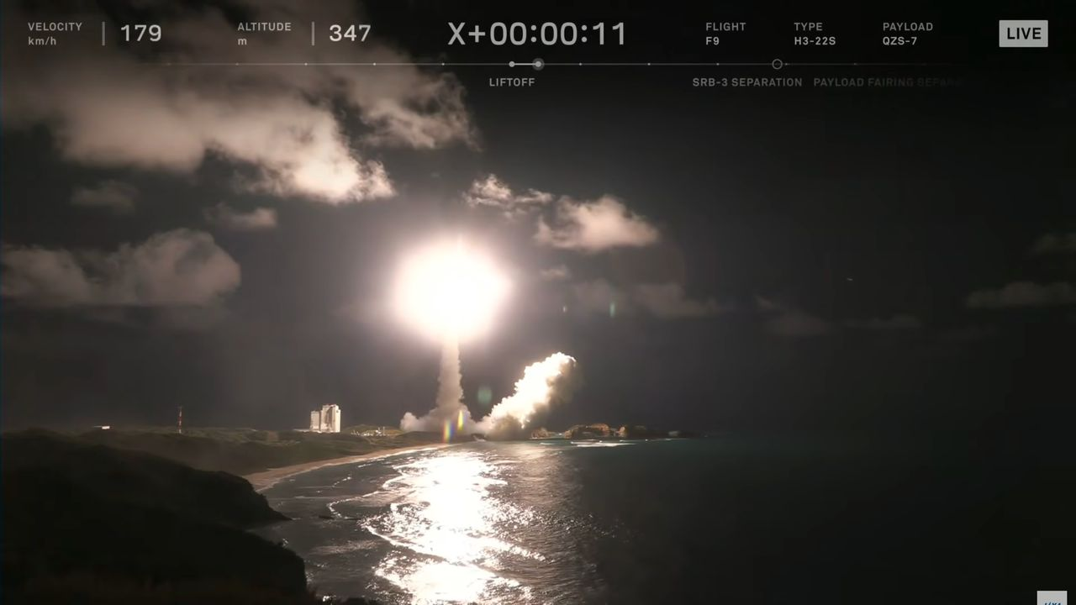
Click for next article Japan's H3 rocket flew for the ninth time ever this afternoon (Aug. 10). The H3 lifted off from Tanegashima Space Center today at 3:23 p.m. EDT (1923 GMT; 4:23 a.m. on Aug. 11 local time), carrying the Michibiki 7 navigation satellite aloft. The H3's upper stage deployed Michibiki 7 into its target orbit 29 minutes later, eliciting cheers from the folks in mission control. A closeup of the H3's first stage powering the rocket to orbit on Aug. 10, 2026. (Image credit: JAXA) The two-stage H3 is the successor to Japan's workhorse H-2A rocket, which retired last year after a total of 50 flights. The H3 - which stands 187 feet or 207 feet (57 or 63 meters) tall, depending on what type of payload fairing it employs - debuted in March 2023 and had eight liftoffs under its belt before today. Two of those eight were failures - the debut flight and the launch of Michibiki 5 in December of last year. But the H3 bounced back from that latter anomaly two months ago, successfully delivering six satellites to orbit on June 11 . Michibiki 7 will be part of Japan's Quasi-Zenith Satellite System (QZSS), a homegrown navigation system that operates high above Earth in geosynchronous orbit . "This system is compatible with GPS satellites and can be utilized with them in an integrated fashion," Japanese officials wrote in a description of the QZSS project . "QZSS can be used even in the Asia-Oceania regions with longitudes close to Japan, so its usage will be expanded to other countries in these regions as well." The QZSS network will eventually consist of 11 satellites , if all goes according to plan. There are five such spacecraft operating in orbit at the moment. Michibiki 7 is carrying a payload for the United States as well - the Situational Awareness Camera Hosted Instrument (SÃCHI), which was developed for the U.S. Space Force by the MIT Lincoln Laboratory. This is the second of two SACHIs to go up on a QZSS satellite; Michibiki 6, which launched atop an H3 in February 2025 , hosts the other one. (Yes, Michibiki 6 launched before Michibiki 5.) "This program will allow the United States to monitor satellite behavior within the GEO belt over a very interesting part of the world," Mark Huber, a technical staff member in the Lincoln Laboratory's Space Systems and Technology Division, said in a statement in December 2020. "It is also a pathfinder in several ways," he added. "The U.S. team is blueprinting methods to allow sensitive data sharing between the United States and Japan." Editor's note: This story was updated at 3:55 p.m. ET on Aug. 10 with news of successful launch and satellite deployment.

12. Window for 2026 launch debut of Rocket Lab's Neutron rocket 'is narrowing' as development continues
Read more
Rocket Lab's anticipated debut of its medium-lift Neutron rocket may end up slipping beyond this year and into 2027. In a filing to the U.S. Securities and Exchange Commission (SES) ahead of is second quarter 2026 earnings call with investors on Tuesday, the company noted that it's working through various qualification testing and made "significant milestones across the Neutron program." "Production of the Stage 1 tank is currently aligned with the target delivery of Neutron to the launch pad in Q4 2026," the company wrote in its filing. "While the window for an end-of-year launch date is narrowing, we are balancing the schedule of the first launch with entering Neutron into service as a system ready for full-scale production and high-cadence launch beyond flight one. "Exact launch timing will also depend on the outcome of first stage qualification and other critical tests occurring later in 2026." Rocket Lab's Neutron rocket, a 43-meter-tall (141 ft.), liquid methane-fueled launch vehicle, was announced back in March 2021 and has been in development ever since. It's designed with a reusable first stage booster that features actuating payload fairing halves that remain fixed to the booster after the second stage and payload are released. Back on Jan. 21, the company's first stage fuel tank ruptured unexpectedly during a water loading test called a "hydrostatic pressure trial." That setback pushed the planned debut from the middle of the year to late 2026. During Monday's earnings call, Rocket Lab founder and CEO Peter Beck said the ability to reuse its rockets will be the x-factor that can unlock good launch cadence. "As we're working forward with the vehicle right now, and the way we're thinking about things, it's not just to get to the pad quickly for flight one. Of course we all want that and no one more than I, but it's really about how do we get to flight ten in the shortest time possible," Beck said. "So for us, it's all about reusability. And we're constantly trading the timelines and the qualification criteria for the various systems and subsystems to get to the pad for flight one, but also making sure that when it comes to flight ten, that we don't have to go back and re-qualify things," he added. "So there's a constant assessment along that way." Asked about the milestone with the highest risk on the road to Neutron's debut, Beck said it would be the integrated static fire testing that will happen at the launch pad in Virginia. "The stage testing is always the thing that gets your adrenaline running because you have fully fueled vehicles on the pad and you're igniting the engines for the first time. And I think you can also see for another space company that when it doesn't go well, it really doesn't go well," Beck said, making a nod to the explosion of Blue Origin's New Glenn rocket during a static fire test on May 28 prior to its fourth planned launch. Awaiting their ride The future for Neutron launches includes the defense sector, where Rocket Lab holds a $397 million contract for building and launching satellites for the U.S. Space Force's (USSF) Space-Based Airborne Moving Target Indicator (SB-AMTI) program. Launch dates for this program haven't been announced. Neutron will also be able to compete for task orders as part of the National Security Space Launch Phase 3 Lane 1 procurement contract, managed by the USSF's Space Systems Command. On the commercial side of the ledger, Rocket Lab also has more than half a dozen customers lined up for flights on the rocket. The newest of those is Kepler Communications, based in Toronto, Canada. Neutron has been selected for a dedicated launch by @KeplerComms as part of their largest network expansion yet - the first time Kepler has booked an entire rocket for constellation deployment rather than fly rideshare. Press release: https://t.co/vQJAttEbTe pic.twitter.com/gPVrPVcAdh - Rocket Lab (@RocketLab) August 10, 2026 Ahead of its second quarter 2026 earnings call with investors, Rocket Lab unveiled that it will fly a dedicated mission for Kepler no earlier than 2028 to "deploy multiple satellites to low Earth orbit, expanding Kepler's constellation with additional optical connectivity, on-orbit compute, and hosted payload capacity. The satellites will support a range of commercial and government missions." The previous 33 satellites launched for Kepler were on rideshare missions across a series of rockets beginning in 2018. Those included China's Long March 11, India's PSLV-CA, Russia's Soyuz-2.1a, and SpaceX's Falcon 9. The most recent batch flew as part of SpaceX's Twilight rideshare mission in January 2026. The promised NET 2028 launch for Kepler marks its first dedicated flight, though the specific number of satellites that will fly onboard hasn't been disclosed. "Securing our first dedicated launch reflects the next stage of growth for Kepler," said Beau Jarvis, Chief Revenue Officer of Kepler, in a statement. "As we continue expanding our constellation to keep pace with growing customer demand, multiple launches in 2028 will increase capacity, strengthen resilience, and enable new services for customers around the world. Rocket Lab is an outstanding partner for this important milestone." During the earnings call, Beck called this launch contract "another strong signal of the expectation for Neutron to become the industry's alternate ride to space for medium-lift missions," alongside the Falcon 9 rocket. "We have a proven track record with Electron and HASTE (Hypersonic Accelerator Suborbital Test Electron) and customers know we develop and scale reliable launch vehicles, which is why they're coming to us now and locking in Neutron slots early," Beck told investors. "Neutron is going to help unblock the industry's bottleneck, giving operators a reliable capacity that they need for years to come."

13. SpaceX scrubs planned Monday launch of its Falcon 9 rocket; targets Tuesday morning
Read more
Update Aug. 10, 3:46 p.m. EDT (1946 UTC): Added updated forecast from the 45th Weather Squadron. SpaceX was set to kick off the work week with a Falcon 9 flight from Cape Canaveral Space Force Station to deliver another batch of its Starlink V2 Mini Optimized satellites to low Earth orbit. However, the mission was scrubbed hours before is scheduled liftoff at 12:20:09 p.m. EDT (1620:09 UTC) The Starlink 10-19 mission represents the 72nd flight of these broadband internet satellites this year. Following this launch, SpaceX will have flown 93 Falcon 9 rockets in 2026. Liftoff from Space Launch Complex 40 is scheduled for 10:26 a.m. EDT (1426 UTC) on Tuesday, Aug. 11. The rocket will fly on a northeasterly trajectory upon leaving the launch pad. <span data-mce-type="bookmark" style="display: inline-block; width: 0px; overflow: hidden; line-height: 0;" class="mce_SELRES_start"></span> The 45th Weather Squadron forecast an 85 percent chance for favorable conditions near the opening of the window, which decreases to 75 percent as the window progresses. "The Atlantic ridge axis will continue to slide southward over the Spaceport, shifting winds to a very light south-southwesterly flow," launch weather officers wrote on Monday. "With the relatively dry air mass remaining in place, conditions will be similar to Monday, with the Cumulus Cloud Rule remaining the primary concern and an increasing probability of violation towards the end of the window." SpaceX will launch this mission using the Falcon 9 first stage booster with the tail number B1085. This will be its 18th flight with a flight history that includes NASA's Crew-9, GPS III-7, and Fram2. Nearly 8.5 minutes after liftoff, B1085 will target a landing on the droneship, A Shortfall of Gravitas, positioned in the Atlantic Ocean off the coast of South Carolina. If successful, this will be the 163rd landing on this vessel and the 647th Falcon booster landing.

