 |  | 

🌌 अंतरिक्ष समाचार | Space News
शनिवार, १३/०६/२०२६ | Saturday, 13/06/2026

1. PM Modi congratulates ISRO on historic 100th launch - News On AIR
Read more
Prime Minister Narendra Modi has congratulated the Indian Space Research Organisation (ISRO) on the historic 100th launch. In a social media post, Mr. Modi said, this incredible milestone illustrates the vision, dedication and commitment of nations' scientists and engineers. He said, that with the private sector joining hands, the country's space journey will continue to attain new heights. Science and Technology Minister Dr Jitendra Singh termed ISRO's 100th launch of the GSLV-F15 from Sriharikota as a quantum leap in the country's space journey. Talking to the media following ISRO's remarkable feat, Dr. Singh underlined that the country's space sector has undergone unprecedented expansion in terms of both infrastructure and investment. He also highlighted the contributions of early pioneers like Vikram Sarabhai and Satish Dhawan in laying the foundation for the country's space sector. Dr Singh further asserted that 90 percent of foreign satellite launches are being carried out through ISRO. He also informed that the space economy, currently valued at 8 billion dollars, is projected to reach 44 billion dollars in the next decade.

2. Barricades block parking, worsen traffic near ISRO Junction - Bangalore Mirror
Read more

The removal of public parking along Wind Tunnel Road beside the Air Force Colony has triggered complaints from residents, motorists and auto drivers, who say the decision has worsened traffic congestion on an already strained corridor.Barricades installed along the Air Force compound wall have blocked access to a stretch that was widely used for roadside parking. The situation has become particularly difficult due to the ongoing underpass construction near ISRO Junction, which has already disrupted traffic movement in the area.Urban strategist Vinod Jacob alleged that the closure of more than 200 metres of parking space has severely disrupted traffic flow on one of the area's busiest commuter routes. According to him, thousands of commuters use this road daily, and removing parking without providing an alternative has simply shifted the problem onto the carriageway. He suggested a temporary arrangement allowing two-wheelers on one side and four-wheelers on the other to ease congestion until a permanent solution is found.Long-time resident Avinash Bhurani, who has lived in the locality for 25 years, claimed the restrictions were introduced after a verbal altercation reportedly took place between a fish vendor and an officer near the Air Force premises.While some residents blame the restrictions for worsening congestion, others point to a different problem. Milind D Kulabkar, a nearby resident, alleged that the absence of organised parking management has allowed the area to deteriorate into an unregulated parking zone. According to him, trucks, buses, cabs and even abandoned vehicles frequently occupy public road space.During a visit to the location, security personnel stationed at the entrance defended the restrictions, stating that the measures followed repeated concerns over loitering, smoking, illegal parking and activities considered a potential security risk near the Air Force premises.However, auto drivers operating in the area say they are now bearing the consequences. Drivers who regularly pick up students from nearby schools said they have effectively been left without any legal space to wait for passengers, forcing them to stop on the main road and worsening congestion.

3. G20 satellite is expected to be launched in 2027: ISRO Chairman - News On AIR
Read more
ISRO Chairman V. Narayanan has said that the G20 satellite, designed to study climate and air pollution and monitor weather, is expected to be launched in 2027. He said India is the first country to succeed in placing more than 100 satellites using a single rocket without any collision. Dr Narayanan was addressing scientists from DRDO, ISRO, and the Aeronautical Society of India at the Engineering Staff College of India in Hyderabad yesterday. He said India is taking the lead role in the launch of the G20 satellite for the G-20 countries. Dr Narayanan said ISRO is working towards sending a human to the moon by 2040. He said if ISRO makes it happen by 2040, India will be on par with any other space-faring nation in terms of launcher technology, satellite technology, application area, and human space flight program. According to Dr Narayanan, ISRO is in the process of making a 2.2 metre diameter, 100 mm thick titanium vessel for Samudrayaan, a project for the Deep Ocean Mission.

4. Tripura youth secures prestigious ISRO-funded research project - Tripuratimes
Read more

Tripura youth secures prestigious ISRO-funded research project Dr. Sourabh Paul, a native of Belonia, a small town in the South Tripura district of Tripura, has achieved a remarkable milestone in his academic career by securing a prestigious research project funded by the Indian Space Research Organisation (ISRO). Born and brought up in Belonia, Dr. Sourabh Paul completed his early schooling in the town before pursuing higher education with a determination to build a career in science and engineering. He earned his Bachelor of Engineering (B.E.) degree from Tripura Institute of Technology (TIT), followed by a Master of Technology (M.Tech.) degree from National Institute of Technology (NIT), Agartala. He later completed his Doctor of Philosophy (Ph.D.) from National Institute of Technology Rourkela, specializing in signal and image processing. His academic journey from a small town in Tripura to premier technical institutions of the country stands as a testament to dedication, hard work, and perseverance. Currently associated with Vellore Institute of Technology (VIT), Chennai Dr. Sourabh Paul continues to contribute to cutting-edge research in image processing, remote sensing, and deep-learning. Recently, ISRO sanctioned his research project titled "Design and Development of Algorithm for Illumination, Scale, Translation and Rotation Invariant Image Matching." The project has received funding support of Rs. 29.93 lakhs and focuses on developing advanced image-matching algorithms capable of handling variations in illumination, scale, translation, and rotation. Such robust techniques are essential for accurate satellite image analysis, remote sensing applications, environmental monitoring, disaster management, and space-based observation systems. The project is expected to contribute significantly to indigenous technological development in image processing and strengthen India's capabilities in remote sensing and space research. It will also provide opportunities for students and researchers to work on advanced technologies with real-world applications. Expressing his gratitude, Dr. Sourabh Paul acknowledged the support of his teachers, mentors, colleagues, and family members throughout his academic journey. He noted that coming from a small town like Belonia and receiving an ISRO-funded research project demonstrates that determination and quality education can help individuals achieve excellence regardless of their background. He further expressed hope that his achievement would inspire students from Belonia, Tripura, and other small towns across the country to pursue higher education, research, and innovation. The achievement has brought pride not only to VIT Chennai but also to the people of Belonia and Tripura. It highlights the growing contribution of young researchers from the North-Eastern region to India's scientific community and space research initiatives.

5. ISRO, Andhra University build AI system to warn beach visitors - YourStory.com
Read more
ISRO, Andhra University build AI system to warn beach visitors YourStory.com

6. ISRO, Andhra University Launch AI-Based Project to Improve Beach Safety - Shiksha
Read more
ISRO, Andhra University Launch AI-Based Project to Improve Beach Safety Shiksha

7. NASA to Cover 34th SpaceX Resupply Mission Space Station Departure
Read more

The SpaceX Dragon cargo spacecraft supporting the company's 34th commercial resupply services mission for NASA approaches the International Space Station on May 17, 2026, carrying nearly 6,500 pounds of food, supplies, and equipment for the Expedition 74 crew. Credit: NASA NASA and its international partners are set to receive scientific research samples and hardware as a SpaceX Dragon spacecraft is scheduled to depart the International Space Station on Tuesday, June 16, for its return to Earth. Watch NASA's live undocking coverage beginning at 11:45 a.m. EDT on NASA+, Amazon Prime, and the agency's YouTube channel. Learn how to watch NASA content through a variety of online platforms, including social media. The Dragon spacecraft will undock from the forward port of the station's Harmony module at about 12:05 p.m., after receiving a command from SpaceX ground controllers. The spacecraft then will fire its thrusters to move safely away from the orbiting complex. Following a June 16 departure, the spacecraft will reenter Earth's atmosphere on Wednesday, June 17, before splashing down off the coast of California at approximately 5:08 a.m. PDT. NASA will not stream the splashdown but will post updates on its space station blog. Dragon will return to Earth with thousands of pounds of cargo, carrying samples that could shape future space exploration and life on Earth. Research returning includes bioprinted organ and cartilage tissue, data on improving cryogenic fuel storage for future space missions, and DNA‑inspired materials to develop new cancer treatments. The returning hardware includes an ocular imaging device used to monitor crew members' eye health, an absorbent bed that filters trace contaminants from cabin air, and a separator pump from the waste and hygiene compartment. Loaded with nearly 6,500 pounds of crew cargo and science experiments, Dragon arrived at the station on May 17 after launching two days earlier on a Falcon 9 rocket from Space Launch Complex 40 at Cape Canaveral Space Force Station in Florida. For more than 25 years, people have lived and worked continuously aboard the International Space Station, advancing scientific knowledge and making research breakthroughs not possible on Earth. The space station helps NASA understand and overcome the challenges of human spaceflight, expand commercial opportunities in low Earth orbit, and build on the foundation for long-duration missions to the Moon, as part of the Artemis program, and to Mars. Get breaking news, images, and features from the space station on Instagram, Facebook, and X. Learn more about International Space Station research and operations at: https://www.nasa.gov/international-space-station -end- Jimi Russell Headquarters, Washington 202-358-1100 james.j.russell@nasa.gov Leah Cheshier Johnson Space Center, Houston 281-483-5111 leah.d.cheshier@nasa.gov

8. Hubble Sees Swarm of Galaxies
Read more

This NASA Hubble Space Telescope image features the galaxy cluster MACS0329-0211. NASA, ESA, M. Postman (STScI); Image Processing: G. Kober (NASA/Catholic University of America) Looking somewhat like a swarm of bees returning to their hive, this NASA Hubble Space Telescope image features the galaxy cluster MACS0329-0211. Galaxy clusters like MACS0329-0211 are important signposts in the story of how the structure of the universe evolved, and are the ultimate telescopic lenses, placing gravitationally lensed galaxies from the earliest stages of the universe into our view. Zoom into this galaxy swarm and you will find large, oval-shaped elliptical galaxies, and thin spiral and lenticular galaxies viewed from the edge. We can also see the full, face-on view of spiral galaxies and their curving spiral arms. The image's upper-right quadrant holds faint arcs of distant galaxies gravitationally lensed by the cluster's massive gravity. The largest of these arcs appears above the bright oval shape of a giant elliptical galaxy. Closer inspection of the image's center reveals several bright-white intersecting curves that appear as a distorted figure eight. This may be another distant galaxy whose light was magnified and distorted by this massive cluster's gravity. Hubble looked at MACS0329-0211 as part of an observing program of X-ray bright galaxy clusters. Researchers used Hubble's two main cameras, the Advanced Camera for Surveys and its Wide Field Camera 3, to gather data visible and infrared light from the cluster. Hubble's ability to see such a broad spectrum of light makes it a valuable tool in understanding the very nature of these galaxy clusters. Media Contact: Claire Andreoli NASA's Goddard Space Flight Center, Greenbelt, MD claire.andreoli@nasa.gov

9. Ever have a scary HR meeting on your calendar? That's how the Artemis 3 crew found out their assignments
Read more
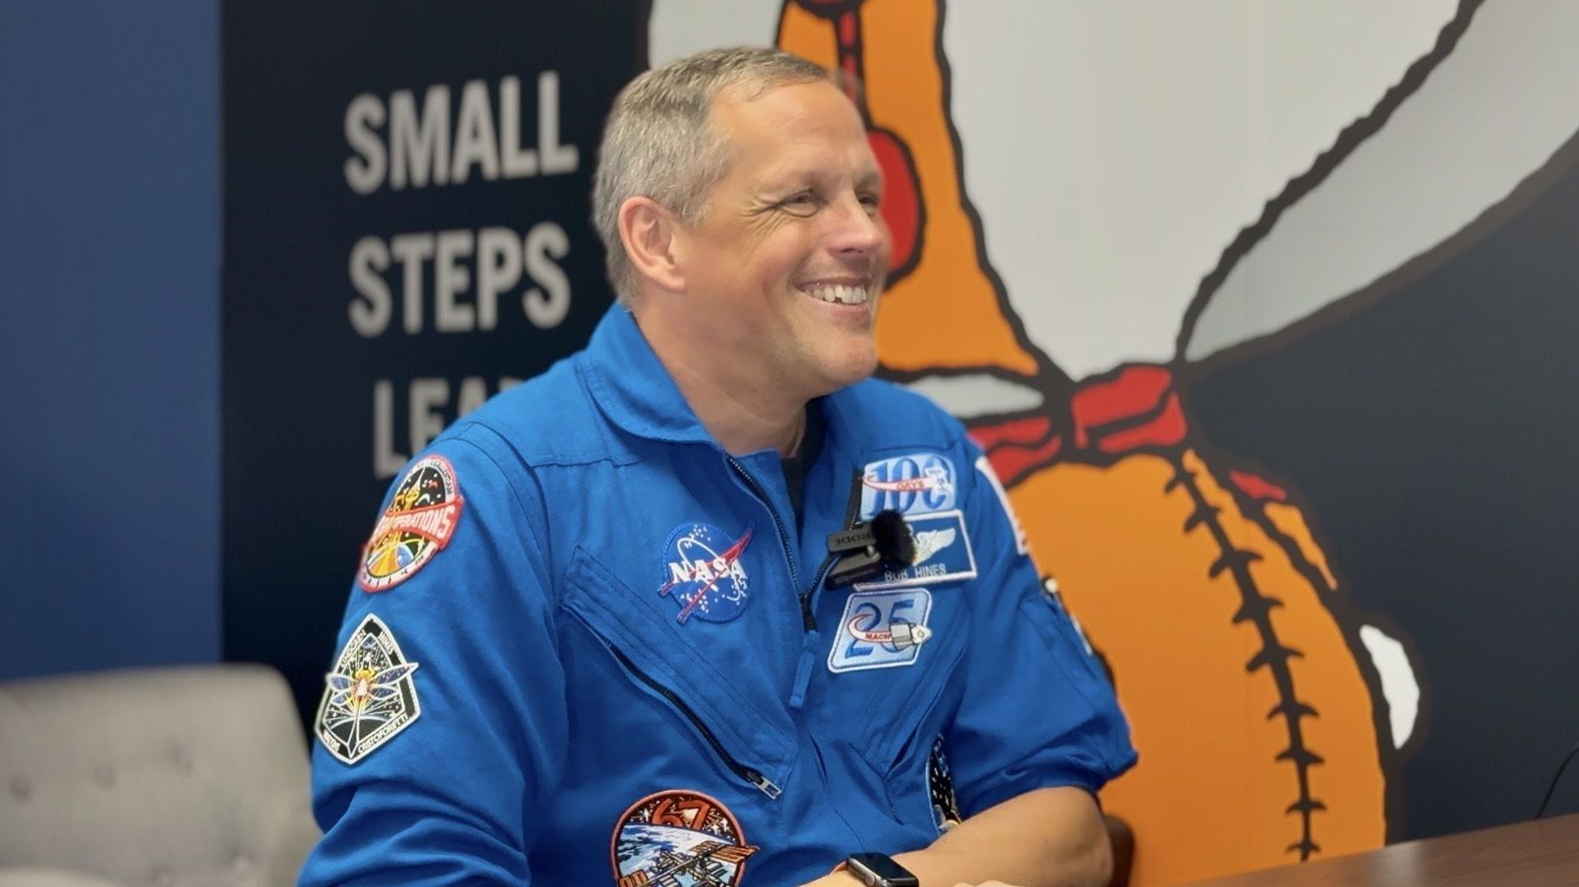
Click for next article HOUSTON - Ever had a mysterious meeting with management show up on your work calendar? Unannounced and unprompted? With invitees from parts of the company you don't normally sit in on meetings with? That kind of calendar event might send spikes of panic down the spines of some recipients, but it's not always the dreaded meeting with HR you may fear. In this case at NASA , the unsuspecting attendees were not handed their pink slips and shown the door. Quite the opposite. They were gathered to learn the crew assignments for Artemis 3 , the agency's next mission progressing its efforts to return astronauts to the moon . Turns out, the five astronauts sitting in the room that day were to become the primary and backup crew for Artemis 3. "Historically, I think most of us have been told in the past individually," Artemis 3 backup crew member NASA astronaut Bob Hines told Space.com. "There was some fake meeting name that showed up on a calendar, and we all ended up in a room together," he said. NASA announced the Artemis 3 crew to the public during a reveal ceremony at the Johnson Space Center (JSC) on June 9. It includes NASA astronaut Randy Bresnik as mission commander, Italian astronaut Luca Parmitano from the European Space Agency as pilot, NASA's Frank Rubio and Andre Douglas as mission specialists, and Hines as backup. The quartet will lift off aboard an Orion spacecraft on NASA's Space Launch System (SLS) rocket, and spend about two weeks in low Earth orbit . There, Orion will rendezvous and dock with two different lunar lander designs to test the vehicles' compatibility in space. It's the follow-on mission to NASA's Artemis 2 , which flew Orion and a crew of four on a 10-day mission around the moon in April, and the precursor to the Artemis program's first planned lunar landing mission, Artemis 4 . Near the end of Artemis 2, NASA associate administrator Amit Kshatriya told reporters the Artemis 3 crew announcement would come "soon" - and now that the picks have been revealed to the public, we're also gaining a little more insight into how the astronauts found out the news themselves. Sitting together around a table in a room at JSC about two weeks before the public announcement, not knowing why they had been called in, NASA's chief astronaut Scott Tingle told the group: "'Look around. This is your Artemis 3 crew,'" Hines said. "That was a really, really cool way to find out." "We know that there's a cast of thousands that make it happen," he said. "There are a lot of astronauts that are qualified and capable of doing it, and it is an incredible responsibility that not just the astronaut office or NASA, but that the country bestows upon us." Primary crew of NASA's Artemis 3 mission. (from left) Andre Douglas, Luca Parmitano, Randy Bresnick and Frank Rubio. (Image credit: NASA/Bill Stafford) NASA announced a group of 18 astronauts up for consideration for Artemis mission assignments in 2020. Since then, however, the eligibility pool has grown as NASA's broader astronaut cadre has gained more experience, widening the possibilities leading up to the Artemis 3 crew selection. The commander for Artemis 2, NASA astronaut Reid Wiseman , was one of those from outside the original 18 - and now, only one astronaut from the original list, Rubio, wound up being assigned to Artemis 3. Even though he is designated as the mission's backup, Hines and his Artemis 3 colleagues see themselves as a single group. "We're really looking at it as a crew of five and making sure that everybody's ready to go come launch," Hines said. In fact, as the sole backup astronaut for the Artemis 3 crew, Hines' training will cover the needed skills for each mission crew member, rather than the individualized responsibilities of any one of them. "The intent is that I can substitute in for anybody if they drop out at any time," Hines said. "So, as you can imagine, that's a lot of things to cover." Now that the Artemis 3 crew selection has been made, the group will begin training for their mission ahead. NASA is targeting the latter half of 2027 to launch Artemis 3, putting the astronauts on a time crunch leading up to liftoff. By comparison, NASA announced the astronauts for Artemis 2 in 2023. Their three years of training will be cut in half for the Artemis 3 crew, if it launches on schedule, and for a much more complex mission than its predecessor. Both lunar lander vehicles for the Artemis program, SpaceX's Starship and Blue Origin's Blue Moon lander, have faced significant development delays, and neither has yet made it to orbit. So, for NASA to launch Orion to rendezvous, dock and perform maneuvers with two unproven spacecraft makes Artemis 3 one of the agency's most complicated missions it's ever taken on. For his part, Hines doesn't mind being the backup for Artemis 3's primary crew, even if it means not getting to fly to space as a part of the mission. "We all are really excited to play any role in it," he said. And his role on Artemis 3 gives him a potential advantage when NASA chooses the crew for Artemis 4. Prior to his selection as mission specialist for Artemis 3, Douglas served as the backup astronaut for Artemis 2 . So Hines could very well be positioned for an upcoming lunar landing. "I think any astronaut is lying to you if they say they don't hope they're not on the next mission," Hines said. "The best mission is the current mission, and the next best mission is the next mission … Certainly, everybody would like to have a role in upcoming missions, and so that's an exciting thing to look forward to. And whether or not my name is on it, if I can contribute to making it successful, that's the most important thing. Because there's certainly an urgency in getting NASA back to the moon - getting America back to the moon - and trying to do that as soon as we can, as successfully as we can, is really important."

10. SpaceX's stock wasn't the company's only launch today - It also put 29 Starlink satellites in orbit
Read more
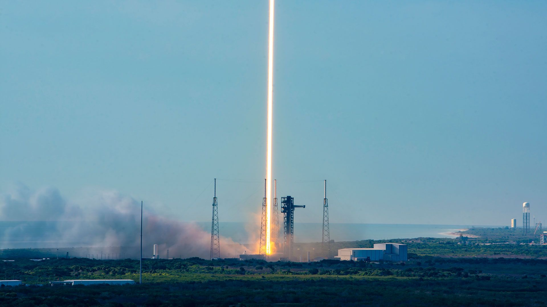
Click for next article SpaceX made history today (June 12) with the largest IPO in history, but for its launch team in Florida, it was business as usual. Just over an hour (8:17 a.m. EDT or 1217 GMT on Friday) before the company's stock went public on the Nasdaq exchange -quickly making founder Elon Musk the world's first trillionaire - a Falcon 9 rocket carrying 29 Starlink satellites lifted off from Space Launch Complex 40 at the Cape Canaveral Space Force Station in Florida. The broadband relay satellites ( Group 10-54 ) were deployed into low Earth orbit at just about the same time trading of SpaceX stock began. "$SPCX. Now trading on Nasdaq," the exchange posted and SpaceX re-shared on social media. As the market closed, SpaceX's stock price sat at just over $161 a share, up from $155 when it debuted. The company is now valued at just over $2.1 trillion, according to the New York Times . Like the direction of SpaceX's IPO, a timelapse exposure of a Falcon 9 launch catches the rocket's daytime liftoff as a bright beam skyward. The launch occurred at 8:27 a.m. EDT on Friday, June 12, 2026, from the Cape Canaveral Space Force Station in Florida. (Image credit: SpaceX) Meanwhile, as the company's value soared, the Falcon 9's first stage (B1080) completed its 27th flight, touching down on its four landing legs atop the autonomous droneship "A Shortfall of Gravitas" stationed in the Atlantic Ocean. The Starlink megaconstellation has more than 10,600 active satellites, according to tracker Jonathan McDowell. The network provides access to the internet from locations around the world, in-flight on airliners and direct-to-cell on select providers. The launch on Friday was SpaceX's 68th Falcon 9 mission of the year.

11. Why is the US Space Force researching 'orbital warehouses'?
Read more
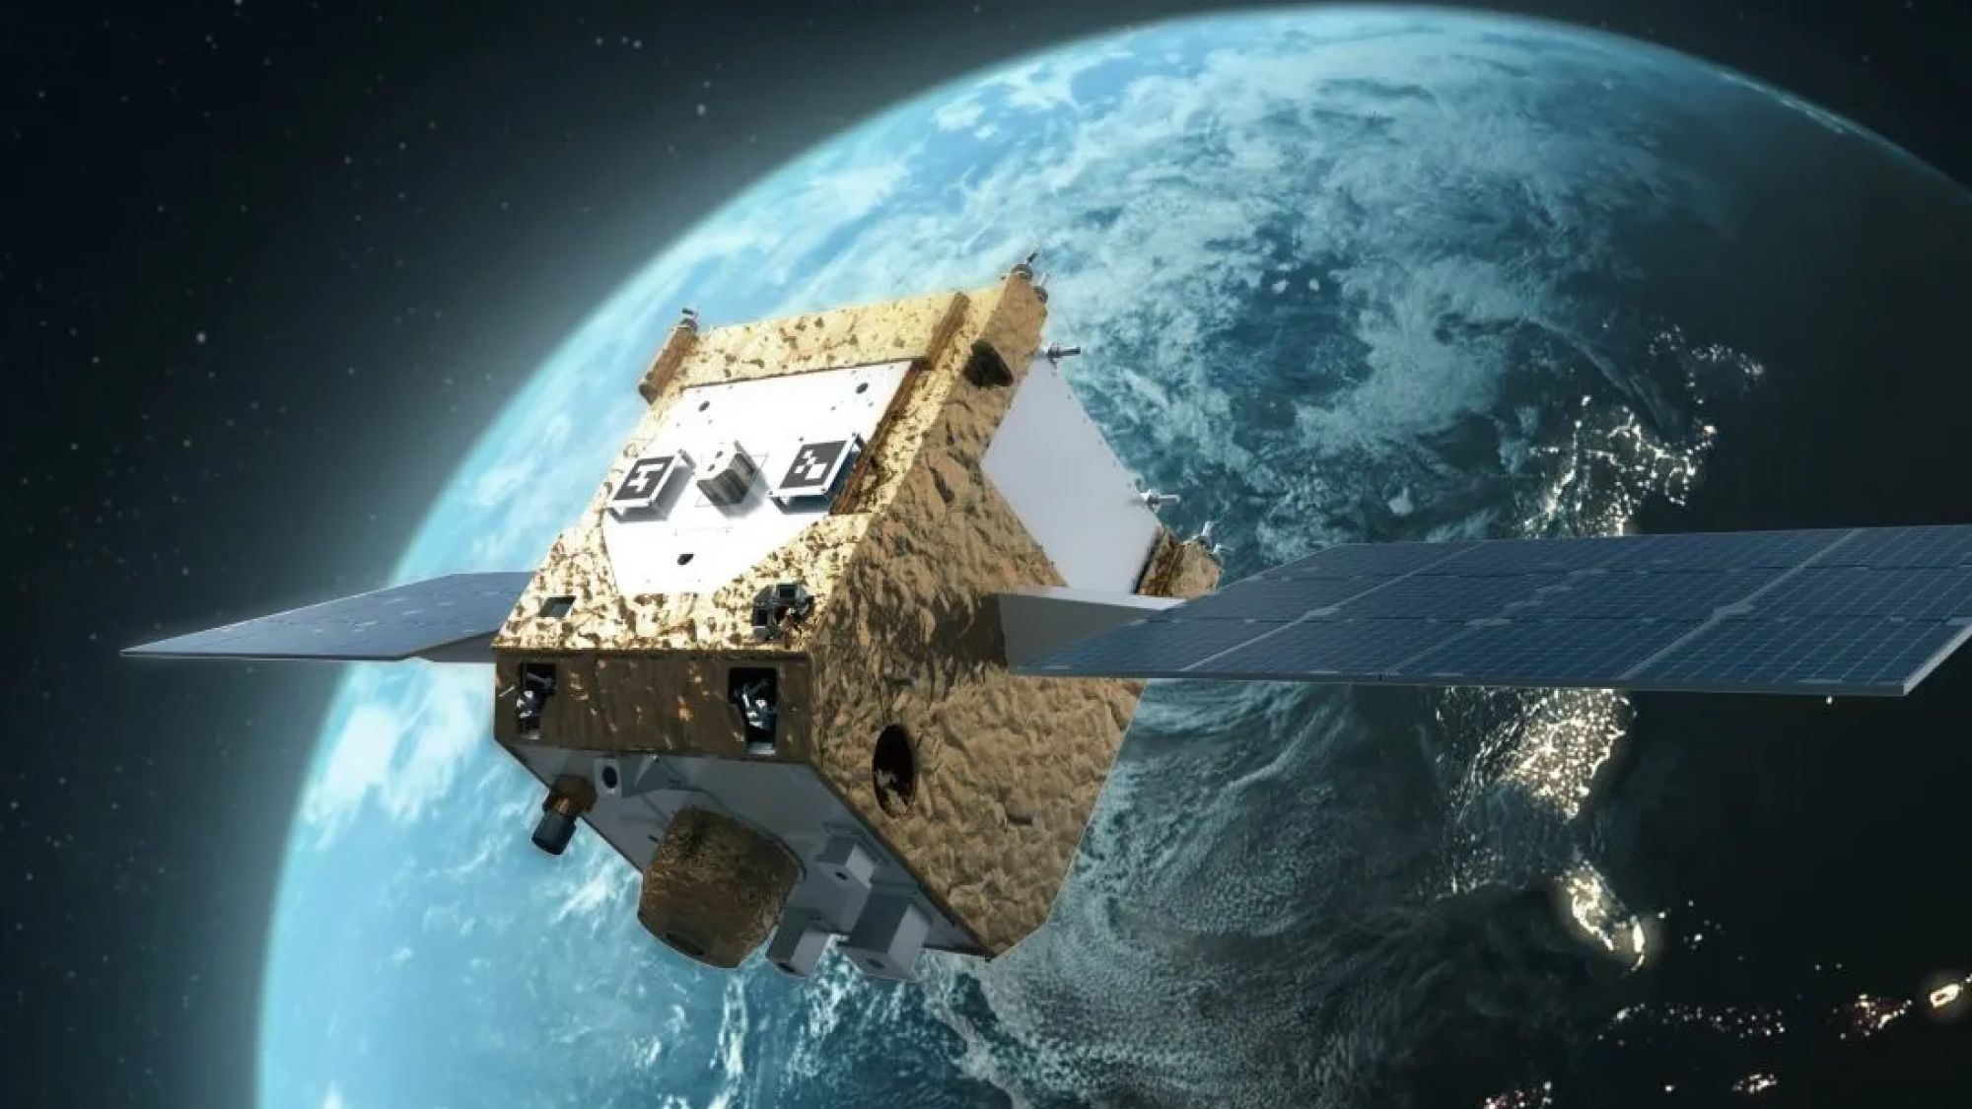
Click for next article Artist's illustration of Astroscale's APS-R Refueler spacecraft high above Earth. The U.S. military will test the spacecraft this year in a mission to refuel a spacecraft in orbit. The U.S. military is looking into putting "orbital warehouses" into orbit around Earth where fuel and other materials could be stored for easy pickup by future spacecraft on satellite servicing missions. A new U.S. military challenge aims to "accelerate operational logistics" for to help the U.S. Space Force keep its satellites active and respond in a timely fashion to threats. The challenge was created amid repeated warnings that China and Russia are actively maneuvering their own satellites close to U.S. spacecraft in orbit and launching new types of orbital weaponry . "An orbital warehouse will have the same functionality as a terrestrial warehouse: to receive, store, inspect, and cross-load supplies, while offering protection of those supplies from the environment," a SSC spokesperson told Space.com via email. "The orbital transfer vehicles would transport the supplies to and from the orbital warehouse, or other location of interest." The challenge , led by Space Force 's Space Systems Command (SSC) and SpaceWERX (Space Force's innovation arm), is asking companies to offer fundable ideas for orbital warehouses and orbital "transfer vehicles" that can haul fuel and supplies to and from these depots, as well insight on the best orbits in which to put the depots and vehicles, and how to manage fuel and reusability for longer-term missions. A call-out this summer will offer more details. There's no timeline available on when these orbital warehouses (or other assets) will be operationally ready, although the SSC spokesperson added that the work is linked with the new " Objective Force 2040 " planning document released in April by Space Force, defining where the branch of the U.S. military hopes to be in the next 15 years. SSC stated the capabilities it is looking for include in-space servicing, propulsion, orbital mechanics, robotics, autonomy, metrology (measurement tools), materials and cryogenics, ground-to-space logistics, and mission analysis. Planning is already underway for two funded on-orbit demonstrations in 2027 to help inform the requirements of the challenge. "Starfish Space will build and launch the US-Otter 1, which will demonstrate rendezvous and proximity operations and docking with a client vehicle in near geosynchronous orbit ," the SSC spokesperson said in an email. (Geosynchronous orbit is 22,236 miles or 35,786 kilometers above our planet, and allows a spacecraft to remain above a fixed location on Earth.) Additionally, Astroscale plans to build and launch its Provisioner (or Astroscale Prototype Servicer-Refueler) in partnership with the Air Force Research Laboratory (AFRL), the Defense Innovation Unit (DIU), and two directorates of SSC. The demonstration will use fuel from DIU, stored on a commercial Orbit Fab depot. The Provisioner would then be used to refuel satellites owned by the government: AFRL Tetra-5, and so-far undisclosed SDA satellites. SSC, the spokesperson stated, fully expects warehouses will be key to future missions using capabilities like those demonstrated by Astroscale and Starfish Space. A broad sweep of entities can participate in the challenge: anything from startups and small businesses, to larger companies, academia and research labs.

12. Satellite-boosting spacecraft inside air-launched rocket | Space photo of the day for June 12, 2026
Read more
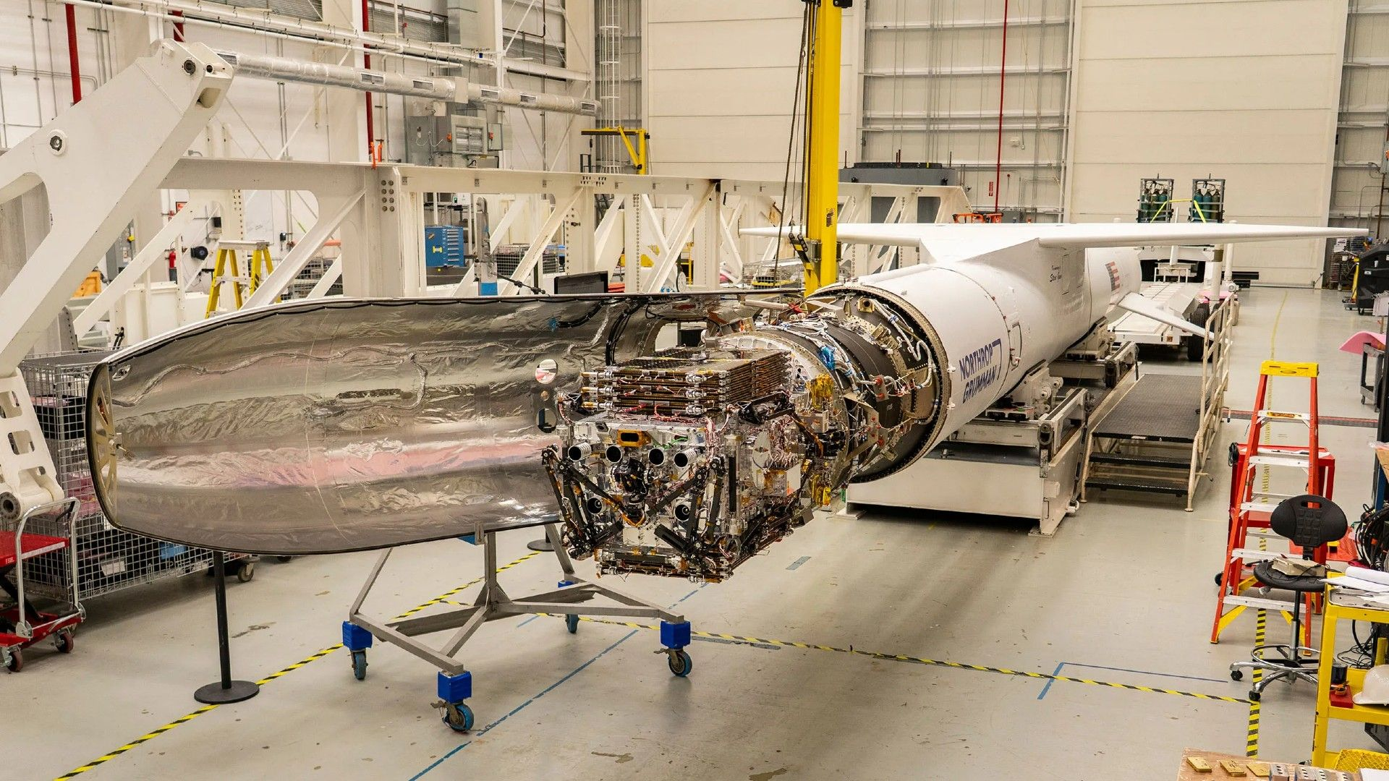
Click for next article Katalyst Space's LINK robotic servicing satellite awaits encapsulation inside a Northrop Grumman Pegasus XL on June 8, 2026, at NASA's Wallops Flight Facility in Virginia. (Image credit: NASA/Ron Beard) NASA is fast-tracking a mission to launch a spacecraft that will attempt to boost another one of the agency's science satellites into a higher orbit before it falls to a fiery death in Earth's atmosphere. The spacecraft was recently prepped for encapsulation inside its rocket at one of NASA's launch facilities. What is it? This photo shows Katalyst Space's LINK robotic servicing satellite awaiting encapsulation inside the fairing of Northrop Grumman's Pegasus XL rocket at NASA's Wallops Flight Facility in Virginia. Pegasus XL is an air-launched rocket that is carried to around 39,000 feet (12,000 meters) by a Lockheed L-1011 TriStar mothership aircraft, known as Stargazer. Once at altitude, the aircraft releases the rocket, which then ignites its motor to send its payload to space. In this case, that payload is the LINK servicing satellite, which will attempt to rendezvous with NASA's $500 million Neil Gehrels Swift Observatory , or Swift. The satellite's orbit has decayed from an initial 373 miles (600 kilometers) to about 249 miles (400 km), but NASA wants to save it by using LINK to boost it back up to a healthy orbit. Why is it incredible? NASA's mission to boost Swift is an ambitious one, not only because it will involve using one spacecraft to rendezvous with and boost another, but because NASA is still attempting to predict where Swift will be when LINK meets up with it. The mission is incredible, too, in that it will involve four separate vehicles: the Stargazer mothership, the Pegasus XL rocket, Katalyst Space's Link spacecraft, and NASA's Swift observatory. Swift launched on Nov. 20, 2004, on a planned two-year mission to study gamma-ray bursts , the most powerful explosions in the universe.

13. The critical robot arm on the ISS isn't working properly, but NASA has a plan to fix it
Read more
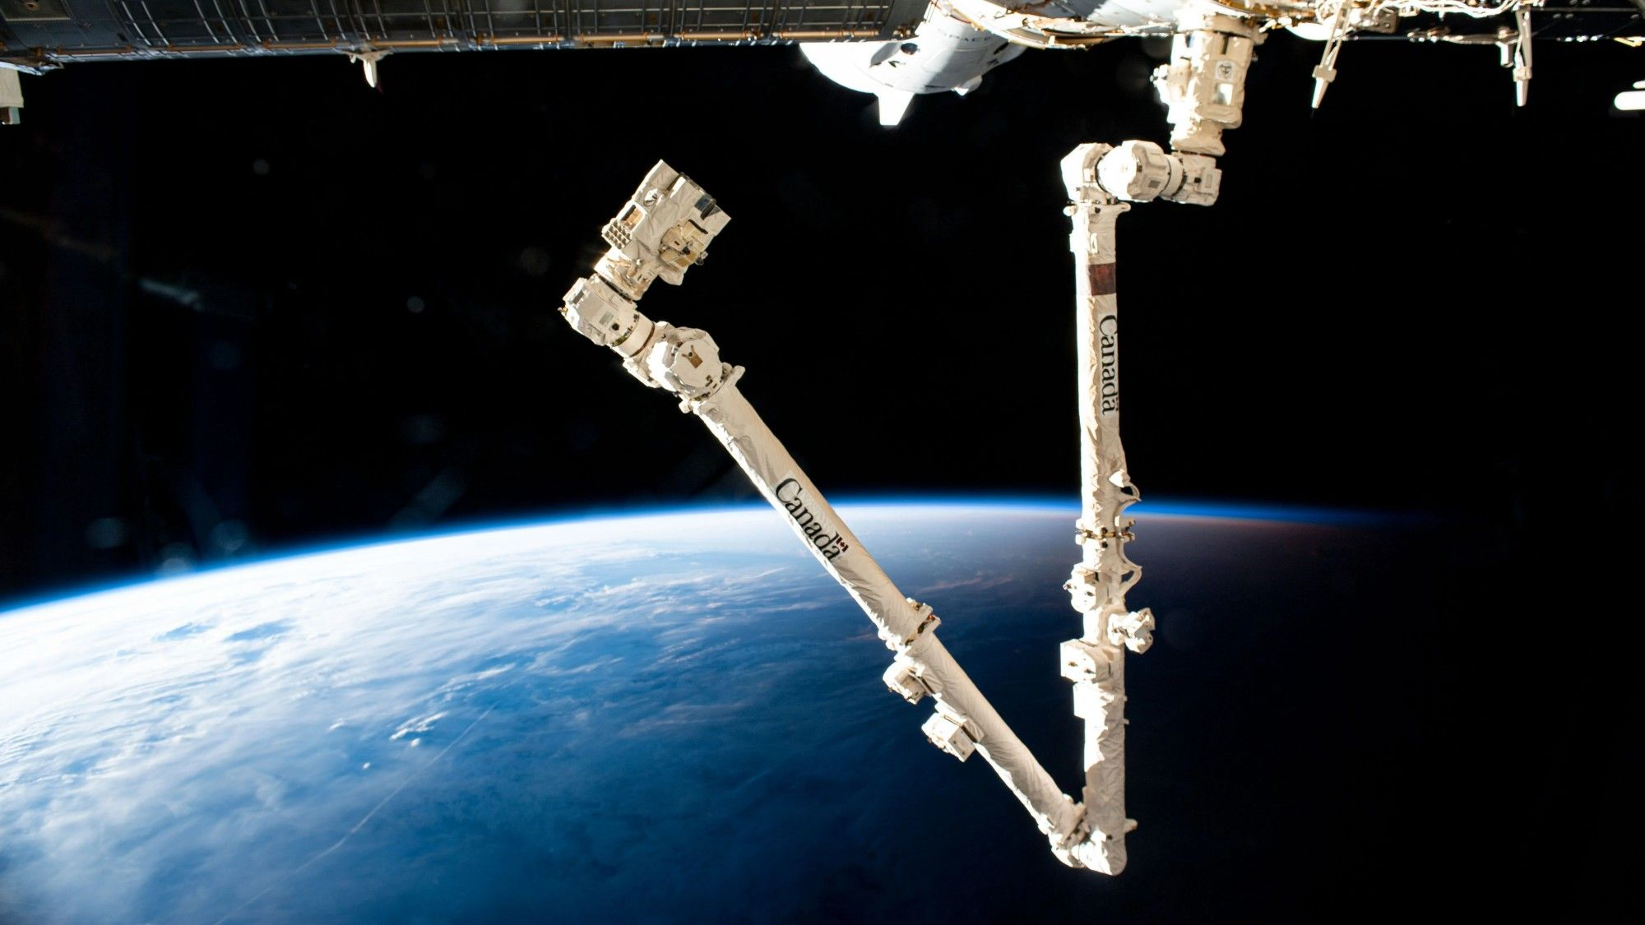
Click for next article One of the space station's robot arms, crucial for catching cargo ships and doing a share of maintenance duties, is offline for at least a few weeks for repairs. Canadarm2, which just passed 25 years of service in April on the International Space Station (ISS), will require a spacewalk to fix an apparently broken part that seized up during routine work on May 27, NASA said in a blog post Wednesday (June 10). The arm is in a stable spot, but it is awaiting help from spacewalking astronauts on June 30 - the day before Canada Day, a national holiday in that country. "The system demonstrated an elevated motor current in a wrist joint, and arm motion did not occur as expected," NASA officials wrote of the issue. Consultation with the Canadian Space Agency (CSA), which funds the arm and supports its operations with MDA Space, showed a spacewalk will be needed to replace the affected joint. Luckily, a spare is already on station. "Canadarm2 was designed with these kinds of potential issues in mind: it is made up of several segments that can be pulled out and replaced in space," the CSA wrote in a Wednesday update on its website. "Knowing that parts would eventually have to be replaced, the CSA planned shipments of key spares to the station well in advance. In 2017, a similar repair happened with one of the robotic arm's 'hands' after it started to show signs of normal wear and tear." NASA plans a news conference at a to-be-announced date to discuss the spacewalk and to share more about the assigned spacewalkers. The two astronauts will likely be drawn from the Expedition 74 crew on the U.S. side of the station, which include NASA's Chris Williams, Jessica Meir and Jack Hathaway, and the European Space Agency 's Sophie Adenot. Getting Canadarm2 back online will be critical to berth some cargo ships at the space station, which carry food, equipment and other supplies to the astronauts, as well as to perform a share of maintenance on the orbiting complex. The last Canadarm2 berthing took place in April with Williams controlling the arm, and Hathaway supporting, to pick up the arriving Northrop Grumman Cygnus XL spacecraft. Notably, Canadarm2 was not originally designed for ship arrivals (it flew to station in 2001, long before the rise of commercial spacecraft), but it made a milestone 50th " cosmic catch " in 2024 and has kept going despite being now 10 years past its design life as of this year. Northrop Grumman's 21st Cygnus cargo craft, with its prominent cymbal-shaped UltraFlex solar arrays, is pictured in the grips of the Canadarm2 robotic arm shortly after its capture on Aug. 6, 2024. (Image credit: NASA) Moreover, tasks over the decades have increasingly transferred to the ground, both at NASA in Houston and at the CSA headquarters near Montreal, Quebec. Controllers in Canada alone support more than 100 days of work a year for Canadarm2 and other Canadian ISS robotics (including the Dextre "hand"), which includes picking up equipment, transferring experiments, and performing other duties that don't require precious astronaut time. The CSA's robotics on station represent its share of the ISS funding arrangement, allowing CSA astronauts and science to fly. The next CSA astronaut to go there will be Josh Kutryk , flying aboard SpaceX Crew-13 no earlier than September; the last was David Saint-Jacques in 2018-19. NASA astronaut Scott Parazynski, anchored to a foot restraint on Canadarm2, repairs a damaged solar panel on the International Space Station during an spacewalk on the STS-120 mission in October 2007. (Image credit: NASA) Canadarm2 forms part of a long line of Canadian space robotic arms, originating in part with Canada's National Research Council technology that underlay early satellite antennas and the "legs" of Apollo lunar landers . The first Canadarm made its debut flight on the second space shuttle mission in 1981. Canadarm2 helped build the ISS and supports station activities, and Canadarm3 is a next-generation arm being constructed to support the Artemis program , which saw CSA astronaut Jeremy Hansen fly around the moon on Artemis 2 in April.

14. My quiet obsession with satellites - and how they're ruining everything
Read more

Click for next article Did you ever see an Iridium flare? For two decades until 2019, these communication satellites would become dazzlingly bright for a second or so in the night sky. I used to see them by accident before discovering that some websites and apps could forecast precisely when and where they would occur. I got so obsessed with Iridium flares that I would build my stargazing sessions around them. Eventually, I started trying to take night sky images just as they flared. Why? In a long exposure, the flare produced a diamond-shaped light. It was beautiful. I carried on doing the same for the International Space Station (ISS), capturing it racing across the night sky, again to a tight pre-determined schedule. Then SpaceX came along. After launching the non-flaring replacements for Iridium in May 2019, SpaceX began launching its Starlink satellites into low Earth orbit . There were complaints about their brightness from astrophotographers, who saw their streaks in long exposure photos, but for stargazers, they were initially a delight. Each time SpaceX launched a batch of satellites into orbit on a Falcon 9 rocket, a string of moving lights could be seen in the night sky. It got called a "train" by some because it resembled a freight train racing through the sky. To me, it looked like an alien invasion. During COVID-19, glimpsing Starlink trains was something new to do (I spent hours on Heavens Above). Now it's something to actively avoid. About 11,000 Starlinks later, that seems naive. Sure, there are now 12 million people worldwide who use Starlink internet access. I hope most of them are in previously off-grid communities in Africa, which was said to be one of Starlink's major selling points. Look up soon after sunset, and Starlinks and other satellites are everywhere. As primarily a naked-eye stargazer and binocular astronomer, it doesn't particularly bother me, but for astrophotographers and both visual and radio astronomers, the mega-constellation era is a tragedy. Being photobombed by satellite streaks in images is a big problem, but so is radio interference in low Earth orbit. Astrophotographers can stack images and use software to remove trails (as if post-processing wasn't already time-consuming enough), but for astronomers, mega-constellations can hugely affect spectroscopic data and wide-field surveys, such as the Rubin Observatory. An Iridium flare, which ceased in 2019. (Image credit: Jamie Carter) Within a few years, there's likely to be about 40,000 Starlinks, but with Amazon and other companies preparing rival mega-constellations, a phase of hyper-expansion is about to begin. It's going to get a lot, lot worse. As with Iridium satellites, mega-constellations of satellites will eventually de-orbit, burn up and disappear from the night sky, though probably not en masse in our lifetimes. When to see satellites The best time to fully appreciate just how dominant satellites are becoming in the night sky is during summer in the twilight hour immediately following sunset or before sunrise. At this time of year, the sun may have dipped below your horizon, but it's not far below, so its light still shines on satellites far above you. By the middle of the night, the sun is farther below the horizon. Satellites therefore pass through Earth's deep shadow and don't get lit by the sun, making them more or less invisible. Stargazer's corner: June 12-18, 2026 See a waxing crescent close to Venus and the Beehive Cluster on June 17. (Image credit: Stellarium) Here comes a beautiful week for being outside looking west as twilight unfolds after sunset. That's because the moon reaches its new phase on Sunday, June 14, which means dark skies (albeit during short nights in the Northern Hemisphere's mid-latitudes) and a crescent moon after sunset. On June 15, you'll see a young waxing crescent with Venus, Jupiter and Mercury, with the latter as high as it gets. On June 17, the crescent passes close to Venus and the Beehive Cluster. These moments are short-lived, but they reward those willing to step outside at just the right time. Constellation of the week: Lyra The constellation Lyra. (Image credit: E. Slawik/NOIRLab/NSF/AURA/M. Zamani) Lyra is small (and said to resemble a harp), but it commands attention because of Vega , one of the brightest stars in the night sky. About 25 light-years away, it's one of the most studied stars and serves as a standard yardstick to measure the apparent magnitude (brightness) of other stars. It's also the brightest in the famous Summer Triangle asterism, now obvious in the east after dark. In the cult movie Contact (1997), astronomers discover an extraterrestrial signal emanating from Vega. In reality, a recent image from the Hubble Space Telescope of a 100-billion-mile-wide disk of dust around Vega revealed no directly visible large planets. My latest stargazing obsession: the ISS The International Space Station crosses the night sky. (Image credit: Jamie Carter)

