 |  | 

🌌 अंतरिक्ष समाचार | Space News
शुक्रवार, ०३/०७/२०२६ | Friday, 03/07/2026

1. Authorities prepare for floods, landslides and waterlogging
Read more
PIONEER EDGE NEWS SERVICE /Dehradun The Dehradun district administration conducted a mock drill at seven sensitive locations to check its preparedness for floods, landslides and waterlogging during the monsoon season as part of a State level exercise on Thursday. Speaking about the preparations, additional district magistrate KK Mishra said that the government had started planning for the monsoon nearly three months in advance. He said the first priority was to clean drains and rivers to prevent waterlogging during heavy rain. Another important task was to keep roads open, especially in landslide-prone areas. Mechanical excavators have been deployed at vulnerable locations, including Chakrata, Mussoorie and other rural routes, while nodal officers have been appointed and their contact numbers shared with the control room for quick action. The mock drill was held at Sahastradhara, Karligarh, Rishikesh, Vikasnagar, Mussoorie, Doiwala and Chakrata. Mishra informed that three months worth of essential ration has already been supplied to remote mountainous areas. He added that Quick Response Teams (QRTs) have been formed for Dehradun and Rishikesh. These teams will work with sub-divisional magistrates and other departments during emergencies. Waterlogging-prone areas have also been identified so that immediate action can be taken if heavy rainfall causes flooding. The administration said the mock drill will help improve disaster preparedness and ensure a faster response during the monsoon season.

2. Magisterial probe ordered into Lal Pul bus accident
Read more
PIONEER EDGE NEWS SERVICE /Dehradun The Dehradun district administration has ordered a magisterial inquiry into the bus accident that took place near Lal Pul on Saharanpur Road on June 23. The accident claimed two lives and left three persons injured. The Dehradun district magistrate Ashish Chauhan has appointed the sub-divisional magistrate (Sadar) as the inquiry officer on Thursday and asked him to submit the report within one week. According to officials, the city bus met with the accident at around 11 AM on June 23. While two locals had died during treatment, three others had sustained injuries. The initial report of the accident stated that the driver had claimed to have suffered a fit, causing him to lose control of the vehicle. The inquiry will examine all aspects of the accident. It will look into the exact cause of the crash, the number of passengers travelling in the bus, details of the deceased and injured, the medical condition of the injured and the legal heirs of the deceased. The inquiry will also review the technical inspection report prepared by the Transport department and check whether the bus complied with the provisions of the Motor Vehicles Act and other rules. Chauhan said that the inquiry report will help identify the real cause of the accident and ensure that necessary action is taken. The administration also aims to prevent similar accidents in the future. The district administration officials said that people who have any information, evidence or eyewitness accounts related to the accident can submit them to the office of the SDM within one week on any working day.

3. Iron Fluorescence on the Sun During Massive Solar Flares: Aditya-L1 Observation - isro.gov.in
Read more

July 03, 2026 India's maiden space-based solar observatory, Aditya-L1, continues to help us understand the mysteries of our nearest star. During its first year operating at the Lagrangian point 1 (L1) in 2024, the Sun was exceptionally active, producing numerous intense solar flare events. Aditya-L1 observation from special vantage point L1, presents the first comprehensive analysis to help us understand a fascinating solar phenomenon: photospheric iron fluorescence. The "iron fluorescence" phenomenon was observed during 47 massive X-class solar flares in the year 2024. What is Iron Fluorescence? When a massive solar flare erupts, it heats the Sun's upper atmosphere (the corona) to extreme temperatures (tens of mega Kelvin), releasing massive burst of high-energy X-rays. While most of these X-rays are emitted outward into space, a fraction of them travel downward, interacting with the Sun's cooler, denser surface layer known as the photosphere, where they interact with abundant neutral iron atoms, as illustrated in Figure 1. When these coronal X-rays strike neutral iron atoms, the iron atoms absorb the energy and emit their own characteristic X-ray glow at energy of 6.40 keV. This process is called "X-ray fluorescence". Solar Low Energy X-ray Spectrometer (SoLEXS) on board Aditya-L1 are suitable to detect X-rays from the flare as well as photospheric iron fluorescence from strong flares. SoLEXS instrument is indigenously developed at the U. R. Rao Satellite Centre (URSC), ISRO. Figure 1: An illustration showing how a solar flare (represented by the black star) high in the corona emits X-rays down onto the Sun's surface (the red area). When iron atoms on the surface absorb these X-rays, they emit a characteristic fluorescence (blue arrow). SoLEXS confirmed that this fluorescence is much stronger when the flare happens near the center of the Sun's disk (right) compared to the edge or "limb" (left). Understanding Solar Flare's Geometry By analyzing these extreme flares, the study discovered that the observed brightness of the iron fluorescence depends heavily on where the flare occurs on the Sun's disk. As illustrated in Figure 1, flares occurring near the center of the Sun's disk, as viewed by the observer, showed a strong fluorescence signal, while the signal was heavily suppressed for flares occurring near the Sun's edge (the limb). This "center-to-limb" variation matches with theoretical models. By studying exactly how this efficiency changes, researchers can now use the iron fluorescence as a potential diagnostic tool to probe the altitude of the coronal X-ray source high up in the solar atmosphere and study the unique viewing geometries of these explosive events. The study has been published in the international, peer-reviewed journal Solar Physics. Reference: Sarwade, A. R., et al. (2026). "Iron Fluorescence in X-Class Solar Flares: Aditya-L1/SOLEXS Observations". Solar Physics. DOI: 10.1007/s11207-026-02685-3 arXiv: https://arxiv.org/abs/2605.22573

4. Bomb threat email to ISRO, Bengaluru headquarters evacuated for thorough search - The Hindu
Read more
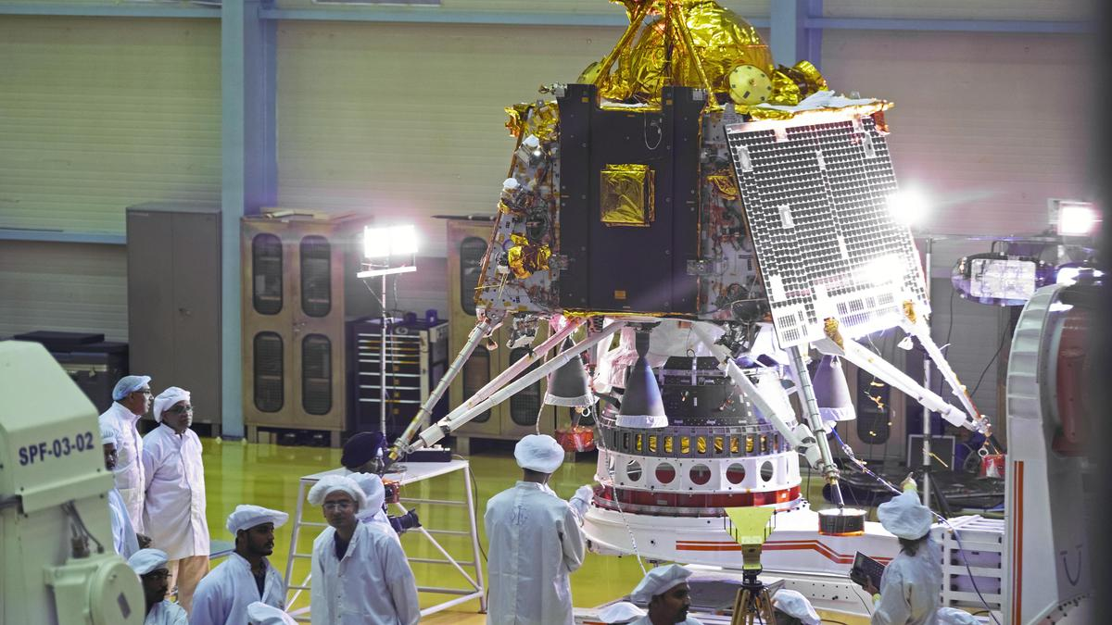
A hoax bomb threat was emailed to the Indian Space Research Organisation (ISRO) headquarters in Bengaluru, claiming explosives were planted at the high-security establishment. After a thorough security check by police and bomb disposal squads, the threat was declared a hoax. The email was received by the ISRO staff post-lunch. They immediately alerted the police. The police, along with Bomb Detection and Disposal Squads (BDDS), rushed to the spot, and evacuated the campus. A thorough anti-sabotage check did not reveal any explosive material. The Sanjay Nagar police have taken up a case to track down the sender of the email. ISRO stated, "ISRO headquarters in Bengaluru was evacuated on July 2 after a bomb threat email. Police and bomb disposal squads searched the premises. No suspicious object found so far. Officials say the probe is on to trace the email. Threat being taken seriously."

5. ISRO receives hoax bomb threat e-mail - The New Indian Express
Read more

BENGALURU: The Indian Space Research Organisation (ISRO) headquarters on New BEL Road in Bengaluru received a bomb threat e-mail on Thursday morning. The e-mail was sent to the office of ISRO Chairman Dr V Narayanan. It claimed that the explosives were planted at the high-security establishment. However, checks by the police and the bomb disposal squad found no suspicious objects or explosives and declared the threat a hoax. According to ISRO officials, an e-mail was sent on the e-mail address of the chairman and public relations official. "We saw the e-mail at around 11am and the Bengaluru City police was informed. The bomb squad and the teams came to the campus at around 11.30am and a thorough check was done of the entire campus, including Antariksh Bhavan. The search went on till around 3.30pm., before it was confirmed that it was a hoax," sources in ISRO said. Despite repeated attempts, ISRO teams refused to share the contents of the e-mail. The Sanjaynagar police have registered a case and are further investigating. Meanwhile, district courts in Mysuru, Yadgir and Chikkamagaluru also received hoax bomb threat e-mails on Thursday. After thorough checks by bomb disposal squads and security personnel, the threats were declared a hoax.

6. ISRO Gets Bomb Threat, Mail Sent To Chairman - NDTV
Read more
ISRO Gets Bomb Threat, Mail Sent To Chairman NDTV

7. Isro headquarters get hoax bomb threat mail | India News - Hindustan Times
Read more

A bomb threat emailed to the Indian Space Research Organisation (ISRO) on Thursday triggered the evacuation of its Bengaluru facility and a large scale security operation, police said, adding that preliminary searches found no evidence of explosives and investigators belive it was a hoax. India News The threat, sent to ISRO's campus on New BEL Road, claimed that explosive material had been planted inside the premises. Authorities immediately cleared the facility as police, bomb disposal personnel and sniffer dog squads began searching offices, laboratories and other buildings. The operation involved the Bomb Detection and Disposal Squad (BDDS), local police and canine units, which examined the campus while following standard security protocols before declaring the premises safe. Officials said the initial search did not uncover any suspicious objects or explosive material, though inspections continued as a precaution. "We received an alert from ISRO authorities about a bomb threat email. We immediately searched the premises with the BDDS and sniffer dog squad, but found no clues," Bengaluru North Division Deputy Commissioner of Police Babasab Nemagouda said. "It is a hoax bomb call. Our cyber experts have launched a probe to trace the origin of the email. We have registered a case at Sanjaynagar police station and launched an investigation," he added. Investigators are examining the digital trail left by the message, including technical data that could help identify its sender. Police are also looking into whether the threat is connected to a recent series of anonymous bomb emails targeting prominent institutions across Karnataka. Similar messages have been sent in recent days to the Karnataka High Court, district courts and several educational institutions in Bengaluru, each resulting in precautionary evacuations and extensive security checks. Authorities said they have not ruled out the possibility that the same individual or group may be responsible for multiple hoax emails directed at government offices and public institutions in recent weeks. The investigation is continuing.

8. NASA's Artemis II Breaks Agency Streaming Record
Read more
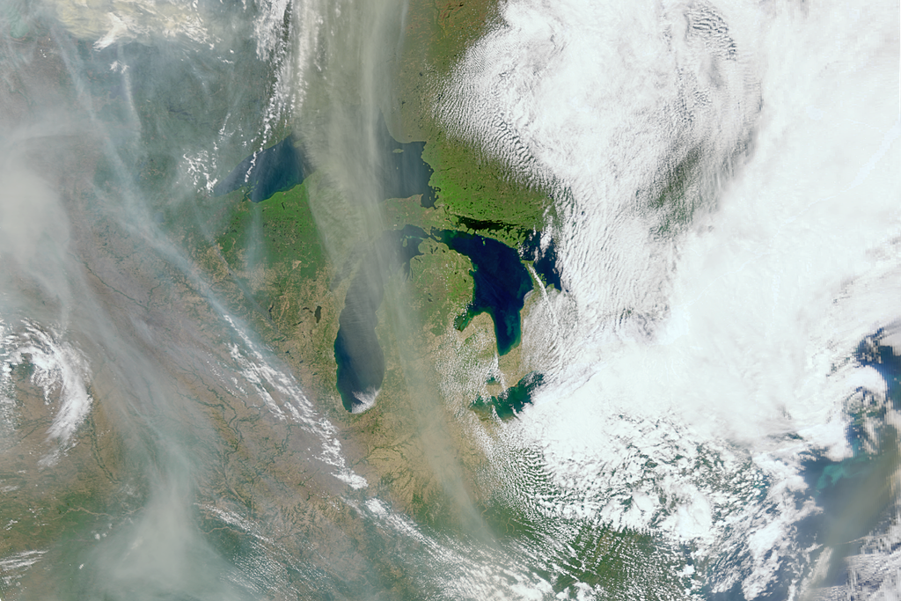
From left: The Artemis II crew-NASA astronaut Christina Koch; CSA (Canadian Space Agency) astronaut Jeremy Hansen; and NASA astronauts Reid Wiseman and Victor Glover-take time out for a group hug inside the Orion spacecraft on April 6, 2026. NASA NASA's live coverage of the Artemis II mission mission drew unprecedented public interest - including more than 149.4 million views of the launch, lunar flyby, splashdown on NASA-owned platforms, including the 24/7 streams covering the mission and the Orion spacecraft views - demonstrating strong, sustained global engagement throughout the mission. Around the Clock Live Broadcast NASA's Artemis II Crew Launches to the Moon broadcast set unprecedented viewership records across the agency's streaming platforms, drawing a combined peak of 3,662,554 viewers-rising to 3.66 million when including more than 411,130 concurrent viewers on X and Twitch-surpassing previous milestones, including the launches of Artemis I (2022) and the James Webb Space Telescope (2021-2022). The launch generated 23.9 million total views across NASA platforms, with 16.6 million people watching live, underscoring the mission's broad national and global appeal from liftoff onward. NASA en español's dedicated broadcast also reached a landmark peak of 458,366 concurrent viewers and has since amassed 2.8 million total views, highlighting the mission's strong resonance with Spanish‑speaking audiences and expanding the global reach of Artemis communications. NASA's Artemis II Lunar Flyby broadcast delivered one of the largest peak audiences ever recorded across the agency's streaming platforms, reaching 1,471,069 total concurrent viewers - driven largely by 897,789 on YouTube, one of NASA's strongest single platform performances - along with an additional 190,221 viewers on X and Twitch, underscoring the mission's broad global reach and sustained excitement. Together, the Artemis II launch and Moon flyby broadcasts have redefined NASA's livestreaming benchmarks, demonstrating record-breaking public interest in humanity's return to the Moon. As of April 13, the flyby broadcast has accumulated 40 million views across NASA+, YouTube, X, and Twitch, highlighting the intense and enduring engagement surrounding Artemis II. Pre‑splashdown coverage across major outlets emphasized the "riskiest moments" still ahead-particularly Orion's reentry and heat‑shield performance-framing the return as the mission's climax and driving heightened public attention. As anticipation grew, audience interest that had already surged during the record‑setting launch only intensified: Artemis II's liftoff drew 3,662,554 peak viewers, but global curiosity about the crew's safe return pushed splashdown viewership even higher to 3,838,418, a 4.8% increase that reflected widespread investment in the mission's outcome as viewers tuned in to witness the critical reentry sequence, confirm crew safety, and celebrate humanity's first journey around the Moon in more than 50 years. NASA's Artemis II Crew Comes Home generated 29.5 million total views across NASA-owned platforms, with an estimated 24.1 million occurring during the live return sequence-an exceptional level of engagement that underscores the deep public interest carried through the mission's final and most critical moments. Major entertainment platforms including HBO Max, Netflix, Peacock, and Amazon Prime Video exponentially expanded NASA's global footprint by placing Artemis II in front of hundreds of millions of potential viewers worldwide, with HBO Max reaching 120-150 million global subscribers; Netflix reaching 325 million paid subscribers and covering 54% of global households; Peacock contributing 36-41 million U.S. subscribers; and Amazon Prime Video reaching up to 275 million global subscribers. Together, these partners enabled NASA to reach mainstream, international, and non-traditional audiences at a scale unattainable through NASA-owned channels alone. Four astronauts aboard NASA's Orion spacecraft atop the SLS (Space Launch System) rocket launched on the agency's Artemis II test flight on Wednesday, April 1, 2026, from Launch Complex 39B at NASA's Kennedy Space Center in Florida. NASA/Michael DeMocker Websites NASA's Artemis II mission drove a major surge in traffic across the agency's websites, with NASA.gov recording 125.1 million pageviews between April 1 and 10 - more than double the roughly 50 million logged in all of March - reflecting intense public interest in following the mission in real time. On launch day alone, NASA sites saw 17.6 million pageviews from 8.3 million visitors, with the Artemis Real-Time Orbit Website (AROW) drawing 797,796 pageviews, Interest spiked again during the April 6 lunar flyby, generating 16.5 million pageviews from 6.2 million visitors; AROW registered 1.9 million pageviews - boosted by more than 440,000 Google referrals - while the NASA homepage reached 2.3 million. Splashdown day brought another surge to NASA-owned websites, with more than 16 million pageviews from 6.1 million visitors as audiences followed the Artemis II crew's return; AROW drew over 1 million pageviews and surpassed 11 million cumulative views since launch. Together, these metrics show sustained, high-volume engagement across all mission milestones, with live hubs, broadcast pages, and real-time tracking consistently ranking among the most-visited content throughout launch, flyby, and splashdown. Social Media Public reaction to NASA's Artemis II mission remained largely steady across launch week, with neutral and positive posts dominating the online conversation. Neutral sentiment consistently led daily discussion, ranging from 47 to 60 percent, while positive reactions accounted for 30 to 42 percent, fueled by excitement over the crew's historic lunar journey, striking mission imagery, and renewed interest in deep space exploration. Engagement spiked around major mission milestones, with NASA accounts generating 35 million engagements on splashdown day content alone and 261 million from March 27 to April 13, underscoring how closely audiences followed each phase. Strong amplification from major news outlets, brands, and international partners, further boosted visibility and cemented Artemis II as a global cultural moment. NASA's Artemis II mission drove major social media growth across the agency's flagship and mission‑specific accounts, with follower numbers climbing steadily from rollout through the lunar flyby and splashdown. Internal tracking shows NASA's flagship Instagram account added more than 4.6 million followers, while the Artemis‑dedicated Instagram account grew by 2 million-a 66% increase over the course of the mission. Significant gains were also recorded across X, Facebook, and YouTube, including a 2 million increase in YouTube subscribers and NASA's flagship Facebook page climbing by 1.7 million. Collectively, these gains highlight how Artemis II's human‑spaceflight narrative, real‑time crew updates, and highly visual moments drew millions of new followers across platforms. From left: The Artemis II crew-NASA astronaut Christina Koch, CSA (Canadian Space Agency) astronaut Jeremy Hansen, and NASA astronauts Reid Wiseman and Victor Glover-pause for a group photo with their zero-gravity indicator "Rise" inside the Orion spacecraft on April 7, 2026. NASA Mission Images NASA has long shaped its legacy through unforgettable imagery-pictures that don't just document history but become part of it. Artemis II carries that tradition forward with a growing collection of images capturing every phase of the mission, from the anticipation of launch to the sweep of a lunar flyby and splashdown. For those eager to explore more, the mission's dedicated image galleries offer a rich visual journey, complemented by additional photos on the NASA Headquarters official Flickr account and the NASA Image and Video Library. NASA Campaigns Moon Mascot: NASA Artemis II ZGI Design Challenge Last year, the Moon mascot design contest received thousands of submissions from more than fifty countries for the Artemis II mission's zero‑gravity indicator. This plush item serves a special purpose - it begins to float once the astronauts reach space, signaling the onset of zero gravity. It also provides a comforting reminder of Earth when the crew is far from home. Ultimately, the Artemis II astronauts selected "Rise"-inspired by the iconic Earthrise photograph captured during the Apollo 8 mission and designed by Lucas Ye of Mountain View, California-as the zero‑gravity indicator that will accompany them around the Moon. "Rise" also features a small pouch that will carry an SD card containing all 5.6 million names submitted through the Send Your Name with Artemis campaign. Send Your Name with Artemis II NASA invited the public to join the agency's Artemis II test flight as four astronauts ventured around the Moon and back to test the systems and hardware needed for deep space exploration. As part of the agency's "Send Your Name with Artemis II" effort, anyone could claim their spot by signing up before Jan. 21, 2026. Participants launched their names aboard the Orion spacecraft and SLS (Space Launch System) rocket alongside NASA astronauts Reid Wiseman, Victor Glover, Christina Koch, and CSA (Canadian Space Agency) astronaut Jeremy Hansen. Online Collaborations Google Doodle The April 1, 2026, Google Doodle celebrated the launch of Artemis II, the NASA mission that sent astronauts around the Moon and back for the first time in more than 50 years. During the approximately 10‑day voyage, the crew tested the spacecraft's systems while traveling farther into deep space than any human had gone since the Apollo program. This critical test flight brought us one step closer to a long‑term return to the Moon and future missions to Mars. Spotify Playlist: The Artemis II Crew's Wake-up Songs NASA's official playlist for the Artemis II mission featuring songs selected by the crew for their historic 10-day journey around the Moon. Merriam-Webster Dictionary Merriam-Webster highlighted the Artemis II mission on their official Facebook page, engaging with astronauts in deep space to discuss the experience of traveling farther than any human before. In New York, a digital display on the Nasdaq Marquee and special lights on the Empire State Building marked successful Artemis II mission milestones. In London, Piccadilly Lights celebrated the mission with a digital display following a successful lunar flyby. Offline Collaborations NASDAQ, New York Nasdaq celebrated the successful launch of NASA's Artemis II mission, marking humanity's return to the Moon after more than 50 years. Empire State Building, New York Red, white, and blue for the Artemis II crew. Welcome back to Earth. Sphere, Las Vegas As the astronauts on Orion reached their closest approach to the Moon, the sphere celebrated this milestone here on Earth. NASA provided the Sphere with a 3D model of the Orion spacecraft and unique soundbites from the April 1, 2026, launch to help design the moon, spacecraft, and flight path to match the real-life version. Piccadilly Lights, London London's Piccadilly Lights celebrated the lunar flyby of Artemis II, where the four astronauts aboard the Orion spacecraft went deeper into space than ever before. NASA's Artemis Program The Artemis II mission launched April 1, 2026, on NASA's SLS (Space Launch System) rocket from Kennedy Space Center in Florida. During the nearly 10‑day test flight, the crew achieved the mission's primary objectives, including testing its life support systems; manually piloting the Orion spacecraft; performing maneuvers to propel Orion to the Moon and adjust its course; conducting a lunar flyby with unprecedented views of the Moon's far side; and completing a safe re-entry and recovery. The astronauts also set a record for the farthest distance traveled by humans away from Earth. As part of a Golden Age of innovation and exploration, NASA will send Artemis astronauts on increasingly challenging missions to explore more of the Moon for scientific discovery, economic benefits, establish an enduring human presence on the lunar surface, and lay the groundwork for sending the first astronauts - American astronauts - to Mars.

9. SpaceX Falcon 9 rocket launches 24 Starlink satellites from California (video)
Read more
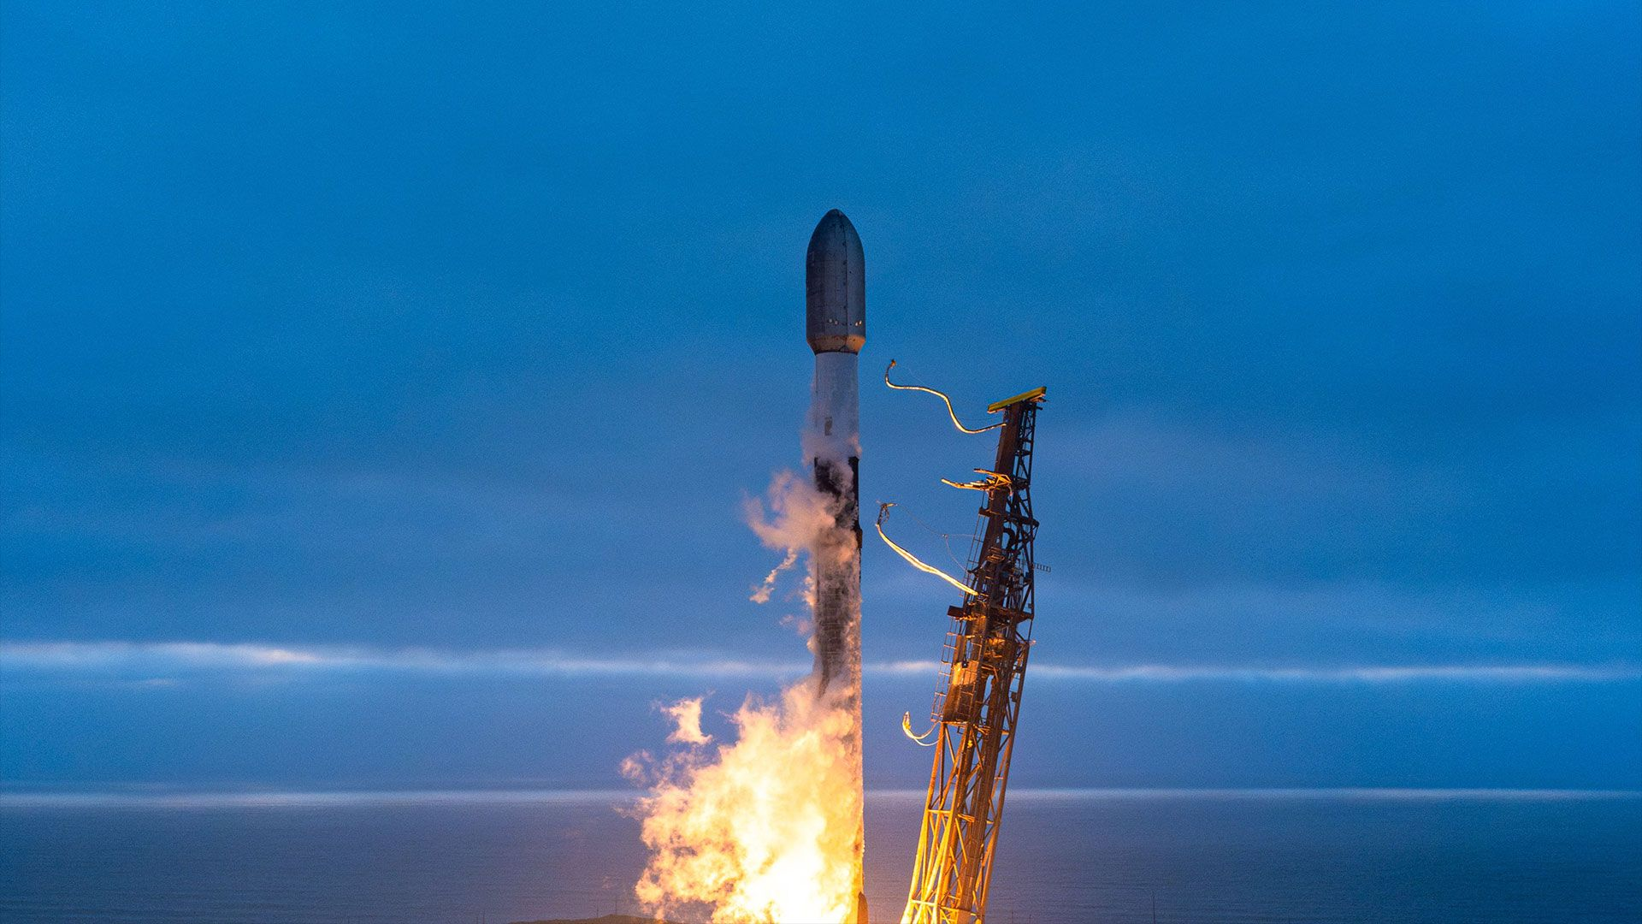
Click for next article SpaceX grew its Starlink network by 24 more satellites on Wednesday evening (July 1) with a launch from California. A Falcon 9 rocket carrying the two dozen new relay spacecraft ( Group 17-46 ) lifted off from Space Launch Complex 4 East at Vandenberg Space Force Base at 10:58 p.m. EDT (0258 GMT on July 2 or 7:58 p.m. PDT local time). About an hour later, SpaceX confirmed the satellites were successfully deployed in low Earth orbit. A SpaceX Falcon 9 rocket carrying 24 Starlink satellites launched from Vandenberg Space Force Base in California on Wednesday, July 1, 2026. (Image credit: SpaceX) Previous Booster B1100 launches NROL-105 | 5 Starlink missions The Falcon 9's first stage (Booster 1100) completed its seventh flight to space and back, landing on the drone ship "Of Course I Still Love You" positioned in the Pacific Ocean. SpaceX's Starlink megaconstellation now totals more than 10,700 active satellites, according to tracker Jonathan McDowell . The service supports connectively around the globe, as well as in-flight and direct-to-cell services. Wednesday's launch was SpaceX's 79th Falcon 9 liftoff of the year.

10. 'Stellar death is not the end': James Webb Space Telescope glimpses the fate of the solar system in a weird exoplanet orbiting a dead star
Read more
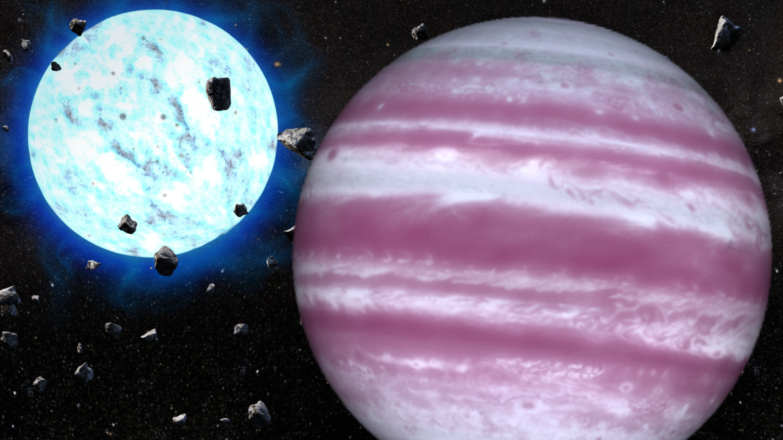
Click for next article Astronomers have used the James Webb Space Telescope (JWST) to observe an oddball gas giant exoplanet orbiting a dead star, a white dwarf, located some 80 light-years away. This "life after death" system gives scientists a portentous vision of what the solar system may look like in around 6 billion years after the sun has exhausted the hydrogen in its core, shed its outer layers, and left behind a smoldering white dwarf stellar remnant. Prior to the final stages of that transformation, our star will have become a red giant , swelling out to many times its original radius, swallowing the inner rocky planets including Earth but leaving the outer planets - although changing them irrevocably. Reflecting this, the white dwarf at the heart of this research is orbited by a Jupiter-sized exoplanet, designated WD 1856 b . As WD 1856 b orbits its dead parent star, it crosses or "transits" the face of this white dwarf, known as WD 1856+534. By observing these transits with the JWST, the team was able to measure the mass and temperature of this Jupiter-like planet while also observing the composition of its atmosphere. To their surprise, they found WD 1856 b is hotter than expected. They also discovered how this planet came to have such an unusually tight orbit around its host white dwarf star. "We're used to looking back in time when we use telescopes, but this is the first time we have been able to look forward to what might happen to the outer planets around the remnant of a sun-like star; it's like using a time machine to peer into the distant future of our solar system," team leader Ryan MacDonald from the University of St Andrews in Scotland said in a statement . "This is just the beginning of our exploration of planets orbiting dead stars with Webb, and the search for further planets orbiting white dwarfs is ongoing. "Our results show that stellar death is not the end - some planets experience a vibrant and lively future after the death of their star." The team's research was published on Wednesday (July) in the journal Nature. Survivor planet is a real oddball The gas giant WD 1856 b was first discovered in 2020 by NASA's exoplanet-hunting spacecraft TESS (Transiting Exoplanet Survey Satellite) and the Spitzer Space Telescope. TESS detects exoplanets using the tiny dips in starlight they cause as they transit their host stars, blocking starlight. This was the first intact planet ever discovered closely orbiting a white dwarf. What immediately stood out about WD 1856 b was how close its orbit is to its white dwarf host. The orbit is around 2% the size of Earth's orbit around the sun and takes just 1.4 Earth days to complete. "The planet is quite the oddball. It's about the size of Jupiter, but the white dwarf it orbits is the size of Earth, so the planet is seven times larger than its star," MacDonald said. The planet couldn't have always been in such a close orbit to its star. If it had, it would have been obliterated when the star transformed into a red giant before shedding its puffy outer layers and leaving behind a white dwarf. An illustration showing NASA's exoplanet hunter TESS. (Image credit: Robert Lea (created with Canva)) "The big question is how WD 1856 b ended up where it is today, and there are two theories," team member Christopher O'Connor of Northwestern University said. "One is that the planet was swallowed by the host star as it was dying, and managed to survive on the inside. The other is that the migration took place due to the gravitational effect of other objects in the system. The white dwarf is part of a triple star system, and the outer companion stars could have influenced WD 1856 b's orbit." The clue that allowed the team to differentiate between these migration mechanisms was the temperature of WD 1856 b, which at 260 degrees Fahrenheit (127 degrees Celsius) is about 240 degrees hotter than it would be if its only source of heat were the light from its white dwarf parent star. With no energy available to warm the planet to these temperatures, the team reasoned that the temperature must be a residual effect of prior warming either from being engulfed by the red giant or during an inward migration. Using observations of the planet's mass of between four and 11 times that of Jupiter, the team was able to model how it would have cooled over time. WD 1856 b watches from a safe distance as its parent star transforms into a red giant and destroys its inner planetary system (Image credit: Robert Lea (Created with Canva)) MacDonald and colleagues determined that WD 1856 b was likely heated up around 3 billion to 5.5 billion years ago. Its host star has been a white dwarf for longer than that, which means the exoplanet was safe during the star's destructive red giant phase, and moved into its tight orbit afterwards. "As the planet moved inwards, its interactions with the strong gravity of the white dwarf will have caused it to warm up considerably, and it has been cooling ever since," O'Connor said. The results indicate that Jupiter could move closer to the sun after the violent drama of its red giant phase and the destruction of the inner solar system. The findings also demonstrate the incredible observing power of the JWST and how the $10 billion space telescope is still discovering things no other instrument can. "White dwarfs like WD 1856 are exceptionally dim compared to the planet-hosting stars we normally observe with the JWST," team member Victoria Boehm of Cornell University said. "To make things even harder, the planet's transit only lasts 8 minutes, so it's very much if you blink you miss it! Capturing enough light to see WD 1856's spectrum, while also doing so quickly enough to not miss the transit, is something only Webb can do."

11. 'Flying saucer' arrives at NASA for Artemis 3 moon mission in time for World UFO Day | Space photo of the day for July 2, 2026
Read more
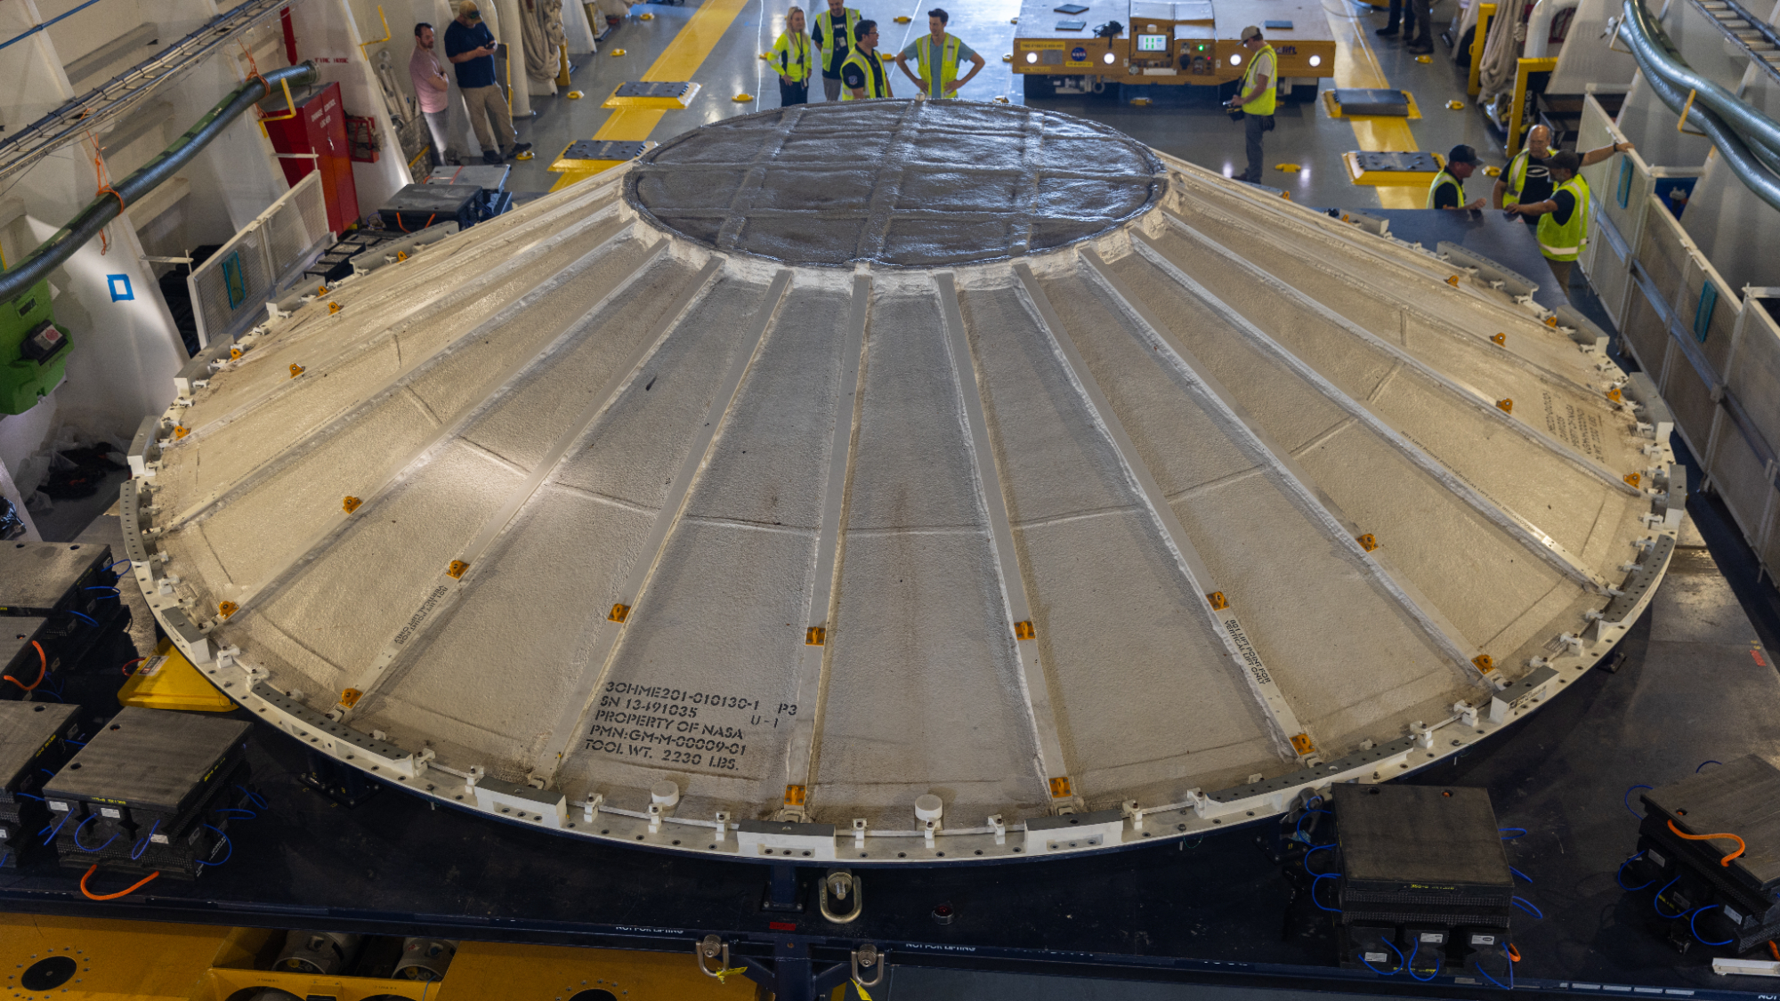
Click for next article The weather cover for the Artemis 3 SLS core stage arrived at NASA's Kennedy Space Center. (Image credit: NASA/Amber Jean Notvest) Did a flying saucer just land at NASA? It sure looks like it. This is actually the weather cover for the core stage of NASA's Space Launch System (SLS) rocket, which is currently gearing up to launch the Artemis 3 mission in mid-2027. What is it? Aboard NASA's Pegasus barge, floating out in the Atlantic ocean, sits what looks like a classic, sci-fi movie UFO flying saucer. With some flashing lights, this thing flying around in the sky would cause quite a commotion. But it's actually a critical piece of hardware for NASA's Artemis program returning humans to the moon . The Pegasus barge is a large cargo ship - it's a whopping 310 feet (94.4 meters) long - designed to carry the massive core stage of NASA's SLS megarocket. As the agency marches forward with its plans for Artemis 3, a crewed flight to low Earth orbit that will serve as a key test ahead of future missions to the moon, the SLS prepares for launch. Once stacked on the launch pad at NASA's Kennedy Space Center in Florida, this flying saucer will actually serve as a weather cover, protecting the rocket's core stage and its thermal systems from the often turbulent and unpredictable weather on the Space Coast. Why is it incredible? It is always fun when science fiction and science fact meet. The design of this weather cover could not be closer to the flying saucer designs that have flown across screens in sci-fi flicks for the 1950s and '60s to today. It's interesting to wonder whether these familiar images of flying saucers somehow inspired this functional design. But however inspiration struck, this weather cover will serve an incredible purpose. It will shield the rocket's core stage, the tallest rocket stage NASA has ever built, which holds hundreds of thousands of gallons of propellant and supports the weight of the rocket's upper stage, payload, and the Orion crew capsule. The safety of the Artemis astronauts and the success of these missions depend on the rocket launching perfectly, and every single piece, including this weather cover, are part of ensuring that success.

12. Last-minute launch problem delays satellite rescue mission for NASA
Read more

A rush rescue mission to save a NASA space telescope remains grounded, this time because of a last-minute launch problem.

13. Scourge of satellites lighting up the sky could be mitigated with help of ultra-black coating
Read more

Astrophysicists working to tackle the growing impact of satellite constellations have pioneered a new ultra-black coating as one possible way to mitigate the problem.

