 |  | 

🌌 अंतरिक्ष समाचार | Space News
रविवार, ०५/०७/२०२६ | Sunday, 05/07/2026

1. ISRO conducts ground test for new sub-orbital solid motor-based test vehicle - isro.gov.in
Read more

July 04, 2026 ISRO is developing a solid motor based Sub-Orbital Launch Vehicle for Experiments (SOLVE) as a test platform to carry out Integrated Parachute Tests for validation of deceleration system of Gaganyaan Crew Module under various test conditions. During these test missions, the Crew Module will be carried to an altitude of 10 - 17 km and separated from the vehicle. A series of 10 parachutes will be deployed to reduce the velocity of the Crew Module before splashdown in the sea. The solid stage of SOLVE is derived from the PSLV Strap-on Motor with few modifications to meet the Gaganyaan test requirements including development of slow burn rate propellant and straight nozzle with secondary injection thrust vector control. The first ground test of the SOLVE solid motor was carried out successfully at the Static Test Facility, Satish Dhawan Space Centre, Sriharikota. The test was successfully conducted on 03-07-2026 at 10:00hrs and the motor performance parameters are as expected. The development of SOLVE vehicle provides flexibility in conducting Gaganyaan Test Missions simulating various conditions in the actual mission.

2. India Monsoon 2026: ISRO satellite captures 2 giant monsoon systems soaking India - Moneycontrol.com
Read more
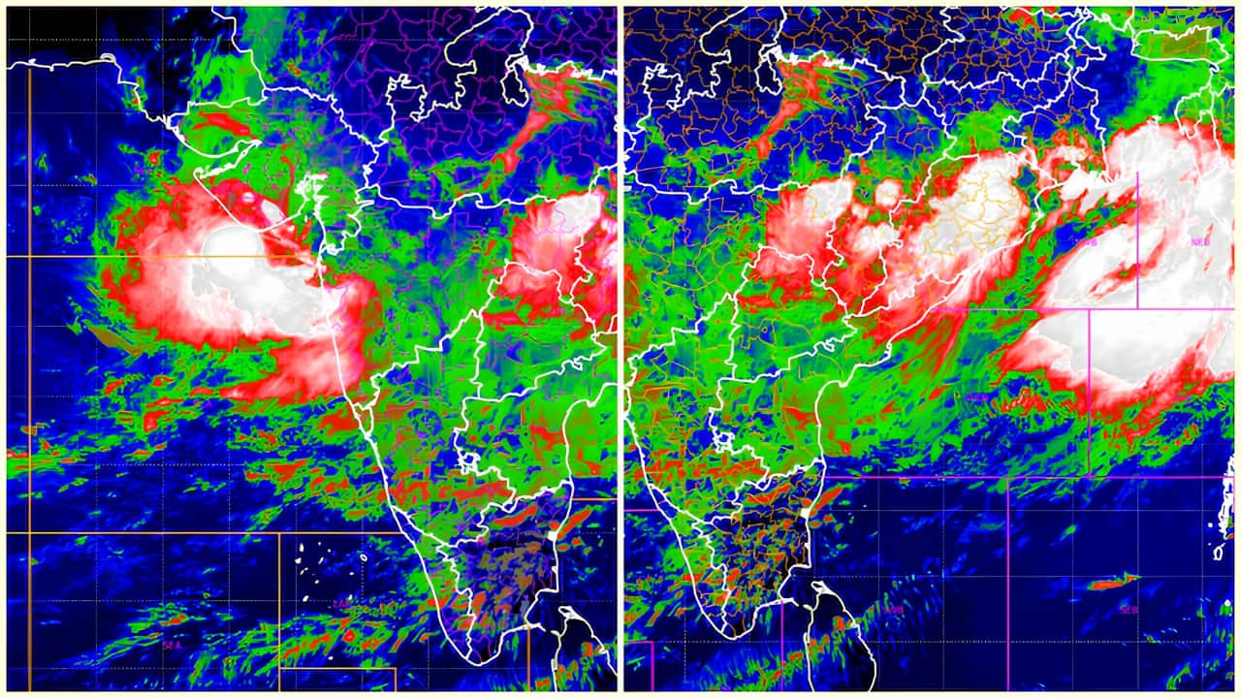
ISRO's INSAT-3DR weather satellite has captured two giant monsoon systems over the Arabian Sea and Bay of Bengal. The striking images explain Maharashtra, West Bengal and several other states are witnessing intense rainfall. New INSAT-3DR images from ISRO reveal two massive monsoon systems over the Arabian Sea and Bay of Bengal. (Image: ISRO) ISRO satellite shows two powerful monsoon systems. Arabian Sea system brings rain to Maharashtra. Bay of Bengal system affects West Bengal and northeast India. Did our AI summary help? The southwest monsoon has entered one of its most powerful phases of the season. This time the view is not from the ground but from space. Fresh satellite images released by the ISRO reveal two enormous monsoon rain systems stretching across India, bringing relentless downpours to Maharashtra in the west and West Bengal in the east. ISRO's satellite spotted two giant rain systems The images were captured by ISRO's INSAT-3DR weather satellite, which continuously monitors India's atmosphere. The satellite recorded two massive cloud systems at the same time. The stunning images highlight how the Arabian Sea and the Bay of Bengal are simultaneously fuelling the country's monsoon. Where are this rain systems? 1. Arabian Sea: One weather system is positioned over the Arabian Sea, feeding heavy rainfall across Maharashtra and the Konkan coast. 2. Bay of Bengal: The second system has developed over the Bay of Bengal, spreading dense rain clouds over West Bengal, Bangladesh and parts of northeastern India. What did these images show? The satellite's thermal infrared imagery shows bright white cloud tops. Scientists use weather satellites like INSAT-3DR to track the formation of clouds, precipitation, and the strength of a storm in near real-time. This is a clear sign of towering storm clouds that are capable of producing intense rainfall, thunderstorms and lightning. The simultaneous activity of both monsoon branches has intensified rainfall over vast areas of the country. What happens next? The India Meteorological Department (IMD) says the active monsoon is likely to continue over the next few days. Heavy to very heavy rainfall is expected across Maharashtra, Konkan, Goa, Odisha and Gangetic West Bengal. The rain is helping reduce this season's rainfall deficit. However, it also increases the risk of urban flooding and travel disruption. The images to scientists provide a rare aerial-eye view. They demonstrate two powerful monsoon systems, in action.

3. Isro tests experimental Solve rocket motor to advance Gaganyaan mission - India Today
Read more
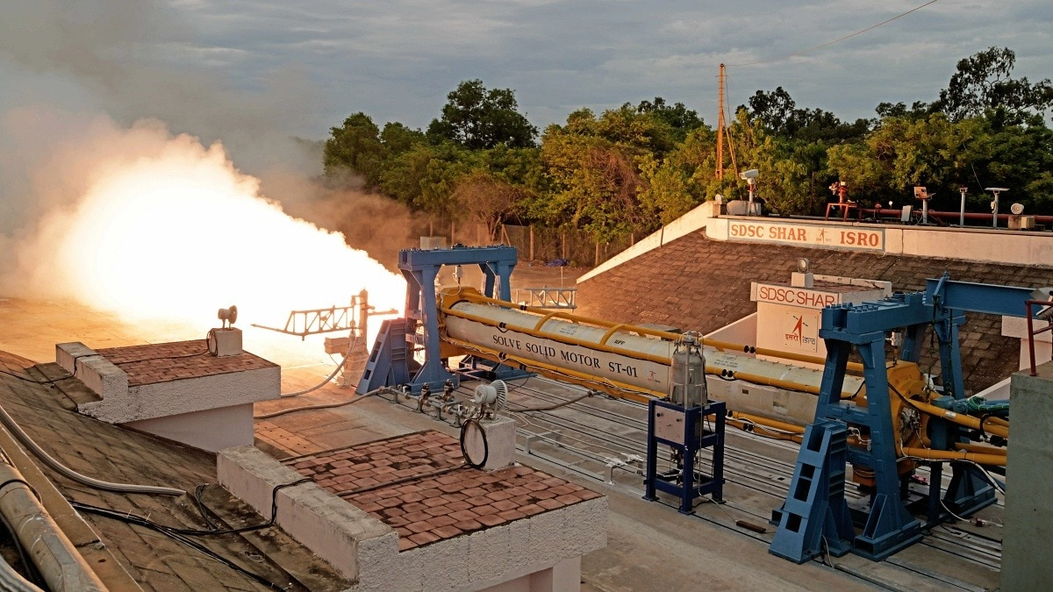
The Indian Space Research Organisation (Isro) has successfully conducted the first ground test of the solid motor that will power its experimental Sub-Orbital Launch Vehicle for Experiments (Solve), marking another major milestone in the development of technologies for India's maiden human spaceflight mission, Gaganyaan. The static test was carried out at the Static Test Facility at the Satish Dhawan Space Centre (SDSC), Sriharikota. Isro said the motor performed as expected, with all key performance parameters meeting mission requirements. Read Full Story The Solve rocket is being developed as a dedicated test platform to validate critical systems that will be used during Gaganyaan missions, particularly the crew module's parachute-based deceleration system. Unlike an orbital launch vehicle, Solve is designed for sub-orbital flights. During these missions, the Gaganyaan crew module will be carried to an altitude of 10 to 17 kilometres before separating from the rocket. Following separation, a carefully choreographed sequence of 10 parachutes will deploy to progressively slow the module before it splashes down safely into the sea. The tests are intended to simulate a wide range of flight conditions that astronauts could encounter during future missions, allowing engineers to verify the reliability of the recovery system before India sends humans into space. The solid propulsion stage of Solve has been derived from the PSLV strap-on booster motor, but incorporates several significant modifications to suit Gaganyaan's unique testing requirements. These include the development of a slow burn-rate propellant to achieve the desired flight profile, a straight nozzle configuration, and a secondary injection thrust vector control system for improved steering during flight. Isro said developing the Solve vehicle gives the agency greater flexibility to conduct repeated Gaganyaan test missions under varying conditions, enabling engineers to validate the crew module's performance before operational human spaceflight. The latest achievement builds on a series of successful Gaganyaan qualification tests carried out over the past year, including integrated air-drop tests and parachute qualification trials. The new test platform is expected to play a crucial role in validating astronaut recovery systems, one of the most critical safety elements of any human spaceflight programme. Gaganyaan, India's first crewed space mission, aims to send a team of Indian astronauts into low-Earth orbit aboard an Indian rocket and safely return them to Earth, making India only the fourth nation to independently achieve human spaceflight. - Ends

4. ISRO successfully conducts 2nd integrated air drop test for Gaganyaan mission - News On AIR
Read more
The Indian Space Research Organisation (ISRO) has successfully conducted the second integrated air drop test (IADT-02) for the upcoming Gaganyaan mission at Sriharikota in Andhra Pradesh. The system is essential to ensure safe recovery of the crew module - the capsule in which astronauts sit during a human flight. After the module's release, a parachute system, comprising 10 parachutes, was deployed, helping the capsule decelerate to a safe splashdown speed. The IADT-02 follows the successful completion of the first IADT, which took place on August 24, 2025, at the Satish Dhawan Space Centre in Sriharikota. In the first IADT, a 4.8-tonne dummy crew module was dropped from a height of three km by a Chinook helicopter. Air drop tests recreate the last leg of a spacecraft's return to the Earth. An aircraft or helicopter drops the spacecraft from a height to test various systems under different scenarios. These are the deployment of the parachute system in case the mission is aborted mid-flight, system performance when one parachute fails to open, and the spacecraft's orientation and safety during splashdown. Union Minister Jitendra Singh congratulated the ISRO for successfully conducting the test. India's first human spaceflight will be launched from Sriharikota in 2027.

5. Integrated Parachute tests for Gaganyaan a success: ISRO - The Indian Express
Read more
The test involved deployment of 10 parachutes to facilitate the deceleration of the Crew Module before splashdown. (ISRO) The Indian Space Research Organisation (ISRO) Friday successfully conducted Integrated Parachute tests required to validate deceleration systems, which will be used in the Gaganyaan's Crew Module splashdown at sea. Crew Module is a special, pressurised space vehicle which houses the astronauts during take-off, space flights and splashdowns. ISRO Saturday said it was developing a solid motor based Sub-Orbital Launch Vehicle for Experiments (SOLVE). This is a special test rocket that can perform numerous experiments under various test conditions. During such tests, the Crew Module is separated from the vehicle at an altitude of 10 to 17 km. ISRO added that the tests performed on July 3 at its Sriharikota centre saw the deployment of about 10 parachutes, which are primarily responsible for reducing the velocity of the Crew Module as it descends and splashes down into the sea.

6. ISRO Bengaluru receives hoax bomb threat, investigation underway - The News Mill
Read more
ISRO Bengaluru receives hoax bomb threat, investigation underway The News Mill

7. Planned 1.7 million satellites 'devastating' for astronomy: Study
Read more

The 1.7 million satellites that companies are aiming to launch into Earth's orbit in the coming years will have "devastating consequences for astronomy," new research warned Wednesday.

8. China tests new 'record-breaking' satellite engine designed for 14 hours of continuous operation
Read more
A Chinese satellite engine has reportedly broken a record for 14 hours of continuous thrust in orbit, Chinese media reports. The engine was able to produce 169 pounds-force (750 Newtons) of thrust, and fired for a total of 3.2 hours over 5 manoeuvres over a total of 14 hours. For reference, the satellite was launched on June 23 on board a Long March-7A from Wenchang Spacecraft Launch Site, Hainan Province, China. The satellite's (Communications Technology Experiment Satellite 26A) test took place during the satellite's maiden flight in June. This test has now safely put the satellite in a stable Earth orbit of around 22,000 miles (35,800 km) from its delivery elliptical transfer orbit. Engines of this kind are used to perform the final leg of satellite deployment once it is delivered to space from Earth. This is a bit like you needing to take a taxi from an airport to your final destination. From Earth to orbit Such engines are also used to make small final corrections once in position. They can also be used to keep the satellite in orbit over the years, or potentially relocate the satellite later down the line. The thrust of the engine doesn't sound like much when compared to a rocket engine (typically in the kilonewton range), but once outside of Earth's atmosphere, you don't need that much to get around. Once in space, there is no air resistance, and objects are already travelling at around 17,448 mph (7.8 km/s) thanks to Earth's existing orbital velocity. This means that even small, continuous pushes in thrust can be enough to make changes in orbital position. As for the recent test, the satellite engine's test is significant, as such engines must work flawlessly in a vacuum without any possible need for repair or recovery. They must also operate at extremely high temperatures and restart multiple times without incident. Chinese state media claims that the recent test has now left its US rivals "far behind" too. However, even a cursory glance at the claims shows this is a little overegged. The claim is likely meant to refer to the engines' designed total endurance of around 14 hours tops. For reference, most existing engines are designed for around 7 hours of total endurance. Reducing reliance on imports However, the recent test only ran the engine for a total of 3.2 hours, not 14. Total endurance of an engine is also not the only metric that matters anyway. Engineers care much more about the fuel efficiency of an engine, its reliability, mass, cost, and thrust-to-weight ratio. So, in other words, one particular engine can be better in one area while worse in another. But perhaps the most interesting aspect of this news is the potential military applications for this new engine. More capable engines of this kind could easily be militarized to allow military satellites to reach orbit much more quickly. They could also enable them to carry more payload instead of fuel, and be able to manoeuvre in orbit much more easily for threat avoidance or repositioning purposes. So, while certain claims about the recent test appear to be hyperbolic, this is genuinely an impressive technical achievement for the team behind it. What's more, the technology appears to have been mostly domestically produced, meaning Chinese space research is making moves to reduce its reliance on imported technologies.

