IIRS Daily Space Digest Thursday, 21/05/2026

1. UP CM Yogi Adityanath proposes data centre cluster for Bundelkhand region
Government News | Latest news on eGovernance, Digital India, Smart Cities | ET Government : ETGovernment.com
Read more


- Economy - 4 min read Yogi reviews the data centre cluster, Project Ganga and wheat processing policy; pitches Bundelkhand as future AI infrastructure hub ETGovernment Desk - ETGovernment - Published On May 21, 2026 at 11:50 AM IST Copy Link Share on WhatsApp Share on Linkedin Share on X Share on Telegram Share on Facebook Chairing a high-level review meeting in Lucknow, CM Adityanath asked officials to start dialogue with major technical companies, including the Tata Group, to develop Lucknow as an 'AI City'. Uttar Pradesh Chief Minister Yogi Adityanath on Wednesday directed officials to explore setting up a major data centre cluster in the Bundelkhand Industrial Development Authority (BIDA) area, saying the state's digital infrastructure push should extend beyond the NCR and help position Uttar Pradesh as a future artificial intelligence (AI) hub. Advt According to the official press release, the meeting was convened to deliberate on three important subjects linked to the future economy of the state, which include the Uttar Pradesh Data Centre Cluster (UPDCC), Project Ganga, and possible exemption in mandi fee and cess to promote in-house processing of wheat. The meeting underscored the state government's focus on building digital infrastructure, expanding rural connectivity and strengthening food security amid emerging climate risks. Reviewing the proposed Uttar Pradesh Data Centre Cluster, CM Adityanath said the project would serve as the foundational infrastructure for the state's AI ambitions and should not remain confined to the NCR region alone. "The data centre cluster should not remain limited to NCR. Other regions of the state must also be connected to this ecosystem," he said. Officials informed the chief minister that UPDCC is being envisioned as a long-term strategy to position Uttar Pradesh as India's largest AI compute power hub and a major digital infrastructure centre for the Global South. The proposed cluster aims to establish Uttar Pradesh as a global destination for artificial intelligence, cloud infrastructure, data centres and high-tech digital manufacturing. According to the presentation made during the meeting, the initiative could help support the state's aspiration of building a $5-trillion economy, generate over 1.5 lakh direct jobs and create a 5-gigawatt AI compute corridor by 2040. Officials said the global economy over the next two decades is expected to be driven by sectors such as AI, cloud computing, cyber security, semiconductors, robotics, electric vehicles and space technology, with a combined market potential estimated between $29 trillion and $48 trillion. The meeting highlighted Uttar Pradesh's strategic advantages, including its inland geography, large land bank, expanding infrastructure network and technical talent pool supported by institutions such as IIT Kanpur, NIT Prayagraj and over 50 engineering colleges. Officials also described Uttar Pradesh as one of Asia's most scalable and connected inland AI territories, noting that major fibre networks pass through the state and provide low-latency connectivity to key digital hubs, including Mumbai and Chennai. The chief minister also reviewed Project Ganga - Government Assisted Network for Growth and Advancement - an ambitious rural broadband initiative aimed at expanding fibre-based internet connectivity across rural Uttar Pradesh. Adityanath stressed the need for rapid expansion of the optical fibre network and directed officials to ensure complete transparency in project implementation. He said youths selected as digital entrepreneurs under the programme should receive high-quality training and be linked with companies undertaking survey and field operations. Officials informed the meeting that the project aims to connect more than 20 lakh households through high-speed broadband services while developing over 10,000 Digital Service Providers (DSPs), potentially creating around 50,000 direct and more than one lakh indirect jobs. Under the scheme, each DSP is expected to connect 200-300 households and provide services including broadband, IPTV, OTT access, public Wi-Fi, CCTV solutions and cybersecurity support. The government also plans to offer interest-free loans of up to ₹5 lakh to participating entrepreneurs. The project is currently being developed as a proof of concept in 21 priority districts before statewide expansion. The chief minister also reviewed measures to promote in-house wheat processing and emphasised the need for reforms in the mandi tax and fee structure. He directed officials to modernise mandis across the state and ensure better cleanliness, painting, lighting during festivals, removal of encroachments and improved management systems. Referring to the possible impact of El Niño conditions on agriculture, Adityanath said Uttar Pradesh must strengthen its food security preparedness and maintain adequate food grain reserves. Officials informed the meeting that Uttar Pradesh remains the country's largest wheat-producing state, with production for 2025-26 estimated at 372 lakh metric tonnes and total availability projected at 407 lakh metric tonnes. However, despite having 559 roller flour mills with an installed capacity of 218.4 lakh metric tonnes, actual utilisation remains significantly lower, resulting in substantial quantities of wheat being transported outside the state for processing. According to officials, increasing local processing capacity could boost employment generation, GST revenues, electricity consumption and growth in food processing industries. A committee examining the issue has proposed exemption from mandi fees and development cess for registered mills procuring wheat for processing within Uttar Pradesh, while excluding trading activities from the benefit. ETGovernment Desk , --> - By - See more on: - Bundelkhand data centre cluster , - Uttar Pradesh Data Centre Cluster , - Yogi Adityanath AI infrastructure hub , - Uttar Pradesh digital infrastructure expansion , - Uttar Pradesh food security Telegram Facebook Comments What are your thoughts? Comment Now --> Comment Now Read Comment (1) All Comments By commenting, you agree to the Prohibited Content Policy Post Find this Comment Offensive? Choose your reason below and click on the submit button. This will alert our moderators to take actions REASONS FOR REPORTING Foul Language Defamatory Inciting hatred against a certain community Out of Context / Spam Others Report Join the community of 2M+ industry professionals. Subscribe to Newsletter to get latest insights & analysis in your inbox. All about ETGovernment industry right on your smartphone! - Download the ETGovernment App and get the Realtime updates and Save your favourite articles. Scan to download App -->

2. ISRO's Chandrayaan 3 hop experiment reveals layered structure beneath Moon's surface - The New Indian Express
"ISRO OR NRSC OR IIRS after:2026-05-20" - Google News
Read more
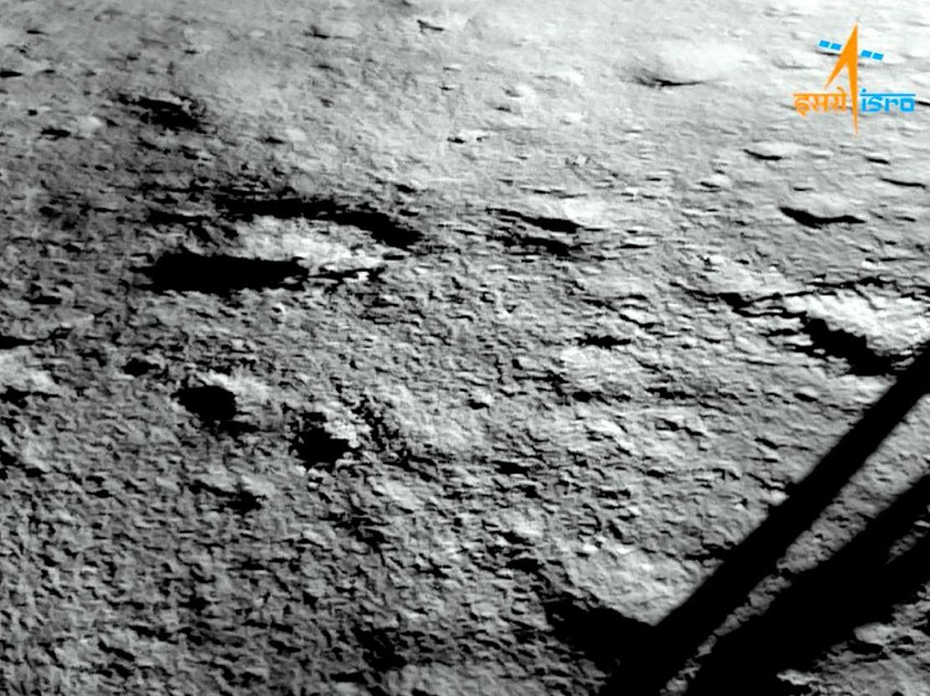

Lander Imager Camera of ISRO's This layer is crucial in the storage of water-ice molecules in the subsurface, and in selecting the sites for future scientific bases and habitat construction on the Moon. (Photo | PTI) BENGALURU: A team of scientists from the Indian Space Research Organisation (ISRO) on May 18 shared a report of the findings of the 'Hop' experiment conducted by the Vikram Lander of Chandrayaan-3 and the Chandra's Surface Thermophysical Experiment (ChaSTE) on the moon. The researchers noted, "While we often call it lunar soil, the more apt term to be used is lunar regolith. The lunar regolith is actually shattered rock, tiny, jagged glass-like shards that are abrasive and cling to everything." They also pointed out that the complex structure of regolith has unique geo-technical and thermophysical properties. They said the top 2-6 cm regolith is found to be highly cohesive or sticky and hyper-porous, which can act as a thermal blanket. This layer is crucial in the storage of water-ice molecules in the subsurface, and in selecting the sites for future scientific bases and habitat construction on the Moon. The ISRO scientists said, "For an astronaut, this means the surface might feel like walking on dry flour, while just a few inches deeper. This is because, even at that small depth of a few centimetres, the bulk density changes from 750 to 1600 kg m⁻³." Understanding the thermal and physical properties of the moon's regolith is important from both scientific and technological angles. They said the thermophysical characteristics of the regolith hold clues to some questions, like how the moon manages the solar heat input, or how much it absorbs and how much it radiates back to space.

3. NIAS, ISRO to trace '101 temples, 101 wells' beneath Lakkundi's landscape in Gadag - The Times of India
"ISRO OR NRSC OR IIRS after:2026-05-20" - Google News
Read more

NIAS, ISRO to trace '101 temples, 101 wells' beneath Lakkundi's landscape in Gadag The Times of India

4. ISRO delayed LVM3-M6 flight by 41 seconds to avoid potential collision - MSN
"ISRO OR NRSC OR IIRS after:2026-05-20" - Google News
Read more

ISRO delayed LVM3-M6 flight by 41 seconds to avoid potential collision MSN

5. Chandrayaan Lander Hopped A Little In 2023, Now ISRO Is Jumping At Discovery - NDTV
"ISRO OR NRSC OR IIRS after:2026-05-20" - Google News
Read more

Chandrayaan Lander Hopped A Little In 2023, Now ISRO Is Jumping At Discovery NDTV

6. New Chandrayaan 3 Discovery - The Hans India
"ISRO OR NRSC OR IIRS after:2026-05-20" - Google News
Read more

India's Chandrayaan 3 mission has made a new discovery on the Moon. ISRO scientists found that the Vikram Lander made a small "hop" after landing successfully in 2023. This Chandrayaan latest news has excited space fans across the country. According to the ISRO Chandrayaan update, the Chandrayaan lander lifted slightly from the Moon's surface and According to the updates given for ISRO Chandrayaan, the Chandrayaan Lander lifted up slightly from the Moon's surface but thankfully landed again quite nearby it's original position. This lander hop was done as a small test after the main mission was officially completed. Scientists are trying to study how landers actually work on the Moon. The Chandrayaan 3 moon mission had already make a whole new history because India has became the first ever country to land near the south pole of the Moon. And now, this unique and great ISRO discovery yet achievement is helping many experts near more about the lunar surface and future of the Moon. Scientists said the Chandrayaan lander movement explained how spacecraft may move safely on the Moon in the future. The ISRO moon discovery can help future astronauts and robotic missions. Many people are now asking, "what did ISRO discover on moon" after hearing this update. The Chandrayaan mission news and Chandrayaan 3 latest findings have made Indians proud once again. Experts believe this lunar discovery India achieved will help ISRO improve future space missions and research. The ISRO new Chandrayaan discovery shows that India is growing stronger in space research and technology.

7. La NASA informará sobre su estrategia y misiones para la Base Lunar
NASA
Read more
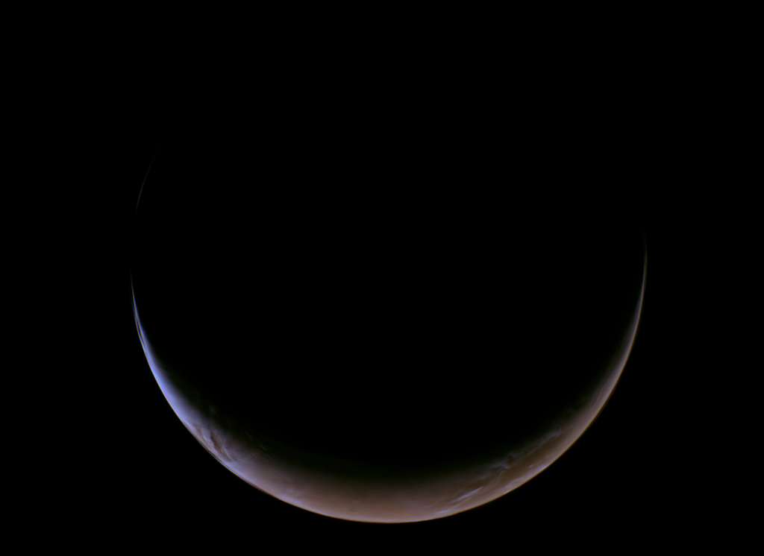

3 min read Gerelle Q. Dodson May 20, 2026 MEDIA ADVISORY M26-038 NASA Headquarters Concepto artístico de astronautas trabajando en la superficie lunar. Crédito: NASA Read this news release in English here . La NASA ofrecerá una conferencia de prensa el martes 26 de mayo a las 2 p.m. EDT (hora del este) para compartir los planes para la Base Lunar y destacar los avances hacia una presencia sostenida en la superficie lunar. La sesión informativa para los medios tendrá lugar en la sede central de la agencia en Washington. Líderes de la agencia hablarán sobre los avances del programa, incluyendo a los nuevos socios de la industria y los planes de la misión. Una vez finalizada la conferencia de prensa, habrá expertos en la materia disponibles para dar entrevistas individuales. Siga la rueda de prensa en vivo a través de la aplicación NASA+ y el canal de YouTube de la agencia. Descubra cómo ver el contenido de la NASA en diversas plataformas en línea, incluidas las redes sociales (información ofrecida en inglés). Entre los participantes se encuentran: - Jared Isaacman, administrador de la NASA - Lori Glaze, administradora asociada interina, Dirección de Misiones de Desarrollo de Sistemas de Exploración - Carlos García-Galán, director del programa Base Lunar. García-Galán es hispanohablante. Los representantes de los medios que no puedan asistir en persona podrán hacer preguntas por teléfono. Para participar en persona o por teléfono, debe confirmar su asistencia a la oficina de prensa de la sede a más tardar a las 11 a.m. del 26 de mayo, enviando un correo a: hq-media@mail.nasa.gov . La política de acreditación de medios de la NASA está disponible en línea (en inglés). La NASA impulsa el desarrollo de la Base Lunar, una iniciativa de exploración e infraestructura lunar a largo plazo diseñada para permitir una presencia humana sostenida y una mayor actividad científica y comercial en el Polo Sur lunar. Como parte de una edad de oro de innovación y exploración, la NASA enviará astronautas en misiones cada vez más difíciles para explorar más de la Luna con fines de descubrimiento científico y beneficios económicos, y para continuar sentando las bases para las primeras misiones tripuladas a Marte. Para más información sobre las misiones de la NASA, visite: https://www.nasa.gov (inglés) https://ciencia.nasa.gov/ (español) -fin- Bethany Stevens / James Gannon / María José Viñas Sede central, Washington +1-202-358-1600 bethany.c.stevens@nasa.gov / james.h.gannon@nasa.gov / maria-jose.vinasgarcia@nasa.gov Share Details Last Updated Location Related Terms - NASA en español

8. NASA TechLeap Prize: Robotically Manipulated Payload Challenge
NASA
Read more


The Robotically Manipulated Payload Challenge - the fifth in the NASA TechLeap Prize series - is a competition to advance persistent infrastructure for in-space servicing, assembly, and manufacturing. NASA Flight Opportunities invites applicants to propose a payload that can be manipulated by a robotic arm in low Earth orbit. Up to three winners will each receive up to $500,000 to develop a flight-ready payload. In addition, NASA intends to provide an opportunity for the winning teams to demonstrate their payload in orbit (at no additional cost). These TechLeap payloads will fly aboard an orbital spacecraft that will rendezvous with the Fly Foundational Robots (FFR) platform. The FFR mission is expected to launch in late 2027, and the TechLeap payloads are slated to launch in early 2028. Across three phases, applicants will move from ideation to payload build over 12 months. The timeline for this challenge is intentionally rapid, with the goal of increasing the pace of space. Award: Up to three winners may receive up to $500,000 in prizes across three phases Challenge Open Date: May 20, 2026 Phase 1 Registration Close Date: July 29, 2026 Application Close Date: August 12, 2026 For more information, visit: https://rmpc.nasatechleap.org/

9. Psyche Spacecraft Completes Mars Flyby
NASA
Read more


NASA's Psyche spacecraft completed its close approach of Mars on May 15, coming within 2,864 miles (4,609 kilometers) of the planet's surface. During the flyby, it took this image and others. This representative color image, captured by Psyche's multispectral imager instrument, features the double-ring crater Huygens and the surrounding heavily cratered southern highlands. This flyby used a gravity assist from Mars to provide a critical boost in speed and to adjust the spacecraft's orbital plane without using any onboard propellant, sending it on its way toward the metal-rich asteroid Psyche. When it arrives in August 2029, it will insert itself into orbit, then map the asteroid and gather science data. If the asteroid proves to be the metallic core of an ancient planetesimal, it could offer a one-of-a-kind window into the interior of rocky planets like Earth. Learn more about the flyby and see more photos from the event. Image credit: NASA/JPL-Caltech/ASU

10. NASA-developed AI Could Help Track Harmful Algae
NASA
Read more


Green swirls of microscopic algae (phytoplankton) are visible off the U.S. Gulf Coast in this image captured Oct. 21, 2024, by the Ocean Color Instrument on NASA's PACE satellite. The sensor also observed autumn leaf colors, visible as a reddish streak, to the northeast. NASA NASA scientists have developed an artificial intelligence tool to take on a longstanding challenge in ocean waters. In a study recently published in AGU Earth and Space Science, researchers reported the tool was able to fuse data from multiple satellites and detect harmful algal blooms that occurred in western Florida and Southern California. Severe blooms can pose health risks and cost coastal economies in the United States tens of millions of dollars every year. Areas in Florida such as Tampa Bay and Sarasota have wrestled with the problem for decades. A species called Karenia brevis can thrive in Gulf of America waters, spawning harmful algal blooms that kill wildlife, foul beaches, and sicken swimmers. On the West Coast, blooms of Pseudo-nitzschia have poisoned hundreds of dolphins, California sea lions, and other marine animals in recent years. Toxins from algaecan even enter the air and cause respiratory illness in humans. To manage the risk, health agencies regularly test waters and issue warnings or beach closures when necessary. The National Oceanic and Atmospheric Administration (NOAA) works with states and other local partners to issue harmful algal bloom forecasts, like weather forecasts, during bloom seasons. On-site testing requires hours in a boat to manually collect water samples that must be sent to a lab for analysis, taking a day or more and requiring multiple tests. It's even more challenging to know where to test before a bloom starts spreading. NASA's Earth-orbiting satellites already track harmful algal blooms with their unique global view. By bringing together diverse datasets, the new AI tool could serve as a force multiplier to help communities determine where to focus their efforts. "At the very least, a tool like this can help us know where and when to collect water samples as an algal bloom is starting," said one of the paper's coauthors, Michelle Gierach, a scientist at NASA's Jet Propulsion Laboratory in Southern California. "It can also drive collaboration between specialists, fostering new ways to conduct the science and deliver decision-support products." Today, satellites can detect a variety of clues that signal an algal bloom. A hyperspectral sensor aboard NASA's Plankton, Aerosol, Cloud, ocean Ecosystem (PACE) satellite, for example, can identify algal communities by their size, shape, and pigment. Other instruments like TROPOMI (Tropospheric Monitoring Instrument) pick up on the faint red glow emitted by species such as K. brevis as they photosynthesize. The study team, consisting of Gierach, Kelly Luis of NASA JPL, and research data scientist Nick LaHaye of Spatial Informatics Group, brought together findings from five space missions or instruments, including PACE and TROPOMI. The challenge for them was the quantity of raw data involved. How would AI distinguish between deep water and a coastline? Could it recognize a bloom across different data streams? Would it ever be able to handle inputs from both satellites and sensors in the water? The team developed a self-supervised machine learning system, designed to learn patterns from multiple kinds of satellite data and compare them with field observations. This approach enables AI to recognize relationships between different data sources without needing any labeling in advance. The system was trained on satellite data collected in 2018 and 2019. Field and lab measurements were then used to add real-world context to the patterns that the system was recognizing. The scientists evaluated the tool's performance across later time periods in the same geographic areas. Initial results indicate that it can correctly identify and map harmful blooms, including specific species like K. brevis, performing well even in complex coastal waters swirling with sediment, plants, and runoff. "Applying self-supervised AI to massive streams of satellite data is rapidly becoming a powerful tool for generating actionable ocean intelligence," said Nadya Vinogradova Shiffer, lead program scientist at NASA Headquarters in Washington. The team is now improving the tool with more data from more coastlines and expanding tests to other kinds of water bodies, including lakes, with the goal of making it accessible to decision-makers in coming years. "The aim of this work is to start to bridge technologies to better serve end users and their needs, from aquaculture to tourism," Luis said. "To do that, we're going to bring all our NASA assets to the table." Media Contacts Andrew Wang / Andrew Good Jet Propulsion Laboratory, Pasadena, Calif. 626-379-6874 / 818-393-2433 andrew.wang@jpl.nasa.gov / andrew.c.good@jpl.nasa.gov 2026-034

11. NASA to Provide Update on Moon Base Strategy, Missions
NASA
Read more


An artist's concept of astronauts working on the lunar surface. Credit: NASA NASA will host a news conference at 2 p.m. EDT, Tuesday, May 26, to share Moon Base plans and highlight progress toward a sustained presence on the lunar surface. The media briefing will take place at the agency's Headquarters in Washington. Leadership will discuss program progress, including new industry partners and mission plans. Subject matter experts will be available for one-on-one interviews after the news conference ends. Watch live on NASA+ and the agency's YouTube channel. Learn how to watch NASA content through a variety of online platforms, including social media. Participants include: NASA Administrator Jared Isaacman Lori Glaze, acting associate administrator, Exploration Systems Development Mission Directorate Carlos García-Galán, program executive, Moon Base Media unable to attend in person may ask questions by telephone. To participate in person or by phone, media must RSVP to the headquarters newsroom no later than 11 a.m. on May 26, at: hq-media@mail.nasa.gov. NASA's media accreditation policy is available online. NASA is advancing development of Moon Base, a long-term lunar exploration and infrastructure initiative designed to enable sustained human presence and expanded scientific and commercial activity at the lunar South Pole. As part of the Golden Age of innovation and exploration, NASA will send astronauts on increasingly difficult missions to explore more of the Moon for scientific discovery, economic benefits, and to build on our foundation for the first crewed missions to Mars. For more information about NASA's missions, visit: https://www.nasa.gov -end- Bethany Stevens / James Gannon Headquarters, Washington 202-358-1600 bethany.c.stevens@nasa.gov / james.h.gannon@nasa.gov

12. NASA Releases Technology Priorities to Energize Space Industry
NASA
Read more
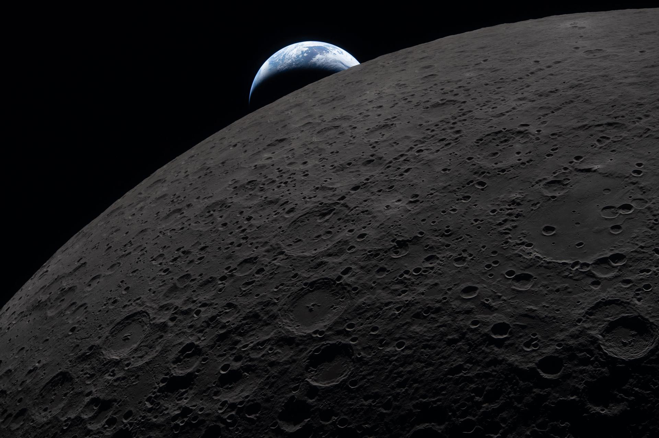

NASA released the 2026 Civil Space Shortfall Ranking list on Wednesday, which integrates more than 400 responses from stakeholders including industry organizations, government agencies, and academia. Shortfalls refer to technology areas requiring further development to meet future exploration, science, and other mission needs. The goal of this document is to rank the space community's most pervasive shortfalls to help guide NASA's space technology development and investments. The greatest technological breakthroughs are built on shared vision. At the intersection of government and industry, we're poised to use this feedback to accelerate high-risk, high-reward technologies, pushing NASA beyond the cutting edge to enable the near impossible. Greg Stover Acting associate administrator for NASA's Space Technology Mission Directorate at the agency's headquarters in Washington As NASA lays the foundation for long-term missions to the Moon and paves the way for human exploration on Mars, the top ranked shortfalls reflect the challenges industry is most eager to solve, such as developing infrastructure and capabilities for assets to operate for extended durations in the lunar environment, providing surface mobility and logistics for crew and assets on planetary surfaces, and developing on-board advanced computing capabilities for space operations. From this year's public call for feedback, NASA received 454 total external responses. Each response was considered the input of a single individual, not a consolidated response of the organization they represented. The cross-cutting nature of this feedback underscores the importance of public, private partnership to drive U.S. leadership in space technology and energize the space economy. "This feedback provides an invaluable dataset," said Angela Krenn, acting chief architect for NASA Technology. "As our process matures, each round of input helps target our resources, ensuring America's space industry can tackle tomorrow's greatest challenges. By tapping into the collective expertise of our stakeholders, we turn their insights into fuel for NASA's next giant leap." The 2026 shortfalls process builds on NASA's first shortfall ranking, which asked participants to rank 187 civil space shortfalls, resulting in an integrated list of technology priorities. Leveraging the feedback provided by stakeholders, this year's exercise streamlined the process by consolidating the shortfalls into 32 broader, integrated categories. This restructuring maintains the original content's depth while creating a more efficient and accessible feedback mechanism for participants. Using the 2026 shortfalls results, NASA Technology selected 40 primary focus areas for its fiscal year 2026 investments. These focus areas combine the quantitative data of the shortfall rankings with considerations from NASA's Ignition initiatives, science and technology, while establishing paths for collaboration with industry, ensuring relevance with academia, and leveraging overlaps in interests with other government agencies. The 40 focus areas include several capabilities to enable NASA's future lunar infrastructure including: landing at the lunar South Pole exploration sites in various illumination conditions with accuracy; excavating and transporting lunar regolith at a scale relevant for a demonstration mission; and providing low power, thermal management, and actuation for distributed surface assets to survive and operate in the lunar environment. The list of 40 focus areas is available on page 10 of the shortfalls document. To learn more about the civil space shortfall feedback opportunity and results as well as monitor future feedback opportunities, visit: www.nasa.gov/civilspaceshortfalls

13. I Am Artemis: Tim Goddard
NASA
Read more
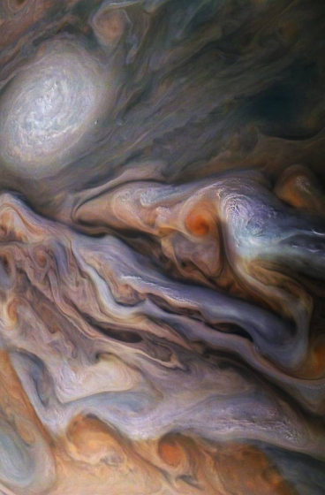

Listen to this audio excerpt from Tim Goddard, NASA open water lead: 0:00 / 0:00 Your browser does not support the audio element. At the end of their mission around the Moon, NASA's Artemis II astronauts were recovered from their Orion spacecraft by a team of U.S. Navy divers and NASA personnel. This included Tim Goddard, NASA open water lead, who helped guide the complex open water recovery of both Orion and the crew members, once they safely splashed down in the Pacific Ocean off the coast of San Diego. As the open water lead, Goddard is responsible for the design, certification, procurement, and training, for both the NASA and Navy team. He also oversees the hardware and operations that are needed to recover the crew and spacecraft from the open ocean and bring them to safety aboard an amphibious Navy ship after splashdown. Tim Goddard, NASA open water lead, stands in the Neutral Buoyancy Laboratory (NBL) at NASA's Johnson Space Center in Houston. Goddard conducts training in the NBL with NASA and U.S. Navy recovery teams to prepare for Orion spacecraft recovery operations. NASA/Rad Sinyak "This is a very complex set of operations," said Goddard. "We have six small boats in the water. We're relying on four separate helicopters and the host Navy ship at the same time. We have over 50 folks in the water and in different boats. I have team members underwater, on the surface, and small boats moving all around." And that's just Goddard's portion of the recovery - the larger operation entails coordination of activities that includes the Navy ship's operations, communications, vessel traffic, medical needs, aviation operations, and more. It's a large orchestration of personnel and hardware to just enable recovery of the astronauts from the capsule - and then, we have to recover the spacecraft in the well deck of the Navy ship, which can be up to nine hours later. Tim Goddard NASA Open Water Lead Goddard and his team practice, practice, practice long before recovery day to ensure the complicated dance goes smoothly. They start by performing training runs with representative Orion hardware at the Neutral Buoyancy Laboratory at NASA's Johnson Space Center in Houston, one of the world's largest indoor pools that can support large-scale underwater and topside operations. The team then pushes out to San Diego, starting with bay operations and working their way up to open ocean conditions similar to what they'll see on recovery day. "By the time they do the real mission, they have hours and hours on each type of facet or each phase of that recovery," said Goddard. "We bring them out and then we just go through repetition after repetition. When we do the real thing, it's not their first time seeing it." NASA and U.S. Navy recovery teams, including NASA Open Water Lead Tim Goddard, prepare to transfer the crew to the USS John P. Murtha following the splashdown of the Orion spacecraft on April 10, 2026, marking the conclusion of the nearly 10‑day Artemis II mission around the Moon. NASA/Joel Kowsky It's actually Goddard's third time recovering Orion - the team recovered the capsule on Orion's first flight, Exploration Flight Test-1 in 2014, and Artemis I, Orion's first uncrewed test flight around the Moon in 2022. "We were strictly focused on capsule recovery for both of those flights," said Goddard. "Now we introduced humans to the loop with a flight crew being in the capsule. Our primary focus has shifted from recovering the capsule to recovering the crew first. Once we get the crew safe and sound on the ship, we transfer our focus and shift our operations to the recovery of the capsule." Goddard joined the initial Orion recovery team in 2007, and has served as the open water lead for over 10 years. He joined NASA in the 1990s after a 27-year career as a Navy diver, initially serving in dive operations in the Neutral Buoyancy Lab and then pursuing mechanical engineering. Over half of my time at NASA has been supporting this operation. That's a long time, and to finally have the Moon mission go off and bring the folks back - it's an immense pleasure. I am very excited and proud to be able to support this mission. Tim Goddard NASA Open Water Lead With crew aboard, there was an immense responsibility along with the pleasure of getting them home safely for Goddard. "There was a lot of weight and stress that the other folks and I carried," he said. "I can tell you under the previous two missions, once we set the capsule down, that was the moment of elation and 'I can sleep now.' That was tenfold when we recovered the crew. Once they were recovered and the capsule was back in San Diego, I had an immense feeling of relief."

14. NASA's Fermi Glimpses Power Source of Supercharged Supernovae
NASA
Read more
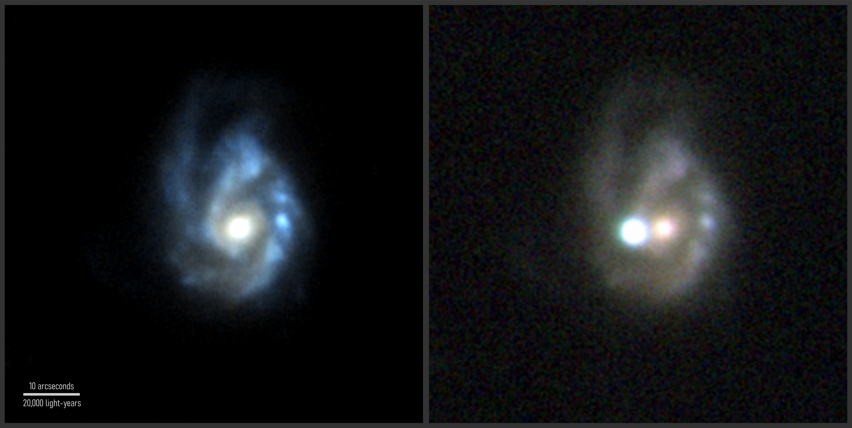

An international team studying data from NASA's Fermi Gamma-ray Space Telescope concludes the mission detected a rare, unusually luminous supernova. The researchers say it likely received its power-up from a supermagnetized neutron star born in the stellar collapse that triggered the explosion. Gamma rays detected by NASA's Fermi Gamma-ray Space Telescope gave scientists a look under the hood of a rare supernova that produced much more light than normal. NASA's Goddard Space Flight Center The Fermi mission is part of NASA's fleet of observatories monitoring the changing cosmos to help humanity better understand how the universe works. "For nearly 20 years, astronomers have searched Fermi data for gamma-ray signals from thousands of supernovae, and while a few intriguing hints have been reported, none were definitive until now," study lead Fabio Acero at the French National Centre for Scientific Research (CNRS) and the University of Paris-Saclay. A paper describing the findings published Wednesday in the journal Astronomy & Astrophysics. This composite image shows two views of SN 2017egm, in visible light (inset) and gamma rays (background). The optical image shows the supernova - the brightest object in the scene - and its host galaxy on July 1, 2017. The background map shows a wide area of the sky surrounding the supernova's position. Brighter colors indicate greater statistical likelihood that gamma rays are associated with the explosion. The map includes gamma rays detected by Fermi's Large Area Telescope from July 5, 2017, to Oct. 25, 2017, or from 43 to 155 days after the supernova was discovered. Background, NASA/DOE/Fermi LAT Collaboration and Acero et. al. 2026; inset, NOT+ALFSOC/Bose et al. 2020 Core-collapse supernovae occur when the energy-producing center of a star many times our Sun's mass runs out of fuel, collapses under its own weight, and explodes. During the collapse, a city-sized neutron star or an even smaller black hole may form. A blast wave blows away the rest of the star, which rapidly expands as a hot, dense cloud of ionized gas. In the last couple of decades, nearly 400 exceptional core-collapse supernovae have been identified. Each of these events, dubbed superluminous supernovae, produced 10 or more times the amount of visible light normally seen. In 2024, a study led by Li Shang at Anhui University in Hefei, China, noted that Fermi's Large Area Telescope may have seen gamma rays - the most energetic form of light - from a superluminous supernova that occurred years earlier. Dubbed SN 2017egm, this supercharged outburst occurred in galaxy NGC 3191, located about 440 million light-years away in the constellation Ursa Major. Even at this distance, the explosion remains one of the closest of its type to us on Earth. The superluminous supernova SN 2017egm was discovered by the European Space Agency's Gaia mission on May 23, 2017. It exploded in a massive barred spiral galaxy known as NGC 3191, shown on the left before the eruption. The image at right, taken on July 1, 2017, shows the supernova outshining the entire galaxy. Left, SDSS and PS1; right, NOT+ALFSOC/Bose et al. 2020 "We searched for gamma rays from the six nearest superluminous supernovae seen during the first 16 years of Fermi's mission," said Guillem Martí-Devesa, a researcher previously at the University of Trieste in Italy and now a fellow at the Institute of Space Sciences in Barcelona, Spain. "Only SN 2017egm shows evidence for gamma rays, confirming earlier hints that some supernovae can be as luminous in gamma rays as they are in visible light. This opens up a new window for studying these fascinating events." Theorists have debated the possible energy sources that give these explosions their extra punch. High on the list has been the formation of a magnetar, a type of neutron star with the strongest magnetic fields known - up to 1,000 times the intensity of typical neutron stars. That's 10 trillion times stronger than a refrigerator magnet. The team undertook a deeper analysis of the supernova's observed optical and gamma-ray features to compare how well different theoretical models reproduced them. A model developed by co-authors Indrek Vurm at the University of Tartu in Estonia and Brian Metzger at Columbia University in New York City traced how light and particles produced by a newborn magnetar would move outward and interact with the supernova's expanding debris. Scientists expect a newly formed magnetar to spin a few hundred times a second. This rapid rotation produces a strong outflow of electrons and positrons, their antimatter counterparts, that forms a vast cloud of energetic particles. The Crab Nebula formed in a supernova explosion observed in 1054. At its heart lies an isolated neutron star, the crushed core of the original star. It spins about 30 times a second, sweeping a beam of radiation toward Earth with every rotation, lighthouse style, which classifies the neutron star as a pulsar. This rapid spin powers X-ray jets (elongated blue-white feature near center) and a high-speed outflow of electrons and other particles. The particles collect in a vast cloud-like structure called a pulsar wind nebula, which also forms around magnetars, the pulsar's supermagnetized cousin. This emission gradually slows the neutron star's spin. These images combine X-ray data from NASA's Chandra X-ray Observatory (bluish white) and infrared data from NASA's James Webb Space Telescope. X-ray, Chandra: NASA/CXC/SAO; Infrared, Webb: NASA/STScI; Image Processing: NASA/CXC/SAO/J. Major Within this cloud - called a magnetar wind nebula - various interactions fuel the production and absorption of gamma rays. For example, an electron and a positron can annihilate into a pair of gamma-ray photons, or two gamma rays can collide and produce the particles. In these and other ways, gamma rays interact with the supernova debris. Unable to escape directly, they become reprocessed, downshifted into lower-energy visible light that provides the supernova with its extra boost in luminosity. "About three months after the collapse, as the supernova debris expands and cools, the gamma rays can begin to leak out," Acero said. "This magnetar model best reproduces the supernova's luminosity and the arrival time of its gamma rays during the first months, but we see room for improvement at later times, when the visible light fades quite irregularly." Acero and his colleagues suggest that additional processes likely played contributing roles during SN 2017egm's long fade-out. These include debris falling back onto the magnetar and interactions between the blast wave and matter ejected by the star in the centuries prior to its demise. The X-ray glow associated with a source known as Swift J1834.9-0846, located near the center of the W41 supernova remnant, comes from the first magnetar wind nebula identified (outline). ESA/XMM-Newton and Younes et al. 2016 The team also examined how well a new ground-based gamma-ray facility, the Cerenkov Telescope Array Observatory, might detect events like SN 2017egm. With about 50 hours of observing time, they say, a similar supernova could be detected out to about 500 million light-years. Our understanding of phenomena like SN 2017egm will improve thanks to cooperation between such facilities and NASA's fleet of space-based observatories that watch for rapid changes in the universe. "The magnetar central engine mechanism discussed in this paper builds upon a lot of observational and theoretical advances in magnetars over the last 20 years," said Judy Racusin, a deputy project scientist for the Fermi mission at NASA's Goddard Space Flight Center in Greenbelt, Maryland. "Observing gamma rays from supernovae will give us a new way to explore their inner workings." By Francis Reddy NASA's Goddard Space Flight Center, Greenbelt, Md. Media Contact: Claire Andreoli 301-286-1940 claire.andreoli@nasa.gov

