 |  | 

🌌 अंतरिक्ष समाचार | Space News
बुधवार, २६/०८/२०२६ | Wednesday, 26/08/2026

1. Govt simplifies registration, renewal process for tourism businesses
Read more
PIONEER EDGE NEWS SERVICE/Dehradun The Uttarakhand Tourism department on Tuesday has simplified the registration and renewal process for tourism businesses across the state under the Uttarakhand Tourism, Travel Trade Registration Rules 2026, making the system more transparent and time-bound. The department has directed all the district tourism development officers to prioritise registration and renewal applications and ensure they are disposed of without unnecessary delays. The new rules cover hotels, resorts, guest houses, ashrams, dharamshalas, homestays, bed and breakfast units, travel agencies, tour operators, adventure tourism operators and other tourism-related establishments. Unregistered tourism units and those whose previous registration has expired will have to register under the new rules within 180 days of notification. Existing registered units whose registration has completed five years will have to apply for renewal within 90 days, while homestays will be required to renew their registration after two years. The department has also simplified the issuance of online provisional certificates. During renewal, the provisional certificate will be generated automatically once applicants submit the required documents, including the fire safety certificate or bill, FSSAI certificate and prescribed fee. The rules also provide eligible homestay operators an exemption from mandatory GST registration, subject to submission of an affidavit on a Rs 100 notarised stamp paper. The tourism secretary and CEO of the Uttarakhand Tourism Development Board (UTDB) Dhiraaj Singh Garbyal said that officials had been instructed to make the registration and renewal process "simple, transparent and time-bound" and prevent unnecessary pendency. The additional director Poonam Chand urged tourism operators to comply with the new rules and complete registration or renewal within the prescribed deadlines.

2. ISRO changes tack on launch vehicle manufacture - Developing Telecoms
Read more

The Indian Space Research Organisation (ISRO) has reportedly announced a change of policy that means it will cease direct manufacturing of commercial launch vehicles, though this may boost its other businesses. ISRO, whose main focus is the development and application of space technology for various national needs, plans to transfer end-to-end rocket assembly and operational manufacturing to private industrial consortia while refocusing its internal resources on advanced space exploration research, technology development, and deep-space missions. The operational transition transfers production lines for ISRO's operational launch fleet to domestic private aerospace contractors, which will assume responsibility for serial production, component sourcing, and launch vehicle integration. The launch fleet includes the Polar Satellite Launch Vehicle (PSLV), Launch Vehicle Mark-3 (LVM3), and the Small Satellite Launch Vehicle (SSLV). Commercial operations and mission procurement will continue through NewSpace India Limited (NSIL), the commercial arm of ISRO, while regulatory authorisations will still be managed by the Indian National Space Promotion and Authorisation Centre (IN-SPACe). According to the SatNews website, this industrial policy shift accelerates ISRO's initiatives to expand spacecraft and launch throughput while adapting to competitive pressures from global commercial launch providers, where ISRO continues coordinating international rideshare manifests. It explains that by shifting routine hardware fabrication to private industry, the Indian government aims to expand the nation's domestic space economy from approximately US$8 billion to US$44 billion by 2033 - an estimated 8% of the global space market. Commercialising launch vehicle production is designed to establish an export-oriented aerospace supply chain, positioning Indian prime contractors to supply launch services and satellite buses to international commercial customers.

3. After Centre rejig, Anand Mahindra and former ISRO chair appointed to RBI board - ANI News
Read more
After Centre rejig, Anand Mahindra and former ISRO chair appointed to RBI board ANI News

4. Private Players Might Take Over ISRO's Rockets - The Federal
Read more
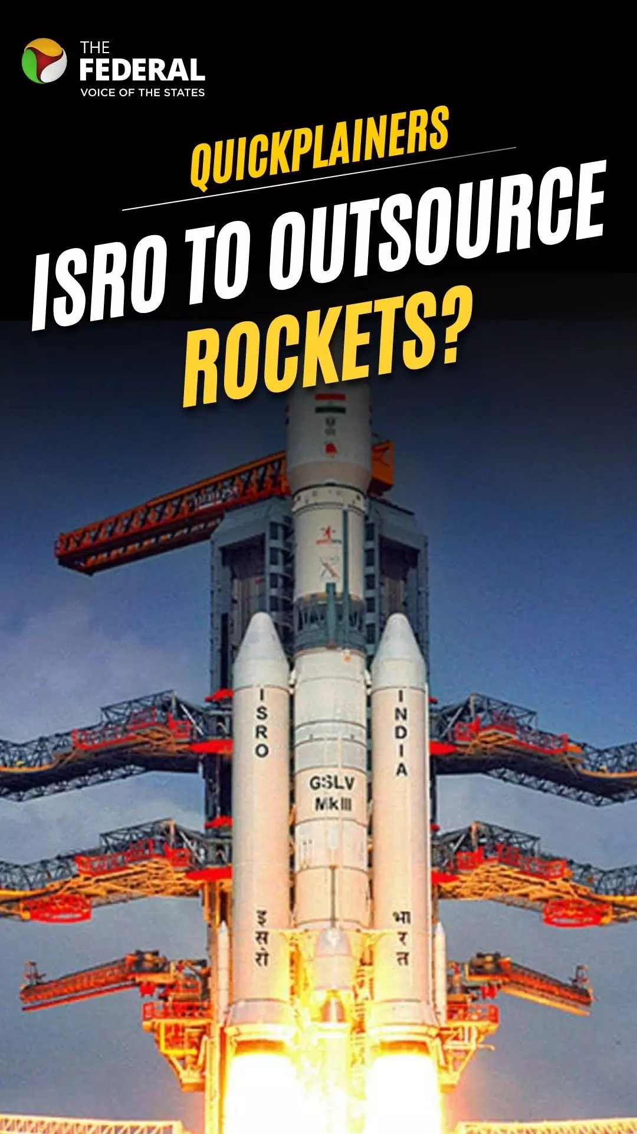
Private Players Might Take Over ISRO's Rockets The Federal

5. Cutting-edge infrared space telescope Roman set to launch
Read more
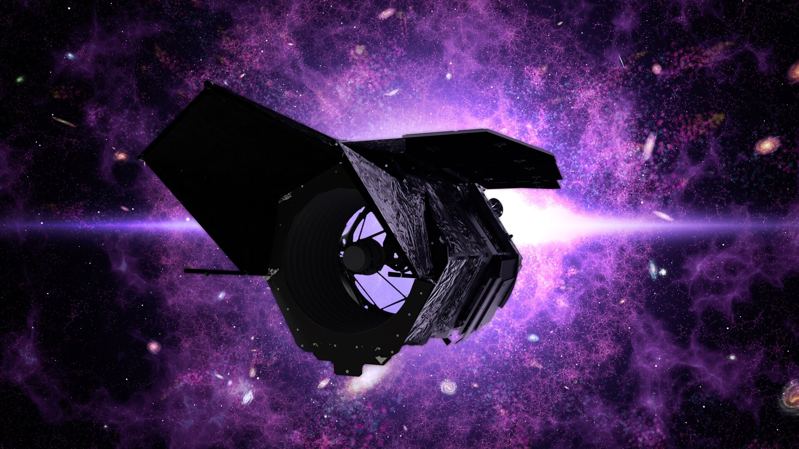
Science & Exploration Cutting-edge infrared space telescope Roman set to launch 25/08/2026 380 views 7 likes The NASA-led Nancy Grace Roman Space Telescope is set to launch on 30 August 2026 at 07:26 EDT / 12:26 BST / 13:26 CEST from NASA's Kennedy Space Center in Florida, USA. With its wide field of view and advanced optical design, the Roman telescope will conduct detailed scans of the sky in visible to near-infrared light. In doing so, Roman will help reveal the nature of dark energy and dark matter and find new exoplanets. "ESA is contributing essential hardware to Roman, including the spacecraft's star trackers, batteries, detectors for the coronagraph instrument, and communications support through its deep-space ground station network," says Bethan James, ESA's Roman Project Scientist. "Through the Mission of Opportunity programme, Europe contributes scientific expertise, helping guide and maximise the mission's scientific return." ESA will also enable data download from Roman using the new 35-metre antenna in New Norcia, Australia. Looking back at the early Universe Roman will conduct fast, detailed scans of the sky in infrared light. This will reveal a lot about the early Universe and how it expanded over time. "It will combine Hubble-quality imaging with a field of view more than 200 times larger, allowing it to study billions of stars, millions of galaxies, thousands of exoplanets, and vast regions of previously unexplored space," explains Bethan. "This will enable astronomers to address some of the biggest open questions in astrophysics, from the nature of dark energy to the abundance of planets throughout our Milky Way galaxy." Dark matter and dark energy Roman will join ESA's Euclid in uncovering the mysteries of the dark Universe About 25% of the Universe appears to be made up of invisible dark matter. The presence of dark matter can only be 'seen' by how it affects the apparent shape of galaxies. Light from a distant galaxy is bent and distorted due to the presence of clumps of dark matter, making the galaxy look slightly warped. This effect is called weak gravitational lensing. One of Roman's main tasks will be to scan about 12% of the sky high above our galactic plane to look for the lensing effect in millions of distant galaxies. By studying tiny changes in the shapes of galaxies, Roman will help astronomers accurately map the distribution of ordinary and dark matter across the history of the Universe and trace how galaxies evolved. Roman will investigate how the Universe has expanded over time. The expansion appears to be speeding up, and dark energy seems to be the culprit. Scientists think that dark energy makes up about 70% of the Universe and yet its nature remains a mystery. Like ESA's Euclid, Roman will use multiple methods to help us understand what dark energy is and how it has evolved over time. In one method, Roman will look for exploding stars known as supernovas, in distant galaxies, especially type Ia supernovas. Because these explosions peak at a predictable brightness, astronomers can use them to measure cosmic distances, which in turn provide insights into how fast the Universe is expanding. In another method, Roman will map how galaxies cluster together in time and space to test the effect of dark energy on them. Roman will study baryonic acoustic oscillations - imprints of sound waves that once rippled through the very early Universe. Like ESA's Euclid, Roman will use the method of baryonic acoustic oscillations to trace the expansion of the Universe As the Universe cooled, these ripples froze in place. Over time clusters of galaxies formed along the frozen ripples. Eventually, as the Universe expanded, the ripples stretched, and the distance between the surrounding galaxies increased. By looking at how galaxies are distributed across cosmic distances, astronomers can study how the Universe expanded over time. This will further shine a light on the nature of dark energy. Exoplanets Another task of Roman will be to look for exoplanets including planetary systems like our own. Using its deep and wide field of view, Roman will peer into the heart of our own galaxy. By doing so, it will track the amount of light coming from millions of stars and study how the intensity of light changes over time. Roman will keep an eye on microlensing events that may reveal over 1200 new worlds. At the same time, the telescope is expected to reveal more than 100 000 transiting planets that dim the light of their host stars when the planets cross in front of them. Roman's advanced coronagraph instrument will allow astronomers to directly image some of the exoplanets in detail by blocking the host stars' light, even when the planet is over 100 million times fainter than its host star. Extreme cosmic objects Roman is so sensitive that it will also detect extreme events, such as the birth of black holes when neutron stars merge, and tidal disruption events. The mission will also observe active galaxies hosting extremely bright quasars at their centres and several faint faraway quasars from the period of reionisation. Wide-eyed telescope in space Roman Wide Field Instrument detector plane The Roman Telescope is equipped with a primary mirror of 2.4 m in diameter. The telescope has two main instruments: the Wide Field Instrument (WFI) and a Coronagraph Instrument. The WFI is a 300-megapixel multi-band visible and near-infrared camera capable of obtaining extremely crisp images and very sensitive spectroscopic data. The Coronagraph Instrument is a high-performance technology demonstrator that blocks out starlight to look for faint planets around them. The instrument could be capable of directly imaging reflected starlight from Jupiter-sized exoplanets in Jupiter-like orbits around their host stars. "Whenever astronomy opens a new window on the Universe, history has shown that some of the most important discoveries are the ones we never anticipated," remarks Bethan. "With its unprecedented combination of depth, area and image quality, Roman has every opportunity to surprise us." Follow the launch live here Roman is scheduled to launch on a SpaceX Falcon Heavy rocket from NASA's Kennedy Space Center in Florida, USA on 30 August 2026 at 07:26 EDT /12:26 BST / 13:26 CEST. Watch the launch live via NASA's YouTube channel. Follow NASA for updates. For more information, please contact: ESA Media Relations Email: media@esa.int

6. 'You just saved the video dish': Two astronauts complete spacewalk to replace ISS antenna
Read more
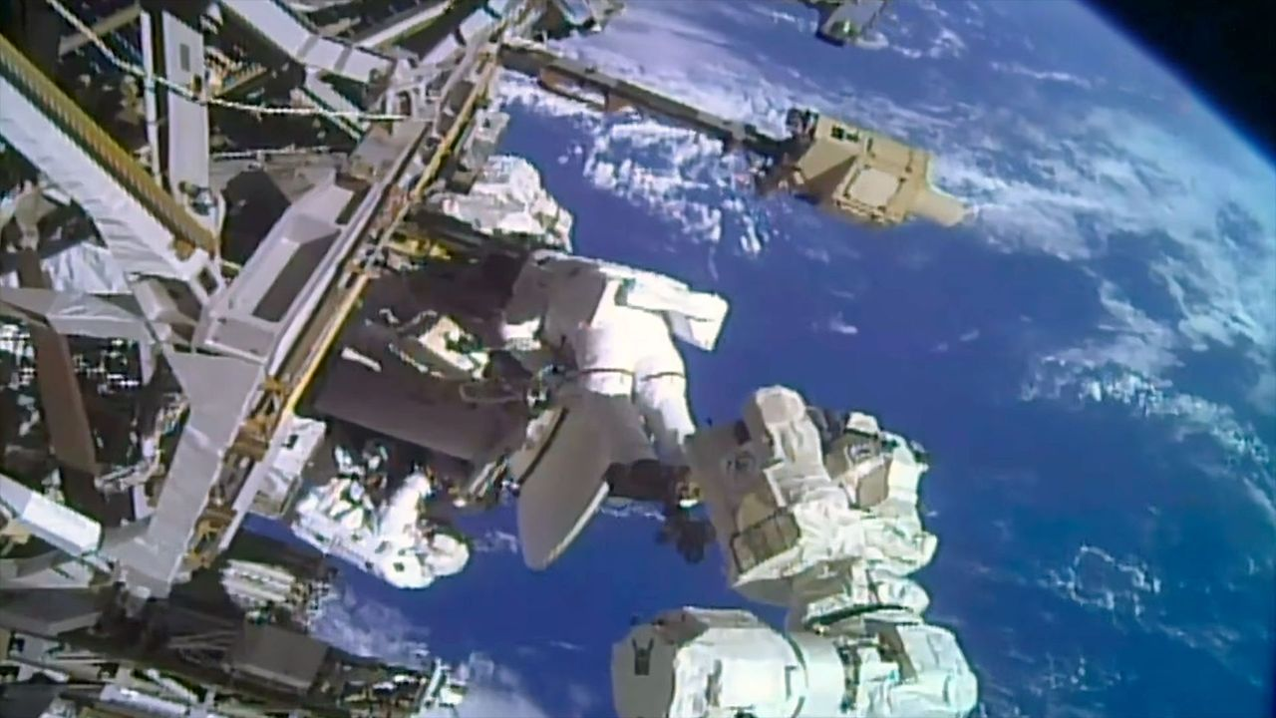
Click for next article Astronauts Anil Menon and Sophie Adenot conduct a spacewalk to install a replacement Space-to-Ground antenna on the outside of the International Space Station on Tuesday, Aug. 25, 2026. "Houston, we have a working comm link again." Thanks to the efforts of two astronauts, such a call is possible again using one of two Space-to-Ground antennas outside the International Space Station (ISS). The pair finished the replacement of a faulty dish assembly during a spacewalk on Tuesday (Aug. 25). Anil Menon of NASA and Sophie Adenot of the European Space Agency (ESA), who previously removed a faulty dish during a spacewalk on Aug. 18, installed a spare in its place and moved the broken assembly from a temporary to more permanent storage location along the station's backbone truss. As seen from a camera mounted on ESA astronaut Sophie Adenot's helmet, fellow Expedition 75 crew member Anil Menon of NASA works to mount a replacement Space-to-Ground antenna during a spacewalk outside of the International Space Station on Tuesday, Aug. 25, 2026. (Image credit: NASA) With Menon positioned at the end of the Canadarm2 robotic arm and Adenot traversing by handrails to join him, the two Expedition 75 crewmates first retrieved a spare Space-to-Ground Antenna (SGANT) from an external stowage position. Menon and the spare dish were then maneuvered to the Z-1 truss, where it was mounted and connected to the station's power and data systems. Menon and Adenot then retrieved the faulty antenna, which they had stowed on the Z-1 truss during the prior spacewalk. Menon (on the arm) moved it to external stowage platform-3 (ESP-3) on the starboard side of the truss. The replacement work became necessary after the SGANT ceased being able to track NASA's data and relay satellites , rendering it unusable, beginning last November. A second antenna has been in use since, continuing the transmission of voice and critical data, but this repair re-established redundancy to the system. "On behalf of CAPCOM and I, we're going to count down like a bolt: '3, 2, 1… You just saved the video dish, you just saved the video dish,'" sang astronaut Anne McClain from Mission Control at NASA's Johnson Space Center in Houston, parodying the The Buggles' 1979 hit "Video Killed the Radio Star." "Oh my god, it is hard to top that," replied Menon, who could be heard laughing along with Adenot. "I want to thank the entire team on executing this complex, time-critical operation successfully." Tuesday's spacewalk began at 8:27 a.m. EDT (1227 GMT) and was completed exactly 6.5 hours later, at 2:57 p.m. EDT (1857 GMT). The extravehicular activity (EVA) was the 283rd in support of ISS assembly, maintenance and upgrades. It was Menon's third EVA, increasing his total spacewalking time to 19 hours and 20 minutes. It was the second time that Adenot worked in the vacuum of space, raising her time on EVA to 12 hours and 53 minutes after becoming the first woman and fifth citizen of France to perform a spacewalk. This was the sixth outing from the International Space Station this year, the second EVA for Expedition 75 and the 98th spacewalk using U.S. extravehicular mobility unit (EMU) spacesuits at the station.

7. Starbase Louisiana: SpaceX announces enormous $100 billion Starbase launch site
Read more

Click for next article Illustration of SpaceX's planned Starbase Louisiana site, which the company says will support thousands of Starship launches per year. A new spaceport will bring 10 launch pads to Louisiana's Gulf Coast and support thousands of Starship launches per year. SpaceX and Louisiana Governor Jeff Landry announced Tuesday (Aug. 25) a $100 billion investment in the state's Vermilion Parish to build "Starbase Louisiana," a sprawling new manufacturing and launch facility for SpaceX's massive Starship rocket. It will be one of the biggest projects in the state's history, and serve as SpaceX's largest center for spaceflight operations. Once complete, the new site will feature five complexes that feature two Starship towers each, for a total of 10 launch pads across the facility, each with its own propellant farm. That fuel will also be produced onsite as well. "We're planning to build a self-sustaining spaceport with its own propellant production, power generation, deep water shipping capabilities, vehicle processing facilities, and probably an airport," SpaceX President Gwynn Shotwell said during the announcement event. "And thanks to the abundant resources here in Louisiana, we have ready access to the natural gas that fuels these rockets to get to orbit." SpaceX and Louisiana officials say the site will eventually support thousands of launches per year and will be central to SpaceX's effort to dramatically increase Starship's flight rate. SpaceX founder and CEO Elon Musk recently estimated that Starship will be launching more than 30 times per day by 2030, which equates to more than 10,000 flights per year. Landry framed the project in historic terms, saying."This will be the place [from] which America reaches farther than it has ever reached before. In 1803, Louisiana gave America a continent. Today, Louisiana and SpaceX will give America the stars ." Starship is SpaceX's next-generation, fully reusable launch vehicle. The giant rocket is still under development, but the company is quickly making strides to mature the rocket to operational status. SpaceX is preparing for Starship's 14th test flight in September, and is on a tight timeline to qualify the rocket for operational missions. Shotwell said SpaceX's existing infrastructure can't support the number or cadence of Starship launches the company anticipates reaching, and tied Starbase Louisiana to SpaceX's long-term goal of using Starship to make human life interplanetary. In the nearer term, Starship is also tasked with returning astronauts to the surface of the moon . NASA has contracted SpaceX to design a lunar lander version of Starship for the agency's Artemis program . Artemis III is scheduled for mid-2027, and will launch NASA's Orion spacecraft to Earth orbit to practice rendezvous and docking maneuvers with one of SpaceX's current "Version 3" Starship test vehicles. The first moon landing of the program is planned for Artemis IV in 2028, giving SpaceX a fast-approaching deadline to mature Starship from test article to crew-certified lunar lander. Render of Starship and Orion docked on Artemis III, scheduled for mid-2027. (Image credit: SpaceX) For the Artemis IV Starship to carry out its mission of landing astronauts on the surface of the moon and then launching them back to lunar orbit to rendezvous with Orion, and for any Starship mission beyond low Earth orbit, the spacecraft requires refueling launches of additional "tanker" Starships. Artemis IV's Starship may need up to a dozen such refueling flights. But Starbase Louisiana's 10 launch pads will be for more than propellant delivery. SpaceX plans to launch its next-generation Starlink internet satellite constellation aboard Starship. To date, SpaceX has launched more than 300 Starlink missions aboard its workhorse Falcon 9 rocket, which has delivered more than 11,000 of the satellites to orbit. Already preparing for the transition to Starship, SpaceX just launched its last Falcon 9 Starlink mission from Florida , and plans to fly the remaining Falcon 9 Starlink launches from Vandenberg Space Force Base in California. SpaceX intends to retire Falcon 9 entirely once Starship is fully operational. The company is also planning for Starship to launch its huge artificial intelligence network and build out an orbital infrastructure to "move supercomputing to space," Shotwell said, as artificial intelligence drives greater demand for resources. Illustration of SpaceX's planned Starbase Louisiana site, which the company says will support thousands of Starship launches per year. (Image credit: SpaceX) "Put all of this together, and these tasks will require thousands of launches," Shotwell said. "Starbase Louisiana is being designed from day one to support this dramatic increase in launch cadence." Construction on the new Starbase is expected to begin in 2027, with the first launch from the site targeted for 2029, SpaceX said. According to an outline of the plan from Louisiana Economic Development, the state agency overseeing the project's economic development efforts, the project is expected to create 3,000 direct jobs over the next decade, and thousands of additional jobs indirectly tied to its development. Already having gone through the processes in Texas and Florida, SpaceX has also already begun working with Louisiana wildlife and coastal agencies to assess the impacts of such a large industrial complex along the Gulf Coast. "We are committed to doing our part to ensure that this land doesn't disappear," Shotwell said, viewing the area as a unique opportunity to fly the world's most powerful rocket, while supporting Louisiana's coastal resilience. "SpaceX is partnering with state and federal agencies to expand Louisiana's coastal master plan, including shoreline protection, marsh restoration, and wildlife conservation," she said. Starbase Louisiana will be SpaceX's biggest undertaking ever, and likely the eventual hub of the company's launch operations. "This will be a project like no other," Shotwell said, "another piece of science fiction transported into reality."

8. NASA's Roman Space Telescope will reveal the universe in a way the JWST and Hubble cannot
Read more
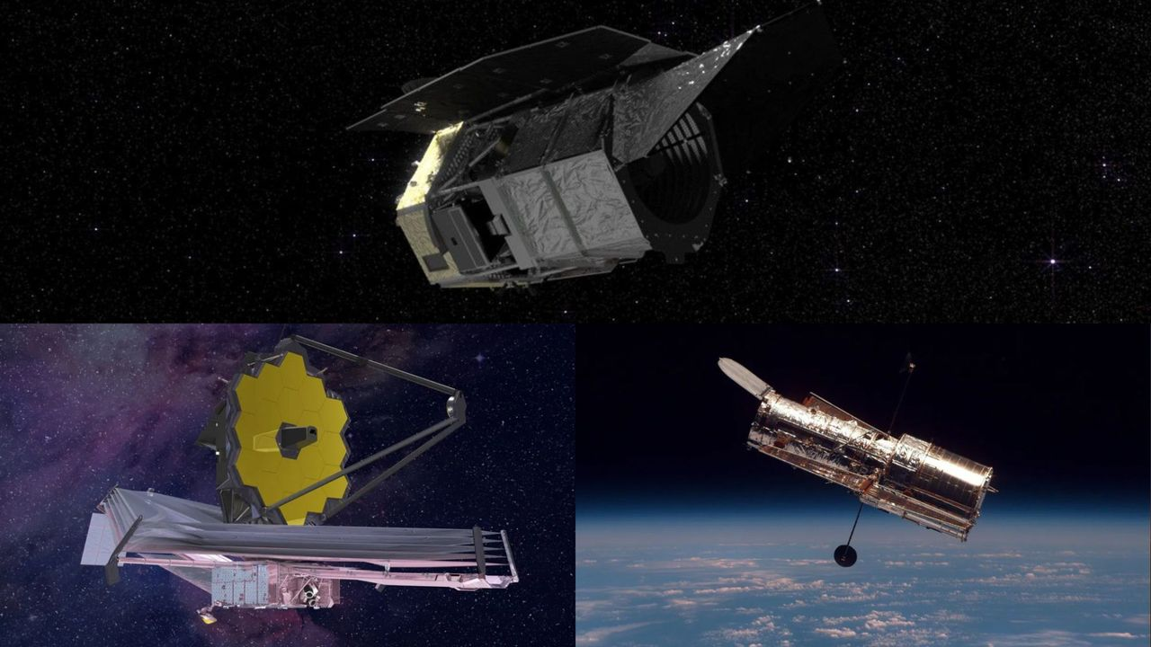
Click for next article The Roman Space Telescope on top, the James Webb Space Telescope on the bottom left and the Hubble Space Telescope on the bottom right. Even if you aren't the kind of person who often looks up the latest space images, it's hard to navigate life (especially on the internet) without running into a few. Try choosing a new iPhone background and you'll have your pick of sharp, gray moon portraits. Watch an old "Star Trek" episode and you may not realize how many of those translucent nebulas outside the spaceship's windows were based on real, hard data. When it comes to space, we're spoiled. Mind-bending objects light-years away from us have managed to become integrated into our everyday lives - and though we're still a ways away from understanding the true nature of the universe, we're also the closest we've ever been. It's in large part thanks to how impeccable our fleet of space telescopes is. In seconds, you can find a Hubble Space Telescope Deep Field with luminescent galaxies warped along the curvature of spacetime and James Webb Space Telescope images of strange hazy red objects from just after the dawn of time. Moreover, what's tremendously exciting is this fleet is constantly growing. Indeed, very soon, a new space telescope will launch from NASA's Kennedy Space Center in Florida. It's called the Nancy Grace Roman Space Telescope , and it should be able to unlock a new level in the astronomy layer of our lives. It will show us new types of images, reveal new types of data and lead us in directions we may not yet know are possible. What is Roman? To put it succinctly, the Nancy Grace Roman Space Telescope is an approximately 42-foot-long (12.7-meter-long), cylindrical metal observatory scheduled to lift off from our planet on Aug. 30 aboard a SpaceX Falcon Heavy rocket. Across a five-year-long mission (a 10-year-long one if everything goes well), Roman is meant to use two powerful instruments - the Wide-Field Instrument (WFI) and Coronagraph Instrument - to image huge swaths of the cosmos and tackle some crucial questions. It will help scientists probe the mysteries of dark matter and dark energy , directly image exoplanets near and far, witness an extensive amount of stars exploding in colossal supernovas and more. But whether or not it's a fair thought, it's hard not to want to compare the specifications of this space telescope to some of the others that have brought the cosmos down into our daily lives. This is particularly true for two of the major players right now: the James Webb Space Telescope and the Hubble Space Telescope. What can Roman do that these two cannot? The multiple-image effect seen in this Hubble picture is produced by a process called gravitational lensing, a quirk of warped spacetime in which the gravitational field of a massive object bends and amplifies light from a background object. (Image credit: ESA, NASA, K. Sharon (Tel Aviv University) and E. Ofek (Caltech)) Roman vs. Hubble To start, one of the biggest benefits of Roman over Hubble is its processing power. By numbers, that means Hubble has managed to gather about 400 terabytes of data over its approximately 35 years of service so far. Roman is expected to be able to create 500 terabytes of data every single year. "Its surveying capabilities are over 1,000 times faster than Hubble, and can chart 200 times more sky in a single image," NASA administrator Jared Isaacman said during a press conference about Roman in April . "What would take Hubble 2,000 years to process, Roman can do in a year - the images it captures will be so large there is not a screen in existence large enough to show them." Roman's primary mirror is about 7.9 feet (2.4 meters) wide, which is actually the same as Hubble's. Primary mirrors are arguably the most important aspect of a space telescope, because it's how an observatory manages to gather light coming from the universe. Bigger mirrors can collect more light, which allows them to see dimmer or more distant objects. Interestingly, Roman's primary mirror is also about 80% lighter than Hubble's. Roman has a secondary mirror as well; it's just under 2 feet (0.5 meters) wide. Hubble's secondary mirror is very similar at exactly 12.2 inches (0.3 m) in width. On the left, the Roman Space Telescope. On the right, Hubble. (Image credit: NASA's Goddard Space Flight Center) Yet even though Roman's mirrors are so comparable to Hubble's, because of Roman's processing power as well as the capabilities of its WFI, it will be able to image a far wider stretch of sky than Hubble can. Though Roman does have some visible light capabilities like Hubble, WFI specializes in infrared light - actually the kind of light the JWST works with, but we'll get to that telescope comparison shortly - so we should compare it to Hubble's infrared instrument. The WFI's field of view is about 100 times greater than the Hubble infrared instrument's field of view. According to NASA, this view will allow Roman to measure light emanating from a billion galaxies and billions more cosmic phenomena over its years of service. "Both observatories will perform spectroscopy," NASA explains, "which involves splitting light into individual colors to study patterns that reveal detailed information. But Roman's spectral studies will have lower resolution over a large area, while Hubble's has higher resolution over a small area." This concept really sums up the difference between the two telescopes, and in fact foreshadows what we'll soon discuss about the JWST. NASA's Nancy Grace Roman Space Telescope is encapsulated in the payload fairing of its SpaceX Falcon Heavy rocket. (Image credit: SpaceX) Roman vs. the JWST The main similarity between the Roman Space Telescope and the JWST is those infrared light goggles. Infrared light, unlike visible light, is invisible to human eyes. You can think of it more like a heat signature. Firefighters, for instance, use infrared trackers on burning buildings from the outside to see where the source of the fire might lie within. And when it comes to astronomy, infrared light is priceless - that's why the JWST's strong infrared capabilities give it an advantage over Hubble. Infrared light's role in astronomy observations has to do with the way light moves throughout the universe. As light from a distant region of space moves toward us - through a continuously expanding universe, no less - those light wavelengths stretch out from tight, bluer ones into long, redder ones. Eventually, the wavelengths stretch out into the infrared region of the electromagnetic spectrum , which is the part of the spectrum we cannot see with our own eyes. Plus, any objects in our line of sight that are hidden behind dense clouds of interstellar dust or gas can only be seen via their infrared emissions. What this means is that very, very distant objects as well as concealed objects in space are pretty much invisible to us, hiding in the infrared part of the spectrum. We therefore need infrared decoders, like the JWST's suite of tools or Hubble's infrared instrument, to reveal them. The JWST has already made absolute strides in this regard, revealing to us peculiar objects from the early years of the universe, consistently breaking its own record while finding the most distant galaxies we've ever seen and revamping Hubble portraits like the spectacular Pillars of Creation with its infrared filter. It's even reintroduced us to our own solar system with crisp views of Neptune 's frail, oft-forgotten rings and Saturn 's big, bright ones. The JWST's view of Neptune and its rings. The world looks so small when seen this way. (Image credit: ESA/NASA) When it comes to mirrors, the JWST's iconic golden primary mirror made of 18 hexagonal segments is a beautiful 21 feet and 4 inches (6.5 meters) across, which is much larger than Roman's. This means the JWST can collect tons more light than Roman can, which makes a lot of sense because it was built to see as deep into the ancient universe as possible. But where the JWST lacks is, you guessed it, its field of view. This is on purpose. The whole point of JWST is to pierce into the universe with a highly narrow view in order to get great resolution on whatever it's looking at. Roman definitely won't be getting that same resolution, as its images will be shallower than the JWST's, but its WFI will see a region 50 times wider than what the JWST can see. A view of the James Webb Space Telescope's giant mirror. (Image credit: NASA) The Roman Space Telescope's mirror. (Image credit: NASA/Sydney Rohde) To be clear, there are indeed other survey telescopes that are able to image huge amounts of the sky at once, but Roman's version of doing this is expected to be with higher clarity. For example, the ground-based Rubin Observatory is revolutionary for the vast amounts of data it's able to collect while scanning a new section of the sky every 40 seconds. However, Rubin is on the ground. A space telescope sits above Earth's atmosphere, and therefore has less atmospheric interference to sift through. This makes the observations way better. Okay, you've probably figured out the moral of the story at this point: Roman's reach is shallower than Hubble's and the JWST's, but extremely wide. So, what's the benefit of this enormity? Simulated views of what a section of space would look like from the Rubin Observatory and the Roman Space Telescope. Because it has to peer through Earth's atmosphere, Rubin's images won't always be sharp enough to distinguish multiple, close sources as separate objects. (Image credit: J. Chiang (SLAC), C. Hirata (OSU), and NASA's Goddard Space Flight Center) The promise of Roman Imaging huge amounts of the universe in one go is of foremost importance because things in the universe happen simultaneously. A supernova on one end might be worth checking out, but a fleeting fast radio burst buzzing on the other end of the cosmos could be just as vital to study. Yet, with a narrow field of view, you'd have to select which target to zoom in on. And if you aren't sure which targets are even options, while perusing an ancient black hole with immense resolution you will most definitely miss an even older one that lurks 50 frames or so away. With Roman, scientists won't have to be as selective about which parts of the sky they scan. Roman is designed to be able to capture the supernovas, fast radio bursts, black hole emissions and warped galaxy candidates all at once. For example, NASA explains how Roman will be able to spot colliding neutron stars - stellar corpses so dense a tablespoon of one is equal to the weight of Mount Everest - with its infrared view. The JWST would likely never even come across such an event due to its tunnel vision. Of course, Roman won't be able to image these objects with as much depth as the JWST or Hubble - or several other telescopes for that matter, like maybe SPHEREx or Euclid - but it will be able to notice that these objects exist. The next step would be to have one of those other telescopes follow up on the targets. You can think of Roman as creating the Google Maps of hotspot locations in the universe that the JWST, Hubble or another telescope may want to examine someday. Big field of view means big science Furthermore, capturing information from billions of objects in such a short period of time will enable specific kinds of research, such as the hunt for the truth about dark matter and dark energy. Despite collectively making up about 95% of the universe's contents, dark matter and dark energy aren't visible to us. However, we know dark energy exists because it appears to be applying a force that accelerates the expansion of our universe and we know dark matter exists because it seems to be the glue around galaxies that prevents them from falling apart like horses on a merry-go-round spinning too fast. What this means is imaging tons of galaxies at once could allow scientists to have a better picture of how those interactions between the dark universe and our regular universe play out. Roman will also be able to create time-lapse "movies" of the universe in three dimensions and offer scientists the chance to see how other observations fit into that picture. It would also be remiss not to mention what Roman's other instrument can do: the coronagraph. The telescope's coronagraph is actually one-of-a-kind. You can think of it like a special artificial eclipse that brings objects into view that would otherwise be obscured by bright starlight. No other space observatory in service right now has the ability to directly image exoplanets like Roman will be able to using that coronagraph. It would take an entire other article to explain the awesome complexities of this instrument - an article that you can definitely expect soon - but to go through the basics, this tool will block out the glare of distant stars and then measure the polarization of light around them in order to help scientists tease out exoplanets orbiting those stars. A side by side view of the Hubble Telescope's view of the Pillars creation and the JWST's. (Image credit: NASA, ESA, CSA, STScI, Hubble Heritage Project (STScI, AURA), Joseph DePasquale (STScI), Anton M. Koekemoer (STScI), Alyssa Pagan (STScI)) According to NASA, Roman's coronagraph will be able to detect planets 100 million times fainter than their stars. That capability is about 100 to 1,000 times better than existing space-based coronagraphs. This will give scientists the opportunity to study planets beyond our solar system that are dimmer, colder, farther and more elusive than what we're currently able to see. With all this in mind, there is an important concept to remember. When the JWST first entered service in the year 2022, everyone (including me) started comparing it to Hubble and thinking of it as Hubble's upgrade. It's hard not to, especially when the images rolling out of a shiny new telescope are so utterly gorgeous. But "upgrade" couldn't be farther from reality . The JWST is just different. Impressive, sure, but different. The goal is for all of these telescopes to work together, each one giving us a new sheet of the universe to explore. Stack up all the sheets, and you'll get the full picture. Roman will simply be offering us one breathtaking new sheet.

9. Astronauts make history repairing the ISS | Space photo of the day for Aug. 25, 2026
Read more
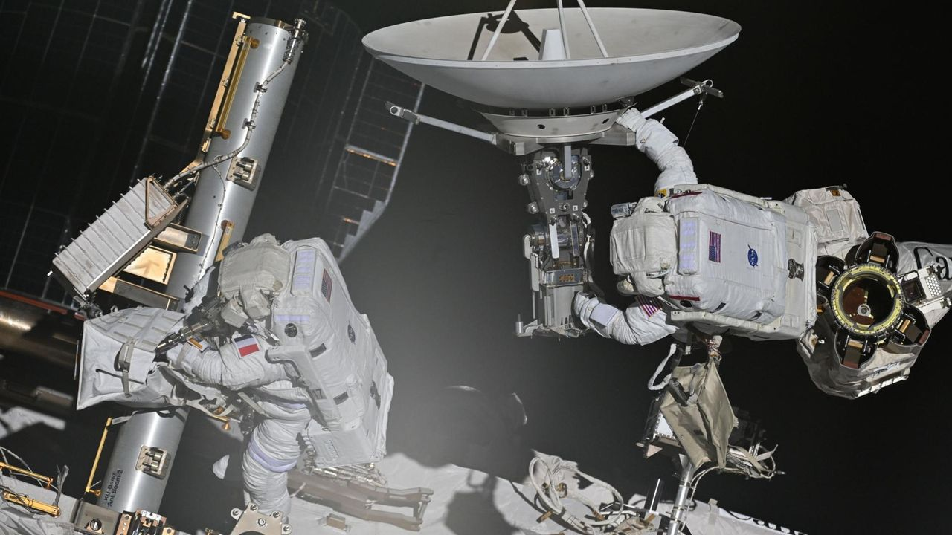
Click for next article ESA astronaut Sophie Adenot and NASA astronaut Anil Menon complete a spacewalk on Aug. 18, 2026. (Image credit: Roscosmos/Anna Kikina) Intensely focused and tethered to a floating laboratory in the vacuum of space, two astronauts spent over 6 hours working on the International Space Station during a historic spacewalk. What is it? Two astronauts aboard the ISS set out on a spacewalk recently (Aug. 18). European Space Agency astronaut Sophie Adenot and NASA astronaut Anil Menon set out recently a historic spacewalk. This was Adenot's first spacewalk and, in journeying out into the darkness of space she became the first French woman to conduct a spacewalk (or, formally, an extravehicular activity, or EVA). In this snapshot from the space station, you can see Adenot on the left and Menon on the right, both hard at work on their mission. On this spacewalk , which took the pair 6 hours and 23 minutes, the astronauts were tasked with removing a failed antenna from the space station. However, while it was a successful outing, the pair didn't have enough time to replace the old antenna with a new, working one. Why is it incredible? Getting to space is hard enough. And then once you're there, venturing out of an orbiting laboratory into the darkness of space to do a physically demanding but technically complex repair job on that laboratory is certainly no picnic. But these two astronauts pushed through almost six-and-a-half hours of grueling space work to remove the broken antenna before running out of time. And this big step forward in this fix is critical, as these antennae help to connect the space station to Earth, which is of the utmost importance. The antenna, a "Space-to-Ground" antenna, started malfunctioning months ago and a second antenna has temporarily taken over. But this solution was temporary and a more permanent replacement was needed as this antenna ensures that astronauts on the space station can quickly transmit critical information back down to Mission Control back on Earth.

10. On this day in space! Aug. 25, 1997: NASA launches Advanced Composition Explorer to track solar wind and so much more
Read more
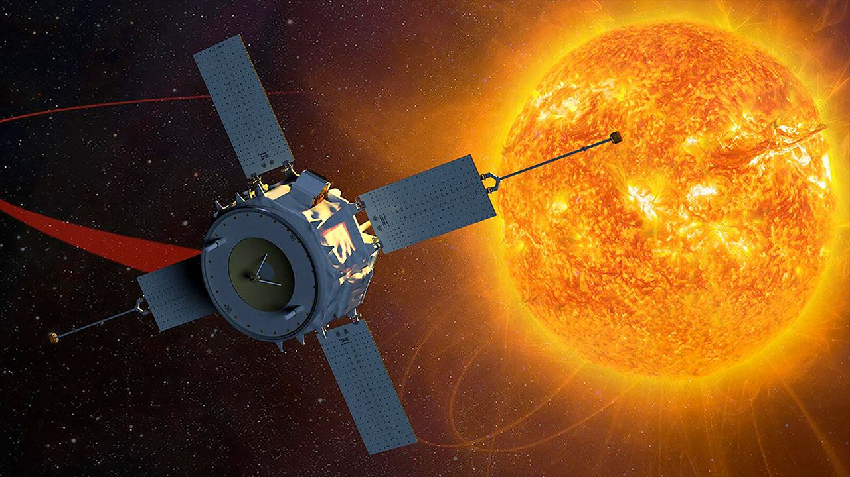
Click for next article On Aug. 25, 1997, NASA launched the Advanced Composition Explorer, or ACE satellite to study energetic particles traveling through space. It lifted off from Kennedy Space Center in Florida on a Delta II rocket and spent the next three and a half months making its way to its orbital post near the L1 Lagrangian point , a point of gravitational equilibrium between Earth and the sun. There, the spacecraft is monitoring the stream of accelerated particles coming from the sun known as the solar wind . ACE provides 24/7 continuous coverage of the solar wind, which lets scientists know when to expect geomagnetic storms that can disrupt communication satellites and power grids on Earth. Why it mattered A Boeing Delta II rocket launches NASA's Advanced Composition Explorer satellite from Launch Complex 17A at the Cape Canaveral Air Force Station in Florida on Aug. 25, 1997. (Image credit: NASA) The ACE satellite is a NASA sentinel survivor. When it launched in 1997, NASA hoped the ACE satellite mission would last up to five years as it monitored solar wind speeds and conditions, as well as the flow of other critical charged particles through space, such as galactic cosmic rays , as well as interplanetary and interstellar particles. As of today, ACE has been hard at work for 29 years and shows no signs of stopping. It's one of NASA's oldest still-operating sun-monitoring spacecraft (the Solar and Heliospheric Observatory , or SOHO, is two years older, as it launched in 1995). ACE serves as a core part of NASA's early-warning system for incoming space weather. It's nine primary instruments were between 10 and 10,000 times better than any sensors flown in space when the satellite launched in 1997. In 2005, one of those instruments - the Solar Energetic Particle Ionic Charge Analyzer - stopped sending data, but it is the only instrument to be lost during ACE's lifetime, NASA has said . Want more space history? Check out our full On This Day In Space Story archive and watch our On This Day In Space videos on YouTube .

11. Polish startup Ares Shield hired to protect data center satellites with high-power microwave weapons
Read more
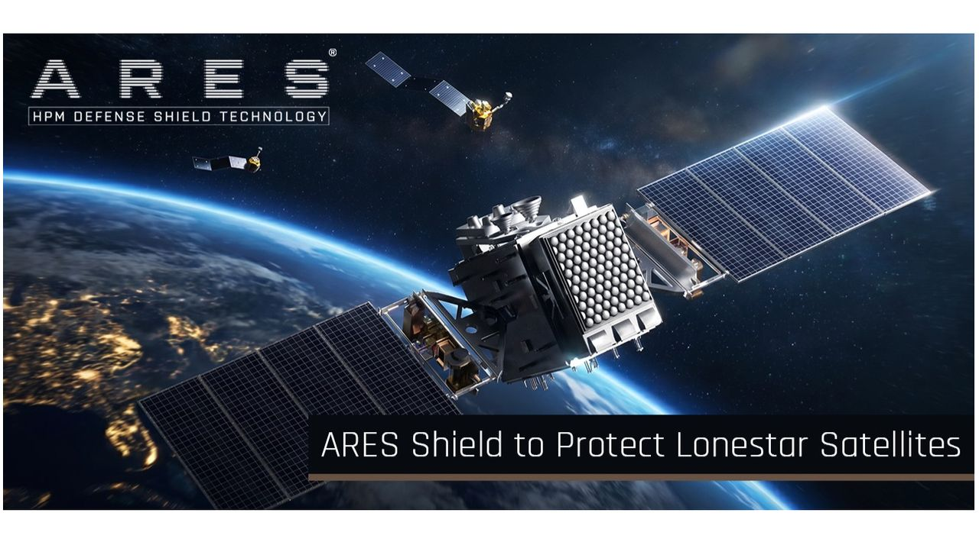
Click for next article Ares Shield just signed a deal to provide protection for some of Lonestar Data Holding's satellites. The final frontier is getting more and more contested, so satellite companies are investing in some self-defense. At least one of them is, anyway. Florida-based Lonestar Data Holdings announced today (Aug. 25) that it has contracted Polish startup Ares Shield to provide protection for its off-Earth data centers , in a deal worth up to $6 million. "Our clients entrust us with mission-critical data, which is why we treat the security of our orbital infrastructure as the foundation of our entire service," Lonestar CEO Stephen Eisele said in a statement today. "Ares Shield technology offers a unique solution that allows us to further protect our satellites without the risk of generating space debris. For a company whose product is data security, it is a compelling option." Lonestar has already tested its data-storage tech on four space missions, including two that went to the moon . For example, one of the company's devices hit the gray dirt aboard Intuitive Machines ' Athena lander in March 2025. Athena toppled over shortly after touchdown, but Lonestar's mini data center achieved its desired milestones regardless , according to the company. Such work has helped inform the development of Lonestar's first commercial space-based offering - a platform called StarVault, which will store customer data at a healthy remove from natural disasters and other issues that could crop up here on terra firma. "StarVault combines Lonestar's advanced cryptographic key escrow capabilities with space-based data storage infrastructure, creating a new class of digital resilience - extending secure data beyond Earth," the company said in a statement in April. The first StarVault payload is currently scheduled to fly aboard Sidus Space's LizzieSat-4, which is manifested on SpaceX 's Transporter 18 rideshare mission. That flight is expected to launch from California's Vandenberg Space Force Base in late October. Other StarVault missions will follow, as Lonestar builds a data-storage network in low Earth orbit and, perhaps, more far-flung locales. 🛰️Russian satellites multi-object proximity event in LEORadar tracking data via @LeoLabs_Space, processed through COMSPOC SSA Suite.This week we observed a complex proximity event involving Russian satellites: COSMOS 2581, 2582, 2583, and Object F (a subsatellite released by… pic.twitter.com/3nDkcOmTuDMay 1, 2026 Multiple satellites in that network will be protected by Ares Shield technology, if all goes according to plan. That tech is a combination of sensors, AI-driven analytics and a high-power microwave (HPM) emitter, which are integrated into a module that attaches to the client satellite. Ares Shield's system will be able to detect and classify potential threats, such as approaching "inspector" satellites that may have designs on stealing the client's data. And the defense module can neutralize them via electronics-frying HPM emissions, knocking satellites out without creating a cloud of space debris . But shooting to kill will likely not be the first option, said Ares Shield CEO Grzegorz Zwolinski. "The defense system can show the opponent that we can create malfunctions in their hardware, jam them, or do like small-energy attacks," Zwolinski, who previously co-founded the Polish aerospace company SatRev, told Space.com. "Then they will realize that it's not worth losing their system on this particular infrastructure, which we are protecting." Ares Shield plans to deliver its first defense systems for Lonestar in 2028 or 2029, he added. The newly announced agreement calls for three satellites to be protected initially, with Ares providing modules for more spacecraft in the constellation over time. And there could be other customers in the near future as well. "We are discussing another delivery for other operators," Zwolinski said. "So, we are seeing more and more interest." Such interest is not surprising, given the rise of in-space surveillance and the continuing development of satellites capable of rendezvous and proximity operations (RPO) - the ability to meet up, and potentially interfere, with other satellites in orbit. These threats have increased dramatically in the past few years, according to Zwolinski. When he co-founded SatRev back in 2016, "there were mostly peaceful actions, but during the the war in Ukraine, more hostile actions started to appear on orbit," Zwolinski said, referring to Russian's ongoing invasion, which began in February 2022. "The inspector robots and RPO attacks started to be more frequent," he added. "Russia is is trying to exercise those attacks more and more often . China is doing a lot of RPO attacks on NATO satellites. There are more and more actors which are producing the inspector robots. "So, it appears to me that we should have something to answer for those problems," he continued. "I think in the future, most satellites will need our protection." That need will only increase as more and more data centers reach orbit. And that's expected to happen relatively soon. For example, Elon Musk has said that SpaceX plans to operate one million of its " Starmind " AI satellites in Earth orbit - and that it aims to launch the first prototype spacecraft early next year. Ares Shield plans to protect infrastructure here on Earth as well. The company is currently building HPM systems that can take out drones - which have become key weapons on the modern battlefield - at a distance of 330 feet (100 meters), according to Zwolinski. "The plan is that, in the next five months, we want to increase the distance where we are shooting the drones, and the most wanted is 2 kilometers," he said.

12. NASA satellites ace world's 1st 'lost-in-space' GPS-free navigation experiment
Read more
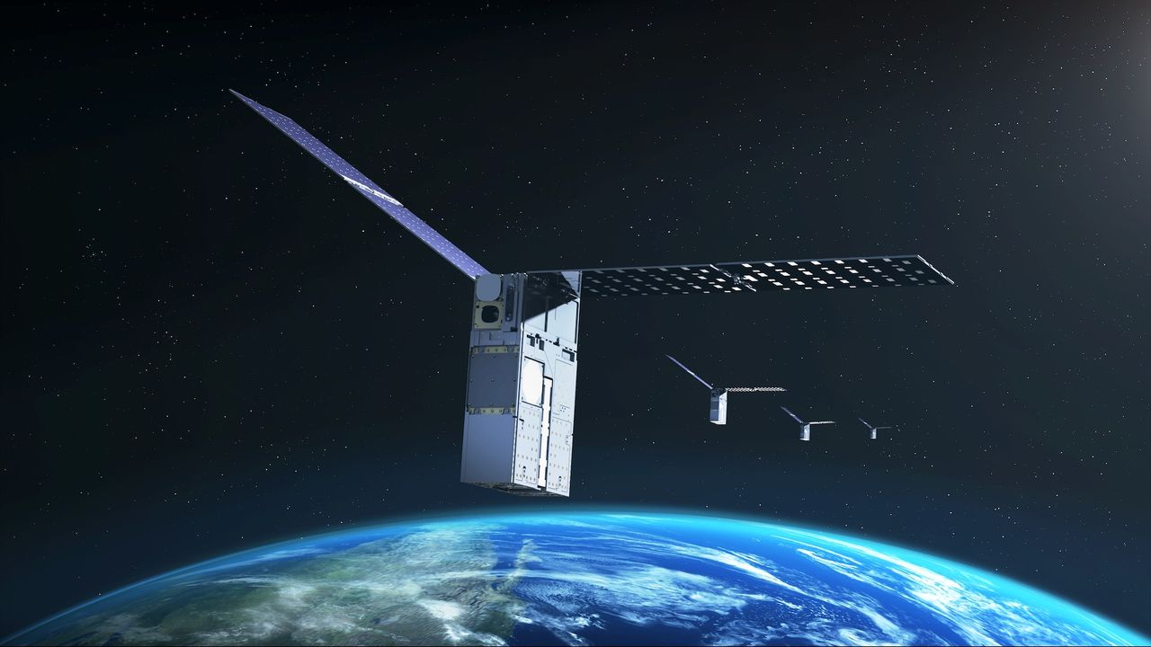
Click for next article No GPS available in space? A satellite experiment may have a solution for that. NASA's Starling mission - made up of a swarm of four cubesats in low Earth orbit (LEO) - is testing out navigation by using other satellites as moving landmarks. The hope is that this tech will allow future missions to navigate if GPS is not available. The three-year-old tech demo will be extended beyond its previous expiration date this year until at least 2028, NASA announced on Monday (Aug. 17). The aim is to get the most out of the onboard experiment, a collaboration with industry partner EraDrive called FALCON (short for "Fast Autonomous Lost-in-space Catalog-based Optical Navigation"). "As NASA prepares for more missions beyond Earth's orbit, technologies like FALCON can support lunar satellite swarms, distributed science missions and human exploration," NASA officials said in Monday's statement. While NASA's applications are civilian, alternative GPS solutions are also being investigated by the U.S. Department of Defense (DoD) out of concern that the limited number of GPS satellites could be vulnerable to adversaries. Earlier this year, for example, Space Force entities SpaceWERX and Space Systems Command jointly launched an initiative aiming for new ideas for "positioning, navigation and timing" (PNT) capabilities in space. The aim of FALCON, however, is to deal with sheer distance. While satellites in Earth orbit have ample access to purpose-built navigational markers such as GPS, that access rapidly thins out as missions go farther afield. And this isn't just an abstract concern; NASA aims to send astronauts to the surface of the moon again as soon as 2028 on the Artemis IV mission, as part of a larger effort to build a moon base . Industry and the military are also very interested in the moon and the area around it, known as cislunar space - and how best to navigate in the new environment. The moon's orbit also introduces complications to navigation; in 2025, for example, Canada's Outer Space Institute reported that "mass concentrations," or mascons , pull down on orbiting satellites and may affect their pathway, in some cases even inducing crashes into the lunar surface. But before testing at the moon, NASA wants to learn more closer to home. It partnered with EraDrive, an autonomous spacecraft navigation company that originated with a group at Stanford University, which provided flight software and algorithms for FALCON. The experiment uses data from Starling's cameras, as well as a catalog on the spacecraft that charts thousands of known satellites and space objects around it. The mission not only is trying out "GPS-independent navigation" but is also showcasing space situational awareness, or SSA - that is, the ability to understand the environment around the spacecraft (including other satellites). Some other spacecraft, like SpaceX's Starlink broadband satellites, use SSA to automatically dodge threats of space debris in LEO. Starling's team is hoping to bring even more capabilities for navigation and SSA. "The results from FALCON can have far-reaching implications for on-orbit space-traffic monitoring, collision avoidance and alternative navigation," Roger Hunter, program manager for NASA's small spacecraft and distributed systems program, said in the statement. NASA plans a to build a permanent base on the moon over the next decade or so, via a step-by-step approach. (Image credit: NASA) FALCON notched two major milestones in its first three years. For PNT, the spacecraft used its cameras to observe other satellites and objects - and to match their information with the onboard database, which includes roughly 20,000 objects from publicly available DoD records. "FALCON then used the observed and verified objects as reference points to determine Starling's orbit," NASA stated. FALCON's in-orbit observations also helped mission managers better understand the pathways of 200 individual objects, beyond the orbital estimates in the DoD catalog. The estimating work was performed over just three days and autonomously, meaning ground operators did not participate. "The self-orbit determination capability made possible through FALCON is a first for spacecraft using optical cameras, to navigate by their relative position to other objects in space," NASA stated. "Separately, the catalog-update experiments produced better object position predictions onboard Starling than those provided by ground stations." Starling's four spacecraft operate at an altitude of about 350 miles (565 km), which is about 6 miles (10 km) higher than originally planned. That's because SpaceX advised mission managers that Starling's mission plan put it at risk of coming close to Starlink satellites already operating in an orbital shell at 340 miles (555 km), according to Space News . By comparison, the International Space Station typically orbits slightly lower than Starling or Starlink, at 250 miles (400 km).

