 |  | 

🌌 अंतरिक्ष समाचार | Space News
बुधवार, २४/०६/२०२६ | Wednesday, 24/06/2026

1. ISRO successfully conducts 2nd integrated air drop test for Gaganyaan mission - News On AIR
Read more
The Indian Space Research Organisation (ISRO) has successfully conducted the second integrated air drop test (IADT-02) for the upcoming Gaganyaan mission at Sriharikota in Andhra Pradesh. The system is essential to ensure safe recovery of the crew module - the capsule in which astronauts sit during a human flight. After the module's release, a parachute system, comprising 10 parachutes, was deployed, helping the capsule decelerate to a safe splashdown speed. The IADT-02 follows the successful completion of the first IADT, which took place on August 24, 2025, at the Satish Dhawan Space Centre in Sriharikota. In the first IADT, a 4.8-tonne dummy crew module was dropped from a height of three km by a Chinook helicopter. Air drop tests recreate the last leg of a spacecraft's return to the Earth. An aircraft or helicopter drops the spacecraft from a height to test various systems under different scenarios. These are the deployment of the parachute system in case the mission is aborted mid-flight, system performance when one parachute fails to open, and the spacecraft's orientation and safety during splashdown. Union Minister Jitendra Singh congratulated the ISRO for successfully conducting the test. India's first human spaceflight will be launched from Sriharikota in 2027.

2. Saint John's students participate in ISRO Young Scientist Programme - MorungExpress
Read more
Class IX students Tshope Lasushe and Kimeri Sangtam of Saint John's Higher Secondary School, Diphupar-B, represented Nagaland at the Indian Space Research Organisation's Young Scientist Programme 2026 in Shillong from May 10 to 23. (Photo Courtesy: St John HSS) Chümoukedima, June 23 (MExN): Two students from Saint John's Higher Secondary School, Diphupar-B, participated in the Indian Space Research Organisation's (ISRO) Young Scientist Programme (YUVIKA) 2026 held in Shillong from May 10 to 23. The students, Tshope Lasushe and Kimeri Sangtam of Class IX, represented the school at the programme, continuing the institution's record of participation in the prestigious initiative aimed at promoting interest in space science and technology among school students. According to the school, this marks the fourth consecutive year of representation at the programme. The school's participation began with one student in 2019, followed by four students in 2024 and five students in 2025. The Young Scientist Programme, organised by ISRO, seeks to impart basic knowledge of space technology, space science and space applications, while encouraging students to pursue careers in science, technology, engineering and mathematics (STEM). During the programme, Kimeri Sangtam secured third position in the project work category. Principal Johny Abraham congratulated the students on their achievement and said the school's continued participation reflects its commitment to promoting science education and innovation. He noted that the programme provides valuable exposure and opportunities for students to interact with scientists and peers from across the region. The school also expressed appreciation to ISRO for providing a platform to nurture young scientific talent in the Northeast.

3. Govt says ISRO has developed & operationalised wide range of space-based applications to benefit society - News On AIR
Read more
The Government has said that the Indian Space Research Organisation (ISRO) has developed and operationalised a wide range of space-based applications to benefit all sections of society, including the welfare of the Scheduled Caste community. Science and Technology Minister Dr. Jitendra Singh informed this in a written reply in the Lok Sabha today. The Minister said that key space application areas include satellite-based Potential Fishing Zone (PFZ) advisories, crop acreage and production forecasting, agrometeorological advisories for farmers, crop insurance support, geospatial support for flagship government programmes, tele-education, telemedicine, the Vessel Communication and Support System, and disaster management support. Mr. Singh noted that ISRO has established robust awareness and capacity-building programmes to promote the use of space technology for societal, governance, and disaster management purposes, enabling decision-makers to operate effectively at the grassroots level. He added that these initiatives are designed to be inclusive and accessible to targeted beneficiaries across the country. The Minister further said that the benefits of Earth observation, satellite communication, and navigation applications, particularly in terms of improved connectivity and navigation services, are reaching SC farmers, students, and disaster-prone regions within satellite coverage areas. He also highlighted that the Department has undertaken several measures to ensure the inclusive use of space technology, including the implementation of flagship initiatives such as Digital India, the BharatNet Programme, the Vessel Communication and Support System (VCSS) under the Pradhan Mantri Matsya Sampada Yojana (PMMSY), and the PM e-VIDYA scheme for tele-education.

4. ISRO ISTRAC Apprentice Recruitment 2026 Out, Apply Online for 95 Graduate, Diploma & ITI Apprentices Posts - Adda247
Read more
ISRO ISTRAC Apprentice Recruitment 2026 Out, Apply Online for 95 Graduate, Diploma & ITI Apprentices Posts Adda247

5. Isro Says Mangalyaan Mars Orbiter Passes Major Comet Hurdle - NDTV
Read more
Isro Says Mangalyaan Mars Orbiter Passes Major Comet Hurdle NDTV

6. ISRO opens XPoSat data to Indian scientists - Ahmedabad Mirror
Read more
Others SciTech ISRO opens XPoSat data to Indian scientists Researchers invited to explore black holes, neutron stars and cosmic mysteries #New Delhi The Indian Space Research Organisation (ISRO) on Monday made an Announcement of Opportunity, inviting proposals from the country's astronomical community to access data from the XPoSat Mission, which studies bright astronomical X-ray sources in extreme conditions. Launched on January 1, 2024, the XPoSat, or X-ray Polarimeter Satellite, currently orbits Earth in a near-equatorial orbit at an altitude of 650 kilometres. It carries two scientific payloads that help study X-ray emission mechanisms of black holes, neutron stars, and active galactic nuclei, among others. In a statement, ISRO said that only "Indian scientists or researchers residing and working at institutes, universities or colleges in India" can submit proposals to access the mission's data.PTI

7. NASA Names Sean Gallagher as Chief Information Officer
Read more
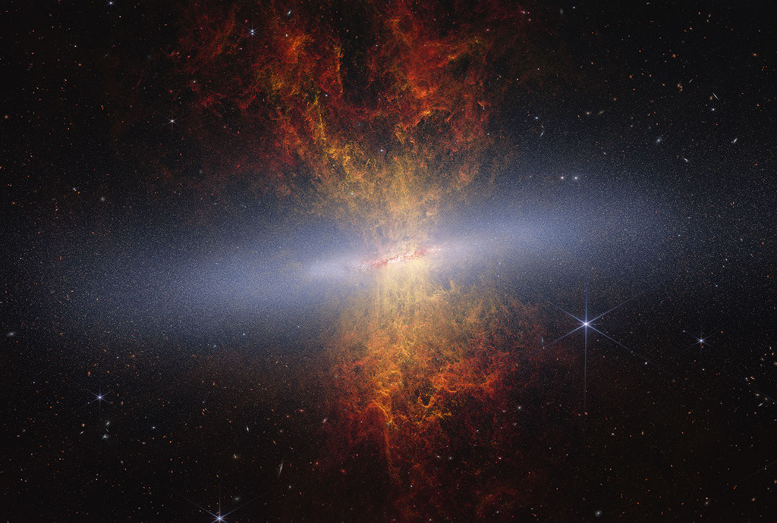
Official NASA portrait of Sean Gallagher Credit: NASA NASA has selected Sean Gallagher as the agency's chief information officer (CIO). In this role, he is responsible for the agency's entire portfolio of Information Technology products and services. Gallagher has been serving in an acting capacity since January and his permanent role is effective immediately. "Sean Gallagher's leadership has been instrumental in strengthening NASA's IT foundation and ensuring our workforce has the secure, modern tools needed to enable groundbreaking missions every day," said NASA Deputy Administrator Matt Anderson. "As CIO, Sean will continue advancing the agency's technology capabilities to support discovery, innovation, and mission success across NASA." Most recently, Gallagher also has served as the deputy chief information officer for Operations in the Office of the Chief Information Officer at NASA Headquarters in Washington, as well as a senior advisor for Transformation. This team provides services to tens of thousands of end users located in the U.S. and abroad in support of NASA missions, enabling discoveries, faster data sharing, increased workforce productivity, and more. Gallagher has worked with all NASA centers to implement efficient and effective IT operating models. Previously, Gallagher was the CIO of NASA's Glenn Research Center in Cleveland, leading IT initiatives for aeronautics, space, research and engineering, and test missions. He joined NASA in 2012 as Glenn's deputy CIO and previously worked at Booz Allen Hamilton as a senior associate supporting a variety of federal, defense, and commercial customers. Gallagher developed his leadership and management experience as a Signal Corps officer in the United States Army. He also served as a platoon leader managing the combat service support readiness of a tactical communications unit, a human resource manager for the 40th Signal Battalion, and as a network engineer for the 11th Signal Brigade. He has a bachelor's degree in physics from John Carroll University and a master's degree in computer information systems from the University of Phoenix. For more information about NASA's missions, visit: https://www.nasa.gov -end- Camille Gallo / Cheryl Warner Headquarters, Washington 202-358-1600 camille.m.gallo@nasa.gov / cheryl.m.warner@nasa.gov

8. CSDA Selects Eight Commercial Satellite Data Providers for On-Ramp 2 Contract Awards
Read more

NASA's Commercial Satellite Data Acquisition program (CSDA) announced contract awards with eight commercial satellite data providers offering a range of data types to support the agency's Earth science research and application goals. The CSDA program On-Ramp 2 Multiple Award contract is a firm-fixed-price indefinite-delivery/indefinite-quantity (IDIQ) multiple-award contract with a maximum cumulative value of $476 million and a performance period through November 2028. The CSDA IDIQ contract includes an on‑ramp provision that allows NASA to periodically reopen the solicitation, giving new vendors the opportunity to submit proposals. This mechanism also enables existing CSDA vendors to propose new data products, whether newly developed or derived from new instruments, that were not available during the original proposal period. Newly Added Contract Holders Vendor Sensor HydroSat Thermal Infrared Visible and Near-Infrared (VNIR) Ororatech Thermal Infrared - Medium Wavelength Infrared (MWIR) and Long Wavelength Infrared (LWIR) ImageSat Optical Multispectral Instrument (MSI) Satlantis Optical MSI / Greenhouse Gas (GHG) Emissions Kuva Space Hyperspectral - VNIR and Short Wavelength Infrared (SWIR) Wyvern Hyperspectral - VNIR Orbital Sidekick Hyperspectral - VNIR and SWIR Muon Space Global Navigation Satellite System - Radar (GNSS-R) Current CSDA Contract Holders with New Products Vendor Sensor Airbus Optical MSI / Synthetic Aperture Radar (SAR) ICEYE SAR GHGSat GHG Emissions Planet Labs Optical MSI / Hyperspectral PlanetiQ Global Navigation Satellite System - Radio Occultation (GNSS-RO) Tomorrow.io Microwave Sounder "NASA's Earth science community relies on a diverse suite of observations from spaceborne, airborne, and in situ assets to better understand our changing planet," said CSDA Project Manager Dana Ostrenga. "The commercial providers added through this latest CSDA contract on-ramp complement NASA's existing Earth observation capabilities and our current portfolio of commercial partners, expanding the range of data available for evaluation and use. Together, these observations provide researchers with a more comprehensive view of Earth's atmosphere, land, oceans, cryosphere, and solid Earth, helping advance scientific discovery and applications that benefit our communities." Following issuance of the contract awards, the selected vendors' data products will be made available to authorized CSDA data users via the Satellite Data Explorer (SDX), CSDA's web-based data discovery and data access tool that allows approved users to search, discover, access, task, and download the data the program has acquired from its commercial partners. The Vendor Selection Process The award process begins with the CSDA issuing a request for proposals that is posted on Sam.gov, the U.S. government's official system for managing federal contract proposals. Interested companies then submit proposals to enter into an IDIQ contract with CSDA. A Solicitation Evaluation Board is formed to determine whether the proposals are competitive and meet the CSDA's technical requirements for continuous observations, orbit platforms, and data that aligns with NASA Earth Science Division (ESD) goals. The CSDA makes its selections from the proposals that meet the requirements and then submits them to NASA leadership for approval. Once approved, the contracts are then awarded and the companies are able to get their data evaluated by CSDA. Once the evaluations are complete, the commercial data providers can then compete for competitive task orders through CSDA. About the CSDA Program NASA's Earth Science Division (ESD) established the CSDA Program as the agency's central mechanism for identifying, acquiring, and evaluating commercial Earth observation (EO) data. The program augments NASA's and partner agencies' Earth-observing capabilities by acquiring commercial satellite data that offer higher spatial resolution, increased revisit frequency, complementary measurement capabilities, and taskable observations. To learn more about the program, its commercial partners, data evaluation process, and more, visit the CSDA website. Become an Authorized Data User Commercial data discoverable through the SDX is made available to CSDA authorized data users. To become an authorized user, fill out the CSDA Program Data Authorization Form. Note: Use of SDX also requires an Earthdata Login.

9. This is How NASA Flight Tests New Technology
Read more
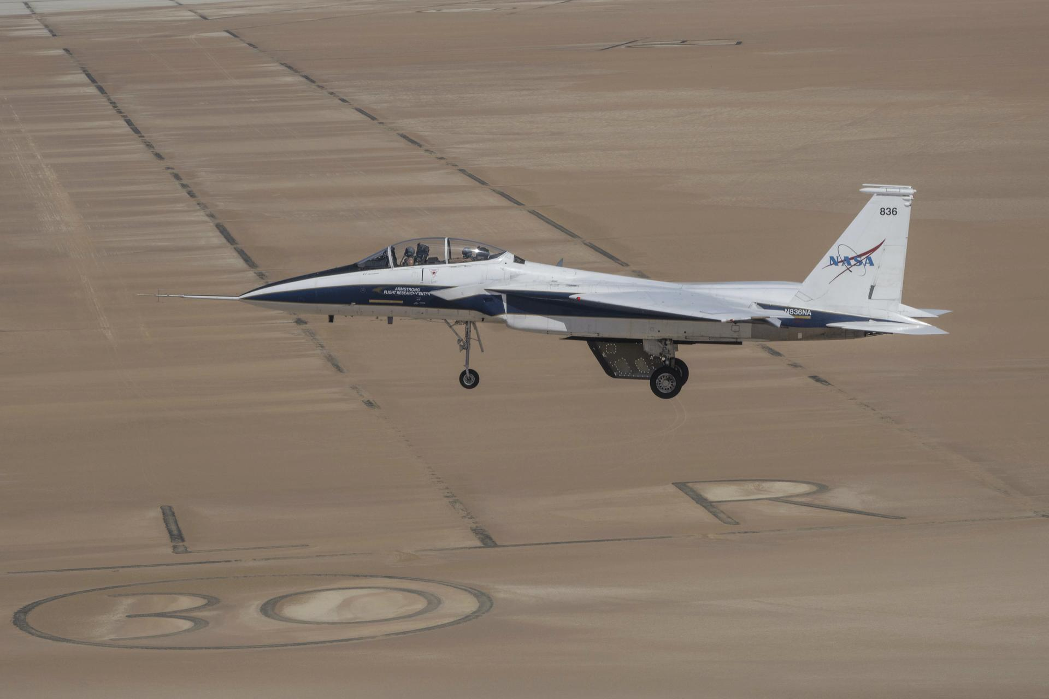
Flight tests are a big part of how NASA turns breakthrough ideas into reality. From flying humans faster than the speed of sound to proving designs that helped shape the space shuttle, flight testing transforms bold concepts into safer, more efficient technologies that benefit the public. "Flight tests are a way to safely and effectively prove new technology, which helps certification authorities certify equipment," said Wayne Ringelberg, chief pilot at NASA's Armstrong Flight Research Center in Edwards, California. "It helps industry iterate and make systems better, and it promotes research in areas where new ideas can be developed." For nearly 80 years, teams at NASA Armstrong have used flight testing in the Southern California desert to push the limits of aerodynamics and advance aviation. Thanks to that work, NASA-developed innovations are aboard every U.S. commercial aircraft and inside every control tower today. "The space side of NASA uses flight test, too. Every mission, like Artemis II, is never routine," Ringelberg said. "Everything we're doing when flying a test mission is something new or different." NASA test pilots Jim Less, left, and Nils Larson walk away from a hangar at NASA's Armstrong Flight Research Center in Edwards, California, on Thursday, Feb. 4, 2026. The pilots support the agency's Crossflow Attenuated Natural Laminar Flow (CATNLF) project, which aims to lower fuel costs for future commercial aircraft by testing a scale-model wing designed to improve laminar flow. NASA/Christopher LC Clark Every NASA test flight - whether it's studying new software, hardware, or the revolutionary technology of an experimental X-plane - relies on engineers, researchers, pilots, maintenance crew, control room operators, and many others working together. "Experienced operators and engineers evaluate how things work in flight," Ringelberg said. "Most new technologies are designed to work in a lab or can be tested in a wind tunnel or other facility, but you never really know how they'll perform until you fly them." Preflight tests often include computer analysis, simulation, wind tunnel testing, and ground tests focused on an aircraft's ability to withstand the forces of flight and the environments through which it may fly. After hardware or software is deemed safe to fly, researchers turn the mission over to the flight test team. To support testing, NASA Armstrong maintains an aircraft fleet modified to create space for new hardware or instruments, as well as the ability to integrate new software. These aircraft are flying laboratories, and pilots are trained to accomplish experimental missions. An F-15 research aircraft sits on the ramp at NASA's Armstrong Flight Research Center in Edwards, California, on Tuesday, March 17, 2026. NASA pilots Jim Less, front seat, and Carrie Worth prepare for the flight. The agency's Crossflow Attenuated Natural Laminar Flow (CATNLF) test article is attached to the bottom of the F-15. The project aims to lower fuel costs for future commercial aircraft by testing a scale-model wing designed to improve laminar flow. NASA/Carla Escamilla For example, flight testing recently helped NASA gather critical data on laminar flow, or the smooth flow of air, over a wing. The work could lower fuel costs for future airliners. Computer modeling, wind tunnel tests, and other methods helped advance the research, but to find out even more about how the wing concept could reduce drag for future airliners, NASA used a scale model in actual flight. NASA researchers strapped the Crossflow Attenuated Natural Laminar Flow (CATNLF) model wing to the belly of one of NASA Armstrong's F-15s. The arrangement allowed them to collect all the information they would need without doing the extensive, costly modifications required to install a full-scale wing on an aircraft. After a flight series is complete, engineers and researchers analyze the data. Did the instrument work as designed? Did the experimental aircraft perform safely at a high altitude? Did the software operate as planned? Each test raises its own set of questions to evaluate. NASA continues working with academia, the Department of War, and industry partners to advance U.S. aviation through flight test and bring new benefits to the flying public.

10. I Am Artemis: Jason Peterson
Read more

Jason Peterson's responsibilities for NASA's Artemis II mission went beyond his usual role as the range operations manager at NASA's Stennis Space Center near Bay St. Louis, Mississippi. For Peterson, working at NASA is a surreal full-circle moment. "I grew up in DeLisle, Mississippi, right down the road from NASA," said Peterson. "You would hear NASA testing, the windows would shake, and you knew they were out there. Not in a million years would I have ever dreamed I would work with NASA." His career journey took a few turns before reaching the space agency. "I got out of school, welded, went to college and then to the Air Force. The path to NASA really started to develop from there," said Peterson. Peterson spent 24 years in the U.S. Air Force and Air National Guard, working in airfield and air-to-ground range operations, followed by a few years working as an aircraft dispatcher at Airbus Final Assembly Line. Peterson credits his military experience with preparing him for the 12-to-16-hour workdays that helped bring the Artemis II test flight around the Moon and into view for audiences around the world. He supported the team responsible for delivering video and communication feeds for the launch of NASA's SLS (Space Launch System) rocket with the Artemis II crew aboard the Orion spacecraft, and then splashdown in the Pacific Ocean. During the nearly 10-day mission, NASA astronauts Reid Wiseman, Victor Glover, Christina Koch, and CSA (Canadian Space Agency) astronaut Jeremy Hansen completed a record-setting lunar flyby, taking them 252,756 miles at their farthest distance from Earth. Aboard the USS John P. Murtha, Peterson was the first on the ship to spot the capsule returning with the crew. "The sonic boom was the moment it truly hit me. Even though I was tracking the capsule, it did not fully register until then. Chills went down my neck and back. You realize our astronauts are coming home. It was an incredible and emotional moment." JASON PETERSON Range Operations Manager for NASA Stennis Jason Peterson, NASA Stennis range operations manager, is shown with the Orion spacecraft aboard the USS John P. Murtha on April 13, 2026. Peterson was the first to spot the capsule returning with the Artemis II crew as he supported the team responsible for delivering video and communication feeds during splashdown operations. Credits: NASA NASA Peterson operated one of six cameras providing live coverage by using a high‑resolution, multi‑sensor system with thermal capabilities. Using the ship's heading and Orion's predicted trajectory, he located the capsule within minutes and began tracking it. Orion entered Earth's atmosphere at about 400,000 feet above the planet's surface, traveling nearly 35 times the speed of sound and about 1,956 statute miles from its splashdown point off the coast of California. Peterson tracked Orion from the release of the small parachutes that first slow and steady the capsule, through the main parachutes opening, and all the way to splashdown. "You are fully locked in, keeping it centered, in focus, and steady," said Peterson. Peterson's focus on the mission began weeks earlier at NASA's Kennedy Space Center in Florida. In the days leading to launch, Peterson worked with the team running full systems checks, staging communications gear, and preparing drones and fixed‑wing camera assets. He helped configure and operate the systems that ensured live video flowed from the launch pad, the crowds, and surrounding air and ground platforms. On April 1, the launch day of Artemis II, the team unloaded and set up high‑resolution sensors, connection terminals, routers, monitors, fiber lines, and drone equipment. They flew drones to capture crowd scenes and aerial views before liftoff. As the SLS rocket launched, Peterson's full attention was on positioning the drone and maintaining the shot. "There is not much time to step back and take in the moment, as you are concentrating on precision," said Peterson. As the mission got underway, Peterson and the team packed up, returned to the facility, and downloaded the day's footage. The Artemis II crew were more than halfway to the Moon as Peterson arrived in San Diego on April 4. In the days leading to splashdown, the team loaded and installed high‑fidelity cameras and supporting equipment, all to help the world witness a historic milestone when the Artemis II crew returned to Earth on April 10. Next up will be Artemis III. NASA will launch four astronauts from NASA Kennedy aboard the Orion spacecraft on the SLS rocket. Building on the successful Artemis II crewed test flight in April, Artemis III will pave the way for future surface missions, with experts like Peterson helping every step of the way.

11. Space.com just launched an app! Get your inside scoop on space exploration
Read more

Click for next article Space.com just launched into the app frontier with our news app to take you out of this world, every day, with all the space news you've come to love. Hey, space fans! For over 25 years, we here at Space.com have dedicated ourselves to bringing you the best space mission news, astronomical discoveries, night sky guides and out-of-this-world sci-fi. Now, we're launching into a whole new frontier. Yes, we have an app. Our new Space.com app is available free on Android on the Google Play store and for iOS via the Apple Store and includes the same great coverage that you'll find on your laptop or desktop, but now in the palm of your hand. Are you wondering how to prepare for this summer's great total solar eclipse in August? We've got that . How about NASA's plans to launch the first-ever commercial spacecraft to rescue a falling space telescope? We've got that . (That Swift Boost mission will launch this Saturday, June 27, by the way.) And if you're wondering just how close Steven Spielberg's "Disclosure Day" is to how the U.S. government could handle the real discovery of E.T. in real life, we even have that . The Space.com app also allows you to curate your space news experience by picking your favorite news categories and saving articles and features for later reading. A post shared by Space.com (@spacedotcom) A photo posted by on If you download our Space.com app, register for free and get your daily space news fix, but are still left wondering how you can better support the amazing work of our news and reviews team, there is a way. Our Space.com app has an ad-free version available for a small recurring monthly fee (or one annual subscription) that helps support or live on-site coverage of space missions like NASA's upcoming Artemis 3 moon lander test flight and more. I'm extremely excited to welcome you to our Space.com app and look forward to any thoughts and feedback you might have about it. Have a question, comment or complaint? You can let me know directly through my email above or below. Thank you all for your interest in space and for supporting Space.com over the years. We look forward to another 25 years and more of taking you out of this world, every day. Sincerely,

12. Rocket Lab launches US Space Force mission with less than 17 hours' notice - a new record
Read more
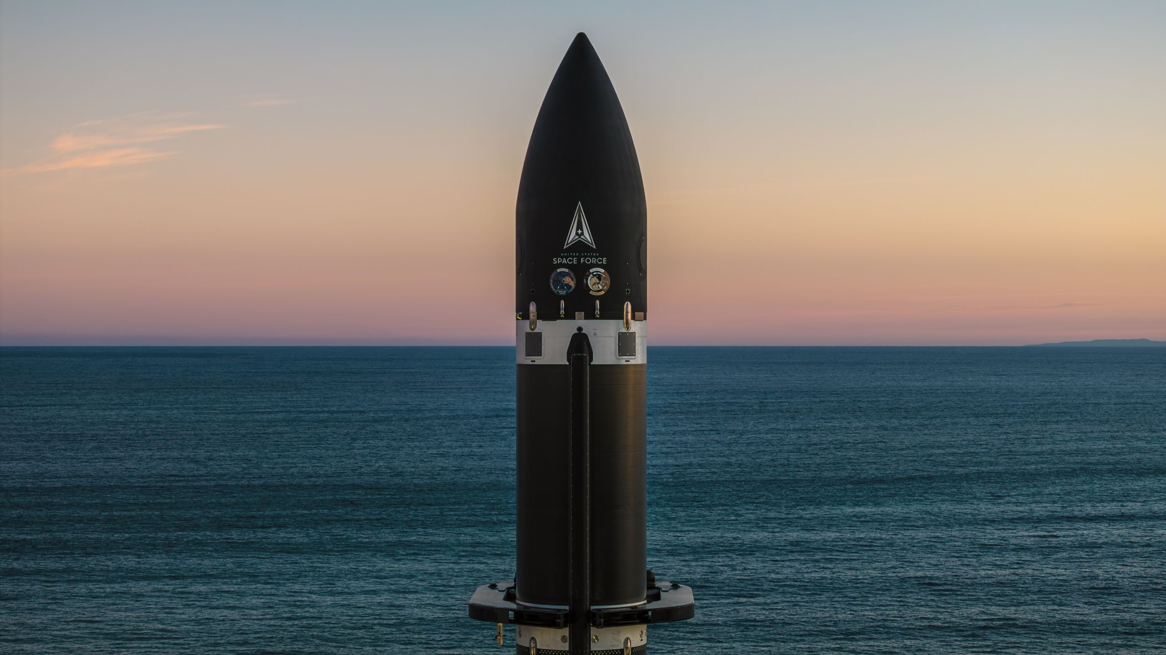
Click for next article Rocket Lab has successfully launched the second spacecraft for the U.S. Space Force's Victus Haze Tactically Responsive Space (TacRS) mission, setting a new readiness record in the process. Only 16 hours and 42 minutes passed between Rocket Lab receiving the Notice To Launch from the Space Force's Space Safari Program Office and liftoff of the company's Electron launch vehicle , beating the previous TacRS record set by Firefly Aerospace on the September 2023 Victus Nox mission by more than 10 hours. Liftoff occurred on Friday (June 19) at 6:19 a.m. EDT (1019 GMT, 10:19 p.m., local time), from Rocket Lab's Launch Complex-1, in New Zealand, beginning a rapid-response demonstration designed to simulate a real-world orbital threat scenario. Rocket Lab's Electron rocket launched on Friday (June 19) at 6:19 a.m. EDT (1019 GMT, 10:19 p.m., local time), from Rocket Lab's Launch Complex-1, in New Zealand. (Image credit: Rocket Lab) Electron delivered a Rocket Lab -built Pioneer spacecraft to low Earth orbit (LEO), where it has begun pursuit of another Victus Haze spacecraft that was launched by SpaceX in May and serves as the target vehicle for the demonstration - True Anomaly's Jackal satellite . According to a June 22 Rocket Lab statement , "[Pioneer] is now fully commissioned and conducting complex orbital maneuvers to chase down another spacecraft on orbit and conduct Rendezvous and Proximity Operations (RPO)." Victus Haze is a TacRS mission managed by Space Systems Command's Space Safari Program Office, with the objective of demonstrating the rapid acquisition, launch and operation of spacecraft in response to orbital threats and "non-compliant satellites," the Rocket Lab release said. "Rendezvous and Proximity Operations on such short timelines are certainly not trivial, especially in a crisis or conflict scenario, but this demonstration of our ability to commission a complex and capable space vehicle within less than 72 hours, and immediately begin an RPO scenario thereafter, shows that we can field capability to deny adversaries first-mover advantage into novel orbits," said Lt. Col. Lincoln Miller, Space Safari system program manager, in the statement. Rocket Lab and True Anomaly teams are now managing their respective spacecraft in orbit. They will soon enter the RPO phase of Victus Haze, conducting space domain awareness (SDA) threat-response scenarios and "dynamic engagements with the other," according to a separate statement from the U.S. Space Force (USSF). The VICTUS HAZE mission explained. Phase 1: Launch on demand 🚀 The @USSpaceForce's @USSF_SSC called, told us to launch, and just 16 hours 42 minutes hours later, Electron successfully left the pad from LC-1.Phase 2: 🛰️ With Pioneer spacecraft checkouts complete 34 hours… pic.twitter.com/lJK226LhzTJune 23, 2026 Space Force officials have increasingly looked to commercial providers to develop new capabilities and technologies to address potential conflicts in space. "Victus Haze is primed to further demonstrate our readiness to lean on our commercial partners to deny, disrupt, and counter any adversarial advantage - no matter where they try to operate in space," acting Space Force portfolio acquisition executive Col. Bryon McClain said in the USSF statement. With its Electron rocket and Pioneer spacecraft both vertically integrated into Rocket Lab's manufacturing processes, this Victus Haze launch marks the first TacRS mission to be carried out by a single prime contractor, providing the spacecraft, launch vehicle and on-orbit operations. "This is what modern space power looks like: the ability to reinforce and reimagine national security space architecture at will," said Rocket Lab CEO Peter Beck. "We're proud to be providing the nation with those next-generation space capabilities, today."

13. NASA wants to dump the ISS in the sea. Experts say the plan 'raises serious concerns for ocean health'
Read more

Click for next article The International Space Station with the oceans of Earth far below it. NASA's plan to deorbit the International Space Station in coming years has fallen under the scrutiny of a government watchdog group and stirred up a wave of reaction by a leading ocean conservation organization. As presently blueprinted by NASA , the International Space Station will be de-orbited via a series of actions. Firstly, in early to mid-2028, the ISS will start to be lowered through a combination of Earth's natural atmospheric drag and the execution of re-entry maneuvers by the ISS's Russian segment. Then, in mid-2029, NASA plans to launch a SpaceX-supplied, government paid for, U.S. Deorbit Vehicle (USDV) and attach that craft to the ISS, which will fire its 46 Draco thrusters and push the station down to a watery grave. But there's one issue that has ecology experts concerned. The Ocean Foundation, a Washington, D.C.-headquartered group with a mission to improve global ocean health and the human relationship with the sea via carefully chosen strategies and projects, says the planned deorbit of the International Space Station "raises serious concerns for ocean health that the space community has not adequately grappled with," according to Mark Spalding, president of the foundation. A troubling gap A just-issued U.S. Government Accountability Office (GAO) report has focused on issues related to NASA's plan to bring down the International Space Station (ISS) and transition from the ISS to commercial space stations, namely NASA's concern about having a "gap" in continuous human presence in low Earth orbit. The GAO report explains that, at the end of 2030 or early 2031, the USDV is to perform a re-entry burn. That would push the ISS through the Earth's atmosphere and into a pre-determined spot - an ocean zone called Point Nemo . "As part of the reentry process, NASA expects portions of the ISS and deorbit vehicle to break up and fall into the remote part of the ocean to minimize the risk to populated areas," states the GAO report. SpaceX rendering of its U.S. Deorbit Vehicle (USDV), a Dragon-derived spacecraft with 46 Draco engines designed to propel the International Space Station into a controlled reentry. (Image credit: SpaceX) But as for using Point Nemo or any part of the ocean as a convenient dumping ground, Spalding told Space.com that "there is a troubling structural gap in international law that the ISS de-orbit throws into sharp relief." Under the Space Liability Convention of 1972, if space debris falls on another nation's territory or damages property, Spalding said, the launching nation owes compensation - absolutely and without needing to prove fault. "But no equivalent protection exists for the ocean," he said. "As a result, when space agencies have control over where debris falls, they aim for the high seas, and in doing so, they incur no legal obligation to pay for cleanup or environmental remediation," said Spalding. The Ocean Foundation leader said he understood the legitimate safety rationale for targeting Point Nemo, the point on Earth farthest from any populated area. "But the ocean's remoteness from human infrastructure should not be mistaken for a lack of value or vulnerability," Spalding said. "The ocean and its creatures deserve the same protection that international law affords to national territories." Concerning the ocean's ecosystems, Spalding asks what happens to the marine ecosystems and creatures on the seafloor where the ISS leftovers land? "The honest answer is, we don't fully know. That is deeply troubling for a structure the size of a football field. We do know that not everything burns up on reentry. Denser components will survive and reach the seafloor," Spalding added. Point Nemo (marked in red) in the south Pacific Ocean is farther from land than any other point on Earth. It is also home to the world's largest "Spacecraft Cemetery." (Image credit: PGC/NASA IBCAO Landsat/USGS/Google) The problem: uncertainty What denser, specific materials from the ISS re-entry will be, and what harm they may cause to marine life, Spalding said, "has not been adequately studied or disclosed. That uncertainty is itself the problem." Additionally, what environmental harm may begin before the debris hits the water is worrisome. As the largest reentry in history, the cumulative atmospheric impact of down-falling ISS hardware deserves serious study, he said. For one, Spalding flagged a newly negotiated High Seas Treaty (BBNJ Agreement) that is relevant to downing the ISS. It requires parties to conduct environmental impact assessments for activities that may affect the marine environment beyond national jurisdiction when effects are unknown or poorly understood. "It is fair to ask whether the ISS deorbit - the largest such reentry in history, targeting the high seas - should trigger that obligation," Spalding said. The International Space Station. (Image credit: NASA/ESA-T. Pesquet) Position statement As for the Ocean Foundation's position on the ISS deliberate crashing into the Pacific Ocean, the group believes that discussion points prior to the ISS downing include: A full environmental impact assessment of the anticipated seafloor debris field and atmospheric effects; Public disclosure of all materials that will survive reentry and reach the ocean floor; A rigorous legal analysis of obligations under the UN Convention on the Law of the Sea (UNCLOS,) the London Protocol of 1996 that provides an international standard and framework for countries to individually and collectively protect and preserve our oceans from pollution caused by the dumping of wastes and other matter into the ocean, along with the BBNJ Agreement. The high seas have no sovereign who can demand accountability, concluded Spalding. "We believe this gap in international law needs to be closed, and the ISS de-orbit is a vivid illustration of why."

14. Ignite a child's imagination with the stars: Our expert-picked Astronaut Galaxy Star Projector is a Prime Day steal at just $25
Read more

Click for next article This Astronaut Galaxy Projector is sure to delight children, and some adults. Are you scratching your head, wondering what to buy for a child? Our expert Tantse recommends this Astronaut Galaxy Projector and right now, during Prime Day, it's just $25. Enjoy stunning, starry displays with this Astronaut Galaxy Projector, now $25 at Amazon Faced with buying a present for her nephews, and having been suitably impressed when she reviewed this Astronaut Galaxy Projector, Tantse (our long-time star projector reviewer), settled on this gift and she's had no complaints! We rank it one of the best star projectors and best star projectors for kids because, despite its budget price tag, it creates some amazing, room-filling displays that'll leave children wide-eyed. Adults are just as likely to be delighted, too! Looking for more savings? Check out our other Prime Day deals. Tantse Walter Contributing writer Tantse Walter is a writer, photographer and travel enthusiast who has spent over a decade facilitating global adventurous expeditions. She loves getting into the nitty-gritty of sourcing and planning itineraries, getting out and about in nature, and admiring the night sky. From star projectors to smart telescopes and beyond, she's adept at anything that aids skywatching. Image 1 of 3 It may be cheap but there's nothing nasty about this projector, which can light up a whole room. (Image credit: Tantse Walter) The astronaut's power pack has its own power port, a cute design feature. (Image credit: Tantse Walter) The star projector, disassembled. (Image credit: Tantse Walter) As challenges go, one of the biggest trials in life is buying a gift for someone else's child. Assuming you like their respective adults, a drum set or a Nerf gun is right out. Fortunately, our expert Tantse Walter has the answer, with this impressive but pocket-friendly Astronaut Galaxy Projector. Despite the name, this cool projector, which Tantse gifted to her nephews, projects both stars and galaxies. It's not scientifically accurate, but it punches well above its price tag. In Tantse's review of the Astronaut Galaxy Projector called it "a well-made novelty star projector that every kid, or space fan, will love to have in their bedroom," and even if the kids in question aren't skywatchers, it could well kindle their interest in the cosmos. With its remote control, customizable displays and 45-90 minutes sleep timer, adults will find it a handy meditation tool or relaxation tool too. At $25, this Astronaut Galaxy star projector is a superb gift that can transform any room. Key features: Remote control, projects light shows, sleep timer, compact Price history: This model tends to retail for between $29.99 and $34.99. We've sometimes seen it dip cheaper, though there are also several versions of this projector. Price comparison: Amazon: $25 Reviews consensus: In our review of the Astronaut Star Projector, expert Tantse awarded it four stars out of five and Amazon purchasers rank it even higher. Space: ★★★★ Featured in guides: Best star projectors, best star projectors for kids ✅ Buy it if: You want a star projector that, despite its novelty appearance, offers excellent performance and won't cost you a fortune. ❌ Don't buy it if: You want scientific accuracy because, as impressive as they are, this projector's displays don't match the night sky. Instead, consider the Sega Toys Homestar Flux. Check out our other guides to the best telescopes, binoculars, cameras, star projectors, drones, lego and much more.

