IIRS Daily Space Digest Saturday, 09/05/2026

1. ISRO completes preliminary design review of Venus Orbiter Mission - MSN
"ISRO OR NRSC OR IIRS after:2026-05-08" - Google News
Read more

ISRO completes preliminary design review of Venus Orbiter Mission MSN

2. Hyderabad start-up TakeMe2Space turns to SpaceX after ISRO PSLV mission failure - ThePrint
"ISRO OR NRSC OR IIRS after:2026-05-08" - Google News
Read more

"Any space startup is burning cash whether or not they launch. Accessing space-based services as quickly as possible is important for business," said Anand Rajagopalan, executive vice president (business strategy), TakeMe2Space. "As soon as C62 failed, we started looking for the earliest launch slot. There was one on SpaceX, and we took it." In a LinkedIn post on 15 April, TakeMe2Space announced that the MOI-1a satellite will fly aboard SpaceX's Falcon 9 rocket soon. New Delhi: Hyderabad-based start-up TakeMe2Space is all set to launch its MOI-1a satellite on SpaceX's Transporter 18 mission no earlier than October. The satellite, designed as India's first AI laboratory and data centre in orbit, replaces MOI-1, which was lost aboard ISRO's PSLV-C62 Mission in January after an anomaly in the rocket's third stage. The PSLV-C62 mission, which took off on 12 January, failed midway, taking down the main Earth Observation Satellite (EOS-9) and 15 co-passenger satellites, including TakeMe2Space's MOI-1. It was ISRO's only launch in 2026 and the second consecutive failure of the PSLV rocket. MOI-1 was TakeMe2Space's maiden satellite, and was joined by payloads from other three other Indian start-ups, including Dhruva Space, EON Space Labs, and OrbitAid. PSLV-C62 also carried satellites from Indian university students and organisations across four countries. Apart from Theos-2a, a joint UK-Thailand satellite, none of the other payloads were insured. Union Minister of Science and Technology Jitendra Singh had earlier remarked that ISRO was planning on reattempting the PSLV-C62 mission in June. Currently, there is no communication from ISRO in this regard. "None of the foreign passengers booked on PSLV-C62 have withdrawn. The success rate of our launches is still pretty high compared to any other country around the world," Singh said in February. While TakeMe2Space and EON SpaceLabs are planning a SpaceX launch no earlier than October, OrbitAid too is planning its next move. According to a post on their website, the Tamil Nadu-based start-up is in conversation with both SpaceX and ISRO for a 'twin satellite launch' for an in-space docking and refuelling mission. "Depending on the availability of the rocket for our two satellites we will decide on the launcher," R.Sakthikumar, Founder and CEO of OrbitAid, said in the post. Also read: A Hyderabad startup is launching India's 1st 'thinking' satellite. A brain in space What is TakeMe2Space's satellite? TakeMe2Space's MOI-1a satellite is equipped with AI compute power to not just collect satellite imagery but also process it in space. It is the first in a series of five satellites that would together form a constellation, to enable earth observation and data computing in space. Besides working with Indian start-ups EON Space Labs for the satellite's sensor and lenses, TakeMe2Space is also collaborating with private companies to 'indigenise' its satellite as much as possible. The two-year-old start-up had also performed a tech demonstration in 2024, aboard ISRO's PSLV-C60 mission. After the failure of PSLV-C62 Mission, Rajagopalan said, they knew they had to get into problem solving mode right away. Over the next two years, the company plans to launch four more MOI satellites, and by the end of 2029, it plans to be ready with its massive 50kW orbital data centre. TakeMe2Space still plans to continue its collaboration with ISRO and is in talks to launch AaduSat satellite later this year. The details of the launch will be shared by New Space India Limited and IN-SPACE. (Edited by Prashant Dixit)

3. ISRO to open astronaut cadre to civilians, selection of second batch to begin - MSN
"ISRO OR NRSC OR IIRS after:2026-05-08" - Google News
Read more

ISRO to open astronaut cadre to civilians, selection of second batch to begin MSN

4. ISRO provides updates on planned planetary exploration missions - MSN
"ISRO OR NRSC OR IIRS after:2026-05-08" - Google News
Read more

ISRO provides updates on planned planetary exploration missions MSN

5. ISRO reveals Gaganyaan astronaut training details: What's ready, what's pending - MSN
"ISRO OR NRSC OR IIRS after:2026-05-08" - Google News
Read more

ISRO reveals Gaganyaan astronaut training details: What's ready, what's pending MSN

6. Maharashtra launches new scheme; top students to visit NASA and ISRO - MSN
"ISRO OR NRSC OR IIRS after:2026-05-08" - Google News
Read more

Maharashtra launches new scheme; top students to visit NASA and ISRO MSN

7. NASA's SpaceX 34th Commercial Resupply Mission Overview
NASA
Read more

NASA's SpaceX 34th commercial resupply mission will launch on the company's Dragon spacecraft on the SpaceX Falcon 9 rocket to deliver research and supplies to the International Space Station. NASA NASA and SpaceX are targeting a mid-May launch to deliver scientific investigations, supplies, and equipment to the International Space Station. Loaded with about 6,500 pounds of supplies, the SpaceX Dragon spacecraft will lift off aboard the company's Falcon 9 rocket from Launch Complex 40 at Cape Canaveral Space Force Station in Florida. Following its arrival to the orbital complex, Dragon will dock autonomously to the forward port of the space station's Harmony module. Watch agency launch and arrival coverage on NASA+, Amazon Prime, and NASA's YouTube channel. Learn how to watch NASA content through a variety of online platforms, including social media. NASA's SpaceX 34th commercial resupply mission will launch from Launch Complex 40 at Cape Canaveral Space Force Station in Florida. NASA For more than 25 years, the International Space Station has provided research capabilities used by scientists from more than 110 countries to conduct more than 4,000 experiments in microgravity. Research conducted aboard the station helps advance long-duration missions to the Moon as part of the Artemis program and to Mars, while providing multiple benefits to humanity. Science highlights: In addition to cargo for the crew aboard the space station, Dragon will deliver several new science experiments, including: ODYSSEY will evaluate how well Earth-based microgravity simulators recreate space conditions. NASA ODYSSEY will evaluate how well Earth-based microgravity simulators recreate space conditions. Researchers will examine bacterial behavior in space and compares the results to experiments conducted in microgravity simulators on Earth. STORIE will monitor charged particles in orbit around the Earth, which respond to space weather and can affect assets like power grids and satellites. NASA STORIE will monitor charged particles in orbit around the Earth, which respond to space weather and can affect assets like power grids and satellites. The instrument could help researchers gain knowledge to better predict and respond to these changes. Laplace will study the movement and collision of dust particles in microgravity to understand particle motion in space. NASA Laplace will study the movement and collision of dust particles in microgravity to understand particle motion in space. Researchers hope to learn more about Earth's origins and provide fundamental understanding of how planets in our solar system and beyond came into existence. Green Bone will observe how bone cells grow and develop in space on a bone scaffold made from wood. NASA Green Bone will observe how bone cells grow and develop in space on a bone scaffold made from wood. Microgravity results could help researchers improve products that treat fragile bone conditions such as osteoporosis. SPARK will evaluate how red blood cells and the spleen change in space for future astronauts. NASA SPARK will evaluate how red blood cells and the spleen change in space for future astronauts. Researchers will observe human samples and imagery taken before, during, and after spaceflight to identify ways to protect astronaut health during long-duration space missions. Arrival and return: NASA astronaut Jack Hathaway and ESA (European Space Agency) astronaut Sophie Adenot will monitor the arrival of the SpaceX Dragon cargo spacecraft from the International Space Station. NASA astronaut Jack Hathaway and ESA (European Space Agency) astronaut Sophie Adenot will monitor the spacecraft's arrival. Dragon will remain docked to the orbiting laboratory for about a month before splashing down in the Pacific Ocean, returning critical science and hardware to teams on Earth. Cargo highlights: NASA's SpaceX 34th commercial resupply mission will launch on the company's Dragon spacecraft on the SpaceX Falcon 9 rocket to deliver research and supplies to the International Space Station Launch European Enhanced Exploration Exercise Device Power Cable - A replacement power cable is launching for installation on the European Enhanced Exploration Exercise Device. Catalytic Reactor - A vital component of the Water Recovery and Management System, the catalytic reactor oxidizes volatile organics from wastewater that are removed by the Gas Separator and Ion Exchange Bed orbital replacement units. This part is launching to maintain on orbit sparing. Universal Pretreat Concentrate Tank - This is a passive tank to provide alternate pretreat concentrate to the Universal Waste Management System (UWMS) and Waste Hygiene Compartment (WHC). Two units are launching to maintain this hardware, in tandem with Russian pretreat tanks currently used. A universal pretreat concentrate tank adapter will accompany the tanks to connect with the Russian hose. Additional equipment launching includes an Ultraprobe to replace a worn ultrasonic inspection tool, a Remote Sensor Unit to restore spares for the station's vibration monitoring system, and flexible repair patches for sealing the pressure hull if needed. The mission also will deliver an updated ARMADILLO (AOGA ReMediation, Advanced DeIonization and Limited Life Optimization) cartridge and hose assemblies to improve water processing for oxygen generation, along with a nitrogen recharge tank assembly to help maintain the station's gas reserves. Return When Dragon returns in mid‑June, it will bring back an ocular imaging device used to monitor crew eye health, a sorbent bed that filters trace contaminants from cabin air, and a separator pump from the Waste and Hygiene Compartment. The Advanced Plant Habitat, which supported long-duration plant biology studies, also will return for eventual museum display. A pressure management device that recovers vestibule air during depressurization will come back for repair and storage as a ground spare.

8. NASA's Psyche Mission Captures Mars During Gravity Assist Approach
NASA
Read more


Description This colorized image of Mars was captured by NASA's Psyche mission on May 3, 2026, about 3 million miles (4.8 million kilometers) from the planet. The spacecraft is approaching the planet for a gravity assist on May 15 that will give it a boost in speed and adjust its trajectory toward asteroid Psyche for eventual arrival in 2029. The spacecraft is approaching Mars from a high-phase angle, meaning that the planet appears only as a thin crescent, like our own crescent Moon seen around its new Moon phase. From this viewing geometry, the Sun is out of frame and "above" both Mars and Psyche. Figure A Figure A is a zoomed-out view from the imager. No stars are visible in the background since they are much dimmer than the sunlight being reflected by Mars. The observation was acquired by the multispectral imager instrument's panchromatic or broadband filter, with an exposure time of just 2 milliseconds. Even with this very short exposure time, the crescent is extremely bright and parts of the image are oversaturated. The light seen here is sunlight reflected off the surface of Mars and also scattered by dust particles in its atmosphere. Because the quantity of dust in the atmosphere can vary rapidly over time, the anticipated brightness of the crescent was hard to predict before this early image was acquired. The dustiness of Mars leads to sunlight being scattered by its atmosphere, making the crescent appear to extend farther around the planet than if it had no atmosphere (as with our Moon).Of note, on the right side of the extended crescent, there appears to be a gap, which coincides with the planet's icy north polar cap. The cap is currently in winter and mission specialists hypothesize that seasonal clouds and hazes may be forming in that region, possibly blocking the atmospheric dust's ability to scatter sunlight like it does elsewhere around the planet. The Psyche mission's imager team will be acquiring, processing, and interpreting similar images in the lead-up to the close approach on May 15. The images are primarily designed to calibrate the cameras and to characterize their performance in flight as a practice run for the approach to asteroid Psyche in 2029. For more information about the Psyche mission, read: https://science.nasa.gov/mission/psyche/

9. NASA Names Brian Hughes to Launch Operations Role
NASA
Read more

During his tenure as chief of staff, NASA's Brian Hughes is seen during a NASA town hall event, Wednesday, June 25, 2025, at the NASA Headquarters Mary W. Jackson Building in Washington. Credit: NASA/Bill Ingalls NASA announced Friday that Brian Hughes will return to the agency as senior director of launch operations, based at the agency's Kennedy Space Center in Florida. In this role, Hughes will provide enterprise-level leadership, strategic direction, and operational oversight for NASA's launch infrastructure. Reporting to NASA Headquarters in Washington, Hughes will have direct responsibility for launch operations at NASA Kennedy, as well as the agency's Wallops Flight Facility in Virginia. He will work across government, industry, and local leadership to strengthen coordination among stakeholders supporting NASA's spaceports, enable increased launch cadence, and support execution of the President's National Space Policy to ensure continued American leadership in space. "Brian brings a unique combination of operational expertise, strategic leadership, and public service experience at the highest levels of government," said NASA Administrator Jared Isaacman. "His track record leading complex organizations and executing high-stakes missions makes him exceptionally well-suited to help shape the future of NASA's launch operations as we accelerate into a new era of exploration and innovation." Most recently, Hughes served as NASA's chief of staff, where he helped drive agencywide priorities and decision-making. Prior to NASA, he served as deputy national security advisor for Strategic Communications at the White House, helping shape policy and communications on national security matters. Hughes also served as chief administrative officer for the City of Jacksonville, overseeing a workforce of more than 7,000 employees and managing a multi-billion-dollar budget across public safety, infrastructure, and emergency management operations. Earlier in his career, he served as chief of staff to former Jacksonville Mayor Lenny Curry and as chief executive officer of the Downtown Investment Authority, leading economic development initiatives across the city. A veteran of the U.S. Air Force, Hughes served as a KC-135 aircrew member during operations over the Middle East in support of the Gulf War. His return comes as NASA continues advancing a growing portfolio of civil, commercial, and national security launch activities across its spaceport infrastructure. Learn more about NASA's mission at: https://www.nasa.gov -end- Bethany Stevens / George Alderman Headquarters, Washington 202-358-1600 bethany.c.stevens@nasa.gov / george.a.alderman@nasa.gov

10. NASA Fuel Cell Tests Pave Way for Energy Storage on Moon
NASA
Read more

Lead research engineer Dr. Kerrigan Cain adjusts tubes connected to a fuel cell inside NASA Glenn Research Center's Fuel Cell Testing Laboratory in Cleveland on Feb. 23, 2026. His team is testing a system that could revolutionize power generation and energy storage for future Moon and Mars missions. NASA/Jef Janis With a small blue crane, four researchers hoist a cylindrical fuel cell, which looks like a stack of flattened silver and gold soda cans bundled together, into the air and lower it into a rectangular cart on wheels. A tangle of tubes and wires spiral away from the system, where nearly 270 sensors and 1,000 components are nestled inside. "It's a behemoth; it's a researcher's dream," said Dr. Kerrigan Cain, lead engineer for the team at NASA's Glenn Research Center in Cleveland preparing to test this technology, known as a regenerative fuel cell system, over the next few months. The system, about as long as a sedan and as tall as a person, operates like a rechargeable battery and could revolutionize the way NASA stores energy during future Moon missions through the Artemis program. When power is needed, it's designed to combine hydrogen and oxygen gas into water, heat, and electricity, and then "recharge" by splitting the water back into hydrogen and oxygen - all on the lunar surface. "It is an ideal technology for habitats, exploration with rovers, and many of the systems that are envisioned under Artemis," Cain said. "Developing a sustainable, long-term human presence on the Moon requires power and energy storage solutions that fit those needs. Regenerative fuel cells fit into that puzzle perfectly." From left to right, Dr. Kerrigan Cain, Jessica Cashman, Dr. Devon Powers, and Ryan Grotenrath install a fuel cell onto the regenerative fuel cell system inside NASA Glenn Research Center's Fuel Cell Testing Laboratory in Cleveland on Feb. 23, 2026. NASA/Jef Janis This technology can weigh less but store the same amount of energy as comparable battery systems and could even operate during cold, dark, nearly two-week-long lunar nights. Its recharging capability also would ensure astronauts make the most of their resources and energy on the lunar surface without needing new supplies delivered from Earth. The upcoming tests are the culmination of over five years of work. The system was designed and assembled at NASA Glenn. Researchers completed initial testing in 2025 to understand the basics of how the technology functions and make modifications. Now, the team is passing a major milestone as they get ready to operate the complete system, storing the hydrogen and oxygen gas generated during recharge for the first time. They hope to gather essential data, identify any additional challenges, and further advance the technology toward a lunar mission. On an average test day, researchers will secure the thick double doors to the test cell where the system is located in NASA Glenn's Fuel Cell Testing Laboratory, head to a nearby control room, and begin to run the system remotely. Once it is powered up and a test has started, the technology can operate on its own without researcher intervention. From left to right, Jessica Cashman, Dr. Kerrigan Cain, Dr. Mathew McCaskey, and Dr. Devon Powers discuss operation of the regenerative fuel cell system inside the control room of NASA Glenn Research Center's Fuel Cell Testing Laboratory in Cleveland on Feb. 23, 2026. NASA/Jef Janis "This testing is going to generate crucial data, so every day is exciting," Cain said. "This effort was made possible by countless hours of work. The desire for fuel cell technology is so high, it makes it very easy to get up every morning and go, 'All right, we have to keep moving forward so that we can be ready for Artemis.'" Researchers will use lessons learned from testing to continue advancing regenerative fuel cell technology. Before the system can launch to the Moon, researchers will put it through its paces outside of the lab. "We want to simulate being on the lunar surface and prove the system can work under much harsher conditions compared to a controlled laboratory environment," Cain said. Cain and his team noted working on the complex regenerative fuel cell system is both rewarding and challenging as they consider the impacts their research could have on NASA's future deep space missions. "Creating a sustainable presence on the Moon is a team effort requiring a lot of collaboration between NASA and industry," Cain said. NASA's Regenerative Fuel Cell project is funded by the Space Technology Mission Directorate's Game Changing Development Program, managed at NASA's Langley Research Center in Hampton, Virginia.

11. Pentagon unveils trove of declassfied 'UFO' videos. How to see them all, from 'a football-shaped body' to 'a misshapen and uneven ball of white light'
Latest from Space.com
Read more
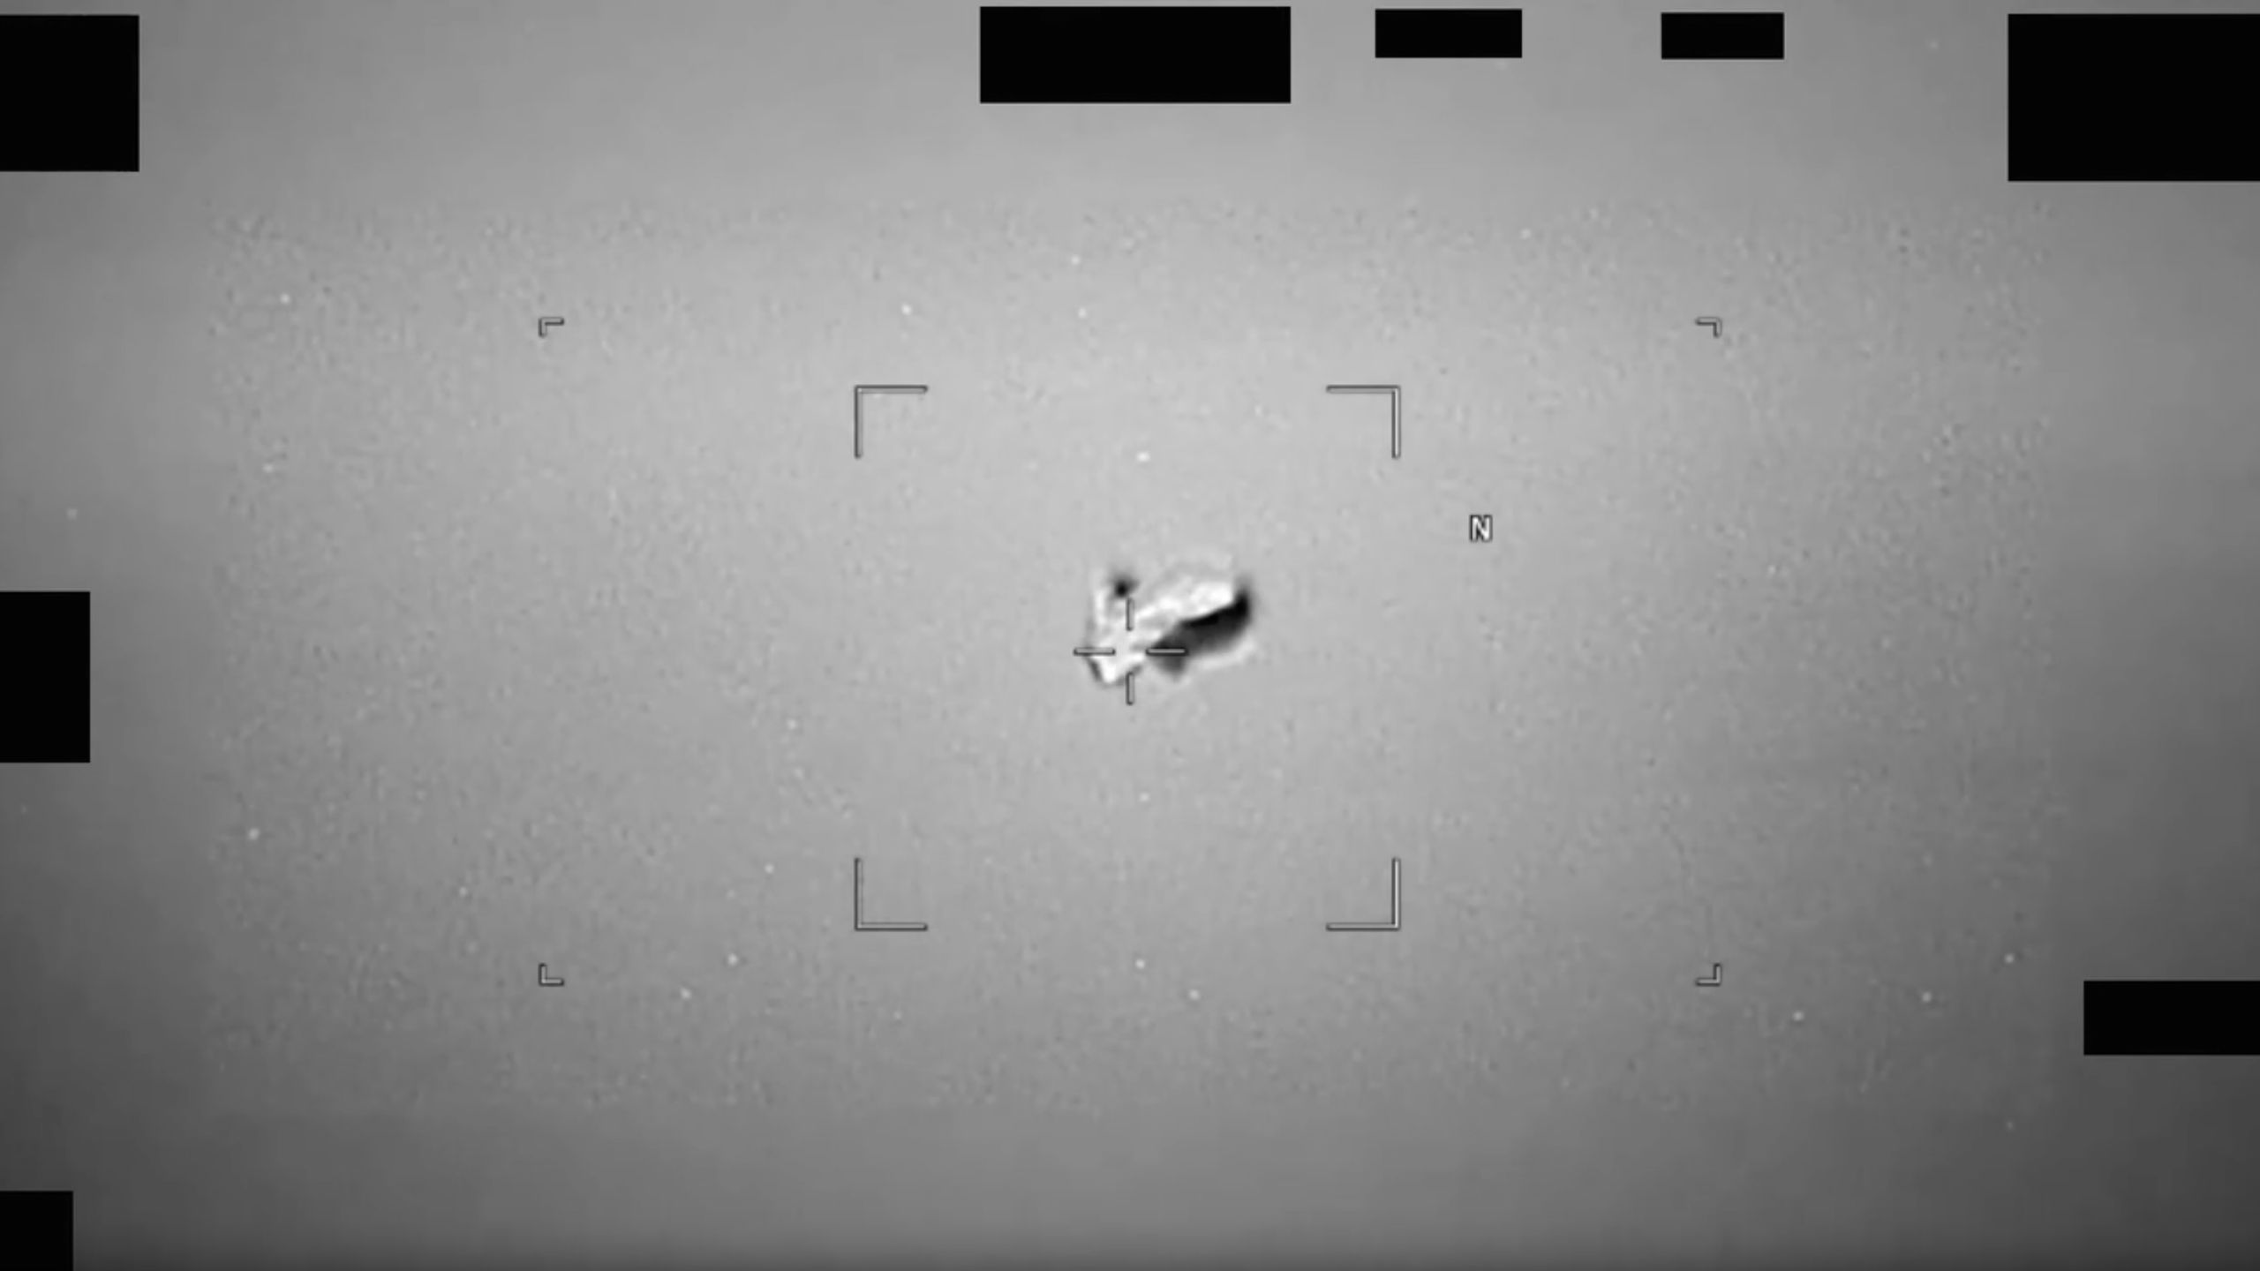

Click for next article UFO enthusiasts just got a big old bone to sink their teeth into. The Pentagon released its first tranche of declassified "UFO files" on Friday (May 8), responding to a directive that President Trump issued in February . The new release consists of 161 files, most of which are PDFs recounting investigative reports and eyewitness testimonials (including from a few Apollo astronauts, who saw some strange things near the moon ). But there's also quite a bit of imagery, including nearly 30 videos, which feature a range of intriguing unidentified flying objects - or unidentified anomalous phenomena ( UAP ), as they were recently rebranded. A "football-shaped" UAP (unidentified anomalous phenomenon) observed by an infrared sensor on a U.S. military platform in 2024. The Pentagon released this observation on May 8, 2026. (Image credit: U.S. Deparment of War) Space.com combined all of those newly declassified videos into a supercut, which you can see above or via Space.com's YouTube channel . And the new footage is definitely worth a look. For example, one submission from U.S. Central Command features five seconds of imagery captured in Syria by a full-motion video (FMV) camera in October 2024. "An accompanying mission report, DoW-UAP-D32, described the UAP as consisting of a 'misshapen and uneven ball of white light,' and reported that a 'light/glare halo effect' occurred at the top of the FMV feed," Pentagon officials wrote in a description of the video . Another video, submitted by U.S. Indo-Pacific Command, features a nine-second observation gathered in 2024 by an infrared sensor aboard an unspecified U.S. military platform. "The sensor focuses on an area of contrast that resembles a football-shaped body with three radial projections: one oriented vertically, and two oriented downward at a 45-degree angle relative to the major axis of the main mass," Pentagon officials wrote in a description of the video . Another 2024 infrared video from the same command has a more artistic feel, and not just because it's considerably longer (100 seconds). It shows a small, bright dot cruising through an array of windmills, looking like a wanderer lost in a ghostly forest of monstrous mechanical trees. The Pentagon does not attempt to explain the UAP featured in these videos. Indeed, the accompanying text features the following disclaimer: "Readers should not interpret any part of this description as reflecting an analytical judgment, investigative conclusion, or factual determination regarding the described event's validity, nature or significance." And, of course, "unidentified" does not necessarily mean "alien" where UAP are concerned. Experts stress that there are a variety of possible earthly explanations for such observations, from advanced drone technology to software bugs and instrument issues. Releasing the files will get more eyes on UAP footage, which military officials say is a good thing. "The materials archived here are unresolved cases, meaning the government is unable to make a definitive determination on the nature of the observed phenomena," the Pentagon wrote on the new UFO files website. "This can occur for a variety of reasons, including a lack of sufficient data, and the Department of War welcomes the application of private-sector analysis, information and expertise." And there will be more files coming soon, according to that page: "Given the scope of this task, the Department of War will be releasing new materials on a rolling basis as they are discovered and declassified, with tranches posted every few weeks."

12. The charred hull of Artemis 2's Orion | Space photo of the day for May 8, 2026
Latest from Space.com
Read more
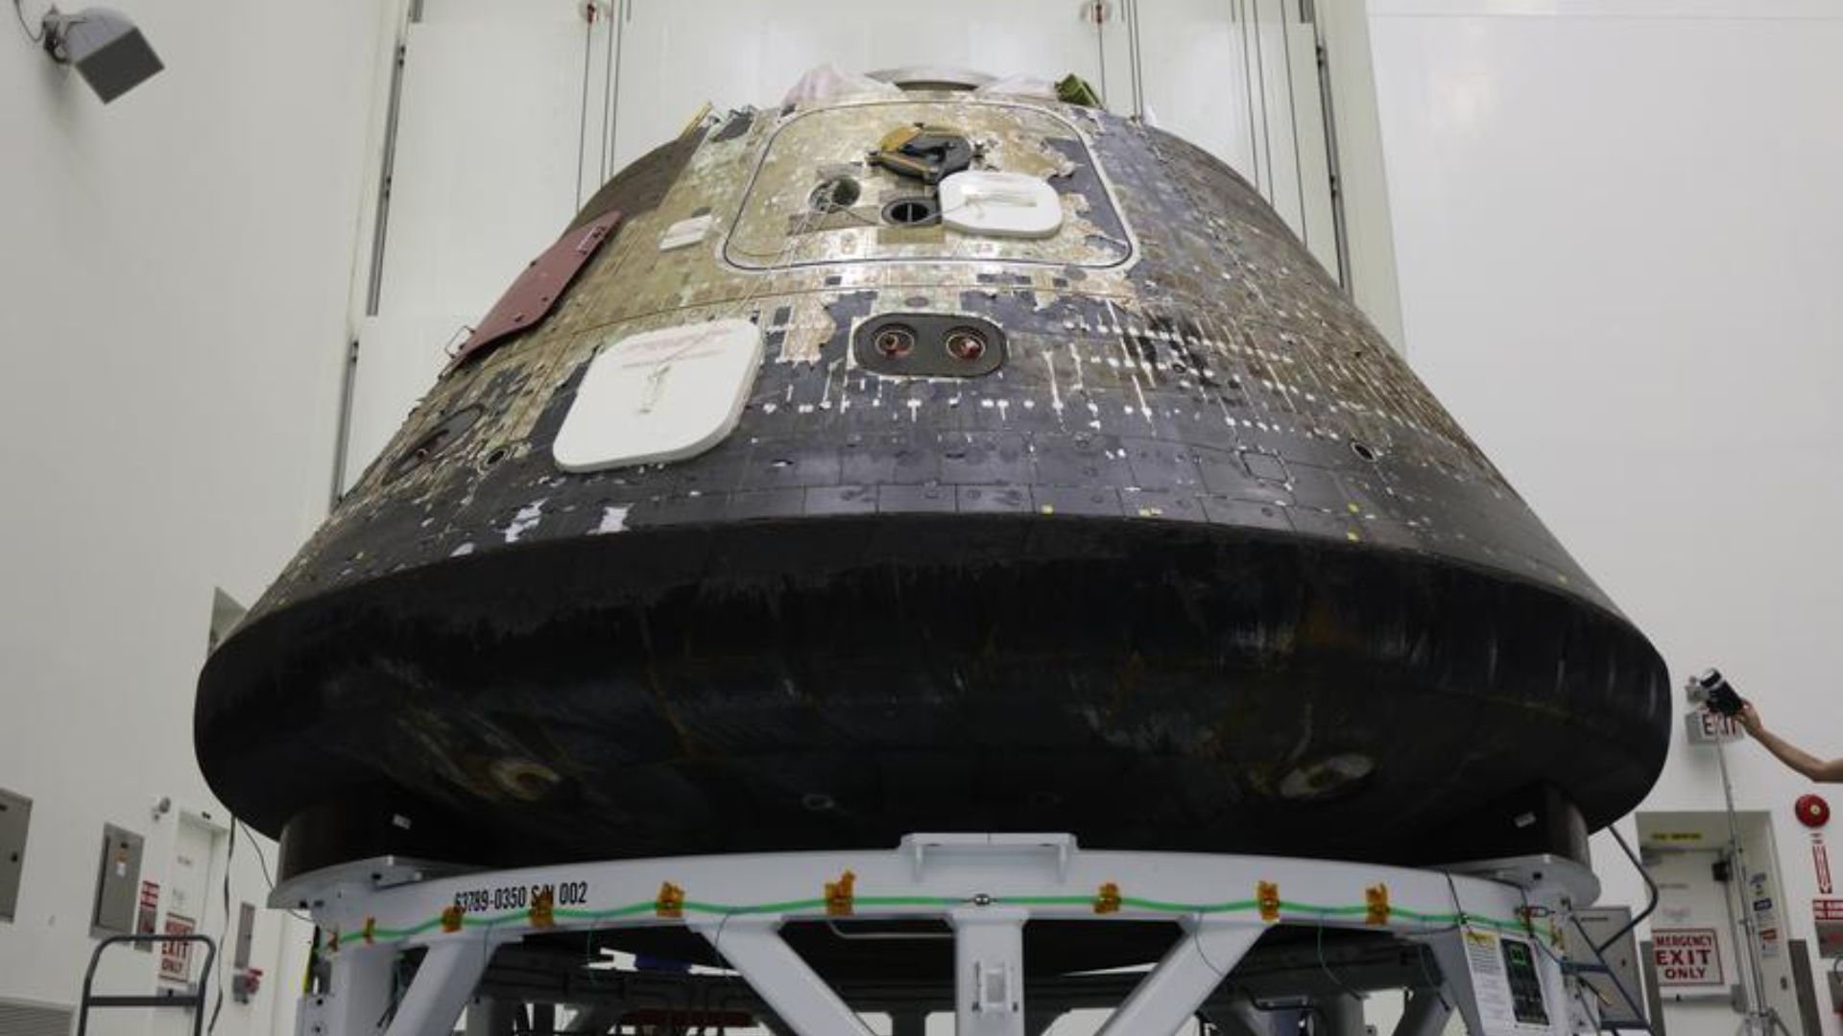

Click for next article NASA's Artemis 2 Orion capsule sits at the Kennedy Space Center, charred from its return journey through Earth's atmosphere. (Image credit: NASA/Ben Smegelsky) NASA's Artemis 2 Orion spacecraft rests after its flight around the moon, charred from the return to Earth. The Artemis 2 mission launched four astronauts on a journey around the moon aboard an Orion capsule that its crew named "Integrity." Looking at the capsule now, you can see what it went through to get home. What is it? On April 1, NASA launched four astronauts on a 10-day journey around the moon and back to Earth. This mission, called Artemis 2, was the first time humans have traveled to the moon in over 50 years, since NASA's final Apollo mission in 1972. Latest Videos From View more On their trip home, the crew - NASA astronauts commander Reid Wiseman, mission pilot Victor Glover, mission specialist Christina Koch, and Canadian Space Agency mission specialist Jeremy Hansen - hurtled back through Earth's atmosphere before splashing down in the Pacific Ocean on April 10. This return trip was no picnic. During its descent, temperatures around the capsule reached up to 5,000 degrees Fahrenheit (2,760 degrees Celsius). And while the capsule's heat shield kept the astronauts inside safe, this picture clearly shows the extreme environment that the craft had to ensure. In the photo, the capsule sits , burned by its return journey, at NASA's Kennedy Space Center Multi-Payload Processing Facility in Florida. Why is it incredible? Launching to space is a spectacular feat. To have a rocket launch with astronauts on board go perfectly well is even more amazing. But once you're in space, whether it's on a mission to the moon or the International Space Station , at some point you have to come home to Earth. And returning can be just as tricky as getting there. The Orion capsule, sitting propped up at NASA's Kennedy Space Center , is a charred testament to the challenge of that return trip. You can see the dark tiles on the capsule's side, and underneath it is entirely burnt.

13. NASA's Artemis 2 astronauts saw flashes on the far side of the moon that cameras struggle to capture. Here's why scientists are excited
Latest from Space.com
Read more
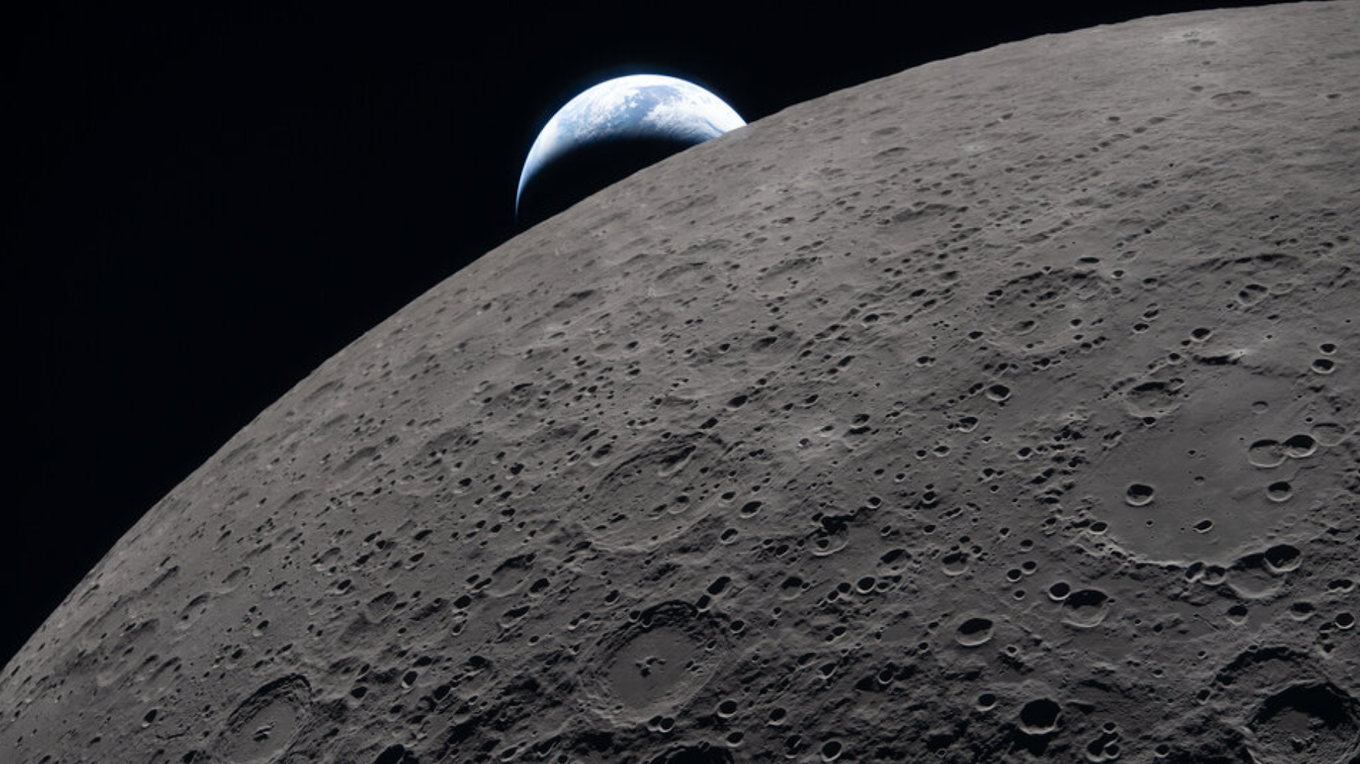

Click for next article The Artemis 2 astronauts remained vigilant while zipping around the far side of the moon last month, on the ready to record meteoroid impact flashes on the lunar landscape. Their diligence was rewarded. The four crewmembers reported seeing several impact flashes - flickers of light created when a meteoroid hits the lunar surface and vaporizes. "These observations were made with the unaided eye. It's extremely difficult to capture impact flashes with a camera, which is one of the benefits of sending trained crew to observe the moon ," Kelsey Young, NASA Artemis 2 lunar science lead, told Space.com. "Early data indicates that the impact flashes were observed on the far side of the moon ." Citizen scientists help out Artemis 2 , the first crewed moon flight since Apollo 17 in 1972, launched from Florida's Space Coast on April 1 and flew around the far side of the moon on April 6 . As the astronauts scrutinized the moon that day, so did citizen scientists here on Earth. They were also looking for impact hits, although they would likely not have spotted the same ones as the crew. Those observations were gathered as part of the newly launched Impact Flash citizen science project under the auspices of the Geophysical Exploration of the Dynamics and Evolution of the Solar System ( GEODES ), a unit within the NASA Solar System Exploration Research Virtual Institute. The Impact Flash effort is geared to gather more data on the location and brightness of flashes throughout recent and upcoming Artemis moon missions. "These flashes are vital to scientists who study the moon," notes the Impact Flash website . "By tracking when and where they happen, scientists can learn how often impacts of different sizes occur, what kinds of craters they create, and how the shock waves travel through the moon's interior." When combined with data from NASA's moon-circuiting Lunar Reconnaissance Orbiter (LRO), future lunar surface instruments, and crew observations, the citizen science observations "can provide valuable constraints on the origin and characteristics of impactors, as well as craters that form from the impacts," Young said. Up-close and far-side viewing of the moon made possible by the Artemis 2 mission. (Image credit: NASA) Observation window The Artemis 2 astronauts' impact-flash observation window extended out onto the lunar near side in darkness, Benjamin Fernando, of the Department of Earth and Planetary Sciences at Johns Hopkins University in Baltimore, told Space.com. In a paper posted earlier this year on the preprint server EarthArXiv, Fernando and colleagues reported that coordinated impact flash observations seen both from Earth and from lunar flyby/orbit will allow more detailed information to be gathered about the timing, location and dynamics of flashes than is possible from either method alone. Joint observation campaigns enable researchers to better constrain the impact flux on the moon and also the associated impact hazard on the lunar surface, Fernando and his colleagues concluded. Moon base implications Updated knowledge about the meteoroid impact flux also plays into planning for Artemis Base Camp , the outpost NASA plans to build near the moon's south pole. "To design for longevity, one must account for the myriad environmental hazards that a long-duration outpost will face - among them radiation, extreme thermal cycling, regolith dynamics, seismic shaking, dust, and, of particular importance to this work, impacts," notes a 2025 study led by Daniel Yahalomi, now a Torres Postdoctoral Fellow at MIT. The lunar south pole offers a natural reduction in impact risk relative to equatorial sites, according to the study, "supporting its selection for sustained human presence." Furthermore, currently available shielding technology "is sufficient to suppress micrometeoroid hazards by nearly five orders of magnitude, reducing the effective risk to a manageable level for current habitat designs," Yahalomi and his research colleagues concluded. An artist's rendering of a NASA Artemis moon base. (Image credit: NASA) Big science haul Hunting for impact flashes was one of many science tasks for the astronauts during their historic April 6 flyby. The Artemis 2 Lunar Science Team remains busy analyzing the mission's science haul - gathered with the aid of 31 cameras aboard the Orion capsule "Integrity" - and archiving it all on NASA's Planetary Data System.

14. Rescue mission for NASA's $500 million space telescope passes key testing milestone
Spaceflight Now
Read more

A mission to prevent a $500 million NASA space observatory from meeting a fiery demise just passed a notable prelaunch testing milestone. The Neil Gehrels Swift Observatory, a spacecraft launched in 2004, is at risk of falling back through the atmosphere and burning up without intervention. On Friday, NASA announced that the Link spacecraft, manufactured by Katalyst Space Technologies to intervene before Swift's fate is sealed, completed its slate of environmental testing at the agency's Goddard Space Flight Center in Greenbelt, Maryland. Testing in the Space Environment Simulator concluded on Monday, May 4, and the spacecraft returned to Katalyst's facilities in Broomfield, Colorado, for additional, prelaunch testing. "The Swift boost attempt is a fast, high-risk, high-reward mission," said John Van Eepoel, Swift's mission director at NASA Goddard, in a NASA press release. "Swift will likely re-enter the atmosphere sometime later this year if we don't attempt to lift it to a higher altitude. Katalyst has gotten to this point in just eight months, and we're glad they were able to use NASA's facilities to test Link and draw on our expertise to help tackle questions that popped up along the way." Swift doesn't have it's own onboard propulsion system and would naturally decay in orbit over time. However, increased solar activity in recent years accelerated the lowering timeline for the observatory, dropping it from about 600 km to 400 km, with anticipated reentry in late 2026 without intervention. That's why in September 2025, NASA awarded Katalyst a $30 million contract to develop a spacecraft capable of docking with Swift and boosting its orbit. "Given how quickly Swift's orbit is decaying, we are in a race against the clock, but by leveraging commercial technologies that are already in development, we are meeting this challenge head-on," said Shawn Domagal-Goldman, acting director, Astrophysics Division, NASA Headquarters, at the time. "This is a forward-leaning, risk-tolerant approach for NASA. But attempting an orbit boost is both more affordable than replacing Swift's capabilities with a new mission, and beneficial to the nation - expanding the use of satellite servicing to a new and broader class of spacecraft." "We're in an unusual situation where the schedule dictates how much risk we're willing to accept, rather than the other way around," said Kieran Wilson, Link's principal investigator at Katalyst. "The clock is ticking on Swift's descent, so we have to find a balance between testing and problem solving that gives the mission the best chance of success." Swift is in an orbit inclined 20.6 degrees from the equator, which is why Katalyst selected Northrop Grumman's Pegasus XL air-launched rocket in November to fly the mission. "The versatility offered by Pegasus' unique air-launch capability provides customers with a space launch solution that can be rapidly deployed anywhere on Earth to reach any orbit," said Kurt Eberly, Director of Space Launch for Northrop Grumman. "The stringent mission requirements necessary to save the Swift observatory, including the unique low-inclination orbit and the tight mission timeline, all pointed to Pegasus being the perfect choice." The mission is set to launch in June. Link will first integrate with the Pegasus rocket at NASA's Wallops Flight Facility in Virginia early in the month and then the company's L-1011 aircraft will deploy the spacecraft from the Marshall Islands later in the month.

