 |  | 

🌌 अंतरिक्ष समाचार | Space News
सोमवार, २६/१०/२०२६ | Monday, 26/10/2026

1. No permanent geographic split of fighter assets; theaterisation must address India's security needs: IAF Chief AP Singh
Read more

- Defence - 5 min Read Air Chief Marshal Singh also emphasised that the "transformation of this scale" should be implemented in phases so that operational readiness is "never compromised" and warned against the "trap" of trying to predict the future battlefield with "excessive certainty". - PTI - Published On Oct 25, 2026 at 05:21 PM IST - Select ETGovernment as Preferred Choice on Google - Share Icon Copy Link Share on Whatsapp Share on Linkedin Share on X Share on Telegram Share on Facebook - Bookmark - Comment The IAF chief added that future conflicts will be multi-domain by their very nature, and the three services will plan and operate together "far more closely than ever before." In his first comprehensive articulation on the theaterisation plan , Chief of Air Staff AP Singh said on Sunday that the Indian Air Force is not in favour of permanently splitting fighter assets geographically, advocating instead for a tailored structure built around India's specific security requirements rather than replicating foreign models. In an exclusive interview to PTI, the Air Chief Marshal said the guiding principle for theaterisation should be " centralised control " where necessary and "decentralised execution" where appropriate as he cited ongoing conflicts in various geographies to assert that air power can decisively shape military outcomes . Announced in 2019 as India's most ambitious military reform since Independence, the theaterisation plan seeks to integrate the three services for greater operational synergy. The proposed architecture envisaged three integrated commands: a Northern Theatre Command in Lucknow focused on China, a Western Theatre Command in Jaipur to address challenges from Pakistan and a Maritime Theatre Command in Thiruvananthapuram. However, progress has stalled due to divergent views among the three services over the proposed command structures. The IAF has been cautioning against implementing the plan in a hurry and has strong reservations about splitting its fighter squadrons under the proposed structures. Referring to Operation Sindoor , Air Chief Marshal Singh said it was carried out under a joint architecture established by the Chief of Defence Staff and the three service chiefs where the centralised allocation and swift reallocation of critical assets proved decisive. "Recent conflicts around the world have once again underlined how decisively air power can shape military outcomes. That is precisely why the question of how air power is organised matters so much," the IAF Chief said. "We are not viewing theaterisation as an exercise to permanently divide fighter assets geographically. The IAF is fully committed to jointness and integration ," he said, outlining the IAF's vision for the project. At the same time, he asserted that air power remains India's primary responder to any security challenge. Air Chief Marshal Singh noted that the real question is how to employ air power to its greatest effect within an integrated structure, arguing air power's defining strengths are its speed, reach, flexibility and ability to concentrate combat power rapidly at the point of decision. "An aircraft is not relevant only to the geographical area from which it operates. With aerial refuelling, long-range weapons, networked sensors and appropriate basing, air power can be massed from considerable distances and shifted between sectors as the threat evolves," he said. "The guiding principle should, therefore, be centralised control where necessary, and decentralised execution where appropriate. That way, air power can be concentrated where it is needed most, while commanders retain the agility to act swiftly on the ground," he said. The Chief of Air Staff, then, highlighted how the joint structure during Operation Sindoor produced desired results. "Our own experience bears this out. During Operation Sindoor, under a joint architecture established by the Chief of Defence Staff and the three service chiefs, the centralised allocation and timely reallocation of critical resources proved decisive in the outcome." "The tri-service air picture I described a moment ago is what made such dynamic employment possible," he said. Air Chief Marshal Singh also called for avoiding the trap of trying to predict the future battlefield with "excessive certainty". "As we design future structures, we must also avoid the trap of trying to predict the future battlefield with excessive certainty. What we can anticipate is that the next conflict will likely be: faster, more autonomous, yet more network-dependent, more transparent, yet more deceptive and more precise in some respects, and characterised by mass in others," he said. "Our structures must be able to absorb that shift. They should be evaluated against India's specific security requirements, not built by replicating models from other countries, because each nation operates within its own strategic, geographical, technological and operational environment," he noted. "A transformation of this scale should also be implemented in phases, so that operational readiness is never compromised," he said. The Air Chief Marshal said the IAF is a committed partner in this national effort. "We will work hand in hand with our sister Services to build structures that are distinctly Indian, that preserve the inherent flexibility of air power, and that ensure India fights its future wars as one," he said. The IAF chief added that future conflicts will be multi-domain by their very nature, and the three services will plan and operate together "far more closely than ever before." Under the theaterisation model, the government seeks to integrate the capabilities of the Army, Air Force and Navy and optimally utilise their resources for wars and operations. According to the theaterisation plan, each of the theatre commands will have units of the Army, the Navy and the Air Force and all of them will work as a single entity looking after security challenges in a specified geographical territory. At present, the Army, Navy and the Air Force have separate commands. Previous Chief of Defence Staff Gen. Anil Chauhan (retd.) had submitted to Defence Minister Rajnath Singh a comprehensive proposal on the theaterisation plan. However, it is not immediately known whether the defence ministry is pursuing the theaterisation plan in line with the report. The theatre commands are being planned to integrate the capabilities of the three services and to ensure optimal utilisation of their resources. Last year, Chauhan had said the "dissonance" in the military on the tri-services commands will be addressed considering the "best national interest". Current Chief of Defence Staff Gen NS Raja Subramani is learnt to be focusing on key aspects of the overall theaterisation plan. The government in 2019 had tasked the Chief of Defence Staff to implement the theaterisation plan. Comments What are your thoughts?

2. India to expand its space operations with four functional launch pads by 2029, says ISRO Chairman - News On AIR
Read more
India to expand its space operations with four functional launch pads by 2029, says ISRO Chairman News On AIR

3. Sapphire International School students explore India's space missions at ISRO - Pioneer Edge
Read more
Sapphire International School students explore India's space missions at ISRO Pioneer Edge

4. Cyclone Arnab: Isro satellite captures storm barreling towards Andhra Pradesh - India Today
Read more
Cyclone Arnab: Isro satellite captures storm barreling towards Andhra Pradesh India Today

5. India Targets Four Functional Space Launch Pads by 2029 as ISRO Outlines Gaganyaan Roadmap - www.nationpathindia.com
Read more
India Targets Four Functional Space Launch Pads by 2029 as ISRO Outlines Gaganyaan Roadmap www.nationpathindia.com

6. ISRO will not be privatised, says chairman V Narayanan - SME Futures
Read more
ISRO will not be privatised, says chairman V Narayanan SME Futures

7. Hunting Red Leaves with Satellites
Read more
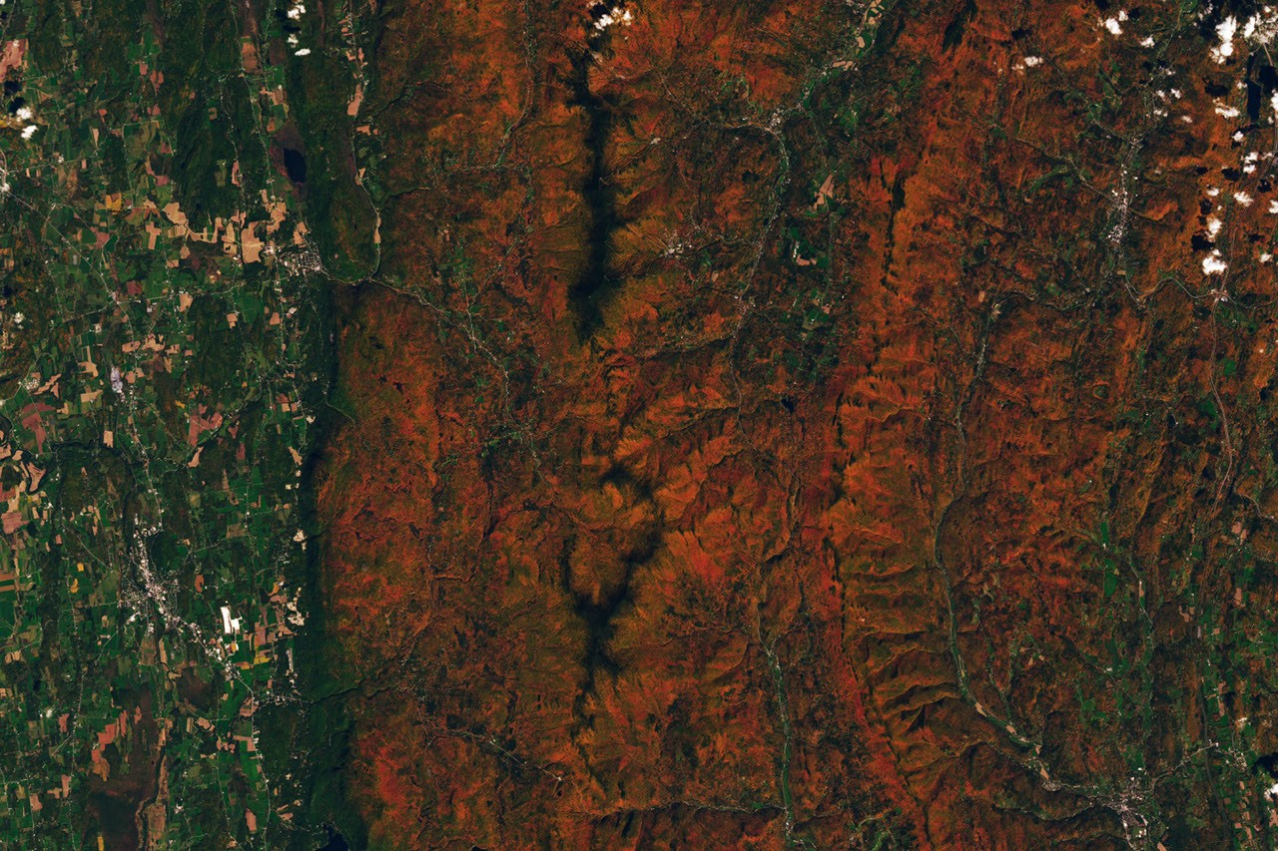
September 29 to October 4 October 5 to 11 A map depicts vegetated parts of Earth's land surfaces from September 29 to October 4. Vegetation color is depicted on a spectrum ranging from dark green to light yellow to dark red. The largest patches of red vegetation appear in Alaska, northern Canada, Mongolia, and Russia. Smaller patches of red are visible in Australia. NASA Earth Observatory / Lauren Dauphin A similar global map depicts the redness of vegetation from October 5 to 11. The reddest areas have shifted equatorward, with more color visible in the Mid-Atlantic, the U.S. Southeast, southern Russia, China, and Mongolia. NASA Earth Observatory / Lauren Dauphin September 29 to October 4 October 5 to 11 A map depicts vegetated parts of Earth's land surfaces from September 29 to October 4. Vegetation color is depicted on a spectrum ranging from dark green to light yellow to dark red. The largest patches of red vegetation appear in Alaska, northern Canada, Mongolia, and Russia. Smaller patches of red are visible in Australia. NASA Earth Observatory / Lauren Dauphin A similar global map depicts the redness of vegetation from October 5 to 11. The reddest areas have shifted equatorward, with more color visible in the Mid-Atlantic, the U.S. Southeast, southern Russia, China, and Mongolia. NASA Earth Observatory / Lauren Dauphin September 29 to October 4 October 5 to 11 Curtain Toggle 2-Up Image Details These maps show the redness of vegetation as measured by the OCI (Ocean Color Instrument) on the PACE (Plankton, Aerosol, Cloud, ocean Ecosystem) satellite in September and October 2026. Red foliage appears to peak in New England, northern Canada, and northern Russia from September 29 to October 4, then spreads southward into the Mid-Atlantic, Mongolia, and northern China from October 5 to 11 (right). The Japanese tradition of momijigari, or "red leaf hunting," stretches back more than a millennium, as evidenced by ancient poems describing journeys to admire fall foliage. In America, mentions of foliage trips began appearing in the historical record in the 19th century, around the time artists and poets such as Frederic Church and Emily Dickinson celebrated autumn color in depictions of the Northeast. Modern-day leaf peepers have a new way to track and savor the seasonal phenomenon. The hyperspectral OCI (Ocean Color Instrument) on NASA's PACE (Plankton, Aerosol, Cloud, ocean Ecosystem) satellite observes the planet's oceans and vegetation daily at 286 spectral bands. Among this array are a few groups of wavelengths that allow scientists to track subtle changes in leaf pigments key to fall foliage displays, including anthocyanins (reds), carotenoids (yellows and oranges), and chlorophylls (greens). NASA scientists can track fall color by measuring how much red, orange, and yellow forests show compared with green. Tracking the ratio over time reveals where leaves are changing and when color peaks. The maps above show vegetation "redness" from September 29 to October 4 (left) and October 5 to 11 (right). Areas shown in green have values near 1, meaning the satellite detects about as much red as green, and most leaves have not yet turned. Areas shown in light yellow and red have higher values, indicating progressively more red pigment relative to green. The satellite detected particularly high levels of redness in parts of northern and eastern Russia, northern Alaska, and northern Canada from September 29 to October 4. In New England and upstate New York, redness began to fade during the week of October 5 to 11, even as it spread across much of the Midwest and the Mid-Atlantic. (Not all the yellows and reds on the maps represent fall colors. Crops in some agricultural areas, for instance, show high anthocyanin levels as they age and after they are harvested. Also, in some regions, clouds produce what appear to be gaps in the vegetation.) Seeing Red in Vermont Many of the reddest areas-such as the Adirondacks in New York, the Green Mountains in Vermont, and the White Mountains in New Hampshire-have large numbers of sugar maples (Acer saccharum) and red maples (Acer rubrum), deciduous trees that turn a brilliant shade of crimson in the fall. Blueberries, bilberries, sedges, mosses, and grasses likely contribute to the intense reds detected in marshy tundra areas in northern Alaska, Canada, and Russia. Red and orange hues cover the forested ridges of central Vermont, while river valleys and lower-elevation areas are still green. The OLI (Operational Land Imager) on Landsat 9 captured this image on October 3, 2026. NASA Earth Observatory / Lauren Dauphin The OLI (Operational Land Imager) on Landsat 9 captured an image (above) of intensely red foliage around Ripton, Vermont, on October 3, 2026, around the peak of redness in the region. Poet Robert Frost, author of "October," "The Road Not Taken," "Nothing Gold Can Stay," and several other poems that evoke fall foliage, kept a summer home and farm in Ripton and taught at Middlebury's Bread Loaf School of English. Some other satellites with hyperspectral sensors can measure fall foliage pigments in a way that is similar to PACE, but only in more localized areas and less frequently. PACE is the first satellite capable of measuring all three key leaf pigments-anthocyanins, carotenoids, and chlorophylls-across the entire planet every day or two. "It's the ability to collect time-series data of anthocyanins and carotenoids everywhere on Earth repeatedly that is game-changing," said Karl Huemmrich, a vegetation scientist with the Goddard Earth Sciences Technology and Research II center at the University of Maryland, Baltimore County. Huemmrich, who is also a member of the PACE science team, was eager to work with the satellite because of OCI's broad swath and short revisit time. "The time-series data allow us to determine peak redness and yellowness anywhere on Earth," he said. In the fall, leaves change colors as they lose chlorophyll, a green molecule that plants use to synthesize food. Since chlorophyll is not a stable compound, plants must continuously synthesize it, a process that requires ample sunlight and warm temperatures. As temperatures decrease and days shorten in autumn, levels of chlorophyll drop, causing greens to fade and presenting an opportunity for carotenoids and anthocyanins to show their colors. Observing Leaves in a Canopy Near You As part of the ongoing North American Phenology Campaign run by the Global Learning and Observations to Benefit the Environment (GLOBE) program, NASA data scientist Skye Caplan has been posting weekly foliage maps of vegetation redness. The maps show waves of red emerging in the high latitudes in August and shifting equatorward in September and October. The PACE team is asking the public to submit photos of fall foliage to help scientists "ground truth" the satellite observations and better understand how various factors influence vegetation color. Fall foliage sprinkles a forested New England landscape in a photo taken in Meredith, New Hampshire, on October 11, 2026, by a participant in GLOBE's North America Phenology Campaign GLOBE "Changes in pigments can also occur when vegetation is stressed due to drought or insect damage," said Caplan. She noted that changes like these likely help explain why PACE measures high levels of redness in agricultural regions of Brazil, Australia, and Canada that don't track closely with broader seasonal changes. "The more photos we can get from the ground, the better," Caplan said. Ground photos help scientists refine PACE's observations of vegetation color, which the team hopes will eventually support several lines of research. These include how the timing of spring greening and fall senescence is changing, how vegetation changes affect the global carbon cycle, and how leaf color influences wildfire risk. Scientists also want to know whether PACE can detect early warning signs of drought, insect infestations, and plant disease. People can participate in the GLOBE campaign even if they live in an area without dense forests or picturesque fall foliage displays. Scientists also want ground observations of shrubs, grasses, wildflowers, evergreens, crops, and other vegetation. But when it comes to "red leaf hunting," don't delay, Caplan said. "Color changes happen kind of slowly, then all at once, and then they're gone." NASA Earth Observatory images by Lauren Dauphin, using PACE data courtesy of Skye Caplan/NASA's Goddard Space Flight Center and Landsat data from the U.S. Geological Survey. Photo courtesy of the GLOBE Program. Story by Adam Voiland. Downloads September 29 - October 4, 2026 October 5 - October 11, 2026 Landsat 9: October 3, 2026 References & Resources

8. US engineers could help NASA detect if a drone's motors or propellers are damaged using sound
Read more
Engineers in the United States are using sound to identify potential catastrophic failures of drones. The team from the University of Cincinnati are using sound to help NASA detect if a drone's motors or propellers are damaged to prevent a crash. Research partners recorded the various sounds that drones make when their propellers get chipped or cracked or their motor becomes damaged or begins to fail. They converted the recordings into valuable data that computers at a ground station can use to alert operators that a drone is not airworthy before it takes off. Autonomous drone to use sound alone to detect damage "The project started in 2024 with interest by NASA in detecting problems with motors before a drone took off," said UC College of Engineering and Applied Science doctoral student Prissha Chawla. "More and more, drones are being used for public safety. You don't want them to crash." Eventually, the students envision an autonomous drone that can use sound alone to detect damage to its own propellers and other mechanical systems in flight so it can return to base before sustaining a catastrophic failure, according to a press release. Besides chips or cracks in propellers, Chawla said grit and other debris can get into motor bearings, causing it to seize. Damage-detection system could be a feature "We're focusing on pre-flight tests that NASA already runs," she said. UC student Luke Busse said the damage-detection system could be a feature of fully autonomous "drone-in-a-box" systems. Drones deploy from a weatherproof docking station that handles launch, landing, charging, data upload and mission scheduling without an on-site operator. "In that scenario, it would be great. You could have sensors in the box that provide preflight checks," Busse said. Drone motors and propellers generate characteristic sounds during operation. When a component becomes damaged or begins to fail, these sounds can change, potentially providing an early indication of a mechanical problem. The approach is particularly valuable because not every mechanical problem can be easily identified through a visual inspection. While a crack in a propeller may be visible, contamination inside a motor bearing can be more difficult to detect. According to the researchers, grit and other debris can enter motor bearings and cause them to seize, potentially resulting in a loss of propulsion. Acoustic monitoring could therefore provide an additional layer of protection by identifying unusual mechanical behaviour that might otherwise go unnoticed during routine inspections. The technology could be particularly useful in situations where drones operate frequently or perform missions with limited time for detailed manual checks. Detecting a fault before launch could prevent equipment damage, reduce operational interruptions, and help protect people and property on the ground.

