 |  | 

🌌 अंतरिक्ष समाचार | Space News
रविवार, १४/०६/२०२६ | Sunday, 14/06/2026

1. Japan's H3 rocket returns to flight with successful launch after earlier setback
Read more
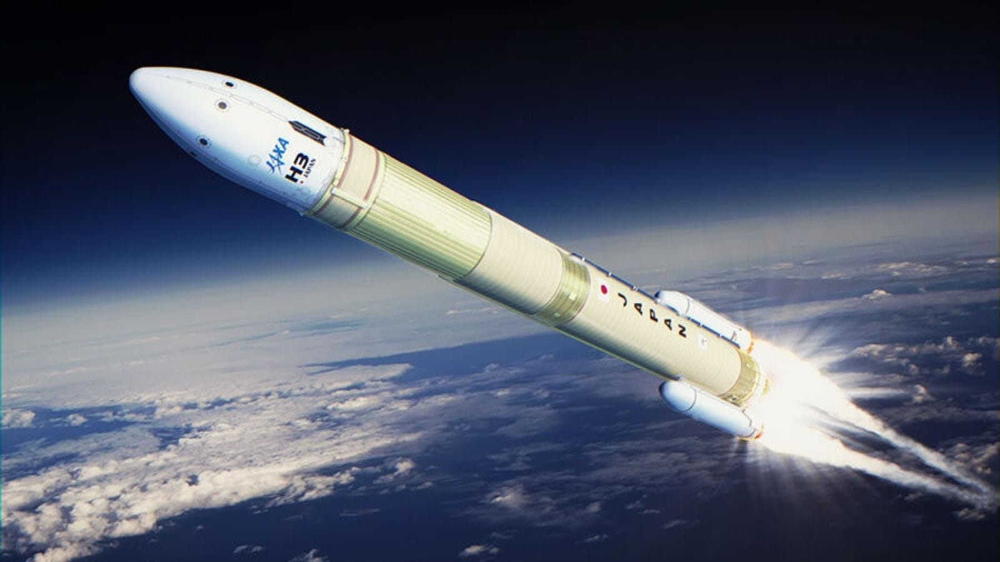
Japan's space program has scored an important victory after the successful launch of its H3 rocket, marking the vehicle's return to flight following a mission failure last year. The Japan Aerospace Exploration Agency (JAXA) launched the H3 rocket from the Tanegashima Space Centre on June 12, successfully delivering six satellites into their planned orbits. The mission represents a significant milestone for Japan's flagship launch vehicle, which is designed to become the country's primary rocket for government, scientific, and commercial missions. The launch was particularly important because it came after the H3's previous mission in December 2025 ended in failure. During that flight, the rocket was unable to deploy the Michibiki 5 navigation satellite after a damaged payload adapter caused problems that affected the second stage and prevented proper engine ignition.

2. ISRO, Department of Atomic Energy collaborate on advanced lunar lander technology - News On AIR
Read more
Indian Space Research Organisation (ISRO) Chairman V Narayanan has informed that they have collaborated with the Department of Atomic Energy to develop an advanced artificial heating system that can protect lunar lander from the freezing weather of the Moon. Addressing the CSIR-RISE Conclave in Bengaluru, ISRO chief explained that Chandrayaan 3 lander Vikram fuelled by solar energy, operated only for 14 days on Moon. ISRO will now work with the Atomic Energy Department to develop a lunar lander that can survive on the Moon for up to 200 days. This lander with artificial heaters can survive harsh weather conditions on the Moon. He added that this will help long-duration lunar exploration in future missions. The lunar days and nights last about 14 Earth days each, and heat reaches 121 celsius and temperature dips to minus 129 celsius at night. Speaking further about research partnerships, V Narayanan disclosed that ISRO and the Council of Scientific and Industrial Research, CSIR have identified 40 areas of technological cooperation and 17 among them have already been approved for implementation in the first phase. Similar research partnerships are also forged with the Department of Science and Technology and others in the private sector to develop space medicines for the Gaganyaan human spaceflight mission. ISRO also worked with the Department of Biotechnology on microgravity experiments that were carried out by Group Captain Subhanshu Shukla during the Axiom 4 mission to the International Space Station.

3. Anomaly in PSLV detected and resolved: Jitendra Singh - The Hindu
Read more
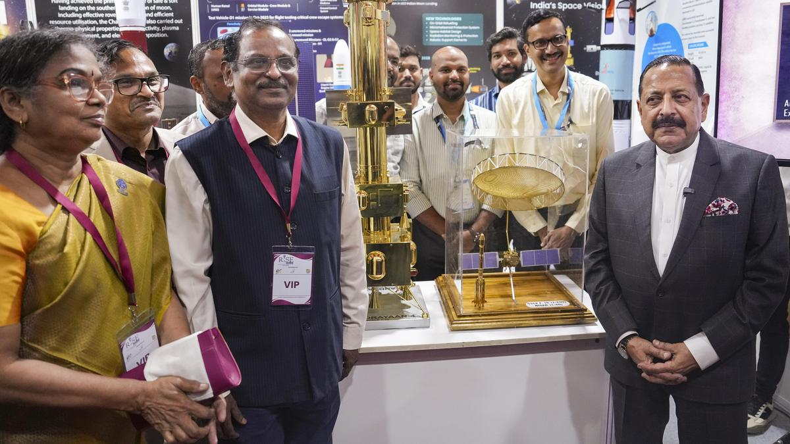
Union Minister of State for Science and Technology Jitendra Singh on Saturday said that the anomaly in the Polar Satellite Launch Vehicle (PSLV) has been resolved. Dr. Singh said on the sidelines of the Research, Industry, Start-up and Entrepreneurship (RISE) Conclave 2026 in Bengaluru, that the national level expert committee constituted to review the reason for anomaly in PSLV Vehicle has submitted its report and the anomaly has been detected. "The report has come out and the anomaly has been detected. However we cannot share that (reason for the anomaly) on a public platform. But experts are working on it, which has been resolved and very soon we will be back on the track," Dr. Singh said replying to a query by The Hindu. It can be recalled that the PSLV which is referred to as the workhorse of the Indian Space Research Organisations (ISRO) had suffered two back to back setbacks. On January 12, 2026 the PSLV-C62 mission carrying the EOS-N1 earth observation satellite failed to finish its intended trajectory after an anomaly was detected during the end of the third stage of the launch vehicle. On May 18, 2025, while ISRO attempted to launch the EOS-09 satellite aboard the PSLV-C61 mission, it couldn't complete it. It was also due to an anomaly in the third stage of the rocket. Following this a National level expert committee was constituted which included K. Vijay Raghavan, former Principal Scientific Advisor, and former ISRO Chairman S. Somanath. Dr. Singh said that the two back to back failures of the PSLV should not be seen as a failure but a setback and learning experience. "There is no such thing as failure in a space mission. It is sometimes delayed, sometimes a setback which actually is a learning experience. Even if you take it that way, if you call every unsuccessful or half successful attempt as a failure statistically our number of so-called failures is much lesser than the USA. Chandrayaan-3 and Mars Orbiter Mission were successful in their very first attempt so that way we have a better statistical record," Dr. Singh said. ISRO Chairman V. Narayanan said that ISRO's next launch, which would be the first one since the PSLV failure in January, would take place next month. "We are building the rocket and may be within a month we will launch. The first launch will be a Geosynchronous Satellite Launch Vehicle (GSLV) mission and subsequently we will launch the PSLV," Mr. Narayanan told The Hindu.

4. ISRO expanding student participation in space missions, 11 student satellites already launched: Jitendra Singh - DD News
Read more
Union Minister of State for Science and Technology Dr. Jitendra Singh on Thursday said the Indian Space Research Organisation (ISRO) is expanding student participation in space missions through structured programmes that allow young researchers to design satellites, develop payloads and participate in real mission experiments. Replying to an unstarred question by Sumitra Balmik in the Rajya Sabha, Singh said the government is committed to widening access to space technology so that students from institutions across the country, including those in tier-2 and tier-3 cities, can contribute to India's growing space ecosystem. The minister said ISRO has launched several initiatives aimed at providing hands-on exposure to space technology for students and researchers. Student satellite programme gaining momentum Singh said that ISRO's Student Satellite Programme, led by the U R Rao Satellite Centre, encourages academic institutions to design and develop satellites with technical mentorship from ISRO scientists. The organisation also supports integration and launch opportunities for these satellites through its missions. So far, the Indian National Space Promotion and Authorisation Centre (IN-SPACe) has authorised 17 student satellites and payloads, of which 11 have already been successfully launched, the minister informed. These projects have involved several academic institutions including the Indian Institute of Astrophysics, Indian Institute of Space Science and Technology, RV College of Engineering, Amity University Maharashtra, MIT World Peace University, Assam Don Bosco University and CV Raman Global University, reflecting growing national participation in student-led space missions. Competitions and innovation initiatives Singh said student engagement is also being promoted through national competitions organised by IN-SPACe. These include satellite and model rocketry competitions in which 97 student teams comprising nearly 850 students have participated. One such event - the Model Rocketry and CanSat India Student Competition - was organised jointly by IN-SPACe, ISRO and the Astronautical Society of India in October 2025 at Kushinagar in Uttar Pradesh. The event saw 67 teams with nearly 500 students design, fabricate and launch model rockets carrying CanSat payloads to an altitude of about one kilometre. Internship and research support The minister said students are also benefiting from internship and project trainee programmes that provide research exposure at ISRO centres for undergraduate, postgraduate and doctoral students. To strengthen collaboration between universities and ISRO scientists, the government has established Space Technology Incubation Centres (STICs) across various regions. These centres support students in developing indigenous space technologies under expert mentorship. In addition, Regional Academic Centres for Space (RAC-S) have been created to help students from smaller towns and institutions access ISRO programmes and research opportunities. Strengthening space education ecosystem Singh also highlighted the role of ISRO's RESPOND Programme, which provides financial and technical support to universities undertaking research in space science, technology and applications. He said the All India Council for Technical Education has approved a Space Technology Minor Course, while a national committee has been formed to promote adoption of space technology education in line with the Indian Space Policy 2023. The government has also earmarked around ₹10 crore annually for educational outreach activities in space science and technology. Singh said IN-SPACe is further supporting the next generation of space entrepreneurs through mentorship from domain experts, pre-incubation programmes and co-working facilities at its technical centres. "These initiatives are part of the government's broader vision to build a vibrant and inclusive space ecosystem in India, where students, startups, academic institutions and industry all contribute to the country's expanding role in the global space sector," the minister said.

5. Govt says ISRO has developed & operationalised wide range of space-based applications to benefit society - News On AIR
Read more
The Government has said that the Indian Space Research Organisation (ISRO) has developed and operationalised a wide range of space-based applications to benefit all sections of society, including the welfare of the Scheduled Caste community. Science and Technology Minister Dr. Jitendra Singh informed this in a written reply in the Lok Sabha today. The Minister said that key space application areas include satellite-based Potential Fishing Zone (PFZ) advisories, crop acreage and production forecasting, agrometeorological advisories for farmers, crop insurance support, geospatial support for flagship government programmes, tele-education, telemedicine, the Vessel Communication and Support System, and disaster management support. Mr. Singh noted that ISRO has established robust awareness and capacity-building programmes to promote the use of space technology for societal, governance, and disaster management purposes, enabling decision-makers to operate effectively at the grassroots level. He added that these initiatives are designed to be inclusive and accessible to targeted beneficiaries across the country. The Minister further said that the benefits of Earth observation, satellite communication, and navigation applications, particularly in terms of improved connectivity and navigation services, are reaching SC farmers, students, and disaster-prone regions within satellite coverage areas. He also highlighted that the Department has undertaken several measures to ensure the inclusive use of space technology, including the implementation of flagship initiatives such as Digital India, the BharatNet Programme, the Vessel Communication and Support System (VCSS) under the Pradhan Mantri Matsya Sampada Yojana (PMMSY), and the PM e-VIDYA scheme for tele-education.

6. Beyond Chandrayaan-3: ISRO developing long-life moon landers - Telangana Today
Read more
Beyond Chandrayaan-3: ISRO developing long-life moon landers ISRO is developing artificial heating technologies with the Department of Atomic Energy to help future lunar landers survive the Moon's harsh nights for 100-200 days. The innovation could significantly extend mission life beyond Chandrayaan-3's 14-day operational period By PTI Published Date - 13 June 2026, 09:00 PM New Delhi: The Indian Space Research Organisation (ISRO) is working on developing technologies that could significantly extend the operational life of future lunar landers to as much as 100-200 days, a major advancement over the current 14-day lifespan achieved by Chandrayaan-3, ISRO Chairman V. Narayanan said on Saturday. The initiative - undertaken in collaboration with the Department of Atomic Energy (DAE) - aims to address one of the most challenging aspects of lunar exploration, surviving the extreme conditions of the Moon's night, when temperatures drop sharply and solar power becomes unavailable. Explaining the challenge, Narayanan noted that while India successfully achieved a historic soft landing near the Moon's south pole with Chandrayaan-3 in August 2023, the Vikram lander remained operational only for the duration of the lunar day. Once the lunar night set in, the absence of sunlight led to a loss of power, limiting operations. To overcome this limitation, ISRO and DAE are now developing artificial heating systems that could protect spacecraft electronics and instruments during the prolonged lunar night. These systems are expected to ensure continuous functionality even in extremely low-temperature conditions. "We are going to develop artificial heaters. If we succeed, such landers can survive for 100 to 200 days instead of only 14 days," Narayanan said. India made history on August 23, 2023, by becoming the first country to land near the Moon's south pole, a region considered crucial for future exploration due to the possible presence of water ice. Earlier in June, the government's Indian National Space Promotion and Authorisation Centre (IN-SPACe) has selected three Indian space startups - Astrobase Space Technologies, SatSure Analytics India and TM2SPACE Technologies - as the first set of Non-Governmental Entities (NGEs) for funding under its Technology Adoption Fund (TAF) scheme.

7. TRACERS spacecraft maps solar energy's route into Earth using cusp electrons
Read more
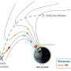
Physicists led by the University of Iowa have documented in the finest detail to date how energy from the sun interacts with Earth's magnetic field, which could yield greater insight into solar effects on Earth that drive space weather.

8. Chinese scientists identify critical vulnerability in NASA's single-engine lunar landing system
Read more
The design philosophy behind the American lunar architecture depends heavily on a single high-performance main engine responsible for critical mission phases. During descent, that engine governs the entire journey from lunar orbit down to the Moon's surface. On ascent, the same single-point system becomes the only means of returning astronauts to lunar orbit. The lack of redundancy means that a malfunction would eliminate any backup option, a concern highlighted in a peer-reviewed study published in Chinese Space Science and Technology in March, which argues the system "contains some glaring weaknesses." By contrast, China's proposed lunar lander adopts a multi-engine approach. Developed by a Shanghai-based national laboratory team, it uses four variable-thrust engines producing over 30 kilonewtons collectively. Even if one engine fails entirely, the remaining three would still deliver thrust comparable to the main engine of NASA's Orion spacecraft. Lunar ascent safety debate centers on redundancy versus mass constraints Beyond the primary propulsion system, the design includes an additional safeguard layer intended to improve mission resilience. If the main engines were to become inoperative, six smaller orbit-control thrusters can still be activated on the lunar surface, providing an alternative pathway for a rapid ascent. This redundancy raises a broader engineering question: if multiple engines offer greater safety than a single one, why are they not universally adopted, the South China Morning Post writes. The constraint is mass, as additional engines typically increase overall vehicle weight, reducing efficiency and payload capacity. The Chinese engineering team addressed this trade-off through a structural optimization known as a common bulkhead tank, which integrates fuel storage more efficiently and reduces excess mass while still enabling a multi-engine configuration. China introduced a new tank design in a crewed deep-space vehicle that uses a pressure-fed system, where fuel and oxidiser are separated by a shared wall, often called a "common bottom." In earlier lunar lander designs, the two propellants were stored in completely separate tanks, which added extra structural weight and took up more space inside the vehicle. By combining them into a single structure with a shared barrier, the system reduces unnecessary duplication in the tank framework. According to the researchers, this change cuts weight at the "hundred-kilogram level," making the overall design more efficient without sacrificing capacity or performance. The reduction in mass created by this design enables the use of four engines instead of a single main unit, increasing redundancy without exceeding launch constraints. Built from composite materials, the tank achieves more than a 20 per cent weight reduction compared to traditional metal alternatives. Beyond storing propellant, the structure also serves a dual purpose as a load-bearing component of the spacecraft, effectively becoming part of the vehicle's frame and improving overall mass efficiency. The approach is backed by experimental validation, with the paper drawing on results from full-system hot-fire tests. These tests provide real-world performance data under operating conditions, confirming the feasibility of the integrated structural and propulsion design. Test results indicate that the four variable-thrust engines can be closely coordinated, keeping thrust variation within less than 100 Newtons. This level of precision is crucial for preventing unstable motion that could cause the lander to tumble during critical flight phases. The experiments also suggest that pressure challenges within the common bulkhead tank can be effectively managed. Replicating this kind of system would be difficult for any other space programme. It requires highly precise autonomous control of pressure inside a shared-tank structure operating with very narrow safety margins. In addition, it demands tightly synchronised performance across multiple throttling engines, a task that becomes significantly more complex as each additional engine is introduced.

