 |  | 

🌌 अंतरिक्ष समाचार | Space News
शुक्रवार, २८/०८/२०२६ | Friday, 28/08/2026

1. Mukhyamantri Championship Trophy registration crosses 2.35 lakh
Read more
PIONEER EDGE NEWS SERVICE/Dehradun Registrations for the Mukhyamantri Championship Trophy have set a record this year, with over 2.35 lakh players registered online so far. Sports minister Rekha Arya on Thursday held a video conference with all district magistrates from the NIC auditorium in the secretariat to discuss preparations for the competition. During the meeting, it was noted that last year, nearly 1.62 lakh players registered online for the Mukhyamantri Championship Trophy. This year, more than 2.35 lakh registrations have been received and this number is expected to rise further by August 31, the final date for registration. In the meeting, Arya instructed officials to ensure that all arrangements for the event are completed on time. She emphasised the importance of ensuring participation from as many talented players as possible. She suggested setting a target to register at least 2,000 players from each block. Additionally, she directed the district planning department to increase the budget for organising the competition to facilitate better arrangements, including accommodation and food for the players. The Sports minister asked the district magistrates to verify that all necessary arrangements for the event are in place, ensuring that players do not encounter any issues. This year's competitions will feature players in two age groups- eight to 14 years and 14 to 19 years. Additionally, women between the ages of 20 and 25 will be eligible to compete in the women's open category. Separate competitions will also be organised for athletes with disabilities. Special principal secretary of Sports, Amit Sinha was also present in the meeting.

2. Uttarakhand sets up helplines after Nepal disaster
Read more
PIONEER EDGE NEWS SERVICE / Dehradun The Uttarakhand government has issued 24×7 helpline numbers for people in Dehradun and other parts of the State after a devastating flood reportedly killed hundreds of people in the nation bordering the State. The flood in Nepal's Rasuwa and Nuwakot districts supposedly after a glacial lake burst affected normal life and tourism activities in the border areas. The helplines have been issued to provide information and assistance to citizens, district administration said. The flood situation was reported in the Bhotekoshi and Trishuli rivers in Nepal on the morning of August 26. The incident took place in areas close to the Uttarakhand region, raising concerns among people who may have relatives, contacts or travel plans in the affected areas. Based on what is known so far, many Indian nationals are reported missing, especially those undertaking the pilgrimage to Kailash Mansarovar from the Nepal route. Apart from this, many from Uttarakhand frequently travel to Nepal and even Tibet from travel, trade and other activities. The status of those from Uttarakhand who may have been affected by this disaster is yet to be ascertained officially by the State government. The Uttarakhand government has issued five helpline numbers for information and assistance. People can contact 0135-2710334, 0135-2710335, 0135-2664314, 0135-2664315 and 0135-2664316. A mobile number, 8218877005, and toll-free number 1070 have also been issued. For Dehradun district, residents can contact 0135-2726066 and 0135-2626066. The district administration has also provided mobile number 7534826066 and toll-free number 1077.

3. Isro to return to launchpad with Gisat-1A; lift-off likely on Sept 4 - The Times of India
Read more

Isro to return to launchpad with Gisat-1A; lift-off likely on Sept 4 The Times of India

4. ISRO's Quiet Loss of Its Critical Asset - Centre for Strategic and Contemporary Research
Read more
ISRO's Quiet Loss of Its Critical Asset Centre for Strategic and Contemporary Research

5. Space Beyond ISRO - Daily Excelsior
Read more
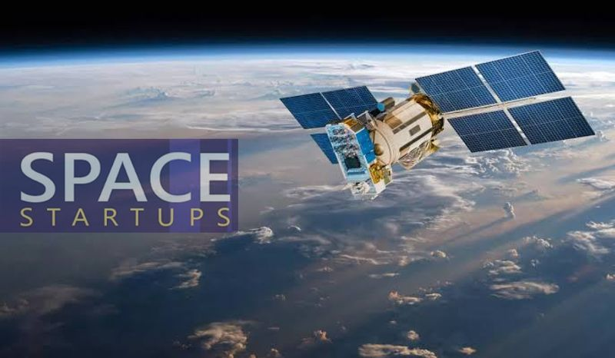
The global space race is being rewritten at a pace few could have imagined a decade ago. Space exploration is no longer the exclusive preserve of Governments and national agencies; it is being reshaped by private enterprise, commercial capital and... The global space race is being rewritten at a pace few could have imagined a decade ago. Space exploration is no longer the exclusive preserve of Governments and national agencies; it is being reshaped by private enterprise, commercial capital and rapid technological innovation. Prime Minister Narendra Modi's call, made during his interaction with the founders of 20 space startups on National Space Day, for India to build a global "aura" around its private space sector, comes at precisely the right moment. The next phase of India's space journey must rest not merely on national prestige but on a genuine commercial space ecosystem capable of taking on the world's best. Nowhere is this transformation more visible than in the United States, where NASA no longer holds anything resembling a monopoly over access to space. Private companies have become dominant forces in launch technology, satellite systems, reusable rockets and space-based communications. Elon Musk's SpaceX has redefined what private enterprise can achieve beyond the atmosphere. The lesson is unambiguous: the future of space will belong as much to nimble companies as to traditional state agencies. This matters because space technology is quietly becoming the backbone of everyday life. Satellites already underpin navigation, broadcasting, disaster response, weather forecasting and strategic communication. The next major leap is wireless, satellite-delivered connectivity that reduces reliance on the vast physical cabling networks stretching across lakhs of kilometres today. Starlink has demonstrated that high-speed connectivity can be beamed from orbit, particularly to remote or difficult terrain where laying conventional infrastructure is costly or simply impractical. The applications reach well beyond communication. Agriculture, arguably India's most vital sector, stands to gain enormously. Satellite imagery and weather data can help farmers track crop health, assess soil and moisture conditions, and anticipate adverse weather before it strikes. Better forecasting of rainfall and extreme weather events can sharpen agricultural planning and cut losses, while space-based data can equally support livestock and dairy management, environmental monitoring, water conservation and disaster preparedness - a point Modi himself urged the startup founders to explore further. India embarks on this new era with a solid foundation of strength. ISRO has repeatedly shown that extraordinary achievement does not require extravagant spending; its reputation for delivering ambitious missions at remarkably low cost has earned global respect. Chandrayaan-3's successful lunar landing, commemorated each year on National Space Day, proved beyond doubt India's technological maturity and its capacity for missions of global significance. But Government achievement alone cannot sustain leadership in an increasingly commercial space economy. ISRO has laid the foundation; the logical next step is to hand a substantial part of the baton to private enterprise - not by diminishing ISRO's role, which must continue to anchor frontier research and strategic missions, but by allowing private players to bring the speed, capital, commercial discipline and appetite for risk that Government institutions cannot always match. The early signs are genuinely encouraging. Skyroot Aerospace, India's first space-tech unicorn, has already flown the country's first privately built rocket into orbit, and its founders speak of scaling from one launch a month to one a week and eventually several a day. Alongside it, a growing cluster of firms - spanning launch services, satellites, earth observation and space situational awareness - is beginning to attract serious investment and international contracts, one startup reportedly securing eight launch contracts within a month of its debut flight. India's deepest asset remains its scientific and engineering talent, and there is now a real opportunity to draw back Indian-origin professionals who built careers abroad. Unlike the more structured recruitment pathways of public institutions, private companies can hire laterally, reward niche expertise and assemble multidisciplinary teams quickly - a flexibility that could prove decisive in the global contest for talent. None of this works, however, without policy stability. Investors committing large sums to rockets and satellites need confidence that rules will not shift arbitrarily, and the Prime Minister's own emphasis on consistency and trust is well placed. A predictable regulatory environment and reliable access to infrastructure will do more to unlock entrepreneurial risk-taking than any amount of rhetoric. India has proven scientific capability, cost competitiveness, deep talent and a maturing entrepreneurial culture. The space juggernaut has begun to move.

6. Public base, private launchpad - The New Indian Express
Read more
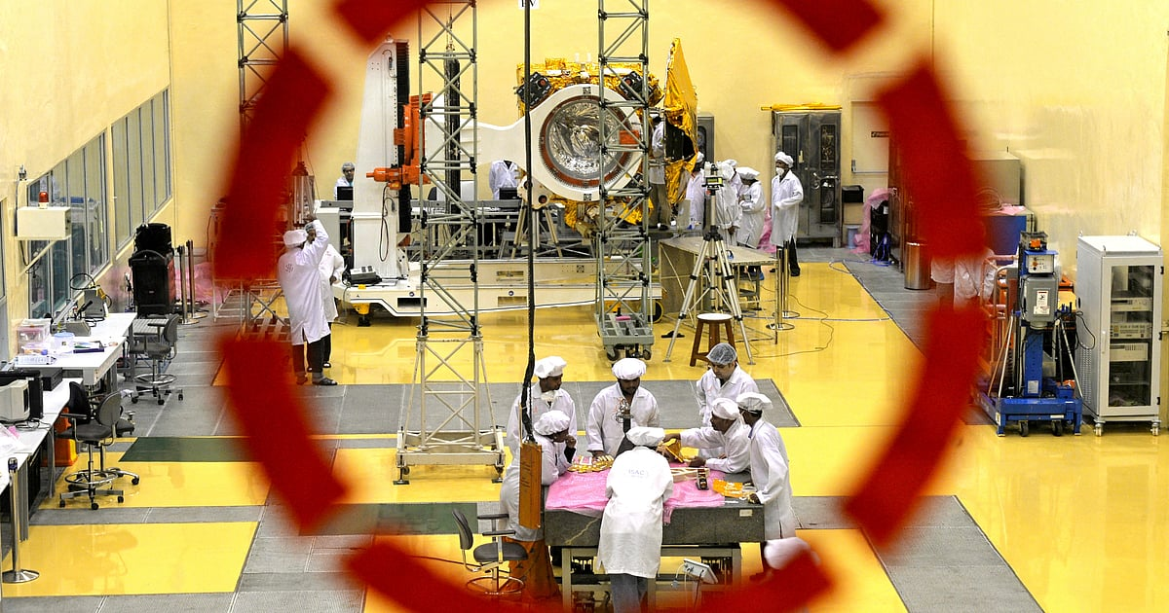
On August 23, Prime Minister Narendra Modi celebrated India's third National Space Day, observed to mark the landing of Chandrayaan-3 near the lunar south pole, during an interaction in New Delhi with the CEOs and founders of 20 Indian space startups. Calling for a private-sector environment to magnetise global talent, investments and companies, he challenged private companies to create thousands of startups within the next five years and increase launch capacity from less than 10 a year at present to 50 rockets from 2029 onwards. The 2026 celebrations were held under the theme 'Towards Viksit Bharat: Innovating, Collaborating and Aspiring to Global Space Leadership'. What seems grandiose is not the ambition-the Modi government has never lacked in esprit-but that the PM said it not at the beating heart of India's space programme, the Indian Space Research Organisation headquartered at Bengaluru, but in front of major private-sector honchos and startup founders in the country's capital, where policy decisions are made. What remained unuttered was the Indian government's latest decision to relegate Isro to a role highlighted in its name: research and research alone. As I had hazarded might happen in my previous column, Isro has been divested of all rocket production and launches, which have been handed over to the private sector. It has begun transferring the production rights and technology of rockets-beginning with the SSLV (small satellite launch vehicle) to Hindustan Aeronautics, and the PSLV (polar satellite launch vehicle) and LVM3 (launch vehicle mark-3)-the erstwhile geosynchronous satellite launch vehicle mark III, India's most powerful operational heavy-lift vehicle-to private domestic industry. Equally to the point, unlike with the SSLV process, public sector units will not be allowed-please note the finality-to participate in the transfer process, leaving the private sector entirely in charge. The 'private domestic industry' bit appears to be for public consumption. For the government announced that it has "liberalised" the "foreign direct investment policy for the space sector" in order "to make it more investor-friendly". How friendly is the pointer to the level of domestication: the government has updated its FDI guidelines to allow up to 49 percent through the automatic route in launch vehicles and spaceports, 74 percent in satellite manufacturing, and 100 percent in component manufacturing.

7. James Webb Space Telescope observes 72 stars and finds planet formation is a race against time
Read more
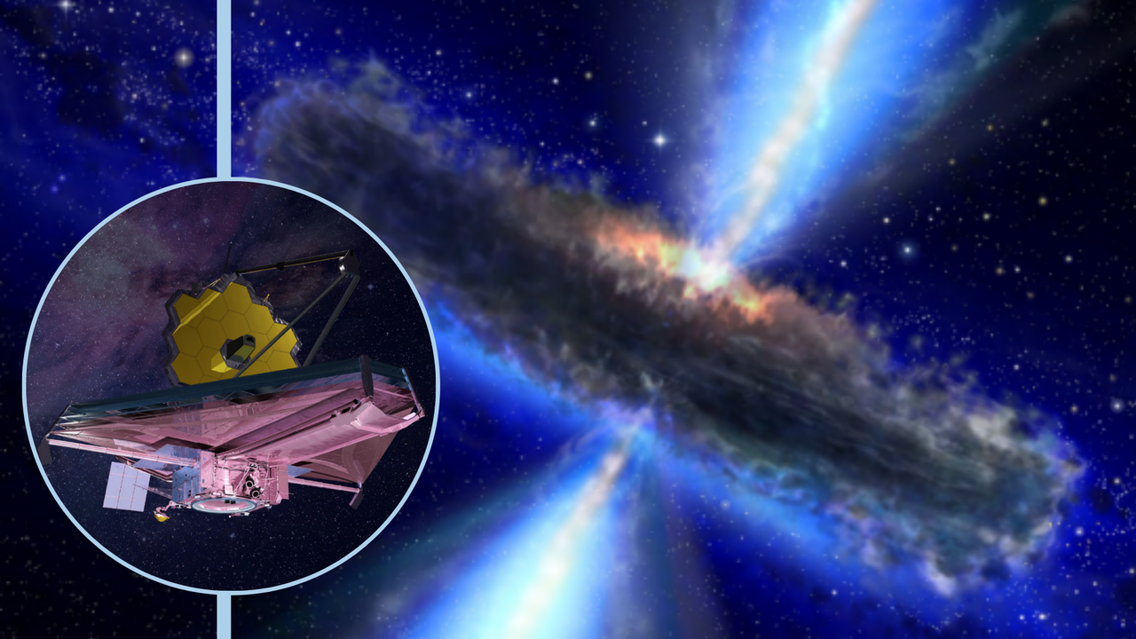
Click for next article Using the James Webb Space Telescope (JWST), astronomers have studied 72 young, sun-like stars. As a result, they found that forming planets is a real race against time. This is because the material that serves as the building blocks for planets is constantly escaping the swirling platters of gas and dust, or protoplanetary disks , that wrap around infant stars. Some types of planets may find their formation window closing sooner than others. The team's research represents the most in-depth investigation yet into how matter escapes these protoplanetary disks and how this escape gives rise to different stages of planet formation around sun-like stars. All in all, the study helps paint a better picture of how and why our solar system took the shape it did around the infant sun around 4.6 billion years ago. "Gas giants like Jupiter must assemble their massive atmospheres while the disk is still substantial enough to supply them, before winds and jets carry that raw material away into space," team leader Naman Bajaj from the University of Arizona said in a statement . An ill wind blows around infant stars The team conducted its research using data collected by the JWST's Mid-Infrared Instrument (MIRI) . The scientists tracked matter loss by following the movements of molecular hydrogen, one of the most common molecules in protoplanetary disks. Each of the stars involved in the investigation represented a different stage in the early life of a star system. That meant putting these snapshots together allowed the researchers to create a "movie" detailing the early life of a planetary system. One of the most important findings of this approach is the mechanisms for material loss from protoplanetary disks seem to evolve and switch dominance as an infant star ages. This is important because gas giants like Jupiter and Saturn have vast atmospheres. They thus require more raw material to form than smaller rocky worlds like Earth do. Understanding matter loss allows scientists to determine at what stages of protoplanetary disk evolution gas giants can form. "What is exciting about this study is that we can now see, across a large sample of young systems, how the mechanisms that remove gas from planet-forming disks change with time," team member Uma Gorti from the SETI Institute said in the statement. "Disk dispersal sets a fundamental clock for planet formation: once the gas is gone, the opportunity to build gas-rich planets is essentially over." An illustration of an evolved protoplanetary disk in which material close to the infant star has been dispersed (Image credit: NASA/ JPL-Caltech/ T. Pyle (SSC)) The researchers found that early in the evolution of protoplanetary disks, powerful, magnetically driven jets and winds dominate mass loss. These jets and winds are powered by magnetic fields that weave through protoplanetary disks. Later, as the disk thins and starlight can pass through it more easily, these winds and jets weaken, and magnetic processes are dominated by high-energy radiation from the infant star ionizing gas and blowing it into space. The latter process is called photoevaporation . All this reveals there is no one single process responsible for stripping planet-forming material from around infant stars. The research also demonstrates the JWST is more than capable of studying the dispersal of gas and dust around individual infant stars. The next step for the team is to discover just how much material these different mechanisms shift. The scientists could also look into the areas of the disks in which the mechanisms studied operate. Down the line, this will help develop a model to reveal just how rapidly planet-formation is shut off - and in which regions of a protoplanetary disk different types of planets are most likely to form.

8. Astronaut Jonny Kim leaves NASA, will return to active military duty
Read more
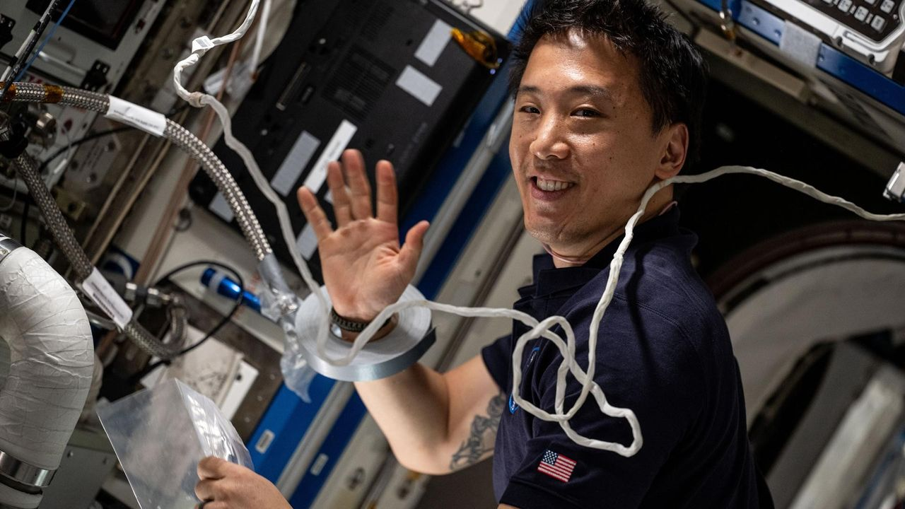
Click for next article Former NASA astronaut and Expedition 73 Flight Engineer Jonny Kim services an experimental carbon dioxide removal device aboard the International Space Station in May 2025. Jonny Kim is leaving NASA to continue his military career. The 42-year-old astronaut, who has one of the most jaw-dropping resumes of any person alive, is departing today (Aug. 27) after nine years with the agency. He has one mission under his belt, a long-duration flight to the International Space Station (ISS). "Jonny has been an integral part of the agency, and his immeasurable impact will be felt for generations to come," Vanessa Wyche, director of NASA's Johnson Space Center (JSC) in Houston, said in a statement today . "From advancing groundbreaking science to inspiring the next generation, Jonny has been an incredible source of inspiration to our nation. His exceptional talent, determination, and grit will leave a lasting legacy at NASA." NASA picked Kim as part of its 2017 astronaut class, the 22nd in the agency's history. He and his 11 fellow selectees nicknamed themselves "The Turtles." Kim was already incredibly accomplished before he got the NASA nod. He's a physician with a medical degree from Harvard. He served in the U.S. military, as a dual-designated naval aviator and flight surgeon as well as a Navy SEAL - a commando trained to conduct special operations on sea, air and land (hence the acronymic name). "Over the course of more than 100 combat operations, he served as a medic, sniper, navigator and point man, earning the Silver Star, Bronze Star with Combat 'V,' and numerous additional commendations," NASA officials said in the same statement. After completing his mandatory two years of NASA astronaut training, Kim served as a CAPCOM ("capsule communicator") at JSC, relaying information between Mission Control and crewmembers on the ISS. "Kim also contributed to Artemis program development through his work in the astronaut exploration branch, leading the astronaut crew operations branch, and serving as increment lead for Expedition 65," NASA officials said in the same statement. "His experiences as a Navy SEAL, physician and naval aviator provided unique perspectives in mission operations and crew support." In April 2025, Kim got the chance to go to space himself. He launched to the ISS aboard a Russian Soyuz spacecraft along with Russian cosmonauts Sergey Ryzhikov and Alexey Zubritsky. The trio lived and worked in space for 245 days, circling Earth 3,920 times and traveling a total of nearly 104 million miles (167 million kilometers), according to NASA. During that time, Kim conducted a variety of scientific experiments that could advance technological development and aid space exploration down the road. Kim, Ryzhikov and Zubritsky returned to Earth in December , touching down in their Soyuz on the steppe of Kazakhstan . Kim isn't walking off into the sunset now. Far from it: He's going back to active duty, "to finish out the remainder of his military career within naval aviation training," according to NASA. "Contributing to space exploration and serving NASA has been the honor of a lifetime," Kim said in the same NASA statement. "Throughout my career, I've learned that beyond the missions, the training, and the hardware, success always comes down to the people," he added. "They are our greatest asset, and leading with love and empathy is how we achieve the impossible. I look forward to carrying my commitment to service, my enduring love for space and technology, and the hard-earned lessons of this past decade into my next chapter to make a meaningful impact on humanity's future."

9. After failure of private rescue mission, NASA's Swift space telescope will crash back to Earth. But when and where?
Read more
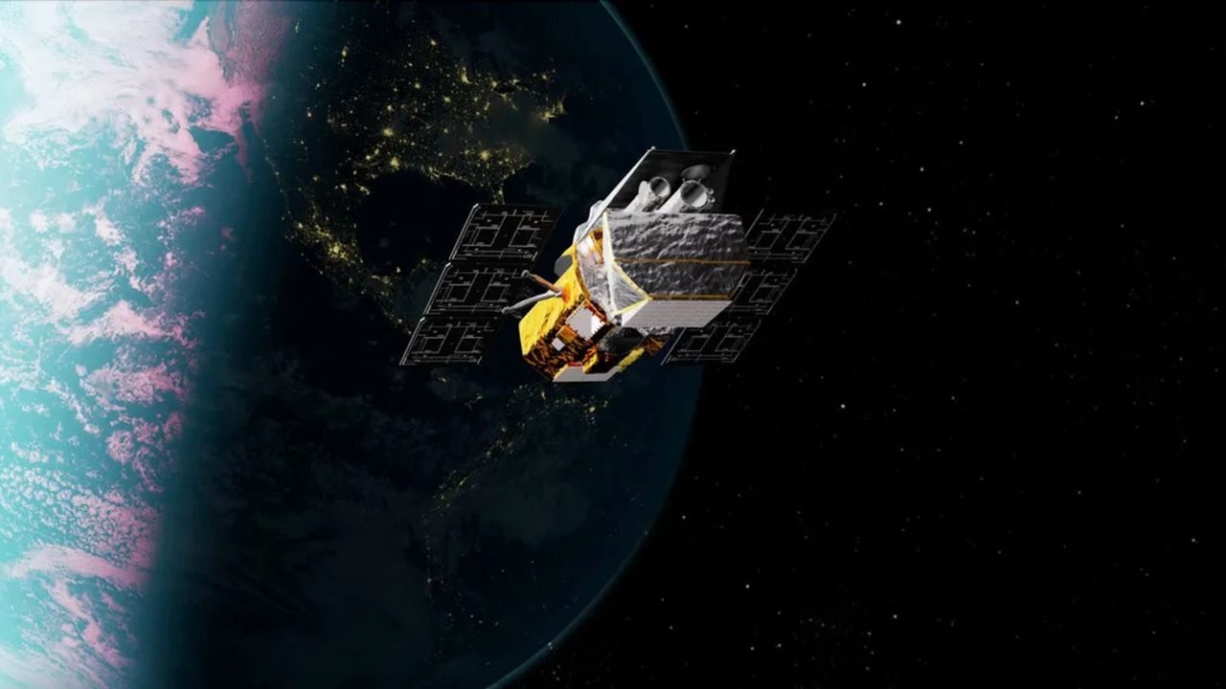
Click for next article Artist's illlustration of NASA's Neil Gehrels Swift Observatory, which launched to Earth orbit in November 2004 and will soon fall out of space. A private spacecraft failed to rescue NASA's Swift space telescope, meaning the big observatory will come crashing back to Earth in the near future. The Neil Gehrels Swift Observatory launched to Earth orbit in November 2004. Over the past two decades, it studied gamma-ray bursts - the most powerful explosions in the universe - and other cosmic objects and events using a trio of telescopes. But Swift's science work is now done, and its days in orbit are numbered. Call to action In September 2025, NASA put out a call to action to save Swift, whose orbit was decaying quickly due to high solar activity. The bottom line: The observatory needed a boost to a higher orbit soon, or it would be dragged down to its death in Earth's atmosphere . The Arizona-based company Katalyst Space Technologies answered that call, and won a $30 million NASA contract to perform the re-boost. In hurry-and-scurry mode, Katalyst built a robotic spacecraft called LINK, which launched on July 3 to meet up with Swift and haul it to a higher orbit. But LINK suffered attitude-control issues after launch, causing NASA and Katalyst to wave off the rescue attempt . Artist's illustration of Katalyst Space Technologies' LINK spacecraft meeting up with NASA's Swift space telescope in orbit. This did not happen, however; LINK suffered issues after launch and was unable to pull of the rendezvous. (Image credit: NASA) Timeline troubles Ghonhee Lee is the CEO of Katalyst Space Technologies. Speaking to CNN News Central on Aug. 24, Lee said: "You know, this is not the outcome that we wanted, but I think it's very important to recognize the unprecedented scale. This was an ambitious, high-risk, high-reward mission where we designed, built and launched a space robot within nine months." Lee said that the timeline worked against the group. "I think if we had had 12 months even - just three more months - it would have made a tremendous difference," he told CNN's Kate Bolduan. Swift is now coming back down to Earth , but it's unclear when and where. A pre-launch photo showing technicians working on NASA's Swift space telescope. (Image credit: NASA/GSFC) Uncontrolled reentry "Yes, Swift will have an uncontrolled reentry ," said Alise Fisher, public affairs specialist in astrophysics within the Office of Communications at NASA Headquarters in Washington, D.C. The spacecraft's specific timing for reentry will depend on a number of factors, Fisher told Space.com. "Swift is not likely to reenter sooner than October. NASA will share more information as reentry approaches, following established interagency procedures for such notifications." NASA expects most of the Swift spacecraft to burn up as it travels through the atmosphere, Fisher said, "but some components are expected to survive reentry. The risk of harm coming to anyone on Earth is unlikely." Diagram depicting the Swift observatory. (Image credit: NASA/GSFC) Survivability analysis Swift's dry mass is 613 kilograms (1,351 pounds). The spacecraft's science gear includes a Burst Alert Telescope, an Ultraviolet/Optical Telescope and an X-Ray Telescope. So what might make it to Earth during Swift's speedy fall through the atmosphere? The observatory's "dry mass and instruments are such that it will likely disintegrate sufficiently upon reentry to not pose a ground casualty hazard," said Darren McKnight, a senior technical fellow at LeoLabs, a company that keeps a persistent eye on what's going on in Earth orbit. "However, it has both an X-ray telescope and optical telescope, so the internal workings of those devices might survive," McKnight told Space.com. He said that optical lenses, along with titanium tanks, are components that might make it to the ground . "I am sure that they have done the analysis but have seen no public reporting on the survivability analysis," he said. A sign of things to come? Swift is unlikely to burn up entirely upon reentry, given its mass, said Ewan Wright, a Ph.D. student in interdisciplinary studies at the University of British Columbia in Vancouver and a junior fellow at the university's Outer Space Institute. We also don't know where it will come down, he noted. "It has an orbital inclination of 21 degrees, so could reenter anywhere in any latitude from 21 North to 21 South," Wright told Space.com. "The most likely outcome is that any surviving debris will land in the sea, but there is a chance it could impact a built-up area and cause a casualty."

10. Starship is coming home! SpaceX loads floating spacecraft onto huge ship in the Indian Ocean (photos)
Read more
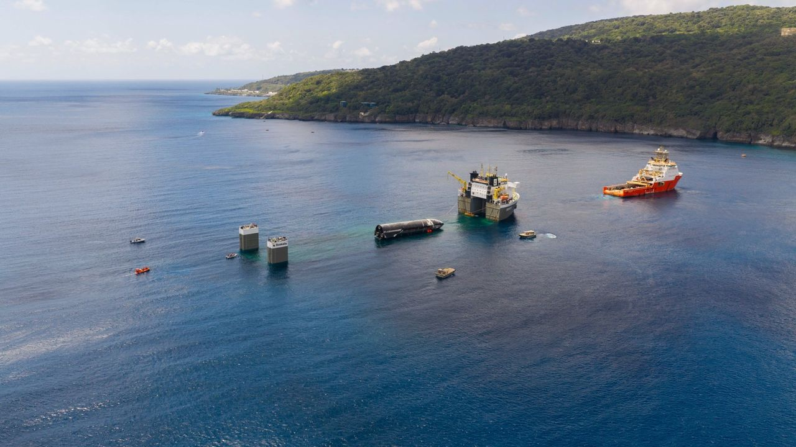
Click for next article SpaceX loads the upper stage that flew on Starship's 13th test flight onto a "semi-submersible" ship off Christmas Island. The company posted this photo on X on Aug. 27, 2026. More than a month after its epic spaceflight, Starship is finally headed home. SpaceX announced today (Aug. 27) that it has loaded Starship 's 171-foot-tall (52 meters) upper stage - known as Starship, or simply Ship - onto a huge "semi-submersible" ship in the Indian Ocean, off the coast of Christmas Island. Ship had been in the water since July 24, when it splashed down to bring an end to the Starship program's 13th test flight . The vehicle will now head back to SpaceX's Starbase site in South Texas, a journey expected to take several months, according to the company . The semi-submersible's deck rises with Ship on board. (Image credit: SpaceX) Starship Flight 13 lifted off from Starbase, sending Ship on an hour-long suborbital jaunt that went quite well. The vehicle deployed its payloads - 20 of SpaceX's big, next-gen Starlink "Version 3" satellites - into space as planned and also managed to relight one of its six Raptor engines in the final frontier as well. Ship then splashed down softly in the Indian Ocean off the coast of Western Australia - so softly, in fact, that it survived the ordeal intact . This was unprecedented; on every previous Starship flight, the upper stage had either broken apart during reentry to Earth's atmosphere or exploded shortly after splashdown, when it toppled sideways into the waves. (Starship's first-stage booster, known as Super Heavy, attempted a soft splashdown in the Gulf of Mexico during Flight 13 but suffered engine problems and hit the water hard.) SpaceX determined to take advantage of this unexpected development. Getting an up-close look at Ship, the company said, would shed light on how its heat shield held up during the flight - key information that could advance the development of Starship, which is designed to be fully and rapidly reusable. SpaceX engineers inspect Flight 13's Ship as it floats off the coast of Christmas Island. (Image credit: SpaceX) So the company began towing the Flight 13 Ship to shore - an endeavor that initially seemed doomed to failure . "Unfortunately, ship recovery is not looking good right now," SpaceX founder and CEO Elon Musk said in an Aug. 7 post on X , the social media platform he bought in 2022. He was responding to a SpaceX post that same day, which cited "challenging conditions and increasingly rough seas." Ship is now on its its way back to Texas. (Image credit: SpaceX) SpaceX persevered, however, and managed to tow Ship to Christmas Island, an Australian territory that lies about 1,200 miles (1,900 kilometers) northwest of the city of Broome. Once there, company engineers inspected the vehicle for several days as it bobbed in the waves, gathering valuable data, according to SpaceX. "They collected heatshield samples and gained vital insight into how the vehicle handled reentry with improvements now planned on future vehicles," SpaceX said today in an X post that shared several photos of the operation. Further analysis doubtless awaits, after the semi-submersible hauler vessel - so called because its deck goes underwater beneath heavy floating payloads, then rises up with them on board - arrives in Texas.

11. Trump tried to scrap NASA's Roman Space Telescope last year. Now it's ready to launch
Read more
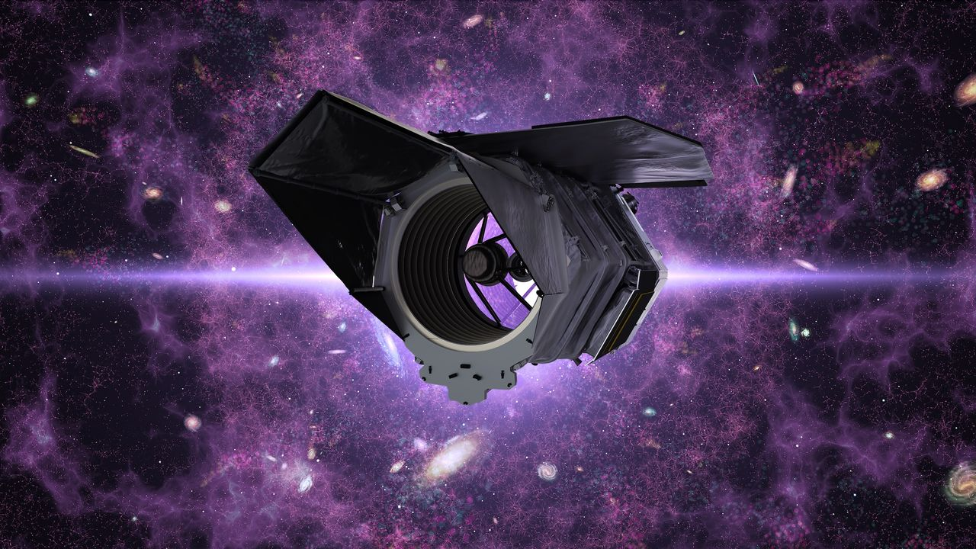
Click for next article The hours are counting down to the launch of NASA's newest flagship orbital observatory. The spacecraft recently got its last glimpse of terrestrial light before being encapsulated in its rocket's protective payload fairing last week and is imminently bound for liftoff. The Nancy Grace Roman Space Telescope is NASA's next-generation research satellite , and it's currently slated to launch on Sunday (Aug. 30). Roman will lift off atop a SpaceX Falcon Heavy rocket at 7:27 a.m. EDT (1127 GMT) from NASA's Kennedy Space Center in Florida. The scope will then head to sun-Earth Lagrange Point 2 (L2), an orbital sweet spot about 930,000 million miles (1.5 million km) away that will park the spacecraft on the side of Earth opposite the sun. Roman's upcoming launch will cap nearly two decades and $4 billion of development and usher in a new wave of astronomical research into dark matter and dark energy , exoplanet discoveries and the ability to capture visible-to-near-infrared images of the universe that are 50 times wider than the field of view on the James Webb Space Telescope (JWST). But last year, as Roman's assembly and testing neared completion, President Trump's leaked budget proposal for fiscal year 2026 (FY26) stoked fears that the entire mission could be canceled. In April 2025, reporting about initial "passback" budget documents outlined a proposal for the largest cut in NASA's history - a 24% overall reduction in funding, with a 50% loss to science programs. The document detailed continued support for missions like Hubble and JWST but allocated "no funding … for other telescopes." The news shocked scientists and engineers across NASA missions, who were suddenly dealt a dose of uncertainty as their job security teetered in political limbo. For Roman's team, the prospect of abandoning the telescope just before the finish line hit hard. Lisa, an engineer who worked on Roman's team at NASA's Goddard Space Flight Center in Maryland and wished to be identified by an alias, was left confounded at the time. "We're 95% there. If it gets canceled, it would be really ridiculous, and I don't know how I would handle it," she told Space.com in an interview. "This is basically my life's work." Others working on Roman took the news in stride. Jamie Dunn has worked at Goddard since 1991. He served as Roman's project manager from 2018 until he was appointed director of the center this past June. During a question-and-answer session with a committee of the National Academies of Sciences, Engineering, and Medicine on Aug. 10 - part of a congressionally mandated assessment prompted in part by reporting from Space.com about accelerated facility closures and consolidations at Goddard last year - Dunn described a calmer reaction to Roman's potential cancellation. "Out of the eight years I [worked on Roman]," he told the committee, "we were zeroed out in the president's budget … in at least half of them. Not to be casual about it, but that happens." When the president's official "skinny budget" proposal was published a few weeks after the April leak last year, Roman's prospects shifted from dire to just worrisome. Instead of cancelling the mission outright, the administration's budget request allocated just $156.6 million to Roman's continued development in FY26 - less than half of what the project received in FY25. Scientists working on the Roman Space Telescope. (Image credit: NASA/Sophia Roberts) Goddard personnel began working around the clock at a time when government agencies, including NASA, were initiating reductions in force and encouraging civil servants to accept a " deferred resignation " option. Of three skilled technicians working in one department of Roman's team, two left, according to Lisa, which put further strain on the telescope's ongoing qualification testing at the time. "We're pushing forward to get as far as we can while we have our current funding, and we'll see what happens," Lisa told Space.com last summer. "That amount of funding obviously will make it impossible, in my opinion, to keep schedule, because we can't keep running two shifts with half the people." On the management side, Dunn tried to keep his team from getting distracted by politics. "Sometimes you've just got to keep coloring," he told the National Academies committee. "We kept working, and I [told the Roman team that] the best thing we can do is deliver on our commitments. And if delivering on our commitments isn't good enough, then what else can we do?" Lisa said that Roman's mission leadership mitigated the team's panic. "[They] actually did a really good job of telling us, 'We're just going to proceed as we were before … Just focus on the work,' and, 'The best way to make sure we don't get cut is to continue delivering and continue to stay on schedule,'" she said. Many of the engineers and technicians working on Roman "just put on blinders, put our heads down and kept working," Lisa said. "People were giving up their weekends, and at the same time, there was this compartmentalized knowledge that it could all get cut." Rather than merely stay on schedule, though, the Roman mission team was pushed to accelerate it. Congress ultimately rejected the steep cuts to NASA in the president's budget request and restored the agency's funding to the previous year's levels. Not wanting to go through a repeat of uncertainty for FY27, Roman mission management began eyeing faster routes to the launch pad. "They just kept pulling it earlier and earlier, because I think they were pushing to get it off the ground and in space before it could get cut," Lisa said. Eventually, Roman's target launch date moved up to September, and then to the end of August "so that it could happen within this fiscal year." "In order to stay on schedule at the time, the Roman teams were running two shifts every day and working every Saturday, sometimes on Sundays," Lisa said. The strain took a toll on morale, but their hard work paid off. NASA announced the Roman Space Telescope's completion in April, eight months ahead of schedule, and under budget. "Lo and behold, it turns out delivering on your commitments means something," Dunn said. Now, all eyes are turning to watch Roman leave Earth . Having passed all its political hurdles leading up to launch day, Roman has one more major milestone: Launching to space to begin its mission. Rocket rides to orbit aren't known for being particularly smooth, and after so much time spent worrying about budgets and schedules, Lisa said the part that makes her and her colleagues most nervous now is that it's out of their hands. "The launch vehicle … that's what we kind of don't have control over," Lisa said. "I'm really nervous, because it's just so many people's effort and years of work and sacrifice." It'll take the telescope 30 days to reach its L2 destination, and there are a few benchmarks it has to meet along the way. Roman will have to perform a few trajectory adjustments, including the mid-course "correction 1" maneuver about 24 hours after launch, which Lisa described as one of Roman's most consequential in reaching its designated orbit. After nearly two decades of development - and a final year spent wondering whether the telescope would make it to the launch pad at all - the team's focus has finally shifted to Roman's actual in-space operation as it awaits delivery to its new home in the final frontier.

12. Powerful Ariane 6 rocket launches European weather satellite to orbit (video)
Read more
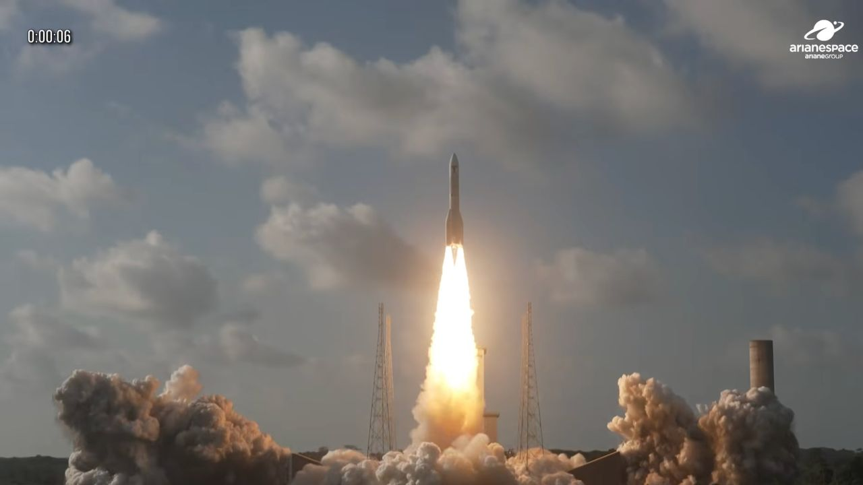
Click for next article Europe's most powerful rocket flew again today (Aug. 27). An Ariane 6 launched the MTG-I2 weather satellite from Europe's Spaceport in Kourou, French Guiana today (Aug. 27) at 4:10 p.m. EDT (2010 GMT; 5:10 p.m. local time in Kourou), right at the beginning of a 2.5-hour window. Everything went according to plan today: The Ariane 6 released MTG-I2 into geostationary transfer orbit (GTO) 36 minutes after liftoff. An Ariane 6 rocket launches the MTG-I2 weather satellite from Kourou, French Guiana on Aug. 27, 2026. (Image credit: Arianespace) The 8,400-pound (3,800 kilograms) MTG-I2 is the second imaging satellite in the Meteosat Third Generation network (hence the name). It will complete the three-spacecraft constellation in geostationary orbit , which lies 22,236 miles (35,786 kilometers) above Earth. Its companions, MTG-I1 and MTS-S1, launched in December 2022 and July 2025 , respectively. MTG-I1 is an imaging craft and MTS-S1 is a "sounder," using an infrared instrument to probe different layers of Earth's atmosphere . The MTG satellites are operated by the European Organisation for the Exploitation of Meteorological Satellites ( EUMETSAT ), an international group based in Germany. And they're very capable, according to Arianespace. "The MTG system is part of a new generation of geostationary satellites providing imagery for the early detection of fast-developing severe storms, weather forecasting and climate monitoring," the company wrote in the MTG-I2 press kit, which you can find here . Arianespace went on to describe MTG as "the most complex and innovative meteorological geostationary system ever built," citing its potential to improve the prediction and early detection of severe weather events. "The data gathered will have a wide range of uses, from enabling aircraft to avoid storms and for earlier alerts of flooding, through to more precise monitoring of fires and fog," the company wrote. Today's launch was the ninth to date for the Ariane 6, which can deliver up to 12.7 tons (11.5 metric tons) to GTO in its burliest configuration. For comparison, SpaceX's workhorse Falcon 9 rocket has a GTO payload capacity of 9.15 tons (8.3 metric tons). The Ariane 6 debuted in July 2024. Before today, the rocket last flew this past June , when it successfully sent 36 of Amazon's broadband satellites to low Earth orbit . Editor's note: This story was updated at 4:20 p.m. ET on Aug. 27 with news of successful liftoff, then again at 4:50 p.m. ET with news of satellite deployment.

13. NASA Johnson pilots chase moon's shadow for eclipse science
Read more
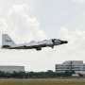
During the Aug. 12 total solar eclipse over Europe, scientists aimed to study a long-standing mystery: why the sun's outer atmosphere, the corona, is far hotter than its visible surface. Capturing the data they needed meant being in exactly the right place at the right time.

14. NASA's Webb telescope rules out two new Dyson sphere candidates
Read more

The latest Swedish-led search for technosignatures in the form of Dyson spheres has again come up empty-handed. The two latest stellar candidates in the hunt for such hypothetical extraterrestrial technology have been eliminated as Dyson spheres.

