 |  | 

🌌 अंतरिक्ष समाचार | Space News
शुक्रवार, १४/०८/२०२६ | Friday, 14/08/2026

1. IN-SPACe overreach threatens ISRO's strategic future: G Madhavan Nair - The Federal
Read more
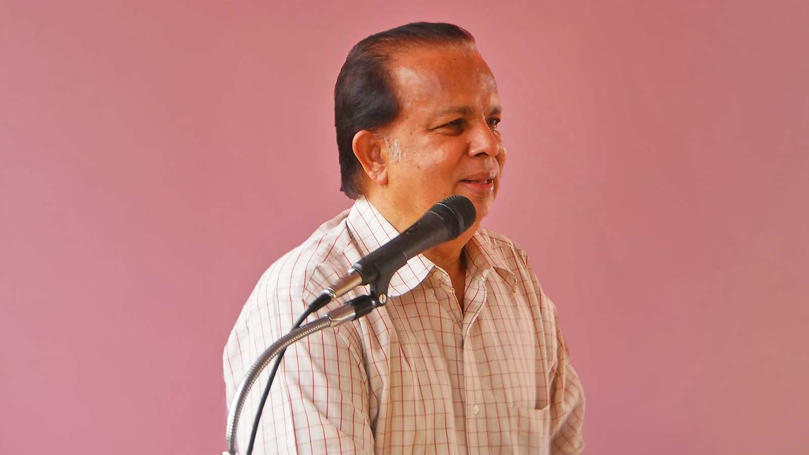
It appears that the Indian Space Research Organisation (ISRO) plunges into a crisis after achieving every major milestone. Is it a jinx or something that the Indian strategic organisation must contend with, wondered G Madhavan Nair, retired Secretary, Department of Space (DoS). and former Chairman, ISRO, in an interaction with The Federal. Nair also categorically said the Indian National Space Promotion and Authorisation Centre (IN-SPACe), the regulator for private space sector players, is acting beyond its mandate by calling bids from industries for ISRO's technologies and assets. First about the jinx Once is happenstance, twice is coincidence and three times is enemy action, goes the old saying. In ISRO's case, there appears to have been more than one such instance. Is it merely coincidence, a recurring institutional vulnerability, or something more deliberate? "There seems to be a pattern. Soon after ISRO achieves a major technological milestone, some controversy or action happens, putting the organisation into a sort of crisis to pull it down," Nair told The Federal. In support of his view, Nair said India successfully launched its Polar Satellite Launch Vehicle (PSLV) in October 1994, proving its ability to put satellites into orbit with its own rockets. Also Read: TN rocket port in private hands: Is IN-SPACe becoming Centre's space privatisation arm? Shortly after this achievement, the agency was rocked by an espionage scandal. But the Supreme Court ruled that the charges against a top ISRO scientist were fabricated. Antrix-Devas controversy "The next issue was the Antrix Corporation-Devas Multimedia issue that happened soon after India's first moon mission, or Chandrayaan-1, came to an end in 2009," Nair said. Also Read: Why are top scientists quitting ISRO? The Chandrayaan-1 mission was launched in October 2008. In August 2009, ISRO formally announced the mission's end, by which time several discoveries, including evidence of water on the Moon, had been made by the Indian payloads. ISRO's unique culture should be nurtured, and the golden egg-laying goose should not be killed. And soon after that, the Antrix-Devas Multimedia agreement blew up into a major controversy and the agreement was scrapped. LVM3 success and the new challenge The year 2014 saw the emergence of ISRO's heavy-lift rocket LVM3. Since then, the LVM3 rocket has been flown nine times for orbiting domestic and foreign satellites, including those of European player OneWeb and US company AST SpaceMobile. Also Read: Centre changes ISRO resignation rules amid exodus of experienced scientists After launching of the foreign communication satellites, Nair sees the current phase as posing a sort of existential challenge to ISRO, with not only its rockets and other technologies being tendered out but also its infrastructure assets, including the upcoming spaceport at Kulasekarapattinam in Tamil Nadu. IN-SPACe, set up as the regulator for private sector space players, has called for Expressions of Interest (EoI) for ISRO's PSLV and LVM3 rockets and for the about Rs 1,000 crore rocket port coming up in Tamil Nadu. "IN-SPACe is overacting, assuming roles not assigned to them. They are interfering with ISRO's and NewSpace India Ltd's (NSIL) activities. A sectoral regulator cannot be the executor of programmes," Nair said. Rocket tech transfers Adding a note of caution on the transfer of rocket technologies with dual-use applications, Nair said there should be an appropriate legal framework, and currently there is no safeguard for this. "There is no space law in India now. And many things are happening before it is enacted," he said. Citing India's other strategic sector, Nair said both space and nuclear power have a unified command structure. Also Read: ISRO's PSLV failure: Who pays when rocket missions go wrong? The chairman of the sectoral apex bodies - the Space Commission and the Atomic Energy Commission - and the respective Departments are headed by one person. "Any change will upset the balance," Nair said. Like the space sector, the Indian government has opened up the atomic power sector for private players. And it is only the Nuclear Power Corporation of India Ltd (NPCIL) that had invited bids for its small atomic reactors and not the sectoral regulator, Atomic Energy Regulatory Board (AERB). ISRO, NSIL and IN-SPACe According to Nair, the government-owned Indian space sector has three important organisations: 1) ISRO, which develops technologies and builds infrastructure, carries out space missions and, till date, remains India's only end-to-end integrated space sector player. 2) NSIL, formed to commercialise ISRO's services, its technologies and rockets. 3) IN-SPACe, a regulator, largely for the private sector. Also Read: ISRO to triple spacecraft output, target Chandrayaan-4 launch in 2028: Narayanan IN-SPACe is encroaching into the domain of NSIL and ISRO, Nair emphasised. "While the sectoral regulator can be independent, ISRO, NSIL and industrialisation should be under one roof, with the unity of direction and command being a must. NSIL can form a joint venture with the interested parties instead of transferring the technologies," he observed. He said earlier the industry was not willing to set up separate facilities to cater to ISRO's needs. "Nearly 60% of ISRO's budget was spent in favour of industries in sourcing various systems and components," he recalled. Private sector: hype vs reality Referring to private players in the sector, Nair said there is a lot of hype but nothing major has come out, barring Skyroot Aerospace's successful maiden orbital launch of its rocket. Nair also said the Indian space agency must check whether any of its intellectual property rights have been used without proper licence. IN-SPACe is overacting, assuming roles not assigned to them. They are interfering with ISRO's and NSIL's activities. A sectoral regulator cannot be the executor of programmes. He estimates that an outlay of about Rs 50,000 crore would be needed to realise India's plans to set up a space station, send humans to the Moon, build space capsules and pursue other ambitious programmes. It is only the government that can fund these programmes and not the private sector, he added. Also Read: ISRO's strategic satellite delays expose cracks in India's space readiness There is, however, another side to the debate. The opening up of the space sector to private players is a deliberate policy decision of the government, with IN-SPACe created precisely to facilitate and regulate private participation. The question, therefore, is not whether private participation is desirable, but whether a regulator should also determine which ISRO technologies and assets should be transferred or commercialised, and on what terms. 'Do not kill the goose...' The real test of India's space-sector reforms, therefore, may not be the number of private companies entering the sector or the number of ISRO technologies transferred to industry. It will be whether private participation strengthens India's overall space capability without weakening the institutional capacity, technological independence and strategic role of ISRO. Also Read: ISRO plans to send astronauts to Moon by 2040 "As compared to other R&D organisations in India, ISRO is the only organisation that has acquitted itself well and has taken the country to the skies. ISRO's unique culture should be nurtured, and the golden egg-laying goose should not be killed," Nair remarked. The government can set up committees or groups to chalk out the roadmap for the sector as there are a large number of retired ISRO officials and Chairmen, he suggested. "There is no dearth of space scientists in India. What is the logic of sending home space technologists at 60 while having much older and an expert in the automobile sector as the sectoral regulator?"

2. ISRO taking steps to tackle space debris, rising satellite congestion: Dr Jitendra Singh - Greater Kashmir
Read more
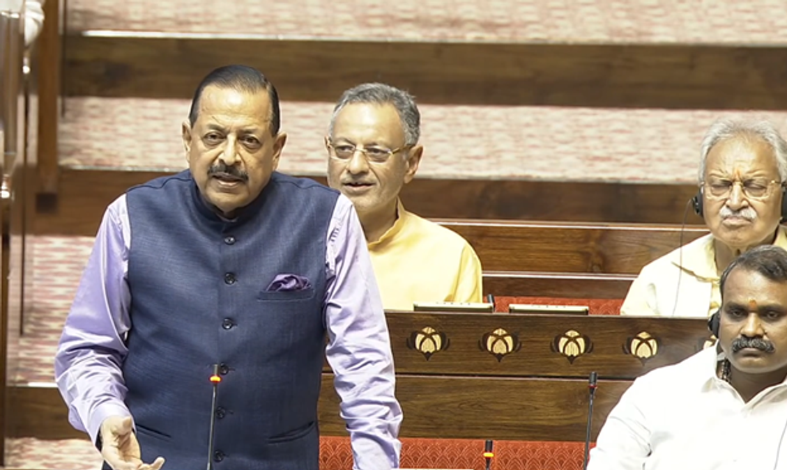
New Delhi, Aug 13: The Indian Space Research Organisation (ISRO) is seized of the issue of proliferation of a large number of Low Earth Orbit (LEO) satellite constellations or Satellite Internet constellations causing accumulation of Space debris and is taking all possible steps for its mitigation and prevention, Minister of State for Personnel, Public Grievances & Pensions and Prime Minister's Office, Dr. Jitendra Singh, said in a reply in the Rajya Sabha today. Advertisment ISRO's 'Debris Free Space Mission' will play a key role in safeguarding space assets and limiting further generation of debris through Active Debris Removal (ADR) and other means, the Minister added. Dr. Jitendra Singh stated that satellite constellations for internet connectivity typically consist of a few thousand satellites, significantly increasing collision risks in orbital regions around their respective orbital shells. While many large constellations have autonomous collision avoidance capabilities, some satellites may fail on-orbit and may not be capable of manoeuvring to avoid collisions. The Minister further noted that small-sized untrackable debris poses an additional risk, as such debris cannot be avoided through collision avoidance or adequately shielded against. An impact can cause mission-ending damage, rendering a satellite non-functional and generating further debris. Given the large number of satellites involved, the aggregate risk of debris creation is significant. He also pointed out that any fragmentation event, whether caused by a collision or accidental break-up near a populated orbital shell, could further escalate these risks. Highlighting India's institutional engagement on space debris monitoring and mitigation, Dr. Jitendra Singh informed that the Inter-Agency Space Debris Coordination Committee (IADC), formed in 1993, is considered the most recognised body dealing with space debris monitoring and mitigation matters. ISRO under the Department of Space has been a member of IADC since 1996. He also stated that the United Nations Committee on the Peaceful Uses of Outer Space (UN-COPUOS) addresses space debris mitigation and long-term sustainability matters, including the safety of space operations. India is represented in international fora dealing with space debris, including the IADC, UN Scientific and Technical Subcommittee (UN-STSC) Working Group on Long-Term Sustainability and Expert Group on Space Situational Awareness (SSA). Dr. Jitendra Singh stated that IADC members regularly deliberate on space debris-related matters and revise space debris mitigation guidelines in response to the evolving space debris environment. Space debris monitoring and spaceflight safety aspects are also discussed in the Long-Term Sustainability and Space Situational Awareness working groups. He further informed that other international platforms, including the IAA Space Debris Working Group and ISO Working Group 7, provide avenues for coordination between the Department of Space and international agencies on space debris monitoring and mitigation. On end-of-life disposal of satellites, Dr. Jitendra Singh said the Indian Space Policy mandates adoption of internationally recognised guidelines on space debris mitigation, including measures relating to end-of-life disposal, in the Indian space programme. The Debris Free Space Mission initiative, spearheaded by ISRO, is a proactive step towards implementing guidelines on end-of-life disposal of satellites. The Minister also stated that the Norms, Guidelines and Procedures released by IN-SPACe in 2024 encourage all Indian space actors to adopt adequate post-mission disposal measures or ensure that their space assets have very limited orbital life through natural orbital decay. Dr. Jitendra Singh identified Space Situational Awareness (SSA) as one of the most crucial enablers of long-term space sustainability. He said other important requirements include operators fulfilling technical requirements such as manoeuvrability and trackability, meeting basic obligations including registration and sharing of points of contact, and ensuring a robust regulatory framework. The Minister further stated that wider implementation of internationally recognised space debris mitigation measures and better compliance with the requirements of the Debris Free Space Mission will play a key role in safeguarding space assets and limiting further generation of debris. He also highlighted the importance of Active Debris Removal (ADR) in curtailing the growth of space debris. Activities serving as precursors to ADR have already been initiated through on-orbit demonstrations and are expected to mature over time. Emphasising the importance of both international cooperation and indigenous capabilities, Dr. Jitendra Singh said international collaboration and data sharing are essential for comprehensive Space Situational Awareness and long-term sustainability. At the same time, self-reliance through indigenous capacity building for space object monitoring will be pursued along with innovative measures and R&D to address emerging challenges. He also stressed the importance of raising awareness among space actors about the fragility of utilisable regions of the space environment to ensure long-term sustainability.

3. LS Speaker, Defence Minister, Science and Technology Minister pay tribute to former ISRO Chairman Dr Vikram Sarabhai | Akashvani News - News On AIR
Read more
Lok Sabha Speaker Om Birla today remembered Scientist and Padma Vibhushan recipient Dr Vikram Sarabhai on his birth anniversary. In a social media post, Mr Birla said that Dr Sarabhai believed that science should not be confined merely to laboratories, but its purpose must be to improve the life of the common man. He noted that this visionary outlook of Dr Sarabhai laid a strong foundation for modern scientific research in India and transformed space science into an effective instrument of nation-building. The Lok Sabha Speaker highlighted that under Dr Sarabhai's leadership, Indian Space Research Organisation (ISRO) was established, guiding India toward becoming a self-reliant, capable, and credible space power. Mr Birla said that his ideals, thoughts, and scientific vision will continue to inspire upcoming generations. Defence Minister Rajnath Singh also paid tribute to former ISRO chairman Dr. Vikram Sarabhai on his birth anniversary. In a social media post, Mr Singh said, Dr Sarabhai's scientific imagination helped lay the foundations of India's space journey. The Minister noted that his conviction that science must serve the nation and improve people's lives, gave a new direction to India's pursuit of scientific excellence. He highlighted that the heights India's space programme has reached today are a profound vindication of Dr Sarabhai's vision, determination and pioneering spirit. Union Science and Technology Minister Dr Jitendra Singh also paid tribute via a social media post. Dr Singh said that the ambitious dream for India that Sarabhai saw sitting in his primitive scientific set-up stands gloriously vindicated today. The Minister described Dr Sarabhai as one of the founding fathers of India's Space programme.

4. NASA Invites ISRO to Join Moon Base Programme, Significance - Vajiram & Ravi
Read more
NASA Invites ISRO to Join Moon Base Programme, Significance Vajiram & Ravi

5. Kerala University recommends honorary doctorates on former ISRO chief, others - The New Indian Express
Read more
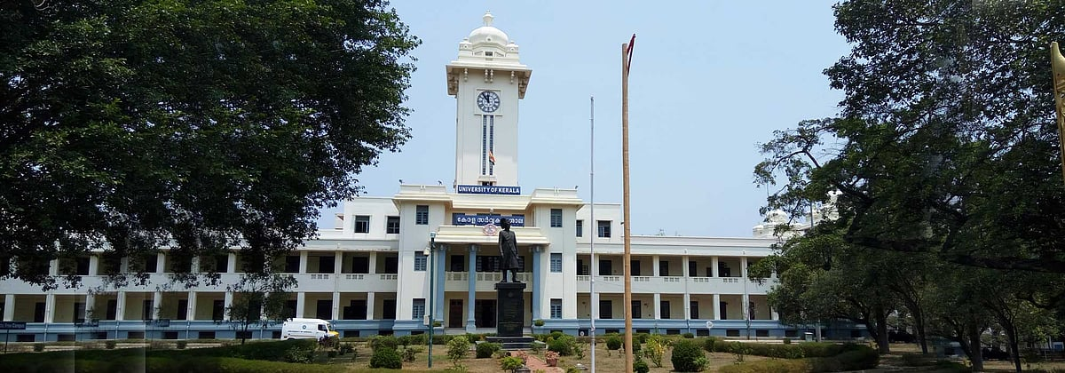
THIRUVANANTHAPURAM: Former ISRO chairman Dr K Radhakrishnan, veteran film actor Madhu, poet-filmmaker Sreekumaran Thampi and former Indian hockey team captain and Olympian P R Sreejesh are set to receive honorary doctorate degrees from the University of Kerala. The University Syndicate, which met on Thursday, decided to recommend to Governor Rajendra Arlekar, the Chancellor of the University, that the honours be conferred on the four. While K Radhakrishnan will receive an honorary Doctor of Science (DSc) degree, Madhu, Sreekumaran Thampi and P R Sreejesh will be conferred honorary Doctor of Letters (DLitt) degrees. In 2019, the University of Kerala had conferred honorary doctorates in science on scientist CNR Rao, astrophysicist Jayant Narlikar and Infosys co-founder Kris Gopalakrishnan.

6. Chandigarh University joins ISRO to host National Space Technology Conclave on 17th-18th August; Group Capt Shubhanshu Shukla among 30 Space Scientists to attend - UNITED NEWS OF INDIA
Read more
30 Eminent Scientists & Mission Leaders from ISRO, IIST, IN-SPACe & NSI to be part of 'Chandigarh University Declaration on Space Technology for Viksit Bharat CHANDIGARH, India, Aug. 13, 2026 /PRNewswire/ -- Giving fresh impetus to India's growing space ambitions and advancing the Viksit Bharat vision through innovation, indigenous space capabilities and a future-ready scientific workforce, Chandigarh University's Kalpana Chawla Centre for Research in Space Science and Technology (KCC) is all set to organise India's first university-led National Space Technology Conclave (NSTC) 2026 on August 17-18 at the University campus. The two-day conclave, being jointly organised in collaboration with the Indian Space Research Organisation (ISRO) and the Indian Institute of Space Science and Technology (IIST), Department of Space, Government of India will focus on the theme 'Emerging Space Technologies for India's Future Space Missions' and will provide students a direct platform to engage with 30 distinguished scientists, mission leaders and technologists from ISRO, IIST, Indian National Space Promotion and Authorization Center (IN-SPACe), NewSpace India Limited (NSIL) and U R Rao Satellite Centre (URSC) with 10 CEOs and senior leaders from leading Indian space industries and start-ups. The conclave will feature five roundtables and space technology demonstrations, facilitating discussions on the technologies shaping India's next phase of space exploration and human spaceflight while inspiring the next generation of innovators to contribute to the nation's Viksit Bharat journey. The conclave will feature Group Captain Shubhanshu Shukla, Ashoka Chakra, Indian astronaut and Indian Air Force officer, as the Special Guest. Group Captain Shukla created history in June 2025 by becoming the first Indian to visit the International Space Station (ISS) and participated in scientific experiments, marking a defining moment in the nation's space exploration journey. He has also been selected as one of the astronauts for India's Gaganyaan human spaceflight programme. Among the prominent space scientists and experts expected to participate are Dr Pawan Goenka, Chairman, IN-SPACe, Department of Space; Dr S Somnath, Former Chairman, ISRO; Dr Rajeev Jyothi, Director, Technical Directorate, IN-SPACe, Department of Space; Prof D Banerjee, Vice-Chancellor, IIST, Department of Space; Dr A Bharadwaj, Director, PRL, Department of Space; M Sankaran, Director, URSC, ISRO; Dr RP Singh, Director, IIRS, ISRO; and I S S Sarkar, Director, SAC, ISRO. The wider participation will include senior scientists, directors, project leaders, researchers, technologists, industry leaders and start-up representatives from across India's space sector. A major outcome of the two-day conclave will be the 'Chandigarh University Declaration on Space Technology for Viksit Bharat 2047' which will bring together space scientists, institutional leaders and the Chandigarh University team to define the role and responsibilities of universities in contributing to India's space technology ambitions. The declaration is envisaged as a collaborative roadmap for strengthening the university participation in space technology education, research, innovation and industry collaboration, with its recommendations and outcomes proposed to be shared with the Prime Minister's Office. The initiative is aligned with the conclave's larger objective of strengthening collaboration among ISRO, IN-SPACe, NSIL, academia, industry and start-ups while creating new avenues for research, skill development, internships, employment and technology development. Speaking about the significance of the conclave, Prof. (Dr) Eswar Sunkara, Senior Director, Kalpana Chawla Centre for Research in Space Science and Technology, Chandigarh University, said, "For the first time, Chandigarh University is bringing together leading ISRO scientists, IIST, space agencies, astronauts and industry leaders on a common university platform to deliberate on what universities can contribute to India's space technology journey. The Chandigarh University Declaration on Space Technology for Viksit Bharat 2047 will define the roles and responsibilities of Chandigarh University and other universities in supporting the national space vision. Our objective is to build a systematic space technology hub with the support of ISRO, develop space-ready human resources and create capabilities in satellite development, payloads, launch technologies, data analysis and other emerging areas. The outcomes of these deliberations will provide a roadmap for CU's long-term contribution to India's space programme." Prof. (Dr) Eswar Sunkara added, "The conclave will set out a strategic roadmap for establishing Chandigarh University as a premier national space technology hub in North India with the Kalpana Chawla Centre envisaged as the focal point for space technology research, innovation and capacity building. The proposed roadmap will explore areas including satellite development, satellite payloads, launch and mission technologies, reusable launch vehicle technologies, ground stations, space data analysis, artificial intelligence for space, space entrepreneurship and development of industry-ready human resources for the country's growing space sector." The proposed programme includes an inaugural session, expert talks, roundtable deliberations, a student space technology showcase, expert interaction and one-to-one mentoring, technical reviews and brainstorming sessions on areas including small satellite laboratories, payload development, ground stations, collaborative research and national funding. About Chandigarh University Chandigarh University is a NAAC A+ Grade University and QS World Ranked University. This autonomous educational institution is approved by UGC and is located near Chandigarh in the state of Punjab. It is the youngest university in India and the only private university in Punjab to be honoured with A+ Grade by NAAC (National Assessment and Accreditation Council). CU offers more than 109 UG and PG programs in the field of engineering, management, pharmacy, law, architecture, journalism, animation, hotel management, commerce, and others. It has been awarded as The University with Best Placements by WCRC. Website address: https://www.cuchd.in/ View original content to download multimedia:https://www.prnewswire.com/in/news-releases/chandigarh-university-joins-isro-to-host-national-space-technology-conclave-on-17th-18th-august-group-capt-shubhanshu-shukla-among-30-space-scientists-to-attend-302851041.html Disclaimer: This is syndicated feed from PR agency and any legal liability for the content is theirs only.

7. NASA's 737 Reveals New Paint
Read more

A newly painted NASA 737 aircraft sits on a ramp in Oklahoma on Thursday, Aug. 13, 2026. NASA/Carla Escamilla NASA's 737 aircraft was painted this week in Oklahoma as it progresses with modifications for use as a reduced gravity test aircraft for the agency. NASA's Armstrong Flight Research Center in Edwards, California, took ownership of the aircraft from the United States Air Force in June. The aircraft will perform lunar-gravity parabolic flights to validate astronaut lunar suits and associated crew systems required to support Artemis mission objectives. These flights will happen at NASA's Johnson Space Center in Houston for reduced-gravity operations, with NASA Armstrong oversight. In addition, the aircraft will serve as a key asset for systems‑integration research for flight testing autonomy, sensors, and other digital systems.

8. For West Virginia Engineer, Home Is Where the Heart Is… and NASA, Too
Read more
NASA's Katherine Johnson Independent Verification and Validation Facility (IV&V) held a swearing-in ceremony for civil servants on Monday, Aug. 10, 2026, at the facility in Fairmont, West Virginia. In total, 51 new employees were hired at IV&V as part of NASA Administrator Jared Isaacman's directive to strengthen NASA's technical core competencies. Growing up in Grafton, West Virginia, engrossed in Star Wars and all things science fiction, Fletcher Newell had an early interest in space exploration. That interest only grew when, in 2013, his fourth-grade class took a field trip to a nearby NASA facility he had not yet heard of - NASA's Katherine Johnson Independent Verification & Validation Facility, located in nearby. Thirteen years later, Newell and 48 of his colleagues at the facility were sworn in as NASA civil servants during a ceremony on Aug. 10. "I had always admired NASA from afar," said Newell, who started working at IV&V as a systems engineer contractor in early 2025. "To my surprise, the agency was doing impactful work in my backyard." During high school, he began cultivating programming skills that would lay the foundation for his future. A self-professed computer aficionado, Newell taught himself how to code. In algebra class, he discovered that his graphing calculator was programmable, leading him to create basic scripts. He quickly moved to popular software applications, learning how they were built in order to develop his own programs. Artificial intelligence was still on the brink of becoming mainstream, but he was already asking himself, "What are the more interesting things we can teach computers to do?" As a junior in 2019, the precocious programmer merged his talents with his passion for space after being accepted into IV&V's high school internship program. Newell created a database for engineering methods, processing hundreds of documents to facilitate the work of his colleagues from a procedural aspect. "Working as a high school intern really elevated my fascination for NASA," he said. Following graduation in 2020, Newell headed west to Stanford University in Palo Alto, California, majoring in, naturally, computer science, with a focus on AI and machine learning when both were scaling rapidly across industries and in everyday usage. Instead of pursuing internships in the neighboring Silicon Valley - widely considered the global center for technological innovation - he returned to West Virginia for three consecutive summers, cutting his teeth at the Fairmont facility. Fletcher Newell stands in front of the Katherine Johnson Independent Verification & Validation Facility in Fairmont, West Virginia, as a high school intern in 2019. Photo courtesy: Fletcher Newell He began researching AI safety as engineers learned how to give spacecraft more onboard autonomy and have them learn on their own. Later, he was on a team responsible for assessing the safety of Terrain Relative Navigation, a vision-based guidance technology that could enable spacecraft to land on planetary surfaces without GPS. During his final internship, generative AI - which creates content based on user prompts - was becoming widespread, and he worked on teams exploring how to responsibly integrate it into mission assurance. Newell also performed research about autonomous space docking at Stanford's Center for AI Safety, resulting in two publications. Following his undergraduate education, he remained at Stanford to earn a master's in computer science. When it came time to enter the workforce, one organization was atop his list. A contractor opportunity opened up at IV&V, and he leapt at the chance. "I enjoyed the work at IV&V back in high school and college," he said. "There's nothing better than pursuing what aligns with your interests." As a systems engineer, he has worked primarily on mission safety and security, identifying and resolving system defects and vulnerabilities for such spacecraft as Space Reactor-1 (SR-1) Freedom, Orion, Gateway, and the Human Landing System, all while helping guide NASA's responsible adoption and development of AI systems. His colleagues took notice of their junior member's contributions, resulting in Newell being named IV&V Engineer of the Year in 2025 less than a year into the job after identifying more than 70 issues in Gateway - and later SR-1 Freedom - with clear mission impact and, as noted in his award citation, developing a reputation for clearly articulating their implications. "During his internships and now as a full-time engineer, Fletcher has consistently demonstrated exceptional talent, curiosity, and a passion for our mission," said Wes Deadrick, IV&V director. "He could have gone almost anywhere after Stanford. The fact that he chose to come home to build his career supporting NASA through the IV&V Program makes me incredibly proud." The Aug. 10 ceremony for Newell and his colleagues was part of NASA's workforce directive to bring core, mission-critical positions into the civil service, from early-career professionals to seasoned technical experts. "It's an investment in NASA's future, giving us the opportunity to bring exceptionally talented people into the civil service while strengthening long-term technical capabilities that support our nation's most challenging missions," said Deadrick. "At IV&V, initiatives like this help ensure we continue providing independent expertise and mission assurance that our customers depend on." For Newell, as he takes this next step in his professional progression as a civil servant computer engineer, he looks forward to expanding on his responsibilities, especially to help NASA return to the Moon. He is currently helping identify safety and security issues, including ones that could impact crew safety and lead to the loss of spacecraft control, related to the agency's lunar endeavors. "At IV&V, teams are ensuring every major lunar vehicle and system will be ready to safely embark on their missions, not just for flying around the Moon, but also for putting American boots on the surface and eventually establishing and working on a Moon Base," he said. More than a decade after taking that field trip and now working on some of NASA's high-priority missions, Newell readily admits he didn't always envision staying in West Virginia. "It was a little strange coming back, but I was continually getting to do amazing things at an amazing organization in a place I already know," Newell said. "And that's really cool."

9. NASA astronaut Mike Fincke retires after 30 years at the space agency
Read more
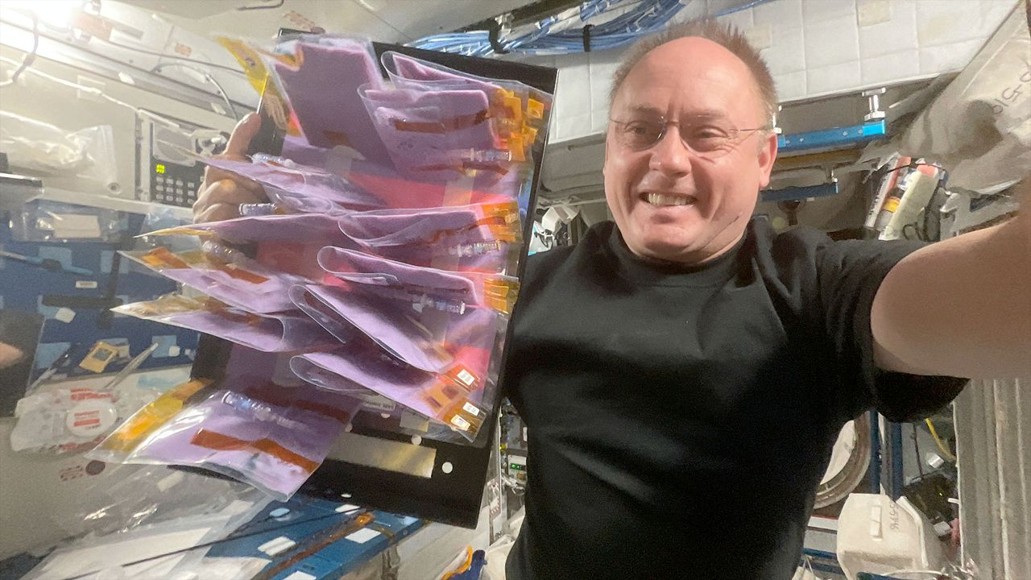
Click for next article Prolific NASA astronaut Mike Fincke has announced his retirement from the U.S. space agency after 30 years of public service. NASA announced Fincke's decision on Wednesday (Aug. 12), celebrating his contributions to spaceflight and long career of accomplishments. "Few people have had the opportunity to shape as many chapters of NASA's history as Mike Fincke," NASA Administrator Jared Isaacman said that day in a statement . Fincke departs as NASA's fourth-most flown astronaut, racking up a cumulative 549 days in space over four separate spaceflights. During those, he performed nine spacewalks and served twice as commander of the International Space Station (ISS). Most recently, he launched as pilot on SpaceX's Crew-11 mission to the ISS, stepping into the role of commander for ISS Expedition 74 from August 2025 to January 2026. Before his acceptance into NASA's 16th astronaut class in 1996, Fincke earned two bachelor's degrees from the Massachusetts Institute of Technology (MIT), in aeronautics and astronautics as well as Earth science, atmospheric and planetary sciences. Following his time at MIT, he did a summer stint at the Moscow Aviation Institute and later earned master's degrees in aeronautics and astronautics, and in planetary geology from Stanford and the University of Houston-Clear Lake, respectively. Fincke also served in the U.S. Air Force prior to his career at NASA. He graduated from the U.S. Air Force Test Pilot School in 1994, then was assigned as a space systems engineer and flight test engineer at Edwards and Eglin Air Force bases in California and Florida, respectively. Those stints were followed by his role as U.S. flight-test liaison for the Japanese-U.S. XF-2 fighter program in Japan. Following his two years of astronaut-candidate training, Fincke was assigned to NASA's Astronaut Office Station Operations Branch's Crew Test Support Team in Russia. There, he served as ISS CAPCOM (Spacecraft Communicator) and ISS crew procedures team lead until he began official spaceflight training in 1999. His first rocket launch was aboard the Soyuz TMA-4 mission to the ISS in 2004, where he served as science officer and flight engineer for Expedition 9 and completed four EVAs (extravehicular activities, or spacewalks). Fincke's second launch brought him back to the ISS in 2008, as a member of Soyuz TMA-13. It was then that Fincke took command of the space station for the first time. As Expedition 18 commander, Fincke added two more EVAs to his career total and oversaw the preparation of ISS facilities to begin supporting an increase from three-person to six-person crews. Fincke was also aboard for the final launch of NASA's space shuttle Endeavour on the STS-134 mission in 2011 , which returned him to the ISS for a third time. As mission specialist and robotic-arm operator, he supported the installation of the space station's dark-matter-hunting Alpha Magnetic Spectrometer (AMS) instrument, and performed three additional EVAs that marked the official completion of ISS orbital assembly and were the last-ever spacewalks by a space shuttle crew . By 2014, Fincke was serving as chief of the Astronaut Office's Commercial Crew Branch, where he played a key role in the development and testing of the SpaceX Crew Dragon and Boeing Starliner spacecraft. In January 2019, he was assigned to Boeing's Crew Flight Test (CFT) mission as joint operations commander, and he remained on the prime crew until June 2022, when he transitioned to the CFT backup crew. Mike Fincke is helped off SpaceX's Crew Dragon after Crew-11 splashdown in the Pacific Ocean on Jan. 15, 2026. (Image credit: NASA/SpaceX) Fincke's most recent mission, Crew-11, launched to the ISS in August 2025. It was the second time he was appointed commander of the space station, this time for Expedition 74, but his stint, and that of the other Crew-11 astronauts, was cut short due to an unexpected medical issue. Leading up to what would have been his 10th career EVA, NASA abruptly canceled spacewalk prep by Fincke and fellow NASA astronaut Zena Cardman after a "medical concern" arose that took priority over the planned station maintenance. Though not considered an emergency, the episode was deemed serious enough for NASA to return the Crew-11 astronauts to Earth earlier than expected, and Fincke and his fellow crewmates safely splashed down in the Pacific Ocean aboard their SpaceX Crew Dragon a week later. During the mission, NASA did not reveal the afflicted astronaut's name and condition, citing privacy concerns. A little more than a month after Crew-11's return, however, NASA and Fincke revealed that he was the crew member who experienced the medical issue, which he later described as a temporary inability to speak, according to an Associated Press report . Fincke fully recovered from the episode and is now in good health. "Mike approached every assignment with experience, humility, and an unwavering focus on the mission," said Scott Tingle, chief of NASA's Astronaut Office, in the agency's announcement. "Whether flying aboard the station, supporting crews from the ground, or helping shape the spacecraft that future crews will rely on, he consistently strengthened our team. His legacy is woven into the way we fly today." NASA did not indicate if Fincke plans to continue his involvement with the space industry through the private sector, but did highlight his dedication to support humanity's drive to explore the cosmos. "I remain deeply committed to the work of exploration," Fincke said in the statement. "NASA gave me the extraordinary privilege of serving alongside remarkable people, flying and helping develop spacecraft, and contributing to the International Space Station from its earliest days through command in orbit … I am excited to carry those lessons forward and help prepare the next generation of engineers, explorers, and leaders."

10. NASA's canceled lunar space station tech will help build the Artemis moon base
Read more
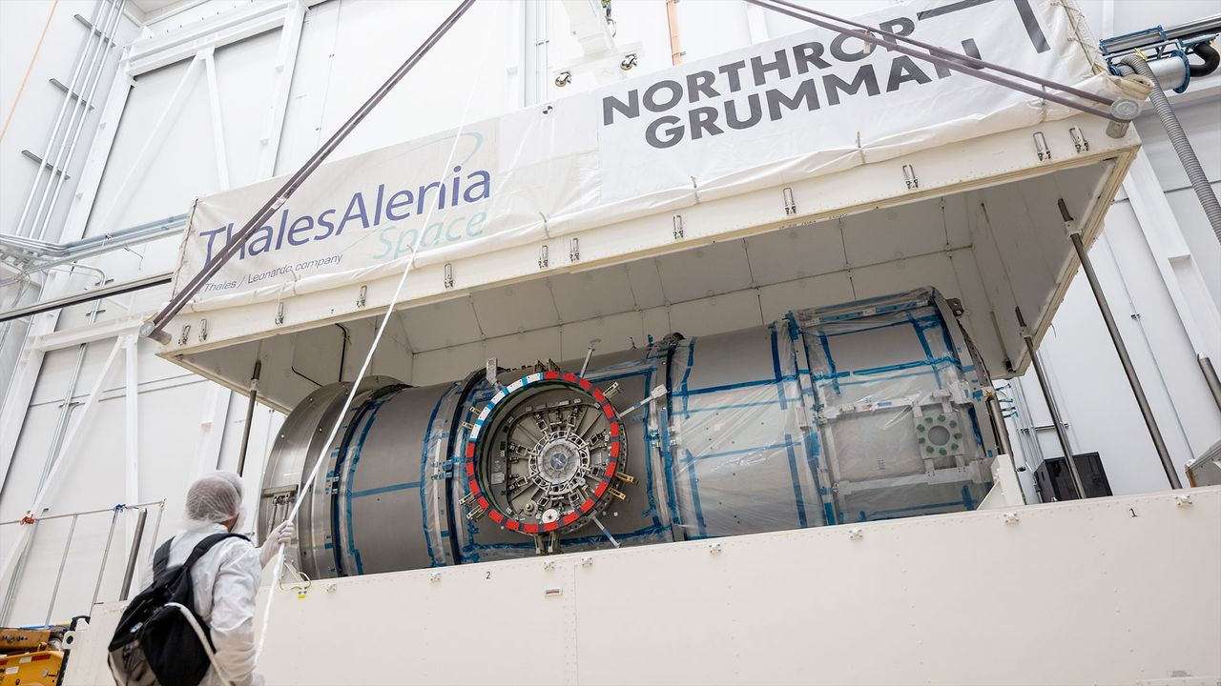
Click for next article Not every canceled NASA program earns a halo after its demise, but one scrapped project is finding new life by contributing its parts to help the space agency achieve its moon base goals faster. Northrop Grumman is repurposing hardware and technology from the Habitation and Logistics Outpost (HALO) space station module for use on a new series of Lunar Infrastructure Demo (LID) missions. HALO was originally designed as the habitation module for NASA's since-cancelled moon-orbiting Gateway space station but found itself on the chopping block when the agency restructured the Artemis program architecture earlier this year. Rather than scrap the unfinished module outright, Northrop Grumman will adapt HALO's electrical and mechanical components to support the development of technologies for a moon base that can survive the cold, weeks-long night at the lunar south pole while sustaining the long-term habitation of astronauts inside. Part of NASA's reasoning for canceling Gateway was the need for expedience. As the agency's vision for Artemis and the return of astronauts to the lunar surface has evolved, China's plans to land the first taikonauts on the moon have steadily taken shape. Those ambitions, and the continued progression of China's lunar program, have kicked off a new space race in which the U.S. and NASA are intent on maintaining their first-place position. In March, NASA Administrator Jared Isaacman announced a shakeup to the Artemis program designed to enable a more step-by-step approach toward developing the technologies needed for a next-generation crewed lunar landing, and to achieve that landing on the shortest timeline possible. That timeline currently puts the first Artemis lunar landing with astronauts on the Artemis IV mission, scheduled for late 2028. Before then, however, NASA is planning nearly two dozen uncrewed missions to the moon to lay the groundwork for the infrastructure needed to precede astronauts' return. And, rather than let HALO rust in a warehouse, Northrop is doubling down on its commitment to the cause. "To help NASA move faster … HALO's power, data and mechanical interfaces will enable NASA to move with speed and begin gathering real lunar surface performance data sooner," the company said in a press release on Aug. 4. Northrop Grumman's Lunar Infrastructure Demos (LID-1, LID-2 and LID-3) will reuse HALO derived technologies to rapidly mature lunar surface power, thermal, autonomy, communications and hosted payload services that can survive the lunar night and scale into persistent infrastructure near the moon's south pole. (Image credit: Northrop Grumman) Northrop announced 3 LID missions to "reuse HALO-derived technologies to rapidly mature lunar surface power, thermal, autonomy, communications and hosted payload services," which will help NASA gather data to better protect robotics and crews during long-duration stints near the moon's south pole, where the agency plans to establish its Artemis moon base. Neither the company nor NASA gave a target timeline for these missions. NASA is targeting the south pole specifically because of the abundance of water ice that scientists have detected in that region on the moon. When harnessed appropriately, such ice concentrations can be used for a variety of applications to enable sustainable habitation on the lunar surface - the ultimate goal of the Artemis program - including potable water, radiation shielding and rocket fuel. NASA believes that overcoming the technological hurdle of "in-situ resource utilization" (ISRU), or the ability to rely on materials locally available to you in order to sustain your survival, is the gold standard of spaceflight that will open the door to humanity's long-term exploration of the cosmos. Manufacturing propellants off Earth , for example, would mean a substantial increase in the distance any particular mission to space can fly, because nearly 95% of a rocket's mass at launch is fuel. So, the ability to refuel in space, circumventing the burden of launching to orbit fully fueled, would give satellites and crewed spacecraft the ability to fly much farther into the solar system than current launch systems allow. As much as Artemis is, in itself, a program to establish a permanent human presence on the moon, NASA also sees it as the proving ground for technologies that could one day sustain astronaut missions to Mars . There is worry, however, over the national security and economic consequences that could accompany China beating the U.S. to the moon, so speed is top of mind for those tasked with the country's lunar return. "As America embarks on the next chapter in human space exploration, our Lunar Infrastructure Demos will help turn the moon into a place where astronauts can stay, work and make discoveries that benefit humanity," said David Schiller, Northrop Grumman's vice president of civil space and sciences, in a statement. "Our ready‑to‑fly, reliable HALO technologies allow NASA to move faster, putting in place robust infrastructure that can endure the lunar night and establish a strong blueprint for a future moon base."

11. On this day in space! Aug. 13, 2014: Game-changing WorldView-3 Earth-observing satellite launches to orbit
Read more
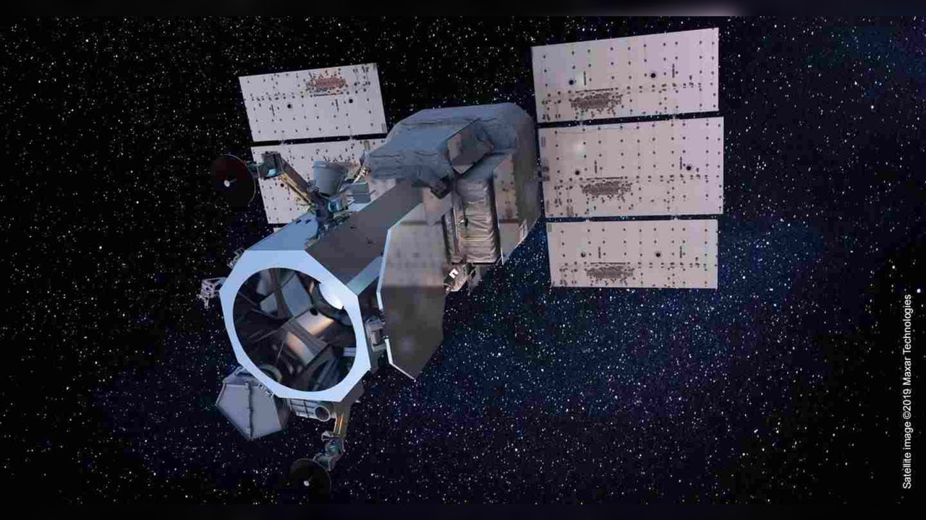
Click for next article On Aug. 13, 2014, a company called DigitalGlobe launched what was then the sharpest-eyed satellite of all time. WorldView-3 is a high-resolution imaging satellite that can resolve features as small as 1 foot (31 centimeters) across. Its instruments allow it to peer through fog and smoke to see Earth's surface at a level of detail that was unprecedented for a non-governmental spacecraft. WorldView-3 lifted off on a United Launch Alliance Atlas V rocket from Vandenberg Air Force Base in California and has been orbiting Earth ever since. The WorldView-3 Earth-observing satellite. (Image credit: Maxar Technologies) Why it mattered WorldView-3 pushed forward the technology of Earth-observing satellites. With its high resolution and ability to create mosaic images and deliver data in record time, the spacecraft changed the game in terms of studying Earth from space. While technology continued to advance beyond WorldView-3, it was a critical step in the process. For example, its data has helped researchers better track methane emissions coming from offshore oil and gas rigs, which is important as methane is a powerful greenhouse gas which contributes substantially to climate change . WorldView-3's data is sorted by an algorithm that helps filter, process and color-correct images that might have been affected by atmospheric effects. With all of the imagery and data from satellites like WorldView-3, researchers can better track and understand contributors to climate change like methane plumes, as well as monitor deforestation and agriculture and study the spread and effects of natural disasters like wildfire. Lastly, in an unexpected but amazing find, in 2015 , archaeologists used data from WorldView-3 to discover what is thought to be a lost Viking village in Newfoundland. The near-infrared imagery captured by the satellite helped an international team to spot this village, which was only the second Viking settlement found in North America.

12. New private 'Perceptor' probes will keep an eye on satellites high above Earth
Read more
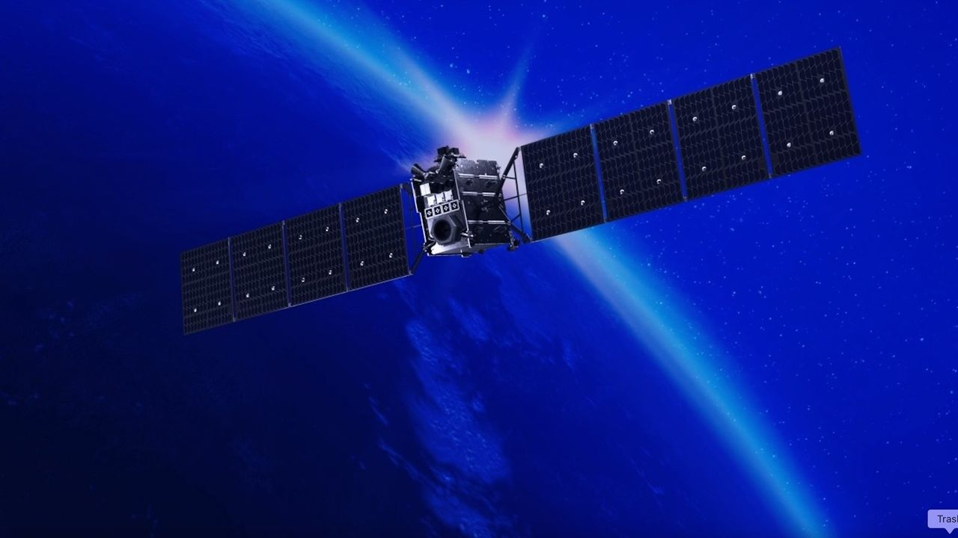
Click for next article Satellites high above Earth may soon have fewer places to hide. San Francisco-based company Astranis announced today (Aug. 13) that it's developing a line of spacecraft called Perceptor, which will keep an eye on satellite activity in geostationary orbit (GEO). GEO lies 22,236 miles (35,786 kilometers) above Earth, an altitude at which orbital speed matches our planet's rotational velocity. It's therefore a popular destination for communications, weather and reconnaissance spacecraft - and, increasingly, an arena for off-Earth spying, as space powers seek to keep tabs on their competitors' activities . Astranis currently operates five satellites in this distant orbital realm, which "support the U.S. military, bring connectivity to remote areas and provide critical capabilities like GPS ," according to the company's website . It plans to leverage and extend this expertise with Perceptor, helping the U.S. government and other potential customers learn more about what's happening high above our heads. The new line will be based on Astranis' "MicroGEO" satellite platform, so named because it's smaller than typical GEO craft. "Astranis provides mission-critical infrastructure for strategic higher orbits. What we found is our means to detect and respond to emerging threats to this infrastructure are sorely lacking," John Gedmark, Astranis' CEO and co-founder, said in a statement today. "There are blind spots that will be used against us if not eliminated," he added. "With Perceptor, we're meeting the increasing demand for security in GEO with our proven on-orbit platform and ability to produce at scale." Four Astranis MicroGEO satellites, which launched atop a Falcon 9 rocket in December 2024. (Image credit: Astranis) Perceptor spacecraft will sport a variety of sensors, which will allow them to take the measure of other satellites and their broader GEO surroundings. "Multi-angle flybys can assess spacecraft capabilities, help troubleshoot anomalies on friendly spacecraft, and provide additional eyes in a domain where awareness has historically been limited," Astranis' statement reads. Each Perceptor will also be highly maneuverable, using electric propulsion "to traverse the full GEO arc, repositioning dozens of times over its mission lifetime," company representatives added. The statement does not provide a target timeline for the first Perceptor missions. But the need for such a capability already exists, as the activities of certain Russian and Chinese satellites show. In 2020, for example, officials with the U.S. Space Force announced that two Russian spacecraft got within 100 miles (160 kilometers) of an American spy satellite, behavior the branch's then-chief described as "unusual and disturbing."

13. Chinese missiles autonomously spot F-22, F-35 heat signatures with 90 percent accuracy
Read more
The F-22 and F-35 are notorious for frustrating radar detectors, but their heat signatures are difficult to hide. China has developed a lightweight AI system that could allow air-to-air missiles to recognize their infrared signatures in flight. The new system achieved up to 97.1 percent accuracy identifying F-22 and F-35 targets during simulated laboratory tests. Researchers from the Beijing Institute of Technology and China Airborne Missile Academy designed it for missile-mounted infrared imaging systems. The work tackles a practical problem facing future missile seekers. They need to process infrared imagery almost instantly, yet missiles have strict limits on computing power, weight and available space. Reading fighter heat Aircraft produce infrared signatures through engine exhaust, aerodynamic heating and other sources across the airframe. Heat-seeking missiles can detect those emissions, while fighters can deploy flares to create competing infrared targets. That creates a recognition problem for the missile. An infrared seeker needs to determine whether the heat it sees belongs to the aircraft or a decoy, often with only milliseconds available to make that assessment. The researchers trained their system using 3,245 infrared images collected by a missile-borne scanning system. The dataset included three airborne target categories, with simulated F-22 and F-35 aircraft among them. The model reached 97.1 percent recognition accuracy during testing, according to the researchers. A separate test produced recognition rates of about 90% for the simulated fighter targets. Those results do not show how the system would perform against actual F-22 or F-35 aircraft. Lead researcher An Jiangshan said the relevant test data remains confidential and cannot be disclosed. Making AI smaller The researchers also had to solve a hardware problem before putting the model aboard a missile. Conventional deep-learning systems can require too many computing resources for compact weapons with tight size and power constraints. The team reduced its model to 16.1 percent of the parameters used by previous methods. It also brought computational requirements down to 19.2 percent, according to the study. A dedicated AI accelerator helped push the system further. The hardware uses optimized convolution operations, parallel processing, and data buffering to process infrared imagery more efficiently. During hardware testing, the system achieved 96.4 percent accuracy and processed each image in roughly 1.5 milliseconds. Its overall power consumption reached about 2.2 watts, giving the researchers a relatively low-power system for missile-mounted applications. That speed could matter during an engagement because a missile cannot spend long deciding what its sensor sees. Processing the imagery onboard could let the seeker classify targets without depending on external computing systems. New stealth challenge The research does not establish that Chinese missiles can identify operational F-22 or F-35 fighters. The experiments used simulated targets, and the researchers say further work will be needed to improve both recognition accuracy and processing speed. The team also limited its study to close-range air-to-air missile fuzes. It has not yet established whether the approach could work against surface-to-air missile systems.

