IIRS Daily Space Digest Monday, 25/05/2026

1. Crackdown on illegal homestays in Dehradun, 103 registrations cancelled
Pioneer Edge | Uttarakhand News in English | Dehradun News Today| News Uttarakhand | Uttarakhand latest news
Read more

PIONEER EDGE NEWS SERVICE /Dehradun The Dehradun district administration has cancelled the registrations of 103 homestays in the district for allegedly violating government norms and operating like commercial hotels. The administration has also started the process of removing these homestays from the Tourism department's website. The action was taken in the Raipur, Sahaspur and Vikasnagar areas of Dehradun. According to officials, the action was carried out under 'Operation Safai.' So far, five magistrate teams have conducted 153 inspections in different parts of the district. During the inspections, 103 homestays were found violating the Uttarakhand Homestay Rules. In the first phase, registrations of 17 homestays were cancelled, followed by 79 in the second phase and seven in the third phase. The district administration said that many homestays were being operated like hotels and commercial properties instead of family run tourist accommodations. Officials also claimed that some of these places had become centres of illegal activities, including late night parties, loud DJ music and unauthorised bar operations. According to the administration, several recent incidents in the city, including drunken hooliganism, overspeeding and firing incidents involving pistols, were linked to people staying in such homestays. Authorities said that some properties were being run on lease or rent, which is against the purpose of the homestay policy. During inspections, officials found several violations, including lack of kitchen facilities, absence of valid fire safety equipment and operation without food licences. In some cases, owners were not staying at the properties and the number of rooms exceeded the permitted limit.

2. Avalanche in Kanchanganga near Badrinath, no damage reported
Pioneer Edge | Uttarakhand News in English | Dehradun News Today| News Uttarakhand | Uttarakhand latest news
Read more

PIONEER EDGE NEWS SERVICE/Jyotirmath An avalanche occurred in the upper reaches of Kanchanganga near Badrinath Dham at about 10 AM on Sunday. The incident did not cause any damage. The pieces of snow from the peak rolled down the Kanchanganga gorge and settled in it. Following the incident, Chamoli district magistrate Gaurav Kumar said that no loss of life or damage to property had resulted from the avalanche in the Kanchanganga area. He further said that this is part of a natural process. Such incidents take place from time to time. The impact of the avalanche did not even reach the road and was limited to the gorge. Though the traffic and routine life has not been affected, the administration is consistently monitoring the area, he said, while adding that the situation is completely normal.

3. ISRO Aims to Help India Become Developed Nation by 2047, Showcases Space Milestones - Newsonair
"ISRO OR NRSC OR IIRS after:2026-05-24" - Google News
Read more

ISRO Aims to Help India Become Developed Nation by 2047, Showcases Space Milestones Newsonair

4. Science took over bars for three nights, and an ex-Isro chief stole the show - India Today
"ISRO OR NRSC OR IIRS after:2026-05-24" - Google News
Read more
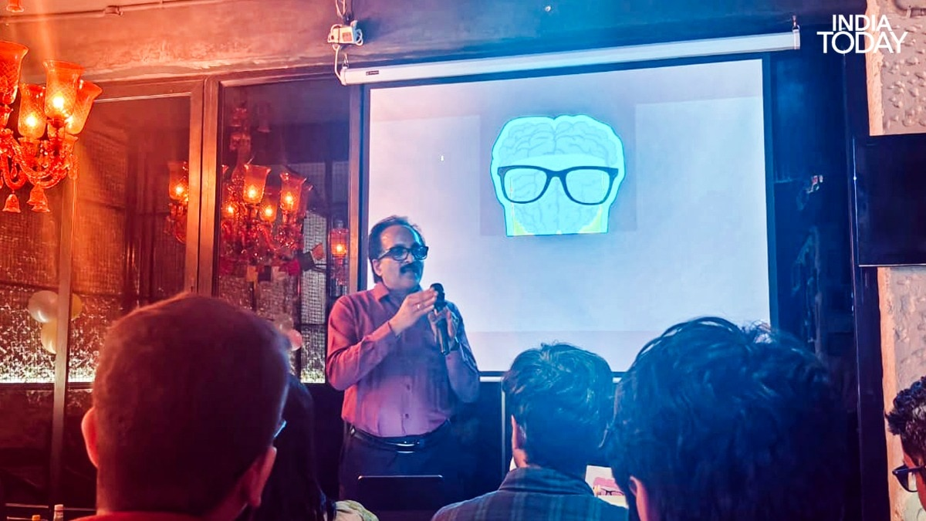

A quirky bar in Hauz Khas was still filling up when I found myself asking a former Isro chief about rockets. On a Wednesday evening in May, the pub had not yet settled into the particular hum it would find later in the night, when the room was packed, and questions from the audience were coming faster than anyone anticipated. Right then, it was quiet enough to talk. So we did, about my engineering degree, about his research on vibrations, about the specific way that a background in how materials behave under stress turns out to be surprisingly useful preparation for a conversation about aerospace. Read Full Story Dr S Somanath, who led the Chandrayaan-3 and Aditya-L1 missions, was unhurried. He was genuinely interested. He asked me as many questions as I did. Me in conversation with Dr S Somanath, former Isro chairman, at Fort City Brewing in Hauz Khas on May 20, before his session at Pint of Science 2026. I had many questions. So did he. When I walked away from that exchange, before the evening had properly begun, I felt something I had not experienced before. It was more exciting than meeting any celebrity I had ever interviewed. Not slightly but considerably. That feeling, it turned out, was the theme of the entire week. Pint of Science 2026 ran from May 18 to May 20, across several venues in Indian cities. This year it came to Pune, Bengaluru, Mumbai, New Delhi and, for the first time, Guwahati, marking the festival's debut in India's Northeast. It is the kind of festival that sounds, on paper, like it should not work: scientists in bars, talking to whoever showed up, about whatever they happen to spend their lives thinking about. And yet it does work, year after year, because of people like Professor Debarati Chatterjee. The wonderfully miscellaneous crowd that Pint of Science attracts. School students, college-goers and journalists who simply wandered in, all gathered in the same bar, in front of the same blank projection screen, at the end of an evening that none of them had quite expected. This is what it looks like when curiosity becomes social. Professor Debarati Chatterjee, a theoretical astrophysicist at the Inter-University Centre for Astronomy and Astrophysics (IUCAA) in Pune and Director of Pint of Science India, is largely responsible for the fact that an ex-Isro chairman and five other scientists spent several evenings in bars across multiple cities explaining complex ideas to curious strangers, who paid to be there. She has been building this quietly and determinedly, and the results, across three nights this year, were extraordinary. On the ground in Delhi, that work was carried out by Vishaka Ranjan, the festival's Delhi coordinator, who made sure the right rooms were found, the right people were in them, and the whole thing ran with the kind of ease that only comes from a very great deal of invisible effort. The Delhi chapter saw six scientists walk into a bar, and stopped sounding like jargonised professors. Audiences stopped faking interest and started actually feeling it. They asked questions that nobody present had the complete answer to, and the admission of that fact produced, reliably, the best moments of each night. Pint of Science 2026, Delhi. Between sessions, the questions started coming faster than anyone anticipated. The Pint of Science booklet on the table, the balloons on the wall, and a bar that had not yet settled into the particular hum it would find later in the night. The crowds were wonderfully miscellaneous. Students sat beside retired engineers. A woman in a saree compared notes with a man in a band T-shirt. A table of friends who had come for the drinks found themselves leaning forward when the science started. It was an amalgamation of nightlife, pop culture, urban curiosity and genuine intellectual hunger, and it was entirely unforced. One of those scientists was Dr Somanath, who stood up on Wednesday and explained, pleasantly and without fanfare, that rockets invent their own problems mid-flight. That the best engineers in the country sometimes just build things more robust than necessary and accept, with remarkable equanimity, that certainty is not always available. Dr S Somanath at Pint of Science 2026. The man who built things that left the Earth stood in front of a screen with a logo that puts a brain in a beer glass. Yes, he said pleasantly, rockets generate vibrations that nobody fully anticipated. This is a known problem. We work with it. (Photo: Radifah Kabir/India Today) Another was a homeopath who tracks cow lactation curves to predict the next pandemic. A third was a researcher who explained, with quiet authority, why the tattoo on your arm is held there not by your skin but by your immune system. A fourth was a mathematician who regarded the suggestion that his work might be useful the way a concert pianist regards a request to play Happy Birthday: technically possible, deeply beneath the point. A fifth was a mycologist who introduced a hospital pathogen using Game of Thrones. A sixth was an astrophysics scholar from University College London who read the history of galaxies through the chemistry of dying stars. The audience was up for their explanations. MONDAY NIGHT: THE NIGHT KING CHECKS IN The first night was at a bar that had not quite decided whether it was a pub or a cafe, which felt appropriate. I ordered a Margherita pizza and found a seat near the front. Around me, a group of college students were sharing nachos and taking selfies. The Margherita pizza that went cold at Pint of Science 2026. When the science is this good, food can wait. (Photo: Radifah Kabir/India Today) Two men in suits were deep in conversation at the bar. A woman was reading something on her phone. By the time the first speaker took the floor, the room had the particular energy of people who have no idea they are about to be genuinely surprised. Dr Aakriti Jain walks to the front of a room with the manner of someone who has completely stopped worrying about whether the audience is ready for what she is about to say. A post-doctoral researcher at the Vallabhbhai Patel Chest Institute in New Delhi, she received her doctorate in Biophysics and Bioinformatics from the University of Delhi. Her subject that Monday night was a global health crisis that has spent decades hiding in plain sight. Dr Aakriti Jain presenting the dual nature of fungi at Pint of Science 2026, Delhi. Fungi feed us, heal us and nourish the planet. They also cause infections, drive drug resistance and produce allergens and toxins. The question, she told the room, is not whether to pay attention. It is whether we have been paying enough. (Photo: Radifah Kabir/India Today) She opened by calling a drug-resistant fungal pathogen the Night King of hospitals. The room, carrying the particular tiredness of a Monday, came immediately and completely alive. For anyone who has watched Game of Thrones, the analogy is exact, and she knew it. The Night King spreads silently, converts everything he touches, and laughs at conventional weapons. So does Candida auris. The Wall that was supposed to stop him fell. So did hospital infection control. A fungal pathogen is spreading silently through wards. Surviving for weeks on clinical surfaces. Resisting multiple drug classes. Persisting despite everything a hospital's cleaning protocols throw at it. The researchers mapping the fungus's genome are Bran Stark. The bioinformaticians are the Ravens. The slide that made a Monday bar go quiet. Dr Aakriti Jain's Game of Thrones framing of Candida auris at Pint of Science 2026, Delhi. The Night King of hospitals: invisible, persistent, resistant, always returning. The researchers are Bran Stark. The data is Dragonglass. The antifungals are Valyrian Steel. Knowledge, as the slide notes, is power. (Photo: Radifah Kabir/India Today) The antifungal drugs growing useless in real time are Valyrian Steel. And the data the world is still scrambling to build is Dragonglass. The one thing that might actually work, if enough of it can be found in time. I put down my pizza. I noticed several other people around me doing the same thing with their drinks. The underlying science is frustratingly structural. Fungi are eukaryotes, cells with a membrane-bound nucleus. Their cellular machinery closely resembles ours. Most targets worth attacking in a fungal cell also exist in human cells. Design a drug to destroy the pathogen, and you risk harming the patient alongside it. Only four drug classes exist globally for fungal infections. The first class, azoles, has already been largely defeated by fungal evolution. The others are following. Dr Aakriti Jain's introduction slide at Pint of Science 2026, Delhi. A post-doctoral researcher at the Vallabhbhai Patel Chest Institute in New Delhi, she received her doctorate in Biophysics and Bioinformatics from the University of Delhi. Her subject that Monday night was a global health crisis that has spent decades hiding in plain sight. (Photo: Radifah Kabir/India Today) Fungal infections kill approximately 3.8 million people every year worldwide. The World Health Organization (WHO) published its first fungal priority pathogen list only in 2022. India has played a significant role in generating the standardised dosage data that the international research community depends on. Those standards are still being collated. The pathogen is not waiting. When asked about artificial intelligence, Dr Jain was direct. "Machine learning models for fungal resistance do not yet exist in clinical practice in India because the underlying data is not labelled, curated or sorted adequately to train them," Dr Jain told IndiaToday.in. "If a doctor cannot understand why the machine flagged a resistance pattern, the model is not ready. The human stays in charge of the decision. The machine helps. It does not substitute," she added. The pandemic, she explained, did not create the fungal crisis. It created conditions for catastrophic acceleration. COVID-19 filled every ICU in India with immunocompromised patients simultaneously for months. Mouldy bread, Dr Aakriti Jain explained at Pint of Science 2026, is what she calls tolerable foe behaviour. The fungi doing serious damage, the ones spreading silently through hospital wards and resisting every drug thrown at them, do not announce themselves nearly as clearly. (Photo: Radifah Kabir/India Today) People admitted for liver transplants, for respiratory illness, or for entirely unrelated primary conditions developed secondary fungal infections that became the actual cause of death. Black Fungus, also known as Mucormycosis, entered the national vocabulary during the Delta wave of SARS-CoV-2, and then quietly disappeared from public attention. It did not disappear from hospitals. She ended on a line calibrated for exactly this kind of room. We may like fungi, or we may hate them. But we cannot ignore them. The Margherita pizza, I noticed, had gone completely cold. I did not mind at all. THE HOMEOPATH WHO WATCHES COWS TO PREDICT PANDEMICS Dr Pratiksha Nagar is a homeopath and a researcher at University College Dublin. She is also, it turns out, one of the more compelling people in the room when the subject is pandemic prediction, which tells you something useful about the limits of disciplinary boundaries. She works on early warning surveillance systems, specifically on the question of how to detect an incoming pandemic before it reaches humans. Me with Dr Pratiksha Nagar, homeopath and researcher at University College Dublin, outside Fort City Brewing, Hauz Khas, at Pint of Science 2026. Dr Nagar spent the evening explaining why predicting the next pandemic means watching a cow's milk yield. The audience found this considerably more alarming than expected. Her answer, which she arrived at through an unlikely combination of medicine, veterinary science, ecology and data, is that you watch cows, but not metaphorically. Most pathogens that cause human pandemics originate in animals. The interactions between animal and human populations allow those pathogens to cross over in the millions every single day. The question her research tries to answer is not which of those interactions is dangerous. The question is which signals, buried in the ordinary behaviour of animal populations, indicate that something is changing before it reaches us. The signal she tracks is a 305-day lactation curve. Dr Pratiksha Nagar presenting her surveillance and prediction framework at Pint of Science 2026, Delhi. The slide shows milk yield curves alongside human productivity data. Deviations in a cow's 305-day lactation cycle, she explained, can signal an incoming disease long before any symptoms appear in a human population. (Photo: Radifah Kabir/India Today) A healthy cow follows a predictable arc of milk production across her lactation cycle. When that arc shifts, when the pattern changes in a way that cannot be explained by feed or breed or season, it is a signal. Not necessarily of disease. It could be a signal of environmental change, of something spreading across farms, of a stress that has not yet declared itself as an infection. But something is happening. The One Health framework, which treats human, animal and environmental health as a single interconnected system rather than three separate fields, is, as Dr Nagar is quite honest about, still finding its footing. "One Health is a very naive concept. It's just getting its legs and hands, and it's moving," Dr Nagar told IndiaToday.in. Can we predict the next pandemic? Dr Pratiksha Nagar asked at Pint of Science 2026, Delhi. Her answer involves syndromic monitoring, surveillance data and early signals, built around the One Health framework that treats human, animal and environmental health as a single interconnected system. (Photo: Radifah Kabir/India Today) "Mitigating a pandemic is a relay race. You take the thing and you run with it. You give it to the next person, and they run with it. Not one person can do everything," Dr Nagar added. When the subject turned to artificial intelligence, she was thoughtful rather than dismissive. AI helps, she said. But she drew a line clearly. "It's really very important that we come to a stage where AI does not tame us, but we are taming it," Dr Nagar explained. She reached for two examples. Newton, sitting under a tree, the apple falling, a mind making a connection that no pattern-recognition system would have made because the pattern had never existed before. Alexander Fleming, noticing the mold on a Petri dish that everyone else would have discarded, and discovering penicillin in what looked like a mistake. Me going through the programme at Pint of Science 2026, Delhi. Three nights, six scientists, a sold-out festival. I had a lot of notes to take. Neither discovery was the product of a system that learned from existing data. Both required a human mind paying attention to something the data said was irrelevant. The audience, which had come to hear about cow milk and pandemic early warnings, found itself sitting with a much larger question about what human consciousness is actually for. TUESDAY NIGHT: TATTOOS AS MEDICAL DEVICES The second night of Pint of Science had a noticeably different energy. Tuesday's crowd was younger, louder, and visibly more tattooed. Friends with elaborate sleeve tattoos filled the front row, while the rest of the room ranged from PhD students to people who seemed to have wandered in from nearby gigs, still wearing concert wristbands. That is one of the festival's quiet strengths. It does not curate its audience or demand credentials. It simply trusts whoever walks in. Nishtha Bhargava, a molecular biologist at Plaksha University, opened her session with a photograph of a tattooed forearm. Almost immediately, people in the audience began glancing at their own tattoos. The reason tattoos last, she explained, has little to do with ink depth and everything to do with the immune system. When tattoo ink is injected into the dermis, immune cells called macrophages rush to the site. Their job is to destroy foreign material, but tattoo pigments are too large and inorganic to break down. The macrophages swallow the particles and simply hold them in place. Nishtha Bhargava, an independent science communicator, at Pint of Science 2026, Delhi. She opened her Tuesday session with a photograph of a tattooed forearm and spent the next hour explaining why a tattoo belongs to whoever's macrophages happen to be on duty. That is why tattoos remain visible. Every few days, those macrophages die and release the ink. New macrophages arrive, consume the same particles, and hold them again. The cycle repeats continuously throughout life. Bhargava showed a micrograph of an army veteran who had undergone a complete bone marrow transplant. Despite having an entirely new immune system, his tattoo remained unchanged. New macrophages from another person's bone marrow had seamlessly taken over the same process. Your tattoo is not held in place by ink or skin. It is held by immune cells called macrophages that capture, release and recapture the same pigment particles every few days, for the rest of your life. (Photo: Unsplash) The session then turned more serious. Tattoo ink can travel through the lymphatic system and has been found in lymph nodes during surgeries. But Bhargava stressed the distinction between correlation and causation. Current research does not show tattoos cause cancer. She ended on a hopeful note: the same tattooing technique could one day improve vaccine delivery by targeting immune-cell-rich layers of skin directly. From tattoos to immunology, the leap turned out to be surprisingly small. THE MATHEMATICIAN WHO HATES BEING USEFUL The knot theory session had two things going for it. The science was genuinely extraordinary. And Souradeep Sengupta, a biophysicist at Ashoka University, had the singular quality of being funny without trying. He opened with a confession. He was not, he clarified, a biologist by training. Some parts of biology he honestly did not know. He had done his best. The room liked him immediately. Then he started talking, and the room forgot to keep liking him and simply started listening. Your DNA is roughly two metres long. The nucleus it lives inside is roughly half a micrometre in diameter. Souradeep Sengupta, a biophysicist at Ashoka University, explaining why a physicist is talking about DNA knots at Pint of Science 2026, Delhi. (Photo: Radifah Kabir/India Today) The DNA does not sit there tidily. It wraps around anchor proteins called histones, which compact it considerably. And even with all that structural effort, it knots. Constantly. Because long objects in tight spaces tangle. Because entropy applies to your genome with the same indifference it applies to everything else. Because disordered states are statistically more probable than ordered ones, and your biology is not an exception. Think about your earphones stuffed into a pocket, he said. Now think about that, except it is your DNA, in every single cell in your body, right now, while you are sitting here. Someone in the front row looked briefly alarmed. The enzymes that resolve these knots are called topoisomerases. Dr Sengupta told the room that the same mathematical structures governing DNA knots are playing out in the nucleus of every human cell, constantly, without pause. (Photo: Radifah Kabir/India Today) Asked whether they follow some mathematically elegant path when untangling, brute force, he said, without hesitation. The enzyme sees only what is directly in front of it. It has no global awareness of the chain whatsoever. "Mathematicians do not care. I think they genuinely do not care. Most mathematicians I know, if you tell them their work has real-world applications, they hate it. They are interested in mathematics for the mathematics," Dr Sengupta told IndiaToday.in. Asked whether any knot can ever be truly impossible to untangle, he reached for Hercules and the Gordian knot, noted the resolution, and delivered the line of the festival. "If you have scissors, all knots are untangled," Dr Sengupta said. WEDNESDAY NIGHT: READING DEAD STARS By Wednesday, Fort City Brewing in Hauz Khas had become something of a ritual. I arrived early, found a table, ordered chicken malai tikka and watched the bar fill up with what had become, by the third night, a familiar kind of crowd: people who looked like they had come from work, from college, from other bars, from other conversations, and were now, all of them, here. Before the session began, I managed to pull up a chair beside Dr Somanath. A conversation about engineering degrees, rocket vibrations and the specific way that materials science turns out to be surprisingly useful preparation for a conversation about space. Radifah Kabir and Dr S Somanath at Pint of Science 2026. We spoke briefly about rockets and about the kind of engineering instinct that comes from years of designing against failure. He was easy to talk to in the way that only genuinely confident people are: no performance, no impatience, no sense that he had somewhere more important to be. I asked him a question about vibrations. He answered it and then asked me a question. "No, it's generally on vibrations," he said, when I suggested his talk would centre on rockets specifically. "Not maybe specifically on rockets, but generally." It was, I would discover over the next hour, a distinction that mattered enormously. It was more exciting than meeting any celebrity I had ever interviewed. Not slightly but considerably. Me with Dr S Somanath, who led Chandrayaan-3 and Aditya-L1. There is something specific about the demographic that Pint of Science attracts, and it resists easy summary. It is not exclusively young. It is not exclusively English-speaking. It is not the usual crowd of a science communication event, which tends toward the already-converted. It is something messier and more interesting: people who are curious without necessarily knowing what they are curious about yet. Preksha Sethia, an astrophysics scholar from University College London who studies stellar populations, works on something she calls galactic archaeology, which is exactly what it sounds like and far stranger than the name suggests. Stars are time capsules. Not metaphorically. Their elemental composition is a record, written in the physics of nuclear fusion, of everything that happened in the galaxy before they were born. Every star carries inside it the chemical signature of its origins, the environment it formed in, the ancient collisions and mergers of galaxies that predate our solar system by billions of years. Preksha Sethia, an astrophysics scholar at University College London who studies stellar populations, reconstructing the Milky Way's story at Pint of Science 2026, Delhi. She is pointing to the position of the Sun in a galaxy that absorbed another galaxy entirely, called Gaia-Enceladus, long before Earth existed. The stars above us, she told the room, are archives. (Photo: Radifah Kabir/India Today) The Gaia satellite has been mapping stellar motion with enough precision to reconstruct one such event, a collision called Gaia-Enceladus, a galaxy absorbed by the Milky Way long before Earth existed. A nitrogen-rich star almost certainly spent its early life inside a globular cluster. The presence of certain oxygen and nitrogen markers in a stellar core indicates a biography entirely unlike anything typical in our galaxy's present atmosphere. Preksha Sethia put it simply. You can read a star, she said, the way you read a letter written before anyone knew there would be a reader. The room went very quiet. Someone at the bar stopped mid-conversation. The chicken malai tikka arrived and I did not notice for a while. THE MAN WHO LANDED INDIA ON THE MOON Dr S Somanath has a PhD in vibrations from IIT Chennai. He spent his career at an institution that landed India on the moon, put satellites in orbit and done it with budgets that should not have produced those results. He had led Chandrayaan-3, which placed a lander near the lunar south pole for the first time in history. He had led Aditya-L1, which put an observatory at the first Sun-Earth Lagrange point. "Yes, rockets generate vibrations during flight that nobody fully anticipated. This is a known problem. We work with it," Dr Somanath told IndiaToday.in. Dr S Somanath in a conversation with me, explaining why rockets sometimes surprise their own engineers. His ease about this, the complete absence of defensiveness in admission, gave the session a quality none of the other evenings had quite matched. This was not a researcher explaining a field from the outside. This was a man who had built things that left the Earth, and was now telling the honest version of what that involved. "Rocket vibrations begin with acoustics. A rocket at Mach 10 is generating noise on a scale that is biologically lethal in proximity. The jet plume creates sound. The supersonic interaction of the body with air creates more. These sources are partly modelled, and partly understood," Dr Somanath said. "Everything can fail under vibration," he said. "Because it excites them to a state where the stress will exceed the limit. Glasses can vibrate, window panes can vibrate, electronic connections can detach, fuel can break down," the former Isro chairman told me. Dr S Somanath at Pint of Science 2026. He told the room that vibration failures are very, very common, that some recent failures could possibly be attributed to that, and that the governing principle of Isro's testing philosophy is to subject components to double the energy they expect to face in actual flight. (Photo: Radifah Kabir/India Today) "When there is too much vibration, you need to isolate. You create barriers to not pass the sound or vibration to the other side. This is a very complex technology," he explained. "That noise becomes vibration. And that vibration reaches every joint, connection, fuel line and electronic component on board. A joint that opens and leaks cannot be sealed. In a mission carrying a satellite to orbit, any single failure of this kind ends everything, permanently and without appeal," the former Isro chairman added. The testing infrastructure he described carries the weight of a career spent inside it. Reverberation chambers built from concrete are designed to generate acoustic loads on full rocket sections more severe than any actual launch. These have vibration shakers capable of generating 25 to 30 tons of force. "Vibration failures are very, very common. Much of this is addressed on the ground. But sometimes when confidence is low, we overdo it," Dr Somanath said. "Some joints can open and leak. Some connectors detach," he said quietly. "Possibly one of the failures of recent times could be attributed to that. I can't claim or talk about it." Dr S Somanath compared the engineering philosophy that protects a satellite from its own launch to the silence of a well-built car cabin. The satellite, he said, is the passenger. Everything exists to ensure it does not feel the journey. (Photo: Radifah Kabir/India Today) The governing principle: test at least three decibels above the predicted flight environment. Three decibels means double the energy. He compared the philosophy to the inside of a modern car. The silence of a well-built cabin, the complete absence of engine noise reaching the driver, is the product of decades of isolation engineering: polyolefins and silicones placed at structural joints specifically to prevent one form of energy from crossing into a space where it does not belong. "Today's cars, you don't even hear them. There is a huge amount of engineering that goes into making cars. How the engine noise is not transmitted to the chassis, how the sound doesn't come to the cabin," Dr Somanath explained. The satellite at the top of a rocket is the passenger in that car. Everything, the chambers, the shakers, the split pins, spring washers and wire locking, exists to ensure that passengers do not feel the journey. The man who landed India on the Moon explaining why rockets lie. Me in conversation with Dr S Somanath at Pint of Science 2026, Delhi. I asked Dr Somanath whether unpredictable in-flight vibration events were becoming less frequent as rocket technology advanced. It was, by any reasonable count, three questions nested inside one. Dr Somanath looked at me with something warm. "You asked a lot of questions in that," he told me. We laughed, easy and genuine. THE CROWD THAT CHOSE THIS Here is the question underneath all of it, and Pint of Science does not answer it directly, which is possibly why the answer keeps surfacing anyway. Why are people here? Not in the promotional or science communication sense. Why, on a Monday, Tuesday and Wednesday in May, in Indian cities that offer every conceivable distraction, do people choose to sit in a room and think hard about hospital fungi and tattoo macrophages and DNA knots and pandemic surveillance and rocket acoustics and the chemistry of dying stars? The wonderfully miscellaneous crowd at Pint of Science 2026, Delhi. Students sat beside retired engineers. People who came for the drinks found themselves leaning forward when the science started. Nobody left early. (Photo: Radifah Kabir/India Today) Why do they come in groups of friends, in couples, or alone? Why does the person who wandered in, still wearing a concert wristband, stay for the entire session? The festival is not about making science accessible. It is about making it social. About putting curiosity in the same room as a cold beer and trusting what happens next. Across three nights and six very different scientific disciplines, the answer that kept surfacing was not glamour, not relevance, not even entertainment in any conventional sense. It was something older and harder to name. The pleasure of a real problem. The specific satisfaction of sitting with something genuinely difficult and finding that the difficulty is not a barrier but an invitation. What Pint of Science does, and what no amount of formal science communication quite manages, is remind people that curiosity is social. The moment after the session was as important as the session itself. At Pint of Science 2026, school students in uniforms stood in the same room as researchers, asked questions they would never have asked in a classroom, and got answers that were honest rather than reassuring. (Photo: Radifah Kabir/India Today) It is more fun in a room. That the question you were afraid to ask in school sounds perfectly reasonable in a bar, and that the person next to you, the one you have never met and will probably never meet again, is almost certainly wondering the same thing. Six scientists across three evenings. Venues that were simply venues, not conference rooms or convention centre, just places where people happened to be with beer in hand, and where, for a few hours each night, something happened that is genuinely difficult to produce by design and impossible to fake. The audiences at Pint of Science 2026 were not scientists. They were people who, for three consecutive evenings in May, chose to be. The Pint of Science 2026 team with scientists and journalists outside Fort City Brewing in Hauz Khas, Delhi, where three nights of beer mixed with science played out from May 18 to May 20. There is a particular kind of evening that does not announce itself. It arrives looking like any other Wednesday in May, with the traffic and the deadlines and the specific exhaustion of a city that has been going since seven in the morning, and then somewhere between the first drink and the second question from the audience, something shifts. By the time Dr Somanath finished speaking, the chicken malai tikka on my table had gone cold, the clearest measure I know of how a single conversation can take over a room and time just flies. - Ends

5. KV Umroi Student Shines at ISRO's YUVIKA-2026 Programme - shillongtoday.com
"ISRO OR NRSC OR IIRS after:2026-05-24" - Google News
Read more

Shillong, May 24: Adarsh Singh, a Class X student of PM SHRI Kendriya Vidyalaya Umroi Cantt, has brought laurels to the institution and Meghalaya by successfully participating in the prestigious YUva VIgyani KAryakram (YUVIKA-2026) organised by Indian Space Research Organisation at North Eastern Space Applications Centre from May 11 to May 22, 2026. YUVIKA is a flagship initiative of ISRO aimed at nurturing scientific curiosity and encouraging school students to pursue careers in space science, technology and research. The programme provided participants with exposure to satellite technology, space applications, scientific innovation and ongoing research activities. During the programme, Adarsh Singh was part of a project team that secured first prize for its presentation titled "Detection and Analysis of Earth's Dynamic Movements Through the Eyes of Satellites." The award-winning project demonstrated how satellite technology can be effectively used to monitor and analyse dynamic changes occurring on Earth. The achievement has been widely appreciated by the school fraternity, which described it as a reflection of the growing scientific temperament and academic potential among students of the region. The school also expressed gratitude to ISRO and NESAC for offering students an opportunity to engage with advanced scientific learning and research exposure. Educators believe that such accomplishments will motivate more students to explore careers in science, innovation and space research, while strengthening interest in STEM education among young learners. Krishna Nand Singh, Librarian of PM SHRI Kendriya Vidyalaya Umroi Cantt, congratulated the student on the achievement and lauded the organisers for conducting the programme.

6. ISRO's Chandrayaan 3 hop experiment reveals layered structure beneath Moon's surface - EdexLive
"ISRO OR NRSC OR IIRS after:2026-05-24" - Google News
Read more
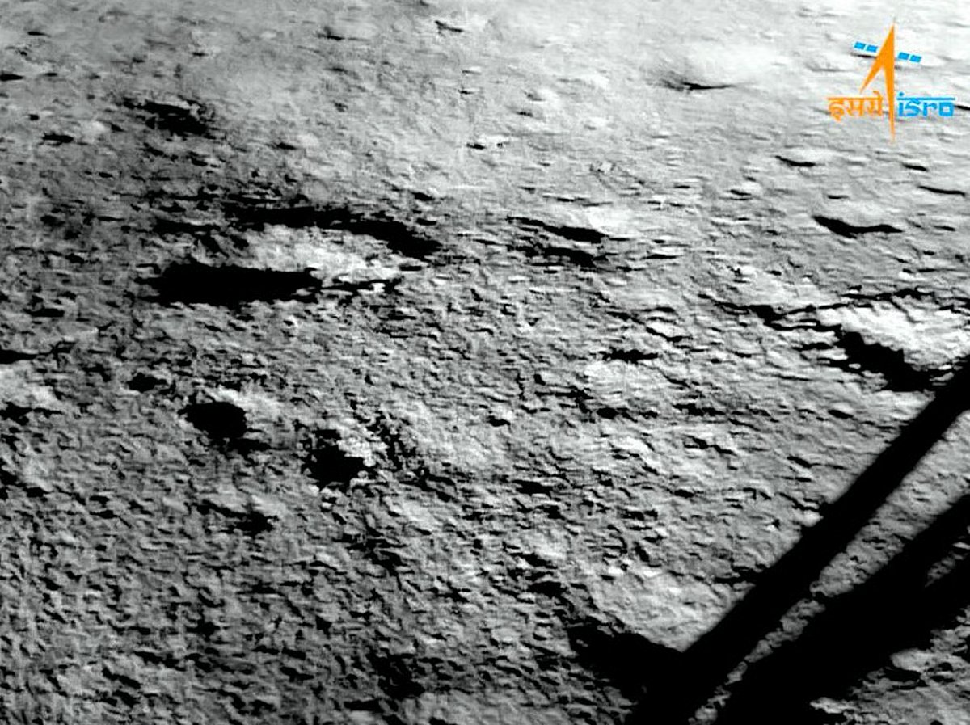

BENGALURU: A team of scientists from the Indian Space Research Organisation (ISRO) on May 18 shared a report of the findings of the 'Hop' experiment conducted by the Vikram Lander of Chandrayaan-3 and the Chandra's Surface Thermophysical Experiment (ChaSTE) on the moon. The researchers noted, "While we often call it lunar soil, the more apt term to be used is lunar regolith. The lunar regolith is actually shattered rock, tiny, jagged glass-like shards that are abrasive and cling to everything." They also pointed out that the complex structure of regolith has unique geo-technical and thermophysical properties. They said the top 2-6 cm regolith is found to be highly cohesive or sticky and hyper-porous, which can act as a thermal blanket. This layer is crucial in the storage of water-ice molecules in the subsurface, and in selecting the sites for future scientific bases and habitat construction on the Moon. The ISRO scientists said, "For an astronaut, this means the surface might feel like walking on dry flour, while just a few inches deeper. This is because, even at that small depth of a few centimetres, the bulk density changes from 750 to 1600 kg m⁻³." Understanding the thermal and physical properties of the moon's regolith is important from both scientific and technological angles. They said the thermophysical characteristics of the regolith hold clues to some questions, like how the moon manages the solar heat input, or how much it absorbs and how much it radiates back to space. The lander had conducted the Hop experiment on September 3, 2023, with a jump of around 50 cm, by utilising the residual propellant. In the ChaSTE, a sharp-tip, rod-shaped probe, with temperature sensors attached to its length and a heater at the tip, penetrated the moon's regolith. The hop manoeuvre allowed ChaSTE to analyse different locations and understand how the engine plume eroded the lunar surface. The list of critical finding included details pertaining to surface erosion and compaction, layered stratigraphy, geotechnical variability and twilight thermal profiles. The teams noted details of the top 3cm of lunar loose dust, which was exposed when the lander's engine was fired during the Hop experiment. The report stated: "Moon's surface is not just one uniform pile of dust. By looking at the 'hop' site, the results suggested a distinct two-layer cake-like structure within the top few centimetres."

7. Maha Kumbh: Former ISRO Chairman S Somnath takes holy dip in Triveni Sangam - The News Mill
"ISRO OR NRSC OR IIRS after:2026-05-24" - Google News
Read more
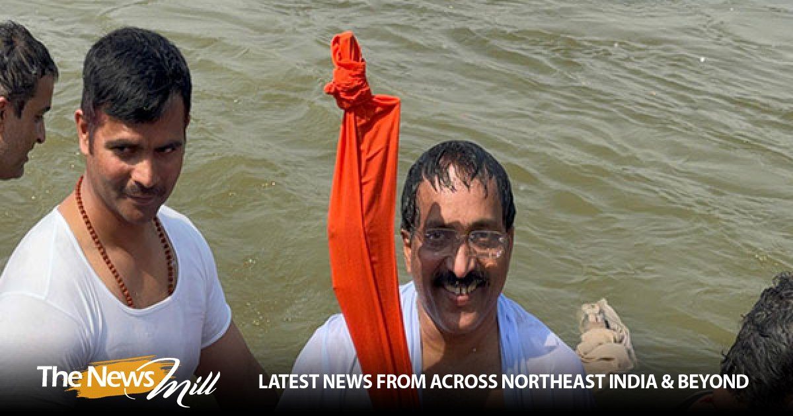

Former ISRO Chairman S Somnath, along with his family, participated in the ongoing Mahakumbh Mela 2025 in Prayagraj and took a holy dip at the sacred Triveni Sangam and offered prayers at the world's largest spiritual gathering. Taking to social media, X, the Former ISRO Chairman, wrote, "Maha Kumbh was experienced as humanity's search for the connection to the universe and have the 'Amrut', the nectar of life. I had a blissful snan at the Triveni Sangam in the company of Sadhus." Maha Kumbh was experienced as the humanity's search for the connection to the universe and have the 'Amrut', the nectar of life. I had a blissful snan at the Triveni Sangam in the company of Sadhus.#SomanathSpeak pic.twitter.com/U7lzaGRIU5 - Dr. S Somanath (@s_ssnath) February 18, 2025 ISRO Chairman called the Maha Kumbh a symbol of humanity's search for a connection to the universe and the "nectar of life." He mentioned having a blissful holy dip at the Triveni Sangam, accompanied by Sadhus, reflecting on the spiritual significance of the event. With over 3.09 million (30.94 lakhs) devotees taking the holy dip on Wednesday till 8 am, the total number of devotees taking the holy dip has crossed over 555.6 million (55.56 crores), as per the UP Information Department. The 2025 Mahakumbh, the world's largest spiritual and cultural gathering, commenced on Paush Purnima (January 13, 2025) and is set to conclude on February 26. Several prominent leaders, including Prime Minister Narendra Modi, Home Minister Amit Shah, Uttar Pradesh CM Yogi Adityanath and several other Union Ministers, leaders and celebrities have taken a holy dip at the Triveni Sangam. Earlier on Monday, Uttar Pradesh Chief Minister Yogi Adityanath highlighted the transformative progress in Uttar Pradesh, citing Prayagraj, Kashi, and Ayodhya as symbols of India's growing potential and credited Prime Minister Modi's leadership for restoring the country's faith and respect globally. He said that the number of devotees visiting Ayodhya has skyrocketed from 2.35 lakh in 2016-17 to over 14-15 crore in 2024, reflecting the respect for faith and the region's economic growth. A massive influx of devotees was also witnessed at the Kashi Vishwanath Temple in Varanasi and Ayodhya as pilgrims, after taking a holy dip in Prayagraj, are arriving at the temples for darshan.

8. ISRO delayed LVM3-M6 flight by 41 seconds to avoid potential collision - MSN
"ISRO OR NRSC OR IIRS after:2026-05-24" - Google News
Read more

ISRO delayed LVM3-M6 flight by 41 seconds to avoid potential collision MSN

9. Grab the Estes Blue Origin model rocket ahead of Memorial Day with it's lowest price since January!
Latest from Space.com
Read more


Click for next article The Estes Blue Origin New Shepard toy rocket is 17% off for Memorial Day and is actually cheaper than the official Estes webstore. If you are after a beginner's model rocket kit, you won't be disappointed with this model from one of the biggest names in the industry. Our editor-in-chief Tariq Malik crashed it into the ground and said that it was ready to launch again almost instantly. Get the Estes Blue Origin New Shepard model rocket, on sale right now for $29.99 at Amazon. We have included a bunch of Estes rockets in our best model rockets guide, so even though we haven't published a review of this product, we are confident it is high quality. It has a 4.6 rating on Amazon and has many positive reviews, with users commenting on the strong build and the details that make it similar to the real New Shepard rocket. Blue Origin Save 17% Estes Blue Origin New Shepard Rocket: was $36.09 now $29.99 at Amazon Save 17% on the New Shepard model rocket. Usually on sale for $36, you can get it now from Amazon for $29.99. It's a 1/66th scale model of the real Blue Origin craft and is capable of flight up to 400ft with an appropriate launch set (sold separately). Image 1 of 2 The 1:66 scale model include the rocket parts, design decals, recovery parachute and instructions. (Image credit: Amazon) The Estes Blue Origin New Shepard model has a projected altitude of 400 ft. on a C6-3 Estes rocket engine (sold separately). (Image credit: Estes) The Blue Origin New Shepard is a sub-orbital launch vehicle which had its maiden flight in 2015 and is designed for space tourism . Six passengers can be housed in the crew capsule on top and it has succesfully launched 37 times to date! The Estes New Shepard model is to a scale of 1:66, so while it might not be as big as the real thing, it sure looks like it. Many user reviews praise the details on the replica and it is easy enough for beginners to put together in about 10 minutes. You can simply display this model rocket but if you want to blast it into the sky, then you will need to buy an engine separately for it. Estes gives a projected altitude of 400 ft on a C6-3 Estes rocket engine but it is also compatible with a C5-3 engine. After launch, a parachute will help the New Shepard come back down to Earth but fear not if the landing is a little rocky! Our editor-in-chief Tariq Malik has crashed this model and it came out unscathed and ready for re-launch. Key features: Ages 10+, 1:66 scale, requires an engine (sold separately), can fly up to 400ft Product launched: August 2021 Price comparison: Amazon: $29.99 | Walmart: $42.15 Reviews consensus: We haven't reviewed the Estes Blue Origin New Shepard model rocket but our editor-in-chief Tariq Malik has crashed it hard into the ground and said that it was ready for relaunch almost immediately. It is a tough model rocket. Amazon user reviews are extremely positive. People like how realistic and well-made the rocket is and the rocket makes a great display piece too. Featured in guides: best model rockets ✅ Buy it if: You want a beginners model rocket that resembles the Blue Origin New Shepard that won't break the bank. ❌ Don't buy it if: You are already experienced with model rockets. This is a simple model and you might be better off looking at a model like the Estes Leo Space Train . Check out our other guides to the best telescopes, binoculars, cameras, star projectors, drones, lego and much more.

10. Live coverage: SpaceX to launch 29 Starlink satellites on a Falcon 9 rocket from Cape Canaveral
Spaceflight Now
Read more

The expansion of SpaceX's Starlink network of internet relay satellites will continue Monday with a Memorial Day launch from Cape Canaveral Space Force Station. The Starlink 10-47 mission will add another 29 Starlink V2 Mini Optimized satellites to the low Earth orbit megaconstellation, which consists of more than 10,000 spacecraft. This will be SpaceX's 60th orbital flight of the year, consisting of 59 Falcon 9 rockets and one Falcon Heavy rocket. Liftoff from Space Launch Complex 40 is scheduled at 7:48 a.m. EDT (1148 UTC). The rocket will fly on a north-easterly trajectory upon leaving the pad. Spaceflight Now will have live coverage beginning about an hour prior to liftoff. On Sunday, the 45th Weather Squadron forecast a 85 percent chance for favorable weather during the launch window. Meteorologists said they're watching a small chance for interference from cumulus clouds. "The start of the window will still have a chance of showers forming in the Atlantic and moving onshore making the Cumulus Cloud Rule the primary concern of violation on launch day," the Space Force meteorologists said in a forecast issued on Sunday. SpaceX will launch the mission using the Falcon 9 first stage B1078, making its 28th flight. Its previous missions included NASA's Crew-6, USSF-124, SES' O3b mPOWER-B, BlueBird 1-5, Nusantara Lima (PSN N5), and 22 Starlink deliveries. Nearly 8.5 minutes after liftoff, B1078 will target a landing on the drone ship, 'A Shortfall of Gravitas,' positioned in the Atlantic Ocean off the coast of South Carolina This will be the 151st landing for this vessel and the 614th booster landing to date for SpaceX. Meanwhile, the second stage will shutdown eight minutes and 39 seconds into flight and enter a coast phase, before short second burn at T+52 minutes. If all goes according to plan, the stack of Starlink satellites will deploy 61 minutes and 26 seconds after launch.

11. China launches crewed space flight as part of moon ambitions
Space News - Space, Astronomy, Space Exploration
Read more
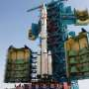

China launched its crewed Shenzhou-23 spacecraft and eased it into a successful docking with a space station early Monday as part of Beijing's ambitions to send humans to the moon by 2030, state media said.

12. Spacecraft production, avionics testing accelerate in US with 144,000 sq feet campus
Interesting Engineering
Read more

A Texas-based company is accelerating the production of spacecraft with expanded campus and innovation lab in central Texas. Firefly Aerospace has expanded its cleanroom space, and added an innovation lab to support Firefly's growing workforce, accelerate spacecraft production, and enable breakthrough space technologies. "With operations centralized in Texas, Firefly is producing rockets and spacecraft at scale to meet the demand of the rapidly growing defense, exploration, and commercial space markets," said Ramon Sanchez, COO of Firefly Aerospace. "The strategic investments we've made in our Cedar Park campus allow us to template our successful Blue Ghost lunar lander into a production line for multiple lunar missions a year that support NASA's Moon Base initiative and the larger commercial lunar economy." Firefly's new innovation lab The expansion includes two new buildings adjacent to Firefly's existing spacecraft facility in Cedar Park, Texas, enabling one robust campus with 144,000 total square feet for spacecraft assembly and testing, mission control, avionics and component production, engineering, and business operations. The new campus is twice the size of Firefly's former Cedar Park facilities and is less than 30 miles from Firefly's 200-acre Rocket Ranch in Briggs, Texas, where the company operates six test stands and 217,000 square feet of facilities for launch vehicle engineering, manufacturing, and integration, according to a press release. Called Gloworks, Firefly's new innovation lab further enables rapid technology innovation in key areas, such as propulsion, carbon composites, robotics, and 3D printing. This emergent-work lab is utilized to enhance the capabilities of Firefly's launch, lunar, and orbital vehicles and break into new categories that align with the growing needs of Firefly's diverse customers. Lab houses high-tech machinery The lab houses high-tech machinery, including 3D and titanium printers, plasma cutters, composite fabrication, welding, and automated milling machines. As part of the expanded campus, Firefly has made significant progress on a new cleanroom that is four times the size of its existing cleanroom. Funded by a Texas Space Commission grant, the new cleanroom enables a dedicated assembly line of Firefly's Blue Ghost lunar landers and Elytra orbital vehicles, as per the release. "Gloworks allows us to amplify our rapid, innovative mindset to tackle the problems of the future, including everything from surviving the lunar night to efficiently deorbiting spacecraft that reach end of life," said Shea Ferring, Chief Technology Officer at Firefly Aerospace. "This lab is the incubator driving key space technologies and differentiators that disrupt the future without disrupting our existing production line." The company also highlighted that additional upgrades are being made to Eclipse engine test stand to support multiple engines on the stand at once and increase testing cadence. Alpha's stage test stand is also getting enhancements to streamline test operations and improve ground system reliability. The company is also making vast improvements to its Rocket Ranch and recently added two new mezzanines for an additional 30,000 square feet of engineering and manufacturing workspace. The company is further making continuous upgrades to its automated carbon composite and propulsion machinery as well as improvements in its production and integration workflow for enhanced quality and scalability.

13. Life at 17,500 mph: ISS astronauts juggle 16 sunrises, sleep schedules, and celebrations
Interesting Engineering
Read more

Science is less about sudden discoveries and more about steady, often frustrating work. It advances through experiments that fail, results that need to be replicated, and questions that take years, sometimes decades, to answer. This category focuses on how scientific knowledge is built, tested, challenged, and refined over time. Coverage at Interesting Engineering spans fundamental and applied research across physics, chemistry, biology, earth sciences, and interdisciplinary fields. But the emphasis isn't on headlines or one-off findings. It's on methods, evidence, and the process that turns observations into something reliable enough to build on. Peer review, reproducibility, instrumentation, data quality, and statistical rigor matter here as much as the results themselves. This category also examines how science extends beyond the lab. That includes translation into technology, medicine, and policy, as well as the gaps and delays that often appear along the way. Many promising findings never scale, fail to replicate, or prove too complex or costly to apply outside controlled settings. Understanding why is part of understanding science. Science doesn't happen in isolation. Funding structures, institutional incentives, publishing pressures, and geopolitical priorities all shape what gets studied and what gets ignored. This category examines those forces without assuming the system always works as intended. Scientific consensus is treated as something earned through evidence, not declared by authority. We also pay attention to uncertainty. Not every question has a clear answer, and not every study should be taken at face value. Conflicting results, revisions, and course corrections are normal parts of scientific progress, not signs of failure. This category tracks how understanding evolves, especially in fast-moving or high-stakes fields. Rather than treating science as a collection of facts, this category treats it as an ongoing process. It focuses on work that deepens understanding, withstands scrutiny, and remains useful long after the initial result or announcement fades.

