 |  | 

🌌 अंतरिक्ष समाचार | Space News
शुक्रवार, ०७/०८/२०२६ | Friday, 07/08/2026

1. India's space college broke its bond with ISRO. Not its dependence - The Ken
Read more
Gaurav Seth, founder and CEO of Piersight, thought he had found an effective way to recruit from the Indian Institute of Space Sciences and Technology (IIST). Students at IIST have to undertake a six-month industry project as part of their final semester, and Seth offered them the opportunity to develop synthetic aperture radar systems for maritime surveillance at his company. They'd be given a monthly stipend of Rs 25,000, along with the possibility of pre-placement offers for strong performers. Between December 2025 and June 2026, six students completed their industry project at Piersight. By the end of their stint, the company was ready to hire all six. None of them joined. The reason had little to do with Piersight and everything to do with the Indian Space Research Organisation (ISRO). Turns out, the space agency released its recruitment offers in April and May. All six students who interned at Piersight received an offer, and every one of them accepted. "It completely screwed up our plans," said Seth, adding that he doesn't blame the students. "Obviously, ISRO is an aspirational ideal. So when it comes out with offers, students will switch." All he asks for, from ISRO's side, is more clarity on its hiring timelines, so that private companies can plan their recruitment around it. ISRO, for its part, is trying to loosen its hold over the institute. In 2024, in what was a major development, it did away with the bond that required BTechs graduating from IIST to join the space agency, if offered a position. There were several reasons for this. For starters, private spacetech is no longer negligible, raising nearly Rs 2,000 crore in funding in 2025 alone. More tellingly, it employs around 8,000-9,000 people today, closing in on ISRO's current workforce of 14,637ISRO Annual Report 2025-26 people. Understandably, IIST can no longer afford to ignore private spacetech.

2. ISRO expands satellite-based services in J&K - The Tribune
Read more

The Indian Space Research Organisation (ISRO) has significantly expanded the use of satellite-based applications in Jammu and Kashmir over the past five years, implementing projects ranging from disaster management and agriculture to urban planning, environmental monitoring and broadband connectivity. According to the Department of Space (DoS), 12 operational communication satellites currently provide coverage over the Union Territory, with satellite capacity being offered to various service providers to strengthen telecommunication and broadband services. Union Minister Jitendra Singh told Parliament that to improve disaster preparedness, ISRO has launched the Satellite Integrated Landslide Assessment and Alert System (SILAAS) under its Disaster Management Support Programme. The system uses satellite data to map landslides and generate village-level landslide alerts. It has also prepared a landslide inventory covering all districts of Jammu and Kashmir for the 2023 monsoon season.

3. ISRO rolled out multiple space technology projects in J&K over five years: Centre - thekashmirhorizon.com
Read more
ISRO rolled out multiple space technology projects in J&K over five years: Centre thekashmirhorizon.com

4. ISRO Expands Satellite-Based Disaster Management Across Jammu Kashmir - Kashmir Life
Read more
SRINAGAR: The Indian Space Research Organisation (ISRO) has implemented a range of satellite-based and space technology applications across Jammu and Kashmir, including landslide alerts, watershed monitoring, waterbody mapping, disaster management and decentralised planning, the Rajya Sabha was informed on Thursday. Minister of State in the Prime Minister's Office Jitendra Singh said in a written reply to an unstarred question by MP Ghulam Ali that 12 operational communication satellites have coverage over Jammu and Kashmir. The capacity is made available to service providers to support and enhance telecommunication and broadband connectivity in the Union Territory. Among the major initiatives is the Satellite Integrated Landslide Assessment and Alert System (SILAAS) under ISRO's Disaster Management Support Programme, which is being used to map landslides and generate village-level alerts. ISRO has also undertaken landslide inventory mapping covering all districts of JK for the 2023 monsoon season. Under the National Hydrology Project, an inventory of glacial lakes in JK has been prepared, while Glacial Lake Outburst Flood hazard and risk maps have been generated for Mundiksar lake in the Indus River basin. Geospatial technologies are also being used to monitor Integrated Watershed Management Programme and Watershed Development Component of the Pradhan Mantri Krishi Sinchayee Yojana (WDC-PMKSY) 2.0 projects across 20 districts of JK. The districts covered include Anantnag, Bandipora, Baramulla, Budgam, Doda, Ganderbal, Jammu, Kathua, Kishtwar, Kulgam, Kupwara, Poonch, Pulwama, Rajouri, Ramban, Reasi, Samba, Shopian, Srinagar and Udhampur. Under the Urban Waterbody Information System (UWaIS) linked to AMRUT 2.0, waterbodies have been mapped in Anantnag, Jammu and Srinagar. The Geo-MGNREGA Phase-II project is also being implemented across the same 20 districts for planning and monitoring MGNREGA activities. The government said the National Wetland Inventory and Assessment project was undertaken with the University of Jammu, covering wetland inventory and district-wise assessment across JK. A separate project with the University of Kashmir, Srinagar, covered land degradation and vulnerability assessment in Kathua, Budgam and Udhampur and included preparation of an action plan for combating land degradation in a micro-watershed. The Long Term Ecological Research Stations project, conducted from 2021 to 2025, has covered the North-West Himalaya, including JK, for climate and ecosystem response studies. The Space Based Information Support for Decentralised Planning-Update (SISDP-U) project has covered all districts of JK, generating thematic information on land use, settlements, infrastructure and drainage using high-resolution satellite data. Annual satellite-based assessments of land use and land cover at a scale of 1:2,50,000 have also been carried out for 2021-22 to 2024-25, along with a five-yearly assessment at 1:50,000 scale for 2020-21. The government provided project-wise financial details in its reply. The ongoing land-cover and land-use project for 2025-28 has a sanctioned amount of Rs 75.78 lakh, of which Rs 30.31 lakh has been released and utilised by the Department of Ecology, Environment and Remote Sensing, Srinagar. The SILAAS project for 2023-28 has a sanctioned allocation of Rs 50.16 lakh, with Rs 23.36 lakh released and utilised by the University of Jammu. The WDC-PMKSY 2.0 monitoring project for 2023-29 has a sanctioned amount of Rs 4.95 lakh, of which Rs 3.70 lakh has been released and utilised. The SISDP-U project for 2019-24 had a total sanctioned, released and utilised amount of Rs 220 lakh, with the Directorate of Ecology, Environment and Remote Sensing as the implementing agency. The IWMP watershed monitoring project for 2022-23 involved Rs 27.62 lakh, which was fully released and utilised by the University of Jammu. The National Wetland Inventory and Assessment project had a sanctioned amount of Rs 11.43 lakh, of which Rs 5 lakh was released and utilised, while the desertification and land degradation project had Rs 5.91 lakh sanctioned, released and utilised. Singh said ISRO was working on experimental landslide forecasting for all districts of JK under SILAAS. The organisation also conducts national and regional workshops and training programmes for disaster management agencies, including training on the National Database for Emergency Management, in which participants from JK have taken part. For space education and research, ISRO has established the Satish Dhawan Centre for Space Science at the Central University of Jammu, providing faculty and research students access to ISRO facilities. The government also said satellite-based tele-education is being facilitated under the PM e-Vidya programme, while telemedicine nodes have been installed in the Jammu and Kashmir regions. In 2024, the addition of the High Throughput Satellite GSAT-N2 further enhanced broadband connectivity, including in JK.

5. ISRO provided 33 flood inundation maps to Assam this monsoon to aid relief operations: Centre - India Today NE
Read more

The Indian Space Research Organisation (ISRO) provided 33 flood inundation maps and value-added products to the Assam State Disaster Management Authority (ASDMA) during the ongoing monsoon season to support flood monitoring, rescue and relief operations, the Centre informed Parliament. In a written reply in the Lok Sabha, Union Minister Jitendra Singh said the maps and products were supplied up to July 28 using Synthetic Aperture Radar (SAR) and optical satellite data through the National Database for Emergency Management (NDEM). Flood inundation maps provide near real-time and historical information on flood-prone areas, helping authorities plan rescue and relief operations, regulate developmental activities in floodplains and assess flood impacts. The minister said SAR technology enables all-weather, day-and-night imaging, while optical satellite data provides high-resolution imagery under clear weather conditions. Singh said the flood inundation maps are part of several initiatives undertaken by ISRO to improve district-level flood monitoring and enhance the timeliness of disaster response in Assam. These initiatives include the use of globally available satellite data, development of semi-automated sensor-specific data processing algorithms, flood-mapping workflows and the generation of district-level flood reports. "The spatial flood inundation data is published on the National Database for Emergency Management (NDEM) portal for visualisation at the district and sub-district levels. High-resolution satellite data is also used to assess flood damage at the district level, subject to the availability of cloud-free satellite imagery," the minister said.

6. NASA's SkyFall Helicopters at Work (Artist's Concept)
Read more
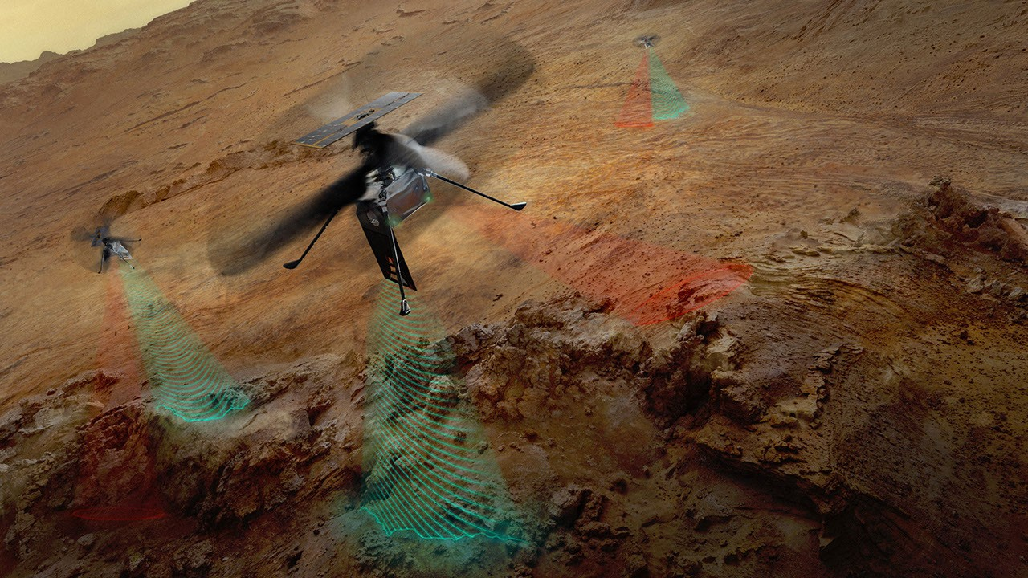
Description This artist's concept depicts NASA's three SkyFall Mars helicopters collecting data while flying over the surface of the Red Planet. The green frequency waves emanating from the helicopters' large antennas depict collection of subsurface radar data. The red beams depict collect near-infrared imagery data from regolith (crushed rock and dust) and other surface features. Equipped with four instruments each, the three helicopters will follow in the footsteps of the agency's Ingenuity Mars Helicopter, a technology demonstrator that flew 72 times over nearly three years, proving that powered, controlled flight is possible in the rarefied Martian atmosphere. It also demonstrated how an aerial perspective can generate valuabledata by helping NASA's Perseverance Mars rover team plan time-saving routes and choose locations for science-gathering. SkyFall is expected to launch aboard NASA's Space Reactor-1 Freedom in late 2028. The SkyFall project, which will carry three Mars helicopters to the Red Planet in December 2028, is managed by NASA's Jet Propulsion Laboratory. AeroVironment of Arlington, Virginia - which worked with JPL to design and build the history-making Ingenuity rotorcraft - will co-design and co-manufacture the SkyFall helicopters. Managed by Caltech for NASA, JPL manages the overall Mars Exploration Program on behalf of NASA's Science Mission Directorate in Washington. For more information about NASA's SkyFall: https://science.nasa.gov/mission/skyfall/

7. Antenna Testing for NASA's SkyFall Mission
Read more
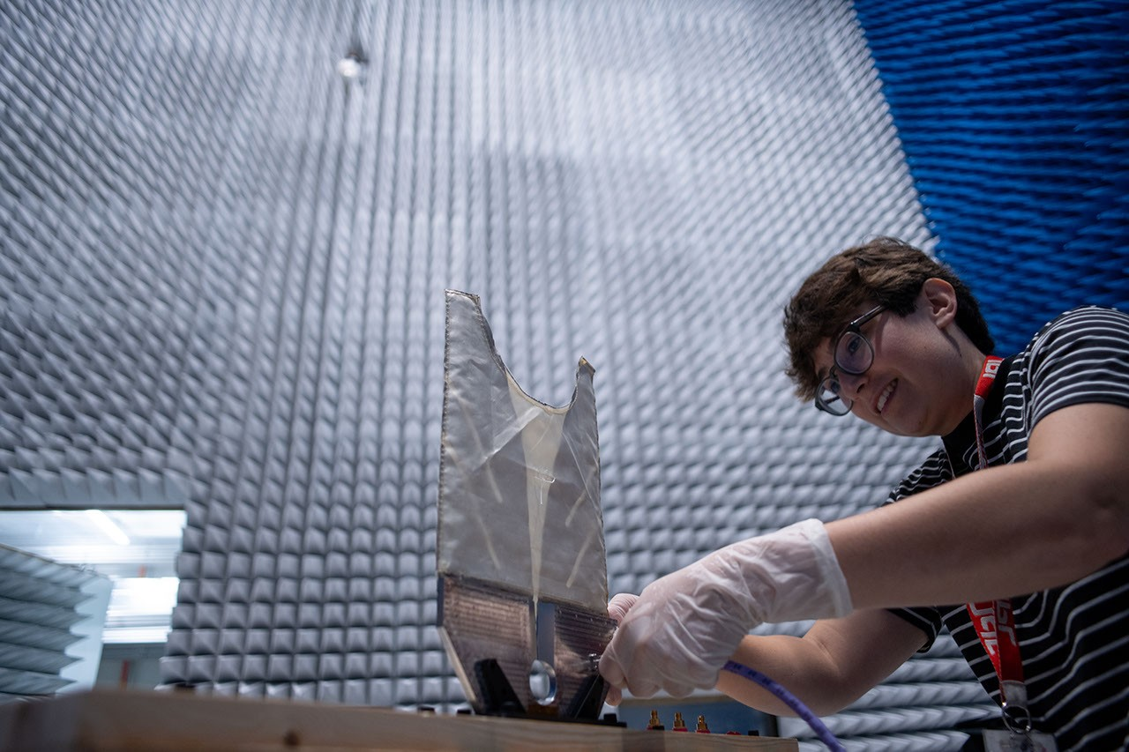
Description SkyFall ground-penetrating radar engineer Maya Román connects a coaxial cable to a test antenna in the Environmental Test Lab's electromagnetic interference testing chamber at NASA's Jet Propulsion Laboratory in Southern California. The antenna was pointed up during test to minimize reflections and interferences with the antenna pattern during the measurement. Equipped with four instruments each, the three SkyFall aircraft will follow in the footsteps of the agency's Ingenuity Mars Helicopter, which flew 72 times over nearly three years, proving that powered, controlled flight is possible in the rarefied Martian atmosphere. It also demonstrated how an aerial perspective can generate valuable data by helping NASA's Perseverance Mars rover team plan time-saving routes and choose locations for science-gathering. SkyFall is expected to launch aboard NASA's Space Reactor-1 Freedom in late 2028.

8. I Am Artemis: Tom Percy
Read more
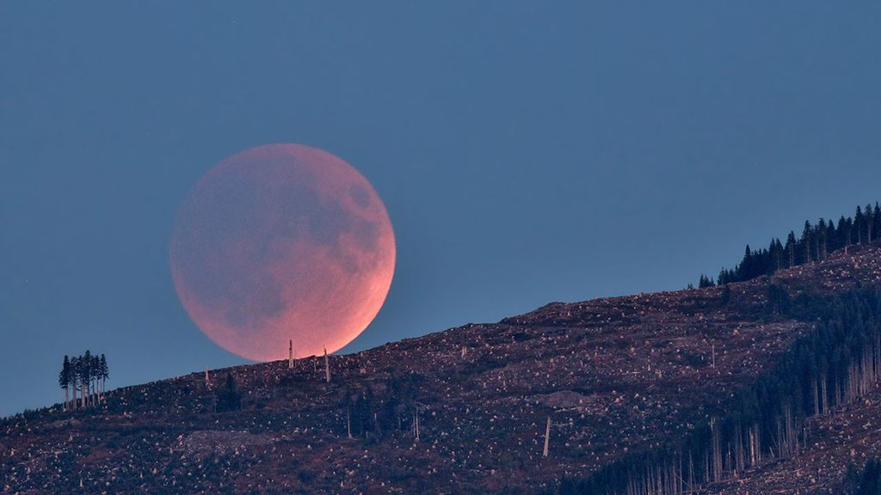
As NASA sets its sights on long-term exploration of the Moon and Mars, the agency is increasing the cadence of its Artemis missions. Helping bring these plans to fruition is Tom Percy, manager of systems engineering and integration for NASA's Human Landing System Program. Tom Percy, manager of systems engineering and integration for NASA's Human Landing Systems Program, stands in front of an Apollo Program lander exhibit at the U.S. Space and Rocket Center in Huntsville near NASA's Marshall Space Flight Center. NASA/Charles Beason Percy serves as a focal point in working with providers SpaceX and Blue Origin to accelerate and streamline systems designs, manufacturing, testing, and certification. He ensures the crewed landers that SpaceX and Blue Origin are developing for Artemis are designed, built, tested, and will operate with other NASA exploration assets safely and effectively. "You might say that all human landing system integration work lands on my desk. And with the rest of my talented, hard-working systems engineering and integration team, we're working to make it all happen," Percy said. A native of North Easton, Massachusetts, Percy earned a bachelor's degree in mechanical engineering from the Rochester Institute of Technology in Rochester, New York, where he first got hands-on experience working on designs that could be applied to NASA's sustainable lunar architecture. "As an undergrad, I served as president of the Rochester Institute of Technology's chapter of the American Society of Mechanical Engineers. To get some real-world engineering experience, we decided to participate in the Great Moonbuggy Race," Percy said. "Now called the Human Exploration Rover Challenge, the competition is held annually at NASA's Marshall Space Flight Center in Huntsville, Alabama. "At the time, I had never heard of Marshall Space Flight Center," said Percy. "But our student team designed and built a rover and traveled to Huntsville for the race. That's when I learned about some of the projects in Marshall's diverse portfolio that the center works for NASA. And that's when I began planning to make my way to NASA Marshall for my career." Percy chose to move south and earn a master's degree in aerospace engineering from the Georgia Institute of Technology in Atlanta. His research in the advanced propulsion lab and courses in space systems design culminated in a spacecraft design course and the chance to work directly with engineers at Marshall. Since landing at Marshall in 2003, Percy has been involved in evaluating transportation architecture options for human deep space exploration, including missions to land astronauts on the Moon and Mars. He also has expertise in space transportation, including advanced propulsion technology development; trajectory analysis; and spacecraft and mission concept development. Percy earned a doctorate in aerospace systems engineering from the University of Alabama in Huntsville. The range of experience comes together in his current role as manager of human landing systems engineering and integration. "The world watched the amazing success of Artemis II. NASA and our commercial providers are looking forward to flying again soon and executing increasingly complex Artemis missions," Percy said. Through the Artemis program, NASA will send astronauts on increasingly complex missions to explore more of the Moon for scientific discovery, economic benefits, establish an enduring human presence on the lunar surface, and to build on our foundation for the first crewed missions to Mars. To learn more about the Artemis program, visit: https://www.nasa.gov/artemis

9. JOB OPPORTUNITIES: NASA OFFICE OF THE GENERAL COUNSEL
Read more
Summary not available.

10. 'One more step': NASA astronauts conduct 6.5-hour spacewalk to prep ISS for solar array upgrade
Read more
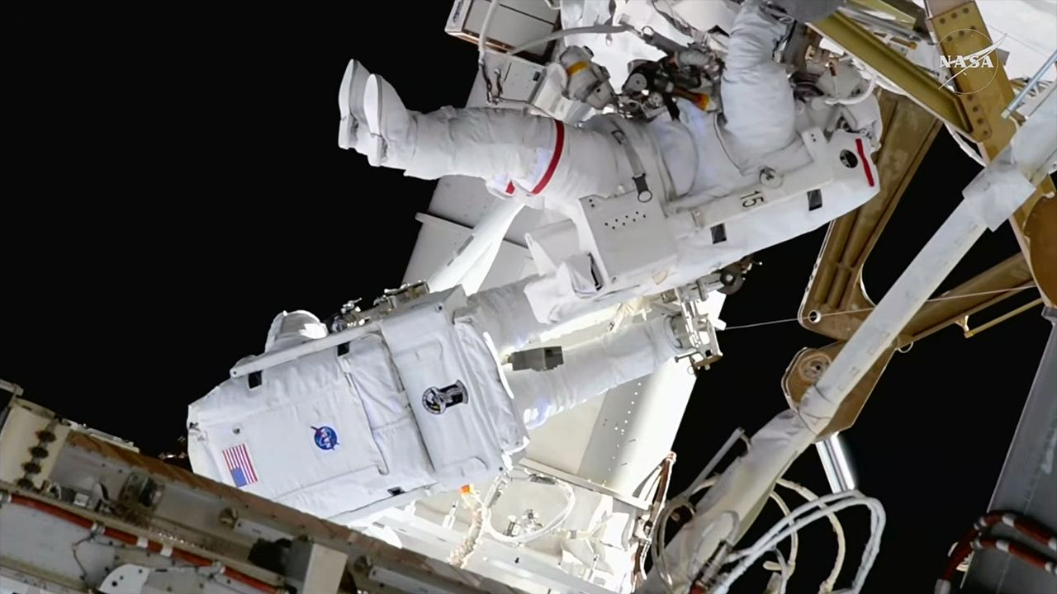
Click for next article NASA astronauts Jessica Meir (at right) and Anil Menon (facing away from camera) completed a 6.5-hour spacewalk to install solar array mounting hardware outside of the International Space Station on Thursday, Aug. 6, 2026. Two NASA astronauts installed the seventh and final set of mounting hardware for new sets of solar arrays during a successful 6.5-hour spacewalk outside of the International Space Station. Jessica Meir and Anil Menon on Thursday (Aug. 6), assembled the modification kit for one of the space station's eight power channels, which will allow for the future addition of a new ISS Rolll-Out Solar Array (iROSA). Since 2021, astronauts on prior spacewalks have deployed six of the iROSA assemblies, leaving now just two awaiting delivery to the station later this year. Like building a giant erector set, Meir and Menon worked to assemble and bolt together the triangular brackets on the 3B power channel, located on the far right, or starboard (S6) segment of the station's backbone truss. Menon was positioned on an articulating portable foot restraint (APFR) atop a worksite interface (WIFEX), providing a stable angle to work from the truss. NASA graphic showing the augmentation plan for the ISS Roll-Out Solar Arrays (iROSAs), including where work has been completed and where work is still needed prior to a spacewalk that installed the mounting hardware on power channel 3B on Thursday, Aug. 6, 2026. (Image credit: NASA) Once the modification kit structure was built and secured to the 3B mast canister, the two spacewalkers routed cabling that will carry the electricity from the future iROSA into the 3B power channel and then covered the struts with multi-layer insulation to protect them from micrometeoroid strikes . The iROSA wings sit forward of the legacy solar arrays, augmenting their electricity generation rather than replacing it. The station's eight original arrays began showing degraded power output as they exceeded their 15-year design life. When used in tandem with the new iROSA wings, the upgraded system will increase the station's electricity supply by 20% to 30%. The other power channel currently without an iROSA deployed is 2A on the left, or port side, of the station. NASA astronauts Jessica Meir (at left) and Anil Menon (with feet to camera) installed solar array mounting hardware during a spacewalk outside of the International Space Station on Thursday, Aug. 6, 2026. (Image credit: NASA) "Anil, you can see the moon to the - well, I am not sure what way you're facing, but…," said Meir, taking a short break during the spacewalk to notice NASA's next destination for astronauts under its Artemis program . "To my right. Yeah, I see it - thanks for the heads-up," said Menon. "I can see a future moon base there." "I can see it, too!" Meir said. Meir later turned her attention to Mars with her closing words of the day. "On this day in 2012, NASA's robotic rover Curiosity successfully landed on the surface of Mars with the goal of understanding if the planet could have fostered life. Curiosity achieved that goal within a year," she said. "One day, humans will visit Curiosity, propelled by the groundbreaking science, technology demonstrations and operations conducted here on the International Space Station for almost 26 years now." "Today, we made one more step toward expanding the ISS power system, further sustaining our human presence in low Earth orbit , as we prepare to take those next steps," said Meir. A camera mounted on NASA astronaut Anil Menon's spacesuit helmet captured this view of NASA astronaut Jessica Meir (at left) and the worksite where they assembled and installed mounting hardware for a new solar array outside of the International Space Station on Thursday, Aug. 6, 2026. (Image credit: NASA) Thursday's spacewalk began at 8:33 a.m. EDT (1233 GMT) when Meir and Menon switched their spacesuits to internal battery power. After collecting their tools and reentering the Quest airlock, the spacewalk, or extravehicular activity (EVA), concluded at 3:00 p.m. EDT (1900 GMT), 6 hours and 27 minutes after it began. This was the 96th U.S. EVA and 281st spacewalk overall in support of the International Space Station's assembly, maintenance and enhancement. It was the first career spacewalk for Menon and the sixth for Meir, bringing her total time on EVA to 42 hours and 33 minutes.

11. Rocket Lab launches Japanese Earth-observing satellite after 5-week delay (video, photos)
Read more
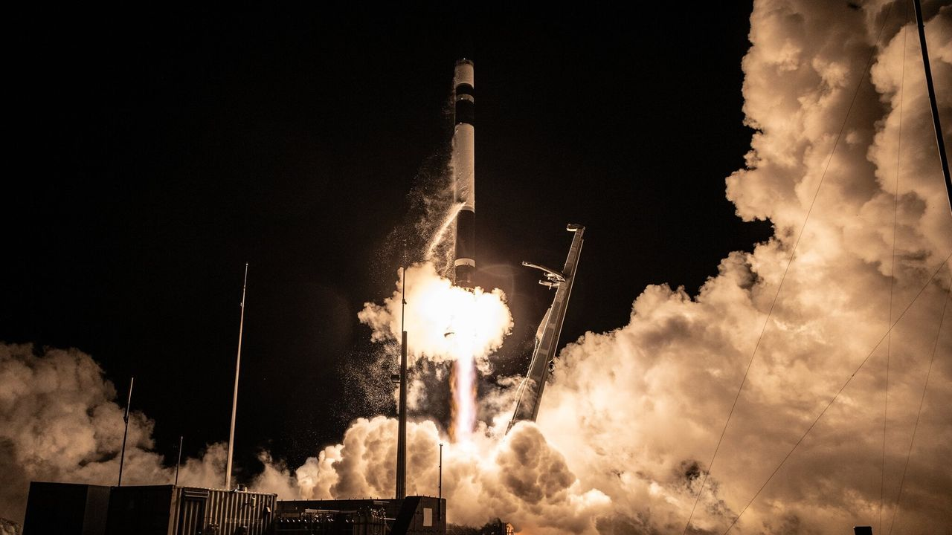
Click for next article A Japanese Earth-observing satellite got to orbit early this morning (Aug. 6), five weeks later than originally planned. The spacecraft - a radar satellite that will be operated by the Tokyo-based company iQPS - lifted off atop a Rocket Lab Electron vehicle from New Zealand today at 5:18 a.m. EDT (0918 GMT; 9:18 p.m. local time). It was a deferred round two for the mission: Rocket Lab originally tried to launch it on June 30 but aborted that attempt at the last second . The company has not yet revealed what caused that abort. A Rocket Lab Electron rocket launches "The Grain Goddess Provides" mission for the Japanese company iQPS from New Zealand on Aug. 6, 2026. (Image credit: Rocket Lab) Everything went well on this morning's flight, which Rocket Lab called "The Grain Goddess Provides." The Electron deployed the iQPS satellite into its target orbit about 357 miles (575 kilometers) above Earth, Rocket Lab announced via X this morning. The spacecraft - known as QPS-SAR-13 or MIKURA-I, after a Japanese goddess associated with abundance and prosperity - will study our planet using high-resolution synthetic aperture radar (SAR), which can peer through clouds and collect imagery both day and night. iQPS is building a constellation of 36 such SAR satellites in low Earth orbit . Electron is the primary launcher for this network; "The Grain Goddess Provides" was the eighth of a total of 15 launches that Rocket Lab will conduct to help assemble the constellation. A closeup of the Electron's nine first-stage Rutherford engines in action on Aug. 6, 2026. (Image credit: Rocket Lab) Today's mission was the 92nd overall for Rocket Lab and the company's 13th of 2026. Most of these flights have involved the 59-foot-tall (18 meters) Electron, the company's workhorse small-satellite launcher. But a growing number these days are performed by HASTE , a suborbital variant of Electron that allows customers to test technologies in a hypersonic flight environment.

12. SpaceX rocket's impact crater on the moon spied by Korean lunar orbiter (photos)
Read more
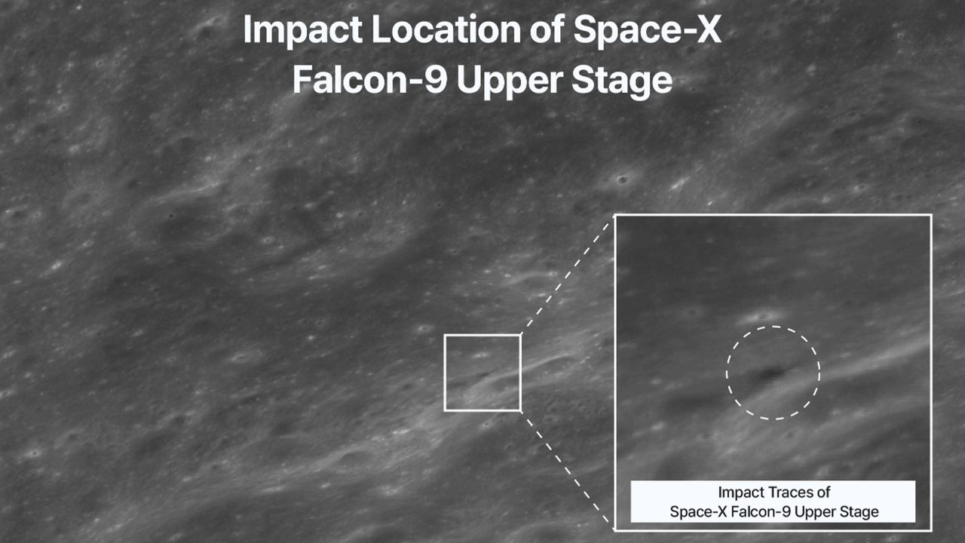
Click for next article South Korea's Danuri lunar orbiter captured this image of the crater blasted out by a SpaceX Falcon 9 upper stage when it hit the moon on Aug. 5, 2026. The final resting place of SpaceX's moon-smashing rocket has been found. The Korea Pathfinder Lunar Orbiter, known as Danuri , has captured imagery of the crater blasted out by the Falcon 9 upper stage that slammed into the moon early on Wednesday morning (Aug. 5). "Danuri began observations about 30 minutes before the collision and, through orbit control, passed over the impact site multiple times, conducting a total of 8 imaging sessions," officials with the Korea Aerospace Research Institute (KARI) said via X this morning (Aug. 6). "Through this observation, changes in the terrain around the impact site and traces of ejecta spread were confirmed." "Danuri secured both pre-collision and immediate post-collision footage, enabling analysis of changes caused solely by the collision and providing important research data," they added in the X post, which shared several before-and-after images of the impact site. Before-and-after imagery of the impact site. (Image credit: KARI) The Falcon 9 in question launched on Jan. 15, 2025 , sending two private robotic moon landers - Firefly Aerospace's Blue Ghost and ispace's Resilience - to a high, moon-crossing Earth orbit. The duo then made their own way to the moon ; Blue Ghost landed successfully on March 2 of that year, but Resilience crashed during its touchdown attempt. The Falcon 9's first stage came back to Earth shortly after liftoff for recovery and reuse, as such boosters commonly do . Falcon 9 upper stages, by contrast, are expendable. SpaceX usually disposes of them in Earth's atmosphere , but the upper stage on the Blue Ghost-Resilience mission used almost all of its fuel getting its payloads to their distant destination. So the 8,800-pound (4,000 kilograms) rocket body remained up there, orbiting Earth - until solar activity and gravitational forces pushed it on a collision course for the moon. Another before-and-after image, with the "before" photo taken by NASA's Lunar Reconnaissance Orbiter back in 2015. (Image credit: KARI) That collision occurred at 2:34 a.m. EDT (0634 GMT) on Wednesday, according to KARI officials - right in line with predictions. Scientists calculated some other parameters ahead of time as well. For example, the rocket body probably hit the moon at about 5,400 mph (8,690 kph), gouging out a crater up to 89 feet (27 meters) wide. The new observations by Danuri, as well as future work by other lunar probes, will help verify such predictions. "The observation data secured by Danuri will be linked with follow-up observations from NASA's Lunar Reconnaissance Orbiter (LRO) and utilized in international collaborative research," KARI officials said in the X post. It may be that some ground-based telescopes caught the impact as well. Astronomers at the Instituto de Astrofísica de Andalucía in Spain believe they captured a video of ejected material blasting off of the lunar surface around the predicted time of impact: Our team at @iaa_csic has captured the impact on the Moon of the upper stage of a Falcon 9 rocket. We attach a preliminary video showing the evolution of the ejected material. The black area corresponds to the lunar disk @SpaceX @JuanLuisRizos @elonmusk @tiempobrasero @A3Noticias… pic.twitter.com/5Ry7hRdCeSAugust 6, 2026 The Falcon 9 upper stage wasn't the first rocket body to slam into the moon. The third stage of a Chinese Long March 3C crashed into the lunar surface on March 4, 2022, for example. And the third stage of NASA's Saturn V rocket gouged out craters during multiple Apollo moon missions.

13. On this day in space! Aug. 6, 2012: NASA lands huge Curiosity rover on Mars with a rocket-powered sky crane
Read more
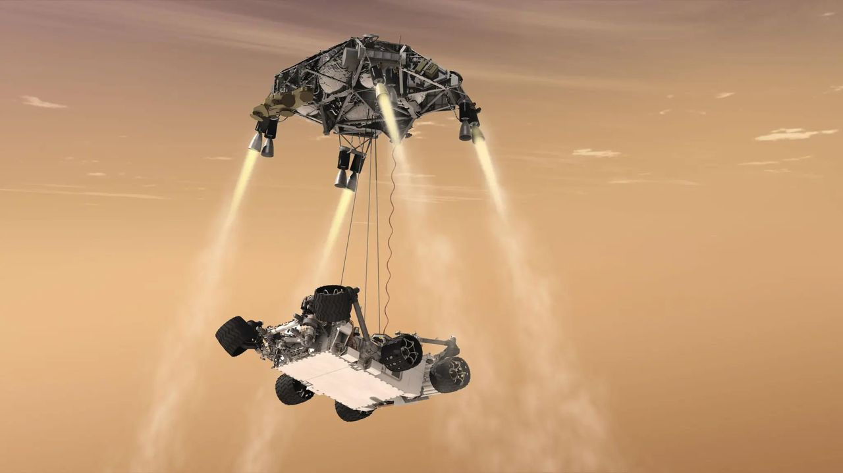
Click for next article On Aug. 6, 2012, NASA's Curiosity rover successfully touched down on the Martian surface. At the time, the Curiosity rover was the biggest and most ambitious Mars rover that NASA ever launched. Its landing involved a new kind of maneuver that had never been tried before using something called a " sky crane. " Like previous rovers that have landed on Mars, Curiosity used a parachute and rocket engines to slow down as it descended through the Red Planet's atmosphere. But while other rovers used airbags to cushion the last part of the fall, Curiosity's rocket-propelled sky crane hovered over the ground and gently lowered it with cables . Touchdown was confirmed at 1:31 a.m. EDT (0531 GMT), though it was 10:31 p.m. PDT on Aug. 5 at Curiosity's JPL control room. Image 1 of 2 How Curiosity landed on Mars. (Image credit: NASA/JPL-Caltech) NASA's Curiosity rover on Mars (Image credit: NASA, JPL-Caltech and MSSS) Image 1 of 2 View Original Image 2 of 2 View Original Why it mattered The Curiosity Mars rover was built by engineers and scientists at NASA's Jet Propulsion Laboratory in Pasadena, California. The space center's motto is ambitious: "Dare Mighty Things." With Curiosity, JPL may have dared more mightily than it ever had before. First, there's the rover's immense size. It weighs nearly 1 ton on Earth and is the size of a small car . It's powered by a nuclear battery and was the first of a new family of massive rovers to land on Mars. The sky crane landing approach was a big departure from the direct touchdowns of the Viking landers , as well as the bouncy airbag landings of the Mars Pathfinder , Spirit and Opportunity missions. It all had to go right autonomously during a time NASA called the " 7 minutes of terror " - the time it took for the landing, which would happen faster than the rover could get instructions from flight controllers on Earth due to the signal travel time to reach Mars. And it all worked spectacularly. Curiosity not only aced its landing at Gale Crater on Mars, but it changed Mars landings forever. NASA repeated the feat nine years later with the successful landing of the Perseverance rover at Jezero Crater on Mars in February 2021 . Curiosity and Perseverance are the largest rovers ever to explore Mars and set a new benchmark for what is possible on other planets. As of this writing, Curiosity has spent 14 years exploring Mars, drilling into rocks and finding new clues about water on Mars and the planet's potential habitability in the ancient past. It's still going strong, even if it got a rock stuck on its drill for a few days earlier this year.

