 |  | 

🌌 अंतरिक्ष समाचार | Space News
शनिवार, १८/०७/२०२६ | Saturday, 18/07/2026

1. SpaceX aborts Starship Flight 13 launch seconds before liftoff, targets retry next week
Read more
Starship Flight 13 was set to test Version 3 of the fully reusable rocket and deploy 20 next-generation Starlink satellites. (Image: Reuters) SpaceX called off the launch of its Starship Flight 13 test mission just seconds before liftoff on Thursday, after an issue occurred during the ignition sequence of the rocket's first-stage engines. The launch attempt from the company's Starbase facility in South Texas was scheduled for 6.45 pm EDT (04.15 am IST Friday) at the start of a 90-minute launch window. However, the countdown halted moments before launch as the vehicle's 33 Raptor engines began firing up. During the live webcast, SpaceX spokesperson Dan Huot said the company would investigate the cause of the last-second abort before deciding on the next launch attempt. "We'll take some time, dig into what triggered that abort once the booster was igniting to launch, and then we'll figure out what our path forward is going to be," Huot added.

2. EPFO launches VISHWAS 2026 to settle employer penalty disputes
Read more

- Policy - 2 min read The EPFO has launched VISHWAS 2026, a six-month, one-time dispute resolution scheme to help employers settle pending damages and penalty cases under provident fund laws. The initiative offers substantially reduced penalty rates for eligible defaults before June 14, 2024, through a fully digital, transparent and time-bound process. - ET Bureau - Published On Jul 18, 2026 at 11:16 AM IST Select ETGovernment as Preferred Choice on Google Copy Link Share on WhatsApp Share on Linkedin Share on X Share on Telegram Share on Facebook Applicants are also required to furnish an undertaking that no further appeal shall be pursued in respect of the dispute settled under the Scheme. New Delhi: The Employees' Provident Fund Organisation ( EPFO ), under the ministry of labour and employment, launched 'VISHWAS, 2026', a one-time dispute resolution initiative to facilitate amicable settlement of disputes relating to levy of damages or penalty under section 14B of the Employees' Provident Funds and Miscellaneous Provisions Act, 1952 and section 128 of the Code on Social Security , 2020. The scheme will remain operational for a period of six months, starting from June 29, and will provide employers with an opportunity to settle eligible cases through a transparent, fully digital and time-bound process. The scheme covers cases where orders for penalty or damages are under challenge before judicial forum and final damages or penalty orders where recovery is pending or only partly made, including Recovery Certificate (RRC) cases. Advt Further, cases where notices have been issued but final orders for damages or penalty are yet to be passed will also be covered under along with cases where notices for penalty and damages are yet to be issued. Under VISHWAS, 2026, damages or penalty for defaults pertaining to the period prior to June 14 2024 shall be recalculated at substantially reduced rates, namely 0.25 per cent per month for defaults up to two months, 0.50 per cent per month for defaults from two to less than four months, and 1.00 per cent per month for defaults exceeding four months. "These concessional rates are intended to encourage employers to resolve pending disputes expeditiously," the ministry said. According to the statement, in order to avail the benefits of the scheme, employers are required to ensure that the entire interest payable under the schemes, as applicable, has been fully remitted before submitting an application. - See more on: - EPFO , - VISHWAS 2026 , - dispute resolution , - penalty-related disputes , - Employees' Provident Fund Organisation , - Section 14B , - Social Security Code , - digital processing , - employers compliance , - social security Telegram Facebook Comments What are your thoughts? Comment Now --> Comment Now Read Comment (1) All Comments By commenting, you agree to the Prohibited Content Policy Post Find this Comment Offensive? Choose your reason below and click on the submit button. This will alert our moderators to take actions REASONS FOR REPORTING Foul Language Defamatory Inciting hatred against a certain community Out of Context / Spam Others Report Join the community of 2M+ industry professionals. Subscribe to Newsletter to get latest insights & analysis in your inbox. --> All about ETGovernment industry right on your smartphone! - Download the ETGovernment App and get the Realtime updates and Save your favourite articles. Scan to download App -->

3. Meet The Former ISRO Scientists Behind India's Private Space Revolution - NDTV
Read more
Meet The Former ISRO Scientists Behind India's Private Space Revolution NDTV

4. Skyroot's Vikram-1 to launch on 18 July. Sriharikota viewing gallery opens registrations - ThePrint
Read more
Vikram-1, a seven-storey-tall rocket, is the first attempt by the eight-year-old startup to send a rocket into Low Earth Orbit. It is equipped with multiple foreign and domestic payloads. According to the company, the launch window was scheduled anywhere between 12 July and 4 August, depending on weather, safety, and operational conditions. The launch is an important milestone in the Indian private space sector's journey, with Skyroot becoming the first company after the Indian Space Research Organisation (ISRO) to be able to launch rockets. New Delhi: Vikram-1, India's first private rocket by Hyderabad-based startup Skyroot Aerospace, is set to take off on 18 July at 11:30 am. The four-stage rocket is set to launch from ISRO's Satish Dhawan Space Centre at Sriharikota. The launch date was confirmed by the ISRO SDSC website, which opened registrations for the viewing gallery Thursday. This will also be the second launch from Sriharikota this year. The last one was the PSLV C62 mission in January 2026, which failed due to a stage-III anomaly. Titled 'Mission Aagaman', the flight marks Skyroot's second launch ever. In 2022, the company launched Vikram-S in a suborbital flight to demonstrate the ability to reach space and enter into orbit around Earth. Since then, Skyroot has been working on building Vikram-1 and Vikram-2, both four-stage rockets designed to carry 350 kg and 900 kg payloads to space, respectively. "With Vikram-1, we take our biggest step, yet toward a reliable, high-cadence launch programme built in India, for India and the world. This mission is designed as both a technology demonstration and a learning mission," said Naga Bharath Daka, COO and co-founder of Skyroot Aerospace, in a press release shared earlier. It's official. 🚀 July 18. 11:30 AM IST. Vikram-1. Test Flight-1. Mission Aagaman. India's first private orbital launch from the historic First Launch Pad at SDSC-SHAR, Sriharikota. The countdown begins. 🇮🇳#Vikram1 #MissionAagaman #SkyrootAerospace #OpeningSpaceForAll pic.twitter.com/tGHCbQzsm8 - Skyroot Aerospace (@SkyrootA) July 16, 2026 What is Vikram-1? Vikram-1 is an indigenously designed and developed rocket built to carry 350 kg of satellite payloads to space. According to the founders, it is like a 'cab to space', one satellite companies and institutions can use to send their payloads to specific, unique orbits. The design, with 3-D printed engines and a carbon-fibre composite outer structure, is meant for rapid production and manufacturing, said the company's press release. Skyroot Aerospace was founded by Pawan Kumar Chandana and Naga Bharath Daka, former ISRO scientists, in 2018 in Hyderabad. The company is currently valued at $1.2 billion, making it India's first space tech unicorn. They have four facilities in Hyderabad, with their latest Infinity campus having the capacity to build one rocket a month. (Edited by Prasanna Bachchhav) Also read: Vikram 1 is like a cab to space. And it is set to take off between 12 July and 4 August

5. Who is destroying ISRO? - madhyamamonline.com
Read more
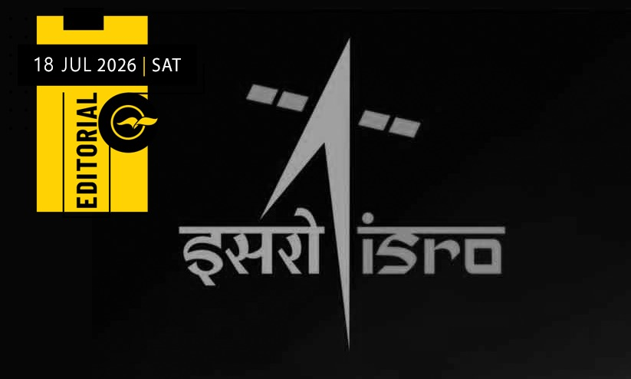
The Indian Space Research Organisation (ISRO) is an organisation that has played a significant role in establishing India's place on the world map in the field of space research and exploration. Thanks to such entities, in the 21st century, India stands alongside the world's major powers in the field of space exploration. Over the past 25 years, none of ISRO's major missions has missed its mark. The world has witnessed India's achievements in this field through the successful launches of Chandrayaan-1 (2008), Mangalyaan (2014), Astrosat (2015), Chandrayaan-3 (2023) and Aditya-L1 (2023). Except for the unsuccessful soft landing attempt of Chandrayaan-2 (2019), ISRO's space science missions over the past quarter of a century have been remarkably successful. Major projects, including Gaganyaan, are also progressing with the aim of paving the way for human spaceflight. None of these achievements came about by chance; they were the result of sound policy, careful planning and close collaboration between scientists and the government. The scientific vision of India's first Prime Minister, Jawaharlal Nehru, and the corresponding government planning turned the dream of establishing an indigenous space research programme into reality. Along with that, the dedicated efforts of a talented group of scientists and engineers who devoted their lives to the nation helped India emerge as a global leader in this domain. However, what is now emerging from ISRO is not a story of success but of an unfortunate reality of growing attrition. Within a matter of days, more than 100 officials, including senior scientists, are reported to have resigned or opted for voluntary retirement from ISRO and its affiliated research institutions, including the Vikram Sarabhai Space Centre (VSSC). As the large-scale departure of researchers and officials began affecting the organisation's day-to-day functioning and key projects such as Gaganyaan, the Union Ministry of Science and Technology was forced to intervene. The government is now attempting to curb the loss of scientists by introducing stricter conditions for employees seeking to leave the organisation. This apparent decline at ISRO was foreseeable even as its missions advanced towards the Moon and Mars. The primary reason is a failure in government policy. There was a time when ISRO was the preferred destination for those aspiring to build careers in space research. Interest in joining the organisation increased further after the success of Chandrayaan missions. However, the situation changed after the space research sector was opened to private individuals and institutions in 2020. This policy change had invited reproach from the very beginning. Today, several private companies and start-ups, including Skyroot, Agnikul and Pixxel, are active in the sector. Many of these organisations are led by former senior officials from ISRO and its affiliated institutions. As private companies have developed the capability to launch rockets, they have attracted not only young researchers but also experienced ISRO scientists by offering alluringly better incentives. It is in the last five years that such a major transformation has taken place. The resulting desertions have affected ISRO's functioning considerably. The indefinite delay in missions such as Gaganyaan and PSSLV is also a result of this crisis. The increased workload on the remaining scientists has become another major challenge. Consequently, many are choosing to resign because of mounting work pressure. Although private companies play an important role in the space sectors of other leading nations, they generally operate without weakening government-run research institutions. However, in India, shortcomings in policy formulation have placed the functioning of the prestigious institution ISRO itself under a cloud of uncertainty. Administrative orders alone are unlikely to resolve this problem. This crisis should also be viewed as a consequence of the science policy pursued by the Sangh Parivar-led central government. Since the Modi government came to power, the country's scientific community has, in general, been uneasy. From the outset, the government has been accused of weakening scientific research by reducing funding and support for research institutions. This triggered widespread protests. Several distinguished scientists, including Dr Shahid Jameel, one of India's leading biotechnology researchers, joined the protest by leaving government-affiliated research positions. It is also important to recognise that, according to this view, this policy failure begins with the Modi government's approach to defining science itself. For several years, efforts have been made to create new branches such as 'Puranic Science' and 'Bharatiya Science', presenting myths and epics first as history and then as science. Claims such as the Kauravas being test-tube babies and the Sudarshan Chakra being an ancient missile have been promoted in this context. Research into the medicinal properties of cow urine, promoted in the name of Indian culture, has also received significant encouragement under the Modi government. They further cite the Uttarakhand government's allocation of a whopping Rs 25 crore to search for the mythical 'Mrita Sanjeevani' mentioned in the Ramayana. From this perspective, the current situation at ISRO is seen as the outcome of policies that undermine scientific research. And there is no reason to believe that the consequences of such policies will remain confined to ISRO alone.

6. ESA's Mars Express meets NASA's Psyche
Read more
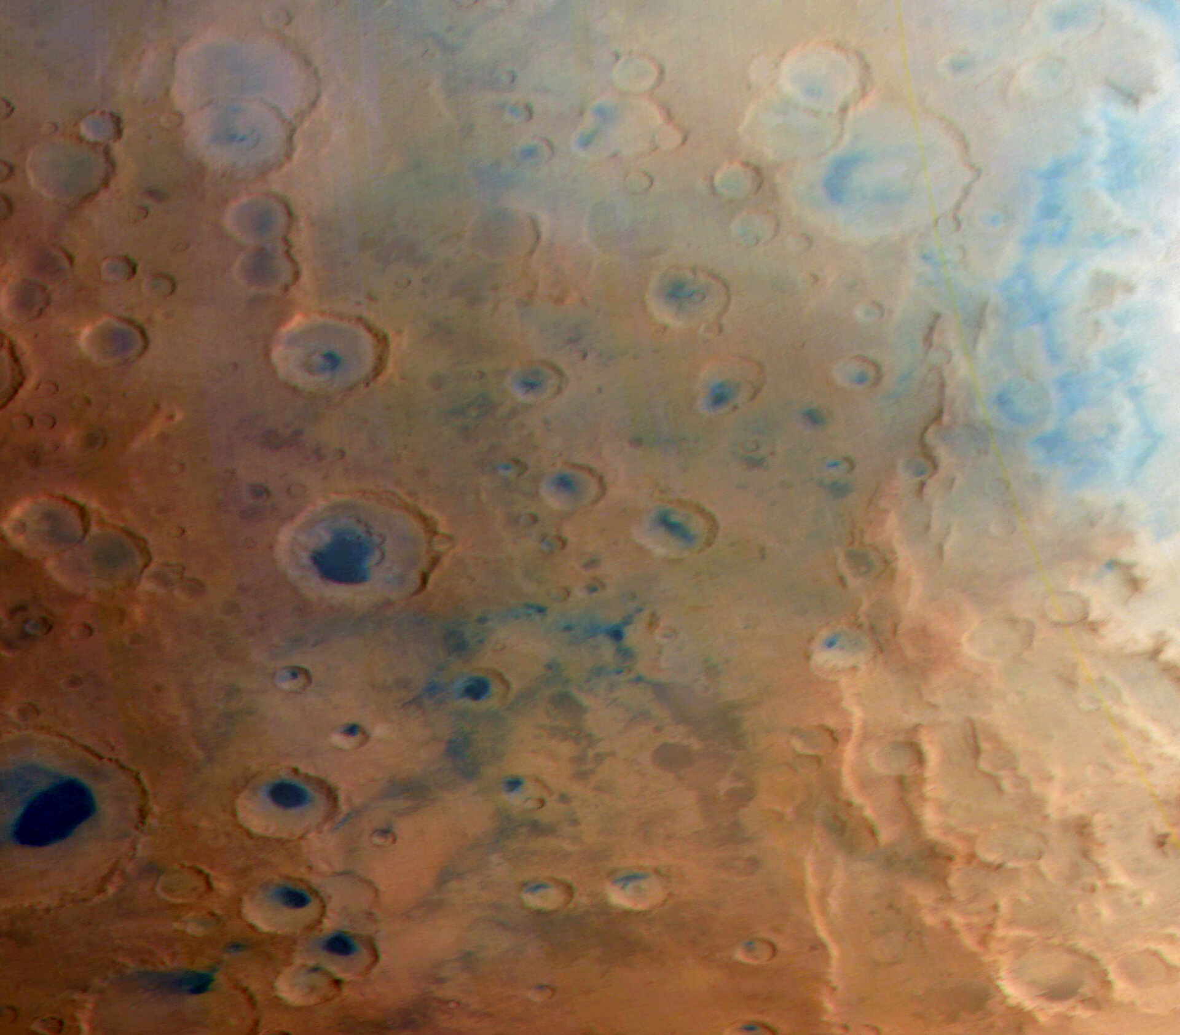
On 15 May, whilst en route to a metallic asteroid, NASA's Psyche mission flew just 4500 km above the surface of Mars. It was using the gravity of the Red Planet to boost its speed and adjust its trajectory. So-called 'gravity assist flybys' are common for interplanetary spacecraft. They make journeys to the inner or outer Solar System much more efficient. But they also provide a valuable opportunity to test a spacecraft's science instruments. Psyche did just that, snapping photos of Mars's dusty surface in the hours before and after its closest approach. Upon hearing of Psyche's flyby, the teams behind ESA's long-running Mars Express and its High Resolution Stereo Camera (HRSC) wondered if the paths of the two spacecraft would cross, allowing them to point at the same patch of the Red Planet. Teams working on both missions coordinated their observation plans weeks in advance, exchanging trajectories and observation timelines to photograph the same parts of the martian surface as close in time as possible. The images here show one of two coordinated observations. On the left is the image captured by Mars Express. On the right is the same landscape captured by Psyche's camera just 1 hour and 50 minutes later. The images show part of Noachis Terra, one of the oldest known parts of Mars's surface. The region is scattered with craters filled with sand dunes that are shown in dark blue. Though relatively close in time, the images were taken from very different distances and viewing angles. By the time Psyche passed over this region, about 2.5 hours after its closest approach to Mars, its altitude had increased to about 41 000 km. Mars Express, meanwhile, was at an altitude of just 6000 km; it was looking from an inclined angle, whereas Psyche was looking almost straight down towards Mars's surface. The two coordinated observations are not only nice visual comparisons, but could be used to help calibrate Psyche's camera. By comparing the brightness and colour recorded in each image pixel, scientists could discover small differences in how the two cameras respond to light. Though more investigation is needed into whether the observations are similar enough to be useful, these comparisons could help with checking and adjusting Psyche's camera, ensuring that it works optimally in future. Image notes The Mars Express image has a resolution of 800 metres per pixel. The Psyche image has a resolution of 500 metres per pixel. Though Mars Express's HRSC camera has a resolution of less than 20 metres per pixel in optimum conditions, its observation settings were adjusted to capture an image best comparable to Psyche's image resolution at the large distance of 41 000 km. Both images are RGB colour composites generated from the respective red, green and blue filters (Psyche image) or image channels (Mars Express image). Both images have been stretched for improved comparability. [Image description: A square image showing a mostly-orange patch of Mars's surface, scattered with sharp craters, many of which are blue inside. A vertical bar lets viewers slide between two views of exactly the same patch of surface. Whilst the landscape is identical, the left image is slightly more orange and the right image is slightly more blue.]

7. NASA Pushes New Wing Design to Find Structural Limits
Read more
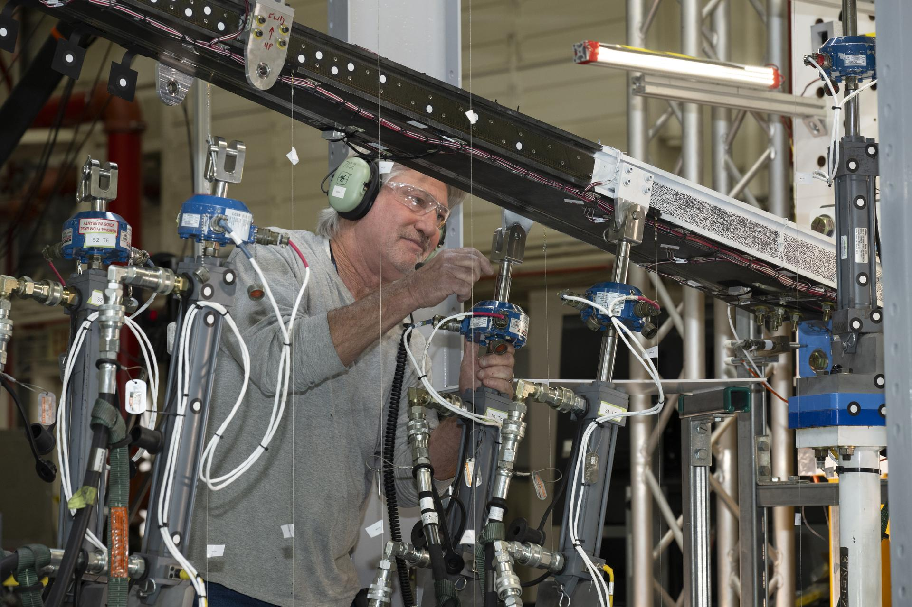
NASA researchers recently put a new wing design, appearing long and thin with a lightweight structural design, through a series of grueling tests to find its structural limits. What they found left them encouraged about the wing's potential, even when they pushed it past its intended limits. The 15-foot Structural Wing Experiment Evaluating Truss-bracing (SWEET-15) test article is part of NASA's research to develop future ultra-efficient aircraft. The design incorporates a long wing supported by an aerodynamic strut, based on NASA's earlier Transonic Truss‑Braced Wing concept. The research team is working to understand whether SWEET-15's design and its new lightweight structural designs could help commercial airliners save fuel. But first, they need to understand how it behaves under the kinds of force wings experience in flight. Lab technicians Phil Tofts, Chris McLain, and Jeff Howell and NASA engineers Erin Anderson and Richard Larson prepare the 15-foot Structural Wing Experiment Evaluating Truss-bracing model in the Flight Loads Laboratory at NASA's Armstrong Flight Research Center in Edwards, California, on Thursday, Dec. 11, 2025. The model is part of NASA's research to develop technologies for future ultra-efficient aircraft. NASA/Christopher LC Clark The SWEET-15 design originated with combining five different advanced composite manufacturing and assembly technologies that enabled the novel structural design. The 15-foot-long test article was then designed and fabricated at NASA's Langley Research Center in Hampton, Virginia, before traveling to NASA's Armstrong Flight Research Center in Edwards, California, for testing. Over several months, NASA engineers intentionally bent the test wing in the Flight Loads Laboratory at NASA Armstrong. Numerous strain and load sensors, including fiber-optic strain sensors, were placed throughout the structure to track how the wing responded as forces increased. The data from the sensors confirmed the predictions made by NASA's computer models. According to initial findings, the wing withstood the anticipated in-flight forces without issue. The results provided the team with confidence in the new manufacturing approaches and methods for connecting wing parts used in SWEET-15, which could support future efficient aircraft designs. The manufacturing approach, developed at NASA Langley used the Integrated Structural Assembly of Advanced Composites robot, aims to produce lighter and stronger composite structures for aerospace vehicles. Lab technicians Jeff Howell, left and Chris Mount install the 15-foot Structural Wing Experiment Evaluating Truss-bracing model in the Flight Loads Lab at NASA's Armstrong Flight Research Center in Edwards, California, Wednesday, February 11, 2026. The model is part of NASA's research to develop technologies for future ultra-efficient aircraft. NASA/Christopher LC Clark The test concluded with a deliberate test-to-failure, where engineers increased loads beyond the wing's design limits to determine how and where it would fail. The structure ultimately failed at roughly 127% of its design limit load, with visible damage appearing near the back edge of the wing and in the upper wing cover. This element of testing provided valuable insight into how the joints connecting the wing to its main strut and a secondary one, called a jury strut, behave under forces beyond the expected flight envelope. This marks the first time a representative composite truss-braced wing configuration has undergone this type of structural evaluation. It was made possible only through NASA collaboration across centers and projects, with researchers utilizing agency resources such as the Fiber Optic Sensing System developed to gather data on both aircraft and spacecraft. NASA research engineer Walter Hargis regulates the 15-foot Structural Wing Experiment Evaluating Truss-bracing model in the Flight Loads Laboratory at NASA's Armstrong Flight Research Center in Edwards, California, on Tuesday, March 31, 2026. The model is part of NASA's research to develop technologies for future ultra-efficient aircraft. NASA/Ryan Kline To prepare for the testing, engineers at NASA Langley designed, analyzed, and manufactured the wing and completed safety preparations and lab setup. Researchers will now analyze the data collected during testing to inform future airframe designs and support NASA's ongoing efforts to develop more efficient aviation technologies. The work is being conducted through NASA's Subsonic Flight Demonstrator project in the agency's Research Technology Mission Directorate. The successful testing of multiple innovative components marks a milestone in NASA's aeronautics research. To learn more, visit: https://www.nasa.gov/aeronautics/

8. The Growing Crescent of Mars as NASA's Psyche Mission Approaches
Read more
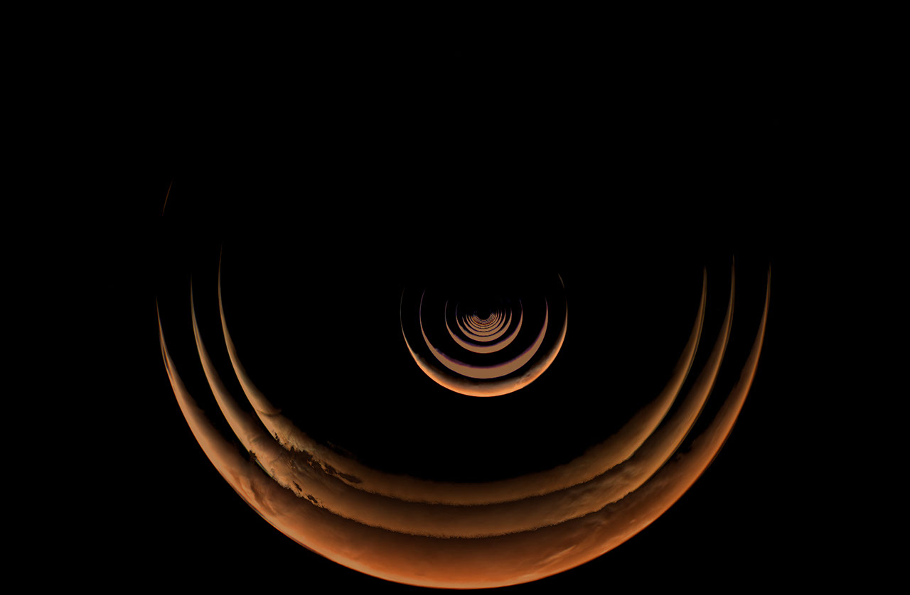
Description This composite of images taken by NASA's Psyche mission shows the crescent of Mars grow as the spacecraft approached the planet for a gravity assist from May 2 to May 15, 2026. The series begins with the smallest crescent at the center of the of the image as Mars is farthest from the spacecraft, and progressively grows as the spacecraft gets closer. After these views were captured by the spacecraft's multispectral imager instrument, Mars began to overfill the field of view as Psyche made close approach with the planet and captured a series of high-resolution images of the surface. Because Psyche approached Mars from a high phase angle, the planet appeared as a thin crescent in the days running up to the close approach, lit by sunlight reflecting off its surface. Using these views of the approach, close approach, and departure from Mars, the Psyche team compiled a stunning time-lapse of its entire Mars encounter. For more information about NASA's Psyche mission, visit: https://science.nasa.gov/mission/psyche/

9. Establishing a VTE Risk Score for Astronauts Algorithm
Read more

Spontaneous echo contrast (SEC) grade 3 with peripheral echogenicity. NASA/Pavela In April 2026, NASA's Office of the Chief Health and Medical Officer (OCHMO) initiated a working group to review updated VTE case information, additional data gathered revealing altered blood flow status within a cohort of astronauts, and discuss progress of research and clinical activities intended to mitigate the risk of VTE during spaceflight with new evidence-based clinical practice recommendations. Recommendations The following is a summary of the working group's recommendations: The working group's conclusions emphasized that stasis in the left internal jugular vein (IJV) is consistently viewed as a dominant risk factor for VTE in microgravity, though there is active debate regarding the relative contributions of slow qualitative flow, endothelial factors and/or retrograde flow. Limitations of current in-flight ultrasound capabilities to accurately measure stasis/slow flow was cited as a concern, especially if using only stasis as a factor for indicating the need for prophylaxis. Additional review of assessing stasis with ultrasound in-flight was recommended. After reviewing the risk factors, additional discussions following the working group led to the majority of the panel agreeing that stasis and retrograde flow warranted use of prophylaxis. The working group also recommended assessing all other risk factors other than stasis to also determine when prophylaxis is warranted. Based on a literature review and summary of the panel contributions, a VTE Risk Score for Astronauts Algorithm was developed, which includes providing anticoagulation prophylaxis for stasis alone, or a combination of other thrombosis risk factors that are weighted by terrestrial literature. Risk of Venous Thromboembolism During Spaceflight NASA initially formed a working group in October 2024 after diagnosing venous thromboembolisms (VTEs) in astronauts during ISS missions. Experts reviewed case data, updated Clinical Practice Guidelines, and examined possible causes.

10. NASA Awards Facilities Support Services Contract for Ames Research Center
Read more

CONTRACT RELEASE NASA has selected Chugach Intelligence Solutions LLC to provide comprehensive operations, maintenance, and repair services for NASA's Ames Research Center in California's Silicon Valley. The Ames Facilities Support Services II contract ensures that the center's historic and specialized facilities are properly maintained, fully operational, and capable of supporting the agency's missions and tenant partners in the NASA Research Park. The hybrid contract has a five-year period of performance, consisting of a 12-month base period and four 12-month option periods, with the possibility of a six-month extension. The performance period is expected to begin Thursday, Aug. 13. The contract includes cost-plus-award-fee core requirements, firm-fixed-price phase-in, and indefinite-delivery/indefinite-quantity task orders, providing flexibility to address both routine and emergent facility needs. The award has a maximum potential value of approximately $158 million, inclusive of all options and total indefinite-delivery/indefinite-quantity ceiling value. For more information about NASA and its missions, visit: https://www.nasa.gov -end- Jeanne Neal Ames Research Center, Silicon Valley, Calif. 650-604-4789 jeanne.c.neal@nasa.gov

11. NASA's Chandra and IXPE Study Pulsar in Lighthouse Nebula
Read more

Scientists using NASA's IXPE (Imaging X-ray Polarimetry Explorer) directly measured the magnetic fields of PSR J1101−6101, a pulsar located within what is often referred to as the "Lighthouse" Nebula, for the first time. X-ray: Chandra: NASA/CXC/Stanford Univ./J. Dinsmore et al.; IXPE: NASA/MSFC/J. Dinsmore et al., Radio: CSIRO/ATNF/ATCA; Optical: 2MASS/UMass/IPAC-Caltech/NASA/NSF; Image processing: NASA/CXC/SAO/L. Frattare This composite image, released on July 9, 2026, shows the region around a pulsar - a neutron star with a strong magnetic field that spins incredibly fast - within the Lighthouse nebula. The image contains X-ray data from NASA's Chandra X-ray Observatory in purple, X-rays from NASA's IXPE (Imaging X-ray Polarimetry Explorer) in blue, and radio emission captured by the Australia Compact Telescope Array in green. Scientists used IXPE - for the first time ever - to directly measure the magnetic fields of the pulsar. The results provide new insight into the structure of some of the most extreme objects in the cosmos, as NASA continues to explore the secrets of how the universe works. A paper describing the results published July 9 in the Astrophysical Journal. Image credit: X-ray: Chandra: NASA/CXC/Stanford Univ./J. Dinsmore et al.; IXPE: NASA/MSFC/J. Dinsmore et al., Radio: CSIRO/ATNF/ATCA; Optical: 2MASS/UMass/IPAC-Caltech/NASA/NSF; Image processing: NASA/CXC/SAO/L. Frattare

12. La NASA invita a los medios de comunicación al lanzamiento del telescopio espacial Roman
Read more

2 min read Lauren E. Low Jul 17, 2026 RELEASE Aquí puede verse el telescopio espacial Nancy Grace Roman de la NASA en la sala limpia del Centro de Vuelo Espacial Goddard de la agencia en Greenbelt, Maryland, donde este observatorio fue construido y sometido a pruebas. Los amplios y profundos sondeos de Roman explorarán la materia oscura, la energía oscura, los exoplanetas y prácticamente cualquier objeto celeste, desde nuestro propio sistema solar hasta galaxias situadas en los confines del universo observable. Crédito: NASA/Jolearra Tshiteya Read this release in English here . Ya está abierto el plazo de acreditación de los medios de comunicación para el lanzamiento de la misión del telescopio espacial Nancy Grace Roman de la NASA. El lanzamiento del telescopio Roman está programado para no antes de las 7:20 a.m. (hora del este) del domingo 30 de agosto, a bordo de un cohete Falcon Heavy de SpaceX, desde el Complejo de Lanzamiento 39A en el Centro Espacial Kennedy de la NASA en Florida. Este observatorio, que lleva el nombre de la primera astrónoma jefa de la NASA, ofrecerá una visión profunda y panorámica del cosmos, generando imágenes nunca antes vistas que revolucionarán nuestra comprensión del universo. Los medios interesados en asistir al lanzamiento deben presentar su solicitud antes de los siguientes plazos: - Los representantes de medios de comunicación internacionales sin ciudadanía estadounidense deben presentar su solicitud antes de las 11:59 p.m. del domingo 26 de julio. - Los medios de comunicación de Estados Unidos y los ciudadanos estadounidenses que representen a organizaciones de medios internacionales deben presentar su solicitud antes de las 11:59 p.m. del jueves 30 de julio.• Todas las solicitudes de acreditación deben ser enviadas en línea a través del sitio web: https://media.ksc.nasa.gov La política de acreditación de medios de la NASA está disponible en línea. Para consultas sobre la acreditación o para solicitudes logísticas especiales, envíe un correo electrónico a: ksc-media-accreditat@mail.nasa.gov . Para otras consultas, comuníquese con la sala de prensa del Centro Espacial Kennedy de la NASA al teléfono: 321-867-2468. Para obtener más información sobre esta misión, visite el sitio: https://www.ciencia.nasa.gov/roman -fin- Alise Fisher / María José Viñas Sede central de la NASA, Washington 202-385-1287 alise.m.fisher@nasa.gov / maria-jose.vinasgarcia@nasa.gov Leejay Lockhart Centro Espacial Kennedy, Florida 321-747-8310 leejay.lockhart@nasa.gov Claire Andreoli Centro de Vuelo Espacial Goddard de la NASA, Greenbelt, Maryland 301-286-1940 claire.andreoli@nasa.gov Share Details Last Updated Related Terms - NASA en español

13. NASA Invites Media to Roman Space Telescope, Crew-13 Launches
Read more

Credit: NASA Media accreditation now is open for the launch of NASA's Nancy Grace Roman Space Telescope and the agency's SpaceX Crew-13 missions, both targeting launch in the coming months. The Roman telescope is slated to launch no earlier than 7:20 a.m. EDT Sunday, Aug. 30, aboard a SpaceX Falcon Heavy rocket from Launch Complex 39A at NASA's Kennedy Space Center in Florida. The observatory, named after NASA's first chief astronomer, will have a deep, panoramic view of the cosmos, generating never-before-seen pictures that will revolutionize our understanding of the universe. NASA's Nancy Grace Roman Space Telescope is seen here in the clean room at the agency's Goddard Space Flight Center in Greenbelt, Maryland, where the observatory was built and tested. Roman's vast, deep surveys will explore dark matter, dark energy, exoplanets, and almost anything from our own solar system to galaxies at the edge of the observable universe. Credit: NASA/Jolearra Tshiteya Crew-13 is scheduled to launch no earlier than mid-September from Space Launch Complex 40 at Cape Canaveral Space Force Station. The mission will carry NASA astronauts Jessica Watkins and Luke Delaney, CSA (Canadian Space Agency) astronaut Joshua Kutryk, and Roscosmos cosmonaut Sergey Teteryatnikov to the International Space Station for a science and research expedition. This will be NASA's 13th commercial crew rotation mission with SpaceX's Falcon 9 rocket and Dragon spacecraft. NASA's SpaceX Crew-13 members are pictured in their pressure suits seated inside a mockup Dragon spacecraft during a preflight training session at the company's headquarters in Hawthorne, California. From left to right, Roscosmos Sergey Teteryatnikov, NASA astronauts Luke Delaney and Jessica Watkins, and CSA (Canadian Space Agency) astronaut Joshua Kutryk. Credit: SpaceX Media interested in attending either or both launches must apply by the following deadlines: International media without U.S. citizenship must apply by 11:59 p.m. on Sunday, July 26. U.S. media and U.S. citizens representing international media organizations must apply by 11:59 p.m. on Thursday, July 30. All accreditation requests must be submitted online at: https://media.ksc.nasa.gov NASA's media accreditation policy is online. For questions about accreditation or special logistical requests, email: ksc-media-accreditat@mail.nasa.gov. For other questions, please contact NASA Kennedy's newsroom at: 321-867-2468. For more information about these missions, visit: https://www.nasa.gov -end- Alise Fisher (Roman) / Joshua Finch (Crew-13) Headquarters, Washington 202-385-1287 / 202-358-2546 alise.m.fisher@nasa.gov / joshua.a.finch@nasa.gov Leejay Lockhart (Roman) / Steve Siceloff (Crew-13) Kennedy Space Center, Fla. 321-747-8310 / 321-867-2468 leejay.lockhart@nasa.gov / steven.p.siceloff@nasa.gov Claire Andreoli (Roman) Goddard Space Flight Center, Greenbelt, Md. 301-286-1940 claire.andreoli@nasa.gov

