 |  | 

🌌 अंतरिक्ष समाचार | Space News
शनिवार, १४/११/२०२६ | Saturday, 14/11/2026

1. ISRO's Participation in the Thirtieth Session of the Intergovernmental Consultative Committee (ICC-30) on 26 - ISRO
Read more
ISRO's Participation in the Thirtieth Session of the Intergovernmental Consultative Committee (ICC-30) on 26 ISRO

2. ISRO PSLV Third Stage Test 2026, Key Highlights and Significance - Vajiram & Ravi
Read more
ISRO PSLV Third Stage Test 2026, Key Highlights and Significance Vajiram & Ravi

3. Cyclone alerts to train tracking: PM Modi explains how Isro tech serves Indians - India Today
Read more
Cyclone alerts to train tracking: PM Modi explains how Isro tech serves Indians India Today

4. Apple HomeView Launches in India and Other Select Markets with Siri AI-Powered Smart Home Features - Indianweb2.com
Read more
Apple HomeView Launches in India and Other Select Markets with Siri AI-Powered Smart Home Features Indianweb2.com

5. ISRO Clears 200-Second Cryogenic Engine Test for GSLV-F19 Mission to Launch NavIC Satellite NVS-04 - theopenpress.in
Read more
ISRO Clears 200-Second Cryogenic Engine Test for GSLV-F19 Mission to Launch NavIC Satellite NVS-04 theopenpress.in

6. Gemini Astronaut Photos Inspired Early Earth Observation Program
Read more
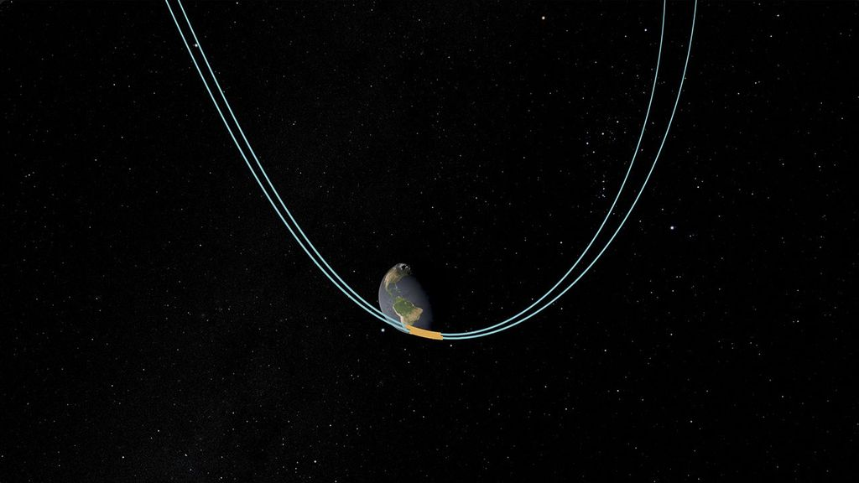
NASA astronauts James A. Lovell Jr. and Edwin E. "Buzz" Aldrin Jr. captured this image of the area surrounding the Red Sea and Nile river valley on November 14, 1966, during their four-day mission in space. Gemini XII was the final flight of NASA's Gemini Program. NASA Astronauts James A. Lovell Jr. and Edwin E. "Buzz" Aldrin Jr. orbited Earth from November 11 to 15, 1966, on Gemini XII, the final mission of NASA's Gemini program. In addition to successfully completing rendezvous maneuvers and spacewalks, procedures vital to sending American astronauts to the Moon, the crew was also spurring the development of a different field of exploration, observing Earth from space. The photos taken by Lovell, Aldrin, and other Gemini astronauts demonstrated the value of orbital imagery for studying Earth's surface. Their images helped scientists make the case for a dedicated Earth observation satellite program. One of strongest advocates for accelerating the use of Earth-observing satellites was William T. Pecora, the director of the United States Geological Survey from 1965 to 1971. In a 1969 statement, Pecora noted that the Earth Resources Observation Satellite (EROS) program he championed, and which later paved the way for Landsat, was "conceived in 1966 largely as a direct result of the demonstrated utility of Mercury and Gemini orbital photography to Earth resource studies." For more than five decades, Landsat and other Earth-observing satellites have provided invaluable data used around the world to monitor crops, wildfires, flooding, vegetation health, land use, and countless other changes to our planet.

7. SpaceX launches Starship on ambitious 22-hour Flight 15 test, but aborts booster 'chopsticks' catch (video)
Read more
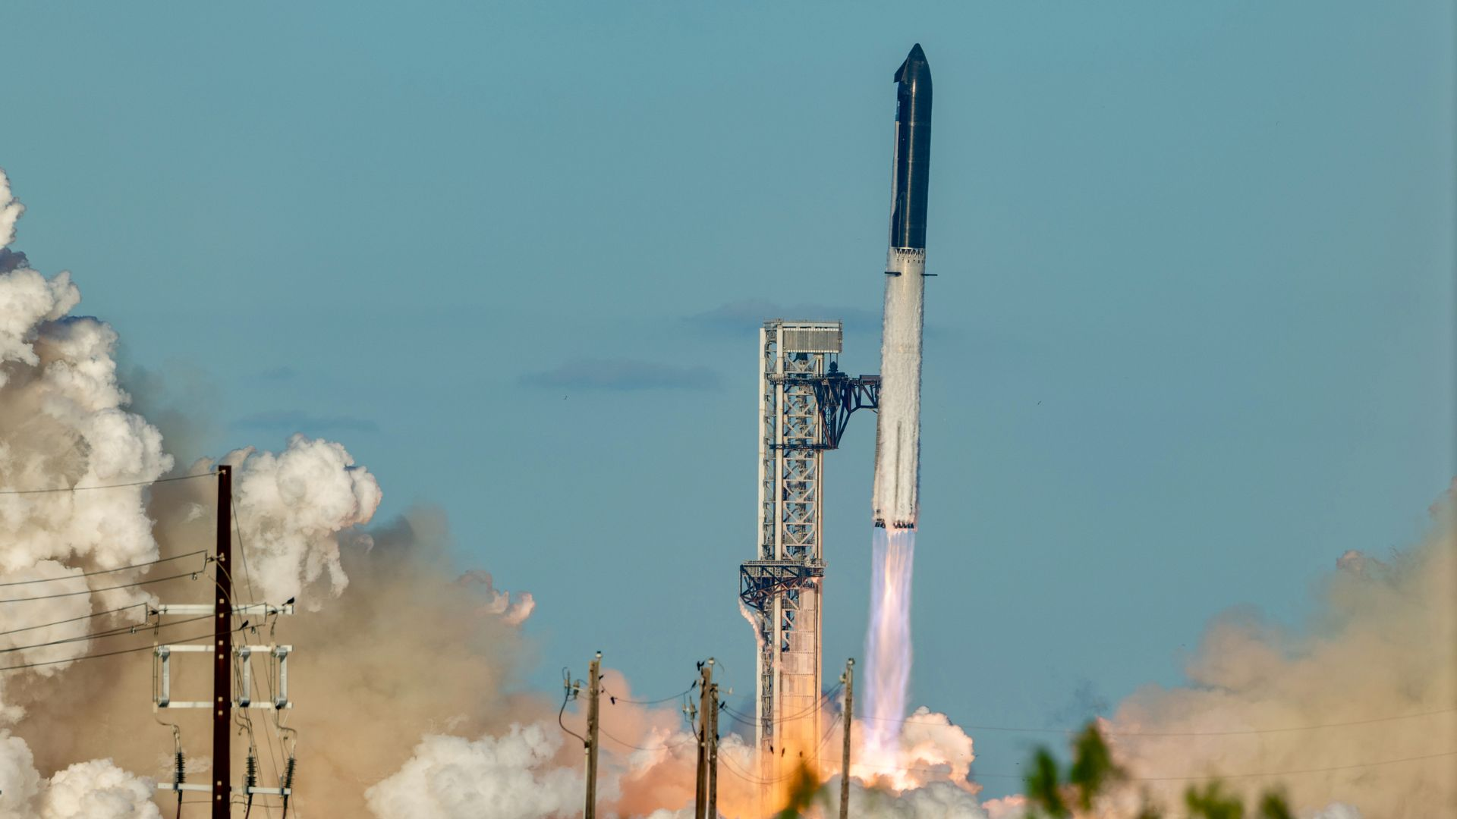
Click for next article STARBASE, Texas - SpaceX launched the 15th test flight of its massive Starship rocket today (Nov. 13) and is preparing the vehicle's upper stage for its first-ever return to the launch site in less than 24 hours. Flight 15 lifted off from SpaceX 's Starbase facility here in South Texas at 5:47 p.m. ET (2247 GMT; 4:47 p.m. local Texas time). The towering Super Heavy booster and Ship upper stage cleared the tower without incident and climbed into the skies under more than 18 million pounds of thrust from the booster's 33 Raptor 3 engines. The flight continued nominally through its initial ascent, with the successful execution of Super Heavy's main engine cutoff and Ship's subsequent hot-staging - firing its own Raptors during separation from the booster - about 2.5 minutes after launch. Following stage separation, Super Heavy reoriented for a planned return to Starbase as Ship powered its way toward low Earth orbit (LEO). Watch live! SpaceX launches Starship Flight 15, booster splashes down - YouTube Watch On SpaceX originally planned to catch Super Heavy with the Starbase launch tower's giant mechanical "chopstick" arms. But it wasn't to be: The company called off the catch attempt and brought the booster down for a controlled splashdown in the Gulf of Mexico about 6.5 minutes after launch, for reasons that were not immediately clear. A successful catch would have been a significant milestone for SpaceX and its efforts to design Starship as a fully and rapidly reusable launch vehicle. It would have been the first successful recovery of a Version 3 (V3) Super Heavy , which SpaceX began flying earlier this year. The company previously recovered three of its V1 Super Heavy vehicles and reused two of those in later flights. SpaceX's Starship megarocket launches on its 15th test flight from Starbase, Texas on Nov. 13, 2026. (Image credit: Future/Josh Dinner, Space.com) Ship goes to orbit Ship's Raptors continued to fire following stage separation, completing their first burn just after eight minutes into flight. All went according to plan after that for Ship as well: A second engine burn lasting about 20 seconds parked Ship in LEO at an altitude of around 170 miles (275 kilometers) at T+26 minutes and 10 seconds. "We've got a nominal orbit insertion, so Starship now in orbit around Earth for the second time ever," SpaceX's Dan Huot said during today's Flight 15 launch webcast. "That's a really great moment." Ship first reached orbit on Flight 14 , which launched on Sept. 28. Ship carried 26 of SpaceX's Starlink V3 spacecraft, which were deployed into LEO on schedule today over a 42-minute span starting 35 minutes after launch. The upgraded wireless internet satellites are the second V3 batch to reach orbit, after a set of 26 that were delivered on Flight 14 . V3s are significantly more powerful than SpaceX's V2 Starlinks, which currently number more than 11,000 in LEO. The addition of this new set of V3s will add a terabit of data capacity to the constellation, according to SpaceX's Flight 15 mission outline . That's equivalent to the amount contributed by 10 Starlink V2 launches, which are carried out by SpaceX's Falcon 9 rocket. The two stages of SpaceX's Starship megarocket separate during the vehicle's 15th test flight on Nov. 13, 2026. (Image credit: SpaceX) Three of the V3 Starlinks flying today were equipped with cameras to point back at Ship after deployment in order to analyze its heatshield tiles and other hardware following its ascent to orbit. Their data will help SpaceX determine if Ship can indeed come home to Starbase on Saturday. "Starship will only execute a return to launch site if the flight control team has ensured that the vehicle systems critical for reentry maneuvers and final landing burn and tower approach are healthy," SpaceX wrote in its Flight 15 mission description. SpaceX engineers will have ample time to go over Ship's systems before making a final landing decision. Ship is scheduled to circle Earth 14 times, spending more than 21 hours in space before coming home. You can follow all of the action on here at Space.com via our Flight 15 live updates page . The Super Heavy booster of SpaceX's Starship megarocket returns to Earth during its 15th test flight on Nov. 13, 2026. (Image credit: Space.com/Josh Dinner) To catch or not to catch? SpaceX has reserved three contingency checkpoints during Flight 15's mission timeline to allow for an early Pacific Ocean return, should engineers determine a catch attempt to be unfeasible or unwise. The first comes just 10 minutes after the completion of Starlink satellite deployment, the second at T+7 hours and 15 minutes, and a final one at T+20 hours and 41 minutes. Should Ship continue to look good through each of these milestones, SpaceX will proceed with a 10-second deorbit burn at approximately T+21 hours and 36 minutes, setting the spacecraft on a trajectory back toward South Texas. Its plunge through Earth's atmosphere will begin about 35 minutes later. SpaceX has also designated a contingency splashdown zone in the Gulf of Mexico, should conditions prevent a safe catch during Ship's final approach. If all goes according to plan, Ship will return to Starbase on Saturday at approximately 4:17 p.m. EST (2117 GMT; 3:17 p.m. Texas time), about 22.5 hours after liftoff. A successful catch would be a major milestone for SpaceX - the first-ever recovery of a Starship upper stage. Starship's Ship upper stage flies high above Earth on the vehicle's Flight 15 test fligt on Nov. 13, 2026. (Image credit: SpaceX) Full reusability is central to the company's ambitions for launching its V3 Starlink satellites, as well as a proposed constellation of orbital data centers envisioned by company founder and CEO Elon Musk . The next-gen Starlink constellation will consist of about 100,000 satellites, while the AI network will be 10 times that size, Musk has said. Building and maintaining those constellations will require a mind-boggling number of launches. Indeed, SpaceX is targeting 10,000 Starship liftoffs per year by 2030 , according to Musk. Some of Starship's other planned missions won't necessarily require full reusability, but the spacecraft's reliability will be critical to NASA's Artemis program and its efforts to return astronauts to the moon . The space agency selected Starship as one of the program's crewed lunar landers, and it's slated to fly a demonstration mission with NASA's Orion spacecraft and Artemis III astronauts to Earth orbit in the summer of 2027. Editor's note: This story was updated at 7:10 p.m. ET on Nov. 13 with news of successful payload deployment.

8. 100 launches! Rocket Lab sends Earth-observing satellite to orbit on milestone mission (photos)
Read more
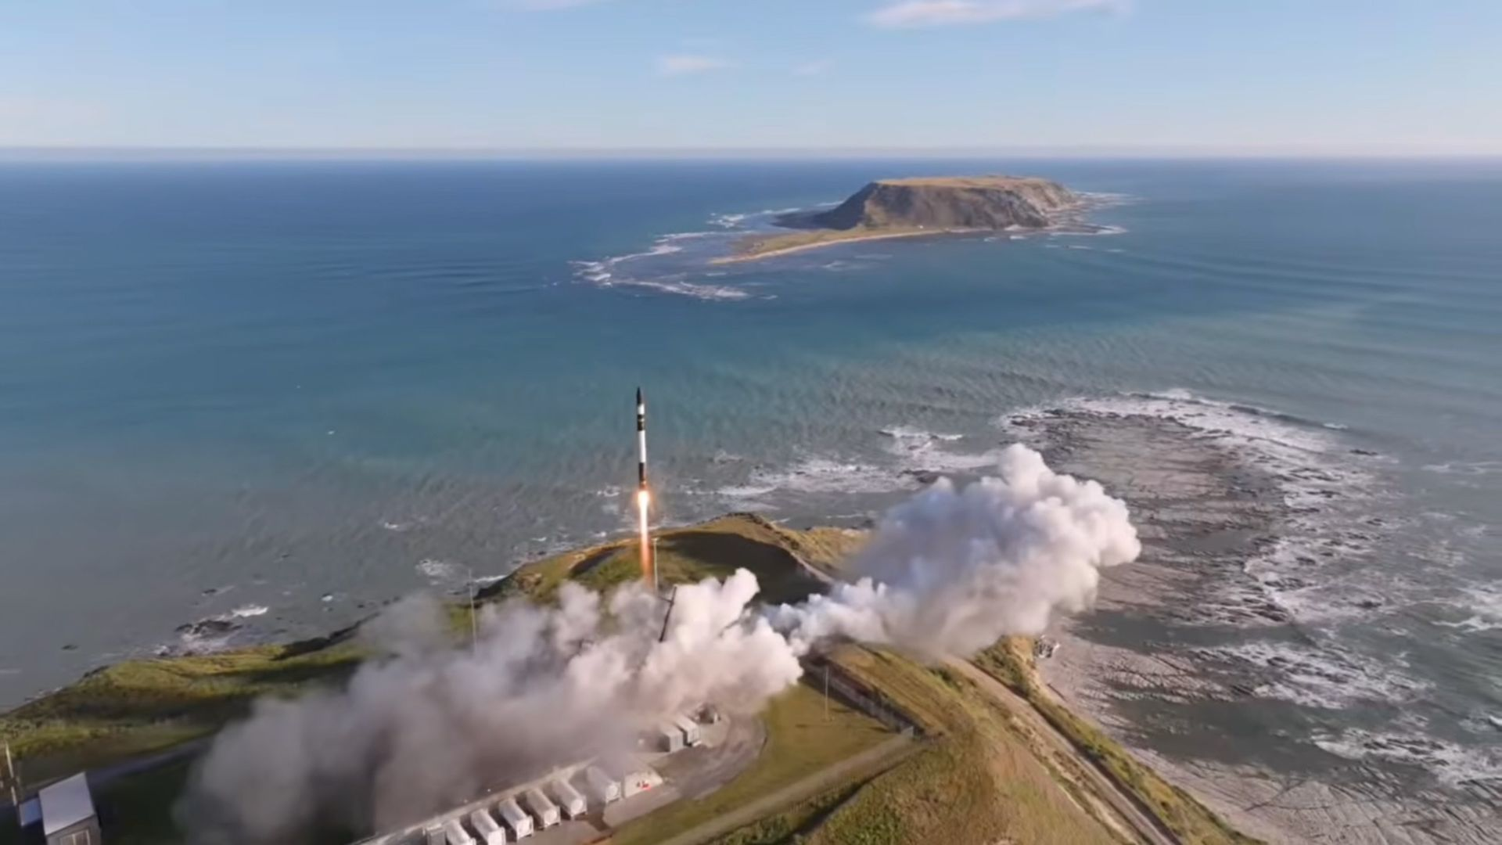
Click for next article A Rocket Lab Electron rocket launches from New Zealand on Nov. 14, 2026 on "The Mountain God Rises," the 100th mission for the company to date. Rocket Lab just hit the century mark. An Electron rocket topped with a private Japanese Earth-observing satellite lifted off from Rocket Lab's New Zealand site on Saturday (Nov. 14) at 12:30 a.m. EST (0530 GMT; 6:30 p.m. local New Zealand time). The mission, which Rocket Lab called "The Mountain God Rises," was a big one: It marked the 100th launch to date for the California-based company. The first stage of Rocket Lab's Electron rocket falls back to Earth during "The Mountain God Rises" mission on Nov. 14, 2026. (Image credit: Rocket Lab) Rocket Lab launched for the first time in May 2017, sending the brand-new Electron up on a test flight from New Zealand. That effort failed, but Electron bounced back on its second-ever liftoff, delivering several cubesats to low Earth orbit (LEO) in January 2018. In the years since, the 59-foot-tall (18 meters) Electron has become one of the most prolific and reliable rockets in the world, carrying small payloads to the final frontier for a variety of customers. And it hit the century mark on Saturday in record-breaking fashion: No commercially developed rocket has gotten there faster, not even SpaceX's workhorse Falcon 9 , according to Rocket Lab founder and CEO Peter Beck. "It's an unprecedented milestone for a commercial small-lift orbital rocket, and a threshold rarely crossed in modern spaceflight," Beck said on Monday (Nov. 9), during Rocket Lab's third-quarter earnings call with investors. "But what matters most to us and our customers is that we have achieved a 96% reliability rate across 99 launches." Electron met the moment in style on Saturday morning, thanks to some fancy livery. "Black rocket 🤝 Golden milestone. Electron is all dressed up for launch 100," Rocket Lab said via X on Tuesday (Nov. 10), in a post that shared a photo of the specially painted first stage. Not all of Rocket Lab's missions have gone orbital, it should be noted: A suborbital variant of Electron known as HASTE , which customers use to test technologies in a hypersonic flight environment, has nine missions under its belt to date. The Electron rocket that flew Rocket Lab's 100th mission sported some special livery. (Image credit: Rocket Lab) "The Mountain God Rises" was Rocket Lab's 11th launch to date for the Tokyo-based company iQPS, which is building a constellation of three dozen synthetic aperture radar (SAR) satellites in LEO. And all went to plan on the mission: Electron's upper "kick stage" deployed a single iQPS spacecraft 357 miles (575 kilometers) above Earth. SAR satellites can see through cloud cover and image our planet at night as well as during the day, offering key advantages over spacecraft that are optimized to view in optical wavelengths. Editor's note: This story was updated at 12:40 a.m. ET on Nov. 14 with news of successful liftoff, then again at 1:30 a.m. ET with news of satellite deployment.

9. Astronaut Suni Williams rides through NYC as Grand Marshal of the Veterans Day Parade | Space photo of the day for Nov. 13, 2026
Read more

Click for next article NASA astronaut Suni Williams rides through New York City as the Grand Marshal of the Veterans Day Parade on Nov. 11, 2026. (Image credit: Photo by Slaven Vlasic/Getty Images) New Yorkers got a space-y surprise on Wednesday (Nov. 11): Retired NASA astronaut and U.S. Navy Captain Sunita "Suni" Williams rolled down 5th Avenue in the back of a classic convertible wrapped in patriotic decals as Grand Marshal of the Veterans Day Parade. What is it? On Wednesday, New York City's 107th annual Veterans Day Parade made its way through Manhattan to the cheers and respectful nods of thousands of onlookers. The parade is an annual tradition on the holiday, which honors veterans of the U.S. armed forces. As part of the parade, veterans, active-duty soldiers, firefighters, marching bands, youth cadets and more march through the city and honor those who have served and sacrificed in the U.S. military. This year, the parade featured Suni Williams as its grand marshal. "I'm proud to join New Yorkers and Americans from around the country in honoring the service, sacrifice, and commitment of veterans from every generation," she said during the event. Why is it incredible? Williams was selected for NASA's astronaut program in 1998 and retired from it in December 2025 . She spent 608 days in space during her astronaut career, the second-most by an American astronaut behind Peggy Whitson , who racked up 695. Williams also had an extensive career in the U.S. Navy. She began as an ensign in 1987 before serving in a number of different roles. For example, she was a diving officer and a naval aviator and also provided helicopter combat support during Operation Desert Shield and Operation Provide Comfort. She further served as a squadron safety officer and finally as a captain, a rank she achieved in 2017. During this time, Williams supported relief efforts following Hurricane Andrew, trained within the U.S. Naval Test Pilot School and gained a wealth of further experience flying as a military pilot. Williams is part of a longstanding tradition of astronauts serving in the U.S. military. From test pilots to naval officers and more, there's a strong link between the U.S. armed forces and NASA's astronaut program.

10. Double-catch drama: Why Starship's Flight 15 is so important to SpaceX
Read more
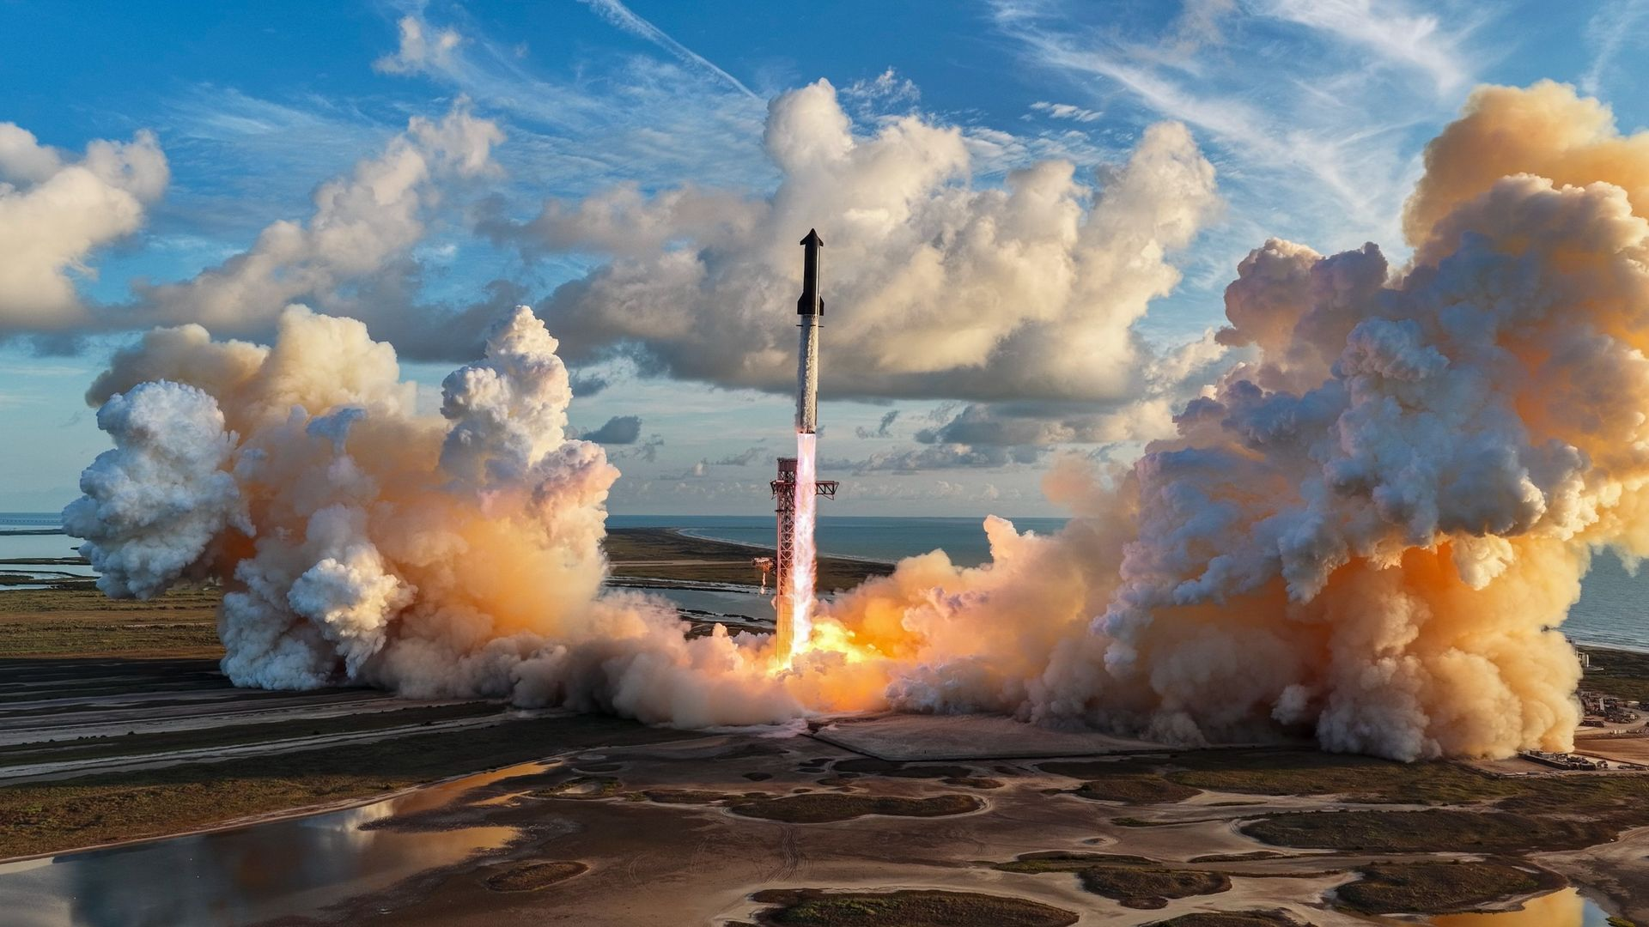
Click for next article Watch live! SpaceX launches Starship Flight 15 with potential double catch attempts - YouTube Watch On Update for 6:25 p.m. ET: SpaceX has launched the Starship Flight 15 mission, but did skip the first stage Super Heavy booster landing. See launch video and our full Starship Flight 15 liftoff wrap . Having reached orbit for the first time with Starship last time out, SpaceX is looking to take a huge stride toward full reusability with Flight 15 - the first attempt to catch the megarocket's Ship upper stage, as the company eyes hourly launches by 2030. SpaceX is targeting today (Nov. 13) for Starship 's 15th flight, which will lift off from the company's Starbas site in South Texas. If all goes well, the mission - which you can watch here at Space.com - will end on Saturday (Nov. 14) with the first attempt at what SpaceX itself calls the "Holy Grail of rocketry": Catching both Starship's Super Heavy booster and Ship upper stage chopstick-style back at the launch pad. "If successful, this will mark the first full recovery of an orbital launch system and a breakthrough moment in making Starship a reliable, rapidly reusable rocket," SpaceX wrote in its Flight 15 mission description . The 75-minute Flight 15 launch window opens today at 5:45 p.m. EST (2245 GMT), and a number of Starship firsts are planned for early in the flight. For example, while SpaceX has caught three Super Heavy boosters and reused two of them to date, the first attempt to catch a next-gen Super Heavy "V3" vehicle will come today, around 6.5 minutes after liftoff. If the Ship upper stage gets the go-ahead for orbital insertion, it will deploy 26 Starlink V3 satellites - designed especially for use on Starship - into low Earth orbit (LEO), starting about 35 minutes after launch. Then, 21 hours later, if "internally developed, and FAA-approved, conditions" for a return to Starbase and catch are met - including on-orbit assessment of Ship's heat shield by three of the V3 satellites - SpaceX will attempt to recover the orbital upper stage. This landmark try will follow the first-ever Ship reentry over inhabited areas, as the vehicle will maneuver its way over sparsely populated regions of northern Mexico and southern Texas. (On previous missions, Ship has splashed down in the open ocean.) It will head back to Starbase and make a bellyflop maneuver as it descends to the site's Pad 2 before flipping itself vertical, ready for embrace of the launch tower's waiting mechanical arms. "SpaceX will attempt to catch both the Super Heavy booster and Starship on the upcoming flight. If both are successful, it will mark the first time that all parts of an orbital rocket return to Earth intact," Elon Musk said via X, the social media platform he owns, on Nov. 6 . "This is the critical breakthrough needed to make life multiplanetary." Composite photo showing the Super Heavy booster of SpaceX's Starship megarocket coming in for a landing on the launch mount on Oct. 13, 2024. (Image credit: SpaceX via X) The catch Half of the system is already proven. With catching and reflying boosters largely established, the next and unprecedented step is catching Ship. This is no easy task. The vehicle, returning from orbital speeds, must survive the heat of reentry, make its way precisely back to the pad put itself in position to be caught by the tower's "chopstick" arms. The full recovery of an orbital launch system would, in the words of SpaceX, be a "breakthrough moment in making Starship a reliable, rapidly reusable rocket" and would open the "door to airplane-like cadence." A successful catch would allow SpaceX to then work on refurbishing Ship for reflight, the next challenge of full reusability. Musk said in August in a SpaceX earnings call that the company will aim to refly the Super Heavy and Ship early next year. SpaceX has a lot of experience with rocket reuse, as its workhorse Falcon 9 rocket pioneered the practice. But the company is eyeing another level of reflight with Starship: It's targeting roughly 10,000 launches of the megarocket per year by 2030, which works out to more than one launch per hour. "We're aiming to reach 30+ Starship launches/day in 2030, which is ~10k annualized," Musk posted on X in August. Why so many launches? The company has repeated that figure to regulators. In comments filed with the U.S. Federal Aviation Administration in late October, it said that "SpaceX anticipates conducting 10,000 launches per year itself." Meanwhile, the recently signed National Space Transportation Policy aims to boost the U.S.'s capabilities to support more than 1,000 rocket launches per year by 2030. Musk added that SpaceX's planned Starbase Louisiana site alone could support that many Starship launches. For context: SpaceX launched 165 Falcon 9 missions in 2025, and that was about half of the global total for orbital flights. Why is SpaceX targeting this incredible increase in launch cadence? It wants to build satellite megaconstellations that dwarf anything the world has ever seen. The company's V3 Starlink satellites are too large to fly efficiently on the Falcon 9. Each one of the next-gen spacecraft adds 1 terabit of capacity to SpaceX's broadband network, and the 26 flying on Flight 15 are equivalent to around 10 Falcon 9 launches packed with Starlink V2 Mini satellites, according to SpaceX. And the company wants to put a staggering 100,000 V3 Starlink satellites into orbit. (There are currently about 11,000 current-gen Starlink satellites in orbit, and that's by far the largest satellite network assembled to date.) SpaceX's Starmind project blows even this figure out of the water. SpaceX wants to launch up to 1 million satellites to serve as orbital AI data centers, and it appears to be making the moves terrestrially regarding the hardware. On Nov. 10, German firm Singulus Technologies announced a contract worth more than 60 million euros for a solar cell production line for Starmind satellites, which SpaceX builds in Bastrop, Texas. Musk said the order covers equipment for 100 gigawatts of solar cells per year. In terms of orbital hardware, the project is only feasible if SpaceX can reach its targeted "airplane-like cadence." The gap The gap between SpaceX's vision and the situation today is vast. Starship flew four times in 2024 and five times in 2025, and Flight 15 would be its fourth launch of 2026. Musk said on the earnings call that he expects Starship to fly weekly at some point in the first half of 2027, and twice weekly or more by the end of that year. Starbase in Texas is currently authorized for 25 launches per year, and the Louisiana site is not expected to host a launch before 2029. Even a perfect outing for Flight 15 and two clean catches will leave lots of work to do. SpaceX will then need to demonstrate reflight with Ship, after assessing the impact on its heat shield system. Then comes orbital refueling , which is a necessary step for any Starship trip beyond LEO and a requirement for SpaceX's commitment to NASA's Artemis program of moon exploration. It's unclear how many tanker flights and refuelings will be needed to make a lunar mission possible, but, whatever the number, Starship will probably need to be rapidly reusable. Another step is carrying people. SpaceX has tested life support hardware on the ground in a crew cabin for the moon lander version of Starship that it is building for NASA, but no Starship has flown with such a system. There are no guarantees for Flight 15. Ship will only be cleared for a return to Starbase and a catch attempt if it meets safety checks after reaching orbit, which itself is an achievement not to be taken for granted. Flight controllers may end up needing to bring Ship down in the Pacific Ocean or divert its reentry into the Gulf late into flight.

11. 'Don't panic': SpaceX pens familiar message on Starship ahead of historic double-catch test flight
Read more
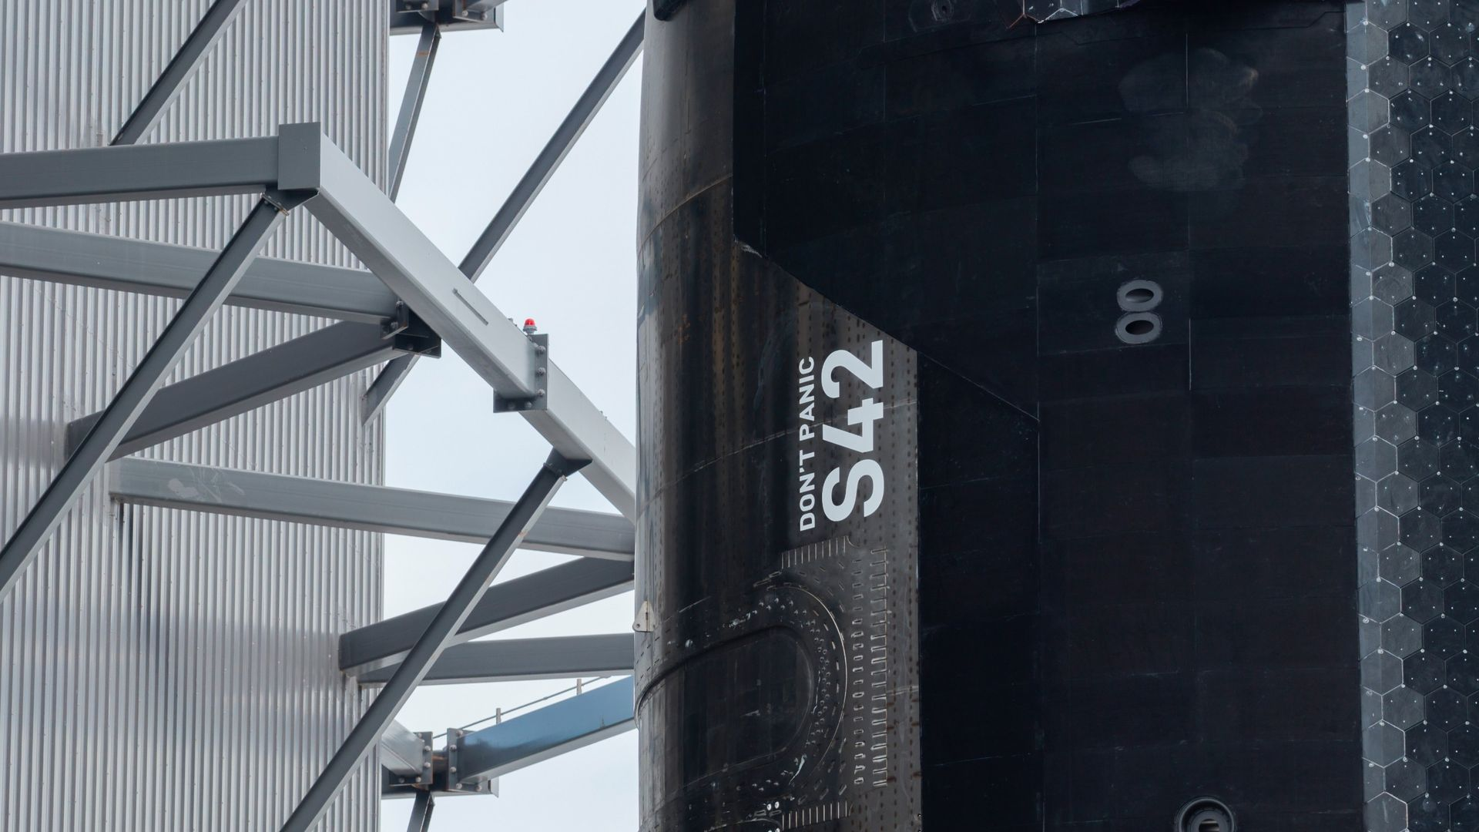
Click for next article SpaceX rolled Ship 42, the upper stage that will fly Starship's 15th test flight, out to the pad on Nov. 12, 2026. The vehicle is adorned with the words "Don't panic," a phrase that features prominently in "The Hitchhiker's Guide to the Galaxy." SpaceX has a message for itself, and for the spacecraft set to make history today (Nov. 13): Don't panic. The company's Starship megarocket will conduct its 15th test flight this afternoon, a landmark liftoff that will feature the first-ever attempt to catch both of its stages with its launch tower's "chopstick" arms. On Thursday (Nov. 12), SpaceX rolled the Flight 15 upper stage, a vehicle known as Ship 42, out to the launch pad at its Starbase site in South Texas to prep. The company shared photos of the move on X , and in two of those shots we can see some intriguing words inked on the spacecraft: "Don't panic." Another look at Ship 42 at the pad on Nov. 12. (Image credit: SpaceX) The phrase is familiar to fans of Douglas Adams' sci-fi classic " The Hitchhiker's Guide to the Galaxy ": In the novel, the electronic guidebook that helps travelers find their way across the cosmos has "Don't panic!" on its cover. And Ship 42 itself is connected to the beloved book, by virtue of its serial number. In "The Hitchhiker's Guide," a supercomputer named Deep Mind is asked to come up with "the answer to the ultimate question of life, the universe, and everything." It thinks for 7.5 million years and comes up with "42." SpaceX founder and CEO Elon Musk has voiced his affection for "The Hitchhiker's Guide" in the past - and he has already paid tribute to it with a well-placed "Don't panic." The debut launch of SpaceX's Falcon Heavy rocket back in February 2018 sent Musk's red Tesla Roadster into orbit around the sun , with a spacesuit-clad mannequin named Starman at the wheel and its entertainment display programmed to read "Don't panic!" Starship Flight 15 is scheduled to launch today during a 75-minute window that opens at 5:45 p.m. EST (2245 GMT; 4:45 p.m. local Texas time). You can watch it here at Space.com. If all goes according to plan, Starship's Super Heavy first stage will come back to Starbase for a chopsticks catch about 6.5 minutes after liftoff. Ship 42, meanwhile, will head to orbit, a destination that Starship reached for the first time on Flight 14 , which took place on Sept. 28. Ship 42 will deploy 26 of SpaceX's next-gen Starlink V3 satellites today - the second batch of the spacecraft to reach orbit. (The first set of 26 were delivered on Flight 14). The Ship 42 upper stage rolls to its launch pad at SpaceX's Starbase site on Nov. 12, 2026 ahead of Starship's Flight 15. (Image credit: SpaceX) Ship 42 will stay up for a while after that, circling Earth 14 times before coming back for its own chopsticks catch on Saturday afternoon (Nov. 14), 22.5 hours after launch. That's the plan, anyway; SpaceX will only go through with a Ship catch attempt if all systems on the vehicle look good. If there are any problems, the company will divert to a splashdown in the Pacific Ocean, near either Hawaii or Chile. The two stages of the Starship rocket that will conduct Flight 15 at their Starbase launch pad on Nov. 12, 2026. (Image credit: SpaceX) Both of Starship's stages - Super Heavy and the Ship - are designed to be rapidly reusable. And "rapidly" is a bit of understatement: SpaceX wants to launch 10,000 Starship missions per year by 2030, Musk has said. The chopsticks-catch strategy is a big part of that vision. Bringing both Starship stages directly back to the launch mount will greatly reduce the time needed for inspection, refurbishment and reflight, according to SpaceX. The company has already caught Super Heavy on three previous Starship test flights. It has never tried to do so with Ship, instead targeting ocean splashdowns with the upper stage. The double catch attempt may be unprecedented, but SpaceX seems to be taking its own advice: There's no panic around Flight 15 or its bold goals.

12. Starship in orbit ahead of catch attempt, booster diverts to explosive splashdown
Read more
Liftoff of the Starship vehicle from Starbase in Texas occurred at 4:48 p.m. CST (5:48 p.m. EST / 2248 UTC) on Friday, Nov. 13. The Ship could return to a landing at Starbase on Saturday.

13. ULA delays to Saturday Vulcan rocket launch of 40 Leo satellites for Amazon
Read more
Liftoff from Space Launch Complex 41 at Cape Canaveral Space Force Station is now scheduled for 12:32 p.m. EST (1732 UTC) on Saturday.

