 |  | 

🌌 अंतरिक्ष समाचार | Space News
बुधवार, ११/११/२०२६ | Wednesday, 11/11/2026

1. ISRO conducts flight acceptance test of Cryogenic engine for next GSLV mission - ISRO
Read more
ISRO conducts flight acceptance test of Cryogenic engine for next GSLV mission ISRO

2. Gaganyaan mission reaches advanced stage as ISRO completes key systems, infrastructure - DD News
Read more
Gaganyaan mission reaches advanced stage as ISRO completes key systems, infrastructure DD News

3. New cyclone brewing in Bay of Bengal? Isro satellite reveals what's happening - India Today
Read more
New cyclone brewing in Bay of Bengal? Isro satellite reveals what's happening India Today

4. India, France discuss space collaboration, review ISRO-CNES cooperation at Strategic Dialogue - MorungExpress
Read more
India, France discuss space collaboration, review ISRO-CNES cooperation at Strategic Dialogue MorungExpress

5. Gaganyaan Safety Component Made in Coimbatore Delivered to ISRO - Urban Acres
Read more
Gaganyaan Safety Component Made in Coimbatore Delivered to ISRO Urban Acres

6. ISRO conducts flight acceptance test for cryogenic engine for GSLV mission to launch fourth next navigation satellite - The Tribune
Read more
ISRO conducts flight acceptance test for cryogenic engine for GSLV mission to launch fourth next navigation satellite The Tribune

7. NASA Invites Media, Public to Join Voyager 1 One-Light Day Activities
Read more
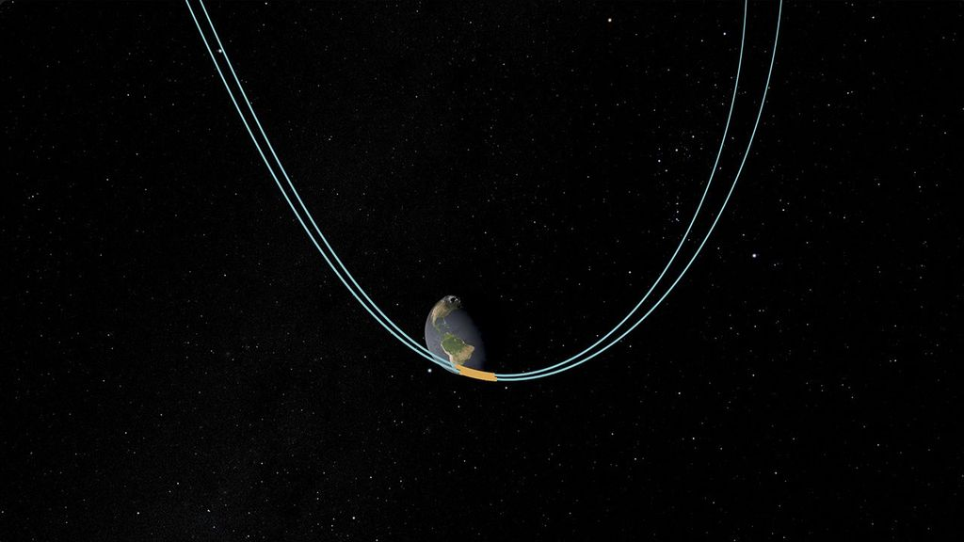
An artist's concept depicting a Voyager spacecraft. Credit: NASA/JPL-Caltech Launched nearly 50 years ago in 1977, NASA's Voyager 1 on Wednesday, Nov. 18 will have traveled one light-day from Earth, which is more than 16 billion miles (25.9 billion kilometers). Voyager 1 is the most distant human-made object, and any light from Earth would take 24 hours to reach the spacecraft. NASA will highlight this historic milestone with two events. On Tuesday, Nov. 17, NASA invites the world to participate in "Shine Bright for Voyager's Light-Day" by creating a symbolic wave of golden light encircling the planet after sunset. NASA has created a website that enables smart phones and tablets to flash "VGR", Voyager's call sign, in morse code. For more information about how to participate in "Shine Bright for Voyager Light-Day," visit: go.nasa.gov/shinebright Everyone is encouraged to capture photos or videos of their light-day signal and share it on social platforms, tagging @NASA. On Thursday, Nov. 19 at 12 p.m. EST (9 a.m. PST), NASA's Jet Propulsion Laboratory (JPL) in Southern California will host a moderated discussion with mission members and NASA leadership about the status of Voyager 1 and 2, the unique science the twin probes continue to gather in interstellar space, and the challenges of keeping the spacecraft operating for so long over such vast distances. A Q&A with media and other audience members will follow. In addition, there also will be a preview of the upcoming NASA+ Voyager documentary, planned for release in 2027 for the mission's 50th anniversary. The event will take place in NASA JPL's von Kármán Auditorium, where JPL hosted Voyager briefings during the spacecraft's grand tour of the outer planets. The participants will be: Nicky Fox, associate administrator, Science Mission Directorate, Washington Jonathan Lunine, chief scientist, NASA's Jet Propulsion Laboratory, Southern California, and professor of planetary science, Caltech Suzanne Dodd, Voyager project manager, NASA JPL Kareem Badaruddin, Voyager mission manager, NASA JPL Jamie Rankin, Voyager deputy project scientist, Princeton University Learn where to watch online at: https://www.nasa.gov/live U.S. media interested in attending the event in person must RSVP by Monday, Nov. 16 to Josh Smooha at: josh.smooha@jpl.nasa.gov. To be considered for onsite credentials, foreign national media must RSVP no later than Thursday, Nov. 12. Media interested in participating virtually must RSVP no later than two hours before the event. NASA's media accreditation policy is available online. For almost half a century, the agency's Voyager mission has blazed a trail through space. Voyager 1 and Voyager 2 were designed to explore the outer planets by taking advantage of a planetary alignment that occurs once every 176 years. Voyager 1 entered interstellar space in 2012. Following a different trajectory, Voyager 2 entered in 2018. Both spacecraft continue to provide unique scientific observations of the environment beyond the heliosphere, the protective bubble created by the Sun. Managed by Caltech in Pasadena, California, NASA JPL built and operates the Voyager spacecraft. NASA's Deep Space Network, also managed by NASA JPL, enables communication with the distant probes. The Voyager mission is funded by NASA's Heliophysics Division at NASA Headquarters in Washington. For more information about NASA's Voyager mission, visit: https://science.nasa.gov/mission/voyager/ -end- Abbey Interrante / Karen Fox Headquarters, Washington 202-358-1600 abbey.a.interrante@nasa.gov / karen.c.fox@nasa.gov Josh Smooha Jet Propulsion Laboratory, Pasadena, Calif. 626-298-4414 josh.smooha@jpl.nasa.gov

8. NASA to Welcome Expedition 74 Astronauts Home at Space Center Houston
Read more
(March 15, 2026) - The International Space Station orbits 267 miles above a cloudy Atlantic Ocean southwest of Cape Town, South Africa. The Kibo laboratory module's External Platform and the Canadarm2 robotic arm highlight the top foreground above Earth's terminator-the line between night and day-in this photograph taken at approximately 6:36 a.m. local time. Credit: ESA/Sophie Adenot NASA will welcome home the Expedition 74 crew during a public event at Space Center Houston following their return from a long-duration mission aboard the International Space Station. NASA astronauts Jessica Meir, Jack Hathaway, and Chris Williams; ESA (European Space Agency) astronaut Sophie Adenot; and Roscosmos cosmonauts Sergey Kud‑Sverchkov and Sergei Mikaev will share mission highlights at 6 p.m. CST Tuesday, Nov. 17, at NASA Johnson Space Center's visitor center. An awards ceremony recognizing key mission contributors will follow the presentation. The astronauts will be available for media interviews before the event. Media may request an in-person interview no later than 5 p.m. Monday, Nov. 16, by emailing the JSC Newsroom at jsc-newsroom@mail.nasa.gov. Williams, Kud‑Sverchkov, and Mikaev launched aboard the Soyuz MS-28 spacecraft from the Baikonur Cosmodrome in Kazakhstan on Nov. 27, 2025. The trio returned to Earth on July 26, making a parachute-assisted landing southeast of Dzhezkazgan, Kazakhstan. The crew was in space for 241 days, orbiting the Earth 3,856 times and traveling more than 102 million miles. The mission was the first for Williams and Mikaev and the second for Kud-Sverchkov. Meir, Hathaway, and Adenot launched aboard a Dragon spacecraft on Feb. 13 as part of NASA's SpaceX Crew-12 mission from Space Launch Complex 40 at Cape Canaveral Space Force Station in Florida. After more than seven months aboard the space station, Meir, Hathaway, and Adenot safely splashed down on Oct. 8 in the Pacific Ocean off the coast of Los Angeles. During their 237-day mission, the four crew members traveled more than 100 million miles and completed more than 3,792 orbits around Earth. The mission was the second for Meir and the first for Hathaway and Adenot. Roscosmos cosmonaut Andrey Fedyaev also flew as part of Crew-12 but is unavailable for the event. The Expedition 74 crew dedicated more than 1,400 hours to scientific research and technology demonstrations aboard the International Space Station. Its work advanced in-space manufacturing by testing metal and tissue 3D-printing technologies and supported human health studies examining the effects of long-duration spaceflight. Research included blood flow studies, assessments of piloting capabilities under changing gravitational conditions, and activation of a new compact exercise system. The crew also evaluated life-support and environmental systems critical to future exploration missions under NASA's Artemis program. In addition, the crew members conducted pharmaceutical research to crystalize proteins for cancer medications, advance tumor targeting treatments, and grow stem cells for therapeutics. They cared for the first set of plants studied outside of curated systems, upgraded an instrument used to advance our understanding of matter and develop new quantum technologies, managed visiting spacecraft, and performed essential maintenance to support the continued operation of the orbiting laboratory. Beyond research and operational achievements, Expedition 74 engaged students and audiences around the world through live educational events, outreach activities, and the sharing of stunning imagery that highlights the importance of scientific discovery and international collaboration in space. For more than 26 years, people have lived and worked continuously aboard the International Space Station, advancing scientific knowledge and making research breakthroughs not possible on Earth. The space station helps NASA understand and overcome the challenges of human spaceflight, expand commercial opportunities in low Earth orbit, and build on the foundation for long-duration missions to the Moon, as part of the Artemis program, and to Mars. Learn more about International Space Station research and operations at: https://www.nasa.gov/station -end- Anna Schneider / Shaneequa Vereen Johnson Space Center, Houston 281-483-5111 anna.c.schneider@nasa.gov / shaneequa.y.vereen@nasa.gov

9. NASA Scientists Show How Gravitational Waves Can Reveal New Worlds
Read more
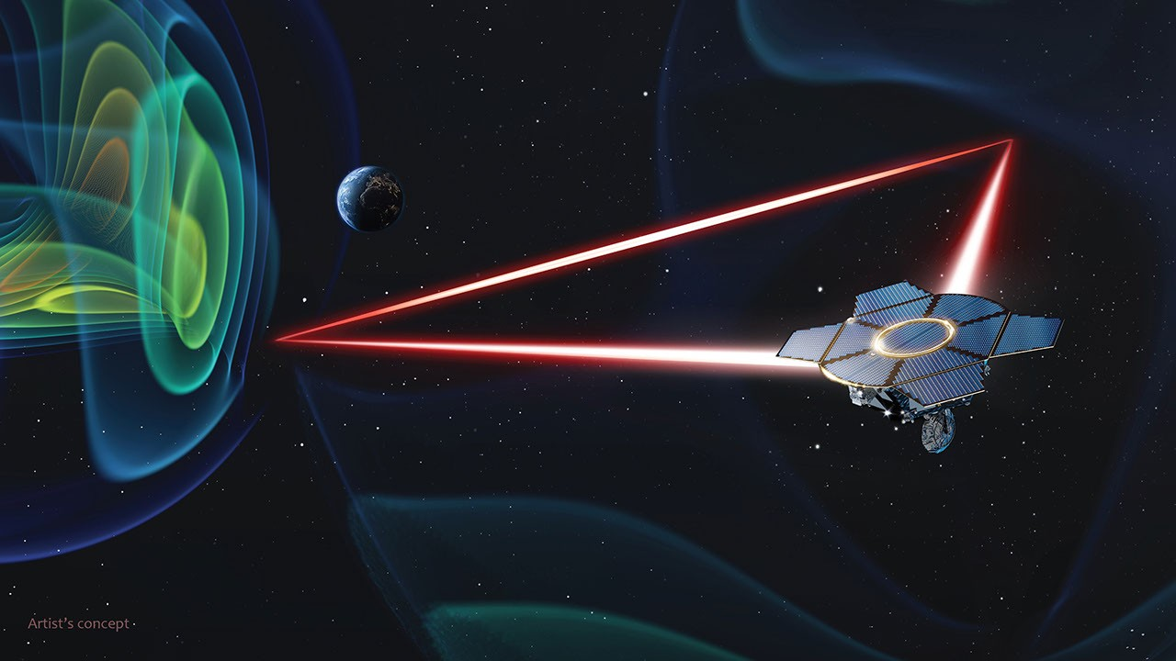
The LISA (Laser Interferometer Space Antenna) observatory, now in development, will detect gravitational waves, the tiny ripples in space-time caused by orbiting masses. Now two studies led by NASA astrophysicists show in new detail how LISA could reveal a new and unique population of exoplanets - worlds beyond our solar system - throughout our galaxy. Watch to learn how the presence of a planet modifies the gravitational wave signal from tightly orbiting white dwarfs. The LISA (Laser Interferometer Space Antenna) observatory could detect a Jupiter-mass planet in such systems up to thousands of light-years away. NASA's Goddard Space Flight Center "The most common source for LISA is expected to be double white dwarf systems, which are binaries composed of white dwarfs in tight orbits," said Casey McGrath, a postdoctoral researcher at the University of Maryland, Baltimore County and NASA's Goddard Space Flight Center in Greenbelt, Maryland. "If an exoplanet also orbits within one of these systems, its presence becomes imprinted on the gravitational wave signal in a way we'll be able to uncover." Two papers published Tuesday in The Astrophysical Journal detail the findings. The first, authored solely by McGrath, examines the detection method and determines the planet masses and orbital periods where it would work best. The second paper, by McGrath and coauthors, investigates how such planets could be confirmed using NASA's James Webb Space Telescope. The possibility of detecting exoplanets around LISA double white dwarf systems was first proposed by Japanese astronomer Naoki Seto in 2008. Led by ESA (European Space Agency), the LISA mission is slated for launch in the mid-2030s. As a collaborative partner, NASA is contributing the telescopes, other critical hardware, and engineering and scientific support as part of its mission to better understand how the universe works. The LISA detection method is similar to one called radial velocity that uses light and is already employed to find exoplanets around nearby stars. As a planet orbits, its gravity tugs on its host star, imparting a small reflex motion, or wobble, onto it. This wobble causes the star's spectrum to oscillate, with spectral lines shifting from redder wavelengths as the star moves away from us to bluer ones as the star moves toward us. The shift is due to a phenomenon called the Doppler effect. "Something similar occurs with gravitational waves," said Scott Noble, a theoretical astrophysicist at NASA Goddard and a coauthor on the confirmation paper. "By themselves, double white dwarfs will emit gravitational waves at a nearly continuous frequency. Add a sufficiently massive planet to the system, and its presence causes the binary to experience reflex motion, adding a Doppler modulation to the gravitational signal." For LISA, this modulation will appear as sidebands, secondary signals at both higher and lower frequencies than the primary one. McGrath likens the situation to modern radio communication, where some of the energy of a main radio carrier frequency goes into forming sidebands at adjacent upper and lower frequencies that carry messages (like voices or music). For gravitational waves, the sidebands carry messages about the presence of a planet. White dwarfs are the Earth-sized remnants of stars like the Sun. While exoplanets have been detected around a few isolated white dwarfs, none have yet been found around a binary white dwarf, which means the LISA detections would represent a distinct new exoplanet population. NASA's infrared-sensitive James Webb Space Telescope, shown in this artist's concept, will be able to confirm planets detected by gravitational waves in binary white dwarf systems located within a few hundred light-years. NASA's Goddard Space Flight Center Conceptual Image Lab Astronomers estimate that our Milky Way galaxy contains 10 million double white dwarf systems with orbital periods of less than an hour, which generate gravitational waves in the right range for LISA to find. They expect LISA will resolve about 10,000 individual systems, as well as around 100 mixed binaries - with white dwarfs, neutron stars, or black holes - orbiting in similar periods. "Once LISA captures its first exoplanet detections, it will be critical for us to validate some of them," said Mary Anne Limbach, an assistant research scientist at the University of Michigan and a co-author on the confirmation paper. "These joint detections will allow us to establish that the gravitational signals correspond to genuine planets rather than false positives." The team described a new method for confirming these planets by taking advantage of the Webb telescope's infrared sensitivity. A planet in a double white dwarf system produces a larger portion of infrared light than what's expected from the stars themselves. Webb's instruments can easily detect this infrared excess out to a distance of at least 500 light-years. Using this technique for a test case system at this distance, the researchers find that Webb could detect an exoplanet about five times Jupiter's mass, while LISA could detect a sub-Jupiter exoplanet under ideal circumstances. The LISA observatory will consist of a trio of spacecraft following Earth as it orbits the Sun. They will form a vast triangular array stretching 1.6 million miles (2.5 million kilometers) on each side. Each spacecraft will include two telescopes that will use infrared laser beams to simultaneously transmit and receive signals between adjacent spacecraft. Through these telescopes, the spacecraft will measure miniscule changes - smaller than the width of a helium atom - in their relative distances, the signals of passing gravitational waves. This artist's concept shows the LISA mission at work. Telescopes aboard each of the three spacecraft simultaneously transmit and receive infrared laser beams, measuring their mutual distances to extremely high precision across 1.6 million miles (2.5 million kilometers). ESA Gravitational waves were predicted by Albert Einstein's 1916 general theory of relativity and first detected by ground-based observatories in 2015. The waves form whenever massive objects accelerate, such as two stars in orbit around each other. They travel through space-time, moving at the speed of light, and are unaffected by objects they encounter along the way. These properties make them a valuable tool for probing the cosmos. Additional NASA contributions to the mission include the laser system, devices to manage the buildup of electric charge on the proof masses, data analysis for identifying and characterizing individual gravitational wave sources, and additional scientific and engineering expertise. To learn more about the LISA mission, visit: https://nasa.gov/lisa

10. SpaceX moves Starship Flight 15 booster to launch pad for 'squeeze test' ahead of epic double-catch attempt (photos)
Read more
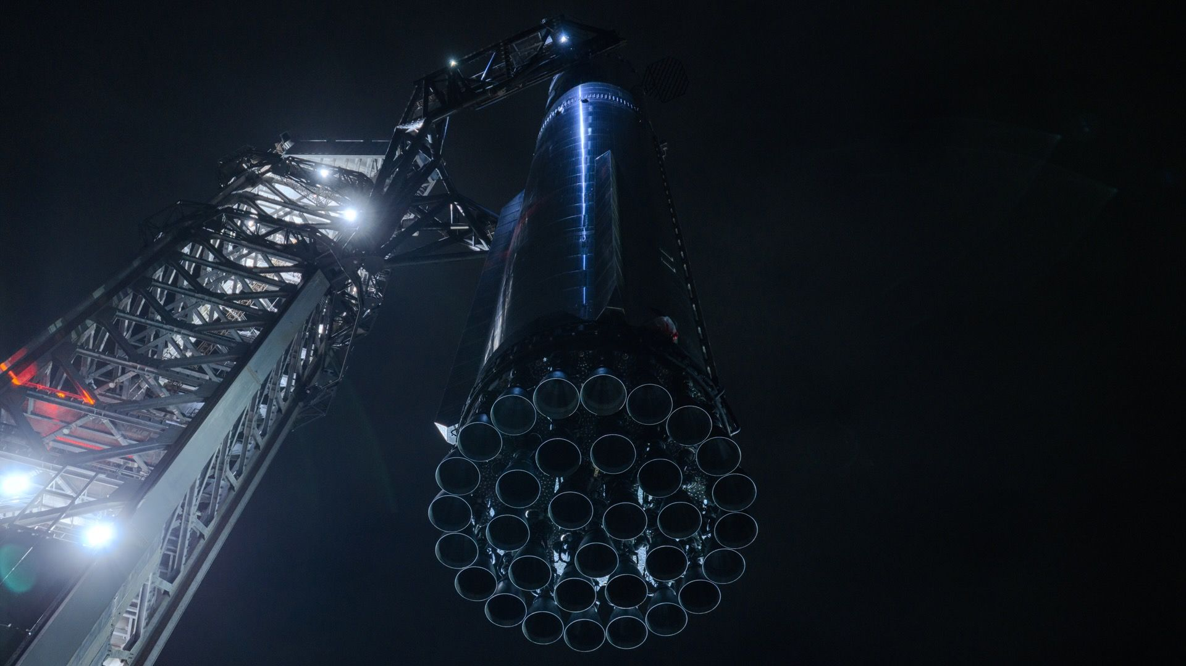
Click for next article SpaceX's Starship Super Heavy booster is held by its launch tower during prep work for the megarocket's 15th test flight. SpaceX posted this photo on X on Nov. 10, 2026. SpaceX is one big step closer to the 15th test flight of its Starship megarocket. The company announced today (Nov. 10) that it had moved its latest Starship first stage, known as Super Heavy Booster 22, to the launch mount at its Starbase facility in South Texas ahead of Flight 15, which is scheduled to lift off this Friday (Nov. 13). During the upcoming launch test, SpaceX plans to catch both Booster 22 and Starship's Ship upper stage with its launch tower's "chopstick" arms in a double landing catch - something the private spaceflight company has never tried before. It will be the first full recovery of an orbital rocket in history. SpaceX's Flight 15 Starship Super Heavy booster in its assembly bay, before its move to Starbase's launch mount. (Image credit: SpaceX) Booster 22 therefore "was used for final catch testing upon arrival [at the pad], including a suspended squeeze test at catch height," SpaceX said in an X post today (Nov. 10). That post shared four photos of the giant booster, which is powered by 33 of SpaceX's next-gen Raptor engines. The first shot showed Super Heavy in one of Starbase's "Mega Bay" assembly buildings before rollout, while the other three depicted it grasped by the tower's arms, held high in the South Texas sky. SpaceX will try to catch both Super Heavy and Ship during Flight 15 - something it's never done before. (Image credit: SpaceX) SpaceX has used the chopstick arms during Starship flights before; it has successfully caught Super Heavy on three separate occasions. But the company has never attempted a catch of Ship, which flies higher and farther than the booster and is therefore a more challenging target. And SpaceX only reached orbit with Starship for the first time on Flight 14, which launched on Sept. 28. So Flight 15 will break new ground. And, if all goes to plan, it will give us a look at the future: SpaceX plans to catch Super Heavy and Ship on all operational Starship missions, as this recovery strategy will allow the company to boost the megarocket's launch cadence. And SpaceX wants to fly Starship incredibly often, so that it can build out its Starlink V3 broadband constellation and even bigger Starmind AI data-center network . Indeed, Elon Musk has said the company is eyeing 10,000 Starship flights per year by 2030. The launch tower's "chopstick" arms giving the Flight 15 Super Heavy a loving squeeze. (Image credit: SpaceX) If all goes to plan, Flight 15 will launch from Starbase on Friday during a 75-minute window that opens at 5:45 p.m. EST (2245 GMT; 4:45 p.m. local Texas time). Super Heavy will return to Starbase for its catch about 6.5 minutes after liftoff. Ship will follow suit much later - about 22 hours later, in fact, after it has deployed 26 Starlink V3 spacecraft into LEO and completed 14 circuits of our planet.

11. On this day in space! Nov. 10, 2013: Europe's GOCE satellite, the 'Ferrari of space,' fell out of orbit after mapping Earth's gravity field
Read more
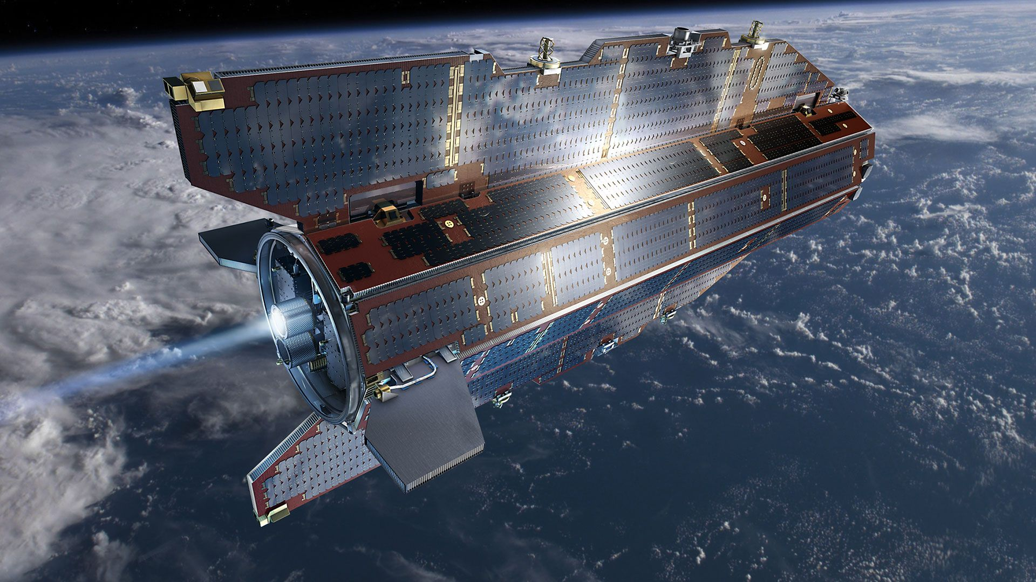
Click for next article On Nov. 10, 2013, Europe's GOCE satellite fell to Earth after four years in orbit mapping the planet's gravitational field. GOCE, its name was short for Gravity field and steady-state Ocean Circulation Explorer, launched in 2009 on a mission to map Earth's gravity like never before. But despite that successful mission, it was doomed in 2013 when it ran out of fuel . At the time, controllers weren't sure where GOCE would fall back to Earth . Some people worried that it might crash into a populated area. However, the small spacecraft broke up in the atmosphere and didn't cause any property damage. It disintegrated about 50 miles above the Falkland Islands in the South Atlantic Ocean. The European Space Agency called the mission a success. GOCE lasted far longer than expected. It showed small variations in Earth's gravity , mapped the structure of Earth's crust and mantle, and tracked ocean currents. Artist's rendering of the "Ferrari of space," the European Space Agency's Gravity field and steady-state Ocean Circulation Explorer (GOCE), before it fell from space in 2013. (Image credit: European Space Agency) Why it mattered The GOCE satellite was a sleek spacecraft, with fins covered in solar panels that gave it a futuristic design. In fact, its look earned it a pretty cool nickname. "GOCE's sleek, elegant aerodynamic design - responsible for it being dubbed the 'Ferrari of space' - immediately set it apart from most other satellites,." ESA officials said in a description . There was more than looks behind GOCE's design. In order to generate the best map ever of Earth's gravitational field, GOCE had to fly in an orbit so low - just 139 miles (224 kilometers) - it needed to counteract the drag from the gossamer thin atmosphere of Earth at that altitude. The International Space Station orbits Earth at nearly twice that altitude. GOCE was powered by an xenon ion engine that allowed to maintain its low orbit for four years. Once it ran out of fuel, the 1-ton satellite could not maintain its position in space , leading to a fiery plunge to Earth. The large size of GOCE - it weighed 2,425 pounds (1,100 kilograms) and was 17 feet (5.3 meters) long and 3.2 feet (1 m) wide - made its reentry stand out, particularly since at least 25% of the satellite was expected to reach the Earth's surface . Want more space history? Check out our full On This Day In Space Story archive and watch our On This Day In Space videos on YouTube .

12. Curiosity Mars rover sizes up new 'Nazca' dig site | Space photo of the day for Nov. 10, 2026
Read more
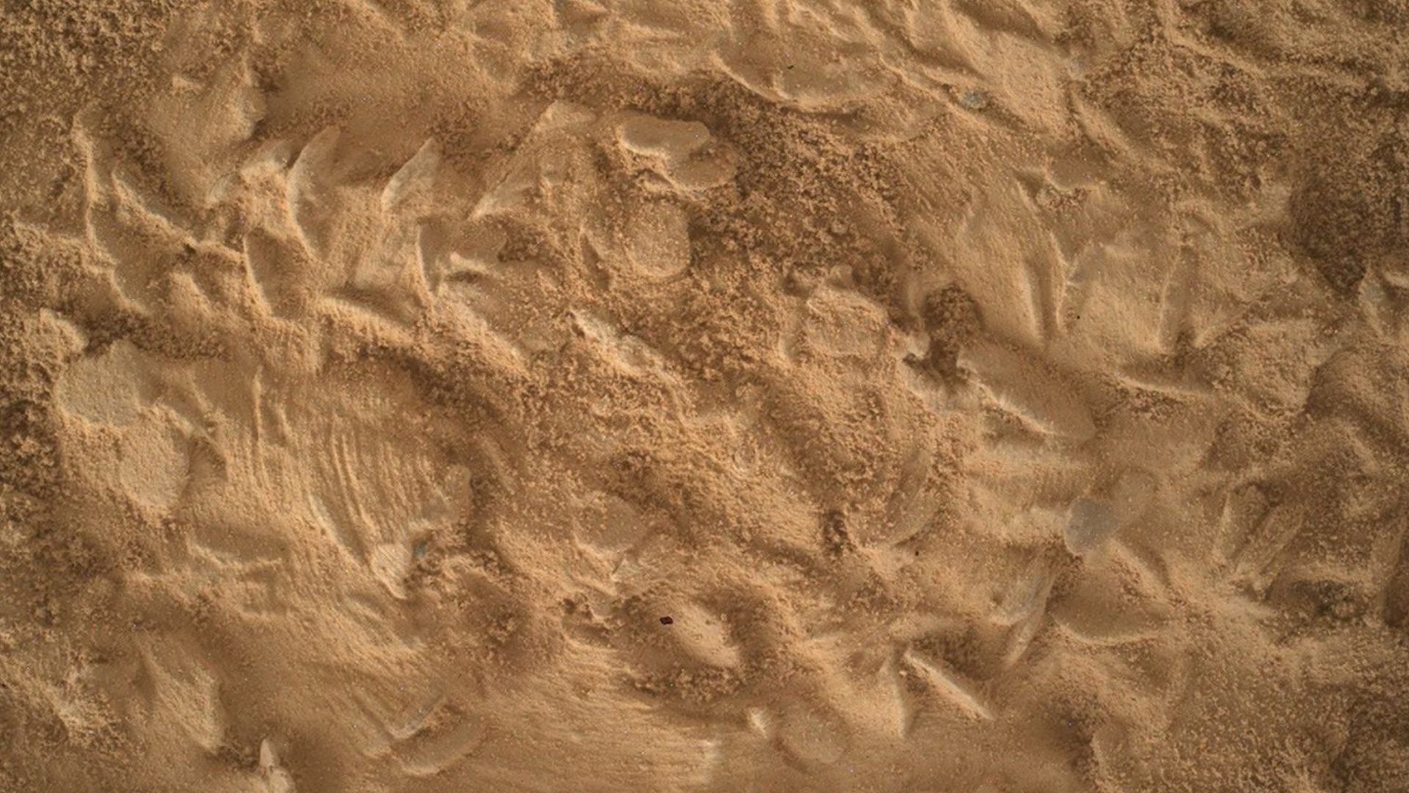
Click for next article NASA's Mars rover Curiosity acquired this close-up image using its Mars Hand Lens Imager, showing the abundance of disc-shaped potential crystal forms on our next drill target, dubbed "Nazca." NASA's Curiosity Mars rover is sizing up its next dig site on the Red Planet. The Curiosity team will characterize the surface composition of the Mars site, informally named "Nazca," as thoroughly as possible before drilling into it. What is it? Curiosity snapped the close-up image on Oct. 18, 2026, using its Mars Hand Lens Imager (MAHLI). The image shows multiple roughly disk-shaped potential crystal formations at the rover's next drill target. MAHLI is located on the turret at the end of the rover's robotic arm. It uses an onboard focusing process to make a composite of images of the same target acquired at different positions to focus on multiple features in a single image. Why is it incredible? Scientists theorize that the "discs and needles" texture takes its characteristic shape as crystals, or "crystal forms," grow. The relatively large sizes of the crystal forms at "Nazca" may provide clues about the temperatures at which they grew, as well as information about the abundance of salts and fluids in the area at the time. Complicating this picture, however, is the fact that mineral crystals can be replaced by other minerals after their original crystallization. The new minerals are known as "pseudomorphs," because they have the same shape as the original minerals but not the same composition or molecular structure. The Curiosity team will characterize the surface composition of Nazca - which shares its name with an ancient South American civilization that's famous for the large designs it etched into the rock and dirt - before drilling begins. The NASA researchers will then be able to compare the deeper composition to the surface-level composition.

13. NASA's twin ESCAPADE Mars probes slingshot around Earth in unprecedented double 'gravity assist'
Read more
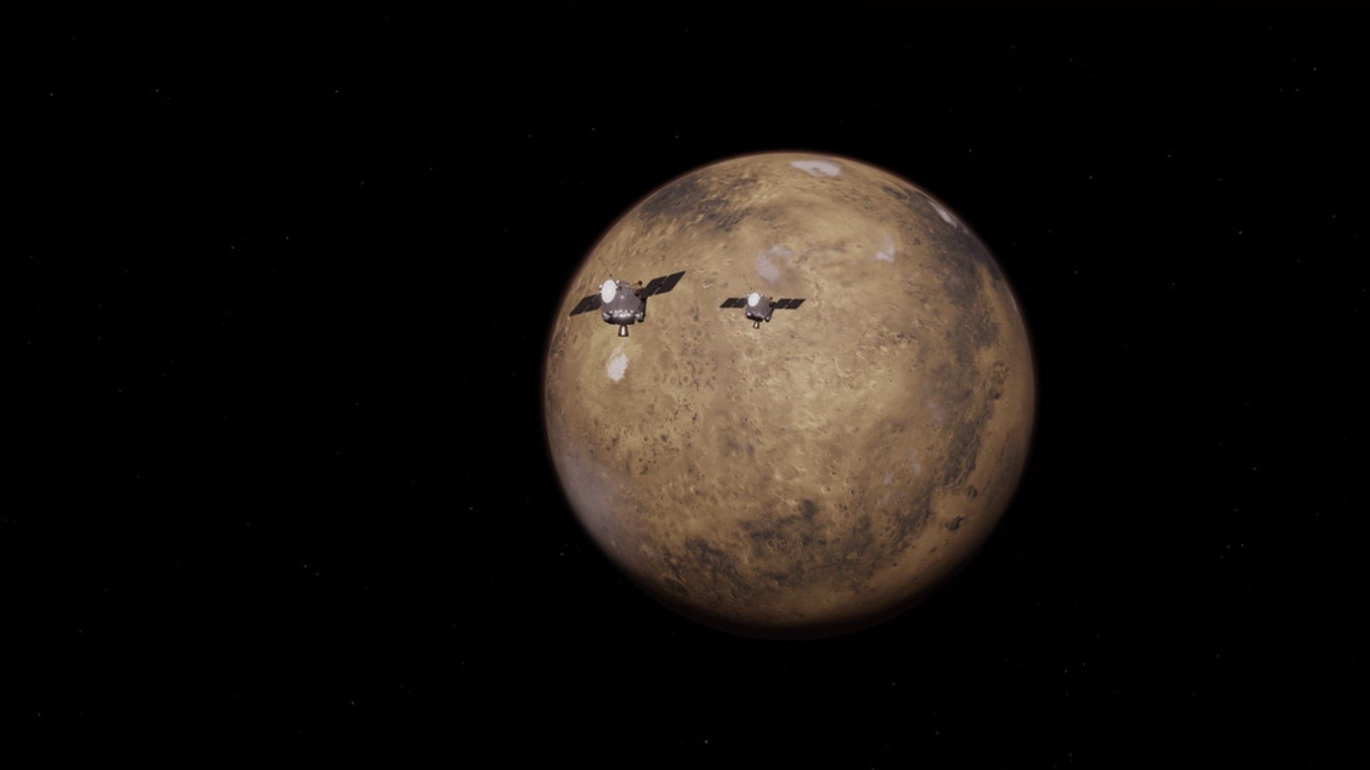
Click for next article Twin NASA spacecraft are wrapping up a year-long escapade, ready to make a beeline to the Red Planet. The Escape and Plasma Acceleration and Dynamics Explorers (ESCAPADE) spacecraft launched in November 2025 on the second-ever flight of Blue Origin's New Glenn rocket. But rather than head straight to Mars, the two spacecraft dawdled through a looping trajectory . Now, they are back in Earth's neighborhood where they tackled a crucial engine burn unusually close to Earth that - if all goes well - will set them on track for Mars . "No NASA mission has ever done this before," said Rob Lillis, a planetary and space physicist at the University of California, Berkeley and principal investigator of the ESCAPADE mission. "For most missions, it just isn't necessary." That's because traditionally NASA's Mars missions have been carefully choreographed within cosmic launch constraints, leaving Earth during a brief window of planetary alignment that only occurs every 26 months. ESCAPADE was meant to launch in October 2024, when Earth and Mars were favorably aligned, but delays with the New Glenn rocket forced the mission to sit out the precious launch window. Rather than wait to launch this fall, NASA decided to try something new. ESCAPADE mission planners designed a "loitering" orbit , shaped like a kidney bean. It called for the twin probes to loop through that trajectory to be back at Earth in early November 2026, ready to continue on to Mars. The ESCAPADE mission's unique path to reach Mars. After launching in November 2025, the twin ESCAPADE probes looped around the Earth-Sun Lagrange point 2 (L2), in a "loiter" orbit that returned them to Earth in November 2026 where they used our planet's gravity to slingshot themselves to Mars. (Image credit: Advanced Space/Matt Bolliger) Once they arrived, however, the twin probes faced a major hurdle: Each had to perfectly execute an engine burn within Earth's gravity well. The maneuver is similar to the slingshot flybys that spacecraft regularly conduct to adjust their trajectories - but here, the probes had to fire their engines to amp up the effect of the burn rather than acting alone. The first spacecraft tackled the feat on Nov. 7; the second did so on Monday (Nov. 9). And according to NASA, the burns went perfectly. "This is the first time NASA has used a powered Earth flyby to propel a spacecraft toward Mars, and we've now executed this maneuver twice, flawlessly, in just two days," Asal Naseri, acting associate flight director for NASA's Heliophysics Division said in a statement . After just a few minor course corrections, ESCAPADE will be sailing toward a September 2027 Mars arrival. A scenic detour The twin ESCAPADE spacecraft have made the most of their extended tour. Each spacecraft is about the size of two refrigerators and equipped with three scientific instruments and a couple cameras. All are tailored for studying the strange magnetic field of Mars, which is created both globally by charged particles from the sun interacting with the atmosphere and locally by areas of highly magnetic crust. Earth's magnetic field is much stronger and generated by the planet's core. But it too is affected by the solar wind, as scientists call the constant stream of charged particles flowing off the sun and across space. On the side of Earth opposite the sun, the solar wind stretches the magnetic field to form an elongated tail structure, like a terrestrial windsock. A range of missions have studied this magnetotail at various points up to nearly 800,000 miles (1.27 million kilometers) away from Earth, but beyond that, it has been a mystery. Conveniently, the two ESCAPADE spacecraft traveled through the structure over the course of about 10 days early last year at a much greater distance from Earth - some 1.19 million miles (1.91 million km) away. "We were able to capture the magnetic field structure of that distant tail, how it flaps, how it moves, how the plasma flows within it," Lillis said, gathering data that he called "unprecedented." "And not only that but for the first time, we were able to do that with two spacecraft simultaneously." Illustration of the ESCAPADE spacecraft in orbit around Mars. (Image credit: Rocket Lab USA/UC Berkeley) A second shot at the magnetotail came over the summer, when the spacecraft were much closer to Earth but the moon was also passing through the magnetic structure. The two ESCAPADE spacecraft were able to partner with twin ARTEMIS-THEMIS spacecraft at the moon to observe the structure from four different perspectives simultaneously. That's a huge boon when trying to study the magnetotail and its intricate and ever-changing magnetic field lines and plasma, Lillis said. "These are generally not things you can measure remotely," he said. "You kind of have to be there."

14. Germany's Isar Aerospace eyes overtaking Elon Musk's SpaceX
Read more
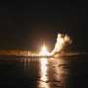
The head of Germany's Isar Aerospace voiced hope Tuesday that the company could one day overtake Elon Musk's SpaceX to become the world's premier space launch company.

