IIRS Daily Space Digest Sunday, 17/05/2026

1. National Jute Board expands tech-driven crop monitoring system with ISRO collaboration - DD News
"ISRO OR NRSC OR IIRS after:2026-05-16" - Google News
Read more

The National Jute Board has stepped up implementation of the Jute Crop Information System (JCIS), a technology-driven platform developed in collaboration with Indian Space Research Organisation and the Jute Corporation of India to improve crop monitoring and production assessment in the jute sector. According to the Ministry of Textiles, the system integrates satellite imagery, weather analytics, vegetation indices and field-level inputs to enable near real-time monitoring of jute cultivation and production trends. The project, being implemented since 2023, includes two digital tools - BHUVAN JUMP, a mobile application for field-level monitoring, and PATSAN, a web-based analytics platform designed to provide surveillance and crop-related assessments for officials and stakeholders. Before the rollout of JCIS, crop area and yield estimates in the jute sector were largely dependent on fragmented field reports and manual data collection, often resulting in delays and inconsistencies, the ministry said. The absence of geo-referenced data and limited integration between satellite observations, weather inputs and ground-level assessments also affected planning and response mechanisms, particularly during floods, droughts and pest outbreaks. The ministry said the new system has introduced a more structured and evidence-based approach to crop monitoring by combining multiple data sources on a single platform. The framework supports automated reporting, near real-time crop estimation and early warning alerts linked to weather and crop stress conditions. Through its I-CARE field network, the National Jute Board has facilitated large-scale collection of geo-tagged field data using the BHUVAN JUMP application. The agency has also supported Crop Cutting Experiments using geospatial smart-sampling techniques aimed at improving the accuracy of yield estimation and production modelling. According to the ministry, JCIS outputs are now being integrated into planning and monitoring processes within the sector, helping improve coordination between state and national-level estimates and enabling targeted interventions in jute-growing regions. The system has also been used to develop flood impact assessment models based on satellite data and field validation to estimate crop and quality losses in affected areas. Weather analytics integrated into the platform are supporting district-level early warning systems for rainfall variation, dry spells and temperature fluctuations. The Ministry of Textiles said future plans under the initiative include expanding JCIS coverage to more jute-growing districts, strengthening farmer advisory systems through mobile and SMS alerts, and integrating advanced analytics for sustainability measures such as water resource mapping and carbon-related interventions. Officials said the initiative is expected to improve the accuracy of crop area, production and yield estimates and support policy formulation in the jute sector through a more data-driven approach.

2. The most automation-hungry industry in the world is also one of the last to trust AI with its decisions. Why? At Cypher 2025, Nitish K., Scientist at ISRO - Indian Space Research Organization, sat down to unpack exactly that. Space demands automation at every - LinkedIn
"ISRO OR NRSC OR IIRS after:2026-05-16" - Google News
Read more


AIM 371,761 followers 18h Report this post The most automation-hungry industry in the world is also one of the last to trust AI with its decisions. Why? At Cypher 2025, Nitish K. , Scientist at ISRO - Indian Space Research Organization , sat down to unpack exactly that. Space demands automation at every level, from ground operations to what you watch on national television during a launch countdown. Yet, the sector has been deliberate, even cautious, about bringing AI into the loop. He began laying out the reasons and where the real opportunities lie. What he said next is the part worth watching. And if conversations like this are what excite you, Cypher 2026 is where you need to be. Do not miss it. Register now at https://lnkd.in/d63jgNkn #Cypher2025 #Cypher2026 #ISRO #SpaceTech #AIInSpace #AIMNetwork …more 1 Comment Like Comment Share Copy LinkedIn Facebook Transcript At the first instance, it seems AI and space technology will be like a love at first sight kind of thing because you know, in space we need a lot of automation. Space is the sector which is automation hungry both on ground and on board. But it is not the case. If you look at the space technology landscape today, people have been hesitant to take AI on board. There are obviously a lot of attempts being made. But there are good reasons for that. There are a lot of areas in which you can apply space technology launch operations, which includes what you see on TV when the launch is going on, on did you on national TV, right. So all those operations, there are a lot of checks, there is a countdown, right and we can automate a lot of it by. Putting AI into loop, right, right, right. Now we have humans in the loop. Tharakeswaran Jeyaseelan Report this comment Ohh bb bib hi jbh Reply 1 Reaction To view or add a comment, sign in

3. From ISRO to Unicorn: Ex-scientist's startup eyes historic rocket launch - Indianweekender
"ISRO OR NRSC OR IIRS after:2026-05-16" - Google News
Read more
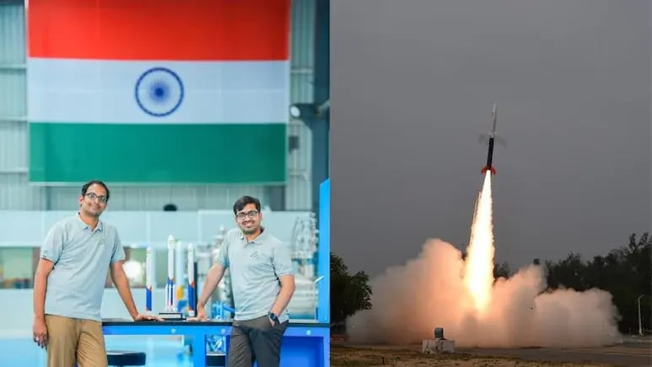

India's rapidly evolving private space sector is approaching a defining moment as Hyderabad-based Sky root Aero space prepares for the maiden orbital launch of its Vikram 1 rocket from Sriharikota in the coming weeks as reported by NDTV. Founded by former ISRO scientist Pawan Kumar Chandana and cofounder Naga Bharath Daka, Skyroot Aerospace has emerged as India's first private space-tech unicorn. According to NDTV, the company is now valued at nearly Rs 1,500 crore, marking a remarkable rise just eight years after Chandana left his government job at ISRO, where he earned a monthly salary of Rs 75,000. Speaking to NDTV, Chandana described the company's larger vision for the future of space technology and accessibility. "Our mission is to open space for all," he said, envisioning a future where accessing space could become as seamless as booking a cab or chartering a private jet. Standing inside Delhi's Nehru Planetarium, Chandana reflected on the inspiration that led him toward rocket science. A mechanical engineering graduate from IIT Kharagpur, he explained how he became fascinated with rockets early in his career. "For me it was always a rocket. I was really inspired by launches across the globe. I thought this is my calling; I need to get into the rocket industry," he said. His journey eventually took him to Indian Space Research Organisation, where he worked on India's heavy-lift Launch Vehicle Mark-3, popularly referred to as the "Bahubali" rocket. According to NDTV, Chandana later left his secure government career to pursue entrepreneurship and combine his passion for technology and innovation. "It became a marriage of two passions, entrepreneurship and rocket science," the 36-year-old entrepreneur said. India's First Space Unicorn Skyroot Aerospace had already made history in November 2022 by launching Vikram S, India's first private suborbital rocket. NDTV reported that the company has since secured approximately 160 million dollars in funding and crossed a valuation of one billion dollars. Despite the milestone, Chandana said the company's journey is only beginning. "It is just still the beginning of a journey," he remarked. "We have to do commercial launches. That is what will truly define us." The upcoming Vikram 1 rocket represents Skyroot's next major step. Designed as an orbital launch vehicle, the rocket is currently capable of carrying around 300 kilograms of payload into orbit, with future upgrades expected to increase that capacity to nearly one tonne. An 'Uber To Space' Model What differentiates Skyroot Aerospace from many traditional launch providers is its business approach. Chandana explained the company's model using a simple analogy. "Think of Skyroot's rockets like cabs to go to space. It is like Uber to go to space," he said. Unlike conventional large-scale rocket launches that carry multiple satellites from different clients simultaneously, Skyroot aims to provide dedicated launch services where customers can select their preferred schedule and orbit. "It is a premium service. It is a very exclusive service," Chandana explained. "Rather than waiting for launches in a big rocket, you hire your own." According to NDTV, this approach aligns with growing global demand as more than 90 per cent of satellites launched today reportedly weigh less than 500 kilograms, increasing the need for flexible and customised launch services. A Growing Space Economy Chandana also highlighted the expanding opportunities within the global space economy, which continues to witness rising demand for satellite launches and data infrastructure. "The need for launch keeps increasing every year. Now data centres are set to be in space. Communication, direct to mobile, all these applications are increasing demand," he said. Smaller satellite constellations are increasingly replacing traditional large satellites, significantly transforming the economics of space operations and opening doors for agile private companies like Skyroot. Built In India, Designed For The World One of Skyroot's biggest strengths, according to Chandana, lies in India's well-established space ecosystem created through decades of work by ISRO. NDTV reported that more than 90 per cent of Skyroot's rocket components are sourced domestically, with over 400 Indian suppliers contributing to the programme. "What we are today is all because we are operating from India. It is fully designed, developed and manufactured within India, and it is going to go global from India for the world," Chandana stated. India's geographic location also provides a strategic advantage for launches, especially with launch facilities close to the Equator and additional infrastructure developing in Tamil Nadu for polar orbit missions. The Challenge Of Rocket Science Despite the company's rapid rise, Chandana admitted that building rockets proved far more difficult than initially expected. "We thought it was much easier than what it actually is. Then we realised why it is called rocket science," he said. Skyroot currently employs more than 1,000 people, with a median employee age of just 28 years. Chandana believes managing talent is as important as engineering rockets themselves. "We do two things at Skyroot, one is rocket engineering, the other is people engineering," he explained. The company's young workforce is now playing a central role in India's ambitions to establish itself as a major player in the global private space industry. Future Plans: Reusable Rockets And Human Spaceflight While Skyroot's immediate focus remains on the Vikram 1 and Vikram 2 launch vehicles, Chandana also outlined future ambitions involving reusable rocket systems and eventually human spaceflight. "We will have a very good modern architecture for reusability," he said while discussing the company's long-term roadmap. Human space missions also remain part of the larger vision, though not an immediate priority. Chandana admitted that he personally dreams of experiencing space one day. "I would love to personally experience space. I want to watch Earth from space and go for a holiday for sure," he said. Inspired By India's Space Legacy Throughout the conversation, Chandana repeatedly credited India's space pioneers for laying the foundation that enabled companies like Skyroot to emerge. He particularly acknowledged the influence of visionary scientist Vikram Sarabhai and astronaut Rakesh Sharma, whose achievements continue to inspire India's modern space ecosystem. "Without that ecosystem, we could not have flourished today," Chandana said. As Skyroot prepares for the crucial Vikram 1 orbital launch, the mission carries significance not just for the company but for India's entire private space industry. If successful, the launch could mark the beginning of a new era where private Indian companies play a major role in global space exploration and satellite deployment. For Chandana, however, the vision remains simple and consistent: "Open space for all." And if Skyroot's ambitions succeed, accessing space may someday become as routine as booking a ride on Earth.

4. Ex-ISRO Scientist's $1 Billion Startup Eyes Maiden Orbital Rocket Launch - NDTV
"ISRO OR NRSC OR IIRS after:2026-05-16" - Google News
Read more

Ex-ISRO Scientist's $1 Billion Startup Eyes Maiden Orbital Rocket Launch NDTV

5. Not ISRO, but civil services: The IITian saga with bureaucracy - MSN
"ISRO OR NRSC OR IIRS after:2026-05-16" - Google News
Read more

Not ISRO, but civil services: The IITian saga with bureaucracy MSN

6. ISRO scientist's saree from Mars mission showcased at US museum: "One of India's rocket women" - MSN
"ISRO OR NRSC OR IIRS after:2026-05-16" - Google News
Read more

ISRO scientist's saree from Mars mission showcased at US museum: "One of India's rocket women" MSN

7. NASA's Psyche spacecraft is flying to a metal asteroid. So, why did it just visit Mars?
Latest from Space.com
Read more
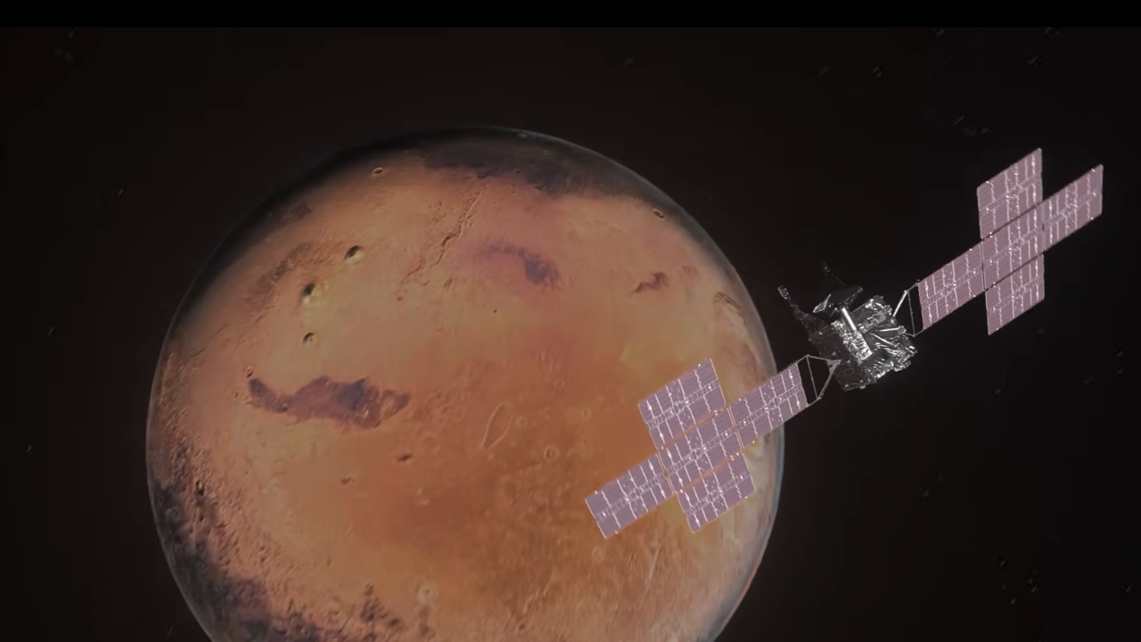

Click for next article NASA's Psyche spacecraft flew by Mars on Friday (May 15), diving closer to the Red Planet than either of its tiny moons. But the precisely timed maneuver was not designed to study Mars, Instead, the Psyche spacecraft zipped by Mars to use the planet as a celestial slingshot on its journey to its namesake, the metal-rich asteroid Psyche.The spacecraft passed within about 2,800 miles (4,500 kilometers) of Mars , which had appeared steadily larger and brighter in Psyche's view since early May. On Friday, Psyche hurtled past the planet at roughly 12,333 mph (19,848 kph), according to NASA. The flyby boosted Psyche's speed and, more importantly, shifted its trajectory toward its destination, the asteroid 16 Psyche , which orbits the sun between Mars and Jupiter. Scientists believe the 173-mile-wide (280 km) space rock may be the exposed metallic core of a shattered protoplanet - a primordial building block of the rocky worlds whose outer crust and mantle were likely stripped away in catastrophic collisions billions of years ago. If so, the mission could offer humanity its first direct glimpse of material normally buried deep inside planets like Earth. A Mars assist Friday's flyby marked one of the mission's most important milestones, conserving precious fuel while placing the spacecraft on course to reach the asteroid in 2029. The maneuver was an example of one of the most important techniques in modern spaceflight known as the gravity assist . By carefully flying past a moving planet, spacecraft can gain speed, alter direction and conserve propellant, allowing missions to travel farther and faster than rockets alone would permit. The concept can seem almost counterintuitive, as though spacecraft are somehow getting energy for free. A spacecraft accelerates as it falls toward a planet, then slows again while climbing back out of the planet's gravity well. Intuitively, those gains and losses should cancel each other out. What makes the maneuver possible, however, is not simply the planet's gravity, but the planet's own motion around the sun. Mars is hurtling through space carrying enormous momentum as it orbits the sun. By approaching the planet at a carefully calculated angle and departing in another, Psyche effectively stole a tiny fraction of that orbital energy. The exchange follows Newton's Third Law - every action has an equal and opposite reaction - as the spacecraft gains momentum by borrowing an infinitesimally small amount from Mars, a transfer imperceptible to the planet but transformative for the mission. Mars as a bright crescent as seen by the Psyche spacecraft just before its Red Planet flyby on May 15, 2026. (Image credit: NASA/JPL-Caltech/ASU) "It's smart, it's cheap, and it's phenomenally clever … it's a bit like interplanetary billiards," Shadan Ardalan, a NASA scientist who was involved with the agency's Juno mission to Jupiter, previously told Space.com . Gravity assists have long been used to explore humanity's cosmic backyard. The technique dates back to the dawn of the Space Age in 1959, when the Soviet spacecraft Luna 3 used the moon's gravity to swing behind it and photograph the lunar far side for the first time. Many of humanity's most ambitious robotic missions would also have been impossible without such maneuvers. NASA's Voyager probes famously used a once-every-176-years alignment of the outer planets in the late 1970s to slingshot from Jupiter to Saturn , with Voyager 2 continuing onward to Uranus and Neptune in a historic grand tour of the outer solar system. Cassini relied on gravity assists with Earth, Venus and Jupiter to build up the speed needed to reach Saturn, while New Horizons swung past Jupiter to shave a few years off its journey to Pluto. Most recently, NASA's historic Artemis 2 mission adopted a similar principle, following a "free-return" trajectory that used the moon's gravity to arc the crew of four back toward Earth without requiring major engine burns after looping around the lunar far side. On to the asteroid belt On Friday, the Mars encounter gave Psyche the equivalent of roughly a 2-kilometer-per-second change in velocity relative to the sun, according to a paper published in October detailing the maneuver. Psyche uses solar-electric propulsion , relying on its solar panels to convert sunlight into electricity and slowly push the spacecraft forward by releasing charged xenon gas. The system is highly efficient, but it generates only a small amount of thrust over long periods of time. Achieving the same boost in speed and shift in trajectory using propulsion alone would have been extraordinarily expensive and likely impractical, requiring enormous amounts of propellant - more than the spacecraft could realistically carry - while also adding weight and dramatically increasing launch costs. The Mars flyby allowed the spacecraft to use the planet's gravity to do much of the work instead, saving fuel for the rest of the journey. Like a baseball launched off a bat, Psyche now leaves Mars carrying new momentum and a reshaped trajectory, bound for a metallic world that may reveal what lies hidden inside planets themselves. It should arrive at asteroid 16 Psyche in July 2029.

8. World's largest operating tokamak begins commissioning with major 8-meter coils upgrade
Interesting Engineering
Read more

European and Japanese teams have begun the integrated commissioning of the JT-60SA tokamak to test its systems before a six-month round of plasma experiments scheduled for the end of 2026. The JT-60SA is currently the largest operational tokamak in the world. The upcoming experimental campaign will push the machine to higher current levels to study long-pulse and steady-state plasma scenarios. To prepare for these operations, the experiment team is reviewing over 150 research proposals submitted by scientists from Europe, Japan, and the ITER Organization. This commissioning phase follows a two-year shutdown that began shortly after the machine's initial low-power plasma startup in late 2023. During this period, assembly teams installed new components, including in-vessel coils. "Among them are two ring-shaped coils, designed to control the plasma position at high speed," said Fusion for Energy (F4E). "They are 8 meters in diameter and were wound directly inside the machine, in a display of high-precision skills." These coils were wound directly inside the machine to control the plasma position at high speeds. The device was built under the Broader Approach agreement and is hosted by the National Institutes for Quantum Science and Technology (QST) in Japan. Modifications focused on necessary components The recent modifications focused on components necessary for achieving higher plasma temperatures and managing increased thermal loads. Teams installed new diagnostics and cryopumps provided by Europe, alongside additional heating systems. The interior of the JT-60SA was also updated with a new first wall and a divertor utilizing a carbon-based armour. "We included diagnostics and cryopumps from Europe, as well as additional heating systems, key to achieving hotter, more powerful plasmas," stated Jerónimo García, JT-60SA Project Leader. The integrated commissioning serves as a gradual start-up to verify the main systems of the upgraded machine. Operations began at room temperature and under non-vacuum conditions, focusing on the newly installed in-vessel coils connected to European power supplies. The next phase requires pumping the cryostat and vacuum vessel to create high-vacuum conditions. Finally, teams will cool down and energize the large superconducting magnets to validate the integration of all new components. This process will also test new artificial intelligence and high-performance computing tools designed to improve plasma simulations and operational efficiency. International collaboration for future objectives Personnel from F4E are stationed in Naka to work alongside QST, providing technical expertise to help operate the technologies now coming online. Scientists from EUROfusion laboratories and the ITER Organization will also participate on-site during the campaign to gather data for ITER and future fusion reactors. Valerio Tomarchio, Project Manager for F4E, stated that the start of commissioning represents the completion of the component delivery schedule. He noted that expectations across the fusion community are high as the teams prepare to deliver the experimental results. "JT‑60SA will conduct high‑temperature high pressure plasma experiments ahead of ITER, currently under construction in France, and in support of the development of DEMO reactor aimed at demonstrating fusion power generation," concluded QST.

