 |  | 

🌌 अंतरिक्ष समाचार | Space News
सोमवार, १७/०८/२०२६ | Monday, 17/08/2026

1. Cyber Kushti 2026: NIELIT launches national challenge to test human judgment in the age of AI
Read more
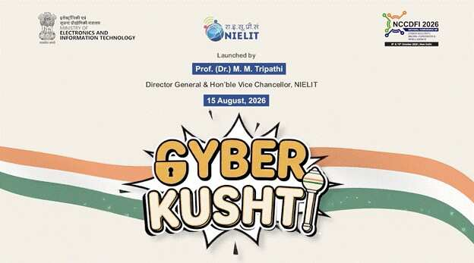
- Digital India - 7 min read NIELIT launches Cyber Kushti 2026, a national hackathon testing human judgment against AI-generated cyber findings to identify real threats, reject false alerts and strengthen cyber skills. Anoop Verma - ETGovernment - Published On Aug 17, 2026 at 06:46 AM IST Select ETGovernment as Preferred Choice on Google Copy Link Share on WhatsApp Share on Linkedin Share on X Share on Telegram Share on Facebook NIELIT launches Cyber Kushti 2026, a national challenge designed to test human judgment against AI-generated cybersecurity findings. As Artificial Intelligence increasingly transforms cybersecurity operations, the Government of India is putting the spotlight on a capability that automated systems still struggle to replicate reliably: human judgment. The National Institute of Electronics and Information Technology ( NIELIT ), under the Ministry of Electronics and Information Technology (MeitY), has launched CYBER KUSHTI 2026 , a national cybersecurity and AI hackathon designed to test how effectively participants can scrutinise machine-generated security findings, separate genuine threats from false alarms and determine which vulnerabilities require priority action. Advt Launched on August 15, the competition marks a departure from conventional cybersecurity hackathons that typically emphasise vulnerability discovery, penetration testing or Capture The Flag challenges. CYBER KUSHTI instead seeks to measure the quality of participants' security assessment and decision-making. In doing so, the initiative reflects an emerging challenge in the AI era: cybersecurity professionals increasingly have access to automated tools capable of generating enormous volumes of alerts and findings, but the usefulness of these outputs ultimately depends on the ability of skilled professionals to interpret them. The hackathon was formally launched by Prof. (Dr.) M. M. Tripathi, Director General of NIELIT and Vice Chancellor of NIELIT Deemed to be University. It will serve as the official parallel technical track of the 3rd National Conference on Cyber Security, Digital Forensics and Intelligence (NCCDFI 2026). The competition is being conducted in collaboration with the Information Sharing and Analysis Center (ISAC Foundation) under the National Security Database, with CERT-In serving as the Knowledge Partner. At the heart of the initiative is an important proposition: as AI becomes more capable of detecting anomalies and producing cybersecurity assessments, the scarce capability may no longer simply be finding potential problems. Instead, the premium could increasingly shift towards determining which findings are accurate, which pose the greatest risks and what should be fixed first. "The most difficult part of security work has shifted," Tripathi said at the launch. "For a generation, the scarce skill was finding the problem. Today, machines generate findings faster than any team can read them." He added that machines cannot yet reliably determine "which findings are real, which matter most, and what must be fixed first," making human judgment a critical institutional capability. Putting AI Outputs Under Human Scrutiny The structure of CYBER KUSHTI has been designed specifically around this human-machine interface. Every participating team will receive the same deliberately imperfect Security Assessment Package. It will include AI-generated findings, static analysis outputs, dependency and secrets scans, architecture documentation, source code and application logs. Prof. (Dr.) M. M. Tripathi, Director General of NIELIT, launches Cyber Kushti 2026, highlighting the importance of human judgment in AI-driven cybersecurity. Crucially, participants will not be able to assume that the automated findings are correct. The package will contain genuine findings alongside false and duplicated ones, while some real vulnerabilities will deliberately be left out. Teams will therefore have to scrutinise the material, identify errors and omissions, prepare a corrected and prioritised security assessment and subsequently defend their conclusions. The approach is significant because the proliferation of generative AI and automated cybersecurity tools is creating a new kind of operational problem. Security teams can potentially process far greater volumes of data than before, but increased machine output can also generate false positives, duplication and poorly prioritised warnings. In critical systems, blindly accepting such outputs could be almost as problematic as failing to detect vulnerabilities in the first place. CYBER KUSHTI attempts to recreate this challenge in a controlled competitive environment. Participants will be rewarded not merely for identifying genuine security problems, but also for correctly rejecting false findings. In effect, the contest evaluates whether cybersecurity professionals can challenge an automated assessment rather than simply accept the machine's conclusions. Participants will be allowed to use AI tools of their choice. Since all teams will receive identical tool-generated material at the same time, NIELIT says the format is intended to reduce the competitive advantage that could otherwise arise from access to expensive commercial cybersecurity platforms. Tripathi linked this design to the broader idea of technological self-reliance. "A student from a college in any part of the country can compete on entirely equal terms with a corporate team," he said. Explaining the significance of launching the competition on Independence Day, he argued that independence in an age of increasingly capable machines also entails the confidence to examine information critically, disagree with machine-generated conclusions and explain precisely why those conclusions may be wrong. From 'Akhada' to 'Kesari' Drawing on the vocabulary of traditional Indian wrestling, the competition has been structured into three stages - Akhada, Dangal and Kesari. Registration opened on August 15 and will continue until September 10. Participation is free and open to students and independent researchers competing in teams of three. The first stage, called The Akhada, will be conducted online on September 15, with 50 teams advancing to the next round. The second stage, The Dangal, will take place online on September 24 and narrow the field to 10 finalist teams. The final round, The Kesari, will be conducted in person on October 9 at the Dr. Ambedkar International Centre in New Delhi. The finalists will work under supervision before presenting and defending their security assessments on the main stage of NCCDFI 2026. One of the more distinctive elements of the final round will be a direct comparison between automated analysis and human assessment. An automated analysis of the same security material will be displayed alongside the finalists' presentations, enabling delegates to examine where machine-generated conclusions and expert human judgment converge - and, perhaps more importantly, where they diverge. The competition will be judged by a panel constituted jointly by NIELIT and ISAC, comprising cybersecurity practitioners and experts from government, industry and academia, including National Cyber Security Scholars recognised under the National Security Database. The winning team will receive the title "Cyber Kesari 2026" and a traditional Gada, while the runners-up will be recognised as "Rustam" and "Pahalwan." The organisers are also introducing an unusual category that rewards the quality of reasoning rather than merely the correctness of the answer. A special award will recognise the "most instructive incorrect submission" where the reasoning is clearly documented and offers instructional value. Participants in the first round will receive certificates and individual scorecards, while those advancing beyond it will receive National Security Database recognition credits. Building Cybersecurity Talent for an AI-Driven Economy Beyond the competitive format, CYBER KUSHTI reflects the growing need to rethink cybersecurity skills as India expands its digital economy and adopts AI across government, business and critical infrastructure. Cybersecurity professionals will increasingly have to work alongside automated systems rather than simply perform tasks that automation can replicate. This changes the nature of the skills required. Technical proficiency in identifying vulnerabilities remains essential, but professionals will also need the ability to evaluate machine outputs, understand context, assess the potential impact of vulnerabilities, prioritise remediation and explain their decisions to organisations and policymakers. NIELIT's nationwide footprint gives the initiative an additional skilling dimension. According to the institute, it operates through 56 centres, more than 700 accredited institutes and over 8,000 facilitation centres, and has trained and certified millions of students in electronics, information technology and emerging technologies. NIELIT has also been accorded Deemed-to-be-University status under the distinct category, with its main campus at Ropar in Punjab and 11 constituent campuses across the country. The final round of CYBER KUSHTI will coincide with NCCDFI 2026, scheduled for October 9-10 at the Dr. Ambedkar International Centre. The conference is intended to bring together representatives of government, law-enforcement agencies, the judiciary, industry and academia, along with cybersecurity researchers and students. All stages of the hackathon will operate in controlled environments provided by the organisers. Participants will not be permitted to engage with live systems, third parties or public infrastructure, ensuring that the exercise remains focused on assessment and learning rather than real-world intrusion. The larger significance of CYBER KUSHTI lies in its recognition that the cybersecurity challenge is evolving with AI. As automated systems become increasingly capable of discovering vulnerabilities, generating code and producing security assessments at scale, the competitive advantage of human professionals may increasingly lie in their ability to interrogate those outputs rather than simply generate more of them. For India's expanding digital ecosystem, that distinction is important. The next generation of cybersecurity professionals will need to know not only how to use AI, but also when to question it. CYBER KUSHTI 2026 is designed around precisely that proposition: machines may accelerate detection, but accountability, prioritisation and judgment remain fundamentally human responsibilities. Anoop Verma , --> - By - See more on: - Cyber Kushti 2026 NIELIT , - Cyber Kushti 2026 , - NIELIT , - AI in cybersecurity , - human judgment in cybersecurity , - cybersecurity hackathon , - Dr. Madan Mohan Tripathi , - automated cybersecurity tools , - National Cyber Security Conference 2026 , - National Institute of Electronics and Information Technology Telegram Facebook Comments What are your thoughts? Comment Now --> Comment Now Read Comment (1) All Comments By commenting, you agree to the Prohibited Content Policy Post Find this Comment Offensive? Choose your reason below and click on the submit button. This will alert our moderators to take actions REASONS FOR REPORTING Foul Language Defamatory Inciting hatred against a certain community Out of Context / Spam Others Report Join the community of 2M+ industry professionals. Subscribe to Newsletter to get latest insights & analysis in your inbox. All about ETGovernment industry right on your smartphone! - Download the ETGovernment App and get the Realtime updates and Save your favourite articles. Scan to download App --> - Home - News - Cyber Kushti 2026: NIELIT launches national challenge to test human judgment in the age of AI

2. Tripura's National Awardee Presided Dias Of ISRO NASA NCRTS Veterans Conferred Sarabhai Student Scientist & Teacher Scientist Award 2026 With Recall For Vikram Sarabhai's Leapfrog Vision. - TRIPURA STAR NEWS
Read more
Spread the love Agartala, Tripura, 16th of August, 2026 : Tripura pride National Awardee Science Teacher Anjan Banik, being nominated as Hon. National Chairman to National Council of Researcher Teacher Scientist VIPNET India (then knowingly affiliated to VIPNET Vigyan Prasar under Ministry - Dept of Science and Technology of Govt of India) presided over the Online International event Dias of celebration of 107th Birth anniversary of Dr Vikram Sarabhai, father of India's Space Programme on 12th August 2026 under webcast at [ https://www.youtube.com/watch?v=4eeFSkrdu4k ] , where the galaxy remain twinkled with the active virtual presence of former ISRO Star Scientists with Deputy Director of Planetary Div of JPL NASA remain an attraction to the aspirant space science loving future scientists & students from India. A gathering of veteran Indian space scientists, a NASA planetary scientist and young science learners turned the 107th birth anniversary of Vikram Sarabhai into a vivid reflection on the vision, leadership and scientific culture that shaped India's space programme. The virtual programme, organised to commemorate Sarabhai and to confer young selected winner - participants with the 8th India International Sarabhai Student Scientist Award 2026 from its organizing team of National Council of Researcher Teacher Scientist India (VIPNET DST Govt of India) academic partnership with the National Council of Student Scientist India and DASA India, brought together scientists who had directly experienced the formative decades of India's space journey. The India International Sarabhai Student Scientist Award is a national-level science competition and platform in India. It honors young space science loving student achievers and mentors in science education, inspired by the legacy of Dr. Vikram Sarabhai, the pioneer of India's space program, which has been mentored, designed and coordinated by Anjan Banik. ANJAN BANIK is an national award-winning science teacher, educational researcher, science communicator and teacher mentor from Agartala, Tripura, whose work has contributed significantly to science education, scientific communication and educational innovation at the state and national levels. He is widely recognized as the sole recipient from Northeast and East India, even from his state Tripura to win the prestigious National Award for Science and Technology Communication 2022 to 2023 in Category E for outstanding efforts in science and technology communication through innovative and traditional methods, conferred by the National Council for Science and Technology Communication under the Department of Science and Technology, Government of India. The official award conferred to Shri Anjan Banik of Agartala on the National Science Day 2023 at Vigyan Bhawan, New Delhi and was presented on National Science Day at Vigyan Bhawan New Delhi by Union Minister Dr Jitendra Singh in the presence of senior national scientific leadership including the Union Secretary of the Department of Science and Technology Dr S Chandrasekhar, Principal Scientific Adviser to the Government of India Professor A K Sood, former Principal Scientific Adviser Professor K Vijayaraghavan, Head Scientist of NCSTC Dr Manoranjan Mohanty, and Director of Vigyan Prasar Dr Nakul Parashar. He has subsequently been selected as a National Mentor Resource Person under the National Mission for Mentoring of National Council of Teacher Education (NCTE), Ministry of Education, Government of India, and has continued to contribute to teacher mentoring and science education. There are more then 29 science educational research work in his credit which has been presented or published up on him by NCERT, its RIEs at Ajmer, Bhopal, Bhubaneswar, Shilong and Mysore, CSIR NiScPR. His landmark educational research undertaken for IGNOU analysed approximately 45 years of Tripura Board of Secondary Education results, examining the movement of students from Madhyamik to Higher Secondary education and particularly their choice and achievement in Science, Humanities and Commerce. A major finding of the study reported that only 7.97 percent by mean score of Madhyamik enrolment ultimately pursued Science education through Higher Secondary, highlighting the need for stronger scientific orientation, career guidance and educational interventions. His professional contribution has also extended to science textbook authorship for NCERT oriented school education, innovative science communication and the use of puppetry and digital cultural approaches for communicating science and mathematics. In February 2026, ANJAN BANIK was invited as a delegate to the India AI Impact Summit 2026 at Bharat Mandapam, New Delhi, representing Tripura in a major international forum on responsible, inclusive and research driven artificial intelligence. His continuing work reflects a sustained commitment to scientific temper, experiential learning, teacher empowerment and the wider national objectives of science education. The mega event Organized by its organizing team of National Council of Researcher Teacher Scientist India (VIPNET DST Govt of India), National Council of Student Scientist India and DASA India (an Agartala, Tripura-based national voluntary organization) under the administrative and academic Leadership of its National Chairman Anjan Banik which has been knownly affiliated with VIPNET, Vigyan Prasar (Department of Science and Technology, Government of India). The Star gathering conferred this year's 8th India International Sarabhai Student Scientist Award 2026 to Top 11 scorers who compete with nearly about 1 lac students gathering for a long period of last 7 months and the winners are : 1st : Aiyra Alvi (U.P.) of SMS Dutta Memorial Nosegay Public School, Khatima, U S Nagar, Uttarakhand 2nd : S. Dharunraja (Puducherry) of Shree Bharath Vidyaashram CBSE, Puducherry 3rd : DT Tanishka Shri (Puducherry) of Shree Bharath Vidyaashram CBSE, Puducherry 4th : DT Gagana Sree (Puducherry) of Shree Bharath Vidyaashram CBSE, Puducherry 5th : Yeshmithaa R. (Puducherry) of Shree Bharath Vidyaashram CBSE, Puducherry 6th : S. Sai Swetha (Puducherry) of Shree Bharath Vidyaashram CBSE, Puducherry 7th : Mahnoor Riyaz (Kulgam Kashmir) of Radiant Public Hr Sec School Batengoo Anantnag Kashmir and under guidance of Aloha Anantnag 8th : Priya Joshi (Uttarakhand) 9th : Pratiksha Rath (Puducherry) of Shree Bharath Vidyaashram CBSE, Puducherry 10th : Tai Nanam (Arunachal Pradesh) of Vivekananda Kendra Vidyalaya CBSE Arunachal Pradesh 11th : Aryan Parasar (Arunachal Pradesh) of Vivekananda Kendra Vidyalaya CBSE Arunachal Pradesh The President of event National Chairman National awardee Anjan Banik as part of The event also declared to honour the three mentor guide teachers Dr Sir Ariz Alvi (U.P.) being guide teacher of 1st position holder, Shahnawaz Ahmad Shapoo Sir (Kashmir) being guide teacher of 7th position holder, Sir Avinash Sonar of Vivekananda Kendra Vidyalaya of Itanagar, Arunachal Pradesh being guide teacher of 10th & 11th position holder and Sir Arun Kumar R (Puducherry) being the guide teacher of both 2nd, 3rd, 4th, 5th, 6th, and 9th position holders by conferring the prestigious India International Sarabhai Teacher Scientist Award 2026 for their contribution towards students, which will be conferred on 30 Dec 2026 on death anniversary of Dr Vikram Sarabhai. This event is a part of organisation's objective to inspire science loving students and Participants to engage in assignments, spaceflight simulator tasks, and astronomy projects mentored by veteran scientists from ISRO and NASA, where scientists are directly and occasionally interacting with those selected students. This event conducted in every year starts as a prelim google e quiz session available at the link of [ http://forms.gle/nnZrKVZEuZbNAXMw9 ] during 1st January (Birth anniversary of Sir Meghnath Saha) every year to 28th February (National Science Day in India). The most striking message came from veteran ISRO scientist Professor R R Elango, who recalled Sarabhai's philosophy of moving rapidly beyond existing technology rather than repeatedly rebuilding what the world had already developed. Referring to the principle as a form of technological leapfrogging, Elango said that Sarabhai believed India should use existing technological knowledge as a foundation and move forward to create new capabilities. "Do not try to redo it again what you have done already. Use that technology and go further," he recalled. According to Elango, this approach remains deeply connected with the remarkable achievements of ISRO today. The programme began with a tribute to Vikram Sarabhai, widely regarded as the father of the Indian space programme. The speakers highlighted how the name Vikram has subsequently become associated with several landmarks of Indian space exploration, including the Vikas engine and the Vikram lander associated with the Chandrayaan programme. This Mega event Dr M R Shivaramans memories of Sarabhai and the evolution of satellite navigation Dr M R Shivaram, a veteran space scientist and former Deputy Project Director associated with the GAGAN programme, joined from the United States. Dr M R Shivaram born on 6th March, 1944 and did his MSc (Applied Physics) in 1966 from University of Kerala, PhD (Physics) on the subject "Topside Sounding of the Ionosphere" from University of Gujarat in 1975. His professional journey began in 1966 at the Physical Research Laboratory, Ahmedabad, founded by Sarabhai, before he moved to the Space Applications Centre of ISRO and continued till 1975. He Joined Space Applications Centre (SAC), Ahmedabad in 1975 and started working in Satellite Geodesy Division. While in SAC, he contributed in Development of Geo-receivers and its applications, Development of GPS Receivers and its Applications, Satellite Navigation Programmes viz. GAGAN and IRNSS (NavIC), Development of Time Synchronisation Techniques, Development of Ionospheric and Tropospheric Models for GAGAN, and Ka Band Radio Wave Propagation. He has been superannuated in 2004 from SAC. But later also he contributed as a Visiting Scientist in SAC till 2007. Dr M R Shivaram was Deputy Project Director for "GAGAN" Project from 1998 to 2007. Dr M R Shivaram had also worked in IRNSS Programme, in its initial stages of development. From 2002 to 2007, he contributed to publish more than 50 Scientific papers and also guided some PhD students in Dharam Sinh Desai University, Nadiad. Recalling his encounters with Sarabhai during the late 1960s, Dr Shivaram said Sarabhai had an unusually simple and approachable personality despite his enormous responsibilities. Sarabhai would visit students, interact with them directly and listen to their problems. Dr Shivaram recalled an occasion when a disparity in scholarships affecting research students came to Sarabhai's attention. Sarabhai immediately intervened and ensured that the students received a fairer arrangement. Dr Shivaram also described Sarabhai's contribution to building the foundations of satellite communication and space applications in India. He recalled how Sarabhai supported the development of experimental satellite communication facilities and encouraged Indian scientists to develop indigenous capabilities rather than remain dependent on imported technology. Speaking about his own later work, Shivaram described his involvement in satellite navigation, including GAGAN and the early development of the Indian Regional Navigation Satellite System. He explained that GAGAN evolved into an advanced satellite based navigation capability designed to provide highly accurate navigation services and support aviation applications. His account also highlighted an important dimension of Sarabhai's legacy: the transformation of space science from a purely scientific pursuit into a technology serving communication, navigation, surveying and other national requirements. Elango recalls Sarabhai's leadership and Kalam connection Professor R R Elango, who later worked with the Vikram Sarabhai Space Centre and became associated with launch vehicle development, recalled several stories about Sarabhai's leadership style and his relationship with young scientists. According to Elango, Sarabhai's first major strength was team building. He brought scientists and specialists from different fields and countries to India and created an environment where expertise could be combined for national objectives. Elango recalled an incident involving Dr APJ Abdul Kalam following a rocket development setback. Instead of simply criticising Kalam after a failed test, Sarabhai reportedly handed him an official envelope. Kalam expected disciplinary action, but the envelope contained a promotion order. The episode, Elango said, demonstrated Sarabhai's ability to distinguish between failure and incompetence and to encourage scientists to learn from technical setbacks. Elango further explained Sarabhai's emphasis on system integration. Components could function successfully individually but still fail when assembled as a complete system. Sarabhai therefore encouraged the creation of systematic integration and testing facilities so that complete systems could be evaluated before launch. He also recalled Sarabhai's practice of listening to young engineers and scientists rather than restricting decision making to senior levels. According to Elango, Sarabhai valued technical competence, encouraged his colleagues and gave team members opportunities to present their own work. The scientist said this leadership culture eventually became one of the foundations of ISRO's institutional strength. Kishor Kumar Barucha explains the camera behind space imagery Kishor Kumar P Barucha, associated with optical imaging and camera technology at the Space Applications Centre in Ahmedabad, described another important but less visible part of the Indian space story. Barucha explained how optical systems and multispectral cameras are essential for obtaining information from Earth and other planetary bodies. His work involved lens systems, beam splitters and imaging instruments designed for different spectral regions and orbital applications. He described the demanding process of making space qualified optical systems. Components have to undergo environmental testing involving temperature variation, humidity, vacuum and other conditions before they can be considered suitable for space missions. Barucha also discussed imaging systems used for Earth observation, weather applications, land use studies and planetary missions. He highlighted the importance of cameras not merely for obtaining spectacular photographs but for generating scientific information about agriculture, land, water bodies, vegetation and geological features. He also stressed the educational value of space imagery. Through exhibitions, school programmes and science awareness activities, satellite images can turn abstract concepts of Earth and space science into something students can directly observe and investigate. A C Mathur: Sarabhai wanted space technology to reach ordinary people Former ISRO Group Director A C Mathur provided a broader account of the development of space applications in India. He recalled joining ISRO in 1978 and subsequently working with several scientists who had themselves worked closely with Sarabhai. Mathur described Sarabhai as a visionary who understood that the ultimate value of space technology would lie in its applications for ordinary people. He recalled the development of experimental satellite communication earth stations and India's gradual transition from imported technology towards indigenous design and manufacturing. According to Mathur, one of the most important elements of Sarabhai's vision was the creation of institutions capable of converting space research into practical applications. Remote sensing, satellite communication and other technologies were developed not simply as demonstrations of technological capability but as tools for national development. He emphasised that the benefits of space science should reach ordinary citizens and that the fundamentals of space science should also reach school students. Such an approach, he suggested, would be crucial if India is to remain a global leader in space technology. Mathur's account also highlighted India's growing indigenous capability in satellite antenna technology. He recalled how Indian engineers developed and tested antennas that were subsequently evaluated by NASA, marking an important step in building confidence in India's ability to design sophisticated space hardware. NASA scientist Rosaly Lopes highlights perseverance The programme also featured Dr Rosaly M C Lopes of NASA's Jet Propulsion Laboratory, a renowned planetary scientist and a leader associated with academic engagement at JPL. Lopes congratulated the students and emphasised the importance of international scientific collaboration. She noted that India and NASA are partners in space exploration and highlighted India's achievements in lunar exploration and planetary science. But the most personal part of her message concerned perseverance. Recalling her childhood in Brazil, Lopes said that nobody in her family had been a scientist and that people initially found it unusual that a young girl wanted to study astronomy. She explained that perseverance was one of the most important factors behind her eventual scientific career and her association with NASA's Jet Propulsion Laboratory. "Students bring fresh ideas," she said while stressing the importance of encouraging and recognising young learners. She also pointed out that NASA's postdoctoral opportunities are open to students from different countries, underlining the international nature of modern scientific research. Students demonstrate the next generation of scientific thinking The programme also showcased the experiences of young participants selected for the India International Sarabhai Student Scientist Award. Their assignments included practical experiments involving light, shadows, observation, data collection and pinhole cameras. The students repeatedly described how hands on activities helped them move beyond memorising scientific facts. One participant explained that the pinhole camera experiment helped demonstrate the straight line propagation of light and image formation. Another said that analysing shadows connected mathematics with physics and real life observation. A student from Jammu and Kashmir summarised the learning philosophy particularly clearly by saying that science is not merely about learning concepts but about observing, questioning, thinking, experimenting and discovering. Another participant expressed an aspiration to become an ISRO scientist and contribute to India's space programme. Sarabhai's legacy continues through students The programme ultimately connected three generations of Indian science. Veteran scientists recalled Sarabhai's institution building and leadership, NASA's Rosaly Lopes spoke about perseverance and international scientific cooperation, while school students demonstrated how practical experimentation can cultivate scientific curiosity. The organisers emphasised that the objective of the Sarabhai Student Scientist initiative is not merely to confer awards but to inspire young people to remain curious, experiment independently and develop the confidence to ask how and why. The central message emerging from the programme was therefore larger than a celebration of a historic scientist. Sarabhai's legacy was presented as a continuing educational philosophy: build strong teams, listen to young minds, learn from failure, use existing knowledge intelligently, develop indigenous capability and take science to society. For the young participants, the most enduring lesson may have been the one recalled by Professor Elango: India does not need to repeat every technological journey from the beginning. It can learn from what has already been achieved, adapt it, and move further. At the final conclusion Anjan Banik, the National Awardee National Chairman of this event invites all the Ex ISRO-Scientists to contribute to inspire the future India and also invite the future India, the Gen Next to participate in this Science and scientists-oriented event for the next year as it beings on next 1st January at its exam link of [ http://forms.gle/nnZrKVZEuZbNAXMw9 ] . Related

3. Andaman Media Team Gets Rare Opportunity to Visit Satish Dhawan Space Centre, Sriharikota - ANDAMAN SHEEKHA
Read more
Andaman Media Team Gets Rare Opportunity to Visit Satish Dhawan Space Centre, Sriharikota ANDAMAN SHEEKHA

4. Astronaut Shubhanshu Shukla at Idea Exchange: 'Today's kids are brilliant… you have to be with a dream for a long time, work on it, only then will it happen' - The Indian Express
Read more
Astronaut Shubhanshu Shukla at Idea Exchange: 'Today's kids are brilliant… you have to be with a dream for a long time, work on it, only then will it happen' The Indian Express

5. NASA funds spherical 'Aerobots' that could explore the caves of Saturn's moon Titan
Read more
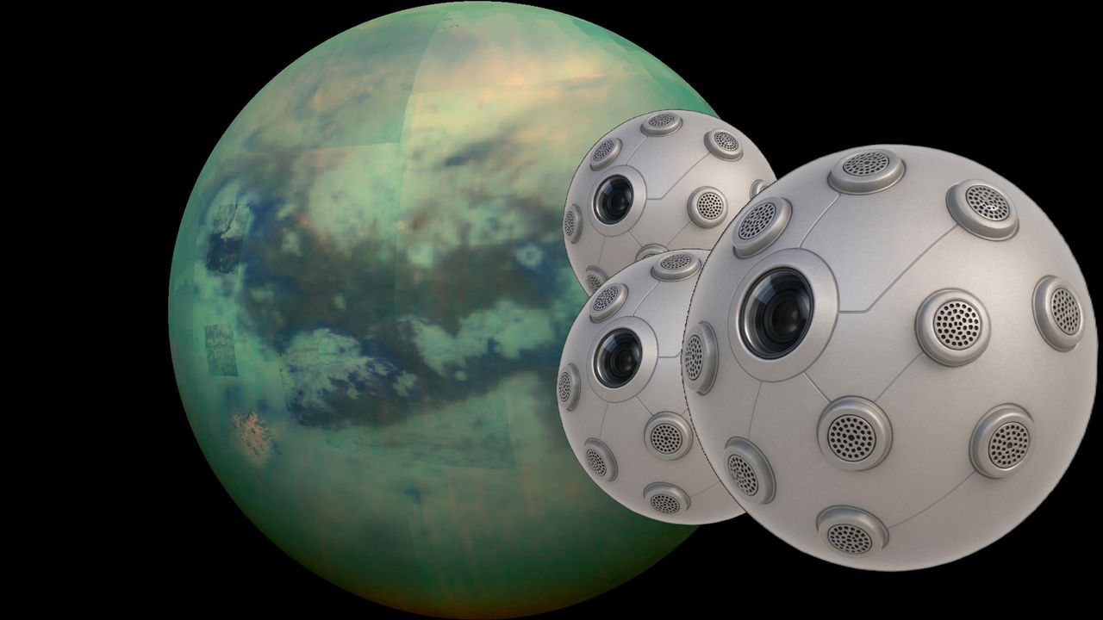
Click for next article A composite image of an infrared view of Saturn's moon Titan from NASA's Cassini spacecraft; renderings of several "SPARK" Aerobots being developed by Daniel Drew of the University of Hawaii. Spherical "Aerobots" may one day swarm the caves of Titan - a moon of Saturn that NASA says is one of the most Earthlike in our solar system. Titan is covered in rivers, lakes and seas of hydrocarbons, like methane and ethane, as well as a strange "karst" terrain including underground sinkholes and caves . No rover could easily traverse this surface, but flying vehicles may have more success. So a new grant, under the early-stage NASA Innovative Advanced Concepts (NIAC) program, aims to create small, flying vehicles that could explore those caves. It's unclear if the aerobots - called SPARK , or Solid-state Propulsion for Autonomous Reconnaissance of Karst - would be ready in time for NASA's Dragonfly mission to Titan, project lead Daniel Drew, an assistant professor at the University of Hawaii at Mānoa, told Space.com. That's because SPARK is beginning a nine-month Phase 1 grant and would need to at least get through the up-to-two-year Phase 2 before things look "more realistic" for a liftoff, he noted. Dragonfly, meanwhile, is targeted for a 2028 launch but if the mission is delayed, that provides more possibilities for late-mission additions. "Where does that line up with the current Titan mission timeline, assuming we've missed the window for Dragonfly? I don't know," Drew said of SPARK. But whenever the mission lifts off, Drew said SPARK has a good chance of doing well on Titan with its novel ion (electric) thrusters. Drew said his design could "provide persistence, maneuverability, robustness to the challenging near-cryogenic [icy] conditions, and minimize downwash disturbance of scientifically-important hydrocarbon layering." He hopes that SPARK, he added, could be a cave-exploration forerunner at Titan similar to the Ingenuity helicopter on Mars that made 72 flights - more than tenfold what the Red Planet demo mission was supposed to do. Drew has been working on a particular type of ion thrusters, called electrohydrodynamic (EHD) propulsion, since he did graduate school at the University of California, Berkeley. Thanks in part to a National Science Foundation (NSF) fellowship, Drew explored several designs for flying and became interested in creating robots that flap their wings in a way similar to real-life creatures. While exploring, he stumbled on the hobbyist "lifter" community "pretty much by chance," he said. "These [prototypes] are triangular balsa wood, magnet wire, and aluminum foil prototypes. You connect them to 40,000 volts from a flyback transformer that you rip out of a microwave or CRT monitor or whatever, and they can float above the table. There are plenty of examples of people making these on YouTube," he said. More plumbing the archives revealed early experiments and studies at NASA and the Air Force similar to what the hobbyists were using. And by coincidence, NIAC awarded funding to another research group, led by the Massachusetts Institute of Technology, that was interested in using EHD propulsion for Earthborne aircraft. As such, Drew sensed a fruitful direction for research. "Long story short, I ran with that idea," Drew said, "and wrote a bunch of papers where I created microfabricated centimeter-scale flying robots propelled by atmospheric ion thrusters." His accomplishments prior to the NIAC grant included what he says is the first demonstration of microfabricated EHD actuators (mechanical devices), and other firsts such as a centimeter-scale "ionocraft" taking off and subsequently, carrying a payload. "We recently published the design and takeoff of the first ion-propelled micro-hovercraft," he added, referring to a paper on preprint server arXiv . "That may seem like a pretty decent list of significant milestones, but it's really not a crowded space of people working on this topic. I'm mostly racing against myself here." Now with the NIAC support, Drew said he hopes to dive deeper into the benefits of EHD propulsion, such as its scalability, the fact that it's virtually silent, and its simplicity (being solid state, there are fewer parts to worry about). A graphic depiction of the SPARK concept being developed by Daniel Drew of the University of Hawaii. (Image credit: Daniel Drew/University of Hawaii) More applications could come outside of Titan, he noted: all-electric aircraft, indoor drones, and mini-flying swarms are just some ideas, but he said the utility will be limited. "The huge weakness is that it just isn't very efficient," he said of EHD propulsion. "Barring a major breakthrough, it will be impossible to really compete with more conventional propulsion techniques, like rotors and jet engines, for the vast majority of terrestrial applications." As Phase 1 only encompasses about nine months, Drew and his collaborators-including Ethan Schaler and Jacob Izraelevitz from NASA's Jet Propulsion Laboratory, as well as Michael Malaska from the Blue Marble Space Institute of Science-plan to quickly design experiments, perform a "trade study" of which subsystems are best to prioritize for aspects like power, and model matters like the thermal effects on the power system. "I think the idea of 'standing on the shoulders of giants' is very much ingrained into the NIAC culture," Drew noted. "Our major contribution at the end of this process is a comprehensive, public report. Leveraging past related reports, and other open research in the field, is critical for doing a good job with this."

6. Artemis II pilot thanks NASA for letting him fly Orion by hand: 'I'm still blown away by that trust'
Read more
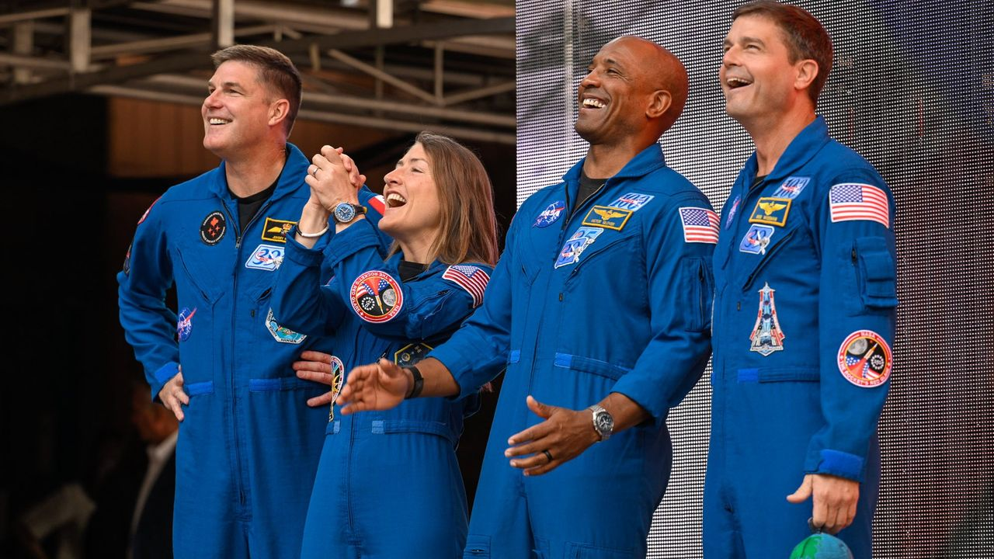
Click for next article MORRISON, Colorado - The Artemis II crew that circuited the moon earlier this year came full circle, dropping by a distinctive spot on Earth that's visually reminiscent of both the moon and Mars. On Aug. 3, the vast and stunning Red Rocks Amphitheatre served as both an inoculation of near-term nostalgia and heart-felt congratulations to the crew for the impressive journey of Artemis II. The 10-day mission began on April 1 of this year , flew around the moon and back , and splashed down in the Pacific Ocean on April 10. It was the first crewed flight to saunter spaceward beyond low Earth orbit in 53 years. Some 8,500 people packed the open-air venue at Red Rocks to make eye-contact with space travelers Reid Wiseman, commander, Victor Glover, pilot, Christina Koch and Jeremy Hansen as mission specialists - all of them clearly awestruck by the crowd reaction. The event was a broader post-flight campaign for the foursome, also spotlighting the region's contributions to the sojourn of Artemis II. A science, technology, engineering, and mathematics (STEM) fest was also part of the early morning affair. The Artemis II crew speaks at Red Rocks Amphitheatre in Morrison, Colorado on Aug. 3, 2026. (Image credit: Lockheed Martin) Iconic location "I can't imagine a more iconic location on Earth to hear about the trip to the moon," said Robert Lightfoot, president of Lockheed Martin Space and a major aerospace contractor for the Artemis program. There were hundreds of suppliers across the rocky mountain region, over 10,000 employees, that supported the Artemis II mission, he told the gathered throng. Leadership from industry prime contractors including Lockheed Martin, Amentum, Boeing, L3 Harris and Northrop Grumman took part in the salute to the Artemis II voyage. Colorado Governor Jared Polis pointed out that "here in Colorado, we're a mile closer to space." As the best and biggest homecoming for the Artemis II crew, he added, "keep reaching for the stars." Lori Glaze, NASA associate administrator for the Human Spaceflight Mission Directorate, said today "is a truly revolutionary and exciting time for NASA and America's space program. We are going to reach farther. We're going to dream bigger. And we're going to secure America's leadership in deep space exploration and discovery." The Artemis II crew speaks to a crowd of 8,500 at Red Rocks Amphitheatre in Morrison, Colorado on Aug. 3, 2026. (Image credit: Lockheed Martin) What next? In a pre-event press gaggle, Space.com asked the Artemis II crew members how their Orion spacecraft named Integrity performed and would help the upcoming Artemis III crewed flight in Earth orbit. "It handled incredibly well," said Reid Wiseman, Artemis II commander. "Just from habitability, I think that is where we learned the most, putting four humans in the spacecraft. We knew that the machine was technically competent and capable of getting to the moon … Artemis I taught us that," he told Space.com. "We had some heat shield things we needed to sort out on Artemis II. But putting the four of us in there, seeing how the life support system worked and how is it for habitability, to eat, live, work, and sleep in there, we definitely learned a lot that we've handed on to Artemis III," said Wiseman. Sense of gratitude The Red Rock Artemis II stage event had the four Artemis II crew members facing a huge gathering of supportive spectators. In excess of 1,300 questions were submitted by the attendees. The Artemis II crew entrance was marked by roaring footage of the Artemis I launch scored by music from thunderous Metallica's "Fuel." "The biggest thing that this mission has given us is an overwhelming sense of gratitude. I think we've got to figure out how to keep this going," Glover said. For Christina Koch, the Red Rocks gathering spurred a call and response audience participation. "I say moon, you say joy," to which the throng promptly called back three times. She also asked the audience to put their thumb out in the air. From a distance, "you can cover the entire Earth with your thumb. That's how small it was to us," she said, "but what you knew was that was home." Proximity operations Victor Glover, the pilot of Artemis II, focused on a proximity operations demonstration during the flight . That entailed the crew guiding the spacecraft through a series of controlled approach and retreat maneuvers using the detached upper stage, the interim cryogenic propulsion stage, as a reference target. "That is when we had a chance to fly the spacecraft by hand, not just using the computers," Glover told Space.com. "We actually got to fly. One of the most amazing aspects of that is looking out the window or through the cameras on the [cockpit] displays to determine how far we were from the upper stage," he explained. That task made use of all four sets of eyes onboard Orion, Glover said. "We did not have radar, or some other type of digital ranging system between us and that vehicle. But the Artemis II team trusted us to fly like that. I'm still blown away by that trust," he said, "and it flew marvelously." The Artemis II crew gives a thumbs-up to the crowd at Red Rocks Amphitheatre in Morrison, Colorado on Aug. 3, 2026. (Image credit: Lockheed Martin) South pole ambitions NASA's Glaze added that Artemis III is to fly sometime mid-year in 2027 . "We are going to demonstrate docking with one or both of our two landers, the Blue Origin and the SpaceX lander . They've got some demonstration versions that they are preparing right now. We're working on that mission to prove out, not just going back and forth at a target, but actually docking and doing that hard job," Glaze told Space.com. Space.com pressed Glaze on the term "demonstration versions" of the Blue Origin and SpaceX lunar landers. Would the fidelity of those demos be good enough to green-light an actual human moon landing on the Artemis IV mission? "I do," Glaze responded. "We're working really hard with both of our lander providers on development of the demo pathfinder versions of their landers that we will dock with […] to assure that the docking systems are the same docking system we're going to work with when we are going for the landing mission," she said. Glaze said that "this is one of the key risks. This allows us to buy down that risk and at least work through that part of the mission. So when we do the landed mission we've got that part out of the way. "We've got our lessons learned from those docking demonstrations. And then we are really focused on all the risks associated with the landing on the moon … we can really focus our efforts there." According to Space.com sources, however, there is active discussion of whether the lunar south pole is an advisable location for the first human landing of the Artemis Program. Indeed, Artemis II pilot Glover recently stated that he thinks there's a need to be realistic and progressively work our way to the south pole locale rather than land there first. "We've had a lot of conversations with both of our lander vendors. The designs they have are for the south pole," responded Glaze. "We're working really closely with them on those designs. And we are very focused on landing at the south pole." Over the moon Canada's Artemis II mission specialist, Jeremy Hansen , told the audience that their space trek was a very human experience for the four crew members, "but we came to see and feel you. You shared the moon joy," he said. Hansen underscored the international character of Artemis II. "It was one of those deliberate contributions to the planet," he said, because billions of us on Earth have to join forces. "We have to work together. We can no longer believe that our end-state is not working together. Not acceptable. We have to collaborate," he said. Asked by a young audience member about items taken on their excursion around the moon, mission specialist Koch replied: "I took handwritten letters that I hadn't read before from my family, and also a very tall cow figurine. My dad had the idea of having a cow jump over the moon."

7. New record! SpaceX launches 2 Falcon 9 rockets just 38 minutes apart (video)
Read more
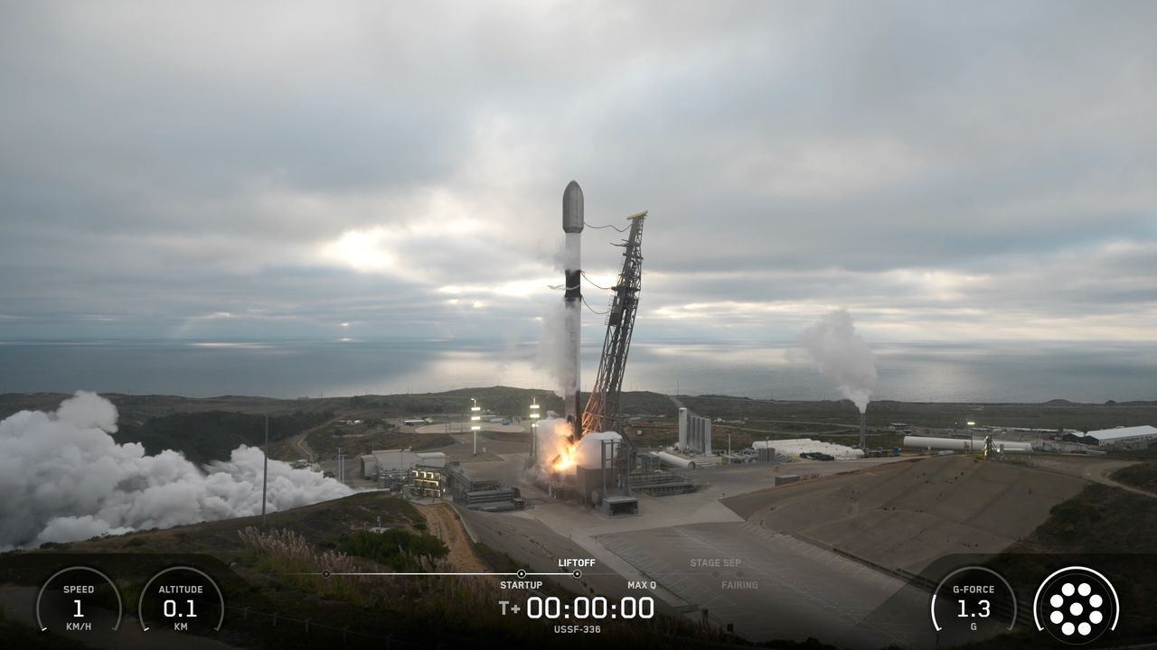
Click for next article SpaceX keeps setting spaceflight records. Elon Musk 's company launches far more frequently than any other outfit, and it operates the largest satellite constellation ever assembled - the Starlink broadband network, which consists of nearly 11,000 satellites (and counting). On Saturday evening (Aug. 15), SpaceX set another mark, for the shortest time between orbital flights: It launched two Falcon 9 rockets just 38 minutes apart, besting its old mark - set on Aug. 31, 2024 with two Starlink missions - by 27 minutes. A SpaceX Falcon 9 rocket launches eight satellites for the telecom company Globalstar from Florida's Cape Canaveral Space Force Station on Aug. 15, 2026. (Image credit: SpaceX) The first liftoff, from Florida's Cape Canaveral Space Force Station , occurred Saturday at 9:12 p.m. EDT (0112 GMT on Aug. 16) and carried eight satellites to low Earth orbit (LEO) for Louisiana-based telecom company Globalstar. All eight spacecraft were deployed successfully, separating over a six-minute span beginning 56.5 minutes after liftoff, SpaceX announced via social media. While that Falcon 9 was powering its way to LEO, another one launched from Vandenberg Space Force Base , on California's central coast. That liftoff, at 9:50 p.m. EDT (6:50 p.m. local time; 0150 GMT on Aug. 16), kicked off a mission for the U.S. Space Force called USSF-366. A Globalstar satellite deploys from the upper stage of its Falcon 9 rocket on Aug. 15, 2026. (Image credit: SpaceX) We know very little about USSF-366, which isn't surprising given its classified status. However, rocket watchers have made a few inferences from the limited available information. "It is possibly a batch of classified LEO satellites for a U.S. government entity based on SpaceX's Starshield satellite bus, based on locations of rocket stage drop zones being exact fits with previous Starlink Group 15 launches," NextSpaceflight.com wrote in its mission description . ( Starshield is a SpaceX project that uses modified versions of Starlink craft to fly national security missions for the U.S. government.) It's unclear when and where the rocket's upper stage will deploy the USSF-366 payload(s); SpaceX's mission description doesn't reveal that information. And the company ended its livestream shortly after the first-stage landing, as is typical for national security flights. Both of Saturday's missions featured successful rocket landings. The Falcon 9 first stage that launched the Globalstar mission came back for a touchdown at Cape Canaveral about eight minutes after launch. It was the 14th flight for that particular booster. The USSF-366 Falcon 9 first stage, meanwhile, came back to Earth about 8.5 minutes after its launch, touching down in the Pacific Ocean on the SpaceX droneship "Of Course I Still Love You." That booster now has 18 missions under its belt. Saturday's doubleheader brought the tally of Falcon 9 launches in 2026 to 96. The vast majority of those - about 75% - have been Starlink missions.

