IIRS Daily Space Digest Wednesday, 13/05/2026

1. Ahead of 2027 launch, Nasa starts Artemis 3 rocket assembly at Kennedy Space Centre
Science | The Indian Express
Read more
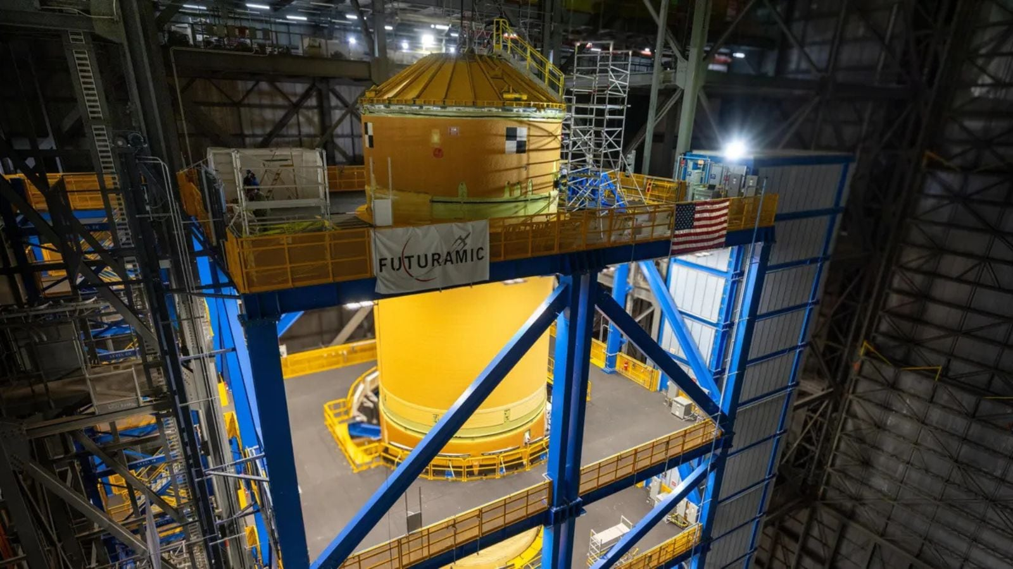

Nasa has begun assembling the massive Space Launch System (SLS) rocket that will power the Artemis 3 mission, marking another major milestone in the American space agency's plan to return astronauts to the Moon later this decade. The core stage of the Artemis 3 rocket has now been lifted into a vertical position inside the Vehicle Assembly Building (VAB) at Nasa's Kennedy Space Centre in Florida. The stage is currently stationed inside High Bay 2, where engineers will continue preparing it for integration with the rocket's engine section and other components ahead of launch. The Artemis 3 mission is currently targeted for launch in late 2027 and is expected to play a crucial role in testing Nasa's next-generation lunar landing systems before astronauts attempt to land on the moon again.

2. IFAD and Govt of India launch rural prosperity roadmap focused on climate resilience & Global South cooperation
Government News | Latest news on eGovernance, Digital India, Smart Cities | ET Government : ETGovernment.com
Read more


- Policy - 4 min read India and IFAD have launched an eight-year rural development strategy focused on climate resilience, rural finance, women-led enterprises and scalable livelihood models aligned with Viksit Bharat@2047. Anoop Verma - ETGovernment - Published On May 13, 2026 at 11:00 AM IST Copy Link Share on WhatsApp Share on Linkedin Share on X Share on Telegram Share on Facebook India and IFAD Expand Strategic Partnership for Rural Finance and Agricultural Growth The International Fund for Agricultural Development (IFAD) and the Government of India have launched a new eight-year rural development strategy aimed at expanding economic opportunities, strengthening climate resilience, and scaling inclusive rural development models across India and the Global South. The announcement was made during the IFAD-India Partnership for Rural Prosperity event held at Bharat Mandapam in New Delhi. The new Country Strategic Opportunities Programme (COSOP) 2026-2033 aligns with India's Viksit Bharat@2047 vision and seeks to enhance the social, economic and climatic resilience of rural communities while strengthening knowledge systems capable of scaling successful rural development models domestically and internationally. Advt The event brought together senior representatives from the Government of India, IFAD leadership, development institutions, private sector organisations and practitioners working in rural transformation and agricultural development. Addressing the gathering, Anuradha Thakur, Secretary, Department of Economic Affairs, Ministry of Finance, Government of India, highlighted the long-standing alignment between IFAD's work and India's rural development priorities. "India-IFAD partnership is distinguished by not only its longevity, but its strategic alignment. IFAD's programmes in India have remained closely integrated with national priorities - supporting agricultural transformation, livelihood diversification, women's empowerment, and institutional strengthening," she said. "Over time, the focus has evolved from basic poverty alleviation to building sustainable, market-oriented rural livelihoods that are resilient to climate and economic shocks." The new framework places strong emphasis on creating sustainable systems that connect finance, institutions, markets and rural infrastructure. According to IFAD, the strategy aims to move beyond isolated projects and establish scalable models rooted in community institutions such as self-help groups (SHGs) , farmer producer organisations (FPOs) and cooperatives. Donal Brown, Associate Vice-President at IFAD, underscored the long-term institutional vision of the partnership. "What we are building together is not a collection of projects-it is a system that connects institutions, finance, infrastructure and markets, and that delivers results for rural people long after any single investment ends. That is what makes this partnership uniquely valuable, and uniquely replicable," Brown said. The strategy draws upon successful rural transformation models already implemented across several Indian states. In Maharashtra, nearly one million women have developed financial track records through self-help group federations, resulting in more than ₹1,300 crore in bank lending with repayment rates close to 99 percent. In Meghalaya, investments in cold storage infrastructure, farm equipment and logistics systems have enabled smallholder farmers to access export markets, including Dubai. In Uttarakhand, women-led producer enterprises have converted locally sourced natural products into nationally recognised brands sold through e-commerce platforms. The new COSOP also seeks to position India as a provider of scalable rural development models for other developing economies, particularly in Africa, Southeast Asia and Latin America. The programme intends to facilitate knowledge sharing in areas such as cooperative governance, digital agricultural services, inclusive rural finance and climate-resilient value chains. Speaking on India's expanding global development role, Reehana Rifat Raza, IFAD Regional Director for Asia and the Pacific, said, "India is not only transforming its own rural economy-it is generating solutions that are relevant globally. What we are seeing are systems that can be scaled. The new strategy is about deepening that approach, and making sure the best of what India has built reaches the communities and countries that need it most." During the event, IFAD also formalised a strategic partnership with the National Bank for Agriculture and Rural Development (NABARD) to strengthen rural finance and innovation ecosystems. Shaji K V, Chairman, NABARD, said the collaboration would help develop blended finance mechanisms capable of supporting India's rural enterprises over the long term. "NABARD and IFAD share a conviction that rural financial systems work best when built from the community up. The partnership we are formalising today reflects years of complementary work. Together, we are committed to developing the blended finance instruments that India's smallholders, cooperatives and agri-enterprises can rely on for the long term," he said. IFAD noted that it has worked with the Government of India for nearly five decades and has financed 35 rural development projects across the country with a cumulative value of US$4.2 billion. India currently represents one of IFAD's largest global portfolios, including ongoing and upcoming projects worth over US$459 million. The COSOP 2026-2033 strategy was prepared through an extensive consultative process involving central and state governments, multilateral institutions, bilateral agencies, UN organisations, producer groups and private sector stakeholders. Anoop Verma , --> - By - See more on: - Donal Brown Associate Vice-President at IFAD , - IFAD and Govt of India , - International Fund for Agricultural Development , - Economic Affairs Secretary Anuradha Thakur , - Anuradha Thakur IAS , - India-IFAD partnership , - self-help groups (shgs) , - farmer producer organisations (fpos) , - NABARD and IFAD Telegram Facebook Comments What are your thoughts? Comment Now --> Comment Now Read Comment (1) All Comments By commenting, you agree to the Prohibited Content Policy Post Find this Comment Offensive? Choose your reason below and click on the submit button. This will alert our moderators to take actions REASONS FOR REPORTING Foul Language Defamatory Inciting hatred against a certain community Out of Context / Spam Others Report Join the community of 2M+ industry professionals. Subscribe to Newsletter to get latest insights & analysis in your inbox. All about ETGovernment industry right on your smartphone! - Download the ETGovernment App and get the Realtime updates and Save your favourite articles. Scan to download App -->

3. Jitendra Singh congratulates ISRO for successful completion of IADT-02 for Gaganyaan Mission - DD News
"ISRO OR NRSC OR IIRS after:2026-05-12" - Google News
Read more

Union Minister Dr Jitendra Singh on Friday congratulated Indian Space Research Organisation (ISRO) for the successful completion of the Second Integrated Air Drop Test (IADT-02) for Gaganyaan, India's first human spaceflight mission scheduled for launch in 2027. He described the achievement as a significant milestone in preparing for the ambitious mission. Taking to social media platform X, Singh wrote, "Congratulations ISRO for the successful accomplishment of Second Integrated Air Drop Test (IADT-02) for Gaganyaan, India's first Human Space flight scheduled next year." He further noted, "The second Integrated Air Drop Test (IADT-02) was successfully conducted at Satish Dhawan Space Station, Sriharikota. This marks an important milestone towards the readiness for the Gaganyaan mission." India's first human spaceflight will be launched from Sriharikota in 2027. Although the mission has faced multiple delays due to its technological complexity, India has been developing the capabilities indigenously. Notably, such critical spaceflight technologies are closely guarded, and no country shares them. The government has allocated approximately Rs 10,000 crore for the Gaganyaan programme. The mission is now in its final phase, with the first crewed flight expected in the first quarter of 2027. Earlier, on April 8, ISRO Chairman V. Narayanan stated that all preparations for the uncrewed Gaganyaan missions are progressing smoothly. Speaking at the inaugural session of the 2nd International Conference on Smart Spacecraft Mission Operations, he said, "We are meeting just before the first uncrewed Gaganyaan mission. This is no ordinary mission but a crucial one for India. There will be three uncrewed missions before the final crewed launch. All activities for the first mission are progressing well, though challenges remain." The conference was also attended by former ISRO chiefs A.S. Kiran Kumar and S. Somanath, along with ISRO centre directors, students, and representatives from space startups. Meanwhile, India's human spaceflight preparations advanced further on April 4, as four selected astronauts began a high-altitude experiment in Ladakh under the "Mission Mitra" (Mapping of Interoperable Traits and Reliability Assessment). The programme aims to evaluate human performance in extreme environments. The astronauts, including Group Captain Shubhnashu Shukla and P. Balakrishnan Nair, arrived in Leh earlier this week for acclimatisation. The mission is supported by a multidisciplinary team of scientists, engineers, medical experts, and psychologists, marking another crucial step in India's journey towards human space exploration. -IANS

4. After last leak, ex-ISRO chief's panel had called for reforms; all gather dust - The Indian Express
"ISRO OR NRSC OR IIRS after:2026-05-12" - Google News
Read more


While this is the first time that the National Eligibility cum Entrance Test-Undergraduate (NEET-UG), for admission to undergraduate medical education, is being cancelled over an alleged paper leak, there have been claims of malpractices and breaches before. Under fire over an alleged NEET-UG paper leak in 2024, the BJP-led government, which had just returned to power then for a third term, had constituted a high-level committee of experts led by former ISRO Chairman K Radhakrishnan to recommend reforms in the examination process, and improve security protocol. In its October 2024 report submitted to the Education Ministry, the committee had presented a detailed set of recommendations. But, nearly two years after a CBI probe found that candidates allegedly paid to get solved NEET-UG papers before the exam, with a centre superintendent in Jharkhand aiding the paper leak, the committee's key recommendations remain on paper. Live Updates | NTA to reconduct exam; CBI to investigate alleged paper leak The committee had noted that there is a "strong case for the transition from PPT (pen-and-paper testing) to CBT (computer-based testing) as the preferred methodology". It called for a robust CBT model with an examination in multiple shifts as a "sure way forward". While some exams like the JEE(Main) - which is held in two sessions each year, in January and April, for admission to undergraduate engineering education - are conducted as a computer-based test, NEET-UG is yet to switch to computer mode. A member of the committee noted that it had "emphasised on computer-based testing" and pointed to the "technology-driven measures" that the panel had recommended. On Tuesday, National Testing Agency (NTA) Director General Abhishek Singh told The Indian Express that a call on computer-based testing would have to be taken by the Ministry of Health and Family Welfare, on behalf of which the NTA conducts NEET-UG. Story continues below this ad The health ministry did not respond to questions on why it had not agreed to a computer-based test. However, officials said, on condition of anonymity, that the main hurdle has been the process for normalising question papers across an estimated 15 shifts in which the NEET-UG - the country's largest exam in terms of applicant numbers - would have to be conducted. While denying that the health ministry has any role in deciding how the NTA conducts a test, an official said: "While there exists a process to normalise question papers across several shifts, as is done with examinations such as JEE, it will be very difficult to do so across multiple shifts and will lead to litigations and delay the admission process." Why the government is wary of multiple shifts Normalisation refers to a process adopted to ensure fairness across exam shifts. Questions are divided into different levels of difficulty, with a statistical process determining that each paper contains a certain percentage of questions from these different levels. Another official said the health ministry had decided against shifting to computer-based tests as it had tried to conduct the NEET-PG test in two shifts last year, but the Supreme Court had directed it not to do so. "Around 2 lakh students appear for NEET-PG each year. Last year, in order to conduct the test only at the most trusted centres, the National Board of Examinations in Medical Science had decided to do it in two shifts. But the Supreme Court directed against it to ensure fairness for candidates," said the official. "The NTA can conduct a computer-based test for 2 lakh students in one shift at most, meaning there would be a need for more than 15 shifts for the nearly 25 lakh students who appear for NEET-UG," the official said. "There is no way to conduct the pen-and-paper test fairly. This is because NEET is a high-stakes examination and there are always people who are willing to pay for the question paper. With the papers being physically transported, there are several levels at which it can be leaked," said the first official. The high-level committee had recommended multi-session testing "spread over typically a few days to a couple of weeks", especially when the number of registered participants exceeds 2 lakh. It had also suggested multi-stage testing for NEET-UG as a "viable possibility that needs to be followed up". The NEET-UG continues to be held in a single session and shift. Newsletter Follow our daily newsletter so you never miss anything important. On Wednesday, we answer readers' questions. Subscribe "The parameters and methodology of normalisation process that is integral to multi-session testing, should be well-defined, established, documented, and communicated transparently for each test," the committee had said in its report. To "eliminate potential breaches during printing, storage and transportation" of question papers, the committee had also recommended a "hybrid process of computer-assisted secure" pen-and-paper testing. This involves delivering encrypted question papers to confidential servers at testing centres, printing the question paper at the centre, and then distributing the question papers to candidates. This has not been done so far. In the long term, the committee had recommended shifting to computer-adaptive testing - questions are delivered to candidates based on their level, instead of a fixed question paper for all candidates. So far, the NTA has implemented only a couple of the committee's recommendations - collaborating with authorities at the state and district levels, and an Aadhaar-based biometric authentication system to prevent impersonation.

5. Smithsonian displays saree worn by ISRO Mars mission scientist - MSN
"ISRO OR NRSC OR IIRS after:2026-05-12" - Google News
Read more

Smithsonian displays saree worn by ISRO Mars mission scientist MSN

6. ISRO Scientist's Saree From Mars Mission Showcased At US Museum: "One Of India's Rocket Women" - NDTV
"ISRO OR NRSC OR IIRS after:2026-05-12" - Google News
Read more

ISRO Scientist's Saree From Mars Mission Showcased At US Museum: "One Of India's Rocket Women" NDTV

7. How to follow the Smile launch live
ESA Space Science
Read more
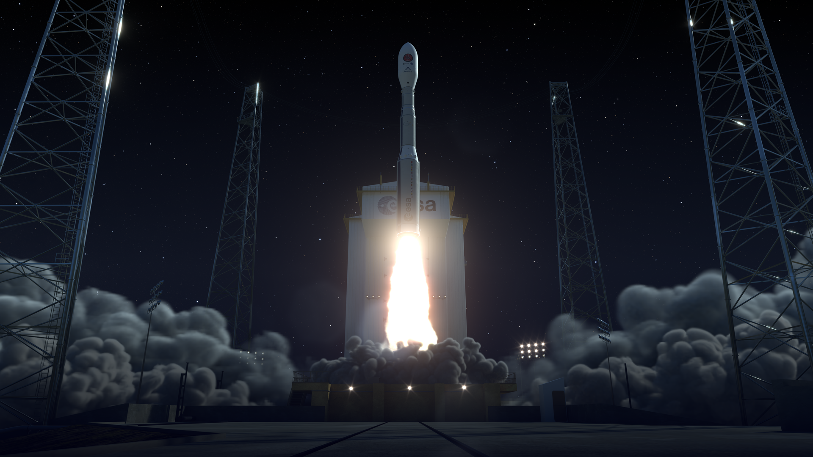

Science & Exploration How to follow the Smile launch live 12/05/2026 4428 views 37 likes ESA will be broadcasting live as the European-Chinese Smile mission launches at 04:52 BST/05:52 CEST (00:52 local time) on 19 May 2026. Smile will launch on a European Vega-C rocket from Europe's Spaceport in French Guiana. Times subject to change at short notice. Watch live from 05:30 CEST on 19 May Tune into ESA Web TV directly or via the ESA YouTube livestream to follow the launch live. The launch programme will run from 05:30-07:09 CEST. Milestones include: Event Time after liftoff Time in CEST Liftoff, first stage ignition 00:00 05:52 First stage expends all its fuel and separates 00:02 05:54 Second stage ignition 00:02 05:54 Second stage expends all its fuel and separates 00:04 05:56 Third stage ignition 00:04 05:56 Fairing opens revealing Smile to the sky 00:04 05:56 Third stage expends all its fuel and separates 00:07 05:59 First ignition of upper stage 00:20 06:12 End of first upper stage boost 00:24 06:16 Second upper stage boost starts 00:52 06:44 End of second upper stage boost 00:54 06:46 Smile separates from Vega-C and flies free 00:56 06:48 Expected time of acquisition of Smile's first signal from space 00:57 06:49 Expected time of deployment of Smile's solar arrays 01:03 06:55 Third upper stage boost to deorbit 02:00 07:52 End of third upper stage boost. Vega-C mission complete 02:01 07:53 Smile: A global answer to a global mystery Beyond launch day After the Vega-C rocket drops Smile off in a circular orbit 700 km above Earth's surface, the spacecraft will fire its engines 11 times in 25 days. These engine burns will gradually elongate Smile's orbit around Earth's poles, until it is reaching 121 000 km above the North Pole and 5000 km above the South Pole. Once Smile has arrived in this final operational orbit, the mission team will prepare the spacecraft for science. As well as checking that everything works as planned, this involves remotely unfolding Smile's magnetometer boom, opening the shutter of its X-ray camera and opening the cover of its ultraviolet camera. About three months after launch, the team will receive the first X-ray and ultraviolet images, and then finally begin the science that Smile is designed to do. The planned mission lifetime is three years. Stay updated via esa.int/Smile. What is Smile about to discover? About Smile Smile (the Solar wind Magnetosphere Ionosphere Link Explorer) is a joint mission between the European Space Agency (ESA) and the Chinese Academy of Sciences (CAS). Smile will use four science instruments to study how Earth responds to the solar wind from the Sun. In doing so, Smile will improve our understanding of solar storms, geomagnetic storms and the science of space weather. ESA is responsible for providing Smile's payload module (which carries three of the four science instruments), one of the spacecraft's four science instruments (the soft X-ray imager, SXI), the launcher, and the Assembly Integration and Testing facilities and services. ESA contributes to a second science instrument (the ultraviolet imager, UVI) and the mission operations once Smile is in orbit. CAS provides the other three science instruments and the spacecraft platform, and is responsible for operating the spacecraft in orbit. Smile is part of ESA's Cosmic Vision programme, principally contributing to answering the question 'How does the Solar System work?' For more information, visit: https://www.esa.int/Science_Exploration/Smile About Vega-C Europe's Vega-C rocket can launch 2300 kg into space, such as small scientific and Earth observation spacecraft. At 35 m tall, Vega-C weighs 210 tonnes on the launch pad and reaches orbit with three solid-propellant-powered stages before the fourth liquid-propellant stage takes over for precise placement of satellites into their desired orbit around Earth. Complementing the Ariane family to launch all types of payloads into their desired orbits, Vega-C ensures that Europe has versatile and independent access to space. ESA leads the Vega-C programme, working with Avio as prime contractor and design authority. For more information, visit: https://www.esa.int/Enabling_Support/Space_Transportation/Vega/Vega-C

8. NASA Langley Engineer Attends FAA Training
NASA
Read more

At a busy airport, every aircraft in the area shares just a handful of radio frequencies. Spectrum and time are constrained and if multiple people speak at once, both messages can get lost. Communications like "clearance delivery," which require long transmissions and readbacks, are challenging in high-traffic areas, particularly when weather or other factors require many aircraft to communicate with controllers at once. Going digital clears that channel for urgent, time-critical calls, among other things. And it's the current practice at some airports, where pilots can confirm clearances with the touch of a button, that the response goes directly to the controller's screen, and the updated information loads into their flight management system. Will Cummings-Grande, aerospace engineer with the Systems Analysis and Concepts Directorate based at NASA's Langley Research Center, is leading technical work that centers around Communications Architecture and Performance for Digital Clearance in NASA's Air Traffic Management and Safety (ATMS) project. He's researching the next layer of digital clearance, extending that same logic down to taxi instructions on the ground, so that pushback timing, routing, and runway assignments could also arrive digitally rather than over the radio. He sought out the most current, ground-level knowledge about how digital clearance delivery works in practice - not in a research paper, but in a real tower, on real systems, with the people who run them every day. The Federal Aviation Administration (FAA) offers the training he wanted to air traffic controllers, so he reached out to the FAA Academy "on a hope and a prayer" that they might accept him as a student. And in early April, Cummings-Grande traveled to the Mike Monroney Aeronautical Center (MMAC) in Oklahoma City to complete the Tower Data Link Services (TDLS) Application Specialist training - the same two-day, hands-on course required of working controllers at the 72 U.S. airports currently equipped with digital clearance delivery capability. Will Cummings-Grande, aerospace engineer with the Systems Analysis and Concepts Directorate, based at NASA's Langley Research Center Credit: NASA The air traffic control tower at the Mike Monroney Aeronautical Center in Oklahoma City, where Cummings-Grande visited to observe the Tower Data Link Services system in live operation. Credit: Will Cummings-Grande/NASA In the Classroom Cumming-Grande shadowed a working controller during exercises, trading off at the terminal during breaks so both got time on the system. His classmates were application specialists from Seattle, Sacramento, San Jose, and Fort Lauderdale, all controllers with day jobs managing high-traffic airspace who were there to become the designated system maintainers at their home airports. During breaks, Cummings-Grande had a luxury: time to test. "I got to bounce some of my ideas and concepts off of controllers who are out there interacting with the TDLS and all of the tools it touches in the current system," he said. "It was great to have both - here's what the controller-in-training gets, and here's what I get as a researcher - kind of lumped into the same experience." The FAA Academy also connected him with the systems engineers responsible for developing, testing, and implementing new TDLS hardware and software versions, and arranged a visit to the OKC tower to observe the system in live operation. What He Found The TDLS runs on fully air-gapped software, completely isolated from standard operating systems - a deliberate cybersecurity design that made the hands-on experience revelatory in ways a research paper couldn't replicate. "Interacting with the system was just very eye-opening as to how different these systems are from other computers that we commonly interact with," he said. The more significant discovery came from the curriculum itself. Reviewing the FAA's system architecture during training, Cummings-Grande noticed something he didn't know to look for: a link between the TDLS and the Terminal Flight Data Manager (TFDM), which does not yet exist operationally. That gap is now the center of his research questions. "I didn't realize I was missing this piece until I took this course," he said. Building on Two Decades of Homework The research Cummings-Grande is pursuing connects to a long thread of NASA work on surface safety and digital communications, including the Terminal Area Productivity program, the Surface Operation Automation Research (SOAR) project, the Low Visibility Landing and Surface Operations (LVLASO) project, and Surface Trajectory Based Operations (STBO) studies. These efforts kicked off in the mid-90s to inform FAA NextGen and demonstrated digital taxi clearances in a series of simulations at multiple facilities and ultimately flight tests at the Atlanta Airport. Those findings showed meaningful workload reductions, but the cost-benefit case wasn't there yet, and the technology wasn't ready in the fleet or in the facilities. What's changed, in Cummings-Grande's view, is the convergence of new infrastructure investments, including the rollout of systems derived from Airspace Technology Demonstration (ATD-2) technologies like the Spot and Runway Departure Advisor and the Precision Departure Release Capability through the TFDM, with renewed industry interest from a partner on the aircraft side. "We have all this homework that people have been doing for the last 20-30 years," he said. "Can we take advantage of the renewed interest from FAA and industry to enable this safety-enhancement?" His timeline estimate for a fully implemented system leans somewhere in the range of five to ten years. And the payoff, he says, will be tangible to anyone who flies. "This means that your flight will be safer than ever, and that your pilots will be focused on the right things during taxi. Instead of relying on pilots to write down their taxi clearance correctly or be familiar with the airport, the airplane will know and can double-check what the pilot is doing." A Case for Partnership Cummings-Grande isn't aware of another NASA researcher having taken this FAA course, and he thinks the model is worth repeating. He pointed to terminal procedures design (TERPS) as another area where FAA Academy training could benefit researchers working on urban air mobility and small UAS integration. "Anytime someone needs to do a deep dive into one of the systems - understanding the current state of practice, here are the buttons you push to make this happen - I think it'd be great to have an ongoing partnership with the FAA Academy and make that possible." The FAA Academy team was, by all accounts, a willing partner. Cummings-Grande extends his special thanks to the FAA's Eric Gandrud and Carol Raiford.

9. Perseverance Stuns in New Selfie
NASA
Read more

NASA's Perseverance rover recently took a self-portrait against a sweeping backdrop of ancient Martian terrain at a location the science team calls "Lac de Charmes." Assembled from 61 individual images, the selfie shows Perseverance training its mast on a rocky outcrop in the foreground after creating a circular abrasion patch, with the western rim of Jezero Crater stretching into the background. During abrading, the rover grinds down a portion of the rock's surface, allowing the science team to analyze what's inside. The selfie was captured on March 11, the 1,797th Martian day (or sol) of the mission, during the rover's deepest push west beyond the crater. Image credit: NASA/JPL-Caltech/MSSS

10. NASA's Perseverance Rover Snaps Selfie in Mars' Western Frontier
NASA
Read more

To view this video please enable JavaScript, and consider upgrading to a web browser that supports HTML5 video NASA's Perseverance looks down at a rocky outcrop nicknamed "Arethusa" and then appears to look into the camera in this animated selfie, which is composed of 61 images taken March 11, 2026, during the rover's deepest push west beyond Jezero Crater. NASA/JPL-Caltech/MSSS NASA's Perseverance Mars rover recently took a self-portrait against a sweeping backdrop of ancient Martian terrain at a location the science team calls "Lac de Charmes." Assembled from 61 individual images, the selfie shows Perseverance training its mast on a rocky outcrop on which it had just made a circular abrasion patch, with the western rim of Jezero Crater stretching into the background. The selfie was captured on March 11, the 1,797th Martian day, or sol, of the mission, during the rover's deepest push west beyond the crater. Perseverance is in its fifth science campaign, known as the Northern Rim Campaign, of its mission on the Red Planet. The Lac de Charmes region represents some of the most scientifically compelling terrain the rover has visited. NASA's Perseverance captured this enhanced-color panorama of an area nicknamed "Arbot" on April 5, the 1,882nd Martian day, or sol, of the mission. Made of 46 images, the panorama offers one of the richest geological vistas of the rover's mission, revealing a windswept landscape of diverse rock textures. NASA/JPL-Caltech/ASU/MSSS "We took this image when the rover was in the 'Wild West' beyond the Jezero Crater rim - the farthest west we have been since we landed at Jezero a little over five years ago," said Katie Stack Morgan, Perseverance's project scientist at NASA's Jet Propulsion Laboratory in Southern California. "We had just abraded and analyzed the 'Arethusa' outcrop, and the rover was sitting in a spot that provided a great view of both the Jezero Rim and the local terrain outside of the crater." During abrading, the rover grinds down a portion of the rock's surface, allowing the science team to analyze what's inside. The technique enabled the team to determine that the Arethusa outcrop is composed of igneous minerals that likely predate the formation of Jezero Crater. Igneous rocks with large mineral crystals form underground as molten rock cools and solidifies. Perseverance acquired the selfie - its sixth since landing on Mars in 2021 - using the WATSON (Wide Angle Topographic Sensor for Operations and eNgineering) camera mounted at the end of its robotic arm, which made 62 precision movements over approximately one hour to build the composite image (learn more about how selfies are made). Significant science Along with the selfie, Perseverance used Mastcam-Z, located on its mast, to capture a mosaic of the "Arbot" area in Lac de Charmes on April 5, or Sol 1882. Made of 46 images, the panorama offers one of the richest geological vistas of the mission, revealing a windswept landscape of diverse rock textures. The image provides the team a clear road map for investigating the ridgeline and the area's ancient rock variety, including what appear to be megabreccia - large fragments (some the size of skyscrapers) hurled by a massive meteorite impact that occurred on the plain called Isidis Planitia about 3.9 billion years ago. "What I see in this image is excellent exposure of likely the oldest rocks we are going to investigate during this mission," said Ken Farley, Perseverance's deputy project scientist at Caltech in Pasadena. "There is a sharp ridgeline visible in the mosaic whose jagged, angular texture contrasts starkly with the rounded boulders in the foreground. We also see a feature that may be a volcanic dike, a vertical intrusion of magma that hardened in place and was left standing as the softer surrounding material eroded away over billions of years." The rock color in the mosaic offers less information to the science team than the distinctive textures, which help them differentiate the rock types. Unlike Jezero Crater's river delta, which is composed of sedimentary rock, some rocks here appear to be extrusive igneous rocks (molten rock that reached the surface as lava flows) and impactites (rocks created or modified by a meteorite impact) believed to have formed before the crater about 4 billion years ago, offering a window into the planet's deep early crust. New ballgame, near-marathon distance "The rover's study of these really ancient rocks is a whole new ballgame," said Stack Morgan. "These rocks - especially if they're from deep in the crust - could give us insights applicable to the entire planet, like whether there was a magma ocean on Mars and what initial conditions eventually made it a habitable planet." After studying Arethusa, Perseverance drove northwest to the Arbot area, where it has been analyzing other rocky outcrops. When the team is satisfied with the work accomplished there, the rover will drive south to "Gardevarri," a site with a notably clear exposure of olivine-bearing rocks. Formed in cooling magma, these types of rocks contain information that can help scientists better understand Mars' volcanic history and provide context for large-scale geological processes. From there, the rover is expected to head southeast toward a region the team is calling "Singing Canyon" for more insights into the planet's early crust. After more than five years of surface operations, Perseverance has abraded 62 rocks, collected 27 rock cores in its sample tubes (25 sealed, 2 unsealed), and traveled almost 26 miles (42 kilometers) - in other words, just shy of a marathon (26.2 miles, or 42.195 kilometers). "Having the benefit of four previous rover missions, the Perseverance team has always known our mission was a marathon and not a sprint," said acting Perseverance project manager Steve Lee at JPL. "We've almost reached marathon distance. Our selfie may show that the rover is a bit dusty, but its beauty is more than skin deep. Perseverance is in great shape as we continue our explorations and extend into ultramarathon drive distances." More about Perseverance NASA's Jet Propulsion Laboratory, which is managed for the agency by Caltech, built and manages operations of the Perseverance rover on behalf of NASA's Science Mission Directorate in Washington, as part of NASA's Mars Exploration Program portfolio. The WATSON imaging system was built by, and is operated by, Malin Space Science Systems in San Diego. To learn more about NASA's Perseverance: https://science.nasa.gov/mission/mars-2020-perseverance News Media Contacts DC Agle Jet Propulsion Laboratory, Pasadena, Calif. 818-393-9011 agle@jpl.nasa.gov Karen Fox / Alana Johnson NASA Headquarters, Washington 240-285-5155 / 202-672-4780 karen.c.fox@nasa.gov / alana.r.johnson@nasa.gov 2026-032

11. NASA's Perseverance Captures Panorama at 'Arbot'
NASA
Read more
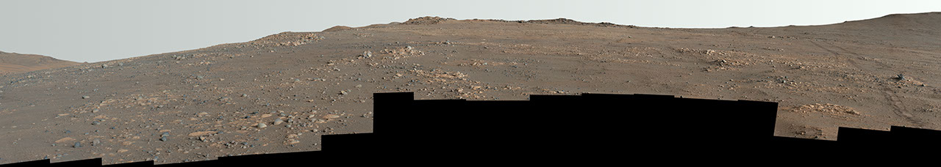

Description NASA's Perseverance Mars rover used its Mastcam-Z camera to capture this panorama of an area nicknamed "Arbot" on April 5, 2026, the 1,882nd Martian day, or sol, of the mission, during the rover's deepest push west beyond Jezero Crater. Made of 46 images, the panorama offers one of the richest geological vistas of the mission, revealing a windswept landscape of diverse rock textures. This is an enhanced-color version, which had its color bands processed to improve visual contrast and accentuate color differences. Figure A Figure A is a natural-color version of the mosaic. Figure B Figure B is a 3D anaglyph version designed for use with red-blue glasses. It is composed of 92 images collected by Mastcam-Z. NASA's Jet Propulsion Laboratory, which is managed for the agency by Caltech in Pasadena, California, built and manages operations of the Perseverance rover. Arizona State University leads the operations of the Mastcam-Z instrument, working in collaboration with Malin Space Science Systems in San Diego, on the design, fabrication, testing, and operation of the cameras, and in collaboration with the Niels Bohr Institute of the University of Copenhagen on the design, fabrication, and testing of the calibration targets. For more about Perseverance: science.nasa.gov/mission/mars-2020-perseverance/

12. NASA's Perseverance Rover Snaps Westernmost Selfie
NASA
Read more
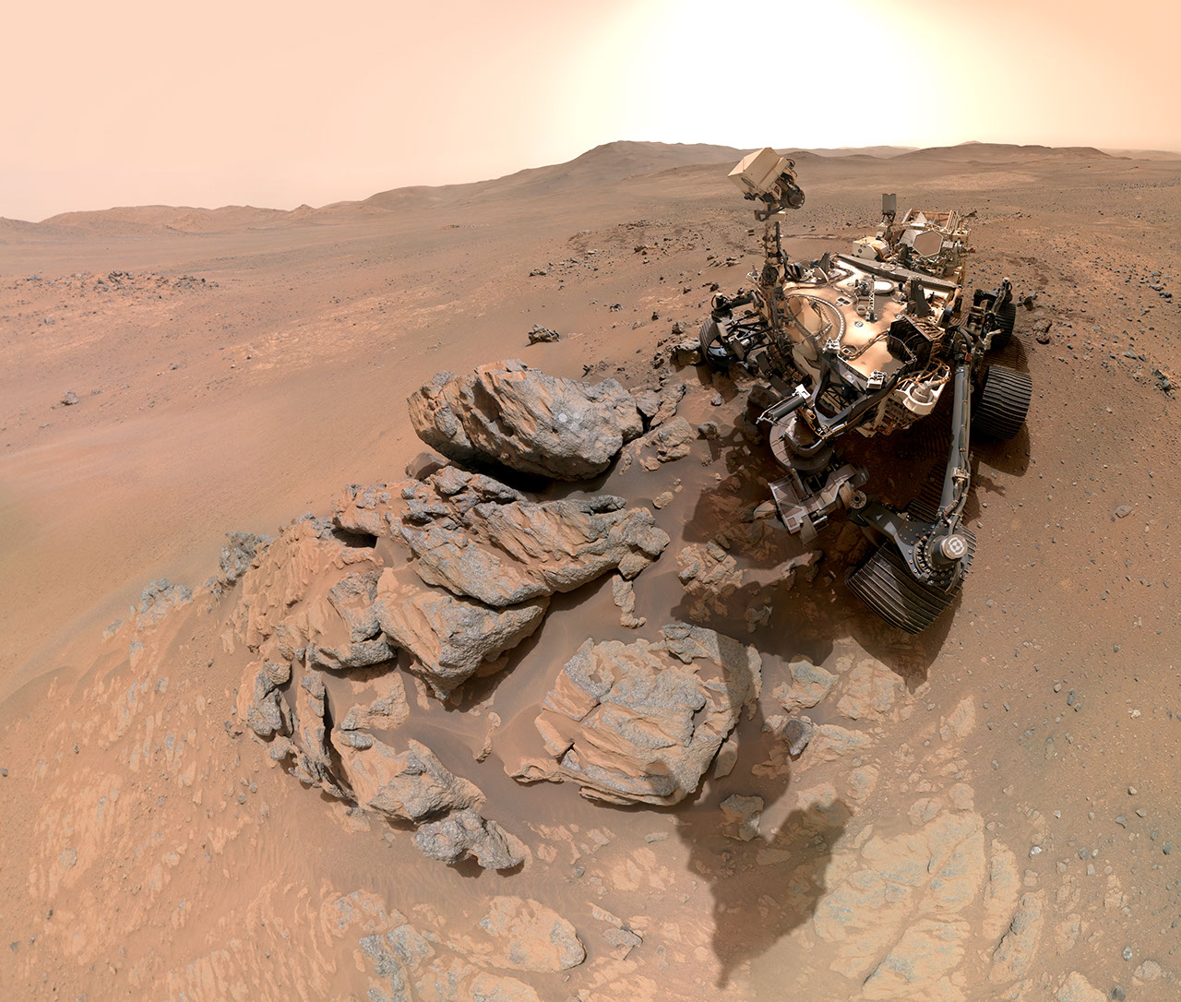

Description NASA's Perseverance Mars rover took this selfie on March 11, 2026, the 1,797th Martian day, or sol, of the mission, during the rover's deepest push west beyond Jezero Crater. Assembled from 61 individual images, the selfie shows Perseverance training its mast on the "Arethusa" rocky outcrop after creating a whitish circular abrasion patch. The crater's western rim of Jezero Crater is visible in the background. Figure A Figure A is a version of the selfie in which the rover appears to be looking at the camera. Animation (.gif) Here is a GIF combining the main image and Figure A, in which the rover appears to look up and down. The selfie is composed of images taken by the WATSON (Wide Angle Topographic Sensor for Operations and eNgineering) camera on the end of the rover's robotic arm. The images were stitched together after being sent back to Earth. WATSON is part of an instrument called SHERLOC (Scanning Habitable Environments with Raman & Luminescence for Organics & Chemicals). WATSON was built by Malin Space Science Systems (MSSS) in San Diego and is operated jointly by MSSS and JPL. The rover's process for taking a selfie is explained in this video. NASA's Jet Propulsion Laboratory, which is managed for the agency by Caltech in Pasadena, California, built and manages operations of the Perseverance rover. For more about Perseverance: https://science.nasa.gov/mission/mars-2020-perseverance/

13. Hello Universe: NASA's Next-Gen Space Processor Undergoes Testing
NASA
Read more

Small enough to fit in the palm of a hand, NASA's High Performance Spaceflight Computing processor packs the power of a full system-on-a-chip. This next-generation processor is made to survive deep space while delivering a massive leap in computational speed compared to current spacecraft technology. NASA/JPL-Caltech NASA's High Performance Spaceflight Computing project aims to dramatically improve the computing power of spacecraft. Missions need processors that can withstand the harsh space environment, so they use chips developed years ago that are hardy and reliable. But upgraded chips are needed to enable the development of autonomous spacecraft, accelerate the rate of scientific discovery through faster data analysis, and support astronauts on missions to the Moon and Mars. "Building on the legacy of previous space processors, this new multicore system is fault-tolerant, flexible, and extremely high-performing," said Eugene Schwanbeck, program element manager in NASA's Game Changing Development program at the agency's Langley Research Center, in Hampton, Virginia. "NASA's commitment to advancing spaceflight computing is a triumph of technical achievement and collaboration." The centerpiece of the High Performance Spaceflight Computing project is a new radiation-hardened, high-performance processor, designed to provide up to 100 times the computational capacity of current spaceflight computers while enduring a barrage of challenges in space. NASA's Jet Propulsion Laboratory in Southern California has been conducting various tests that replicate those challenges. "We are putting these new chips through the wringer by carrying out radiation, thermal, and shock tests while also evaluating their performance through a rigorous functional test campaign," said Jim Butler, High Performance Space Computing project manager at JPL. The processor must endure myriad tests to prove it can survive the rigors of spaceflight, including electromagnetic radiation and extreme temperature swings, both of which can degrade electronics. High-energy particles from the Sun and interstellar space can cause errors that send a spacecraft into "safe mode," where nonessential operations are shut down until mission operators resolve the issue. There are also unique challenges associated with landing on planetary bodies. "To simulate real-world performance, we are using high-fidelity landing scenarios from real NASA missions that would typically require power-intensive hardware to process huge volumes of landing-sensor data," said Butler. "This is an exciting time for us to be working on hardware that will enable NASA's next giant leaps." Testing at JPL, which began in February, will continue for several months. Results have been promising: The processor is working as designed and indications show it operating at 500 times the performance of the radiation-hardened chips currently in use. In a symbolic milestone, the team sent an email at the start of testing with the subject line "Hello Universe" - a nod to the test message that was popular in early computer development. Computing superpowers Built by Microchip Technology Inc., headquartered in Chandler, Arizona, the High Performance Spaceflight Computing processor is being developed by the company and JPL through a commercial partnership. Samples have been provided to early access partners in the broader defense and commercial aerospace industry. The technology will enable autonomous spacecraft to use artificial intelligence to respond in real time to complex situations and environments where human input isn't possible. It will help deep space missions analyze, store, and transmit troves of data to Earth, accelerating the rate of science discoveries. It could also support future human missions to the Moon and Mars. Known as a system-on-a-chip (or SoC), the processor can fit in the palm of a hand and includes all the key components of a computer, such as central processing units, computational offloads, advanced networking units, memory, and input/output interfaces. Compact and energy-efficient, SoCs are commonly found in smartphones and tablets. But only the SoCs JPL is testing are built to survive for years, millions (or even billions) of miles from the nearest repair technician, enduring conditions that even the toughest home user couldn't replicate. Once certified for spaceflight, NASA will incorporate the chip into the computing hardware for many of the agency's Earth orbiters, rovers exploring planetary surfaces, crewed habitats, and deep-space missions. The technology will be adapted by Microchip for Earth-based industries too, such as aviation and automotive manufacturing. The versatility of High Performance Spaceflight Computing supports NASA's continued advancements in space exploration while providing transformative tools for numerous fields on Earth. The project is managed by the Space Technology Mission Directorate's Game Changing Development (GCD) program based at NASA Langley. The GCD program and JPL, a division of Caltech in Pasadena, California, led the end-to-end maturation of the High Performance Spaceflight Computing technology by developing mission requirements, funding industry studies, and guiding the project life cycle to delivery. NASA JPL selected Microchip as a partner in 2022, and the company funded its own research and development of the processor. For more information about the High Performance Spaceflight Computing project, visit: https://go.nasa.gov/4cIGUKu News Media Contacts Ian J. O'Neill Jet Propulsion Laboratory, Pasadena, Calif. 818-354-2649 ian.j.oneill@jpl.nasa.gov Jasmine Hopkins NASA Headquarters, Washington 321-432-4624 jasmine.s.hopkins@nasa.gov 2026-031

14. I Am Artemis: Kathleen Harmon
NASA
Read more

Listen to this audio excerpt from Kathleen Harmon, the Artemis II Mission Interface Manager for NASA's Deep Space Network: 0:00 / 0:00 Your browser does not support the audio element. Captivated by Apollo launches on her television as a child, Kathleen Harmon now plays a key role in NASA's Artemis program. Harmon serves as the Artemis II mission interface manager for NASA's Deep Space Network, an international array of giant radio antennas which are used to communicate with spacecraft. Managed by the agency's Jet Propulsion Laboratory in Southern California, the Deep Space Network is the largest scientific telecommunications system in the world, supporting more than 40 missions exploring deep space. The network is also a key component of NASA's Moon-bound Artemis missions. Kathleen Harmon, Artemis II Mission Interface Manager for NASA's Deep Space Network, in the Charles Elachi Mission Control Center at NASA's Jet Propulsion Laboratory in Southern California. NASA/JPL-Caltech "If you're in a car and you're going somewhere and you don't have GPS or a cellphone, you might get lost, or you might not be able to tell someone that you're lost," said Harmon, illustrating how the Deep Space Network "talks" to spacecraft. "The network provides that lifeline to spacecraft across the solar system, and even interstellar space, so that they can talk to Earth and send back amazing science data, images, and videos from Mars rovers, space telescopes, orbiters, and more." In her role as a mission interface manager, and with her background as a systems engineer and decades of experience with NASA, Harmon prepares missions for launch and operations. This role requires careful coordination and collaboration across international partners, as the Deep Space Network's radio antennas are spread around the world. She was responsible for ensuring the Deep Space Network was prepared to support the Artemis II spacecraft before launch. You could not get any of that information back without the network. It's a critical asset that also lets spacecraft know where they are. Kathleen Harmon Artemis II Mission Interface Manager for NASA's Deep Space Network "The network has three complexes equally spaced around the world so, as the Earth rotates, one is always in view to communicate with spacecraft wherever they are in the solar system," said Harmon. At any given moment, the Deep Space Network complex that is currently experiencing daylight is "in control" of the entire network to ensure consistent spacecraft connectivity, an operational approach the network team calls "follow the Sun." While the network supports NASA's return to the Moon, working in partnership with the Near Space Network, it will continue to maintain a close watch on NASA's fleet of spacecraft at the Moon and beyond. "We supported Artemis II 24 hours a day, seven days a week for the entire mission with two antennas - a prime and a backup," Harmon said. She added that while the network was supporting Artemis II, it also communicated with robotic rovers and spacecraft throughout the solar system. While Harmon's work has supported missions from Juno to Voyager, her contributions to the Artemis program remind her of what first inspired her to join to NASA. "I was a very small child when the Apollo missions happened," said Harmon. "Apollo was my earliest memory."

