 |  | 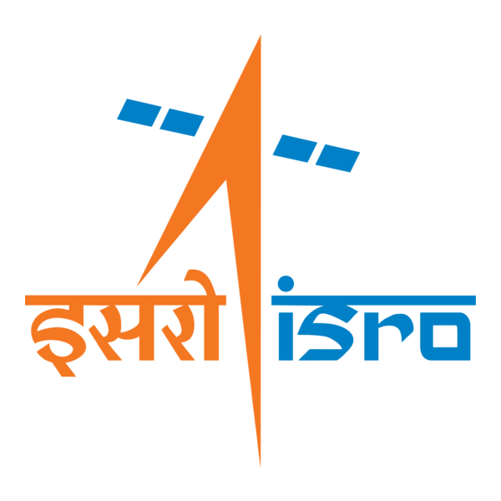

🌌 अंतरिक्ष समाचार | Space News
बुधवार, ३०/०९/२०२६ | Wednesday, 30/09/2026

1. ISRO Conducts National Meet on 'Scientific Exploration of the Moon through Chandrayaan Missions' - ISRO
Read more
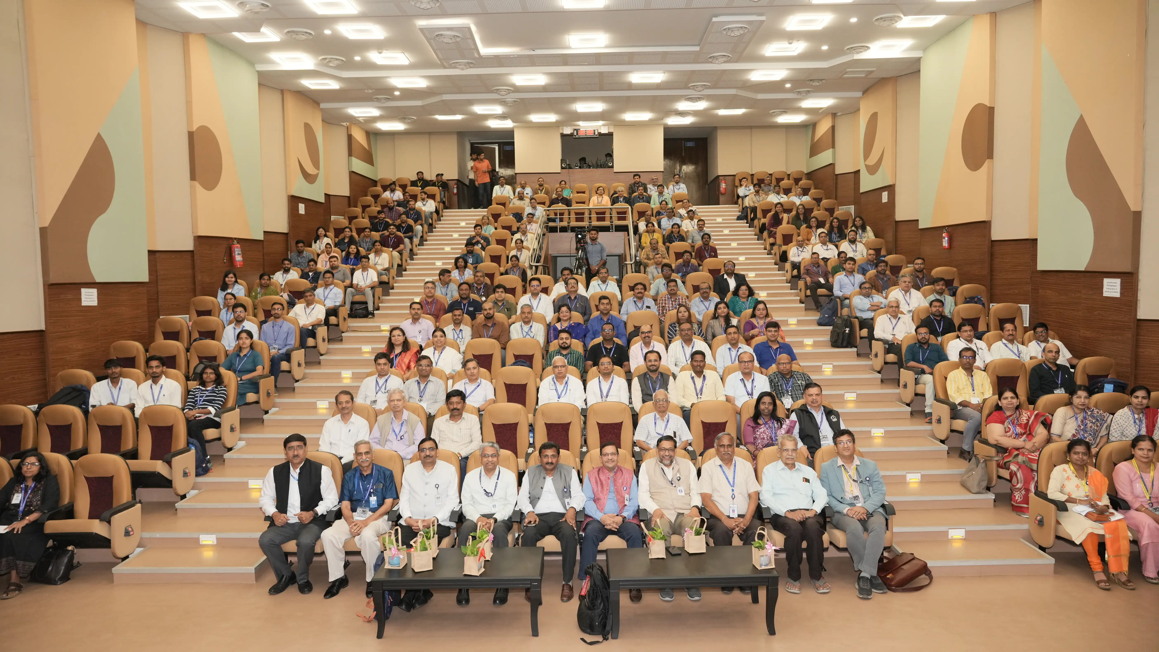
ISRO Conducts National Meet on 'Scientific Exploration of the Moon through Chandrayaan Missions' ISRO

2. Nilekani Panel Consults Ex-ISRO Chief On NTA Reforms - TradingView
Read more
Nilekani Panel Consults Ex-ISRO Chief On NTA Reforms TradingView

3. ISRO IPRC Recruitment 2026 Notification Out For 22 Posts, Apply Online Link - PW
Read more
ISRO IPRC Recruitment 2026 Notification Out For 22 Posts, Apply Online Link PW

4. NVS-03: Why India's armed forces eagerly await this navigation satellite from ISRO - theweek.in
Read more
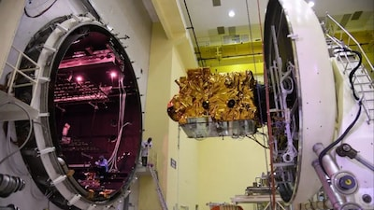
NVS-03: Why India's armed forces eagerly await this navigation satellite from ISRO theweek.in

5. India-France Third Joint Satellite Progresses as Gaganyaan Support Continues - The Policy Edge
Read more

India-France Third Joint Satellite Progresses as Gaganyaan Support Continues The Policy Edge

6. Lesjöfors supplies springs and components for ISRO space docking mission - torque-expo.com
Read more
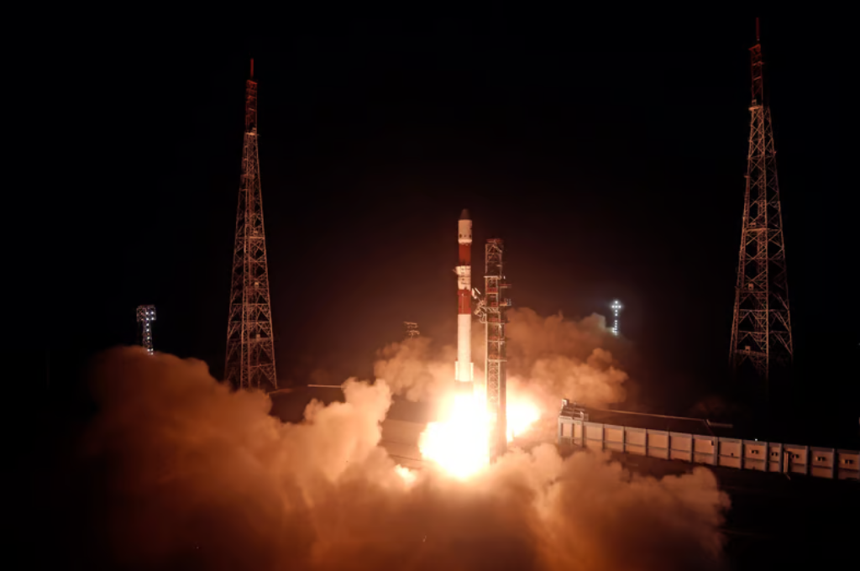
Lesjöfors supplies springs and components for ISRO space docking mission torque-expo.com

7. Under the Microscope: NASA-made material for moon manufacturing
Read more
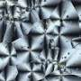
Photos taken using a microscope reveal the colorful, kaleidoscope-like crystal structure of a new NASA-made material that could be used for manufacturing during future space missions. Developed at NASA's Glenn Research Center in Cleveland, the material could be created directly on the moon or Mars, allowing NASA to pack fewer supplies-saving weight and reducing launch costs.

8. NASA highlights lessons learned from Swift boost mission
Read more
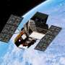
A commercial mission to boost NASA's Neil Gehrels Swift Observatory ended without raising the spacecraft's orbit, but the agency and Katalyst Space gained experience that will benefit future in-space servicing programs.

9. NASA ramps up support to get Boeing's astronaut capsule flying after Butch and Suni fiasco
Read more
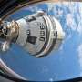
NASA is throwing extra support and money behind Boeing's troubled astronaut capsule to get it fixed and flying again as soon as possible.

10. How NASA's Nancy Grace Roman Space Telescope will open a window into the Milky Way
Read more
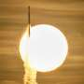
Look up at the night sky with the naked eye and it may seem like it rarely changes. Yet the universe is in constant flux. Stars drift through space, orbiting the center of the Milky Way as planets orbit them. They rotate, showing spots on their surfaces and sometimes producing violent outbursts that affect planetary atmospheres much like solar storms produce auroras on Earth.

