IIRS Daily Space Digest Saturday, 16/05/2026

1. Audit flags former Delhi Medical Council registrar's irregular service extension, losses worth over Rs 10 crore
Delhi | The Indian Express
Read more


From expensive Diwali gifts and foreign trips to irregular extension of service and enhancement of retirement age of its registrar, a special audit conducted by the Delhi Health department has flagged financial and administrative irregularities in the functioning of the Delhi Medical Council (DMC), estimating losses worth over Rs 10 crore to the government exchequer. The audit report observed that the then Registrar Dr Girish Tyagi, in his official capacity, was responsible for the government losing more than Rs 5.57 crore between 2019 and 2025 due to a reduction in renewal fees that doctors had to pay while they renewed their registration with the DMC. In addition, the report recommended that the government should recover monetary benefits exceeding Rs 3.23 crore from Tyagi that he had received in the form of salary, allowances and related expenditures. Responding to the allegations, Tyagi termed the audit findings "misleading" and maintained that they appeared aimed at "deliberately creating a false public perception of corruption where none has been established". Alleging that the issue regarding extension of service was being selectively projected, Tyagi said that as the registrar, he was merely an employee of DMC. "An employee cannot grant an extension to himself. The extension of service was approved by a duly constituted 25-member Delhi Medical Council through its competent decision-making process. Significantly, many of the very persons now attempting to raise false allegations were themselves signatories to or participants in those decisions," he added. He maintained that the matter is sub judice and any attempt to publicly pronounce guilt or create a media narrative was "premature, improper, and contrary to principles of natural justice". According to the report, the DMC extended Tyagi's tenure, enhanced his retirement age and granted extension of service to him without obtaining mandatory approval of the competent authority. Tyagi had joined the DMC as deputy registrar in June 2007 and became registrar in July 2008. While he was originally due to retire at 60 in November 2019, a DMC amendment in February that year enhanced the retirement age to 65. After he turned 65 on November 3, 2024, the DMC on November 11 approved an additional one-year extension from December 1, 2024. Last July, the Delhi government constituted a committee to investigate the alleged lapses. Story continues below this ad The report noted that no records were produced by the DMC to indicate that Tyagi fulfilled the eligibility conditions prescribed under guidelines issued by the Union Ministry of Health and Family Welfare for continuation in service up to the age of 65 years. "The mandatory prior approval of the competent authority for such enhancement was neither sought nor obtained," it added. "These irregular actions resulted in avoidable financial liability to the government exchequer on account of payment of salary and other related allowances made to Dr Girish Tyagi… for the period from 01.12.2019 to 10.02.2025 (beyond the age of 60 year to till his resignation)," the report said. The total loss amounted to Rs 3,23,57,768, it added. The audit further held Tyagi liable for financial irregularities worth over Rs 1.24 crore on account of regularisation of multi-tasking staff to lower division clerk posts, irregular payment towards medical insurance of council members and purchase of costly gift items in violation of prescribed financial rules and procedures. Further, it recommended to the government to recover around Rs 13 lakh spent in lieu of the mandatory three-month notice period required for tendering resignation as per DMC Act and Rules. The report flagged non-maintenance of stock records and purchase of costly gifts worth Rs 64.47 lakh between 2019-20 and 2024-25. It also pointed to discrepancies in maintenance of service books, which contain an employee's service history, including promotions, pay, leave and transfers. The audit, conducted by the accounts wing of the Health department, scrutinised all payments made to Tyagi pertaining to salary and allowances, pay fixation, leave encashment, bonus, medical expenses, court fees, foreign visits, hiring of vehicle and telephone expenses. The DMC is a statutory body constituted under the Delhi Medical Council Act, 1997, responsible for regulating the practice of modern medicine in the Capital.

2. Only electric three-wheelers to be registered from January 2027: CAQM
Delhi | The Indian Express
Read more


From mandating electric three-wheelers to restricting fuel for polluting vehicles, the Commission for Air Quality Management (CAQM) on Friday issued a set of directions aimed at tackling key sources of air pollution across the NCR. At its 28th full Commission meeting, the panel decided to allow only electric three-wheelers (L5 category) - both passenger and goods - to be registered in a phased manner. The rollout will begin in Delhi from January 1, 2027, extend to high vehicle-density districts including Gurugram, Faridabad, Sonipat, Ghaziabad and Gautam Buddha Nagar from January 1, 2028, and cover the remaining NCR districts from January 1, 2029. This also means that existing CNG or diesel three-wheelers would still be allowed to operate until they are gradually phased out. The Commission also directed to restrict the sale of fuel to vehicles without a valid Pollution Under Control Certificate (PUCC) across the NCR from October 1 this year, tightening enforcement against polluting vehicles. Flagging a spike in crop residue burning, the Commission noted that Punjab recorded 8,986 stubble burning incidents between April 1 and May 14 this year, and directed state authorities to step up enforcement measures to curb such cases. It is also for the first time that paddy stubble burning will be officially monitored on ground. To implement this, the Commission also directed for the implementation of the Action Plan for prevention and control of paddy stubble burning in 2026 with a target of complete elimination of paddy stubble burning in the NCR states. According to a statement by the Commission, state governments have prepared and updated state-specific action plans for this year's paddy harvest season in line with the broad framework provided by the CAQM. The Commission also reviewed the expansion of the Continuous Ambient Air Quality Monitoring Stations (CAAQMS) network, noting that 46 additional stations are proposed across the NCR, taking the total to 157. Under revised norms, monitoring density will be one station per 25 sq km in Delhi and contiguous cities, and one per 50 sq km in other districts, with directions issued for faster installation. It ratified the reconstitution of a sub-committee on monitoring and compliance, and noted that a digital MIS portal is being developed to track implementation of Annual Action Plans across sectors. Why the transition The Commission noted that a recent report by an air quality expert panel identified the vehicular sector as one of the major contributors to PM2.5 emissions in Delhi-NCR. The expert panel has recommended a transition of three-wheelers to EV, besides pushing for "accelerated transition towards cleaner mobility". This is also in line with the draft EV policy rolled out by the Delhi government. Story continues below this ad The Commission noted that controlling vehicular pollution is critical to control PM2.5, NOx and CO levels. The expert panel, in its report, had highlighted that transport consistently ranks as the most significant source of pollution in Delhi, encompassing both on-road and off-road vehicles powered by petrol, diesel, and CNG. The impact of tailpipe emissions, a major urban pollutant, depends on several factors: vehicle type, age, mileage, fuel type, maintenance, and adherence to fuel standards. Vehicles following modern emission standards, such as BS-VI, demonstrate significantly lower pollutant output than those under older regimes like BS-IV, BS-III, or earlier standards. Older vehicles often show higher emission intensity as engines deteriorate and control systems fail over time. The type of pollutants varies from fuel to fuel: diesel engines primarily release particulate matter along with nitrogen and sulphur oxides, while CNG engines mostly emit nitrogen oxides with reduced particulate levels, it said.

3. ISRO to launch PSLV-C62 mission on January 12 from Sriharikota - The News Mill
"ISRO OR NRSC OR IIRS after:2026-05-15" - Google News
Read more


The Indian Space Research Organisation (ISRO) will launch its PSLV-C62 mission on January 12 (Monday) at 10:17 AM IST from the First Launch Pad at Satish Dhawan Space Centre (SDSC), Sriharikota. In a post on X on Tuesday, ISRO shared, "The Launch of PSLV-C62 Mission is scheduled on 12 January 2026 at 10:17 hrs IST from First Launch Pad (FLP), SDSC SHAR, Sriharikota." The Launch of PSLV-C62 Mission is scheduled on 12 January 2026 at 10:17 hrs IST from First Launch Pad (FLP), SDSC SHAR, Sriharikota. Public can witness the launch from Launch View Gallery at SDSC SHAR, Sriharikota by registering through online from the following link… - ISRO (@isro) January 6, 2026 On December 24, ISRO successfully launched the BlueBird Block-2 communication satellite for the United States' AST SpaceMobile. The satellite was successfully placed in orbit, and the mission was declared a success. The launch took place from the Satish Dhawan Space Station in Sriharikota, Andhra Pradesh, at 8:55 AM IST. The mission deployed the next-generation communication satellite designed to provide high-speed cellular broadband directly to smartphones worldwide. The BlueBird Block-2 spacecraft would be the heaviest payload to be launched into Low Earth Orbit in the history of the LVM3 rocket. ISRO stated that the LVM3-M6/BlueBird Block-2 Mission is a dedicated commercial mission onboard the LVM3 launch vehicle, which will launch the BlueBird Block-2 communication satellite of AST SpaceMobile, USA. This mission marks the sixth operational flight of LVM3. In this mission, LVM3-M6 will place the BlueBird Block-2 satellite into Low Earth Orbit, which is the largest commercial communications satellite to be deployed in Low Earth Orbit. It will also be the heaviest payload to be launched by LVM3 from Indian soil. LVM3, developed by ISRO, is a three-stage launch vehicle comprising two solid strap-on motors (S200), a liquid core stage (L110), and a cryogenic upper stage (C25). It has a lift-off mass of 640 tonnes, a height of 43.5 meters, and a payload capability of 4,200 kg to Geosynchronous Transfer Orbit (GTO)

4. ISRO scientist's saree from Mars mission showcased at US museum: "One of India's rocket women" - MSN
"ISRO OR NRSC OR IIRS after:2026-05-15" - Google News
Read more

ISRO scientist's saree from Mars mission showcased at US museum: "One of India's rocket women" MSN

5. Odisha minister visits ISRO facilities in Bengaluru - newskarnataka.com
"ISRO OR NRSC OR IIRS after:2026-05-15" - Google News
Read more

Odisha minister visits ISRO facilities in Bengaluru newskarnataka.com

6. Gaganyaan: Isro integrating Vyommitra in crew module, key safety tests underway - The Indian Panorama
"ISRO OR NRSC OR IIRS after:2026-05-15" - Google News
Read more

India's human spaceflight ambitions are entering a decisive phase, with the Indian Space Research Organisation initiating pre-flight integration of its humanoid robot Vyommitra ahead of the maiden uncrewed mission of the HLVM3-G1/OM1. Vyommitra, designed to simulate astronaut functions in space, will play a crucial role in testing life-support systems, crew interfaces and microgravity conditions during the upcoming mission. The robot is expected to gather vital data that will help refine systems before Indian astronauts, referred to as Gaganyatris, are sent into orbit under the Gaganyaan mission. The HLVM3 rocket, a human-rated version of India's heavy-lift launch vehicle, will carry Vyommitra on this critical test flight. Engineers are currently focused on integrating the robot with onboard systems, ensuring seamless communication, environmental monitoring and response simulations during the mission. Parallel to flight preparations, Isro is also advancing ground safety systems, a key requirement for any human spaceflight programme. Among these is the Flight Crew Emergency Egress System, a specialised infrastructure designed to evacuate astronauts from the launch pad in case of emergencies such as fire, fuel leaks or other pre-launch hazards. Unlike the onboard Crew Escape System, which activates during in-flight emergencies, the egress system is intended for use while the rocket remains on the launch pad. It functions as a rapid evacuation mechanism, allowing astronauts to exit the crew module and move to safety within seconds. The system uses a zipline-based mechanism, enabling Gaganyatris to slide away quickly from the launch tower to a secure distance. This ground-based "emergency exit" is a standard feature in global human spaceflight operations and is critical for ensuring crew safety during the most vulnerable pre-launch phase.

7. Chandrayaan-2 Just Mapped the Moon's Hidden Fuel Station - The Hans India
"ISRO OR NRSC OR IIRS after:2026-05-15" - Google News
Read more
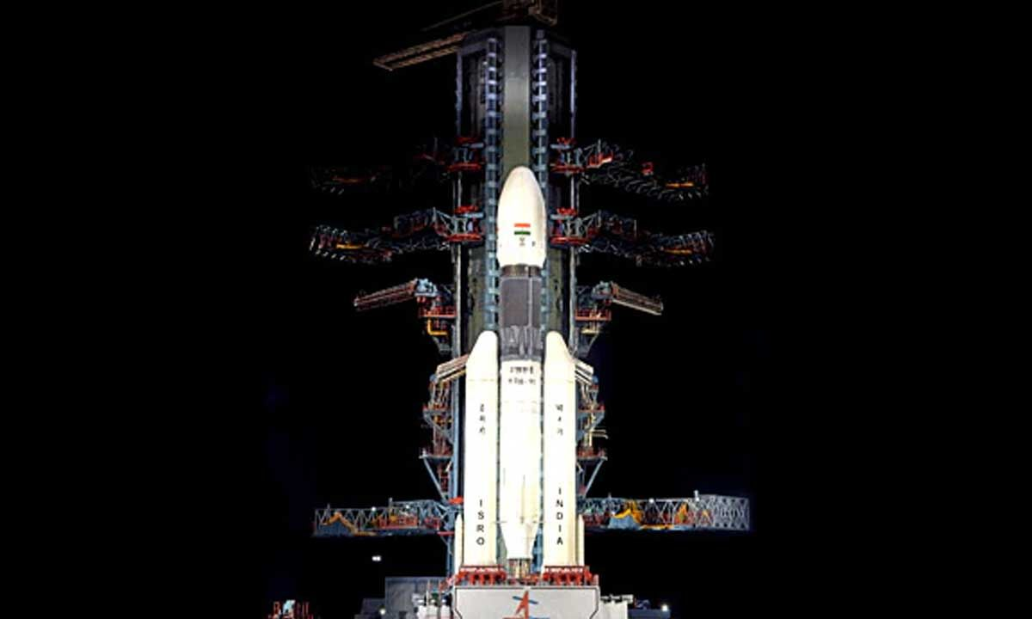

In a discovery that is reshaping the global lunar race, Indian scientists have confirmed the presence of significant subsurface water ice at the Moon's South Pole. Using data from the Chandrayaan-2 orbiter, the Indian Space Research Organisation (ISRO) has successfully "seen through" the lunar surface, identifying ice deposits buried meters beneath the dust-a feat that has eluded previous international missions. The findings, centered on the Faustini Crater, provide a definitive "map" for future exploration, positioning India as a leader in the search for life-sustaining resources in deep space. For decades, space agencies have debated whether lunar radar signals were reflecting off water ice or just jagged rocks. ISRO's Dual Frequency Synthetic Aperture Radar (DFSAR) has finally settled the debate. By analyzing the way radar waves bounce back from the lunar soil (regolith), scientists identified a unique "blueprint": * High Circular Polarisation: Indicates the signal is bouncing multiple times within a substance. * Low Depolarisation: Proves the substance is uniform (like ice) rather than irregular (like rough rocks). This technological precision allowed the DFSAR to differentiate between dry regolith, buried rocks, and pure subsurface ice located 2-3 meters below the surface. The Mission Roadmap: From Chandrayaan-2 to LUPEX While Chandrayaan-2 found the ice from orbit, India's next move is to touch it. The upcoming LUPEX (Lunar Polar Exploration) mission, a joint venture between India (ISRO) and Japan (JAXA), will send a rover equipped with a massive drill to the exact coordinates mapped by DFSAR. "The Moon is no longer just a destination," experts say. "It is a fuel station for Mars and beyond." Why Lunar Water Changes Everything The discovery is a game-changer for the "Three Powers"-India, China, and the United States-all of whom are racing to establish a permanent presence at the South Pole. Lunar water is not meant for drinking; it is the key to deep-space survival. The discovery of lunar water is a transformative milestone because it provides the two essential components for sustained deep-space travel: energy and life support. Through the process of electrolysis, the water ice (H_2O) found in craters can be split into its core elements. The hydrogen acts as a high-efficiency rocket fuel, while the oxygen provides breathable air for astronauts stationed in lunar bases. Beyond these chemical uses, the water ice itself is invaluable in its raw form, serving as a natural shield against space radiation and acting as a cooling agent for equipment. By harvesting these resources on-site, space agencies can transform the Moon into a functional "fuel station," drastically reducing the weight and cost of missions heading to Mars and beyond. India's Strategic Edge By being the first to successfully land near the South Pole (with Chandrayaan-3) and now possessing the most detailed maps of subsurface ice, India has secured a strategic advantage in the "New Space Race." As the global community looks toward Mars, the ability to harvest "Fuel + Air" directly from the Moon significantly reduces the cost and complexity of long-term human missions. India now knows exactly where the most valuable substance in the solar system is buried. The race to extract it has officially begun.

8. School Assembly News Headlines (May 16, 2026): PM Modi UAE Visit, NEET 2027 Digital Shift, ISRO Navigation Satellite, South China Sea Standoff, Queen Margrethe Health, Heatwave Red Alert Other News Updates - Jagran Josh
"ISRO OR NRSC OR IIRS after:2026-05-15" - Google News
Read more

Manisha Waldia is an accomplished content writer with 4+ years of experience dedicated to UPSC, State PCS, and current affairs. She excels in creating expert content for core subjects like Polity, Geography, and History. Her work emphasises in-depth conceptual understanding and rigorous analysis of national and international affairs. Manisha has curated educational materials for leading institutions, including Drishti IAS, Shubhara Ranjan IAS, Study IQ, and PWonly IAS. Email ID: manisha.waldia@jagrannewmedia.com

9. NASA Science, Cargo Launch on 34th SpaceX Resupply Mission to Station
NASA
Read more

The SpaceX Falcon 9 rocket, carrying the Dragon cargo spacecraft atop, launched Friday, May 15, 2026, from Space Launch Complex 40 at Cape Canaveral Space Force Station in Florida. Credit: NASA+ The 34th SpaceX commercial resupply mission under contract with NASA is headed to the International Space Station with new scientific experiments after lifting off at 6:05 p.m. EDT Friday on a Falcon 9 rocket from Space Launch Complex 40 at Cape Canaveral Space Force Station in Florida. The SpaceX spacecraft, loaded with nearly 6,500 pounds of cargo for the space station's Expedition 74 crew, is scheduled to autonomously dock at about 7 a.m. Sunday, May 17, to the forward port of the station's Harmony module. Watch NASA's live rendezvous and docking coverage beginning at 5:30 a.m. on NASA+, Amazon Prime, and the agency's YouTube channel. Learn how to watch NASA content through a variety of online platforms, including social media. In addition to cargo for the crew aboard the space station, Dragon will deliver several new experiments, including a project to determine how well Earth-based simulators mimic microgravity conditions, a bone scaffold made from wood that could produce new treatments for fragile bone conditions like osteoporosis, and equipment to help researchers evaluate how red blood cells and the spleen change in space. The Dragon spacecraft also will carry a new instrument to study charged particles around Earth that can impact power grids and satellites, an investigation that could provide a fundamental understanding of how planets form, and an instrument designed to take highly accurate measurements of sunlight reflected by Earth and the Moon. These experiments are just a sample of the hundreds of investigations conducted aboard the orbiting laboratory in the areas of biology and biotechnology, physical sciences, and Earth and space science. For more than 25 years, people have lived and worked continuously aboard the International Space Station, advancing scientific knowledge and making research breakthroughs that aren't possible on Earth. The space station helps NASA understand and overcome the challenges of human spaceflight, expand commercial opportunities in low Earth orbit, and build on the foundation for long-duration missions to the Moon, as part of the Artemis program, and to Mars. The Dragon spacecraft is scheduled to remain at the station until mid-June, when it will depart and return to Earth with time-sensitive research and cargo, ahead of splashing down off the coast of California. Learn more about International Space Station research, operations, and its crews at: https://www.nasa.gov/station -end- Jimi Russell Headquarters, Washington 202-358-1100 james.j.russell@nasa.gov Danielle Sempsrott / Leejay Lockhart Kennedy Space Center, Fla. 321-867-2468 danielle.c.sempsrott@nasa.gov / leejay.lockhart@nasa.gov Sandra Jones / Joseph Zakrzewski Johnson Space Center, Houston 281-483-5111 sandra.p.jones@nasa.gov / joseph.a.zakrzewski@nasa.gov

10. Hubble Sights Galaxy in Transition
NASA
Read more
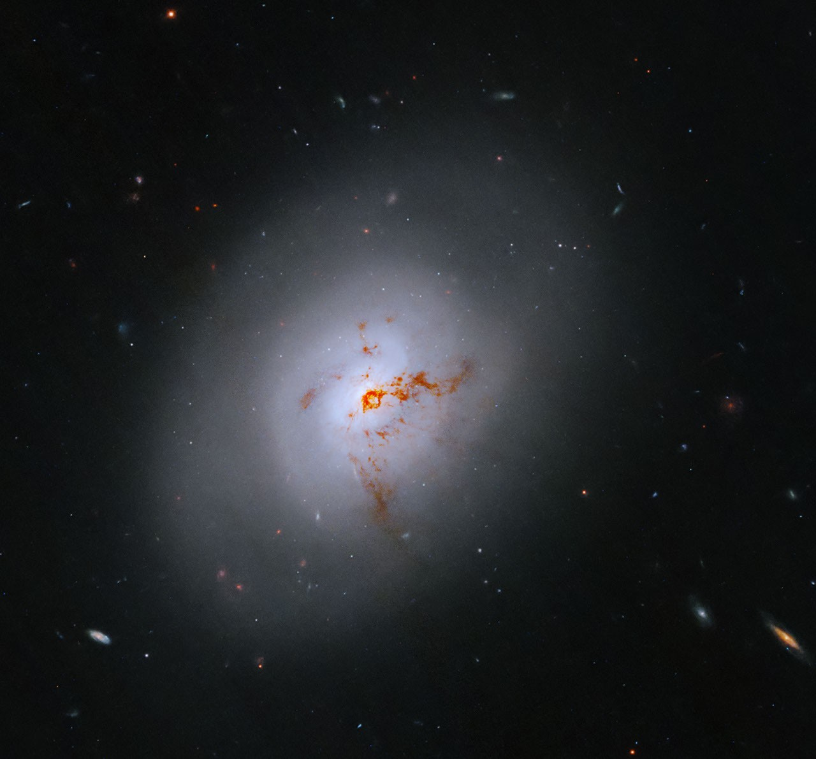

This NASA Hubble Space Telescope images reveals the lenticular galaxy, NGC 1266. This enigmatic post-starburst galaxy has a bright center and a face that hints at spiral structure, yet it holds no discernable spiral arms. NASA, ESA, K. Alatalo (STScI); Image Processing: G. Kober (NASA/Catholic University of America) This NASA Hubble Space Telescope image reveals an enigmatic galaxy with a bright center and a face that hints at spiral structure, yet it holds no obvious spiral arms. Reddish-brown clumps and filaments of dust partially obscure the galaxy's full face, while red, blue, and orange light from distant galaxies shines through its diffuse outer regions and dots the inky-black background. NGC 1266 is a lenticular galaxy located some 100 million light-years away in the constellation Eridanus (the Celestial River). Astronomers classify lenticulars as transitional galaxies that represent an evolutionary bridge between spirals and ellipticals. Lenticulars are "lens-shaped" and have a bright central bulge and flattened disk like spirals, but they have no spiral arms and little to no star formation like ellipticals. As interesting as this galaxy's structure and lenticular classification are, those traits aren't its most intriguing features. NGC 1266 is a rare post-starburst galaxy that is in transition between a galaxy that experienced a major burst of star formation and a quieter elliptical galaxy. Post-starburst galaxies have a young population of stars but few star-forming regions. Roughly one percent of the local galaxy population is a post-starburst galaxy. Astronomers think that NGC 1266 had a minor merger with another galaxy some 500 million years ago. The merger spurred the formation of new stars and increased the mass of the galaxy's central bulge while funneling gas into its supermassive black hole. The additional matter made the black hole much more active, creating an active galactic nucleus or AGN. The black hole's increased activity would have generated powerful winds and jets of gas along its axis of rotation. Over time, the burst of new stars and the black hole's powerful jets would deplete the galaxy's reservoir of star-forming gas, while the turbulence generated in these processes suppressed new stars from forming in the gas that remained. Observations by Hubble and other observatories reveal a strong outflow of gas from the galaxy and that the space between its stars is shocked or highly disturbed. Researchers found that any remaining stellar nurseries are in the core of the galaxy, and that very little to no star formation happens beyond that core. These observations suggest the supermassive black hole in the galaxy's heart may be suppressing star birth by stripping or ejecting star-forming gas from the galaxy. The shockwaves from this process would create turbulence that disturbs the gas and dust between stars enough to stop any remaining matter from gravitationally condensing into infant stars. Post-starburst galaxies like NGC 1266 are ideal subjects for astronomers to study the complex physical processes that suppress star formation. They help us better understand the evolution of galaxies and how supermassive black holes interact with their hosts. Media Contact: Claire Andreoli NASA's Goddard Space Flight Center, Greenbelt, MD claire.andreoli@nasa.gov

11. The devil may wear Prada on Earth, but NASA Artemis astronauts will on the moon. Here's why.
Latest from Space.com
Read more


Click for next article Space makes a surprise cameo in The Devil Wears Prada 2, but we bet you didn't know Prada is really working to dress Artemis astronauts on the moon? In "The Devil Wears Prada 2," there's a blink-and-you'll-miss-it moment where a billionaire character scoffs at the idea of sending astronauts to the moon - "We went there 60 years ago!" And Mars, pfft! Who is he, Musk? No, the real innovation, he suggests, is sending astronauts to the sun. He even has a name for his spaceship: The Icarus (yes, the irony is lost on him). That character may be against sending crewed missions back to the moon, but NASA certainly isn't. The agency plans to land humans on the lunar surface as part of its ongoing Artemis initiative - in Prada , no less. The spacesuits for Artemis 3 and Artemis 4 were designed in a collaboration between the famous Italian fashion house and Axiom Space , a private space company based in Houston, Texas. The (relatively) sleek suits allow astronauts a greater degree of mobility than previous versions, while still protecting them from dangerous cosmic radiation. They're also designed to fit a wider range of body types, incorporating more adjustable features. Axiom Space and Prada unveiled the suit at the 2024 International Astronautical Congress in Milan. In April, NASA successfully launched its Artemis 2 mission , which sent a crew of four astronauts on a flyby trip around the moon. Artemis 3, slated for 2027, will see astronauts test the new Prada spacesuits for the first time in low Earth orbit. Axiom Space and Prada unveiled the design of the new Axiom Extravehicular Mobility Unit (AxEMU) spacesuit at the International Astronautical Congress in Milan on Oct. 16, 2024. (Image credit: Andrew Jones/Space.com) Artemis 4 is currently scheduled to lift off by the end of 2028 . It will mark the first time humans have set foot on the moon since 1972, as well as the first time a woman has been there. NASA's long-term goal is to establish a moon base, which will allow astronauts to work (and eventually hop to Mars) from our satellite's surface. For now, Prada has the market cornered on out-of-this-world space fashion. But who knows - there's still plenty of time for Dior to unveil its 2028 lunar collection.

12. James Webb Space Telescope maps our universe's largest structure in unprecedented detail
Latest from Space.com
Read more
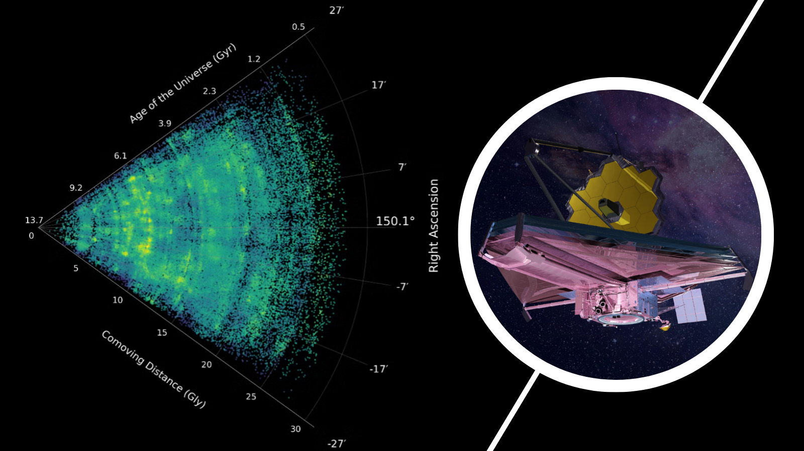

Click for next article A slice of the COSMOS-Web cosmic-web map, created with JWST data, showing galaxies across nearly 14 billion years of cosmic history. Using the James Webb Space Telescope, astronomers have mapped the "cosmic web" of galaxies - the largest structure in the universe - with unprecedented detail. This is the largest James Webb Space Telescope (JWST) survey conducted to date, and is known as COSMOS-Web. It traces a network of galaxies back to when the universe was about 1 billion years old. The cosmic web is the term scientists use to describe a skeleton-like framework of filaments and sheets of dark matter and gas along which galaxies gathered and evolved over time, which is punctuated by nearly empty voids. Thus, the cosmic web forms the architecture of the universe - it's a singular, intricate, far-reaching structure that traps galaxies and galactic clusters like flies strung along the sticky silk web of a greedy spider. The results obtained by the COSMOS-Web team further demonstrate the power of the JWST to refine and redefine our view of the universe since the $10 billion space telescope began beaming data back to Earth in the summer of 2022. "JWST has completely changed our view of the universe, and COSMOS-Web was designed from the start to give us the wide, deep view we need to see the cosmic web," leader of this research, Hossein Hatamnia of the University of California, Riverside (UCR), said in a statement . "For the first time, we can study the evolution of galaxies in cluster and filamentary structures across cosmic time, all the way from when the universe was a billion years old up to the nearby universe." By the "nearby universe," Hatamnia means up to a distance of around 1 billion light-years. The solar system is estimated to be around 2 light-years wide, giving you an idea of just how far astronomers consider our cosmic backyard to extend. COSMOS-Web extends this by another 13 or so billion light-years. That kind of depth of view is the only way astronomers can get a true picture of the cosmic web. A slice through the COSMOS-Web cosmic-web map, showing galaxies across nearly 14 billion years of cosmic history. The vertex on the left marks the present day; moving outward, each galaxy is placed at its distance in cosmic time, reaching back to when the universe was less than a billion years old. Bright yellow regions show the dense clusters and filaments of the cosmic web, while dark regions mark the near-empty voids in between. (Image credit: UCR/Hossein Hatamni) The large-scale structure delivered by COSMOS-Web provides a wealth of information greater than that provided by earlier maps of the same region of sky captured by the Hubble Space Telescope . Team member and UCR scientist Bahram Mobasher explained that comparing Hubble and JWST shows that many cosmic structures had been "smoothed over" in data from the JWST's space telescope predecessor. "The jump in depth and resolution is truly significant, and we can now see the cosmic web at a time when the universe was only a few hundred million years old, an era that was essentially out of reach before JWST," Mobasher said. "What used to look like a single structure now resolves into many, and details that were smoothed away before are now clearly visible." The impressive leap in detail provided by the JWST and COSMOS-Web is the result of the unification of two of this powerful new space telescope's key strengths. "The telescope detects many more faint galaxies in the same patch of sky, and the distances to those galaxies are measured far more precisely," Hatamnia said. "Each galaxy can therefore be placed into the correct slice of cosmic time, sharpening the map's resolution."

13. NASA, SpaceX launch Dragon mission with 6,500 pounds of science and supplies to the space station
Spaceflight Now
Read more

Update May 15, 6:33 p.m. EDT (2233 UTC): SpaceX confirms successful separation of the Dragon spacecraft. The third time was the charm as SpaceX successfully launched its Cargo Dragon spacecraft on Friday evening, loaded with 6,500 pounds of science and supplies for the International Space Station after two delays earlier in the week due to bad weather. Liftoff of the resupply mission, atop a Falcon 9 rocket from Space Launch Complex 40 at Cape Canaveral Space Force Station, happened at 6:05 p.m. EDT (2205 UTC). It was SpaceX's 34th mission for NASA, funded by the agency's Commercial Resupply Services (CRS) contracts. A slow-moving weather front, bringing thick clouds and thunderstorms to central Florida, stymied launch attempts on Tuesday and Wednesday. The countdown on Wednesday reached T-28 seconds before the launch director called a hold due to the presence of lightning-triggering anvil clouds in the vicinity of the launch pad. Launch was rescheduled for Friday so ground crews could reload 'late load' items with a short shelf life. With high pressure building over central Florida, creating drier conditions, forecasters are calling for a 90-percent chance of acceptable weather for launch, with only a small risk of violating the cumulus cloud rule. The Falcon 9 departed Florida's Space Coast on a northeasterly trajectory to target a rendezvous with the orbiting space station. Less than eight minutes after liftoff, the first stage booster returned for a touchdown at Landing Zone 40 (LZ-40) adjacent to the launch pad at SLC-40. This was the fourth booster recovery at this site and the 108th on-shore landing across the four pads SpaceX has used since 2015. SpaceX launched the CRS-34 mission using Falcon 9 first stage booster B1096. This was its sixth flight following the launches of NASA's IMAP, GPS III-9, NROL-77, Kuiper Falcon 01, and Starlink Group 6-87. This was also the sixth flight for the Cargo Dragon spacecraft, serial number C209. It launched the CRS-22, -24, -27, -30, and -32 missions. This was the first time that a Cargo Dragon spacecraft launched for a sixth time, but the second for the Dragon-2 program overall. The Crew Dragon Endeavour had already flown for a sixth time. The Cargo Dragon separated from the Falcon 9 second stage about 9.5 minutes into the mission, kicking off a nearly 37-hour orbital chase to catch up with the space station. It's set to dock with the orbiting outpost at about 7:05 a.m. EDT (1105 UTC) on Sunday, May 17.

14. Customizable drinks could provide essential nutrients during space missions
Space News - Space, Astronomy, Space Exploration
Read more


After the success of Artemis II, longer space journeys are expected, raising new health and nutritional challenges for astronauts. Current space foods rely on dried, shelf-stable items.

15. NASA draws on industry for Mars telecommunications network
Space News - Space, Astronomy, Space Exploration
Read more


On Thursday, NASA issued a Request for Proposal (RFP), seeking industry collaboration for the Mars Telecommunications Network.

16. New 250-watt nuclear generator could fuel future NASA Uranus orbiter missions
Interesting Engineering
Read more

NASA could soon gain a more powerful energy source for missions far beyond Mars after a next-generation nuclear space generator cleared a major development milestone. L3Harris announced that its Next-Generation Radioisotope Thermoelectric Generator, or Next Gen RTG, passed its critical design review on April 2. The review confirms the system meets technical requirements and can move toward manufacturing. The new generator could begin powering NASA deep-space missions in the early 2030s. Engineers designed the system for spacecraft operating in the outer solar system, where sunlight becomes too weak for solar panels to work efficiently. Power for deep space The Next Gen RTG produces roughly 250 watts of electricity at the start of its operational life. It generates that power by converting heat from decaying plutonium-238 into electricity. NASA has relied on RTGs for decades. The technology-powered historic missions include Voyager, Cassini, New Horizons, and the Curiosity and Perseverance Mars rovers. Unlike the RTGs used on Mars rovers, the new system targets spacecraft operating in the vacuum of deep space. Engineers optimized the design for heat rejection and power generation in extremely cold environments. That improvement allows the generator to produce more electricity without increasing its overall weight. The compact design could become critical for future missions, where every kilogram affects launch costs and spacecraft performance. "The Next Gen RTG represents a significant leap forward in efficiency," said Bill Sack, general manager of RocketWorks and Power Systems at L3Harris. He added that the system delivers more power within the same mass range, an important factor for long-range exploration missions. Uranus mission plans NASA could use the new generator on several future projects, including a proposed Uranus orbiter. That spacecraft would likely carry two Next Gen RTGs. The generators would not only provide electricity. They would also keep onboard systems warm enough to function in the freezing outer solar system. The mission concept reflects growing interest in exploring distant planets and moons that remain largely unexplored. Scientists have pushed for a Uranus mission for years because the planet may reveal new clues about planetary formation and icy worlds. The technology could also support missions to Neptune and Triton, long-duration probes studying outer planet moons, and future Kuiper Belt explorers traveling farther than New Horizons. Engineers even see the system supporting interstellar precursor missions that could venture beyond the path of Voyager 1 and Voyager 2. Restarting critical production The U.S. Department of Energy's Idaho National Laboratory selected L3Harris in 2021 to revive and modernize the technology behind earlier RTGs. The effort involved rebuilding capabilities that had seen limited production in recent years. Engineers also had to replace outdated components and recover incomplete technical documentation tied to older systems. "We are proving we can do it again," said Leo Gard, Space Propulsion and Power Systems program manager at L3Harris. Gard said engineers recreated missing technical details and found modern replacements for obsolete parts through extensive problem-solving. L3Harris leads overall integration work for the program. Teledyne Energy Systems supplies thermoelectric components, while BAE Systems develops insulation systems for the generator. The program is expected to reach production readiness review in 2027.

